Committee on the Elimination of Discrimination
against Women

Thirty-fifth session
Item 5 of the provisional agenda*
15 May-2 June 2006

Implementation of article 22 of the Convention on the
Elimination of All Forms of Discrimination against Women

Reports provided by specialized agencies of the
United Nations on the implementation of the Convention
in areas falling within the scope of their activities

Note by the Secretary-General

Addendum

United Nations Educational, Scientific and
Cultural Organization

1. On behalf of the Committee on the Elimination of Discrimination against Women, the Secretariat invited the United Nations Educational, Scientific and Cultural Organization (UNESCO) to submit to the Committee a report on information provided by States to UNESCO on the implementation of the Convention on the Elimination of All Forms of Discrimination against Women in areas falling within the scope of its activities, which would supplement the information contained in the reports of the States parties to the Convention that will be considered at the thirty-fifth session of the Committee. Other information sought by the Committee refers to activities, programmes and policy decisions undertaken by UNESCO to promote the implementation of the Convention. The Secretary-General has the honour to transmit the report of UNESCO submitted pursuant to the above-mentioned request.

* CEDAW/C/2006/II/1.

Report of the United Nations Educational, Scientific
and Cultural Organization

I. Introduction

1. The Committee on the Elimination of Discrimination against Women will, at its thirty-fifth session, examine the national reports of the following countries: Bosnia and Herzegovina, Cyprus, Guatemala, Malawi, Malaysia, Romania, Saint Lucia and Turkmenistan.
2. Article 22 of the Convention on the Elimination of All Forms of Discrimination against Women provides that the Committee may invite specialized agencies to “submit reports on the implementation of the Convention in areas falling within the scope of their activities”, giving an account of recent activities, policies and programmes in implementation of article 10 (in the case of the United Nations Educational, Scientific and Cultural Organization (UNESCO)) and related articles. Section II of the present report summarizes UNESCO activities to implement the Convention within the organization itself; section III presents initiatives taken to implement the Convention in the countries to be considered by the Committee.

II. United Nations Educational, Scientific and Cultural Organization activities to implement the Convention
within the organization itself

3. Pursuant to the UNESCO medium-term strategy for 2002-2007, a gender-equality perspective has been integrated in policy planning, programming, implementation and evaluation activities in all areas of the organization’s competence with a view to promoting women’s empowerment and achieving gender equality. Women’s priorities and vision of development goals and approaches are addressed and promoted through greater participation of women at all levels and in all areas of UNESCO action. Region-specific programmes and activities that benefit girls and women of various ages, including the young and the elderly, focus on networking, exchange of information, sharing of knowledge and building alliances across borders and cultures in the framework of the United Nations Declaration and Programme of Action on a Culture of Peace. Further promotion and implementation of the Convention on the Elimination of All Forms of Discrimination against Women and all other international normative instruments that promote women’s human rights remain a top priority.

III. Measures taken by the United Nations Educational, Scientific and Cultural Organization to implement the provisions of the Convention in the countries to be considered at the thirty-fifth session of the Committee

A. Longitudinal and comparative gender-parity educational statistics for all countries reporting for the thirty-fifth session

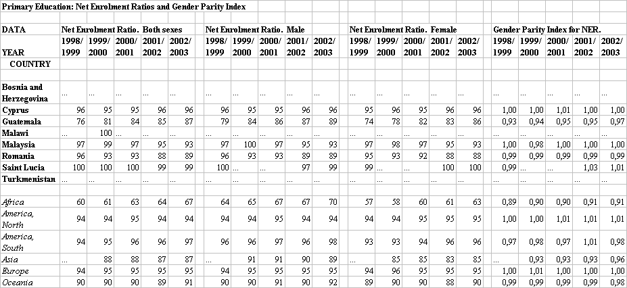
Source
UNESCO Institute for Statistics, Education, Gross and Net Enrolment Ratios, primary (available data from 1998-2004. October 2005 release); available at http://stats.uis.unesco.org/TableViewer/tableView.aspx?ReportId=51 (last accessed 28 January 2006).
Source
UNESCO Institute for Statistics, Education, Gross and Net Enrolment Ratios, secondary (available data from 1998-2004. October 2005 release); available at http://stats.uis.unesco.org/TableViewer/tableView.aspx?ReportId=52 (last accessed 28 January 2006).
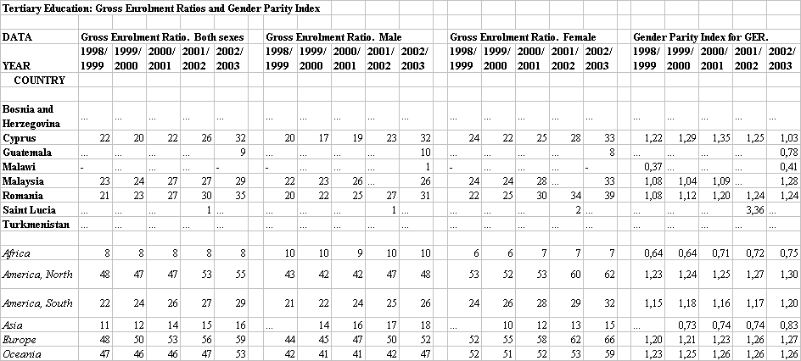

Source
UNESCO Institute for Statistics, Education, Gross Enrolment Ratios, tertiary (available data from 1998-2004. October 2005 release); available at http://stats.uis.unesco.org/TableViewer/tableView.aspx?ReportId=47 (last accessed 28 January 2006).

B. Country-specific reports

BOSNIA AND HERZEGOVINA
Education
Has given notification of succession in 1993 to the UNESCO Convention against Discrimination in Education.

- Constitution 1995: Art II, paragraph 3 (l) All persons within the territory of Bosnia and Herzegovina shall enjoy the human rights and fundamental freedoms these include:
(l) The right to education

- Note: The 2003 Framework Law on Primary and Secondary Education is an effort to develop a common policy for the country as a whole (including Rep. Srepska). This Framework Law stipulates inclusive learning and integration of children with special needs into mainstream education, the establishment of a 9-year cycle of compulsory education and the Action Plan for meeting educational needs of Roma and other national minorities.

Communication
The media at the service of poverty alleviation for refugees: Production and exchange of television news items on trafficking of women in Southeast Europe; increased cooperation between the public broadcasters in the SEE region; increased public awareness of illegal women trafficking in South East Europe.

Fellowships:
Research Fellowships (UNESCO/JAPAN: OBUCHI): One fellowship was granted in 2001 within the field of Intercultural Dialogue.

CYPRUS
Education
Has accepted the UNESCO Convention against Discrimination in Education in 1970.
Reorienting national policies including teacher education in member states: Education for Sustainable Development linkages with MDGs, EFA (Education for All), UNLD (UN Literacy Decade) established and incorporated in the national policies, including the re-orientation of teacher education.

Fellowships:
Two fellowships were awarded in 2000 and 2003, within the fields of Education (Evaluation-Recognition of Qualifications) and Arts Policy and Management, respectively.

GUATEMALA
Education
Has ratified the UNESCO Convention against Discrimination in Education in 1983.

- Constitution 1985, modified in 1993. Relevant Provisions:
  - Art.36 - Any person has the right to practice his religion or belief, both in public and in private, through education, (…).
  - Art.51 - The State will protect the physical, mental and moral health of minors and the elderly. It will guarantee them their right to food, public health, education, security, and social insurance.
  - Art.71 - Right to education: The freedom of education and educational standards are guaranteed. It is the obligation of the State to provide and facilitate education to its inhabitants without any discrimination whatever.
  - Art.73 - The family is the source of education and parents are entitled to choose what is to be taught to their minor children. The State will be able to subsidize free private education centers and the law will regulate issues relating to this matter. Private education centers will operate under the inspection of the State. They are obligated to fill, at least, official study plans and programs. As cultural centers they will be exempt from all types of taxes and customs duties. Religious education is optional in public schools and can be given during regular hours without any discrimination. The State will contribute to the maintenance of religious education without any discrimination.
  - Art.74 - Obligatory education: The inhabitants have the right and obligation to receive early, pre-primary and basic education within the age limits set by the law. Education provided by the State is free. The State will provide and promote scholarships and educational credits. The State will promote special education, diversified education and education outside of school.

UNESCO supports activities in favor of the protection and rehabilitation of under-age street girls in Guatemala City: Chased from their homes by families that reject them, these young girls run away and settle on the streets. UNESCO supports the setting up of early childhood activities for the babies and young children of the mothers living in the home as well as basic education programmes for the mothers. UNESCO is realizing a methodological guide for stakeholders working with street girls, based on the experience of Guatemala.

Regional Project for Education in Latin America and the Caribbean: This project aims at improving equity in terms of gender and socio-economic conditions in primary and secondary schools in Peru, Jamaica, Chile, Mexico, Guatemala and Saint Lucia.

National survey and seminar on adult illiteracy and strategies for its Elimination: Study documenting national experience in literacy for rural women, with a focus on information and communications technologies in Peru, Mexico, Guatemala.

Reorienting national policies including teacher education in member states: Education for Sustainable Development linkages with MDGs, EFA (Education for All), UNLD (UN Literacy Decade) established and incorporated in the national policies including the re-orientation of teacher education.

Culture
Support to socio-cultural initiatives oriented to the creation of “Cultural Cooperatives” in Central America: This project gives visibility to the role of women in the economic, social and cultural development of their communities in Guatemala.

Science
Caribbean Conference on Science, Technology and Environment organized in order to identify and promote scientific and technological priority areas for sub regional co-operation as well as projects that can enhance multinational cooperation, participation of young and women researchers. Information was disseminated in Peru, Chile, Mexico, and Guatemala through web pages and brochures, technical meeting and conference reports, and consultation documents.

MALAWI
Education
Has not ratified the UNESCO Convention against Discrimination in Education.

- Constitution 1994:
  - Art.13 The State shall actively promote the welfare and development of the people of Malawi by progressively adopting and implementing policies and legislation aimed at achieving the following goals:
    - (f) Education: To provide adequate resources to the education sector and devise programs in order to: (i) Eliminate illiteracy in Malawi, (ii) Make primary education compulsory and free to all citizens of Malawi,

UNESCO provided financial and technical support to FAWE (Forum for African Women Educationalists) in order to organize - in Mauritius, Congo, Cape Verde and Malawi - demonstration interventions on how to mainstream gender-responsive best practices in policies. This initiative led to the formulation of policies and plans along gender lines, and greater public awareness of these issues.

Reorienting national policies including teacher education in member states: Education for Sustainable Development linkages with MDGs, EFA (Education for All), UNLD (UN Literacy Decade) established and incorporated in the national policies including the re-orientation of teacher education, relating to all report countries.

UNESCO supported the Centre on Guidance, Counseling and Youth Development for Africa (GCYDA) based in Lilongwe, Malawi. This Centre aims at developing /strengthening Guidance and Counseling services in education systems for children and young people, with special attention to the issues of girls’ education and HIV and AIDS in the Sub-Saharan African region. In Malawi, in addition to the training of trainers in Guidance and Counseling, GCYDA has organized training workshops on HIV and AIDS Peer Counseling and Prevention targeted to girls. Findings of a recent study in Malawi show that Guidance and Counseling enhances retention and completion of school and thus, contributes to the achievement of EFA goals 2 (Universal quality primary education by 2015) and 5 (Gender parity by 2005 and gender equality in basic education by 2015).

Analysis of the integration of gender equality concerns in the Malawi National Action Plan for EFA: Conclusions of the study helped improve the gender-responsiveness of the Plan.

Training seminar for African Parliamentarians on how to strengthen their capacity to advocate in favor of EFA: In the context of expanding and improving primary education in Africa, a seminar was conducted to train parliamentarians in Mauritius, the Congo, Cape Verde and Malawi to promote education as a fundamental right.

Science and Technology Education (STE)
Regional consultation on the development of policy guidelines to enhance girls’ participation in STE: This initiative brought improvements in gender-responsive STE policies and programmes in Mauritius, Congo, Cape Verde and Malawi. As a result, a science career counseling program for Africa, entitled “Girls into science” is being developed in collaboration with the Namibian government, and the Guidance, Counseling and Youth development Center for Africa in Lilongwe, Malawi.

Case study on best practices in technology and vocational education skills participation among girls: Conducted in Mauritius, Congo, Cape Verde, Malawi.

Support for women groups to improve African women access and participation in engineering: Implemented in Mauritius, Congo, Cape Verde, Malawi.

Promoting out of school programmes: Interest of girls in STE increased; increased participation and achievement level of girls in STE, implementation in Mauritius, Congo, Cape Verde, Malawi.

Youth Development
The Malawi Center, created following the Pan-African Conference on the Education of Girls, seeks to develop and institutionalize guidance, counseling and youth development services as non-academic support, with needs of girls as a special focus. Over the biennium 2003 – 2004, UNESCO contributed USD 180,000 for the activities of the Center. During the biennium 2004 –2005, UNESCO contributed to the development of the Center’s programmes by providing financial support aimed at building capacity within participating countries, for both girls and boys, and at institutionalizing guidance and counseling as a non-academic support within the education systems of the beneficiary countries. UNESCO’s support throughout the biennium was provided through a series of contracts with the Center, supporting training of trainers’ courses at regional and national levels with special focus on HIV/AIDS, adolescent sexual and reproductive health, drug use/abuse, enterprise education and behavior modification. Training held in Malawi, Mauritius, Congo, Cape Verde.

HIV/AIDS
Training and awareness on HIV/AIDS using a culturally appropriate approach: Pedagogical material reproduced and distributed; training workshops on the “theatre forum” organized; film on sensitization of HIV/AIDS produced and distributed in Mauritius, Congo, Cape Verde, Malawi.

Peace and Conflict Resolution
Production of pedagogical tool kits for peace education and non-violent conflict resolution: Enhanced capacities for growth of women in Mauritius, Congo, Cape Verde, Malawi.

Information and Communications
Promoting participation of women as users, managers, staff and activities in Community Multimedia Centres (CMC): Empowerment of women through CMCs, resulting in their active participation in the information society, through the appropriation of communication and information tools; Implemented in Mauritius, Cape Verde, Congo, Malawi.

MALAYSIA
Education
Has not ratified the UNESCO Convention against Discrimination in Education.

- Constitution of 1963:
- Relevant article for Right to Education: Article 12
(1) Without prejudice to the generality of Article 8, there shall be no discrimination against any citizen on the grounds only of religion, race, descent or place of birth –
(a) in the administration of any educational institution maintained by a public authority, and, in particular, the admission of pupils or students or the payment of fees; or
(b) in providing out of the funds of a public authority financial aid for the maintenance or education of pupils or students in any educational institution (whether or not maintained by a public authority and whether within or outside the Federation).

Capacity-building for Gender and Education Network in Asia (GENIA) gender focal points: Awareness raised, experiences and best practices shared regarding equity of access to quality education, with a special emphasis on gender in Uzbekistan, India, China, Turkmenistan, Malaysia.

Research on gender bias in school environments: Awareness raising, policy changes and new practices to promote gender equality in learning environments in Uzbekistan, India, China, Turkmenistan, Malaysia.

Projects aiming at supporting education policies in favor of girls and women education improved in Uzbekistan, India, China, Turkmenistan and Malaysia.

Reorienting national policies including teacher education in member states: ESD (Education for Sustainable Development) linkages with MDGs, EFA (Education for All), UNLD (UN Literacy Decade) established and incorporated in the national policies including the re-orientation of teacher education, relating to all report countries (except Bosnia and Herzegovina).

Training of researchers and university staff, with priority to LDCs (least developed countries) and poor women: Collaboration with Asia Pacific Gender Equality Network (APGEN) and the Gender Advisory Board. Implemented in China, Malaysia.

EFA (Education for All) Observatory: Implemented in Uzbekistan, India, China, Turkmenistan, Malaysia.

Initiative on rural based vocational training, collaboration with Asia Pacific Gender Equality Network (APGEN): Implemented in Uzbekistan, India, China, Turkmenistan, and Malaysia.

Vocational Training
Cross-disciplinary programmes on training of girls in scientific vocational careers among indigenous, rural based populations: Cross-disciplinary basic science programme in capacity building for girls in Uzbekistan, India, China, Turkmenistan, Malaysia.

Information and Communications
Women and the media: Better accessibilities for media and youth; training of media professionals, notably women; women’s voices in the media enhanced; Implemented In Uzbekistan, India, China, Turkmenistan and Malaysia.

Social and Human Sciences
Policy-oriented research on how the socio-economic conditions and rights of working women promote the implementation of international instruments such as CEDAW, along with the enhancement of women’s trade union leadership. Malaysia is among the countries to be studied.

ROMANIA
Education
Has ratified the UNESCO Convention against Discrimination in Education in 1964.

Reorienting national policies including teacher education in member states: Education for Sustainable Development linkages with MDGs, EFA (Education for All), UNLD (UN Literacy Decade) established and incorporated in the national policies including the re-orientation of teacher education, relating to all report countries.

Fellowships:
Seven Fellowships were granted within the fields of Education and Community Development, Communication (Television Documentary Program Production), Life Sciences, Awards Ceremonies at UNESCO Headquarters, and Promotion and Encouragement of Dialogues between Cultures, between the years 2002 to 2005.

SAINT LUCIA
Education
Has not ratified the UNESCO Convention against Discrimination in Education.

- Constitution of 1979. The Constitution (Commonwealth) includes human rights guarantees, but not specifically the right to education.

- Legislative measures: Education Act n° 41 of 1999:
14. Subject to available resources, all persons are entitled to receive an educational programme appropriate to their needs in accordance with this Act.
16.—(1) No tuition fees consequent to the student’s attendance in an educational programme at a public school under section 27 shall be charged to the student or the parents of the student.
19.—(1) A student may express any religious, political, moral, or other belief or opinion so long as the expression does not adversely affect the rights or education of other students, or the rights of other persons in the school.
27.—(1) Every child shall attend school from the beginning of the school year in which that child attains the age of 5 years until the end of the school year in which that child attains the age of 15 years.

Identification of out-of-school children from 6 to 12 years of age: Study conducted, in Saint Lucia and Jamaica, in order to further implement the Dakar objectives and the MDGs. Study consisted of examining the rate of out-of-school children, sex disaggregated data, geographical distribution, causation, and proposed strategies to get children to school.

Capacity-building workshop on Education for All (EFA) early childhood policies: 2000 Assessment of EFA in the Caribbean identified critical issues and developed a Plan of Action 2000-2015 for the region, endorsed by Ministers of Education. UNESCO’s Kingston Office has worked over the past biennium closely with the Caribbean Child Development Center to enhance and strengthen regional planning and information on sharing through a network of early childhood and parenting institutions/specialists, to support regional systemization of early childhood data collection, to plan for the extension of the Caribbean network on Early Childhood Care and Education (ECCE). A regional training workshop on ECCE Policy was organized to provide support to Caribbean Member States and to train national policymakers based on research results on the situation in the region, to build government officials’ capacity to develop/implement policies, to raise awareness in HIV/AIDS in ECCE, and to support the dissemination of information and networking in the Caribbean.

Regional Project for Education in Latin America and the Caribbean: Meeting organized in order to improve equity in terms of gender and socio-economic conditions in primary and secondary schools in Peru, Jamaica, Chile, Mexico, Guatemala and Saint Lucia.

Reorienting national policies including teacher education in member states: Education for Sustainable Development linkages with MDGs, EFA (Education for All), UNLD (UN Literacy Decade) established and incorporated in the national policies including the re-orientation of teacher education, relating to all report countries.

TURKMENISTAN

Education
Has not ratified the UNESCO Convention against Discrimination in Education.

- Constitution of 1992
- Articles 1-56 : http://www.turkmenistanembassy.org/turkmen/business/consta.html
- Articles 57-116 : http://www.turkmenistanembassy.org/turkmen/business/constb.html
- Extracts concerning education
  - Article 11. The state shall guarantee the freedom of religions and confessions and their equality before the law. Religious organizations shall be separate from the state and may not fulfill state functions. The state education system shall be separate from religious organizations and shall be a secular nature. Everyone shall have the right independently to define his attitude toward religion, to profess any religion or not profess any either individually or jointly with others, to profess and disseminate beliefs associated with his attitude to religion, and to participate in the practice of religious cults, rituals, and rites.
  - Article 25. Women and men, upon attaining the age of marriage, shall have the right to marry and create a family upon mutual consent. Spouses shall have equal rights in family relations. Parents and legal guardians shall have the right and obligation to raise their children, care for their health and development and education, prepare them for labor, and to install culture and respect for laws and historical and national traditions in them. Adult children shall be obligated to care for their parents and to render them assistance.
  - Article 35. Each citizen shall have the right to education. General secondary education is obligatory, and everyone shall have the right to obtain this for free at state educational institutions. The state shall facilitate access for everyone in accordance with their abilities to professional, special secondary, and higher education. Organizations and citizens shall have the right to create paid educational institutions on the basis and in the manner established by law.

Capacity-building for Gender and Education Network in Asia (GENIA ) gender focal points: Awareness raised, experiences and best practices shared regarding equity of access to quality education, with a special emphasis on gender in Uzbekistan, India, China, Turkmenistan, Malaysia.

Research on gender bias in school environments: Awareness raising, policy changes and new practices to promote gender equality in learning environments in Uzbekistan, India, China, Turkmenistan, Malaysia.

Central Asian Education Forum: Since 2002 UNESCO, jointly with UNICEF, has been supporting the annual Central Asian Education Forum. The Forum gathers relevant UN and other international, national governmental and non-governmental partners to coordinate implementation of EFA strategies. It also aims at building capacities within sub-regional framework for education policy reforming and strategic planning. UNESCO will, in this context, conduct the Forum, translate and disseminate advocacy and information materials to support EFA plans, demands and needs with regard to education policy reforms.

Reorienting national policies including teacher education in member states: Education for Sustainable Development linkages with MDGs, EFA (Education for All), UNLD (UN Literacy Decade) established and incorporated in the national policies including the re-orientation of teacher education, relating to all report countries.

Cross-disciplinary programmes on training of girls in scientific vocational careers among indigenous, rural based populations: Cross-disciplinary basic science programme in capacity building for girls in Uzbekistan, India, China, Turkmenistan, Malaysia.

EFA (Education for All) Observatory: Implemented in Uzbekistan, India, China, Turkmenistan, Malaysia.

Vocational Training
Initiative on rural based vocational training, collaboration with Asia Pacific Gender Equality Network (APGEN): Implemented in Uzbekistan, India, China, Turkmenistan, and Malaysia.

Communications and Information
Women and the media project: Better accessibilities for media and youth; training of media professionals, notably women; women’s voices in the media enhanced. Implemented in Uzbekistan, India, China, Turkmenistan and Malaysia.

ViewPoints Book on Gender, Youth and Social Inclusion in Arab States: Workshops, seminars and publications promoting participation of women, youth and indigenous groups in communication and media activities; promoting participation of women, youth and indigenous groups in communication; promoting media awareness on gender and youth issues; production of radio programmes on violence against women, and equal educational opportunities for women (particularly young women) by Radialistas; production of radio programmes on violence against women and providing equal educational opportunities. Implemented in Turkmenistan.

