|  |  |  |  |
| --- | --- | --- | --- |
|  | United Nations | CMW/C/PRY/2 | |
| _unlogo | **International Convention on the Protection of the Rights of All Migrant Workers and Members of Their Families** | | Distr.: General  20 December 2019  English  Original: Spanish  English, French and Spanish only |

**Committee on the Protection of the Rights of All   
Migrant Workers and Members of Their Families**

Second periodic report of Paraguay due in 2017 under article 73 of the Convention pursuant to the simplified reporting procedure[[1]](#footnote-1)\*, [[2]](#footnote-2)\*\*

[Date received: 13 November 2019]

Introduction

1. The Republic of Paraguay submits to the Committee on the Protection of the Rights of All Migrant Workers and Members of Their Families (the Committee) its second periodic report, pursuant to article 73 of the International Convention on the Protection of the Rights of All Migrant Workers and Members of Their Families (the Convention), in response to the list of issues transmitted under the simplified procedure adopted at its fourteenth session.

2. The present report is the product of an inter-agency consultation process coordinated by the Ministry of Foreign Affairs and the Ministry of Labour, Employment and Social Security. The process was facilitated by the SIMORE Plus recommendations monitoring system, a publicly accessible online platform for compiling the recommendations of international human rights bodies and linking them to the Sustainable Development Goals, along with information on follow-up and implementation.

3. Since 2018, the lists of issues prepared by treaty bodies have been incorporated, on a pilot basis, into SIMORE Plus, which is being enhanced as a data-collection tool for the preparation of periodic reports. Thus, the present report contains information provided by more than 100 officials from the three branches of Government, as well as by other bodies that make up the focal points network of SIMORE Plus.

4. Bearing in mind the recommendations of different treaty bodies on the need to foster the constructive engagement of civil society in the preparation and submission of national reports pursuant to the SIMORE Plus regulations, on 12 September 2019, a workshop was carried out to present the preliminary report to representatives of civil society organizations and labour and business associations, with the aim of exchanging comments and observations.

Section I

A. General information

Issue 1

5. As regards follow-up to recommendations in SIMORE Plus, the State invites the Committee to visit the website of the mechanism.[[3]](#footnote-3) The advanced browser that is available in the public module provides easy access to updated information based on different organization and classification criteria, including the rate of follow-up.

6. While the tool has an option for focal points to add existing indicators for the institutional actions reported, in addition to the referential use of Sustainable Development Goal indicators, establishing a unified system based on the Guide to Measurement and Implementation of Human Rights Indicators issued by the Office of the United Nations High Commissioner for Human Rights (OHCHR) is a challenge that is being addressed based on the experience to be gained from an ongoing initiative on follow up to the National Plan of Action on the Rights of Persons with Disabilities, using SIMORE Plus.

7. To manage the information efficiently, seven populations/themes have been identified as those which are most often referred to in the recommendations received by Paraguay. In addition to serving as criteria for classifying and organizing data, these populations/themes were taken up by inter-agency working groups of focal points, in order to analyse and assign recommendations to the agencies for follow up, implementation and monitoring. One of these working groups dealt with issues related to the migrant population.

8. At present, 11 organizations have active users on the OSC-Plus platform; however, increasing participation and harmonising interactions on the module according to the Transparency Act is a major challenge. The coordinating office for the mechanism is actively promoting the platform at meetings and events and organizing training courses for representatives of civil society organizations, most recently in September 2018.

9. Several agencies, including the Ministry of Labour, Employment and Social Security,[[4]](#footnote-4) the Directorate-General for Migration,[[5]](#footnote-5) the Public Defence Service,[[6]](#footnote-6) the Ministry for Children and Adolescents,[[7]](#footnote-7) the Supreme Court[[8]](#footnote-8) and the Public Prosecution Service,[[9]](#footnote-9) have published the text of the Convention on their websites in order to disseminate information on the rights of migrant workers and their families, not only within their community but also among the general public, given the broad scope of and easy access to information online.

Issue 2

10. The migration bill,[[10]](#footnote-10) which was submitted on 17 August 2016 (file No. D-1641000), proposes the establishment of a migration regimen that is consistent with the Constitution, international human rights instruments and the migration policy currently in force. To guarantee the rights of migrant workers and members of their families, the bill incorporates the principles of universality; equality; non-discrimination; social, gender and inter-generational equity; reciprocity; transparency; family reunification; respect for cultural diversity and labour rights; social integration; legality; rationality; efficacy; the general interest, and non-refoulement.

11. With regard to progress in the legislative debate and process, the bill was drafted with the cooperation of a high-level technical and legal team, with the support of the International Organization for Migration (IOM) and broad participation and consensus of the Directorate-General for Migration and the Ministry of the Interior. It is still under consideration by the Chamber of Deputies of the legislature.

12. On 11 November 2016, a public hearing on the bill was held with significant citizen participation, after which it was referred to the advisory committees on constitutional matters; legislation and codification; national defence, security, intelligence and law enforcement; and migration issues and development. The latter two committees have issued favourable opinions with amendments, thus clearing the way for consideration by the legislature.

Issue 3

13. The International Convention on the Protection of the Rights of All Migrant Workers and Members of Their Families, the International Labour Organization (ILO) Migration for Employment Convention (Revised), 1949 (No. 97), the ILO Migrant Workers (Supplementary Provisions) Convention, 1975 (No. 143) and the ILO Private Employment Agencies Convention, 1997 (No. 181) are all currently in force and are not, therefore, on the list of instruments pending ratification by Paraguay.

Issue 4

14. The Ministry of Foreign Affairs and the Ministry of Justice, with the support of OHCHR, conducted the second high-level course on human rights, with a view to strengthening the capacities of civil servants in the SIMORE focal points network,[[11]](#footnote-11) so as to optimize monitoring and implementation of the recommendations received by Paraguay. One module focused on migrants’ rights, covering topics such as a human rights-based approach to migration, the Convention and the Committee, trafficking in persons and the smuggling of migrants.

15. The Directorate-General for Migration has conducted training courses for public officials on preventing and combating human trafficking; international humanitarian cooperation with a focus on migrants, refugees and stateless persons; women in migration; and unaccompanied and/or separated children and adolescents. The courses were developed with the support of IOM, the Institute of Public Policies on Human Rights and the Embassy of the United States, among others.

16. The issue is also addressed in regular briefings that are conducted to update consular staff in centrally located capital cities within certain geographic regions. At the most recent meeting of consuls (June 2019), an advanced course on migration and development, with special reference to the Convention, was held with experts from the European Union.

17. One of the lines of action followed by the Ministry of Education and Science is the support programme for migrant families, which is included as a training module for technical teams, supervisors, community and hospital educators, totalling 75 participants in the Central department and the capital city. All curricula of the Directorate-General for Continuing Education for Young People and Adults of the Ministry of Education and Science include topics relating to the Convention, which are aimed at the entire population, especially students enrolled in the programme.

18. The Convention and the Committee’s recommendations have also been included by the General Secretariat of the Judiciary in the Supreme Court’s training programmes on international human rights instruments. The Supreme Court has taken on the challenge of promoting the dissemination and implementation of the Convention by the local courts.

Issue 5

19. The National Plan of Action on the Rights of Persons with Disabilities 2015–2030[[12]](#footnote-12) has been designed with a focus on human rights, based on the Convention on the Rights of Persons with Disabilities and the recommendations of the international promotion and protection system compiled in the SIMORE Plus mechanism. With the cooperation of OHCHR, the process of constructing indicators, using the methodology for human rights indicators developed by OHCHR. was begun between 2017 and 2018.

20. Indicators for areas/themes such as production of national data (National Plan of Action on the Rights of Persons with Disabilities, pp. 16–17), accessibility (pp. 19–20), disability sector investment (pp. 21–23), right to education (pp. 29–30) and the right to work and employment (pp. 32–34) were adopted by decision No. 4004/17 of the National Secretariat for the Human Rights of Persons with Disabilities and included in the outcome-based planning system of the Technical Secretariat for Economic and Social Development Planning.[[13]](#footnote-13)

21. The matrices include breakdowns, timelines and linkages with the Sustainable Development Goals, and metadata sheets for short-term indicators are being drafted; the goal is to publish information on progress in the construction of indicators as soon as possible. The matrix of indicators of the theme/area on the right to work and employment is provided as an annex.[[14]](#footnote-14)

Issue 6

22. While Paraguay does not have an independent mechanism for monitoring the human rights of all migrant workers and members of their families, the existing arrangements within the organizational structure of the State provide orientation, receive complaints and offer assistance free of charge.

23. The National Preventive Mechanism was created by Act No. 4288/11 to prevent practices involving torture and other cruel, inhuman or degrading treatment or punishment and to protect persons deprived of their liberty or in situations of confinement. The sphere of action of the National Preventive Mechanism is limited to public or private places where there are, or are presumed to be, individuals, whether nationals or not, whose liberty is affected, including inter alia “...7. Immigration transit points” (art. 4).

24. The Specialized Unit to Combat Human Trafficking and the Sexual Exploitation of Children and Adolescents of the Public Prosecution Service has a system for receiving complaints that works in coordination with the Ministry of Foreign Affairs, the Ministry for Women, the Ministry for Children and Adolescents and the National Police, as well as an online complaint mechanism.[[15]](#footnote-15)

25. The free nationwide helpline, 147 Fono Ayuda[[16]](#footnote-16) (also available as an application for mobile phones) can be reached 24 hours a day, 7 days a week. The helpline staff provide psychological, social and legal guidance in cases of high risk and/or violation of the rights of children and adolescents. The helpline staff work in coordination with agencies belonging to the National System for the Comprehensive Protection and Advancement of Children and Adolescents, such as the National Police, the Advisory Services on the Rights of Children and Adolescents, the Office of the Ombudsman for Children, juvenile courts, the Public Prosecution Service, the Ministry of Public Health and Social Welfare, the Ministry for Women and the Ministry of Education and Science. The National System for the Comprehensive Protection and Advancement of Children and Adolescents takes action on all reports of violation of the rights of children and adolescents, regardless of their migration status.

26. The Immediate Response System[[17]](#footnote-17) is a set of strategies providing for ongoing assistance in situations involving violations of the rights of children and adolescents. It works in coordination with the telephone helpline and covers reports of violations through outreach to street children, emergency interventions, support for access to health services, identity and education, among other situations.

27. The Ministry for Women manages the free helpline 137, an operating system designed to provide security for women victims of violence which has nationwide coverage and is available 24 hours a day, 365 days a year. The helpline receives communications from witnesses and/or victims of violence and is staffed by people who are trained in vital risk assessment and are able to make referral decisions with the support of psychologists specializing in emotional support.

28. In 2009, the Ministry of Foreign Affairs set up the Directorate for Paraguayan Communities Abroad, which works in coordination with Paraguayan embassies and consulates, national and foreign agencies and civil society organizations to provide assistance for Paraguayans abroad, helping to promote social inclusion, combat trafficking and facilitate channels of communication and ties between Paraguayans abroad and the homeland. The Directorate deals with cases that originate in embassies and consulates and follows up on complaints received by telephone or e-mail.

29. Each consulate or embassy has an emergency helpline that is always available, as well as a telephone directory of local agencies that provide help on an immediate-response basis. When rights are violated, the consulate helps the victims, provides assistance in emergencies and processes complaints through the competent authorities.

30. The Directorate for Paraguayan Communities Abroad coordinates protection activities in different ways, e.g., by helping to locate Paraguayans abroad, assisting detainees, providing guidance and advice on migration procedures, and supporting and monitoring the return of minors, voluntary repatriation, deportation or expulsion.

31. Consular offices administer social funds for assistance to nationals in situations of vulnerability and extreme urgency; the funds are allocated once an assessment has been made of the circumstances of each case. Support, assistance and monitoring of the return of minors, repatriation, voluntary return, deportation or expulsion are arranged with the competent agencies in the receiving State, in coordination with the consular offices, the Directorate for Paraguayan Communities Abroad, the Secretariat for Paraguayan Returnees and Refugees and the Ministry for Children and Adolescents.

32. Travelling consular offices conduct workshops on comprehensive assistance to migrants. This service and the services available in the consular offices are disseminated through the websites and social networks of the different consulates and the Ministry of Foreign Affairs. These services are also promoted in advance through radio stations and/or local newspapers, which provide opportunities to inform the public about the assistance and services that are available.

B. Information relating to the articles of the Convention

1. General principles

Issue 7

33. According to the Directorate-General for Migration, aliens generally do not declare their status as migrant workers upon entering the country; however, considering that the Convention was incorporated into the domestic legislation by Act No. 3452/08, the Directorate-General for Migration respects and enforces it as part of regular migration law, especially in cases of arrest/expulsion, provided that when an alien enters the country, he or she reports his or her status as a migrant worker.

34. The courts of the Republic are required to be guided by the principle of non-discrimination when enforcing domestic law, applying the same treatment to nationals and foreigners. However, the lack of disaggregated data in the national courts poses a challenge that must be overcome in order to generate up-to-date information on implementation of the Convention in this area.

35. Public defenders in the Public Defence Service provide free legal aid and advocate for the application of domestic laws without distinction of any kind. Although the public defenders usually do not find it necessary, in the performance of their duties, to invoke the Convention when making their case before the courts, a team of specialists on the rights of migrants and refugees has been set up to strengthen implementation of the provisions of the Convention and other international instruments.

Issue 7 (a)

36. In the policy context reflected in articles 86 and 247 of the Constitution, according to which the fact of being an inhabitant of the country is the only requirement for a person’s rights to be protected by the courts, regardless of nationality or migratory status, the procedural laws clearly stipulate that jurisdiction in such cases is exercised by the courts of first instance, the courts of appeal and the Supreme Court, which are not precluded from prosecuting cases involving migrant workers.

37. In keeping with the constitutional principle of equality and the guarantee of access to the courts and equality before the law,[[18]](#footnote-18) migrant workers and members of their families are entitled, in addition to access to judicial and administrative bodies available to everyone in the national territory, to lodge complaints with the Public Prosecution Service.

38. At the administrative level, the competent body to investigate and resolve complaints involving migrant workers and members of their families in the sphere of labour is the Ministry of Labour, Employment and Social Security.

Issue 7 (b)

39. Three years ago, the Directorate of Labour of the Ministry of Labour, Employment and Social Security put in place a system for recording complaints. In 2017, out of 2,525 complaints received, 21 were from foreigners; in 2018, out of 9,463 complaints, 69 were from foreigners; from January to July 2019, out of 6,018 complaints, 36 were made by foreigners. Statistics are attached herewith.[[19]](#footnote-19)

40. According to statistics supplied by the Office of Judicial Information and Orientation, between January and August 2019, of the 6,479 cases of assistance to persons recognized as vulnerable under the Brasilia Regulations, 305 were migrant workers, who received assistance and information in connection with proceedings before the Supreme Court.

Issue 7 (c)

41. The Public Defence Service provides free legal aid, as required by its Organic Charter (Law 4423/11), which provides inter alia that it must advise, assist, represent and defend, free of charge, individuals who do not have sufficient resources to have access to the courts. It must ensure effective judicial protection of their rights on an equal footing (Art. 9, para. 3).

42. The public defence service has a staff of professionals (the Deputy Public Defender and public defenders) for the various jurisdictions, who are responsible for representing and defending in court, either as plaintiffs or defendants, workers who appeal, so as to safeguard the rights and guarantees enshrined in the Constitution and the relevant international instruments and laws.

43. In accordance with the constitutional principle and guarantee of equality and the principle of non-discrimination in the workplace, as enshrined both in the Constitution (art. 88) and in the legislation (arts. 3, 9, 16 and 229 of the Labour Code), the public defenders assigned to labour and administrative cases, as well as those dealing with other issues, provide legal assistance without distinction of any kind or for any reason, including nationality or migration status.

44. On 21 August 2019, the Public Defence Service set up a team of five public defenders specializing in the rights of migrants and refugees, in order to enhance the agency’s capacity to deal with the increase in the number of immigrants and asylum seekers and ensure that they have access to justice, especially in the case of older persons, women, children and adolescents, persons with disabilities and others who find themselves in such situations.

Issue 7 (d)

45. The policy framework for reparations is primarily enshrined in article 94 of the Constitution and developed in title II, chapter IX and related articles of the Labour Code, covering compensation regimes and other forms of reparation, including the death of the worker. In the event of death, a worker’s heirs are entitled to compensation based simply on proof of their relationship (art. 91 of the Labour Code). The right to reparations is guaranteed for workers and their families, regardless of their migration status.

46. The Office of the Public Defender for Labour and Administrative Cases of the Public Defence Service has provided data on legal aid and representation provided to migrants by the different public defenders from that Office who were assigned to the Capital judicial district. The data show the type of assistance provided and the status or outcome of the cases in question.[[20]](#footnote-20)

Issue 7 (e)

47. A cooperation agreement between IOM and the Ministry of Labour, Employment and Social Security is being drawn up that would provide for officials of the Ministry of Labour, Employment and Social Security to receive training on assistance to foreigners working in Paraguay and to conduct joint campaigns to disseminate information on the right of migrant workers to appeal, when their rights are violated, to the administrative units of the Ministry as well as to the courts and the Public Defence Service.

48. In 2015, the Global Action Programme on Migrant Domestic Workers and their Families, which is carried out by ILO in collaboration with UN-Women and with financial support from the European Union, launched the publication *Pasaporte Informativo – Migración Laboral con Derechos,*[[21]](#footnote-21) with a view to disseminating information to facilitate observance of the rights of domestic workers in the Paraguay-Argentina migration corridor.

49. On 14 July 2016, the Ministry of Labour, Employment and Social Security, the Social Welfare Institute and the Paraguayan Industrial Union entered into a cooperation agreement on strategic planning to coordinate inter-agency monitoring of the rights of migrant workers in the country.

50. The guidebook entitled *Trabajar en el MERCOSUR* contains up-to-date information for citizens of all member countries about their rights, obligations, procedures, places and contact information in all States parties to the regional bloc.

2. Part II of the Convention

Article 7

Issue 8

51. Although Paraguay does not yet have regulations governing the constitutional principle of non-discrimination, given that a bill on the matter is still in the process of being drafted and debated by the general public and the branches of Government, article 45 of the Constitution clearly stipulates that the lack of regulatory legislation may not be invoked to deny or curtail any right or guarantee.

52. The Constitution clearly emphasizes the principle of non-discrimination in the workplace (art. 88); the principle is reinforced by the interpretation reflected in articles 3, 9, 16 and 229 of the Labour Code, which leave no doubt about the inadmissibility of discrimination on the grounds of nationality or migratory status. However, a bill (file No. D-1847972, of 16 August 2018) is in the final stage of debate in the legislature; the bill would amend article 9 of the Labour Code to read as follows:

“Article 9 … No discrimination against workers shall be allowed on the grounds of ethnicity, nationality, sex, age, religion, social status, religious, political or trade-union preference …”

53. Bearing in mind the above-mentioned constitutional and legal provisions, as well as the recommendations received from international human rights bodies, Paraguay is making a concerted effort to further this agenda by taking concrete action in several areas, as described throughout this report.

54. The migration policy[[22]](#footnote-22) adopted by Decree No. 4483/2015 provides a framework for a new policy and institutional system that will improve migration management in accordance with the Constitution and ratified international instruments, ensuring full respect for human rights. The policy lays down a number of governing principles for implementation, including the principles of equality and non-discrimination (*Política Migratoria*, 2015, pp. 23, 24).

55. Paraguay welcomes without discrimination those migrants who explicitly state their desire to reside temporarily or permanently in the country; with no discrimination whatsoever, they are accorded the same constitutional and legal rights and guarantees as Paraguayan nationals, including the right to decent work, social security, education and health, family reunification, the sending or receipt of remittances and access to justice and due process.

56. As described in different sections of this report, these principles are fully applied in all State actions, both at the time of admission of aliens and during their stay in the country, in the services provided and procedures followed by the competent institutions.

Issue 9

57. Paraguay has a long tradition of migration, as immigration has contributed groups of people who have had a strong influence on national development, the mixing of races and social and cultural systems and the development of thriving integrated communities within society. The deeply rooted spirit of solidarity and hospitality has led the people and the State to understand that human mobility fosters the dissemination of innovative skills for work, technology transfer, scientific knowledge and cultural enrichment.

58. The migration policy embodies the principles of respect for cultural diversity, social integration and recognition of labour rights, leading the State to promote diversity as a national heritage in public spaces and in development efforts. Different nationalities of immigrants are included through regularization and social integration, and by promoting decent work and fair pay as inherent rights of the individual based on their status as workers and not their migratory situation.

59. Because lack of regularization can hinder the full exercise of rights, since 2012, the Directorate-General for Migration has been conducting workshops on regularization of migrants, so as to facilitate the documentation of aliens who live, work and/or study in Paraguay. Every year, an average of 10 workshops are carried out in the main border areas, accredited consular offices within Paraguay and centres of higher education; these activities offer opportunities to highlight and disseminate useful information so as to prevent and eliminate any negative stereotyping of migrants.

60. The Directorate-General for Migration carries out periodic campaigns to promote regularization services for migrants. The communications plan for 2019 calls for campaigns to be conducted so as to enable aliens to enjoy their rights and fulfil their obligations as legal residents. The most recent campaign was carried out during the first week of June 2019, coinciding with the National Week of the Immigrant, which was established by Act No. 2749/05.

61. Considering the special situation created by the phenomenon of Venezuelan migrations, the first information workshop on integration of Venezuelan citizens was held on 27 July 2019, in collaboration with IOM, to promote their integration into society and their inclusion in the development process.

62. Migrant workers have access to the same sources of formal employment as nationals through the employment exchanges facilitated by the Ministry of Labour, Employment and Social Security. The Directorate-General for Employment conducts open calls for nationals and foreigners without distinction, who all have equal access to opportunities for free job training offered by the National Career Development Service and the National Labour Training System.

3. Part III of the Convention

Articles 8 to 35

Issue 10 (a)

63. The records of the Ministry of Labour, Employment and Social Security do not show any cases of exploitation in which the victims were migrant workers. The Office of Labour Affairs of the Ministry of Labour, Employment and Social Security has no record of cases involving workers in agriculture or domestic service. However, the Ministry has the capacity to initiate administrative procedures to identify such circumstances, and persons affected by exploitation may lodge complaints and request an investigation.

Issue 10 (b)

64. In compliance with ILO Domestic Workers Convention, 2011 (No. 189), the Directorate-General for the Advancement of Working Women of the Ministry of Labour, Employment and Social Security has worked on strengthening the Office of Labour Affairs to support and promote the rights of working women and in particular, to protect pregnant or breastfeeding women and women working in the domestic sector from all forms of discrimination or violence in the workplace. The Office provides free comprehensive advice on enforcement of labour standards, mediation and procedures for reporting complaints, among other matters.

65. According to records for the period from August to December 2018, assistance was provided to 2,977 women, including 2,216 domestic workers. No cases of domestic servitude have been reported.

66. In 2015, with the assistance of ILO and UN-Women, workshops were held on the subject of the Paraguay-Argentina Migration Corridor: Strategies for Promoting the Rights of Migrant Domestic Workers and their Families. These workshops were key to the identification of needs and development of a tripartite action plan. In addition, an information guide on integration of Paraguayan domestic workers under labour and migration reforms in Argentina and a manual on occupational training for persons working in private homes, prepared by the Argentine Ministry of Labour, Employment and Social Security, were presented, and a *Pasaporte Informativo* was developed (in print and digital form and as an application for mobile phones).

67. With regard to forced labour, the National Strategy for the Prevention of Forced Labour was adopted by Decree No. 6285/16,[[23]](#footnote-23) and the Commission on the Protection of Fundamental Rights at Work and the Prevention of Forced Labour was created by Decree No. 7865/17. In coordination with the Ministry of Labour, Employment and Social Security, the Commission adopted its two-year plan for 2017 to 2019[[24]](#footnote-24) and the Tripartite Guide to Inter-agency Intervention in Cases of Forced Labour,[[25]](#footnote-25) which establishes a procedure to be followed when forced labour is discovered. A mechanism for regular inspection and surveillance of working conditions is also in place. Evidence of potentially punishable acts is reported to the Public Prosecution Service for investigation.

68. Public defenders in the Public Defence Service provide personalized assistance; cases of forced labour are identified through interviews and appropriate legal action is taken. At this time there is no specific record of migrant workers in forced labour either in the database of the Ministry of Labour, Employment and Social Security or in the reports of public defenders.

69. Considering that sexual exploitation is one of the main goals of the perpetrators of trafficking and exploitation of children and adolescents, in March 2018, the Specialized Unit on Trafficking in Persons of the Public Prosecution Service expanded its role, becoming the Specialized Unit to Combat Human Trafficking and Sexual Exploitation of Children and Adolescents. Since 2013, this unit has received a total of 458 reports of punishable acts that fall within its sphere of competence.

70. The Comprehensive Act against Trafficking in Persons (Act No. 4788/12) is designed to prevent and punish trafficking in all its forms, whether perpetrated in the country or abroad, and to protect and assist victims by strengthening Government action. Once a case is identified, all protection and assistance mechanisms are activated by the Public Prosecution Service, in coordination with the Inter-agency Committee to Prevent and Combat Human Trafficking (Committee on Trafficking), regardless of the nationality or migratory status of the victim.

71. To that end, a Manual of Operational Procedures is provided which includes four protocols, namely: (1) Certifying victimization; (2) Assistance to victimized persons and management of referrals; (3) Registration of cases for statistical purposes; and (4) Risk assessment of victimized persons.

72. In addition to creating the Committee on Trafficking, the Act envisages a national programme to prevent and combat trafficking and provide assistance for victims, as well as a national investment fund, both of which are implemented by the Ministry for Women. The budget for these programmes has been adequately funded since 2018. Further information on the approach to sex trafficking is included below in the replies to the relevant issues.

73. With regard to children and adolescents, Act No. 5683/2016 makes it obligatory to display signs in public places stating that trafficking, especially for the purpose of sexual exploitation of children and adolescents, is a crime in Paraguay, and urging the public to report such cases. Decree No. 8307 of 27 December 2017 lays down the regulations to the Act, stipulating that the implementing authority is the Ministry for Children and Adolescents and that municipal governments are responsible for oversight and punishment. In addition, Act No. 6202/18 establishes standards for the prevention of sexual violence and for the provision of comprehensive care for children and adolescents who have been sexually abused.

74. The National Policy on Children and Adolescents 2014–2024,[[26]](#footnote-26) which is implemented through the National Plan of Action 2014–2018[[27]](#footnote-27) (currently being updated), targets Paraguayan children and adolescents, whether or not they are in the country, and children and adolescents of any nationality who are in the national territory, without distinction as to migratory status. It provides the framework for implementation of plans, programmes and projects for the protection of children and adolescents, such as the Plan for the Prevention and Eradication of the Sexual Exploitation of Children and Adolescents 2012-2017, the Abrazo Programme,[[28]](#footnote-28) the project on Building Bridges to Combat Commercial Sexual Exploitation and Trafficking of Children and Adolescents, and the ARAPOTY project on strengthening efforts to combat trafficking in children and adolescents, among others. In order to disseminate the rights of children and adolescents and promote their enjoyment and respect, as envisaged in the National Plan of Action, awareness-raising campaigns such as those described in the annex have been carried out.[[29]](#footnote-29)

75. The National Tourism Secretariat has been promoting national campaigns on prevention of trafficking and sexual exploitation of children in the context of tourism.[[30]](#footnote-30) It has also promoted training opportunities and issued audiovisual materials in that context. Workshops have been carried out for government officials and civil society organizations in order to highlight the problem and the mechanisms available for complaints and assistance.

76. Training has been provided throughout the country for children and adults on approaches to the issue, assistance and intervention of trafficking and sexual exploitation of children and adolescents:

# Table 1

**Number of persons trained and/or sensitized on trafficking and sexual exploitation**

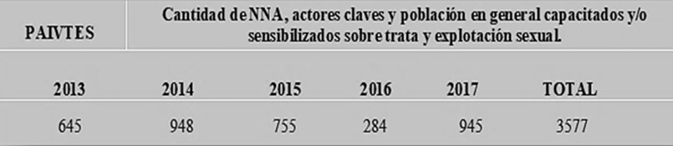

Issue 10 (c)

77. With the establishment, by Act No. 5115/13, of the new Ministry of Labour, Employment and Social Security, emphasis has been placed on strengthening the labour inspection system. On 21 December 2018, a standardized digital system for monitoring compliance with labour laws was put in place which helps expedite the work of labour inspectors.

78. Training has been provided on implementation of all ratified ILO Conventions, in particular the ILO Forced Labour Convention, 1930 (No 29), the ILO Abolition of Forced Labour Convention, 1957 (No. 105), and the ILO Worst Forms of Child Labour Convention, 1999 (No. 12).

79. In the context of ILO Conventions Nos. 29 and 105, the Ministry of Labour, Employment and Social Security coordinates the National Commission on the Protection of Fundamental Rights at Work and the Prevention of Forced Labour, a tripartite body for coordination of policies on prevention and eradication of forced labour. It main tools are the National Strategy on Prevention of Forced Labour 2016-2020, the Tripartite Inter-agency Guide to Intervention in Cases of Forced Labour and the Two-year Plan 2017-2019, which serves as its road map. Since its inception, the National Commission on the Protection of Fundamental Rights at Work and the Prevention of Forced Labour has been supported by ILO, and since 2018, by the Paraguay Okakuaa Project, which is funded by the United States Department of Labour.

80. The National Commission on the Prevention and Elimination of Child Labour and the Protection of Adolescent Workers developed the National Strategy for the Elimination of Child Labour and the Protection of Adolescent Workers 2019–2024, which was approved by the National Council for Children and Adolescents and officially launched on 29 April 2019, with the aim of focusing and coordinating public policies to prevent children and adolescents from being exposed to the worst forms of child labour.

81. With a view to eliminating the economic exploitation of children, the National Commission on the Prevention and Elimination of Child Labour and the Protection of Adolescent Workers proposed a bill that defines and punishes hazardous child labour and *criadazgo*. The bill was submitted to the legislature on 3 November 2016 (file No. S-161319) and is currently being discussed and reviewed by the Senate. As a result of the adoption by the legislature of Act No. 5407/15, on Domestic Work, no child may ever be engaged in domestic work (art. 5).

Issue 11

82. In line with the principle and the guarantees of equality and non-discrimination, Paraguay grants migrants who enter the country to reside temporarily or permanently the same rights and guarantees as nationals, including the right to decent work, social security, education, health, family reunification, sending or receipt of remittances and access to justice and due process.

83. These concepts are reflected in the migration policy, which incorporates the principle of respect for and recognition of labour rights that is due all workers, regardless of their migration status. Consequently, all inhabitants of Paraguay have the right to formal employment, decent wages and social security, regardless of their nationality or migration status, as well as to regularization of their status and opportunities for free technical and vocational training.

84. To facilitate access to formal employment, the Ministry of Labour, Employment and Social Security set up the ParaEmpleo Platform[[31]](#footnote-31) as a job placement service on which all job seekers may register and companies may list their vacancies. The Ministry conducts regular job fairs throughout the country to provide opportunities for employment; it also offers job placement through labour intermediation services in the various employment offices.

85. The National Career Development Service and the National Labour Training Service offer free, accessible technical-vocational training[[32]](#footnote-32) and job training,[[33]](#footnote-33) in an effort to provide immediate responses to market demand. Both entities make available to nationals and foreigners hundreds of training options in Asunción, as well as in the interior of the country.

86. The Integrated Strategy to Formalize Employment in Paraguay, which was adopted by Decree No. 818/2018 and expanded by Decree No. 1076/2018, is aimed at reducing levels of informality over a five-year period, setting six priorities to focus actions aimed at accomplishing the goal of formalization.

87. In the case of Paraguayan returnees, the National Labour Training System has offered courses on business plans with an emphasis on marketing and finance at the Secretariat for Paraguayan Returnees and Refugees. A total of 151 beneficiaries received certificates between February 2018 and April 2019.

88. Under the Constitution[[34]](#footnote-34) and the Labour Code,[[35]](#footnote-35) all workers who are in an employment relationship and are duly registered, as well as their beneficiaries, have access to social security. This means that migrant workers who contribute to the pension system, as well as their relatives, are not excluded from the benefits of the Social Welfare Institute.

89. As mentioned above, since 2012, the Directorate-General for Migration has conducted workshops on regularization of migratory status in key border locations, consular offices in Paraguay and institutions of higher education, to facilitate documentation of foreigners living, working and/or studying in Paraguay.

Issue 12

90. The legislature adopted Act No. 5777/16, on Comprehensive Protection of Women against All Forms of Violence, which is aimed at establishing prevention strategies, arrangements for care and measures for protection, punishment and redress in the public and private spheres. The Act provides for the adoption of protocols for care and investigation in crises and emergencies when differentiated care is needed.

91. The regulations to the Act (Decree No. 6973/17) ensure protection for all women in situations of violence, without discrimination of any kind on the basis of age, language, religion or beliefs, marital status, nationality, disability, health, physical appearance, economic status, cultural group membership, ethnic origin, sexual orientation, urban or rural origin or any other circumstance; this includes their children and dependants.

92. The Act also criminalizes various forms of violence, including sexual, physical and psychological violence, cyberbullying and economic, political, labour-related and media-based violence. It also covers the concept of femicide, which is punishable with imprisonment of 10 to 30 years. It lays down administrative sanctions for non-compliance and prohibits conciliation, mediation, arbitration or any other alternative means for settling cases of violence against women.

93. To implement the Act, the Ministry of Labour, Employment and Social Security adopted decision No. 388/2019, establishing the Office of Care and Prevention of Workplace Violence and outlining a procedure to be followed in cases of workplace violence (physical, psychological/mobbing, sexual). The Office, which provides operational responses, regardless of the nationality or migratory status of victims, is coordinated by the Directorate-General for the Advancement of Working Women and the Labour Directorate of the Ministry of Labour, Employment and Social Security. Since its launch in February 2019, the Office of Care and Prevention of Workplace Violence dealt with 133 cases in February, 210 in March and 129 in April.

94. The second National Plan to Combat Violence against Women 2015–2020 was adopted by Decree No. 5140/16, which also established the Inter-agency Board on Prevention of Violence against Women.[[36]](#footnote-36) The Board is comprised of 18 agencies in the three branches of government, as well as representatives of civil society organizations; it is coordinated by the Ministry for Women as the advisory body for implementation of Act No. 5777/16. The plan is to set up a national system of case records; this effort entails coordinating actions with key data-collection agencies and creating a monitoring and evaluation team.

95. By Decision No. 021/19, the Ministry for Women created the Observatory on Women’s Right to a Life Free from Violence,[[37]](#footnote-37) which monitors and conducts research on violence against women with a view to designing public policies on the prevention and elimination of such violence, pursuant to article 31 of Act No. 5777/16.

96. The Women’s Support Service provides comprehensive care, information and advice to women in situations of domestic, sexual, physical, economic and psychological violence through an interdisciplinary team specializing in socio-educational care and guidance. Services are provided on average to 1,500 women per year. In 2018, 1,896 women received assistance, and 3,917 services were provided in the different areas.

97. The Mercedes Sandoval Women’s Home provides a temporary shelter that ensures care and protection for women facing violence. It provides free accommodations, security, care and psychological support, legal advice, counselling and training, medical care, occupational therapy, educational support for children and a way to generate income. In 2018, it benefitted 145 persons (61 women and 84 children).

98. The regional women’s centres, which operate in Alto Paraná, Amambay, Canindeyú and Boquerón, offer social, psychological and legal services as a strategy for deconcentration of public policies on prevention, care and protection of women facing violence. In 2018, the centres assisted 2,589 women and provided 4,780 services in the different areas. In addition, training on Act No. 5777/16 was given to officials in the Complaints Office of the Public Prosecution Service and police officers.

99. In February 2018, the Ciudad Mujer Centre[[38]](#footnote-38) was inaugurated with the aim of providing access to quality public services with a comprehensive and caring approach and fostering the advancement, autonomy, personal growth and empowerment of women. The Centre brings together the services of 13 agencies and focuses on five areas of care, which are coordinated by State entities, according to their competencies:

* Sexual and reproductive health – Ministry of Public Health and Social Welfare
* Economic development – Ministry of Labour, Employment and Social Security
* Assistance for a violence-free life – Ministry for Women
* Childcare – Ministry of Education and Science
* Education for equity – Ministry of Education and Science

100. The General Secretariat of the Judiciary has an office in Ciudad Mujer that serves as a link to the judicial system. Since its opening, Ciudad Mujer has helped around 50,000 women who sought its services.

101. Ciudad Mujer Móvil, de la gente[[39]](#footnote-39) is implementing a strategy for reaching women in their own communities through a mobile system of services and inter-agency coordination, including legal advice, assistance and support for victims of violence, self-esteem workshops, empowerment, comprehensive health care, career development and productive enterprises. Since its launch in October 2018. it has provided 12,217 services to 4,530 women, in Central, Presidente Hayes, Itapúa, San Pedro, Canindeyú, Ñeembucú, Concepción and Guairá.

102. Since 2011, the General Secretariat of the Judiciary has operated the Gender Observatory, a virtual platform that provides a forum for discussion of and proposals for action in the area of administration of justice with a gender perspective, in accordance with the principle of equality of human rights. A 2017 agreement between the General Secretariat of the Judiciary and the German cooperation agency GIZ provides for strengthening the Observatory in line with advances in technology.

103. Through the Regional Programme to Combat Violence against Women in Latin America, diagnostic studies and training workshops were conducted for judges and officials in the judicial districts of Boquerón, Alto Paraná and Amambay. In 2018, meetings were held in the districts of Central and Capital, San Pedro, Paraguarí, Cordillera, Guairá and Itapúa, with the support of UN-Women. In 2019, the plan is to cover the districts of Misiones, Caazapá, Caaguazú, Concepción, Ñeembucú and Capital.

104. In 2018, the Education and Training Centre carried out courses on Act No. 5777/16 for public defenders. Between May and June of that year, two 8-day workshops were held with 48 and 46 staff members, in that order. In addition, a multi-jurisdiction course on Act No. 5777/16 was held for public defenders and officials of the Public Defence Service in Ciudad del Este, Presidente Franco, Santa Rita, Hernandarias, Minga Porá, Concepción, Horqueta, Yby Yaú, Vallemi, Pilar, Alberdi, Ayolas and General Díaz, Misiones, Caaguazú, Coronel Oviedo, Villarrica and Caazapá; a total of 146 participants attended this course.

105. The Ministry for Women and the General Secretariat of the Judiciary are in the process of drafting a bill on the establishment of courts and tribunals specializing in violence against women, staffed with specialists. These courts would be set up under a pilot plan that will eventually extend to the whole country.

106. The Public Prosecution Service’s General Instruction No. 9/11 provides for immediate assistance to women victims of violence. A deadline of 24 hours is set for processing cases involving investigations into acts of domestic and gender-based violence.

107. As a result of the joint efforts of civil society organizations, the Public Prosecution Service and the Ministry of Public Health and Social Welfare, a handbook entitled *Manual de Atención Integral a Víctimas de Violencia Intrafamiliar y de Género en el Sistema de Salud* (Comprehensive Assistance to Victims of Domestic and Gender-based Violence in the Health System) was issued, in order to establish appropriate uniform procedures for comprehensive assistance to victims and facilitate the gathering of evidence and punishment of those responsible.

108. The Office of Gender Affairs of the Public Prosecution Service was established with the aim of improving access to justice for women by providing guidance on cases of violence and support for victims in the process. To that end, it works in tandem with prosecutors and promotes information campaigns and sensitization workshops.

109. The Council of Judges announced a public competitive process for the appointment of specialized defenders in the context of Act No. 5777/16 (2018) in the departments of Guairá, Itapúa, Concepción, Amambay, Alto Paraná, Caaguazú, Ñeembucú, Misiones, Paraguarí, Caazapá, San Pedro, Cordillera, Presidente Hayes, Canindeyú, Central and Capital. To operate these offices, the Public Defence Service selected, in a competitive process, 16 individuals who took up their duties as assistant defenders in several locations in July 2018.

110. With regard to measures to ensure that women migrant workers, especially those employed in domestic service, have access to effective complaint mechanisms, the legislature ratified Act No. 4819/12, ILO Convention No. 189 and Recommendation No. 201. On 13 October 2015, the legislature adopted Act No. 5407/15, on Domestic Labour, the regulations to which were adopted on 22 April 2016 by Decision No. 233/16 of the Ministry of Labour, Employment and Social Security, within the framework of the Tripartite Commission on Equal Opportunity.

111. This legal framework envisages changes aimed at equating rights and advancing towards decent working conditions, such as contracts for domestic work, wages, overtime pay, bonuses, length of work day, rest periods, holidays, leave, job stability, compensation for unfair dismissal, quitting for cause and social security. Pursuant to Act No. 6338 of 1 July 2019, the legislature amended article 10 of Act No. 5407/15 by equating domestic workers’ wages to the statutory minimum wage in force.

112. The Office of Labour Affairs of the Directorate-General for the Advancement of Working Women provides differentiated advisory services to workers and employers in the domestic sector. It receives complaints on non-compliance with labour regulations, conducts mediation, offers free legal aid and responds to queries on security records and liquidation of assets, among other services. The Service Centre for Domestic Workers in the Ministry of Labour, Employment and Social Security provides guidance to workers and employers and facilitates alternative dispute resolution procedures in the workplace.

113. Of the 2,977 women who received assistance from the Office between August and December 2018, 2,216 were domestic workers dealing with dismissal, changes in working conditions, harassment in the workplace, quitting for cause, maternity and breastfeeding leave, resignation, collection of maternity subsidies, as well as questions about labour regulations concerning women at work.

114. Strategic inter-agency partnerships for disseminating and promoting the labour rights of domestic workers were established with the Ministry for Women, the Inter-Agency Group on Care Policies, UN-Women, the United Nations Development Programme (UNDP), the United Nations Population Fund (UNFPA), ILO and South-South Cooperation. At the twelfth meeting of Ministers and High-level Authorities on Women’s Affairs, the Ministry for Women presented an informational brochure on social security for domestic workers in the Southern Common Market (MERCOSUR).

115. The Strategic Plan 2016–2020 of the judiciary provides for activities to comply with the 100 Brasilia Regulations on access to justice for persons in situations of vulnerability, with special emphasis on rule 6, regarding migrants and displaced persons. The Brasilia Regulations were ratified by Supreme Court Decision No. 633/10.

116. The Public Defence Service has 19 public defenders assigned to labour and administrative matters, including five who focus on responding to queries, receiving complaints and conciliation in labour matters. None of the 36 open cases related to domestic work involve migrant workers in an irregular situation or domestic servitude.

117. Information on proceedings involving exploitation and human trafficking is included in the reply to issue 33 (a).

Issue 13

118. Although the Ministry for Children and Adolescents does not carry out actions specifically targeting unaccompanied or separated migrant children and adolescents, the National System for the Comprehensive Protection and Advancement of Children and Adolescents is triggered, as required by ratified international instruments and domestic law in cases of children and adolescents in situations of vulnerability or child labour, regardless of their migratory status. The System is made up of agencies such as the National Police, the Advisory Service on the Rights of Children and Adolescents, the Public Defence Service, the judiciary, the Public Prosecution Service, the Ministry of Public Health and Social Welfare, the Ministry for Women, the Ministry of Education and Science and others that implement protection procedures.

119. On 5 August 2019, the Directorate-General for Migration and the Ministry for Children and Adolescents signed a cooperation agreement on protection of unaccompanied or separated migrant children and adolescents; the agreement provides for training of officials at checkpoints and collaborating with international returns in accordance with the principle of comprehensive protection and the best interests of children and adolescents which is enshrined in the domestic legislation and migration policy.

120. The National Strategy on the Eradication of Child Labour and Protection of Working Adolescents 2019–2024 seeks to eradicate and prevent child labour and protect adolescent workers through effective monitoring, income generation for parents or carers of children in the worst forms of child labour, and access to and continuation in the education system.

121. The National Commission on the Prevention and Elimination of Child Labour and the Protection of Adolescent Workers adopted the Protocol on *Criadazgo*, which updates the Guide to Inter-agency Intervention for Workers under 18. The Ministry of Labour, Employment and Social Security conducted training on the Protocol with other agencies in the National System for the Comprehensive Protection and Advancement of Children and Adolescents for over 1,200 participants in Alto Paraná, Itapúa, Concepción, Guairá, Boquerón and San Pedro.

122. A team set up by the Ministry of Education and Science, the Ministry for Children and Adolescents and the Ministry of Labour, Employment and Social Security developed a workshop series with the slogan “No to child labour, No to *criadazgo*, Respect my rights”, which reached a total of 335 participants in Caazapá, Coronel Oviedo, Ciudad del Este, Filadelfia, Pilar and Concepción. The workshops were designed to raise awareness among key players and encourage them to make a commitment to play a leading role in the defence and protection of children and adolescents in regard to child labour, trafficking for purposes of labour exploitation, *criadazgo* and routes of intervention.

123. During the second stage, workshops were held, with a total of 487 participants, in the cities of Ñemby, Ypané, San Antonio, Villa Elisa, Fernando de la Mora, San Lorenzo, Luque, Mariano Roque Alonso, Itá, José Augusto Saldívar, Guarambaré, Nueva Italia, Itauguá, Capiatá and Ypacaraí. Awareness-raising campaigns were also conducted for family farmers on the worst forms of child labour, including *criadazgo* and unpaid domestic child labour, bearing in mind the characteristics and needs of each region.

124. The Directorate-General for the Protection of Children and Adolescents of the Ministry of Labour, Employment and Social Security conducted information campaigns through print media on the 26 worst forms of child labour in Paraguay. The most recent publication, issued on 11 June 2019 to coincide with the World Day against Child Labour, spelled out the requirements for protected adolescent labour. Also in observance of World Day against Child Labour, a seminar-workshop was organized by the Supreme Court of Justice, with support from the Ministry of Labour, Employment and Social Security, to present the bill on criminalization of *criadazgo*.

125. To reduce child labour, the Paraguay Okakuaa project, which is funded by the United States Department of Labor, has been implemented since 2015. The aim is to improve the enforcement of labour laws and working conditions, with emphasis on preventing and combating child labour in Guairá and preventing forced labour in the Chaco region.

126. Paraguay Okakuaa is coordinated by Partners of the Americas and the Ministry of Labour, Employment and Social Security, in cooperation with the Ministry of Education and Science, the Ministry for Children and Adolescents, the Ministry of Social Development, PETROPAR, municipal governments and executing agencies (Fundación CIRD and Fundación ALDA). The project takes a coordinated and comprehensive approach in four areas, the first three[[40]](#footnote-40) in the five districts of Guairá and the fourth[[41]](#footnote-41) in Boquerón.

127. The protected labour training programme of the National Career Development Service, which was relaunched by Decision No. 1609/19 of the Ministry of Labour, Employment and Social Security seeks to provide a comprehensive response to growing adolescents. Some 2,000 young people between the ages of 15 and 17 benefited under the programme from services and programmes carried out by institutions such as the National Secretariat to Combat Drugs, the National Secretariat for Culture, the National Secretariat for Sports and the Ministry of Public Health and Social Welfare.

128. Under the National Plan and the National Strategy for the Prevention and Eradication of Child Labour and the Protection of Adolescent Workers, the Ministry for Children and Adolescents is implementing the Abrazo Programme, which is part of the Vamos National System of Social Protection. Immediate protection is provided to children and adolescents aged 0 to 17 years who are engaged in hazardous child labour and/or at risk of child labour, through the following components:

* Targeting: the process of identification and inclusion in the programme, through a social worker
* Family support: access to public services through a plan that grants TMC cards (debit/savings cards), scholarships, a basic food basket, social micro-insurance and financial inclusion
* Protection centres: alternatives to child labour, in three modalities (early childhood centres, open centres and community centres), which provide food, sports and recreation, and tutoring
* Networks: protective services linked to departmental and municipal councils for children and adolescents

129. In the framework of the National Financial Inclusion Strategy, the Abrazo Kyrey project provides education and financial inclusion for vulnerable families through training for formal employment, entrepreneurship training, investment, savings and loans.

# Table 2

**Evolution of the Abrazo Programme**

**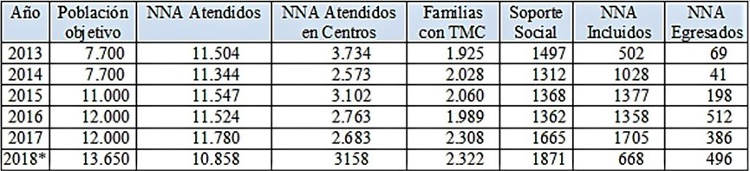**

\* First six months.

130. The Ministry for Children and Adolescents works on prevention and elimination of child labour among indigenous children and adolescents, through field work with an emphasis on comprehensive and intercultural care and improvement of the quality of family and community life, as well as on restoration, protection and promotion of rights in community centres.

131. In 2018, meetings were held on the drafting of a manual on child labour for trial judges who deal with criminal, labour and juvenile matters. From March to April 2019, informational material was issued, for justices of the peace, on access to justice at the community level in cases involving child labour, especially in its worst forms, including hazardous work, and with a focus on indigenous peoples.

Issue 14

132. Pursuant to article 56 of Act No. 1337/99, on National Defence and Internal Security, as amended by Act No. 5036/13, Decree No. 103/13 was issued to provide for the use of combat troops of the armed forces for domestic defence operations in the departments of Concepción, San Pedro and Amambay.

133. Under this provision, the Army, the Air Force and the Navy have been working in unison with the National Police, the National Anti-drug Secretariat and the Public Prosecution Service to strengthen citizen security and deal with criminal groups that undermine State institutions, endangering the lives, physical integrity and fundamental freedoms of the people who live in the geographical area referred to in the above-mentioned decree.

134. The Joint Task Force is fulfilling its duties to provide domestic defence and citizen security for the benefit of all inhabitants of the area, without distinction, safeguarding the rights of nationals and aliens, through its staff of approximately 900 members in active service who receive ongoing training. Through its office, the Joint Task Force is able to deal appropriately with complaints, to maintain statistical records of the most common situations, seek solutions and prevent future occurrences.

135. The Directorate of Civil Affairs and the Directorate of Social Communication coordinate their services with other State agencies so as to reach remote high-risk places. They provide medical care, arrange for evacuations, build and repair roads and dwellings, drill for wells, prepare soil for crops and give talks at educational institutions.

136. An updated list of investigations into cases of abductions and killings in the area of activity of the Joint Task Force, prepared by the Public Prosecution Service, is attached.[[42]](#footnote-42)

Issue 15

137. While national authorities have maintained a good relationship with their Brazilian peers in terms of cooperation and exchange of information, it should be noted that the conflicts that occurred in Ñacunday had more to do with differences relating to land tenure and ownership than with migration issues. These issues were addressed and resolved in a timely manner through the National Institute of Rural Development and Land Management.

138. On 13 May 2019, the Ministry of Labour, Employment and Social Security opened the Regional Employment Office in Ciudad del Este, Alto Paraná, which provides services specific to the Ministry, such as job placement, job fairs, employment exchanges and career development and job training for everyone without discrimination.

Issue 16

139. It is not possible, with the most recent information available from the 2014 Continuous Household Survey conducted by the Directorate-General for Statistics, Surveys and Censuses, to fully identify the children of Paraguayan migrant workers who have remained in the country. In such cases, the households take on a different composition, and kinship relations are reconfigured under a new head of household. The inclusion of data-collection parameters for efficiently measuring aspects mentioned in this issue is a challenge that will have to be addressed in future data-collection processes.

140. In this regard, the Directorate-General for Statistics, Surveys and Censuses, with the support of the Latin American and Caribbean Demographic Centre (CELADE), has been carrying out the project on collection and use of data on international migration in the context of the 2030 Agenda for Sustainable Development and the New York Declaration for Refugees and Migrants. The idea is to improve the availability of data related to international migration, in line with the new demands for information and the need for follow-up on different public policies and international commitments.

Issue 17

141. According to article 3 of the immigration legislation currently in force, the same procedural rights granted by article 17 of the Constitution to Paraguayan citizens are also guaranteed by the Directorate-General for Migration and the judicial authorities for aliens, including migrant workers and family members.

142. Upon entry into the country, migration issues are not grounds for detention per se, but rather for delay, pending an administrative decision taken on the premises of the Directorate-General for Migration. Depending on the situation, the authorities may tell the individual in question to regularize his or her migratory status or order him or her to leave the country within a reasonable period of time, under caution of expulsion.

143. When on grounds envisaged in the law, the competent authorities (judicial authorities in the case of permanent residents and migration authorities in the case of temporary residents and non-residents) cancel an alien’s residence permit, the alien must be ordered to leave the national territory within the reasonable period of time established for his or her case, under caution of being expelled by a court order. If allowable under the circumstances and provided that the grounds for cancellation of residency no longer exist, the competent authority may order the individual in question to regularize his or her migratory status within a reasonable period of time.

144. Detention is in fact an exceptional measure of last resort which is applicable only when expulsion is justified under the law, unless there are grounds of public order and the person has already been ordered to regularize his or her migratory status or leave the country within a reasonable period of time. In any event, detention must be ordered by a judicial authority for the minimum time necessary to ensure that the individual concerned will leave the country within the time established.

Issue 17 (a), (c) and (d)

145. It should be noted in this regard that there is a difference between cases and circumstances in which there are grounds for detention and cases of administrative delay. Bearing in mind that detention is applicable only in cases that warrant expulsion, there are no reported instances of aliens having been expelled after having been detained for being in the country in an irregular situation. Removal is a provision of last resort that is implemented by a judicial or administrative authority against foreign citizens who have breached criminal standards.

146. However, since the Convention is an integral part of the domestic legislation, article 17 therein is taken into account in all migration proceedings involving situations of delay and detention of migrants, particularly women, children and families, especially if expulsion is a possibility.

Issue 17 (b) and (f)

147. Comprehensive protection and the best interests of the child are the guiding principles of migration policy, as required by the Constitution and the domestic legislation. In all decisions by migration authorities that involve children and adolescents, directly or indirectly, the best interests of the children always prevail.

148. The Directorate-General for Migration and the Ministry for Children and Adolescents have established a cooperation arrangement in regard to protection of migrant unaccompanied or separated children so as to train officials at checkpoints and collaborate, where necessary, with international returns. They are also working on drafting appropriate regulations for dealing with the issue of unaccompanied children, in accordance with international requirements.

149. The Directorate-General for Internal Audits of the Ministry for Children and Adolescents are responsible for coordinating international cooperation for the return or reintegration of children and adolescents, working with a multidisciplinary team (lawyers, psychologists and social workers) that monitors administrative and judicial cases and carries out a socioenvironmental assessment of the children involved. The Ministry for Children and Adolescents provides psychological support in coordination with other agencies, such as the Ministry of Foreign Affairs, the Secretariat for Paraguayan Returnees and Refugees and the Directorate-General for Migration.

150. Working sessions have been held with INTERPOL Paraguay with a view to implementing a pilot plan and assisting in the search for and location of children and adolescents or members of their families, in the context of requests for return or international cooperation. Work has also begun on developing a protocol for action to improve implementation of the Hague Convention on the Civil Aspects of International Child Abduction.

151. Children and adolescents in vulnerable situations, orphans and unaccompanied children abroad are assisted by the consular offices in the locations where they are found. Assistance efforts are coordinated with the authorities responsible for protection in the country in question, the Secretariat for Paraguayan Returnees and Refugees, the Ministry for Children and Adolescents and the Directorate-General for Migration. Requests for assistance are received in consular offices or transmitted by the Directorate for Paraguayan Communities Abroad at the request of family members. The Directorate-General for Internal Audits coordinates the search for relatives or carries out socioenvironmental studies, which are then submitted to the requesting authority in order to determine what is in the best interests of the children and adolescents, with a view to achieving family reunification.

152. The Secretariat for Paraguayan Returnees and Refugees provides a repatriation subsidy to cover return costs for Paraguayan nationals and their children in situations of vulnerability and for the international return of children, pursuant to article 13 of the Inter-American Convention on the International Return of Children, which directs the requesting State to defray the costs if the claimant lacks the means.

Issue 17 (e)

153. Information on the identification of victims of trafficking is provided in the reply to issue 33 (a).

154. For more information on the protection of victims of trafficking, including witness protection, please refer to the reply to issue 33 (b).

Article 16

Issue 18

155. Pursuant to the Vienna Convention on Consular Relations (Act No. 91/69), in Paraguay foreigners deprived of liberty, including migrant workers and members of their families, are entitled to have full access, should the case arise, to the consular authorities of their State of origin (art. 36 (1) (b)).

156. The Vienna Convention also provides that consular officers shall have the right to visit a national of the sending State who is in prison, custody or detention, to converse and correspond with him and to arrange for his legal representation (art. 36 (1) (c)). These provisions are fully implemented by the migration authorities, the police, prosecutors or judicial officials involved in proceedings that affect a foreign citizen.

157. For investigations of cases of aliens in irregular migratory status, the Migration Security Operations Unit of the Directorate-General for Migration follows a procedure that allows for the possibility of requesting reports or assistance from other agencies such as the National Police, the National Anti-Drug Secretariat, INTERPOL, the Secretariat for the Prevention and Investigation of Terrorism, the Secretariat for the Prevention of Money Laundering, diplomatic or consular missions, among others; conducting on-site inspections and verification; and convening hearings and interviews with those affected, all within the framework of summary proceedings. A formal record must be kept of all such proceedings.

158. If a person’s migratory status is found to be irregular, the Migration Security Operations Unit must order offenders to initiate regularization procedures within a time frame to be determined by the circumstances of the case, under caution that in the event of non-compliance, the individual(s) concerned must leave the country by their own means or through expulsion proceedings.

159. Under this procedure, the Migration Security Operations Unit and other agencies involved act in strict compliance with the procedural guarantees established in the Constitution and the statutes and in the Vienna Convention on Consular Relations, given that the process is carried out in communication with the embassy and/or consulate of the country of origin of the person concerned. Likewise, the authorities involved keep the foreign national fully informed of his or her rights and guarantees throughout the process.

Article 23

Issue 19 (a)

160. Consular offices have areas that provide specialized assistance for Paraguayan nationals in connection with social aspects, legal matters, migration issues and documentation. These services primarily target those working abroad, who constitute a significant share of the migrant population, since the desire for economic advancement is the main reason why they choose to take up residence abroad.

Issue 19 (b)

161. In the framework of programmes of assistance and protection of due process rights and guarantees for migrant workers and their families, the diplomatic and consular missions have departments in charge of ensuring the rights of Paraguayan nationals deprived of their liberty. These offices are responsible for visiting and interviewing the individuals concerned in order to understand and address their needs and verify their legal status and health.

162. The Directorate for Paraguayan Communities Abroad facilitates family unification and coordinates actions with national agencies and diplomatic and consular offices to protect the human rights of Paraguayan nationals deprived of their liberty and ensure their due process guarantees. The Directorate monitors the person’s legal status and health, provides legal aid, facilitates family contacts and transmits documents for their defence.

163. In addition to visiting Paraguayan nationals deprived of their liberty, in accordance with the Vienna Convention on Consular Relations, consular offices keep a log on the persons in question, advocate for compliance with fundamental legal safeguards, such as the right to maintain contact with the consulate, to physical and psychological integrity, to counsel and to invoke the benefits of agreements on the transfer of sentenced persons.

164. Consular officers inform the Paraguayan nationals concerned of the scope of the Vienna Convention on Consular Relations, the Convention on the Transfer of Sentenced Persons with the receiving State, should that be applicable and if not, the Inter-American Convention on Serving Criminal Sentences Abroad, in the framework of the Organization of American States (OAS), and their subsequent right to request a transfer to Paraguay to complete their sentence. Consular offices transmit to the Directorate for Paraguayan Communities Abroad an updated list of persons requesting transfer in this connection.

165. Honorary consulates in locations far from the consular offices collaborate by visiting or providing consular assistance to Paraguayan nationals who have been detained, tried or convicted.

166. In addition to seeking the assistance of public defenders, consular districts with the highest concentration of Paraguayan nationals have one or more lawyers hired by the consulate to give advice to detainees or prisoners and follow up on their cases. They have a list of reputable law firms that is made available to Paraguayan citizens who do not request the assistance of public defenders.

167. During the course of assistance and verification sessions, visits are made to prisons and detention facilities to renew identity documents (identity cards or temporary passports). In addition, campaigns are being carried out to provide comprehensive assistance to migrants, in coordination with the National Police and the Directorate-General of the Civil Registry, to issue identity cards, register citizens and issue birth certificates to Paraguayan migrants.

168. In States in which Paraguay does not have a consular office, assistance is provided through consular offices of third countries in the context of existing consular cooperation mechanisms in MERCOSUR. Thus, assistance has been provided to Paraguayan nationals in Hong Kong, Shanghai and Beijing through consular offices of other countries, such as Argentina and Chile.

169. The Secretariat for Paraguayan Returnees and Refugees provides assistance and advice in connection with the issuance of repatriation certificates to Paraguayans who are in the process of return and reintegration, in order to arrange for the exemptions envisaged by law, such as the exemption from residence fees and the allowance for duty-free import of household goods and work tools.

Issue 19 (c)

170. Most statistics on assistance to Paraguayan nationals in a situation of vulnerability abroad show that specialized training of consular staff is ongoing, both at the Ministry of Foreign Affairs and in the host country. Regular briefings are held to provide up-to-date information in centrally located capitals of certain regions, such as the European Union (in Madrid) or northern America (in a Central American country).

171. The Directorate-General of Consular Affairs and the diplomatic and consular offices work with national institutions and authorities of host countries with the aim of extending assistance to Paraguayan nationals at all levels. Regular training is offered for consular officials, new consulates are opened, and mobile units are set up to reach citizens who are unable to go to a consulate in cases of extreme vulnerability and emergencies relating to documentation and/or social assistance.

172. The consulates regularly make use of existing consular cooperation mechanisms in MERCOSUR to assist nationals in places where Paraguay does not have a diplomatic or consular representative, in emergencies or high-risk situations, especially when they involve children and adolescents, accompanied or otherwise, and victims of domestic violence or trafficking, a state of destitution, deprivation of liberty, repatriation or natural disasters.

Issue 19 (d)

173. Fluency in the Guaraní language is indeed a prerequisite for the performance of consular duties, given that Paraguay is a bilingual country, and most migrants come from cities in the interior of the country where Guaraní is the main language. Given the widespread use of that language, the staff of the Ministry of Labour, Employment and Social Security provides assistance in Guaraní to migrant workers who request it.

174. In May 2016, the Secretariat for Language Policy began the process of normalizing the use of Guaraní as a co-official language, along with Spanish, in State assistance services, in compliance with the Languages Act. Likewise, from June to August 2019, the National Civil Service Institute, working with the Secretariat for Language Policy, offered a course on Guaraní for communication in the Civil Service.

Articles 25–30

Issue 20

175. Labour standards in Paraguay are in line with all the universal principles of labour law and provide the same guarantees to all workers simply by establishing the existence of an employment relationship, regardless of a person’s qualifications. Judicial authorities, court officials and State administrative bodies observe these guarantees and principles in all their actions.

176. Workers in the Republic have access to legal and labour protection mechanisms, job programmes and career development and job training. They are entitled to the same pay and working conditions as Paraguayan workers, regardless of their migration status.

177. The Ministry of Labour, Employment and Social Security receives complaints and provides guidance to all workers (and employers) who approach the administrative offices. Women, whether citizens or aliens, receive equal treatment; this right is guaranteed by the Directorate-General for the Advancement of Working Women and the Office of Labour Affairs. Through the module on the economic advancement of women, which is coordinated by the Ministry of Labour, Employment and Social Security, Ciudad Mujer and Ciudad Mujer Móvil, de la gente carry out strategies to empower women and develop their job skills and productive enterprises.

178. Article 229 of the Labour Code stipulates that wages must not create inequality on grounds of sex, physical impairment, nationality, religion, social status or political or trade union preference. A significant step forward in this area was made with the adoption by the legislature of Act No. 6338/19, of July 2019, which equates the wages of domestic workers to the existing minimum wage.

179. The guarantees provided in the Constitution and the Labour Code in terms of working conditions are applicable to nationals and foreigners alike. Article 47 (e) of the Labour Code stipulates that any condition establishing lower wages, on grounds of age, sex or nationality, than the wages paid to other workers in the same company for equal work in terms of efficiency, class or working hours are non-binding.

180. All workers, whether national or foreign, are protected against unfair dismissal, and in such cases, they are entitled to the compensation envisaged in article 91 of the Labour Code, regardless of whether or not they received advance notice (pursuant to article 87 of the Labour Code).

181. Regarding access to employment, the Directorate-General for Employment of the Ministry of Labour, Employment and Social Security provides vocational orientation, job placement and training opportunities through the National Career Development Service and the National Labour Training System. The Directorate-General for Employment regularly carries out job fairs in several locations in the country.

182. The ParaEmpleo job search platform, launched in 2018 with financing from the Inter-American Development Bank, is available to everyone, regardless of migration status. It brings together people, businesses, jobs and projects that complement each other according to the needs of the labour market, taking into account skills, competencies and experience.

183. The Centre for Strategic Studies was established to promote and encourage entrepreneurship. It provides training, formalization and connections with financing entities for persons interested in starting a business. The Directorate-General for Employment of the Ministry of Labour, Employment and Social Security and the Secretariat for Paraguayan Returnees and Refugees have organized job fairs to enhance the employability of spouses and children born abroad who currently reside in Paraguay.

184. Under an agreement between the Ministry of Labour, Employment and Social Security, the National Labour Training System and two entities, vocational training was given to Paraguayan nationals in Spain, for a total of 41 beneficiaries in the first cycle, 57 in the second and 37 in the third.

185. The Days for Comprehensive Assistance to Migrants help bring Paraguayan communities together, as do regular consular services; talks on labour rights, with support from the Ministry of Labour, Employment and Social Security; on women’s rights, with specialists from the Ministry for Women, and training on micro-enterprises, through the Ministry of Industry and Trade.

Issue 21

186. Information on guarantees and safeguards for access to a justice mechanism to denounce trafficking, exploitation or persecution is provided in the response to issue 33 (b) (access to justice and legal remedies).

187. In any judicial proceedings involving aliens, including legal action brought by migrant workers against employers or perpetrators, the court or the prosecutor asks the Directorate-General for Migration for information regarding status and migratory movements. If irregularities are found, as a safeguard, the Directorate-General informs the alien of the situation, reports it to the person’s diplomatic or consular authorities, and orders him or her, within a specified time frame depending on the circumstances of the case, to proceed to regularize his or her situation, under caution of being required to leave the national territory, except in the case of victims of trafficking.

188. To date, there have been no cases of foreign complainants having been expelled because of their irregular status, since expulsion is an extreme measure applied by the judicial or administrative authorities primarily in cases of violation of criminal laws, and such expulsion orders are preceded by opportunities for the person concerned to regularize his or her migratory status.

Issue 22

189. Migrant workers have access to contributory and social security systems through the Social Welfare Institute, even with an identity document from their country of origin, in order to ensure that they will be covered from the outset. They may opt on an equal footing with citizens for either the ordinary social security system for workers in an employment relationship or the special system for self-employed workers.

190. The Directorate-General of Social Security of the Ministry of Labour, Employment and Social Security allows migrant workers to participate in contributory social security schemes in two ways: as nationals, by complying with established local procedures; or through international agreements that enable migrant workers to continue contributing to social security in Paraguay until they retire.

191. At present, the following arrangements are in force: the Multilateral Social Security Agreement among MERCOSUR countries (Act No. 2513/04), which benefits workers who have contributed to social security systems in Paraguay, Brazil, Argentina and Uruguay; the Ibero-American Multilateral Social Security Convention (Act No. 4223/10), which benefits workers from Paraguay, Spain, Bolivia, Brazil, Chile, Ecuador, Uruguay and El Salvador; and bilateral agreements with Spain, Chile and the Netherlands.

Issue 23

192. Article 68 of the Constitution recognizes the right to health care for the entire population, while article 69 calls for the establishment of a compulsory national health system which must provide services with no discrimination whatsoever, based on principles of equity, quality, efficiency and social participation. This is reflected in the migration policy, under which immigrants and their families have the same constitutional and legal rights and guarantees as nationals, including the right to health.

193. The Ministry of Public Health and Social Welfare has promoted the creation and implementation of integrated comprehensive networks of primary health-care services which incorporate strategic lines of action involving the establishment of family health units staffed by multidisciplinary teams working in the communities, with a focus on rights, efficiency and equity in a social context of respect for multiculturalism and promotion of integrated policies to improve the determinants and constraints that affect quality of life and health, in coordination with other government agencies.

194. The fundamental objective of the National Health Policy 2015–2030, adopted by Decree No. 4541/2015, is to move towards universal access to health care and to achieve comprehensive coverage at the highest possible level, so as to reduce inequities and improve the quality of life of the population, in the framework of sustainable human development.

195. The strategic institutional plan of the Ministry of Public Health and Social Welfare is based on the right to health as a fundamental human right, including the rights to universal health care without discrimination and with equality and integrity, to well-being and to participation.

Issue 24

196. Registration of Paraguayans abroad is done through the consulates, which act as Civil Registry offices outside the country, allowing for the option of Paraguayan nationality for children born abroad. These records are transmitted to the Directorate-General of the Civil Registry through the Directorate-General of Consular Affairs of the Ministry of Foreign Affairs.

197. Mobile consular offices organize special days in areas with a high concentration of Paraguayans to renew and issue documents required to regularize their migratory status, carry out censuses and draw up voter lists, support the organization of Paraguayan communities and facilitate the exercise of the right to vote.

198. Consular offices conduct campaigns to provide comprehensive assistance to migrants, in coordination with the National Police and the Directorate-General of the Civil Registry, to issue identity cards, register citizens and issue birth certificates. The most recent campaign was carried out in 2017 in New York, Washington, New Jersey and Spain, and others are planned for this year.

199. In the case of Paraguayan children born abroad, the consular offices, as an exception and subject to parental agreement, issue a provisional passport, at which time the minor is registered in the records, and the following inscription is written in the passport: “Juvenile with the right to receive natural Paraguayan nationality pursuant to article 146 of the Constitution.”

200. The Secretariat for Paraguayan Returnees and Refugees offers free legal services to initiate proceedings on choice of nationality for Paraguayan children born abroad who are at risk of being stateless or who choose to return to the country to stay.

201. With regard to foreign migrant workers and members of their families who do not have identity documents in Paraguay, the special days organized by the Directorate-General for Migration for regularizing migratory status help bring to light such situations and activate the procedures described above for regularizing the documentation and migratory status of the person concerned through communication with the diplomatic and consular missions of their State of origin.

Issue 25

202. The Constitution guarantees access to all levels and modalities of education for everyone (art. 73), with emphasis on equal opportunities for access to the benefits of the humanities, science and technology, without discrimination (art. 74). The right to education is inherent to all inhabitants of the Republic, irrespective of their nationality and immigration status, in line with article 46 of the Constitution, which establishes the principles of equality and non-discrimination.

203. For the benefit of migrants, a system was developed to determine equivalencies in basic and secondary education. To regularize academic status, applicants must submit academic records or some other document to justify the level attained in the country of origin, a copy of identity documents, birth certificate and a document authorizing entry into the country or Paraguayan identity document. In the absence of academic documentation, a placement exam is administered for continuing education in the country.

204. There is no formal obligation to report on the residence status of children to the immigration authorities; however, the migration policy grants immigrants the same rights and guarantees as Paraguayan nationals, including the right to an education, and bearing in mind the documentation requirements for enrolment in educational institutions, immigration regularization services for foreigners are made available to families.

205. On this basis, the Single Register of Students does not include information on migrant workers’ children who are enrolled in the different levels of education; however, the State intends to address the challenge of generating data on enrolment rates of migrant children for statistical purposes, in accordance with its policy of openness to migration.

Issue 26

206. The migration policy proposes that there should be collaboration between immigration authorities and banks, in order to facilitate and reduce the cost of sending and receiving remittances and to offer savings and loan programmes and productive investments. The matter of how best to implement such initiatives is currently under consideration.

207. It is envisaged that associations of Paraguayans abroad could put in place the best mechanisms for channelling remittances and offering advice on their use, with a view to the funds becoming a means to support their possible return. The challenge is to develop strategies to enable national agencies such as the Directorate-General for Migration, the Secretariat for Paraguayan Returnees and Refugees, the Central Bank of Paraguay, the Ministry of Industry and Trade and the National Institute of Cooperatives to work in coordination with banks and financial institutions, national production cooperatives and credit unions.

208. The Central Bank of Paraguay prepares regular economic reports[[43]](#footnote-43) which include a statistical annex that contains inter alia data on the amounts and origins of remittances as a category of foreign exchange inflows.

4. Part IV of the Convention

Article 41

Issue 27

209. Since the amendment in 2011 of article 120 of the Constitution, Paraguayan nationals residing abroad are now eligible to vote in national elections for president, vice-president, senators and members of the MERCOSUR Parliament. Paraguayans may register and vote with either their identity card or their passport.

210. Under Act No. 5583/16, Paraguayans residing abroad may use communication technologies to register in the Permanent Civil Registry. The regulations to this Act were issued by Decision No. TSJE 138/2016, which provides that citizens may register on a website of the Supreme Electoral Tribunal, through an electronic system that is safe and easy to access and which allows for verification of the citizen’s identity.

211. Mobile consular offices are responsible, among other things, for renewing and issuing documents to regularize residence, conducting censuses and drawing up voter lists, supporting the organization of Paraguayan communities and facilitating the exercise of the right to vote.

212. For the 2018 general elections, the Supreme Electoral Tribunal set up polling stations in several cities in Argentina, the United States, Spain and Brazil. Coverage will be increased as budgetary allocations are made available.

# Table 3

**Participation of Paraguayans abroad – 2018 General Elections**

**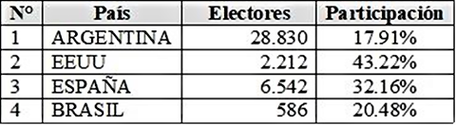**

5. Part VI of the Convention

Article 64

Issue 28

213. The principles of reciprocity and consistency that govern the migration policy lay the foundation for generating strategies to promote sound, equitable and humane conditions for international migration within the framework of standards for the protection of human rights (*Política Migratoria*, 2015, pp. 25, 26).

214. The migration policy is implemented in the context of Paraguay’s strong involvement in the international context, as it participates in bilateral, regional and international discussions aimed at reaching agreement on policies and rules to benefit migrants and furthering the development of both sending and receiving countries.

215. In keeping with those principles, and even before the entry into force of the migration policy, Paraguay has concluded bilateral and multilateral agreements aimed at achieving better conditions for migration through cooperation with other States, as shown in the attached list.[[44]](#footnote-44)

216. Information on the outcome of implementation of the Agreement on the Regularization of Internal Migration of Citizens of MERCOSUR States Parties, the Plurinational State of Bolivia and Chile are provided in the reply to issue 35.

217. With regard to the involvement of civil society organizations in recalibrating migration policies and programmes, the migration policy was adopted in 2015 with the broad participation of public agencies and a wide diversity of civil society organizations both of foreigners residing in Paraguay and of Paraguayans living abroad. The migration bill was drafted and submitted to a public hearing in which a significant number of citizens participated; it is currently under review by the Chamber of Deputies. Given that both the migration policy and the migration bill were drafted in a participatory process, it follows that any revision of either instrument will necessarily involve the participation of the same sectors.

Article 67

Issue 29

218. The Identification Department of the National Police is the division charged with issuing regular passports[[45]](#footnote-45) through its offices throughout the country. Passports follow the model agreed on for MERCOSUR countries (Decision No. GMC 40/98), based on the recommendations of the International Civil Aviation Organization (ICAO).

219. Decree No. 11345/13 allows for the Directorate of Passports and Consular Services of the Ministry of Foreign Affairs to authorize diplomatic and consular missions to issue consular passports to Paraguayans abroad. Similarly, consular offices abroad issue provisional passports to Paraguayan nationals who need to return to the country and have no travel documents either because their documents are invalid, lost, stolen, or expired, or because they are under an arrest warrant or prohibition from leaving the country.

220. Consular offices abroad also issue emergency passports in cases when a passport is invalid or has been lost or stolen or for humanitarian reasons, and for Paraguayan children born abroad, when it has not been possible to complete the procedures for obtaining Paraguayan nationality or when foreign authorities do not recognize provisional passports.

221. The Ministry of Foreign Affairs has taken steps to meet the technological and security standards recommended by ICAO so as to expedite the issuance of consular passports to nationals abroad. The consular information technology system is an integrated system that allows for real-time connectivity between diplomatic and consular offices and the main office of the Ministry of Foreign Affairs, so that formalities and requests initiated abroad can be to be received and processed by the Directorate of Passports and Consular Services immediately and transmitted periodically to the consular offices abroad.

Issue 30

222. Budgetary funds for the Secretariat for Paraguayan Returnees and Refugees come from treasury resources (FF10) and allocations under Act No. 4815/12, creating a standing fund for returnees and establishing its use[[46]](#footnote-46) (FF30).

# Table 4

**Budget of the Secretariat for Paraguayan Returnees and Refugees**

**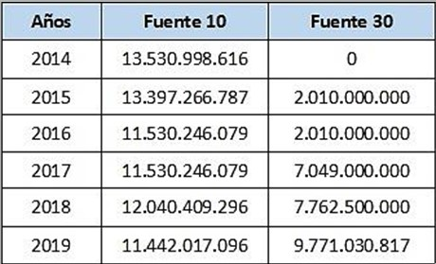**

# Figure 1

**Budget of the Secretariat for Paraguayan Returnees and Refugees**

223. The Secretariat for Paraguayan Returnees and Refugees carried out strategic programmes on behalf of Paraguayans who had emigrated and wished or needed to return, in accordance with its charter and international treaties to which Paraguay is a party. The National Development Plan 2030 is the primary management tool guiding the implementation of current policies; actions are prioritized according to their objectives.

224. The proposed public policy for social development 2010–2020 and the Economic and Social Strategic Plan 2008–2013 have been continued in the National Development Plan 2030. In this context, the Secretariat for Paraguayan Returnees and Refugees promotes the dignified reintegration of nationals and their inclusion in the development process, paying special attention to forcible return, with a focus on human rights, and assisting returnees as they reintegrate into their family and social environment. Since its inception, the proposed policy has included the following lines of action, which were developed over time:

(a) Voluntary returns: assistance and advice on the issuance of repatriation certificates to Paraguayan returnees and their families in the process of return and reintegration, in connection with granting of legal exemptions;

* Exemption from residence fees of spouses and children of nationals
* Access to Paraguayan identity for foreign children of Paraguayan nationals
* Exemption from customs duties for import of personal belongings, machinery and a utility vehicle
* Waiver of fees for recognition of studies (basic and secondary education) and accreditation of university degrees

# Table 5

**Voluntary returns**

**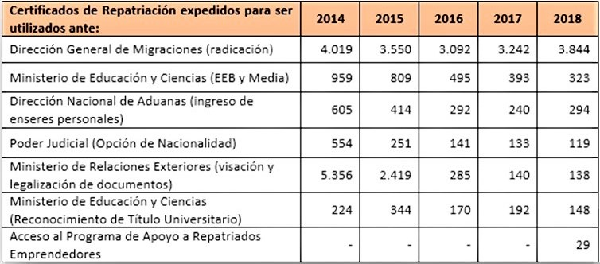**

# Figure 2

**Voluntary returns**

**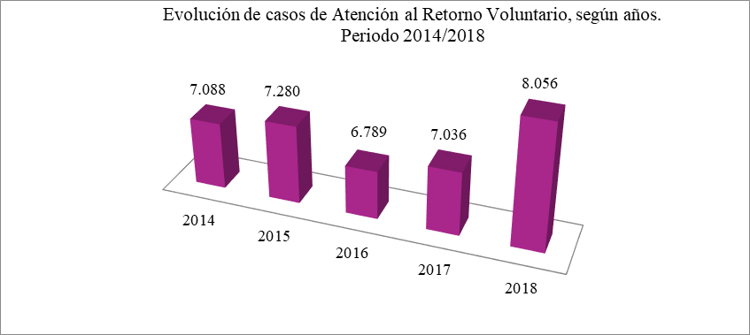**

(b) More complex repatriations: assistance for unplanned and emergency return of talented citizens and their nuclear families or citizens in situations of vulnerability, indigence, prolonged unemployment, health problems, remains, victims of trafficking, international return of children and adolescents and victims of natural disasters or conflicts, among others.

# Table 6

**More complex repatriations**

**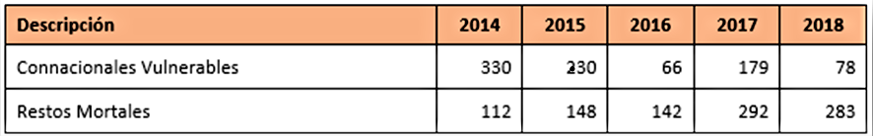**

# Figure 3

**More complex cases**

**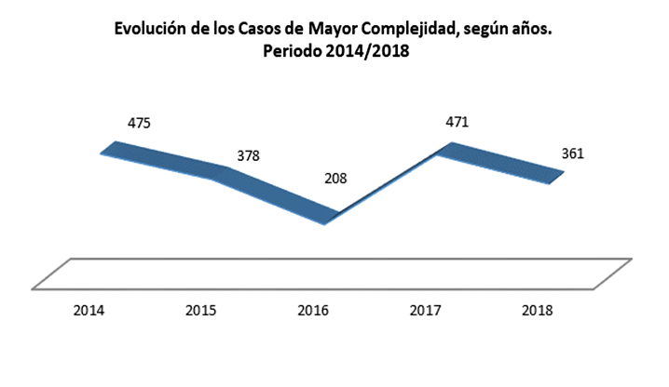**

(c) Granting of national identity: article 146 of the Constitution confers natural Paraguayan nationality on children born abroad of a Paraguayan mother or father, when the parents reside permanently in Paraguay. To preserve Paraguayan identity, professional sponsorship is provided free of charge for proceedings on choice of nationality for children of Paraguayan returnees and representation before the courts to obtain a final judgment and register with the Directorate-General of the Civil Registry.

# Table 7

**Inclusion in the national identity**

**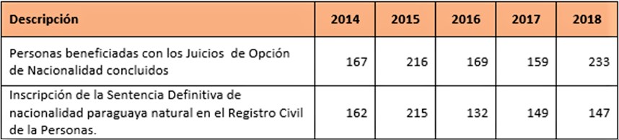**

# Figure 4

**Cases of inclusion in the national identity**

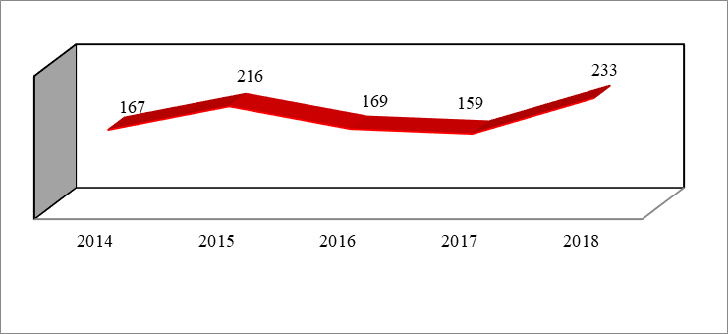

# Table 8

**General lines of action of the Secretariat for Paraguayan Returnees and Refugees**

**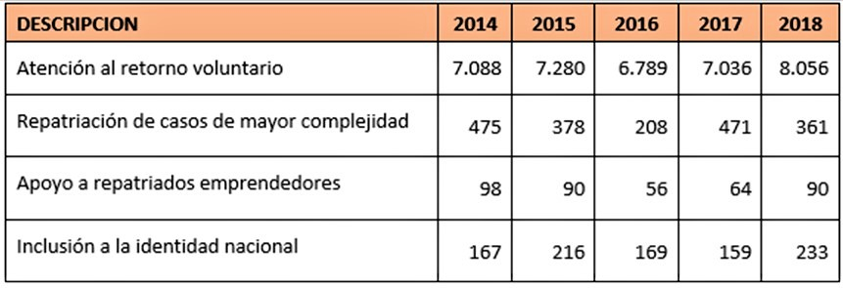**

225. In the area of employment, on 18 February 2019, the Ministry of Labour, Employment and Social Security and the Secretariat for Paraguayan Returnees and Refugees signed a framework agreement to promote actions relating to education, training, research, extension and professional and technical cooperation for Paraguayan returnees.

Issue 31

226. The migration policy has identified the search for a job as one of the main reasons for migration, and in that context, it gives priority to intersectoral cooperation to foster the creation of micro, small and medium-sized enterprises that create productive employment and develop professional, technical and managerial skills commensurate with demand.

227. The Secretariat for Paraguayan Returnees and Refugees is implementing a line of action to support entrepreneurial returnees which involves providing technical and financial assistance for relocating, starting up and/or strengthening undertakings and support for operating capital, in order to avoid repeat migration for financial reasons, situations of unemployment and underemployment, by generating income through the establishment of micro, small and medium-sized enterprises.

228. In 2017, the Spanish Agency for International Cooperation and Development (AECID) cooperated with the Secretariat for Paraguayan Returnees and Refugees to strengthen this programme by providing business training for returnees and helping to improve their competitiveness with supplementary financial support, in order to make it possible for the human, social and economic capital of returnees to be reintegrated under favourable conditions.

# Table 9

**Technical and financial assistance to returning entrepreneurs**

**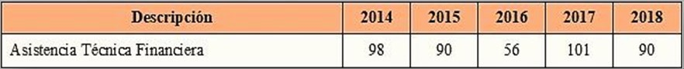**

# Figure 5

**Cases of support for returning entrepreneurs**

**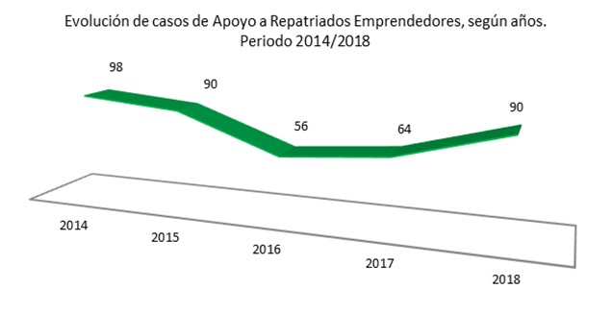**

229. The Ministry of Industry and Trade and the Secretariat for Paraguayan Returnees and Refugees took steps to formalize a partnership to provide business development services and optimize the use of public resources for the benefit of returnees, in response to the need for training and technical assistance in setting up micro, small and medium-sized enterprises.

230. The beneficiaries of the programme of support for returning entrepreneurs have received assistance from the Office of the Deputy Minister for Micro, Small and Medium-sized Enterprises of the Ministry of Industry and Trade. This consists of training for business model definition, advice on formalization of businesses and advice on a range of existing support tools. Between 2017 and 2018, the Office of the Deputy Minister for Micro, Small and Medium-sized Enterprises provided training and technical assistance to 607 people, including 344 in Asunción and 263 in San Lorenzo (of whom 57 per cent were women).

231. The National Labour Training System, the Secretariat for Paraguayan Returnees and Refugees and the Office of the Deputy Minister for Micro, Small and Medium-sized Enterprises of the Ministry of Industry and Trade coordinate their actions in connection with the selection and training of returnees; in 2018, these efforts benefited 114 persons.

Article 68

Issue 32

232. One of the main reasons people migrate is that they want to find work and improve their socioeconomic situation. Please note the relevant aspects of the reply to the previous issue.

233. In order to improve socio-economic conditions, the Ministry of Social Development has made a concerted effort to implement programmes designed to protect the right to health, food and shelter, as well as the social inclusion and advancement of vulnerable population groups.

234. Tekoporã, Tenonderã, Tekoha and PACOC (a support programme for canteens set up by community organizations) are flagship programmes that help mitigate the basic needs of the most disadvantaged sectors and provide the necessary means to earn a decent living and avoid the need to emigrate.

235. Tekoporã provides TMC cards (debit/savings cards) in the areas of health and education and offers a life microinsurance programme for low-income families. Tenonderã supplements Tekoporã and promotes income generation by providing start-up capital for productive enterprises, along with training. Tekoha provides lots in urban areas and facilitates the enjoyment of other rights, such as access to water, sanitation and electricity, as well as to roads and adequate housing. Since 2016, the PACOC programme has provided inputs for food delivery to community canteens.

236. In recent years, the Ministry of Social Development has significantly expanded investment in its programmes. The budget allocated for Tekoporã in 2013 was doubled in 2018, bringing the number of families covered to 95 per cent compared with 2013 and covering 100 per cent of the national territory.

237. The coverage of Tenonderã has increased almost 20 times in terms of families assisted. During its first year (2014), the programme covered 1,465 families in nine districts of six departments. In 2018, it benefited 8,536 families; since its inception, it has reached more than 26,500 families nationwide.

238. Between 2002 and August 2013, Tekoha had signed 12,500 contracts for the sale of property in 195 social territories; in 2018, 27,700 households had signed contracts. From 2013 to 2018, the number of beneficiary families doubled.

239. On climate change, the National Adaptation Plan (adopted in 2016) and the National Mitigation Plan (2017) prioritize the sectors of food security and sovereignty, water and sanitation, energy, biodiversity and forests, health, clean industries, infrastructure and transport. On 6 October 2016, by Act No. 5681, the legislature adopted the Paris Agreement on climate change, and by Act No. 5875/16, the National Climate Change Act.

240. By Act No. 6123/18, the legislature upgraded the Secretariat of the Environment to the rank of Ministry of the Environment and Sustainable Development and charged it with establishing, monitoring and assessing the national environmental policy, in compliance with the Constitutional mandate to ensure a healthy environment and environmental protection. On 27 July 2018, the legislature adopted Act No. 6125, endorsing the Kigali Amendment to the Montreal Protocol on Substances that Deplete the Ozone Layer, of 15 October 2016.

241. In terms of measures to address immigration, by its Decision No. 062/19 of 1 February 2019, the Directorate-General for Migration adopted a protocol to facilitate formalities for granting temporary residence to Venezuelans, bearing in mind the socioeconomic and political situation prevailing in that country. The Directorate-General has been working with the National Commission for Refugees to provide protection for persons displaced by violence and discrimination on the grounds of sex, ethnicity and others.

Issue 33 (a), related to issues 12 *in fine* and 17 (e) (identification of human trafficking victims)

242. Article 30 of Act No. 4788/12 instructs the Committee on Trafficking to develop procedures for identification of victims and charges the Specialized Unit of the Public Prosecution Service with certifying that the person in question is a victim and has access to the rights, benefits and services established by law.

243. On that basis, approval was given to the Manual of Operating Procedures,[[47]](#footnote-47) which contains the following four protocols: certifying that a person is a victim of trafficking;[[48]](#footnote-48) assistance to victimized persons and management of referrals;[[49]](#footnote-49) recording of cases for statistical purposes;[[50]](#footnote-50) and risk assessment of victimized persons.[[51]](#footnote-51)

244. According to established practice, the Act provides that in order to certify victim status, it is enough to show reasonable grounds for believing that the person in question is or was trafficked, without the need for a complaint or criminal proceedings.

Issue 33 (b), related to issues 17 (e) (effective assistance and protection measures for victims of trafficking) and 21 *in fine* (guarantees of access to justice and legal remedies)

245. Through the Arapoty Project, the Ministry for Women has promoted the establishment and strengthening of the inter-agency commissions to prevent and combat trafficking in Ñeembucú, Caaguazú, Itapúa, Central and Alto Paraná.

246. Act No. 4788/12 provides for a national programme to prevent, combat and assist victims and a related national investment fund, to be implemented by the Ministry for Women. The purpose of the programme is to promote, monitor and oversee the implementation of public policies to address trafficking and to take steps to strengthen forums for coordination (the Committee on Trafficking and departmental commissions), ensuring comprehensive care for victims.

247. The Directorate-General for Prevention and Care Services relating to the fight against trafficking of the Ministry for Women addresses trafficking with an emphasis on prevention, reporting and comprehensive protection of victims, along three lines of action: (1) Campaigns, symposiums and sensitization workshops; (2) inter-agency coordination through the Committee on Trafficking and creation of inter-agency bodies at the departmental and district levels; and (3) comprehensive specialized care for victims through the following channels:

(a) Referral Centre: provides comprehensive care for women victims in three areas: social (social assistance, user intake, development of social case files, etc); psychological (emotional support, assessment and psychotherapy); and legal (advice, support and monitoring of court cases).

(b) Temporary Shelter for women victims: in addition to a multidisciplinary team (social workers, psychologists, lawyers), protection, food and clothing are provided. Between 2013 and 2019, 155 women were helped at the referral centre and the temporary shelter, where they received protection, psychological, legal and social assistance; in addition, some 25 women benefited from income-generating micro-enterprises.

(c) The Social Reintegration Programme for victims seeks to promote social reintegration through empowerment and support for women’s physical, psychological, social and communal recovery. The Ministry for Women continually coordinates its work with the Public Prosecution Service, the Ministry for Children and Adolescents, the Secretariat for Paraguayan Returnees and Refugees, the Ministry of Social Development, the Public Defence Service and other agencies that provide comprehensive care and reintegration of victims; a specific protocol for that purpose will soon be drawn up.

248. A Manual on reintegration of women affected by trafficking[[52]](#footnote-52) has been prepared, the aim of which is to expand and strengthen strategies for addressing family, community and social reintegration with a comprehensive approach.

249. The General Protocol for the care of persons affected by trafficking in Paraguay establishes common performance standards for agencies, organizations and care services and sets up a mechanism for intervention and victim identification, as well as for referral of cases.

250. Under article 34 (4) of Act No. 4788/12, the Ministry of Social Development has, since 2016, included in its programmes for women victims, longer-term assistance under the category of support for family, social and community reintegration. The Tekoporã programme provided assistance to five female victims, all with minor children. The Tekoha programme provided plots for housing in several areas of the country to:

* A woman with three children: in the Las Colinas social territory (Itauguá)
* A woman with two children, her mother and her brother: in the Las Colinas social territory (Itauguá)
* A woman with two daughters: in the Independencia II social territory (Luque);
* A woman with her partner: in the Oñondivepa social territory (Guarambaré)
* A woman: in the Familia Unida social territory (Caaguazú)
* A woman: in the 16 de Julio social territory (Luque)

251. Article 38 of Act No. 4788/12 provides that when necessary, subject to a risk assessment by the prosecution service, comprehensive protection must be provided for witnesses and victims throughout criminal proceedings, or as long as the risk factors make it necessary.

252. Since 2008, the Programme on Comprehensive Assistance to Victims of Trafficking and Sexual Exploitation has been providing protection and care for child and adolescent victims of trafficking and sexual exploitation throughout the country. The programme promotes prevention and awareness-raising activities for children and adolescents, stakeholders and the general public. It also provides comprehensive assistance for rescued children and adolescents in court proceedings and police procedures, within the country and abroad, including psychological, legal and social support until they are reunited with their families.

253. In October 2015, an agreement was signed between the Ministry for Children and Adolescents and the non-governmental organization Sisters of the Good Shepherd with the aim of strengthening the National System for the Comprehensive Protection and Advancement of Children and Adolescents and public policies for children and adolescents. In this context, the Rosa Virginia residential centre for child victims of trafficking and sexual exploitation was set up to protect these victims until they can be reintegrated into their families and society. In 2019, an agreement was signed between the Ministry for Children and Adolescents and the central Government to create centres for the protection and comprehensive care of children and adolescents who are victims of sexual exploitation, labour exploitation and organ removal.

254. During their time in the protection system, victims are given psychological assistance, and they receive medical care and assistance with obtaining documents and during legal proceedings. At the same time, socioenvironmental visits are carried out to assess family reintegration, while school and community reintegration is coordinated with other institutions. Psychological support continues through the health services in their community, once reintegration is complete.

# Table 10

**Number of children and adolescents in the Rosa Virginia shelter**

**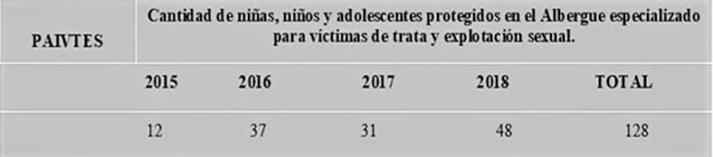**

255. Act No. 4788/12 criminalizes trafficking and considers punishable the acts of recruiting, transporting, transferring, harbouring or receiving persons for the purpose of subjecting them to sexual exploitation, servitude, servile marriage, forced labour or service, slavery or any similar practice (art. 5). The main safeguard for victims’ access to justice, regardless of their migration status, is that they are exempted from punishment (art. 14) for offences arising from their having been trafficked; neither can they be punished for migration-related offences arising from their status as victims.

256. The Act also protects victims by establishing their right to free legal assistance and the benefit of litigation at no cost through mechanisms that protect the confidentiality of judicial proceedings and during the implementation of care protocols, as well as the identity and other data of the victim and/or witness.

257. The Specialized Unit of the Public Prosecution Service has a system for receiving complaints that works in coordination with the Ministry of Foreign Affairs, the Ministry for Women, the Ministry for Children and Adolescents and the National Police, as well as an online complaint mechanism. A national office was set up to coordinate and supervise investigations of trafficking, child sexual exploitation and criminal acts against children.

258. The Technical Support Directorate of the Specialized Unit deals with victims of trafficking and sexual exploitation by providing the services of psychologists, social workers and lawyers, to ensure their participation in criminal proceedings and their access to justice, and coordinates actions to promote their social reintegration and restoration of rights. Through an agreement between IOM and the Public Prosecution Service, a seed fund project is being implemented for the care of victims.

259. During 2018, the Technical Directorate assisted 110 victims: 95 females (67 adolescents) and 15 males (7 adolescents). During the same period, it issued 212 intervention reports and responded to 99 requests for intervention from Specialized Units in Asunción and Presidente Franco; it also developed and implemented the Immediate Care for Victims plan and submitted reports to the Committee on Trafficking and national and international agencies.

260. The Guide to Services for Persons Victimized by Trafficking is a tool for justice officials that includes a map of services requested by victims and an analysis of those existing in the country, by departments, showing the location of places with the highest number of victims.

Issue 33 (c), related to issue 39 (f)

261. Between 2015 and 2018, the Supreme Court took up 75 cases involving 103 persons who were investigated and 19 who were unnamed. Of this total, four cases were dismissed, 19 were closed, and seven are inactive because the defendants are either on the run or have been declared in contempt. Sixty-two per cent of the cases were investigated, and 21 resulted in convictions. In seven cases, no conviction was obtained, and 21 cases are ongoing with defendants and/or accused persons. During this period, 50 women and 53 men between the ages of 21 and 79 were investigated.

# Table 11

**Number of cases considered by constituency**

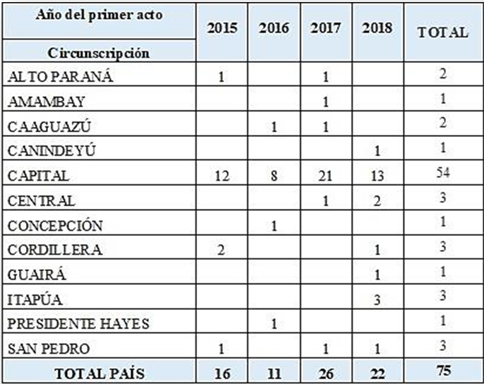

# Figure 6

**Number of persons tried for trafficking**

**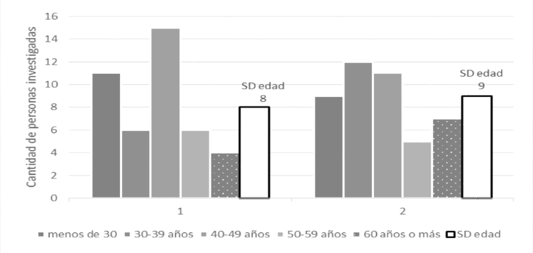**

SD edad: age not recorded.

# Table 12

**Status of proceedings in trafficking cases**

**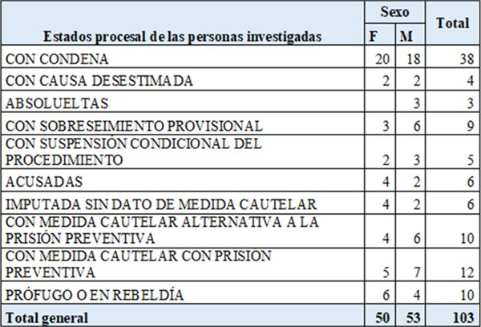**

262. The records of the Public Prosecution Service show that of the 458 complaints received by the Specialized Unit between 2013 and 2018, 285 were for trafficking for the purpose of sexual exploitation, 152 within Paraguay and 133 internationally. At the same time, 162 of all cases involved trafficking for the purpose of labour exploitation, 90 within Paraguay and 72 internationally.

263. During the aforementioned period, 56 convictions were obtained, including 45 for trafficking for the purpose of sexual exploitation and 11 for trafficking for the purpose of labour exploitation; a total of 71 persons were convicted, including 4l males and 30 females. Of this total, 20 convictions were obtained in 2018, during which time 37 victims were also rescued.

Issue 33 (d)

264. After the entry into force of Act No. 4788/12, the National Programme to prevent and combat trafficking and provide assistance for victims was set up with the aim of promoting, monitoring and overseeing the implementation of public policies to address trafficking and to take steps to strengthen forums for coordination, ensuring comprehensive care for victims through a National Investment Fund.

265. According to the statement of purpose, which refers to information from State agencies regarding the scope of trafficking in the country, both the Act and the National Programme have taken guidelines from the report entitled *La Trata de Personas en Paraguay y Propuesta de Política Nacional de Prevención y Combate 2010–2019*[[53]](#footnote-53) (Trafficking in Persons in Paraguay and Proposal for a National Policy to Prevent and Combat Trafficking 2010–2019), which was launched in June 2010 as a joint initiative of the then Ministry of Justice and Labour, the Technical Secretariat for Economic and Social Development Planning, the Secretariat for Women (now the Ministry for Women), the Office of the Deputy Minister for Youth, the United Nations Development Programme (UNDP), ILO, the United Nations Population Fund (UNFPA), the United Nations Development Fund for Women (UNIFEM) and the United Nations Children’s Fund (UNICEF), in the framework of the Joint Programme entitled Oportunidades.

266. Likewise, in accordance with article 48 of Act No. 4788/12, which entrusts the Committee on Trafficking with the design and approval of the National Policy to Prevent and Combat Trafficking, the institutions that comprise this inter-agency body are taking steps to make the necessary adjustments to that end.

Issue 33 (e)

267. Since the entry into force of the Agreements against the smuggling of migrants between the States Parties of MERCOSUR and the Republic of Bolivia and the Republic of Chile (adopted by Act No. 3566/2008 and Act No. 3567/2008), a number of initiatives aimed at preventing trafficking have been adopted at the regional level.

268. The *Guía MERCOSUR para atención de mujeres en situación de trata con fines de explotación sexual*[[54]](#footnote-54) (Guide for assistance to women in a situation of trafficking for the purpose of sexual exploitation) was adopted by Decision MERCOSUR/CMC/DEC. 9/12 of 6 December 2012, and by Decision MERCOSUR/CMC/DEC. 26/14 of 16 December 2014, the Meeting of Ministers and High-level Authorities for Women was charged with monitoring implementation of the Coordination Mechanism for Assistance to Women Victims of International Trafficking.[[55]](#footnote-55) In addition, a regional plan for the prevention and eradication of forced labour and trafficking for the purpose of labour exploitation was also drawn up. (Acta XLVI – SGT 10 Asuntos Laborales, Empleo y Seguridad Social – 9 May 2019).

269. The Operating Agreement for the Implementation of Mechanisms for the Exchange of Migration Information between the States Parties of MERCOSUR was signed in July 2019. It establishes procedures for consultation and exchange of migration information, with a view to facilitating the movement of persons and strengthening cooperation for the prevention of transnational crimes, especially those related to the smuggling of migrants and trafficking.

270. With the aim of increasing and updating mechanisms of mutual consular assistance in the regional bloc, the Agreement on Consular Cooperation between States Parties and Associated States of MERCOSUR was signed in July 2019, in order to guarantee assistance to nationals of States Parties in places where there is no diplomatic or consular representation of the State of their nationality, should they be victims of trafficking, among other situations.

271. In 2017, the Ministry of the Interior and the Ministry of Security of Argentina entered into a formal cooperation agreement to prevent, investigate and detect trafficking and to strengthen coordination in connection with this and other transnational crimes. In this context, the Directorate-General for Migration and the National Directorate of Migration of Argentina signed an operating agreement on implementation of mechanisms for exchanging information.

272. The Ministry for Women is a member of the MERCOSUR Network for Assistance on the Coordination Mechanism for Assistance to Women at Risk of International Trafficking. Within the framework of the Meeting of Ministers and High-level Authorities on Women’s Affairs, the Ministry for Women is a member of the Working Group on Gender and Trafficking of the Integration Committees (Paraguay-Argentina) of Clorinda-Puerto Falcón, Formosa-Alberdi, Pilar-Bermejo, Ayolas-Ituzaingó and Encarnación-Posadas. At the thirteenth Meeting of Ministers and High-level Authorities on Women’s Affairs (June 2019), consensus was reached on the redesign of the MERCOSUR Free from Trafficking in Persons Campaign, with the support of UN-Women and IOM, taking an ethnic and racial approach that includes trafficking for the purpose of labour exploitation.

273. The Public Prosecution Service has received assistance from AECID and IOM in connection with identification of victims of trafficking so that they can be effectively assisted and referred. The Public Prosecution Service and AECID implemented the bilateral project on Prevention, Protection and Defence of the Rights of Victims of Trafficking.

Issue 33 (f)

274. The Directorate-General for Prevention and Care Services in the fight against trafficking of the Ministry for Women continually carries out awareness-raising and training sessions for public officials at the central, departmental and local levels who deal with trafficking. Since 2019, with support from the Paraguayan Association for Comprehensive and Sustainable Development (ADIS Paraguay), the Ministry for Women has designed and implemented the project on Promotion for the Prevention of Trafficking, to disseminate information on preventing and combating trafficking and assisting victims through communication campaigns and informational workshops with grassroots leaders of districts designated by the Ministry for Women.

275. Five districts in three departments were selected: J.E. Estigarribia (Caaguazú), San Alberto and Naranjal (Alto Paraná) and Tomás Romero Pereira and San Rafael del Paraná (Itapúa), where workshops and forums on awareness and dissemination were held with public officials (102 participants), neighbourhood organizations, high school students, civil society organizations and the general public (381 participants). In addition, an audiovisual and several audio presentations (in the official languages of MERCOSUR), produced by ADIS Paraguay, were disseminated.

276. From time to time, since the entry into force of Act No. 4788/12, several institutions have collaborated with the Directorate-General for Migration to train officials at checkpoints on prevention and detection of trafficking.

277. The judiciary has promoted training for civil servants and judges on national and international regulations relating to migration and human rights, especially with regard to trafficking. Workshops were held for judges and key officials, with the participation of national and international experts.

278. Within the framework of the cooperation by AECID with the Public Prosecution Service, and with support from IOM, between 2013 and 2018, four international seminars on trafficking were held, as well as 46 training workshops in different departments of the country, for prosecutors, judges, police, labour inspectors, migration officials and members of civil society organizations.

279. The Specialized Unit of the Public Prosecution Service, the Training Centre and the deputy prosecutors’ offices provide training and awareness-raising workshops for prosecutors on punishable acts that are within their sphere of competence. The Specialized Unit also arranges for talks in elementary and secondary schools on the subject of sexual exploitation and trafficking.

280. Since the Directorate-General of Consular Affairs of the Ministry of Foreign Affairs is the coordinator of the Committee on Trafficking, consular officials receive guidelines on the subject, as well as ongoing training on identification and referral issues, mainly within the framework of refresher courses.

Issue 33 (g)

281. Since 2018, the resources of the National Investment Fund for the Prevention and Care of Victims of Trafficking, established by Act No. 4788/12, have been included in the budget of the Ministry for Women. These resources are managed by the Directorate-General for Prevention and Care Services in the fight against trafficking, a body for prevention, reporting and comprehensive protection that provides psychological, social and legal assistance through the Referral Centre, the Temporary Shelter and the Social Reinsertion Programme described in the reply to issue 33 (b).

282. For the fiscal year 2019, a fund of 1,727,000,000 guaraníes (G) (about US$ 280,000) was allocated to the Type 2 Budget: Action Programmes: National Programme to Prevent and Combat Trafficking and Provide Assistance to Victims, of the Ministry for Women.

Issue 33 (h)

283. Article 40 of Act No. 4788/12 provides for the issuance within a maximum period of five days, at the request of a victim or of the Public Prosecution Service, of a residence permit for a period of no less than 90 days, to coincide with the recovery and reflection period. The Act also stipulates that all deportation proceedings must be suspended while the permit is being processed.

284. Under article 41 of the Act, the Directorate-General for Migration is to grant renewable temporary residence permits for six months to victims and any dependants who may be with them, or permanent residence or refugee status on humanitarian grounds; the lack of a valid passport or other identity documents or non-compliance with immigration requirements arising from their status as victims does not constitute grounds for denying a request.

285. The Directorate-General for Migration issued Decision No. 296/16, approving and establishing the Manual of Procedures for Foreign Victims of Trafficking, which provides that immigration documentation for residence must be issued free of charge, the only requirement being a victim certificate issued by the Public Prosecution Service.

Issue 34

286. Act No. 4208/10, approving the Agreement between the Republic of Paraguay and the Republic of Bolivia for the Creation of a Border Committee remains in force. The Committee serves as a forum for proposing solutions and expeditious and timely procedures for the movement of persons, vehicles and goods through border crossings that have been and will be established, as well as for promoting cooperation, integration and better understanding of border populations and for fostering projects conducive to development.

Article 69

Issue 35, relating to issue 28 (implementation of the Agreement on Residence for Nationals of States Parties to MERCOSUR)

287. In accordance with the principles of equality and non-discrimination enshrined in domestic legislation and set out in the migration policy, special days for migration regularization[[56]](#footnote-56) are organized. Mobile teams from the Directorate-General for Migration are deployed for one week to areas that have a large presence of migrants, consulates accredited to Paraguay and centres of higher education to facilitate the documentation of foreigners living, working and/or studying in Paraguay.

288. The Directorate-General for Migration processes residence documentation for aliens who wish to remain in Paraguay as residents. All foreigners who wish to become temporary or permanent residents must apply in person – with the possibility of having a representative follow up on the process – for one of the following types of residency:

(a) Temporary residence: granted to foreigners who wish to reside in the country temporarily for the duration of the activities that give rise to the request. The requirements for temporary residence are:

* A valid identity card from the country of origin
* A consular visa or a visa issued upon arrival, in the case of countries that require it
* A birth certificate, issued in the country of origin or by its diplomatic representation in Paraguay
* An up-to-date police certificate or criminal background report
* Proof of marital status, issued by the competent authority of the country of origin
* A valid Certificate of Life and Residence, issued by a local police station in Paraguay
* A health certificate issued by a doctor authorized by the Ministry of Public Health and Social Welfare, stating that the applicant is in good physical and mental health and has no infectious-contagious disease
* Proof of financial solvency
* Fee: Temporary Admission Card + Change of Category: G 1,337,961

(b) Temporary residence in a MERCOSUR country: granted to nationals of countries that have signed the Agreement on Residence for Nationals of States Parties to MERCOSUR and Associated States[[57]](#footnote-57) who wish to reside in the country temporarily, for the duration of the activities that give rise to the request. The requirements are similar, and the fee is the same as required for a temporary residence permit, except for the consular visa or visa on arrival (instead, proof of entry into the country is required). The Certificate of Life and Residence and proof of financial solvency are also required. Additionally, a valid police or criminal background report issued by the Communication Technology Department of the National Police must be presented, as well as a sworn statement that the person has no international police record.

(c) Permanent residence: granted to foreigners who wish to reside permanently in Paraguay, for activities considered useful for the development of the country. Applicants must submit all the documents required for ordinary temporary residence, as well as a valid police background report for foreigners, issued by the Communication Technology Department of the National Police and a sworn statement of compliance with article 23 of Act No. 978/96, issued before a Notary Public in Paraguay, in which the applicant expressly undertakes to respect and comply with the Constitution and the laws of Paraguay. A fee of G 1,108,380 for the Permanent Admission Card + Change of Category, and another optional fee of G 110,838 for the Certificate of Residence.

(d) Permanent residence in a MERCOSUR country: granted to nationals of countries that have signed the Agreement on Residence for Nationals of States Parties to MERCOSUR and Associated States for activities considered useful for the development of the country. Requirements:

* MERCOSUR Temporary Admission Card or Police Report (in case of loss)
* A valid identity card from the country of origin
* Also, a valid police or criminal background report issued by the Communication Technology Department of the National Police of Paraguay
* Proof of financial solvency
* Fee: Temporary Admission Card + Change of Category: G 1.408,380 Certificate of Residence (optional): G 140,838

289. The data on residence permits granted since 2012, broken down by nationality and type of residence, are provided in the annex.[[58]](#footnote-58)

Issue 36

290. With regard to measures for expanding visa liberalization, the Republic of Paraguay has signed numerous bilateral visa waiver agreements; a list is attached as an annex.[[59]](#footnote-59)

291. Decisions Nos. 1384/12 and 822/16 of the Ministry of Foreign Affairs authorize the Directorate of Passports and Consular Services to issue non-resident tourist visas, non-resident business visas, non-resident technician visas and visas for beneficiaries of intercultural educational programs and courses. In special cases, the following measures are implemented:

* Temporary protection for asylum seekers: until such time as a final decision is taken on an application for refugee status, applicants are issued a document allowing them to remain legally in the country, to work and to have access to basic health and education services.
* Courtesy Visas: parameters have been established for granting visas to Syrians in a crisis situation, and on this basis, it was decided to grant courtesy visas to applicants coming from places in humanitarian crisis; applications may be submitted by any Paraguayan citizen who demonstrates that he or she has strong ties in the country and is financially solvent.
* Family reunification: recognition of refugee status is extended to the spouse or common-law partner of applicants and to their descendants and ascendants in the first degree, in order to maintain the family unit.

Section II

Issue 37 (a)

292. A list of related legislative and regulatory developments, provided by the legislature, is attached.[[60]](#footnote-60)

Issue 37 (b)

293. Decree No. 11539/13 provides for the reorganization of the Directorate-General of Migration, charging it with the public duty of ensuring security, supervising, monitoring and implementing migration policies, in accordance with the Constitution, international treaties and other related legislation. The organizational structure, competencies and powers arising from the reorganization are described in detail in the decree, which is attached as an annex.[[61]](#footnote-61)

Issue 37 (c)

294. The adoption in 2015 of the migration policy closed the gap in migration policy, bringing it in line with the new reality and reflecting approval of the migration policy in 2015 has solved the lack of a migration policy in line with the new realities, and reflecting the principles embodied in the Constitution, international law and human rights instruments. This has gone hand in hand with improvements in the legal framework (whose early adoption is expected) and an efficient, professional and transparent institutional organization that is better suited to meeting the present challenges of human mobility.

295. On the basis of the current migration policy, the Directorate-General of Migration has worked to improve the analysis and issuance of documents and to enable students and foreign workers to regularize their migratory status, through mobile teams and permanent offices in the main cities.

296. Since 2012, the Directorate-General of Migration has implemented regularization programmes through one-week training sessions carried out by mobile teams in border cities, accredited consular offices in Paraguay and centres of higher education, with the aim of expediting the regularization of large numbers of migrants by receiving, processing and issuing the largest possible number of documents on a daily basis.

297. The scope of these programmes varies, depending on how many training sessions are carried out during the year; this in turn depends on the availability of funds. Funding is covered by revenues allocated under code FF30 (own resources) from fees collected by the Directorate-General of Migration. Attached is a list of revenues collected during the period 2014–2018, including the percentage of execution in institutional programmes.[[62]](#footnote-62)

# Table 13

**Scope of migration regularization programmes**

****

Issue 37 (d)

298. The study entitled *Trabajadores migrantes en el MERCOSUR – Estado de situación y opciones de políticas* (Migrant Workers in MERCOSUR – Status and Policy Options)[[63]](#footnote-63) was published in August 2019 by the Social Institute of MERCOSUR. The study describes the process and historic trends in migration in the countries of the bloc and provides a systematic analysis of the legal regime of worker mobility.

299. The publication provides useful inputs for decision-making on integration policies and seeks to facilitate the identification of problems faced by workers and States at the social, economic and regulatory levels, in terms of insertion in labour markets and receiving countries; it concludes with recommendations for action to be taken to improve the situation.

Issue 37 (e)

300. In order to facilitate quick and easy access to information on migration issues, the Directorate-General of Migration has set up the Citizen Services Office, as well as a website, social networks and technological media for use by the public. It also conducts regular information campaigns through these media.

301. In addition to facilitating the documentation of foreigners, the migration regularization days provide an extremely useful opportunity to disseminate information on migration issues. Information on the rights enshrined in the Convention is available on the websites of several agencies that have published it in full, as mentioned in the reply to issue 1.

Section III

Data, official estimates, statistics and other information, if available

Issue 38

302. The biometric system of the Migration Information and Data Analysis System (MIDAS) has been expanded to four additional migration control posts, in strategic borders with Argentina (Pilar), Brazil (Salto del Guairá and Pedro Juan Caballero) and Bolivia (Infante Rivarola); these are added to another five posts where the technology was already being used to record entries into and exits from the country. The following have direct connectivity in real time with Interpol headquarters in Lyon (France): Silvio Pettirossi Airport (Luque), Guaraní Airport (Ciudad del Este), the International Friendship Bridge (Ciudad del Este), the San Roque González de Santacruz International Bridge (Encarnación) and Puerto Falcón.

303. The MIDAS system is being used in the posts of Itá Enramada and Alberdi, thus making a total of 11 checkpoints. The following improvements have been made to the project:

* Automation and biometrics: automatic reading of passports and identity documents with their security features, reading of fingerprints, photo registration and facial recognition
* Connectivity: real-time interconnection between checkpoints and the INTERPOL database
* Training: training of immigration inspectors to improve services to citizens crossing the border and faster individual registration times
* Complete refurbishment of posts: arrangement and adaptation of infrastructure, optimization of connectivity, renovation of furniture and improvement of signs and posters

# Figure 7

**Progression of MIDAS**

**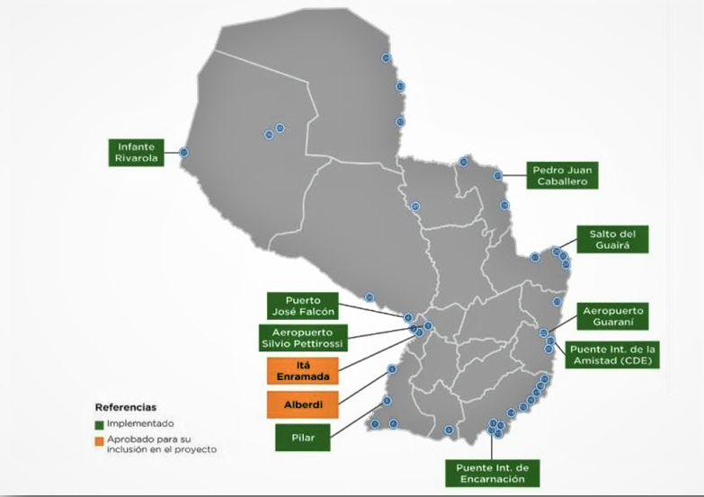**

Issue 39 (a)

304. The total number of Paraguayan migrants recorded up to December 2018, by continent of destination, is shown in the following table provided by the Directorate-General of Consular Affairs of the Ministry of Foreign Affairs:

# Table 14

**Total migrants, by continent of destination**

**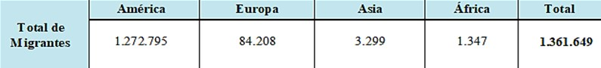**

305. The following table shows the total number of migrants from and to Paraguay who were processed by the Directorate-General of Migration over the last five years:

# Table 15

**Total number of national and foreign migrants, by year**

**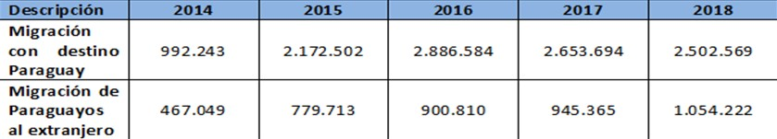**

Issue 39 (b)

306. The Directorate for Paraguayan Communities Abroad followed up on 4,430 cases of arrests for different punishable acts. It also provided advice to 3,627 family members of Paraguayan nationals who were deprived of their liberty, monitoring their procedural and health status and transmitting documentation for their defence. A record was kept of the total number of Paraguayans arrested or convicted abroad in the last five years, broken down by type of offence, as follows:

# Table 16

**Paraguayans detained and sentenced abroad**

**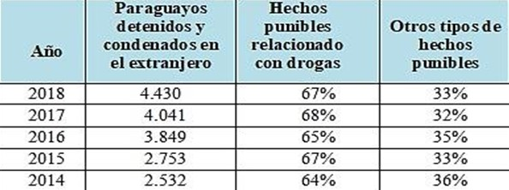**

Issue 39 (c)

307. According to the records of the Directorate-General of Migration, there have been no verified expulsions of migrant workers and members of their families. Because it is an extreme measure, expulsion has been ordered for the commission of different types of punishable acts, following the guidelines of zero tolerance for drug trafficking and transnational organized crime. The table below shows the expulsions carried out for the above reasons so far in 2019:

# Table 17

**Number of expulsions by country of origin**

**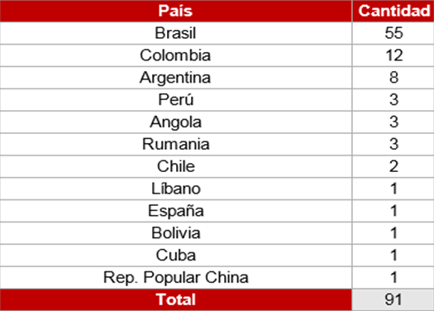**

Issue 39 (d)

308. Neither the Directorate-General of Migration, the Ministry for Women or the National Commission for Refugees have any record of unaccompanied children entering the country. However, the Directorate-General for Migration and the Ministry for Women are reviewing the issue of unaccompanied children in order to establish regulations that will meet international requirements. Accordingly, they have entered into formal arrangements for the protection of such children, with a view to training migration officials and collaborating in regard to their international return.

309. The Directorate-General for Internal Audits of the Ministry for Children and Adolescents carries out the international return of children and adolescents, who are either transferred to their habitual place of residence with adult relatives or accompanied by social workers, in cases of illegal transfer or unlawful detention.

310. Since 2019, the National Commission for Refugees has been implementing a digital database containing biometric identification of applicants for refugee status in cases when they have no documents. Act No. 1938/02, the General Act on Refugees, grants quasi-automatic refugee status to children and adolescents and their relatives, on grounds of family unification/reunification. To improve border response mechanisms, an inter-agency board is being set up by the National Commission for Refugees and the Directorate-General of Migration.

Issue 39 (e)

311. The following tables provided by the External Sector Statistics Department of the Central Bank of Paraguay show the evolution of family remittances by country of origin and as a percentage of GDP since 2010:

# Table 18

**Family remittances in millions of US$**

**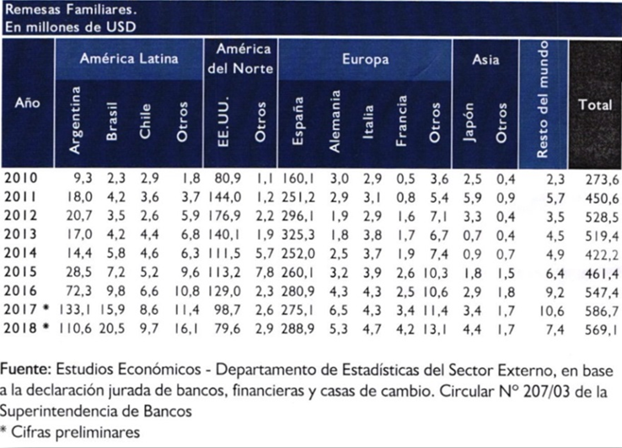**

# Table 19

**Family remittances as % of GDP**

**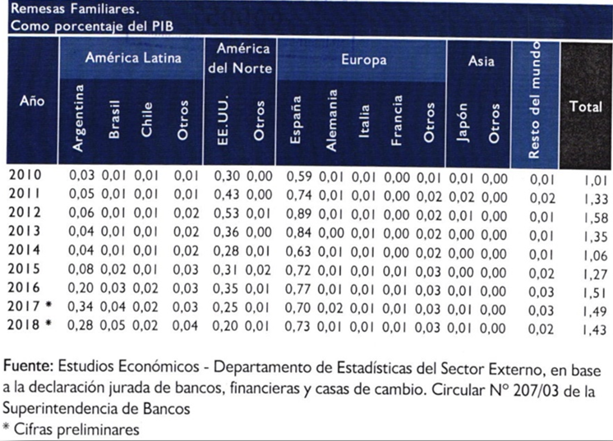**

Issue 39 (f)

312. Information on reported cases of trafficking and smuggling of migrants, investigations, prosecutions and convictions is provided in detail in the response to issue 33 (c).

Issue 39 (g)

313. The information requested is shown in detail in the rejection forms[[64]](#footnote-64) for the period 2015 to 2018, which have been provided by the Directorate-General for Migration.

Issue 39 (h)

314. On the question of legal assistance provided to migrant workers and members of their families, please refer to the reply to issue 7 (c), referring to the fact that the Public Defence Service provides free legal assistance without distinction on any grounds. As regards statistical data on the services provided, the regulations of the Public Defence Service do not require that disaggregated data on migrant workers be included in the reports of public defenders. However, from this year onward, more detailed data on assistance to migrants will be provided.

315. Information on legal assistance provided to nationals abroad is contained in the responses to issues 19 (b) and 39 (b).

Issue 39 (i)

316. The Directorate-General of Migration does not have data on the number of persons in an irregular migratory situation. However, the Migration Security Operations Unit keeps a record of investigations conducted in cases of foreigners in that situation. From January to August 2019, there were 17 investigations of persons in irregular migration status in Paraguay.

1. \* The present document is being issued without formal editing. [↑](#footnote-ref-1)
2. \*\* The annexes to the present report are available on the Committee’s web page. [↑](#footnote-ref-2)
3. http://www.mre.gov.py/SimorePlus/. [↑](#footnote-ref-3)
4. https://www.mtess.gov.py/institucion/convenios/convencion-internacional-sobre-la-proteccion-de-los-trabajadores-migratorios-y-sus-familiares. [↑](#footnote-ref-4)
5. http://www.migraciones.gov.py/index.php/interes-general. [↑](#footnote-ref-5)
6. http://www.mdp.gov./Convencion Internacional sobre Trabajadores migrantes py/application/files/8215/6640/0311.Pdf. [↑](#footnote-ref-6)
7. [http://www.minna.gov.py/archivos/documentos/LEY%203452-08%20Que%20aprueba%20la%20convencion%20internacional% 20sobre%20la %20proteccion%20de%20los%20derechos%20de%20todos%20los%20trabajadores%20migratorios%20y%20de%20sus %20familiares\_ehqkq4sg.pdf](http://www.minna.gov.py/archivos/documentos/LEY%203452-08%20Que%20aprueba%20la%20convencion%20internacional%25%2020sobre%20la%20%20proteccion%20de%20los%20derechos%20de%20todos%20los%20trabajadores%20migratorios%20y%20de%20sus%20%20familiares_ehqkq4sg.pdf). [↑](#footnote-ref-7)
8. https://www.pj.gov.py/contenido/135-direccion-de-derechos-humanos/699. [↑](#footnote-ref-8)
9. https://www.ministeriopublico.gov.py/convencion-trabajadores-migrantes-i1215. [↑](#footnote-ref-9)
10. Annex 2. [↑](#footnote-ref-10)
11. Annex 3. [↑](#footnote-ref-11)
12. Annex 4. [↑](#footnote-ref-12)
13. Annex 5. [↑](#footnote-ref-13)
14. Annex 6. [↑](#footnote-ref-14)
15. www.ministeriopublico.gov.py - link: “Denuncia la Trata”. [↑](#footnote-ref-15)
16. http://www.minna.gov.py/pagina/1224-fono-ayuda-147.html. [↑](#footnote-ref-16)
17. http://www.minna.gov.py/pagina/2454-dri.html. [↑](#footnote-ref-17)
18. Arts. 46 and 47 of the Constitution. [↑](#footnote-ref-18)
19. Annex 7. [↑](#footnote-ref-19)
20. Annex 8. [↑](#footnote-ref-20)
21. Annex 9. [↑](#footnote-ref-21)
22. Annex 10. [↑](#footnote-ref-22)
23. [https://www.mtess.gov.py/application/files/3115/5913/3271/estrategia\_trabajo\_forzoso.pdf](https://www.mtess.gov.py/application/files/3115/5913/3271/ESTRATEGIA_TRABAJO_FORZOSO.pdf). [↑](#footnote-ref-23)
24. [https://www.mtess.gov.py/application/files/5915/5913/3239/plan\_bianual\_de\_la\_conatrafor.pdf](https://www.mtess.gov.py/application/files/5915/5913/3239/PLAN_BIANUAL_DE_LA_CONATRAFOR.pdf). [↑](#footnote-ref-24)
25. https://www.mtess.gov.py/application/files/1215/5913/3250/Guia\_TRAFOR.pdf. [↑](#footnote-ref-25)
26. http://www.minna.gov.py/archivos/documentos/Manual%20POLNA%20-%20PNA\_97hlh3is.pdf. [↑](#footnote-ref-26)
27. Ibid. ref. 24. [↑](#footnote-ref-27)
28. See <http://www.minna.gov.py/pagina/229-abrazo.html>. [↑](#footnote-ref-28)
29. Annex 11. [↑](#footnote-ref-29)
30. Annex 12. [↑](#footnote-ref-30)
31. <https://paraempleo.mtess.gov.py/es/>. [↑](#footnote-ref-31)
32. [https://identidad.mtess.gov.py/listado\_cursos\_identidad/planificacion\_cursos\_disponibles\_list.php?go to=11](https://identidad.mtess.gov.py/listado_cursos_identidad/planificacion_cursos_disponibles_list.php?go%20to=11). [↑](#footnote-ref-32)
33. http://www.sinafocal.gov.py/index.php?cID=1018. [↑](#footnote-ref-33)
34. 46, 86, 88 and 95. [↑](#footnote-ref-34)
35. Arts. 9, 12, 14 and 382. [↑](#footnote-ref-35)
36. http://www.mujer.gov.py/application/files/4914/6177/0403/plan\_nacional\_contra\_la\_violencia\_hacia \_las\_mujeres\_set\_2015.pdf. [↑](#footnote-ref-36)
37. http://observatorio.mujer.gov.py/index.php. [↑](#footnote-ref-37)
38. http://www.ciudadmujer.gov.py/. [↑](#footnote-ref-38)
39. http://www.mujer.gov.py/index.php/ciudad-mujer-movil. [↑](#footnote-ref-39)
40. Education, livelihood, and institutional strengthening. [↑](#footnote-ref-40)
41. Forced labour. [↑](#footnote-ref-41)
42. Annex 13. [↑](#footnote-ref-42)
43. Most recent issue: https://www.bcp.gov.py/anexo-estadistico-del-informe-economico-i365. [↑](#footnote-ref-43)
44. Annex 14. [↑](#footnote-ref-44)
45. Procedure and requirements at: http://www.policianacional.gov.py/identificaciones/pasaporte-policial/. [↑](#footnote-ref-45)
46. A fund consisting of 2 per cent of revenues from the selective consumption tax on the sale of cigarettes and alcoholic beverages. [↑](#footnote-ref-46)
47. Annex 15. [↑](#footnote-ref-47)
48. Annex 16. [↑](#footnote-ref-48)
49. Annex 17. [↑](#footnote-ref-49)
50. Annex 18. [↑](#footnote-ref-50)
51. Annex 19. [↑](#footnote-ref-51)
52. Annex 20. [↑](#footnote-ref-52)
53. http://migracion.iniciativa2025alc.org/download/08PYf\_Propuesta\_PoliCC81tica\_Trata.pdf. [↑](#footnote-ref-53)
54. Annex 21. [↑](#footnote-ref-54)
55. Annex 22. [↑](#footnote-ref-55)
56. http://www.migraciones.gov.py/index.php/jornadas-de-regularizacion. [↑](#footnote-ref-56)
57. Argentina, Brazil, Uruguay, Bolivia, Chile, Peru, Colombia and Ecuador. [↑](#footnote-ref-57)
58. Annex 23. [↑](#footnote-ref-58)
59. Annex 24. [↑](#footnote-ref-59)
60. Annex 25. [↑](#footnote-ref-60)
61. Annex 26. [↑](#footnote-ref-61)
62. Annex 27. [↑](#footnote-ref-62)
63. http://www.ismercosur.org/biblioteca/download-info/trabajadores-migrantes-en-el-mercosur/. [↑](#footnote-ref-63)
64. Annex 28. [↑](#footnote-ref-64)