|  |  |  |  |
| --- | --- | --- | --- |
|  | United Nations | E/C.12/COD/RQ/6 | |
| United Nations logo | **Economic and Social Council** | | Distr.: General  3 December 2021  English  Original: French  English, French and Spanish only |

**Committee on Economic, Social and Cultural Rights**

**Seventy-first session**

14 February–4 March 2022

**Consideration of reports: reports submitted by State parties  
in accordance with articles 16 and 17 of the Covenant**

Replies of the Democratic Republic of the Congo to the list of issues in relation to its sixth periodic report[1]*

[Date received: 23 November 2021]

Introduction

1. From 9 to 13 March 2020, the Committee’s pre-sessional working group held a pre-session meeting.

2. On that occasion, the group adopted a list of issues in relation to the sixth periodic report of the Democratic Republic of the Congo on the implementation of the Covenant.

3. The Democratic Republic of the Congo provides the following information in response to the questions posed by the Committee.

Reply to the questions raised in paragraph 1

4. The courts in the Democratic Republic of the Congo have rarely invoked the Covenant in their decisions.

5. Unfortunately, an examination of case law failed to identify any such cases. In this regard, it is essential to train Congolese judges in the application of international human rights standards in national courts.

Reply to the questions raised in paragraph 2

6. At the time of writing, all the provinces of the Republic are under the control of the government authorities, in the form of the armed forces and the Congolese National Police, with the exception of certain territories or towns in the provinces of North Kivu, South Kivu, Ituri and, to a certain extent, Maniema and Tanganyika, which continue to suffer attacks involving serious human rights violations perpetrated by armed groups against civilians and symbols of the State. These groups are difficult for the defence and security forces to control because they move from one area to another.

7. On 6 June 2021, the President declared martial law in the provinces of North Kivu and Ituri in order to put an end to the abuses committed by armed rebel groups against civilians and to ensure that the public can enjoy the rights set out in the Covenant.

8. Troops supported by the United Nations Organization Stabilization Mission in the Democratic Republic of the Congo are continually deployed by the military high command to the areas occupied by the rebel groups in order to reduce the groups’ capacity to harm the population and to ensure that people can go freely about their business.

Reply to the questions raised in paragraph 3

9. Pending the adoption of the bill on the protection of human rights defenders in the Democratic Republic of the Congo, which is now being examined by Parliament, human rights defenders benefit from two levels of protection:

• Firstly, they enjoy the same protection as all other citizens.

• Secondly, they benefit from the protection afforded by the establishment and implementation of the National Human Rights Commission, which became operational on 23 July 2015. In fulfilling its mission and functions, the Commission contributes, in various ways, to the protection of the fundamental rights of all citizens, including human rights defenders. The Ministry of Human Rights and civil society organizations have also taken steps to support human rights defenders.

Reply to the questions raised in paragraph 4

10. The Congolese State has already addressed this question by ensuring that companies in the extractive and forestry industries assume social responsibility under the Forestry Code and the Mining Code.

11. This responsibility requires companies to take due care in their dealings with stakeholders (the State, local communities, civil society and all those affected by their operations).

12. Moreover, the Democratic Republic of the Congo strives to adhere to the Voluntary Principles on Security and Human Rights initiative in the extractive industries.

Reply to the questions raised in paragraph 5

13. Article 8 of annex XVIII of the mining regulations, relating to the relocation, displacement and resettlement of and compensation for communities affected by mining projects, provides that affected communities have the right to easy access to effective remedies provided by the mining operator and the State authorities and to appropriate and timely redress.

14. Many examples of such remedies can be found in the areas concerned.

Reply to the questions raised in paragraph 6 (a)

15. Consultations with local communities are conducted to identify probable impacts and the appropriate mitigation measures, particularly with regard to the arrival of displaced communities (see article 11 of annex XVIII of the mining regulations).

16. The consultations with the local community provided for in article 2 of Act No. 18/001 of 9 March 2018, amending and supplementing Act No. 007/2002 of 11 July 2002 on the Mining Code, involve the following activities, which are conducted during all stages of the displacement and resettlement process:

• Communication about the process

• Progress made in the displacement and resettlement process

• Specific issues raised by the communities affected and stakeholders (see article 11 of annex XVIII of the mining regulations)

• Exchanges with representatives of affected communities, stakeholders and all types of affected persons (see article 16 of annex XVIII of the mining regulations)

Reply to the questions raised in paragraph 6 (b)

17. The mining regulations do not specify the conditions that may justify population displacement.

Reply to the questions raised in paragraph 6 (c)

18. Royalty shares are allocated to the following parties:

• Local communities

• Grass-roots community organizations

• Local administrative authorities

• The National Fund for Advancement and Social Services

Reply to the questions raised in paragraph 6 (d)

19. Local communities have the following rights in the compensation and resettlement process:

• The right to effective participation in decision-making concerning the planning, implementation, monitoring and evaluation of the relocation, compensation and resettlement process

• The right to compensation and other forms of resettlement assistance

• The right to be given reasonable notice before being displaced

• The right to be resettled

• The right to have access to remedies and redress

Reply to the questions raised in paragraph 6 (e)

20. All the provisions of the mining regulations are in accordance with the Guiding Principles on Business and Human Rights.

Reply to the questions raised in paragraph 6 (g)

21. Article 414 sixtus of the mining regulations provides that the sum allocated as a contribution to community development projects, amounting to 0.3 per cent of the turnover for the financial year in which the sum is established, is managed by a legal entity composed of 12 members, as follows:

• Two representatives of local communities

• Two representatives of grass-roots community organizations

• Two representatives of the holder of the mining rights

• Two representatives of the local administrative authority

• Two representatives of the National Fund for Advancement and Social Services

• Two representatives of the Directorate responsible for the protection of the mining environment

Reply to the questions raised in paragraph 7

22. All the provisions of the Mining Code and the mining regulations provide that the Directorate responsible for the protection of the mining environment is empowered to monitor mining companies to ensure that they do not pollute the environment. The Directorate therefore makes efforts to monitor mining companies to ensure that they continue to uphold the commitments they have undertaken. If a company is found to be polluting the environment, the Directorate has three options:

• To issue a cessation order

• To issue a suspension order

• To revoke the company’s mining rights

23. It is rare for the Directorate to revoke mining rights since companies bring their activities into alignment with the provisions in force as soon as they are issued with a cessation order.

Reply to the questions raised in paragraph 8

24. The Democratic Republic of the Congo comprises 26 provinces, 145 territories and 96 towns and cities.

25. The rules of procedure of the National Human Rights Commission provide that, in the provinces, the Commission must be represented by provincial branch offices in each provincial capital and city and by local branch offices in each territory.

26. The Commission has been progressively established in the provinces.

27. When the Subcommittee on Accreditation of the Global Alliance of National Human Rights Institutions reviewed the Commission’s file and issued its recommendations, the Commission was represented in only 11 of the 26 provinces. Moreover, this representation was limited, as the 11 provincial branch offices each had only one staff member (the coordinator).

28. Substantial progress has been made in line with the recommendations of the Subcommittee on Accreditation. The increase in the level of funding allocated to the Commission for the 2018 financial year has allowed it to recruit and deploy 145 staff members in the provinces. Thus, the Commission currently has:

• 26 provincial branch offices, each with four officials (the coordinator and three deputy coordinators)

• 32 urban branch offices, each with only one official (the branch manager)

• 20 territorial branch offices, each with only one official (the head of branch)

29. The number of staff of the Commission in the provinces thus increased from 11 in 2017 to 156 in 2020.

30. The Commission’s budget forecast for 2021 provides for an increase in funding that will enable it to cover all cities and territories and increase the number of staff assigned to offices and branches.

Reply to the questions raised in paragraph 9 (a)

31. The proportion of persons living below the national poverty line (for which the threshold is $1.90), disaggregated by gender and age, is 76.6 per cent (Human Development Report, 2020).

Reply to the questions raised in paragraph 9 (b)

32. Below are summary tables showing tax revenues, non-tax revenues and mining sector revenues, in line with the Budget Act of 2020:

Summary table of tax revenues set out in the Budget Act of 2020

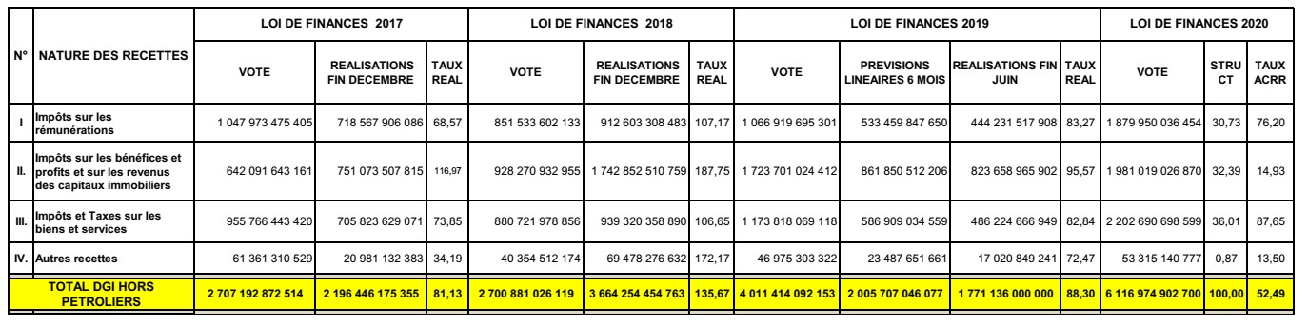

Summary table of non-tax revenues set out in the Budget Act of 2020

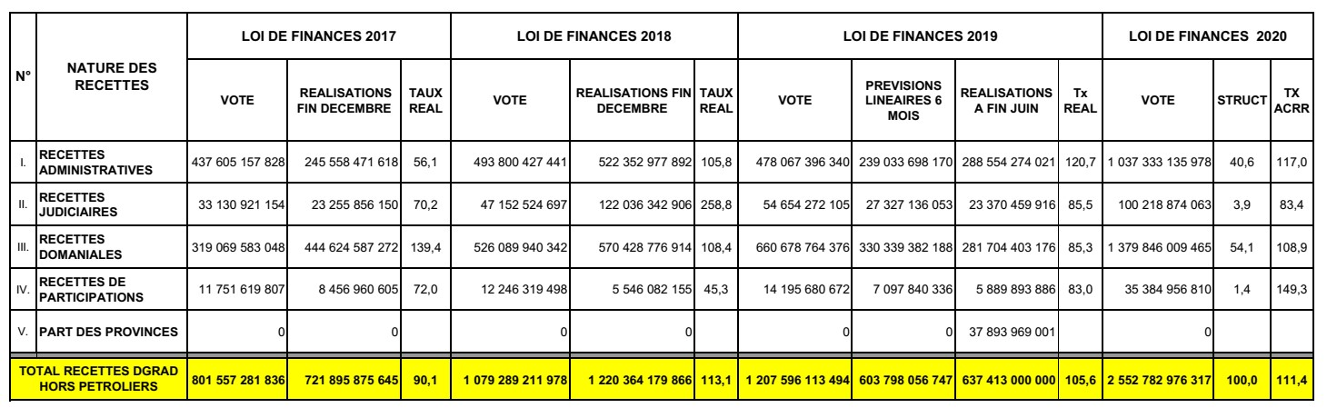

Mining sector revenues set out in the Budget Act of 2020

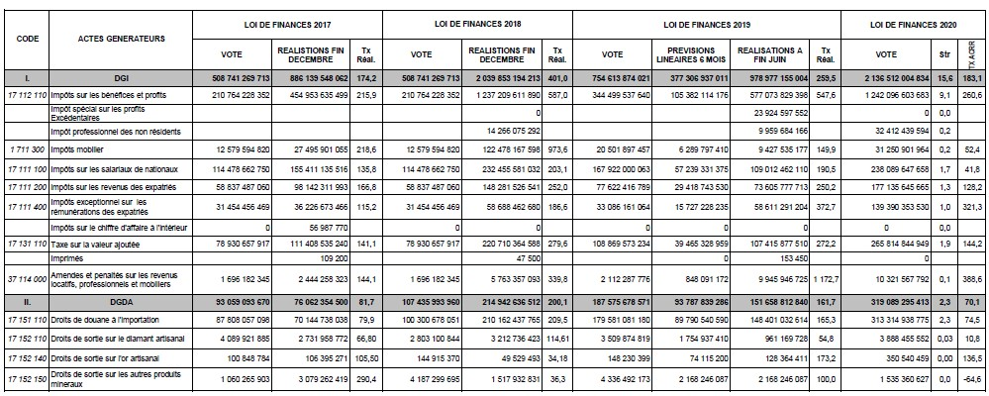

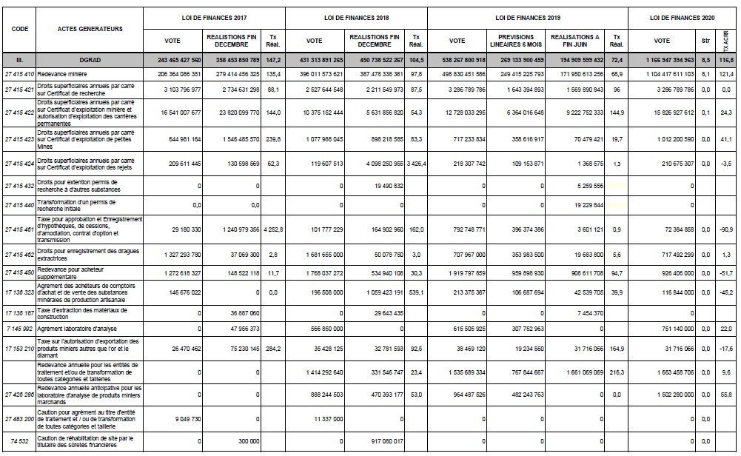

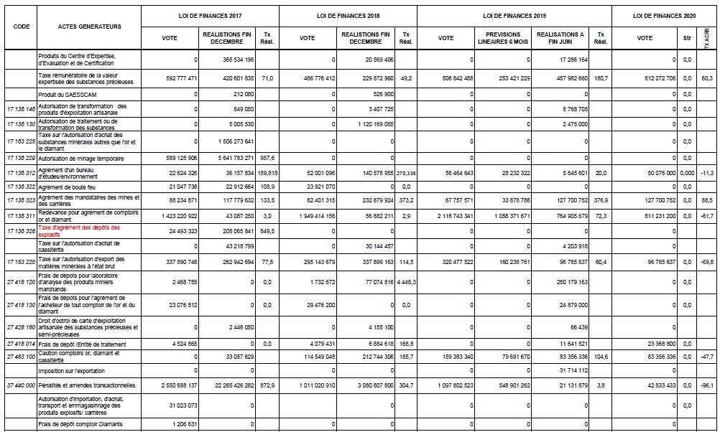

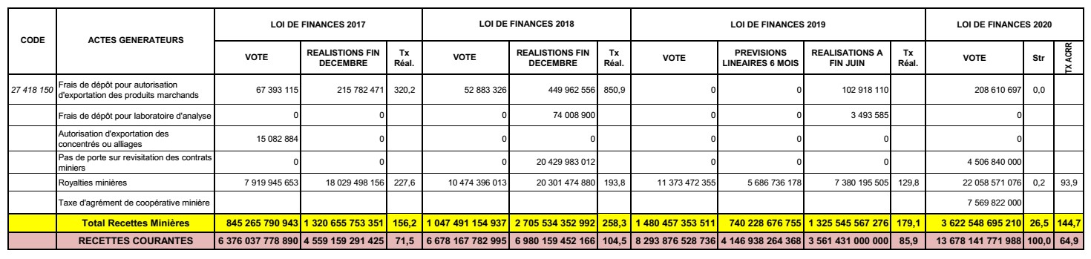

Reply to the questions raised in paragraph 9 (c)

33. The rates of tax on corporate profits and on personal income stand at 35 per cent, while value added tax (excluding taxes on luxury items, tobacco, alcohol, sugared drinks and snacks, and fuel) stands at 16 per cent. The percentage of total revenue generated from the personal income tax levied on the richest decile of the population (wealth tax) is not relevant to the Democratic Republic of the Congo.

Reply to the questions raised in paragraph 9 (d)

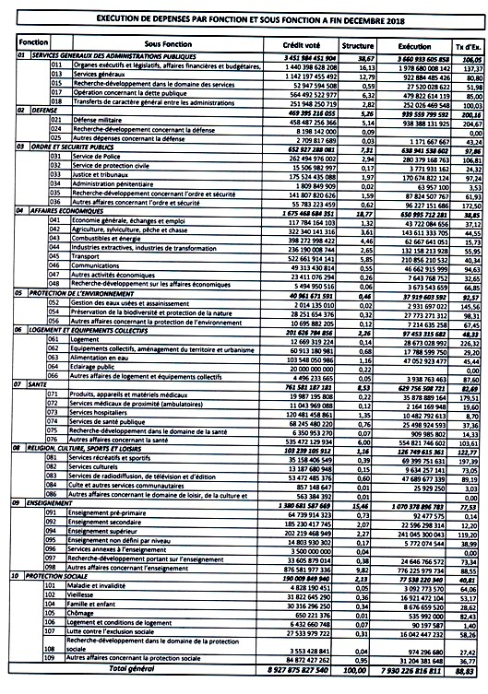

Reply to the questions raised in paragraph 9 (e)

34. Summary of expenditure by main functions:

| *Main function* | | *Amount (Congolese francs (CGF))* | *%* |
| --- | --- | --- | --- |
| 01 | General public services | 6 376 654 528 976 | 37.02% |
| 02 | Defence | 640 607 987 028 | 3.72% |
| 03 | Public order and safety | 1 024 754 003 906 | 5.95% |
| 04 | Economic affairs | 3 017 669 103 214 | 17.52% |
| 05 | Environmental protection | 93 525 055 600 | 0.54% |
| 06 | Housing and community amenities | 193 721 185 349 | 1.12% |
| 07 | Health | 1 682 370 938 949 | 9.77% |
| 08 | Religion, culture, sports and recreation | 223 022 535 784 | 1.29% |
| 09 | Education | 3 559 383 499 551 | 20.66% |
| 10 | Social protection | 413 539 208 932 | 2.40% |
| **Grand total** | | **CGF 17 225 248 047 289** | |

Reply to the questions raised in paragraph 9 (f)

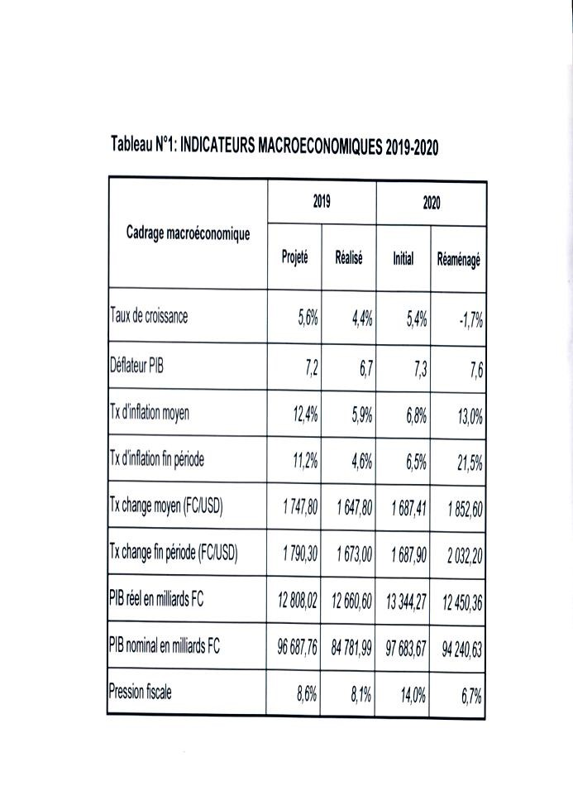

Reply to the questions raised in paragraph 10

35. With regard to the impact of the fight against corruption, the Government is making great efforts to mobilize revenue. The services responsible have collected more revenue than in previous years, thanks in particular to the actions of the General Inspectorate for Finance.

36. The number of individuals prosecuted for corruption has increased. A number of cases have been initiated and a compilation of relevant case law is being produced.

37. Generally, the penalties handed down for the various forms of corruption are removal from office, loss of civil and political rights, and imprisonment. By way of example, high-profile legal proceedings have been brought against the Chief of Staff of the President of the Republic and other senior officials for corruption and misappropriation of public funds, as well as against the Director of the air transport authority and officials of the Societé des transports du Congo.

Reply to the questions raised in paragraph 11

38. In the Democratic Republic of the Congo, all persons, including members of disadvantaged groups, enjoy economic rights. In that connection, the Head of State has decreed that free primary education should be available to all children, without exception. Social workers representing the Ministry of Social Affairs provide assistance to vulnerable groups in the areas of health, justice and education by issuing certificates of poverty, which give the holders access to those services.

39. The Government has created the post of junior minister responsible for persons with disabilities and vulnerable groups.

40. Where access to water is concerned, the Government’s efforts to drill for water in remote areas are supported by partners such as the United Nations Children’s Fund (UNICEF), the World Bank Group and the Social Fund of the Republic.

41. In order to improve support for persons with disabilities and ensure that they do not have to resort to begging, the Government allocates CGF 30,000,000 each to a number of local non-governmental organizations.

42. The Government is not yet considering adopting comprehensive legislation providing for protection against discrimination in all areas.

Reply to the questions raised in paragraph 12

43. The Government protects all persons involved in the mining sector, including women and children.

44. As mentioned above, the Democratic Republic of the Congo strives to adhere to the Voluntary Principles on Security and Human Rights initiative in the extractive industries.

45. A number of measures have been taken to better protect women against violence, including:

• Adoption by the armed forces of the Democratic Republic of the Congo and the Congolese National Police of an action plan to combat sexual violence

• Establishment in the provinces of Congolese National Police units specializing in child protection and prevention of sexual violence

• Appointment of the Personal Representative of the Head of State on Sexual Violence and Child Recruitment

• Strengthening of the “Break the Silence” campaign in 2015 to prevent sexual violence; the campaign was launched in two phases in order to encourage the reporting of rape

• Establishment of an emergency hotline (473333) offering referrals to medical or legal services for victims of sexual violence and any other persons in the country

• Updating of the 2014 text prepared by the Ministry of Justice on the reparation fund for victims of sexual violence, thus enabling the legislature to prepare a proposed amendment of the 2006 laws to include a victim assistance fund and a financial mechanism for compensating victims

Reply to the questions raised in paragraph 13

46. As stated in the report, the Government has established programmes to reduce unemployment as part of the implementation of the Second Generation Growth and Poverty Reduction Strategy Paper. Over the past five years, however, these projects and programmes have failed to make a significant impact. Nevertheless, a number of advances have been made, including the validation of the National Employment and Vocational Training Policy Paper, the National Action Plan to Combat the Worst Forms of Child Labour and the Youth Employment Action Plan.

| *Indicator* | *2003* | *2012* | *2016* | *Index* |
| --- | --- | --- | --- | --- |
| Persons of working age (millions) | 29 182.2 | 43 456.3 | 43 334 | 1.48 |
| Persons not in the workforce (millions) | 8 213.3 | 13 892.9 | 14 415.8 | 1.48 |
| Actual workforce (millions) | 20 968.9 | 29 563.4 | 28 947.1 | 1.76 |
| Employed persons (millions) | 15 028.8 | 24 292.1 | 24 223.7 | 1.38 |
| Unemployed persons (millions) | 5 940.1 | 5 271.3 | 4 723.4 | 0.80 |
| TC-employment (overall evolution, %) | 100.0 | 161.6 | 161.2 |  |
| TC-employment (relative evolution, %) | 100.0 | 161.6 | 99.7 |  |
| *Indicator as %* | *2005* | *2012* | *2016* | *Index* |
| Formal employment rate | 9.4% | 11.5% | 14.4% | 1.53 |
| Informal employment rate | 89.6% | 87.5% | 86.6% | 0.94 |
| Unemployment rate (Lu1%) | 28.3% | 17.8% | 16.1% | 0.57 |
| Lu1% unemployment rate (men) | 14.1% | 12.9% | 12.7% | 0.90 |
| Lu1% unemployment rate (women) | 42.3% | 22.9% | 19.8% | 0.47 |
| Unemployment rate 15–24 years | 44.6% | 35.6% | 31.3% | 0.70 |
| Lu2% (35h) | 74.2% | 52.9% | 66.9% | 9.90 |
| Lu2% (men) | 57.2% | 67.5% | 59.9% | 1.05 |
| Lu2% (women) | 90.9% | 60.1% | 74.5% | 1.22 |
| Proportion of salaried workers | 11.6% | 16.3% | 16.4% | 1.41 |
| Proportion of workers holding multiple jobs | 19.0% | 19.2% | 19.4% | 1.02 |

*Source*: Directorate of Studies and Planning/Employment, database of 1-2-3 surveys and the questionnaire on basic indicators of well-being (2016), National Institute of Statistics.

Reply to the questions raised in paragraph 14

47. Through the monitoring mechanism of the General Labour Inspectorate, the State ensures that the national minimum wage provides workers and their families with a decent standard of living. The labour inspectors and monitors recently deployed in the field to monitor the implementation of labour and social security laws and regulations found that employers had committed a number of violations.

48. There is a shortage of labour inspectors across the country. To overcome this problem, the Ministry of Labour has begun the process of recruiting 1,000 labour inspectors and monitors. This initiative is awaiting the approval of the Ministry of the Budget. As discrimination in the workplace does not exist in the Democratic Republic of the Congo, the State has no plans to strengthen legal protection in this area.

Reply to the questions raised in paragraph 15

49. The Congolese State has taken many measures to enable informal production units to formalize their activities. These measures include establishing a one-stop shop for setting up businesses, reducing the time needed to set up a business, strengthening the National Agency for Investment Promotion and establishing an authority for regulating insurance.

Reply to the questions raised in paragraph 16

50. The measures taken to ensure respect for workers’ rights to just and favourable conditions of work in the mining sector include the steps taken by the Ministry of Mines to raise awareness of Act No. 16-010 of 15 July 2016 amending Act No. 15-2002 on the Labour Code and Act No. 18/001 of 9 March 2018 amending and supplementing Act No. 007/2002 of 11 July 2002 on the Mining Code.

51. The State does not plan to strengthen legal protection against discrimination in the workplace because, in reviewing certain articles of the Labour Code, it took a number of measures to combat all forms of discrimination related to gender, income and access to employment.

Reply to the questions raised in paragraph 17

52. Pending the reform of Act No. 17/002 of 8 February 2017 setting out the fundamental principles relating to mutual insurance and welfare funds, which is aimed at progressively extending social protection to the entire population, the forms of social assistance available to the most disadvantaged and marginalized groups are public health care for the vulnerable and lower cost care for the destitute, including through the National Social Security Fund clinic in the commune of Kalamu. It also covers the distribution of food to older persons’ homes and orphanages. Furthermore, the Ministry of Social Affairs, Humanitarian Action and National Solidarity makes efforts to coordinate social assistance programmes.

Reply to the questions raised in paragraph 18

53. The implementation of the 2017–2020 three-year action plan has brought about a significant reduction in the number of children working in artisanal mines. The introduction of free primary education has enabled many children who had been working in the mines to return to school.

Reply to the questions raised in paragraph 19

54. On the question of synergy in combating sexual violence, medical facilities providing free care for victims are operational in various provinces of the country, particularly in the east. Panzi Hospital in Bukavu, renowned for the work of Dr. Denis Mukwege, the Nobel Peace Prize laureate, is one such facility. In Kinshasa, victims receive psychological care at the Saint Joseph Hospital in Limete and the Roi Baudouin Hospital in Kimbanseke. Under the “Tupinge Ubakaji” project, integrated multisectoral service centres in the east of the country (North Kivu and South Kivu provinces) provide survivors with four types of care (medical, psychosocial, socioeconomic and legal) in one place. The joint programme to combat gender-based violence, entitled Justice, Empowerment and Dignity for Women and Girls in the Democratic Republic of the Congo, is now operational in Kinshasa and Kasai Central provinces.

Reply to the questions raised in paragraph 20

55. Compared to previous development plans, the National Strategic Development Plan is based on the following five lines of action:

• Enhancing human capital and social and cultural development, with a view to promoting social inclusion as part of inclusive growth; all the main social actors, including households, companies, young persons, women, nationals and foreign nationals, must be involved in the realization of growth and the distribution of its benefits;

• Strengthening good governance, restoring State authority and consolidating peace in order to establish the conditions for achieving the three elements of inclusive growth;

• Consolidating economic growth and diversifying and transforming the economy in order to prioritize sectoral inclusion by combining sectors with strong growth potential (mining, hydrocarbons, metallurgy, etc.) and those with high job creation potential (forestry, food and cash crops, agribusiness, etc.);

• Planning land use and reconstructing and modernizing infrastructure, giving priority to activities that structure the territory of the country through the establishment of transport routes and other types of infrastructure (signage, fibre optics, water and electricity production plants, etc.);

• Protecting the environment, combating climate change and promoting sustainable and balanced development in order to promote social inclusion by grouping together actions that ensure the sustainability of development; this line of action involves activities that mitigate the effects of climate change and promote adaptation to changes that are already happening (floods, erosion, landslides, heat, drought, etc.).

56. The priority accorded to the lines of action is consistent with the rationale behind the National Strategic Development Plan. First, a form of governance is established that is conducive to laying the groundwork for inclusive growth through sustainable human development, in accordance with the Sustainable Development Goals. Then, steps are taken to diversify the economy and undertake land-use planning.

Reply to the questions raised in paragraph 21

57. The specific measures taken by the State to adapt to climate change, some of which are targeted at households and individuals whose livelihoods depend on natural resources, include the National Action Programme for Climate Change Adaptation – Women and Children Adaptation Project and the Project to Strengthen Women and Children’s Resilience and Capacity to Adapt to Climate Change.

58. The National Action Programme for Climate Change Adaptation – Women and Children Adaptation Project is a community-based adaptation project that focuses on the needs of women and children in four provinces of the Democratic Republic of the Congo, namely, Haut-Katanga, Kongo Central, Kwilu and Lomami. This project capitalizes on and strengthens the achievements of the former National Action Plan for Climate Change Adaptation – Agricultural Sector Adaptation Project, which was implemented from June 2010 to December 2013 in the same target areas.

Reply to the questions raised in paragraph 22

59. In addition to the measures described in the report, plans are in place to take other measures to ensure the progressive realization of the right to housing, including in rural areas. These measures include the promulgation of laws and regulations on the protection of private property, the restructuring and renovation of residential buildings, the reconstruction and rehabilitation of private housing owned by the State, and the updating and drafting of urban development plans and local development plans specifically drawn up for any site that is to be occupied. The Ministry of Urban Development and Housing is also aiming to promote the extension of towns by restructuring roads and housing and revitalizing towns and villages by connecting dispersed hamlets, land consolidation and resolving problems of customary governance.

Reply to the questions raised in paragraph 23

60. Statistics will be published on the progress made since the promulgation of Act No. 15/026 of 31 December 2015. UNICEF supports the Government by supplying quality water, sanitation and hygiene kits for emergency situations and under specific programmes. In this connection, the National Healthy School and Village Programme was launched. Under the Programme, 10,145 villages and 2,626 schools have been certified as healthy. In 2019, more than 8 million people had improved access to water supplies, sanitation and hygiene services while more than 1 million children had access to a healthy school environment, which improved attendance rates. The Programme includes a component related to hygienic health-care centres, which was implemented in 11 of the country’s 26 provinces in order to incorporate the minimum required standards on water, sanitation and hygiene. The Government has developed a strategy on water, sanitation and hygiene for all in order to improve the low level of access to these resources.

61. The Government is using rural hydraulics systems to create water boreholes in order to ease the financial burden on households in certain rural areas.

Reply to the questions raised in paragraph 24

62. With regard to the impact of the national sanitation policy on the improvement of waste and wastewater treatment and sanitation in urban areas of the country, it should be noted that a State agency reporting to the Ministry of Planning has established a mechanism for coordinating the sanitation sector and that a study of the institutional framework of the sanitation sector in the country has been conducted. The Government also receives financial support for certain sanitation projects.

63. The sanitation tax is aimed at ensuring the sustainable financing of sanitation services. In this connection, tax proposals have been put forward at the central government level while taxes that take into account vulnerable or disadvantaged groups have been established at the provincial level.

Reply to the questions raised in paragraph 25

64. Outcomes in this area have resulted from the commitment and joint financing established by the Government and its main technical and financial partners (the Global Fund to Fight AIDS, Tuberculosis and Malaria, the United States President’s Emergency Plan for AIDS Relief, the World Health Organization, UNICEF and the Joint United Nations Programme on HIV/AIDS). The various programmes and plans, including the National Health Development Plan and the National Strategic Plan on HIV for 2016–2020, have made it possible to coordinate efforts more efficiently. According to the National Health Accounts Programme (2019), the Government increased the funding allocated to fighting HIV/AIDS and other sexually transmitted diseases from $83.5 million to $188 million (i.e. by 125.3 per cent) between 2013 and 2017. This subcategory of infectious and parasitic diseases receives the second highest level of budget spending allocations by category of disease.

Reply to the questions raised in paragraph 26 (a)

65. The provision of supplies is coordinated under the National Programme for Combating HIV/AIDS and Sexually Transmitted Infections with support from the National Drug Supply Programme, the Global Fund to Fight AIDS, Tuberculosis and Malaria and the President’s Emergency Plan for AIDS Relief.

66. The inputs that the country needs to combat these diseases are quantified in the National Programme for Combating HIV/AIDS and Sexually Transmitted Infections. The two technical and financial partners make purchases in accordance with their respective mechanisms.

Reply to the questions raised in paragraph 26 (b)

67. The administrative provinces of the Democratic Republic of the Congo have been classified according to HIV prevalence, population size, the proportion of persons living with HIV who receive antiretroviral treatment, the tuberculosis detection rate, level of multidrug resistance (to tuberculosis drugs) and level of response to the epidemic. These different parameters were incorporated into an Excel tool, which made it possible to identify nine provinces that require high-impact intervention. The provinces in question are Haut-Uélé, Kinshasa, Bas-Uélé, Ituri, Kongo Central, Maniema, Kasai Oriental, Haut-Katanga and North Kivu.

Reply to the questions raised in paragraph 26 (c)

68. Under the National HIV/AIDS Strategic Response Plan, free antiretroviral drugs are provided to patients and free testing is carried out in order to alleviate the financial burden of treatments on households.

Reply to the questions raised in paragraph 27

69. Awareness-raising campaigns are aimed at significantly increasing the availability of mental health services, particularly at the community level. In areas affected by conflict, persons with mental illnesses are referred to the nearest health centres and are generally taken to the Neuropsychological Pathological Centre in Kinshasa and the Katuambi Centre in Kananga, in the province of Kasai Central.

Reply to the questions raised in paragraph 28

Increasing the education budget

70. Within the framework of the Global Partnership for Education, African States committed themselves to increasing expenditure on education to 20 per cent of their budget from 2018 and maintaining it at this level to finance the education of millions of marginalized children.

71. Consequently, the Democratic Republic of the Congo was required to progressively increase the budget allocated to education from 2018 to 2020. This budget rose from CGF 1,524 billion (17.06 per cent of the national budget) in 2018 to CGF 1,754.3 billion (18.26 per cent of the national budget) in 2019 and then to CGF 3,394.2 billion (18.30 per cent of the national budget) in 2020.

72. This increase is reflected in the funding allocated to the primary, secondary and technical education subsector, which rose from CGF 1,104 billion (2.36 per cent of the national budget) in 2018 to CGF 1,202.3 billion (12.51 per cent of the national budget) in 2019, and then to CGF 2,941.4 billion (15.86 per cent of the national budget) in 2020.

73. The efforts made by the State in this sector are tangible and have made it possible to raise teachers’ salaries, pay unpaid teachers and allocate operating costs to schools and administrative offices.

74. Free basic education was introduced for the 2019/20 school year and has enabled more than 4 million children to be included in the education system. However, the following points are still to be addressed:

• The numbers of students to be catered for in view of the lack of infrastructure to accommodate them

• The inclusion of newly recruited teachers on the payroll

• The improvement of the quality of education and the social and professional conditions of teachers

Policy on expanding access to public preschool education, especially for the most disadvantaged and marginalized groups

75. The “programme 1” component of the Plan for the Sectoral Strategy for Education and Training (2016–2025), which concerns preschool education, is aimed at developing quality preschool education in State-owned facilities in rural areas, taking into account the most disadvantaged and marginalized groups in order to promote the acquisition of knowledge at the primary level.

76. In order to achieve this goal, the Government plans to carry out the following measures by 2025:

• Provide infrastructure and equipment to accommodate 15 per cent of children aged from 3 to 5 years

• Equip all State schools and community learning centres with games and materials in order to improve learning conditions

• Promote school enrolment among the most disadvantaged and marginalized rural populations by establishing preparatory classes for 5 year olds in rural and peri-urban primary schools

• Improve the training, supervision and working conditions of teachers

• Progressively establish preparatory classes in primary schools for 5-year-old pupils in order to prepare them for primary education

Security in schools located in conflict zones

77. The Democratic Republic of the Congo is one of the first countries where a specific analysis of the direct risks that schools face as a result of conflict has been conducted. This analysis, which formed part of an assessment of the country’s education system, drew attention to the following points:

• Primary school completion rates in conflict-affected provinces are consistently lower than the national average. This can be explained by interruptions in schooling caused by population displacements; the closure, destruction or looting of schools; deaths in the family; and the enlistment of children in the armed forces.

• The majority of children who are not in school live in the conflict-affected provinces (2.7 million out of 3.5 million). A significant proportion of schoolchildren living in the most affected areas and localities do not feel safe on their way to school. In 2016, in order to address this situation and mitigate the risks related to insecurity, the Government set up a risk-management unit to define strategies for preventing and modifying risk and incorporating risk prevention into the Government’s programme.

• Peace education programmes have been routinely incorporated at all levels of the education system.

• The collection of data related to the conflict has been strengthened in order to improve the planning of interventions.

• Steps have been taken to strengthen collaboration between the national education cluster and the central services of the Ministry of Primary, Secondary and Technical Education, as well as between the provincial level clusters and the decentralized services.

Mitigation of the disproportionate impact of conflict on girls’ access to education

78. The problem of primary school-age children not being enrolled in school appears to be largely confined to rural areas. According to a 2012 study of children and adolescents who are not in school, the percentages of boys and girls who do not attend school are quite similar, at 17 per cent and 19 per cent, respectively, in urban areas, but 30 per cent and 32 per cent, respectively, in rural areas. A total of 3.5 million children aged between 6 and 11 years are not in school (26.7 per cent of the age group). Of these children, the vast majority (around 1.36 million girls and 1.39 million boys) live in rural areas.

79. In order to remedy this situation, the Government plans to carry out the following measures:

• Conduct awareness-raising campaigns to encourage girls to attend school

• Reduce the cultural barriers to education

• Practise a positive discrimination policy to promote girls’ access to education by waiving fees and awarding scholarships

• Remove the financial barriers to girls’ schooling

• Combat insecurity and violence directed at girls in schools

• Discourage early and forced marriages of girls and hostile attitudes towards girls

Reply to the questions raised in paragraph 29

80. The overall aim of technical education is to raise the general educational level of young persons in the country and to provide the skilled workers necessary for economic development by offering quality training tailored to the needs of companies. However, technical and vocational education are hampered by the fact that training courses are not tailored to the needs of the market and fail to attract sufficient numbers of students owing to underlying problems, including the unsuitability of programmes, the limited interaction with economic actors and companies, and the lack of infrastructure and equipment. The Government is making efforts to improve the situation.

Reply to the questions raised in paragraph 30

81. The bill on the protection and promotion of the rights of indigenous peoples has been passed by the National Assembly. It is now being considered by the Senate.

1. * The present document is being issued without formal editing.