|  |  |  |  |
| --- | --- | --- | --- |
|  | United Nations | CED/C/ECU/Q/1/Add.1 | |
| _unlogo | **International Convention for  the Protection of All Persons  from Enforced Disappearance** | | Distr.: General  23 February 2017  English  Original: Spanish  English, French and Spanish only |

**Committee on Enforced Disappearances**

**Twelfth session**

6-17 March 2017

Item 6 of the provisional agenda

**Consideration of reports of States parties to the Convention**

List of issues in relation to the report submitted by Ecuador under article 29 (1) of the Convention

Addendum

Replies of Ecuador to the list of issues[[1]](#footnote-1)\*

[Date received: 13 February 2017]

I. General information

Reply to paragraph 1 of the list of issues

1. The Constitutional Court made an explicit decision in judgment No. 006-09-DTI-CC, case No. 004-09-TI, of 14 May 2009, in which Rafael Correa, President of Ecuador, submitted the Convention to the Court, so that, in keeping with its responsibilities, it could carry out a prior review of the Convention’s constitutionality.[[2]](#footnote-2) The Court’s judgment stated:

“(…) the full Court decides:

to issue a favourable ruling on constitutionality and, therefore, to declare that the full text of the International Convention for the Protection of All Persons from Enforced Disappearance is wholly compatible with the Constitution of Ecuador;

to urge the National Assembly to adopt, within a reasonable time frame not to exceed 365 days, a law to prevent, control, punish and provide redress for enforced disappearance; or, alternatively, to make the necessary changes to the Criminal Code.

The purpose is to strengthen the concept of a constitutional State governed by the rule of law and keep Ecuador from incurring liability internationally. The Court is aware of the set of laws that, to that end, must currently be adopted by the Legislation and Oversight Committee. Accordingly, the time frame for the preparation and promulgation of the law or reforms mentioned shall begin once the new National Assembly is seated.”[[3]](#footnote-3)

2. The Constitutional Court carried out the corresponding substantive and material review of the Convention, as a result of which it found that the Convention was consistent with the Constitution of Ecuador. The Court held as follows:

(a) Formal review:

“In this case, and as explained above, article 419 (3) of the Constitution is applicable to the International Convention for the Protection of All Persons from Enforced Disappearance, and therefore before it is ratified by the President it must be approved by the Legislation and Oversight Commission, which is temporarily discharging the duties of the National Assembly.”[[4]](#footnote-4)

(b) Substantive review:

“(…) the material content of the Convention, with regard to the case provided for in article 419 (3) of the Constitution, is consistent with the rights and obligations established in the Constitution and with a number of international instruments ratified by Ecuador. Thus, for example, article II of the Inter-American Convention on Forced Disappearance of Persons (…).

(…) In these circumstances, the plenary session of the Constitutional Court for the transition period, drawing on the present constitutional review, not only finds that the Convention is compatible in form and substance with the Constitution but also enjoins the Ecuadorian State and the National Assembly in particular to fulfil the obligations arising from the ratification of international treaties or instruments. Thus, in the case under consideration, this Court is of the view that the relevant criminal offence must be defined in order to penalize enforced disappearance, if for no other reason than to ensure that the International Convention for the Protection of All Persons from Enforced Disappearance does not become yet another instrument ratified by the Ecuadorian State but not yet implemented.”[[5]](#footnote-5)

3. In the González (Fybeca) case, which originated on 19 November 2003 in Guayaquil, there were two trials, No. 003-2016, for the offence of kidnapping in the form of enforced disappearance, and No. 1631-2013, for the offence of extrajudicial execution. On 16 December 2014, after an oral hearing, the Criminal Guarantee Court of the special chamber for criminal offences, military and police criminal offences and traffic contraventions of the National Court of Justice acquitted J.F.P.Z., E.A.S.M., D.A.Y.M., H.A.F.M., R.M.Ll.A. and L.A.S.Ch. were found guilty, as perpetrators, and given sentences of 16 years’ extraordinary rigorous imprisonment, while C.P.A., D.A.S.F., L.G.C.R., D.S.C.R. and M.O.V.A. were given 2-year sentences for acting as accessories.

4. It is thus the case that the provisions of the Convention are invoked in case law in Ecuador. The Constitutional Court’s decision means that the courts have the authority to invoke the provisions of the Convention.

II. Definition and criminalization of enforced disappearance (arts. 1-7)

Reply to paragraph 2 of the list of issues

5. The phrase “thereby preventing the exercise of constitutional or legal guarantees” is not a constituent element of the offence of enforced disappearance but the direct consequence of the offence; that is, the commission of the offence may have involved deprivation of liberty alone, followed by an absence of information or a refusal to acknowledge the deprivation of liberty or to provide information on the whereabouts or fate of the victim. The exercise of constitutional or legal guarantees is therefore not an intentional element necessary for the commission of the offence but a direct consequence thereof.

6. In addition, it is possible to punish the act as described in (b), as it is a continuous and imprescriptible offence, in accordance with article 80 of the Constitution:

“Art. 80 Proceedings and penalties for crimes of genocide, crimes against humanity, war crimes, enforced disappearance or crimes of aggression against a State shall not be subject to statutory limitations. Amnesty shall not be granted in any of these cases. That one of these infractions has been committed by a subordinate shall exempt neither the superior who ordered it nor the subordinate who executed it from criminal liability.”

7. There has not yet been any need for the Constitutional Court to rule on this particular issue, and as a result no uncertainty has arisen around this provision and its scope.

III. Judicial proceedings and cooperation in criminal matters (arts. 8-15)

Reply to paragraph 3 of the list of issues

8. The provisions of the Comprehensive Criminal Code relating to the offence of enforced disappearance are:

* Article 16 (4), which addresses the temporal scope of application, and provides that legal proceedings and punishment for the offence of enforced disappearance are not subject to statutes of limitations.
* Article 73, which states that a person who has committed an offence of enforced disappearance will be granted neither pardon nor amnesty.
* The last paragraph of article 75, which states that the punishment for the offence of enforced disappearance is not subject to statutes of limitations.
* Article 84, which makes enforced disappearance a criminal offence:

“Any State official or other person acting with his or her consent who deprives a person of his or her liberty by any means and subsequently fails to provide information about or refuses to acknowledge the deprivation of liberty or to report on the individual’s fate or whereabouts, thereby preventing the exercise of constitutional or legal guarantees, shall be punished with 22 to 26 years’ imprisonment.”

* Article 89, which defines crimes against humanity:

“Crimes against humanity are crimes committed as part of a widespread or systematic attack against any civilian population: extrajudicial execution, slavery, forced displacement for reasons other than the protection of the displaced population’s rights, unlawful or arbitrary deprivation of liberty, torture, rape and forced prostitution, non-consensual insemination, forced sterilization and enforced disappearance shall be punished with 26 to 30 years’ imprisonment.”

9. Article 9 of the Convention provides that each State party is to take the necessary measures to establish its competence to exercise jurisdiction over the offence of enforced disappearance and likewise to take such measures as may be necessary to establish its competence to exercise jurisdiction over the offence of enforced disappearance when the alleged offender is present in any territory under its jurisdiction.

10. In that regard, articles 14 and 400 of the Comprehensive Criminal Code are in conformity with article 9 of the Convention. In particular, article 14 of the Comprehensive Criminal Code, which deals with the Code’s spatial scope of application, states that its provisions apply to:

“1. Any offence committed within the national territory.

2. Offences committed outside the territory of Ecuador, in the following cases:

(a) When the offence has effects in Ecuador or in places under its jurisdiction;

(b) When the criminal offence is committed abroad against one or more Ecuadorians and has not been tried in the country where it was committed;

(c) When the criminal offence is committed by public officials in the course of their official duties;

(d) When the criminal offence affects rights protected by international law, through international instruments ratified by Ecuador, provided that a case has not been opened in another jurisdiction;

(e) When the offences constitute serious human rights violations, in accordance with the procedural rules set forth in this Code.

3. Offences committed aboard military or commercial vessels or aircraft flying the Ecuadorian flag or registered in Ecuador.

4. Offences committed abroad by Armed Forces personnel, based on the principle of reciprocity.”

With regard to universal jurisdiction over acts not defined as crimes against humanity, article 400 (4), which addresses jurisdiction, states that Ecuadorian or foreign nationals who commit offences against international law or in breach of the rights enshrined in international conventions or treaties in force are subject to the criminal jurisdiction of Ecuador, provided that they have not been prosecuted in another State.

11. The offence of enforced disappearance, as defined in the Comprehensive Criminal Code, appears in the list of offences involving serious violations of human rights and breaches of international humanitarian law, so it is not possible for it to be punished as a related offence not appearing in that list.

Reply to paragraph 4 of the list of issues

12. Under article 60 (6) of the Comprehensive Criminal Code, a court hearing a case of enforced disappearance may, as an alternative to a prison sentence, hand down a punishment consisting of disqualification for an occupation, position or employment, but there is no “suspension from duties or removal from office pending investigation”, since such suspension or removal would be a punishment and a violation of the presumption of innocence enshrined in article 5 (4) of the Comprehensive Criminal Code and article 76 (2) of the Constitution.

13. Article 60 (e) of the National Police Personnel Act, however, states that the status of police personnel is “provisional” when an order to try them has been issued in accordance with the Criminal Codes.

14. In that regard, the Act states:

“Art. 56. Provisional status is the situation in which police personnel are given neither authority nor position and a personnel vacancy is created in the National Police, except in the case provided for in article 58.

...

Art. 58. A member of the force who is given provisional status may not return to active duty, unless he or she, given this status in accordance with article 60 (e), has been acquitted in a final judgment, in which case all the rights to which he or she is entitled shall revert to him or her.”

15. Article 76 (e) and (h) of the Armed Forces Personnel Act states that a member of the military will be assigned to inactive status for reasons that include the following:

“(e) For having been ordered to stand trial for military or ordinary offences, once the order is final;

...

(h) For the good of the service, whether because of the member’s misconduct or professional incompetence, as determined by the corresponding Council (…).”

16. Inactive status is the provisional status in which military personnel may be placed for up to six months, a period during which their power to issue orders and carry out their duties is suspended, pending final discharge.

Reply to paragraph 5 of the list of issues

17. The Programme of Protection and Assistance for Victims, Witnesses and Other Participants in Criminal Proceedings is an inter-institutional mechanism for coordinating the efforts, which are led by the Attorney General’s Office, made by the public sector and civil society organizations with a view to preserving the integrity of victims, witnesses and other participants who are at risk as a result of a public prosecution, at any stage of the proceedings, including the pretrial stage.

18. The Programme protects people as subjects of rights with specific protection needs.

A. Structure

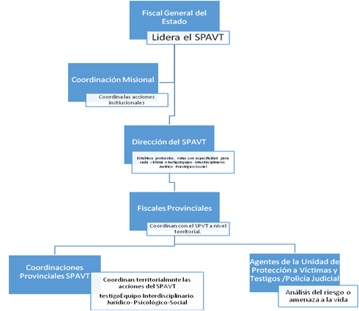

19. The Programme’s implementing regulations derive from articles 195 and 198 of the Constitution and the provisions of the Comprehensive Criminal Code and are based on the principles set out in article 295 of the Organic Code of the Judiciary.

20. Furthermore, the implementing regulations incorporate the provisions of a number of relevant international instruments, such as:

* The Santiago Guidelines on Victim and Witness Protection of the Asociación Interamericana de Ministerios Públicos (Ibero-American Association of Public Prosecutors)
* Convention on the Elimination of All Forms of Discrimination against Women
* Protocol to Prevent, Suppress and Punish Trafficking in Persons, Especially Women and Children, supplementing the United Nations Convention against Transnational Organized Crime (Palermo Protocol)
* Inter-American Convention on the Prevention, Punishment, and Eradication of Violence against Women (Convention of Belém do Pará)
* Declaration on the Elimination of Violence against Women (Vienna, 1993)
* Rome Statute of the International Criminal Court (adopted 1998)
* Convention on the Rights of the Child
* Carta Iberoamericana de Derechos de las Víctimas (Ibero-American Bill of Victims’ Rights)

B. Financial, human and technical resources

21. Article 445 (2) of the Comprehensive Criminal Code provides that the Programme “shall have the necessary resources from the general State budget to be managed efficiently”.[[6]](#footnote-6) At the beginning of each financial year, the Ministry of Finance allocates the annual budget to the Attorney General’s Office, which in turn draws up the budget for the Programme and for each provincial coordination office and the national directorate to ensure that they have the economic resources to provide assistance to victims of crime and cover the Programme’s operating and other costs, as established by the regulations implementing the Programme and by other regulations.

22. In cases of serious upheaval and social significance, the National Directorate for the Programme may approve emerging expenditures necessary to preserve the mental and/or physical health of the protected persons.

23. Current expenditures on the interdisciplinary team that is part of the structure are covered for each administrative unit. The units also have appropriate technology, which has improved the Programme’s information system, thereby ensuring the availability of information for the monitoring and comprehensive assistance of the persons receiving protection, direct and indirect victims of criminal offences.

C. Procedure for admission to the Programme

24. A person enters the Programme at the request of a judge or prosecutor in recognition of a criminal offence reported by that person. The Programme director approves the person’s admission in cases in which urgent protection is required or involving social upheaval,[[7]](#footnote-7) for which he or she has the support of the Directorate’s technical team.[[8]](#footnote-8) The Programme’s provincial analysts may also approve immediate admission.[[9]](#footnote-9)

25. For admission to the Programme, the following elements are considered:

* The substantiated presumption of a real threat to the physical and/or psychological integrity of the applicant, as a result of his or her participation in a criminal case
* The applicant’s condition and the extent of his or her psychological and social vulnerability
* The applicant’s membership in one of the priority groups under the Constitution
* The applicant’s susceptibility to victimization
* The effects of the offence on the welfare of the possible recipient of protection
* The level of risk that participation in the pretrial or trial phases of criminal proceedings entails for the applicant
* The public interest in the investigation and prosecution of the alleged crime as a result of the social upheaval it may cause
* Admission to the Programme, which must be approved in any specific case in which there are situations arising from at least three of these parameters, must be justified.[[10]](#footnote-10)

26. Admission to and continuation in the Programme are voluntary and confidential.

D. Protection and assistance measures

27. Protection and assistance measures include residential security, 24-hour security and part-time security, which are ordered after an analysis of each case, security for local, national and international transfers, security in social rehabilitation centres, a temporary change of a person’s observable characteristics or appearance, the use of new technologies such as the Global Positioning System (GPS), panic alarm buttons, videoconferencing for criminal proceedings, self-protection and other measures deemed necessary, on the basis of the risk report for each case.

28. All measures of special protection and comprehensive assistance should be applied temporarily and are to continue as long as the reasons for which they were adopted obtain. If there is more than one possible measure to take, the measure that is most appropriate and that is also less harmful to or restrictive of rights should be taken.

29. Assistance measures.

| *Assistance measures* | | |
| --- | --- | --- |
| *Psychological assistance* | *Social assistance* | *Legal assistance* |
| A psychological approach is taken before a person enters the Programme, during his or her stay and before he or she leaves; it includes therapy termination.  The aim is to help the protected person to contain and reduce stress levels and redesign and resume a life that was interrupted by the crime he or she experienced. | Social assistance involves providing support and advice to victims, witnesses or families in connection with crisis care, the steps required for training in various subjects, access to public or private social services, access to comprehensive care and contact with the experts of the Comprehensive Care Services — Expert Opinion and Comprehensive Care Unit of the Attorney General’s Office, so that first-hand information may be obtained without secondary victimization. | Legal aid is a free service provided by the Programme; it takes various forms, including the provision of information on relevant judicial or administrative procedures (change of residence, preparation of appeals, notifications, grounds for acquittals and others).  Victims’ concerns are also heard, and the submission of information is coordinated with the Programme’s provincial coordination offices. |

30. The assistance of the Programme is comprehensive, temporary and confidential, with characteristics — preferably those that are less harmful to and restrictive of rights — specific to each beneficiary.

E. Types of assistance provided by the Programme

31. The services provided by the Programme, on a case-by-case basis, are the following: accommodation, food, clothing, education, actions for legal procedures and resettlement, health care, refurbishment of housing and integration into the public sector.

F. Victim and Witness Protection Unit of the Judicial Police

32. The Victim and Witness Protection Unit of the Judicial Police works in coordination with the Attorney General’s Office, whose objective is to ensure a suitable environment for persons receiving protection, so that they may live normally and contribute effectively to the criminal proceedings, thus preventing the crime from remaining unpunished.

33. Criteria used to determine the level of risk.

34. A Varossi matrix, in which vulnerability and profile factors were modified by the Victim and Witness Protection Unit, is used to identify the level of risk.

G. Guaranteeing the persons who are to receive protection and assistance the right to participate in decisions on these measures

35. The provincial analysts should, as appropriate, approve a comprehensive intervention plan that will include the special protection and/or assistance measures deemed necessary.[[11]](#footnote-11) The objectives and reasons for the measures are to be indicated, as is the time frame over which the plan will be carried out. The person or persons receiving protection should be fully apprised of the plan no more than five days after the issuance of the decision to offer admission to the Programme.

H. Guaranteeing that law-enforcement services suspected of having committed the crime are not involved in the protective measures

36. The prosecutor or judge carrying out the inquiry or conducting a trial in a case of enforced disappearance must inform the Programme of police officers who are suspected of being implicated in the offence and are serving in the Victim and Witness Protection Unit, so that steps can be taken for their immediate transfer.

37. It is also possible for an order to be given for protection services to be provided by security agents from the Armed Forces, who will be responsible for ensuring the physical integrity of the protected person and, if appropriate, the family members who are at risk.

38. Persons connected with cases of enforced disappearance who have benefited from measures of protection: in 2015-2016, 12 applicants for protection in connection with enforced disappearance registered with the Programme, seven of them in 2015 and five in 2016.

Reply to paragraph 6 of the list of issues

39. The Attorney General’s Office is aware of a total of 17 victims of enforced disappearance whose cases were documented by the Truth Commission in its 2010 report “Sin verdad no hay justicia” (Without truth, there is no justice), in fulfilment of its obligation to issue reports on enforced disappearances.

| *Restrepo case*[[12]](#footnote-12)  *Volume 3-C64* | *Progress made by the Attorney General’s Office* |
| --- | --- |
| 26 October 2011 | Inspection of the scene. |
| 2-19 December 2011 | Exhumation of remains from 332.48 square metres of burial niches inspected earlier. |
| 29 February 2012 | DNA testing of the skeletal remains exhumed. |
| 31 May 2012 | Inspection of books and records of the San Diego cemetery. |
| 23 October 2012 | Receipt of DNA samples from Pedro Restrepo to compare with human remains. |
| 25 October 2012 | The forensic report concludes: “The genetic profile obtained from several lower teeth taken from zone 1, burial plot J, cannot be that of a biological child of Pedro José Restrepo Bermúdez.” |
| 1 December 2012 | Addition of documentation submitted by the commission of the Ministry of the Interior responsible for the investigation of the Restrepo case (636 pages). |
| 28 February 2013 | Search of the archives of the Judicial Police, leading to the discovery of information on a covert group of the National Police, SIC-10, and making it possible to broaden the scope of the investigation. |
| 2014 | The investigation has been made more comprehensive by consulting the forensic anthropologist José Baraybar and checking the archives and records of the cemeteries of Pichincha and Imbabura Provinces and death certificates provided by the Civil Registry Office, which, together with the statements taken, are making it possible to develop new strategic search parameters that could lead to excavations. In this regard, the non-governmental organization Historical Human Remains Detection was contacted with a view to contracting its services in the search for disappeared persons. |
| 2015-2016 | Multidisciplinary team of civilian status, complying with international standards and generating greater trust among victims and witnesses. |

40. The Attorney General’s Office has pursued two cases in which there are seven victims of enforced disappearance: the González et al. case and the Vaca, Cajas and Jarrín case. In other words, there have been prosecutions in 41 per cent of all cases.

Figure 1

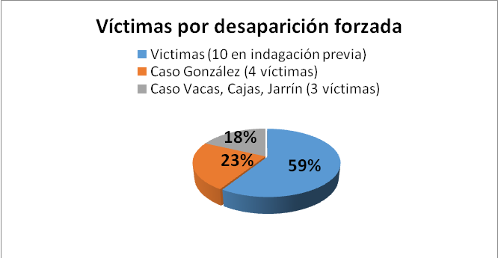

*Source*: *Truth Commission and Human Rights Directorate, December 2016.*

Vaca, Cajas and Jarrín case currently at trial stage

41. The case of Luis Vaca, Susana Cajas and Francisco Jarrín is the first trial for a crime against humanity to be conducted in Ecuador. This trial made it clear that three members of the group ¡Alfaro Vive, Carajo! were illegally detained in Esmeraldas in 1985 and later taken to the School of Military Intelligence Battalion in Conocoto, southeast of Quito, where they were tortured and sexually assaulted.

42. The preliminary investigation began on 30 August 2010.

43. On 1 October 2013, there was an indictment hearing, which led to the criminal investigation, thereby officially starting the procedural phase of the case. It was the first time in Ecuador’s judicial history that high-ranking officers of the Armed Forces and the National Police were prosecuted for crimes against humanity.

44. Between 12 and 21 March 2014, a pretrial hearing in which the National Court of Justice decided to bring the accused to trial was held. The trial order, which highlighted the indiscriminate and systematic character of the assault in question, constituent elements of a crime against humanity, was issued on 30 April 2014.

45. On 29 September 2014, the Court rejected the applications for annulment and an appeal of the trial order.

46. After the corresponding hearing, in a ruling of 1 October 2014, the Court rejected an application to lift the house arrest to which the accused were subject. The Court has scheduled the trial for 3 April 2017.

González et al. case (Fybeca case)

47. On 19 November 2003, at a pharmacy in Guayaquil, eight persons were extrajudicially executed by police officers, and four other persons disappeared.

48. As a litigation strategy, and because of the inherent characteristics of the investigation of serious human rights violations, the case was split into separate proceedings according to the crimes committed. As a result, the investigation into alleged abduction, committed in the form of enforced disappearance, is still ongoing, whereas the extrajudicial executions in the same case were successfully brought before the competent courts. Thirteen persons were sentenced, including six police officers who were given special prison sentences of 16 years. The case of the extrajudicial executions served as the fundamental basis for the investigation of the enforced disappearances of the four persons in the same incident.

49. The indictment hearing for the offence of kidnapping in the form of enforced disappearance, which is a serious human rights violation, was held on 27 June 2016. Fifteen persons were prosecuted, including the then Minister of the Interior and a retired police general. In addition, at the request of the Attorney General’s Office, the national alternate judge ordered that 12 persons be placed in pretrial detention. Three other persons were prohibited from leaving the country and required to report regularly to the competent authorities. Three other persons were later implicated, resulting in the prosecution of 18 persons.

50. One of the four persons who had disappeared after the police operation was located 13 years later, as a result of the efforts of the Attorney General’s Office to investigate the case. The victim, believing that the necessary safeguards were in place, since he entered the Programme of Protection and Assistance for Victims, Witnesses and Other Participants in Criminal Proceedings, returned to the country. On 20 June 2016, the Attorney General’s Office used a Gesell dome to take an advance statement from him.

51. On Wednesday, 24 August 2016, by request of the Attorney General’s Office to the Ecuadorian Navy, six specialized divers were chosen to search the area adjacent to the port maintained by the Guayas Judicial Police for one of the disappeared persons in this case, who was thought to have been thrown into the water.

52. On 6 September 2016, the annulment hearing, during which the steps taken by the Attorney General’s Office were upheld, took place.

53. On 21 September 2016, a hearing at which the prosecution sought an order for two retired police colonels and a general to stand trial was held at the National Court of Justice. The precautionary measures adopted were a prohibition on leaving the country and disposing of property and a requirement to report to the judges every fortnight.

54. On 13 October 2016, a reconstruction of the events was carried out with the international assistance of three experts from the Technical Investigation Corps of the Attorney General’s Office of Colombia. The prosecution’s purpose in organizing re-enactments of the events recounted in each of the statements taken during the investigation is to identify corroborating accounts and contradictions.

55. In a decision of 26 October 2016, an order was issued to close the investigation, and the alternate judge of the National Court of Justice was requested to indicate a date and time for the pretrial hearing.

Reply to paragraph 7 of the list of issues

56. Once the information in the Ecuadorian judicial processing system was checked, it was found that there were no reports of enforced disappearance that involved the constituent elements of the offence (the deprivation of liberty of a person, followed by a lack of information about his or her whereabouts, by a State official or person acting with his or her consent).

57. In addition, according to the records of the Attorney General’s Office, on 7 March 2013, the Office initiated an investigation into the alleged enforced disappearance of José del Carmen Molano Ríos. The incident is still under investigation.

Reply to paragraph 8 of the list of issues

58. The National Directorate for Offences against Life, Violent Death, Disappearance, Extortion and Illegal Confinement (DINASED) is a highly specialized unit of the National Police established, with an administrative and financial structure of its own, by Ministry of the Interior decision No. 3338-A of 19 July 2013.

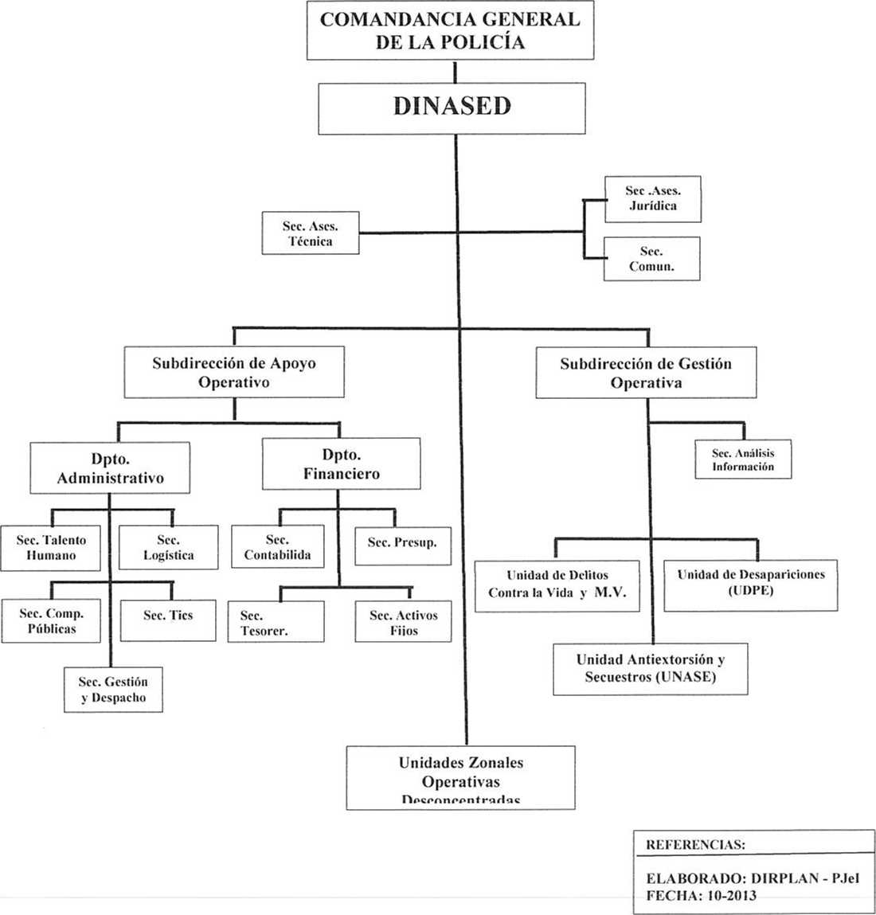

59. The Directorate’s budget, which is allocated by the Ministry of Finance through the General Headquarters of the Ecuadorian National Police, amounted to US$ 1,142,791.47 for 2017.

60. In 2014, 4,382 complaints falling under the Directorate’s jurisdiction were filed, 91 per cent of which were resolved. In 2015, 94 per cent of the 5,424 complaints filed were resolved, and in 2016, 93 per cent were resolved.

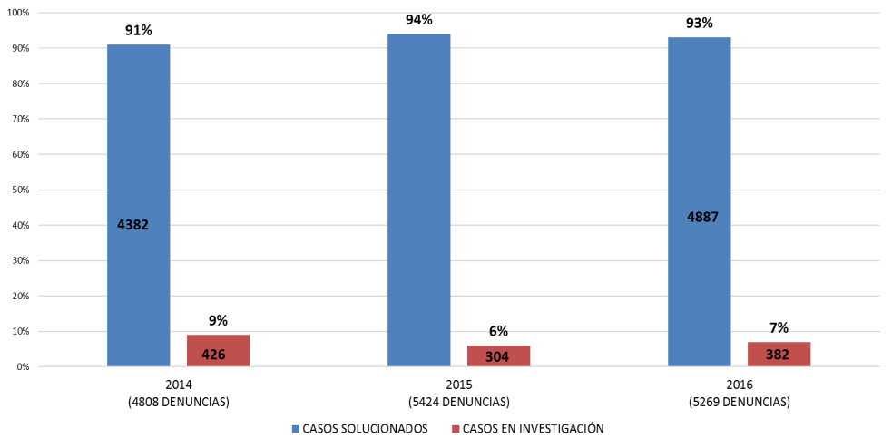

61. The Directorate has a procedures handbook, including a search, investigation and location protocol for disappeared, missing or lost persons, that is based on current national and international law. The Directorate’s members receive yearly training on the contents of the handbook.

62. The Code of Ethics for Judicial Personnel seeks to prevent unethical behaviour that could lead to corruption by judicial officials in the performance of their duties.[[13]](#footnote-13) It also seeks to promote transparency, integrity and efficiency in the activities of the judiciary, with a view to attaining excellence in the provision of judicial services.

63. The ethical principles and values to be promoted are independence, impartiality, integrity, transparency, diligence, respect, training, knowledge and service.

64. Failure to comply with the ethical principles and values established in the Code will be punished as prescribed by the current legal framework and noted in the evaluation of the performance of judicial system personnel.

Reply to paragraph 9 of the list of issues

65. According to information from the computerized treaty-registration system, since the ratification of the Convention, in force since 23 September 2010, the following treaties have been signed:

| *Treaty* | *Signature* | *Status* | *Remarks* |
| --- | --- | --- | --- |
|  |  |  |  |
| Extradition treaty between the Governments of Ecuador and Italy — Code: ITA099 | 25/11/2015 | Not in force, currently being considered by the Constitutional Court. | In article 2, “Extraditable offences”, the offence of enforced disappearance is not mentioned. |
| Extradition treaty between Ecuador and the People’s Republic of China — Code: CHN231 | 11/11/2016 | Not in force, currently being considered by the Constitutional Court. | In article 2, “Extraditable offences”, the offence of enforced disappearance is not mentioned. |
| Draft extradition treaty between Ecuador and the Russian Federation |  | Under negotiation. Submitted to the Constitutional Court for review and analysis. | Article 2, “Extraditable offences”, of the draft treaty states: “3. For the purposes of this article, for the characterization of the offence as such by the laws of both parties ... (b) (1) acts of terrorism; crimes against humanity (…)”. |

66. It should be noted that in the case of signed treaties which do not incorporate article 13 (3) of the Convention, referring specifically to the inclusion of the offence of enforced disappearance, Ecuador should abide, where appropriate, by the multilateral conventions that refer to enforced disappearance, domestic laws, such as the Extradition Act, the Comprehensive Criminal Code and the laws of the requesting States. In that connection, the Constitution states:

“Art. 424 (…) The Constitution and international human rights treaties ratified by the State that recognize rights more favourable than those contained in the Constitution shall prevail over any other legal regulation or act of the public authorities.

“Art. 425. The order of precedence for the application of legal provisions shall be as follows: the Constitution; international treaties and conventions; organic acts; ordinary acts; regional regulations and district ordinances; decrees and regulations; ordinances; agreements and resolutions; and other actions and decisions taken by the public authorities.”[[14]](#footnote-14)

Reply to paragraph 10 of the list of issues

67. A review of the files in the inactive archives of the Attorney General’s Office showed that the three cases are closed.

Case file No. 370-2010-BOES

68. In February 2016, file No. 20161700008851 of 15 February 2016 was referred to Sucumbíos District prosecutor Carlos Ovidio Jiménez Tillaguango by the Colombian Attorney General’s Office, which transferred the proceedings in the case of the alleged abduction of Sharly María Coronado Llanos. The file stresses the difficulty of making progress in the investigation, owing to the time that elapsed between the alleged occurrence of the incident in 1995 and the time when the mother of the victim reported it in 2013 (10 pp.).

Case file No. 162-2012-CERM

69. In July 2012, the Attorney General sent the Colombian authorities a letter with reference to the request concerning the steps taken in the case of the alleged disappearance of the minors Carlos Santiago Restrepo and Pedro Andrés Restrepo. In addition, in July 2012, file No. 20121700043271 of 25 June 2016 was brought to the attention of the Truth Commission’s Special Unit. In the file, the Colombian authorities sent the forensic anthropology report of the Judicial Police, by Jaime Castro Bermúdez (15 pp.).

Case file No. 226-2012-MECM

70. In February 2013, the Attorney General’s Office informed the Truth Commission in writing of the proceedings carried out by the authorities of Peru in connection with the alleged enforced disappearance and extrajudicial execution of Enrique Roberto Duchicela Hernández (14 pp.). With regard to requests for international judicial cooperation, it should be noted that the Attorney General’s Office has requested international assistance in criminal matters in two cases mentioned above (Vaca, Cajas and Jarrín and González et al.) and described in the present report.

71. More broadly, and also valid for the offence of enforced disappearance, in 2015 Ecuador and Argentina signed a bilateral cooperation agreement for the joint and coordinated investigation of crimes against humanity. The agreement provides for the establishment of a joint investigation team, composed of specialized prosecutors from both countries, to collect and analyse information that may contribute to the historical and legal clarification of the crimes against humanity committed in Ecuador and Argentina, in particular those that took place as part of Operation Condor.

IV. Measures to prevent enforced disappearances (arts. 16-23)

Reply to paragraph 11 of the list of issues

72. Article 66 (14) of the Constitution recognizes “The right to move freely throughout the national territory, to choose one’s place of residence and to enter and exit the country freely (...). Foreign nationals may not be returned or expelled to a country where their life, liberty, safety or well-being or that of their family may be in danger (…).[[15]](#footnote-15)

73. Responsibility for deportation procedures lies with judges responsible for hearing cases involving minor offences, who must consider this constitutional provision on issuing a deportation order. The Public Defender Service envisages this situation in the Instructions for the Handling of Cases of Persons in Situations of Mobility and states that the public defender must present the matter at the hearing.[[16]](#footnote-16)

74. The Extradition Act, for its part, states that extradition shall not be granted when, among other situations, the requesting State does not guarantee that the person whose extradition is requested will not be executed or subjected to punishment affecting his or her physical integrity or to inhuman or degrading treatment.[[17]](#footnote-17)

75. The procedure for applying for refugee status in Ecuador begins once an application for such status has been submitted. The application involves the registration of the applicant’s personal data in the information system of the Directorate for Refuge and Statelessness. The applicant is informed of his or her rights and obligations in Ecuador and given details of the procedure for applying for refugee status.

76. If the application is filed within the authorized legal time frame, an interview is conducted to look into the grounds for the request for refugee status and whether the applicant asserts that he or she needs international protection.

77. According to article 19 of Executive Decree No. 1182, all applications for refugee status must go through an admissibility procedure that seeks to distinguish between legitimate applicants with a well-founded fear of persecution and applicants seeking to immigrate to Ecuador for other reasons.

78. Once the application has been found admissible, the applicant is notified so that he or she can be issued with provisional documents until the decision on whether to grant refugee status in Ecuador is taken. To this end, a commission of representatives of the Ministry of Foreign Affairs and Human Mobility, the Ministry of the Interior and the Ministry of Justice, Human Rights and Religious Affairs is set up. It analyses the case files to determine an applicant’s eligibility for refugee status.

79. After that analysis, it decides whether to grant or deny refugee status and proceeds to issue the relevant notification. If the application for refugee status is accepted, a refugee visa will be granted in accordance with article 43 of Executive Decree No. 1182.

80. The Regulations on the Application of the Right to Refugee Status provide for the following methods of appealing denials of refugee status in Ecuador: an application (art. 47), a special application for review (art. 50) and an application for reversal (Statute of Legal and Administrative Rules of the Executive Branch, art. 174).

81. When administrative appeals are exhausted, the person may turn to the competent (administrative litigation) courts, in compliance with the principle of effective judicial protection and the right of petition under the Constitution.

82. Lastly, the principle of non-refoulement is established in articles 2 and 9 of the Regulations on the Application of the Right to Refugee Status.

Reply to paragraph 12 of the list of issues

83. A prison information management system has been set up. Known as the Prison Management System, it makes it possible to have factual information on the formal aspects of a person’s detention, thereby facilitating the management of a prisoner’s release on completion of his or her sentence, the granting of prison privileges and the revocation of measures such as pretrial detention.

84. The following information, listed in article 17 (3) of the Convention, is included in this system:

(a) The identity of the person deprived of liberty;

(b) The date, time and place where the person was deprived of liberty and the identity of the authority that deprived the person of liberty;

(c) The authority that ordered the deprivation of liberty and the grounds for the deprivation of liberty;

(d) The authority responsible for supervising the deprivation of liberty;

(e) The place of deprivation of liberty, the date and time of admission to the place of deprivation of liberty and the authority responsible for the place of deprivation of liberty;

(f) Elements relating to the state of health of the person deprived of liberty;

(g) In the event of death during the deprivation of liberty, the circumstances and cause of death and the destination of the remains;

(h) The date and time of release or transfer to another place of detention, the destination and the authority responsible for the transfer.

85. The Regulations of the National Social Rehabilitation System of the Comprehensive Criminal Code state that the national mechanism for the prevention of torture, the Ombudsman’s Office, is to carry out visits to social rehabilitation centres to monitor conditions and make recommendations to the competent authorities, as set forth in the Optional Protocol to the Convention against Torture and Other Cruel, Inhuman or Degrading Treatment or Punishment. The Office also looks into whether records consistent with the nature of each place it visits are kept. In this regard, for example, it has been found that the information recorded in migrant holding centres is suitable for deportation proceedings. In the case of psychiatric hospitals, on the other hand, health registers, health and medical records in particular, have been examined. Finally, academic records for cadets at military and police academies are kept during their training.

86. In addition, the national preventive mechanism has visited other places, such as shelters for children and addiction rehabilitation clinics, where registers containing information about family reintegration processes or eligibility for adoption and therapeutic treatment have been analysed.

87. With the entry into force of the Constitution of 2008, military and police jurisdiction over places of detention was eliminated; as a result, there is currently no one in detention in military facilities.[[18]](#footnote-18)

Reply to paragraph 13 of the list of issues

88. Article 31 of the Regulations of the National Social Rehabilitation System states that facility staff must record the information mentioned above at the time of a person’s admission to a place of deprivation of liberty.

89. Article 77 of the Constitution, one of the instruments safeguarding the freedom of persons involved in criminal proceedings, establishes a series of guarantees designed to prevent and eliminate the possibility of a person’s being deprived of his or her liberty without an order from the competent authority.

90. The mechanisms adopted in this regard are: the use of pretrial detention only in exceptional circumstances; the prohibition on a detained person’s entering a place of deprivation of liberty without a written order from a competent judge; the right to be informed of the reasons for the deprivation of liberty; the prohibition of incommunicado detention, the right to a defence, the use of alternatives to deprivation of liberty; detention in duly authorized social rehabilitation centres; and immediate release on established legal grounds.

91. The Ministry of Justice, Human Rights and Religious Affairs, as the lead agency of the National Social Rehabilitation System and the institution responsible for the implementation and oversight of the human rights of persons deprived of their liberty, has established procedures designed to prevent unlawful deprivation of liberty.

92. Those procedures include the implementation of the Prison Management System, which makes it possible to have factual information on the formal aspects of a person’s detention, thereby facilitating the management of a prisoner’s release on completion of his or her sentence, the granting of prison privileges and the revocation of measures such as pretrial detention.

93. Swift and efficient procedures, based on the receipt of release orders, have been developed to manage the release of detainees from social rehabilitation centres. The procedures are monitored starting with notification of the orders in the Ministry’s mailboxes.

94. In addition, there is an electronic legal mailbox to which release orders are delivered for electronic signature, making it possible to shorten release processing times and thus to act in accordance with article 12 (15) of the Comprehensive Criminal Code, which states:

“Immediate release: prisoners shall be released as soon as they have served their sentence or been granted amnesty or a pardon, the sole requirement being presentation of a release order issued by the competent authority. Any public servants who delay compliance with this provision shall be removed from their posts after an administrative inquiry, without prejudice to any ensuing civil or criminal liability.”[[19]](#footnote-19)

95. The measures and procedures mentioned have enabled the social rehabilitation system to safeguard the rights of persons deprived of their liberty who are scheduled for release. There have been no enforced disappearances of persons in custody in the social rehabilitation centres.

Reply to paragraph 14 of the list of issues

96. Chapter V (“On detention procedures”), section 3, of the Manual of Investigative Procedures of the Attorney General’s Office and the Judicial Police states that immediately after their arrest, detainees shall be informed of their constitutional rights and the reasons for their detention,[[20]](#footnote-20) the identity of the police officer or officers carrying out the detention, their right to remain silent, their right to request the presence of a lawyer and their right to contact a family member or any person of their choice.

Reply to paragraph 15 of the list of issues

97. In the four years since the establishment of the national mechanism for the prevention of torture, visits have been made to various places, including centres for juvenile offenders, military academies, migrant holding centres, shelters and psychiatric hospitals. The particular focus, as shown in the following table, is on correctional facilities:

| *Type of place visited* | *No.* |
| --- | --- |
| Men’s and women’s social rehabilitation centres (including centres for both sexes) | 27 |
| Regional social rehabilitation centres | 3 |
| Centres for adolescent offenders | 11 |
| Military academies | 3 |
| Police academies | 3 |
| Migrant holding facilities | 2 |
| Pretrial detention facilities | 6 |
| Shelters | 5 |
| Detention centres for traffic offenders | 2 |
| Psychiatric hospitals | 2 |
| Temporary court holding areas for persons arrested in flagrante delicto | 1 |
| Hospitals for comprehensive elder care | 1 |
| Addiction recovery centres | 1 |
| **Total number of places visited** | **67** |

*Source*: Ombudsman’s Office, national mechanism for the prevention of torture (2016)

Places of deprivation of liberty visited, January 2013-December 2016, Quito, Ombudsman’s Office.

98. The protocol for visits by the national mechanism for the prevention of torture was established by Decision No. 96 of 1 September 2015, signed by the Ombudsman. The Decision defines the process to be followed before, during and after the visits and the methods whereby the national preventive mechanism and the various actors from the Ombudsman’s Office are to coordinate their work.

99. It should be stressed that the places of deprivation of liberty and the military and police academies have been willing to receive the visits of the national preventive mechanism.

Budget allocation — National Directorate for the National Mechanism for the Prevention of Torture

| *Date* | *Staff remuneration — National Directorate for the National Mechanism for the Prevention of Torture* | *Budget allocated to the Office of the Ombudsman of Ecuador — National Directorate for the National Mechanism for the Prevention of Torture* |
| --- | --- | --- |
| Budget as of 31 December 2014 | US$ 183 894.82 | US$ 18 136.53 |
| Budget as of 31 December 2015 | US$ 174 238.55 | US$ 21 038.80 |
| Budget as of 31 December 2016 | US$ 200 080.69 | US$ 10 565.00[[21]](#footnote-21) |

*Source*: Ombudsman’s Office, National Finance Directorate and National Planning Directorate (2016), Quito, Ombudsman’s Office.

100. The budget for 2017 will be extended — that is, the resources allocated will be the same as in 2016.

101. The bill on the Ombudsman’s Office contains the articles related to the prevention and prohibition of torture and to the operations and areas of responsibility of the national preventive mechanism. It was submitted to the National Assembly, and the report analysing the bill for an initial debate was adopted on 24 September 2014.

Reply to paragraph 16 of the list of issues

102. In accordance with Comprehensive Criminal Code, transitional provision No. 17, the Council of the Judiciary began providing training in the legal provisions of the Code to judges, prosecutors and public defenders. Tools, including methods, curricula, case studies and supporting material that is disseminated through the virtual platform of the Judicial Training College, were developed.

103. The main subjects include crimes against humanity, infringements of the right to equality and crimes against the inviolability of life. A section on enforced disappearance is included in the coverage of crimes against humanity.

104. E-learning and face-to-face methods, involving simulation and role playing, are used. The process includes a quantitative final assessment, in accordance with the criteria established by the Judicial Training College. A total of 1,195 judges had been trained by 2014.

105. The Ministry of Defence, through the Directorate of Human Rights, Gender and International Humanitarian Law and the decentralized Human Rights Departments of the Army, Navy and Air Force, carries out the task of raising awareness among members of the Armed Forces of respect for domestic and international human rights standards, such as those in the International Convention for the Protection of All Persons from Enforced Disappearance.

106. Similarly, the Prison Security Corps, as part of the Ministry of Justice, Human Rights and Religious Affairs, is made up of officers who are responsible for maintaining order and control in places of deprivation of liberty and ensuring the custody and security of persons serving sentences for criminal offences.

107. The training of the prison officers who work in the country’s places of deprivation of liberty is based on the public policy on higher education, meaning that, after 3,200 hours of training, each officer candidate graduates with an upper-level degree in prison security.

V. Measures to provide reparation and to protect children from enforced disappearance (arts. 24 and 25)

Reply to paragraph 17 of the list of issues

108. The State’s efforts to banish impunity have involved not only criminal cases but also commemoration, with the goal of ensuring comprehensive redress for victims. Accordingly, there have been prosecutions in two cases involving seven victims of human rights violations, and action has been taken to provide symbolic redress to ensure that such violations do not occur again.

109. The recognition of truth and the reconstruction of memory are among the main drivers of the struggle of the victims of human rights violations and their relatives, and it is against that backdrop that the initiatives below have been taken.

110. Seminars: workshops with victims of serious human rights violations and crimes against humanity. In 2014 alone, more than eight workshops with victims and their relatives, which elicited their impressions and understanding of comprehensive redress, were held in several provinces of the country.

111. The “Truth, Justice and Redress” seminar, with the Facultad Latinoamericana de Ciencias Sociales, (Latin American Faculty of Social Sciences), which covered themes that cut across the prosecution of international crimes, such as (i) truth, (ii) justice and (iii) redress.

112. A step towards full redress in connection with the case of González et al. (Fybeca case): a plaque honouring the victims in the case and their relatives for their unwavering pursuit of truth and justice was unveiled outside the Office of the Attorney General of the Province of Guayas.

113. The mural “Grito de la memoria” (Cry of memory), a work of art located in public space on two of Quito’s main thoroughfares, is a tribute to the victims of serious human rights violations and crimes against humanity of Ecuador and Latin America. The mural is a means of stimulating memory and an ongoing search for truth and justice, not an end.

114. The round table “Peace, Justice and Human Rights”: on 8 December 2016, the Attorney General’s Office, together with the Facultad Latinoamericana de Ciencias Sociales, held the round table “Peace, Justice and Human Rights” to develop a theoretical and practical approach to transitional justice in Colombia and Ecuador and analyse the role of States in combating impunity and providing redress to victims.

115. Plaza de la Memoria: on Friday, 9 December 2016, Human Rights Day, the Attorney General’s Office entrusted the Plaza de la Memoria to the people and to victims. The Attorney General’s Office transferred ownership of 25 per cent of its lot to the city of Quito, so that victims have a place where they can demonstrate, organize and/or observe occasions.

116. The Truth Commission found evidence that there were 17 victims of enforced disappearance, although five later reappeared, before the publication in 2010 of the report “Sin verdad no hay justicia” (Without truth there is no justice).

117. In one case (being handled by the Programme of Protection and Assistance for Victims, Witnesses and Other Participants in Criminal Proceedings), the disappeared person’s family members and the Ombudsman’s Office had signed an agreement for non-material reparation before the person’s reappearance. The four other persons have not contacted the Office’s Redress for Victims Programme, which is voluntary.

118. In the case of seven victims of enforced disappearance, the victims’ family members have not availed themselves of the Programme, either. One of those cases is currently being considered by the Inter-American Court of Human Rights. An approach to the victim’s family members was made, but it did not lead to their participation in the country’s voluntary Redress for Victims Programme.

119. There are four cases involving non-material reparation currently being processed by the Ombudsman’s Office, and the victims are receiving the services provided by the State.

120. There are four cases involving non-material reparation being handled by the Ombudsman’s Office, and the victims are receiving the services provided by the State.

Reply to paragraph 18 of the list of issues

121. As indicated in the descriptions of the cases mentioned above (Restrepo; González et al.; and Vaca, Cajas and Jarrín), the Attorney General’s Office has requested international criminal investigation assistance, such as help in locating disappeared persons through DNA tests or the reconstruction of events, as the case may be. Furthermore, important evidence has been collected from state agencies as a result of two of the searches carried out by the Attorney General’s Office.

* On 28 February 2013, the Attorney General’s Office searched the archives of the Judicial Police, finding information relevant to the cases of enforced disappearance and thereby providing it with additional evidence
* On 26 October 2015, the Attorney General’s Office, with the corresponding warrant, searched the National Police archives relating to the Public Safety Directorate, finding material about cases of enforced disappearance (Gustavo Garzón, Elías López Pita and the Restrepo brothers) and the others being investigated by the Truth Commission and Human Rights Directorate of the Attorney General’s Office

122. The documentation seized is subject to chain-of-custody procedures and will be transferred to the national archives for classification and preservation. The relevant documents will be included in the files to help resolve the cases of human rights violations being investigated by the Attorney General’s Office. They will also make it possible to reconstruct the chain of command when the violations were committed.

Reply to paragraph 19 of the list of issues

123. The report of the Truth Commission suggested that laws be enacted to ensure justice for the victims of the cruel repression of the 1980s and the members of their families. Consequently, on 26 November 2013, the National Assembly adopted the Act for the Reparation of Victims and the Prosecution of Grave Human Rights Violations and Crimes against Humanity that Occurred in Ecuador between 4 October 1983 and 31 December 2008.[[22]](#footnote-22)

124. The Act regulates the provision of full redress for the victims of the serious human rights violations and crimes against humanity that were committed in Ecuador between 4 October 1983 and 31 December 2008 and documented by the Truth Commission.

125. The Ecuadorian State accepts responsibility for the human rights violations documented by the Truth Commission and recognizes that the victims’ rights were flouted. As a result, a programme of redress for victims, through administrative channels, was established. This Programme is run by the Ombudsman’s Office and the victims, their spouses, partners in de facto unions, parents, children, grandparents, grandchildren and siblings have direct access to the reparation measures.

126. In addition, the State has taken action for the family members of disappeared persons through twice-yearly workshops, chaired by the President of the country and involving the participation of various organizations of family members of disappeared persons. The commitments made at these workshops included one to create a comprehensive plan to address cases of disappeared persons, ensure presidential monitoring of such cases, empower the family members of the victims of violent deaths and disappeared persons and strengthen their socioeconomic position, use a 1-800-DELITO hotline, circulate images of disappeared persons, create an online case system, train prosecutors and investigators and hire forensic anthropologists.

Reply to paragraph 20 of the list of issues

127. Under article 46 of the Organic Act on Identity Management and Civil Information, the registration of an adoption requires a decision by a competent judge, who must follow constitutional and legal provisions, and any act or regulatory provision contrary to this provision will be null and void.[[23]](#footnote-23)

128. In addition, article 70 of the Code on Children and Adolescents covers the trafficking of children or adolescents and their removal, transfer or retention within or outside the country by any means for the purpose of illegal adoption or other unlawful activities.

129. Article 107 of the Comprehensive Criminal Code establishes the offence of illegal adoption, which occurs when a person facilitates, cooperates in, arranges, provides transport for, intervenes in or benefits from an illegal adoption. Such a person will be punished by imprisonment of 10 to 13 years.

130. Anyone who, in contravention of the legal procedures for placement or adoption and in order to establish a relationship analogous to a parent/child relationship, induces, by any means, the holder of parental authority to surrender a child or adolescent to another person will receive the same punishment.[[24]](#footnote-24)

131. With these provisions, the State protects children and adolescents from illegal adoption and punishes those who arrange or are otherwise involved in adoptions that could originate in an enforced disappearance.

1. \* The present document is being issued without formal editing. [↑](#footnote-ref-1)
2. Article 438 (1) of the Constitution of Ecuador states: “The Constitutional Court shall issue a prior and binding ruling on constitutionality in the following cases, in addition to those determined by law: International treaties, prior to their ratification by the National Assembly.” [↑](#footnote-ref-2)
3. Constitutional Court of Ecuador, decision No. 006-09-DTI-CC, case No. 004-09-TI, 14 May 2009. [↑](#footnote-ref-3)
4. Ibid. [↑](#footnote-ref-4)
5. Ibid. [↑](#footnote-ref-5)
6. Art. 445 (2). [↑](#footnote-ref-6)
7. Regulations for the Programme for Protection and Assistance of Victims, Witnesses and Other Participants in Criminal Proceedings, art. 33 (2). [↑](#footnote-ref-7)
8. Ibid., art. 10. [↑](#footnote-ref-8)
9. Ibid., art. 45. [↑](#footnote-ref-9)
10. Ibid., art. 38. [↑](#footnote-ref-10)
11. Regulations for the Programme for Protection and Assistance of Victims, Witnesses and Other Participants in Criminal Proceedings, *Registro oficial*, No. 219 (4 April 2014), arts. 41-44. [↑](#footnote-ref-11)
12. Víctimas de tortura, privación ilegal de libertad y desaparición forzada en el año 1988 (Victims of torture, illegal deprivation of liberty and enforced disappearance in 1988), Informe de la Comisión de la Verdad, Ecuador, 2010 (Report of the Truth Commission, Ecuador, 2010), executive summary, p. 478. [↑](#footnote-ref-12)
13. Resolution No. 363-2015 of the National Council of the Judiciary, *Registro oficial*, No. 630 (18 November 2015). [↑](#footnote-ref-13)
14. Constitution of Ecuador, *Registro oficial*, No. 449 (20 October 2008), arts. 424 and 425. [↑](#footnote-ref-14)
15. Constitution of Ecuador, *Registro oficial*, No. 449 (20 October 2008), art. 66 (14). [↑](#footnote-ref-15)
16. Instructions for the Handling of Cases of Persons in Situations of Mobility, *Registro oficial*, No. 727 (6 April 2016), art. 11. [↑](#footnote-ref-16)
17. Extradition Act, *Registro oficial*,No. 152 (30 August 2000), art. 5 (7). [↑](#footnote-ref-17)
18. Constitution of Ecuador, *Registro oficial*, No. 449 (20 October 2008), art. 203 (1). [↑](#footnote-ref-18)
19. Comprehensive Criminal Code, *Registro oficial*, No. 180 (10 February 2014), art. 12 (15). [↑](#footnote-ref-19)
20. Constitution of Ecuador, arts. 76 (7) (g), 77 (7) and 51 (2). [↑](#footnote-ref-20)
21. The budget for operating expenses applies until 20 May 2016. [↑](#footnote-ref-21)
22. *Registro oficial*, No. 143 (13 December 2013). [↑](#footnote-ref-22)
23. Organic Act on Identity Management and Civil Information, *Registro official*, No. 684 (4 February 2016), art. 46. [↑](#footnote-ref-23)
24. Comprehensive Criminal Code, *Registro oficial*, No. 180 (10 February 2014), art. 107. [↑](#footnote-ref-24)