|  |  |  |  |
| --- | --- | --- | --- |
|  | United Nations | E/C.12/SRB/RQ/3 | |
| United Nations logo | **Economic and Social Council** | | Distr.: General  8 June 2021  Original: English  English, French and Spanish only |

**Committee on Economic, Social and Cultural Rights**

**Seventieth session**

27 September–15 October 2021

**Consideration of reports: reports submitted by States parties  
in accordance with articles 16 and 17 of the Covenant**

Replies of Serbia to the list of issues in relation to its third periodic report[1]*

[Date received: 29 June 2020]

Reply to paragraph 1 of the list of issues (E/C.12/SRB/Q/3)

1. Proceedings are often brought before national courts to protect the rights guaranteed by the Pact, but direct reference to the provisions of the Pact is very rare. At the eighth session of the Council for Monitoring the Implementation of UN Recommendations, the initiative of civil society to ratify the Optional Protocol to the Pact was presented. The Council submitted the statement of reasons of the initiative to the competent ministry, with a proposal to consider it and hold a meeting with the CSOs that submitted the initiative.

Reply to paragraph 2 of the list of issues

2. The Law on Free Legal Aid stipulates that the beneficiaries shall be the following entities:

“A natural entity who meets the conditions to be a beneficiary of the right to financial social assistance in accordance with the law governing social protection, or a beneficiary of the right to child allowance in accordance with the law governing financial support to a family with children, as well as members of their family. At the same time, it shall also refer a natural entity who does not meet the stated conditions if, due to the financing of legal aid from their own income, in a specific case, they would enter the group of entities meeting the conditions for the exercise of these rights.”.

3. Also, the following entities shall have the right to free legal aid regardless of financial criteria or citizenship: a child whose right, obligation or interest based on law is decided upon in a procedure before a court, other state authority or public authority; entity against which a security measure of compulsory psychiatric treatment and custody in a health institution or a protective measure of compulsory psychiatric treatment is carried out; entity against which the procedure of partial or complete deprivation or restoration of legal capacity is conducted; entity exercising legal protection against domestic violence; entity exercising legal protection from torture, inhuman or degrading treatment or punishment or human trafficking; asylum seeker in the Republic of Serbia; a refugee, a person under subsidiary protection or an internally displaced person; a person with a disability; a child who is protected by the service of accommodation in the social protection system; children and young people whose social accommodation service has been terminated before the age of 26; adults and the elderly who are placed in a social welfare institution without their own consent; entity exercising the right to determine the time and place of birth in accordance with the law governing non-litigious proceedings and an entity affected by the procedure of forced eviction and relocation in accordance with the law governing housing.

4. This Law stipulates that CSOs can provide free legal aid based on the provisions of the law governing the right to asylum and the prohibition of discrimination, which provides an additional level of protection for these entities. Thus, in addition to the existing level of protection, these entities can now also receive legal assistance from lawyers and legal aid services in local self-government units.

Reply to paragraph 3 of the list of issues

5. The independence of the Protector of Citizens is regulated by the Constitution,[2] as well as the Law on the Protector of Citizens.[3] Also, the confirmation of independence is the status of the National Human Rights Institution (NHRI) re-accredited to the highest “A” status, for the period of 2015–2020.

6. Despite personnel changes and new employees, the offices are in the same premises.

7. In the period from 2015 to 2019, in the field of economic, social and cultural rights, the Protector of Citizens published, submitted and sent: 13 special reports, which also contain recommendations for eliminating shortcomings in the work of bodies so that citizens can freely exercise their rights; 34 legislative initiatives, nine of which were accepted by the competent authorities, 18 not, while seven are still pending; 51 opinion on draft or proposed regulations; 25 opinions; 1,474 recommendations (771/acted upon, 303/not, 400/within the deadline for acting upon it or their action is monitored). The Constitutional Court accepted the initiative and declared the provisions of the Decision on determining the status of the insured and the obligation to pay contributions for pension and disability insurance unconstitutional.

Reply to paragraph 4 of the list of issues

8. According to the SILC[4] survey, the at-risk-of-poverty rate remained unchanged at 28, which is above the EU average (16.7 – 17.1%).

# Table 1 **At-risk-of-poverty rate in the Republic of Serbia 2013 – 2018 (in%)**



*Source*: Eurostat.[5]

9. The ratio of the total income of the population of the richest decile and 40% of the poorest, follows the trend of the at-risk-of-poverty rate, and after the growth that was recorded in the period from 2013–2016 (in 2016, the maximum value of 1.9). In 2018, the 10% of the richest in the total distribution of national income own 1.4 times more than the 40% of the poorest residents.

# Table 2 **The ratio of the total income of the population of the richest decile and 40% of the poorest**



*Source*: Eurostat.[6]

Reply to paragraph 5 (a) of the list of issues

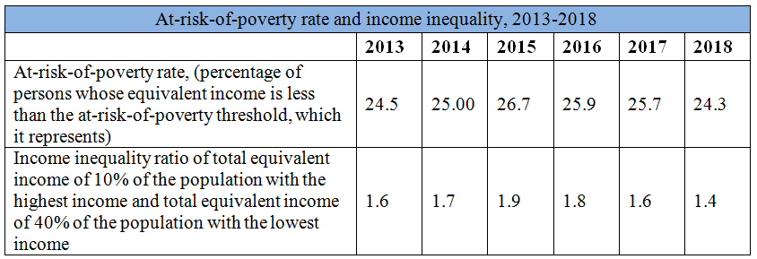

*Source*: SORS, Survey on income and living conditions – SILC.

Reply to paragraph 5 (b) of the list of issues

10. The share of the most acceptable data financed through taxes:

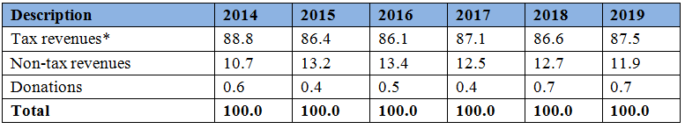

Reply to paragraph 5 (c) of the list of issues

11. In accordance with the Law on Value Added Tax,[7] the supply of goods and services and the import of goods, for which there is an obligation to calculate VAT, texing is carried out at the general or special VAT rate. The general VAT rate, ended with 30 September, 2012, was 18%, and as of 1 October, 2012, it is 20%. The special VAT rate, ended with 31 December, 2013, was 8%, and as of January 1, 2014, it has been 10%.

12. In accordance with the Law on Excise Taxes, [8] the amount of excise taxes on excise products is adjusted once a year with the consumer price index for the previous calendar year, while the amount of excise taxes on cigarettes is adjusted once a year with the consumer price index for the previous calendar year if it is higher than 2%.

13. Amount of excise taxes applicable since 1 February, 2019:

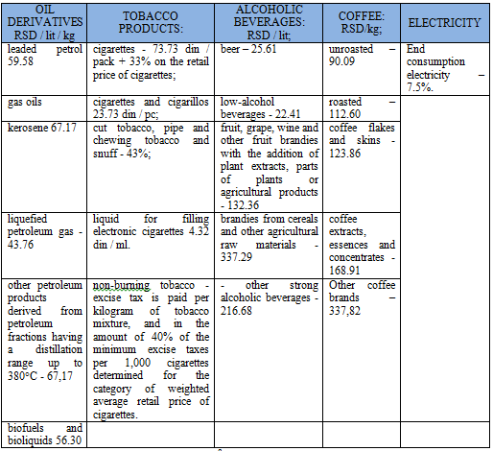

14. Pursuant to the Corporate Income Tax Law,[9] the corporate income tax rate has been 15% since 2013 (2004–2012 it was 10%).

15. In accordance with the Law on Personal Income Tax,[10] certain types of income tax are paid at the following rates:

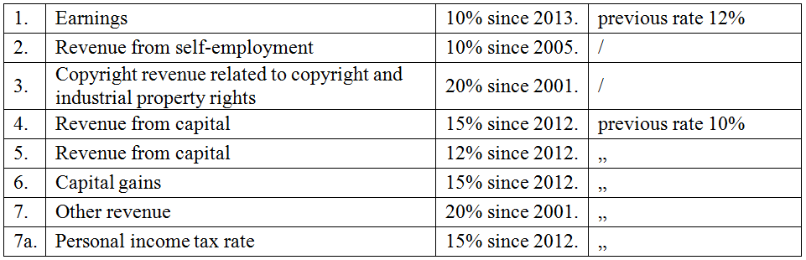

16. Percentage of public expenditures in GDP according to functional classification:

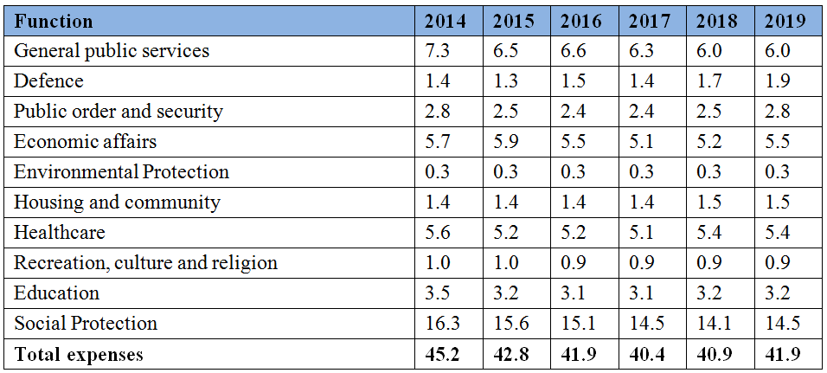

Reply to paragraph 6 of the list of issues

17. The Judicial Academy, in order to raise awareness about the suppression of all forms of discrimination, especially in relation to asylum seekers, women, children and persons with disabilities, deals with topics:

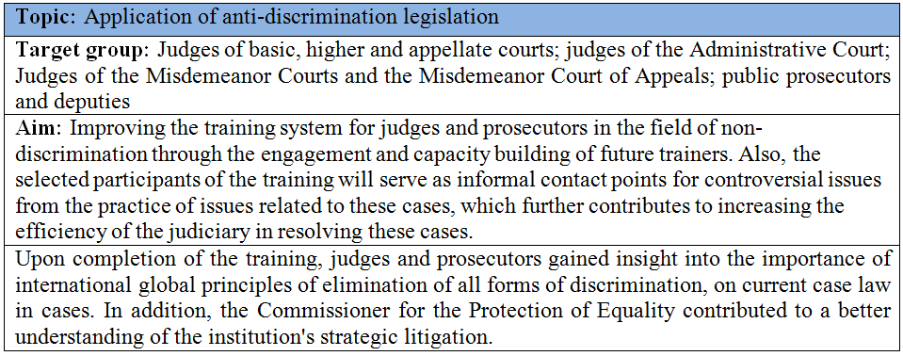

18. Within its IT centre, the Judicial Academy develops a system for cross-linking the provisions of national legislation with the provisions of the European Convention on Human Rights, legal concepts applied by the European Court and its relevant jurisprudence, as well as UN standards and relevant UN conventions.

19. The new segment of the content of the Cross Reference application, which was established during 2018 and 2019, refers to the direct application of UN human rights standards in proceedings before domestic courts. Four areas have been established: asylum and migration; discrimination; the rights of the child and the rights of persons with disabilities. This implies several separate sets of information in the form of excerpts from several relevant UN conventions. They also contain an explanation of the scope of UN standards (in the form of comments, recommendations and conclusions), an indication of the relevant basis for acting in domestic law (provisions of the Constitution, legal provisions and statements from domestic court case law, as well as recommendations, opinions and decisions of independent bodies).

20. The General Training Programme for Civil Servants for 2020, within the area of “Human Rights Protection and Data Secrecy”, contains a training programme dedicated to protection against discrimination and provides knowledge regarding the legal and institutional framework as well as the concept and forms of discrimination, role and competencies of the Commissioner for the Protection of Equality. Training programme entitled Discrimination Before Public Authorities deals with cases when a public authority appears as a potential discriminator, i.e. a person who has acted in a discriminatory manner. Both programmes also contribute to the development of behavioural competences of civil servants.

21. In cooperation with the Ministry of Public Administration and Local Self-Government and the Commissioner for the Protection of Equality, with the participation of the Standing Conference of Towns and Municipalities, 10 regional workshops “Protection against Discrimination – Recognition and Prevention of Discrimination in the Activities of Local Self-Government Units” were conducted.

22. The MoESTD, in accordance with the Action Plan for the implementation of the Education Strategy until 2020, has started work on educational reform. The programmes should provide development of the inter-subject competences, one of which is “Responsible participation in a democratic society”.

23. Within the “Programme of Support of the European Union and the Council of Europe to the Western Balkans and Turkey”, through the project “Promoting Democratic Culture in Schools”, a framework of twenty competences from the Competence Model from the value group, attitude group, skills group, knowledge and critical understanding group was adopted. Schools have organised a number of diverse activities, with pedagogical approaches appropriate for the development of competences for democratic culture and creating a more pleasant, interesting and safer school environment, while strengthening their capacity to eliminate violent, discriminatory and anti-democratic structures in school and school environment and providing support to students. Examples of content that leads to democratic competences can be found in the publication at the link: http://www.mpn.gov.rs/wpcontent/uploads/2019/03/Fostering-a-Democratic-School-Culture-MOESTD-and-COE.pdf in Serbian and English.

24. As a continuation of these activities, the MoESTD, in cooperation with the Council of Europe, is implementing the project “Quality Education for All”. Project activities covered 60 schools.

25. The MoESTD also participates in the Government project “Integrated Response to Violence against Women and Girls in Serbia II” (activity “Gender Awareness, Prevention of Violence and Discrimination in Kindergartens and Schools”), which has a preschool and school component.

26. In the Catalogue of the Programmе of Continuous Professional Development of Teachers, Educators and Professional Associates for the School Year 2018/2019, 2019/2020 and 2020/2021, there are a total of 32 programmеs dealing with human rights. There are seven programmes in the field of improving competences for civic values, and 24 programmes aim to improve capacities in the field of protection against violence and discrimination.

27. In May 2018, the “Instruction with Guidelines for Prevention and Protection Against Gender-Based Discrimination and Discrimination Based on Other Personal Characteristics in the Ministry of Interior of the Republic of Serbia” was adopted. Also, “Handbook for Prevention and Protection Against Gender-Based Discrimination and Discrimination Based on Other Personal Characteristics in the Ministry of Interior of the Republic of Serbia”. In the period of March–May 2019, 9 presentations were given in the regional police administrations for 318 managers.

28. A handbook for trainers and a handbook for trainees covering the topic: “Systemic Integration of Gender Equality into Policing Through the Role of Leaders” were developed. Two two-day seminars were held on the topic” Systemic Integration of Gender Equality into Policing Through the Role of Leaders”, which was attended by 60 managers. In December 2019, the Police Administration for the City of Belgrade held two more presentations attended by 60 managers.

29. In addition to the above activities, topic content related to observance of equality and non-discrimination were implemented, as follows:

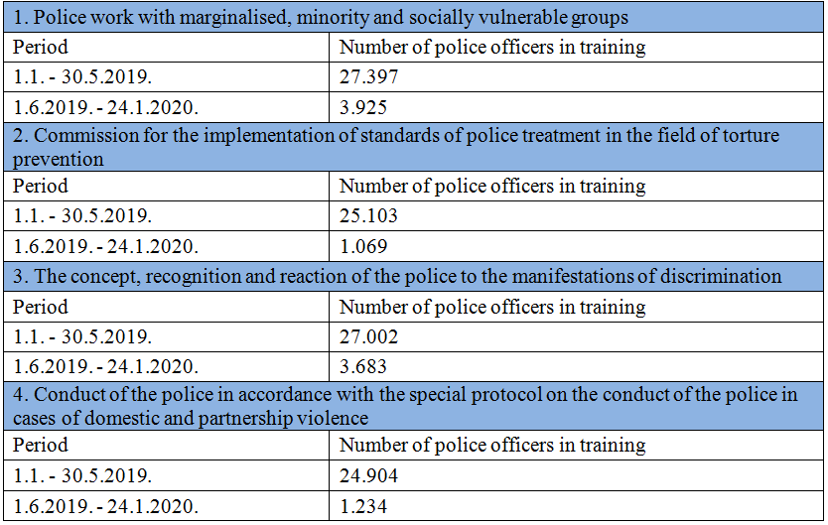

30. Topics related to respect for human rights, inequality, prohibition of all forms of discrimination, as well as prevention of torture and other forms of inhuman or degrading treatment of persons coming from other countries were also implemented, as follows:

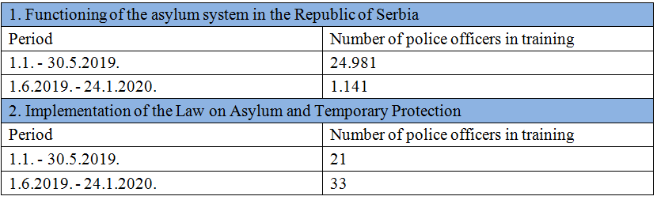

31. In cooperation with the Commissioner for Gender Equality and with the financial support of the OSCE Mission to Serbia, during 2019, four seminars entitled “Recognition and Response to Discrimination” were completed (100 police officers).

32. During October and November 2019, liaison officers with the LGBTI population of the Police Administration for the City of Belgrade, attended the training for trainers for police officers on “Policing Hate Crime Against LGBTI Persons”, organised by the Unit for Sexual Orientation and Gender Identity of the Council of Europe (SOGI), in Madrid and Rome.

Reply to paragraph 7 of the list of issues

33. The Law on Amendments to the Law on Registry Books,[11] the implementation of which began on 1 January, 2019, enables the registration of data on gender reassignment in the birth register. The registration of gender reassignment is conducted on the basis of the decision of the registrar which is made based on the certificate of the competent health institution prescribed by the Rulebook on the Manner of Issuance and the Form of the Certificate of the Competent Health Institution on Gender Reassignment.[12]

34. In March 2018, the Police Administration for the City of Belgrade appointed a female police officer as an officer for liaison with the LGBTI population.

35. In October 2019, within the project “Together for Improving the Status of the LGBTI Community in Serbia” (Labris and the MoI), 100 copies of the Handbook for Police Activities with the LGBTI Population in English were printed.

36. After the complaint of the “Labris” association, referring to the discriminatory content, the MoESTD introduced revised textbooks into the Catalogue of textbooks for the school year 2019/2020.

37. The MoESTD has, on several occasions, pointed out that persons who have changed their name and gender in accordance with legal regulations, acquire the right to new public school documents.

38. The MoESTD provided support in the organisation of pilot research and in-depth interviews/focus groups regarding the examination of general attitudes towards the LGBT population and violence against LGBT students conducted in 3 high schools in Belgrade (Second Secondary School of Economics, Secondary School of Pharmacy and Physiotherapy and Stanković Secondary Music School) which is implemented within the FREE & EQUAL campaign conducted by the UN in cooperation with CSO Labris.

Reply to paragraph 8 of the list of issues

39. The Coordination Body for Monitoring the Implementation of the Strategy for Social Inclusion of Roma Men and Women in the Republic of Serbia for the period from 2016 to 2025 is a mechanism through which policies for Roma inclusion are harmonised, but also their implementation is monitored in practice. As an operational support to the Coordination Body, an Expert Group was formed in charge of all professional affairs related to current issues of social inclusion of Roma men and women. In addition to representatives of the public administration, the Expert Group also includes representatives of the National Council of the Roma National Minority and civil society organisations. Representatives of other bodies and organisations may be involved in the work of the Expert Group in accordance with the needs and topics in focus.

40. Significant mechanisms for the participation of Roma men and women in the implementation of the Strategy at the local level are coordinators for Roma issues, pedagogical assistants (engaged in primary schools and preschools), health mediators and mobile teams.

41. The detailed impact of the Strategy can be seen in the Report, paragraphs 42–53.

42. Continuous support was provided through EU programmes worth about 40 million euros and intended for the inclusion of Roma men and women with the aim of raising the capacity of local governments through the establishment and strengthening of mobile teams[13] and their institutional sustainability, as well as drafting of project documentation for infrastructural improvements and enhanced housing conditions. Projects worth about 26.9m euros are currently being implemented.

43. A new Agreement on Understanding between the Ministry of Public Administration and Local Self-Government, the Protector of Citizens and the UN High Commissioner for Refugees – Representation Office in Serbia was signed for a period of two years on 3 October, 2019. The agreement envisages activities to assess the causes and remaining obstacles that Roma men and women face in practice.

Reply to paragraph 9 of the list of issues

44. Solutions for internally displaced Roma from Kosovo and Metohija who do not have the conditions to return are found through the financing of programmes for improving the living conditions of internally displaced persons. Although members of the RAE population (Roma, Ashkali, Egyptians) make up 10% of the IDP population, they are represented in resolving housing needs in 20% of the total beneficiaries. We would like to emphasise that the data are incomplete because there is no obligation for internally displaced persons to declare their nationality. About 650 IDPs currently reside in the total of 27 informal collective centres. As these are self-initiated occupants with unresolved property-legal relations, the Commissariat did not have the opportunity to conclude the necessary agreements with the owners of the mentioned facilities and include them in the system of official collective centres, but the Commissariat certainly continues to find mechanisms to create conditions for their further closure. When it comes to closing non-formal collective centres, from budget and donor funds, funds were provided for the relocation of Roma from three informal settlements where most Roma IDPs lived (Blaževo/Novi Pazar; Stari Kostolac/Požarevac; South Bypass and “Trmbas” Children’s Resort /Kragujevac; “Karađorđev dom”/Rača; “ES i Remizijana” Hotel/Bela Palanka; “Stara Ciglana”/ Bujanovac and non-formal CC/Sjenica).

45. Since 2016, funds from the Budget of the Republic of Serbia have been provided for solving the housing problem through the purchase of rural households with a garden in the amount of 202,000 euros per year. Implementation is underway, while it is planned to continue finding housing solutions for IDPs in these centres in the coming period.

46. Pursuant to the Law on Amendments to the Law on Registry Books, as of January 2019, registry books have been kept in electronic form. In 2018, 846 requests for subsequent registration of the fact of birth in the birth registry book and 261 proposals for determining the time and place of birth were resolved. As a result of the activities undertaken within the Agreement on Understanding concluded in 2012 between the Ministry of Public Administration and Local Self-Government, UNHCR Serbia and the Protector of Citizens, the problem of exercising the right to enrol in the birth registry, i.e. exercising rights from personal status, has been mainly resolved.

47. In the period from 1 January, 2018 to 31 December, 2019, the Ministry of Interior, in accordance with the Law on Residence and Stay of Citizens and the Rulebook on the Procedure for Registration and Deregistration of Residence and Stay of Citizens, Registration of Temporary Residence Abroad and Return from Abroad, Passivation of Residence and Stay, Forms and Manner of Keeping Records[14] for 853 persons, among whom the majority of members of the Roma population living in informal settlements, determined their residence at the address of the competent centres for social work, after which they were issued personal documents.

Reply to paragraph 10 of the list of issues

48. Officers of the Asylum Office perform official activities in asylum centres on a daily basis, and applicants are able to enter the procedure at any time, as well as to contact the Office with that intention through proxies from CSOs providing provide free legal aid, which is a standard procedure.

49. The Law on Asylum and Temporary Protection prohibits any discrimination on any grounds. It is stipulated that an asylum seeker will be provided with a hearing by a person of the same sex, an interpreter or translator of the same sex, except when this is not possible or associated with disproportionate difficulties for the body conducting the asylum procedure.

50. The asylum procedure takes into account members of vulnerable social groups (minors, persons completely or partially deprived of legal capacity, children separated from parents or guardians, persons with disabilities, the elderly, pregnant women, single parents with minor children and persons who have been subjected to torture, rape or other severe forms of psychological, physical or sexual violence).

51. Persons in the asylum procedure are provided with the right to a free interpreter, free legal aid and free access to the UNHCR during the entire procedure. Also, during the entire procedure, care is taken to protect the best interests of the minor, especially unaccompanied minors.

52. The regular deadline for resolving the request prescribes a deadline of 3 months, which can, for justified reasons, be extended, and the deadline for resolving the deadline is one year from the day of submitting the request.

Statistical data

01.01.2018 – 31.12.2018

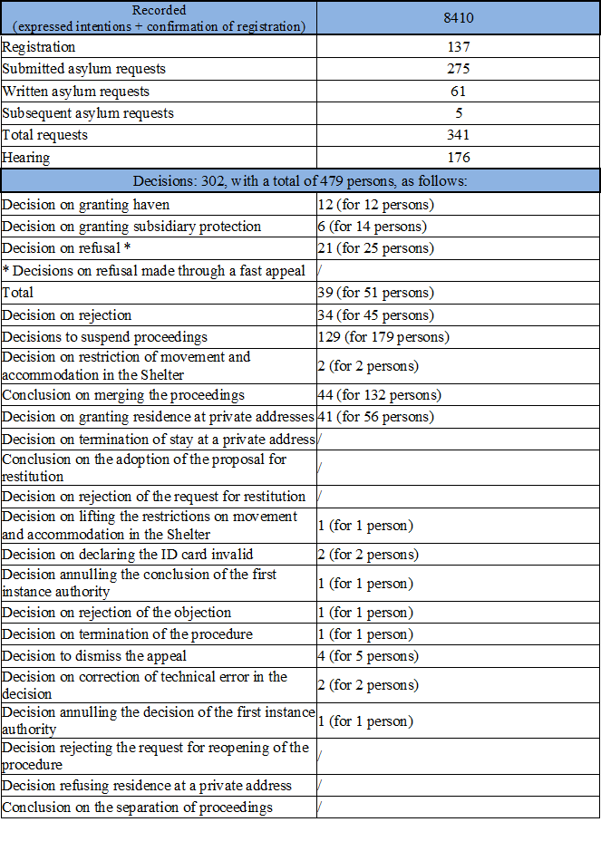

01.01.2018 – 15.06.2018

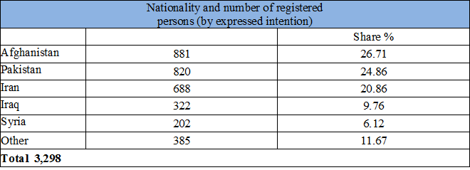

15.06.2018 – 31.12.2018

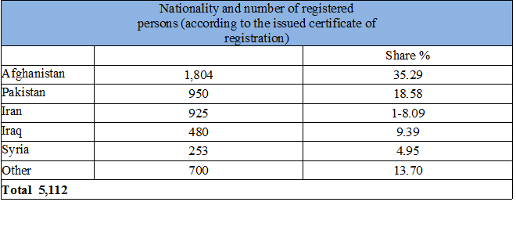

01.01.2019 – 31.12.2019

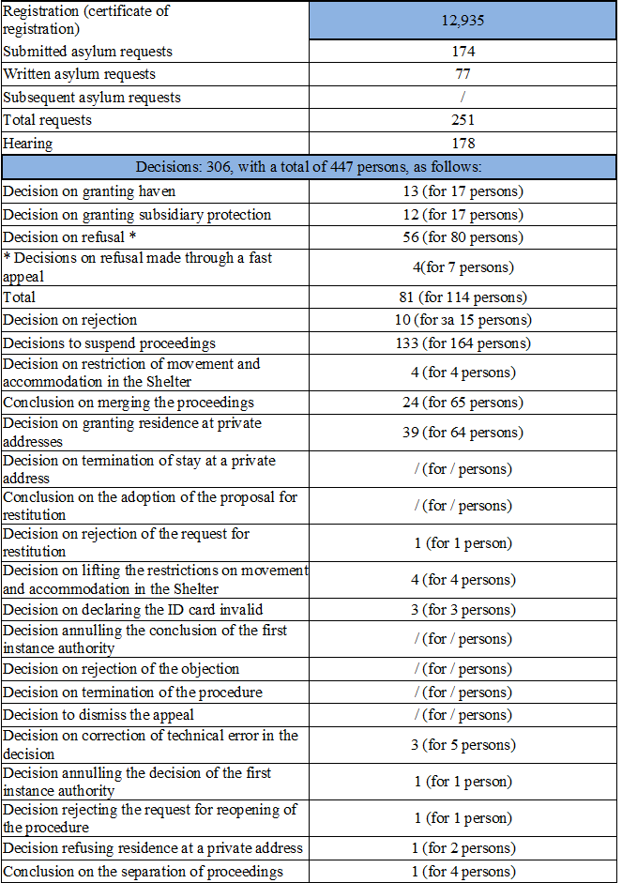

01.01.2019. – 31.12.2019

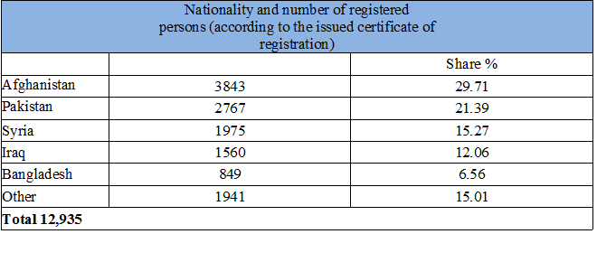

Reply to paragraph 11 of the list of issues

53. In the practice so far, the Republic of Serbia has shown the capacity to adequately and efficiently respond to sudden migration waves, to engage the necessary resources and coordinate the activities of many actors in order to protect its interests and provide the necessary assistance and protect the basic rights of migrants. At the moment, the availability of accommodation capacities is satisfactory. The Commissariat has temporarily put out of operation two transit reception centres due to the rationalisation of funds, while 17 centres are still active.

54. It supports public administration authorities in providing services to the migrant population during 2020 and 2021 in the Project entitled “EU Support to Migration Management in Serbia – Reception and Protection Services”.

55. In addition to accommodation, food, clothing, hygiene, the accommodated persons are provided with appropriate social support in order to prevent conflict, easily overcome uncertainty and train for easier integration/reintegration through educational and occupational activities. In cooperation with CSOs, the centres organise numerous activities for children (sports, art, occupation activities, etc.). In all centres, health care is provided as well as a mandatory examination upon admission to the centre. Persons in a state of special social need are accommodated in social protection institutions. In accordance with the needs of the users, CSW is present. During the accommodation, all available measures are taken in order to maintain the unity of the family (including members of the extended family) and respect the privacy of the person. Rooms for single people are separated by gender. Families with children are housed together. Standard Operating Procedures (SOPs) for the protection of refugee/migrant children have been developed. Immediately upon admission of an unaccompanied minor, the competent CSW is notified. Unaccompanied minors are accommodated in special rooms separated from the rooms where adult singles are accommodated (there are currently 420 of them in three asylum centres). All underage migrants are provided with access to education.

56. Local self-government units near the border, as well as the City of Belgrade, are facing an increased number of migrants, and for this reason their utility services are additionally burdened. In order to maintain the level of tolerance towards the migrant population in these local self-government units, the Commissariat continues to provide direct support to local self-government units affected by the large influx of migrants. Also, the Commissariat continuously allocates significant budget and donor funds for CSO programmes of importance to the population of migrants, asylum seekers, refugees and internally displaced persons.

Reply to paragraph 12 of the list of issues

57. There have been no relevant changes to the Law on Citizenship in the past period.

Reply to paragraph 13 of the list of issues

58. The Gender Equality Coordination Body coordinates the implementation of the National Strategy for Gender Equality 2016–2020 and the accompanying Action plan 2016–2018. In 2018, an evaluation of the implementation of the NAP was conducted, which showed that the most was done in the area of reducing violence against women, and the least in the area related to reducing stereotypes and prejudices and improving the culture of equality. The harmonisation of the second National Action Plan for the implementation of the National Strategy for Gender Equality 2016–2020 is underway.

59. The second Gender Equality Index was developed and presented to the public. Serbia made progress of 3.4 points between the two reporting periods (a shift of 1.2 points at the EU level). In less than three years, Serbia has made almost three times the overall progress, and has not noticed any negative changes in any domain.

60. The introduction of gender responsive budgeting (GRB) has continued. More than 1,012 people employed in the public sector at all levels of government have been trained in the GRB. 255 individual mentoring and information sessions for institutions were conducted. A total of 51 budget users applied the GRB in the budget for 2019 (at the national level 33 out of a total of 40), and at the provincial level all 18. All budget users have the obligation to introduce gender responsive budgeting in 2021.

61. Through IPA 2016 “Key Steps Towards Gender Equality”, by which the EU allocated funds for gender equality in Serbia for the first time, and main implementing partner of which is the Coordination Body for Gender Equality, activities aimed at strengthening mechanisms for gender equality at the local level and support civil society organisations working to improve the economic position of women, improve their position in the labour market, especially rural women, and promote women’s entrepreneurship. Currently, 20 local mechanisms for gender equality in the amount of 83,000 euros and 12 non-governmental organisations in the amount of 345,000 euros are supported in that way. In 2020, support is planned for 4 more CSOs in the amount of 135,000 euros.

62. Also, the project “Let’s Employ 1000 Women in Rural Areas” is being implemented, in cooperation with NALED and Ethno network. Currently, 715 women from the village are employed in this manner. The annual Award for the most gender-sensitive company was also introduced, in cooperation with the Association of Business Women, which was awarded in 2019 for the second time.

63. In January 2018, “Guidelines for the Implementation of Measures for Achieving Gender Equality in the Ministry of Interior of the Republic of Serbia Through the Human Resources Management System” were adopted, which in their introductory part rely on the National Strategy for Gender Equality (2016–2020).

64. Also, in 2019, the Ministry of Labour, Employment, Veterans and Social Affairs conducted a survey on the attitudes of citizens on gender equality, prevention and suppression of violence against women in the family and partnerships. The results show that 58% of respondents answered that gender equality has been achieved in part, 26% of respondents believe that it has not, 14% answered that it has, and 2% of respondents believe that there is a good legal basis that is insufficiently applied in practice to achieve full gender equality.

65. Since the introduction of the National SOS Hotline for Women Who Experienced Violence (0800 222 003), the total number of calls since the establishment until the end of August 2019 was 2,350, of which 1,200 benefited directly from the calls. 80% of callers were women, but also men, who are family members, acquaintances, friends, relatives etc. Eight counselling telephone consultants for violence against women, one person in charge of professional support in the development of competences (individual and group supervision of counsellors) and a service manager work on this SOS telephone.

Reply to paragraph 14 of the list of issues

66. Objectives set by the National Employment Strategy for the period 2011–2020 are operationalised by the National Employment Action Plan, which is adopted annually.

67. The implementation report is submitted to the Government on an annual basis. All reports as of 2018 are available at: https://www.minrzs.gov.rs/sr/dokumenti/izvestaji/sektor-za-rad-i-zaposljavanje. Also, in 2016, a performance assessment was performed for the first five years of implementation with the support of the ILO, the World Bank and the European Commission. The document is available at: https://www.minrzs.gov.rs/sites/default/files/201811/procena_uspesnosti_nacionalne_strategije_zaposljavanja_za_period_2011-2020._godine_za_prvih_5_godina_primene__2011-2015_.pdf

68. During 2018, 152,936 persons from the unemployment register were included in active employment policy measures (AEPM) (which is more than the planned number for 20,736 persons), with an effect on employment and employability of 33.81% (the effects of employment measures are observed six months after the exit of the unemployed person from the measure, so that the effects on employment are not complete considering that certain measures are in progress or the persons have just left the measure). In addition to the above number, and with the support of the project from the IPA 2013 programme cycle, the AEPM (training at the request of the employer – for the unemployed, subsidy for self-employment and subsidy for employment of unemployed persons from the category of hard-to-employ) included 1,896 unemployed persons (943 women), with the impact on employment of 96.20% (1,824 persons).

69. Out of the total number of unemployed persons included in the AEPM, 147,321 persons are from the category of hard-to-employ, which represents a share of 96.33% in the total number of unemployed persons included in the measures. That is, 96.37% with the support of the IPA 2013 project.

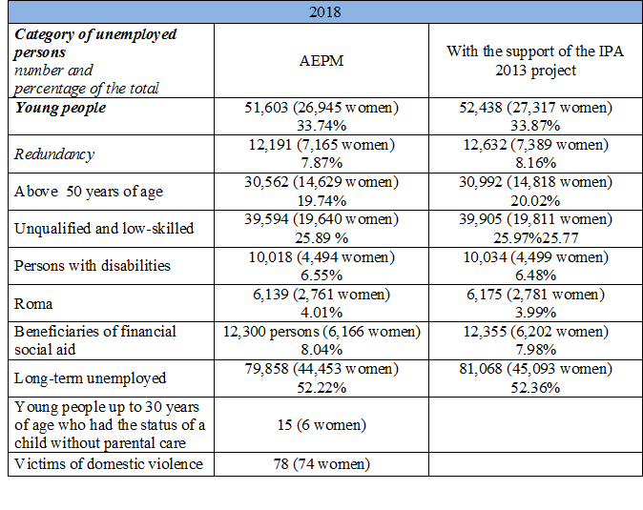

Reply to paragraph 15 of the list of issues

70. According to the data from the Labour Force Survey for the third quarter of 2019, the most favourable values of the employment rate (49.6%) and the unemployment rate (9.5%) were recorded for the population aged 15 and over, since the period when there is a comparable series of data.

71. Within certain AEPM, categories of hard-to-employ persons included in the measure are defined, and in measures within which categories are not defined, priority for inclusion is given to unemployed persons from the following categories: persons without qualifications and low-skilled persons; persons aged 50 and over, long-term unemployed persons looking for a job for more than 12 months, especially unemployed persons seeking a job for more than 18 months, women, especially long-term unemployed women, young people up to 30 years of age, especially young women, young people without qualifications and the low-skilled, as well as young people without work experience; persons with disabilities; Roma; beneficiaries of financial social aid or persons in the status of redundant employees.

72. Also, the AEPM will include: young people in dormitory accommodation, foster and guardian families, victims of domestic violence, victims of human trafficking, refugees and displaced persons, returnees under the Readmission Agreement, single parents, spouses from families in which both spouses are unemployed, parents of children with disabilities, former perpetrators of crimes.

73. The AEPM that will be implemented during 2020 are as follows: employment mediation of job seekers; professional orientation and career planning counselling; additional education and training (internship programme, internship programme for young people with higher education, internship programme for the unemployed with secondary education, programme of acquiring practical knowledge for unskilled persons, redundancies and the long-term unemployed, labour market training, employer-based training for the unemployed and for employees, functional primary adult education and specialist IT training); subsidies for employment of unemployed persons from the category of hard-to-employ persons; support for self-employment; salary subsidy for persons with a disability without work experience; incentives for employment of unemployment benefit beneficiaries; public works; support for persons with disabilities who are employed under special conditions (adjustment of the workplace and work assistance) and co-financing of programmes or AEPM provided through local employment action plans.

74. Pursuant to the Law on Employment of Foreigners, illegal migrants shall not have a temporary residence permit and do not exercise the right to work. In practice, these persons are interested in working on seasonal jobs, but they cannot perform them until they regulate their stay.

75. Persons who have been granted the right to asylum (haven or subsidiary protection), according to the Law on Asylum and Temporary Protection, shall have the right to access the labour market, and the conditions are prescribed by the Law on Employment of Foreigners. Some branches of the National Employment Service exempt the above-mentioned persons from paying the mentioned tax upon request, but there is no uniform practice of all branches.

Reply to paragraph 16 of the list of issues

76. In accordance with the Labour Law, employees shall be guaranteed equal pay for the same work or work of the same value that they perform with the employer, which implies work that requires the same level of education, i.e. education, knowledge and skills, in which equal work contribution is achieved with equal responsibility.

77. The Law on Civil Servants stipulates that every civil servant shall have the right to a salary, allowances and other income according to the law governing salaries in public authorities and prescribes equal opportunities for promotion and remuneration. Also, the Law on Employees in Autonomous Provinces and Local Self-Government Units stipulates that every officer shall have the right to salary, allowances and other incomes according to the law governing salaries in the Autonomous Province and local self-government unit (Article 27) and that they shall have the right to promotion by acquiring a higher rank determined by this law and acquiring a higher salary band determined by the law which regulates the salaries of employees in the autonomous provinces and local self-government units (Article 20).

78. The Law on Salaries of Civil Servants and Public Employees and the Law on Salaries in Public Authorities and Public Services regulating salaries, allowances and other incomes of employees in the public sector, shall apply to the salaries of employees in the public sector. The salary shall consist of the basic salary and the increased salary and contain both taxes and contributions that are paid from the salary on a monthly basis. The basic salary shall be determined by multiplying the base for calculation and payment of salary, which is unique for all employees, by a coefficient, whereby these coefficients shall be determined in the same way for all employees in the public sector, regardless of their gender.

Reply to paragraph 17 of the list of issues

79. In accordance with the Labour Law, an employee shall be entitled to a minimum wage for standard performance and time spent at work. The minimum wage shall be determined: on the basis of the minimum labour price determined in accordance with the Labour Law, time spent at work and taxes and contributions paid from wages. It shall be defined by the decision of the Social and Economic Council, which implies an agreement and respect for the positions of the social partners. If the Social and Economic Council does not make a decision within 15 days from the day of the start of negotiations, the decision on the amount of the minimum labour price shall be rendered by the Government within the next 15 days.

80. The minimum labour price shall be determined for the calendar year, no later than 15 September of the current year, and it shall be applied as of 1 January of the following year and cannot be determined in a lower amount than the minimum labour price determined for the previous year. The following criteria shall be taken into account: existential and social needs of the employee and his family; the value of the minimum consumer basket; employment rate trends in the labour market; GDP growth rates; consumer prices; productivity and average earnings.

81. Determined amounts of the minimum labour price:

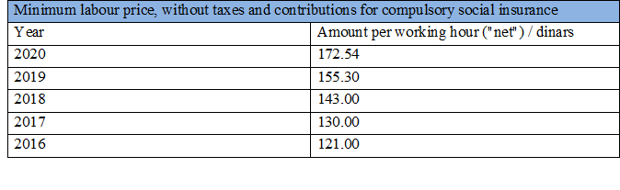

Reply to paragraph 18 of the list of issues

82. In order to draft the Law on strike, the Minister of Labour established a working group that held a total of 19 meetings from March 2016 to March 2018. The working group consisted of representatives of the public administration-line ministries, representatives of social partners-representative trade unions, namely the Federation of Independent Trade Unions of Serbia and the United Branch Trade Unions “Nezavisnost” and the representative association of employers of the Union of Employers of Serbia, professors and experts in this field.

83. At the session held on 19 April, 2018, the Committee for Economy and Finance of the Government determined the Public Hearing Programme on the Draft Law on Strike.

84. The public hearing on the Draft Law was conducted in the period from 20 April to 10 May, 2018, and the text of the Draft Law was posted on the MLEVSA website and on the e-government portal. During the public hearing, remarks, proposals and suggestions were submitted by interested parties via mail to the address of the competent ministry and electronically on: [javnarasprava.strajk@minrzs.gov.rs](mailto:javnarasprava.strajk@minrzs.gov.rs).

85. In May 2018, three round tables were held (in Novi Sad, Niš and Belgrade). In addition to MLEVSA representatives, representatives of: Agency for Amicable Settlement of Labour Disputes, Ministry of Education, Science and Technological Development, Ministry of Interior, Ministry of Health, Commissioner for Protection of Equality, trade unions, employers ‘associations, ILO, citizens’ associations, employers, conciliators and arbitrators, the professional public and other stakeholders.

86. All received proposals were considered and the possibility of their integration into the text of the said draft law was considered, with the aim of improving legal solutions.

87. The draft law on strike, as a protective measure, prescribes the following:

* Organising a strike, i.e. participating in a strike that is in accordance with the law, shall not constitute a violation of work obligations or work discipline, nor can it be a basis for initiating proceedings to determine employee responsibility and cannot result in imposing measures for violation of work discipline, violation of work obligations and termination of employment of the employee;
* The employee who participates in the strike shall exercise the rights from the employment relationship, except for the right to earning/salary and compensation of expenses on the basis of work, and the right to obligatory social insurance shall be exercised in accordance with the law. Exceptionally, employees who are on strike due to unpaid earnings/salaries in accordance with the law shall have the right to earnings/salary;
* An employer may not employ, hire or otherwise replace participants in a strike unless an employee designated to work during the strike to ensure a minimum work process in accordance with this law refuses to work or is absent from work due to temporary incapacity for work, and there are no other employees who, in accordance with the Rulebook on the Organisation and Job Classification or the employment contract, perform the same work or if a court decision determines the illegality of the strike;
* An employer must not prevent employees from organising and participating in the strike or using coercive or threatening measures to end the strike, nor provide for more favourable wages or other more favourable working conditions for employees who do not participate in the strike on the basis of non-participation in the strike.

Reply to paragraph 19 of the list of issues

88. The Law on Amendments to the Law on Social Protection is in the process of obtaining an opinion from the competent department.

89. Each individual user of financial social assistance able to work shall be provided with adequate support through various types of activities: formal and non-formal education, employment, treatment, socially useful work, i.e. work in the local community, etc. in order to actively overcome their unfavourable social situation based on the assessed needs and potentials of the users. The proactive role of beneficiaries of financial social assistance able to work and the opening of opportunities for their activation were emphasised. The law provides for the possibility for CSWs to enter into contracts (individual activation plans) with users for their activation. By-laws will further specify and develop the rules of activation, as well as the cooperation between CSW and NES.

Reply to paragraph 20 of the list of issues

90. The Law on Financial Support to Families with Children prescribes the right to salary compensation during absence from work for the purpose of special child care for employees of legal and natural entities. A new right to other benefits based on special child care has been introduced, which for a child born on 1 July, 2018 and later, can be exercised for the first time by women who are not employed, but independently perform activities, who are owners of an agricultural farm, or employed on the basis of temporary and occasional jobs, work contracts, temporary service contracts or are unemployed at the time of the child’s birth and have not exercised the right to unemployment benefits, and who have worked in a period that affects the exercise of rights, as well as women who are agricultural policy holders. These rights are exercised based on the opinion of the competent commission of the National Pension and Disability Insurance Fund, which examines the child’s health condition and can last up to child`s fifth year of age.

91. Additional support was provided to children with arrested development and children with disabilities because for them this right shall be exercised under more favourable conditions, which include a 20% higher threshold for exercising the right and a 50% higher amount of child allowance. In case of fulfilling the conditions for increasing the amount of child allowance on several grounds, it is prescribed to limit the increase to 80% of the regular amount of child allowance. For children for whom the right to an allowance for assistance and care of another person has been exercised, the right to child allowance shall be exercised regardless of the financial status of the family. Also, the right to reimbursement of the costs of staying in a preschool institution for children with arrested development and children with disabilities has been prescribed.

92. Children from families who have exercised the right to financial social assistance, provided that they regularly attend school, shall also be entitled to child allowance.

93. Also, families with children, beneficiaries of financial social assistance shall be entitled to reimbursement of the costs of staying in a preschool institution, with a decision of the ministry responsible for education on verification, in the amount of the beneficiary’s participation in the price of the service regulated by the decision of a local self-government unit. The right to parental allowance can also be exercised by a mother who is a foreign citizen and has the status of a permanently residing foreigner, for a child born in the territory of the Republic of Serbia.

Reply to paragraph 21 of the list of issues

94. Having in mind the limited budget funds for these purposes, it was not possible to envisage changes in the amount and manner of determining the amount of financial social assistance in the Draft Law on Amendments to the Law on Social Protection.

95. More favourable general and special conditions are envisaged for exercising the right to financial social assistance, which will enable a greater coverage of beneficiaries of financial social aid, so that the following person may exercise the right to the FSA:

* An individual/family if in the past three years (by the current law there is no deadline) they have not sold/donated or renounced the inherited immovable property;
* Able to work individual/family member if in the last 6 months (by the current law there is no deadline) they have not refused employment, participation in public works, active employment policy measures, obligations from the individual employment plan;
* An individual/family member in training, education, retraining in accordance with the individual employment plan (IEP) is equated with a person incapable of work in terms of the duration of the FSA.

Reply to paragraph 22 of the list of issues

96. Eviction from informal settlements is conducted in compliance with the highest international human rights standards. The Law on Housing prescribes when, as well as under what conditions the eviction procedure shall be carried out, legal protection in that procedure, as well as the possibility of moving to appropriate accommodation, if they do not own other real estate for housing or funds to provide other accommodation.

97. Based on the Law on Housing and Building Maintenance, several bylaws have been enacted that are in line with international human rights treaties, in terms of adequate housing and protection during forced evictions. In addition, in order to bring the Law closer to citizens and target groups, a guide was developed – the Law in Pictures (5,000 copies were printed). Eviction from informal settlements is carried out in compliance with the highest international human rights standards. Since 2014, the City of Belgrade alone has taken care of 303 displaced Roma families, or 1,400 people. All persons have the right to give their full and conscious consent to the relocation in advance. None of the residents suffered damage in terms of their human rights, nor was their right to continuous improvement of living conditions violated. All displaced families were entitled to compensation for the loss, collection and transportation of their property affected by the eviction. No displacement of non-formal settlements has resulted in an individual or family becoming homeless.

98. Displaced residents are provided with access to education (enrolment in schools and kindergartens, transportation to school, free textbooks, additional classes in the settlement). In order to improve the overall quality of life in the newly formed settlements, administrative and social protection services are provided (financial social aid, one-time assistance, free meals for all socially vulnerable citizens, presence of social services, etc.), personal documents, public transport, waste removal, settlement maintenance and their surroundings (disinsection, disinfection, deratisation), arrangement of settlements (setting up children’s playgrounds, landscaping of green areas).

99. Able to work tenants in social housing and newly formed settlements were offered a number of jobs – both in city utility companies and in private companies.

100. Through EU programmes, worth about 40 million euros, intended for the inclusion of Roma men and women, continuous support was provided with the aim of building the capacity of local self-government units through the establishment and strengthening of mobile teams[15] and their institutional sustainability, as well as project documentation for infrastructural improvements of the living conditions. Projects worth about 26.9m euros are currently being implemented.

Reply to paragraph 23 of the list of issues

101. We would like to point out that the property tax is regulated by the Law on Property Taxes, and not by the Law on Personal Property Tax, as stated in the question (it has not been changed since 2012).

102. Since the enactment of the Law on Property Taxes (2001), the subject of property tax has been the right to long-term lease of a flat or residential building in accordance with the law governing housing. As of 1 January, 2005, the right to lease a flat or a residential building in accordance with the law governing housing, for a period longer than one year or for an indefinite period, is taxed. If such a legal solution was not introduced, property tax would be paid on the right of ownership, which includes social housing, so it is considered unjustified that the tax is paid by the owner of the flat in case another person has economic benefit from the flat owned by citizens, (e.g. the right to lease social housing, the right to lease exercised by applying the law governing the rights of refugees…). Therefore, the payment of tax on the right to rent social housing should not be linked to economic and social rights, but the funds for the exercise of these rights should be provided in a different way.

103. Determination and collection of property taxes are performed by local self-government units – each for real estate on its territory.

Reply to paragraph 24 of the list of issues

104. The national programme promotes the vision that mental health is a national capital, crucial for the overall well-being of the individual, family, local community and society and as such must be promoted by the joint efforts of the entire community and all stakeholders, including patients, their associations and family groups. The basic values and principles of the Programme are the protection of mental health through improving prevention and improving the quality of services, which should ensure accessibility, equality and protection of human rights with special care for vulnerable social groups (children, adolescents, pregnant women and mothers, single parents, the elderly, refugees and displaced persons). The need for mental health services to provide treatment in the least restrictive way and for exclusion from the family and community should be minimised as much as possible.

105. The National Mental Health Programme implies a comprehensive reform of psychiatric services, which presupposes the reorganisation of the service in accordance with the modern concept of community mental health, based on the principles of deinstitutionalisation and social inclusion of persons with mental disorders, through individualised treatment and active involvement of service users.

106. Mental health centres will be established at the secondary and tertiary levels of health care within the territorially competent, existing psychiatric institutions and psychiatric services at general hospitals. In addition to multisectoral cooperation, the media will also play a significant role in improving mental health, in order to encourage destigmatisation.

Reply to paragraph 25 of the list of issues

107. Roma, refugees, asylum seekers, illegal migrants, displaced persons, persons deprived of their liberty and cancer patients receive health care services in accordance with the provisions of the Law on Health Care (Articles 3, 11–12) and the Law on Health Insurance (Article 11). The health care service for migrants is also financed from the MADAD Project.

Reply to paragraph 26 of the list of issues

108. Prevention of dropping out of the education system is recognised as one of the priority areas of action in providing quality education for all and in the Strategy for Development of Education in Serbia until 2020. A pilot system for early identification and response at the local level was designed to prevent dropouts from the education system, as well as a protocol at the local level to prevent dropouts from education that connects the school with the centre for social work, interdepartmental commissions, health centres, misdemeanour judges, local government and other relevant mechanisms and partners at the local level (Roma coordinators, pedagogical assistants, health mediators). The list of training programmes of public interest also includes the accredited “Training for Early Identification of Students at Risk of Dropping Out and Prevention of Dropping Out”. The following training programmes in the field of social inclusion were completed:

(1) Three training sessions for improving the competences of primary school teachers for working with blind students, 7 schools;

(2) “Training for Planning, Implementation and Monitoring of Measures to Prevent Dropouts”, 90 participants;

(3) Training of trainers to conduct training entitled “Activities to Support All Students – Differentiation of Teaching for 25–30 Participants.” The mentioned training is on the list of programmes of public interest which is approved by the Minister.

Reply to paragraph 27 of the list of issues

109. Several external evaluation studies were conducted which served as a basis for policy development and correction of details. The key results of these policies are as follows:

* The number of children with developmental disabilities in special schools decreased from 5,348 (2013) to 4,760 (2017);
* The number of individual education plans (IEP) increased from 4,826 (2014) to 8,149 for IEP1 and from 3,018 (2014) to 5,897 (2017) for IEP2-345 schools and preschools were supported with 183,793 children (2,583 children with IOP1, IOP2) and 10,298 teachers – directly supported 1,525 children and 2,900 school staff and educators;
* The quality of teaching in inclusive classes has been improved through the training of more than 30,000 teaching staff;
* School teams for inclusive education (teachers, psychologists and pedagogues) have been established in all schools in Serbia and Individual educational plans have been introduced;
* The network for support of inclusive education consists of 120 practitioners and experts for inclusive education, which cover the entire territory of Serbia;
* About 30% of schools in 96% of municipalities received support through a programme of small grants to support inclusive education to build staff capacity, eliminate physical and communication barriers, promote cooperation with parents, raise awareness of local community activities on the importance of inclusive education, etc.;
* In all municipalities, interdepartmental commissions have been established for coordination between the education, health and social protection sectors in order to provide resources and additional support for education and social inclusion of children with developmental disabilities and other children who require additional support. In order to strengthen the interdepartmental commissions, training has been organised for the application of the Rulebook on Additional Educational, Health and Social Support for Children, Students and Adults for the representatives of the IRC from 136 municipalities;
* Monitoring the quality of inclusive education is integrated into a comprehensive quality policy/quality standard for schools and it is a part of the regular external evaluation of the Institute for the Evaluation of the Quality of Education;
* 6,948 textbook units were adapted in the school year 2017/18, of which 642 in Braille, 866 in enlarged font, 4,515 in electronic format and 925 in audio format. 674 students received customised free textbooks;
* Students with developmental disabilities have the opportunity to have the final, entrance and graduation exams adapted to them and enroll in secondary schools according to a special procedure that includes affirmative action.

110. Accredited training sessions that are on the list of training programmes of public interest entitled: “Training for Planning, Implementation and Monitoring of Measures to Prevent Dropouts”; “Teacher Training for Working with Children/Students with Visual Impairment and Providing Support During Braille Literacy Acquisition”; “Activities to Support All Students – Differentiation of Teaching.” These training programmes covered 1,040 employees in education. An international conference entitled “Inclusive Education – the Path of Development of Education in Serbia” was organised.

Reply to paragraph 28 of the list of issues

# Table 4 **Overview of awarded scholarships in the last 5 school years**

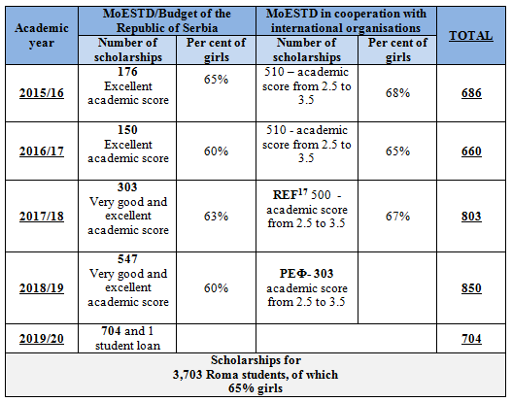

Program of affirmative measures for enrolment of Roma students in secondary school

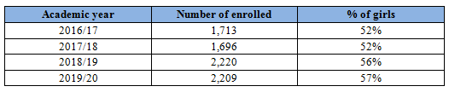

Affirmative action for enrolment in higher education institutions

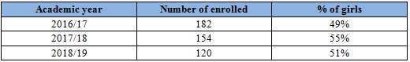

111. The Law on the Basics of the Education System – LBES[16] regulates the establishment of a unique information education system (UIES), as well as the introduction of a unique educational number (UEN) (Articles 175 and 176). The Rulebook on More Detailed Conditions in the Procedure of Assigning a Unique Educational Number[17] was adopted on 15 November, 2019. In cooperation with the Team for Social Inclusion and Poverty Reduction, an internet platform was prepared for the database in which data on the work of pedagogical assistants working with Roma children and students will be collected. Data on the educational achievements of Roma students will be entered into the database by pedagogical assistants at least twice during the school year.

Reply to paragraph 29 (a) of the list of issues

112. Representatives of the Ministry of Culture and Information, national cultural institutions, civil society organisations as well as national councils of national minorities participated in the development of the Strategy. Civil society organisations and national councils of national minorities were first asked to point out problems and priorities in culture from their point of view. During the public hearing held in 2017 in seven cities, civil society organisations and representatives of national minorities actively participated and gave their comments, criticisms and suggestions, which were considered by the Ministry of Culture and Information. The Office for Cooperation with Civil Society also gave its comments and suggestions. The Office for Human and Minority Rights and the Ministry of Labour, Employment, Veteran and Social Affairs also gave opinions on issues related to the culture of national minorities. All proposals, remarks and suggestions that are estimated to improve the text of the Strategy have been included in the text.

113. In the Strategy, in addition to designing and implementing measures and activities of the Ministry of Culture and Information and cultural institutions, certain measures and activities are aimed at creating a supportive environment for action of all cultural entities, including civil and private sectors, both nationally and internationally.

114. The Strategy for the Development of Culture of the Republic of Serbia from 2020 to 2029 is determined to preserve the unity of the cultural space of the Republic of Serbia as well as to preserve cultural diversity, which includes contemporary creativity and cultural heritage of national minorities. One of the basic principles is the protection of the cultural rights of national minorities. It is envisaged that in the dialogue with the representatives of national minorities, all additional institutional possibilities for promoting their cultural creativity and protection of cultural heritage will be considered. The measures in the Strategy refer to the creativity of all citizens, regardless of nationality, but the measure for encouraging artistic creativity and presentation of the culture of national minorities in cultural institutions in nationally mixed local self-government units is especially emphasised. In that sense, one of the first steps, according to the Action Plan for the period 2020–2022, is to change the Decree on Criteria, Standards and Manner of Selection of Cultural Projects Financed and Co-Financed from the Budget of the Republic of Serbia, Autonomous Province, i.e. local self-government units,[18] according to which projects related to the production of national minorities are especially valued.

Reply to paragraph 29 (b) of the list of issues

115. The Law on Culture[19] prescribes the manners of exercising the cultural rights of national minorities and stipulates that national councils of national minorities shall take care of the implementation of cultural policy of national minorities, participate in the decision-making process or decide on certain issues related to their culture, establish cultural institutions and other cultural legal entities in culture. Also, this law shall include, as a general interest in culture, the discovery, creation, study, preservation and presentation of Serbian culture and the culture of national minorities in the Republic of Serbia. According to this Law, national councils of national minorities make proposals for the distribution of funds allocated through a public competition from the budget of the Republic of Serbia, autonomous province or local self-government unit to institutions, events and associations of national minorities in the field of culture.

116. One of the significant influences of the implementation of the new Law on Culture on the exercise of cultural rights of national minorities is the adoption of the Decree on More Detailed Conditions and the Manner of Awarding Acknowledgements for the Greatest Contribution to National Culture, i.e. Culture of National Minorities (Article 14). In addition to the representative associations in culture, national councils of national minorities have been added as authorised nominators of candidates for the award of acknowledgements. Also, in the Commission of seven members, appointed by the Minister of Culture and Information, determining the eligibility for the award, there is also a representative of the national councils of national minorities. All of the abovemention is the result of agreements from round tables held at the Institute for the Study of Cultural Development, in which representatives of national minorities also participated.

117. The state’s support for cultural activities of national minorities is continuously realised through an annual competition procedure in which, in their opinion, national councils of national minorities participate, and the transparency of the procedure, which includes the possibility of attending expert commission sessions, was assessed as an example of good practice by members of national minorities. What is challenging, jointly recognised by both the relevant Ministry and members of national minorities, is the budget available for these purposes, and for the increase of which joint efforts are being made.

Reply to paragraph 30 of the list of issues

118. For students, members of national minorities who attend classes in the Serbian language, as well as for others who want to learn the language of a national minority, an elective subject/programme Mother tongue/speech with elements of national culture is made available. Mother tongue/speech with elements of national culture is implemented as an elective programme in 321 primary schools in the Republic of Serbia. This elective programme is implemented in 15 languages of national minorities, since in 2018/19 school year, the elective programme Slovenian language with elements of national culture was introduced.

119. Every school year, the Ministry of Education, Science and Technological Development prepares a Unified Questionnaire for this elective programme and delivers it to all parents whose children attend school, regardless of whether they are members of a national minority or not, and it includes all languages of national minorities for which lessons are organised within this subject/programme.

120. One of the five priority areas of compulsory training is the creation of a tolerant and non-discriminatory environment, as well as the prevention of violence, discrimination and inclusion of children from socially vulnerable groups. One of the four areas in the Catalogue of Programmes for Continuous Professional Development of Teachers, Educators and Professional Associates is strengthening of the educational role of the educational institution through the development of programmes for the prevention of violence, discrimination, abuse and neglect.

121. In this document, as of academic 2015/16, two programmes in the field of education in the languages of national minorities have been accredited. Also, a total of 32 programmes deal with human rights. There are seven in the field of improving competences for civic values, and 24 programmes aim to improve the capacity of teachers and other professional associates to act in the field of protection against violence and discrimination.

1. * The present document is being issued without formal editing.
2. Article 138, Paragraph 1.
3. Article 138, Paragraph 1.
4. The Republic of Serbia has been using the SILC survey since 2013 and it is not possible to provide data for the past ten years since previous surveys were based on a different methodological approach.
5. <http://appsso.eurostat.ec.europa.eu/nui/submitViewTableAction.do>.
6. <http://appsso.eurostat.ec.europa.eu/nui/submitViewTableAction.do>.
7. “Official Gazette of the Republic of Serbia”, No. 84/04...72/19.
8. “Official Gazette of the Republic of Serbia”, No. 22/01...30/18.
9. “Official Gazette of the Republic of Serbia”, No. 25/01..86/19.
10. “Official Gazette of the Republic of Serbia”, No. 24/01...86/19.
11. “Official Gazette of the RS”, No. 47/18.
12. “Official Gazette of the Republic of Serbia”, No.103/18.
13. Mobile teams for Roma inclusion, in addition to the coordinator for Roma issues, also include pedagogical assistants, health mediators, representatives of CSW and representatives of the NES, and, if necessary, other representatives of local self-government units. So far, 50 mobile teams have been formed in 50 local self-government units.
14. “Official Gazette of the Republic of Serbia”, Nos.68/13, 106/13 and 3/16.
15. Mobile teams for Roma inclusion, in addition to the coordinator for Roma issues, also include pedagogical assistants, health mediators, representatives of CSW and representatives of the NES, and, if necessary, other representatives of local self-government units. So far, 50 mobile teams have been formed in 50 local self-government units.
16. “Official Gazette of the RS”, No. 88/17, 27/18-other laws and 10/19.
17. “Official Gazette of the RS”, No. 81/19.
18. “Official Gazette of the RS”, No. 72/09,13/16, 30/16 - correction, 6/20.
19. “Official Gazette of the RS”, No. 72/09,13/16, 30/16 - correction, 6/20.