|  |  |  |  |
| --- | --- | --- | --- |
|  | United Nations | CRC/C/OPAC/SVK/Q/1/Add.1 | |
|  | **Convention on the Rights of the Child** | | Distr.: General  27 November 2012  English only |

**Committee on the Rights of the Child**

Optional Protocol to the Convention on the Rights of the Child on the involvement of children in armed conflict

List of issues concerning additional and updated information related to the consideration of the initial report of Slovakia (CRC/C/OPAC/SVK/1)

Addendum

Written replies of Slovakia[1]*

Reply to the issues raised in paragraph 1 of the list of issues (CRC/C/OPAC/SVK/Q/1)

1. The legal regulation does not allow the compulsory recruitment of persons who have not reached the age of 18 into the armed forces of the Slovak Republic. The legal order of the Slovak Republic does not allow under any circumstances to reduce the age of compulsory recruitment or of the date of origination of the liability for enlistment. Pursuant to paragraph 5 of the Act on Liability for Enlistment, the liability for enlistment comes into existence for a male citizen on 1 January of the calendar year, in which he reaches the age of 19 years, if he has the permanent residency in the Slovak Republic. The liability for enlistment for a male citizen , who holds permanent residence abroad and has registered for permanent residency in the Slovak Republic after 1 January of the calendar year, in which he reaches the age of 19 years, comes into existence on the date of registration for the permanent residency in the Slovak Republic. The liability for enlistment for a male citizen who has obtained the citizenship of the Slovak Republic after 1 January of the calendar year, in which he reaches the age of 19 years, comes into existence on the date of obtaining the citizenship, if he has the permanent residency in the Slovak Republic.

Reply to the issues raised in paragraph 2 of the list of issues

2. A website of the Public Defender of Rights (child ombudsmen).is accessible to the general public and children. The mentioned site includes the text of the Convention on the Rights of the Child and both Optional Protocols. The text of the Convention and Protocols are also available on the website of the Ministry of Justice in the framework of the Collection of Laws of the Slovak Republic.

3. In November 2012, a seminar was held on “Protection of Children in Armed Conflicts” devoted to the 10th anniversary of the entry into force of the Optional Protocol to the Convention on the Rights of the Child on the involvement of children in armed conflict organized by the Ministry of Foreign and European Affairs of the Slovak Republic, the Slovak Red Cross and the Slovak Society for International Law. The seminar was attended by the representatives of UNICEF, IOM, Ministry of Defence, General Staff of the Armed Forces of the Slovak Republic, Ministry of Justice, Ministry of Foreign and European Affaires, Ministry of Interior, the Slovak Red Cross, Office of the Public Defender of Rights and Academia.

Reply to the issues raised in paragraph 3 of the list of issues

4. In the Ministry of Defence including the armed forces systematic attention has been paid to the education and training of members of the AF in the area of the international law of armed conflict and international humanitarian law, including the exercise of human rights in the activity of the AF SR in the operations supporting peace led by the United Nations, NATO and EU. In its activity, the Ministry of Defence implements the principles of all main human rights international documents. To support this effort, in December 2009, *Directives of the Ministry of Defence of the Slovak Republic No. 119/2008 on education in the area of armed conflict law* were issued as an internal legal regulation. The units prepared for crisis management operations led by NATO, EU and the United Nations take a special training focused on international humanitarian law and human rights, including the rights of children (Optional Protocol to the Convention on the Rights of the Child on the involvement of children in armed conflict, the Guidelines Council of the EU on Children and Armed conflict (doc. 8285/06); Security Council resolutions No. 1612 (2005) on children and armed conflict, and 1325 (2000) on women, peace and security.

Reply to the issues raised in paragraph 4 of the list of issues

5. Only statistical data on unaccompanied minors - asylum seekers from 2006 to October 2012 are available (see below).

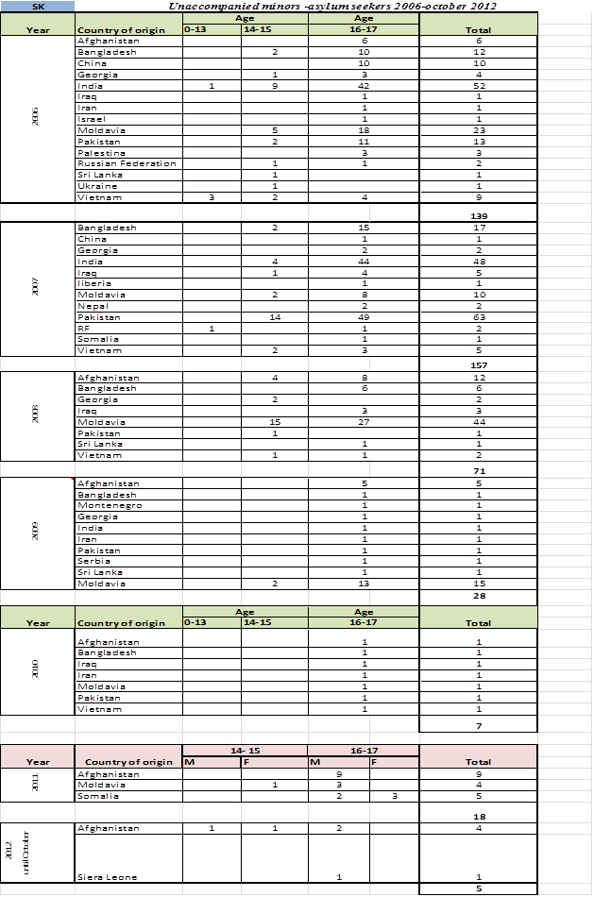

Reply to the issues raised in paragraph 5 of the list of issues

6. In carrying out the export controls, Slovakia strictly observes its international obligations, including the United Nations and EU sanctions, and takes account of other relevant recommendations, including recommendations of multilateral export control regimes as well as the EU Council Common Position No. 2008/944/CFSP of 8 December 2008.

7. Slovakia is a signatory to the United Nations Protocol against the Illicit Manufacturing and Trafficking in Firearms, Their Parts and Components and Ammunition supplementing the United Nations Convention against Transnational Organized Crime.

8. Licenses for exports and imports are granted individually on a case-by-case basis. Authorized persons are obliged to apply for a license for each individual import, export or handling. Licenses are required for each case of refurbishing activity as well.

9. The Ministry of Foreign and European Affairs of the Slovak Republic reviews every export license application, as already mentioned above, on a case-by-case basis. In the process of formulating its final position, the Ministry considers each case separately in the context of the bilateral and multilateral obligations of the Slovak Republic including various factors such as the internal situation in the country, the respect for human rights in the country by its government as well as the respect by that country of international humanitarian law, etc.

Reply to the issues raised in paragraph 6 of the list of issues

10. Provisions of the Optional Protocol do not have the character of a document of criminal law. Nevertheless according to article 7, paragraph 5 of the Constitution of the Slovak Republic, as an international treaty on human rights and fundamental freedoms and an international treaty, which directly establishes rights or impose duties on natural persons or legal persons and which was ratified and declared in a way laid down by law, takes precedence over laws. Pursuant to international treaties by which the Slovak Republic is bound (e.g. the Rome Statute of the International Criminal Court). See also paragraph 62 of the initial report of the Slovak Republic.

1. * In accordance with the information transmitted to States parties regarding the processing of their reports, the present document was not edited.