|  |  |  |  |
| --- | --- | --- | --- |
|  | United Nations | E/C.12/SLV/RQ/6 | |
| United Nations logo | **Economic and Social Council** | | Distr.: General  6 May 2022  English  Original: Spanish  English, French and Spanish only |

**Committee on Economic, Social and Cultural Rights**

**Seventy-second session**

26 September–14 October 2022

**Consideration of reports: reports submitted by State parties   
in accordance with articles 16 and 17 of the Covenant**

Replies of El Salvador to the list of issues in relation to its sixth periodic report[1]*, [2]**

[Date received: 3 March 2022]

1. The Republic of El Salvador is pleased to submit its replies to the list of issues transmitted by the Committee in November 2020 in relation to the sixth periodic report of El Salvador under the International Covenant on Economic, Social and Cultural Rights. The report was prepared on the basis of a consultation with more than 27 State institutions, the mandates of which relate to areas of interest to the Committee. To ensure respect for the prescribed format and the character limit, this report is limited to a discussion of the articles referred to in the Committee’s observations; statistical data and further documentation are attached as annexes.

I. General information

2. In June 2019, the Government began the process of restructuring its institutional framework in order to optimize resources and improve its capacity to respond to the needs of the people; as part of the process, it assumed the duties of various institutions by executive decree. This transfer of powers resulted in the establishment of the Office of the Presidential Commissioner for Operational and Cabinet Affairs, which replaced the Technical and Planning Secretariat of the Office of the President.

3. The duties of the Secretariat for Vulnerability Issues were assumed by the National Civil Protection Commission, to which the Secretariat had been attached, and the Ministry of Local Development took over the programmes formerly run by the Secretariat for Social Inclusion, including the Women’s City Programme.

4. Under the Act on Social Development, Protection and Inclusion, the Office of the Presidential Commissioner for Operations and Cabinet Affairs is responsible for the Social Development Plan 2019–2024, which contains sections on economic, social and cultural rights and has been used as a reference document for social programmes. The Office also developed the Poverty Eradication Strategy, which contains sections on pensions, housing and agricultural programmes, among other topics. The State recognizes the essential role of human rights defenders, including defenders of economic, social and cultural rights, in cementing democracy. Their work is no way limited by State policy.

5. The Criminal Code makes it an aggravating circumstance for a criminal offence to have been committed against a person for his or her humanitarian work in promoting and protecting human rights. Any rights violation that constitutes an offence may be reported to the Attorney General’s Office.

6. The independence of the different branches of government is recognized in the Constitution and subsidiary legislation. The organization and operations of the judiciary are regulated by the Organic Act on the Judicial System.

7. The functional independence of judges is guaranteed by the existence of a professional judicial service in which judicial tenure is secure. Judges’ independence in the exercise of their duties is protected by the Constitution, which provides that judges are subject only to the Constitution and the law of El Salvador. Consequently, regardless of their position in the judicial hierarchy, all judges are empowered to act with full independence when trying the cases brought before them.

8. The judges of the Supreme Court of Justice are elected by the Legislative Assembly for a term of nine years – with the possibility of re-election – after nomination and evaluation of their candidacy, in accordance with the requirements established in the applicable legislation.

9. The National Climate Change Plan establishes the country’s priorities for adaptation and mitigation in respect of climate change, provides an estimate of the technical and financial capacities required in that regard and names the public institutions responsible for each priority. The Plan’s objective is to improve the ability of people and communities to withstand or bounce back from climate hazards and crises. It proposes measures aimed at the development and implementation of a climate risk identification and assessment system, the development of instruments and mechanisms to ensure that social protection policies are able to withstand climate change, community risk is reduced and recovery, including of local economies, is timely.

10. The National Climate Change Strategy is structured around three thematic areas: (a) mechanisms to address recurrent losses and damages, (b) adaptation to climate change and (c) climate change mitigation and its co-benefits.

11. The measures taken to adapt to the adverse effects of climate change on the enjoyment of economic, social and cultural rights include the adoption of the Ecosystem and Landscape Restoration Programme, the goals of which are to enhance people’s means of securing the basic necessities of life, strengthen local development and food security, reduce vulnerability by restoring ecosystem functions directly related to the hydrological regime and help people adapt to the adverse effects of climate change through the restoration of natural infrastructure and integrated natural resources management.

12. Measures have also been taken to improve hazard monitoring, including the installation and operation of eight weather radars; the installation of more than 100 new telemetric transmission stations, including meteorological, hydrological, rainfall, tide and seismic measurement stations; the training and equipment of 600 local observers; the establishment of the Centre for Comprehensive Hazard Monitoring, which is active 24 hours a day, seven days a week; and strategic cooperation with municipal environmental units.

13. Other measures that have been taken include preventive drought management through the proactive preparation of systems for risk and impact reduction; resilience-building and adaptation measures, with an emphasis on the recovery of degraded land and the restoration of ecosystems; strengthening of agroclimatic monitoring and information systems; and the establishment of early warning systems. In the agriculture sector, higher-productivity varieties of bean, corn and sorghum with greater protein content that are more resistant to diseases, insects, other pests, low humidity and high temperatures have been developed, and rainwater reservoirs have been constructed to irrigate crops during the dry season, mitigate the effects of droughts in the dry corridor and provide water for animals.

14. An ecosystem-based adaptation approach is being taken to reduce the vulnerability of local communities, including urban areas, to the effects of climate change. The approach involves various projects, including a project to build the climate resilience of urban systems through ecosystem-based adaptation in San Salvador, which is intended to strengthen urban-planning capacities.

15. The declaration by the World Health Organization of the coronavirus disease (COVID-19) pandemic triggered a global public health emergency, and on 23 January 2020, in view of the international epidemiological situation and the spread of the virus in El Salvador, the Ministry of Health issued Ministerial Agreement No. 301 as a preventive public health measure.

16. A number of guidelines were issued in response to the pandemic, in accordance with the Constitution and the Health Code. The Ministry of Health, acting pursuant to its mandate, took measures to respond to the threat of an epidemic or other disaster that could have negative health consequences, declared sanitary control areas and took extraordinary preventive measures on the basis of technical and scientific standards developed by the health authorities.

17. The right to health has individual and collective facets. The Constitution provides that, in extraordinary situations, the enjoyment of some fundamental rights may be suspended in all or part of the territory to protect health, as a public good. Hence, the legislature adopted the Act on the Temporary Restriction of Specific Constitutional Rights in Response to the COVID-19 Pandemic, in accordance with article 29 of the Constitution. The Act was published in the Official Gazette of 15 March 2020.

18. All administrative and legislative measures taken to contain the spread of COVID-19 were adopted in accordance with the criteria of strict exceptionality and temporality; the precautions and supervisory measures that were taken to protect the health of Salvadorans and ensure that they had immediate and adequate access to health care were sufficient and did not cause more harm than necessary.

II. Issues relating to the general provisions of the Covenant (arts. 1–5)

Right to freely dispose of natural wealth and resources (art. 1 (2))  
Maximum available resources (art. 2 (1))

19. The National Action Plan for Indigenous Peoples has been incorporated into the National Policy for Indigenous Peoples, which is part of the Cuscatlán Plan. Although the implementation of the National Policy was delayed because of the COVID-19 pandemic and the storms Amanda, Eta and Iota, some of the measures to revitalize and promote indigenous culture that it provides for have been taken.

20. El Salvador is still reviewing the possibility of acceding to the International Labour Organization Indigenous and Tribal Peoples Convention, 1989 (No. 169).

Maximum available resources (art. 2 (1))

21. (a): The table below shows the percentages of the population living in poverty from 2010 to 2020 and living in extreme poverty from 2016 to 2020.

| *Indicator* | *Area* | *2010* | *2011* | *2012* | *2013* | *2014* | *2015* | *2016* | *2017* | *2018* | *2019* | *2020* |
| --- | --- | --- | --- | --- | --- | --- | --- | --- | --- | --- | --- | --- |
| Percentage of the population living in poverty | National | 42.5 | 47.5 | 40.7 | 34.8 | 37.2 | 40.6 | 38.2 | 33.7 | 30.9 | 26.8 | 28.7 |
| Urban areas | 38.2 | 41.7 | 35.1 | 30.6 | 33.3 | 37.9 | 34.5 | 31.2 | 28.3 | 25.2 | 27.1 |
| Rural areas | 49.6 | 57.2 | 50.0 | 41.7 | 43.7 | 45.1 | 44.2 | 37.4 | 35.1 | 29.4 | 31.3 |
| Ratio of the total income of the wealthiest 10 per cent of the population to the total income of the poorest 40 per cent of the population | National | 2.4 | 2.4 | 2.8 | 3.9 | 3.6 | 1.9 | 1.9 | 1.8 | 1.8 | 1.8 | 2.2 |

*Source*: Directorate General of Statistics and Censuses, multipurpose household surveys 2010–2020.

Percentage of the population living in extreme poverty

| *Area* | *2016* | *2017* | *2018* | *2019* | *2020* |
| --- | --- | --- | --- | --- | --- |
| National | 9.9 | 7.5 | 7.3 | 5.5 | 8.7 |
| Urban areas | 7.7 | 6.2 | 6.3 | 4.9 | 6.8 |
| Rural areas | 13.4 | 9.6 | 9 | 6.5 | 11.7 |

22. (b) and (c): With regard to subparagraphs (b) and (c), the table below shows tax revenue, in millions of dollars, the percentage of total public revenue generated by taxes, and a breakdown of total tax revenue by item. It shows a progressive increase, from 35.7 per cent in 2012 to 39.3 per cent in 2019, in the share of all tax revenues accounted for by income tax, as a result of the 2012 income tax reform, which raised the tax rate for corporate taxpayers from 25 to 30 per cent but maintained the tax rate for individual taxpayers who earn under $150,000 at 25 per cent. The share of all tax revenue accounted for by value added tax decreased by around five percentage points over the same period.

Tax revenue as of December, 2009–2019

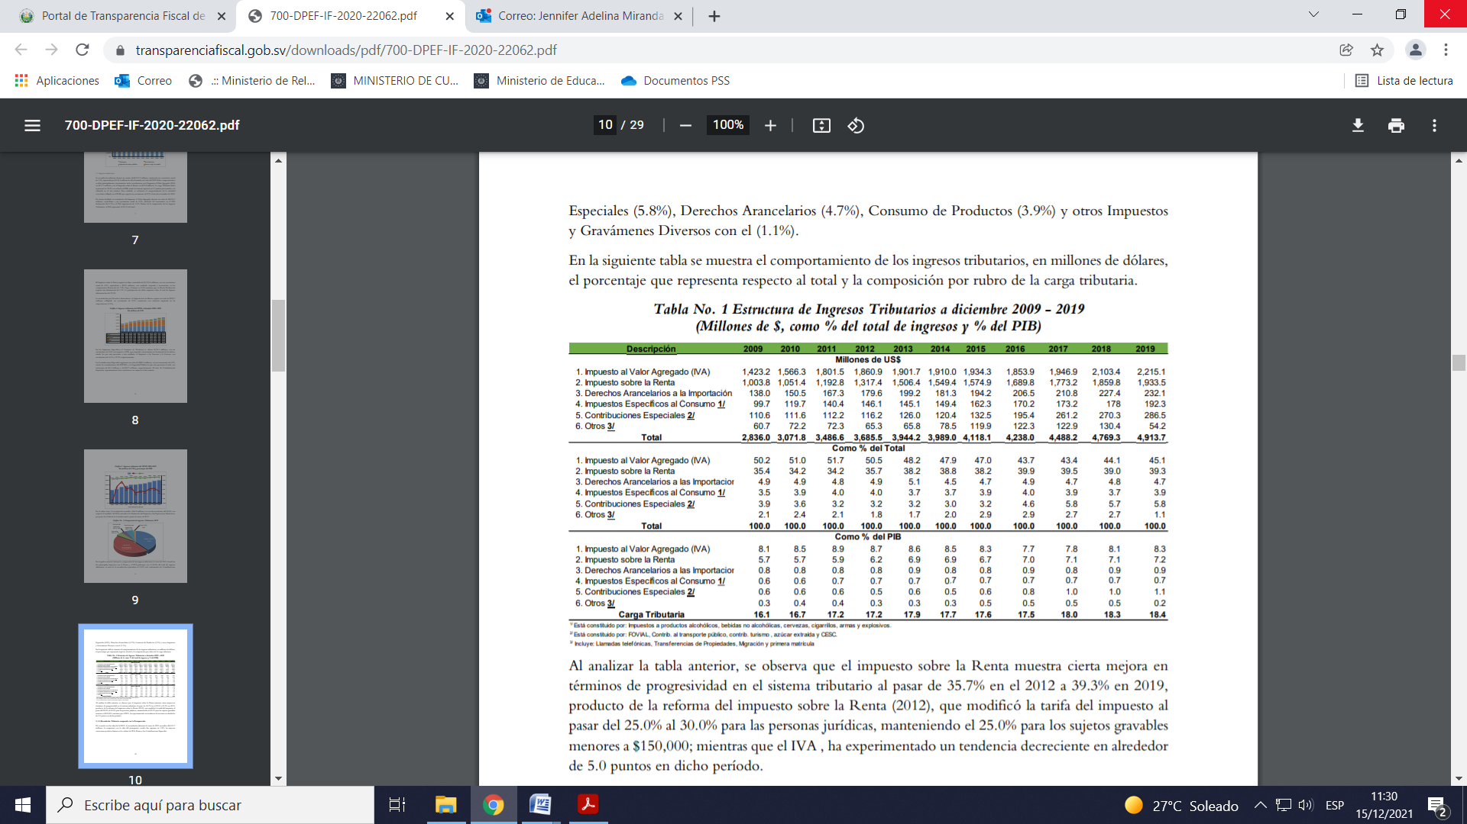(In millions of dollars, as a percentage of total revenue and as a percentage of gross domestic product (GDP))

23. (d): Total expenditure in the non-financial public sector as at the fourth quarter of 2019 was $6.628 billion, $310.7 million more than in 2018, as there was an increase in current expenditure of $318.1 million and a decrease in capital expenditure of $7.6 million. Total expenditure accounted for 24.8 per cent of GDP, 0.6 percentage points more than in the previous year.

Changes in total public expenditure in the non-financial public sector, 2009–2019

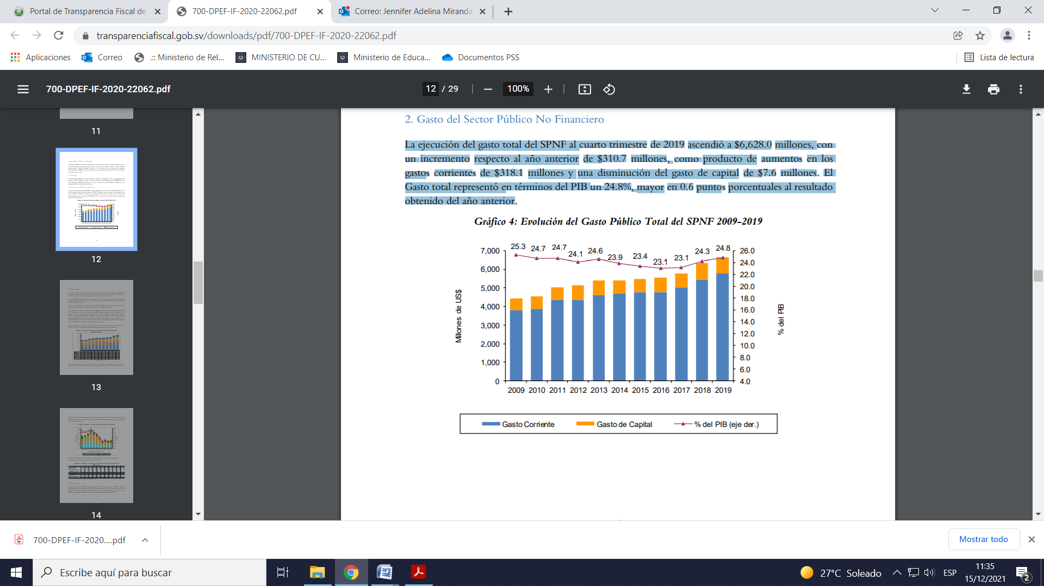

24. (f): A series of measures was taken to mitigate the economic impact of the pandemic, including: a temporary waiver on payment for drinking water, electricity and telecommunications services and the suspension of the disconnection of drinking water services for the duration of the emergency; the transfer of $300 to nearly 1.5 million vulnerable families; a monthly bonus of $150 for essential public workers; the extension of the deadline for the payment of income tax for the 2019 fiscal year; temporary tax relief (deferred payments) for individuals and businesses especially affected by the emergency; the freezing of commercial rent payments for three months; and a moratorium on the collection of mortgage, personal, credit card, working capital and business debt, during which no arrears, fines or interest were imposed or charged.

25. The State recognizes that transparency and access to public information are prerequisites for the strengthening of public institutions, improving the quality of democracy and enforcing the rule of law. For that reason, it adopted the Act on Access to Public Information and Law and established the Institute for Access to Public Information.

26. When, in June 2019, the Administration of President Nayib Bukele took power, it inherited a relatively inactive civil service characterized by an institutional culture of minimal effort; most of the State apparatus was obsolete. A thorough review of the institutional framework was therefore carried out, and a need for restructuring was identified.

27. As part of this restructuring, the Legal Secretariat of the Office of the President was tasked with taking steps to promote transparency, accountability and citizen participation in the work of the Government, organizing the Unit for Access to Public Information and coordinating all public information access units in the executive branch of government.

28. The Special Anti-Corruption Investigation Division, the Corruption Information Analysis Division, the Asset Investigation Division, the Forfeiture and Financial Crimes Division and the Operational Techniques Unit were placed under the authority of the Anti-Corruption Investigation Subdirectorate after an amendment to the Organic Act on the National Civil Police.

29. An amendment to article 32 of the Code of Criminal Procedure adopted on 7 September 2021 establishes the non-applicability of statutes of limitations to corruption offences. A special commission has been set up in the Legislative Assembly to investigate the distribution of public funds, in the form of bonuses, to officials, businesses and private persons by the offices of previous Presidents.

30. There are a number of special monitoring institutions, including the Public Prosecution Service, the Government Ethics Tribunal, the Court of Audit, the Notarial Section of the Supreme Court of Justice and the Institute for Access to Public Information, that have the legal power and duty to guarantee access to information, ensure transparency in the administration of public affairs and combat corruption.

Non-discrimination (art. 2 (2))

31. The Special Act on the Inclusion of Persons with Disabilities that came into effect on 1 January 2021 repealed the Act on Equal Opportunities for Persons with Disabilities. The Special Act provides for the restructuring of the National Council for the Inclusion of Persons with Disabilities.

32. In response to the pandemic, the Banco de Desarrollo de la República de El Salvador, a government development bank, granted non-repayable subsidies of up to $1,500 under the Economic Recovery Fund for Salvadoran Businesses to 285 people with disabilities to help them build their businesses or otherwise stimulate their productive activities.

33. The Salvadoran Institute for the Rehabilitation of Persons with Disabilities organized the following training programmes in 2019 and 2020.

| *Job training workshops* | | |
| --- | --- | --- |
| *Year* | *Female participants* | *Male participants* |
| 2019 | 44 | 72 |
| 2020 | 20 | 33 |

| *Activity* | *2019* | *2020* |
| --- | --- | --- |
| Employment outreach visits to businesses | 112 | 51 |
| Workplace monitoring | 103 | 177 |
| Labour integration services | 45 |  |

34. The internal regulations of the executive branch of government provide that the Ministry of Culture and the Ministry of Local Development are responsible for promoting the rights of lesbian, gay, bisexual, transgender and intersex persons. The Diversity and Gender Unit was established to combat discrimination based on sexual orientation and gender identity or expression, in accordance with themes five and six of the Five-Year Operational Plan 2019–2024, which relate to inter-institutional and local anti-discrimination measures. Awareness-raising activities have been organized and partnerships have been created to comply with Executive Decrees No. 56 (2010) and No. 20 (2019), lead training and capacity-building activities promoting respect and inclusion and provide guidance on incorporating respect-based approaches.

Equal rights of men and women (art. 3)

35. The Salvadoran Institute for the Advancement of Women administers the Substantive Equality Training School.[3] Between January 2017 and December 2020, the Specialized Training Unit trained more than 4,226 people (2,548 women (60.3 per cent) and 1,678 men (39.7 per cent)) on substantive equality, a life free from violence against women, perceptions of masculinity, the regulatory framework, sexual and reproductive health and women’s rights literacy:

• Between July and December 2021, the Ministry of Culture, the Salvadoran Institute for the Advancement of Women and the Banco de Desarrollo de la República de El Salvador took steps to further the integration of lesbian, bisexual and transgender women into the Human Rights and Financial Education Programme with a view to promoting their economic autonomy. Women’s City centres provided training on sexual diversity in a bid to include lesbian, bisexual and transgender women in the Secretariat for Innovation’s Career Guidance for Women Programme.

• The number of women in decision-making positions in the executive branch of government rose from five (35.7 per cent) in the 2014–2019 presidential term to seven (43.8 per cent) in the 2019–2024 term. Twenty-nine of the 262 municipal authorities (11.1 per cent) are led by women. Four of the 15 judges of the Supreme Court are women. National lawmakers for the 2021–2024 legislative term include 23 women (27.38 per cent).

III. Issues relating to the specific provisions of the Covenant (arts. 6–15)

Right to work (art. 6)

36. The table below presents information provided by the Directorate General of Statistics and Censuses on the formal and informal employment rates in urban areas, disaggregated by sex and age, between 2016 and 2020. There is currently no way to measure the informal employment rate in rural areas.

Informal employment rate in urban areas

| *Demographic group/area* | *2016* | *2017* | *2018* | *2019* | *2020* |
| --- | --- | --- | --- | --- | --- |
| National | 42.3 | 42.7 | 42.0 | 42.6 | 47.7 |
| Men | 35.0 | 35.9 | 36.3 | 36.9 | 42.1 |
| Women | 50.8 | 50.7 | 48.8 | 49.6 | 54.4 |
| 16–29 years | 37.5 | 37.4 | 36.9 | 38.2 | 43.0 |
| 30–59 years | 42.6 | 43.1 | 42.0 | 42.9 | 48.2 |
| ≥60 years | 53.8 | 55.3 | 56.4 | 53.0 | 57.7 |

Formal employment rate in urban areas

| *Demographic group/area* | *2016* | *2017* | *2018* | *2019* | *2020* |
| --- | --- | --- | --- | --- | --- |
| National | 50.9 | 50.5 | 52.0 | 51.2 | 45.5 |
| Men | 56.7 | 55.9 | 56.5 | 56.6 | 50.7 |
| Women | 44.0 | 44.2 | 46.6 | 44.8 | 39.1 |
| 16–29 years | 48.9 | 49.4 | 50.6 | 49.5 | 42.6 |
| 30–59 years | 53.4 | 52.7 | 54.5 | 53.6 | 47.8 |
| ≥60 years | 42.4 | 41.2 | 41.5 | 43.3 | 39.9 |

37. At the national level, the Ministry of Labour and Social Security facilitates access to safe and fairly remunerated formal employment opportunities, mainly for young people, persons with disabilities and women. Programmes include the National Youth Institute’s “My First Job” programme and the “Opportunities” programme, which was launched in October 2021 and as part of which businesses can apply for subsidies that cover for three months over half of the wages of all new employees between the ages of 18 and 21 and new employees over 40 who have been out of work for more than 18 months.

38. With regard to access to social security, self-employed workers can contribute to an individual pension savings account and are eligible for a special regime for workers that allows them access to the health benefits offered by the Salvadoran Social Security Institute.

39. The Banco de Desarrollo established the Economic Recovery Fund for Salvadoran Businesses, which has granted loans totalling $139.2 million to more than 27,000 entrepreneurs in the formal and informal sectors. In addition, the Consumer Protection Authority monitors the cost of the products that make up the basic food basket to prevent speculation and hoarding. Food packages continue to be delivered to families throughout the country under the Health Emergency Programme.

Right to just and favourable conditions of work (art. 7)

40. In 2021, a 20 per cent increase in the minimum wage was approved for all sectors of the national economy (Official Gazette, 7 July 2021).[4] The Salvadoran economy is currently strong and dynamic as a result of the timely measures taken by the Government to manage the global crisis caused by the COVID-19 pandemic.

41. The Directorate General of Labour Inspection conducts inspections to combat labour exploitation in the private security and domestic labour sectors (annex I).

42. In 2019, the Public Prosecution Service registered 80 cases of sexual exploitation and forced labour, of which nine led to prosecutions and three resulted in convictions – specifically, two convictions for sexual exploitation and one for forced labour. Data relating to the above-mentioned offences for 2020 and January to October 2021 are attached as annex II.

Trade union rights (art. 8)

43. Article 48 of the Constitution recognizes the right of employers to lock workers out and workers’ right to strike, except in essential public services as determined by law. Under article 553 (a) of the Labour Code, strikes called by workers performing essential services are illegal.

44. Twelve per cent of union registration applications are rejected. According to the records of the National Department of Social Organizations for the period 2016–2021, the most common reason for rejection is that the applicant organization did not meet the minimum membership requirement.

45. The Public Prosecution Service has data on complaints and sentences in relation to infringements of labour or social security regulations (Criminal Code, art. 244), appropriation and withholding of dues payable by the employer (ibid., art. 245), labour discrimination (ibid., art. 246) and coercion with regard to the exercise of freedom of association or the right to strike (ibid., art. 247) (annexes III and IV).

46. With regard to the complaint lodged by the Union of Workers of the Salvadoran Social Security Institute in 2019, the documents were submitted to the Directorate General of Labour, which merely verified that proper procedure had been followed in accordance with the Labour Code and the Union’s by-laws and issued a decision on that basis.

Right to social security (art. 9)

47. Under the Universal Basic Pension Programme, the Ministry of Local Development made pension payments to 38,207 persons over the age of 70, of whom 18,806 were men and 19,401 women. Under the “Sustainable Families” poverty eradication strategy, the Ministry made 1,132 cash transfers (solidarity pension payments) to persons with severe disabilities (555 women and 577 men).

48. An average of 2,539 self-employed workers were contributing to the protection system for domestic and agricultural workers in late 2020.

49. Domestic workers can register for social security benefits from the Salvadoran Social Security Institute by submitting a paper form at its central administrative offices or on its digital platform at [www.isss.gob.sv](http://www.isss.gob.sv). Moreover, the Social Security Institute has launched two contributory health insurance regimes, one for Salvadorans living abroad and their families and another for self-employed workers. Enrolment is expected to increase steadily over time, thus significantly increasing the coverage rate.

Protection of the family and children (art. 10)

50. The Ministry of Labour and Social Security undertakes monitoring activities to prevent forced labour, in accordance with the Special Act against Trafficking in Persons, the National Policy on Trafficking in Persons and an inter-institutional operational protocol. In 2020, it conducted 557 child labour inspections to enforce the minimum age for employment and/or hazardous work; it found no cases of child labour without a work permit and one case with a work permit. The Social Development, Protection and Inclusion Plan 2019–2024 provides for measures to improve protections for young children, facilitate the restitution of their rights and eliminate child labour in the informal and agricultural sectors.

51. As of June 2021, the National Council for Children and Adolescents had 141 local committees on the rights of children and adolescents, which execute policies and plans to protect collective rights (Child and Adolescent Protection Act, arts 153 and 155 (1)). These committees were responsible for various activities to prevent and eradicate child labour and the economic and social exploitation of children and adolescents in 2019 but were inactive in 2020 because of the pandemic (annex V).

52. Outreach activities involving 40 participants have been organized to prevent child labour, and measures have been taken to prevent the economic and social exploitation of children in street situations (annexes VI and VII).

53. In 2020, a road map for addressing real and potential violations of the rights of children and adolescents in street situations was drawn up. The road map provides for inter-institutional coordination of various forms of support. It was piloted in San Salvador, which has the highest concentration of children and adolescents living in street situations.

54. From the data gathered through multipurpose household surveys carried out by the Department of Statistics and Censuses, it can be inferred that the measures taken to reduce and ultimately eliminate child labour have been effective, as the number of children engaged in child labour has decreased. Nonetheless, eliminating child labour is still a challenge (annex VIII).

55. The Salvadoran Institute for the Advancement of Women has provided statistical data on cases of violence against women over the last five years. These data are set out in annexes IX, X and XI.

56. The Public Prosecution Service had recorded a total of 12,624 cases as of October 2021, including 4,528 cases of acts of violence against women that resulted in prosecution. Investigations are under way in 3,585 cases, while 4,411 cases involving offences such as femicide and aggravated femicide, obstruction of access to justice and dissemination of pornography have been closed (annex XII).

57. In 2019, a total of 86 judgments were rendered, of which 49 were acquittals and 37 were convictions. In 2020, there were 49 judgments, of which 21 were acquittals and 28 were convictions. As at 12 October 2021, there had been 29 acquittals and 36 convictions (annex XIII).

58. There were 106 cases (53 per cent) of femicide and aggravated femicide, with judgments pronounced in 71 cases (66.98 per cent). In 34.14 per cent of cases, penalties were imposed for acts of violence against women, while in the remainder convictions were secured for the dissemination of pornography or theft of property.

59. The Public Prosecution Service registered 4,938 cases of other offences established in the Criminal Code in 2019, 3,720 cases in 2020 and 2,674 cases between January and July 2021. Data on cases involving minors under the age of 18 are presented in annexes XIV and XV.

Right to an adequate standard of living (art. 11)

60. Envisaged as part of the Social Development Plan are specific measures to combat poverty, early childhood care, the establishment and strengthening of a new educational and health system, the fight against and elimination of the scourge of violence and the generation of employment and contributory and non-contributory social protection systems. The overall goal is to make progress towards social transformation.

61. The Plan, which is intersectoral, draws on a results-based framework and causality networks that are informed by evidence and causes and risk factors.

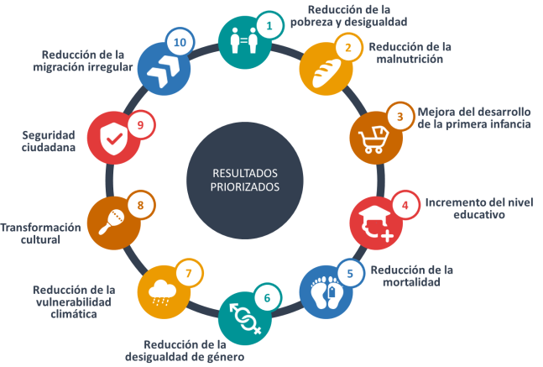

62. The Plan is a tool for promoting coordination and complementarity between other government strategies through synergies and the achievement of common goals. The main areas of cooperation are described below.

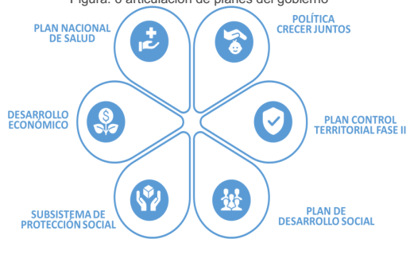

63. Under the Social Development Plan, various information and technological tools will be used to monitor and evaluate (i) the indicators set out in the Plan for the period 2019–2024, (ii) multidimensional poverty indicators and (iii) the central register of social programme beneficiaries.

64. As in other countries all around the world, the pandemic had an impact on poverty indicators in El Salvador. The proportion of households in extreme poverty rose from 5.5 per cent in 2019 to 8.6 per cent by 2020 (multipurpose household survey 2020).

65. The Government of President Nayib Bukele responded to this situation through emergency social protection programmes, which are still in effect and are primarily aimed at supporting poor households and those most at risk of falling into poverty.

| *Cash transfers* | *Transfers in kind* | *Provision of basic services* | *Social protection for workers in the formal sector* | *Other forms of direct support to individuals and families* |
| --- | --- | --- | --- | --- |
|  |  |  |  |  |
| New cash transfer programme | Health Emergency Programme (food baskets)  Adaptation of the School Meals Programme (delivery of food packages containing the equivalent of a school meal directly to students’ homes) | Postponement of payment[5] for water, electricity, telephone, Internet and television services | Reduced risk of exposure to COVID-19 (teleworking)  Income and job protection (prohibition of layoffs) | Tax relief  Debt relief  Price controls on basic food basket products, goods or services directly related to the prevention and containment of the pandemic and pandemic-related treatment and care |

66. An investment was made to improve public health care by hiring medical personnel, purchasing supplies and equipment, building new hospitals and modernizing existing hospital infrastructure and establishing a hospital specializing in intermediate and critical care for COVID-19 patients. An efficient COVID-19 vaccination campaign is under way. Vaccination is universal, free and voluntary. As a result of this campaign, El Salvador has one of the highest vaccination rates in the region.[6]

67. Efforts were made to ensure continuity of education. Those efforts are described in the section on education.[7]

68. The Government increased social spending to unprecedented highs in 2021, raising the budgets for education, health and security. After an increase of $281.2 million, the education budget is now $1.32 billion, while the health budget, having risen by $276.5 million, reached a record $1.3 billion, or 3.9 per cent of GDP.

69. Social spending will increase by degrees over five years in order to ensure progress towards universality and uphold fundamental human rights for the entire population. Priority will be given to spending on the most vulnerable and marginalized populations.

70. A milestone for the country is the recent adoption of the Caring Births Act, which provides for decent childbirth and loving and sensitive care for newborn children.[8] The Act is promoted by the First Lady, Gabriela de Bukele, implemented by the Ministry of Health. and provides for support in the run-up to a pregnancy, during pregnancy itself, during the postpartum period and during a newborn child’s first few weeks of life, in accordance with the principles of the supremacy of human dignity and the best interests of the child. The Act encourages decisions that promote the physical, moral and social development of young children.

71. Under the Social Development, Protection and Inclusion System and the Universal Social Protection Subsystem, social policy and social programmes continue to be strengthened to provide security in the face of the lifelong risks and challenges faced by Salvadorans, particularly those who are not covered by the contributory social security system or are economically, socially and environmentally vulnerable.

72. Practical steps are being taken that demonstrate the commitment of the State and, in particular, the Administration of President Bukele, to substantively improving the living conditions of the general public. In El Espino, for example, a community whose inhabitants were evicted by court order in 2018, the Administration’s El Espino Housing Project provided adequate housing to 63 families at a cost of $511,941.50.

73. The National Water Supply and Sewerage Administration is the largest water provider in urban areas. Water providers in rural areas include the municipal authorities, community associations, rural water boards, water committees, private companies and non-governmental organizations, which manage 2,260 water supply systems throughout the country.

74. The Rural Systems and Funds Management Unit provides technical assistance and specialized training to the organizations and communities that manage drinking water and sanitation systems in rural areas along four strategic lines: training and specialized technical assistance; monitoring and follow-up of technical and administrative management; support for the management of financial and technical resources (all of the above for rural system and fund administrators); and contribution to the regulatory framework governing the drinking water and sanitation subsector in rural areas.

75. The National Water Supply and Sewerage Administration launched the National Water Plan, under which various measures were taken between June 2020 and May 2021 to improve water supply services, including 22 projects that benefited 253,729 inhabitants nationwide. Twenty-eight programmes and projects are under way, benefiting a total of 3,185,497 people nationwide.

76. The renovation of the Las Pavas drinking water treatment plant is 98 per cent complete, which has benefited approximately 1.6 million people. Water supply improvement projects have been implemented in the residential areas of Altavista, Santa Eduviges, Rutilio Grande, and in the municipalities of Ilopango, San Martín and Tonacatepeque. During this period, 15 inter-institutional coordination agreements were concluded by different government agencies. A total of 5,290 new services were established nationwide, and an estimated 4.9001 km of pipe was added to the National Water Supply and Sewerage Administration’s network nationwide. An estimated 1,093 km of extensions are expected to be built for the connection of new water supply services. In addition, 336,599 m3 of drinking water were delivered by tanker trucks throughout El Salvador.

77. Despite the COVID-19 pandemic, between June 2019 and June 2021, 61 technical assistance projects and 10 training sessions were carried out, and 35 declarations of social interest were issued, thereby helping to strengthen technical knowledge and the maintenance of drinking water supply systems in rural areas.

78. In view of water resource management considerations and the National Drinking Water Plan, a consultation process is being conducted to assess the requirements of, design and develop an administrative body responsible for organizing and promoting institutional coordination by the governmental bodies and entities responsible for the drinking water and sanitation subsector (National Water Supply and Sewerage Administration contract No. 15/2021). The contract is now in force, and a workplan has been presented, a special commission has been formed, the proposal contained in the National Drinking Water Plan has been updated and internal operating regulations have been drafted.

79. The National Water Supply and Sewerage Administration Act, which was adopted in 1961, before the adoption of the current Constitution, is being revised and updated to ensure that it reflects modern circumstances and meets the institution’s needs.

80. In January 2021, the legislature adopted an amendment to the Constitution that incorporates provisions on the right to food. The amendment will be ratified in the next legislative term, in accordance with established legislative procedure.

81. The Government has reaffirmed its commitment to the Sustainable Development Goals, including Goal 1 – end poverty in all its forms everywhere – and Goal 2 – end hunger, achieve food security and improved nutrition and promote sustainable agriculture.

82. Through the Social Development Plan 2020–2024 and the “Growing Together” policy, the Government hopes to eradicate poverty gaps and malnutrition throughout the life cycle, with an emphasis on early childhood. The Healthy and Sustainable School Meals Strategy was recently launched to strengthen food and nutrition education, provide healthy food to students, promote food production in schools and the community and establish links with local markets. Under the Agricultural Sector Recovery Master Plan, a recently developed plan, loans are provided to small producers and there has been investment in productive infrastructure in the agricultural sector.

83. Under the Agricultural Packages Programme, the Ministry of Agriculture and Livestock delivered 597,944 packages of certified seed maize, sorghum seed and beans and fertilizers. Assistance with technology transfer and adoption was provided to 27,213 male and 17,860 female producers nationwide through technical assistance and training. During the COVID-19 pandemic, 34,000 producers received improved red beans for sowing in an effort to increase domestic production.

84. In 2021, the First Lady, Gabriela de Bukele, launched the “Growing Together” national early childhood development policy, which is designed to help Salvadoran children reach their development potential in early childhood.

85. Through the inter-institutional and intersectoral strategies and programmes launched under the early childhood development policy, high-quality care will be provided in the areas of health, nutrition, education, learning and child protection. In addition, families will be provided with guidelines on positive parenting and information on early stimulation techniques to enhance their children’s emotional, intellectual and physical development.

86. In public primary-care facilities, care is provided during the first thousand days under an initiative for the promotion of care friendly to mother and child. In certain circumstances, feeding services for infants may be provided in human-milk banks and other collection centres.

87. As of July 2021, 65 municipalities had adopted municipal policies for children and adolescents approved by the National Council for Children and Adolescents. Of those policies, 95.3 per cent include measures and strategies to promote the right to healthy food and 90.7 per cent include measures and strategies to promote healthy eating in early childhood.

88. The Food Aid Division of the Ministry of Local Development provides logistical support for the storage, registration and delivery of food and non-food items to 5,100 schools and 1.3 million students nationwide under the Ministry of Education, Science and Technology’s School Health and Nutrition Programme.

89. Logistical services were provided to the Salvadoran Institute for Comprehensive Child and Adolescent Development, thereby benefiting approximately 9,167 children and adolescents in 115 initial care centres.

Prevalence of chronic malnutrition (height-for-age) in first grade schoolchildren by age

| *Age* | *Prevalence (%)* |
| --- | --- |
| 6 years | 5.24 |
| 7 years | 8.09 |
| 8 years | 18.19 |
| 9 years | 27.73 |
| **Country total** | **9.05** |

Fourth national census on children’s height/first national census on the weight of schoolchildren in first grade, May 2016.

90. Data disaggregated by area are not available.

Prevalence of overweight and obesity (body mass index) in first grade schoolchildren by age

| *Age* | *Prevalence of overweight (%)* | *Prevalence of obesity ( %)* |
| --- | --- | --- |
| 6 years | 18.7 | 14.73 |
| 7 years | 17.16 | 14.05 |
| 8 years | 14.41 | 9.95 |
| 9 years | 13.6 | 8.63 |
| **Country total** | **17.1** | **13.64** |

Fourth national census on children’s height/first national census on the weight of schoolchildren in first grade, May 2016.

91. Data disaggregated by area are not available.

Right to physical and mental health (art. 12)

92. In November 2019, the National Comprehensive Health System Act, the purpose of which is to ensure universal access to and coverage of high-quality health care in an equitable and timely manner, came into force.

93. The Ministry of Health is transforming the National Public Health System to protect the lives of all Salvadorans. In spite of the pandemic, investment in hospital infrastructure over the last two years, covering 31 hospitals nationwide, including the new El Salvador Hospital, was larger than it had ever been. Moreover, medicines were purchased to treat COVID-19 and other diseases, personal protective equipment was acquired for medical personnel and community screening was carried out, all of which made it possible to address the pandemic and continue protecting public health.

94. In response to the pandemic, emergency services were opened to everyone in El Salvador in primary-care facilities and hospitals and were gradually extended to outpatient preventive and remedial care centres in the form of special COVID-19 treatment and general consultation areas, with respect for all applicable biosecurity standards.

95. The 131 telemedicine service was launched in August 2020. It focused on care for pregnant women, offering services such as prenatal check-ups, health checks and psychological and mental health assistance for children under 5 years old and help with the scheduling of appointments.

96. Infant mortality and morbidity are expected to fall over the period 2021–2024 as a result of the Early Childhood Policy, which, informed by a loving-and-sensitive care approach, is aimed at strengthening immunization and breastfeeding programmes, milk banks and collection centres and facilitating specialized care for vulnerable groups (including children with Down syndrome, children born prematurely and children with congenital anomalies through, for example, the early detection of risks and delays).

97. The Ministry of Health is taking steps to reduce maternal and infant morbidity and mortality in 14 of the country’s poorest municipalities by strengthening the response capacity of primary- and secondary-level care facilities and comprehensive and integrated health service networks.

98. The Strategic Plan for the Reduction of Maternal and Infant Morbidity and Mortality was updated, and an initiative was launched to strengthen the competencies and skills of all health educators in the community. One of the achievements in this regard is the launch, in coordination with the Pan American Health Organization and the Latin American Centre for Perinatology, of the online Perinatal Information System. Maternal health-care services have also been strengthened, primarily by the Salvadoran Social Security Institute, in coordination with the National Comprehensive Health System.

Data on maternal mortality

• 2019: 24.33 for every 100,000 live births

• 2020: 41.76 for every 100,000 live births

| *Life expectancy at birth* | | | |
| --- | --- | --- | --- |
| *Period* | *Both sexes* | *Men* | *Women* |
| 2014–2015 | 72.7 | 67.8 | 77.0 |
| 2015–2016 | 72.9 | 67.9 | 77.3 |
| 2016–2017 | 73.1 | 68.2 | 77.5 |
| 2017–2018 | 73.2 | 68.3 | 77.6 |
| 2018–2019 | 73.5 | 68.6 | 77.8 |
| 2019–2020 | 73.6 | 68.7 | 77.9 |

*Source*: Directorate General of Statistics and Censuses.

99. (a), (b): Under the Integrated Women’s Health Care Standard, the Salvadoran Social Security Institute promotes sexual and reproductive rights, gender equality and equity and the elimination of discrimination throughout the country. Examples of the services provided include: care prior to conception, during pregnancy, childbirth and puerperium and during the climacteric and menopause; family planning and early detection of gynaecological cancer; family planning counselling; and the promotion of participation by men in sexual and reproductive health processes.

100. The Ministry of Health has taken steps to strengthen the counselling skills of public health workers, with an emphasis on care prior to conception and maternal care, and is implementing the Strategy to Ensure the Availability of Sexual and Reproductive Health Medicines and Inputs.

101. (c): Article 2 of the Constitution guarantees the right to honour, personal and family privacy and physical and mental integrity. Under article 265 (2) of the Code of Criminal Procedure, an exception to the mandatory reporting by health providers of suspected offences is made when such reporting would violate rules on medical confidentiality.

102. Women with obstetric health problems are generally treated in accordance with Ministry of Health technical guidelines, which do not instruct medical staff to report those women, since such complications are not a crime in El Salvador.

103. Current legislation on abortion in El Salvador is applied in accordance with the provisions of article 1 of the Constitution.

104. Abortion is not under discussion as part of the proposed amendments to the Constitution currently being prepared.

105. Inter-institutional and inter-sectoral cooperation led to the launch, in November 2017, of the National Cross-sectoral Strategy for the Prevention of Child and Adolescent Pregnancy 2017–2027,[9] which takes a comprehensive and coordinated approach, establishing measures to be adopted in 25 prioritized municipalities under three main themes: (a) prevention, (b) special protection, access to justice and restoration of rights and (c) knowledge management. There are five strategic objectives related to these measures; the aim is to ensure the protection of the rights of young and adolescent girls.

106. The Salvadoran Institute for the Advancement of Women is carrying out a project to facilitate the implementation of the National Cross-sectoral Strategy for the Prevention of Child and Adolescent Pregnancy in the departments of Sonsonate and La Libertad. The aim of the Strategy is to prevent pregnancy in young and adolescent girls through coordinated intersectoral activities.

107. The National Council for Children and Adolescents has provided information on the progress made between December 2018 and December 2019 by the institutions and agencies responsible for implementing the National Cross-sectoral Strategy for the Prevention of Child and Adolescent Pregnancy for the period 2019–2020 (annexes XVI and XVII).

108. Inter-institutional and intersectoral activities are being carried out under theme one of the National Cross-sectoral Strategy to prevent early marriage and pregnancy and combat sexual violence against young and adolescent girls (annexes XVIII and XIX).

109. In the departments of Cabañas and Usulután, respectively, the National Council for Children and Adolescents, together with local rights committees, has developed a diploma course on new perceptions of masculinity and, with the support of the Spanish Agency for International Development Cooperation, launched training courses on perceptions of masculinity and comprehensive sex education and sexual and reproductive rights.

110. The Salvadoran Institute for the Advancement of Women organized training courses on substantive equality, life free from violence, new perceptions of masculinity and sexual and reproductive health in various municipalities to build the capacities of public officials.

111. According to data provided by the Ministry of Health, in 2016 (the year prior to the implementation of the National Cross-sectoral Strategy for the Prevention of Child and Adolescent Pregnancy), a total of 11,162 girls between the ages of 10 and 17, of whom 89.55 per cent were between 15 and 17 and 10.45 per cent were between 10 and 14, registered their pregnancies (annex XIX).

112. In 2020, the Ministry of Health recorded the pregnancies of 5,912 girls between the ages of 10 and 17 – 47.03 per cent less than in 2016. Of this total, 91.49 per cent were between 15 and 17 and 8.51 per cent were between 10 and 14 (annex XX).

113. Only four cases of the offence of voluntary, self-induced abortion are reported to be under investigation (annex XXI).

114. Health services for drug abusers are provided in public primary health-care facilities, while specialized care is provided in the Health Solidarity Fund’s addiction prevention and treatment centres and by the Salvadoran Social Security Institute in the National Psychiatric Hospital and Arce Polyclinic Hospital.

115. In 2019, there were 6,568 fewer recorded cases than in 2018. Care was provided to persons with mental and behavioural disorders primarily resulting from alcohol abuse as well as from tobacco use and the use of multiple drugs or marijuana (annex XXII).

116. In 2020, as a preventive measure, the Ministry of Education, Science and Technology developed educational television programmes and methodological guides aimed at promoting healthy lifestyles free from tobacco, alcohol and other drugs.

117. Also in 2020, there were 2,570 tobacco control inspections, 462 per cent more than in 2019, when there were only 457 such inspections. In addition, 2,665 health inspections were carried out in supermarkets, shopping centres and commercial premises.

118. In 2020, 8,463 new patients were treated for problems associated with the abuse of psychoactive substances. As a result of the COVID-19 lockdown and the closure of outpatient consultation services in the national health network, the number of cases registered in 2020 fell by 39.83 per cent (5,602 cases) from the 14,065 cases registered in 2019 (annex XXIII).

119. The main type of psychoactive substance abuse in 2020 was alcohol abuse, which affected 88.8 per cent (7,514 cases) of the patients treated, followed by tobacco use (5.4 per cent, or 456 cases), multiple drug and psychoactive substance use (2.5 per cent, or 210 cases), marijuana use (1.4 per cent, or 121 cases) and use of sedatives (0.7 per cent, or 57 cases).

120. Every year, for every 100,000 inhabitants, there were 398 new cases of psychoactive substance use by patients over 10 years of age treated in specialized health facilities managed by the Ministry of Health and the Health Solidarity Fund. In 2020, this rate fell to 138 new cases per 100,000 inhabitants, indicating a decrease in demand.

121. In 2020, the ratio of men psychoactive substance users to women was 8 to 1 (annex XXIV).

122. In 2020, 442 persons received emergency treatment for psychoactive substance abuse or non-fatal overdoses – 97 per cent received treatment for acute alcohol poisoning or an alcohol overdose, 1 per cent for marijuana use, 1 per cent for the use of multiple drugs and psychoactive substances, 0.5 per cent for the use of sedatives or hypnotic drugs, 0.2 per cent for the use of unspecified hallucinogens and 0.2 per cent for the use of cocaine (hydrochloride).

123. During the full COVID-19 lockdown, telephone aftercare was provided to patients in addiction treatment, and monitoring and relapse prevention were facilitated by the outpatient network of addiction prevention and treatment centres run by the Health Solidarity Fund; 1,519 persons received help on their mobile telephones, 274 on their landlines, 19 by email and 72 through home visits.

124. A total of 3,517 people received treatment in the specialized outpatient network of addiction prevention and treatment centres, while 318 patients received treatment for psychoactive substance abuse in the specialized residential treatment network.

125. The National Child and Adolescent Integration Centre treats adolescents with drug, alcohol and tobacco addiction problems who are subject to administrative or judicial measures, in accordance with its legal powers as defined in articles 180 (d) and 181 of the Child and Adolescent Protection Act (annex XXV).

126. With regard to quality assurance, the National Commission for Drug Control has developed a set of basic criteria for awarding best-practice certificates to facilities that do not specialize in providing care for drug users and has visited 17 participating establishments to assess the quality of their services. To promote quality assurance, the Commission is also participating in an initiative to improve national quality assurance systems for drug treatment programmes and services in Latin American countries led by the United Nations Office on Drugs and Crime.

127. Between October 2020 and March 2021, 36 health professionals received training on drug abuse and addiction support from the standpoint of public health under the Programme for Human Resources Training and Certification in the Treatment and Prevention of Drug Use Disorders. They were certified as social and therapeutic drug addiction support workers.

128. Every year, the Ministry of Health organizes training for multidisciplinary health personnel (psychiatrists, psychologists, doctors, nurses, educators, social workers and peer health educators) in the identification and clinical and psychological care of psychoactive substance users.

Right to education (arts. 13–14)

129. The National Institute for Teacher Training is the body responsible for research, evaluation, certification, training and curricular innovation and, as such, ensures that the needs of the educational system and the requirements of a comprehensive, inclusive education based on human rights and multimodal support are met.

130. Closing the technological and connectivity gap in the public education system requires a change in teaching and learning methods for both teachers and students, through the use of available technological educational platforms and digital resources. Likewise, it requires transforming the role of teachers, making them agents of pedagogical mediation, which in turn entails training teachers in the use of technology, rather than mere transmitters of knowledge.

131. The extension of the industrial revolution 4.0 to the Salvadoran education system entails not only mastering new cognitive and communicational skills but also building stronger citizenship skills in school.

132. Students and teachers are expected to be able to handle new situations arising from the use of technology and contribute to comprehensive solutions to global problems. Faced with this paradigm shift, it is crucial for teachers to have the digital skills necessary to teach using a combination of formats. To this end, 1,644 teachers (534 men and 1,110 women) received training in 2020.

133. More than 30,000 teachers successfully completed training and certification in the use of the platform Google Classroom. The training course has been endorsed and certified by Google and meets United Nations Educational, Scientific and Cultural Organization (UNESCO) standards. The goal is to gradually digitalize all levels of public education, making technology and innovation available to students and teachers.

134. In view of the COVID-19 pandemic, teachers took online courses to earn certification in flexible teaching arrangements, and a course was organized on the use of technological platforms and tools to ensure educational continuity. Fourteen per cent of teachers work in rural areas and 86 per cent work in urban areas. To allow them to offer blended learning possibilities, teachers also received training in digital teaching methods, virtual learning environments and the provision of social and emotional support.

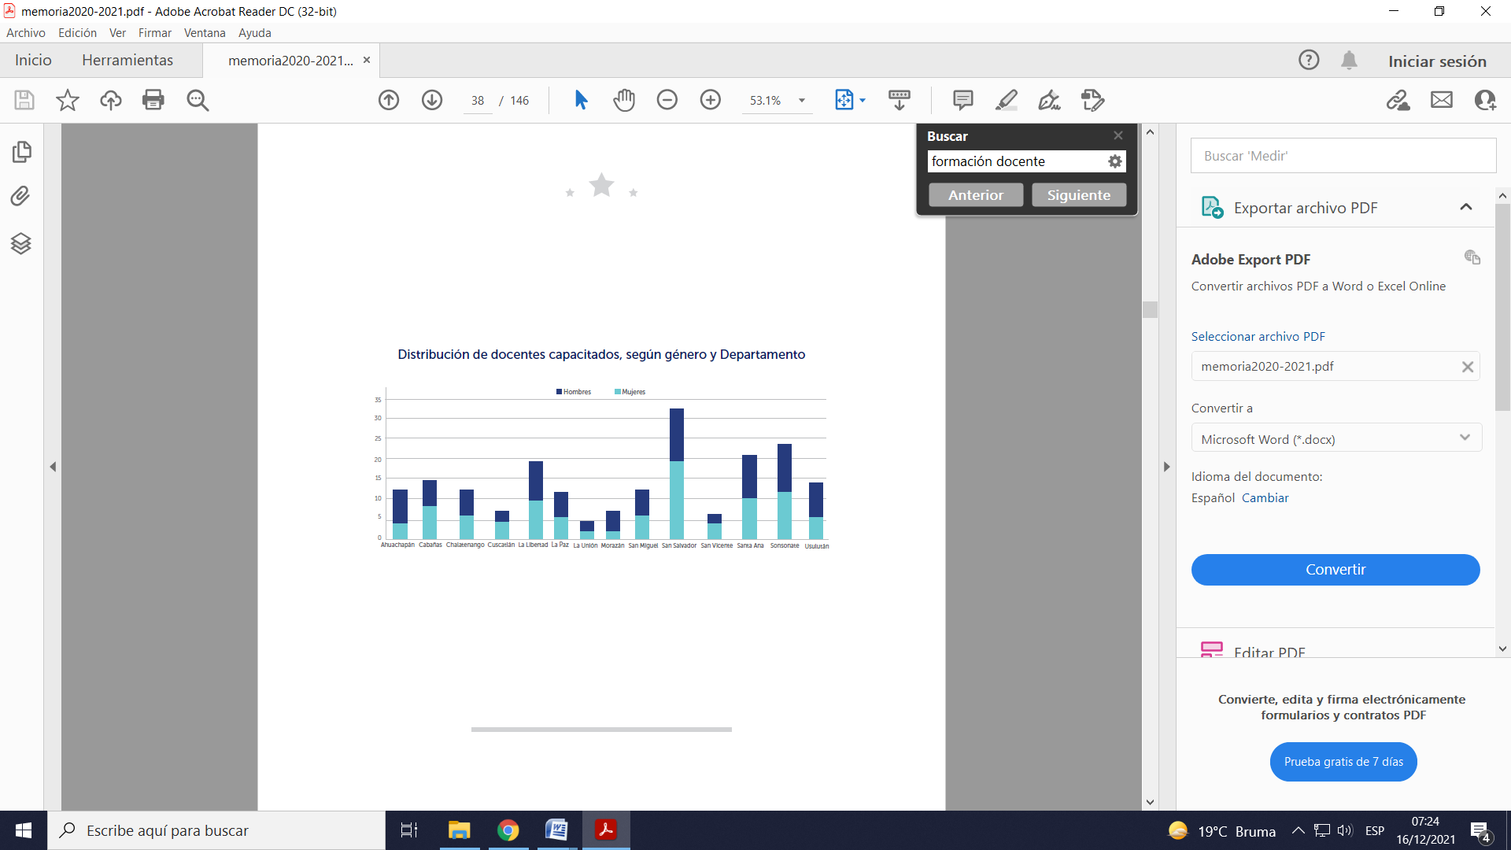

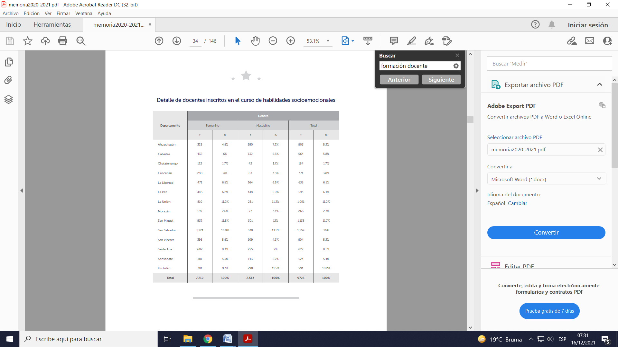

135. The total number of teachers certified in the first and second cohorts was 33,729. Of these teachers, 23,376 (69.31 per cent) were women and 10,353 (30.69 per cent) were men.

136. With regard to teachers’ salaries, 2,744 positions were offered to teachers who had not been assigned a position by decision of the examination board, interim teachers and new recruits.

137. Under the “My New School” project, educational facilities will be redesigned to facilitate learning. The project also promotes community initiatives, such as the construction of parks, theatres and basketball courts, with a view to providing additional opportunities for recreation and leisure. Existing school buildings will be made the property of the Ministry of Education, Science and Technology pursuant to an update of the current norms, regulations and laws.

138. Between June 2020 and May 2021, and with the support of the Government of Japan, Fundación Callejas, the Office of the United Nations High Commissioner for Refugees and the International Organization for Migration, $4.5 million worth of maintenance and repairs was done on 303 schools, benefiting 136,135 students.

139. Comprehensive improvements have been made, at a cost of $39.7 million provided by the Millennium Fund II, to 29 severely dilapidated schools, benefiting 17,944 students. In addition, $700,000 in State funds was spent to provide 173 schools with quality furniture, thereby creating a positive learning environment and benefiting 57,263 students.

140. 25. With the support of the Food and Agriculture Organization, the Government officially launched the Healthy and Sustainable School Meals Strategy within the framework of the School Meals and Health Programme, one of the programmes of the Universal Social Protection Subsystem established pursuant to the Act on Social Development, Protection and Inclusion, the implementation of which is coordinated by the Office of the Presidential Commissioner for Operations and Cabinet Affairs and the Ministry of Education, Science and Technology.

141. The School Meals and Health Programme and the School Milk Programme contribute to the improvement of eating and nutrition habits and promote the development of school, family and community gardens.

142. The purpose of the “My New School” programme is to strengthen education by way of infrastructure improvements to schools located in departments with a high multidimensional poverty rate – there is a special emphasis on preschool and basic and secondary education – in order to improve the quality of education and reduce the dropout rate in these departments by meeting the needs of students.

143. El Salvador has an inclusive education policy as part of which equal opportunities are promoted for all children to have access to, remain in and successfully complete their schooling, with respect for children with disabilities. Under this policy, 1,211 students nationwide have received assessment and psychological and educational guidance services from 17 guidance and resource centres. An average of 12,145 students in basic education have received assistance from special education teachers, and 1,083 blind or visually impaired students are receiving educational support and technical assistance.

Percentage of students who enrol in the first grade of preschool and reach the last year of primary school

| *Percentage of pupils having reached the sixth grade, 2019* |
| --- |
| 82.1 |

*Source*: Ministry of Education, Science and Technology, enrolment, 2019–2020.

Primary school enrolment and completion rate

| *Percentage of pupils having reached the sixth grade, 2019* | |
| --- | --- |
| Boys | 80.0 |
| Girls | 84.3 |
| Rural areas | 75.5 |
| Urban areas | 89.2 |

*Source*: Ministry of Education, Science and Technology, enrolment, 2019.

Secondary school enrolment and completion rate

| *Percentage of pupils having reached the first year of secondary school, 2019* | |
| --- | --- |
| **Total** | **59.8** |
| Girls | 55.7 |
| Women | 64.3 |
| Rural areas | 19.4 |
| Urban areas | 105.7 |

*Source*: Ministry of Education, Science and Technology, enrolment, 2019.

Average number of years of schooling completed



*Source*: Directorate General of Statistics and Censuses. Multipurpose household survey 2019.

144. A health and education benefit, comprising a monthly cash transfer made to families, has been established to provide them with an incentive to send their children for early childhood health check-ups and to ensure that children enrolled in the third cycle of primary school and in high school attend and stay in school. During the reporting period, 33,489 vulnerable families and families living in poverty in 134 municipalities received assistance. Of the total number of beneficiaries, 31,484 were women and 2,005 were men.

145. The Ministry of Education, Science and Technology has strengthened the accelerated first- and second-cycle basic education programme, reincorporating 10,511 students who had dropped out of school for various reasons. These students also received additional support in communication skills, mathematics, self-esteem, resilience, life planning and citizenship to help them pursue their studies successfully (annex XXVI).

146. Measures have been taken to address the intrinsic causes of school dropout by improving reading and writing skills using, for example, primary school textbooks, the “Juego, me divierto y leo” (I play, have fun and read) booklet (offered to 202,773 children in the first cycle of basic education and 10,823 teachers) and school and classroom libraries in the first cycle of basic education, all in accordance with the multimodal strategy for educational continuity (guides and websites containing educational material regarding languages, social studies, science, health and the environment; physical and art education using print and digital media; and video and radio classes and webinars). Questions about lessons submitted by users, including students, teachers and family members, were answered by telephone and on social networks.

147. The Ministry of Education, Science and Technology began providing computers with access to the Internet and computer programs to students at all school levels at 30 locations nationwide. As of October 2021, computers were being provided at 262 mobile delivery points with the support of the municipal authorities, the Office of the First Lady and the Office of the Presidential Commissioner. It is hoped that this initiative will help to bridge the digital divide in public education.

148. With the support of various agencies and strategic partners, standardized tests – namely, the skills certification test and the test Avanzo – were administered remotely. With regard to proficiency tests, an online pre-enrolment system was established, a repository of educational materials for each subject and grade was developed to support and facilitate the study of the syllabus by participants and the tests were administered to small groups.

149. Between June 2020 and May 2021, further steps were taken to revitalize the Nahuatl language, specifically the preparation of 77 early childhood and preschool education guides (under the project Cuna Náhuat and 17 learning guides for first cycle Nahuatl students. In total, 761 students (403 boys and 358 girls) between 3 and 6 years of age participated in the project and took transitional Nahuatl classes. The Government invested $117,000 in the project.

Cultural rights (art. 15)

150. The Ministry of Health has conducted and continues to conduct scientific studies in response to the COVID-19 pandemic. The studies have informed a series of measures, including steps to lower the risk of COVID-19 infection for health personnel, the publication of available evidence on the effects of COVID-19 on pregnant and breastfeeding women and the proposal of an algorithm for the management and administration of RT-PCR molecular diagnostic tests and IgM and IgG serological tests for the detection of SARS-CoV-2. A summary of proportional and scientific evidence, expert proposals and research is annexed to this report.

151. The scientific journal *Alerta*, published by the Salvadoran National Health Institute, is intended for the scientific community, academics and decision makers, clinics, administrators and students of the health sciences. It is indexed in international databases such as AmeliCA, LILACS, LATINDEX, REDIB and LAMJOL. Volume 4, No. 2, of 2021 is a special issue dedicated to the COVID-19 pandemic (see <https://alerta.salud.gob.sv/revista-alerta-vol-4-n-2/>).

152. In 2020, on the initiative of the National Health Institute of the Ministry of Health, in collaboration with the Latin American and Caribbean Centre on Health Sciences Information and the Pan American Health Organization, reorganized the National Network of Documentary Information on Health with a view to reactivating the Virtual Health Library, thus ensuring that research and scientific papers produced in El Salvador are visible at the regional and global level (see <https://bvsalud.org/vitrinas/es/post_vitrines/nuevo_coronavirus/>) (annex XXVII).

153. With regard to chronic kidney disease, information on the first national survey on chronic diseases was provided in paragraph 267 of the sixth periodic report of El Salvador.

154. A secondary analysis of the results of the 2015 national survey on chronic diseases reveals evidence of a close association between chronic kidney disease and historical exposure to agrochemicals.

155. Chronic kidney disease of non-traditional aetiology is present not only in male sugarcane farmers, as was the initial hypothesis; studies show that although this group is the most severely affected, the disease is also present in farmers who work with other types of crops.

156. According to the clinical profile of chronic kidney disease of non-traditional aetiology, chronic kidney disease of non-traditional aetiology is linked to chronic tubulointerstitial nephritis, in the light of its association with abnormalities in urine markers, tubular renal functional tests and histopathological study of the kidney. The discovery of extrarenal abnormalities, including neurological alterations of the peripheral nerves, neurosensory and auditory alterations, and vascular alterations of the thymic arteries that cannot be explained by the renal disease itself has contributed to advances in the causal interpretation of chronic kidney disease of non-traditional aetiology.

157. These results support the most feasible hypothesis: that the disease is caused by environmental exposure to toxins (agrochemicals). This would explain why the disease affects not only male farmers but also the non-farming population and account for the presence of extrarenal neurological, auditory and vascular alterations, which are presumably caused by toxins. This hypothesis indicates the existence of two levels of chronic or prolonged toxicity.

158. In 2021, clinical guidelines for the comprehensive treatment of chronic kidney disease and guidelines for the comprehensive treatment of kidney disease were developed. Screening of the population at risk has begun with a view to detecting the disease early and prescribing treatment, pharmacological or not, to delay its progression. Work is under way with the National Chronic Non-Communicable Diseases Commission, which is comprised of governmental and non-governmental institutions, on the implementation of the Plan for Comprehensive Treatment of Non-Communicable Diseases, which covers chronic kidney disease. The Plan will run until 2023.

159. Health workers employed by the Ministry of Health will receive training in the comprehensive treatment of chronic kidney disease, the laboratory network will be reinforced to improve its capacity to perform blood tests related to the screening of populations at risk of chronic kidney disease and awareness-raising campaigns will be conducted to reduce the risk of developing chronic kidney disease.

1. * The present document is being issued without formal editing.
2. ** The annexes to the present document are available on the Committee’s website.
3. In May 2021, the Substantive Equality Training School was renamed the Specialized Training Unit.
4. <https://goldservice.com.sv/wp-content/uploads/2021/07/Decretos-Ejecutivos-9-y-10-Tarifas-de-Salario-Minimo.pdf>.
5. <https://dds.cepal.org/observatorio/socialcovid19/fichamedida.php?id=189>.

   Special Transitional Act on the COVID-19 Pandemic Emergency, Comprehensive Assistance to Protect Life and Health and the Reopening of the Economy (art. 11), Legislative Decree No. 661, 12 June 2020, *Diario Oficial*, No. 190, vol. No. 428, 22 September 2020.
6. The COVID-19 vaccination process was declared of national interest in Legislative Decree No. 90 of 13 July 2021, published in *Diario Oficial*, No. 133, vol. No. 432, of the same date, which contains the special and transitional provisions on the suspension of gatherings and events of a public or private nature.
7. <https://dds.cepal.org/observatorio/socialcovid19/fichamedida.php?id=194>.
8. Legislative Decree No. 123 of 17 August 2021 – www.asamblea.gob.sv/node/11471, published in *Diario Oficial*, No. 159, volume No. 432, 23 August 2021.
9. Office of Social Management and Inclusion of El Salvador. National Cross-sectoral Strategy for the Prevention of Child and Adolescent Pregnancy 2017–2027 – www.salud.gob.sv/download/estrategia-nacional-intersectorial-de-prevencion-del-embarazo-en-ninas-y-en-adolescentes-2017-2027/.