|  |  |  |  |
| --- | --- | --- | --- |
|  | United Nations | CRC/C/ARG/Q/5-6/Add.1 | |
| _unlogo | **Convention on the Rights of the Child** | | Distr.: General  6 March 2018  English  Original: Spanish  English and Spanish only |

**Committee on the Rights of the Child**

**Seventy-eighth session**

14 May–1 June 2018

Item 4 of the provisional agenda

**Consideration of reports of States parties**

List of issues in relation to the combined fifth and sixth periodic reports of Argentina

Addendum

Replies of Argentina to the list of issues[[1]](#footnote-1)\*, [[2]](#footnote-2)\*\*

[Date received: 28 February 2018]

Part I

Question 1

1. Since the adoption of the National Act on Comprehensive Protection of the Rights of Children and Adolescents (Act No. 26061), the provinces have been urged to bring their internal legislation into line with the related administrative guidelines to ensure compliance with the Convention and article 18 of the Committee’s general comment No. 5.

2. Argentina has a republican and federal system of government through which the provinces establish their own regulations. However, legal standards that comply with Act No. 26061, the Convention and its two protocols have been established. Since the adoption of the new Civil and Commercial Code of the Nation, the provinces have been required to review and, if necessary, adapt their regulatory systems to ensure consistent application of legislation.

3. Twenty-two of the 24 jurisdictions, together with their corresponding administrative authorities,[[3]](#footnote-3) have specific legislation. Steps are being taken to ensure that local laws for the protection of the rights of children and adolescents are adopted by those provinces that do not yet have such legislation (San Luis and Formosa).

Question 2

4. The provinces with administrative bodies that implement protective laws operate under the aegis of their executive authorities.

5. Owing to the fact that the province of San Luis does not have protective legislation, its policies relating to children are implemented through the Programme for Development and Social Protection under the auspices of the Ministry for Social Inclusion.

6. Coordination of the provincial and municipal authorities takes place in accordance with the decentralization criterion established in Act No. 26061.

7. In four provinces (Buenos Aires, Chubut, Entre Ríos and Santa Cruz), the implementation bodies report to the provincial and municipal authorities. In three other provinces (Formosa, La Pampa and Neuquén), they report to the judiciary, the Public Legal Service and/or the Provincial Police. The latter three provinces, unlike the others, do not take in complaints.

8. Measures for the protection of rights are taken in 65 State agencies. The heads of the judiciary or the public legal services ensure that due process requirements are met.

9. In 16 provinces, responsibility for the adoption of these measures lies solely with the provincial and municipal administrative authorities. In 10 provinces, the agencies responsible for implementation report to the central authority (City of Buenos Aires, Catamarca, Formosa, La Rioja, Río Negro, Salta, San Juan, Santiago del Estero, Tierra del Fuego and Tucumán).

10. In some provinces, the administrative authority is responsible for supervising and monitoring the measures implemented. In other provinces (City of Buenos Aires, Corrientes, Jujuy, La Pampa, La Rioja, Río Negro, Santa Cruz, Tierra del Fuego and Tucumán), bodies belonging to the judiciary and the public legal services also carry out monitoring.

11. Regarding exceptional protective measures, bodies in 16 provinces report exclusively to the provincial and/or municipal executive powers; 6 of these 16 provinces share this competence with the judiciary (family courts, juvenile courts, magistrates’ courts and multi-jurisdiction courts) and/or the public legal services. The judicial authorities have sole competence for adopting exceptional measures in two provinces (Neuquén and Río Negro).

12. The monitoring and supervision of exceptional measures are the sole competence of the provincial and municipal authorities in seven provinces (Buenos Aires, Catamarca, Chaco, Córdoba, Entre Ríos, Salta and San Luis). They are the sole competence of the judiciary (civil, family and juvenile courts) and public legal services in seven other provinces (City of Buenos Aires, Chubut, La Pampa, Neuquén, San Juan, Santa Cruz and Santa Fe). Competence is shared between the judicial and administrative powers in 10 provinces.

13. The Federal Council for Children, Adolescents and the Family adopted the following instruments from 2015 to 2017: guidelines and standards for child development centres; guidelines for the active participation of children and adolescents as a matter of State policy; the National Plan of Action for the Rights of Children and Adolescents 2016–2019; the pledge of commitment to the “High Time to End Violence against Children” campaign to combat violence against children; a pledge entitled “securing the foundations of the rule of specialty from the outset of detention”; a pledge of commitment to cooperation over the digital inclusion of adolescents in residential homes and/or in particularly vulnerable situations; a proposal for a bill on the juvenile criminal justice system; a pledge of commitment to cooperation over the implementation of the national network of social tourism for children and adolescents; a pledge to secure the foundations of the rule of specialty during detention.

14. Guidelines on the following have been drawn up: the national plan for training in childhood and the family; the national early childhood plan; the national programme to reduce unintended pregnancy in adolescents; “My Word Counts” adolescent forums; the promotion of children’s lawyers; the promotion of the right to an identity; addictions; child labour; adoption under the new Civil and Commercial Code of the Nation; violence and child abuse; the ratification of the third Optional Protocol to the Convention on the Rights of the Child on a communications procedure; Line 102; guide for child and adolescent migrants from the Southern Common Market countries; Sustainable Development Goals; information systems for registering early childhood spaces; monitoring of the criminal justice system; and the law on supporting graduation among young people without parental care.

Question 3

15. Programmes relating to children and adolescents that have been in operation since 2015 have promoted and strengthened some central government policies, such as the Zero Poverty programme.

16. The Government has placed Argentina on the road to sustainability by ordering its resources in order to eliminate inflation and increase employment, enabling the country to emerge from poverty. To achieve this goal, growth must be inclusive in order to create sustainable jobs and promote equality.

17. In this regard, and within the framework of the objectives set out in the 2030 Agenda, Argentina is working to manage its finances, eliminate structural poverty and strengthen social protection systems to prevent violations of human rights and reduce inequality.

18. According to the data generated by the study on national investment in childhood in perspective, expenditure on children is increasing. The figures for 2016 show that national social public spending on childhood amounted to Arg$ 213,197.1 million. National social public spending on childhood, as a percentage of gross domestic product, has steadily increased to the extent that the most recently recorded value (2.6 per cent, in 2016) is double the initial value (1.3 per cent) recorded in 1995, and is expected to increase further in 2017.

19. The regular resources of the National Secretariat for Children, Adolescents and the Family amounted to Arg$ 1,194,580,688.00 in 2015, Arg$ 2,129,330,012.00 in 2016 and Arg$ 2,522,989,375.00 in 2017, which shows a significant increase both in total and in nominal terms.

20. Measures to ensure the availability and sustainability of the resources allocated to the protection of children’s rights include policies and programmes that focus on two areas: (1) early childhood and (2) adolescence:

(1) The National Early Childhood Plan, established by Decree No. 574/2016, is aimed at protecting and promoting the rights of all children between 45 days and 4 years of age. The public policy set out in the plan has been implemented through the establishment of spaces for early childhood (as at 2017, an agreement on the establishment of 1,183 spaces had been reached);[[4]](#footnote-4) the family support programmes “Home Instruction for Parents and Preschool Youngsters: Learning at Home” and “Early Years”, and the Centre for Prevention and Recovery from Infant Malnutrition, in relation to which an agreement to strengthen 82 centres has been established with the Infant Malnutrition Cooperative.[[5]](#footnote-5)

(2) The Adolescent programme is aimed at adolescents aged from 13 to 17 years. Public policy has been implemented through adolescent centres and centres for the promotion of human rights.

21. Programmes to sustain the increased investment in children include the universal child allowance for social protection (AUH)(2009), which brought the rights of unregistered workers’ children into line with those of the children of workers in formal employment, the “*Conectar Igualdad*” (Switch on to Equality) programme (2011) and the expansion of family allowances. In 2016, benefit payments and income brackets were updated and coverage was expanded to include the children of taxpayers under the simplified tax regime and temporary workers.

**Timeline of national public social expenditure on children, 1995–2016**

(Percentage of gross domestic product)

**FONID**



*Source:* National Directorate of Fiscal and Income Policy and the National Directorate for Macroeconomic Programming, Ministry of Finance.

22. In July 2016, in order to make child benefits universally available, the National Social Security Administration signed an agreement with the Ministry of Social Development and the United Nations Children’s Fund to ensure that an additional 1 million socially vulnerable children would be covered by universal child allowance, enabling 825,000 cases to be incorporated. In November 2017, over 3.9 million children received universal child allowance in the form of a payment of Arg$ 1,412.

23. Through the contributory family allowance subsystem (Act No. 24714), the children of workers registered as employees and taxpayers under the simplified tax regime[[6]](#footnote-6) may, depending on their income level, become eligible for the universal child allowance, which currently covers 4.1 million children and adolescents.

24. The children of beneficiaries of the law on occupational risk and recipients of unemployment benefit are also entitled to universal child allowance.

25. A non-contributory subsystem, benefiting over 700,000 children and adolescents, exists for beneficiaries of the Argentine Integrated Social Security System.

26. Family allowance coverage has increased by 25 per cent in comparison with 2015, which means that 70 per cent of Argentine children receive an allowance.

27. Benefits are updated four times per year (in March, June, September and December), in accordance with changes in prices (70 per cent) and wages (30 per cent) to ensure that the purchasing power arising from the benefits is not eroded. Workers whose earnings are higher than the maximum amount established for recipients of child allowance can deduct a maximum annual amount from their income tax for each child up to the age of 18 years.

28. Every year, the budget items required to maintain the system are established in accordance with the Budget Act and may be increased if necessary.

29. All these policies and programmes are conducted at the national, provincial and local levels.

Question 4

30. The National Plan for the Prevention and Eradication of Child Labour and the Protection of Adolescent Labour 2018–2022 was drafted in 2017.[[7]](#footnote-7) Agreement on the plan was reached between different stakeholders in the trade union sector, the business sector and members of the executive. The Plan is based on strategic considerations that make it possible to address, monitor and evaluate specific actions intended to ensure children’s rights.

31. In this regard, the Ministry of Labour, Employment and Social Security, with the support of members of the Network of Companies against Child Labour, has developed a voluntary guide to standards that will allow organizations to show that their practices are aligned with the decent work model and that they have established due diligence processes in their value chains (including the prevention/elimination of child labour).

32. The Ministry of Labour, through the Responsible Tourism and Children Programme, coordinates the code of conduct for the protection of the rights of children and adolescents in the area of travel and tourism. This code contains principles relating to corporate social responsibility for the prevention of sexual exploitation, child labour and trafficking in persons in the area of travel and tourism, with which tourism providers must comply.

33. The Code is a self-regulatory instrument that focuses on corporate social responsibility and requires a high level of commitment and involvement at all managerial and operational levels within companies.

34. The main purpose of the Code is to establish a tourism sector that takes responsibility for preventing the exploitation of children and adolescents, through stakeholders committed to eradicating these social problems out of a conviction that their conduct can make a difference to the creation of sustainable tourism, and communities in which children fully enjoy their rights.

35. Within the framework of responsible tourism and childhood, a course entitled Responsible Tourism and Childhood promotes public policies intended to prevent the sexual exploitation of children and adolescents, child labour and trafficking. The course addresses the content and implications of the Code of Conduct and national and international standards on children’s human rights, sexual exploitation, child labour and trafficking, and good practices, implemented from a standpoint of corporate social responsibility.

36. Various environmental authorities and agencies in the country deal with toxic agrochemicals, mining and environmental pollution. In 23 jurisdictions, legislation governing the use, inspection and/or monitoring of the use of agrochemicals has been enacted and local ordinances have been issued specifically for the municipalities with the highest usage levels.[[8]](#footnote-8)

37. The Matanza River Basin Authority has an emergency health plan that establishes the specific strategic goal of “carrying out timely and effective actions to reduce the impact of environmental risks on people’s health”.[[9]](#footnote-9) The Authority also carries out monitoring and regular inspections.

38. With regard to children and adolescents’ enjoyment of the right to prior consultation, the National Secretariat for Children, Young Persons and the Family has held forums on adolescent participation from which specific goals relating to the environment have emerged.

39. In 2017, 10 agreements against child labour were signed between the Secretariat, the Tobacco Growers’ Chambers of Salta and Misiones, the governments of Corrientes and Misiones and various municipalities, benefiting 1,850 children and adolescents and 150 employers.

Question 5

40. The National Secretariat for Children, Young Persons and the Family works in conjunction with provincial and municipal agencies and various social actors to create places of exchange in the form of youth centres where young people can express themselves, discuss ideas, share information, generate proposals and take decisions, with a view to bringing about changes to give a positive image of young people. Some 39 centres have been funded.[[10]](#footnote-10)

41. To promote this positive image, adolescent participation forums have been held in every province and the targets proposed by the adolescents now form part of the 2016–2019 national action plan.

42. The National Institute to Combat Discrimination, Xenophobia and Racism has a programme intended to enable children and adolescents to plan their lives in environments free from discrimination and violence through the promotion of inclusive practices and the forging of bonds between peers in conditions of equality.

43. In 2016, an institutional cooperation agreement was signed between the National Institute to Combat Discrimination, Xenophobia and Racism and the National Secretariat for Children, Young Persons and the Family, with the objective of empowering children and adolescents by giving them a space for participation through the establishment of public policy. The Global Forum on Anti-Semitism and the third Youth Federal Parliament were held to facilitate the participation of young people across the country.

44. In order to encourage young people to become involved, the National Institute to Combat Discrimination, Xenophobia and Racism has signed an institutional cooperation agreement with the Undersecretariat for Youth.

45. In order to protect the rights of children and adolescents, a cooperation agreement has been signed with the United Nations Children’s Fund and joint campaigns have been run, including a campaign against cyberbullying entitled #Don’t Share it, which aims to use the hashtags #yestoinclusion and #notodiscrimination to raise children and young people’s awareness of the significance and consequences of making discriminatory or offensive content go viral.

46. In 2017, the Internet Observatory of the National Institute to Combat Discrimination, Xenophobia and Racism received 3,500 complaints through official social networks and the Institute’s website. The majority of complaints concerned online expressions of discrimination, religious beliefs, racism and physical appearance.

47. Materials on discrimination will be developed for distribution in urban and rural centres so that work may be carried out with socially vulnerable adolescents.

48. The Institute promotes good practices to enhance adolescent migrants’ access to education, health care and work in equal conditions, forging links with educational institutions to circumvent the barriers to access caused by migrants’ lack of documentation.

49. With regard to pregnant teenagers, work is carried out in conjunction with the National Comprehensive Sex Education Programme and the National Institute for Women. In addition, workshops are held on the programme for raising teachers’ awareness of the non-discriminatory implementation of comprehensive sex education.

50. Emergency Decree No. 1006/2012 and Act No. 26618 on equal recognition for children born before the introduction of same-sex marriage have been enacted in accordance with strict considerations of equality in order to bring the rights of children born before the law into line with those born after the regulations were enacted. This has enabled new birth certificates to be issued that contain additional filiation details and double surnames. The reverse sides of national identity documents for newborns used to include the names and surnames of the child’s mother and father as a security measure. The wording “son/daughter of” is now used instead to allow one mother, one father, two mothers or two fathers to be included.

51. With regard to the intersex population, the National Institute to Combat Discrimination, Xenophobia and Racism has a section devoted to sexual diversity, which works with the lesbian, gay, bisexual, transgender and intersex community to promote recognition of their rights. In 2016, two cases in which two intersex babies in Misiones were unable to acquire legal identification documents were resolved.[[11]](#footnote-11)

52. The Ministry of Education and Sport, with the approval of the Federal Education Council,[[12]](#footnote-12) has produced the federal guidelines on educational procedures in complex situations relating to school life and has included information on children and adolescents, and lesbian, gay, bisexual, transgender and intersex persons in the comprehensive sex education programme.

53. The Observatory on Discrimination of the national communications authority, and the Advisory Council on Audiovisual Communication and Children, guarantee and protect the right to expression, promoting the quality of content and issuing warnings on content harmful to children and adolescents.

Question 6

54. The Education for Equality Act (No. 27234) has been passed. The implementation of this Act has led to the adoption of measures to eradicate violence within the family and at school. In 2016[[13]](#footnote-13) and 2017, workshops were held in 70,000 educational establishments and training materials were developed for teachers.[[14]](#footnote-14)

55. The National Action Plan for the Prevention and Eradication of Violence against Women and Assistance to Victims (2017–2019) is a vital tool for systematizing actions and measures that enable the State to provide a full and effective response to the problem of gender-based violence, while also making it possible to carry out assessments, monitor the impact of action lines, and coordinate with the provinces in order to ensure that standards of protection and prevention are in place throughout the country.[[15]](#footnote-15) The Plan is designed in accordance with a comprehensive and intersectoral perspective involving the coordinated work of 50 agencies and institutions, overseen by the National Institute for Women. In November 2017, 12 provinces formally subscribed to the Plan, which has a preliminary budget of Arg$ 750 million for three years of implementation.

56. The Plan, which has two lines of action focused on prevention and comprehensive care for women subjected to gender-based violence, is based on three cross-cutting areas: training in the gender perspective at all levels; networking and institutional coordination; and monitoring and evaluation of public policies.

57. In 2016, the prevention campaign #LoveIs (#AmorES) was launched with the aim of preventing violence in relationships.[[16]](#footnote-16)

58. With regard to actions to prevent sexual harassment occurring online and through new technologies, mention should be made of the adoption in 2013 of Act No. 26904, known as the Grooming Act, under which provisions defining and criminalizing this offence are incorporated into the Criminal Code under article 131.

59. The Ministry of Justice and Human Rights has a team of professionals (the #AmorES *niñ@s* team) that carries out prevention, awareness-raising and training activities throughout the country in various sectors, including tourism, the hotel sector, education, health, law enforcement and the civil service. The team tackles the offences of grooming, child pornography, the commercial sexual exploitation of children and adolescents and the sexual exploitation of children and adolescents within the travel and tourism sectors.

60. The team has established a free hotline (0800-222-1717), through which persons making complaints are given counselling and support 24 hours a day, 365 days a year.

61. In November 2017, the National Institute to Combat Discrimination, Xenophobia and Racism, in conjunction with UNICEF Argentina, launched a campaign[[17]](#footnote-17) to prevent online violence among adolescents and cyberbullying.

62. The National Secretariat for Children, Adolescents and the Family provides training and takes action in relation to domestic violence, child abuse and sexual abuse by providing financial and/or technical support and training to provincial bodies, municipal bodies and community agents. In addition, adolescent centres and centres for the promotion of rights have been opened where adolescents can make their own plans and establish useful contacts, with whom to interact and take immediate action against ill-treatment, child sexual abuse, assault and harassment between peers and within adolescent relationships, and violence inflicted in social media and through new technologies (cyberharassment or cyberbullying, grooming and child exploitation).

Question 7

63. The National Disability Agency, which replaced the National Advisory Commission on the Integration of Persons with Disabilities, was established under Decree No. 698/2017 as the government agency responsible for all matters relating to the implementation of the Convention and the Optional Protocol. The Agency promotes the full inclusion of persons with disabilities in the political, social and working life of the country, within the framework of universal accessibility, autonomy and equal opportunities.

64. Decree No. 868/2017 provided for the establishment of the National Disability Plan, which sets out the principles and obligations enshrined in the Convention on the Rights of Persons with Disabilities adopted under Act No. 26378.

65. The National Disability Agency is the government body responsible for all matters relating to the implementation of the Convention and the Optional Protocol. As such, it promotes the full inclusion of persons with disabilities in the political, social and working life of the country, within the framework of universal accessibility, autonomy and equal opportunities.

66. Within the scope of the Agency’s activities, the Federal Disability Council forms part of a network for coordinating actions aimed at implementing policies on disability across the regions. The Council is intended to address decentralization and decision-making capacity at the local and regional levels.

67. Where public policy is concerned, the National Social Security Administration grants social protection to children and adolescents with disabilities through family allowances regulated by Act No. 24714, covering contributory subsystems for workers registered as employees, beneficiaries of the law on occupational risk, recipients of unemployment benefit, workers registered as taxpayers under the simplified tax regime and recipients of pensions under the Argentine Integrated Social Security System.

68. As at October 2017, some 223,495 persons with disabilities had received this allowance.

69. The Universal Child Allowance, which was established in 2009, provides complementary support for persons with disabilities, including family groups who are unemployed or work in the informal economy, i.e., taxpayers under the simplified tax regime or beneficiaries of certain social plans. The Universal Child Allowance is a monthly allowance, not subject to an age limit, that is paid for every child with a disability.

70. As of January 2018, 29,000 persons with disabilities received this benefit, which amounts to Arg$ 4,606.

71. The State ensures that children and adolescents with disabilities can obtain effective access to social security through a non-contributory system, which provides 141,999 allowances to children and adolescents (as at March 2016). The contributory system, which provides for family allowances for children with disabilities, annual school assistance for children with disabilities and universal child allowance/disability allowance, is paid to 28,155 recipients (as at September 2017).

72. In 2016, the Federal Observatory on the Rights of Children and Adolescents with Visual Impairments was established under the auspices of the National Secretariat for Children, Adolescents and the Family to investigate and document the situation of children with visual impairments in the country.

73. In 2014, Act No. 27061 was passed, adopting the Marrakesh Treaty to Facilitate Access to Published Works for Persons Who Are Blind, Visually Impaired, or Otherwise Print Disabled of the World Intellectual Property Organization (WIPO).

Question 8

74. The executive has launched the National Plan to Prevent and Reduce Unintended Pregnancy in Adolescents.[[18]](#footnote-18) The bodies participating in the Plan include the Secretariat for Innovation and Quality Education, through the Comprehensive Sex Education Programme, and the Secretariat for the Promotion of Health and the Prevention and Control of Risks, through the Sexual Health and Responsible Procreation Programme and the Comprehensive Health Programme.

75. The National Plan, which was approved by Ministerial Resolution No. 2017-1790-APN-MDS of 10 August 2017, is intended to ensure that a holistic approach is taken to the problem of unintended pregnancy in adolescents, with a focus on rights, gender and intercultural understanding, and that the life and personal development opportunities of children and adolescents are extended and enhanced.

76. The Plan recognizes children and adolescents as subjects of law and is guided by three principles: progressive autonomy, the best interests of the child and the right to be heard. It also promotes the exercise of sexual and reproductive rights.[[19]](#footnote-19)

77. It seeks to improve the technical and communication skills of staff working in the health system, the education system and the system for the protection of rights, in order to ensure that they are qualified to work with children and adolescents in the health service, schools, State institutions and communities.

78. The following measures have been adopted:

* The “Let’s Talk about Everything” (*Hablemos de Todo*) platform, which gives adolescents the chance to address taboo subjects such as gender and sexuality;
* The publicization of the 0800 sexual health hotline, in accordance with the Sexual Health and Responsible Procreation Programme;
* The development of graphic and audiovisual campaigns with a rights and gender perspective to promote the adoption of practices and methods of care, the right of individuals to decide about their sex lives and the distribution and use of contraceptives;
* The empowerment of girls and female adolescents to make free and informed decisions about their sexuality, their reproductive capacity and family planning, as well as their ability to prevent and respond appropriately to situations of abuse and coercion.

79. For 2018, the Plan established under the National Strategy for Children and Adolescents has prioritized provinces in the north-west and north-east of Argentina (Jujuy, Salta, Tucumán, La Rioja, Catamarca, Formosa, Chaco, Santiago del Estero, Misiones, Corrientes and Entre Ríos) and the Province of Buenos Aires, as they have the highest rates of unintended pregnancy.

80. There are currently 184 counselling mechanisms promoted by the National Programme for Comprehensive Adolescent Health in 13 provinces.

Question 9

81. The implementing regulations of the Refugee Recognition and Protection Act (No. 26165) are under review.

82. In 2011, in order to manage ways to protect unaccompanied or separated child or adolescent asylum seekers and refugees, a protocol has been drawn up on the provision of protection, assistance and durable solutions to child asylum seekers who are unaccompanied or separated from their families (in collaboration with the Office of the United Nations High Commissioner for Refugees, the National Committee for Refugees, the National Directorate of Migration, the Chief Public Defender’s Office, the National Secretariat for Children, Adolescents and the Family, non-governmental organizations, the United Nations Children’s Fund, the International Organization for Migration, the Foundation of the Argentine Catholic Commission for Migration, and the Foundation for Migrants and Refugees in Argentina).

83. The Protocol is divided into three parts: (1) initial measures of protection and care and the implementation of a special procedure for determining international protection needs by using specific forms for unaccompanied or separated children and adolescents; (2) implementation of a formal procedure for determining the best interests of unaccompanied or separated children whose international protection needs have been established and identifying and implementing lasting solutions for their situation; (3) the development of a strategy for implementing the Protocol.

84. The Protocol also provides for the appointment of guardians and/or legal representatives and establishes priority treatment through the following decision: “Unless there are substantial grounds that justify an extension, the National Committee for Refugees shall take a decision on asylum applications within six months of the date on which the Executive Secretariat of the National Committee is informed that a guardian has been appointed”.

Question 10

85. The National Institute to Combat Discrimination, Xenophobia and Racism addresses issues related to discrimination directed at indigenous children and adolescents and works with the National Institute of Indigenous Affairs to enhance their rights and equip them with tools.

86. These tools enable them to exercise their rights and the State to fulfil its international commitments.

87. The section on indigenous peoples plays an active role in enhancing the rights of children and adolescents and organizing workshops on violence and discrimination directed at indigenous women.

88. Various materials have been designed to provide information, raise awareness and educate the population. These include three-page leaflets on indigenous peoples translated into Wichi, Moqoit and Qom, short news items on commemorative days, themed postcards and modules for inclusion in the virtual campus of the National Institute to Combat Discrimination, Xenophobia and Racism.

89. This section also produces publications such as *The Rights of Indigenous Peoples* (2011) (in collaboration with the Secretariat for Culture); *Discrimination and Indigenous Peoples in the Workplace* (2014), in collaboration with the office for the safeguarding of indigenous peoples, which reports to the Ministry of Employment; and *Indigenous Peoples: Publication on Inclusion-Exclusion* (*Pueblos Indígenas. Publicación Inclusión-Exclusión*) (2014), in collaboration with the Social Studies Centre — Delegation of Argentine Jewish Associations.

90. The issue of indigenous peoples has also been addressed in institutional publications such as *Work without Discrimination, The Rights of Patients*, *Schools against Racism* and *Racism and Xenophobia: Towards an Intercultural Argentina*.

91. With regard to the education of indigenous children and adolescents, 13,000 intermediate-level scholarships were granted every year between 2015 and 2017 and 250 university-level scholarships were granted in 2017. Furthermore, 40 indigenous youth support centres run workshops on recovering and promoting culture, identity and ancestral values. In accordance with the school support programme, intercultural tutors work to prevent school dropout, discrimination and repetition.

92. In 2017, the National Health Programme for Indigenous Peoples trained 782 indigenous health workers at the primary care level in 16 provinces, implementing an inclusive and intercultural approach that takes into account the traditional medical practices of each people.

Question 11

93. In 2012, focal points were appointed at the provincial level and in the Autonomous City of Buenos Aires, and a national focal point to head the National Secretariat for Children, Adolescents and the Family; guidelines to the National Assistance Protocol were signed.

94. The National Protocol on Supporting Victims of Trafficking in Persons was issued within the framework of the Federal Council for Children, Adolescents and the Family, the main objective of the Protocol being to restore and protect the rights of the victims of trafficking, for whom each jurisdiction is responsible. Support is provided on an individual basis, taking into account the specificities of each case.

95. In 2013, pursuant to the amendment of National Act No. 26842 on Trafficking in Persons, an executive committee was set up to combat trafficking and exploitation of persons and to protect and assist victims. In accordance with Resolution No. 1280/2015 of the Executive Office of the Cabinet of Ministers, a single coordination protocol was drawn up, that established that the Ministry of Social Development will be primarily responsible for taking steps to restore victims’ rights within its sphere of competence and through its regional network.

96. In 2015, four regional meetings of authorities and technical teams working in the area of assistance to victims of trafficking were held in order to establish provincial assistance protocols as effective tools for the restoration of rights and as mechanisms for inter-agency coordination. Support was received from the International Organization for Migration, the United Nations Children’s Fund, the National Trafficking Victims Rescue and Assistance Programme, federal prosecutors, immigration officials, the National Register of Agrarian Workers and Employers, the Federal Administration of Public Revenues, officials of the national and provincial security services and representatives of other agencies. In October, the fifth national meeting of authorities working in the area of assistance to victims of trafficking was held.

97. In 2016, within the framework of the annual meeting of authorities working in the area of assistance, the commitment to federal coordination established in the guidelines for the coordination of assistance (2012) was renewed.

98. Following the adoption of Act No. 26842, the Federal Council to Combat Human Trafficking and Exploitation and Protect and Assist the Victims, and the Executive Committee for the Fight Against Human Trafficking and Exploitation and the Protection and Assistance of Victims, were established. The latter body, which began operating in 2016, established the National Programme to Combat Trafficking and Exploitation and Protect and Assist the Victims.

99. An official call for NGOs to join the Council was issued in 2018.

100. From 2015 to 2017, training sessions were held in Rio Negro, Salta, Catamarca and Corrientes (260 participants), the Autonomous City of Buenos Aires (290 participants and 700 adolescents), Buenos Aires (120 participants), La Rioja (84 participants); Neuquén (710 participants), and Misiones (189 participants).

101. With regard to the assistance provided to children, adolescents and members of their families in 2015, direct action was taken in 101 situations involving victims, of whom 70 per cent were victims of trafficking for the purposes of labour exploitation, 13 per cent were victims of trafficking for the purposes of sexual exploitation and 11 per cent were children or other family members in places where exploitation was occurring. In 2016, comprehensive assistance was provided to 76 people.

102. The Ministry of Justice and Human Rights has formed a specialized team responsible for taking victims’ statements that is available to work in the Gesell chambers of all courts in order to prevent re-victimization. Reports indicate that some 217 children and adolescents were rescued from 2015 to 2017.

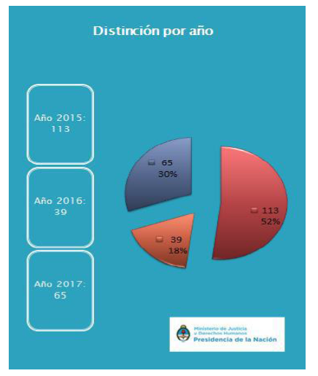

Breakdown by year (2015, 2016, 2017). *Source:* Office of the President.

103. Under the Responsible Tourism and Children Programme and its draft Code of Conduct for the protection of the rights of children and adolescents, the Ministry of Tourism works with different State agencies to coordinate protocols concerning complaints of possible cases of sexual exploitation, child labour and trafficking in persons.

Question 12

104. The National Secretariat for Children, Young Persons and the Family, under the Federal Council for Children, Adolescents and the Family, has signed the papers entitled “Minimum Contents of a New Juvenile Criminal Law” (2015) and “Securing the Foundations of the Rule of Specialty in the first moments of detention” (2016). In 2017, it developed a proposal for a draft law on the juvenile criminal justice system that was in line with the Convention, its complementary rules and guidelines and the general comments of the Committee on the Rights of the Child, signing a deed of commitment to continue taking steps to adapt procedural rules, establish specialized mechanisms, review practices and formalize those practices in protocols. Regular working groups are held at which experts from 18 provinces discuss models for action protocols with a view to applying them uniformly at the federal level. With regard to procedural rules, the National Secretariat for Children, Young Persons and the Family is developing a model draft procedural law on juvenile criminal responsibility that the provinces (to which authority for the establishment of procedural regulations has not been delegated) can adopt, enabling them to adapt their practices to international standards irrespective of the need for basic norms.

105. With regard to alternative measures to the deprivation of liberty, the national programme for the institutional monitoring of juvenile criminal mechanisms has been adopted in accordance with Resolution No. RESOL‑2017-821-APN-SCYMI#MDS. This programme provides for ongoing and specialized follow-up, monitoring and evaluation of public policies aimed at protecting the rights of adolescents in conflict with the criminal law in every jurisdiction in the country. Under this programme, 14 visits have been paid to the provinces of Río Negro, Neuquén, Mendoza, Buenos Aires (Mar del Plata and San Martin), La Rioja, Catamarca, Chubut, Chaco, Formosa and Salta.

106. Lastly, in accordance with Resolution No. RESOL-2017-103-APN-SENAF#MDS, the national programme for the creation and strengthening of admission and referral centres for suspected adolescent offenders has been adopted.

107. The Ministry of Justice and Human Rights has carried out a survey, in every province, of the existence and methods of application of alternative measures to trial and the deprivation of liberty and the implementation of enforcement and/or restorative measures.[[20]](#footnote-20)

Question 13

108. The Ministry of Defence, in accordance with the commitments made by the Committee of Legal Advisers on Public International Law, coordinated the Second International Conference on Safe Schools: Protecting Education from Attack as a follow-up to the first conference held in Oslo in May 2015, at which the Safe Schools Declaration and the Guidelines for Protecting Schools and Universities from Military Use during Armed Conflict were adopted. Efforts are now being made to encourage more States to join the safe schools initiative in order to protect children in conflict zones from attack while exercising their right to education.

109. With regard to the sale of children, child prostitution and child pornography, the Ministry of Justice and Human Rights assists in the rescuing of victims and the preparation of victims’ statements in the criminal courts.

110. The National Secretariat for Children, Young Persons and the Family protects and supports foreign victims within the framework of Resolution No. 1280/2015. Children and adolescents are given direct and immediate assistance for the restoration of their rights (in the form amongst others of accommodation, food, clothing, medical care, counselling, social care and documentation). If they are foreign nationals, they are put in touch with specialized bodies of their country of origin. The bodies in question, which participate in the measures taken, may include consulates, the ministries of foreign affairs of both countries, the International Organization for Migration and the ombudsman’s offices of the public prosecution service.

111. Helplines have been set up, including 137 (for victims against violence) and 145 (the Office for the Rescue and Assistance of Victims of Trafficking).

Part II

Question 14

112. New bills or laws include:

* Act No. 26994, adopting a new Civil and Commercial Code, addresses central concepts for children, such as the best interests of the child, progressive autonomy, parental responsibility and the right to be heard in the adoption system;
* Act No. 26879, establishing the national register of genetic data related to crimes against sexual integrity, entered into force through Regulatory Decree No. 522/2017 of 2017;
* Act No. 27210, establishing a pool of lawyers for victims of gender-based violence, ensures access to justice through the provision of free and comprehensive legal assistance to women victims;
* Act (No. 27234), “Education for Equality”, establishes the framework to ensure that the workshop “Education for Equality: Preventing and Eradicating Gender-Based Violence” is held in all educational establishments, whether they be public, private, at the primary, secondary or tertiary level, the purpose of the workshop being to ensure that students and teachers develop and strengthen attitudes, knowledge, values and practices that help to prevent and eradicate gender-based violence;
* Act No. 27352, amending article 119 of the Criminal Code on sexual abuse, clarifies the definition of the crime in order to reduce the margin of discretion applied by judges in relation to the offence;
* Act No. 27363 on the divestment of the parental responsibility of persons convicted of being perpetrators, co-perpetrators, instigators of, or accomplices to the crime of murder, aggravated by relationship (*homicidio agravado por el vínculo*), or of the perpetration of gender-based violence, as provided for in article 80 (1) and (11) of the Criminal Code.

113. The legislature has established a special bicameral committee for the appointment of the National Ombudsman on the Rights of the Child, for which candidates are currently being assessed.[[21]](#footnote-21)

114. In accordance with Executive Decree No. 1117/16, which is in line with the ILO Worst Forms of Child Labour Recommendation, 1999 (No. 190), the types of work, activities, occupations and tasks that constitute hazardous work for persons under the age of 18 have been established in accordance with article 3 (d) of the ILO Worst Forms of Child Labour Convention, 1999 (No. 182), adopted under Act No. 25255.

115. New institutions include:

* By Decree No. 698/2017, the National Disability Agency and the National Institute for Women were established as decentralized bodies (in terms of their jurisdiction) under the Ministry of Social Development. These bodies will assume the functions of the National Council for Women to strengthen comprehensive public policies for women’s empowerment.

116. Recently introduced policies and programmes include:

* The National Early Childhood Plan, adopted by Decree No. 574/2016, aimed at ensuring the comprehensive development of socially vulnerable children aged between 45 days and 4 years;
* The National Plan to Prevent and Reduce Unintended Pregnancy in Adolescents, approved by Ministerial Resolution No. 2017-1790-APN-MDS (August 2017);
* The National Plan for the Prevention and Eradication of Child Labour and the Protection of Working Adolescents 2018–2022, on which a consensus was reached by different stakeholders in the trade union sector, the business sector and the executive branch, acting on technical advice provided by the International Labour Organization and the United Nations Children’s Fund. Commitments relating to training, strengthening the rights protection system, establishing systems for recording complaints and promoting support services aimed at children and adolescents have been adopted, with two-year and four-year measurable targets;
* In 2017, the coverage provided by the Good Harvest programme, which establishes care and support centres in rural or peri-urban areas to prevent child labour in farming and other sectors, was extended.

117. Examples include:

* Province of Mendoza: 131 centres, supporting 6,000 children and adolescents;
* Province of San Juan: 30 centres, supporting 1,200 children and adolescents;
* Province of Salta: 7 centres, supporting children up to the age of 12 (560 per season);
* Province of Misiones: 1 centre, supporting over 100 children and adolescents per year:
* The “Labour Is Not for Kids” (El Trabajo no es cosa de chicos) programme, managed by the Province of Santa Fe: 35 centres;
* The National Action Plan for the Comprehensive Protection of Children and Adolescents 2016–2019, adopted by the Federal Council for Children, Adolescents and the Family in 2017, in accordance with articles 44 (B) and 46 (B) of Act No. 26061;[[22]](#footnote-22)
* In 2016, the process of adopting and implementing Act No. 26485[[23]](#footnote-23) on comprehensive protection to prevent, punish and eradicate violence against women throughout the country was completed; all 24 jurisdictions in Argentina have now ratified and are implementing Act No. 24685.

118. Recently ratified human rights instruments include:

* Act No. 27016, adopting the Marrakesh Treaty to Facilitate Access to Published Works for Persons Who Are Blind, Visually Impaired, or Otherwise Print Disabled of the World Intellectual Property Organization;
* Act No. 27441 of 2017, in accordance with which Argentina ratified, with reservations, the Budapest Convention on Cybercrime.

Part III

Question 15

119. Regarding national investment in children, the classification of expenditure on children by class requires assessing the extent to which various State social initiatives and programmes are targeted at children.

120. Expanded expenditure grew by 73.1 per cent between peaks, and went from 0.77 per cent to 1.33 per cent of GDP. Although it is the largest item of expenditure in the national social public spending on childhood,[[24]](#footnote-24) accounting for around half of the total for 2016, it has lost ground throughout the series in favour of specific expenditure. Considerable investment in education promoted by, among other initiatives, the National Teacher Incentive Fund; the construction and maintenance of schools; the Fund for Technical and Vocational Education; and the “*Conectar Igualdad*” (“Switch on to Equality”) netbook distribution programme had the effect of tripling the share of specific expenditure in terms of GDP, which went from 0.15 per cent to 0.55 per cent.

121. Indirect expenditure doubled between peaks, going from 0.31 to 0.66 per cent of GDP, as a result of the prevalence acquired by direct cash transfers, the majority of which (Unemployed Heads of Household Plan, Universal Child Allowance, family allowances, the “*Ellas Hacen*” (they do) programme, among others) are calculated as indirect expenditure for the years in question, since they are targeted at families with children and adolescents.

122. Expenditure on public goods, mainly spending on science, technology and culture, has remained at around 0.08 per cent of GDP.

123. The internal composition of indirect expenditure also changed in relation to its main component, family allowances. Children of unregistered workers were included in the social protection system as part of the implementation of the universal child allowance. In 2016, the upper income limit to be eligible for family allowances was doubled; benefit payments were increased, and the children of taxpayers under the simplified tax regime and temporary workers were included. Investment in family allowances amounted to 0.55 per cent of GDP.

124. Direct assistance investment was at its highest in terms of GDP in 2016 and was among those that grew the most throughout the series, going from 0.35 per cent of GDP to nearly 1 per cent.

125. The education category increased the most, rising from 0.09 to 0.41 per cent of GDP.

126. Investment in social work grew in terms of GDP, but lost relative weight given the significant growth in the other categories.[[25]](#footnote-25)

Question 16

127. The mobile support team for victims of crimes against sexual integrity has intervened in 10,511 cases and assisted 9,986 victims, of whom 5,239 (52.5 per cent) were children or adolescents, between October 2006 and August 2016.[[26]](#footnote-26) It should be noted that 9 out of 10 victims of sexual violence are female.

128. With regard to femicides in the country, 48.2 per cent of the victims are girls and adolescents, which is the most vulnerable age group. Parents are most frequently the assailants of young children, as are partners after the age of 16.

129. In relation to children and adolescents with disabilities, 138 victims were detected, 25.4 per cent of whom were under 10 years of age and 74.6 per cent were aged between 11 and 18, with a greater prevalence of females in the 11–15 age group. Among female victims with disabilities, 35 per cent had suffered some type of violation. Around 50 per cent of the total number of victims with disabilities had been forcibly sexually abused.

130. The Office of the President and UNICEF Argentina ran a national campaign on child sexual abuse in 2016 to raise public awareness of the offence. After it was launched, a total of 2,103 calls were received; of these, 754 involved cases of child sexual abuse and 540 were requests for guidance.

131. The Office of the President, the Ministry of Justice and Human Rights and UNICEF[[27]](#footnote-27) launched the “*Hablemos de Abuso Sexual Infantil*” (Let’s Talk about Child Sexual Abuse) national campaign with the 0800-222-1717 helpline, which operates nationwide 24 hours a day, 365 days a year. There were 2,429 calls, resulting in 878 cases of sexual abuse of children and adolescents involving 889 victims. Children and adolescents accounted for 655, or 74 per cent, of the calls received. Between November 2016 and December 2017, a total of 5,175 calls were received from all over the country, giving rise to 2,439 cases of sexual abuse, involving 2,616 victims (cases may involve more than one victim). Children and adolescents accounted for 70 per cent, or 1,845, of the victims; of these, 7 out of every 10 were girls under the age of 18, and 26 per cent were aged under 5.

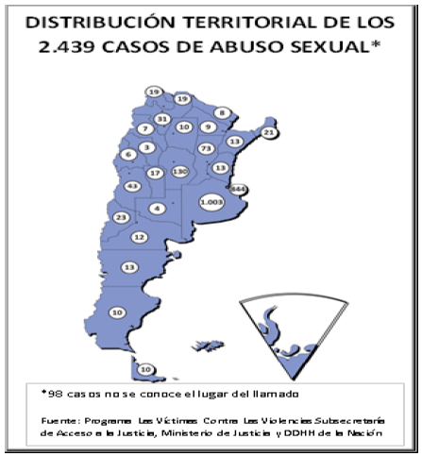

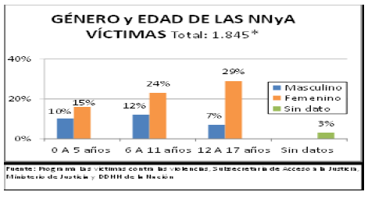

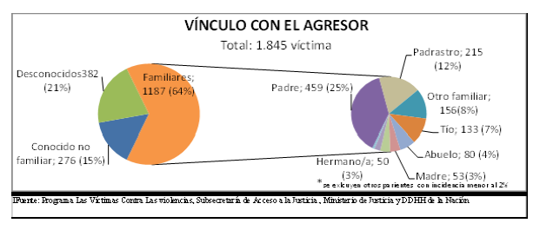

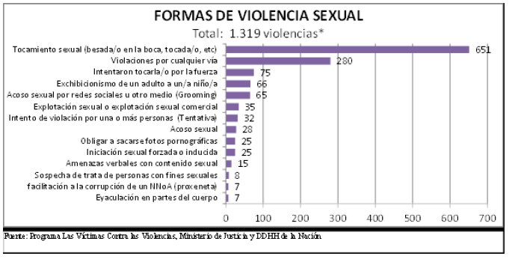

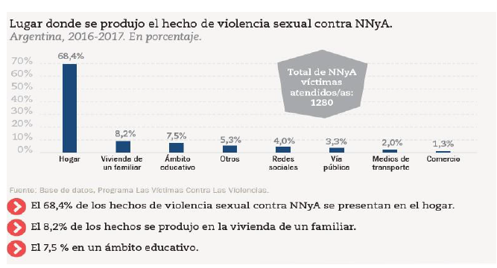

Percentage of children and adolescents (between 0 and 17 years of age) who were victims of sexual abuse as reported via the 0800-222-1717 helpline.

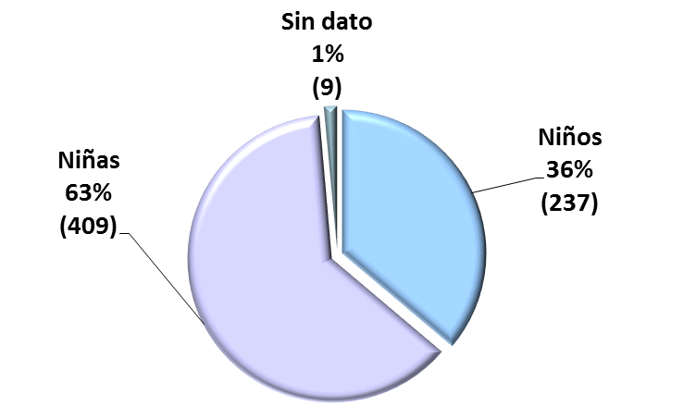

132. The 137 helpline (City of Buenos Aires) and mobile support teams for victims of violence. Between October 2006 and 6 March 2017, 122,387 calls were received. The mobile support team for domestic violence responded to 21,448 incidents on the ground, in which it assisted 28,314 victims.

133. The mobile support team for sexual violence in the city of Buenos Aires responded to 11,181 incidents on the ground between 2006 and 2017, in which it assisted 10,630 victims. Furthermore, legal assistance was provided by the legal team to victims and professionals involved in the programme in 2017.

134. An agreement was signed with the companies Telecom, Personal Argentina, Claro Argentina and Telefónica Argentina via GSMA, in which those companies committed to supporting the “Victims against Violence” programme by promoting and supporting the “Equipo Niñ@s” team campaign against sexual exploitation and grooming and the 137 helpline in the City of Buenos Aires, as well as the “Argentina Matters to Us” (*Nos importa Argentina*) campaign.

135. A total of 2,081 professional reports were sent to the courts, including 1,583 preliminary reports on family interaction and preliminary risk sent to the civil courts by the interdisciplinary group on protection from domestic violence, and 498 reports and responses to requests for information from the courts, public prosecutors and public defenders in relation to the action taken under the programme.

136. The Domestic Violence Office of the Supreme Court of Justice registered 14,724 restraining orders for protecting children and adolescents in 2016.

Question 17

(a) Infant mortality rate (per thousand live births) as at 2015: 9.7 per cent

(b) Maternal mortality rate (per thousand live births) as at 2015: 3.9 per cent

(c) As regards malnutrition, the Second National Food and Health Survey will be conducted in 2018, and will replace the following 2005 data:

**Chronic malnutrition 8.0 per cent;**

**General malnutrition 2.1 per cent;**

**Acute malnutrition 1.3 per cent;**

**Obesity 10.4 per cent.**

137. Chronic malnutrition was more prevalent (11.4 per cent) in children in households with unsatisfied basic needs compared to other households (6.2 per cent). The prevalence of anaemia in children aged between 6 and 23 months was significantly higher in households with unsatisfied basic needs (41.1 per cent) compared to other households (29.4 per cent). The prevalence was also higher among children in poor (37.6 per cent) and destitute (38.6 per cent) households than those in non-poor households. The prevalence of subclinical vitamin A deficiency in children aged between 24 and 72 months was 14.3 per cent. It varied between 6.7 per cent in Patagonia and 20.4 per cent in the North-East. The prevalence of vitamin D deficiency in Patagonia was 2.8 per cent, insufficiency 20.8 per cent and mild insufficiency 40.2 per cent.

(d) Children and adolescents affected by HIV/AIDS

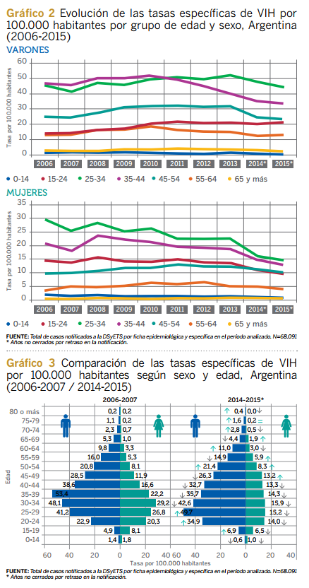

Lastly, 5 out of every 100 babies born to mothers with HIV are diagnosed with the virus.[[28]](#footnote-28)

(e)

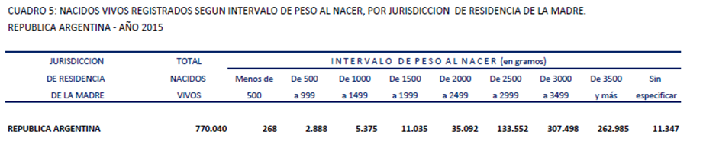

(f) The national immunization schedule protects against 18 illnesses. Vaccinations are compulsory, free and are given in immunization units, health centres and public hospitals throughout the country[[29]](#footnote-29)

138. For the years 2015 and 2016, see annex 10 on vaccination coverage.

(g) Pregnancy rate in early and late adolescence, and overall adolescent pregnancy rate. Argentina. 1990–2015

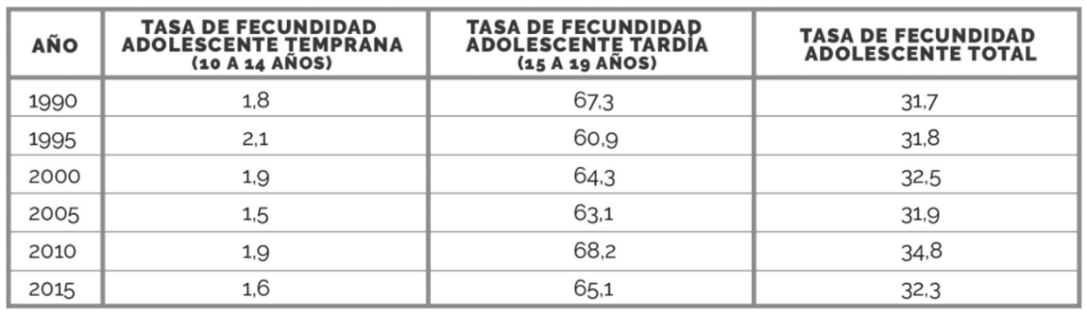

*Source:* Based on data from UNICEF, the National Institute of Statistics and Censuses and the Health Statistics and Information Directorate.

Total live births for mothers under the age of 14 and aged between 15 and 19, according to the mothers’ jurisdiction of residence. Argentina, 2015.

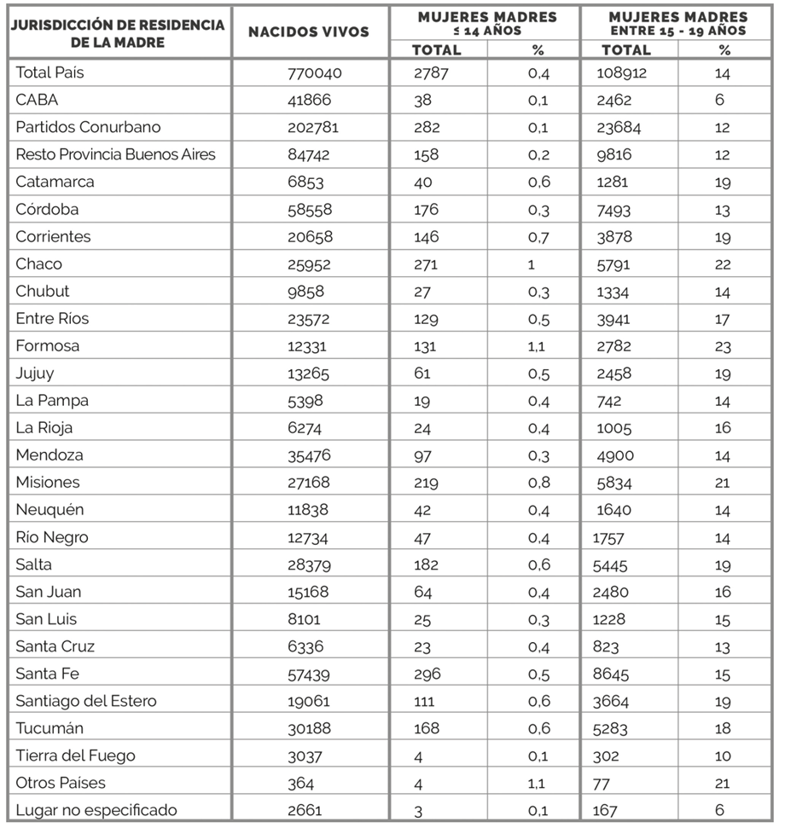

*Source:* Based on data from the Health Statistics and Information Directorate.

(h)

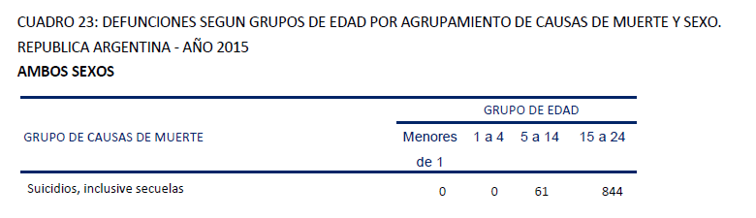

*Source:* Vital Statistics. Basic information 2015, Health Statistics and Information Directorate, Ministry of Health.

(i) The 2017 study by the Secretariat for Comprehensive Drug Policies of Argentina on the consumption of psychoactive substances found that children and adolescents mostly used alcohol, marijuana and illicit drugs

*Source:* Based on the summary of the results of the 2017 study on the consumption of psychoactive substances, Secretariat for Comprehensive Drug Policies of Argentina, Office of the President.

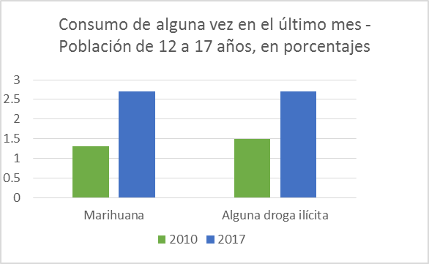

*Source:* Based on the summary of the results of the 2017 study on the consumption of psychoactive substances, Secretariat for Comprehensive Drug Policies of Argentina, Office of the President.

Percentage lifetime prevalence of consumption of psychoactive substances by gender. Population aged 12–17. Argentina, 2017

|  | *Male* | *Female* | *Total* |
| --- | --- | --- | --- |
| Tobacco | 22.6 | 14.7 | 19 |
| Alcohol | 68.6 | 51.1 | 60.5 |
| Tranquillizers without prescription | 0.4 | 1.4 | 0.8 |
| Stimulants without prescription | 0.1 | 0 | 0.1 |
| Opioid analgesics without prescription | 1.8 | 3.6 | 2.6 |
| Weight-loss drugs without prescription | 0.2 | 0.1 | 0.2 |
| Anabolic steroids without prescription | 0.1 | 0 | 0.1 |
| Solvents and inhalants | 0.3 | 0.1 | 0.2 |
| Marijuana | 12.9 | 3.5 | 8.6 |
| Cocaine | 1.6 | 0.7 | 1.2 |
| Coca paste | 0.3 | 0 | 0.2 |
| Hashish | 0.5 | 0 | 0.3 |
| Crack | 0.1 | 0 | 0 |
| Ecstasy | 0.1 | 0.6 | 0.3 |
| Heroine | 0 | 0 | 0 |
| Opium | 0 | 0 | 0 |
| Morphine without prescription | 0 | 0 | 0 |
| Hallucinogens | 0.6 | 0.3 | 0.5 |
| Ketamine | 0 | 0 | 0 |
| Other drugs | 0 | 0 | 0 |
| Any illicit substance | 13.2 | 3.7 | 8.8 |

*Source:* Sixth national study on the consumption of psychoactive substances among the population aged between 12 and 65.

Percentage yearly prevalence of consumption of psychoactive substances by gender. Population aged 12–17. Argentina, 2017

|  | *Male* | *Female* | *Total* |
| --- | --- | --- | --- |
| Tobacco | 15.8 | 10.5 | 13.3 |
| Alcohol | 62.5 | 43.6 | 53.8 |
| Anabolic steroids without prescription | 0 | 0 | 0 |
| Tranquillizers without prescription | 0 | 1.2 | 0.6 |
| Stimulants without prescription | 0.1 | 0 | 0 |
| Solvents and inhalants | 0.1 | 0 | 0.1 |
| Marijuana | 7.8 | 1.6 | 4.9 |
| Cocaine | 0.4 | 0.3 | 0.4 |
| Coca paste | 0 | 0 | 0 |
| Ecstasy | 0 | 0.2 | 0.1 |
| Hallucinogens | 0 | 0.3 | 0.1 |
| Other drugs | 0 | 0 | 0 |
| Any illicit substance | 7.8 | 1.6 | 5 |

*Source:* Sixth national study on the consumption of psychoactive substances among the population aged between 12 and 65.

Percentage monthly prevalence of consumption of psychoactive substances by gender. Population aged 12–65. Argentina, 2017

|  | *Male* | *Female* | *Total* |
| --- | --- | --- | --- |
| Tobacco | 14.3 | 8.8 | 11.8 |
| Alcohol | 42.1 | 26.1 | 34.7 |
| Anabolic steroids without prescription | 0 | 0 | 0 |
| Tranquillizers without prescription | 0 | 0 | 0 |
| Stimulants without prescription | 0 | 0 | 0 |
| Solvents and inhalants | 0.1 | 0 | 0 |
| Marijuana | 4.8 | 0.5 | 2.8 |
| Cocaine | 0.1 | 0.1 | 0.1 |
| Coca paste | 0 | 0 | 0 |
| Ecstasy | 0 | 0 | 0 |
| Hallucinogens | 0 | 0.1 | 0 |
| Other drugs | 0 | 0 | 0 |
| Any illicit substance | 4.8 | 0.6 | 2.9 |

*Source:* Sixth national study on the consumption of psychoactive substances among the population aged between 12 and 65.

(j) Percentage of children in households lacking sanitation and environmental facilities. Country total and national urban total[[30]](#footnote-30)

| *Indicators* | *2010 census* | *Annual Urban Household Survey* | | | | |
| --- | --- | --- | --- | --- | --- | --- |
| *2010* | *2011* | *2012* | *2013* | *2014* |
| Without access to sewage drains | 60.6 | 51.7 | 49.3 | 48.5 | 46.8 | 44.6 |
| Not covered by the public drinking water supply | 19.7 | 12.9 | 11.5 | 10.9 | 8.5 | 10.3 |
| Proximity to landfill sites | - | 9.2 | 9.0 | 9.3 | 8.6 | 8.6 |

*Source:* 2010 census, National Institute of Statistics and Censuses. Based on REDATAM data. Annual Urban Household Survey, National Institute of Statistics and Censuses. Based on REDATAM data.

(k) Population by age group and poverty status. Second half of 2016

| *Age group* | *Total* | *Poor* | | | *Non-poor* |
| --- | --- | --- | --- | --- | --- |
| *Destitute* | *Non-destitute* | *Total poor* |
| **Total** | **100%** | **6.2%** | **22.4%** | **28.6%** | **71.4%** |
| 0–14 | 100% | 10.6% | 31.9% | 42.5% | 57.5% |
| 15–29 | 100% | 7.4% | 27.2% | 34.6% | 65.4% |

*Source:* National Institute of Statistics and Censuses, technical reports. Vol. 1, No. 53, living conditions. Vol. 1, No. 4, incidence of poverty and destitution in 31 urban areas. Second half of 2016.

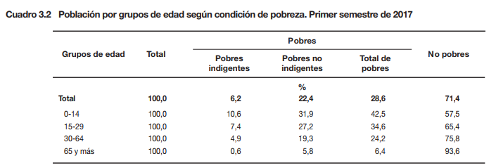

*Source:* Technical reports vol. 1, No. 180, living conditions; and vol. 1, No. 12, incidence of poverty and destitution in 31 urban areas. First half of 2017.

Question 18

(a) Living with their families

139. According to projections by the National Institute of Statistics and Censuses, 14,415,866 inhabitants were aged between 0 and 19 years in 2016 (33.1 per cent of the total population). The number of family households in 2010 was 9,907,743 (81.4 per cent of the total),[[31]](#footnote-31) housing 14,405,298 children and adolescents (99.91).

(b) Abandoned children and adolescents[[32]](#footnote-32)

140. 5,084 children and adolescents.[[33]](#footnote-33)

(c) Separated from their parents

141. 10,568[[34]](#footnote-34) (0.07 per cent of all children and adolescents, including abandoned children).

142. By age group: 1,251 aged 0–2; 4,450 aged 3–11; 2,626 aged 12–15; 1,730 aged 16–18; 219 aged 19–21; 73 aged over 21; and 219 for whom no information was available.

143. By gender: 5,648 female, 4,815 male, 5 other, and 100 for whom no information was available.

144. Permanent disability or illness affected 219 children and adolescents.

(d) Living in institutions

145. 8,456.

(e) Living with foster families

146. 1.303.

Question 19

147. The National Disability Plan envisages conducting, together with the National Institute of Statistics and Censuses, a second national disability survey to complement the 2020 national census on the profile of persons with disability in the country.

2015. Education system: forms of special education[[35]](#footnote-35)

| *2015* | | | |
| --- | --- | --- | --- |
| *Special education* | *Totals* | *State-run* | *Private* |
|  | 124 829 | 95 655 | 29 174 |
| Preschool | 22 569 | 19 742 | 2 827 |
| Primary | 57 125 | 43 284 | 13 841 |
| Secondary | 45 135\* | 32 629\* | 12 506\* |
| Comprehensive education workshops |  |  |  |

Question 20

2015–2016. Education system: general education and youth education

| *Students by year of study and education level* | | | |
| --- | --- | --- | --- |
| *2015* | *Total* | *State-run* | *Private* |
| Preschool | 1 733 374 | 1 152 532 | 580 842 |
| Primary | 4 550 365 | 3 314 198 | 1 236 167 |
| Secondary | 3 946 834 | 2 807 086 | 1 139 748 |
| **Total** | **10 230 573** | **7 273 816** | **2 956 757** |

| *2016* | *Total* | *State-run* | *Private* |
| --- | --- | --- | --- |
| Preschool | 1 765 405 | 1 175 768 | 589 637 |
| Primary | 4 814 965 | 3 513 250 | 1 301 715 |
| Secondary | 3 746 170 | 2 642 838 | 1 103 332 |
| **Total** | **10 326 540** | **7 331 856** | **2 994 684** |

148. The situation with regard to education in urban areas is as follows:

School attendance. Boys and girls aged between 5 and 15

|  | *Total* | *Do not work* | *Work* |
| --- | --- | --- | --- |
| **Total** | **100%** | **100%** | **100%** |
| Attend | 98.7% | 98.7% | 94.3% |
| Do not attend | 1.3% | 1.1% | 5.7% |

Repetition of grade

| *Repetition of grade* | *Total* | *Do not work* | *Work* |
| --- | --- | --- | --- |
| None | 0.0% | 100% | 100% |
| One | 8.7% | 98.7% | 94.3% |
| More than one | 1.3% | 1.1% | 5.7% |
| Unknown/Not available | 0.5% | 0.5% | 0.8% |

*Source:* Ministry of Labour, Employment and Social Security/National Institute of Statistics and Censuses 2016–2017.

149. The situation with regard to education in rural areas is as follows:

School attendance. Boys and girls aged between 5 and 15

|  | *Total* | *Do not work* | *Work* |
| --- | --- | --- | --- |
| Attend | 96.7% | 97.2% | 89.9% |
| Do not attend | 2.4% | 1.8% | 10.1% |
| Unknown/Not available | 0.9% | 1.0% | 0.0% |

Repetition of grade

| *Repetition of grade* | *Total* | *Do not work* | *Work* |
| --- | --- | --- | --- |
| None | 86.3% | 87.5% | 72.1% |
| One | 9.8% | 9.0% | 20.2% |
| More than one | 3.3% | 3.0% | 7.3% |
| Unknown/Not available | 0.5% | 0.6% | 0.4% |

*Source:* Ministry of Labour, Employment and Social Security/National Institute of Statistics and Censuses 2016–2017.[[36]](#footnote-36)

150. The ratio of teachers to pupils stood at 14.8 in 2015.[[37]](#footnote-37)

151. In 2016, 103,420 students repeated grades.[[38]](#footnote-38)

Question 21

152. With the promulgation of Act No. 26165, the National Refugee Commission reported that 222 children who were unaccompanied or separated from their families had filed applications for refugee status as at 12 December 2017. As at the date of the survey, 14 unaccompanied children were asylum seekers or refugees in Argentina.

153. In 2017, the Survey of Activities of Children and Adolescents disclosed information on all provinces, which covered urban and rural areas. It took into account urban areas with 2,000 or more inhabitants, and densely and sparsely populated rural areas with fewer than 2,000 inhabitants. There were 26,115 surveys conducted in urban areas and 9,697 in rural areas to gather data on the issue of child and adolescent labour. The information will be used to formulate public policies, determine the extent of the problem, identify the main characteristics of all the economic and non-economic activities involving children and adolescents, understand the effects on school attendance and health, and contextualize the socioeconomic status of households with children who worked.

154. The following clarifications are made with regard to CRC/C/ARG/5-6.

155. In paragraph 213, the correct Decree is No. 1117/16.

156. With regard to paragraph 214, on the federal system of government, 335 national labour inspectors under the Ministry of Labour, Employment and Social Security work in parallel with inspectors in each of the 24 provinces.

157. Regarding paragraph 215, the Observatory on Child and Adolescent Labour was set up in 2004 within the framework of various agreements between the Ministry of Labour, Employment and Social Security and international agencies in the United Nations system, including the United Nations Development Programme, UNICEF and ILO, in order to gain more insight into the complex issue of child labour.

158. Regarding paragraph 216, the joint support programme has expired.

159. In relation to paragraph 217, the Survey of Activities of Children and Adolescents provides data at the national and regional level. The target population is all 8,965,801 children and adolescents aged 5–17.

160. It has submitted the following data on the number of children aged 5–15:

* The prevalence of child labour among the population of children aged 5–15 nationwide is 9.4 per cent, given that 715,484 children worked out of a total of 7,631,837.
* The distribution of activities at the national level reveals that 3.7 per cent of children work in economic activities for the market, 2.8 per cent work in activities for consumption and 4.3 per cent engage in intensive domestic work.
* The prevalence of child labour among the national urban population is 7.5 per cent, given that 497,923 children work out of a total of 6,604,464.
* The prevalence of child labour among the national rural population is 21.2 per cent, given that 217,561 children work out of a total of 1,027,561.

The regional results in rural and urban areas are as follows

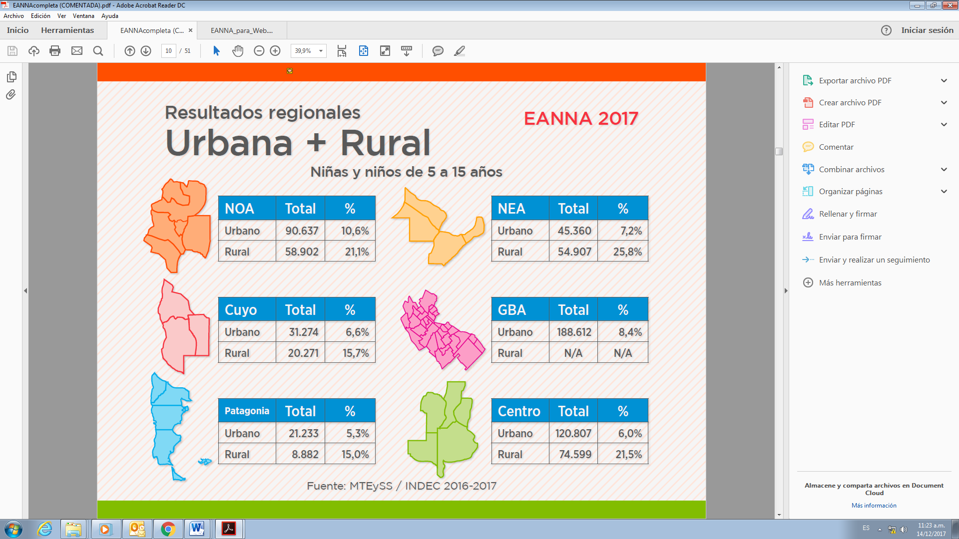

The employment status of children in urban areas is as follows

161. Children aged between 5 and 15 who worked in the week of reference by age group and employment status.

| *Employment status* | *Total* | *Percent* |
| --- | --- | --- |
| **Total** | **212 381** | **100** |
| Assisting parents or other family members | 141 422 | 66.6 |
| Working for an employer | 19 313 | 9.1 |
| In self-employed work | 122 109 | 57.5 |
| Self-employed | 41 619 | 19.6 |
| For an employer | 20 351 | 9.6 |
| Unknown/Not available | 8 989 | 4.2 |

*Source:* Ministry of Labour, Employment and Social Security/National Institute of Statistics and Censuses 2016–2017.

The employment status of children in rural areas is as follows

162. Children aged between 5 and 15 who worked in the week of reference by age group and employment status.

| *Employment status* | *Total* | *Percent* |
| --- | --- | --- |
| **Total** | **73 060** | **100** |
| Assisting parents or other family members | 46 714 | 63.9 |
| Working for an employer | 10 087 | 13.8 |
| In self-employed work | 36 627 | 50.1 |
| Self-employed | 15 926 | 21.8 |
| For an employer | 9 415 | 12.9 |
| Unknown/Not available | 1 005 | 1.4 |

*Source:* Ministry of Labour, Employment and Social Security/National Institute of Statistics and Censuses 2016–2017.

163. Regarding paragraph 220, the Ministry of Labour, Employment and Social Security drafted a voluntary guide to standards that will allow organizations to show that their practices are aligned with the decent work model and that they have established due diligence processes in their value chains (including the prevention/elimination of child labour).

164. The Ministry indicated that 80 organizations adhered to the code of conduct for the protection of the rights of children and adolescents.

165. In 2016, it joined the United Nations Global Compact, promoting corporate social responsibility among organizations and businesses in the tourism sector, with emphasis on preventing sexual exploitation, child labour and human trafficking.

166. With regard to the single register of adoptive parents, all jurisdictions in the country are part of the federal network of registers (23 provinces and the Autonomous City of Buenos Aires) and 594 officials received training in 2017. An information guide on adoption in Argentina was also drawn up. Of the number of guardianship applicants in the register, 5,540 entries were registered as at 7 December 2017, and 1,328 marked as temporarily unavailable.

167. The number of families in the 2017 technical assistance and support programme going through the bonding period was 57.

168. The number of meetings and discussions stood at 275. The number of families in the foster care and adoption period was 14. For the interview stage, the number was 18.

169. The Ministry of Social Development, through the National Secretariat for Children, Adolescents and the Family, signed a memorandum of understanding on 25 September 2017 with the National Institute of Statistics and Censuses, the National Social Policies Coordination Council and UNICEF to implement the 2017–2018 Multiple Indicator Cluster Survey. The results will provide up-to-date and high-quality information with which to improve public policy planning and decision-making.

170. Resolution No. 1833 of the National Secretariat for Children, Adolescents and the Family and of the Ministry of Development approved the guidelines for a project to assist families departing hotels voluntarily. It also provided funds to that end, allowing families to decide where they wanted to live.

171. The number of persons departing from hotels stood at 149 (31 families), and 222 (52 families) from hotels with a housing plan.

172. The National Register of Local Development and Social Economy Providers indicated a total of 383,486 health-care beneficiaries with children.[[39]](#footnote-39)

Question 22

173. The State party gives priority to the following themes:

* The National Plan for the Prevention and Eradication of Child Labour and the Protection of Adolescent Labour 2018–2022
* The National Plan to Prevent and Reduce Unintended Pregnancy in Adolescents
* The Early Years Programme
* The National Early Childhood Plan

1. \* The present document is being issued without formal editing. [↑](#footnote-ref-1)
2. \*\* The annexes and the appendices to the present report are on file with the Secretariat and are available for consultation. They may also be accessed from the web page of the Committee on the Rights of the Child. [↑](#footnote-ref-2)
3. Annex 2, provincial laws. [↑](#footnote-ref-3)
4. See annex 3, early childhood spaces. [↑](#footnote-ref-4)
5. See annex 4, Infant Malnutrition Cooperative centres. [↑](#footnote-ref-5)
6. In 2016, the latter were included under Decree No. 593/16 in accordance with the “Zero Poverty” programme objective. [↑](#footnote-ref-6)
7. Annex 5, National Plan for the Prevention and Eradication of Child Labour and the Protection of Adolescent Labour 2018–2022. [↑](#footnote-ref-7)
8. http://www.agroindustria.gob.ar/sitio/areas/d\_gestion\_ambiental/legislacion/provincial/?accion=imp. [↑](#footnote-ref-8)
9. Comprising representatives of the national Government and the governments of the Province of Buenos Aires and the Autonomous City of Buenos Aires with the purpose of improving the state of the environment and the quality of life of more than 8 million inhabitants. [↑](#footnote-ref-9)
10. Resolution No. 2016-2294-E-APN-SENAF#MDS. [↑](#footnote-ref-10)
11. http://www.telam.com.ar/notas/201710/216666-intervencion-del-inadi-en-casos-intersex-de-la-provincia.html. [↑](#footnote-ref-11)
12. Federal Education Council under Resolution No. 217/14. [↑](#footnote-ref-12)
13. See https://www.youtube.com/watch?v=QSBMaHuuw0o to learn more about the workshops. [↑](#footnote-ref-13)
14. See the Guidelines for Teachers. http://repositorio.educacion.gov.ar/dspace/bitstream/handle/ 123456789/110338/violencia280616.pdf?sequence=1. [↑](#footnote-ref-14)
15. The complete plan is available at http://www.cnm.gob.ar/recursos/PlanNacionalDeAccion\_2017\_ 2019Ult.pdf. [↑](#footnote-ref-15)
16. For more information, see http://www.desarrollosocial.gob.ar/amores/. [↑](#footnote-ref-16)
17. For more information, see http://www.inadi.gob.ar/biblioteca/book/si-discrimina-nodacompartir/. [↑](#footnote-ref-17)
18. See annex 6, National Strategy for Children and Adolescents. [↑](#footnote-ref-18)
19. Acts Nos. 26061/05, 25673/02, 26150/06, and the Criminal, Civil and Commercial Codes. [↑](#footnote-ref-19)
20. https://docs.google.com/forms/d/14vLFLRrxrvzWFv6wnsw6G\_RvUlAeHs\_qCD507xQ8pSY/ viewform?ts=5818a965&edit\_requested=tru

    https://docs.google.com/forms/d/e/1FAIpQLSerZDBHLvYkawCfdE4QaM8\_1SMa66V pzF2PUf4nFOfXxcl\_PQ/viewform?c=0&w=1. [↑](#footnote-ref-20)
21. http://www.diputados.gov.ar/comisiones/especiales/cbdnna/audiencia\_publica/convocatoria.html. [↑](#footnote-ref-21)
22. See Annex 7, National Action Programme 2016–2019. [↑](#footnote-ref-22)
23. http://www.cnm.gob.ar/ovcm/InformeSobreNiLinea144-2016.pdf. [↑](#footnote-ref-23)
24. See annex 8, on national public social expenditure for children. [↑](#footnote-ref-24)
25. See annex 8, on national public social expenditure for children. [↑](#footnote-ref-25)
26. “An analysis of the ‘Victims against Violence’ programme” in conjunction with UNICEF Argentina, which published statistics on the sexual abuse of children: https://www.unicef.org/ argentina/spanish/Proteccion-Violencia\_sexual\_contra\_NNyA\_2016.pdf. [↑](#footnote-ref-26)
27. Link to the national campaign: https://www.argentina.gob.ar/abusosexualinfantil. [↑](#footnote-ref-27)
28. http://www.msal.gob.ar/images/stories/bes/graficos/0000001070cnt-2017-11-30\_boletin-epidemio-vih-sida-2017.pdf. [↑](#footnote-ref-28)
29. See immunization schedule in annex 9: http://www.msal.gob.ar/images/stories/ryc/graficos/ 0000001013cnt-2017-01-01\_calendario-vacunacion.pdf. [↑](#footnote-ref-29)
30. Data from the 2010 census covers the entire population whereas the Annual Urban Household Survey only covers the urban population. According to the 2010 census, 89 per cent of the population aged 0–17 resides in urban areas. [↑](#footnote-ref-30)
31. See annex 11 on households. [↑](#footnote-ref-31)
32. The National Secretariat for Children, Adolescents and the Family has substituted data on children and adolescents subject to exceptional protective measures. [↑](#footnote-ref-32)
33. 50 per cent of jurisdictions cite abandonment as the main reason for taking exceptional measures. [↑](#footnote-ref-33)
34. It should be noted that at the national level there are 809 children and adolescents subject to exceptional measures, living with their family of origin (broad concept of family), Decree No. 415-2006, Act No. 26061. [↑](#footnote-ref-34)
35. See annex 12, on education. [↑](#footnote-ref-35)
36. http://www.trabajo.gob.ar/left/estadisticas/descargas/eanna2017/EANNAcompleta.pdf. [↑](#footnote-ref-36)
37. See annex 12, on education. [↑](#footnote-ref-37)
38. Idem. [↑](#footnote-ref-38)
39. Register database, November 2017. [↑](#footnote-ref-39)