|  |  |  |  |
| --- | --- | --- | --- |
|  | United Nations | CRC/C/OPAC/BTN/1 | |
| _unlogo | **Convention on the Rights of the Child** | | Distr.: General  29 August 2016  Original: English  English, French and Spanish only |

**Committee on the Rights of the Child**

Consideration of reports submitted by States parties under article 8 (1) of the Optional Protocol to the Convention on the Rights of the Child on the involvement of children in armed conflict

Reports of States parties due in 2011

Bhutan[[1]](#footnote-2)\*

[Date received: 3 March 2015]

List of Acronyms

BICMA Bhutan Info Comm and Media Authority

CCPA Child Care and Protection Act

CCPR&R Child Care and Protection Rules and Regulation

CEDAW Convention on the Elimination of Discrimination Against Women

CRC Convention on the Rights of the Child

CSO Civil Society Organisations

CWC Child Welfare Committee

DSRR Defence Service Rules and Regulation

DVPA: Domestic Violence Prevention Act

FAAAB Fire Arms and Ammunition Act of Bhutan

FOP Friends of Police

JAB Journalists Association of Bhutan

LEA Labour and Employment Act

MoE Ministry of Education

MoFA Ministry of Foreign Affairs

MoLHR Ministry of Labour and Human Resources

NACG National Action and Coordinating Group on Action against Violence against Children

NCWC National Commission for Women and Children

NEP National Education Policy

PCB Penal Code of Bhutan

POSYPP Police and Out of School Youth Partnership Program

PYPP Police Youth Partnership Program

RBA Royal Bhutan Army

RBG Royal Body Guards

RBP Royal Bhutan Police

RBPA Royal Bhutan Police Act

RENEW Respect, Educate, Nurture and Empower Women

SAIEVAC South Asia Initiative to End Violence Against Children

WCPD Woman and Child Protection Desk

WCPU Woman and Child Protection Unit

YDF Bhutan Youth Development Fund

Introduction

1. Bhutan was one of the first 20 countries that ratified the United Nations Convention on the Rights of the Child (hereon referred to as the Convention) in 1990. The country did so without any reservations.

2. As a reaffirmation of its commitment towards the protection and promotion of the rights of children, Bhutan ratified the Optional Protocol to the Convention on the Rights of Child on the Involvement of Children in Armed Conflict (hereon referred to as Optional Protocol) on 9 December 2009. The then officiating Foreign Minister reported to the first Parliament that the purpose of the Protocol was to “free children from participating in armed conflicts”.[[2]](#footnote-3)

3. Following the ratification, Bhutan submitted a binding declaration to the United Nations in December 2009. The text read:

“In accordance with Article 3, paragraph 2, of the Optional Protocol to the Convention on the Rights of the Child on Involvement of Children in Armed Conflict, the Royal Government of Bhutan declares that the minimum age at which it permits voluntary recruitment into the national armed forces is 18 years. The minimum age is prescribed by the legal system and no recruitment is carried out without the submission of compulsory proof of age”.

4. Delay in the submission of the initial report was due to the lack of human resources at the National Commission for Women and Children (NCWC) during the period when the report was due for submission, and thereafter the preparation for and subsequently the secondary democratic Parliamentary elections.

5. For the preparation of the initial report, the revised guidelines to prepare initial reports to be submitted by state parties under Article 8, Paragraph 1, of the Optional Protocol to the Convention on the Rights of the Child on Involvement of Children in Armed Conflict, of September 2007, document number CRC/C/OPAC/2 was perused.

I. General measures of implementation

6. This report outlines the laws, policies and programs that serve to implement the Optional Protocol. The report was prepared based on consultations with officials from the three armed forces, the Royal Bhutan Army (RBA), Royal Body Guards (RBG) and the Royal Bhutan Police (RBP); and other government and non-government organisations that are responsible for mainstreaming child rights into sector policies and plans. These included the NCWC, Ministry of Labour and Human Resources (MoLHR), Respect, Educate, Nurture and Empower Women (RENEW) and Ministry of Education (MoE). Inputs on legislative procedures were also sought from Members of Parliament (both National Assembly and National Council), Royal Court of Justice of Bhutan (RCJ) and Ministry of Foreign Affairs (MoFA). A desk review of relevant documents, legislations and publications were also carried out.

7. International human rights treaties that Bhutan ratifies similar to national laws are applicable to the entire country since Bhutan follows a uniform national code of law. However, they do not automatically become a part of the country’s law. Article 10 (25) of the Constitution of the Kingdom of Bhutan (hereafter known as the Constitution), 2008 stipulates that international conventions, covenants, treaties, protocols and agreements shall be deemed law only on ratification by the Parliament. Thereafter, they are submitted to His Majesty the King for Royal assent like any other bill. Once Royal assent is granted, international laws assume the capacity of domestic law and designated government organisations oversee the fulfilment of obligations and commitments.

8. On ratification of international laws, provisions within relevant national laws are subsequently amended and new laws drafted if required, in harmony with the principles of these international instruments. All national laws once drafted are reviewed by the Office of the Attorney General (OAG) and further reviewed by the two Legislative Committees formed under the National Assembly and the National Council, the two Houses of Parliament.

9. The Constitution guarantees the rights and protection of all children. Article 9 (18) on the Principles of State Policy, is explicit about the country’s commitment to take appropriate measures to ensure that all children are protected against all forms of discrimination and exploitation including trafficking, prostitution, abuse, violence, degrading treatment and economic exploitation. With the clear use of the words “abuse”, “violence” and “degrading treatment”, provisions under this Article deter involvement of children in hostilities and conflict thus harbouring the intentions of the Optional Protocol.

10. A fundamental duty of each citizen as per the Constitution is to prevent abuse of children. Article 8 (5) of the Constitution states that “a person shall not tolerate or participate in the acts of injury, torture or killing of another person, terrorism, abuse of women, children or any other person and shall take necessary steps to prevent such acts”.

11. The NCWC was established in 2004 mainly to fulfil obligations towards the Convention and the Convention on the Elimination of All Forms of Discrimination Against Women (CEDAW). The Children Division under the NCWC is responsible for the promotion and protection of the rights of all children in the country. It works in close collaboration with the RBP, Commission for Monastic Affairs of Bhutan and other government and non-government agencies, on mainstreaming the rights of children into sector policies and programs. This is carried out through the child protection focal persons who have been appointed in the relevant organisations.

12. The Secretariat of the NCWC is governed by a Commission, which consists of high-level government officials and is currently chaired by the country’s first woman minister. The Commission also consists of representatives from the civil society organisations (CSOs) and private sector.

13. Parliamentary Committees on Human Rights and Women and Children have been formed under the National Assembly and the National Council. Each Committee comprises five members of Parliament, who deliberate, inquire, investigate, legislate and review any important matters that are referred to them. Both the National Assembly and the National Council have a Legislative Committee.

14. The civil society organisation, RENEW, assists women victims of violence. It has also extended its services to support children in difficult circumstances. The RENEW also works at the community level through a network of volunteers that is spread across the country. It provides scholarships and counselling services to children in difficult circumstances.

15. The six Woman and Child Protection Units (WCPU) and three Woman and Child Protection Desks (WCPD) functioning under the Woman and Child Protection Division of the RBP deal with all the cases related to children and women. They also facilitate protection for children and women when required.

16. The MoLHR, the lead agency for the implementation of the Labour and Employment Act of Bhutan 2007 (LEA) protects children from being engaged in “worst forms of child labour”. The legislation explicitly prohibits recruitment of children “for use in armed conflict”.

17. There are no recorded cases of children being engaged in armed conflict or of their association with any armed groups. Both the MoLHR and the RBP have not received any cases on the involvement of children in armed conflict. There are no incidents of an armed force personnel being penalised for contravening the provisions of the Optional Protocol.

18. The NCWC was designated the national machinery to promote and protect the rights of women and children in Bhutan through an Executive Order from the Cabinet of Ministers in 2004. This role of the NCWC has been further reinforced by the three national legislations- the Child Care and Protection Act of Bhutan 2011 (CCPA), Child Adoption Act 2011 (CAA) and the Domestic Violence Prevention Act 2013 (DVPA), which have designated the NCWC as the competent authority to implement the three legislations.

19. The NCWC is working on establishing a comprehensive child protection system by collaborating with relevant government and non-government organisations. It achieves its goal of protecting and promoting the rights of women and children in Bhutan with the support of these organisations and development partners, particularly the UN agencies and Save the Children.

20. The Optional Protocol has been translated into Dzongkha, the national language and dissemination of the printed copies of the Protocol in English and Dzongkha has begun. Soft copies of the Optional Protocol have also been made available to various organisations for their use. Further awareness on the Convention and two Optional Protocols to the Convention will be carried out by the NCWC.

21. The NCWC also has the mandate to receive complaints on the violation of the rights of women and children. Complaints are reported to the Legal Unit that works to resolve complaints, and coordinates with relevant organisations if required. The NCWC has on behalf of victims registered complaints with the RBP and the RCJ.

22. Capacity building programs on child rights and child protection are underway, with the NCWC having provided a training of trainers programs for officials from various organisations. The Bhutan Youth Development Fund (YDF) a civil society organisation (CSO) conducted a training of trainers program on child protection for government and civil society organisation officials. As follow up to these two training of trainers’ programs, participants from the Department of Immigration, Department of Labour, YDF, RBP and the RENEW have been carrying out trainings on child rights and child protection across the country. Participants of these follow up trainings include officials from these organisations, adult and youth volunteers and children.

23. The Bhutan National Legal Institute (BNLI) has also carried out a number of trainings for judges, legal officers, paralegals and community leaders on child rights and child protection, including the use of the CCPA and the DVPA. A training of trainers program on child justice was also carried out for legal officials and CSO officials in 2013.

24. The Royal Government of Bhutan (RGoB) has been ensuring the implementation of the Convention and the two Optional Protocols to the Convention through the lead designated agency NCWC. The NCWC in coordination with relevant government and non-government agencies and with the support of development partners has taken on a systematic approach towards the promotion and protection of the rights of children. This began with the mapping and assessment of the child protection system in Bhutan, which ensued in a report with a National Plan of Action on Child Protection (NPACP), which was endorsed by the Committee of Secretaries (COS) and the Gross National Happiness Commission Secretariat (GNHC) in 2012. The report including the NPACP has been used as a guideline in mainstreaming protection of children into sector policies and plans into the 11th Five Year Plan (FYP) and implementation of the recommendations in the report and activities under the NPACP are on-going.

25. The lack of required national child rights expertise is another impediment in the full implementation of the Convention and its two Optional Protocols. Although awareness programs on child rights and child protections issues are underway, awareness on these issues has been limited particularly in the rural areas as a result of the geographical terrain. The NCWC and its partners are working on developing strategies to ensure reach to the unreached populations. The establishment of a systematic approach to addressing child protection being in the initial stages is another challenge.

II. Prevention

26. The country has adhered to the requirements of the Convention since its ratification in 1990. Therefore, most national legislations were already in harmony with the Optional Protocol when it was ratified.

27. One of the fundamental measures in place that ensures the implementation of the Optional Protocol is the recruitment process practiced by the armed forces. The Royal Bhutan Police Act 2009 (RBPA), Royal Bhutan Police Rules and Regulation (RBPR&R), Defence Service Rules and Regulation (DSRR) and LEA ensure that any person below 18 years of age is not recruited into the armed forces. The armed forces practice stringent recruitment processes to implement this.

28. The recruitment procedures of the armed forces are purely open and voluntary. Vacancy announcements are made through the media, and the respective website in case of RBP, inviting applicants who fulfil the set criteria. The RBA carries out the recruitment for the RBA and the RBG. Public announcements of vacancies (see annex I, II, III) are made through the media, inviting applications from eligible individuals. Highest level of transparency is maintained during the recruitment and applicants are encouraged to come forward purely on voluntary basis.

29. The eligibility age is explicitly mentioned in the public announcements. For the post of constables, the applicant should be between 18 and 25 years and those applying as cadet officers should not be below 18 years.

30. The age requirements for RBP and RBA are stated in RBPA and DSRR respectively. The DSRR (Paragraph 143, appendix C) has set the minimum age for recruitment into the RBA at 18 years. Section 15 (114) of the RBPA states that only Bhutanese nationals between 19 and 25 years shall be recruited into the RBP. To ensure children below minimum age are not recruited, applicants are required to submit copies of the citizenship identity card that is issued to all Bhutanese citizens on attaining 15 years of age. This reflects the age of the person as recorded in the civil registry and thus validates the legal age of the applicant. Applicants are also required to produce security clearance certificate, medical fitness certificate, a no objection certificate from previous employers, if employed, and a surety letter from parents or a guardian (see annex I). Similarly, the DSRR (appendix C) requires the applicants to produce a surety letter from parents or guardian. Contrary to other countries where parents’ or guardian’s consent is required for those applicants under the age of 18 years, in Bhutan, this surety is a safeguard in case of violation of procedural regulations by any applicant.

31. The documents are validated and applicants are shortlisted for the next round of the selection process that includes interviews and practical exams. Therefore, the issue of recruitment of children under 18 years of age does not arise and is not applicable in the Bhutanese context.

32. The armed forces maintain a very objective recruitment process and do not promise financial or other incentives to encourage more applicants.

33. Section 2 (9) of the LEA provides legal basis for the prohibition of the “worst forms of child labour”. It clearly states that no child shall be subjected to“recruitment for use in armed conflict.” Besides, it also prohibits subjecting children for sale and trafficking, debt bondage and forced or compulsory labour. This Section also protects children from working in an unhealthy environment, exposure from hazardous substances and noise levels that are damaging to their health as well as from working with dangerous machinery or tools. These provisions ensure that children are kept from taking part in hostilities and armed conflict.

34. The CCPA and CAA were passed in 2011 and 2012, respectively to consolidate and provide required services for the care and protection to children in conflict with law and children in difficult circumstances, taking into consideration their best interests.

35. The CCPA as the overarching national law for the care and protection of children in difficult circumstances and children in conflict with the law also provides for the prevention of crimes committed against children. Its Preamble necessitates the best interests of a child to be of primary consideration in all matters related to a child. Given that participation of children in armed conflict would be against the best interests of children, this provision serves as a preventive measure.

36. There are also other national legislations that help pursue the rights of the child as stipulated in the Convention. They are the:

(a) Immigration Act of the Kingdom of Bhutan, 2007;

(b) Royal Bhutan Police Act, 2009;

(c) Prison Act of Bhutan, 2009;

(d) Child Adoption Act of Bhutan, 2012

(e) Domestic Violence Prevention Act of Bhutan, 2013.

37. Article 9 (16) of the Constitution guarantees free education up to the 10th standard for all children of school going age. It also ensures “that technical and professional education is made generally available and that higher education is equally accessible to all on the basis of merit”. This Constitutional provision is in line with Articles 27 and 28 of the Convention, which calls for the fulfilment of every child’s right to standard living through physical, mental, spiritual, moral and social development and the child’s right to education.

38. The draft National Education Policy (NEP) further underpins the constitutional requirement by stating that all Bhutanese children, including those with special needs, have access to free basic education. To enhance access to education, the government is responsible for taking schools closer to communities (not more than an hour’s walking distance).

39. There are no schools “operated by or under the control” of the armed forces in Bhutan. The MoE has established schools in the vicinity of the camps of the armed forces, considering the ease of access for children of armed force personnel. These schools follow the same curricula and rules as other schools across the country.

40. All schools have co-curricular activities and counselling programs to ensure the child’s overall development, which makes them aware of child-friendly policies and facilities. These include the eight schools that have an inclusive special education needs program for children with disabilities.

41. The MoE launched a nationwide program in 2010 called Educating for Gross National Happiness (GNH), which is to be realised by building “green schools”. The initiative looked at redeeming the country’s education system by promulgating the eight “greeneries” in schools identified under environmental, social, cultural, moral, aesthetic, academic, intellectual and spiritual dimensions. The MoE crafted five key themes to do so through meditation and mind training, incorporating GNH into school curriculum, broader learning environment, critical thinking and media literacy and assessment.

42. Over 170 schools principals were oriented on counselling and child protection issues. A training manual for psychosocial support in emergencies has been adopted and shared with youth volunteers and schools counsellors.

43. The country’s law protects children from corporal punishment. Article 8 (5) of the Constitution dissuades a person from acts of injury, torture and abuse of children. Section 214 of CCPA holds a person liable for offence of “harsh and degrading correction or punishment measures at home, in schools or in any other institutions”. The Penal Code of Bhutan (PCB) finds a person guilty of the “offence of endangerment of a child” if the person injures the physical and mental condition of a child. The offence is a “petty misdemeanour” or a “misdemeanour” in aggravated circumstances.

44. The MoE adopted a resolution to ban corporal punishments in schools during its Annual Education Conference in 2008. The Guideline for School Discipline which was developed after the 13th Education Conference in 2010 also bans corporal punishment and places emphasis on the use of alternative methods to motivate a child to behave, learn and perform. Focus has been placed on the use of teacher-child conference, child-counsellor conference, additional assignments, peer separation, social detention, among others to discipline a child, depending on the severity of the violation.

45. The two Colleges of Education in the country have included a session on child rights for teacher-trainees as well as a session on the provisions of the Convention on the Rights of Persons with Disabilities. The lecturer from the College of Education who participated in the training of trainers programs on child rights and child protection has taken the lead in creating awareness on child rights among the college staff and teacher trainees.

46. Timely sensitisation programs are carried out to prevent involvement of children in “worst forms of child labour”. For that, the labour inspectors have been and continue to be trained on child rights and child protection issues.

47. For better understanding of the Convention and Optional Protocol among various monk bodies and people in the remote pockets of the country, majority of whom are conversant with the national language Dzongkha, the NCWC has translated the documents into Dzongkha. Printed versions of the documents will be disseminated to all stakeholders including schools and district governments in 2014. A child friendly version of the CRC has been developed and printed versions in English and Dzongkha will be made available at schools, youth centres, religious institutes and public places across the country by the end of 2014.

48. In 2015, the NCWC will develop a national communications for development strategy on child protection to ensure that awareness on child protection issues are carried out for maximum impact. This strategy will be developed in collaboration with government and non-government organisations and will be informed by the violence against children study and other relevant reports. Follow up on this strategy will also include further awareness programs on the Convention and the Optional Protocol.

49. In line with the LEA, labour inspectors facilitate the implementation of the Act by providing information, advice and guidance to employers and employees about their rights and obligations under the Act. Labour officers also take on the awareness creating responsibility during their routine inspections of the private sector organisations.

50. The MoLHR observes the World Day against Child Labour annually as a part of its awareness program to prevent the worst forms of child labour.

51. The RBP has been building the capacity of its personnel through short training programs. The RBP training centres have included sessions on child rights and child friendly procedures into the curriculum. This curriculum is under review to include a more comprehensive module on child friendly police procedures.

52. The RBP also began sensitising and disseminating information on child rights and protection issues, crime prevention and other youth issues to youth and the general public. They do so through forums like the Friends of Police (FOP), Police Youth Partnership Program (PYPP) and Police and Out of School Youth Partnership Program (POSYPP).

53. The PYPP, a bi-annual event that started in 2008 aims at strengthening youth-police relationship. They work together to reduce youth crimes and delinquencies. The program completed its tenth phase and has a total of 5,125 students registered as members from across the country. The POSYPP, started in 2011 is in its fourth phase today. The bi-annual programs are a RBP-initiative to build positive and productive partnership with in and out of school youth. The FOP, an annual event, is directed towards “adult citizens” to foster “long-term” partnership between the public and the police for maintaining a safe society. The FOP members also help reach out police services to the community during national events. The programs are funded by the UNICEF and Save the Children.

54. The RBP led by the Chief of Police has conducted several advocacy and awareness programs on child rights for school children. Law enforcement officials across the country have taken the lead in educating students on existing laws to protect themselves.

55. RENEW and the YDF conducts trainings for its staff who support women and children on child rights, child protection and other issues that affect youth.

56. The media highlights child related issues, with a particular focus on child protection issues and conformity with international and national laws (see annex 5).

57. The NCWC was allocated with Nu 135M during the 10th Plan and Nu 154M for the 11th Plan to implement programs to promote and protect the rights of children.

III. Prohibition and Related Matters

58. As highlighted under Section II on Prevention of this report, recruitment regulations of each of the armed forces ensure non-engagement of children below 18 years in hostilities or in armed conflict. This mandate finds reinforcement in the Constitution, LEA, PCB and CCPA.

59. Chapter 2 (9) of the LEA explicitly prohibits recruitment of children for use in armed conflict. The provision is categorised under the “worst forms of child labour” and the offence is categorised as a third degree felony under Chapter 2 (10). The penalty for a third degree offence as per the Civil and Criminal Procedure Code of Bhutan 2000 and its amendment in 2011 is a prison term between five and nine years.

60. Chapter 10 (170) of the LEA highlights that the minimum age of employment shall be 18 years. The employment of a child between 13 to 17 years is limited only to the categories of work and in workplaces listed under Chapter 2 (9) of the Regulation on Acceptable Forms of Child Labour.

61. Chapter 3 (11) of the Regulation allows children to work if it does not take place in “an environment that is likely to harm the health, safety or morals of the children and does not prejudice their attendance at school, vocational orientation and training programs”. Chapter 4 states that children aged 13 to 17 years should not work overtime and the daily wage should not be below the minimum rate that MoLHR sets. If an employer contravenes these provisions, Chapter 5 (22) imposes the offence with fine of a minimum 90 times and a maximum 365 times the daily minimum wage of national workforce.

62. The PCB, through the grading of the offence of child abuse and endangerment of child, prevents victimisation of a child through their engagement in harmful situations.

63. Chapter 15 (221 and 222) of the PCB state that in the case of child abuse, where a child is subjected to economic exploitation or any work that is likely to be hazardous, the offence shall be a misdemeanour with a sentence of a minimum of one year and maximum of three years prison term.

64. Chapter 15 (223) of the PCB highlights the “endangerment of a child”. The Section states that a defendant shall be guilty of the offence of endangerment of a child if the defendant engages in a conduct that would injure the physical or mental conditions of a child. In this case, it would be an offence of petty misdemeanour with a minimum of one month and a maximum of one-year prison term or misdemeanour, if aggravated circumstances were present.

65. All the above provisions dissuade individuals and institutions from involving children in armed conflicts.

IV. Protection, Recovery and Reintegration

66. The CCPR&R outlines procedures to determine the best interests of a child. This includes ensuring the provision of appropriate and effective services (preventive, responsive and protective) as per the needs of each child.

67. The CCPA and the CAA and the rules and regulations for these two legislations clearly outline procedures for the determination of the best interests of a child in any decision being made in response to the child’s needs. The Preamble of the CCPA also ensures protection of children against all forms of discrimination and exploitation as provided for in the Constitution.

68. The CCPR&R has outlined procedures for the determination of the best interests of children in difficult circumstances and in conflict with the law under Chapter 2. It has also outlined procedures for various services providers for working with child victims, a category under which children affected by armed conflict can be categorised.

69. Chapter 5 (59) of CCPA looks into “child in difficult circumstances”, which includes children who fall victim to abuse or exploitation for immoral or illegal purposes. Involvement of children in armed conflict put them in situations that pose risk to their lives.

70. Article 38 (4) of the Convention and provisions under the CCPA protect and provide necessary services for children in difficult circumstances. The CCPA mandates the police or the child welfare officer to render such protection and services.

71. Implementing authorities like WCPU officials under RBP, who deal with child victims of various abuses, undergo trainings to handle them with care and sensitivity.

72. Article 6 (3) of the Optional Protocol requires states parties to accord child victims with appropriate assistance for physical and psychological recovery and their social reintegration. When dealing with child victims, RBP officials either hand them over to their parents or seek RENEW’s cooperation to provide shelters. RENEW officials counsel children for social reintegration, family reunification and psychological recovery.

73. In keeping with Article 6 (3) of the Optional Protocol, Chapter 4 (55) of the CCPA provides for the constitution of a multi-sectorial Child Welfare Committee (CWC). It is expected that a CWC will be established in each district by the end of the 12th FYP.

74. Chapter 5 (70) of the CCPA also mandates the child welfare officer to send a child to a place of safety until protection and assistance is no longer required or until the child turns 18 years. The child welfare officer is required to provide counselling to parents or legal guardian on how to provide appropriate care to the child.

75. The CCPA requires education institutions to provide continuing education to children who have dropped out of schools, children in difficult circumstance and children in conflict with law. The CCPA also calls on the participation of CSOs, government organisations and the community to prevent and respond to child protection issues. This is to ensure the prevention of crimes against children and effective rehabilitation and reintegration of children into mainstream society.

76. Measures are taken to protect the identity of the child to prevent possible stigmatisation of victims, particularly by encouraging the media to refrain from giving away the details. Chapter 2 (28) of CCPA calls on the media to maintain privacy in reporting and covering cases of children in difficult circumstances, among others. Chapter 2 (21) of the CCPA also upholds a child’s right to privacy at all stages of legal proceedings, including investigation by agency.

77. The media are guided by the Bhutan InfoComm and Media Authority (BICMA) Code of Ethics, which was developed and endorsed in accordance with Bhutan Information, Communications and Media Act 2006. Journalists Association of Bhutan (JAB) also endorsed its Code of Ethics in September 2014, which the members are expected to adhere to.

78. Section 6.5.2 of BICMA Code of Ethics states that a journalist must show utmost sensitivity in reporting matters relating to children and young persons. It says a journalist shall not “ordinarily publish any matter which would have the effect of identifying the child to the reader” when a child or young person is involved in court proceedings. In cases involving sexual offences against a child or young person, a journalist shall ensure that the identity of the child or young person is not revealed.

79. Article 9 (6) of JAB Code of Ethics states that special caution must be exercised when reporting juvenile crimes. The principle of respecting the future of the young limits a journalist in providing juvenile offenders’ names and photographs.

V. International assistance and cooperation

80. The NCWC was established in 2004 mainly to fulfil the government’s obligations towards the CEDAW and CRC. Through its mandate of coordination and reporting, it serves as a link with international mechanism and ensures implementation of the Convention and Optional Protocol. Among others, it coordinates activities to implement the provisions of conventions like CRC, CEDAW, the two Optional Protocols to the CRC and other international and regional commitments both within and outside Bhutan. It also assists in the mobilisation of resources for implementing agencies.

81. Bhutan is a member of South Asia Initiative to End Violence Against Children (SAIEVAC), an apex body of SAARC that works towards protecting children from violence through comprehensive child protection systems via regional collaboration. Promoting child rights through community sensitisation and awareness program, development and dissemination of child friendly materials, identifying gaps to reform legal system of Violence Against Children, and mapping and documentation of good practices, among others, are some of the activities listed under the initiative. Today, Bhutanese children are also serving as observers on SAIEVAC Governing Board, having served as board members in 2011.

82. The NCWC took lead in establishing the National Action and Coordinating Group on Action against Violence against Children (NACG) in the country. This is a coalition of CSOs, which has been established in all SAARC countries to promote and protect the rights of children victims of violence. The NACG has developed a draft framework to promote and protect the rights of children.

83. Bhutan became a member of the International Criminal Police Organisation (ICPO)- INTERPOL, in 2005. National Central Bureau- Interpol, Thimphu, coordinates and support efforts of ICPO-Interpol in combating transnational and international crimes. Amongst others, the arrangement would help address trafficking cases, including that of child, and other child related crimes beyond the country.

84. Bhutan does not give military assistance to countries where children are involved in armed conflict. Laws like Fire Arms and Ammunition Act of Bhutan, 1990 (FAAAB) prohibits the sale or export of firearms or ammunition. The legislation was drafted in conformity with the Convention following its ratification in the same year in 1990.

85. Section 11 of the FAAAB states that import of firearms and ammunition is banned. The procurement can be carried out only by the licensing authority and issued to individual license holders who should be at least 21 years. Section 3 (b) of the FAAAB requires a person to seek license to own a firearm but no license holder can sell, gift or entrust fire arms or ammunition to a foreigner or to a third person. Violation of this law can result in confiscation of the firearm and ammunitions with prison term of one year to five or a fine of Nu 5,000 to Nu 10,000 or both.

86. Bhutan remains committed to constructive engagement with the human rights mechanisms of the UN. Bhutan will continue to receive Special Rapporteurs and other Special Procedure mandate holders, taking into account its capacity, national priorities, as well as the need for adequate preparations for such visits. Bhutan recently hosted the visit of the Special Rapporteur on Right to Education, from 24 May to 4 June 2014.

VI. Other legal provisions (Art. 5)

87. Bhutan’s ratification of several other international and regional commitments (refer table below) further reinforces the country’s efforts towards preventing children’s involvement in hostilities.

| *No.* | *Conventions/Declarations* | *Year of ratification* |
| --- | --- | --- |
| 1. | Convention on the Elimination of All Forms of Discrimination Against Women (CEDAW) | 1981 |
| 2. | Beijing Platform for Action | 1995 |
| 3. | World congress against sexual exploitation of children (Yokohama declaration) | 2001 |
| 4. | Regional Arrangements for the Promotion of Child Welfare in South Asia | 2002 |
| 5. | SAARC Convention on Regional Arrangements for the Promotion of Child Welfare in South Asia | 2003 |
| 6. | SAARC Convention on Preventing and Combating Trafficking in Women and Children for Prostitution | 2003 |
| 7. | Convention on the Rights of Persons with Disabilities | 2007 |
| 8. | Beijing Declaration on South-South Cooperation for Child Rights | 2010 |

Annexure

Annexure I. RBA vacancy announcement published in Kuensel newspaper

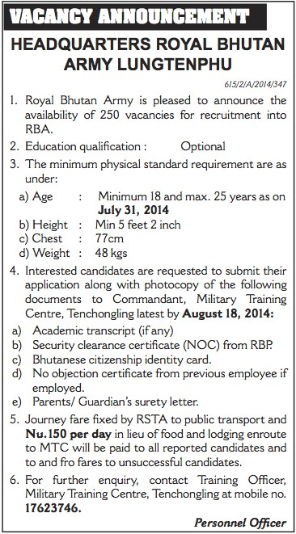

Annexure II. RBP vacancy announcement published on RBP website

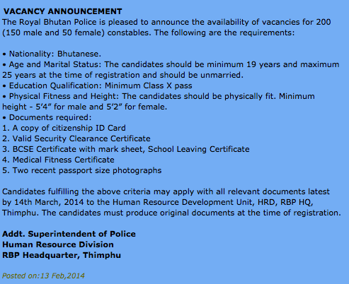

Annexure III. RBP vacancy announcement published on RBP website

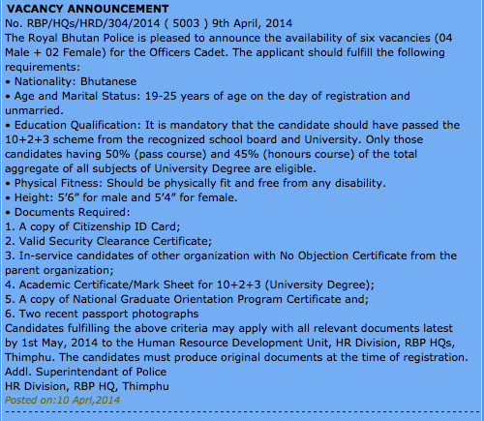

Annexure IV. Announcement inviting volunteers for De-Suung program

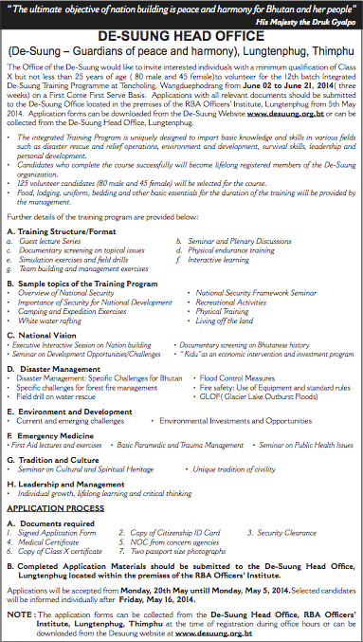

Annexure V: Awareness program on drug abuse and trafficking

**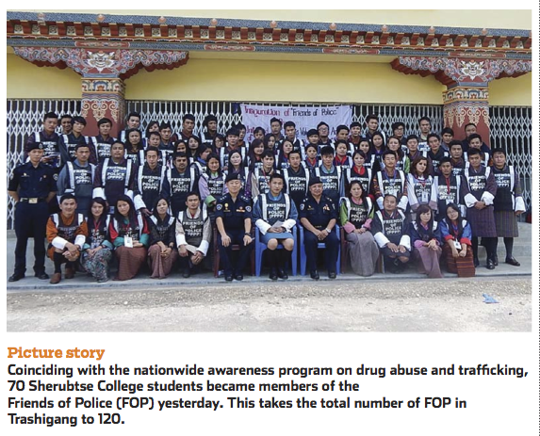**

*Sourc*e: Kuensel.

1. \* The present document is being issued without formal editing. [↑](#footnote-ref-2)
2. National Assembly resolutions, 2009 - During the session, the Parliament was informed that the Royal Bhutan Army assured Ministry of Foreign Affairs (MoFA) its support to uphold the Protocol. [↑](#footnote-ref-3)