|  |  |  |  |
| --- | --- | --- | --- |
|  | United Nations | CERD/C/BRA/18-20 | |
| _unlogo | **International Convention on the Elimination of All Forms of Racial Discrimination** | | Distr.: General  15 September 2020  Original: English  English, French and Spanish only |

**Committee on the Elimination of Racial Discrimination**

Eighteenth to twentieth periodic reports submitted by Brazil under article 9 of the Convention,   
due in 2008[[1]](#footnote-1)\*

[Date received: 14 July 2020]

List of Acronyms

UNHCR United Nations High Commissioner for Refugees

ADCT Temporary Constitutional Provisions Act

CadÚnico Sole Registration for Social Programs of the Federal Government

CF Brazilian Federal Constitution

CONAPIR National Conference for Promotion of Racial Equality

CONAR National Council for Self-Regulation in Advertising

CONARE National Committee for Refugees

EBC Brazil Communication Company

IBGE Brazilian Institute of Geography and Statistics

INCRA National Institute of Colonization and Agrarian Reform

INHOPE International Association of Internet Hotlines

LpT Luz para Todos Program

MEC Ministry of Education

MDH Ministry of Human Rights

Neabs Center for Afro-Brazilian Studies

ILO International Labor Organization

PBP Bolsa Permanência Program

Pcerp Survey on the Ethnic and Racial Characteristics of the Population

PCT Traditional peoples and communities

PMCMV Minha Casa Minha Vida Program

PNAD National Household Sample Survey

PNDH-3 National Human Rights Program

PNPCT National Policy for the Sustainable Development of Traditional Peoples and Communities

PNSIPN National Policy for Comprehensive Health Care to the Afro-Brazilian Population

PROEXT Continuing Education Program

Pronacampo National Program for Rural Education

ProUni Universidade para Todos Program

PSF Estratégia Saúde da Família Program

SECADI Office of Continuing Education, Literacy, and Diversity

SEPPIR Special Office for Policies for Promotion of Racial Equality

SINAPIR National System for Promotion of Racial Equality

SNPPIR National Office for Racial Equality Promotion Policies

STF Brazilian Supreme Court

STJ Superior Court of Justice

SUS Unified Health System

UERJ University of the State of Rio de Janeiro

UENF State University of the North of the State of Rio de Janeiro

I. Introduction

1. The Government of the Federative Republic of Brazil presents herewith its 18th to 20th reports on the International Convention on the Elimination of All Forms of Racial Discrimination (hereinafter the “Convention”), pursuant to the provisions of article 9.

2. This Report presents the main legislative, judicial, and administrative measures implemented by the Brazilian Government for the elimination of racial discrimination in the country. The Report covers the period of 2004 to 2017, but includes references to key measures prior to this period, aiming at contextualizing or responding to specific questions submitted by the Committee.

3. The document was prepared based on the harmonized guidelines related to the submission of national periodic reports on human rights, on the guidelines aiming at reinforcing and improving the effective operation of the human rights body system (HRI/GEN/2/ Rev.6 and A/RES/68/268), as well as specific guidelines related to the Convention, pursuant to the instructions in the document CERD/C/70/Rev.5.

II. Article 1 – Concept of ethnic and racial discrimination

**The document should inform whether the concept of racial discrimination incorporated to the national laws and regulations comprises discrimination based on race, skin tone, ancestry, ethnic origin, or nationality;**

**If direct or indirect forms of discrimination are included in the legal concept;**

**The document should inform whether the national laws provide for different treatment towards immigrants or foreigners.**

4. Brazil does not have an official definition for race. However, since the 1872 Census, the demographic statistics generally classify the population into white, black *pardo* (mixed race), Asian-Brazilian and Indigenous. This classification is used by the Brazilian Institute of Geography and Statistics (IBGE) in the ten-year demographic censuses, by self-declaration. Since the 1980s, it has been used in an increasing number of sample surveys, and, since the 2000s, in the Government’s administrative records. Due to the wide availability of the racial classification data, Brazil is able to calculate a range of socio-economic indicators according to such categories and has build long historical series to analyze trends based on such indicators.

5. IBGE’s classification is more than a mere taxonomy created by bureaucrats. It is based on the perception that Brazil was composed of two races at the end of the 19th century, through the use of categories current at the time for classification of individuals. In a reflective process, it is the main pillar of the national representation of races. Brazilians generally perceive race as defined by individuals’ physical characteristics, such as skin tone, hair type, and traits.

6. The official agencies, together with civil society organizations and public and private research centers, recognize the Afro-Brazilian population as being composed of self-declared black and *pardo* individuas. By incorporating IBGE’s classification system as the basis of its public policies, the Government considers the *pardo* individual to be Afro-Brazilian, officially acknowledging that the presence of phenotypic traits may subject this segment of the population to discriminatory processes. The socio-economic homogeneity between blacks and *pardos* is a symptom of discrimination, rather than an ultimate reason for the grouping of this population.

7. In 2008, IBGE carried out research to improve its production of statistics on skin tone/race, following on work procedures adopted in 1976 and 1998. The 2008 Survey on the Ethnic and Racial Characteristics of the Population (PCERP) confirmed that most of the adult population in several Brazilian regions considered that race was defined by appearance, with skin tone as the main attribute. It was also confirmed that Brazilians understand that a person’s skin tone/race affects his/her opportunities and chances in life, reinforcing the idea that this indicator is a form of perceiving and hierarchizing differences. Almost all interviewees claimed to be able to define their own racial characteristic (96%), and most spontaneously choose IBGE’s classification categories to do so.

8. In order to address this situation, the Government has adopted over the last 30 years major anti-discrimination laws and regulations that have shaped and informed the understanding of ethnic and racial discrimination in the country, resulting from the internal debate but also from international rules and conventions on human rights.

9. In December 2008, the Brazilian Supreme Court partially changed the case law on the legal status of the international treaties ratified by Brazil. If the instrument is a human rights treaty, it has a supra-legal status, i.e., it is considered superior to ordinary and complementary laws. If the ratification has occurred with a special quorum (art. 5, paragraph 3 of the Brazilian Federal Constitution of 1988), the instrument has a constitutional status. In the event of conflict between such conventions and the domestic law, the rules and interpretations deemed more favorable to the individual shall prevail. With reference to human rights, setbacks are prohibited by law.

10. In the Federal Executive Branch, Circular Letter No. 1 of December 28, 2012, signed by the Secretaries of State for Racial Equality and for Policies for Women, together with the Minister for Civil Affairs of the Presidency of the Republic, established that “skin tone or race” is mandatory in the federal government’s administrative records, registrations, forms, and databases.

11. The concept of racial discrimination contained in the International Convention on the Elimination of All Forms of Racial Discrimination has been integrated into the national legal system, which defines racial discrimination as “any distinction, exclusion, restriction, or preference based on race, skin tone, ancestry, nationality, or ethnicity that has the purpose or effect to invalidate or restrict the recognition, enjoyment, or exercise, on the same plane (in equal conditions), human rights and fundamental freedoms in the political, economic, social, cultural, or any other scope in their lives.”

12. From a strictly legal point of view, the system therefore incorporated the concepts of direct and indirect forms of discrimination, not only acknowledging direct discrimination, through intentional acts, but also indirect forms, i.e., the ones produced and reproduced in absentia of intention by a specific agent.

13. Direct and indirect forms of discrimination are also reflected by the political responses elicited, through repressive actions or equality promotion policies. Repressive mechanisms are provided for in the criminal, labor, administrative, and civil laws and regulations, focused on direct forms of discrimination. Promotion policies are especially intended to respond to indirect discrimination, through actions aimed at reaching the foundations of discriminatory processes, as is the case of quota policies and other mechanisms for inclusion, incorporated into Brazilian public policies.

14. Protection against discriminatory treatment does not make a distinction between Brazilians and foreigners. Law No. 13,445/2017 provides for the rights and duties of migrants and people visiting the country, revoking the norm that addressed foreigners as a national security issue. This new regulatory framework on migration incorporates principles of the Constitution by adopting a human rights perspective.

15. The principles and guidelines of the Brazilian migration policy include repudiation and prevention of xenophobia, racism, and any forms of discrimination (Art. 3, II); nondiscriminatory criteria through which someone is allowed into national territory (Art. 3, IV). The following are also ensured: equal treatment and opportunity to migrants and their family (Art. 3, IX); free and egalitarian access to social services, programs, and benefits, public goods, education, full public legal assistance, work, housing, banking services, and social security (Art. 3, XI).

16. Even though foreigners and immigrants cannot be discriminated with respect to Brazilians, there are different legal norms to take into account the specificities of the groups included in this Convention. The 3rd Brazilian report on the compliance with the International Covenant on Economic, Social, and Cultural Rights addresses the matter more carefully, highlighting the new Brazilian Migration Law (Law No. 13,445/2017) of May 24, 2017.

III. Article 2 – Legal provisions and policies for elimination of racial discrimination

A. Brief description of the legal provisions and policies directed to the elimination of racial discrimination and to effecting Art. 2 and its paragraphs.

17. Brazil has instituted extensive anti-discrimination laws and regulations, consisting of rules of constitutional, administrative, criminal, civil, labor, tax, and social-security nature. Over the last few years, several measures were adopted contributing to the establishment of a system of protection against discrimination, that provide penal redress not only against practices but also their effects.

18. These laws and regulations are also based on the international human rights covenants to which the country is a signatory, taking into account the legal understanding provided by the STF.

19. According to Article 3, item IV, of the Brazilian Federal Constitution (FC), the promotion of well-being to all, irrespective of nationality, gender, skin tone, and age and any other forms of discrimination, are fundamental goals of the Federative Republic of Brazil. Pursuant to Art. 3, art. 5 of the Constitution, all individuals are equal before the law, without distinction between Brazilians and foreigners living in the country, guaranteeing the inviolability of the right to life, freedom, security, and property. Article 5, sub-item I, clarifies that men and women have equal rights and obligations. Article 7, XLII sets forth that racism is a non-bailable, imprescriptible crime, subject to confinement as provided by law.

20. Article 5 of the Brazilian Federal Constitution, in sub-items XLI and XLII, sets forth that the law shall punish any discrimination that violates fundamental rights and freedoms, and that racism is a non-bailable, imprescriptible crime, which the offender is subject to confinement. The existence of such constitutional provisions acknowledges that racism is a component of the Brazilian social, political, and economic order, that needs to be faced by public authorities.

21. These provisions provide guidance to all ordinary laws and regulations in force in the country. Regarding the job market, Law No. 9,029/1995 expressly sets forth that “it is forbidden to adopt any discriminatory or restrictive practices regarding access to or maintenance of employment relationships on the grounds of gender, **nationality**, **race**, **skin tone**, marital status, household conditions, disability, professional rehabilitation, age, among others, except for the cases of children and the adolescents as provided for in item XXXIII of art. 7 of the Brazilian Federal Constitution.”

22. Three major types of conducts are characterized as crime or misdemeanors based on discriminatory elements regarding racial identity: the one described in Art. 20 of Law 7,716/1989, generally regulating prejudice on the grounds of race/skin tone, religion or country of origin; the conducts involving disparate treatment, impeding or denying access to the places and services specified therein, based on the discriminatory acts described in arts. 3 to 14 of the abovementioned law; racial slur, a subtype of crime against a person’s dignity, provided for in paragraph 3, Art. 140 of Brazilian Penal Code.

23. The crime of racial slur is committed with the intention of affecting a certain person’s dignity. The offender, in this case, uses elements related to race, skin tone, ethnicity, religion, nationality, or the offended person’s elderly condition or disability.

24. The crime of racism is directed to an undetermined group of individuals, discriminating the entire social group characterized for skin tone/race, ethnicity, religion, background, or country of origin. The penalty related thereto is established by Law No. 7,716/1989.

25. For the crime of racial slur, the Brazilian Penal Code sets forth a penalty of confinement from one to three years, and a fine. For the crime of racism, there are several penalties for different types of conduct, as provided for in Law No. 7,716/1989. Although it regulates a wide range of conducts, the abovementioned laws provide for distinct criminal sanctions for similar situations, which could indicate the need for enhancing the legislation.

26. Until 2016, the crime of racial slur was a bailable and prescribable crime, different from the crime of racism. In January 2016, the Superior Court of Justice (STJ) ruled that racial slur is also an imprescriptible crime, which differs from the regulation established for the other crimes against personal dignity. The case law has consolidated a specific legal regime to address discriminatory practices on the basis of race.

27. By considering the crime of racial slur as a non-bailable and imprescriptible, Brazil confirms the social, political, and institutional condemnation of racist conducts of any kind, while also acknowledging the severity of its damage.

28. There is a wide range of institutions related to the protection and promotion of human rights in Brazil. The Ministry of Family, Women and Human Rights (MDH) is the main government agency responsible for preparing, coordinating, and enforcing public policies on the issue. The Common Core Document of the Brazilian Government presents more detailed information. The National Office for Racial Equality Promotion Policies (SNPPIR), created in 2003, contributed to institutionalize and consolidate racial equality policy as a national policy.

29. The former Special Office for Policies for Promotion of Racial Equality (SEPPIR), currently SNPPIR, at the federal level, fostered the establishment of similar bodies in states and municipalities. These agencies were, as a rule, structured to mainstream national public policies and initiatives, facilitating coordination at the federal, state and local levels, including with private actors and civil society institutions.

30. The National System for Promotion of Racial Equality (SINAPIR) was established with a view to further encouraging the diffusion, coordination, and expansion of actions to fight racism. The System intends to become the locus to organize and coordinate policies and services to overcome racial inequality in Brazil. Created by the Statute of Racial Equality, in May 2015, it aggregates 197 bodies and 106 councils for promotion of racial equality in the entire country.

31. The National Conference for Promotion of Racial Equality (CONAPIR), held every four years, also promotes social participation and integration of the racial debate in Brazilian society. On its latest edition, in 2018, the Conference congregated approximately six hundred representatives from the entire country. Four conferences were held from 2004 to 2018, with the participation of several organizations of civil society, together with the three levels of governments.

32. Since the 1970s, Afro-Brazilian organizations have been expanding, in defense of traditional and contemporary causes. In places were public services are not widely available, they offer assistance to victims of discrimination, providing legal and psychological counseling. Initially, such organizations depended on the support of international foundations, given that traditional human rights NGOs were not focused on the racial debate in the country. These Afro-Brazilian organizations were responsible for raising awareness among judges, public prosecutors and human rights activists about the need to reevaluate how complaints of racism were addressed in the justice system.

IV. Article 3 – Socio-spatial segregation

**The report must inform whether there are measures adopted to prohibit or eradicate segregation practices across all territories;**

**The report must indicate whether there are measures related to the monitoring of tendency of segregation, keeping in mind that racial segregation may occur even without direct involvement of public authorities;**

**The report must also indicate which measures have been adopted to prevent and avoid segregation of individuals/groups protected by the Convention, including Romani populations and non-naturalized foreigners, especially in the fields of education and housing.**

33. Housing is a social right provided for in the Federal Constitution, ensured by the Federal Government, states, and municipalities which should build adequate housing as necessary and improve pre-existing homes. The Constitution also incorporated the concept of adequate housing as the guarantee of the urban infrastructure and the community facilities related to housing, as well as technical and legal support for construction, renovation, or land regularization for housing in urban areas.

34. The Statute of Racial Equality sets forth that “the government shall secure the implementation of public policies to ensure right to adequate housing for the Afro-Brazilian population living in slums, tenements, underused urban areas, and areas degraded or in imminent degradation in order to reintegrate them to the urban dynamics and improve the environment and the quality of life” (Art. 35).

35. The III National Human Rights Program (PNDH-3), in the section addressing the universalization of rights in a context of inequality, establishes, as a commitment of the Brazilian Government, that low-income populations, populations in street situation and vulnerable social groups in the urban and rural spaces should be granted priority in public housing programs. It further establishes that the principles of decent housing, universal design, and accessibility shall be taken into account in the building projects. The Program also sets forth that tracts of land, empty or underused buildings owned by the Federal Government should be allocated to the low-income population, in a fair and pacific manner.

36. Nevertheless, several mechanisms have produced and continue to reproduce forms of land and soil occupancy that induced spatial segregation of vulnerable social groups, in the past. Resettlement, creation of neighborhoods with affordable housing, relocation of residents from downtown to the outskirts, and migration from rural areas into urban centers are among the causes of direct and indirect socio-spatial segregation.

37. Slums are among well-known socio-spatial formations present in the landscape of Brazilian cities. Designated by IBGE as subnormal agglomerations, slums had, in 2011, 11.4 million residents, of which 68.33% were Afro-Brazilian, 30.57% were whites and 0.2% were indigenous. Of the Afro-Brazilian residents in subnormal agglomerates, 68.42% did not have access to street lighting, 67.93% had accumulated garbage in the street, 70.37% had no pavement, and 66.13% had open sewage.

38. A survey prepared by the João Pinheiro Foundation, a research institution linked to the Government of the State of Minas Gerais, highlights that, in 2014, there were 11.3 million housing units in inadequate conditions, including lack of infrastructure, excessive concentration, lack of exclusive bathroom, improper roof and land inadequacy. The estimated housing deficit in Brazil is 6.1 million units, estimated by adding the number of persons living in precarious housing, cohabitation, excessive rental costs or excessive concentration in rental properties. Most demand for new homes (83.9%) is concentrated in the group of families earning up to three minimum wages, most of which are Afro-Brazilians.

39. Despite the fact that there were no specific initiatives to address the Afro-Brazilian population, housing policies have benefited the Afro-Brazilian population, since they adopt income criteria to define the target group.

40. The main policy directed to ensuring the right to housing in Brazil is the Minha Casa Minha Vida Program (PMCMV), established in 2009. Initially aimed at the general housing market, the PMCMV expanded to include social housing, by offering housing to the low-income population (income up to three minimum wages) and granting subsidies covering up to 90% of the price of the listed properties. From 2009 to 2016, 4.5 million new homes were contracted in 96% of the Brazilian cities. In 2016, 3.2 million residential units had already been made available to 11 million people, of which 91% belonged to the lowest income ranges established by the program itself.

41. In order to meet the demand for adequate housing, the Brazilian Government has adopted, since 2007, a set of measures to improve the urban infrastructure, emphasizing land regularization, security, hygiene, and habitability for the population in areas deemed inappropriate for housing. Such measures promoted permanent residency or relocation, integrating actions for housing, sanitation, and social inclusion. As an integral part of Growth Acceleration Plan adopted in 2009, it favoured populations residing in areas subject to risk factors, health hazards, or environmental degradation, aiming at supporting families with a lower per capita income and a large number dependents, as well as households headed by women, elderly people, people with disabilities, *Quilombolas*, Afro-Brazilian and Indigenous communities. The Program was not limited to subnormal agglomerations, but benefited them in a significant manner.

42. From 2007 to 2014, 1,055 urbanization operations were carried out in precarious settlements, benefitting 2,125,865 families according to information provided by the National Housing Office of the Ministry of Regional Development. Out of the total investments in precarious settlements, 30% were directed to construction of residences, 26% to infrastructure, 19% to sanitation, and 5% to residential improvements.

43. Given the large volume of investments, these actions enabled the Government to act in dense, complex areas in a comprehensive and integrated fashion in all cities with precarious settlements. Public facilities, such as day-care centers, schools, and health clinics, have been improved. The expansion of urbanization also mitigated risks and environmental impacts, induced the expansion of land regularization programs and incorporated human mobility measures, promoting better integration of urban areas.

44. The Brazilian housing policy, although reaching significant results through the PMCMV, was still not sufficient to definitively break the segregationist logic that characterizes the geography of the main Brazilian cities. Generally, most units directed to the low-income population were concentrated in regions with low urban quality, precarious buildings, insufficient supply of public goods and services, in addition to social issues, most notably criminal violence.

45. With regard to incarceration, in June 2016, the Brazilian prison population reached 726,712 people, of which 40% were in situation of temporary imprisonment, i.e., there was no final judicial ruling on the case. Of this total, more than half are young adults in full working age (between 18 and 29 years) and 64% are Afro-Brazilian.

46. The National Penitentiary Information System, updated in 2016 by the Ministry of Justice and Public Security, highlights that 75% of the prison population did not complete the basic educational cycle. Approximately 12% of inmates undertook educational activities, similar to the level (15%) that undertook work activities. Of the inmates involved in work activities, 75% were not paid or earned less than 3/4 of the minimum wage, in violation of the Criminal Enforcement Law. 36% of Brazilian prisons had an occupancy rate higher than 200%, and 41% had an occupancy rate between 101% and 200%. Only 7% of the prison population are in facilities with no overcrowding.

47. In June 2016, the female prison population amounted to 42,355 individuals under custody – the fourth largest number of female inmates in the world in absolute terms and third according to incarceration rate (number of incarcerated women per 100 thousand inhabitants). Between 2000 and 2016, the female incarceration rate increased by 455%, a growth unprecedented in the world.

48. The profile of the female prison population follows patterns similar to the ones observed in the male population: 62% of inmates are young Afro-Brazilians with low education (about 66% have graduated from elementary and middle school). Only 25% of the female prison population was involved in education activities in 2016, 24% developed work activities, while 63% either did not get paid or earned less than 3/4 of the minimum wage. The occupancy rate for women was 156.7% in 2016. Additionally, the prison system experiences deficiencies to meet the specific demands and needs of women, for example, adequate food for pregnant and breastfeeding women, space for newborn children, sleeping quarters for pregnant women, as pointed out by the 2016 National Penitentiary Information System.

V. Article 4 – Fight against propaganda with racial superiority and incitement to racial discrimination

49. Law No. 7,716/1989 defined the crimes related to discrimination or prejudice related to race, skin tone, ethnicity, religion, or nationality, and established a penalty of confinement for all forms of crimes set out therein, from one to five years, depending on the court decision.

50. Law No. 9,459/1997 established new incrimination hypotheses to be added to Art. 20 of Law No. 7,716/1989, imposing several penalties to any and all form of propaganda, incitement, or diffusion of racist ideas.

51. Paragraph 1 of Art. 20 establishes that manufacturing, trading, distributing or diffusing symbols, emblems, ornaments, signs, or propaganda using the swastika in order to promote Nazism shall be punished with a penalty of confinement from two to five years, as well as a fine. The same penalty will be imposed on whoever practices, induces, or incites discrimination or prejudice related to race, skin tone, ethnicity, religion, or national origin through social media or any kind of publication, according to paragraph 2 of Art. 20.

52. Paragraph 3 of Art. 20 also establishes that the judge, upon hearing the Prosecution Service or at the request thereof, prior to the police investigation, under penalty of disobedience, may determine the immediate collection or search and seizure of the copies of the relevant material, the cessation of the relevant radiophonic, television, or electronic transmissions or publication through any means, and the interdiction of the respective messages or pages of information in the world wide web. Paragraph 4 establishes that, after the decision becomes final and unappealable, the material seized must be destroyed.

53. If racial prejudice and discrimination are deemed acts that threaten, restrict, or cause moral damage to the personality of citizens, the perpetrators of these illegal acts may also be subject payment of compensation through civil lawsuits.

54. National data on legal suits for racism or racial slur that have been processed in the legal system indicate virtually no cases of convictions or liability for the indicted individuals. Research carried out between 1995 and 2000 revealed that, of 1,050 police reports filed by victims of racial discrimination, 62% were investigated and 37% resulted in legal suits. The percentage of convictions in these proceedings was only 0.4%.

55. Research carried out with data from 2003 to 2011 on how the São Paulo State Court of Appeals processed complaints of racial discrimination in police reports and legal representation of victims by their attorneys. Of the total of 807 legal documents on cases of discriminatory offenses or treatment, only 119 (14.7%) resulted in investigations and legal proceedings.

56. At the inicial level, such cases processed by Special Criminal Courts. Most investigations identified the cases as racial slur (73%) and racism (15%). In the legal proceedings, 53% were classified as racial slur and 7% as racism. Most investigations are dismissed and closed by magistrates, resulting few convictions (4%) for racial slur or racism.

57. Court decisions to close or dismiss a file were justified, among other factors, by the prescription of the deadline for filing the criminal complaint, lack of consistent material evidence on the facts, reclassification of racism into racial slur, followed by the prescription of the new deadline for filing the criminal complaint.

58. The courts of appeals of other federative units have not acted differently, given the high rate of dismissal of legal proceedings and the predominance of judges’ interpretation of the cases reported as slander, not racial slur, under the argument that the motivation for such acts did not result from the notion of race or racism. For most Brazilian judges, slanderous acts against Afro-Brazilians tend to be interpreted as personal quarrels.

59. An understanding to the contrary occurred specifically in the consecutive judgments of the so-called Ellwanger case regarding an accusation of anti-Semitism. This case started in 1990 and concluded thirteen years later, in 2003. Siegfried Ellwanger Castan, born in Candelária, state of Rio Grande do Sul, was the director of Editora Revisão in the 1980s and, as such, published books focused on the historical revisionism of World War II and Holocaust denial. At least four books were published in this regard, which caused Ellwanger to be indicted in 1990 for conveying Nazi and anti-Semitic ideas. He was acquitted in the first trial. In 1998, Ellwanger was indicted again for the same conduct. In that second trial, he was sentenced to imprisonment for two years for the crime of racism.

60. The Ellwanger case became a paradigm. Jewish and non-Jewish leaders supported the court decision. However, this was one of the few times that Laws No. 7,716 and 9,459 were enforced in a racism case in Brazil, attributing to the author full criminal liability. Cases of racism against Afro-Brazilians, whether slander or discrimination, did not have the same fate.

61. In 2006, the partnership between the NGO SaferNet Brasil, the NGO International Association of Internet Hotlines (INHOPE), the Federal Prosecution Service, the Federal Police, the Federal Senate, and the Office of Human Rights of the Presidency of the Republic – as a result of compliance with international human rights conventions ratified by Brazil – gave rise to the online system for reporting of crimes and violations of human rights committed in the cyberspace. Cyber cases of racism, religious intolerance, xenophobia, anti-Semitism, among others, started to be monitored, investigated, and punished through the joint efforts of governments.

62. Brazilian society has used this tool in addition to the hotline channels (Disque 100, police reports, criminal complaints, etc.) as a form of antiracist protection in crimes committed online by forwarding offenses caught in the act and formalizing complaints online. Upon investigation by the relevant authorities, and whenever the crime perpetrator is identified, complaints may attribute criminal liability to the indicted individuals. However, the most common path in a legal proceeding, rather than strict criminal liability, has been the mandatory removal of racist content from the web, from short comments to entire pages.

63. Complaints filed in SaferNet’s and governmental institutions’ channels, in addition to being received and processed, are filed by the NGO’s online system, which also prepares and provides some relevant indicators. With respect to Brazil, complaints can be filed from any country in the world and in any language. Most complaints between 2006 and 2017 were made in Portuguese, reaching 25%, compared to 17% complaints in English and 2% in Russian.

64. An assessment of racism complaints in cyberspace can contribute to define better strategies to fight violations. Four channels receive complaints electronically in Brazil and around the world: the National Complaint Central, the Ministry of Family, Women and Human Rights, the Federal Police, and SaferNet. The main way to approach and solve complaints of racism in cyberspace has been the mandatory removal of pages that hosted the violations and did not spontaneously correct them. Currently, there are discussions in progress on the adequacy of the Brazilian antiracist laws and regulations to cybercrimes and violations. As the prevailing laws do not fully provide for cyberspace as a means through which crimes can occur, authorities have found obstacles for their investigative and punitive actions. Anyway, from 2006 to 2017, taking all four channels into account, the total amount of cyber racism complaints in Brazil is about 1.130 million. Complaints encompassed 187,677 pages and, with respect thereto, 25.7% – or 48,305 – were removed. These data reveal that discriminatory acts and offences based on race are very frequent in the cyberspace.

65. Until 2016, there was no consensus as to the adequacy of the current Brazilian anti-racist laws and regulations to the Internet. In addition to the first amendment made by Law No. 12,735/2012, a recent Bill of the Federal Senate (Senate Bill No. 80/2016) aims precisely at amending once again the wording of Law No. 7,716, making it compatible with the current reality of cyber racism and granting more prohibitive and punitive powers to the members of the judicial system. Despite the fact that the advocates for unrestricted freedom of speech in the virtual space consider it as conflicting with the prevention of racism by the Government, Senate Bill No. 80 has made important progress in the processes for assessment of merits and approval by the Federal Senate, and it is currently in the final decision stage.

VI. Article 5 – Corporate rights of the Afro-Brazilian population

Work, education, inequality, and income

66. Over the last few years, there has been a gradual expansion of governmental and non-governmental actions seeking to speed up the reduction in the still high numbers of racial inequalities in Brazil. Several Actions have been taken, more or less comprehensively, with different levels of effectiveness, directed to ensuring that the Afro-Brazilian people have an improved access to the citizenship rights set forth in the Brazilian Federal Constitution of 1988. These measures were varied and contemplated the domains of the legal system, justice, civil society, primary and higher education, culture, health, and work.

67. The Brazilian social agenda recently combined universal policies and inclusive policies based on programs for affirmative actions, protection, and social promotion. Extreme poverty presented a 63% decrease from 2004 to 2014, which is a result, above all, of the combination of improvement in the employment indicators, in the income related to work, in the increase in social-security coverage, and in the funds disbursed with income transfer policies.

68. As for the job market indicators, informal employment rate was stable both for White and Afro-Brazilians, but decreased until 2015, when it started to increase again, returning to 2013 levels. The unemployment rate also decreased until 2012; in 2013, this trend started to change, and, as of 2015, the most intense increase started. In 2012, the percentage of unemployed Afro-Brazilians was 6.9%, and it increased to 10.6% in 2015. Regardless of the cycle, however, Afro-Brazilians have always had higher unemployment rates when compared to White.

69. Income from labor also increased from 2004 to 2015, with a 6.76% decrease in inequality between Afro-Brazilians and White. However, the differences are still stark between both groups: in 2015, Afro-Brazilians earned 58.21% of the average income earned by White population; Afro-Brazilian men earned 57.14% of the average income of White men, and Afro-Brazilian women, 40.94%.

70. The income ratio is uneven, even when the different forms of insertion into the job market are considered. The income ratio of Afro-Brazilians in formal occupations was 61.4%, in comparison with the income of White in the same types of occupation in 2016. In informal occupations, the differences are even bigger and the discrepancy trend is even more intense: in 2015, Afro-Brazilians inserted into the informal sectors earned 62.3% of the average monthly income received by the self-declared White population. In 2016, the income ratio decreased to 54.4%, indicating that the Afro-Brazilian population is more vulnerable to the cycles of economic activities.

71. Paid domestic work is another sector characterized by a majority of Afro-Brazilian women (67.15% in 2016), with low education level, low remuneration standard, low formalization ratio (below 30%), and low social-security coverage.

72. These indicators, when put together with data on education, show why the social mobility of Afro-Brazilians is more limited when compared to the possibilities of intergenerational ascension among White in the occupational structure. According to 2014 IBGE data, among Afro-Brazilians, 48.3% of individuals of ages between 25 and 65 were in a higher socio-economic layer than their parents, 34.9% were in the same position, and 16.9% in a lower layer. With respect to White, the inter-generational mobility was somewhat superior, with 51.8% in an ascendant mobility, 31.2% in immobility, and 17% in a downward trend.

73. However, a significant portion of this mobility was within short distance, i.e., a very low percentage of Afro-Brazilians managed to achieve better relative positions in comparison with their parents. In 2014, only 8.4% of the Afro-Brazilians in ascendant mobility moved into a very different social class than their parents’.

74. Part of this inequality is related to education differences. Even when the situation of poverty is taken into account, we find that poor Afro-Brazilians are more vulnerable when compared to poor White. Afro-Brazilians have an average of 5.9 years of study. White in the same situation of poverty have 7.4 more years of study. Better education increases the chances of leaving poverty behind.

75. However, education has the greatest amount of initiatives aimed at combatting discrimination over the last few years. As the result of investments made since the 1990s, the indicators of coverage have grown significantly, especially for populations from 7 to 14 years old and 15 to 17 years old. For 0 to 3 years old, however, the coverage is very low, reaching only 22% of Afro-Brazilian children and 29% of White children. This indicator points out a low institutionalization of a policy of care, adversely affecting women specifically.

76. In addition to school coverage, there were also improvements to the flow, decreasing the distortion between age and grade, i.e., individuals are accessing different school cycles in the desirable ages. In 2004, the rate of distortion between age and grade was 52.1%, decreasing to 29% in 2015.

77. Between 18 and 24 years old, school coverage decreases in both groups, and in this age group, individuals experience access to higher education as a rule. However, coverage indicators have decreased. In 2015, school coverage for Afro-Brazilian youth from 18 to 24 years old was only 27%. For White of the same age, the coverage was 35.6%. Improvements are still necessary, because a high rate of distortion between age and grade decreases or blocks access to higher education.

78. Anyway, the proportion of individuals who are 25 years old or older with 12 years of study or more has been growing in all social segments, although social distances remain large. In 2015, 27.1% of White women in this age group had 12 years of study or more, followed by White men (24.4%), Afro-Brazilian women (13.5%), and Afro-Brazilian men (10.1%).

79. The proportion of individuals attending a higher education course indicated significant differences among White and Afro-Brazilians. In 2005, of those who declared attending a higher education course, 69% were White and only 29.8% were Afro-Brazilian. In 2015, 55.4% of the declarants were White and 43.7% were Afro-Brazilian.

80. Reducing social distances and destroying social monopolies, in addition to correcting disparities, contribute to combat discrimination, because part of the negative stereotypes related to belongingness are fed back by translating social inequality into inferiority of a group when compared to another.

81. In this regard, the Brazilian Government has been investing in affirmative action policies to compare, at the same time, racial inequalities and the discriminatory processes in which it is, simultaneously, cause and consequence.

82. In the area of education, a series of initiatives has been adopted since the 2000s as a result of the mobilization of Afro-Brazilian students and entities in universities. The increasing demand for social integration was possible due to some initiatives created directly by the Government.

83. With Law No. 12,711/2012, the obligation to adopt the system for vacancy reservation in the entire public higher education network and in federal institutes was established. The system was already operational as an option in the country since 2001, when the government of the state of Rio de Janeiro approved the first quota law to popularize access by Afro-Brazilian students to undergraduate courses of the University of the State of Rio de Janeiro (UERJ) and the State University of the North of the State of Rio de Janeiro (UENF). Since then, the number of public universities that created affirmative action programs more or less similar to the model in Rio de Janeiro. Between 2002 and 2011, in addition to both pioneers, 58 other public universities in all regions of the country implemented affirmative action programs for public school alumni and/or self-declared Afro-Brazilians, Pardos, or Indigenous – according to IBGE’s skin tone classification – whether by direct addition of bonus to their college entrance exam grade or through the division of the exam between two nom-competing groups: the general exam for the extensive competition and an exam specific for reserved vacancies. The latter was predominant throughout the country between 2002 and 2011.

84. Until 2011, federal universities allocated their vacancies pursuant to their own affirmative action program, defined by the members of their higher decision-making bodies. However, the sanction of Law 12.711 changed this reality, standardizing the system and setting goals. Such law, by obligating the implementation of the policy, ensured that quotas were increased to 31% of the federal higher education network, which, until then, had not adhered to any type of vacancy reservation. The number of vacancies reserved for the policy beneficiaries increased from 140,303 to 247,950 during the period between 2012 and 2015.

85. Part of the expansion in private higher education occurred through the Universidade para Todos Program (ProUni). This program aims at granting partial and full scholarships for courses offered by the private higher education network. Formally created by Law No. 11,096/2005, the program is aimed at students with a maximum income per capita of three minimum wages selected through appraisal of performance in the High School National Exam. Until 2014, more than 1.9 million scholarships had been granted, pursuant to information from the Ministry of Education – MEC. Between the 2nd semester of 2005 and 2014, 51% of scholarships were directed to self-declared Afro-Brazilians.

86. Other important initiatives were adopted to complete the affirmative action program, which, in theory, should ensure not only access, but also conditions for permanence in higher education institutions, enabling an integrating experience for students. The following are noteworthy:

(1) *Bolsa Permanência Program* (PBP). Linked to the national Policy on Student Assistance, it provides financial assistance directly to the undergraduate student through a benefits card. In 2014, 510 *Quilombola* students were benefitted by the Program.

(2) Academic Development Program Abdias Nascimento, created by MEC for Afro-Brazilian and Indigenous students and beneficiaries of affirmative action programs, preferably quotas, ProUni, and Student Financing Fund for Higher Education (FIES). The goal is to complement the education of Brazilian students, providing them with the opportunity to have educational experiences aimed at science and technology, innovation, qualification of teachers, fight against racism and promotion of racial equality.

(3) *Bolsa Prêmio de Vocação para a Diplomacia* Program, established in the Rio Branco Institute to provide Afro-Brazilians with opportunities of access to the career of diplomat and to increase the ethnic diversity in the staff of the Ministry of Foreign Affairs (Itamaraty).

(4) Continuing Education Program (PROEXT). A partnership between SEPPIR and MEC, aiming at reinforcing continuing education actions in order to potentiate and expand, in the scope of continuing education, actions of fight against racism and promotion of racial equality.

87. In relative terms, the main gateway for the Afro-Brazilian population has always been public institutions. The number of Afro-Brazilians in public higher education institutions has always been higher than in private institutions. In 2001, in private institutions, 81% of the students were White and 18% were Afro-Brazilians, according to data from the PNAD; in the same year, in public institutions, 67% were White and 31.4% were Afro-Brazilians. This is because, historically, the income issue and the more restrictive student loan policy contributed to the blocking of admission of Afro-Brazilians into private institutions. However, as the number of vacancies offered was higher than in private institutions, in absolute numbers, this sector welcomed most of the Afro-Brazilian students.

88. In 2015, the relative participation of Afro-Brazilians had already increased both in public and private institutions. In 2015, the relative weight of Afro-Brazilians increased to 45.1% in public universities and to 43.3% in private institutions. This is a significant progress given such a challenging scenario.

89. The expansion of vacancies in public institutions and the adoption of the quota policy were important actions to the benefit of Afro-Brazilian students. Although they have lower participation in the total vacancies offered in higher education, these institutions ensure quality education and are more affordable for low income Afro-Brazilians, which are already a majority. Expansion based on private higher education has limitations for the Afro-Brazilian population, especially given the high inequality rates between White and Afro-Brazilians in Brazil (73% of the poorest 10% in Brazil are Afro-Brazilians, according to data provided by the 2015 PNAD).

90. In the field of employment relationships, the main initiative was the passing, in 2014, of Law No. 12,990, also referred to Law on Quotas in the Public Service. This law reserves 20% of vacancies for blacks and Afro-Brazilians in “exams for permanent and public positions in the scope of Direct and Indirect Administration of the Federal Executive Branch.” The expectation, upon enactment of the law, was to increase the possibilities of inclusion in the job market and ensure access to more valued positions in the federal public service, increasing access to income and providing greater diversity to the composition of the public service workforce.

91. Another important initiative was also the passing of Constitutional Amendment No. 72/2013, which ended up as a legalized form of discrimination against workers in Brazil. Until 2013, domestic workers – mostly Afro-Brazilians – had limited protective legal system when compared to the other categories of workers. Upon passing of the amendment, minimum rights such as control of the eight-hour working day and forty-four hours a week, compensation for extraordinary service, overtime pay, prohibition of night, hazardous, and unhealthy work for individuals under 18 years old, among other rights, were extended to domestic workers.

92. The Brazilian Government also faces the major challenge of building a solid conceptual basis to guide policies to act on the causes rather than on the consequences of discriminatory processes. The absence of such bases has enabled the reproduction, over time, of the identity between poverty and racial belonging, thus postponing, for many years, the adoption of affirmative action policies. Most of the repertoire of policies applicable to the Afro-Brazilian population is intended to their target – the poor population – which means that these policies assume that their target is served equitably, which is not sufficient to mitigate the perverse effects of racism, since evidence points out in another direction, showing that discriminatory processes are produced in different scales and cumulatively, requiring improved public intervention on a heterogeneous reality.

93. The programs, which have been numerous over the last few years but incipient in general, need to incorporate the scale and extent that the racial issue effectively occupies as an element structuring relationships, situations, and experiences.

Health of the Afro-Brazilian population

94. The health of a social group is conditioned and affected by its social, political, and economic context. An environment marked by exclusion and discriminatory processes contributes decisively for the reproduction of several vulnerabilities. In this aspect, it is important to highlight that access to income, housing, and work, among other factors, have major influence over the epidemiologic situation of the Afro-Brazilian population.

95. The health care agenda is particularly important for the Afro-Brazilian women’s movement, which is the main player in these claims. Afro-Brazilian women are more susceptible to maternal mortality due to the triple discrimination – regarding gender, race, and class – they suffer. Since they do not have enough income to access the private health care system, Afro-Brazilian women depend essentially on public or low-cost health care services.

96. Access and quality of access are determinants of high resilience of the indicator of maternal mortality, in which the racial marker acquires a special selective force: 62% of maternal mortality victims in Brazil are Afro-Brazilian women, while 35.6% are White. Between 1990 and 2015, maternal mortality decreased 58%, from 143 to 60 maternal deaths[[2]](#footnote-2) in 100 thousand live births.

97. Maternal mortality rates and the possibilities to reduce them are directly related to the access to and quality of health care services provided. In other words, most deaths could have been avoided through an adequate public policy, which includes seven or more prenatal appointments to perform physical and laboratory tests listed in the prenatal assistance protocols and availability of a Health Care Network to the pregnant woman capable of providing quality services with no discrimination throughout the country. In Brazil, only 55% of Afro-Brazilian women attended seven prenatal appointments in 2012, figure below the national average of 62.4% in 2012.

98. In 2011, the Ministry of Health created a new strategy of attention to women’s reproductive health care through the Rede Cegonha Program, aimed at ensuring to women the right to planned parenthood and humanized assistance to pregnancy, labor, and puerperium, as well as ensuring to children the right to a safe birth and healthy growth and development.

99. The program organizes the actions of the Unified Health System (SUS) throughout the country to the reduction in morbidity and mortality of women and children, but does not have mechanisms to address institutional racism. The accumulation of social disadvantages for the Afro-Brazilian population and its effects on the disparities and vulnerabilities in the access to health care services have been acknowledged by the Brazilian Government over the last few years, hence the National Policy for Comprehensive Health Care to the Afro-Brazilian Population (PNSIPN). The enactment of this policy, through a Ministry of Health ordinance, intends to incorporate actions into the Brazilian Government’s list of health care interventions and acknowledge racism, ethnic and racial inequalities, and institutional racism as a social determinant in the health care conditions of the Afro-Brazilian population. The policy also establishes the search for equality as a principle without which equality and universality are unattainable.

100. PNSIPN has the priority goal of fully promoting health care for the Afro-Brazilian population, with emphasis on reducing inequalities, combatting racism and discrimination within the scope of SUS.

101. The National Campaign “Racism is bad for your health. Report it!” [Racismo faz mal à saúde. Denuncie!] was launched in 2014 in order to fight discrimination within the scope of SUS. The campaign, intended for professional and users of the public health care system, was a response to discrimination reports, confirmed by some indicators pointing out greater vulnerability of the Afro-Brazilian population. According to the Ministry of Health itself, 60% of maternal deaths occurred in 2012 were Afro-Brazilian women and 34% were White women, and 90% of such deaths were avoidable, according to the Ministry itself. The reduction in maternal mortality rate was the fifth millennium goal established by the UN, and the lack of fight against racial disparities in the health care system at a satisfactory level did not enable the country to meet the goal established by the international system.

102. Death by external causes is the main reason for high mortality rates in the Afro-Brazilian population. In 2016, 62,517 homicides occurred in Brazil, as informed by the Ministry of Health, comprising 30.3 deaths per 100 thousand inhabitants. These data do not contemplate violent death by an undetermined cause, which are frequent in five states of the Federation (Minas Gerais, Bahia, São Paulo, Pernambuco, and Rio de Janeiro).

103. These indicators show different behaviors in each State and region, evidencing that the dynamics of violence has been affected by other spatial elements. By monitoring these dynamics, lethal violence against male youth has also increased (56.5% of deaths of males between 15 and 19 years old have been caused by homicides). For this segment, the homicide rate is 142.7 per 100 thousand inhabitants, almost five times higher than the national average.

104. As pointed out annually by successive searches, the homicide rate has increased for Afro-Brazilians and decreased for non-Afro-Brazilians. Between 2006 and 2016, the victimization rate increased by 23.1% for the Afro-Brazilian population and decreased by 6.8% for non-Afro-Brazilians. In other terms, in 2016, 71.5% of individuals murdered in Brazil were Afro-Brazilians.

105. The Public Security Yearbook also indicates that, in 2016, 4,222 deaths resulted from police intervention. Qualitative researches carried out over the last few years and funded by the Ministry of Justice also show that the police approach is made in a selective, discretionary, and subjective manner, barely subject to public control or regulation. The approach and selection of locations to be investigated are not preceded by a prior investigation, but by the stereotypes created by the police officer on duty and by the network of groups that call him/her to protect specific legal assets. One of the elements that characterize police suspicion is the relationship between a certain individual and their clothing, goods carried, or place where they are, as well as their behaviors, usually associated with peripheral urban Afro-Brazilian cultures.

106. Although violent deaths are concentrated in the male population, the mortality rate of Afro-Brazilian women increased by 22%, while the mortality rate of white women decreased by 7.4%.

107. From 1980 to 2016, approximately 910 thousand people were killed by firearms in Brazil, and this factor, despite not explaining violence by itself, contributes to increasing the lethality associated with different social conflicts. The dissemination of firearms had a relative participation reaching 71.1% of the total homicides committed in 2003, and this rate was maintained until 2016.

108. The Juventude Viva Plan was the main response by the Brazilian Government to reduce the high mortality rate of the Afro-Brazilian youth. After an inactive period, it was resumed in August 2017. The objective of the Plan is to reduce the vulnerability of young people exposed to or in a situation of violence, emphasizing 15- to 29-year-old youngsters, based on a reading that gives priority to human rights and promotion of citizenship to solve the problem.

109. Persistently high mortality rates indicate, however, the need for other actions on an even larger scale. They also indicate the need for institutionalizing a human rights perspective in the public security agenda, reconsidering the responses by the Government to the social vulnerability of the Afro-Brazilian youth.

Groups particularly covered by the Convention

Traditional peoples and communities

110. Over the last few years, different social groups have been gaining public identity after the mobilization of the diversification of identity parameters. After identification of the economic activity developed, ethnic origin, products collected, region inhabited, geographic position, religious identity, lifestyle or form of land and territory appropriation, there are currently 29 different rural, Indigenous, and riparian social groups acknowledged by the Brazilian Government.

111. This process benefited from the action of collective organizations, which, by making visible their own forms of living, producing, and reproducing, started to claim political recognition and territorial rights. Through Decree No. 6,040/2007, the Brazilian Government launched the basis of a new process of acknowledgement by amending the National Policy for the Sustainable Development of Traditional Peoples and Communities (PNPCT).

112. According to the Decree, “traditional peoples and communities” are the culturally different groups that recognize themselves as such, with their own forms of social organization, and that occupy and use territories and natural resources as a condition for their cultural, social, religious, ancestral, and economic reproduction, reaffirming themselves through several different criteria, using knowledge, innovation, and practices generated and transmitted through tradition. In short, they are self-identified, automatically organized groups that build territories and reinvent their own traditions.

113. On its turn, the Decree considers as traditional territories the spaces necessary for cultural, social, and economic reproduction of traditional peoples and communities, whether permanently or temporarily. Regarding indigenous peoples and Quilombolas, respectively, the provisions in Art. 231 of the Constitution and Art. 68 of the Temporary Constitutional Provisions Act and other regulations establish the pertinent legal framework.

114. The Government currently recognizes the existence of 29 different traditional groups and communities. This number has increased over time, which is related both to self-organization processes and conflicts arising from the progress of economic frontiers over the territories occupied.

115. The axes of PNPCT comprise the guarantee of access to traditional territories and natural resources, to the social and economic infrastructure required for their specific needs, the social inclusion and differentiated education, and the promotion of sustainable production.

116. The actions and activities directed to the implementation of PNPCT’s goals shall occur in a intersectoral, integrated, coordinate, and systematic manner, according to a list of guiding principles, which include recognition, appreciation, and respect to social, environmental, and cultural diversity of traditional peoples and communities, taking into account ethnicity, race, gender, age, religion, ancestry, sexual orientation, and labor activities, among others, as well as the social relations of such groups in each community or people as to not disrespect, subsume, or neglect the differences of these groups, communities, or peoples, or even cause or reinforce any form of inequality.

117. PNPCT also mentions the need to ensure participation of civil society in the preparation, monitoring, and implementation of this Policy to be implemented by the governmental bodies; the construction of a process for raising awareness among public bodies about the importance of human, economic, social, cultural, and environmental rights, as well as in social control in order to guarantee the rights of the traditional peoples and communities; the eradication of all forms of discrimination, including the fight against religious intolerance, and the protection of cultural rights, the exercise of community practices, cultural memory, and racial and ethnic identity.

118. The main actions directed at these groups include insertion into social programs, especially those of income transfer directed to eradication of extreme poverty; and the creation of the National Plan for the Promotion of Sociobiodiversity Products, aiming at promoting preservation and sustainable use of biodiversity and ensuring income generation alternatives for rural communities, through access to credit policies, technical support, and agricultural extension, to markets and marketing tools, and to the policy of guaranteeing of minimum prices.

119. Additionally, the policy for technical support and agricultural extension for *Quilombola* communities; namely the *Bolsa Verde* Program, is a support program for environmental preservation directed to populations in situation of extreme poverty inserted into activities of environmental preservation, initially to be adopted in the Legal Amazon region.

120. The traditional peoples and communities (PCT) are mostly concentrated in the Northeast (60.3%) and North (19.9%) regions. Traditional peoples and communities are identified specifically for their ethnic composition or by their African traditions.

121. In the 2010 demographic Census, 64.6% of the population declared to belong to the Catholic religion, 22.2% declared to Evangelical religions, and 0.3% to religions of Afro-Brazilian origin, comprising a about 588,000 people in Brazil.

122. A 2010 research by the Ministry of Social Development, with 4,045 leaders of traditional terreiro communities,[[3]](#footnote-3) shows that 72% of the traditional leaders of African origin are self-declared Afro-Brazilian, and 55.6% are women; 71.6% of such leaders receive up to two minimum wages, 46% receive retirement income, and 35.7% are enrolled in the Bolsa Família program.

123. Regarding traditional communities, it is known that 81.6% develop community activities and, of this total, 60.5% hold community meetings frequently, 10.7% offer vocational courses, 17.3% perform health care actions, and 18.7% perform social-assistance actions, especially through the distribution of food in the communities.

124. To respond to the challenge of making this social group visible, the Brazilian Government created the I National Plan for Sustainable Development of Traditional Peoples and Communities of African Origin (2013–2015). The Plan comprises the following axes: Guarantee of rights, Territoriality and culture, and Social inclusion and sustainable development.

125. The Plan provided for a series of initiatives and actions, for example, national campaigns for information and appreciation of African descent in Brazil, inclusion of the theme of traditional peoples and communities of African origin in digital content products, training of public agents for the implementation and protection of their rights, monitoring of manifestations of racism reported by traditional peoples and communities of African origin, increase in education levels, socio-economic and cultural diagnostic and analyses, implementation of land regularization actions, promotion of exchange among groups of African origin, emergency assistance through the distribution of food baskets to families of peoples and communities of African origin suffering from hunger, etc.

126. The religious diversity in the country is protected by a legal framework aiming at promoting pacific inter-religious coexistence. The Federal Constitution sets forth that “the freedom of conscience and belief is inviolable; the free exercise of religious cults is guaranteed; as well as the protection of places of cult and literature, as provided by law” (Art. 5, item VI). It also sets forth that “no one shall be deprived of their rights due to religious belief or philosophical or political conviction, except in the case that they are invoked for exemption from a legal obligation imposed to all and for refusal of compliance with an alternative provision, as provided by law” (Art. 5, item VIII). The Penal Code also states that mocking someone publicly for their religious belief or function, precluding or disturbing a religious ceremony or of worship, and publicly vilifying an act or object of worship is a crime, and the offender is subject to a penalty of detention from one month to one year or fine (Art. 208). In case of violence, the penalty can be increased by one third without prejudice of other applicable sanctions.

127. However, since the 2000s, the number of cases of religious intolerance has increased. Between 2011 and 2017, the National Office of the Ombudsman of MMFDH received 2,356 reports of religious intolerance. Most victims were practitioners of religions of African origin, especially candomblé and umbanda – the two main Afro-Brazilian religions.

128. In 2007, Law No. 11,635 was approved, creating the National Day for the Fight Against Religious Intolerance. Symbolically, the law reflects the recognition by the Brazilian Government that the problem exists and of the importance to adopt measures to ensure peaceful coexistence among communities and religious groups. In 2019, MMFDH established the National Committee on Religious Freedom and Belief.

129. Civil society has been active regarding this issue. Marches in Defense of Religious Freedom have been held in the last few years.

130. Concerning public policies effectively implemented, emergency measures have been emphasized, especially food safety and improvement of the self-esteem of the traditional communities. Until 2015, more than 92,490 staple food baskets were distributed nationally in traditional houses of African origin. Laws complementing the plan were sanctioned, such as Law No. 11,481/2007, which regulates the use of public areas intended for the construction of temples and religious organizations, as well as Law No. 12,966/2014, which includes the dignity of the religious groups to the liability for moral and property damage.

Quilombola communities

131. Today, there are 3,051 Quilombola communities certified[[4]](#footnote-4) by the Palmares Cultural Foundation of the Ministry of Culture. The certification of the Palmares Foundation is the first stage of a registration process for a community to claim public recognition as a Quilombo. This recognition grants to these communities the right to seek public policies directed specifically to this social group. The National Institute of Colonization and Agrarian Reform – INCRA is responsible for guaranteeing the process of regularization of the occupancy of the Quilombola lands and territories.

132. Art. 68 of the Temporary Constitutional Provisions Act (ADCT) sets forth that “individuals with Quilombola origins occupying their lands shall be granted permanent ownership”. The Government is required to ensure social reproduction of groups occupying communities identified by their lifestyle expressed not only through the way they relate to the land but also through elements that concretize the sense of belonging of a specific group. The forms of land appropriation are through collective, individual, or mixed occupancies.

133. Access to land is ensured through a policy of land regularization governed by Decree No. 4,887/2003. Such decree sets forth the administrative proceedings through which the Brazilian Government identifies, recognizes, delimits, demarks, and provides ownership of lands occupied by individuals with Quilombola origins, pursuant to the Brazilian Federal Constitution of 1988. Supported by Convention No. 169 of the International Labor Organization – ILO, the decree establishes that self-determination is the criteria to identify communities, and land demarcation shall take into account the land criteria indicated by Quilombola communities, which may or may not, to an optional basis, present technical documents to support such administrative proceedings. It also establishes the possibility to seize properties of private real estate standing on land that has been through a demarcation process, which has motivated the filing of lawsuits by social groups contrary to the granting of titles.

134. PNDH-3 establishes the need for “ensuring to Quilombola communities the possession of their land, accelerating the process of identification, recognition, demarcation, and granting titles for these lands, respecting and preserving lands with high symbolic and historical value”. It also recommends that the Judiciary Branch shall be efficient to judge cases of demarcation, pursuant to Decree No. 4,887/2003, to article 68 of the ADCT, and to ILO Convention No. 169.

135. PNDH-3 also recommended that the Judiciary Branch shall render a favorable opinion regarding the constitutionality of Decree No. 4,887/2003, which was being judicially challenged. STF recognized in February 2018, by majority of votes, the constitutionality of the Decree currently regulating the process of regularization of Quilombola lands, acknowledging the legality of the policy implemented since 2003.

136. Data indicating institutionalization of the Quilombola identity as a subject of law have been causing a growth in self-identification of several African-Brazilian communities throughout the country. Nonetheless, the process of granting title of lands takes time. There are currently 1,715 pending proceedings for Quilombola land regularization filed by INCRA, but only 116 land titles were issued between 2005 and 2017. There are currently 161 Quilombola communities in situation of conflict regarding the process of land regularization.

137. Furthermore, knowledge about the usual conditions of production and reproduction of the life of Quilombola persons in their communities, as well as about their history is still a challenge. The awareness network publicly constructed in the country still needs further improvement in terms of social memory, increasing visibility of this group both in terms of statistics, aiming at providing access to public policies, and in terms of historical and cultural backgrounds.

138. Therefore, SNPPIR and IBGE have been increasing efforts to identify the Quilombola communities in the next Population Census to be carried out in 2021. Increasing statistical visibility will contribute to identifying their demands and necessities, better knowledge of the characteristics of these territories, and guaranteeing a policy development better suitable for their specificities.

139. As to the access to land and land regularization, some programs have been created to solve infrastructure issues in the country, with Quilombolas as one of the strategic targets, for example, the Luz para Todos (Electricity for All) Program, the National Program for Rural Housing, and the National Program for Rural Sanitation, which takes actions involving water supply systems, sanitary sewer systems, and residential sanitary improvements.

140. The health of the Quilombola population has deserved special attention over the last few years, with references both in the National Policy for Comprehensive Health Care to the Afro-Brazilian Population and in the National Policy for Comprehensive Health Care for Rural and Indigenous Peoples, created by Ordinance No. 2,886/2011. The health agenda is one of the core pillars of the claims of Quilombola women, the main guarantors of the promotion of health in these communities, as traditional midwives, healers, and holders of traditional knowledges.

141. Health care initiatives have been promoted through the Estratégia Saúde da Família Program (PSF). In 2014, 1,548 teams acted in the support of Quilombola communities, and 516 doctors worked in family health care teams distributed in Quilombola territories.

142. Among the basic health care services and actions, it is worth to highlight the provision in complementary law No. 141/2012 about the minimum use of proceeds for health care actions in Quilombola communities and Indigenous areas, as well as its integration with policies to ensure access to water by building of cisterns and water supply systems, and the integration of sanitation actions in communities certified by the Palmares Cultural Foundation.

143. The Luz para Todos Program (LpT), launched in 2004, comprised 44,264 Quilombola households until 2014, benefitting 131,967 people. In 2014, the Program provided about 15 thousand new electrical connections in Quilombolas households. In March 2018, the program was extended until 2022 to complete the universalization of access to electricity in rural areas, especially areas traditionally occupied by Quilombolas.

144. Over the last few years, efforts have been undertaken to consolidate, in the national curriculum guidelines, a specific focus to provide form and content to the Quilombola education. After seminars and public hearings with the participation of SNPPIR and representatives of Quilombola communities, the National Board of Education, through resolution No. 4/2010, established that the Quilombola education should be implemented both in Quilombola communities and education institutions close to such territories attended by members of such communities. These guidelines should be applied to all stages and types of primary education: Early Education, Elementary, Middle, and High School, Rural Education, Special Education, Technical Vocational Training, Youth and Adults Education, and Distance Learning.

145. By holding the Federal Government, States, and Cities responsible for the need to ensure education that respects the cultural traditions of these communities, the Quilombola education also provides for the production of specific educational and pedagogical materials, in addition to the provision of meals that respect the food traditions of these communities.

146. The Escola da Terra Program – an integral part of the National Program for Rural Education (Pronacampo), which aims at promoting continuous education of teachers that meet the specific needs of rural schools and Quilombola schools, in order to offer educational and pedagogical resources that meet the educational specificities of rural and Quilombola populations – is also a part of the list of actions for Quilombola education.

147. Despite the effective institutional progress, data on Quilombola schools also indicate several challenges for the Brazilian Government. Data from the 2012 School Census show that there are libraries in 16% of Quilombola schools, 12.6% have Internet access, 22.6% have an IT laboratory, and 8.5% have sports courts. Although these data are close to the reality of other rural schools, they have not reached yet that of the other primary education institutions.

148. Quilombola communities invariably face limits to the spatial distribution of power, given that their social reproduction occurred historically in absentia of the legal and formal limits that divide the national space into a federation of States and cities. Registration with several jurisdictions and domains and the lack of a set of policies focused particularly at their territorial characteristics are still a challenge.

Roma peoples

149. The underreporting of information about Roma peoples still makes it difficult to perform more sophisticated analyses. Data available are insufficient. They arise from the quantitative researches of the Brazilian Institute of Geography and Statistics from 2009 to 2014. In this report, we will also use data collected in 2015 from the Sole Registration for Social Programs of the Federal Government (CadÚnico).

150. The Roma peoples are currently organized into three ethnicities in Brazil: Calon, Rom, and Sinti. The Calon ethnicity is the largest one in terms of population, concentrated in the North, Northeast, and Midwest regions, followed by the Rom ethnicity, the second most populous one in the country, located mainly in the states of the Southeast and South regions. The Sinti ethnicity is the smallest one, given the small number of families, and they live mostly in the states of the South region. Approximately 500 thousand people are a part of the Roma peoples in Brazil today.

151. Originally from different regions of Europe and Asia, of the Iberian Peninsula, and India, they migrated to Brazil in different centuries, bringing languages, beliefs, mentalities, and habits of their own, that have been maintained over time. Today, the Calon peoples speak the Chibi language, the Sinti peoples speak Sintó, and the official language of the Rom peoples is Romani and its variations. There are variations in the language of the Rom peoples because they are a very diverse group, formed by large genealogical branches, known as *Kalderash*, *Matchuaia*, *Lovara*, *Hororrané*, and *Rudari*. These sub-groups are present in Brazil with all their diversity.

152. The spatial dynamics, with voluntary or forced displacements, are still a common characteristic of one of the ethnicities present in Brazil, the Calon ethnicity. Moving frequently, despite doing so without a pattern, the families of this ethnicity seek new means of subsistence, which leads them to build temporary camps, through which they create the conditions for their physical and cultural survival.

153. In 2009, we found the existence of 290 cities with the presence of camps in Brazil. They were scattered in almost all Brazilian regions, except for the North region, where we found a low number of camps: only 4, in contrast with 97 in the Northeast, 96 in the Southeast, 54 in the South, and 39 in the Midwest. From 290 cities with the presence of Romani camps, only 40 have declared to have developed public policies for this population.

154. In 2014, a new survey found the existence of 337 cities with camps, which represents a 16% increase in comparison with 2009. This increase occurred sharply in the Southeast and the Northeast, increasing the number of camps in these regions to 122 and 117, respectively.

155. A characteristic of Romani camps is that they tend to be present in smaller cities, with populations between 20 and 50 thousand inhabitants. The Calon camps are usually built in the outskirts of small cities, where there are semi-rural areas that enable construction of homes and trade networks with the urban environment. Hand-made products, which represent Romani cultures, are sold in neighboring cities, which does not preclude the sale of other types of products that are common to the Romani lifestyle, such as clothing, domestic utensils, and produce. However, women have more difficulties to adapt to the new forms of trade.

156. The Calon migration to medium cities, with population between 100 and 200 thousand inhabitants, around state capitals and the Federal District was also evidenced in later researches. In these cases, Calon families organized in camps have chosen to stay, which has entailed conflicts with the local population neighboring the areas. Some land regularization proceedings have been filed, with the Government’s intervention, as a result of these conflicts, although most Roma families settled are still in conflict with local populations, not relying on the Government’s intervention.

157. The demographic data available only account for the age structure of the poorest portion of the Romani peoples through social registration. For females and males, the profile is predominantly composed of youth, comprising children and adolescents between 7 and 15 years old, and young adults, between 18 and 34 years old, which is the majority. Older adults, between 35 and 59 years old, compose the middle age group, while elders over 60 years old comprise the least populous age group.

158. Recently, there have been changes in the behavior of the Romani in Brazil in general. Family arrangements have become stricter and more controlled. Nowadays, unlike in the 1980s and 1990s, families tend to be smaller with an average of 2 to 4 children per family. The number of tents per camp has also decreased to an average of 4 to 8 tents per camp.

159. Part of the Calon Romani people have chosen long-term residency, referred to as “semi-permanent”, in fixed camps. They set camps in unoccupied public areas, where they build their houses in an improvised manner. These changes are can be attributed to the situation of social vulnerability of the Romani peoples; therefore, they are not related to the nomadic of caravans. The risks of poverty, hunger, unsafety and other social problems resulted in important behavioral changes, reducing the size of the families and the extent of their camps.

160. The inter-ethnic association was not a strong process among different Romani groups, and neither were competition and conflict. Today, ethnic groups are seeking civil unity in favor of organized actions to seek guarantee of their rights.

161. One of the main demands of Romani groups is related to acknowledgement of their right to have camps with basic infrastructure and safety, respecting their traditions.

162. Cultural specificity, formed by the inter-relationship between settlement and mobility is still a challenge.

163. The existing camps face challenges concerning basic infrastructure, such as access to drinking water, sanitation, electricity, and public transportation.

164. Education is another right claimed by Romani peoples, in terms of access of children to formal education.

165. Adults, on their turn, have also been seeking formal studies. The demand for primary education is also growing among adult Romani persons.

166. Access to health is another important claim of Romani peoples.

167. Romani women play a special role in health care within the groups, as they are responsible for acting in the reproduction of traditional forms of healing.

168. In 2004 the situation of Romani peoples in Brazil gained more public visibility, after the guarantee of the representation of this segment in the National Council of Policies for Racial Equality, a body reporting to SNPPIR/MMFDH and that is responsible for developing strategies for the promotion of racial equality of the federal government.

169. In 2006, a presidential decree established the National Day of the Romani Peoples in the country’s official calendar, celebrated on May 24.

170. In 2007, the Romani peoples were recognized as subjects of law. This inclusion enabled the creation of new public responsibilities, as well as of a new public visibility regime, speeding up the coordination among the governmental bodies and their actions in order to manage the demands of the Romani peoples.

171. It is worth to highlight the following actions and initiatives adopted since then:

• Enactment of Ordinance No. 1,820 of the Ministry of Health, in 2009, which provides for the rights and duties of the users of the Unified Health System, prohibiting discrimination against age, race, skin tone, ethnicity, religion, sexual orientation, and gender identity.

• Inclusion, in 2010, of the Romani rights in the III National Human Rights Program, ensuring conditions for the construction of camps throughout the national territory, aiming at preserving the traditions and cultural heritage of the Romani peoples.

• Ministry of Health Ordinance No. 940 of 2011 regulated the use of the National Health Card, establishing that it is not mandatory to provide a fixed address in case of Romani persons who wish to register with the public health care system.

• National Board of Education Resolutions No. 3 and 14 of 2012, provided guidelines for improving the policy for Assistance in Education for Itinerant Populations.

• Launching, in 2013, by SEPPIR, of the Guide of public policies for Romani peoples [Guia de políticas públicas para povos ciganos], which includes systematic information on the set of citizenship rights of Romani peoples and on how it is possible to ensure them in practice.

• Ministry of Planning Ordinance No. 141 of 2013, which established procedures for monitoring the demands for land regularization regarding Romani camps and the use of real properties owned by the Federal Government.

• Publication of the document Romani peoples: guidance for the education system [Ciganos: orientador do sistema de ensino] by the Ministry of Education in 2014, which aimed at assisting principals and education coordinators, updating their procedures regarding Romani students.

• Ministry of Human Rights Ordinance No. 181 of 2016, which established the Interministerial Working Group for Policies for Romani Peoples, aiming at drafting, monitoring, and evaluating the Federal Government’s National Plan for Romani People.

172. In spite of theses advancements, many challenges still exist. For instance, the Ministry of Human Rights decided to establish strategies focused on providing universal access to civil documents for the Romani population.

173. Furthermore, land regularization of the camps influences investments in infrastructure, as well as the possibility to enjoy basic rights related to the settlement of these peoples. There are currently 20 pending complaints for regularization at the judicial level.

Immigration and refugees in Brazil

174. Brazil has a small immigrant population included in its total population. According to the Ministry of Justice, 1.06 million immigrants lived in Brazil until 2019. Between 2010 and 2014 there was an increase in immigration to Brazil, but since 2015 the migration flow has been decreasing, which is a reflex of the domestic deterioration in terms of economic conditions. In 2016, 94 thousand foreign persons entered the country, 23% less than the number registered for 2014. Since 2013, Haitians were the majority of foreign persons entering in Brazil, followed by Bolivians.

175. As of 2016, however, the crisis in Venezuela has worsened, which caused an increased migration flow of Venezuelans to Brazil, coming especially through the State of Roraima. In response to this demand, the Federal Government has established the Federal Committee for Emergency Assistance to Host persons in vulnerable situation as a result of migration. The Committee regulates the borders, by organizing control, identification, and regulation of immigrants.

176. The second field of action is assistance, with several actions to provide housing, documents, health care, and other actions to promote the human rights of Venezuelans arriving in the country. Additionally, the Committee works with the strategy of conducting immigrants to other states of the Federation, aiming at offering greater opportunities for socio-economic inclusion for these immigrants and at reducing the pressure on the public services in the State of Roraima.

177. Until 2017, the migration policy in Brazil was governed by Law No. 6,815/1980 – the Statute of the Foreign Nationals, enacted during the military regime. Recently, the Brazilian Government passed the Migration Law (Law No. 13,445/2017), which replaces the Statute of the Foreign Nationals. The new law was drafted together with representatives of civil society, incorporating the perspective of human rights, which is materialized in the adoption of principles such as non-discrimination and equality of rights for all immigrant and national workers. The new regulation also prohibits any form of discrimination as a result of the criteria and the procedures pursuant to which a person was accepted into the national territory.

178. Brazil has traditionally hosted refugees. It has adhered to the 1951 Geneva Convention Relating to the Status of Refugees. The procedure for the recognition of the refugee status in Brazil was established by law No. 9,474/1997, pursuant to the 1951 Convention, the 1967 Protocol, the 1984 Cartagena Declaration, and the memoranda of understanding between the Brazilian government and the United Nations High Commissioner for Refugees (UNHCR).

179. At the international level, Brazil is also a signatory to other important initiatives, such as the Mexico Plan of Action (2004), the Brasilia Declaration on the Protection of Refugees and Stateless Persons in the Americas (2010) and the Brazil Declaration and Plan of Action (2014). These commitments adopt a regional approach to increasing flows of persons, strengthening solidarity and cooperation between countries. They reinforce the need for States to enhance the exchange of good practices, propose lasting solutions to refugees, recover programs created to ensure refugees` integration and self-sufficiency, protect children separated from their parents or unaccompanied, as well as to promote accession to the international instruments on the protection of refugees and stateless persons.

180. The recognition of refugee status, as well as of the loss and cessation of this status, is under the responsibility of the National Committee for Refugees (CONARE), as well as the coordination of the actions needed for the effective legal protection, assistance, and support to refugees. CONARE is composed of representatives of the government and civil society, in addition to the United Nations High Commissioner for Refugees (UNHCR), which has a seat in the Committee, but no voting power. Some states created committees with a structure similar to the National Committee, to guide public officials at a local level with respect to cross-sectional actions to ensure the protection of rights through the implementation of public policies.

181. Data provided by CONARE enabled the establishment of a socio-demographic profile of refugees, contributing to enhancement of public policies directed to this group. A report published by the Committee points out that, in 2017, Brazil recognized 587 refugees, of which 53% came from Syria, and 33,866 requests for recognition of refugee status were submitted, of which 53% were submitted by Venezuelans. Moreover, there were 86,007 requests for recognition of refugee status still being processed.

182. From 2011 until 2018, Brazil has received 126,102 requests for recognition of refugee status. Before the recent influx of Venezuelan refugees, Brazil harbored 10,145 recognized refugees, of which 35% are from Syria, 13% from the Democratic Republic of Congo, and 10% from Colombia. The recognized refugees are mostly male – 70% are men and 30% are women.

183. Humanitarian actions to assist refugees are developed through a partnership between governments and civil society organizations. The Brazilian Government provides resources to ensure the protection of the rights of refugees through agreements entered into with the UNHCR and civil society organizations, which develop actions to meet the immediate needs for accommodation in decent and safe places, access to food, medicines, and clothing, inclusion in the job market, and learning of Portuguese.

184. The Migration Law establishes, as one of the principles and guidelines for the Brazilian migration policy, the right to family reunification, expanding the status of refugee to other family members. Refugees are acknowledged the right to work and reside in the country, to access public education and health care systems on a basis equal to national citizens, to freedom of movement throughout the national territory, being entitled to apply for a permanent visa and for citizenship after four years residing in the country. There is also a facilitated process for the naturalization of stateless persons after two years residing in the national territory. As of October 2018, those who request the recognition of refugee status receive a temporary identity card, expanding the access to their rights.

185. With the deterioration of the economy, the number of employed immigrants decreased by 12.8% in 2016 when compared to 2015. The combination of low levels of professional qualification, difficulty with the language, and irregular migration status makes it hard for some of these workers to obtain decent jobs.

186. Over the last years, labor inspecting authorities have rescued workers, especially Bolivians, who were found in conditions which amount to slavery. Working in the textile industry, some of these individuals lived in extremely crowded homes in unhealthy conditions, having their documents withheld by their employers, and being prevented from accessing public health care and public education and even from seeking another source of income.

VII. Article 6 – Access to justice

187. With regards to the cases of racism described by Law No. 7,716/1989, the Prosecution Service is responsible for filing criminal actions in the states. When there is an infringement of common and collective rights, such as the broadcasting of racist propaganda in the media, it may be reported to the Federal Prosecution Service for the Rights of the Citizen or to the Federal Public Defender’s Office. In cases of discrimination in the work environment, the Labor Prosecution Service may also be involved.

188. Furthermore, the Brazilian Civil Code, sanctioned in 2002, ensures to the injured person the right to act against the offender who has threatened his/her right to personality by claiming before a Court, in addition to the end of the threat, compensation for losses and damages, besides other sanctions provided by law. Pursuant to article 186 of the Civil Code, the person who, through voluntary action or omission, negligence or imprudence, violates the rights of another person and causes damage to him/her, even if it is exclusively moral, commits unlawful action. The Code also sets forth, in its article 927, redress for any unlawful action that may have injured another person, such as the mandatory payment of compensation.

189. Some states have also created police stations specialized in crimes of racism and intolerance, expanding the channels for receiving complaints, as well as the capacity to respond, at an institutional level, to cases of racial discrimination. In some states, the Public Defender’s Office also created centers specialized in the fight against discrimination and in the protection of human rights.

190. Moreover, bodies of the executive branch may be contacted by individuals and organizations, through councils, human rights commissions, and ombudsman offices. The Statute of Racial Equality sets forth in chapter IV that the Federal Government shall establish, by law, Permanent Ombudsman Offices to Defend Racial Equality, which shall include the legislative and the judiciary branches. These Ombudsman Offices shall receive and forward complaints related to prejudice and discrimination based on ethnic or racial origin, as well as monitor the measures implemented.

191. The Ministry of Women, Family and Human Rights comprises an Office of the Ombudsman, which is responsible for receiving complaints regarding racism and religious intolerance, forwarding them to the competent authorities at federal, state, and local levels. The Office does not have decision-making power regarding the complaints presented in administrative and judicial levels. It cannot act in the police investigation or in the judgment of cases per se, but it can forward them to the competent authorities, monitor them until they reach the judicial system, and provide information and guidance to complainants and victims.

192. The Office of the Ombudsman is responsible for receiving, examining and forwarding complaints and grievances, thus acting in conflict resolution and in the remediation of human rights violations. The Office of the Ombudsman is also responsible for taking measures, directly or in coordination with other stakeholders. The main channel for communication between the society and the Office of the Ombudsman is the Disque 100, a free of charge hotline that operates around the clock and seven days a week.

193. Since 2015, Disque 100 has been relying on two new units for complaints, one regarding the infringement of the rights of Afro-Brazilians and the other to receive reports of infringement of the rights of Quilombola and Romani communities, as well as those based on African religions. Between 2015 and 2017, the unit of racial equality received 1,203 complaints, a number that does not represent the entirety of cases of racism in Brazil.

194. In the cities, the role of the Office of the Ombudsman is played by new bodies specialized in racial equality, some of which were recently created within institutions that already existed. Thus, in general, Afro-Brazilian citizens can rely on the Federal Police and on specialized police units for racial and intolerance crimes, if any, to present complaints, besides from Disque 100, the Prosecution Service, and the Public Defender’s Office.

195. Despite the fact that the institutional expansion has helped the State to improve its policy for assisting victims of racism, there are still challenges in terms of raising awareness of the Brazilian society of the resources currently available for the protection of Afro-Brazilians against racial prejudice and discrimination.

196. The assistance to victims of racism committed by police officers and the fight against institutional racism provided for in articles 53 and 54 of the Statute of Racial Equality demand further efforts and financial resources, besides from stronger coordinated efforts of several governmental institutions. Nevertheless, there are that have been assisting victims of racism with legal advice, making it easier for them to have free access to justice through the Prosecution Service, the Public Defender’s Office, and the Brazilian Bar Association.

197. However, institutions such as the Public Defender’s Office, which is responsible for ensuring access to justice to any person who does not have the financial resources to afford a private attorney, still do not operate in the whole national territory.

198. The constraints faced by victims of racism regarding access to justice due to a lack of knowledge of their rights have been decreasing, due mostly to actions and legal advice implemented by the public bodies.

199. Although Brazilian laws and regulations are comprehensive with respect to the fight against racism and the protective instruments created to make this fight effective, it should be noted that that there is a lack of researches with quantitative data on the concrete application of Brazilian anti-racism laws and regulations, which makes it difficult to monitor their enforcement and analyze the manner in which the justice system responds to most cases reported.

200. However, due to the very open description of the conducts classified as crimes, their interpretation is contentious within the Judiciary Branch, in which legal technicalities and personal views contribute to decisions on convictions, acquittals, and dismissals of complaints to barely known proportions.

201. Moreover, since the 1990s, empirical researches show that the likelihood of an Afro-Brazilian being convicted by the criminal court is higher than that of non Afro-Brazilians, even if they have the same level of income.

202. A possible way to deal with this is through increasing the visibility of the legal responses to complaints of racism, in order to lay the foundations for actions in the justice system.

203. Although a higher number of police investigations and trials concerning cases of racism and racial slur has been recorded recently, the burden of proof for the prosecutor is a determinant for the great number of dismissals and annulments of civil and criminal proceedings by Courts. It should be noted that racist practices are difficult to prove, because they can take place in the presence of offender and victim only, with no witnesses.

204. Despite the fact that the Statute of Racial Equality, in its article 53, has determined that the Government shall adopt policies to prevent police violence towards the Afro-Brazilian population, this remains a challenge. Over the last few years, there have been investments in human rights education for the police forces and civil servants of the justice system.

205. Empirical researches regarding police work show that, in the process of establishing the profile of the suspect, police officers tend to use, as selective criteria, characteristics associated with clothing, place of residence, social behavior, place of the police approach, age group, among other attributes associated with urban and peripheral Afro-Brazilian culture.

206. Cases of police violence have been frequent over the last few years. According to data from the 2018 Public Security Yearbook, 5,144 individuals were killed as a result of police action in 2017, a number 20% higher when compared to 2016.

VIII. Article 7

Education

207. Between 2003 and 2004, changes in the primary education curriculum were made by Law No. 10,639/2003, which provided for the nationwide obligation of teaching African and Afro-Brazilian history and culture in the school curriculum, both in private and public schools, in Middle School and High School. Afterwards, in 2008, this measure was complemented by Law No. 11,645, which added Indigenous history and culture to the school curriculum, to be specifically taught in History, Literature, and Arts. Schools, universities, and publishers had a two-year period to adapt to the new reality of schools.

208. Education towards ethnic and racial diversity, which is a declared goal of this law, immediately became a challenge to most individuals involved in the educational process, such as students, teachers, coordinators, directors and publishers of educational materials, in light of the lack of knowledge regarding African history and the contribution of Afro-Brazilians to the process of shaping Brazilian society.

209. At federal level, the Secretariat of Continuing Education, Literacy, and Diversity (SECADI), created in 2004 within the scope of the Ministry of Education, is responsible for coordinating and guiding educational policies to ensure that matters related to race, color, ethnicity, origin, economic and social position, sexual orientation, or any other aspects related to social exclusion are taken into account in the formal spaces of the public school system.

210. Some initiatives were developed as a consequence of Law No. 10,639/2003, among which is worth highlighting the creation of the Diversidade na Universidade (Diversity in the University) Program. Although this program was initially intended for supporting college admittance courses for Afro-Brazilians, in 2005, it started to be used to enforce the provisions established by Law No. 10,639/2003. This shift in emphasis resulted in 29 publications within the Educação para Todos (Education for all) collection, of which six addressed matters related to the abovementioned law. There were also 23 publications related to Afro-Brazilian and African culture and history published or supported by the program, with over 1 million copies published. Partnerships with television channels also contributed to the production of audiovisual material, which was later distributed by the Ministry of Education and SNPIR, in addition to educational kits for the training of teachers. However, subsequent assessments showed difficulties in the coordination with state secretariats, which are responsible, together with municipal secretariats, for the implementation of Law No. 10,639, thus limiting the effects of the initiative.

211. In 2005, a cooperation agreement between the Ministry of Education and the Centers for Afro-Brazilian Studies (NEABS) established the Affirmative Action Program for the Afro-Brazilian Population in Public Higher Education Institutions (UNIAFRO). Through this action, more than 1,000 teachers of state and municipal schools were trained, and 15 continuing education courses, 4 specialization courses, and one distance-learning course were offered. Furthermore, 15 publications were approved for federal universities and 13 for state universities. Additionally, 180 Afro-Brazilian undergraduate students received an allowance during 10 months. Although important initiatives were a part of the program, it was implemented on a small scale.

212. Other actions contributed to increase the effectiveness of the law, for example, workshops and continuing education courses for educators from public schools of states with the highest percentages of Afro-Brazilians, the inclusion of this issue in vocational and technological training courses, among other initiatives coordinated by the Secretariat of Continuing Education, Literacy, and Diversity, of the Ministry of Education.

213. In 2005, the *National curriculum guidelines to the education of ethnic-racial relations and teaching of African and Afro-Brazilian history and culture* was published. This document presented contents, competences, attitudes, and values to guide the teaching of African history in schools. It has been gradually applied to teaching practices.

214. In 2009, the National Plan for the implementation of the *National curriculum guidelines to the education of ethnic-racial relations and teaching of African and Afro-Brazilian history and culture* was launched. This plan provided for the inclusion of a set of actions to be performed by the federal, state, and local governments. The varied actions were about the inclusion of the guidelines in the training of education managers and professionals, the development of indicators to monitor this policy, the preparation of teaching materials, communication actions, among others.

215. The inclusion of this topic in the National High School Exam, which enables the admission of high school graduates in higher education institutions, has also fostered its implementation, since there is a near-consensus between specialists that much of the content effectively addressed in schools is selected in accordance with the questions of the exam.

216. In 2012, the *National curriculum guidelines for* Quilombola *school education* were published. This document seeks to extend the offer of school education to *Quilombola* communities, but in a way that is different from education in the cities, taking into account the specific reality of these communities, with their traditions, values, and beliefs.

217. In short, with regards to education, the following measures should be highlighted:

• Laboratories and research centers were installed in universities;

• Research projects and academic conferences were held;

• The University for International Integration of the Afro-Brazilian Lusophony was created;

• Affirmative actions were implemented for undergraduate and graduate courses in most universities;

• New textbooks and academic books, journals, manuals, and other educational materials were published; others were revised and modified;

• Governmental guidelines and plans for teaching were improved;

• Primary and higher education curricula were updated;

• Continuing education programs for teachers were implemented;

• New educational technologies were made available on the Internet;

• Political and pedagogical projects for schools were modernized;

• The issue at stake was included in the subjects taught in primary and higher education institutions.

218. SECADI made available online for High School teachers and students the content of the projects The Color of Culture (A Cor da cultura) and Like stories (Curta histórias). In compliance with Law No. 10,639 and with the Statute of Racial Equality, these projects aimed at producing playful and interactive content, suitable for children and young people, such as short documentaries, songs, games, animated books, textbooks and supplementary educational materials, comic books, and computer wallpapers. Since the main purpose of these projects was to combat stereotypes in schools through the teaching of Arts and Humanities, the characters of the stories, Afro-Brazilians in their majority, were inspired by Orishas, the leaders of Afro-Brazilian movements and the everyday life of Afro-Brazilians, so that their experiences could be adapted to development of the plots.

Culture

219. The actions of the Palmares Cultural Foundation deserve mentioning. This institution, created in 1988, had its competences expanded in 2009, with the enactment of Decree No. 6,853. Among its new competences, there are the promotion and preservation of cultural, social, and economic values arising from the Afro-Brazilian influence in the shaping of Brazilian society, the fostering of exchanges with other countries and international organizations to carry out researches, studies, and events related to the history and culture of people of African descent, the implementation of public policies to promote the participation of people of African descent in the social and cultural development process of Brazil, and the promotion and preservation of the Afro-Brazilian cultural heritage and of the cultural identity of the remaining communities of *quilombos*.

220. The Foundation also supports cultural activities related to Afro-Brazilian cultures, participates in the training of agents of the Afro-Brazilian culture, promotes campaigns, holds thematic workshops, events, and seminars directed to communities of African origin, *Quilombolas*, and Afro-Brazilians cultural groups, promotes researches, prepares and spreads books and instructive kits related to Afro-Brazilian history and culture, among other actions.

Information

221. The dissemination of the Brazilian social and cultural diversity in its five regions has been carried out by the public communications network, which encompasses educational, institutional and university channels.

222. Under Decree No. 6,555/2008, some public broadcasters started to follow the guidelines provided for in that document, such as fostering the involvement of society in the debate and formulation of public policies, reaffirming the values and principles of the Constitution as guiding elements in social communication, and promoting ethnic and cultural diversity, as well as equality and respect regarding racial, generational, gender, and sexual orientation issues.

223. Created in 2008 by Law No. 11,652, the Brazilian Communication Corporation (EBC) has, among its goals, the production of content with educational, artistic, cultural, scientific, and informative purposes. Law No. 11,652 also established as EBC’s ethical principles, on one side, non-discrimination on the basis of ethnicity, religion, philosophical beliefs, gender, and sexual orientation, and, on the other side, the promotion of the Brazilian culture and of regional production. Composed by the newspaper Agência Brasil, the television channels TV Brasil and NBR and the radio stations Nacional FM and Ministério da Educação FM, EBC has complied with its guiding principles.

224. Moreover, EBC has been reporting, on a regular basis, the situation of Afro-Brazilians in universities and other social spaces, by preparing features and television shows on racism, as well as promoting debates in television and on the radio regarding the problems of groups that suffer social discrimination.

225. With a varied and plural schedule, these channels have become relevant vehicles to guarantee the right to communication, addressing the spectator as a citizen rather than a consumer, and expanding the space for human rights-related topics. Nevertheless, the development of a new television audience and the transformation of the public communications network into an alternative to commercial communications networks, in which concerns regarding issues related to ethnic and racial diversity are occasional and subordinated to commercial interests, remains major challenges.

226. As to propaganda, a non-governmental organization has acted in the Brazilian advertising market since 1978, with the sole purpose of regulating advertisement nationwide, an activity developed by the very companies of the industry. The Brazilian Advertising Self-Regulation Council (CONAR) is responsible for establishing a kind of ethical brakes to advertising activities and private and public propaganda. This organization, when inquired regarding the ethics of ads, pieces of advertisement or entire advertising campaigns, has to issue an opinion given any excess, deviation, and even illegalities in them, grounding its decisions on the provisions of the Brazilian Advertising Self-Regulation Code.

227. In its article 20, the Brazilian Advertising Self-Regulation Code determines that no ad should favor or encourage any type of insult or discrimination on the basis of race, social status, political opinions, religion, or nationality. Its article 50 imposes the following penalties for violations of the Code: 1) warning; 2) recommendation to change or correct the ad; 3) recommendation to communication vehicles to suspend the dissemination of the ad; and 4) the issuing of a statement by CONAR regarding the author, the agency, and the communication vehicle, in light of failure to comply with measures and provisions previously recommended.

228. Data available on the cases of racial discrimination in media are poor. For the most part, they are aggregated under the category “miscellaneous”, which, in addition to racial discrimination, includes other human rights violations. It was only as of 2013 that it was possible to have a clear understanding of the number of complaints against racist advertising to CONAR. In 2013, out of 340 proceedings filed, 2.9% were related to racial discrimination. Regarding the 185 proceedings filed based on complaints from consumers, 4.9% were related to racial discrimination. These numbers remained stable for a few years, and then dropped in 2017.

229. Some reports of racist advertisement have had more repercussion recently, such as the cases in which advertisements used ambiguous terms (joke, pun, among others) related to race, in an effort to call consumers’ attention to its commercial appeal. In addition to other ads of minor repercussion, they were reported to CONAR. Upon request, the agency commented on the cases and decided whether each advertisement should still be aired or not.

230. The representation of Afro-Brazilians in the Brazilian media has been changing over the last few years, even if at a slow pace. Nevertheless, Afro-Brazilians continue to be portrayed in a stereotyped way, largely associated with sensual Afro-Brazilian women, manual laborers, and underprivileged children. These are stereotypes found in the traditional social hierarchy between Brazilians that are white and Afro-Brazilians.

231.

Appendixes – consolidated data

Percentage distribution of persons aged 16 or more employed in the reference week, by age group at first employment, according to sex, skin color/race and age group

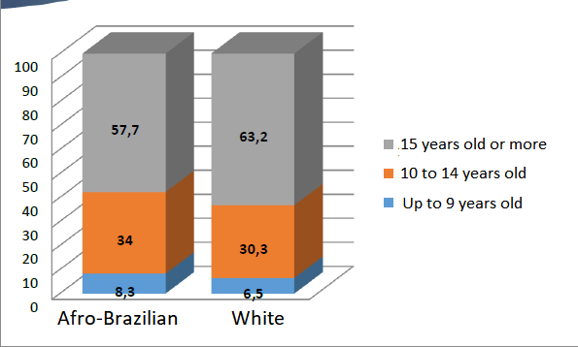

*Source:* IBGE/2016 Annual continuous PNAD.

Unemployment rate of the population aged 16 or more (2004–2015)

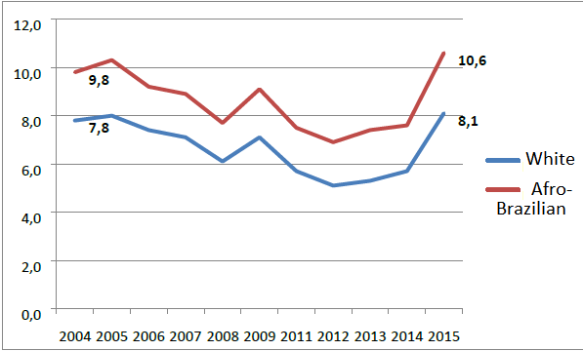

*Source:* IBGE/PNAD.

Prepared by: Institute for Applied Economic Research (IPEA)/Office of Social Studies and Policies (DISOC).

232.

Unemployment rate of the population aged 16 or more (2012–2016)

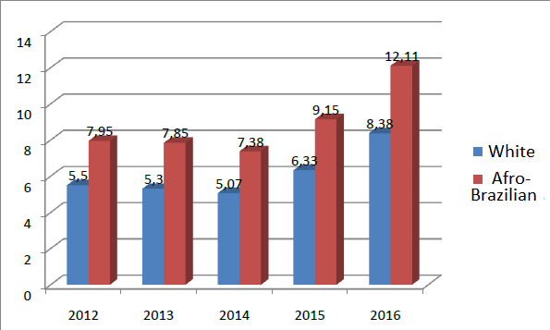

*Source:* IBGE/Annual continuous PNAD.

Prepared by: IPEA/DISOC/Social Information Management Center (NINSOC).

Informal employment rate of persons aged 16 or more by race – Brazil, 2012 to 2016

|  | *White* | *Afro-Brazilian* |
| --- | --- | --- |
| 2012 | 16.3 | 23.65 |
| 2013 | 15.99 | 23.1 |
| 2014 | 15.36 | 22.34 |
| 2015 | 15.17 | 22.12 |
| 2016 | 15.51 | 23.07 |

*Source:* IBGE/Annual continuous PNAD.

Prepared by: IPEA/DISOC/Social Information Management Center (NINSOC).

Average monthly income ratio in the main job of the employed population aged 16 years old or more – 2004 to 2015

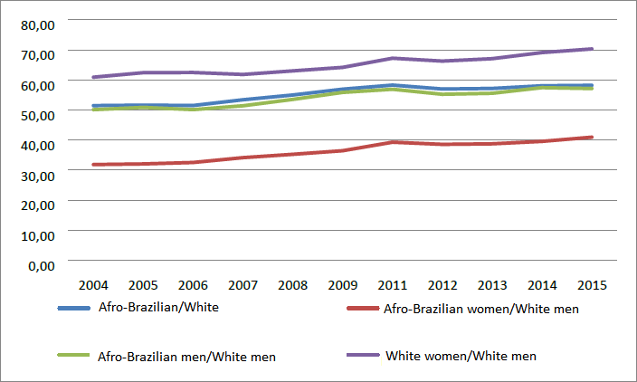

*Source:* IBGE/PNAD.

Prepared by: IPEA/DISOC.

Average monthly income ratio of the main job of persons aged 16 years old or more who were employed in the week of reference

|  | *2012* | *2013* | *2014* | *2015* | *2016* |
| --- | --- | --- | --- | --- | --- |
| Afro-Brazilian/White ratio | 57.6 | 58 | 57.8 | 58.9 | 55.3 |
| Afro-Brazilian/White formal employment ratio | 62.6 | 62.6 | 62.2 | 64.2 | 61.4 |
| Afro-Brazilian/White informal employment ratio | 59.8 | 62.5 | 64.1 | 62.3 | 54.4 |

*Source:* IBGE/2016 Annual continuous PNAD.

Type of occupation of the main job of people of age 16 years old or older by race – Brazil, 2012 to 2016

|  | *Directors and managers* | | *Sciences professionals and intellectuals* | | *Technicians and mid-level professionals* | | *Administrative support workers* | | *Services workers, salespeople in stores and markets* | |
| --- | --- | --- | --- | --- | --- | --- | --- | --- | --- | --- |
|  | *White* | *Afro-Brazilian* | *White* | *Afro-Brazilian* | *White* | *Afro-Brazilian* | *White* | *Afro-Brazilian* | *White* | *Afro-Brazilian* |
| 2012 | 62.72 | 36.25 | 60.29 | 38.68 | 51.53 | 47.84 | 51.1 | 48.3 | 43.18 | 56.15 |
| 2013 | 62.41 | 36.6 | 58.7 | 40.25 | 52.68 | 46.63 | 51.65 | 47.84 | 42.11 | 57.22 |
| 2014 | 62.37 | 36.6 | 59.26 | 39.75 | 51.57 | 47.68 | 50.99 | 48.45 | 41.64 | 57.77 |
| 2015 | 62.56 | 36.53 | 59.18 | 39.77 | 51.22 | 48.22 | 49.69 | 49.74 | 41.11 | 58.28 |
| 2016 | 63.36 | 35.5 | 59.11 | 39.58 | 49.87 | 49.14 | 48.39 | 50.85 | 40.26 | 58.89 |

*Source:* IBGE/Annual continuous PNAD.

Prepared by: IPEA/DISOC/NINSOC.

Proportion of women in domestic work

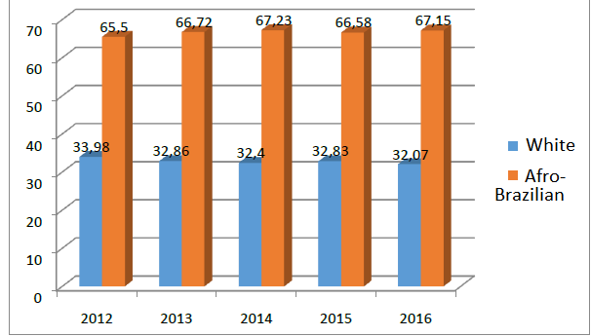

*Source:* IBGE/Annual continuous PNAD.

Prepared by: IPEA/DISOC/NINSOC.

Proportion of individuals attending higher education in a private institution according to skin color/race

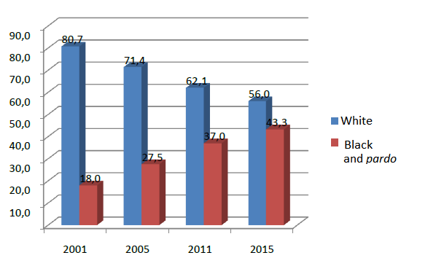

*Source:* PNAD/IBGE.

School coverage of children and young people, according to age group, sex, skin color/race and location of domicile – Brazil, 2004 to 2015

| *Age group* | *Skin color/race* | *2004* | *2009* | *2015* |
| --- | --- | --- | --- | --- |
| 0 to 3 years old | White | 15.2 | 20.2 | 29.5 |
|  | Afro-Brazilian | 11.5 | 16.7 | 22.0 |
| 4 to 6 years old | White | 72.7 | 82.6 | 89.9 |
|  | Afro-Brazilian | 68.5 | 80.1 | 87.9 |
| 7 to 14 years old | White | 98.1 | 98.4 | 99.1 |
|  | Afro-Brazilian | 96.2 | 97.9 | 98.5 |
| 15 to 17 years old | White | 85.2 | 86.9 | 86.9 |
|  | Afro-Brazilian | 78.8 | 83.9 | 83.8 |
| 18 to 24 years old | White | 34.5 | 34.5 | 35.6 |
|  | Afro-Brazilian | 29.9 | 26.6 | 27.0 |

*Source:* IBGE/PNAD.

Rate of distortion between age and grade in high school (1st to 3rd year)

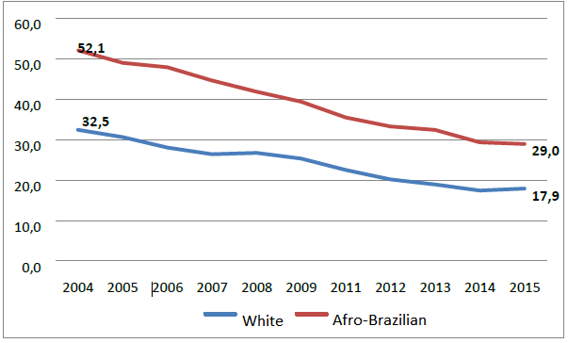

*Source:* IBGE/PNAD.

Proportion of individuals aged 25 years old or more with 12 years of education or more, by skin color/race, according to sex – Brazil and regions, 1995 to 2015

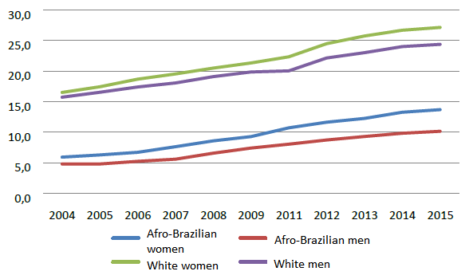

*Source:* IBGE/PNAD.

Prepared by: IPEA/DISOC.

Proportion of individuals attending a higher education course according to race/skin color

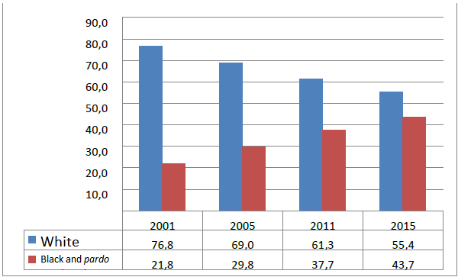

*Source:* IBGE/PNAD.

Scholarships granted by ProUni by skin color/race

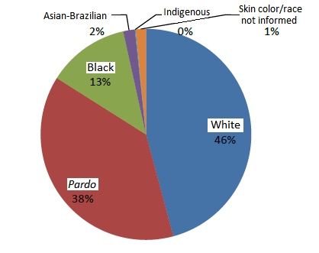

*Source:* ProUni Computerized System (Sisprouni). January 6, 2015.

All scholarship students from the 2nd semester of 2005 to 2014, totaling 1,497,225 granted scholarships.

Granted ProUni scholarships

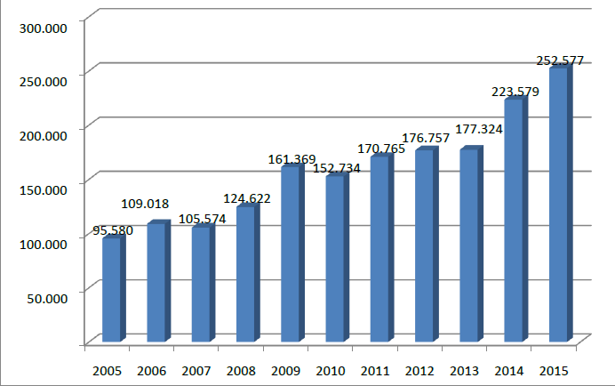

*Source:* Office of Higher Education (Sesu)/MEC.

Proportion of individuals attending higher education in a public institution according to skin color/race

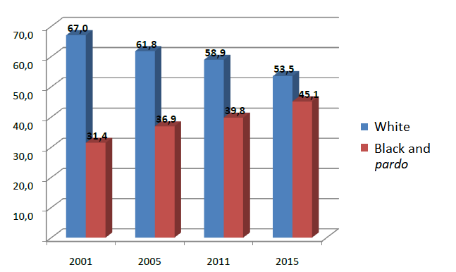

*Source:* IBGE/PNAD.

Subnormal Agglomerations in Brazil by race/skin color (2010)\*

| *Infrastructure service* | *White* | *Afro-Brazilian* | *Total* |
| --- | --- | --- | --- |
| No wheelchair ramp | 30.71% | 68.11% | 6,334,872 |
| No storm drain | 28.94% | 69.81% | 4,468,459 |
| No afforestation | 29.23% | 69.62% | 4,430,738 |
| Open sewage | 32.71% | 66.13% | 4,377,552 |
| No sidewalk | 29.03% | 69.77% | 3,915,473 |
| No address identification | 28.54% | 70.27% | 3,642,911 |
| No pavement | 28.43% | 70.37% | 2,325,920 |
| Accumulated garbage in public spaces | 30.93% | 67.93% | 807,668 |
| No street lighting | 30.38% | 68.42% | 788,925 |

*Source:* IBGE, 2010 Demographic Census, Subnormal Agglomerates.

Prepared by: Racial Equality Coordination \*Except for Asian-Brazilians and Indigenous.

Recognized refugees in Brazil

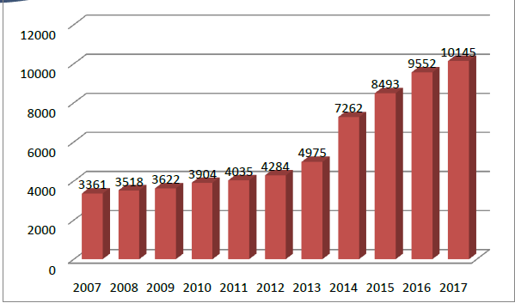

*Source:* CONARE.

Evolution of the number of persons deprived of liberty

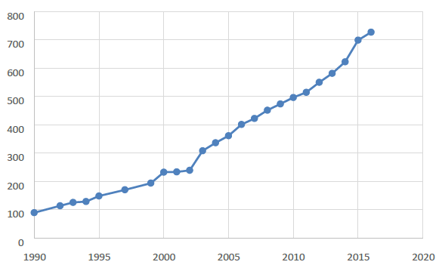

*Source:* Ministry of Justice and Public Security.

Reports received by the National Office of the Ombudsman

| *Year* | *2011* | *2012* | *2013* | *2014* | *2015* | *2016* |
| --- | --- | --- | --- | --- | --- | --- |
| Reports | 219 | 413 | 425 | 567 | 626 | 120 |
| **Total** | **2,370** | | | | | |

*Source:* Authors, with data obtained from SEPPIR – currently SNPPIR.

Comparison among Brazilian municipalities with racial equality bodies and councils

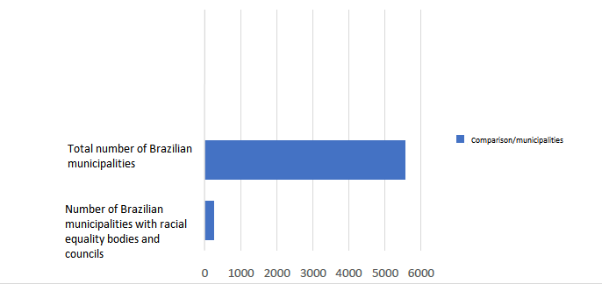

Distribution of racial equality bodies by federative unit

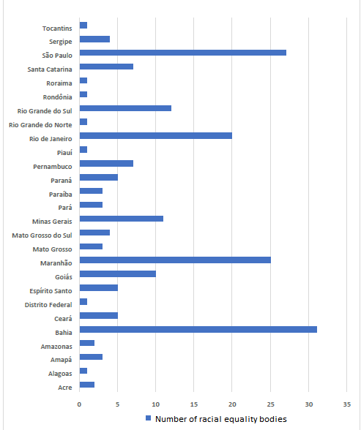

1. \* The present document is being issued without formal editing. [↑](#footnote-ref-1)
2. Maternal death occurs during pregnancy or 42 days after delivery. In this period, death can occur due to obstetric diseases, complications during pregnancy, or pre-existing condition. A careful, quality prenatal care and preventive measures are essential to decrease the rates, and the Government is required to invest further both in the expansion of the provision of such services and in the quality thereof. In other words, through public policies, it is possible to significantly reduce this indicator, which – just for reference – in Japan, is 6 deaths in one hundred thousand live births. [↑](#footnote-ref-2)
3. The research was carried out in Belo Horizonte, Bethlehem, Porto Alegre, and Recife. [↑](#footnote-ref-3)
4. On December 16, 2017. [↑](#footnote-ref-4)