|  |  |  |  |
| --- | --- | --- | --- |
|  | United Nations | CAT/OP/2 | |
|  | **Optional Protocol to the Convention against Torture and Other Cruel, Inhuman or Degrading Treatment or Punishment** | | Distr.: General  1 October 2012  English  Original: Spanish |

**Subcommittee on Prevention of Torture and Other Cruel,   
Inhuman or Degrading Treatment or Punishment**

Provisional statement on the role of judicial review and due process in the prevention of torture in prisons, adopted by the Subcommittee on Prevention of Torture and Other Cruel, Inhuman or Degrading Treatment or Punishment at its sixteenth session, 20 to 24 February 2012

Contents

*Paragraphs Page*

Summary 1 3

I. Introduction 2–6 3

II. Lack of institutional protection 7–10 3

III. Due process 11–13 4

IV. Judicial review 14–18 5

V. Recommendation 19 6

Summary

1. 1. The erroneous premise that due process ends at the moment of sentencing, and that it does not apply to the actual custodial conditions and regime, encourages the use of torture and ill-treatment in places of detention, and more specifically in prisons for adults and juveniles. This is why there is an urgent need for States to provide, in addition to complaints procedures and supervision of such places of detention, a special judicial or similar body to monitor the enforcement of any custodial measure related either to the imposition of a sentence or to pretrial detention. At a later stage, the Subcommittee on Prevention will address due process and judicial review in places of detention other than those within the criminal justice system, such as the places where mental patients and others are confined.

I. Introduction

1. 2. The incidence of torture is closely related to the legal framework governing places of detention.
2. 3. In the specific case of prisons, various cultural factors, such as the idea that inmates are “outside society” or that they are “dangerous” persons, or the reactions of the media to public insecurity, contribute to the neglect and vulnerability of persons serving prison sentences or in pretrial detention.
3. 4. To overcome this lack of protection for inmates, it must be stipulated by law that, as a rule, detainees retain their rights (including the right to integrity and freedom of conscience) and only a few of their rights are suspended (e.g. freedom of residence) or restricted (e.g. the freedoms of assembly and expression). In addition, the rights acquired at the time of detention must be established and guaranteed (e.g. the rights to food, decent living conditions and health services).
4. 5. There is a lack of guarantees regarding the realization of inmates’ rights. These guarantees include procedural bodies as well as safeguards. It is often said that “the laws are good, but what is lacking is their implementation”. However, the problem is not only a practical one but also has to do with shortcomings in the norms that should ensure the availability of the procedural bodies and remedies necessary to their realization. In reality, detainees have “rights without guarantees”.
5. 6. Obviously the absence of a legal framework — both organizational and procedural — in turn leads to impunity and further human rights violations.

II. Lack of institutional protection

1. 7. The lack of legal protection in places of detention is also related to the rehabilitative or correctional conceptions of punishment,[1] which have contributed to the predominance of a model whereby the prison authorities, technical staff and security guards unilaterally decide the punishment regime. Persons in pretrial detention and young people in conflict with the law face very similar situations and need special protection of their rights as inmates as well as their rights as individuals facing prosecution.
2. 8. In this context, it has mistakenly been understood that due process ends at the moment of sentencing and does not include aspects related to the quality of detention, with a focus on the inmate’s rights. That is to say, it governs determination of the penalty and length of the sentence, but not the nature or rigour of the penalty. Thus, food, daily routines, regulations on contact with the outside world, material conditions and supplies, the particular needs of female prisoners, transfers within prisons and to other establishments, and internal punishments, among many other matters, are left in the hands of prison authorities whose actions are not subject to any judicial review to guarantee human rights. As has been documented in the visits conducted by the Subcommittee, these circumstances often change the nature of punishments to such an extent that they become cruel, inhuman or degrading, or lead to torture.
3. 9. Currently, all prison authorities are subject to both internal and external monitoring. Internal monitoring mechanisms include administrative inspection and supervision services, while the main external monitoring systems are the Ombudsman, national mechanisms for the prevention of torture and national human rights institutions. Only rarely do we find judges appointed to supervise prisons or the enforcement of sentences. Monitoring at the international level involves both regional and international human rights protection bodies, including the Subcommittee, which should not only conduct periodic visits to prisons and report on its findings, but should also consider how the absence of laws and judicial reviews encourages abuses such as solitary confinement. The Subcommittee has a mandate to prevent abuses of detainees by identifying the necessary bodies and procedures for this purpose. This is a crucial part of its mandate that cannot be waived.
4. 10. The interaction between more comprehensive internal monitoring mechanisms and, at a subsidiary level, international ones can generate a positive synergy capable of reversing the vulnerable situation faced by inmates. However, it is hard for the efforts of international organizations such as the Subcommittee to be effective in the absence of effective national institutions, including judicial ones.

III. Due process

1. 11. Due process means the path that should be followed so that the State can legitimately give effect to fundamental rights; that is, the set of requirements that must be observed so that individuals can defend themselves properly against any act by the State that might affect their rights. Its importance has been highlighted by Américo Incalcaterra.[2]
2. 12. Within the criminal justice system, due process should cover not only the determination of penalties but also the safeguarding and protection of detainees, providing a framework for the relationship between inmates and prison authorities in terms of rights and obligations, including means of defence and legal remedies for inmates.[3]
3. 13. Given that the principles of due process include access to a defence and openness, their adoption at this stage will make what happens in places of detention more transparent, because cases of inadequate services or the justification for transfers, for example, would be aired in public hearings where the inmate is assisted by defence counsel, and because individuals and organizations will be guaranteed access to the inside of places of detention as a form of social control, all of which will make for more effective prevention of ill-treatment and torture:
4. “The more a detainee is isolated from contact with the outside world, the greater the risk of torture and ill-treatment. The right to consult an attorney is an important means of preventing such situations, as well as a safeguard of due process.”[4]

IV. Judicial review

1. 14. Judicial intervention during the period of confinement, by judges other than those who determined the criminal charges, goes hand in hand with due process. In order for inmates to be able to invoke the norms protecting them from negligent or abusive prison authorities, there must be an impartial third party to enforce those norms, given that no one should act as both judge and party. This means subordinating the prison authorities to watchdog institutions with wide coercive powers that go beyond attending to complaints or supervision by administrative bodies.
2. 15. Given that the enforcement of sentences — and pretrial detention — are part of the criminal justice system, it is natural that the impartial third party should be a judge specialized in resolving conflicts specific to life in detention; that is to say, a prison inspection judge.[5] In this manner a trilateral relationship is established in which such a judge occupies the apex of the pyramid while the prison authorities and the inmate are situated at the lower corners in keeping with the equality of arms principle. The inmate ceases to be the “object” of treatment and becomes a “subject” in a legal relationship and, in the event of a conflict with the authorities, can assert his or her rights on the basis of equality of arms vis-à-vis the administration:
3. 16. In order for inmates to have access to justice in prison, they must be guaranteed specialized legal assistance to protect their rights while they are serving their sentence or in pretrial detention.

Decision

Inmate

Judge

Protection

Lack of Protection

Inmate/defendant claims protection of court

Authority

Prison authorities

Inmate as “object” of treatment

Inmate as “subject” of rights and obligations

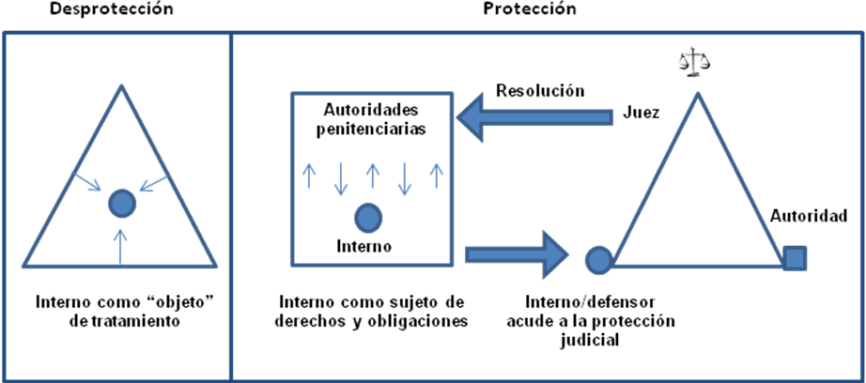

1. 17. Depending on the legal traditions and domestic laws of each State, the role played by the prison inspection judge may, however, be assigned to an administrative judge or even another specialized authority with coercive powers, provided that the authority is established by law and is independent and impartial.
2. 18. The existence of torture and ill-treatment in places of detention is not a chance occurrence; rather, it is fostered by legislative neglect and judicial inactivity that create a breeding ground for these practices. Progress will be achieved in this area if the States parties to the Optional Protocol to the Convention against Torture and Other Cruel, Inhuman or Degrading Treatment or Punishment comply with their obligation to adopt “effective legislative, administrative, judicial or other measures to prevent acts of torture in any territory under its jurisdiction” (Convention against Torture and Other Cruel, Inhuman or Degrading Treatment or Punishment, art. 2, para. 1, which applies to all signatories to the Optional Protocol).

V. Recommendation

1. 19. States parties should consider effective judicial review and due process during the detention of individuals in criminal proceedings as a prerequisite for the prevention of ill-treatment or torture of persons deprived of their liberty and as a means of conferring legitimacy on the exercise of criminal justice.

1. This involves a vision “shared by the three political and cultural trends that have contributed to the formulation of the [Italian] Constitution and subsequent prison reform: the Catholic trend, which conceives of punishment as reform of the criminal; the liberal-conservative trend, which is the source of the therapeutic and integrationist view of punishment; and communism in its Leninist and Gramscian versions, inspired by punishment regimes intended to educate and resocialize criminals. Endorsed by such a convergence of cultures, prison reform has been achieved at the price of its transformation into unequal, atypical and uncertain punishment, and the resulting dissolution of guarantees with regard to punishment”. Luigi Ferrajoli, *Derecho y razón. Teoría del garantismo penal* (Law and Reason. The Theory of Penal Guarantees). Trotta, Madrid. 1995, p. 720.
2. “The right to due process holds a place of vital importance within the fundamental rights protection system. We cannot speak of enforceability and protection of our rights without due process. This is why the International Covenant on Civil and Political Rights, along with other international human rights instruments within both the universal and inter-American systems, makes this right the axis around which international human rights law revolves.” Prologue from “Barómetro Local”, Asociación Mexicana para las Naciones Unidas, A.C. México, 2007.
3. See “Debido proceso y ejecución penal” (Due process and criminal enforcement) at www.miguelsarre.com.
4. Report on the visit of the Subcommittee to Mexico, 31 May 2010, para. 127.
5. Paragraph 9 of general comment No. 32 of the Human Rights Committee establishes that: “Article 14 [of the International Covenant on Civil and Political Rights] encompasses the right of access to the courts in cases of determination of criminal charges and rights and obligations in a suit at law. Access to administration of justice must effectively be guaranteed in all such cases to ensure that no individual is deprived, in procedural terms, of his/her right to claim justice” (CCPR/C/GC/32, 23 August 2007). If there exists a right of access to the courts to claim justice in the determination of criminal charges, then the same access must exist when claiming justice regarding the enforcement of sentences or protective measures determined through criminal proceedings. The lack of access to such justice during enforcement of the sentence would render ordinary justice meaningless, because it would mean that sentences could be changed without the judge’s knowledge. Various countries, such as Spain and Italy, have achieved good results with the introduction of prison inspection judges, whose work complements that of the Ombudsman, national mechanisms for the prevention of torture and national human rights institutions.