|  |  |  |  |
| --- | --- | --- | --- |
|  | United Nations | CMW/C/LBY/1 | |
| _unlogo | **International Convention on the Protection of the Rights of All Migrant Workers and Members of Their Families** | | Distr.: General  4 February 2019  English  Original: Arabic  Arabic, English, French and Spanish only |

**Committee on the Protection of the Rights of All   
Migrant Workers and Members of Their Families**

Initial report submitted by Libya under article 73 of the Convention pursuant to the simplified reporting procedure, due in 2005[[1]](#footnote-1)\*

[Date received: 10 January 2019]

State of Libya

Government of National Accord

Technical Committee tasked with preparing responses to observations by committees of legal experts of the Arab Labour Organization and the International Labour Organization (ILO)

Report on the observations by the Committee of Experts on the Employment Policy Convention (No. 122)

Observations: Provision of detailed and comprehensive information on:

• The proposed labour-market strategy and means of achieving employment objectives;

• The labour-market data system;

• Action on behalf of the growing number of young people with disabilities as a result of the conflict;

• Migrant labour;

• Empowerment programmes for women to enable them to exercise their political, economic and social rights.

I. The proposed labour-market strategy and means of achieving employment objectives

1. The Libyan National Strategy for Human Development and Empowerment focused on:

(a) Transformational training for graduates whose qualifications fail to meet labour-market requirements;

(b) Encouragement of self-employment through the creation of small and medium-sized enterprises;

(c) Establishment of a comprehensive database on human resources and employment opportunities in order to determine the scale of national development and economic reform and to identify human resource requirements. The Strategy also specified six key strategic goals pertaining to training and the workforce, namely:

(i) To promote full and decent employment for all persons who are able to work;

(ii) To address the problems of seasonal unemployment and underemployment and to consider applying the Social Security Act in order to prevent possible criminal behaviour resulting from a loss of income;

(iii) To promote the adoption of vocational guidance and counselling methods for persons who have recently entered the labour market, and to boost the participation of the private sector in vocational and technical training;

(iv) To increase the number of seminars and studies dealing with human resources and to facilitate participation in such events both within the country and abroad; to review recruitment policies, activities and procedures; and to enact legislation capable of responding to globalization and liberalization;

(v) To change the approach to the employment of women through empowerment and capacity-building aimed at:

Promoting their effective participation in economic activity;

Boosting the trend towards equality of opportunity;

Changing stereotypical views of women’s employment;

Reorganizing the labour market to respond to requirements and economic efficiency procedures in the era of globalization and information technology;

(vi) To treat the growing number of persons of working age as an opportunity rather than a problem, and to develop vocational and technological training and retraining methods and mechanisms that correspond to the introduction of advanced methods in the areas of training, in-service training, transformational training and other training modalities.

Small and medium-sized enterprises

2. The National Programme for Small and Medium-sized Enterprises was established to develop a culture of innovation in society and an appropriate environment for the purpose. The Government of National Accord also launched a pilot programme to finance small and medium-sized enterprises through the Economic Development Fund with a view to providing employment opportunities for young people and reducing unemployment. The Programme provides financial loans to entrepreneurs through commercial banks with the backing of the Credit Guarantee Fund. In addition, it was decided to establish enterprises throughout the country to provide assistance for projects, to develop plans for the purpose and to train those responsible for their development. Commercial banks undertake to finance up to 60 per cent of the project’s cost, provided that project support funds cover 30 per cent of the total value and the beneficiary meets 10 per cent of the remaining cost.

3. Ten business incubators to support graduate students were opened in Libyan universities, in cooperation with the Libyan National Oil Corporation, with a view to opening centres in areas with oilfields, such as Jalu and Ubari, to provide training for young people and help them to finance their projects.

4. Several boot camps were held in the city of Tunis, in cooperation with international organizations such as Expertise France. Young entrepreneurs were invited to attend training courses and were offered assistance in setting up projects. A competition for entrepreneurs was held in cooperation with Expertise France. The first stage was held in Libya and the final stage in Tunisia.

II. Labour-market data system

5. The Information and Documentation Centre in the Ministry of Labour and Rehabilitation launched a system for compiling data on the country’s labour force (in the public sector and the private sector) as well as data on jobseekers. The results are shown in the following table:

| *Age group* | *Gender* | *Number of workers* |
| --- | --- | --- |
| 18 to 25 years | Male and female | 170 643 |
| 26 years and over | Male and female | 1 657 049 |
| **Total** | | **1 827 692** |

| *Number of males* | *Number of females* |
| --- | --- |
| 1 089 084 | 738 608 |
| **Total** | **1 827 692** |

6. The Centre announced that the number of registered jobseekers totalled 137,000 and that 12,000 jobseekers had been excluded, since they were found to have been registered twice in areas where labour offices had recently been established. As there were 88,000 registered jobseekers in the southern region, the total number of jobseekers stood at 205,000. The centres and institutes run by the Ministry prepare annual professional and handicraft retraining plans. For example, the Libyan-Korean Institute in the Ministry of Labour provides training courses in a number of fields for graduates and jobseekers. It should be noted that some trainees have been offered jobs in companies such as the National Oil Corporation and others have been referred to the private sector.

7. Moreover, the Libyan Multi-purpose Survey Project 2017–2018 has been implemented, and its results are expected to assist in the development of an employment policy in cooperation with relevant partners in the productive sector.

8. A technical delegation from the International Labour Organization visited Libya in mid-August 2018. The delegation discussed with His Excellency the Minister of Labour the proposal by the State of Libya to open an ILO office in the country. The members of the delegation stated that the climate of support for the idea of opening an office representing the Organization in Tripoli was encouraging and that the strategic partnership linking the Ministry of Labour with the ILO called for more vigorous action to continue achieving common goals, especially in the areas of restructuring, digital governance, development of the public sector, illegal migration, and training and rehabilitation programmes.

III. Action on behalf of the growing number of young people with disabilities as a result of the conflict

9. A special programme has been established on behalf of persons with disabilities by the Ministry for Martyrs and Wounded Persons, in collaboration with the National Programme for Small and Medium-sized Enterprises. The aims of the programme, which is called “*Ad’amni*” (support me), are to enhance institutional capacity so that persons with visual and motor disabilities can obtain decent employment opportunities, and to support them through information and communications technology. The following action will be taken to achieve those aims:

• Specification of needs and appropriate capacity-building;

• Support and training for non-governmental organizations (NGOs) and for training and employment service providers;

• Raising of companies’ awareness of the advantages of employing persons with disabilities and promoting a spirit of entrepreneurship among persons with disabilities who wish to launch private businesses;

• Empowering persons with disabilities by boosting their information and communications technology skills and promoting online learning courses;

• Stimulating technological innovation to meet the needs of persons with disabilities and to facilitate their daily life, training and employment.

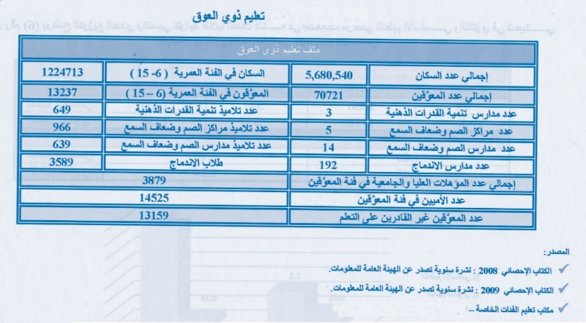

IV. Migrant labour

10. Migrants in an irregular situation periodically seek to regularize their situation out of fear of being returned to their countries of origin and because they wish to migrate to Europe through Libya, which is one of the southern Mediterranean transit States. Nevertheless, the Government, in cooperation with neighbouring countries, countries of origin and relevant international organizations, has made significant progress towards reducing irregular migration, and has encouraged migrants to legalize their situation in the country so that they can exercise their legal right to employment or voluntary repatriation.

V. Empowerment programmes for women to enable them to exercise their political, economic and social rights

11. The Presidential Council of the Government of National Accord attaches special importance to the right of women and people with special needs to employment, while bearing in mind their right to education, health and development as well as other rights that are consistent with the religious and cultural identity of the Libyan people. The Council therefore issued Decree No. 210 of 2016 on the establishment of a support and empowerment unit for women employed in State institutions. The aim of the Decree is to implement policies and programmes that enable women to exercise their political, economic and social rights and to remove obstacles that prevent them from playing their role in a positive and effective manner.

12. The Presidential Council declared in Bulletin No. 2 of 2018 that, pursuant to the provisions of the International Convention on the Rights of Persons with Disabilities, which Libya has ratified, the Convention on the Elimination of All Forms of Discrimination against Women, which it ratified in 1979, as well as the provisions of Act No. 5 of 1987 concerning persons with disabilities and its implementing regulations, and of Act No. 12 of 2010 concerning labour relations and its implementing regulations, and bearing in mind the duty of the Presidential Council to promote access to employment opportunities guaranteed by law for persons with disabilities, the Council must require all ministries, institutions, enterprises and other public bodies to respect and abide by the relevant legislation in force, including the provisions of article 87 of the implementing regulations of Act No. 12 of 2010 concerning the promulgation of the Labour Relations Act, pursuant to which employers are required to employ all persons who have completed their training and rehabilitation courses in posts consistent with their capacities. They must reserve not less than 5 per cent of the overall number of posts for persons with disabilities, who shall be appointed without being subjected to an examination. Moreover, a minimum of 3 per cent of the posts reserved for persons with disabilities shall be granted to men and a minimum of 2 per cent to women.

| *Number of males* | *Number of females* |
| --- | --- |
| 1 089 084 | 738 608 |
| **Total** | **1 827 692** |

1. \* The present document is being issued without formal editing. [↑](#footnote-ref-1)