Committee on the Elimination of Discrimination against Women

Concluding observations on the sixth periodic report of the Czech Republic

Addendum

* The present document is being issued without formal editing.

Information provided by the State party in follow-up to the concluding observations*

[Date received: 15 March 2018]

Introduction

1. The Czech Republic hereby provides the UN Committee on the Elimination of Discrimination against Women (hereinafter referred to as “the Committee”) with a written information on steps taken to implement the recommendations of the Committee on support for greater representation of women in politics (Recommendation No 23) and on coercive or non-consensual sterilisation (Recommendation No 29) (hereinafter referred to as “Written Information”).
2. On 23 February 2016, the delegation of the Czech Republic participated in a session of the Committee in Geneva to review the Czech Republic’s sixth periodic report on the implementation of the Convention. On 4 March 2016, the Committee issued its concluding observations addressed to the Czech Republic (CEDAW/C/CZE/CO/6) and requested information on the implementation of some of these recommendations within two years.
3. Specifically, the Committee asked the Czech Republic for written information on the implementation of the following recommendations:
• To amend its electoral law to implement the “zipper” system for election candidates (Recommendation No 23(a));
• To review the three-year time limit in the statute of limitations for bringing compensation claims in cases of coercive or non-consensual sterilisations with a view to extending it and, as a minimum, ensure that the time limit begins from the time of discovery of the real significance and all consequences of the sterilisation by the victim rather than the time of injury (Recommendation No 29(a));
• To establish an ex gratia compensation procedure for victims of coercive or non-consensual sterilisations (Recommendation No 29(b)).
4. This Written Information summarises the steps taken in response to the above recommendations. With regard to support for greater representation of women in politics it informs about the adoption of the Action Plan for Equal Representation of Women and Men in Decision-making Positions for 2016 to 2018 and the positive trend of the increasing rate representation of women in politics. As for coercive or non-consensual sterilisations, this document reports on the Czech Government’s decision not to establish an ex gratia compensation mechanism and on the Constitutional Court’s ruling ordering courts not to disregard the statute of limitations where this would be contra bonos mores. In the context of sterilisations, the principal means of remedy for victims of coercive or non-consensual sterilisation remains an application to a court seeking pecuniary or non-pecuniary compensation for non-material harm suffered by an infringement of personal rights.

Information in response to the Committee’s recommendations

Participation in political and public life

5. The Committee reiterates its previous recommendation (CEDAW/C/CZE/CO/5, paragraph 27) that the State party take effective measures, including temporary special measures, in accordance with Article 4(1) of the Convention and the Committee’s General Recommendation No 25 (2004) on temporary special measures. In that regard, the Czech Republic should amend its electoral law and implement the “zipper” system for election candidates (see CEDAW/C/CZE/CO/6, para 23 (a)).
6. The recommendation advocates for the introduction of the “zipper” system, i.e. legislative rules on the representation of women and men in electoral lists for certain elections. The introduction of rules on the representation of women and men in electoral lists for elections to the Czech Parliament’s Chamber of Deputies and to regional assemblies had been already considered by the Czech Government in the previous Convention implementation monitoring period.
7. Specifically, in 2015 the Ministry of the Interior drew up a bill amending Act No 247/1995 on elections to the Parliament of the Czech Republic and amending certain other acts, as amended, Act No 130/2000 on elections to regional assemblies and amending certain acts, as amended, and Act No 424/1991 on association in political parties and in political movements, as amended. That amendment required at least one candidate of the opposite sex in the top three candidates in electoral lists for elections to the Chamber of Deputies and regional assemblies, and the representation of at least 40% of each gender in the electoral list. Non-compliance was to be penalised by a 30% reduction of the state financial contribution for the given mandate of the MP or regional assembly member. The Czech Government discussed the draft amendment on 1 July 2015 but did not approve it.
8. Following the Czech Government’s decision to reject rules on the representation of women and men in electoral lists, the Minister for Human Rights, Equal Opportunities and Legislation prepared the Action Plan for Equal Representation of Women and Men in Decision-making Positions for 2016 to 2018 (hereinafter referred to as “the Action Plan”) and submitted it to the Czech Government. The Action Plan was approved by the Resolution No 632 of the Czech Government on 11 July 2016.
9. The Action Plan is a comprehensive strategy paper of the Czech Government specifically aimed at balanced representation of women and men in decision-making positions. The Action Plan’s various measures are organised into four main strands:
• General tasks for promotion of balanced representation of women and men in decision-making positions;
• Tasks for the area of politics;
• Tasks for the area of public administration and other public institutions;
• Tasks for commercial companies.
10. Its implementation is evaluated through an annually adopted document entitled “Summary Report on the Implementation of the Action Plan”. The implementation of the tasks is independently evaluated by the Committee for Balanced Representation of Men and Women in Politics and Decision-making Positions, a body set up at the Government Council for Equal Opportunities for Women and Men.
11. During the implementation of the Action Plan’s tasks relating to equal representation of men and women in politics, the Office of the Government of the Czech Republic held on 8 December 2016 a workshop for political parties. The participants were presented with an analysis of the representation of female candidates in regional and Senate elections and election results, compiled by a non-profit organization Fórum 50 %. At the event, representatives of political parties presented examples of intra-party good practices of promotion of more balanced representation of women and men. Following the workshop, a manual entitled “15 Tips on Supporting Women within Political Parties” was produced. This document contains a guide for political parties on how to be more steadfast in championing the principle of gender equality and increased representation of women in politics. It includes recommendations on the transparency of party rules, women’s networking, promotion of women’s and girls’ interest in politics and mentoring.
12. Building on the Action Plan, the Office of the Government will also analyse by May 2018 gender stereotyping in depiction of women and men in election campaigns. This analysis will include recommendations directed at political parties and those who manage political campaigns.
13. With regard to the Committee’s recommendation on the introduction of the “zipper” system, we note that numerous political parties and movements in the Czech Republic have been applying various measures to increase the representation of women in their electoral lists, including party quotas. The Committee for Balanced Representation of Men and Women in Politics and Decision-making Positions, in which parliamentary political entities are represented, serves as a platform for exchanges of experience and good practices among the parties. Besides sharing good practice, the Committee is also active in awareness-raising activities, analytical work and networking of female politicians.
14. Although the Czech Government did not adopt an amendment to electoral laws establishing the “zipper” rule, the representation of women in politics in the Czech Republic has been gradually increasing due to other non-legislative measures.
15. Elections to regional assemblies were held in 2016. There was a 30.3% share of women in the electoral lists, the highest representation to date. The share of women among those elected to regional assemblies was 20.3%, again resulting in the highest representation of women in regional assemblies to date. As of 31 December 2017, the Czech Republic had four female regional governors (or, more precisely, three governors plus the mayor of Prague), i.e. 28.6% of all regional governors were women (once again, this is the highest representation to date). The president of the Association of Regions of the Czech Republic is also a woman.

Chart 1
Developments in the representation of women among those running and elected in elections to regional assemblies
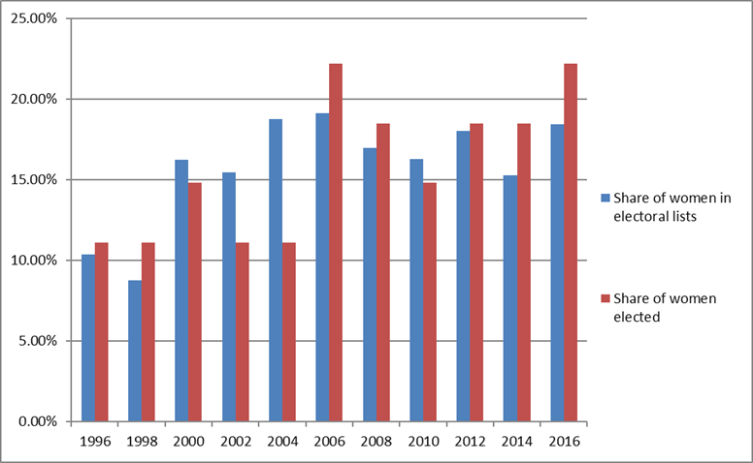
Source: Czech Statistical Office

16. Elections to the Senate were held in 2016. Figures from the Czech Statistical Office and an analysis by the non-profit organisation Fórum 50 % showed that the share of women running for the Senate in 2016 was 18.5%, historically the third highest share of women (and a rise of more than three percentage points from 2014). Following the 2016 election, 19.8% of senators were women. The highest share of elected women (22.2%) was in 2006 (see Chart 2).

Chart 2

Developments in the representation of women among those running and elected in elections to the Senate

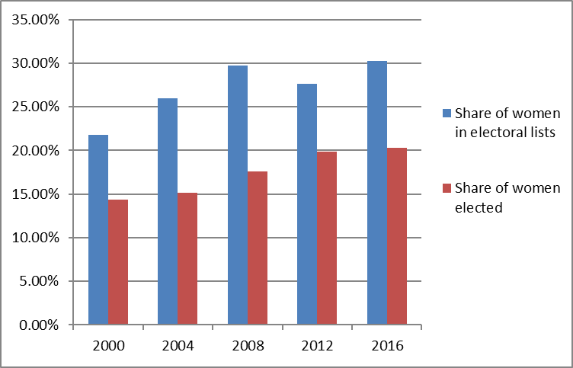
Source: Czech Statistical Office

17. In 2017, elections to the Czech Parliament’s Chamber of Deputies were held. There were 2,154 female candidates (28.6% of all candidates), thus making it the highest number of women to run in such elections. Of the female candidates, 44 were elected to the Chamber of Deputies, equating to 22% of Members of Parliament.

Chart 3

Developments in the representation of women in the Chamber of Deputies, 1996–2017

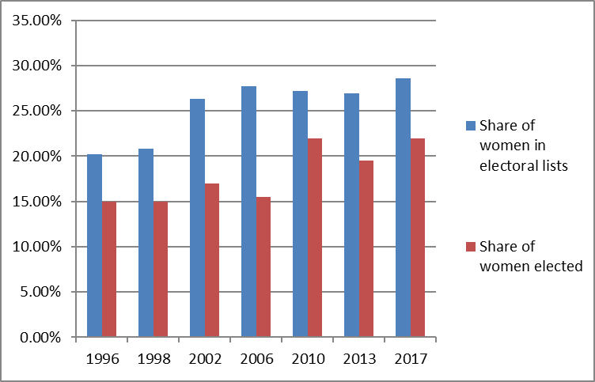
Source: Czech Statistical Office

Health

Coercive or non-consensual sterilizations

18. In accordance with its previous concluding observations (CEDAW/C/CZE/CO/3, para 24 and CEDAW/C/CZE/CO/5, para 35), its general recommendations No. 19 and No. 24 (1999) on article 12 (women and health) and the recommendations in the final statement dated 23 December 2005 of the Ombudsman on the matter of sterilizations performed in contravention of the law and proposed remedial measures, the Committee reiterates its call for the State party (see CEDAW/C/CZE/CO/6, para 29 (a) and (b)).
19. To review the three-year time limit in the statute of limitations for bringing compensation claims in cases of coercive or non-consensual sterilizations with a view to extending it and, as a minimum, ensure that the time limit begins from the time of discovery of the real significance and all consequences of the sterilization by the victim rather than the time of injury (para 29 (a)).
20. To establish an ex gratia compensation procedure for victims of coercive or non-consensual sterilizations (para 29 (b)).
21. The principal means of remedy for victims of coercive or non-consensual sterilization remains an application to a court seeking pecuniary or non-pecuniary compensation for non-material harm suffered by an infringement of personal rights. Through its interpretation in 2008, the Supreme Court changed its view on the time limit for the statute of limitations when it concluded that a standard three-year time will apply in this case, counting from the occurrence of harm. Pursuant to this decision, all applications for pecuniary compensation for non-material harm filed after that time limit were dismissed.
22. Subsequently, the Constitutional Court ordered the necessity that the time-barring claim needs to be examined/assessed from the perspective of good morals, i.e. whether a party caused time-barring of his/her right and whether the application of the time bar is not excessively harsh on that party given the circumstances.
23. In 2011 and 2014, the Supreme Court, twice refused to recognize the contention that claims had been time-barred and the patients subsequently won compensation. The case-law therefore suggests that in those cases when the contention that claims would time-barred would have resulted in consequences that were too harsh, the courts disregarded them and the unlawfully sterilized persons were awarded compensation.
24. Despite discussing a bill on compensation for unlawfully sterilized persons by the Czech Government in 2015, the proposal was not approved. The Czech Government reasoned that after carefully considering all lines of reason deriving from the Czech constitutional order, the case-law of Czech and international courts, including the Constitutional Court and the European Court of Human Rights, the statements of the Public Defender of Rights, and the recommendations of international human rights bodies, it did not assess the mechanism as effective and maintained its view that an application to a court was a sufficient means of remedy while taking into account the its international obligations. The Czech Government also argued that assessing individual cases, often from the distant past, would be arduous and problematic in view of the fact that medical records and other underlying documentation may not have been preserved.
25. The law requires a patient’s written consent for sterilization to be carried out. Prior to the sterilization, a doctor is required to provide information — in the presence of one or more witnesses — on the nature of this medical procedure, its consequences, and the potential risks. Between the provision of this information and the patient’s consent, there must be an interval of at least seven days for sterilization on medical grounds and fourteen days for sterilization on non-medical grounds. That time period is an opportunity for patients to weigh up the circumstances surrounding the operation. Written informed consent must include information on the purpose, nature, benefit, consequences and potential risks of the medical procedure; and advice on the alternatives, the possible future limitations and strain on the body, the regimen, and appropriate precautions. The consent also includes brief information on the anatomy of internal sex organs. By signing the consent, the doctor, the patient and the witnesses confirm that this information has been provided, received and understood. The consent, along with a record of the provision of information, forms part of the patient’s medical records. A template of the written informed consent has been published in the Journal of the Ministry of Health. Healthcare facilities use that template directly or as a basis for inspiration. It has also been translated into Romani. Final consent must be given by the patient immediately before the operation. The Ministry of Health also helps to raise public awareness of patients’ rights and supports trainings of doctors.

Analýza výsledků voleb do Senátu PČR z hlediska zastoupení žen [Analysis of Results of Elections to the Senate of the Czech Parliament in Terms of the Representation of Women] is available [online] [last visited 2017-12-14] at http://aa.ecn.cz/img_upload/ 666f72756d35302d6669313030313139/analyza_senat_2016_vysledky.pdf.

