 | United Nations | CAT/C/GTM/8
 | Convention against Torture  and Other Cruel, Inhuman  or Degrading Treatment  or Punishment |  | Distr.: General  9 June 2023  English  Original: Spanish  English, French and Spanish only
Committee against Torture

Eighth periodic report submitted by Guatemala under article 19 of the Convention pursuant to the simplified reporting procedure, due in 2022*
[Date received: 13 March 2023]

I. Introduction
1. With the objective of strengthening the institutional framework for peace and human rights, the Presidential Commission for Peace and Human Rights was established in 2020 with a 10-year mandate to advise and coordinate with the various agencies of the executive branch to promote actions and mechanisms to ensure the effective enjoyment and protection of human rights, the fulfilment of government commitments arising from the Peace Agreements and efforts to address conflicts in the country.
2. The State of Guatemala hereby submits its eighth periodic report, which contains replies to the list of issues prepared by the Committee against Torture (CAT/C/GTM/QPR/8) pursuant to the simplified reporting procedure. The process of collecting information was coordinated by the Inter-Agency Human Rights Forum, which is made up of some 61 public institutions. The systematized information was uploaded to the system for monitoring the recommendations of the international human rights protection system.

II. Replies to the list of issues

Reply to the issues raised in paragraph 2 of the list of issues (CAT/C/GTM/QPR/8)
3. With regard to the content of articles 201 bis and 425 of the Criminal Code, at the time of writing, responsibility for drafting, amending and/or repealing laws lies with Congress, and there are no predefined time frames for that process or for presuming that an initiative will not be adopted.
4. Measures relating to the criminalization of torture include Bill No. 4998, on the adoption of the Act on the Implementation of the Rome Statute of the International Criminal Court, which has been reported favourably by the Congressional Committee on Legislation and Constitutional Matters.

Reply to the issues raised in paragraph 3 of the list of issues
5. With regard to informing persons of the reason for their arrest, hearing detainees and deciding on the legal situation of persons brought before the courts, mainly in cases of flagrante delicto or by order of a competent authority, Decision No. 40-2022 of the Supreme Court of Justice broadened the provision that created the collegial courts of first instance for criminal matters, drug trafficking and environmental crime of the municipality of Guatemala, adding six judges to these courts.
6. The Ministry of the Interior, through the National Civil Police, is in charge of arresting persons either in flagrante delicto or on the order of a competent judge and notifies them of the reason for their arrest while complying with the constitutional requirement to bring them before the competent judicial authority within six hours. During that time, the relevant officials ensure that their rights are not violated, as established in the Constitution of Guatemala, the National Civil Police Act and other legislation.
7. The National Civil Police is a professional institution and, as such, requires police officers to demonstrate professionalism and effectiveness in order to be promoted. In that connection, officers receive general and specialist training, capacity-building and continuous education, during which they study matters relating to the Guatemalan legal system and international human rights treaties and conventions. Police officers are therefore expected, in the exercise of their duties, to protect the lives and physical integrity of the persons deprived of liberty who are in their custody.
8. With respect to disciplinary action against police officers, according to data provided by the Office of the Inspector General of the National Civil Police, no police officers were sanctioned in 2018 or 2019, two officers were sanctioned for serious misconduct in 2020, one officer was sanctioned for serious misconduct and one for very serious misconduct in 2021, and there have been no sanctions so far in 2022.
9. The Judicial Authority has holding cells for men and women at its headquarters in the municipality of Guatemala. Holding cells for members of the LGBTIQ+ community and mothers with babies were created in 2018 to protect them and meet their needs while they await their hearings. These cells are managed by the Directorate General of the Prison System of the Ministry of the Interior.
10. The Duty Magistrates’ Court of the municipality of Guatemala was established in 2018 with priority jurisdiction to consider petitions for habeas corpus. The Court operates 24 hours a day and comprises three judges who preside over habeas corpus proceedings as soon as they are requested by persons deprived of liberty, or any other person. The Court has territorial jurisdiction in the department of Guatemala and is located in the Judicial Authority’s headquarters.
11. Under the collegial criminal court model, introduced in 2019, one judge was added to each court in the department of Guatemala. The number of judges was thus increased from 12 to 24, in order to expedite proceedings and comply with the relevant time frames. Two judges work simultaneously in each court. In 2020, a system that uses the Zoom platform to conduct trials was introduced for all types of criminal hearing, and videoconferencing rooms are currently being expanded in seven facilities.
12. As part of efforts to strengthen the criminal justice system, 19 magistrate posts have been created for the conduct of remote proceedings. The table below sets out the number of remote hearings held from 2018 to 2022. It should be noted that over this period of four years and nine months, the courts have made use of this legal mechanism that allows persons deprived of liberty to participate in hearings remotely from prisons on 49,281 occasions.
Year | Remote hearings held
2018 | 9 260
2019 | 10 465
2020 | 9 301
2021 | 12 928
January–September 2022 | 7 327
Total remote hearings | 49 281
Source: Prepared by the authors using data from the Judicial Authority.
13. Decision No. 25-2020 of the Supreme Court created the First and Second Mobile Magistrates’ Courts for Criminal Matters, which have exclusive jurisdiction to hear initial statements and conduct habeas corpus proceedings using real-time audiovisual communications. These courts have territorial jurisdiction in the department of Guatemala and will be located at the Pavón Prison Model Rehabilitation Farm, the Fraijanes II men’s prison and the Zone 18 pretrial detention centre for men and women. Between 2018 and 2022, 64,898 habeas corpus hearings were held.
14. With regard to ensuring that the questioning of persons deprived of their liberty is video recorded and that those recordings are stored in a safe place, the judicial system is equipped to produce audio recordings of all judicial proceedings, including interrogations, through an institutional computer system known as the Court Management System. The parties concerned may request copies of audio recordings from the Criminal Management Support Services Centre. All criminal courts have audio and videoconferencing equipment.
15. In response to the coronavirus disease (COVID-19) pandemic, the Supreme Court adopted and implemented the Operational Protocol for Remote Criminal Hearings, which is based on the principles of voluntary participation, good faith and procedural fairness and allowed proceedings to be held remotely and in real time using the technological tools available at the locations of witnesses, experts, victims and other persons involved in proceedings. As of 2022, more than 83,701 remote hearings have been held as a result of the COVID-19 pandemic, in addition to the remote hearings held using the Zoom platform in cases of more serious crime, for a total of 132,982 hearings.
16. In order to ensure that every person deprived of liberty enjoys all the guarantees set out in international standards, the national mechanism for the prevention of torture carries out periodic visits to all prisons. Should it observe any violation of those guarantees or suspect cruel or inhuman treatment or punishment, it will make relevant recommendations or indicate appropriate legal action to guarantee the fundamental rights of all persons deprived of liberty.
17. Upon entry into a juvenile pretrial detention centre, adolescents in conflict with the criminal law receive information on their rights, duties and obligations from the Social Welfare Secretariat, after which they are taken to a washing area and given a uniform and personal items. They are then placed in dormitories according to gang membership status and age group; each dormitory has individual beds and a bathroom. They also receive education and health-care services, legal assistance, spiritual guidance, psychological assistance and attention from social workers, in line with the principles of specialized justice.
18. The specific measures taken to ensure the provision of free legal aid of adequate quality include ongoing training by the Public Criminal Defence Institute for all its staff so that they may provide quality defence services using legal arguments based on law, jurisprudence and compliance with international instruments. Public defenders provide a technical, timely and effective defence from a defendant’s first hearing to ensure access to the fair administration of justice. The Institute’s coverage has been expanded nationwide, with more than 136 centres providing its services completely free of charge. Specialized units have been established in the areas of culturally appropriate access to justice, the gender perspective, less serious crimes, high-risk crimes, human rights and technical support, coordinated through a multidisciplinary team.
19. The Public Criminal Defence Institute has trained its staff members and updated their knowledge of international law on cruel and inhuman treatment and the bodies before which recourse may be sought. It continually ensures that review hearings are held on coercive measures, thereby promoting personal freedom during criminal proceedings. The Institute instructs public defenders to visit prisons to verify prisoners’ health and to prevent cruel or inhuman treatment, thus protecting the human rights of persons deprived of liberty.

Reply to the issues raised in paragraph 4 of the list of issues
20. The legislative measures taken during the period under review include Congress’s adoption of legislative decrees to combat gender-based violence. These include Decree No. 14-2020, approving a loan from the Inter-American Development Bank for the implementation of a programme to strengthen and modernize the Public Prosecution Service, which received US$ 60 million to continue its investigative work. Similarly, Decree No. 16-2020 approved the negotiation of a $300-million loan from the Central American Bank for Economic Integration for a programme of justice sector investment and modernization intended to strengthen the judiciary’s work and the Judicial Authority itself, with a view to combating, inter alia, gender-based violence. Through Decree No. 47-2022, Congress amended the Civil Code, the Code of Civil and Commercial Procedure and the Family Courts Act to promote the use of scientific methods by allowing the National Institute of Forensic Sciences to perform DNA tests in judicial proceedings relating to families, children, adolescents and gender-based violence.
21. With regard to gaps in funding, during financial years 2019, 2020 and 2021 budgetary allocations were granted to the Guatemalan Women’s Group, as set out in article 104 of Decree No. 25-2018, the Act on the State Budget for the 2019 Financial Year, which was in effect during the aforementioned financial years and states the following:
“Article 104. Special allocations and increases. Provision is made for special allocations within the budget approved for the current financial year: ... (b) The Ministry of the Interior shall make adjustments to its budgetary allocations to grant funding to the Guatemalan Women’s Group to support the provision of comprehensive care to women survivors of violence.”
22. Technical committees were set up in 2021 in coordination with the Office of the Third Deputy Minister for Violence and Crime Prevention and the Community Prevention of Violence Unit to enable the Ministry of the Interior to provide advice to women’s organizations not mentioned in the Act on the State Budget.
23. In response to advocacy efforts by the organizations involved, the legislative branch adopted Decree No. 16-2021, the Act on the State Budget for the 2022 Financial Year, which was published in the Official Gazette on 3 December 2021. Article 121 of the Decree reads as follows:
“Article 121. Special allocation for comprehensive support centres for women survivors of violence. Within the budget of the Ministry of the Interior, adjustments may be made for the allocation of 17,403,842 quetzales (Q) to 12 comprehensive support centres for women survivors of violence.”
24. Thus, the budget allocated to the comprehensive support centres for women survivors of violence is specified in the Act on the State Budget for the 2022 Financial Year for each of the women’s organizations referred to in the Act.
25. With respect to the implementation of funds, the Ministry of Public Finance has designated the following recipients:
- Asociación de Mujeres de Occidente Ixquic, San Marcos
- Asociación Generando Equidad, Liderazgo y Oportunidades (non-governmental organization (NGO)), Chimaltenango
- Asociación de Mujeres Luqueñas para el Desarrollo Integral, San Lucas Tolimán
- Asociación de Mujeres Alas de Mariposas, Villa Nueva
- Asociación Nuevos Horizontes, Quetzaltenango
- Asociación Grupo Integral de Mujeres Sanjuaneras
- Asociación por Nosotras Ixmukane para el Desarrollo Integral Sostenible de la Mujer, Quiché
- Asociación de Desarrollo Integral y Beneficio Social Mujer de Propósito, Huehuetenango
- Asociación Ixoq Chajib´al Ja (NGO), Sololá.
26. The designated recipients are the women’s organizations that submitted the documentation requested by the Ministry of Public Finance, consisting of their annual operating plans and updated tax registration certificates.
27. It is worth noting that of the 12 women’s organizations that manage the centres, which are included in the Act on the State Budget for the 2023 Financial Year, just 6 have submitted the documentation required to enter into the agreement with the Ministry. Among those six organizations are the Asociación de Desarrollo Integral y Beneficio Social Mujer de Propósito of Huehuetenango, which is registered under different names in the Register of Legal Entities of the Ministry of the Interior and the Act on the State Budget for the current financial year. This gives rise to a legal impediment under article 13 of the Act, which states:
28. “No ministry of State, secretariat or other department of the executive branch may transfer funds to non-governmental organizations, foundations or for-profit or non-profit national or international associations, or programmes thereof, that are not included in the State budget for the current financial year.” For that reason, any specialized women’s organization that manages a support centre but is not specifically referred to in the Act is not permitted to receive public funds.
29. The women’s organization in question was therefore given advice to enable it to receive the allocated funds. The following options were suggested:
- Its inclusion in the Act on the State Budget for the current financial year by means of an amendment modifying its name in line with its articles of incorporation; or
- A change to its name in the Ministry’s Register of Legal Entities, with the full support of the Ministry and the National Coordination Office for the Prevention of Domestic Violence and Violence against Women.
30. The following women’s organizations that manage support centres have submitted all the required documentation, which is currently being processed:
- Asociación de Mujeres de Occidente Ixquic, San Marcos
- Asociación Generando Equidad, Liderazgo y Oportunidades (NGO), Chimaltenango
- Asociación de Mujeres Luqueñas para el Desarrollo Integral, San Lucas Tolimán
- Asociación Nuevos Horizontes, Quetzaltenango
- Asociación Ixoq Chajib´al Ja (NGO), Sololá
- Asociación de Desarrollo Integral y Beneficio Social Mujer de Propósito, Huehuetenango.
31. With regard to the number of prosecutors’ offices and courts specializing in gender-based violence, the judiciary’s efforts in recent years have mainly revolved around broadening the coverage of specialist bodies in nine departments and the creation of three inter-agency comprehensive care centres operating 24 hours a day, 365 days a year. The centres adopt systemic approaches, namely the Comprehensive Support Model for Children and Adolescents, the Comprehensive Support Model for Juvenile Criminal Justice and the I’x Kem Comprehensive Support Model for Women Victims of Violence. This last model, created in 2021, is supported by the Criminal Court of First Instance for Crimes of Femicide and Other Forms of Violence against Women and Sexual Violence of the department of Guatemala, which comprises six judges of family courts of first instance who hear cases of domestic violence.
32. The I’x Kem Comprehensive Support Model for Women Victims of Violence comprises 15 institutions: the judiciary, the Public Prosecution Service, the Ministry of Economic Affairs, the Ministry of Education, the Ministry of the Interior, the Ministry of Health and Social Welfare, the Ministry of Labour and Social Security, the Ministry of Social Development, the Counsel General’s Office, the National Institute of Forensic Sciences, the Public Criminal Defence Institute, the Victim Assistance Institute, the Guatemalan Institute for Migration, the municipality of Guatemala and the Office of the Ombudsman for Indigenous Women’s Rights. The aim of the Model is to ensure that women victims of violence receive comprehensive care that meets quality standards through the provision of multidisciplinary, specialized and centralized services, which will create the conditions necessary to comprehensively guarantee and protect the human rights of women victims, avoid secondary victimization and improve criminal investigation mechanisms. The court has handled 4,998 cases since 2021.
33. The Comprehensive Support Model for Children and Adolescents, which is unique in Latin America, was created in 2019 and provides immediate and comprehensive care to ensure that child and adolescent victims of crime benefit from a differentiated and efficient response. This is done through intra- and inter-agency coordination that seeks to minimize secondary victimization in a culturally appropriate and gender-sensitive manner and to ensure the enforcement of the law and respect for the guarantees, principles and national and international rights applicable to children and adolescents.
34. The Comprehensive Support Model for Children and Adolescents comprises 14 institutions led by the Public Prosecution Service through the Office of the Public Prosecutor for Children and Adolescents, in addition to the judiciary, the Ministry of Health and Social Welfare, the National Institute of Forensic Sciences, the Counsel General’s Office, the Public Criminal Defence Institute, the Victim Assistance Institute, the Ministry of the Interior through the National Civil Police, the municipality of Guatemala, the Ministry of Education and the Ministry of Culture and Sports. Each of these institutions, from the perspective of its legal mandate, works in a coordinated manner to deliver specialist services to child and adolescent victims.
35. Similarly, the Comprehensive Support Model for Juvenile Criminal Justice was launched in 2021 with the aim of providing immediate, comprehensive and specialized care to adolescents in conflict with the criminal law.
36. It should be noted that the judiciary’s specialized justice services cover 96 per cent of the country, with a presence in 21 of the 22 departments. Between 2018 and 2022, 10 courts of first instance, 10 criminal trial courts for crimes of femicide and other forms of violence against women and two specialized chambers of the Court of Appeal were created. The necessary budgetary provision and agreements have been approved to establish specialized courts in the department of Totonicapán, which are expected to open this year, thereby bringing coverage in the country to 100 per cent.
37. The following departments have specialized courts for femicide and other forms of violence against women and sexual violence: Guatemala, Alta Verapaz, Baja Verapaz, Chimaltenango, Chiquimula, Escuintla, Huehuetenango, Izabal, Jutiapa, Peten, Quetzaltenango, Quiché, San Marcos, Santa Rosa, Sololá, Suchitepéquez, Zacapa, El Progreso, Sacatepéquez, Retalhuleu and Jalapa. Coverage at the national level therefore stands at 96 per cent.
38. Each of the judiciary’s 47 specialized criminal courts has a victim care system, which provides comprehensive care, psychological counselling and support to victims and survivors before, during and after judicial proceedings. The system also identifies women victims in order to afford them comprehensive care. The services are provided promptly and in a caring and empathetic manner, in an appropriate and comfortable setting.
39. Other functions of the comprehensive care system for victims of violence against women include:
- Arranging for support from any public or private institution to safeguard victims’ lives and integrity and promote conditions conducive to their comprehensive development and the fulfilment of their life plans;
- Informing victims in an understandable, simple, clear and precise manner and, when applicable, in their own language, of the status of judicial proceedings and the effects of decisions handed down by judges;
- Informing judges of the need to expand, replace or extend the security measures ordered to protect victims prior to the expiry of those measures and, since the COVID-19 pandemic, to grant them ex officio.
40. The victim care system is also responsible for the ongoing monitoring of compliance with, and the effectiveness of, the security measures ordered to protect victims of violence, which are a valuable tool for protecting victims’ lives and integrity. Between 2018 and 2022, more than 159,773 security measures were ordered by the specialized courts for femicide and other forms of violence against women and sexual violence.
41. Furthermore, a victim care system software module was rolled out nationwide in July 2019. The module contains fields for entering psychosocial and victimology information on victims of violence against women and sexual violence, representing a significant step forward in that it is not only an essential record for generating victim profiles and adjusting the system’s responses to meet their particular needs, but also a mechanism for ensuring accountability in the provision of care.
42. Offices of the Victim Assistance Institute have been opened in the courts dealing with femicide, as well as at the headquarters of the Comprehensive Support Model for Children and Adolescents, the I’x Kem Comprehensive Support Model for Women Victims of Violence and the Judicial Authority, as well as in the departments of Quetzaltenango, Escuintla, Chimaltenango, Jutiapa and Cobán.
43. In 2019 the Supreme Court launched the Specialized Support Model for Women in magistrates’ courts in order to provide primary support and ensure due diligence. The Model is currently used in 78 courts.
44. Between 2018 and 2022, the jurisdictions of 39 magistrates’ courts were expanded in 22 capitals and other locations in 39 municipalities. As part of that process, inter-agency agreements between the Supreme Court, the Public Prosecution Service and the Public Criminal Defence Institute have been reached to allow for the gradual expansion of territorial jurisdictions, taking into consideration levels of ordinary crime and the financial resources required.
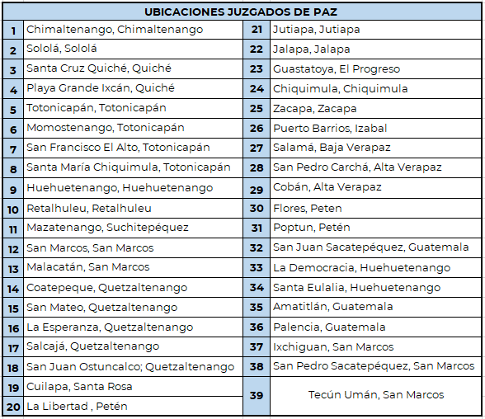
45. The executive branch, through the Subdirectorate for Social Rehabilitation of the Ministry of the Interior, runs programmes and workshops in detention centres that focus on gender issues. The Subdirectorate also has a staff member who provides individual psychological care to prisoners when required.
46. The Vulnerable Groups Unit conducts awareness-raising workshops in detention centres that address the appropriate treatment of vulnerable women deprived of liberty, including women with disabilities, older women, foreigners, members of the LGBTIQ+ community and Indigenous women.
47. With regard to protection and support services for victims of gender-based violence, the mechanism for the prevention of torture has worked jointly with the Public Criminal Defence Institute, the Directorate General of the Prison System and the Victim Assistance Institute with the aim of preventing the cruel and inhuman treatment or punishment of women in prisons.
48. To protect victims, the Victim Assistance Institute requests security measures from the relevant court, which are regulated by Congressional Decree No. 97-96, the Act on the Prevention, Punishment and Eradication of Domestic Violence. In cases where alternative measures are imposed, protection measures for victims are requested, and coordination also takes place to ensure that women victims of violence receive protection in shelters or specific programmes.
49. Similarly, according to the executive branch, in terms of complaints, investigations, prosecutions, convictions and judgments recorded in cases of gender-based violence, the Victim Support Department of the Technical Secretariat of the Subdirectorate General of Operations of the National Civil Police reports that between 2018 and 2022, a total of 69,402 complaints were received, disaggregated as follows:
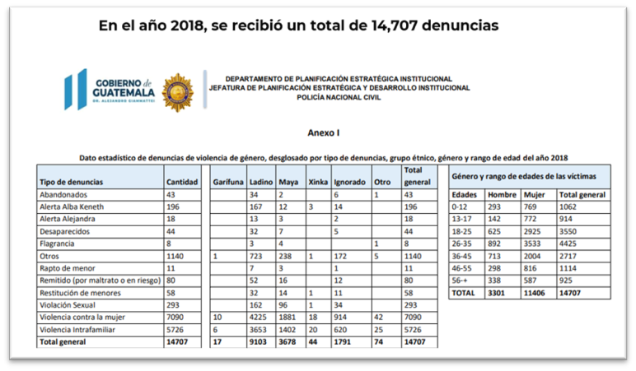
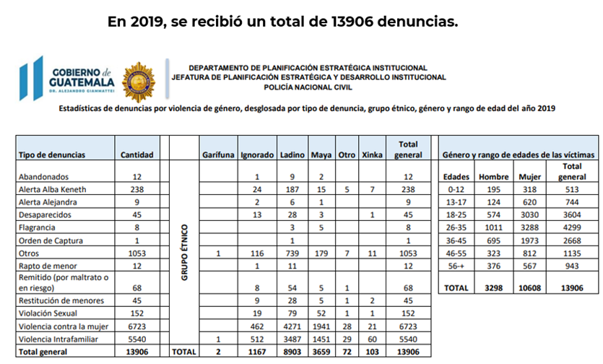
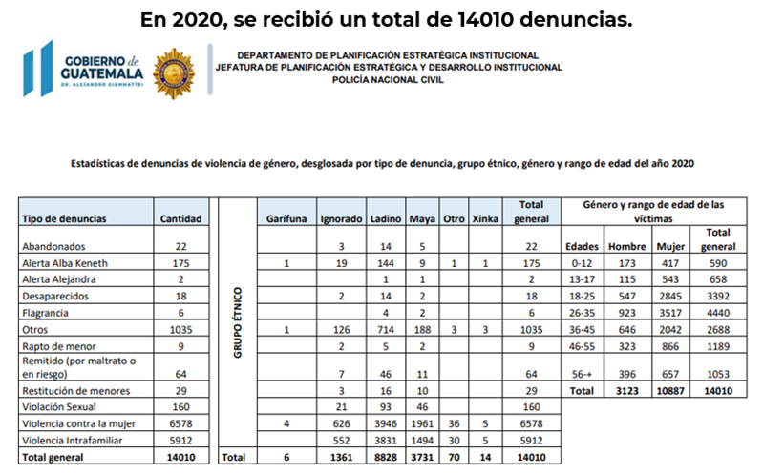
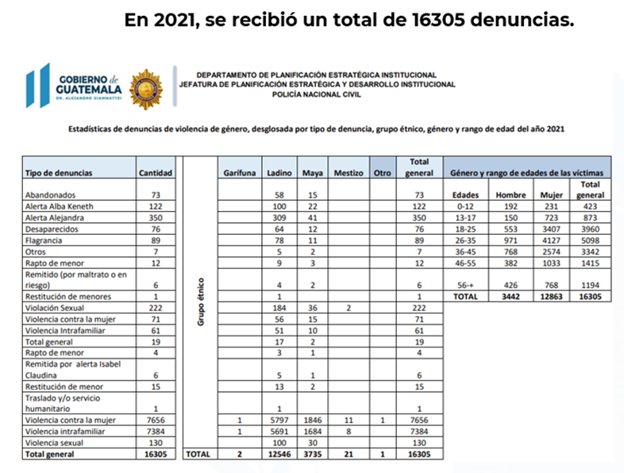
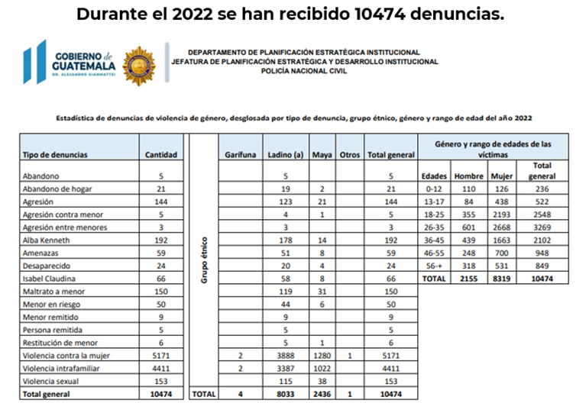
50. Between 2018 and 2022, the Victim Support Department of the National Civil Police recorded the following statistical data, disaggregated by ethnicity: a total of 47,413 complaints were received from persons of Ladino ethnicity; 17,239 from persons of Maya ethnicity; 161 from persons of Xinka ethnicity; and 4,537 from persons of unspecified ethnicity.
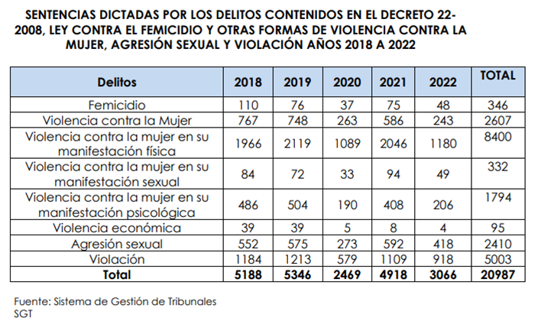
51. With respect to the various mandatory training programmes, the Subdirectorate General for Study and Doctrine of the National Civil Police runs a basic training course for police officers. It aims to develop and strengthen the skills of officers as public servants and professionals to enable them to provide quality service in line with current legislation and human rights standards. The legal component of the course includes content on the human rights of women.
52. The Institutional and Social Challenges to Policing training plan, which is provided by the Department for Continuing Education of the School of Higher Studies of the Subdirectorate General for Study and Doctrine of the National Civil Police, is targeted at all police personnel and includes training on human rights protection with a focus on women.
53. In the same context, the School of Judicial Studies of the Supreme Court provides education and instruction through the various initial, specialized and continuing training programmes organized for all personnel of the judicial system and future judges of Guatemala. The regular curriculum has always included courses, programmes and academic activities related to human rights issues, which, owing to their cross-cutting nature, are covered in specific courses relating to the issue of torture.

Reply to the issues raised in paragraph 5 of the list of issues
54. Guatemala is a pioneer in Latin America in setting up courts specializing in matters relating to trafficking in persons. A criminal court of first instance and a sentencing court have been operating in the department of Quetzaltenango since 2018, with jurisdiction over eight of the country’s departments (western region). In 2019, two similar courts began operating in the department of Guatemala, with jurisdiction over five the country’s departments. Another court in the department of Zacapa will hear cases from four departments.
55. Mindful of the fact that Guatemala is a country of origin, transit and destination, in October 2022, the Supreme Court, in plenary session, approved the proposal of the Criminal Chamber for the creation of new courts of first instance with specialized jurisdiction over human trafficking crimes in border locations, including Huehuetenango, San Marcos, Petén and Izabal. The corresponding studies will be carried out with the support of the United States Agency for International Development.
56. Following the adoption of the specialized Act against Sexual Violence, Exploitation and Trafficking in Persons (Congressional Decree No. 9-2009), new criminal offences have been established, such as the crime of trafficking in persons, which is a complex criminal offence comprising 16 different categories.
57. Regarding the reparation measures granted to victims of trafficking and the benefits of the protection and support measures they are offered, the judiciary reports that, in 2020, through the Women’s Commission, it launched a policy of adequate and transformative reparation as an institutional mechanism for promoting access to justice for persons who have been victims of crimes, applying international and national human rights standards, in accordance with its core components:
- Training for judicial officers;
- Comprehensive care grounded in a victim-centred, human rights-based approach;
- Declaration and implementation of measures.
58. Since the implementation and dissemination of this policy, in 2021, all of the judgments handed down by courts specializing in matters relating to trafficking in persons have included adequate, comprehensive and transformative reparation measures; in the criminal courts, such measures have been included in 603 of the convictions handed down nationwide.
59. The judiciary continues to work on the implementation plan of this policy, which includes a catalogue of measures of adequate reparation for each conviction, and national and international standards on adequate and transformative reparation have been included in the dissemination process. The Centre for Judicial Information, Development and Statistics has adapted the Court Registry System so as to be able to collect data on adequate reparation from the judgments issued by the courts.
60. It is important to note that all judgments issued by the specialized courts for femicide and other forms of violence against women are based on international gender standards. The judgments issued examined the State’s obligation to make reparations based not only on the provisions of domestic law, but also on international human rights law. The measures provided have included the following:
- Providing women or indirect victims (girls and adolescents) with access to study grants or programmes enabling them to develop and/or improve their productive capacities so as to empower them;
- Ensuring that collateral victims of offences of femicide are included, until they reach the age of majority, in medical or food assistance programmes;
- Instructing that private acts of condolence should be held for the victims and their families;
- Conducting awareness-raising campaigns on violence against children and adolescents;
- Delivering municipal-level campaigns to raise awareness of sexual violence, in coordination with the Secretariat against Sexual Violence, Exploitation and Trafficking in Persons;
- Putting up posters in the victims’ places of residence and surrounding areas to inform people about measures to prevent violence against girls;
- Publishing judgments in the language of the victim;
- Broadcasting judgments on community radio stations;
- Establishing rehabilitation measures for women, girls or indirect victims;
- Establishing measures to ensure the non-recurrence of violence through psychotherapy for the accused, with the aim of helping to transform discriminatory sociocultural patterns that justify violence;
- Providing compensation for woman or girl victims, or collateral victims, based on the concept of moral, immaterial damage or material damage.

Reply to the issues raised in paragraph 6 of the list of issues
61. With respect to asylum and the protection of refugees, in 2020, the Department for the Recognition of Refugee Status of the Guatemalan Institute for Migration received a support grant from the Office of the United Nations High Commissioner for Refugees to enable it to adapt its facilities and acquire the furniture and equipment it needed to provide adequate care for asylum-seekers and refugees.
62. The Ministry of Health and Social Welfare reports that the “Responding to Demand” module of the 2018 Integrated Primary and Secondary Health-Care Standards currently includes guidelines for attending to the migrant population and general guidelines for attending to persons moving through the country in migrant caravans in 2021. As a result, health service staff apply the relevant regulations to all persons in the country, including migrants, refugees and asylum-seekers.
63. In 2019, the Counsel General’s Office approved a guide for assessing the best interests of migrant children and adolescents. It established a psychosocial approach to assessment, which is carried out jointly by the Counsel General’s Office and the Social Welfare Secretariat to determine which actions best serve the welfare and protection of children and adolescents, ensuring that any decision taken will safeguard the exercise and enjoyment of their rights.
64. Furthermore, in view of the need to establish specific action pathways, in January 2019, the Counsel General’s Office approved a protocol for assisting unaccompanied foreign children and adolescents present in Guatemalan territory as a result of the displacement of persons. The aim of the protocol, which was updated in the Office’s Decision No. 30-2021, is to establish technical procedures applicable within the field of competence of the Counsel General’s Office for providing assistance and protection and dealing with displaced groups of persons, especially unaccompanied foreign children and adolescents, in Guatemalan territory.
65. Accordingly, the Counsel General’s Office, acting through the Office of the Counsel for Children and Adolescents and the Migrant Children and Adolescents and International Abduction Unit, is responsible for the reception, care, support and provisional legal representation of unaccompanied national and foreign migrant children and adolescents, as well as other functions derived from this mandate.
66. It should be noted that the procedures stipulated in the protocol of the Counsel General’s Office for assisting unaccompanied foreign children and adolescents present in Guatemalan territory as a result of the displacement of persons includes the process of supporting foreign children and adolescents applying for refugee status.
67. Assessments are carried out in these cases and, in accordance with the procedures of the Guatemalan Institute for Migration, the multidisciplinary team will inform, support and assist unaccompanied child or adolescent migrants in their initial application for refugee status in accordance with the mandate of the Counsel General’s Office, explaining in detail the actions and decisions of the process and taking their opinion into account.
68. Likewise, in coordination with the consulate of the country of origin of the unaccompanied child or adolescent, efforts are made to locate and obtain information on suitable family resources in his or her country of origin or transit. In the event that the individual in question is not a Spanish speaker, the support of an interpreter from the consular section is sought in order to ensure that he or she is informed of all the actions being taken. If the National Migration Authority reaches a favourable decision, the Counsel General’s Office will be his or her legal representative and will be responsible for guaranteeing protection; if not, an appeal may be filed or the child’s or adolescent’s eligibility for other extraordinary protection measures is checked (art. 81 of the Migration Code).
69. Concerning the number of children and adolescents that have received assistance, in 2021, 10 children and adolescents applied for refugee status, and 9 applications were processed in 2022. Most of these children and adolescents are from the Northern Triangle countries of Central America and Mexico.
70. The protocol also covers the process of supporting foreign children and adolescents in the repatriation process, which takes place only when the child has requested it of his or her own free will and it has been guaranteed that his or her integrity and life will not be at risk in the destination country. In 2021 and up until 15 September 2022, 400 children and adolescents (245 males and 155 females) were given repatriation assistance.
71. The protocol also contains a procedure for supporting unaccompanied foreign children and adolescents in emergency conditions or mass flows of people moving through Guatemalan territory. It is based on actions set out in the road maps of the procedures described above. Records kept by the Office of the Counsel for Children and Adolescents since 2018 indicate that 539 children and adolescents were assisted by this process between 2018 and 15 September 2022. The details are given in the following table:
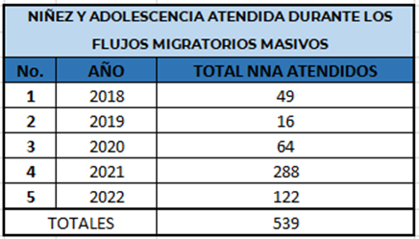
72. The Counsel General’s Office reports that article 17 of Decision No. 2-2019, regulating the procedure for the protection, determination and recognition of refugee status in Guatemala, sets out the procedure to be performed when an application for refugee status is received. It includes providing guidance to the person concerned and ensuring that an interview is conducted within 15 days after the application for refugee status has been submitted in order to examine in detail the reasons for the application. It is at this stage of the process that the particular needs of persons applying for refugee status are identified. If victims of trafficking, torture or similar traumas are identified, inter-agency coordination is carried out in order to provide prompt and specialized care to the persons concerned. The provisions of articles 12, 48, 49 and 83 of the Migration Code (Congressional Decree No. 44-2016) are also taken into consideration.
73. Article 180 of the Migration Code (Congressional Decree No. 44-2016) guarantees the right of asylum-seekers to have access to legal assistance and interpretation services. Likewise, paragraph 2.3 of article 17 of Decision No. 2-2019 of the National Migration Authority, regulating the procedure for the protection, determination and recognition of refugee status in Guatemala, stipulates that, if the asylum-seeker does not speak Spanish, the assistance of a translator or interpreter will be provided.
74. The principle of safeguarding the best interests of the child is observed when receiving and following up on applications for refugee status from accompanied and unaccompanied children or adolescents; applications from unaccompanied children or adolescents are given priority. Care is also taken to safeguard the principle of family unity, which is set out in articles 11, 19 and 169 to 176 of the Migration Code (Congressional Decree No. 44-2016).
75. To date, between 2020 and October 2022, the number of applications for refugee status in Guatemala recognized by the National Migration Authority is 258.

Reply to the issues raised in paragraph 7 of the list of issues
76. The Department for the Recognition of Refugee Status of the Guatemalan Institute for Migration reports that 2,269 asylum applications have been received, 258 of which have resulted in the granting of refugee status in Guatemala. A series of training sessions on refugee status have also been held, especially for staff working at immigration checkpoints and National Civil Police personnel, with the aim of ensuring that the rights of asylum-seekers and recognized refugees, including the right to non-refoulement, are respected.

Reply to the issues raised in paragraph 8 of the list of issues
77. The Department of Migrant Support Centres of the Guatemalan Institute for Migration has put in place logistical arrangements to ensure the fulfilment of court orders to repatriate unaccompanied foreign children and adolescents, voluntary returns at the request of consulates accredited in Guatemala, assisted voluntary returns coordinated by the International Organization for Migration, repatriations on compassionate grounds and the assistance and return of trafficking victims and vulnerable persons.
78. Between 2018 and 2022, a total of 48 people were extradited.

Reply to the issues raised in paragraph 9 of the list of issues
79. Congress reports that, under the Act Regulating the Extradition Procedure (Decree No. 28-2008) and the amendments thereto, the extradition procedure is governed by the treaties or conventions to which Guatemala is a party; in matters not provided for therein, it is governed by the Act. The aforementioned Decree sets out the parties involved in the extradition procedure, namely the Public Prosecution Service, as the investigating agency; the judiciary, as the body responsible for the administration of justice; and the person whose extradition has been requested and his or her defence counsel, in passive extradition procedures. This is in compliance with article 5 of the Convention.
80. The Directorate General for Legal Affairs, International Treaties and Translations of the Ministry of Foreign Affairs reports that it has 12 bilateral extradition treaties and 4 mutual legal assistance treaties, details of which are contained in the attached document.

Reply to the issues raised in paragraph 10 of the list of issues
81. With respect to training programmes, General Order No. 11-2019 of the National Civil Police contains guidelines on the use of force in the course of police activities, as well as the “Institutional and Social Challenges to Policing” training plan; the legal content includes training on human rights protection with a focus on persons deprived of their liberty. This training is targeted at all police personnel and is delivered by the Department for Continuing Education of the School of Higher Studies of the Subdirectorate General for Study and Doctrine of the National Civil Police.
82. The basic training course for police officers covers the Universal Declaration of Human Rights and relevant treaties and conventions.
83. Similarly, the legal content of the “Institutional and Social Challenges to Policing” (“Hora Academia”) training plan included material on human rights protection with a focus on persons deprived of their liberty.
84. In a joint initiative in 2022, the National Office for the Prevention of Torture and the School of Prison Studies of the Directorate General of the Prison System held a workshop on the law and regulations governing the National Office for the Prevention of Torture, which was attended by 57 participants.
85. Likewise, in 2020, the National Office for the Prevention of Torture and the School of Prison Studies of the Directorate General of the Prison System conducted training on the security and custody of persons deprived of their liberty with special treatment, which was attended by 70 participants.
86. The Department of Psychology of the School of Prison Studies of the Directorate General of the Prison System conducted training on human rights in prison management, which was attended by 98 people.
87. Similarly, the judiciary has established the School of Judicial Studies to provide education and instruction through the various initial, specialized and continuing training programmes organized for all personnel of the judicial system and future judges of Guatemala. The regular curriculum has always included courses, programmes and academic activities related to human rights issues, which, owing to their cross-cutting nature, are covered in specific courses relating to the issue of torture.
88. In this context, the judiciary has trained 14,122 personnel of the judicial system on issues relating to the prevention of torture, including the following:
- Conference: Reasonable time as a guarantee for the prevention of torture and cruel, inhuman or degrading treatment.
- Course: International standards for the prevention of torture and cruel, inhuman or degrading treatment.
- Seminar: The role of the judiciary in preventing torture and ensuring respect for human rights.
- Videoconference: Decree No. 40-2010 (Act on the National Mechanism for the Prevention of Torture and Other Cruel, Inhuman or Degrading Treatment or Punishment).
- Seminar: The role of the judiciary in preventing torture and ensuring respect for human rights.
- Seminar: The role of the judiciary in preventing torture and ensuring respect for human rights.
- Course: Victims’ rights and care for victims of crime with a human rights approach.
- Conference: Jurisdictional application of international conventions on constitutional and human rights matters.
- Course: Application of international standards on the human rights of women, child and adolescent victims in judgments.
- Inter-agency course: International human rights standards on the right to work and contemporary forms of slavery.
- Course: Analysis and study of judgments of the Inter-American Court of Human Rights.
- Course: Introduction to the tool for incorporating the gender perspective and the human rights approach into judgments concerning femicide and other forms of violence against women.
- Seminar: Principles and guarantees in processes for the protection of children and adolescents whose human rights have been threatened or violated.
- Seminar: The role of the judiciary in preventing torture and ensuring respect for human rights.
- Course: Human rights in the administration of justice, application of the concept of adequate and comprehensive reparation based on human rights.
- Course: Yogyakarta Principles on the human rights of the lesbian, gay, bisexual, transgender and intersex communities.
89. The School of Judicial Studies has included the following training programmes for judges, prosecutors, forensic doctors and medical personnel in its pretrial detention curriculum:
- Workshop: Judicial oversight of coercive measures and procedural analysis of pretrial detention.
- International seminar: Experiences in case management and oversight of alternatives to pretrial detention. Oversight of detention and pretrial detention by criminal court judges to ensure compliance with international conventions. International seminar: Experiences in case management and oversight of alternatives to pretrial detention.
90. Academic activities relating to the rights of detainees include the following:
- Conference: Constitutional rights of detainees;
- Course: Updating the Central Registry of Detainees module. Also, the following academic activities covered the subject of mothers and persons deprived of their liberty: Discussion: Human rights of children accompanying mothers deprived of their liberty. Course: Jurisdictional analysis of persons deprived of their liberty. Forum: Human rights of children accompanying mothers deprived of their liberty.
91. The Ministry of Defence reports that the curriculum of the vocational education/secondary education centres, training centres and professional development centres of the armed forces includes courses on the use of force and firearms. In 2022, 35 online and face-to-face conferences and workshops were held, providing training to 4,049 participants on topics such as the use of force, the use of firearms, human rights, international humanitarian law, prevention of torture and women’s rights.

Reply to the issues raised in paragraph 11 of the list of issues
92. The training programmes included in the curriculum of the School of Judicial Studies cover the following subjects relating to pretrial detention: Workshop: Judicial oversight of coercive measures and procedural analysis of pretrial detention. International seminar: Experiences in case management and oversight of alternatives to pretrial detention. Oversight of detention and pretrial detention by criminal court judges to ensure compliance with international conventions. International seminar: Experiences in case management and oversight of alternatives to pretrial detention.
93. Academic activities relating to the rights of detainees include the following: a. Conference: Constitutional rights of detainees; and b. Course: Updating the Central Registry of Detainees module. Also, the following academic activities covered the subject of mothers and persons deprived of their liberty: Discussion: Human rights of children accompanying mothers deprived of their liberty. Course: Jurisdictional analysis of persons deprived of their liberty. Forum: Human rights of children accompanying mothers deprived of their liberty.
94. With respect to training processes, the National Institute of Forensic Sciences has shared the records kept at the School of Forensic Studies on the training provided to the forensic medicine staff of the Institute.
No. | Activity name | Aimed at | Number of participants | Date | Organizer
1 | Virtual conference: Istanbul and Minnesota Protocols and the corresponding current legislation | Doctors of forensic thanatology (metropolitan) and forensic clinical medicine and thanatology (regional) | 270 | 3 and 10 August 2020 | School of Forensic Studies of the National Institute of Forensic Sciences
2 | Congress: Good practices in the justice sector for the eradication of torture | Doctors of forensic thanatology (metropolitan) | 3 | 13 and 14 October 2021 | National Office for the Prevention of Torture
3 | Training: Updates of the Minnesota and Istanbul Protocols | Doctors of forensic thanatology (metropolitan) and forensic clinical medicine and thanatology (regional) | 198 | 12 November 2021 | School of Forensic Studies of the National Institute of Forensic Sciences
4 | Training: Updates of the Minnesota and Istanbul Protocols | Doctors of forensic thanatology (metropolitan) and forensic clinical medicine and thanatology (regional) | 34 | 22 June to 7 July 2022 | School of Forensic Studies of the National Institute of Forensic Sciences
5 | International specialized diploma in forensic medicine and thanatology with certification for doctors of the National Institute of Forensic Sciences | Doctors of forensic thanatology (metropolitan) and forensic clinical medicine and thanatology (regional) | 71 | 18 March to  8 October 2022 | School of Forensic Studies of the National Institute of Forensic Sciences, Mexican College of Forensic Sciences and Mexican Federation of Criminology and Criminalistics
6 | Webinar: Application of the Minnesota Protocol in forensic institutions and its importance in the protection of human rights | Doctors of forensic thanatology (metropolitan) and forensic clinical medicine and thanatology (regional) | 121 | 29 September 2022 | Ibero-American network of forensic medicine and forensic sciences institutions, International Criminal Investigative Training Assistance Program, Institute of Forensic Medicine and Forensic Sciences of Panama and International Committee of the Red Cross
7 | Training: Objectivity in forensic medical evaluations of terminally ill persons deprived of their liberty | Doctors of forensic thanatology (metropolitan),  forensic clinical medicine (metropolitan) and forensic clinical medicine and thanatology (regional) | 203 | 9 and 10 October 2022 | School of Forensic Studies
8 | Conference: Forensic medical investigation with a focus on violent deaths | Forensic medicine experts from the National Institute of Forensic Sciences, judges and defence lawyers from the Public Criminal Defence Institute | 241 | 4 and 16 December 2022 | School of Forensic Studies  Catholic University of Argentina
95. It should be noted that the School of Forensic Studies has other activities addressing this topic scheduled for this year for the expert forensic medicine staff of the institution.

Reply to the issues raised in paragraph 12 of the list of issues
96. Regarding interrogation rules, instructions, methods and practices, under article 9 of the Constitution, only the judicial authorities are competent to interrogate detainees or prisoners. Thus, the National Civil Police does not have legal competence to conduct such interrogations.
97. In terms of custody, the role of the National Civil Police is limited to carrying out arrests pursuant to warrants issued by the competent judicial authorities and in cases of flagrante delicto, transporting detainees and placing them at the disposal of the competent judicial authority. Article 88 of the Code of Criminal Procedure empowers the National Civil Police to question accused persons only to ascertain their identity.
98. The Ministry of the Interior, through the Directorate General of the Prison System and the Unit for the New Prison Management Model, carried out the following actions in 2021 to strengthen human resources by recruiting a multidisciplinary team to provide services for persons deprived of their liberty at the Fraijanes I women’s prison.
99. In order to build capacity, training courses were conducted with the support of the Bureau of International Narcotics and Law Enforcement Affairs programme implemented by the Embassy of the United States of America in Guatemala.
100. In the area of security, officers and canine units were trained to provide services for the Directorate General of the Prison System and the Unit for the New Prison Management Model, and inter-agency arrangements were made with the Directorate General of the Prison System for the conduct of searches by the company Grupo ELITE.
101. A diploma course for correctional treatment officers was held, from which 87 officers graduated. They now provide services to the prison population under the new prison management model. The prison system’s School of Prison Studies certified 49 officers in the specialized programme on searches.
102. Achievements in the area of prisoner education include a cooperation initiative between the Directorate General of the Prison System and the Directorate General of Non-Formal Education of the Ministry of Education, which authorized the operation of the Centre for Non-Formal Education, under the Unit for the New Prison Management Model, for the implementation of the Adult Education by Correspondence Programme, the Flexible Formats for Secondary Education Programme, the Diversified Education Cycle and the Secondary-School Diploma programme.
103. Courses in the arts – drawing, watercolour, yoga, theatre, dance, art and culture – and psychosocial workshops have been introduced as part of the rehabilitation process in the Fraijanes I women’s prison, with support from the Community Prevention of Violence Unit of the Ministry of the Interior.
104. In addition, arrangements were made for the evaluation and registration of women prisoners for admission to the Faculty of Humanities at the University of San Carlos de Guatemala. Technical training was initiated with the support of the Technical Training Institute, with courses in basic and intermediate computer skills, basic and intermediate English, dressmaking and personal development.
105. The Pirámide programme (a new flexible format for basic-level formal distance education) and a comprehensive nutritional health programme for women prisoners have been implemented at the Fraijanes I women’s prison.
106. The Unit for the New Prison Management Model started the 2021 academic cycle in the Fraijanes I women’s prison with the following levels: initial stage (literacy), 1; post-literacy stage (primary levels 2, 3 and 4), 2; post-literacy stage (primary levels 5 and 6), basic, secondary-school diploma.
107. The Unit also carried out three profiling processes at the Santa Teresa women’s remand centre and the women’s orientation centre for the transfer of women prisoners to the Fraijanes I women’s prison.
108. The Unit provided individualized treatment to 21 inmates who were released from prison in 2021, thereby contributing to their rehabilitation and social readjustment.
109. In 2021, the prison management model implemented at the Fraijanes I women’s prison was applied in respect of 109 women prisoners.
110. With the aim of promoting employment, the Unit for the New Prison Management Model implemented the first entrepreneurship project carried out by women prisoners. Under this project, which was endorsed by the Technical Training Institute, the participants presented the first entrepreneurial product, called “La Fraijanita hamburgers”. The project enabled them to demonstrate managerial, entrepreneurial, cost management and budgeting skills.
111. As part of their learning under the vocational and technical training programmes of the Technical Institute for Training and Productivity, the inmates made the pants for the uniform used at the Fraijanes I women’s prison.
112. An initiative was launched with the authorities of the bank Banco del Crédito Hipotecario Nacional to open bank accounts for prisoners who start working for private companies.
113. In coordination with the Ministry of Health and Social Welfare, COVID-19 vaccination days were held for inmates and correctional treatment officers, including trainees.
114. A proposal for a complaint box programme was drawn up to ensure the right of expression and petition of the population deprived of liberty by means of a speedy, confidential system for lodging verbal or written complaints.
115. For 2022, the Unit for the New Prison Management Model trained the staff of the multidisciplinary team, the Executive Director, the Acting Operational Director and the Assistant to the Executive Director on prison industries and prison administration, thereby strengthening staff capacities to implement the new prison management model. The training was conducted in Canon City, Colorado, United States, with the support of the Bureau of International Narcotics and Law Enforcement Affairs programme in Guatemala, in June and August 2022.
116. The Unit for the New Prison Management Model drew up a protocol for requests, suggestions, complaints and claims by persons deprived of their liberty and administrative personnel of the Unit for the New Prison Management Model of the Ministry of the Interior.
117. In addition, the protocol for rapid response to disturbances in prisons was finalized. It contains suitable guidelines, adapted to the methodology of the new prison management model, for addressing possible vulnerabilities, threats, risks and existing capacities that jeopardize order in prisons.
118. Courses on the arts and culture – drawing, yoga, watercolour, fashion workshop, dance and theatre – were given to inmates of the Fraijanes I women’s prison. In addition, an international workshop leader was invited to give Colombian dance and rhythm workshops, benefiting 23 inmates.

Reply to the issues raised in paragraphs 13 and 15 of the list of issues
119. Regarding legislation and policies relating to pretrial detention and the measures taken to avoid the excessive use of such detention, Guatemalan legislation, through Congressional Decree No. 51-92 setting out the Code of Criminal Procedure, provides for pretrial detention in article 259, which states: “Pretrial detention may be ordered after the accused has been heard ...”. The courts have discretion to impose this measure. The rights to a defence, the presumption of innocence, a public hearing and due process, which are enshrined in articles 12 and 14 of the Constitution, are respected.
120. Personal liberty may not be restricted except when absolutely necessary and in accordance with article 7 of the Pact of San José, which provides that a person’s “release may be subject to guarantees to assure his appearance for trial”. Accordingly, the Public Criminal Defence Institute performs an analysis of each case and ensures that the defence counsel assigned to the case requests hearings for the review of coercive measures in order to ensure personal liberty during the criminal trial, bolstering his or her arguments with social and psychological studies, information analysis and expert opinions and taking a gender-sensitive approach.
121. With regard to the measures taken by the State to improve conditions of detention and promote compliance with the provisions of the Constitution, measures concerning the need to inform persons of the reason for their arrest, hear detainees and decide on the legal situation of persons brought before the courts, mainly in cases of flagrante delicto or by order of a competent authority, are described in the reply to the issues raised in paragraph 3 of the list of issues.
122. Moreover, 19 magistrate posts have been established for the conduct of remote proceedings, thereby reinforcing the criminal justice system. Over a period of four years and nine months, the courts have made use of this legal mechanism that allows persons deprived of liberty to participate in hearings remotely from prisons on 49,281 occasions.
123. In particular, the Social Welfare Secretariat has worked strategically with the juvenile criminal justice system to analyse and promote non-custodial measures and has made vigorous advocacy efforts with the Public Criminal Defence Institute and private attorneys to expedite proceedings and promote the use of non-custodial measures, through the Directorate of Socio-Educational Measures, departmental offices and referrals.
124. In addition, the juvenile detention centres have been reorganized to improve distribution and reduce overcrowding among male adolescents and youths.
125. The old facilities of the Virgen de la Asunción residential institution have been refurbished. They are now the site of a halfway house and, in the near future, will include a specialized reintegration centre.
126. Regarding the measures taken by the State of Guatemala to ensure that persons in pretrial detention are kept separate from convicted persons, the Social Welfare Secretariat indicates that when adolescents in conflict with the criminal law are remanded in custody while their legal situation is being determined, they are transferred to the juvenile pretrial detention centre and are informed from the moment of admission about their rights, duties and obligations.
127. After sentencing they are transferred to a prison, where they are separated by age group and gang membership status. For the fulfilment of their individual plan and educational road map, they are assigned a multidisciplinary team (a psychologist, a teacher and a social worker) for proper monitoring and compliance.
128. Regarding the existence of educational programmes and social and workforce reintegration programmes, the Cooperation and Implementation Agreement between the Social Welfare Secretariat of the State of Guatemala and the United States Bureau of International Narcotics and Law Enforcement Affairs formalized the intention to provide donations in kind for the implementation of the new model of care for adolescents in conflict with the criminal law, who will receive services at the specialized reintegration centre, the halfway house and the annex to the juvenile detention centre for boys. In addition, education services are provided at different levels by teachers and pedagogical staff who offer these educational tools.
129. The Social Welfare Secretariat guarantees access to education at different levels for adolescents held in juvenile detention centres. It has teaching and pedagogical staff to offer these educational tools and has forged strategic partnerships to strengthen education processes by promoting vocational training, including the following:
- Hiring of pedagogical staff and teachers for juvenile detention centres;
- Coordination with the Ministry of Education for the certification of occupational workshops within the juvenile detention centres;
- Implementation of the agreement with the Technical Institute for Training and Productivity to carry out its technical and workforce training processes for adolescent girls, with the aim of equipping young people with marketable skills, at the following centres:
(i) Halfway house. Programmes implemented:
- Office machines.
- Entrepreneurship workshop.
- Juvenile detention centre for girls.
(ii) Programmes implemented (personal care services):
- Haircutting workshop.
- Hair colouring workshop.
- Self-makeup workshop.
(iii) Implementation of a screen-printing workshop at the following centres:
- Juvenile detention centre for boys.
- Juvenile detention centre for boys II.
- Implementation of a drawing and painting workshop at the juvenile detention centres.
130. In 2021, the Faculty of Humanities at the University of San Carlos de Guatemala offered a bachelor’s degree programme in education (pedagogy). However, the conclusion of Academic Cooperation Framework Agreement No. 001-2022 between the Social Welfare Secretariat and the Rural University of Guatemala increased access to a variety of university programmes of study and attracted a number of adolescents interested in continuing their higher education, with the enrolment of 84 adolescents in the following programmes:
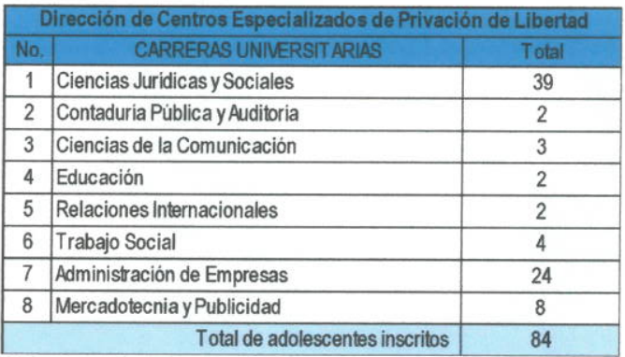
131. The Office of the Undersecretary for the Reintegration and Social Rehabilitation of Adolescents in Conflict with the Law, through the Directorate of Socio-Educational Measures, has secured the support of the Centre for Non-Formal Education, which makes arrangements with the Ministry of Education for the validation of education at the primary level, basic level and up to the diversified level through flexible education formats for adolescents, so that when they complete their sentence they can receive certificates for the levels completed, which are validated by the governing body for education, and can continue their studies without difficulty according to the academic level they have reached.
132. The Directorate General of the Prison System reports that persons deprived of their liberty are classified in accordance with the assessment and placement ordered by the competent judge, at which time the multidisciplinary teams, in view of the person’s legal situation, recommend the most suitable centre for the person to serve the sentence. Currently, the relevant professionals are providing the following five social education programmes in the various detention centres:
- Preparing my family for social reintegration.
- School for Parents.
- School for Mothers.
- Social reintegration.
133. The Education Department of the prison system reports that it is currently implementing formal and non-formal education programmes for the populations of the different prisons under the responsibility of the prison system, which are directly accredited by the Ministry of Education, as well as educational institutions.
134. These education programmes are available to anyone in the prison population who wishes to participate and thus to continue the reintegration and education process in prison. The following programmes are offered:
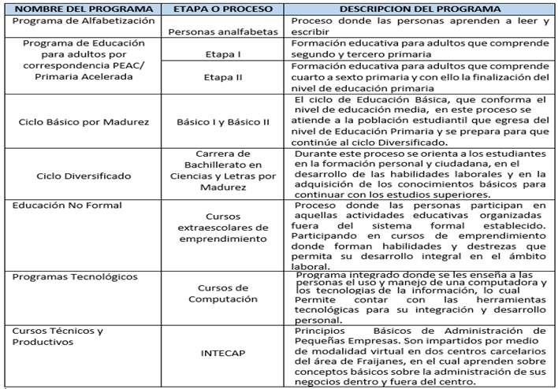
135. The Department of Productive Employment provides workshops aimed at giving the participants tools for carrying out labour-market activities, teaching them new skills and trades, which contribute to the rehabilitation and social reintegration process. The workshops held include the following:
- Workshop on good food-handling practices, to train inmates in the proper methodology for handling food in detention centres;
- Workshop on economic resilience, to provide inmates with tools for coping with economic difficulties, giving them new knowledge and skills that they can use when they regain their freedom;
- Workshop on pattern-making and sewing for beginners, to teach basic skills in making patterns for clothing design;
- Workshop on healthy cooking for children from 0 to 4 years of age, to provide knowledge on proper nutrition for children between the ages of 0 and 4, mainly for women living with their children under 4 years of age;
- Workshop on basic pastry-making, to teach basic pastry-making techniques through the development of skills from the preparation of dough to the plating of each dessert;
- Workshop on wood furniture-making, to contribute effectively to the technical training of inmates by developing skills and abilities that will allow them to improve their environment in terms of infrastructure, inter alia by improving desks, doors and window frames.
136. In addition, with the collaboration of persons deprived of their liberty, training is provided in masonry, bakery, net and hammock making, shoe and garment making and blacksmithing, among other trades.
137. In relation to the inmates’ diet, in order to ensure that decent and nutritionally balanced meals are provided, a gastronomy professional was hired to evaluate, supervise and propose adequate and balanced menus for the food supplier to prepare and serve in juvenile detention centres. Compliance with flavour requirements and proper manufacturing processes is mandatory.
138. A nutritionist is in charge of planning the implementation and evaluation of nutritional interventions for adolescents under the responsibility of the Directorate of Specialized Detention Centres, in order to provide a balanced diet for adolescents’ physical and intellectual development.
139. As part of the improvements in the provision of balanced meals at juvenile detention centres, as from April there have been five mealtimes, as follows:
- Breakfast.
- Morning snack.
- Lunch.
- Afternoon snack.
- Dinner.
140. In addition, periodic microbiological evaluations are carried out by an external laboratory to ensure that the food served in juvenile detention centres meets flavour and manufacturing standards.
141. Regarding water distribution, the authorities of the juvenile detention centres have coordinated measures to improve living and sanitation conditions in the dormitories, as detailed below:
(a) Juvenile pretrial detention centre
- Installation of a new water system to improve access to water, cleanliness and hygiene within the facility.
- Implementation of schedules and cleaning days for the different areas and dormitories used by adolescents and young people in custody, thus improving health and hygienic living conditions.
- Supply of bottled drinking water to adolescents’ and young people’s dormitories for consumption to ensure hydration.
- Installation of a laundry area (washer and dryer) to improve health and hygiene conditions for adolescents and young people in custody.
(b) Gaviotas juvenile detention centre for boys
- Repair of the underground plumbing within the centre’s facilities, improving the distribution of water to the different dormitories and sectors for the benefit of adolescents and young people in custody.
- In coordination with the International Committee of the Red Cross (ICRC), implementation of an event entitled “Improvement of the water system of the Gaviotas juvenile detention centre for boys, under the responsibility of the International Committee of the Red Cross”.
- Installation of Ecofilters (water purifiers) in the areas where adolescents and young people are housed to improve access to drinking water.
- Installation of three water purifiers to improve the supply of drinking water for adolescents and young people.
(c) Gaviotas juvenile detention centre for boys
- Repair of the underground plumbing within the centre’s facilities, improving the distribution of water to the different dormitories and sectors for the benefit of adolescents and young people in custody.
- Repair of the water supply pump, installation of eight 1,100-litre Rotoplast water tanks and repair of water leaks in dormitories and other sectors, to improve the quantity and quality of the water supply in the different areas and dormitories, thus helping to reinforce health and hygiene habits for adolescents and young people in custody.
- Supply of bottled drinking water to adolescents’ and young people’s dormitories for consumption to ensure hydration.
- Installation of a laundry area (washer and dryer) to improve health and hygiene conditions for adolescents and young people in custody.
- Installation of Ecofilters (water purifiers) in the areas where adolescents and young people are housed to improve access to drinking water.
- Installation of three water purifiers to improve the supply of drinking water for adolescents and young people.
(d) Juvenile detention centre for girls
- Supply of bottled drinking water to adolescents’ and young people’s dormitories for consumption to ensure hydration.
- Installation of a laundry area (washer and dryer) to improve adolescents’ health and hygiene conditions.
- Juvenile detention centre for boys II (annex).
- Repair of the underground drainage system within the centre’s facilities, thus improving the flow of rainwater and eliminating foul odours in the adolescents’ and young people’s dormitories.
- Supply of bottled drinking water to adolescents’ and young people’s dormitories for consumption to ensure hydration.
- Installation of a laundry area (washer and dryer) to improve adolescents’ health and hygiene conditions.
142. To ensure that adolescents are housed in decent conditions, with access to light and natural ventilation, during pretrial proceedings and while they are serving their sentences, the juvenile detention centres, through the Infrastructure Department of the Directorate of Planning, have coordinated different renovation projects to improve habitability.
143. The centres have a handbook of policies and procedures approved by Decision No. 121-2018 of 8 June 2018.

Renovation of the specialized reintegration centre
144. In compliance with and follow-up to precautionary measure No. 161-17, “Juvenile detention centers, Guatemala” of 12 June 2017, the authorities sought to devise strategies for reducing overcrowding in juvenile detention centres and accordingly concluded a cooperation agreement (SBS-008-2018) between the United States Bureau of International Narcotics and Law Enforcement Affairs and the Social Welfare Secretariat, with the aim of creating a project for the reintegration of a specialized reintegration centre and halfway house under a care model for adolescents in conflict with the criminal law.
145. In 2018, preparations and coordination began with the Guatemalan Army Corps of Engineers of the Ministry of Defence for the renovation of the specialized reintegration centre facilities, which are located in the former facilities of the Virgen de la Asunción residential institution, located in Finca San Antonio, Aldea El Platanar, San José Pínula.
146. These facilities will have a maximum capacity to house 300 adolescents, who will be distributed in security modules with appropriate spaces conducive to reintegration processes.
147. In accordance with the cooperation agreement between the Bureau and the Social Welfare Secretariat, 87.49 per cent of phase 1 has been completed at the specialized reintegration centre facilities. During the first phase, groups of up to 55 adolescents will be gradually transferred in order to reduce overcrowding at the two juvenile detention centres for boys, thus improving the living and sanitary conditions and allowing for more personalized attention.
148. Similarly, renovation work was carried out at the juvenile detention centre for boys II; planning, renovation and adaptation for transfer from the facilities of the juvenile detention centre for girls to the area known as Técpan at the juvenile pretrial detention centre; the juvenile pretrial detention centre; the Gaviotas juvenile detention centre for boys; the juvenile detention centre for girls; and the juvenile detention centre for boys II (annex).
149. The Subdirectorate General of Operations of the National Civil Police, through the Joint Operations Division, has taken measures to ensure that body search procedures in prisons are not degrading to inmates or visitors. It has trained police personnel responsible for searching inmates and visitors and has directed that searches must be carried out by police officers of the same sex and in specific areas so as to respect the privacy and integrity of inmates and visitors.
150. Regarding the dress code for entry to detention centres, at pretrial detention centres under the responsibility of the National Civil Police, security measures have been adopted on the use of appropriate clothing by women to enable police personnel to conduct thorough searches in order to prevent the entry of illegal items and thus ensure that they cannot endanger the life and integrity of either the prison population or visitors.

Reply to the issues raised in paragraph 14 of the list of issues
151. The Directorate General of the Prison System ensures that medical examinations are conducted as part of the prison intake process. The medical and nursing personnel prepare a clinical record describing the prisoner’s personal data, medical history, physical examination, clinical impression, treatment and follow-up. Likewise, health personnel are instructed that “All persons deprived of their liberty must have a medical record in the medical clinic”.
152. To combat the spread of infectious diseases inside prisons, medical and nursing staff, through daily consultations, detect and diagnose such diseases and provide appropriate treatment. In the event that a prisoner is in need of hospital treatment, the relevant administrative procedures are carried out for his or her transfer to the referral hospital.
153. In this connection, the following amounts were budgeted for medical care in prisons: financial year 2018, allocated amount of Q 10,687,474.00; financial year 2019, allocated amount of Q 9,353,050.00; financial year 2020, allocated amount of Q 9,353,050.00; financial year 2021, allocated amount of Q 9,353,050.00; financial year 2022, allocated amount of Q 9,420,842.00.
154. The Medical Services Department of the Subdirectorate for Social Rehabilitation of the Directorate General of the Prison System has 7 general practitioners, 1 gynaecologist, 1 paediatrician, 3 dentists, 1 psychologist for the sexually transmitted infections/HIV programme, 17 professional nurses and 45 nursing assistants assigned to the different pretrial detention centres and prisons. They are responsible for providing timely, high-quality medical care to the inmate population, including gynaecological and obstetric care; in addition, women’s health care events are held through the Ministry of Health and Social Welfare.
155. The Ministry operates a mobile clinic that visits all prisons and stays for one week at a time, performing GeneXpert screening tests to rule out tuberculosis and conducting hepatitis, HIV and syphilis tests, and swab tests to rule out COVID-19.
156. In 2019, the prison system carried out the first renovation of isolation areas for inmates with tuberculosis at the Canadá Model Rehabilitation Farm in Escuintla, which separates the affected persons from the rest of the inmate population for the sole purpose of preventing the direct spread of the disease.
157. In 2022, four more isolation areas were created under an inter-agency cooperation agreement between the Ministry of Health and Social Welfare and the Ministry of the Interior, through the Directorate General of the Prison System, for the renovation, expansion, construction and equipment of clinics for the care of inmates with tuberculosis at the following detention centres: (I) Cantel Quetzaltenango Model Rehabilitation Farm, (II) Zone 18 Pretrial Detention Centre for Men, (III) Pavón Model Rehabilitation Farm and (IV) Puerto Barrios Departmental Rehabilitation Centre.
158. The measures taken to ensure the timely transfer of persons deprived of their liberty to hospitals include the provision of medical services 24 hours a day, 365 days a year, and the implementation of the relevant administrative procedures to obtain authorization from the competent judge for such persons to be treated in the outpatient clinics of referral hospitals. Emergency hospital treatment is provided as necessary under the inter-agency agreement on measures for the medical evaluation of persons deprived of liberty in prisons and public or private hospitals.

Reply to the issues raised in paragraph 16 of the list of issues
159. The authority on duty at the time of the incident must immediately take the appropriate administrative, operational and legal steps to report it. The aim of this requirement is to prevent such situations and to provide effective information to the Public Prosecution Service, which is responsible for determining the facts of the case and holding those responsible criminally accountable.
160. The Directorate General of the Prison System reports that the review of and follow-up to programmes and workshops on suicide prevention are ongoing and related strategies have been strengthened with the observance of a “Mental Health Week” in detention centres.
161. The prison system has made the 1533 reporting hotline available to the public so that family members of persons deprived of liberty may report illegal extortion through collection of the fee known as talacha by other prisoners. The Prison Information Analysis Unit has made recommendations on several occasions for safeguarding the life and physical integrity of prisoners in such situations.

Reply to the issues raised in paragraph 17 of the list of issues
162. Regarding conditions in shelters for migrants, the State of Guatemala reports that, through the Social Welfare Secretariat, unaccompanied migrant children and adolescents who have been returned to Guatemala receive care for 72 hours, during which time the Counsel General’s Office searches for suitable family resources for them. Unaccompanied foreign children and adolescents in transit through the country also receive care. A psychosocial evaluation is carried out in accordance with the best interests of the child and, in consideration of the child’s right to petition, a judge is asked to repatriate the child or grant asylum. During their stay, such children receive psychological care, primary health care, accommodation, food and hygiene and shelter kits and participate in psychosocial workshops and recreational and educational activities. Family communication through telephone calls is also facilitated.
163. The National Council for Persons with Disabilities has not received any information indicating that persons, including families with children and persons with disabilities, have been held in indefinite detention or inappropriate conditions of detention in shelters for migrants. Furthermore, the Council, until this year, has held consultations with the Guatemalan Institute for Migration to ensure that the 2023 Action Plan for Migration Policy addresses the issue of disability.
164. The Institute reports that unaccompanied children and adolescents are not held in the Centre for Foreign Migrants, in accordance with special national and international protection provisions and the best interests of the child, which are overseen by the Counsel General’s Office.

Reply to the issues raised in paragraph 18 of the list of issues
165. The Public Criminal Defence Institute has not been made aware of these issues or received any complaints in relation to them. At least once a month, persons benefiting from the Institute’s support who are interned at the Federico Mora National Mental Health Hospital receive visits to verify their state of health and hear whether they are being subjected to cruel or inhuman treatment; the human rights of persons deprived of their liberty are thus protected. The Public Criminal Defence Institute therefore complies with the Optional Protocol to the Convention against Torture and Other Cruel, Inhuman or Degrading Treatment or Punishment.
166. Regarding the degrading treatment of drug addicts, the Public Criminal Defence Institute reports that, in accordance with established procedure, when a security measure is imposed, a review is requested with the aim of seeking its conversion to supervised release in respect of persons interned in the Federico Mora National Mental Health Hospital, in line with the judgment of the Inter-American Court of Human Rights in the case of Guachalá Chimbo et al. v. Ecuador, which sets out criteria for the informed consent that persons with disabilities must give in any matter regarding their personal life, and other human rights treaties and conventions.
167. Regarding the number of persons deprived of their liberty in psychiatric hospitals, the Federico Mora National Mental Health Hospital, which admits male and female adult patients, currently has 182 patients who have been admitted to its ward for non-incarcerated persons either as a security measure or due to family rejection or lack of a family.
168. The Subdirectorate of Operations of the Directorate General of the Prison System reports that, in 2022, there were 61 patients in the prisoners’ ward of the psychiatric prison unit of the Federico Mora National Mental Health Hospital.
169. Regarding community-based rehabilitation services and other outpatient treatment programmes, the Ministry of Health and Social Welfare has an outpatient clinic that monitors the health of patients discharged to group homes. Students completing professional internships may complete rotations in psychiatry at Mazatenango Regional Hospital, Quiché Regional Hospital, Santa Rosa Cuilapa Regional Hospital, San Marcos Regional Hospital, Zacapa Regional Hospital, Huehuetenango Regional Hospital and San Benito, Petén Regional Hospital. In addition, resources are allocated to non-governmental organizations, foundations, entities and institutions that provide support and/or rehabilitation services to persons with disabilities.
170. With regard to existing protocols that govern the use of restraint measures and solitary confinement in psychiatric and social assistance institutions, the Ministry of Health and Social Welfare currently has a protocol for the use of physical restraint, solitary confinement, chemical restraint and mechanical restraint; only chemical and mechanical restraints are used, since, in 2013 and 2014, standards and protocols were established for the gentle use of restraint and for updating the list of approved pharmaceuticals in line with international standards for the control of patients in such institutions. In addition, patients have been more clearly and specifically classified or separated according to their symptoms, and a ward for older psychiatric patients and patients with extreme physical vulnerability has been opened.
171. In order to ensure the welfare of patients, a hearing is held within six months to review the security measures imposed and to request supervised release, for which suitable family resources that can provide shelter and care to the person are needed. If suitable family resources cannot be found, attempts are made to find a home or accommodation that can provide the person with protection and shelter, with oversight to ensure compliance with the Constitution and treaties reflecting international human rights standards.

Reply to the issues raised in paragraph 19 of the list of issues
172. In response to the questions on the National Office for the Prevention of Torture, it should be noted that the Office carries out periodic visits to all places of deprivation of liberty under Legislative Decree No. 40-2010. Since 2018, it has carried out 1,548 visits to places of deprivation of liberty in order to examine the treatment of persons in each such institution and the conditions in which they are held.
173. The mechanism for the prevention of torture has taken the necessary steps to obtain an increase in its budget for 2023. During the year 2020–2021, the services of the Office were expanded across the entire country following investment in five new regional branches in leased buildings. The branches, which are fully equipped with the resources they need for their operations, must now be maintained to an appropriate standard and more branches must be opened to ensure that the country’s prisons are within immediate reach of the Office.
174. With regard to transparency, the Office has an open-door policy towards any individual or legal entity that might wish to obtain information on its activities or any other non-sensitive information suitable for disclosure. Responses to all requests for information have accordingly been provided through the Access to Public Information Unit within the deadlines established in the relevant Act, and the public information available on the official website of the Office is constantly updated. As part of efforts to guarantee the transparency of its work, a team from the Comptroller General’s Office operates on the premises of the National Office for the Prevention of Torture.
175. Concerning elections and appointments, the rapporteurs of the mechanism for the prevention of torture are elected by Congress in accordance with article 21 of Congressional Decree No. 40-2010, the Act on the National Mechanism for the Prevention of Torture and Other Cruel, Inhuman or Degrading Treatment or Punishment. In 2021, the acting Chair informed the Congressional Human Rights Commission that the terms of the rapporteurs elected for the period 2019–2022 were coming to an end and requested that the appropriate procedure be set in motion to elect rapporteurs for the period 2022–2025.
176. Through Legislative Decisions Nos. 19-2018, 9-2019 and 9-2022, the Guatemalan Congress elected and swore in rapporteurs and alternate rapporteurs for terms ending 25 March 2022, 25 March 2024 and 25 March 2027. The Committee is hereby informed that rapporteurs have free access to places of deprivation of liberty.
177. Regarding the consultative council, through Record No. 29-2021, the National Mechanism for the Prevention of Torture and Other Cruel, Inhuman or Degrading Treatment or Punishment issued a first call for the establishment of the council, in response to which no applications were received. In 2022, Records Nos. 14-2022 and 16-2022, which were unanimously approved, issued a new call for the establishment of the consultative council. That procedure is currently in process.

Reply to the issues raised in paragraph 20 of the list of issues
178. With regard to the request for information on complaints, according to the information provided by the National Civil Police, there are no records of complaints concerning this type of abuse.

Reply to the issues raised in paragraph 21 of the list of issues
179. Through the adoption of Decree No. 16-2018, Congress declared 8 March a national day of remembrance for the victims of the tragedy at the Virgen de la Asunción orphanage and granted life annuities to the 15 survivors. To allow survivors to remain in their home settings, as a guarantee of non-repetition and to ensure that children and adolescents who have been reunited with their immediate or extended families are not institutionalized or revictimized as a result of factors that caused them be placed in a shelter in the first place, the Social Welfare Secretariat of the Office of the President issued Decision No. 247-2018 on 18 September 2018, thereby adopting regulations on the granting of family allowances to child and adolescent victims of the tragedy of 8 March 2017 at the Virgen de la Asunción orphanage of the Social Welfare Secretariat of the Office of the President. The allowances may be granted for a maximum period of four years, during which time the authorities will see to it that the money is used by its designated administrator for the benefit of the child or adolescent in question. Allowances expire when the child or adolescent reaches the age of majority.
180. Regarding the incident that occurred at the Virgen de la Asunción orphanage, the ruling handed down by a children’s court in child protection proceedings on 2 April 2018 set a precedent by ordering that reparations should be awarded to all the surviving girls and their families. As a result, on 6 November 2018, the Social Welfare Secretariat created the Personal Life Annuity Unit to provide support to the 11 surviving victims of the incident. The Unit had a multidisciplinary team that provided outpatient services focused on psychosocial care, health and education to each of the victims until they reached the age of majority. This legal mandate came to an end on 9 October 2021.
181. The court hearing the criminal proceedings against the individuals allegedly responsible for the tragedy (case No. 1069-2017-00123) divided the defendants into three groups based on the seniority of the posts they occupied at the time of the incident. Initial hearings are under way for the first two groups, while the third is awaiting the intermediate hearing.

Reply to the issues raised in paragraph 22 of the list of issues
182. It is important to note that the State, in accordance with the pillars of transitional justice, namely truth, justice, reparation and guarantees of non-repetition, has made every effort to provide full reparation to the victims of acts of torture and other serious human rights violations committed during the internal armed conflict. In 2022, approximately Q 33,387,830.60 was paid out in compensation to the victims and beneficiaries of victims in the following cases: Río Negro Massacres v. Guatemala, Coc Max et al. (Xamán Massacre) v. Guatemala, Members of Chichupac Village and Neighboring Communities of the Municipality of Rabinal v. Guatemala, Valenzuela Ávila v. Guatemala, Ruiz Fuentes et al. v. Guatemala and Rodríguez Revolorio et al. v. Guatemala.
183. The payment of compensation by the Presidential Commission for Peace and Human Rights entailed coordination with the Social Development Fund. Pursuant to Ministerial Decision No. DS-27-2021 of 2 March 2021, issued by the Ministry of Social Development, the continued implementation of the National Reparations Programme was placed under the responsibility of the executing unit of the Social Development Fund.
184. The Presidential Commission for Peace and Human Rights exchanged information with the Social Development Fund to identify the amounts of compensation that had already been paid out under the National Reparations Programme to the victims in cases that had been handled by the latter, in order to deduct those amounts from the total and determine the level of compensation still owed by the State. In other words, the compensation ordered by the Inter-American Court of Human Rights is being paid in full.
185. Furthermore, in order to provide full redress, special medical and dental health days have been scheduled to provide the affected communities with specialized and comprehensive care services.
186. In its coordinating and advisory capacity, the Presidential Commission for Peace and Human Rights has held inter-agency technical round tables in coordination with representatives to the inter-American human rights system. As a result of those activities and the consensuses reached with the representatives and institutions involved in fulfilling the reparation measures ordered by the Inter-American Court of Human Rights, provision has been made not only for the payment of compensation and education but also for education, food and security, while spaces for dialogue have been created to facilitate the exchange of ideas aimed at improving the situation of victims.
187. With regard to measures to ensure effective protection and assistance, the Victim Support Department of the National Civil Police receives complaints from victims and family members and supports process servers in relation to compliance with the security measures granted by the relevant courts. Such measures include the execution of orders concerning the use of household effects, eviction of the aggressor, return of minors, return of the victim to the home, seizure of firearms and periodic follow-up.
188. The following information is provided with respect to the current status of bills: according to information provided by Congress, Bill No. 5377 is pending debate and approval on third reading, article-by-article approval and final drafting.
189. Bill No. 5920 is pending a recommendation by the relevant committees, debates on first and second reading, debate and approval on third reading, article-by-article approval and final drafting.
190. Bill No. 3590 is pending debate and approval on third reading, article-by-article approval and final drafting. Part of the purpose of Bill No. 3590 is to promote comprehensive care measures for victims and their families based on applicable international standards. These functions are already among the obligations of the Institute for the Provision of Assistance and Care to Crime Victims pursuant to Congressional Decree No. 21-2016. The aim of the Institute is to provide assistance and care to crime victims and to ensure they receive the reparations to which they are entitled; in other words, it is the lead agency for policies aimed at supporting victims in Guatemala, including through the provision of psychological, medical and social services.

Reply to the issues raised in paragraph 23 of the list of issues
191. In 2020, the Supreme Court established the Adequate and Transformative Reparation Policy of the judicial system. This policy is an institutional mechanism for promoting access to justice for victims of crimes through the application of international and national human rights standards.
192. The policy comprises the following pillars:
- Training for judicial officials.
- Comprehensive care grounded in a rights-based, victim-centred approach.
- Ordering and execution of reparation and redress measures.
- Inter- and intra-agency coordination.
193. Since 2021, the year in which the policy began to be implemented, all judgments handed down by courts specializing in matters relating to trafficking in persons have included measures for adequate, full and transformative reparation. In 2021, 603 judgments handed down by criminal courts across Guatemala provided for reparation measures.
194. The Judicial Authority continues to work on the policy’s implementation plan and action plan for the period 2020–2024, which includes a catalogue of measures of adequate reparation for each conviction, and national and international standards on adequate and transformative reparation have been included in the dissemination process. This information is provided as an annex to the report.
195. Psychological care is currently being provided by the Victim Assistance Institute in the following cases:
- Ramírez Escobar et al. v. Guatemala.
- Veliz Franco et al. v. Guatemala.
- Coc Max et al. (Xamán Massacre) v. Guatemala.

Reply to the issues raised in paragraph 24 of the list of issues
196. Article 183 of the Code of Criminal Procedure establishes that “To be admissible, any evidence must relate directly or indirectly to the matter under investigation and must help to establish the truth. Courts may restrict the number of pieces of evidence submitted to demonstrate a fact or circumstance if they are manifestly excessive. Inadmissible evidence includes, in particular, evidence obtained by prohibited means such as torture, invasion of the privacy of the home or residence or of private correspondence, communications, papers or files” (emphasis added).
197. Articles 375 to 380 of the Code set out the process to be followed in each case when obtaining and processing evidence, which normally takes place at the oral proceedings stage. The exceptional processing of evidence in advance of oral proceedings is regulated by articles 317 and 348. According to article 186, on the evaluation of evidence, any evidence obtained and legally accepted in the proceedings must be evaluated on the basis of sound, reasoned judgment.
198. The Code clearly states that “inadmissible evidence includes, in particular, evidence obtained by prohibited means”. This provision is complemented by article 283, which provides that fundamental defects in proceedings are those that entail the non-observance of the rights and guarantees provided for in the Constitution and in treaties ratified by the State. Guatemalan legislation, therefore, seeks not only to ensure the legality of evidence-gathering activities but also to uphold the Constitution and the inviolability of the fundamental rights recognized therein.

Reply to the issues raised in paragraph 25 of the list of issues
199. Under Decree No. 52-2010, the Private Security Services Act, one of the functions of the Directorate General of Private Security Services is to regulate services provided by natural or legal persons in the areas of security, protection, transportation of valuables, surveillance, technology and consulting in the areas of private security and private investigation. It is also responsible for the authorization, monitoring, inspection, oversight and verification of such services. The Directorate General therefore takes actions aimed at ensuring that security companies comply with the registration requirements under Decree No. 52-2010.
200. The Directorate General also has an updated protocol for monitoring, inspection, oversight, surveillance and verification, the aim of which is to ensure that the Department for Oversight and Inspection and the Department for Materials and Equipment have an up-to-date instrument when conducting visits of entities providing private security services.
201. A total of 80 private security companies were registered between 2017 and 2022. In the same period, 110 companies received penalties and 1 company was closed owing to non-compliance with Decree No. 52-2010.

Reply to the issues raised in paragraph 26 of the list of issues
202. Through the Directorate for the Security of the Judiciary, the Judicial Authority has implemented a protocol for providing emergency security support to judges and magistrates, among other measures. The Judicial Authority provides judicial security personnel and a vehicle to judges assigned to courts dealing with high-risk crimes, in line with its security framework.
203. On receiving, by any means whatsoever, a request for emergency support for a judge or magistrate, the Directorate for the Security of the Judiciary and/or the Security Adviser to the President of the Judicial Authority take a number of measures, which include providing advice and support, issuing recommendations and, where a security detail is required, assigning a vehicle and security agents from the Judicial Authority and the National Civil Police.
204. Among other measures taken to ensure safety and security, the National Civil Police follows a protocol for the implementation of immediate preventive security measures for trade union members, leaders, officials, directors, activists and other labour rights defenders as well as the physical spaces in which they carry out their activities. The protocol was approved by the Minister of the Interior on 27 October 2016 and covers the receipt of complaints, the performance of risk analyses through the Personal Protection and Security Division of the Subdirectorate General of Operations and the provision of personalized security plans and/or perimeter security, with a view to protecting the individual’s life and minimizing the risks to which he or she is exposed.
205. In addition, the Personalized Security Section and the Public Facilities and Non-Governmental Organizations Security Section of the Personal Protection and Security Division are currently providing personalized security services to seven activists and/or human rights defenders and to six buildings used for related purposes. This service is provided by 60 police officers, who are divided into two groups to avoid interruptions in service provision.
206. Furthermore, the National Civil Police has issued Decision No. 160-2020 on a police protocol for the performance of risk analyses and security studies and the implementation of security measures specific to individuals or facilities. This protocol is a useful preventive tool for protecting the lives and the personal and physical safety of journalists, human rights defenders and members of Indigenous organizations, among others, and of their families. Security measures are implemented by the Personal Protection and Security Division when such people are threatened or their rights are violated.
207. The four-digit telephone number 1543 is available for use in emergencies relating to security measures for journalists, human rights defenders and members of Indigenous organizations, among others.

Reply to the issues raised in paragraph 27 of the list of issues
208. Congress reports that Bill No. 5674 provides for the adoption of a law to prevent and punish crimes of prejudice. The purpose of the bill is to introduce measures to prevent and punish crimes committed against individuals because of their actual or perceived sexual orientation or gender identity. It also provides for amendments to article 27 (18) of the Criminal Code, concerning contempt of an injured party, which would read as follows: “18. Carrying out the act with contempt for the injured party’s advanced age or youth, sex, sexual orientation, gender identity, medical condition, physical disability or economic hardship, among other characteristics, depending on the nature and circumstances of the act.”
209. The Directorate General of the Prison System is in the process of reviewing and updating the document “Minimum standards and guidelines for the adequate care of lesbian, gay, transgender, trans and intersex persons in situations of deprivation of liberty in Guatemala”, which was developed in 2016.
210. The National Civil Police has implemented Plan No. 02-2022, “A human rights approach to LGBTIQ+ issues”, the objective of which is to strengthen the knowledge, capacities and interpersonal skills of police officers and their capacity to treat members of sexual minorities with dignity and respect for their human rights.
211. All training, capacity-building, specialization and professional development courses include police protocols on issues such as discrimination, racism, human rights and the gender perspective.
212. Measures taken by the Subdirectorate General for Crime Prevention of the National Civil Police to combat violence against individuals based on their sexual orientation or gender identity are outlined below:
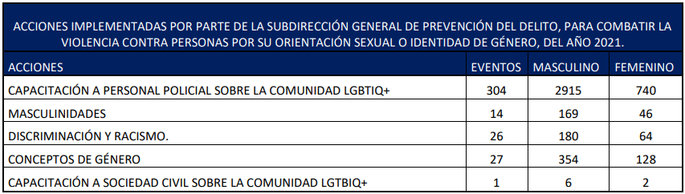

Reply to the issues raised in paragraph 28 of the list of issues
213. On identifying or learning of any situation in which the human rights of a child or adolescent at a reception facility are put at risk or threatened, the Counsel General’s Office, through the Office of the Advocate for Children and Adolescents, takes steps to trigger general protection measures for people accommodated in shelters. Alongside other measures, this has allowed the Social Welfare Secretariat to make substantial changes to the care provided to children and adolescents and has facilitated inter-agency follow-up to the oversight of shelters.
214. Furthermore, the Social Welfare Secretariat of the Office of the First Lady has a protocol and inter-agency road map for identifying, addressing and referring cases of abuse and violence committed against children and cases of undernutrition detected within community day-care centres and childcare and development centres. The protocol provides guidance to the Secretariat’s volunteers and employees – including caregivers, teachers, representatives, departmental supervisors and central office staff – and specifies actions to be taken in response to cases of violence, child abuse and undernutrition observed at such centres.

Reply to the issues raised in paragraph 29 of the list of issues
215. The legislation enacted by Congress is limited by constitutional provisions, which it must not violate. Accordingly, it should be made clear that article 3 of the Constitution indicates that the State guarantees and protects human life “from the time of conception” and that article 4 (1) of the American Convention on Human Rights states that “every person has the right to have his life respected”. On the basis of these principles, human life is protected in Guatemala from the time of conception and no one can be arbitrarily deprived of life. Abortion is therefore currently regulated in accordance with these constitutional parameters, principles and guarantees.
216. Measures have been adopted in this regard, such as Bill No. 5376, which provides for the adoption of a law on comprehensive protection, access to justice and adequate and transformative reparations for girl and adolescent victims of sexual violence, sexual exploitation and trafficking in persons. The purpose of the law is to restore the rights of girls and adolescents who are victims of sexual violence, sexual exploitation and trafficking in persons and who, as a result, face forced pregnancy and forced motherhood, through inter-agency actions that allow them to obtain adequate and transformative reparation, creating and promoting the conditions that ensure they can move forward with their lives. This bill is currently awaiting the report of the Health and Social Assistance Committee.

Reply to the issues raised in paragraph 30 of the list of issues
217. It is important to mention the current situation of the death penalty in Guatemala. In 2000, during the Administration of President Alfonso Portillo, Congress repealed Decree No. 159 (Pardon Act), which gave the executive branch the power to pardon or commute sentences and regulated the procedure for enforcing this right. By repealing the Decree, Guatemala was left without the legal remedies necessary to be able to apply the death penalty, according to article 18 of the Constitution and article 43 of the Criminal Code.
218. Moreover, as the Committee is already aware, the Constitutional Court, by its judgment of 24 October 2017 (case No. 5986-2016), declared that several provisions of the country’s criminal legislation that prescribed the death penalty were unconstitutional. In other words, in compliance with the international commitments made by the State of Guatemala, a number of provisions under which the death penalty could be imposed as a punishment for certain crimes were abolished from the legal system.
219. From this perspective, it may be concluded that the repeal of the Pardon Act amounts to abolishing the use of the death penalty and, therefore, that effective measures aimed at abolishing the death penalty have already been taken in Guatemala.
220. With respect to Bill No. 5001, on 1 March 2019, Congress received an official letter from the Chair of the Technical Support Committee informing it that, on the basis of consensus among the Committee members and of article 45 of the Organic Act of the legislative branch, the bill in question would be withdrawn.
221. Bill No. 5714 was presented to Congress on 27 January 2021 and is pending submission to a committee for the issuance of a recommendation that may be unfavourable, favourable or favourable with amendments. The process of drafting the legislation is therefore still in its initial phase, and it may be adopted as submitted, amended or indeed not adopted by Congress.

Reply to the issues raised in paragraph 31 of the list of issues
222. Concerning Bill No. 5992, on 25 October 2021 Congress heard and approved a privileged motion under which, in accordance with the decisions issued by the Constitutional Court in case No. 4466-2021, the corresponding Legislative Decree was adopted in a single act by an absolute majority of the total number of deputies in the National Congress. Accordingly, the bill was adopted in final form, in a single act, as Congressional Decree No. 13-2021.
223. Regarding the State’s response to terrorist threats or attacks, the Ministry of the Interior has specialized units such as the Police Special Forces Division and its Rapid Response Group, both of which are units of the National Civil Police. These are agile and versatile units trained to carry out a series of specific tasks. They receive more advanced training and equipment than conventional forces and can operate independently or in support of any conventional force. The Rapid Response Group is responsible for intervening in crisis situations such as those involving hostage-taking, the capture and arrest of persons involved in organized crime, aircraft hijackings and counter-terrorism.
224. The main function of the Weapons and Explosives Investigation and Disposal Division of the Subdirectorate General of Criminal Investigation is to restore order in any place where public safety is seriously threatened by the presence of explosive or incendiary devices or chemical or biological agents or similar items that may cause damage to people, their property and the environment.
225. Police personnel of the Police Special Forces Division and its Rapid Response Group are trained in areas including crowd control, urban and rural combat, coastal operations, tactical medicine, rappelling, weapons and shooting, physical conditioning, human rights, policing principles, self-protection measures, report writing and land navigation. Personnel of the Weapons and Explosives Investigation and Disposal Division of the Subdirectorate General of Criminal Investigation of the National Civil Police take the specialized course in weapons and explosives disposal.
226. Concerning the number of persons convicted under counter-terrorism legislation, no record has been found in the judiciary of any convictions for the crime of terrorism or any complaints filed for the crime of terrorism.
227. Congressional Decrees Nos. 71-2001, 57-2005, 58-2005 and 2-2018 establish regulations relating to terrorism, the International Convention for the Suppression of the Financing of Terrorism, the Inter-American Convention against Terrorism and the Act on the Prevention and Suppression of the Financing of Terrorism.

Reply to the issues raised in paragraph 32 of the list of issues
228. With respect to the actions implemented by the State during the pandemic, the Directorate General of the Prison System has guidance on the “Application of the Safety Protocol for COVID-19 in the Prison Environment”, which describes the actions for promotion, prevention, diagnosis, treatment and monitoring in the event that a case of coronavirus disease (COVID-19) is detected in the prison population.
229. In order to coordinate actions to address the pandemic, the inter-agency management of the Directorate General of the Prison System and epidemiologists of the health districts of Guatemala Nor-Oriente, Escuintla and Guatemala Central worked in collaboration with medical services of the Directorate General of the Prison System to carry out preventive actions, diagnosis and monitoring in prisons, and evaluations for the implementation of quarantine areas. In addition, the COVID-19 Care Protocol in the Prison System is reviewed and periodic recommendations are made for improving control measures.
230. During the COVID-19 pandemic, the national preventive mechanism visited the different prisons to check the protocols that were being implemented to prevent contagion and made recommendations to the Directorate General of the Prison System to provide supplies such as alcohol, antibacterial gel, masks and gloves for the use of prison guards and detainees. The health centres near each prison were later approached to carry out vaccination campaigns.
231. The Social Welfare Secretariat implemented the COVID-19 Prevention and Detection Protocol, which was introduced through Decision No. DS-078-2020, and the SARS-CoV-2 Emergency Care Protocol, which was introduced through Decision No. DS-241-2020. Efforts were also coordinated with COVID-19 vaccination brigades from the Mariscal Zavala army brigade, who supported the roll-out of vaccination campaigns aimed at adolescents and staff in juvenile detention and protection centres and departmental headquarters.
232. Likewise, at the request of various institutions, the National Council for Persons with Disabilities has visited homes in the departments of Zacapa and Quetzaltenango and in the capital city in order to assess whether the facilities and accessibility of the relevant premises meet the minimum requirements for persons with intellectual and psychosocial disabilities. After conducting the visits, the Council provides a technical opinion along with its respective recommendations for adapting the spaces to comfortably accommodate persons with disabilities of these types.
233. Similarly, the Social Welfare Secretariat of the Office of the First Lady provides services to persons over 60 years of age through the Directorate of the “My Golden Years” Programme, prioritizing those living in poverty and extreme poverty nationwide. It opened 75 day-care centres for this purpose in 2018, followed by 86 in 2019, 83 in 2020, 77 in 2021 and 79 to date in 2022, and also kept two 24-hour care centres in operation between 2018 and 2022. Psychosocial, educational, occupational therapy, cultural, recreational, physical and health components form the Programme’s seven-pronged approach to providing comprehensive care, in addition to meals, thus helping improve the living conditions of persons benefiting from its assistance and supporting their successful reintegration into society.

Reply to the issues raised in paragraph 33 of the list of issues
234. The judiciary is prioritizing the modernization of its electronic portal in order to prevent technical failures when proceedings are under way, in accordance with Congressional Decree No. 12-2022 amending the Act Regulating Notifications by Electronic Means, whereby parties involved in legal proceedings, and their lawyers, are required to sign up for electronic notifications relating to their cases. The Decree also seeks to prevent crowded courtroom situations by prioritizing the use of electronic services, thus helping to reduce the population’s exposure to infection by COVID-19.
235. In accordance with institutional policies, the judiciary has sought to strengthen the specialized justice system by taking administrative, legal and financial measures to efficiently and effectively meet the demand for prompt and complete justice. In this connection, Decree No. 13-2022, the Digitalization of Legal Proceedings Act, regulates the use of information technology in legal proceedings.
236. The Digitalization of Legal Proceedings Act governs the implementation of information technology in legal proceedings and will allow it to be used in any such proceedings, whether contentious or non-contentious. It builds on legislation currently in force in the country to ensure that digital means can be used to track the filing, conduct, prosecution, disposition and execution of legal proceedings in an agile and effective manner. It establishes a compulsory procedure to expedite court notices by digital means and provides for the presentation of evidence before the judge either physically or virtually.
237. The national preventive mechanism submitted a bill on temporary release from prison to Congress in response to the national emergency triggered by the COVID-19 pandemic.

* The present document is being issued without formal editing.

