 | United Nations | CRC/C/COL/RQ/6-7
 | Convention on the  Rights of the Child |  | Distr.: General  23 October 2025  English  Original: English/Spanish  English, French and Spanish only
Committee on the Rights of the Child
100th session
Geneva, 12–30 January 2026
Consideration of reports of States Parties

Replies of Colombia to the list of issues in relation to its combined sixth and seventh periodic reports*
[Date received: 13 June 2025]

Part I

Replies to the list of issues (CRC/C/COL/RQ/6-7)

Reply to the issues raised in paragraph 2 (a)
1. Act No. 1098/2006 is the backbone of the protection of the rights of children and adolescents in Colombia. It harmonizes constitutional principles and the provisions of the Convention and sets out what is expected of the three branches of government. From 2021 to 2025 the executive and legislative branches of government introduced numerous policies and legal reforms that enhance this harmonization. A list of these policies and reforms can be found in part II of this document.
2. During this period, the country’s high courts have developed jurisprudence on various principles set forth in the Convention, including principles related to the best interests of the child, non-discrimination, the right to life, survival and development, the primacy of the rights of the child and participation. Judges, together with the Attorney General’s Office, provide public officials with guidance on the scope of the legal provisions on the rights and access to justice of children and adolescents and investigate and hold to account those who commit crimes against children and adolescents, while ensuring, in accordance with articles 37 and 40 of the Convention, that due process of law is followed in cases involving adolescent offenders.
3. The Counsel General’s Office fulfils its legal mandate by exercising oversight with a view to ensuring compliance with the rules and policies originating in the three branches of government. From 2021 to 2024, the Counsel General’s Office issued 21 reports and 13 directives whose aim is to monitor the ability of the country’s children and adolescents to exercise their rights.

Reply to the issue raised in paragraph 2 (b)
4. The implementation of the National Policy for Children and Adolescents 2018–2030 has been under way in Colombia since 2018. In 2022, the National Planning Department promoted the inclusion of several of its objectives in “Colombia: World Power of Life”, the National Development Plan 2022–2026, especially in the chapter entitled “The Generation Growing for Life and Peace: Children and Adolescents Who Are Protected, Loved and Have Opportunities”. In 2023, Congress made the comprehensive development of children and adolescents State policy pursuant to Act No. 2328/2023. Under the Policy, there are intersectoral coordination forums and local chapters, as well as the Intersectoral Technical Committee for Children and Adolescents, a committee on which all State institutions that must guarantee the comprehensive protection of children and adolescents are represented. The Comprehensive Care Pathway and the Intersectoral Action Plan for the Administration of the Policy 2024–2035 were developed under the Policy in 2022. Priority has been given to strategic matters along four lines of action: institutional strengthening; quality of comprehensive care; participation, mobilization and civic engagement; and monitoring, evaluation and knowledge management.
5. Since 2021, Colombia has had a budget tracker that makes it possible to identify the amounts invested in children and adolescents. Investment increased from Col$ 1.217 trillion in 2021 to Col$ 1.831 trillion in 2024. Progressive increases in subcategories including health, food and nutrition, education and training, protection from and prevention of violations, and sports, recreation, culture, play, technology and the environment also stand out. In respect of those subcategories, investment in adolescents or matters of interest to adolescents rose from Col$ 1.367 trillion in 2021 to Col$ 1.666 trillion in 2024, to which was added the investment in autonomous sexuality and the transition to young adulthood.
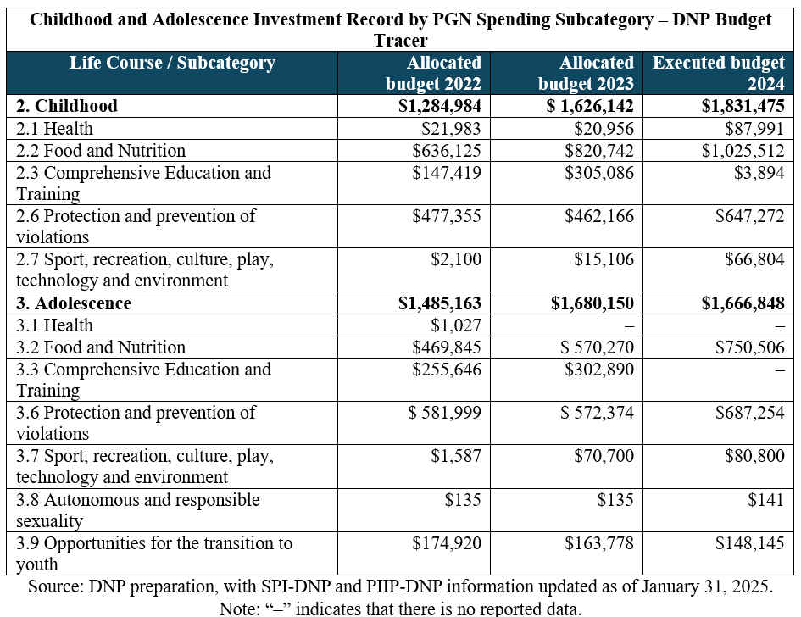
6. In addition, the country is developing a method for closing gaps with access to resources from the General Royalties System. The method prioritizes areas according to variables that include situations that are critical for children. The problem-interrelation index is produced with a view to organizing care for children and adolescents depending on such factors of vulnerability as poverty, exclusion, limited access to services, regional inequality, gender and ethnicity. The method directs the State’s actions towards the most vulnerable population groups and geographical areas, prioritizing investment in the most vulnerable children and adolescents.
7. Between 2022 and 2024, Colombia made progress towards the implementation of the National Policy for the Prevention and Eradication of Commercial Sexual Exploitation of Children and Adolescents (2018–2028) and the National Policy for the Prevention and Eradication of Child Labour and Comprehensive Protection of Adolescent Workers, which are based on the International Labour Organization Worst Forms of Child Labour Convention, 1999 (No. 182), under which the commercial sexual exploitation of children and adolescents is considered one of the worst forms of child labour.
8. Between 2022 and 2024, 28,776 technical assistance sessions and awareness-raising workshops were organized, and strategies such as the following implemented:
- The Pact for a Guajira Free from Child Labour
- The Amazon Basin Pathway to Combat the Commercial Sexual Exploitation of Children and Adolescents
- Technical support for the Inter-Agency Committee for the Eradication of Child Labour and the Protection of the Child Worker
- The Darién Strategy for the Protection of Migrant Children and Adolescents
- The institutional establishment of the System for the Identification, Registration and Characterization of Child Labour and Its Worst Forms
9. Labour and social security inspectors made rights verification visits to employers authorized to employ children and adolescents. They granted 1,140 such authorizations and refused requests for 1,933. They took 60 administrative measures and issued 12 sanctions for hiring children and adolescents without authorization. The following activities were organized between 2022 and 2024 as part of efforts to prevent the recruitment, use and sexual abuse of children and adolescents:
(a) 800 sessions involving the provision of technical assistance to municipal and departmental authorities on the implementation of the rapid response teams and three early and urgent prevention and protection procedures under the supervision of the Intersectoral Commission for the Prevention of the Recruitment, Use and Sexual Abuse of Children and Adolescents by Illegal Armed Groups and Criminal Organizations;
(b) Annual commemoration of Red Hand Day to raise awareness of the recruitment or involvement of children and adolescents in armed conflict and to change public perceptions.

Reply to the issues raised in paragraph 2 (c)
10. The recent establishment, pursuant to Act No. 2281/2023, of the Ministry of Equality and Equity, as well as the move of the Colombian Family Welfare Institute (ICBF) to the Ministry, has not changed the Institute’s mission or work. Both the Ministry and the Institute have a defined mission, and the two institutions, each with its target population, work in concert to implement government policies. The Institute’s Board of Directors and the Council of Ministers, chaired by the country’s President, have forums at which the steps taken by the ministries, and by the Ministry of Equality and Equity and the Institute in particular, are coordinated. For the coordination of policy action at the national and local levels, in addition, this Ministry is a permanent guest member of the Executive Committee of the National Family Welfare System.

Reply to the issue raised in paragraph 2 (d)
11. The preparation of the national budget is informed by the fiscal goals defined in the fiscal rules set out in the fiscal framework and the medium-term expenditure framework. The National Planning Department informs each entity of spending caps by sector and entity so that the available resources may be set aside for investment in the projects registered in the national database of programmes and projects. Likewise, as the entities are informed of the investment caps calculated by the Department, they are urged to prioritize resources by meeting their obligations, including obligations beyond the financial year in question, as well as the commitments deriving from laws, funds, loans authorized for specific purposes, documents of the National Council on Economic and Social Policy and court rulings.
12. Accordingly, the sectors and entities concerned by the budget prioritize the projects to be financed with the funds that have been set aside and submit this information, which is used to prepare the Annual Operational Investment Plan, to the Department. After being adopted by the Council, the Plan forms part of the spending bill submitted to Congress.
13. Since 2016, Colombia has had a methodology for identifying public spending on children and adolescents and a national committee that monitors the resources set aside by the Government to ensure that they can exercise their rights. A budget tracking tool for early childhood, childhood and adolescence used by the Department since 2021 facilitates, through the Comprehensive Public Investment System, the production of a report.
14. In the period 2021–2024, the Colombian Family Welfare Institute had investment projects involving support for comprehensive early childhood development at the national level and capacity-building and the creation of conditions and opportunities for the comprehensive development of children, adolescents, families and communities at the national level. According to the Department’s project database, there is an increasingly solid guarantee of the provision of financial resources for comprehensive early childhood care and comprehensive care for children, adolescents and families. In 2025, however, spending in some categories has been affected by national economic difficulties, as shown in the table below:
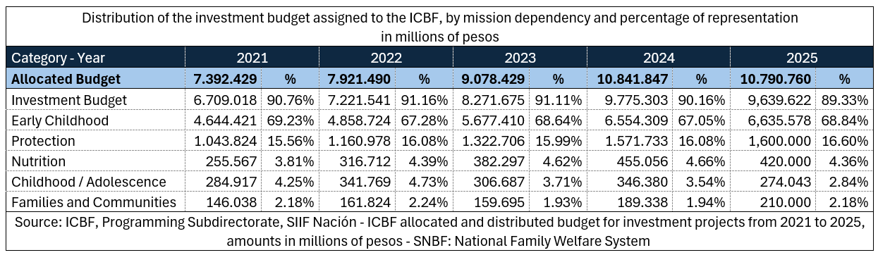
15. Since 2020, the Counsel General’s Office has issued directives for the entities of the National Family Welfare System, gubernatorial offices, mayoral offices, departmental legislative assemblies and district and municipal councils to guide the adoption of a child- and adolescent-centred approach to budgeting and the monitoring of public social spending. Local governments are urged to allocate resources from the investment budget to finance public policies for children and adolescents.

Reply to the issues raised in paragraph 2 (e)
16. The National Department of Statistics is responsible for data collection and statistical analysis in Colombia. The legal framework for the planning, production, dissemination and administration of the country’s official statistics is set out in Act No. 2335/2023, which also sets out the constitutional and legal mandates that recognize children and adolescents as holders of rights and beneficiaries of special constitutional protection. Under Act No. 1581/2012, on the protection of personal data, personal data regarding children and adolescents are to be processed while ensuring respect for their rights.
17. With respect to socioeconomic information, the National Planning Department collects information on households through the Social Programme Beneficiary Selection System (SISBEN) and categorizes the people living in poverty. The results of the comprehensive household survey are taken into account to complete this categorization. As a result, the government agencies responsible for directing social welfare benefits to the appropriate recipients have ample information on the composition of households. There is also the social register of households, an information system that makes it possible to cross-check and supplement the information provided by SISBEN. In addition, it is necessary to integrate the databases of various entities that capture sensitive information on the reality of children and adolescents in order to cross-check and compare data related to the guarantee and protection of their rights when they enter the State’s information systems.
18. The Colombian Family Welfare Institute has two systems for the collection of information on children and adolescents who are beneficiaries of its care services: the Mission Information System and the “Tell Me” system. These systems have national, regional and local coverage and make it possible to break information down by location, age, gender, ethnic group and disability. For migrant children, there are reports from the mobile migrant support teams; for the children and adolescents who leave armed groups, there is the information system of the specialized programme for the restoration of the rights of child and adolescent victims of illegal recruitment, while the mobile units operate an information system for victims of displacement and emergencies.
19. For its part, the Ministry of Education administers the Comprehensive Development Monitoring System, a cross-sector system recognized as the first in Latin America to involve the monitoring of individuals. The Ministry’s Integrated Enrolment System makes it possible to register and obtain information on children in preschool and on primary and secondary school students. The Ministry also has the Unified School Harmony Information System, a tool that, part of the National System for Harmony in Schools, is used to identify, register and monitor cases of bullying, school violence and the violation of sexual and reproductive rights affecting children and adolescents in educational establishments.
20. The Human Rights and International Humanitarian Law Observatory, drawing on the data provided by the entities that make up the Intersectoral Commission for the Prevention of the Recruitment, Use and Sexual Abuse of Children and Adolescents by Illegal Armed Groups and Criminal Organizations, produces a recruitment risk index. It categorizes municipalities as high, medium or low risk. The result is a map that serves as a crucial tool for targeting intersectoral prevention actions, identifying vulnerable areas and prioritizing intervention in the areas at greatest risk.

Reply to the issue raised in paragraph 2 (f)
21. The Attorney General’s Office put in place the Strategy for the Investigation and Prosecution of Crimes against Human Rights Defenders to help ensure that such defenders could exercise their human rights, guarantee their access to justice and promote the reification of a social welfare State governed by the rule of law. The Office also has guidelines for the investigation of crimes committed against human rights defenders in Colombia. The goal is to ensure that investigations into crimes against such persons are conducted in accordance with international standards of due diligence.
22. Currently, the Office is investigating 28 homicides of youth and child leaders that were committed between 2016 and 2025. In addition, the Office has an institutional strategy that prioritizes prosecution and ensures that an interdisciplinary approach, which takes a form suited to the particularities of the victim and his or her role in society, is taken. As soon as it is apprised of a threat, the Office makes a request for the National Protection Unit to take protective measures and for the National Police to take preventive measures.
23. Within the framework of the Prevention and Protection Programme, the Unit issues protection measures for social leaders and human rights defenders who are at extraordinary, extreme or imminent risk. In 2024, it reported that there were 4,748 social leaders and human rights defenders who benefited from protection measures including the provision of 3,698 bulletproof vests, 6,503 means of communication, 4,619 security personnel, 1,129 conventional vehicles and 623 armoured vehicles.

Reply to the issue raised in paragraph 2 (g)
24. Between 2021 and 2024, the Ministry of Justice formulated several public policies to guarantee access to justice for children and adolescents. They include:
(a) The National Public Policy on Restorative Juvenile Justice: strengthening of the State’s criminal policy for the benefit of adolescents, other young people, victims, families and communities affected by crime;
(b) The Public Policy on the Prevention of Adolescent and Youth Crime: to prevent crime and reoffending among adolescents and other young people who have entered or are serving sentences in the adolescent criminal justice system, in application of the principles of the best interests of the child.
25. The Ministry also has a unified system of information on legislation that provides free and organized access to all the country’s legal and other related information. The system has 9,506,018 registered users and has been accessed 27,983,598 times; it hosts more than 100,939 normative and judicial provisions.
26. The Attorney General’s Office has guidelines for the provision of services to users who turn to it for access to justice; the guidelines make it possible to optimize resources and institutional response capabilities. It also has a guide to assistance for child and adolescent victims, the aim of which is to facilitate the reception of complaints from this population group and to provide guidance for the activation of the procedure for the comprehensive restoration of the rights of minors. The Office created a special unit for children and adolescents, to which the national gender working group, made up of prosecutors specialized in sexual and domestic violence and femicide, is attached.

Reply to the issues raised in paragraph 2 (h)
27. The Ministry of Justice, acting through the National System for the Coordination of Criminal Responsibility for Adolescents, has led the formulation of guidelines, policies and strategies to promote restorative juvenile justice. It implements the Restorative Juvenile Justice Programme, which seeks to promote restorative processes and practices in crime prevention, solve problems with the participation of adolescents in conflict with the law, victims and the community, re-establish social harmony and effectively reintegrate adolescents and other young people into their family and social environment.
28. It organized training for officials of the adolescent criminal justice system, other judicial authorities and stakeholders in the education system in Atlántico, Cali, Cesar, Medellín, Quindío, Tolima, Caldas, Caquetá, Cauca, Chocó, Meta, Santander, Huila, Casanare, San Andrés, Cundinamarca, Risaralda, Vichada, La Guajira, Magdalena, Valle del Cauca and Quibdó. In 2024, it prioritized the cities of Cali, Quibdó and San Andrés for the implementation of this training programme, giving training on the prevention of adolescent and youth crime to 463 professionals.
29. With the “Future Colombia” programme, it also trained officials from the Ministry of Equality and Equity and the Attorney General’s Office, and it implemented the strategy “Coordinate + Prevent = A Secure Future” together with the Colombian Family Welfare Institute, the Attorney General’s Office and the National Planning Department. This strategy creates a model public policy for the prevention of and response to crime, puts prevention on the local agenda, proposes a participatory approach, defines inter-agency goals and sets out a methodology focused on impact and evidence-based results. The Colombian Family Welfare Institute and the Ministry of Justice monitor the situation of the rights of adolescents and other young people involved in the adolescent criminal justice system. Between 2021 and 2024, international cooperation agreements were signed with the International Organization for Migration, ACDI/VOCA and the United Nations Office on Drugs and Crime to provide technical assistance for the formulation of the action plans of the departmental or district committees.
30. The 2025 budget for programmes and projects associated with adolescent criminal policy – including for efforts to establish mechanisms for the prevention of crime, enhance the monitoring of the protection of the rights of persons deprived of their liberty and humanize criminal and prison policy – amounts to a total of Col$ 1.295 billion. Since 2021, the Government has issued seven technical documents to enhance assistance for adolescents involved in the adolescent criminal justice system; the documents promote the principles of using the least intrusive effective means, making the best interests of the child a primary consideration and comprehensive protection.
31. Major changes that the adolescent criminal justice system has undergone include de-emphasizing institutional models and promoting non-custodial sentences; enhancing the educational aspect of sanctions and developing individual assistance plans. The number of non-custodial assistance modalities increased from 73 in 2021 to 115 in 2024. Spending increased from Col$ 193.96 million in 2021 to Col$ 272.48 million in 2025.
32. The Attorney General’s Office has units that, specialized in the application of Act No. 1098/2006 and the adolescent criminal justice system, work in coordination with the criminal investigation police. Prosecutors assigned to the system work on restorative justice and matters of relevance or strategic litigation. In the system, prosecutorial discretion prevails, thereby making it possible to restore victims’ rights by adopting disciplinary sanctions without interfering with the liberty of adolescents in conflict with the law.
33. In 2023 and 2024, the Counsel General’s Office produced progress reports regarding compliance with custodial and non-custodial sanctions and recommended allocating sufficient funds for the adoption of non-custodial measures, the improvement of infrastructure and the realization of the rights of adolescents and other young people in conflict with the law. In exercising oversight, it urges the judicial authorities to comply with the principles according to which prosecution and deprivation of liberty should not be the general rule.

Reply to the issues raised in paragraph 3 (a)
34. The Ministry of Foreign Affairs issued Decree No. 1209/2024, under which PEP-TUTOR, a mechanism that grants a special residence permit to the legal representatives or guardians of Venezuelan children and adolescents, was created. The Ministry’s aim is to protect the rights of Venezuelan children and adolescents who find themselves in Colombia, including by promoting solutions to protect them from migrant trafficking and smuggling networks and championing the equal rights of migrant children.
35. The Ministry of Education has protocols for the prevention of gender-based violence, xenophobia and racism that are followed in the framework of the comprehensive support procedure developed to promote harmony in schools. It also leads the National Action and Coordination Commission on Indigenous Education and the prior consultation process of the Indigenous education systems of 115 Indigenous Peoples.
36. In several vulnerable municipalities, the Ministry of Cultures organizes inclusion programmes and strategies for child and adolescent victims of the armed conflict, children and adolescents with disabilities and migrant children. It also executes the National Music for Harmony Plan, which strengthens musical training and benefits children and adolescents in various Indigenous territories.
37. In all its care modalities, the Colombian Family Welfare Institute takes measures to strengthen the differentiated rights-based approach with a view to combating the discrimination and segregation that the population groups it serves are subjected to. In 2023 and 2024, it worked to:
(a) Strengthen migrant support teams in areas with large migrant populations;
(b) Develop guidelines on combating xenophobia and promote the social inclusion of the foreign population;
(c) Make the requirements for admission to specialized care modalities more flexible and open 32 foster homes whose operations are informed by an Indigenous perspective;
(d) Make progress towards the implementation of the Strategy for the Comprehensive Well-being of Children and Adolescents with a view to taking a differentiated approach to the prevention of gender-based violence in 15 jurisdictions.

Reply to the issue raised in paragraph 3 (b)
38. The best interests of the child and primacy of the rights of children and adolescents are constitutional principles expounded on in Act No. 1098/2006. In several rulings, the Constitutional Court has held that children and adolescents enjoy special constitutional protection to ensure their physical, psychological and social development and that, in any administrative or judicial action, the best interests of the child must be a primary consideration. In accordance with these rulings and the Convention, the best interests of the child take precedence over any other legal provision.

Reply to the issues raised in paragraph 3 (c)
39. The Counsel General’s Office monitors compliance with the orders of the Constitutional Court in which the vulnerability of the Wayúu, Emberá, Wounaan and Tule Indigenous Peoples is highlighted with a view to verifying institutional progress and ensuring the fundamental rights of these communities. The Office intervenes at the meetings of the Social Policy Councils, monitoring compliance with the policies and strategies for the advancement of Indigenous groups and the commitments made by the Councils.
40. The Ministry of Education implements the rural early education strategy, reaching areas that require educational offerings suited to their specificities. As of 2024, it had reached 1,554 children and provided support and training to 133 teachers. For Indigenous and campesino groups, the Ministry has signed 14 agreements and organized an event with Indigenous and other authorities, associations and organizations.

Reply to the issues raised in paragraph 3 (d)
41. In its municipalities, Colombia has round tables for children and adolescents that are part of the National Family Welfare System and forums for participation in the educational and cultural systems. There are currently 1,022 local round tables bringing together some 25,500 children and adolescents. The round tables are spaces for advocacy at which children and adolescents discuss issues of interest to them that are then discussed by local-level social policy councils, which make political decisions. In 2024 and 2025, the National Family Welfare System implemented the strategy “Together for Children”, encouraging the participation of children and adolescents in the construction and implementation of Departmental and Municipal Development Plans, concluding 698 pacts for children with the participation of 29,955 children and adolescents and formulating 4,242 children’s initiatives, of which 262 were on climate matters and the environment.
42. Since 2022, children and adolescents have expressed concern about and interest in environmental and climate issues, demanding more action by the State to advance in the fight against climate change. Colombian institutions, together with the United Nations Children’s Fund (UNICEF) and the National Youth Summit for Climate and Biodiversity were active in the forums for participation of the 2024 Conference of the Parties to the Convention on Biological Diversity on Biodiversity and the 2024 Conference of the Parties to the United Nations Framework Convention on Climate Change with a view to ensuring that a child-centred approach is taken to biodiversity and climate change policies and the nationally determined contribution to the global response to climate change.

Reply to the issues raised in paragraph 4
43. The National Civil Registry Office is responsible for ensuring the enjoyment of the right to birth registration. To guarantee the registration of births in the civil register, it has 1,228 offices in all municipalities, has empowered 728 notarial offices and several police inspectors, corregimientos and consulates and has agreements with clinics and hospitals. The Registry reported a total of 2,500,594 registered births between 2017 and 2021.
44. The law establishes that every birth in the country may be registered and defines when nationality is acquired by birth. To build response and registration capacity, the Registry has mobile units that organize free civil registration and identification sessions for vulnerable populations living in hard-to-reach areas, thus reducing the number of children without identification. Between 2015 and 2025, 96,157 Venezuelan children born in Colombia had their births registered thanks to the measure “Children first”, the aim of which is to recognize their Colombian nationality and thereby avoid the risk of statelessness.
45. Colombia has formulated memorandums of understanding, three in all, with Panama, the Bolivarian Republic of Venezuela and Chile to guarantee the protection of children and adolescents in migration contexts; the memorandums cover activities including family tracing, obtaining identity documents, exchanges of information and joint resource mobilization.
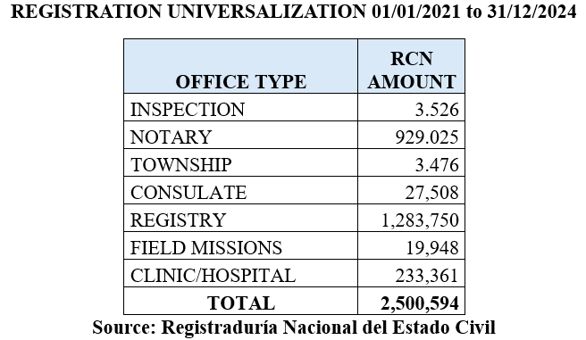
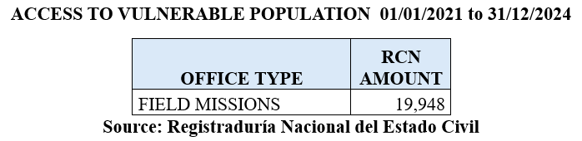
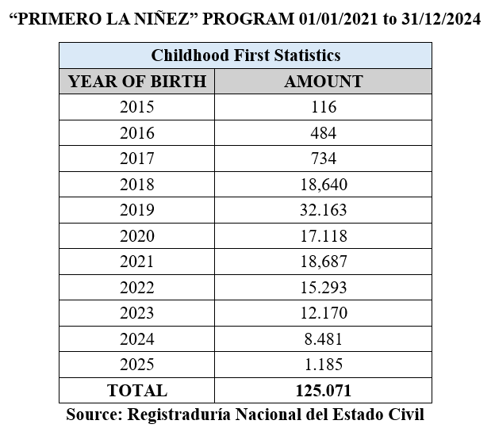

Reply to the issue raised in paragraph 5
46. To uphold the rights of children and adolescents to freedom of association and peaceful assembly, Colombia promotes inclusive participation with impact in decision-making that affects their environment and well-being, including by:
(a) Encouraging the creation of safe spaces where children and adolescents can meet, express their opinions and make proposals in an environment of respect and equality;
(b) Organizing activities that allow them to exercise their rights in civic oversight groups and peer, family and community meetings;
(c) Formulating methods to guarantee the rights of participation, association and peaceful assembly;
(d) Having the National Family Welfare System develop strategies to foster dialogue with children and adolescents on issues related to the public oversight of services and programmes for which public institutions are responsible with a view to protecting their rights and promoting their life projects.
47. Laws on the schools and the internal rules of educational establishments and cultural and sports programmes must encourage child and adolescent participation. They promote civic education, human rights, democratic culture and intercultural harmony, facilitating the creation of safe spaces for children and adolescents to meet, deliberate and make decisions as a group.

Reply to the issue raised in paragraph 6 (a)
48. In 2025, the Colombian Family Welfare Institute and the justice system had 217 local centres in the 33 first-level administrative divisions, 1,417 family advocates and 1,103 family commissioners’ offices. Between 2021 and 2025, the family advocates and the family commissioners’ offices took 491,755 measures for the restoration of rights. Mobile and community-based strategies were implemented to facilitate the identification of risks, the activation of procedures, coordination, links to the cross-sector services and family support and strengthening. In addition, the specialized units that have been put in place include: 10 mobile migrant support teams, 51 mobile comprehensive protection teams to address child labour and children or adolescents in street situations, 19 units for the deployment of the Strategy for the Comprehensive Well-being of Children and Adolescents for victims of sexual violence, 126 mobile units for victims of forced displacement, 10 units for the mutual care of children and adolescents who are victims of armed groups, for a total of 237 teams in the 33 first-level administrative divisions of Colombia.
49. The family commissioners’ offices implement the National Pedagogical and Prevention Strategy against Corporal Punishment and Cruel, Humiliating or Degrading Treatment. The National Family Welfare System and the justice system train the relevant social and other workers with a view to raising awareness, generating knowledge and ensuring a timely and efficient response to intrafamily violence.
50. The schools activate the comprehensive support procedure developed to promote harmony in schools and refer situations of rights violations to the competent authorities to ensure that measures to restore the rights are taken. When it comes to possible crimes involving children and adolescents, the Attorney General’s Office has channels through which institutions or members of the public can report acts of violence that put a person’s physical or emotional safety at risk.

Reply to the issue raised in paragraph 6 (b)
51. Between 2021 and 2024, the country made progress on the design and implementation of comprehensive prevention strategies to protect and restore the rights of children and adolescents in the face of violence. They include the following:
(a) National Alliance to Combat Violence against Children and Adolescents;
(b) Strategy #VocesQuePrevienen (warning voices); the Amazon Basin Pathway for Children and Adolescents in the tri-border area of Brazil, Colombia and Peru;
(c) Strategy for the Prevention of Psychoactive Substance Use and Juvenile Delinquency, with the participation of intersectoral committees for the formulation of the National Plan on Drugs 2023–2033;
(d) Training for community leaders, families and teachers focused on building protective environments and promoting rights;
(e) Social and community mobilization campaigns: promoting respect, inclusion and rejection of violence;
(f) Promotion of the Public Policy on Access to Justice and Prevention of Sex Crimes against Children and Adolescents;
(g) Strengthening the National Family Justice System by establishing the Intersectoral Family Justice Commission;
(h) Implementation of the Family-School Alliance in all administrative divisions within the framework of the National Pedagogical and Prevention Strategy against Corporal Punishment.
52. A ministerial conference on ending violence against children was held in Colombia in 2024, and an initiative was undertaken to set up a national and international governance structure with a view to making an international commitment to protecting children from violence and eradicating violence against children. At the conference, Colombia presented its country pledge, which is entitled “In time: Cross-sectoral system for the comprehensive protection from and elimination of violence against children and adolescents”; the pledge seeks to guarantee a consolidated response to violations of the rights of children and adolescents. The first action plan to leverage public and private resources for the objectives set out in the country pledge was adopted in 2025.

Reply to the issue raised in paragraph 6 (c)
53. Colombia has policies, strategies and programmes, developed by the National Family Welfare System, that seek to prevent, investigate and punish acts of torture and other degrading treatment or punishment to which children and adolescents are subjected by State agents or non-State armed groups. They include:
(a) Safe Childhood and Adolescence Protection Strategy and “Open Your Eyes”, which seek to identify and mitigate risks and strengthen settings and factors of protection at the individual, family, social and cultural levels;
(b) Strategy to Combat the Crimes of Recruitment, the Use of Minors for the Commission of Crimes and Sexual Violence against Children and Adolescents (2024);
(c) Harm Prevention Policy in the adolescent criminal justice system, which is focused on avoiding violence, injuries, suicide or deaths.
54. The Attorney General’s Office investigates suspected acts of torture and other crimes against children and adolescents; prosecutors conduct investigations into torture with the support of the National Institute of Forensic Medicine and Science. The Office proceeds with the prosecution of criminal acts attributable to demobilized personnel of paramilitary and subversive armed groups to safeguard the rights of child and adolescent victims to truth, justice and reparation and guarantees of non-repetition. The Counsel General’s Office promotes public policies intended to prevent the recruitment, use and sexual abuse of children and adolescents in armed conflict. It requires local authorities to include their budgets for preventing and otherwise addressing such recruitment in their planning and management tools.
55. The Special Jurisdiction for Peace is making progress in the investigation of several cases of violence against children and adolescents in the context of the armed conflict. Examples of this progress include:
(a) Macrocase 01: hostage-taking and other serious instances of deprivation of liberty and other attendant crimes committed by the Fuerzas Armadas Revolucionarias de Colombia-Ejército del Pueblo;
(b) Case 03: killings and cases of enforced disappearance presented as deaths in combat by State agents;
(c) Macrocase 07: recruitment and use of children in the armed conflict and other crimes to which they were subjected while they were in the ranks of armed groups, including ill-treatment, torture, homicide, sexual and reproductive violence and discriminatory violence; reproductive violence that affected recruited girls during their time in the ranks; sexual violence against child recruits in the context of their lives with the armed groups and discriminatory violence against child recruits with diverse sexual orientations or gender identities or expressions during their time in the ranks of the armed groups.

Reply to the issue raised in paragraph 6 (d)
56. The implementation of the National Pedagogical and Prevention Strategy against Corporal Punishment and Cruel, Humiliating or Degrading Treatment 2022–2030 has helped raise awareness of the consequences of physical and psychological violence and neglect on children’s development and mental health and strengthened the capacity of educators and families to prevent and address violence in early childhood, including by broadening the concepts of care and safety in relation to child-rearing.
57. The outcomes reported by the National Family Welfare System include:
(a) The promotion of positive parenting and care networks through an intercultural and gender-based approach;
(b) The establishment of partnerships to devise training programmes that are adapted to local realities, such as “Skills for Life and Peace” and “Healing to Grow”;
(c) The publication of technical guidelines to prevent violence, raise awareness of the administrative rights restoration process and build the authorities’ capacities;
(d) The organization of a campaign to prevent all forms of violence in the education system as part of the process to develop social and emotional skills through the “Emotions, Vital Connection” strategy;
(e) The incorporation of a parenting skills module into the “Loving and Protecting: Family Superpowers” toolbox.

Reply to the issues raised in paragraph 6 (e)
58. In order to support the local government of Quibdó, the national Government has developed several strategies intended to stop gang violence in that city and prevent deaths among adolescents and young people. These strategies include the “Safe Childhood and Adolescence” protection strategy, which supported efforts to strengthen ties between families and communities.
59. The Intersectoral Commission for the Prevention of the Recruitment, Use and Sexual Abuse of Children and Adolescents by Illegal Armed Groups and Criminal Organizations drew up a plan focused on five areas of action: psychosocial care, the strengthening of protective environments, infrastructure and security, education and social investment. The Colombian Family Welfare Institute launched the “Dreamcatcher” strategy in order to develop the skills and talents of young people in Quibdó and strengthen protective environments and opened 12 safe spaces in neighbourhoods in which gangs have a strong influence. The Institute provided psychosocial care to 1,500 children and adolescents, who received therapy after being recruited or subjected to violence. Such efforts resulted in a 12 per cent reduction in the number of adolescent victims of homicide in Quibdó in 2023. The Institute organizes educational, sporting and cultural activities that offer constructive alternatives and strengthen the social fabric with a view to keeping young people away from violent environments. It operates 18 centres in key neighbourhoods (50 per cent more than in 2023) and has helped 800 former gang members re-enrol in educational programmes. It has reported, however, that 30 per cent of children and adolescents in the municipality do not participate in the programmes owing to the stigma associated with gangs.
60. The Intersectoral Standing Commission on Human Rights and International Humanitarian Law ran 14 technical assistance activities for the municipality in order to raise awareness of public prevention policy and prevention measures. It has also developed a mechanism to identify social media accounts that promote the recruitment, use and sexual abuse of children and adolescents in the context of the armed conflict, which has led to the closure of 248 TikTok accounts.

Reply to the issues raised in paragraph 6 (f)
61. The national Government has a specific legal framework and develops programmes, strategies and technical guidelines to address domestic violence, sexual abuse and exploitation and acts of enforced disappearance committed against young and adolescent girls in the context of the armed conflict and in situations of human mobility. The most relevant instruments include:
(a) Act No. 2126/2021, which regulates the operation of the family commissioners’ offices and addresses cases of domestic violence that might constitute gender-based violence against young and adolescent girls;
(b) Act No. 2215/2022, which establishes shelters for adolescent and female victims of gender-based and domestic violence;
(c) Act No. 2326/2023 on the Pink Alert mechanism sets out prevention, protection and reparation measures for children, young people and women who have fallen victim to disappearance;
(d) Decree No. 1710/2020, which provides for the adoption of the Coordinating Mechanism for a Comprehensive Approach to Sex- and Gender-based Violence against Women, Children and Adolescents as part of efforts to manage public health;
(e) The Recruitment Prevention Policy, which is led by the Intersectoral Commission for the Prevention of the Recruitment, Use and Sexual Abuse of Children and Adolescents by Illegal Armed Groups and Criminal Organizations and seeks to prevent sexual violence against children and adolescents in the context of the armed conflict;
(f) The technical guideline on the prevention of gender-based and domestic violence, which was developed by the Ministry of Justice to inform the “Families in Action” and “Young People in Action” programmes;
(g) The “Open Your Eyes” strategy, which is run by the National Police;
(h) The protocol for the prevention of gender-based violence within the framework of the comprehensive support procedure for harmony in schools, and Directive No. 01/2022 on addressing sexual violence against children in the education system;
(i) The Strategy for the Comprehensive Well-being of Children and Adolescents, the aim of which is to prevent gender-based violence within the care services of the Colombian Family Welfare Institute.

Reply to the issues raised in paragraph 6 (g)
62. Act No. 2170/2021 seeks to promote safe learning environments for children and adolescents by determining the responsibilities of the Government, educational institutions and families with regard to the use of information technology. The Ministry of Education has drawn up a protocol for the prevention of cyberbullying and digital crimes.
63. The defence and security sector has introduced measures such as:
- A plan whose aim is to identify criminal actors who use social networks to commit crimes that affect children’s rights and launch investigations that should lead to their capture
- The “Safe Childhood and Adolescence” protection strategy, through which activities are run for families to help parents control the use of electronic media by children and adolescents
- Coordination with the police, the International Criminal Police Organization (INTERPOL) and the Ministry of Information Technologies and Communications to block websites that contain child abuse and sexual exploitation material.

Reply to the issues raised in paragraph 6 (h)
64. In accordance with Act No. 1098/2006, policies on early childhood, childhood and adolescence and family strengthening prioritize the development of inter-institutional and intercultural strategies for the prevention, detection, handling and prosecution of sexual violence against Indigenous children. The National Family Welfare System has promoted coordination with the health, justice, education and protection sectors and local entities to ensure the delivery of timely and specialized care in rural settings. The Colombian Family Welfare Institute runs the Strategy for the Comprehensive Well-being of Children and Adolescents and has family advocacy offices that specialize in sexual violence and Indigenous affairs. In 2023 and 2024, priority was given to implementing the Strategy in Guaviare Department.
65. In order to protect children in Indigenous communities, the National Family Welfare System takes measures with an ethnic and gender focus, such as:
- The activation of comprehensive care road maps, tailored to the local area, for victims of sexual violence
- The organization of training on the early identification of cases of sexual violence for teams working in the areas of protection, health, justice and education
- The identification of barriers to access to justice
- The conduct of studies to support the design of public policies against sexual crimes
- The development of a strategic plan for addressing the situation of the Jiw and Nukak Indigenous communities by the expert committees of the Presidential Commission for Guaviare
- The design of the inter-institutional and intersectoral strategy for the protection of children
- The development of guidelines on strengthening Indigenous justice systems in the areas of gender-based violence and access to justice for female victims of that violence
- The preparation, together with the National Commission of Indigenous Women, of a document containing recommendations for Indigenous authorities regarding the handling of sexual abuse
- The launch of the “Protective Territories” initiative to strengthen guarantees in the area of access to justice, uphold the rights of women and girls and establish support networks

Reply to the issues raised in paragraph 7 (a)
66. As part of efforts to implement the Optional Protocol on the sale of children, child prostitution and child pornography, the Colombian Family Welfare Institute and the Ministry of the Interior are leading plans to combat trafficking in persons and defining strategies for monitoring and evaluating that process. Between 2022 and 2025, the Ministry of Trade, Industry and Tourism took steps to address the commercial sexual exploitation of children and adolescents by providing training to 83,796 individuals in the travel and tourism sector through awareness-raising events and a course entitled “Everyone united against the commercial sexual exploitation of children and adolescents”. A total of Col$ 1 billion has been invested in the current campaign for the prevention of that phenomenon.
67. In all, Col$ 6,582,030,753 was invested in projects under way in the period from 2022 to 31 December 2024.
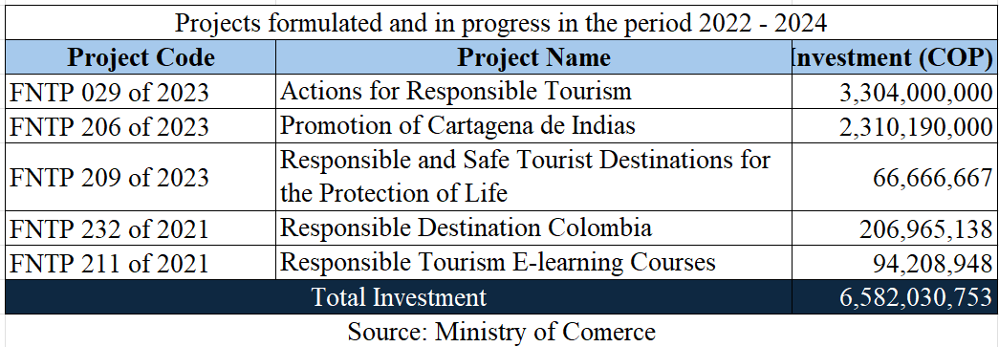

Reply to the issues raised in paragraph 7 (b)
68. The national Government has investigation road maps and protocols to identify perpetrators of sexual abuse and exploitation. The tools available to it include:
- Protocols, a checklist and a booklet for investigations into sexual violence
- A guide on dealing with complaints, with a focus on sexual violence in religious environments and the inclusion of information on that phenomenon in the Democratic Governance Information and Management System
69. The National Family Welfare System is implementing an intersectoral road map on sexual violence, which provides for the coordination of health, justice and psychosocial support services. It is also running the “Dreamcatcher” strategy to prevent violence, abuse and sexual exploitation.
70. The tourism sector is implementing regulations that establish a code of conduct for tourism service providers in order to prevent the commercial sexual exploitation of children and adolescents. In the education sector, the comprehensive support procedure for harmony in schools is being implemented within the framework of the protocol for the prevention of gender-based violence. Reports are sent to the competent authority and guidelines are followed to handle cases of sexual violence in school environments in order to support awareness-raising, prevention, care and monitoring efforts geared towards fostering harmony in schools.

Reply to the issues raised in paragraph 7 (c)
71. Act No. 2447/2025, which provides for the elimination of child marriage and early unions between persons under 18, was adopted in 2025. Judgment C-039/2025 of the Constitutional Court amends the Civil Code by making 18 the minimum age for marriage in Colombia. These legal texts bring the Constitution into line with the Convention.
72. Since 2012, Colombia has been developing programmes and taking action to prevent and eradicate child marriage and other early unions. The National Family Welfare System is behind an initiative to address female genital mutilation, under which tools are being developed to detect the practice and adopt an intersectional, ethnic and gender-based approach to combating it. In 2023, the System provided technical support in the departments that are home to the Emberá People, namely Chocó, Antioquia and Risaralda, in order to enhance understanding of this harmful practice and ensure that it was eradicated. The Emberá People are the only group in Colombia to practise child marriage and other early unions.

Reply to the issues raised in paragraph 8 (a)
73. The Colombian Family Welfare Institute has made deinstitutionalization one of the fundamental focuses under the rights-based differential model with a view to strengthening the alternative care options offered by protection services, in particular within the framework of the administrative rights restoration process. It is leading efforts to reform the protection system in order to shift the focus towards forms of family support and strengthening that help families overcome adverse situations while ensuring that children can remain in or return promptly to the family environment. It is working to incorporate the home-based care service into a service for the promotion of rights and family support.
74. With regard to the care of children and adolescents with disabilities, Colombia is making progress in the implementation of the social model of disability by promoting alternatives such as the launch of road maps, the referral of families to State services and the prioritization of support that prevents families from being separated. The aim of such efforts is to avoid institutionalization as much as possible, ensure that families can stay together and guarantee the autonomy and dignity of persons with disabilities.

Reply to the issues raised in paragraph 8 (b)
75. The National Family Welfare System develops strategies and services to strengthen mutual and community-based care, promoting new forms of supportive relationships through programmes such as “We Are Family, We Are Community” and “Fostering Coexistence and Strengthening Family and Community Ties”. In addition, during the administrative rights restoration process, family advocacy offices are responsible for preventing the removal of children from their family environment.
76. Colombia has signed memorandums of understanding with countries in the region, such as Venezuela, to facilitate family reunification at the international level. The Counsel General’s Office held meetings with the Colombian Family Welfare Institute, Migration Colombia and the authorities of the departments on the country’s borders to identify minors who were migrants, asylum-seekers or refugees, were at risk of statelessness or were travelling unaccompanied. The aim of those meetings was also to coordinate action to ensure that such minors received comprehensive protection and specific assistance and to search for their families.

Reply to the issues raised in paragraph 9 (a)
77. As part of the follow-up to the Comprehensive Early Childhood Development Policy, the Nutrition Committee coordinates the child healthcare services delivered within early childhood education programmes. The Committee monitors aspects such as enrolment in the General Health and Social Security System and access to comprehensive health assessments, vaccination programmes and activities to tackle childhood diseases (acute diarrhoeal diseases and acute respiratory infections) through an approach based on prevention, health maintenance and risk management.
78. The Counsel General’s Office follows up on reports from the National Health Institute regarding cases of morbidity and mortality caused by malnutrition, acute diarrhoeal diseases and acute respiratory infections in children under 5. It is also following up on the court rulings relating to the declaration of an unconstitutional state of affairs in La Guajira, which was made in response to the humanitarian crisis caused by the malnutrition-related deaths among children from the Wayúu communities.

Reply to the issues raised in paragraph 9 (b)
79. Colombia has adopted Act No. 1616/2013 and established the National Council for Mental Health. In 2020, document CONPES/3992 was issued in order to strengthen the Government’s capacity to improve mental healthcare and tackle the use of psychoactive substances. The National Family Welfare System takes sectoral and intersectoral measures to strengthen the comprehensive approach to mental health. These measures include:
- The design of a guide on providing social and emotional support
- The establishment of protocols on educational approaches to situations of risk and the prevention of the use of psychoactive substances, suicidal behaviour, gender-based violence, xenophobia, racism, cyberbullying and digital crimes in schools
- The adoption of Act No. 2383/2024 promoting the social and emotional education of children and adolescents in preschools and primary, lower secondary and upper secondary schools in Colombia
- The development of the “Dreamcatcher”, “Family Well-being Resonates with You” and “Living Well” strategies in hard-to-reach regions with vulnerable communities, with a view to promoting mental health and preventing the use of psychoactive substances and suicidal behaviour

Reply to the issues raised in paragraph 9 (c)
80. The Colombian Family Welfare Institute offers training on the promotion of sexual and reproductive rights in its 33 regional offices in the country’s 32 departments, with the aim of preventing pregnancy among young and adolescent girls. This training is designed for educators and young people who are involved in promoting the sexual and reproductive rights of adolescents and young people. By 2024, 4,797 individuals were qualified. It is hoped that 13,000 education, community and institutional workers will be trained by 2026.

Reply to the issue raised in paragraph 9 (d)
81. Progress in the fight against malnutrition among children and adolescents is closely connected to the paradigm shift provided for in the National Development Plan 2022–2026, which reinforces the human right to food. The National Planning Department has formulated a new National Economic and Social Policy Council document to update document No. 113/2008 and supports the design and implementation of the national system for monitoring and following up on efforts to combat malnutrition. In addition, between 2022 and 2025, 159,127 pregnant women and children under 5 received care through the nutritional rehabilitation centres of the Colombian Family Welfare Institute. As part of the plan to reduce acute malnutrition-related mortality among children under 5, as well as to follow up on individual cases and prevent deaths, 364 emergency nutritional committees, led by the Ministry of Health and Social Protection and the Colombian Family Welfare Institute, have been set up in various regions.

Reply to the issue raised in paragraph 10 (a)
82. Since 2010, the efforts of the Colombian Government have been focused on the universalization of early education as part of the comprehensive care approach. The National Development Plan 2022–2026 established the goal of increasing the number of children under 5 who receive an early education from 1.9 million to 2.7 million.
83. As part of that work, the Colombian Family Welfare Institute has reorganized the first cycle of early education (for children up to 3 years of age) in order to increase the number of places available at that level by 1.9 million. The education sector has also reorganized the second cycle (for children from 3 to 6) in order to double coverage by creating places for 800,000 children in the three preschool grades. In 2024, the number of children who had access to early childhood education services reached 2,210,892.
84. Between 2022 and 2024, 6,171,348 children and pregnant women participated in early education programmes. The Government has made resources available for the appointment of teachers at the pre-kindergarten and kindergarten levels; 1,400 such teachers have been appointed, and it is hoped that the total number of teachers will increase by 25 per cent.
85. To achieve these goals, the education authorities have:
- Established 11,559 teaching posts and filled 2,385 of them
- Trained 21,149 early education teachers
- Delivered 5,186 educational kits and 2,541 collections of children’s literature
- Supported 1,554 children in 10 local school districts and trained 133 teachers through the Rural Early Education Strategy
- Concluded 14 agreements with authorities representing Indigenous Peoples and communities
86. The National Planning Department, which monitors the goals set under the National Development Plan with regard to increasing the coverage of comprehensive early childhood care, reported that sustained progress has been made in that area; by 2024, 1,998,283 children, or 74.89 per cent of the 2026 target of 2.7 million, were attending early education programmes.

Reply to the issues raised in paragraph 10 (b)
87. The National Family Welfare System has made headway in the national coordination of the road map for the prevention of dropping out of school by identifying and mitigating the associated risks and providing guidance to local school districts on its implementation. In 2024, a pilot project was run in the areas prioritized under the National Development Plan, reaching 20 territorial units and 66 municipalities. In addition, the Ministry of Education is implementing the Enrolment, Well-being and Retention Strategy and the Rural Early Education Strategy, which seek to ensure that students do not drop out of school or repeat grades and help improve the quality of education.

Reply to the issues raised in paragraph 10 (c)
88. Various strategies have been implemented to guarantee universal access to quality early education for Indigenous Peoples. The National Development Plan promotes educational models that are based on a differentiated approach, thereby ensuring the participation of communities in their own educational strategies. Within the National Action and Coordination Commission on Indigenous Education, the Ministry of Education has led consultations on the regulation on the Indigenous education system, which has been established as a State policy that is grounded in the autonomy of Indigenous Peoples.
89. The Colombian Family Welfare Institute has taken the following measures:
- The mainstreaming of the rights-based differential model into early education programmes and services
- The design and implementation of a rural early education service
- The expansion of the use of suitable intercultural methods and the recognition of multilingual contexts
- The implementation of the regulation on the Indigenous education system and the Afro-Colombian studies programme
- The provision of support for efforts to prepare 33 regional plans
90. The Ministry of Cultures has taken the following steps:
- The development of a digital strategy for culture and early childhood
- The creation of specialized collections for young children and the distribution of cultural content within the framework of the National Incentives Programme

Reply to the issues raised in paragraph 11 (a)
91. The legal rule applied in Colombia is that all foreign minors whose rights have been violated or who are at risk of rights violations must, regardless of their migration status, be protected in accordance with the rules of the administrative rights restoration process. Migrant children receive protection through specialized care programmes and services. The Government has helped guarantee the rights of migrant children through the following:
- The inter-institutional road map for the protection and care of children and adolescents affected by the smuggling of migrants, which was designed within the framework of the Intersectoral Commission to Combat the Smuggling of Migrants
- Safeguards to protect children and adolescents who are leaving or arriving in the country or are in transit through it
- The management, in 2024, of 829 cases involving children and adolescents in an irregular migratory situation; the cases were managed by the Colombian Family Welfare Institute through the strategy on mobile migrant support teams
- The granting of temporary protected status for Venezuelan migrants
- Measures to guarantee that students in situations of human mobility, the number of whom increased from 34,030 in 2018 to 611,314 in 2024, had access to education and support to remain in it

Reply to the issues raised in paragraph 11 (b)
92. Since 2015, Colombia has taken a number of steps to ensure that asylum-seekers, refugees and migrants in transit receive priority and differentiated treatment. It uses the following tools:
- The differentiated treatment protocol, which aims to ensure that children and adolescents who apply for refugee status are represented throughout the procedure
- The guide on the submission of asylum applications by children and adolescents in Colombia
- The human rights violation risk map for migrants in Colombia
- The guidance for administrative authorities involved in hearings and procedures to determine refugee status or statelessness
- The “Building Pathways” strategy, which sets out a model of comprehensive care for young migrant children
93. In areas such as the Darién Gap, the Colombian Family Welfare Institute, the Family Ombudsman and Migration Colombia prioritize the identification of risks, with a focus on children. Protection measures are taken in response to all human rights violations.

Reply to the issues raised in paragraph 11 (c)
94. Colombia has formulated the Durable Solutions Policy, which is harmonized with the Victims Policy set out in National Economic and Social Policy Council document No. 4031/2021, the aim of which is to improve the socioeconomic situation of victims of displacement and enhance institutional coordination.
95. The Colombian Family Welfare Institute has a system of mobile units to deal with emergencies caused by forced displacement, thereby helping guarantee and restore rights, ensure comprehensive reparation and consolidate peace.
96. The Ministry of Education issued Resolution No. 6519/2025 providing for the adoption of guidelines for the Public Policy on Comprehensive School Risk Management. The objective of the Policy is to protect the right to education and safeguard the lives and integrity of individuals attending educational institutions in the face of risks and unintentional natural or human-made hazards and threats linked to the armed conflict.
97. Since 2024, action has been taken to monitor the institutional response to the humanitarian crisis in the Catatumbo region, with a focus on the recruitment, use and sexual abuse of children and adolescents. The Colombian Family Welfare Institute provides comprehensive support to displaced children and adolescents in Catatumbo in order to ensure that they benefit from humanitarian action.

Reply to the issue raised in paragraph 12 (a)
98. In accordance with current national regulations, minors under 18 cannot join the armed forces. In this respect, the army applies the Optional Protocol on the involvement of children in armed conflict as part of its efforts to comply with the Convention on the Rights of the Child and international humanitarian law.
99. The Intersectoral Standing Commission on Human Rights and International Humanitarian Law manages the technical secretariat of the Intersectoral Commission for the Prevention of the Recruitment, Use and Sexual Abuse of Children and Adolescents by Illegal Armed Groups and Criminal Organizations and assists departments and municipalities in formulating the decrees providing for the establishment of rapid response teams. These teams bring together local institutions to implement and monitor early prevention, urgent prevention and protective prevention procedures. Directive No. 010/2021 urges local authorities and the bodies that make up the Intersectoral Commission to implement action plans and adopt measures and coordination mechanisms to prevent the aforementioned violations.
100. In order to guarantee the effective participation of children and adolescents in peace processes, the Peace Commissioner’s Office establishes forums so that children and adolescents can tell their stories and make contributions that help build peace in their local areas.

Reply to the issues raised in paragraph 12 (b)
101. In the context of the declaration of a state of internal unrest in the Catatumbo region, the Intersectoral Standing Commission on Human Rights and International Humanitarian Law provided technical assistance to the Norte de Santander Departmental Committee to help it formulate a workplan geared towards preventing children and adolescents from joining armed groups.
102. The Counsel General’s Office called on institutions to guarantee support for children and adolescents in situations of forced displacement and to help them disengage from illegal armed groups by offering protection, health, education, food security and specialized care services. In addition, it requested the Constitutional Court to invalidate Legislative Decree No. 155/2024, which was issued by the national Government against the backdrop of the declaration of internal unrest, since the Decree does not address the ongoing emergency but seeks to tackle long-standing structural problems in the education system in the Catatumbo region.
103. In response to the declaration of the state of unrest, the Ministry of Education and local school districts collected information on the impact on educational establishments in Catatumbo, activating the Education Cluster and providing guidance for the provision of educational services amid the emergency.

Reply to the issues raised in paragraph 12 (c)
104. The national Government has taken action to prevent the recruitment, use and sexual abuse of children and adolescents as part of the Public Policy for the Prevention of the Recruitment, Use and Sexual Abuse of Children and Adolescents, which was issued pursuant to Decree No. 1434/2018. This action, which has been taken with an intersectoral approach and spearheaded by the Intersectoral Commission for the Prevention of the Recruitment, Use and Sexual Abuse of Children and Adolescents by Illegal Armed Groups and Criminal Organizations, involves 19 entities and includes the School Life Spaces workplan for 2025 and 2026. Colombia also designed and implemented the National Action Plan for the Implementation of the Safe Schools Declaration with a view to strengthening preventive work, care and efforts to provide comprehensive protection in educational spaces.
105. In 2024, the Ministry of Defence reported that 447 child and adolescent victims of recruitment had been helped to leave illegal groups. The Colombian Family Welfare Institute and organizations such as Justapaz and Benposta have signed agreements to train officials and strengthen institutional pathways through which rapid response teams and public officials from the National Family Welfare System could prevent and protect children and adolescents from being recruited. A campaign entitled “The peaceful generation is growing up here” is being run to help guarantee the rights of children and adolescents through education and activities designed to promote their participation and mobilization in areas where they are at risk of being recruited, used or sexually abused.
106. As part of its peacebuilding work with armed groups, the Peace Commissioner’s Office has stressed the importance of protecting civilians, especially children and adolescents, from actions that violate their rights and put their lives and comprehensive development at risk. Accordingly, in the dialogues it holds, the Office promotes actions that help prevent the recruitment, use and sexual abuse of children and adolescents.

Reply to the issue raised in paragraph 12 (d)
107. Colombia has an early warning system that was established by the Ombudsman’s Office. The Ombudsman’s Office issues two types of alerts: imminent alerts, which warn of risks with a high probability of materializing in the short term, and structural alerts, which identify threats and vulnerabilities in a given area. The alerts are issued at the national level to activate response mechanisms and guarantee the protection of civilian rights. From 2018 to 2025, the Office issued 330 early warnings, of which 144 are active, 97 are structural and 45 are imminent. The Counsel General’s Office follows up on the early warnings in order to monitor the institutional response and promote the timely implementation of protection measures.
108. The Intersectoral Standing Commission on Human Rights and International Humanitarian Law organized 40 local technical assistance activities on risk mapping and 75 follow-up activities on early warnings. The Ministry of Defence is taking steps to identify and protect children and adolescents in regions affected by the armed conflict through its military operations and intelligence activities. The Counsel General’s Office is monitoring the efforts of this Ministry with regard to the prohibition on having the military perform civilian functions in areas where illegal armed groups are present.

Reply to the issues raised in paragraph 12 (e)
109. In 2021, the Victims and Land Restitution Act (No. 1448/2011) was extended until 2031. The Act sets out measures to guarantee the rights of victims of the armed conflict, specifically children and adolescents, to truth, justice and comprehensive reparation.
110. Pursuant to Act No. 1098/2006, the Colombian Family Welfare Institute is restoring rights and supporting efforts to obtain the truth, justice and comprehensive reparation. As part of the administrative rights restoration process, 21 support units, staffed by psychosocial professionals who provide services with a differentiated approach, have been set up in 15 departments.
111. The Attorney General’s Office is implementing a national plan to address the recruitment of minors by identifying relevant criminal cases from 2024 and 2025. It created a working group for the investigation of illegal recruitment and related crimes that supports victims through a differentiated approach underpinned by human dignity, equality and non-discrimination. With regard to progress in the investigation and prosecution of the perpetrators of violence against children and adolescents in the armed conflict, the achievements of the Attorney General’s Office are as follows:
- 12,726 criminal cases brought before the justice and peace courts
- Sentences handed down in 1,517 cases
- 403 criminal convictions
- The exhumation by the Group for the Search, Identification and Handover of Disappeared Persons of the remains of 295 minors from various cemeteries; these remains were then handed over to their families

Reply to the issues raised in paragraph 12 (f)
112. With regard to case No. 07 concerning the recruitment and use of children in the armed conflict and other crimes committed against them by members of the armed groups by which they were recruited, which included ill-treatment, torture, homicide, sexual and reproductive violence and discriminatory violence, the Special Jurisdiction for Peace reported that the following action was taken:
- The adoption of ruling No. 029 of 2019, which established that the forms of victimization of minors under 18 include recruitment, incitement to join armed groups, the provision of military training and the forced use of arms in hostilities
- The adoption of ruling No. 05 of 2024, which established that the Fuerzas Armadas Revolucionarias de Colombia-Ejército del Pueblo had recruited and used 15,561 children and adolescents, who are victims of the war crime of recruitment
- The adoption of measures to support Indigenous Peoples who had been identified as collective victims, such as protection measures for the Koreguaje and Hitnü peoples
- The adoption of ruling No. SRVR-LRG-T-041-2025, which provided for the organization of a day of discussions to explore restorative measures for victims

Reply to the issues raised in paragraph 12 (g)
113. The technical secretariat of the Intersectoral Commission for the Prevention of the Recruitment, Use and Sexual Abuse of Children and Adolescents by Illegal Armed Groups and Criminal Organizations supported efforts to transform schools into protection centres as part of the School Life Spaces 2025–2026 Plan, in line with the Safe Schools Declaration. This Plan is focused on 24 schools in municipalities in Putumayo, Cauca, Valle, Nariño and Norte de Santander.

Part II

Reply to the issues raised in paragraph 13 (a)
114. The relevant laws, regulatory decrees, public policies, newly created institutions and international instruments ratified are listed below.

Laws and regulatory decrees adopted between 2021 and 2025
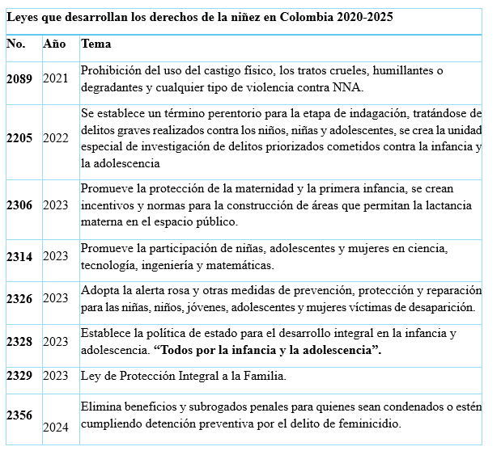
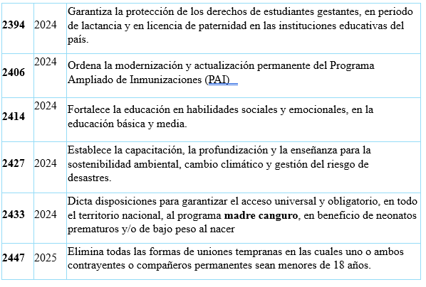
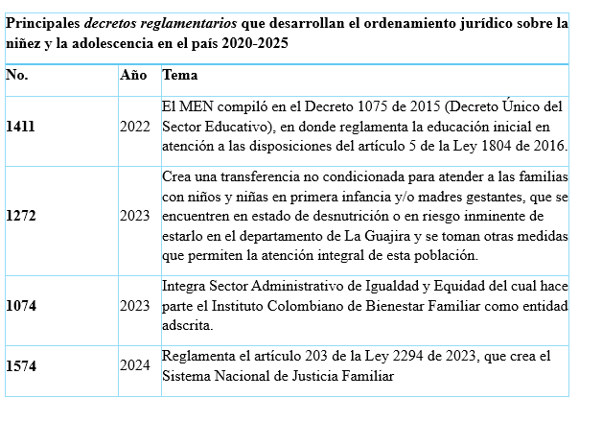
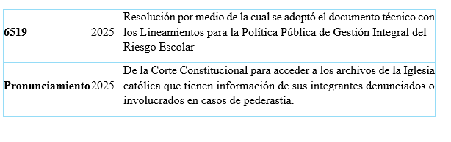

Reply to the issues raised in paragraph 13 (b)

New institutions established and institutional and legal reforms undertaken between 2020 and 2025
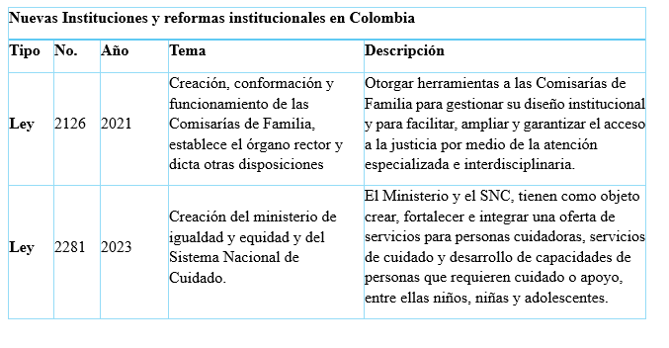
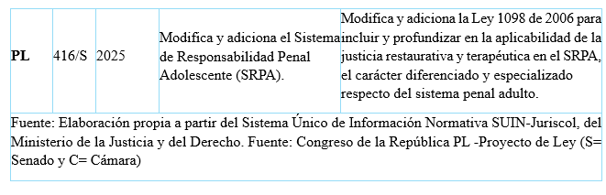

Reply to the issues raised in paragraph 13 (c)

State and other public policies adopted between 2018 and 2025
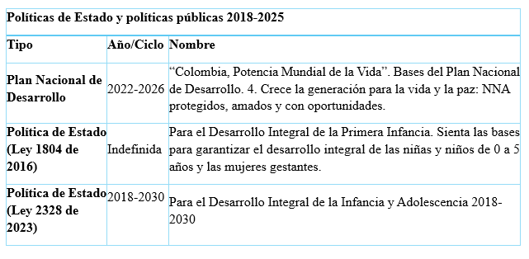
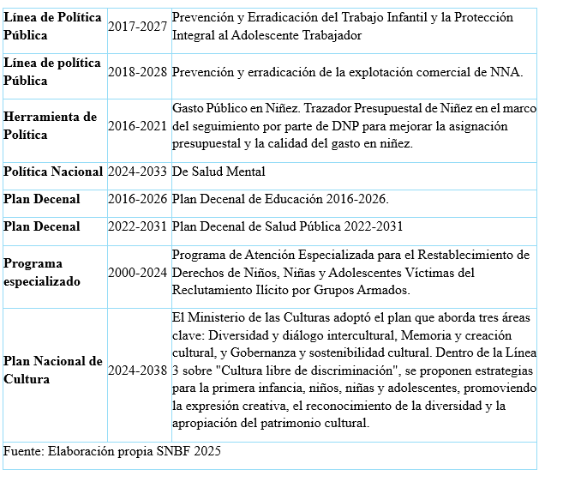

Reply to the issue raised in paragraph 13 (d)

International instruments ratified
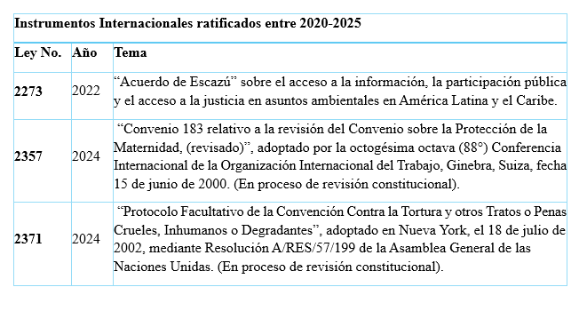

Part III

Reply to the issues raised in paragraph 14
115. Colombia has a budget tracker for the categories of early childhood, childhood and adolescence.
116. The data shown below are nominal figures reported by each entity.
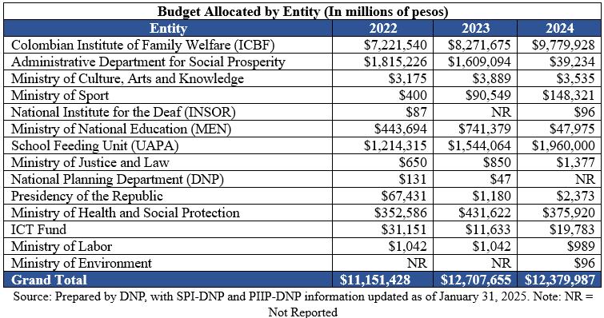
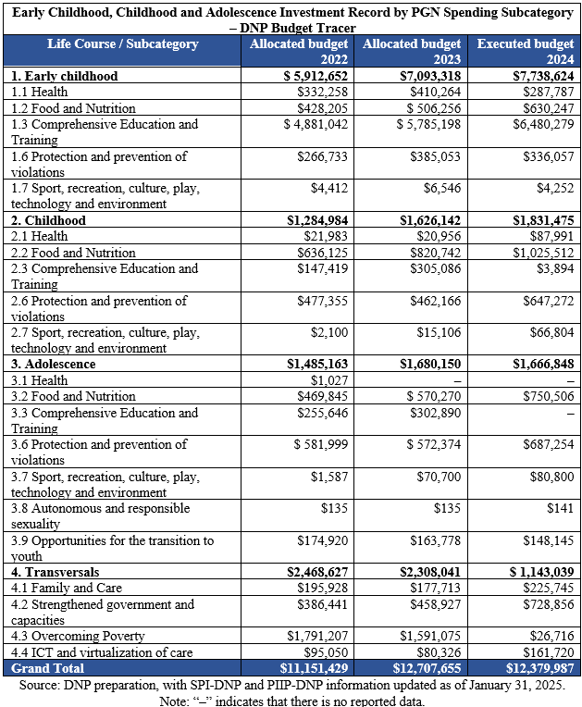
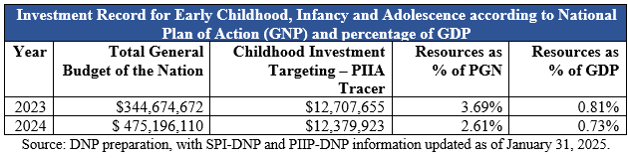

Reply to the issue raised in paragraph 16 (a)
117. The decision to class an act as “torture” may be made only by judges and the Attorney General’s Office. The decision is made on the basis of an examination of the information obtained through the criminal investigation.

Torture
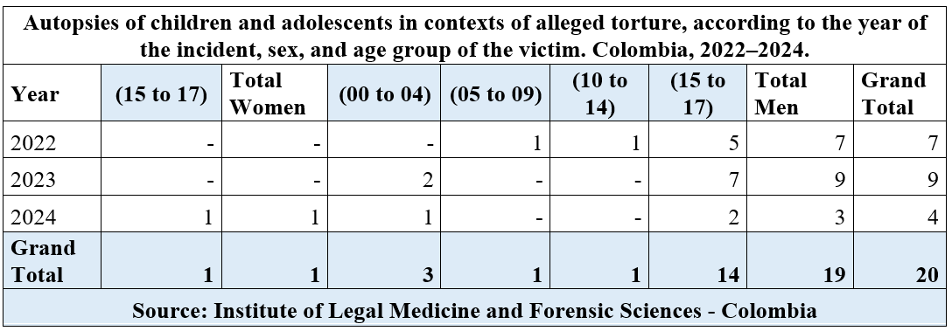
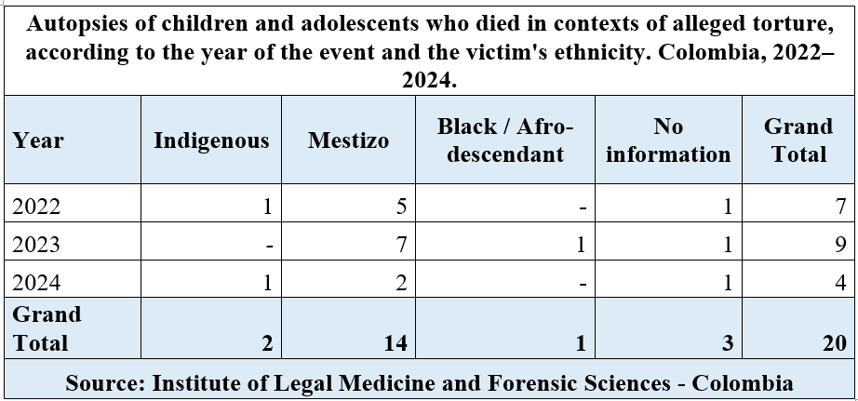
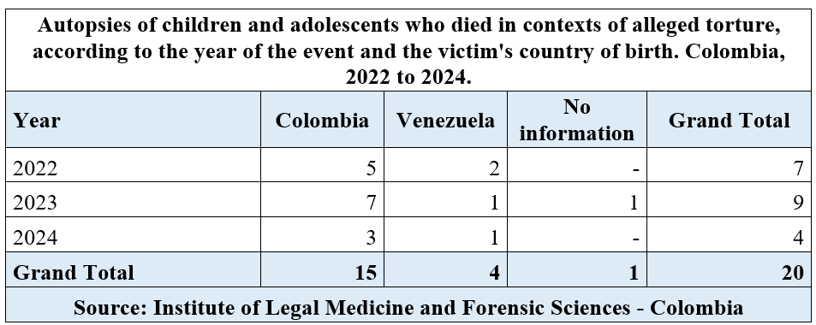
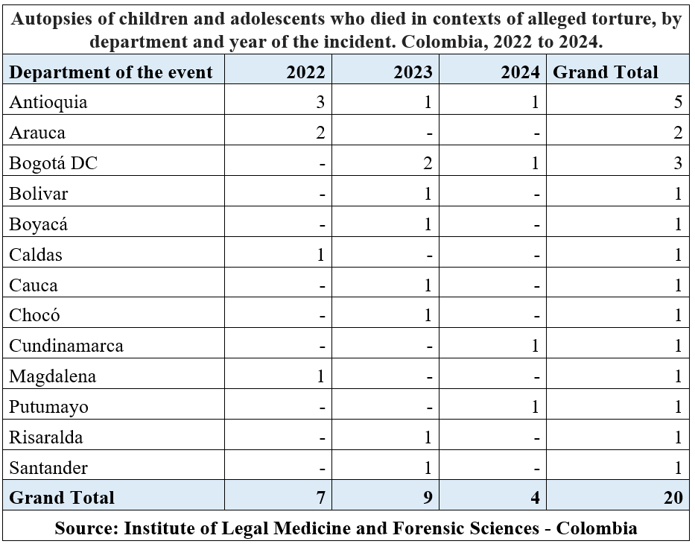

Disappearance
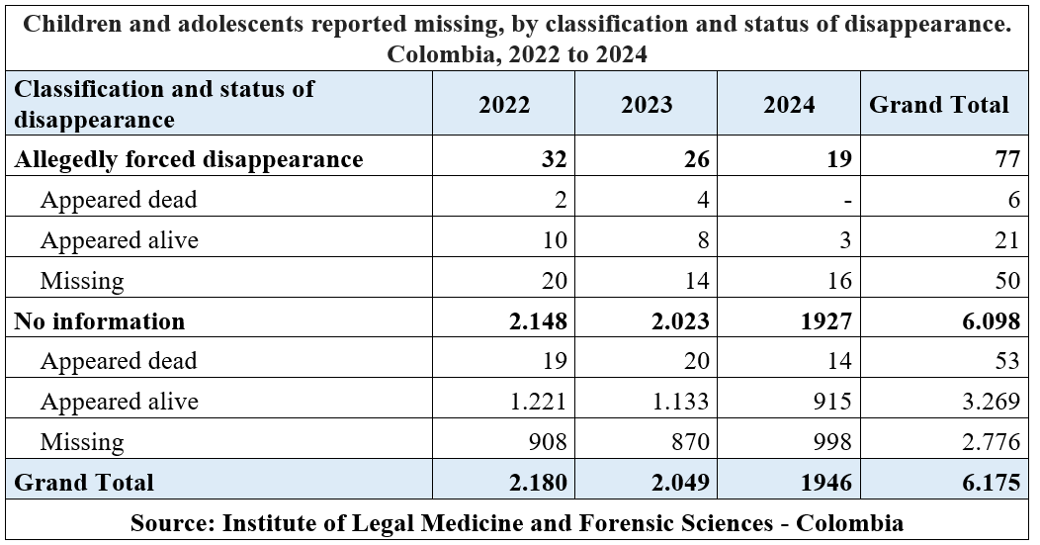
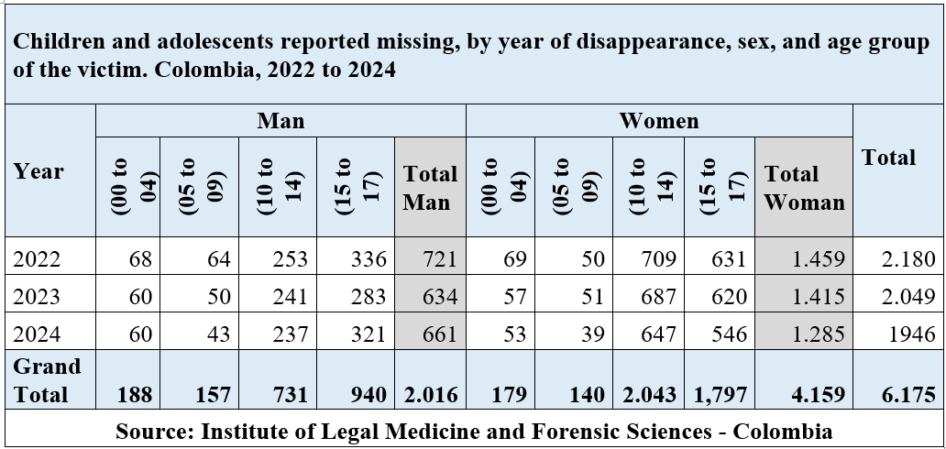
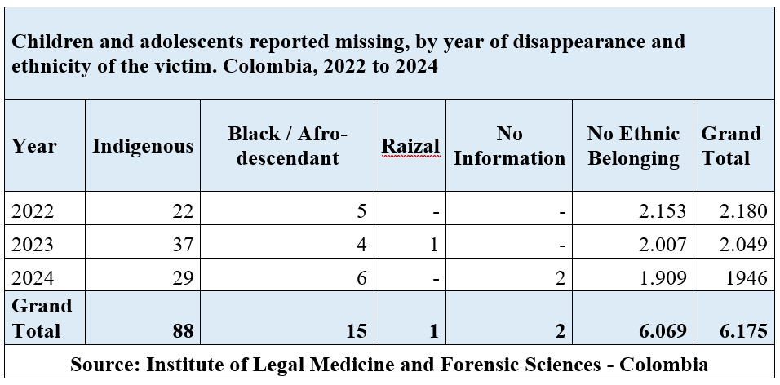
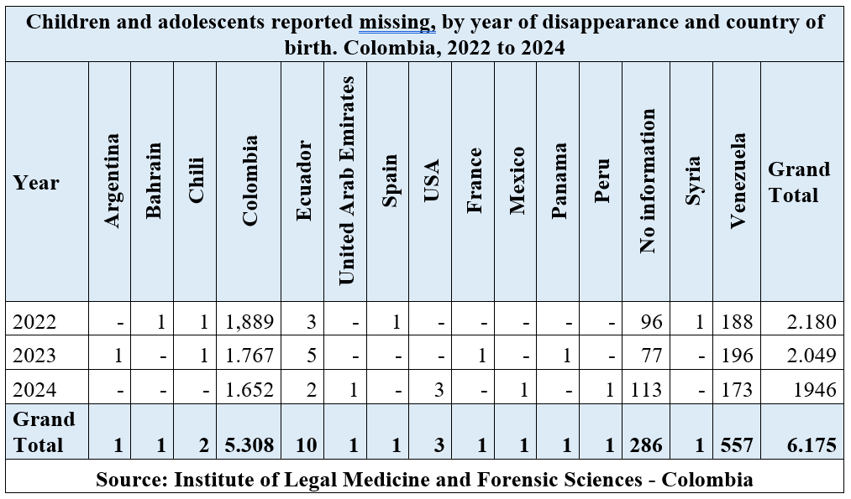
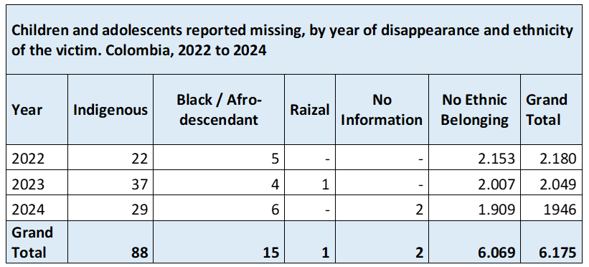
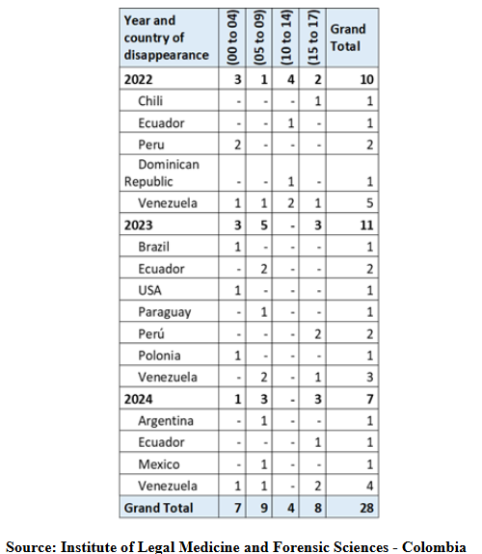
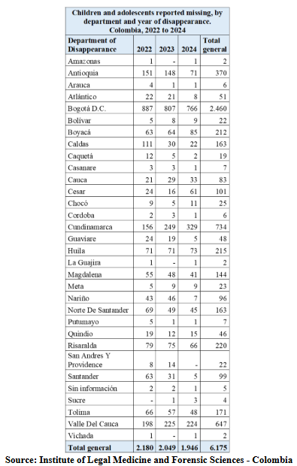

Reply to the issue raised in paragraph 16 (b)
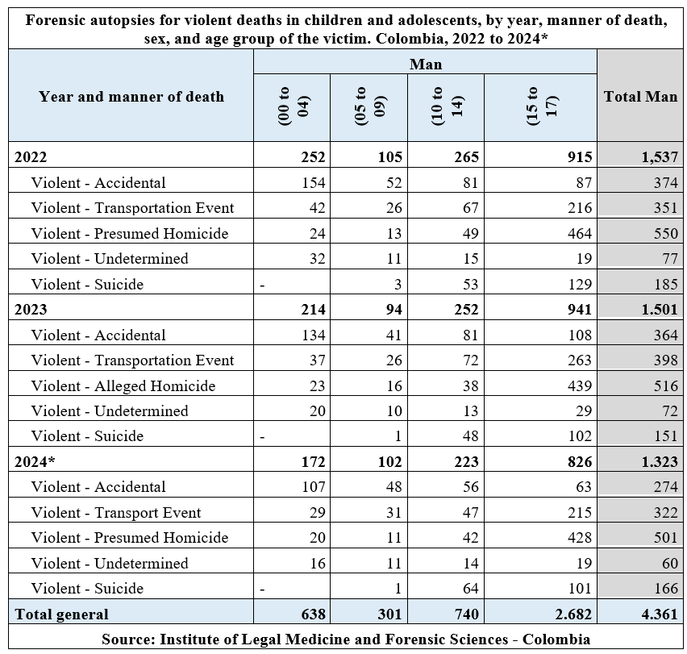
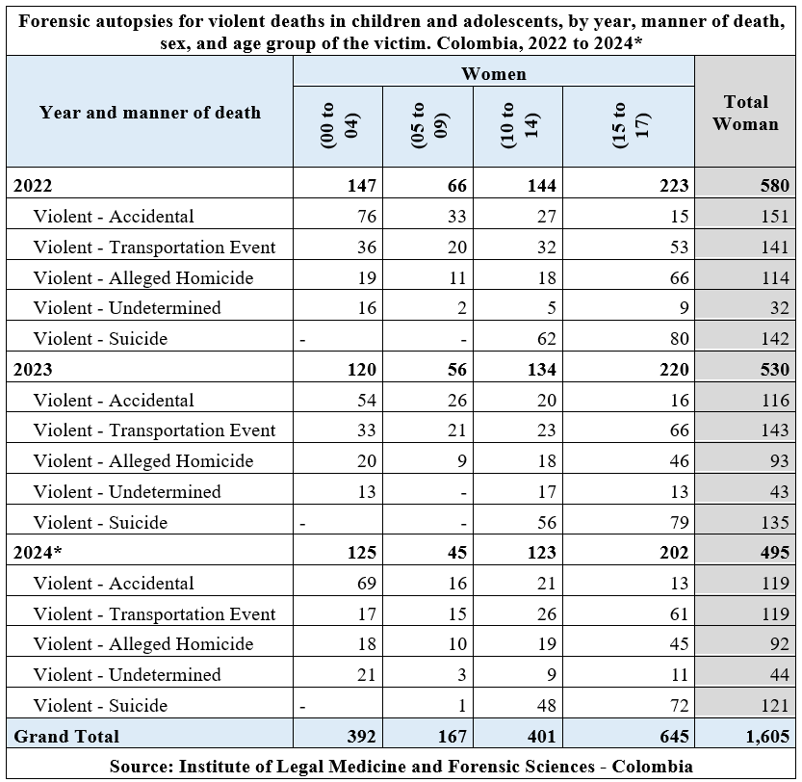
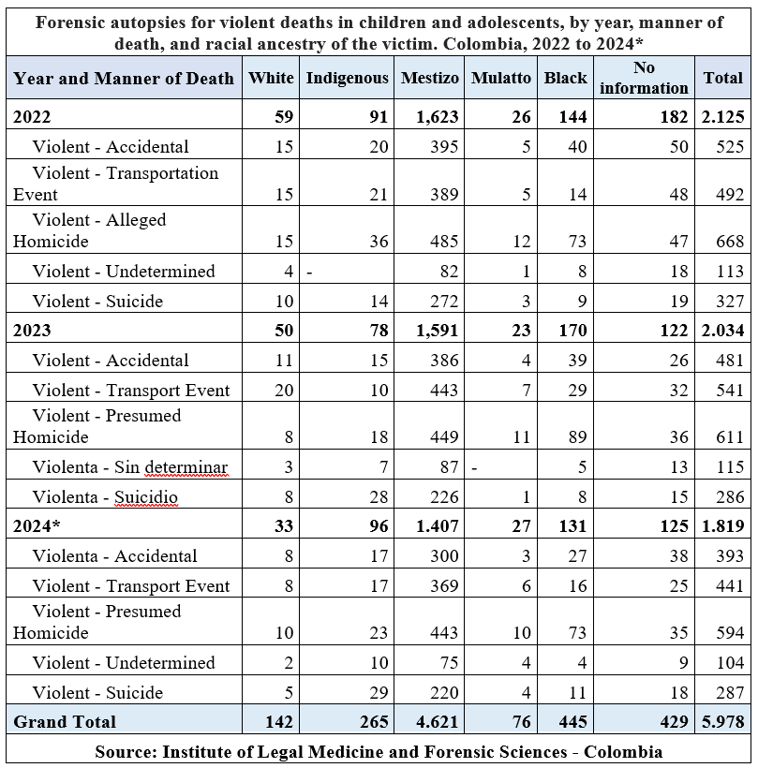
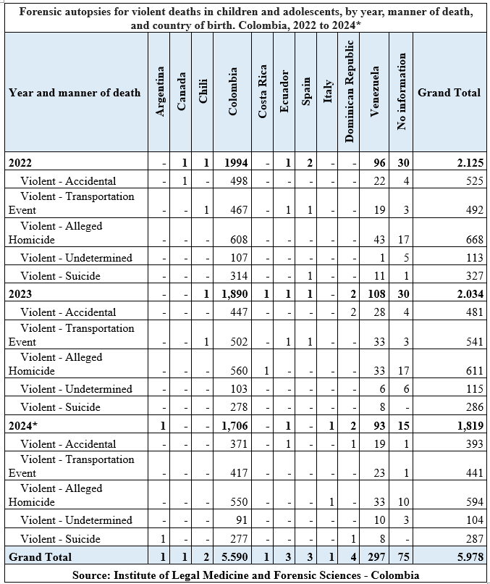

Reply to the issues raised in paragraph 16 (c)
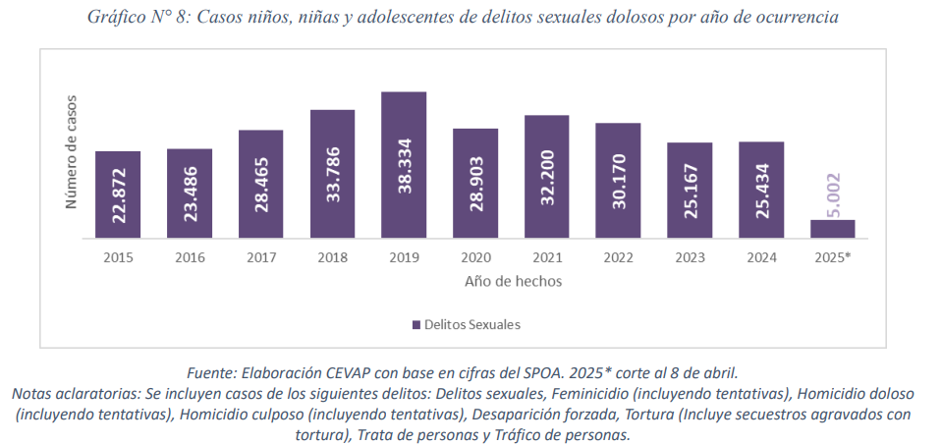
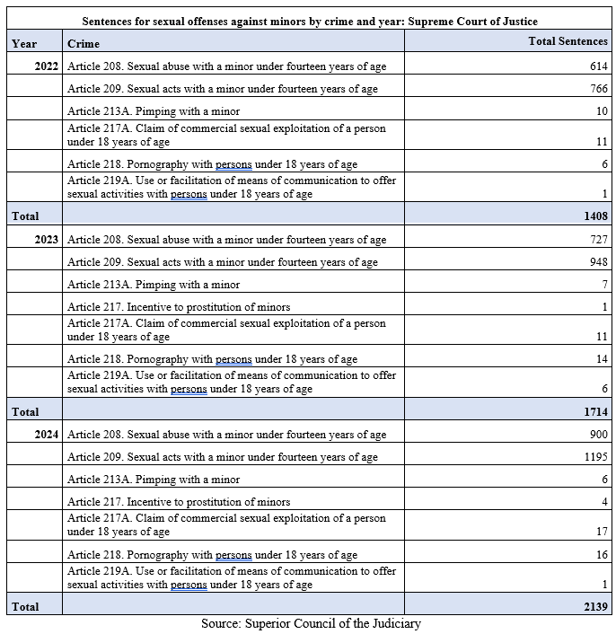

Reply to the issues raised in paragraph 16 (d)
118. An estimate of the number of adolescent pregnancies in Colombia can be made by adding the number of live births to girls between 12 and 18 and the number of stillbirths. The National Department of Statistics reported that the total number of live births and stillbirths to such girls decreased from 72,956 in 2022 to 48,826 in 2024, a drop of 33.1 per cent.

Reply to the issues raised in paragraph 16 (e)
119. The national survey on the use of psychoactive substances was conducted under an agreement with the Ministry of Justice using the methodology of the Inter-American Uniform Drug Use Data System. The results were as follows:
- Data collection period: October to December 2019
- Age range: 12 to 17 years
- Sample size: 3,599 children and adolescents
- Age at first use of cigarettes: 13.7 years
- Age at first use of alcoholic beverages: 13.9 years
- Age at first use of illegal psychoactive substances: 14

Reply to the issues raised in paragraph 16 (f)
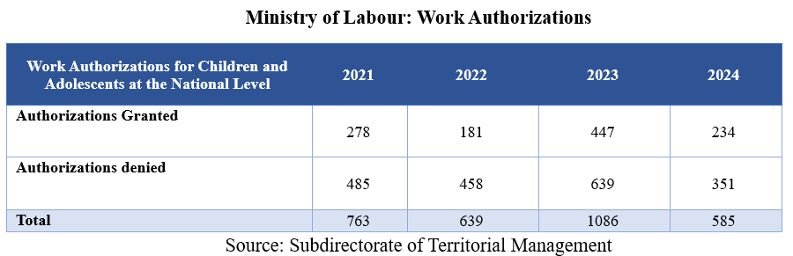
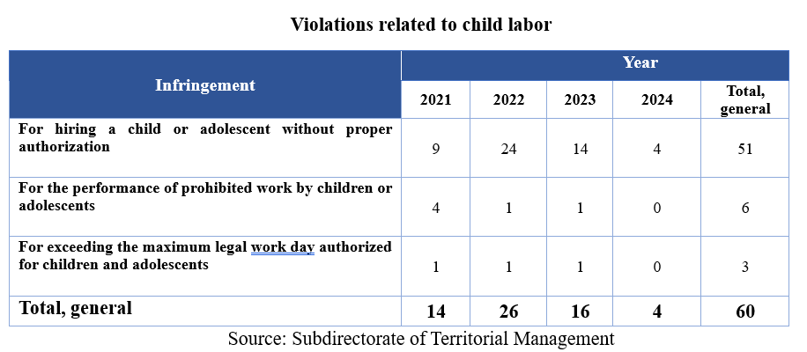
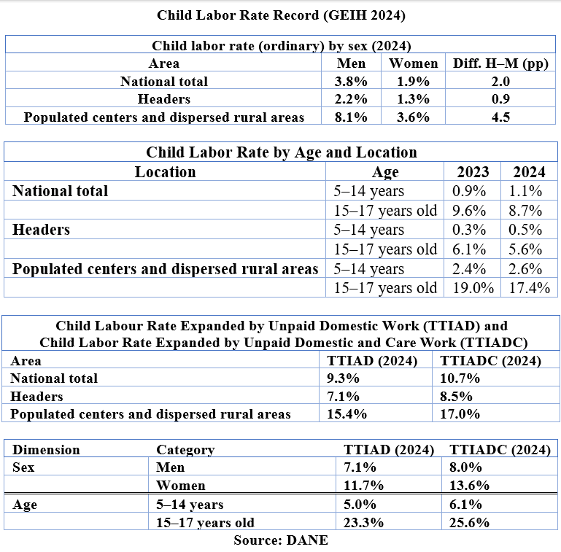

Reply to the issue raised in paragraph 16 (g)
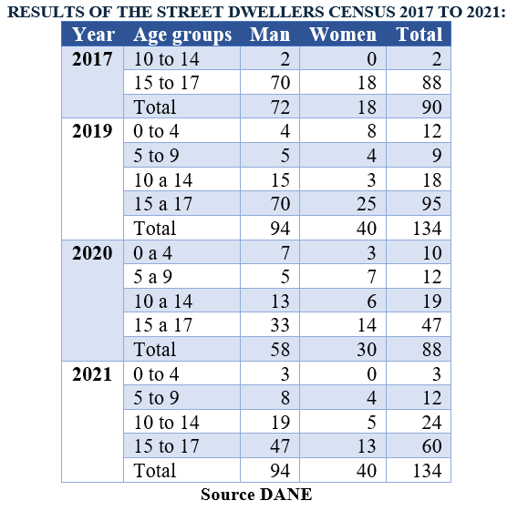

Reply to the issue raised in paragraph 16 (h)
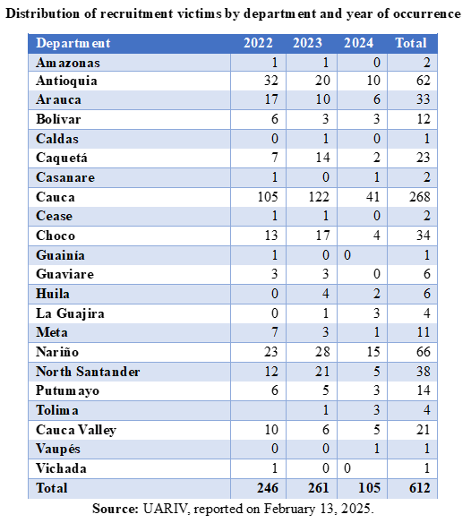
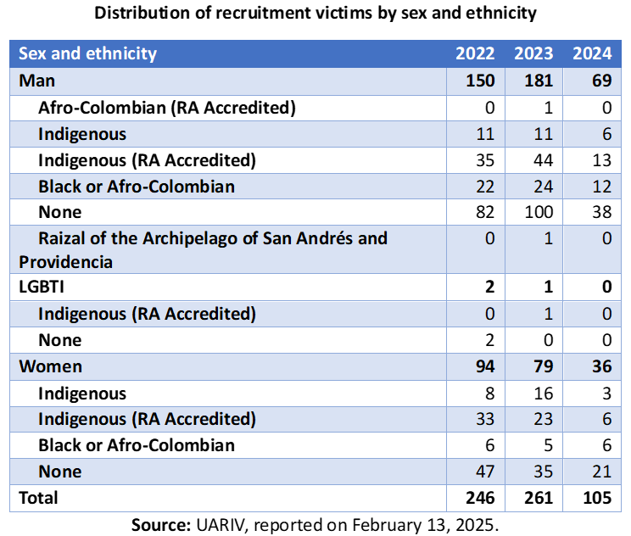
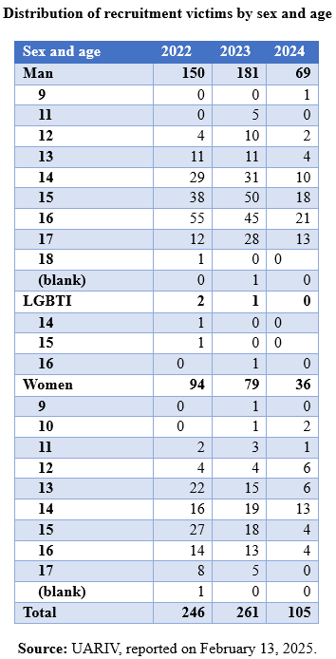

Reply to the issues raised in paragraph 17 (c)
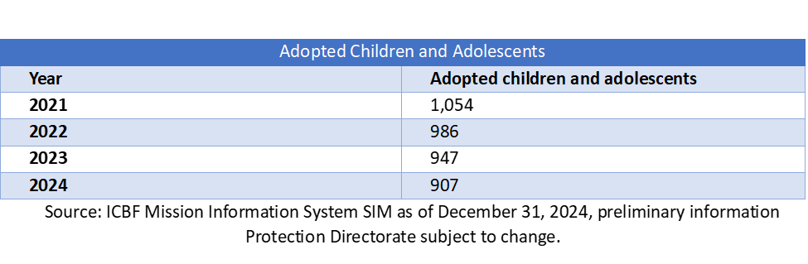

Reply to the issues raised in paragraph 18 (d) and (e)
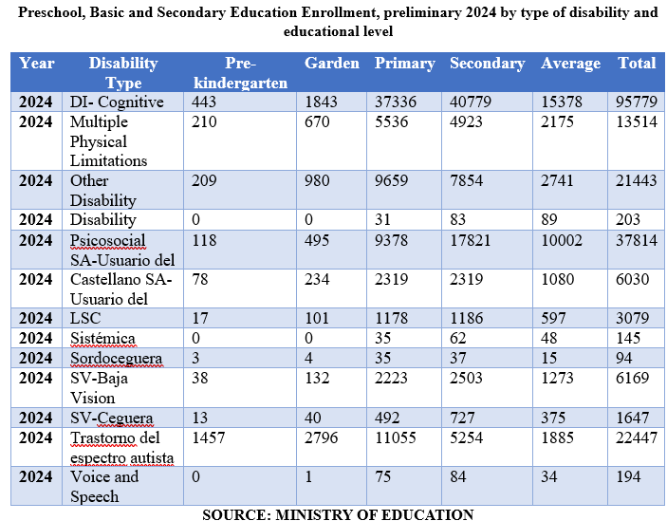

Reply to the issue raised in paragraph 18 (h)
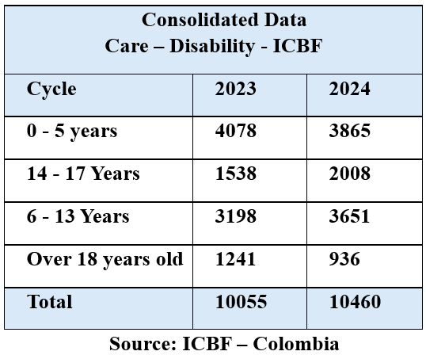

Reply to the issues raised in paragraph 19
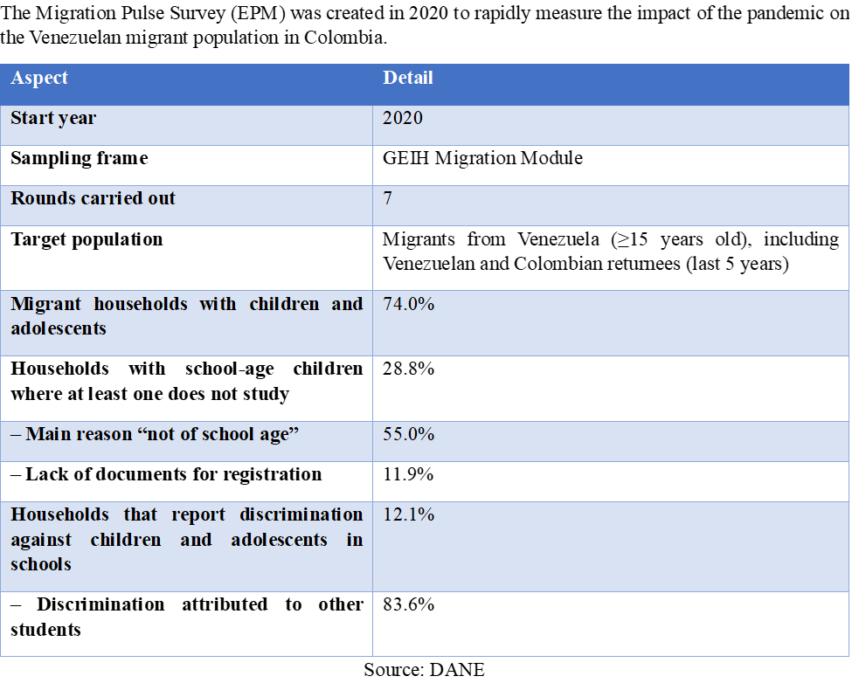

Reply to the issue raised in paragraph 20 (a)
120. The following graph shows the number of children and adolescents who entered the adolescent criminal justice system under Act No. 1098. The information that follows the graph was provided by the Attorney General’s Office.
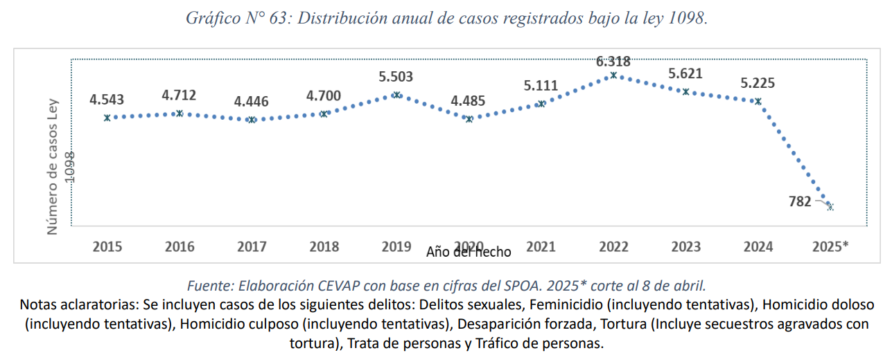
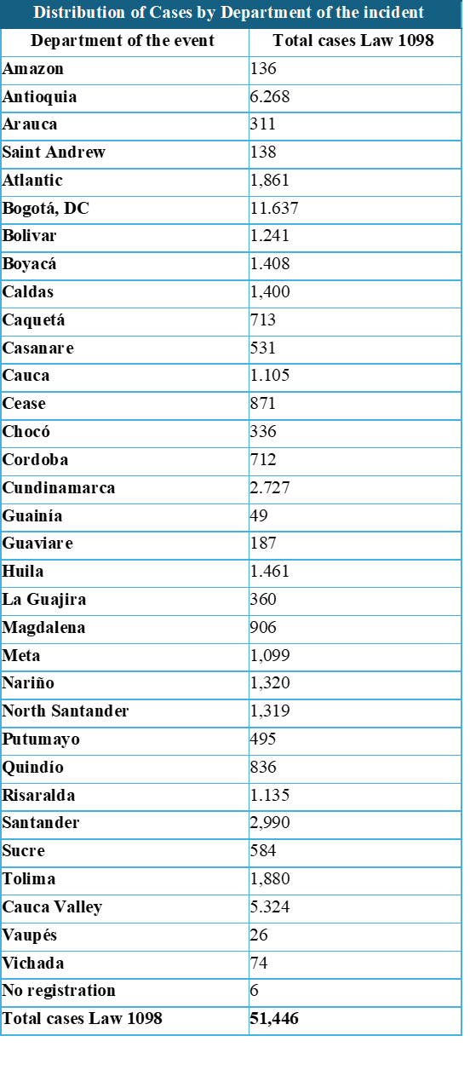
Source: Attorney General’s Office.

Reply to the issue raised in paragraph 20 (b)
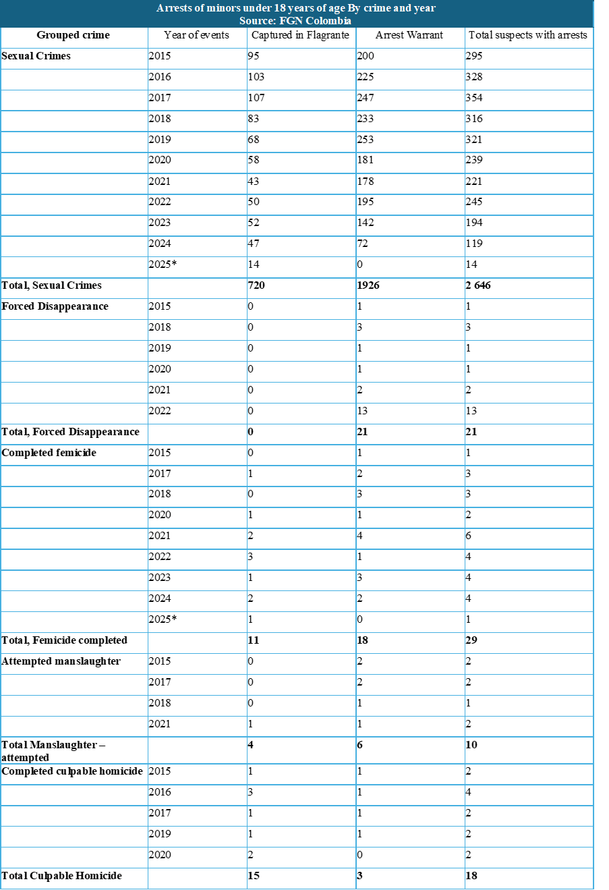
Source: Attorney General’s Office.

Reply to the issue raised in paragraph 20 (c)
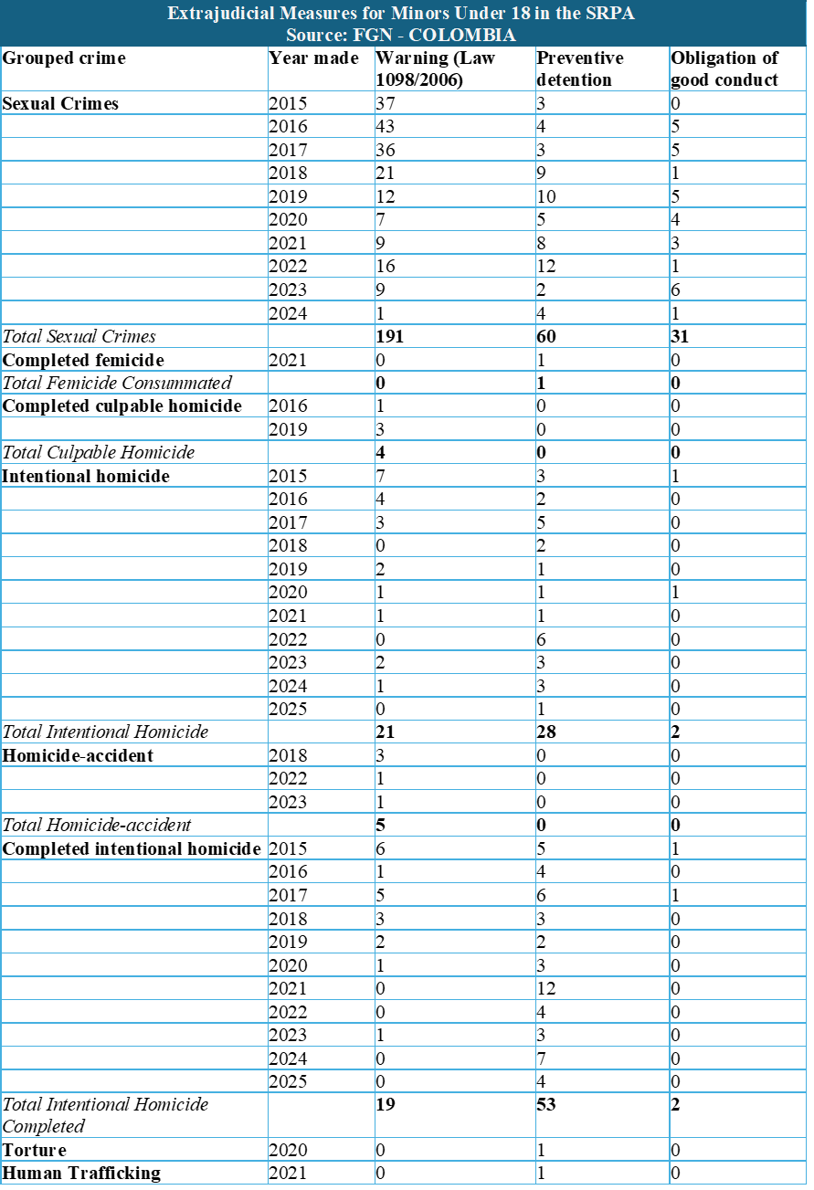
Source: Attorney General’s Office.

Reply to the issues raised in paragraph 21
121. It is important to mark the thirty-fifth anniversary of the Convention on the Rights of the Child by renewing the collective commitment to children, upholding the rights recognized in the Convention, creating new spaces for children’s participation, listening to their voices and acting with determination and discipline to eradicate poverty, violence and all violations that affect them.
122. Children and adolescents played a leading role in the event held in 2024 to commemorate the thirty-fifth anniversary of the Convention. The event, which was organized by the Colombian Family Welfare Institute together with UNICEF, NiñezYA, Alianza por la niñez colombiana, Coalición contra la vinculación de niños, niñas y jóvenes al conflicto armado en Colombia and SOS Kinderdorf International, gave children and adolescents the opportunity to share their knowledge of their rights. The Colombian Family Welfare Institute established a team specializing in the Convention.
123. Colombia held the presidency of the sixteenth Conference of the Parties to the Convention on Biological Diversity. The theme of the event, “Conference of the Parties, Peace with Nature”, was chosen as it reflected the five key areas of action that brought together the national Government’s peace efforts and the commitment to promoting the objectives of the Convention on Biological Diversity. Colombia has promoted fulfilment of the right to enjoy a healthy environment through article 79 of Act No. 1098/2006, which establishes that children and adolescents are entitled to a good quality of life and a healthy environment, to live in dignity and to fully enjoy all their rights. It also supported the General Assembly resolution on the human right to a clean, healthy and sustainable environment and general comment No. 26 (2023) of the Committee on the Rights of the Child on children’s rights and the environment with a special focus on climate change.

Reply to the issue raised in paragraph 22
124. These replies contain updated data and statistics for review by the Committee. Updates for 2024 and 2025 have been provided for most of the data sets, which are complemented by the annexes containing information on efforts to guarantee the rights of children and adolescents.

Reply to the issue raised in paragraph 23
125. Armed groups have exploited the rise of social networks to recruit children and adolescents. As indicated by Scott Campbell, the representative in Colombia of the United Nations High Commissioner for Human Rights, there is a pressing need for platforms such as Meta and TikTok to adopt urgent measures and establish effective policies to prevent social networks from becoming a recruitment channel in Colombia.
126. With regard to the prevention of the recruitment, use and sexual abuse of children and adolescents, the “Social Networks Are Not What They Seem” strategy has been implemented in four departments, reaching 143 children and adolescents. Bill No. 261 of 2024 on the protection of minors on social networks has been put forward to prevent minors under 14 from obtaining access to or creating accounts on social networks without the express authorization of their parents or guardians.

* The present document is being issued without formal editing.
Under article 3 of Act No. 1098/2006, a child is defined as a person 12 and under, and an adolescent as a person over the age of 12 and under 18.
For a table of acronyms and abbreviations, see annex 1.
In this report, Col$ should be understood to mean Colombian pesos.
See annex 3, MINCULTURAS.
See annex 4, ICBF – CATATUMBO.
See annex 2, CPDDHH – CIPRUNNA.
In addition to the amounts reported, the Government allocates operational resources that are not included in the table.
The data on homicide are provided in the reply to the issue raised in paragraph 16 (b).

