 | United Nations | CRC/C/GTM/7
 | Convention on the  Rights of the Child |  | Distr.: General  12 October 2023  English  Original: Spanish  English, French and Spanish only
Committee on the Rights of the Child

Seventh periodic report submitted by Guatemala under article 44 of the Convention, due in 2023*
[Date received: 15 June 2023]

Introduction
1. The present report is submitted in response to the list of issues (CRC/C/GTM/QPR/7) and in follow-up to the concluding observations adopted on 2 February 2018 in relation to the combined fifth and sixth periodic reports of Guatemala, which include information on the progress made in the implementation of the Convention on the Rights of the Child.
2. With the objective of strengthening the institutional framework for peace and human rights, a Presidential Commission was established in 2020 to advise and coordinate with the various agencies of the executive branch to promote actions and mechanisms to ensure the effective enjoyment and protection of human rights, the fulfilment of government commitments arising from the Peace Agreements and efforts to address conflicts in the country.
3. The present report was prepared by the Presidential Commission using a methodology that allowed for the participation of not only State institutions, but also children and adolescents enrolled in public and private schools and institutions nationwide.
4. In compliance with the provisions of the Convention on the Rights of the Child regarding the need to ensure children’s right to express their views “freely in all matters affecting the child, the views of the child being given due weight in accordance with the age and maturity of the child”, in 2023, 2,400 children and adolescents of African descent or of Garifuna, Xinka, Maya or Ladino/mestizo ethnicity, as well as children and adolescents of foreign nationality living in Guatemala, participated in 22 departmental consultations, which for the first time covered all the peoples and departments that make up the State.
5. The participating children and adolescents identified, among the rights they perceive as being ensured, the rights to education, health and food. The rights that in their view should be ensured for all children and adolescents in Guatemala include the rights to education, life, health, food, happiness and recreation, among others. They thus demonstrated a high level of awareness and knowledge of their rights.

Replies to the list of issues prior to submission of the seventh periodic report of Guatemala (CRC/C/GTM/QPR/7)

Reply to the issues raised in paragraphs 2 and 3
6. Guatemala is a pioneer in the region in terms of providing assistance to populations whose rights have been violated, with the implementation, using a systemic approach, of three models of assistance to victims, two of which are specially designed for children and adolescents. This represents a major change and a watershed in the State’s approach to respecting and protecting rights and restoring those that have been violated, through services provided 24 hours a day, 365 days a year, under the following models:
- Comprehensive Support Model for Children and Adolescents.
- Comprehensive Support Model for Juvenile Criminal Justice.
- I’x Kem Comprehensive Support Model for Women Victims of Violence.

Each model involves the following institutions:
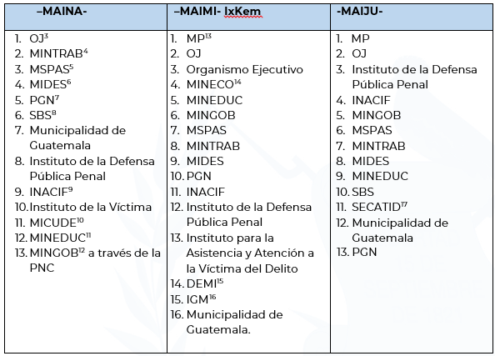
7. The Comprehensive Support Model for Children and Adolescents is a new, gender-and culture-sensitive system for providing access to justice in a specialized, victim-centred and age-appropriate manner. It provides for redress for harm caused to child and adolescent victims of human rights violations. The system was set up with support from the United States Agency for International Development (USAID).
8. Under this model, the State has established a mechanism that optimizes comprehensive support for child and adolescent victims. The participating institutions coordinate with each other to provide quality, caring services to this population group, which is at heightened risk of vulnerability.
9. The Comprehensive Support Model for Children and Adolescents also ensures personal protection and the reduction of practices that lead to secondary victimization of child and adolescent victims of crime, by providing legal, psychological, social and health services and guidance in a single location. In addition, it helps to reduce impunity among perpetrators by ensuring that criminal justice proceedings are initiated when required.
10. From the time of the model’s creation up until May 2023, at least 12,036 child and adolescent victims have received assistance; through this model, the Office of the Public Prosecutor for Children and Adolescents has achieved 97 per cent effectiveness. Requests for arrest warrants and for raids of premises in connection with offences committed against children and adolescents have increased by 70 per cent and 74 per cent, respectively. This is a positive development, as it shows that persons who make use of the model have access to justice.
11. The Comprehensive Support Model for Children and Adolescents is a pioneer in Latin America. There are plans to extend it to other parts of the country, in particular the departments of Quetzaltenango and Escuintla, in order to continue providing comprehensive care to child and adolescent victims.

Comprehensive Support Model for Juvenile Criminal Justice
12. Under this model, adolescents in conflict with the criminal law receive immediate, comprehensive and specialized services. The model is headed by the Office of the Prosecutor for Adolescents in Conflict with the Criminal Law, a division of the Public Prosecution Service, which coordinates with all institutions to ensure comprehensive, human rights-based assistance tailored to each profile. The purpose of the model is to promote successful social reintegration by providing legal, social, educational and medical assistance, as well as other services as needed.
13. Emphasis is placed on the social and educational aims of the specialized fields of juvenile criminal justice and restorative justice. Each participating institution is empowered to take decisions in accordance with its mandate in providing legal, social, educational, psychological and medical assistance to adolescents in conflict with the criminal law, as well as the necessary services to meet their needs, measures to ascertain the truth and the administration of justice in a manner appropriate to the specific profile of each adolescent, while promoting the early conclusion of proceedings and alternatives to deprivation of liberty. In cases involving serious offences, decisions must be consistent with national and international standards and be based on the best interests of adolescents, with a view to ensuring accountability, reintegration and resocialization.
14. According to data from the information system of the Public Prosecution Service, in 2022 the Office of the Prosecutor for Adolescents in Conflict with the Criminal Law, acting on the basis of the best interests of the adolescent and the aim of ensuring that adolescents in conflict with the criminal law are reintegrated into their families and society, exercised prosecutorial discretion in 545 cases and held 920 conciliation meetings. This model was supported by the USAID Youth and Gender Justice Project.

I’x Kem Comprehensive Support Model for Women Victims of Violence
15. This model focuses on the needs and interests of victims. It provides for quality assistance through differentiated, coordinated, multidisciplinary, specialized and centralized services. Its aim is to create conditions for comprehensively ensuring and protecting the human rights of women victims, in accordance with the mandate of each participating institution, by providing specialized justice with a gender and intersectional perspective and in a culturally and linguistically appropriate way from the time a complaint is filed to the completion of the criminal proceedings.
16. The main results of this innovative model for providing comprehensive support to women victims of violence are divided into three areas: protection and assistance, investigation and criminal prosecution, and services for social and economic empowerment.
17. Since its creation, this model has dealt with 6,469 cases, provided 2,704 security and protection measures and received 2,159 cases through other channels. There have been 417 requests for arrest warrants, 1,334 investigation measures by the Specialized Criminal Investigation Division of the National Civil Police in cases not involving arrests in flagrante delicto and 1,317 requests to the Directorate for investigation, documentation, evidence packaging and crime scene processing.
18. Through inter-agency coordination, these three models allow for the provision of immediate and comprehensive assistance to ensure a differentiated and efficient response, while avoiding secondary victimization and improving criminal investigation mechanisms.
19. In 2020, the Institute for Assistance and Support to Victims of Crime began operations as the lead agency for victim-centred policies. It is responsible for providing free, specialized assistance and support to crime victims, with the aim of ensuring access to justice and fair treatment so that victims can receive the dignified, comprehensive and transformative reparation to which they are entitled.
20. The Guatemalan Congress is working on various initiatives, such as the proposed Framework Act for the Comprehensive Protection of Girl Victims of Sexual Violence (No. 5511); Decree No. 11-2022 amending the Criminal Code in relation to offences committed against children and adolescents using technological means; the proposed Act on the Non-Applicability of Statutory Limitations to Sexual Offences Committed against Minors (No. 5827); and the proposed Act for the Protection of Children and Adolescents from Cybercrime (No. 6023).
21. The initial training programmes of the School of Judicial Studies have included a specialized induction programme for personnel of the Totonicapán, Baja Verapaz and El Progreso Courts of First Instance for Children and Adolescents and for Adolescents in Conflict with the Criminal Law.

Measures taken to protect the rights of children in the context of the coronavirus disease (COVID-19) pandemic
22. In 2020 and 2021, the Ministry of Health and Social Welfare held two virtual courses to disseminate and implement a sociocultural guide for the community prevention, containment and management of COVID-19 cases among Indigenous Peoples. The course was attended by radio station directors and community reporters from 14 of the country’s departments. The seminar took a specific methodological approach that included respect for and promotion of the exercise of the rights of rural Indigenous children, in coordination with UNICEF.
23. The Ministry of Health and Social Welfare developed and disseminated health promotion and COVID-19 prevention materials on social media, with children, adolescents, parents, caregivers and teachers as the target audience. It is important to note that, through the Comprehensive Child Health Programme, educational materials were produced in coordination with other technical and regulatory programmes of the relevant department.
24. The Social Welfare Secretariat facilitated the delivery of humanitarian aid packages in the midst of the COVID-19 crisis. The packages, containing basic necessities, benefited children living in private child protection facilities, their caregivers and mothers enrolled in the “Mothers Conflicted by Motherhood” programme.
25. Since its establishment, the Guatemalan Institute for Migration has had specific programmes to assist both accompanied and unaccompanied children and adolescents. It began operations in 2021 and since then has provided assistance to children and adolescents returning from the United States of America and Mexico through a multidisciplinary team that focuses on prevention and management measures and/or the provision of health kits and mental health care to children and adolescents, regardless of whether they test positive or negative for COVID-19.
26. In the light of what took place at the Virgen de la Asunción care centre, and to ensure that such events do not recur, the Government has taken human rights-based measures that meet international standards and ensure the best interests of children and adolescents, with a view to restoring their rights. These measures include the following:
- The Virgen de la Asunción centre has been closed and a new residential model with differentiated, specialized and relevant services has been implemented; 21 such facilities are now in operation.
- The Social Welfare Secretariat established a unit to follow up on the 15 adolescent survivors of the tragedy. By law they were granted life pensions, with the aim of enabling them to build a transformative and productive future.
- On the basis of international standards, 14 protocols were drawn up, one of which concerns complaints and reporting. The purpose of this protocol is to provide a means of establishing whether the human rights of children and adolescents under the protection and care of the State are being violated.
- Computer software is used to record information on six fundamental rights: the rights to identity, health, family, education, decent living conditions and specialized care.
- Staff of the Social Welfare Secretariat participated in 247 workshops, at which they acquired knowledge and tools for providing care and assistance to children and adolescents.

Child protection system
- The authorities have established a high-level committee consisting of representatives of the Social Welfare Secretariat, the Office of the Human Rights Advocate, the judiciary, the National Adoption Council and the Counsel General’s Office. Its role is to evaluate and implement actions for the benefit of children and adolescents in child protection facilities.
- Between 2020 and 2023, 2,342 children and adolescents in such facilities were reintegrated into their families and 20,272 unaccompanied migrant children and adolescents received comprehensive care.
- Children and adolescents in child protection facilities were enrolled in school through flexible remote learning arrangements approved by the Ministry of Education.

Adolescents in juvenile detention centres
- Through administrative, technical and operational reorganization and the use of alternatives to deprivation of liberty, overcrowding was reduced by 100 per cent, with the result that there have been no riots in the last five years.
- A new model for the treatment of juvenile offenders has been implemented, under which juveniles are treated with dignity and humanity, their education, health and safety are ensured and restorative justice is applied.
- A halfway house, or semi-open facility, is now in operation and is a groundbreaking initiative in the region. It makes use of progressive treatment, behavioural re-education and occupational training to facilitate reintegration into society.
- At the specialized reintegration centre, which can accommodate 160 adolescents, living and sanitary conditions have been improved and personalized attention is provided.
- The renovation of the annex to the juvenile detention centre for boys, which meets international standards, is 95 per cent complete.
- Training has been provided to 118 monitors on security and custody of adolescents in conflict with the criminal law.
- Over the past three years, 1,358 adolescents have been enrolled in school at different levels; 84 have enrolled in a private university, 190 have obtained a secondary-school diploma and 456 have participated in vocational training courses.
27. The action taken by the Council during the COVID-19 pandemic included, inter alia, supervisory services, workshops, monitoring and follow-up of containment measures directed towards children and adolescents and the professionals responsible for their care. Evaluations, advisory services and authorization and/or revalidation of child protection facilities were carried out virtually, as appropriate.
28. Virtual communications were an alternative that made it possible to carry out the aforementioned processes during the COVID-19 pandemic. However, the main limitations of this modality become evident in processes involving measurement, evaluation and verification that procedures have been carried out or followed up.
29. Since 2018, the relevant unit of the Counsel General’s Office has been strengthened with the establishment of eight specific work areas, in addition to the approval of various handbooks and procedural guides for assistance to children and adolescents in accordance with their specific needs. Adequate spaces for attending to users of the different services were created and remodelled.
30. In 2018 the Counsel General’s Office approved regulations for the Office of the Advocate for Children and Adolescents, whose purpose is to continually improve the services provided to unaccompanied Guatemalan and foreign children and adolescents so as to expedite administrative and judicial processes and make them more effective.
31. Other adopted instruments that are relevant to the work of the Office of the Advocate for Children and Adolescents include the 2019 protocol of the Counsel General’s Office for assisting unaccompanied foreign children and adolescents who are in Guatemalan territory owing to situations of population displacement, which was updated in 2021, and a handbook and guidelines for the processing of statistical data on children and adolescents. In 2021, a handbook was published on interviewing and specialized forensic evaluation of children and adolescents, for use by the Counsel General’s Office.
32. It should also be noted that in 2019 the Counsel General’s Office carried out academic initiatives on topics such as prevention of child abuse, strengthening of local coordinators for locating and tracing children and adolescents, psychological support in cases of sexual violence against children and adolescents, the operation of the Comprehensive Support Model for Children and Adolescents and the strengthening of processes related to judicial protection measures, under which capacity-building was provided to more than 300 staff members.
33. On 18 April 2023, Ministerial Decision No. 187-2023 of the Ministry of Labour and Social Security was published, creating an electronic referral platform that includes: (a) recording of information on children and adolescents found by the Ministry to be in situations of child labour; and (b) referral of specific cases of children and adolescents in situations of child labour to social programmes run by public institutions or private entities.

Rights under the Convention and the Optional Protocols thereto

Reply to the issues raised in paragraph 4
34. The current status of bill No. 5285 in the legislative process is that it is awaiting presentation and discussion on third reading, after which the bill’s final wording can be negotiated, amendments can be made and the bill can be voted on article by article and adopted. Positive legislation in this area is already in force and promotes comprehensive respect for and protection of the rights of children and adolescents. It is applied through actions carried out by institutions such as the Counsel General’s Office, the judiciary, the National Commission on Children and Adolescents, the Social Welfare Secretariat and the Secretariat against Sexual Violence, Exploitation and Trafficking in Persons.
35. Bill No. 5464 is intended to prevent, punish and eradicate child and adolescent marriage and de facto unions. Regarding child marriage, in 2017, by Decree No. 13-2017, the Guatemalan Congress removed this possibility from the country’s laws by amending the Civil Code and expressly prohibiting the practice. Specifically, article 83 reads as follows: “Prohibition of marriage. Minors under the age of 18 years may not enter into marriage or in any way be authorized to do so.”
36. The Act against Sexual Violence, Exploitation and Trafficking in Persons was promulgated by Decree No. 09-2009, considering that the State has ratified the Convention on the Rights of the Child, under which States parties are to take the necessary legislative measures to ensure the right of children and adolescents to be protected from exploitation and violence. In addition, the Decree amended and added criminal law provisions for the protection of sexual freedom and integrity.
37. Offences of sexual violence are always considered to have been committed when the victim is under the age of 14 years or has a volitional or cognitive disability, even if there is no physical or psychological violence. The penalty is imposed without prejudice to such penalties as may be appropriate for the commission of other offences. The Decree also added the following definition: “Article 173 bis. Sexual assault. Any person who, with physical or psychological violence, performs acts for sexual or erotic purposes on another person, on the aggressor or on himself or herself, provided that they do not amount to the offence of rape, shall be liable to 5 to 8 years’ imprisonment.”
38. As Guatemalan law already criminalizes the act of engaging in sexual relations or acts for sexual or erotic purposes with any minor under the age of 14 years, the content of bill No. 5464 is already in effect in the current legal system.

Reply to the issues raised in paragraph 5
39. The Ministry of Education, through the early education programme Acompáñame a Crecer (Help Me Grow), helps to prevent malnutrition in children up to 4 years old and their families, to enhance comprehensive early childhood development. It offers individual and group training sessions to families, pregnant women and nursing mothers on the topics of early learning, health and hygiene, nutrition and food security, protection and safety, and understanding and commitment, as ways of promoting the optimal growth and development of the child.
40. The Ministry contributes directly, through the School Meals Programme, to the public policy for food and nutritional security and to the great national crusade for nutrition, providing healthy food to preschool and primary school children in public schools. The School Meals Programme benefited 2.5 million pupils in 2019 and 2020; its coverage was expanded in 2021 and 2022 to 2.6 million pupils, with expenditure of 8,231.32 million quetzales (Q) in those years, to contribute to the growth and development of school-age children and adolescents.
41. The Early Childhood thematic subcommittee of the Cabinet Committee for Social Development is updating the public policy on comprehensive early childhood development, with the Ministry of Health and Social Welfare as the lead agency in charge of managing and updating the policy, following the guidelines established by the relevant unit, in which five phases are described: (I) identification of the problem, (II) identification of solutions, (III) decision-making, (IV) implementation and (V) monitoring and evaluation.
42. This inclusive process has involved efforts to obtain different perspectives through consultations, workshops and discussions with State institutions and with non-governmental organizations and agencies specializing in the field of international cooperation.
43. In response to the Sustainable Development Goals, to eradicate poverty and as part of a new development and protection agenda, the Ministry of Labour and Social Security joined the Breastfeeding-Friendly Spaces Initiative in conjunction with UNICEF and has undertaken to promote this initiative in public and private institutions. As part of the Breastfeeding-Friendly Spaces Initiative, a guide for breastfeeding-friendly spaces was officially launched as a means of urging compliance with national and international standards on labour rights, specifically those of women.

Reply to the issues raised in paragraph 6
44. The Social Welfare Secretariat drew up a strategy for strengthening the National Commission on Children and Adolescents, with the aim of enhancing the status and ensuring the financial and administrative independence of the Commission. The strategy included giving priority, in 2022, to the review of and proposals on the Commission’s rules of procedure, a strategic plan with an administrative approach and a process of rethinking the public policy development model. These will be presented for adoption by the General Assembly of the Commission. Information on the Commission’s work is provided to the Council, the Association, the Office of the Vice-President and civil society at the national and regional levels.

Reply to the issues raised in paragraph 7
45. The Guatemalan Congress has worked on the following draft amendments: Decree No. 27-2003, Act on the Comprehensive Protection of Children and Adolescents; Bill No. 5285 on the Act on the National System for the Comprehensive Protection of Children and Adolescents; and Bill No. 5317 on the Act amending the Act on the Comprehensive Protection of Children and Adolescents.

Reply to the issues raised in paragraph 8
46. The Ministry of Finance, within its accounting system, has a transparency and accountability mechanism involving budget tagging, including child-focused expenditure tagging, through which entities identify the budgetary funding allocated to the population under 13 years of age. According to this system, budgetary expenditure tagged as child-focused amounted to Q 475.6 million in 2018, Q 11,090.0 million in 2019, Q 11,885.7 million in 2020, Q 12,742.1 in 2021 and Q 1,586.6 million up until November 2022.
47. The Public Prosecution Service, by means of Order No. 59-2019, strengthened the Office of the Special Prosecutor against Impunity by converting it to a Section Prosecutor’s Office that works in coordination with the Anti-Corruption Secretariat of the Public Prosecution Service, resulting in an increase in the number of cases prosecuted, criminal organizations dismantled and cases investigated.
48. The Presidential Commission against Corruption was established in 2020 to promote and strengthen measures to prevent and combat corruption and to promote integrity, accountability and the proper management of public affairs and public assets.
49. As part of the actions to alleviate the negative impact of the COVID-19 pandemic, the Ministry of Health and Social Welfare continued to implement preventive measures in respect of newborns, infants and children, both within facilities and in out-of-hospital settings through events spotlighting comprehensive health care.
50. During the COVID-19 pandemic, with the support of the Ministry of Health and Social Welfare, a vaccination plan was implemented to vaccinate children between the ages of 12 and 17 living in private child protection facilities. In addition, authorities and representatives of the protection system promoted workshops and forums on the proper care of children and adolescents in the context of the pandemic, such as “Childcare challenges during the coronavirus pandemic”, with the aim of strengthening the efforts of childcare-related public institutions to care for children and adolescents at risk of separation or living in child protection facilities.
51. A psychosocial and occupational treatment plan was implemented in child protection facilities during the pandemic with a view to providing psychosocial stability to children and adolescents and the staff caring for them.
52. The Ministry of Education, with support from parents’ organizations and local authorities, has continued to provide food to parents, guardians and caregivers of children and adolescents. In addition, infrastructure and basic service needs are addressed with the provision of canteens, kitchens, bathrooms, sinks and water supply projects to support the School Meals Programme.
53. In response to the COVID-19 emergency, the Ministry of Education adapted the Programme by arranging for the delivery of food rations to parents belonging to organizations, thus ensuring that pupils received meals without interruption.

Reply to the issues raised in paragraph 9
54. The Ministry of Social Development, through the National Social Information System, integrates and consolidates disaggregated information on social development obtained through social programmes carried out by different public sector entities. In 2022 the catalogue of peoples and language communities established by the relevant entity was updated; this information can be used to characterize the population. The Ministry of Social Development, in coordination with the relevant Secretariat, developed a dashboard on the National Strategy for the Prevention of Chronic Malnutrition 2016–2020. It shows information on population centres, programmes, benefits and beneficiaries, by institution.
55. Currently, for the first time, the Ministry is creating a Social Services Registry of Households, which is an inventory of households designed to identify families’ characteristics in order to determine which families are most in need.
56. This will ensure that problems hindering the enjoyment of rights are brought to the Government’s attention by shedding light on factors such as housing conditions, employment, the current education levels of children and adolescents, the education levels completed by parents and whether the family has migrated.
57. This information is recorded so that the Government can then design social protection programmes to improve living conditions. In November 2019, the Ministry officially launched the Multidimensional Poverty Index for Guatemala after a process of consultation and discussion with different governmental and non-governmental stakeholders in 2017 and 2018.
58. The index is made up of five dimensions: health and food and nutritional security, education, decent work, access to services, and housing. It comprises 17 indicators. Its purpose is to support technical and policy decision-making with a view to the proper planning, programming and allocation of State resources. It serves as a tool for monitoring and evaluation based on national development priorities, as defined in the National Development Plan “Nuestra Guatemala K’atun 2032” and the 2030 Agenda for Sustainable Development, to promote social welfare and equal opportunities, with a focus on the population living in multidimensional poverty.
59. Between 2018 and 2022, the Ministry of Agriculture, Livestock and Food saw an increase of 270 per cent for programmes related to food security and chronic malnutrition.

Reply to the issues raised in paragraph 10
60. In December 2021, the Presidential Commission for Peace and Human Rights initiated the process for the collection of information for the baseline assessment on business and human rights, with the cooperation and guidance of the Office of the United Nations High Commissioner for Human Rights. A four-phase methodology was developed. The first phase, which involved gathering information from government institutions, has been completed.

Reply to the issues raised in paragraph 11
61. Between 2019 and 2022 the National Adoption Council conducted 1,680 oversight visits to child protection facilities, both public and private, encouraging facility directors to strengthen family ties through family visits, calls and residential trips, to promote the importance of family reunification and avoid prolonged institutionalization.
62. In addition, in 2019 and 2020 the Council carried out training and professional development activities for staff to strengthen their capacities and best practices in relation to human rights. Such activities included “Strengthening the adoption process and best practices in relation to children’s and adolescents’ rights”; the international seminar “Ending child and adolescent incarceration”; the workshop “Training and strengthening of the adoption process and best practices in relation to children’s and adolescents’ rights”; and the “Workshop on Prevention of Sexual Violence, Exploitation and Trafficking in Persons”, among others.
63. Virtual and in-person training, coordinated with the Secretariat against Sexual Violence, Exploitation and Trafficking in Persons, was provided for public and private child protection facilities. The training, entitled “A comprehensive approach to sexual violence, exploitation and trafficking in persons”, with a focus on children and adolescents, was attended by 295 individuals from the 127 facilities registered with the National Adoption Council.
64. Between 2019 and September 2022, 445 professional consultations with a human rights approach were carried out to guide facility directors and multidisciplinary teams on the comprehensive care of children and adolescents and to ensure respect for their human rights, without discrimination of any kind and in accordance with the quality standards for the care of children and adolescents in child protection facilities.
65. The Counsel General’s Office, through the Office of the Advocate for Children and Adolescents, carries out various actions for the care and protection of children and adolescents whose rights have been threatened or violated, such as initiating protection proceedings before the competent courts and filing complaints with the Public Prosecution Service in cases where criminal acts may have been committed against children and adolescents, in addition to issuing legal opinions in judicial, notarial and administrative proceedings. These actions are carried out in the interest of respecting and defending the rights of children and adolescents in a comprehensive, specialized and individualized manner, in accordance with the needs of each child or adolescent and the nature of the violation of his or her rights.
66. The Ministry of Education provides educational materials for the primary and secondary school levels. Non-formal education programmes cover topics related to human rights; in addition, tutors and mentors further reinforce these concepts. Action is also taken through educational radio programmes. More than 40 programmes with segments on human rights awareness were broadcast in 2022. The education-oriented community radio stations Quezada and Momostenango keep human rights issues on their regular programming schedule by running eight spots each.
67. The Ministry of Education has taken the following actions:
(a) From 2020 to 2022, the relevant Directorate General addressed the issue of promoting bilingual intercultural education at the pre-primary and primary education levels by printing folders, promotional calendars and poster designs for pandemic safety protocols in the Mayan languages Garifuna, K’iche’, Kaqchikel, Q’eqchi’ and Mam, to raise teachers’ awareness of the need to teach Indigenous children in their native language and in the context of their own culture, so as to ensure their right to a contextually appropriate education;
(b) Training courses and workshops were held with teachers to ensure that teaching takes due account of students’ cultural and linguistic background. Radio spots were recorded to promote the education of Indigenous children in accordance with their culture and language at the pre-primary and primary levels. Educational materials were developed in the minority Mayan languages Q’aanjob’al, Tz’utujil, Itzá, Chuj and Achi’ for use by the education community;
(c) As a form of inter-agency coordination to promote better understanding of the human rights of children and adolescents, training sessions on the Constitution of Guatemala were carried out with different authorities, such as the relevant court;
(d) The School Meals Programme has positioned itself in the School Meals Coalition as a model of decentralized implementation through 22,882 parents’ organizations, 57 per cent of which are headed by women;
(e) Educational materials have been designed, produced and distributed in 15 national languages: K’iche’, Kaqchikel, Q’eqchi’, Mam, Q’aanjob’al, Tz’utujil, Ixil, Achi’, Itzá, Ch’orti’, Popti’, Poqomchí, Chuj, Garifuna, Xinka and Spanish. These materials have benefited 1.4 million students, with an investment of Q 36.7 million;
(f) An inclusion strategy has been implemented for students with disabilities in situations of vulnerability, with the provision of an annual subsidy of Q 1,000 to each student to promote the completion of each level of education. In 2020 and 2021 an amount of Q 12.3 million was invested, benefiting 11,537 students.
68. By Legislative Decree No. 3-2020, Congress adopted the Guatemalan Sign Language Act, which provides for the inclusion of students with hearing impairments in the national education system. Teachers have received training on deaf culture, and courses on Guatemalan Sign Language have been delivered. These practices help to reduce the inequality gap among persons with disabilities.
69. Children and adolescents under the protection of the Social Welfare Secretariat receive services and access to education in public schools with curricular adaptations according to disability, as determined by Ministry of Education professionals. In addition to attending special schools according to the type of disability, each resident receives educational follow-up in the residence to reinforce the content learned.
70. The Social Welfare Secretariat coordinates with the team of professionals to ensure that children and adolescents have access to justice and that their other human rights to judicial protection and defence are duly respected.
71. The Guatemalan Institute for Migration observes the principle of non-discrimination, in accordance with the Act on the Comprehensive Protection of Children and Adolescents (Decree No. 27-2003), the Migration Code (Decree No. 44-2016) and the Convention on the Rights of the Child. Its actions include the development of a procedure for assisting unaccompanied children and adolescents, under which public institutions work in coordination.
72. In 2019 the Indigenous Peoples Secretariat of the Public Prosecution Service, in coordination with the relevant unit, held three training workshops for 56 students enrolled in the institution’s training programmes, at which the topic “Culture, children and Indigenous Peoples in Guatemala” was discussed. In 2022 workshops were held for prosecutorial staff on the topic “Specific rights of Indigenous children and adolescents”, in which approximately 594 people participated.

Reply to the issues raised in paragraph 12
73. In the Office of the Advocate for Children and Adolescents, all processes carried out in the different areas observe the best-interests principle, which is laid down in the various handbooks on standards and procedures as part of the general policies and standards to be followed. In addition, in 2019 the Office adopted a procedure for assessing and determining the best interests of children and adolescents. It is contained in the Counsel General’s Office guide for the assessment of the best interests of migrant children and adolescents, which was updated in 2021.
74. The Social Welfare Secretariat has implemented a protocol for complaints and reports, the main purpose of which is to directly ascertain the views of children and adolescents, applying the principle of the best interests of the child. In the same vein, the Act on the Comprehensive Protection of Children and Adolescents is applied as a legal instrument aimed at ensuring the full development of children and adolescents and respect for their rights.
75. The National Adoption Council has made oversight visits and has encouraged directors of child protection facilities to strengthen family ties through family visits, calls and residential trips and to participate in investigations, searches and socioeconomic evaluations with a view to finding suitable family resources. The Council also raises their awareness of the importance of family reunification to avoid prolonged institutionalization. In addition, checks are carried out on the status of case files, which should reflect the implementation of comprehensive care programmes in the legal, psychological, medical, social and educational spheres for each child and adolescent in the facility.
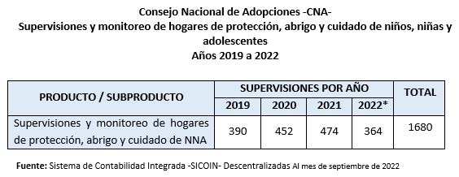
76. The Public Prosecution Service has a Policy on Democratic Criminal Prosecution, which includes guidelines, directives and associated actions that set out the approach to be taken to the offences set out both in ordinary laws specifically relating to this matter and in the international human rights treaties and conventions to which Guatemala is a party. The Service also has internal regulations that establish special approaches for the provision of assistance, protection and specialized criminal prosecution in cases involving child and adolescent victims.
77. The Guatemalan Institute for Migration carries out ongoing information and awareness campaigns for the adult population, including a psychosocial tool for providing emotional support to migrant children and adolescents and enabling them to be heard.
78. The Supreme Court has institutionalized continuous and specialized training on children and adolescents and juvenile criminal justice, with the aim of strengthening and following up on plans for the training of human resources in the different specialized courts.

Reply to the issues raised in paragraph 13
79. The Ministry of Health and Social Welfare coordinates the following preventive actions in respect of newborns, infants and children:
- Newborns: Breastfeeding promotion, growth and development monitoring, immunizations, detection of risk factors.
- Infants: Growth monitoring, micronutrient supplementation, neurodevelopmental surveillance, immunizations, among others.
- Children: Evaluation of nutritional status, early detection of neurodevelopmental disorders, immunizations, micronutrient supplementation.

Reply to the issues raised in paragraph 14
80. As part of the administrative process of child adoption, steps are taken to hear the views of the child or adolescent and information about the adoption process is provided to him or her. The National Adoption Council carried out 406 visit and placement processes between 2019 and September 2022, benefiting an average of 100 children and adolescents per year. Two days after the end of the placement period, professionals from the multidisciplinary team ask the child, in accordance with his or her age and maturity, to confirm his or her wish to be adopted. The child’s consent is given or recorded in writing.
81. A total of 161 life plans have been prepared for children and adolescents, in which National Adoption Council professionals give children and adolescents a suitable opportunity to participate in planning and building their future. This involves defining personal, educational, occupational, family, social, economic and other objectives and goals of interest to the children or adolescents, who are consulted in accordance with their age and maturity, to prepare them to gradually become independent.
82. The Counsel General’s Office bases its work on several principles, including the right of children and adolescents to be heard, in accordance with their age and maturity, in the different phases of proceedings that directly affect their lives and well-being. In cases involving protection measures, care is taken to ensure that they are heard during the proceedings so that the decisions take their views into account. In the case of unaccompanied foreign migrant children and adolescents, the authorities consider their views about returning to their country of origin or applying for refugee status.
83. The Ministry of the Interior has taken the following measures:
(a) Through the relevant Unit, it conducted the “Recreate My Childhood” campaign to promote well-being, rights and values by strengthening harmonious relations among children. At the same time, this campaign is intended to create opportunities for reflection on ways to prevent violence affecting children and adolescents by promoting a culture of reporting. In 2021 it carried out the “Knowing My Rights” campaign. This initiative includes educational workshops to raise awareness of the importance of children’s rights and obligations. Colouring books on this theme are distributed to help participants acquire this knowledge through art;
(b) In 2021, the “Meeting My Obligations” campaign was carried out to reduce risk factors and strengthen protective factors in the family, educational and community environments, for the population participating in the Safe Schools Programme.
84. The Ministry of Education, on the basis of Ministerial Decision No. 1120-2014 of the Directorate General of Bilingual Intercultural Education and through the Subdirectorate of Education for Vulnerable Populations, planned strategic actions in 2020, 2021 and 2022 on the human rights of the Indigenous population.
85. The judiciary has established and strengthened the specialized justice system for protecting the human rights of children and adolescents whose rights have been threatened or violated. This system proactively addresses situations of threat or risk to children and adolescents; there are currently 341 magistrates’ courts that provide immediate protection measures 24 hours a day, 365 days a year.
86. The Supreme Court has drawn up instructions on the use and operation of Gesell chambers, closed-circuit television and other tools for taking statements from child and adolescent victims and/or witnesses, with a view to avoiding revictimization.

Reply to the issues raised in paragraph 15
87. The National Registry Office carries out various activities to prevent, reduce and eradicate underregistration of births among children and adults and to promote free, universal and timely birth registration. It therefore seeks to change the behaviour of Guatemalan society in this regard and to develop a culture of identification, using various strategies:
(a) Awareness-raising events targeting different stakeholders in governmental and non-governmental institutions, private institutions, mayors, community leaders, civil society, midwives and medical and administrative personnel of hospitals in the public, private and Social Security systems;
(b) Formation of the Network for Dialogue and Registration of the Guatemalan Population, which was launched in 2018;
(c) Efforts to identify areas where the population is underregistered and implementation of a comprehensive procedure involving the formation of inter-agency expert committees;
(d) Documentation days for the delayed registration of births in municipalities throughout the national territory;
(e) Promotion of timely registration of births, stillbirths and deaths through the establishment of National Registry Office branch offices within the hospital network;
(f) Implementation of the closed system in the hospital network of the Ministry of Health and Social Welfare in hospitals where a National Registry Office branch office is located in order to register 100 per cent of births.
88. The institutions that make up the Cabinet Committee for Social Development have access to an electronic tool known as the social services portal, through which they can consult, free of charge, the biographical identity information of individuals benefiting from any of the Government’s social programmes.

Reply to the issues raised in paragraph 16
89. Among the functions of the Secretariat against Sexual Violence, Exploitation and Trafficking in Persons is the prevention of sexual exploitation committed through technological means. In this regard, a number of preventive and awareness-raising actions have been carried out. Congress has amended Decree No. 17-73, setting forth the Criminal Code, in relation to offences committed against children and adolescents through technological means.
90. The following virtual tools have been created to keep children, adolescents, parents and teachers informed: the Me Conecto Sin Clavos webpage, the Me Conecto Sin Clavos mobile application and the Tu Amig@SVET counselling chat.
91. Awareness-raising and prevention training has been carried out. Information and prevention fairs have been held in different municipalities. In 2021 and 2022, more than 5,600 people received information about the prevention of sexual exploitation and online sexual exploitation.
92. In 2019 a Commission was established as an intersectoral authority for consultation on and coordination, formulation, proposal and promotion of agreements, plans, actions and/or policies for preventing, comprehensively addressing and combating sexual violence and sexual exploitation of children and adolescents by and through information and communication technologies. Professional development training has been provided to personnel of the institutions that make up the Commission to build capacity in cybersecurity and combating cybercrime.
93. The “technology in the classroom” project of the Ministry of Education is aimed at promoting and encouraging the use of technology as a complementary tool for classroom learning. It involves the delivery of technology kits that run on an intranet, which does not require Internet connectivity to operate. The project delivered technology kits to 1,896 public primary schools, including 300 schools with solar panels, located in areas out of reach of the power grid. The project has directly benefited 303,517 pupils and 12,775 teachers.

Reply to the issues raised in paragraph 17
94. There are currently several bills in Congress, including a bill for the comprehensive protection of children and adolescents from gender identity disorders (No. 5940); a bill on child and family care centres (No. 6150); and a bill amending Decree No. 27-2003, Act on the Comprehensive Protection of Children and Adolescents (No. 6019).
95. In 2022 the National Adoption Council, through the Unit for Authorization and Oversight of Child Protection Facilities and International Agencies, delivered a course on the comprehensive care of children and adolescents in child protection facilities to ensure respect for their human rights. The course included a module with four different topics focusing on tools for the application of “affirmative discipline” in such facilities.
96. In addition, between 2019 and September 2022, 445 professional consultations were carried out to guide facility directors and multidisciplinary teams on the comprehensive care of the children and adolescents in those facilities, in accordance with the Act and the quality standards for the care of children and adolescents in child protection facilities.
97. Between 2019 and September 2022, the National Adoption Council drew up 128 family empowerment plans to develop the conditions required by or suited to the profiles of priority children and adolescents prior to placement, providing follow-up to enhance the capacities identified in the family and prevent ill-treatment of adopted children and adolescents. Materials were designed to inform families interested in adoption about the legal and administrative process and the profiles of children and adolescents identified as having priority for adoption. The materials include information on the consequences of abandonment and institutionalization of children and adolescents, among other topics.
98. To help prevent and combat child abuse, the National Adoption Council informed adoptive families of the circumstances of the children and adolescents concerned and the process of repairing the harm suffered. Information was provided to 2,329 families interested in adoption. Over the same period, 2,007 families were evaluated, counselled and prepared for the placement of a child, with information on affirmative and appropriate methods of child-rearing.
99. The Office of the Advocate for Children and Adolescents intervenes in cases involving threats or violence against children and adolescents, seeking to restore their rights through investigation and active participation in administrative and judicial processes. For this purpose, it has specific units for: (a) receipt and analysis of complaints; (b) findings and removals, in the event that the complaint warrants removal from the home; (c) judicial protection, with the provisional representation and supervision of the child or adolescent; and (d) criminal justice in cases involving children, in which the Office files complaints with the Public Prosecution Service when it considers that a criminal act may have been committed against the child or adolescent.
100. Upon learning of violations of or possible threats to the rights of children and adolescents, the Office of the Advocate for Children and Adolescents ensures that the cases are dealt with in a comprehensive, specialized and individualized manner in accordance with the needs of each child or adolescent. When a complaint is received, an analysis is performed and a finding is made; if appropriate, the child or adolescent is removed from the home. Between 2019 and 2022, the numbers of cases addressed nationwide were as follows: 22,816 complaints, 42,347 children and adolescents and 3,269 removals in 2019; 19,261 complaints, 31,992 children and adolescents and 2,070 removals in 2020; 23,800 complaints, 36,792 children and adolescents and 2,699 removals in 2021; 23,339 complaints, 40,776 children and adolescents and 2,943 removals in 2022.
101. Among the removals carried out by the Office during the period 2019–2022, the numbers related to the right to protection against ill-treatment were as follows: 1,514 removals in 2019; 978 removals in 2020; 1,231 removals in 2021; 1,341 removals in 2022.
102. Following the removal of children or adolescents whose human rights have been violated, the Counsel General’s Office initiates protection proceedings before the competent courts, attending 11,446 hearings in 2020, 18,165 in 2021 and 20,519 in 2022.
103. The Department for the Protection of Children and Adolescents with Mild and Moderate Disabilities of the Social Welfare Secretariat is responsible for the residential care of children and adolescents with mild and moderate intellectual disabilities. It takes a specialized approach to ensure their quality of life, covering their basic individual and specific needs, as well as teaching good habits and values in an environment conducive to their comprehensive development. This residential care system for children and adolescents includes the Nidia Martínez I, Nidia Martínez Annex and Ónice II residences, each of which, in accordance with the relevant policies, carries out its own activities to protect human rights and provide special care for persons with disabilities from 0 to 18 years of age.
104. The children and adolescents housed in the Department’s protection facilities receive weekly medical visits from a Social Welfare Secretariat general practitioner. Those requiring special treatment receive it at La Esperanza Health Centre in Quetzaltenango or at Regional de Occidente, San Juan de Dios or Roosevelt Hospital (for psychiatric referrals or particular specialties). All children and adolescents have had access to the COVID-19 vaccine and booster, as required by the Ministry of Health and Social Welfare, according to the vaccination schedule corresponding to their age. The Social Welfare Secretariat covers the cost of medicines prescribed in medical referrals, as well as laboratory tests, to guarantee the right to health.
105. The Social Welfare Secretariat has a multidisciplinary team composed of professionals in the areas of social work, psychology, speech therapy, education, physiotherapy and personal assistance to implement the residential model and assist in the process of social habilitation and rehabilitation, depending on the disability. The team develops an intervention plan for each resident according to his or her abilities in order to achieve short-, medium- and long-term goals.
106. The Office of the Public Prosecutor for Children and Adolescents, which is part of the Public Prosecution Service, is responsible for leading the Comprehensive Support Model for Children and Adolescents and is competent to investigate offences of a sexual nature, child abuse and offences involving the abduction or disappearance of children and adolescents. It provides comprehensive, caring, quality assistance that is aligned with international standards, protocols, guarantees, rights and principles and reflects a gender-sensitive and culturally relevant approach. It is the only model in Latin America that encompasses the psychological and emotional, health, criminal prosecution and restoration of rights aspects of child protection.
107. The Act on the Comprehensive Protection of Children and Adolescents provides for the establishment of courts for children and adolescents, each of which must have a multidisciplinary team consisting of a psychologist, social workers and an education professional.
108. In all criminal proceedings in which the Office of the Advocate for Children and Adolescents participates as an additional complainant, it acts as a guarantor of the rights of children and adolescents, joining the prosecution and seeking adequate reparation when a conviction becomes final. For this purpose, social workers and psychologists prepare reports that are used in determining the amount of compensation for the harm caused as a result of the offence, as well as the necessary victim-centred measures, in accordance with each specific case.
109. The multidisciplinary team of the Guatemalan Institute for Migration provides individual and group psychosocial care to returning migrant children and adolescents in order to provide support, identify vulnerabilities and make referrals to the appropriate bodies of the protection system.
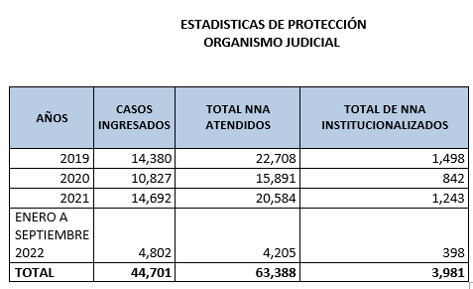
110. The Counsel General’s Office, through the State Criminal Attorney’s Office, is participating in case No. 1069-2017-00123 in three capacities: as an additional complainant, a victim and a third-party civil defendant. The court divided the criminal trial into three groups of defendants, since the prosecuting authority is conducting the investigation by hierarchical level in order to establish the criminal responsibility of each defendant according to the position he or she held at the time of the disaster. Each group is currently at the following stage of the proceedings: group 1 (three defendants) and group 2 (five defendants) are awaiting the start of oral arguments, and group 3 (four defendants) has an intermediate-stage hearing rescheduled for October 2023.
111. As a result of the investigations carried out, the Public Prosecution Service brought criminal charges against 12 individuals. Oral arguments in respect of eight defendants were to have begun on 30 January 2023, but the hearing could not be held because one of the defendants brought a challenge against the trial court judge. The hearing on the charging decision against four defendants was scheduled for October 2023. The families of the 56 adolescent victims, who are listed as victims in the case under investigation, were kept informed.

Reply to the issues raised in paragraph 18
112. Pursuant to Government Decision No. 260-2019 approving the Public Policy against Sexual Violence in Guatemala 2019–2029, the Secretariat against Sexual Violence, Exploitation and Trafficking in Persons is the operational agency responsible for implementing the policy; developing, implementing and disseminating the information campaign “United against Sexual Violence”; and carrying out training initiatives for children and adolescents on the prevention of sexual violence. It also helps to raise awareness of the harmful effects of sexual violence against Guatemalan children and adolescents among the public and professionals alike. The Secretariat against Sexual Violence, Exploitation and Trafficking in Persons has opened an advisory office on offences of this nature.
113. The Ministry of Health and Social Welfare has encouraged mandatory reporting of cases of sexual violence and underage pregnancy (among girls under 14 years of age) by introducing an inter-agency procedure for action in cases of sexual violence, under which coordinated institutions work directly with victims and/or family members at medical facilities or specialists’ offices (psychologists and social workers) to draw up complaints. In addition, materials on prevention, specifically concerning cybercrime, sexting and grooming, have been distributed to hospitals that have a clinic for sexual violence survivors, as part of the Ministry’s participation in the activities of the Intersectoral Commission on Information and Communication Technologies.
114. The Secretariat against Sexual Violence, Exploitation and Trafficking in Persons is implementing and disseminating the information campaign “United against Sexual Violence”; workshops and dialogues on the prevention of sexual violence have been held with adolescents as agents of change; culturally relevant information and prevention materials and games have been developed for children and adolescents in Alta Verapaz for the prevention of sexual violence; and the programme “School for Families: Prevention of Sexual Violence” has been carried out nationwide.
115. The Secretariat also provides information to children and adolescents, especially girls, on the age of sexual consent to prevent them from becoming victims of sexual violence. The monitoring tool for specialized clinics that provide care to survivors of sexual violence is being updated.
116. The Social Welfare Secretariat conducts monthly training sessions in the Department for the Gender-Sensitive Protection of Child and Adolescent Victims of Sexual Violence and the Specialized Programme for Child and Adolescent Victims of Sexual Violence, Exploitation and Trafficking, with empowerment workshops for girls who are victims of sexual violence, exploitation and trafficking in persons. Staffing in these areas meets the quality standards established by the National Adoption Council.
117. The Ministry of Education promotes peaceful and harmonious relations in school communities so that education centres can operate as safe spaces free from violence. There are regulations and legal instruments such as the protocol for identifying, addressing and referring cases of violence in the national education system, the regulations on harmonious relations, disciplinary regulations applicable to Ministry of Education personnel and specific regulations for identifying and resolving cases of violence against children and adolescents in the national education system.
118. The Ministry of Health and Social Welfare, in coordination with international cooperating partners, held a seminar on comprehensive care for children and women who are victims of violence, which was aimed at personnel from the health districts of central Guatemala, personnel from the sexual violence clinics of national hospitals and personnel of the relevant entity who treat victims of sexual violence.
119. The Secretariat against Sexual Violence, Exploitation and Trafficking in Persons launched a national awareness campaign on the shared responsibility of public servants and the population in preventing sexual violence in Guatemala, with the prevention of sexual violence as its first phase. It also prepared information materials with recommendations on preventing sexual violence, exploitation and trafficking in persons and sent these materials to hospitals and health centres nationwide and to the Ministry of Health and Social Welfare during the COVID-19 pandemic. It made recommendations to the Ministry of Health and Social Welfare for the prevention of sexual violence, exploitation and trafficking in persons, with an emphasis on the COVID-19 pandemic. It also provides information to the institutions in charge of public health on responsible behaviour towards victims of sexual violence in order to avoid stigmatization, especially in cases involving children and adolescents.
120. The Counsel General’s Office, under the Comprehensive Support Model for Children and Adolescents, acts to determine whether or not to apply special protection measures in respect of children and adolescents whose human rights are threatened or violated. It may request such a measure before a competent court or provide an alternative solution in the form of a protection plan when the case does not warrant judicial action. Between July 2019 and October 2022, a total of 4,255 complaints were dealt with and 2,498 hearings on protection measures were held.
121. The Office of the Advocate for Children and Adolescents intervenes as an additional complainant in proceedings related to sexual offences. Such proceedings are aimed at restoring the rights of the child and ensuring the holistic development of minors who are victims of sexual abuse, enabling them to build a future. The criminal division of the central office processed 843 cases of sexual assault and/or rape against children and adolescents in 2020, 1,189 cases in 2021 and 442 cases between January and May 2022.

Reply to the issues raised in paragraph 19
122. The police, through the Subdirectorate General for Crime Prevention and behaviour modification programmes, carries out the “Your Friend the Police Officer” programme, the Gang Resistance Education and Training (G.R.E.A.T.) programme and the early childhood programme.
123. Through phase II of Comprehensive Operative Tactical Plan No. 13-2022, the Ministry of the Interior establishes strategic actions to be undertaken by the National Civil Police to reduce the crime rate, prevent illegal acts and strengthen security in border areas, blind spots and routes in the country. The relevant plan is aimed at strengthening security measures against organized crime, drug trafficking and gangs.

Reply to the issues raised in paragraph 20
124. The National Registry Office has implemented controls within the respective systems to ensure that underage marriages entered into after the amendment of Decree-Law No. 106, contained in Decree No. 13-2017 of the Guatemalan Congress, cannot be registered. Instructions have been issued to civil registrars regarding the ban on registering underage marriages.
125. When the Counsel General’s Office receives a report of a possible marriage of this nature, it carries out an investigation. Out of the total number of reports registered between 2020 and 2022, 56 rescues were carried out in connection with this issue.

Reply to the issues raised in paragraph 21
126. In 2021 the National Adoption Council held a virtual forum on the importance of deinstitutionalizing children and adolescents in temporary protection facilities as a means of restoring their rights. The aim was to promote deinstitutionalization and transformation processes aimed at reintegrating children into their families and preventing adverse consequences for their development due to prolonged institutionalization.
127. With the support of international cooperation partners, the authorities have worked to promote family strengthening, support the deinstitutionalization of children and adolescents, prevent family separation and help to achieve the mandate of the National Adoption Council to ensure the protection and care of children, adolescents and youth in terms of progressive deinstitutionalization in accordance with the United Nations Guidelines for the Alternative Care of Children.
128. The National Adoption Council has implemented the pilot plan of the proposed deinstitutionalization model with an ecosystemic approach. The results include, inter alia, the design of psychosocial instruments for the comprehensive care of children, adolescents and their families, monitoring of individual cases and a group matrix, which were approved by the multidisciplinary teams of the participating protection facilities; provision of guidance on family and community case management; reintegration of 95 children and adolescents into their families; and steps to encourage protection facilities to contribute to the search for and the investigation and socioeconomic evaluation of suitable family resources, in order to present the results to the competent courts.
129. Standard No. 6, “Relationship with the child’s or adolescent’s family of origin”, of the quality standards for the care of children and adolescents in temporary protection facilities has been strengthened to expand the minimum operational practices for evaluating, approaching and following up with the family of origin or alternative family. This is expected to result in greater commitment and action, on the part of teams in child protection facilities, to avoid prolonged institutionalization.
130. The Counsel General’s Office has a case management system for children and adolescents that takes a multidisciplinary approach to the restoration of children’s and adolescents’ rights and seeks to ensure their comprehensive development within the nuclear family or extended family. The principles observed include the best interests of the child, equality and non-discrimination and the right of children and adolescents to be heard. This system also acts as a filter that reduces the number of cases that reach the courts. The system is currently deployed in nine departments through 11 multidisciplinary teams. In terms of results, it should be noted that between 2019 and 2022, out of 26,450 complaints processed under the system, 17,597 were administrative complaints and 8,853 were judicial complaints.
131. The Counsel General’s Office carries out the necessary investigations to ensure the rights of minors under court supervision, with a view to enabling them to remain with their biological family. Children or adolescents at risk are placed with their extended family or in other family-based care; only in exceptional cases are they placed in a child protection facility. The Office of the Advocate for Children and Adolescents thus reunited 413 children and adolescents with family resources in 2021 and 524 between January and October 2022.
132. The deinstitutionalization programme was created jointly by the judiciary’s Secretariat for Children, the Counsel General’s Office and the Social Welfare Secretariat to promote the establishment of mechanisms, models, indicators and other actions to standardize the way in which the courts analyse cases of children and adolescents in child protection facilities, in order to find suitable family resources.
133. The judiciary has implemented the “Judicial Policy for the Special Protection of Children and Adolescents 2020–2025”, generating strategic guidelines for action in courts that deal with cases involving children and adolescents.

Reply to the issues raised in paragraph 22
134. Since the amendment of article 194 of the Criminal Code, irregular adoptions have been treated as a form of trafficking in persons. The various investigations conducted since 2006 have shown that, in the past, irregular adoption procedures were carried out systematically, with the participation of doctors, notaries, private individuals, officials of the Counsel General’s Office and other institutions.
135. Under the implementing regulations of the Adoption Act, one of the functions of the multidisciplinary team of the National Adoption Council is to provide guidance to biological parents who voluntarily wish to place a child for adoption or who are conflicted about the situation. Between 2019 and September 2022, 720 counselling sessions were held, including 442 by order of a court and 278 on a voluntary basis.
136. Since the establishment of the National Adoption Council, alternatives to institutionalization have been implemented and illegal adoptions have thus been prevented. One of the alternatives to institutionalization is adoption. Between 2019 and September 2022, 353 children and adolescents were integrated into adoptive families.
137. The National Adoption Council has an Origins Search Programme under which individuals can avail themselves of a professional mechanism that begins with the submission of requests from adoptees wishing to obtain information on their origins. Adult adoptees, and child adoptees who have the consent of their adoptive parents, are then given access to information about their origins, following an analysis by the National Adoption Council and the provision of psychosocial support. Information on the biological parents is disclosed only with the mutual consent of the adoptee and the biological parents. Between 2019 and 2021, 37 origins search processes were carried out.
138. In accordance with article 23 of the Adoption Act, the National Adoption Council collects and preserves information on each child’s origins, consisting primarily of information on the child’s identity and that of his or her parents and the medical history of the child and of his or her parents. Access to this information is thus guaranteed. The information requirements include “the child’s full identification, as attested by a certified copy of the birth certificate, and the document containing the footprints and handprints, the fingerprints of the mother and, where applicable, those of the father, as well as other scientific means”.
139. Between 2019 and September 2022, the National Adoption Council carried out 1,436 post-adoption professional counselling processes. In these processes, adoptive families are trained, prepared and guided on how to proceed when the child or adolescent expresses a desire to access information about his or her origins so as to forge his or her identity and, therefore, to initiate the process for obtaining access to the information available on the causes and circumstances of the adoption and the identity of his or her biological family.
140. The Council, through information and training workshops, trains adoptive families on the disclosure of origins and the child’s right to his or her identity. At the psychosocial evaluation stage, psychologists and social workers discuss relevant topics with the future families, including the origins search procedure for children and adolescents found to be adoptable and integrated into their home. Between 2019 and September 2022, a total of 2007 families interested in adoption were evaluated, counselled and trained.
141. As part of the administrative process of adoption, the Child Services Unit of the National Adoption Council is specifically tasked with providing information to the child on the adoption process and obtaining his or her views, in accordance with his or her age and maturity, pursuant to article 22 of the implementing regulations of the Adoption Act. This procedure is carried out during the visit and placement period, as established in article 45 of Decree No. 77-2007 setting forth the Adoption Act. Between 2019 and September 2022, 705 comprehensive evaluations were conducted, benefiting an average of 167 children and adolescents declared adoptable per year.
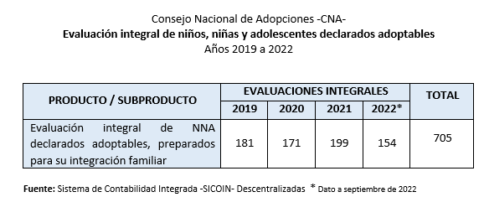
142. On the basis of the evaluations, the relevant professionals issue biopsychosocial reports, which are duly added to the file of each adoptable child.
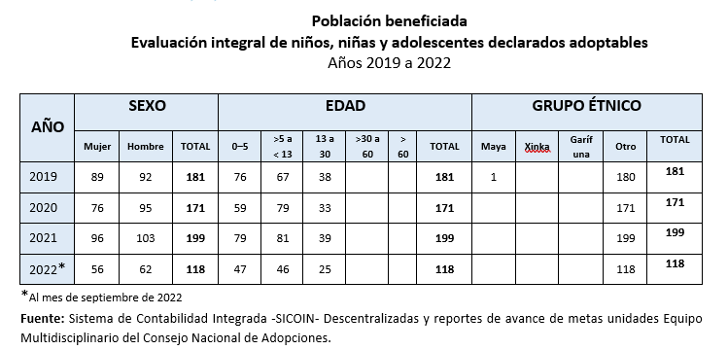
143. The National Adoption Council has carried out the following actions:
(a) Information workshops were held to explain the adoption process in Guatemala through the National Adoption Council and the consequences of taking another person’s child as one’s own through any other act or process that is contrary to the provisions laid down in the Adoption Act, specifying that such conduct could be defined as irregular adoption and as amounting to offences such as trafficking in persons, alteration of civil status, illicit association and denial of justice, among others;
(b) Between 2019 and September 2022, 177 information events were held on the programme for biological mothers and/or fathers who are conflicted about their parenthood, at which 5,342 individuals and social actors in the health and education sectors and religious and community leaders were informed of the resources available to such mothers and/or fathers to reduce the risk of child abandonment, trafficking and illegal adoption, among other consequences;
(c) Professional follow-up counselling was provided in 340 cases between 2019 and September 2022 to determine or verify the situation of the child and ensure that he or she can remain with the mother and/or the biological family in conditions conducive to his or her comprehensive development.
144. When the Counsel General’s Office is informed, either directly or through a complaint, of a possible irregular adoption, it requests protection measures before the competent court, seeking the certification of the appropriate measures so that the Public Prosecution Service can carry out the necessary investigations to determine whether an adoption is irregular, with the aim of restoring the child’s or adolescent’s right to his or her family and identity. Between 2019 and 2022, the Office of the Advocate for Children and Adolescents carried out 25 removals of children because of this type of risk.

Reply to the issues raised in paragraph 23
145. The Social Welfare Secretariat ensures the quality of life of children and adolescents with mild and moderate disabilities through a specialized approach by a multidisciplinary team made up of a physician, a nutritionist, a speech therapist, personal assistants, psychologists, psychiatrists and social workers.
146. To facilitate access to inclusive education services, the Ministry of Education implements strategies such as: (a) strengthening the use, promotion and learning of Guatemalan Sign Language, pursuant to Legislative Decree No. 3-2020; and (b) strengthening actions in the framework of the Marrakesh Treaty to Facilitate Access to Published Works for Persons Who Are Blind, Visually Impaired or Otherwise Print Disabled, including the provision of textbooks transcribed into Braille for persons with visual impairments and the generation of educational materials by the Educational Resource Centre for Persons with Visual Impairments.
147. The Educational Records System is currently being improved in terms of data and information collection on the number of students with disabilities enrolled in the system.
148. The Social Welfare Secretariat, in coordination with the Counsel General’s Office and the judiciary, conducts psychosocial studies to identify possible family resources and request family reintegration as a deinstitutionalization strategy, with the aim of locating biological or extended family members who can care for children and adolescents currently housed in child protection facilities and who can protect their rights, including their right to live in a family environment. In addition, the Social Welfare Secretariat has implemented a foster care programme as an alternative means of caring for children and adolescents. A letter of understanding has been concluded between the Counsel General’s Office, the Social Welfare Secretariat and the judicial branch to establish the areas of work involved in the deinstitutionalization process.

Reply to the issues raised in paragraph 24
149. The relevant unit of the Ministry of Health and Social Welfare has contributed to the process of updating the health services network design standard, which is coordinated by a different unit, taking into account culturally appropriate environments and elements in the design of the different types of health services at the first, second and third levels of care. For this purpose, cultural elements of the country’s three Indigenous Peoples (Maya, Garifuna and Xinka) have been taken into account in the implementation of health services and care.
150. The Ministry of Health and Social Welfare, in accordance with the mandate of the Directorate General of the Comprehensive Health-Care System, has reviewed and analysed requests from the health district authorities for the hiring of health-care personnel, issuing expert opinions for the categorization and qualification of personnel of the public health services network, in addition to strengthening health management and care, in compliance with the internal rules for budget execution.
151. In 2022, the Ministry of Agriculture, Livestock and Food delivered 511,805 food rations as part of the food supply and assistance programme for vulnerable families at risk of food insecurity due to crop failure, emergency or other serious circumstances; 12,000 producers were trained, given technical assistance and provided with inputs for use in family and community gardens; and 33,904 family farmers benefited from agricultural insurance against climate risk to improve food security.
152. In 2022, the Ministry of Agriculture, Livestock and Food programmed actions under the plan to tackle seasonal hunger, through programme 11, “Food access and availability”, under the subprogramme “Addressing food access”, and also carried out the following activities: food supply and assistance, with the delivery of 136,645 rations in 88 municipalities targeted by the plan to tackle seasonal hunger, and assistance to address food vulnerability, with the provision of agricultural goods and inputs to 1,607 farmers.
153. Between 2016 and 2019, the Secretariat for Food and Nutrition Security, in coordination with the Ministry of Health and Social Welfare, implemented the National Strategy for the Prevention of Chronic Malnutrition. It is also coordinating the implementation of the great national crusade for nutrition. The number of priority departments has been increased and emphasis is being placed on children under the age of 2 and other vulnerable groups. Measures under the initiative are being carried out in 114 municipalities across 10 departments.
154. Furthermore, the following programmes have been implemented: the “1,000-day window” programme; breastfeeding and complementary feeding from the age of 6 months; and the plan to tackle seasonal hunger 2020–2024.

Reply to the issues raised in paragraph 25
155. The Secretariat against Sexual Violence, Exploitation and Trafficking in Persons carries out training processes for adolescents and educators on the theme “Prevention of violence and pregnancy to build a better future”, in coordination with the Secretariat for Social Affairs of the Municipality of Guatemala. It also follows up on actions and workplans through meetings and coordination with the Expert Committee to address pregnancy in girls under 14 years of age and the programme to strengthen the course on protection from sexual violence against children and adolescents.
156. The Counsel General’s Office monitors and ensures the rights of girls and adolescents who are pregnant or are already mothers. As part of the process related to protection measures, psychotherapeutic support and “school for parents” courses are offered, thus empowering the beneficiaries by equipping them with tools to cope with the situation.
157. The Office of the Advocate for Children and Adolescents participates in the Expert Committee to address pregnancy in girls under 14 years of age and the Expert Committee of the national Responsible Parenthood Network, which devise strategies to strengthen the relevant processes and collaborate in prevention campaigns to reduce early pregnancy. As part of its work, between 2019 and 2022, the Counsel General’s Office removed 313 girls and adolescents from their homes for reasons related to pregnancy.
158. The Public Prosecution Service has the 2411-8686 hotline to receive reports of cases of pregnancy among girls under 14 years of age from hospitals, clinics and public and private health centres throughout the country.
159. The Ministry of Education is implementing an internal procedure for dealing comprehensively with pregnancies in girls under the age of 14, which begins with the process of identifying and responding to cases detected in the national education system. The measures available to support pregnant girls’ return to education include the “Me Supero” (Aspire) programme, which finds pregnant girls and provides them with support in the form of in-school and out-of-school education programmes at various educational levels, with an inclusive and culturally and linguistically relevant approach, to ensure that they stay in school and continue and complete their studies.
160. The Ministry of Education has a curriculum that sets out the “Democracy and Culture of Peace” pillar of the education reform; this pillar includes a component on gender, ethnic and social equity, which in turn includes “equity and equality, gender and self-esteem, sex education: HIV and AIDS”. The approach is thus comprehensive, scientific and appropriate to the age of the students.
161. The Social Welfare Secretariat has carried out sexual and reproductive education campaigns, both for adolescents and young people at the Gorriones centre and at centres for boys, to help prevent adolescent pregnancy. Through the clinics at these centres and the health centres of the districts where the juvenile centres are located, education plans have been developed on the subject of pregnancy among adolescents and children under 14 years of age.
162. Since 2019, the Social Welfare Secretariat, through seven of its departmental offices, has implemented the Social Civic Service Project, training young people as multipliers of national efforts for the prevention of adolescent pregnancy as a cross-cutting theme of the project and contributing to the relevant national plan through the provision of community services and activities addressing key aspects of the subject in communities and public and private education centres in the target areas, as determined in the project approved annually by the Executive Secretariat of the Civic Service.
163. The legislation enacted by Congress is limited by constitutional provisions, which it must not violate. Article 3 of the Constitution indicates that the State guarantees and protects human life “from the moment of conception”, and article 4 (1) of the American Convention on Human Rights states that “every person has the right to have his life respected”. Abortion is currently regulated in accordance with these constitutional parameters, principles and guarantees.
164. The Counsel General’s Office ensures the provision of psychotherapeutic support and empowerment to girls and adolescents who are pregnant or have given birth. This is because abortion is prohibited by national law.

Reply to the issues raised in paragraph 26
165. The Ministry of Social Development carries out the following activities:
(a) It coordinates services for children and adolescents in terms of access to education and health through the Social Subsidies Programme, under which conditional cash transfers are provided to children, adolescents and pregnant women in families living in poverty or extreme poverty in exchange for regular attendance at health check-ups to prevent diseases and malnutrition and at prenatal check-ups, as well as school attendance at the pre-primary and primary levels. In 2018 it benefited 152,702 families with an investment of Q 259,138,000.00; in 2019, 128,036 families with an investment of Q 230,455,500.00; in 2020, 126,509 families with an amount of Q 307,705,300.00; in 2021, 100,248 families with an amount of Q 326,171,100.00; and to date, 118,444 families with an amount of Q 346,280,400.00;
(b) The Directorate of Preventive Social Programmes provides services to children and adolescents in secondary and higher education and in Young Leaders workshops and/or activities;
(c) Under the Young Leaders programme, adolescents and young people in situations of vulnerability and social risk are encouraged to participate in voluntary non-formal education processes through training, arts and sports workshops. Over the period 2018–2022, the programme benefited 12,084 young women and 13,604 young men, of whom 14 were of Garifuna ethnicity, 163 of Xinka ethnicity, 7,300 of Mayan ethnicity and 18,103 of Ladino ethnicity; no information on ethnic background was available for 108 of the participants. Of the total number of participants, 257 had physical disabilities and 121 had intellectual disabilities;
(d) The higher education scholarship programme promotes university education through conditional cash transfers. In 2018, the programme benefited three girls; in 2019, three girls; in 2020, three girls and one boy; in 2021, three girls and two boys; and in 2022, eight girls and three boys, with an average age of 17 years;
(e) The secondary education scholarship programme benefited 297 children and 5,120 adolescents in 2018; 2,532 children and 3,197 adolescents in 2019; 29 children and 5,112 adolescents in 2020; 18 children and 5,080 adolescents in 2021; and 2,836 children and 2,895 adolescents in 2022.
166. The national policy of the Ministry of Health and Social Welfare for the drinking water and sanitation sector includes strategies and objectives to ensure that the Guatemalan population has access to drinking water and sanitation services, focusing efforts on the most remote areas where there is child malnutrition and thus a low level of human development. Providing access to drinking water and sanitation services can significantly reduce poverty, chronic malnutrition, morbidity rates, maternal and child mortality and school dropout rates. The policy is aimed at improving quality of life by ensuring access to safe drinking water.
167. The Social Welfare Secretariat implements the Comprehensive Care Centres Programme, under which the most vulnerable Guatemalan families with limited economic resources are provided with reliable, free day care for children of working parents during the workday; it also implements the Family Subsidies Programme, which provides a family subsidy of Q 500.00 per month for a maximum period of four years to children and adolescents who have disabilities or are in situations of vulnerability, to improve their quality of life. It also has special education centres and an occupational training centre.

Reply to the issues raised in paragraph 27
168. The Ministry of Education, through the Acompáñame a Crecer (Help Me Grow) programme, supports expansion of the coverage of early childhood education so that children from 0 to 4 years of age have access to educational services. According to the Educational Records System, the programme covered a total of 30,524 children in 2022. At the pre-primary, primary and middle school levels, textbooks and guides were provided to pupils.
169. The Ministry of Education created the “Me Supero” (Aspire) programme for the purpose of reintegrating adolescents and young people who are outside the national education system, through timely, quality initiatives enabling them either to start or continue the basic (lower secondary) and diversified (upper secondary) school cycle, in its alternative form, or to benefit from basic tools for entry into the productive labour market through free courses. Under this programme, teams are deployed to seek out students who have withdrawn from the national education system so that they can continue their studies.
170. The Ministry of Education has a scholarship programme for students with disabilities. The families of students with disabilities use the scholarship funds to pay the costs of some of the needs related to the student’s disability and/or to support the education process in general.
171. The scholarship programme is part of the Ministry’s scholarship system and, as such, reflects the State’s obligations regarding access to education, which are laid down in the Constitution.
172. As part of the implementation of bilingual intercultural education for pupils at the preschool and pre-primary levels, in 2020 and 2021 the Ministry of Education distributed materials called “Let’s Do Science” to strengthen pupils’ scientific knowledge. At the middle school level, the technical-pedagogical support strategy was implemented and arts festivals were organized to promote young people’s leadership and encourage them to continue their studies; the participating students are Indigenous and come from rural areas and low-income families.
173. Children and adolescents under the protection of the Social Welfare Secretariat, together with the multidisciplinary teams, engage in activities according to the seasons and cultural events of the year, such as the commemoration of Independence Day, Children’s Day, Easter, Christmas and birthday celebrations, among others. This opens up opportunities for them to become better acquainted with their social and cultural environment. In the residences, participation in outside events such as plays, ballet performances and art exhibits is encouraged, as is participation in drawing and sculpture workshops.
174. The Social Welfare Secretariat’s learning centres programme, by providing early learning opportunities, ensures an individualized process of responsible and committed care. The programme ensures physical, emotional, cognitive and social stimulation, training and development among the children served, thereby promoting a participatory and creative early and pre-primary education through its 44 comprehensive care centres to enhance the children’s skills, capacities and abilities, based on the national core curriculum of the Ministry of Education.
175. To enable Indigenous students to continue their studies remotely, the Ministry of Education implemented the “Learning at home” and “Learning at home and in class” strategies. For this purpose, educational programmes were recorded and broadcast on State channels. From 2020 to 2022, the programmes consisted of videos with educational segments in the various areas of the curriculum for students at the primary, basic and diversified education levels. For 2023, educational segments in minority Mayan languages were produced.
176. Guidelines are drawn up to guide teachers on actions they can take in their classrooms to motivate young people who are at risk of dropping out and thus help to retain students at the secondary education level. These guidelines are shared with all directors of public secondary schools, at both the upper and lower secondary levels.
177. To prevent students from dropping out, tutors working in the non-formal education subsystem run by the Ministry of Education adapt programmes to students’ needs. Programme hours and calendars are flexible, educational materials are provided and different formats are offered, including hybrid, remote and virtual learning.
178. In 2008, the budget allocated to this Ministry was equivalent to 2 per cent of gross domestic product (GDP). For 2023 it has been increased by 3 per cent.
179. The budget allocated by the central Government to education, science and culture was equivalent to the following percentages of GDP: 3.5 per cent in 2018, 3.5 per cent in 2020 and 3.6 per cent in 2021.
180. In the 2020, 2021 and 2022 school years, the Ministry of Education implemented four programmes to improve education quality, benefiting more than a million Indigenous students enrolled in the education system: (a) the programme of scholarships in English language studies; (b) the professional development programme for teachers; (c) the initial teacher training programme; and (d) the national reading and writing programme.
181. Plans have been made to develop new materials and to launch the tenth cohort of the professional development programme for teachers, the third cohort of the bachelor’s degree programme and a master’s degree programme in bilingual intercultural education under the professional development programme for teachers.
182. The Ministry of Education implemented a learning improvement strategy to strengthen the skills of second- to fourth-grade public school pupils in the areas of reading and mathematics. In 2022, 18,101 primary-school pupils in need of such strengthening were assisted by 8,372 student tutors and volunteer tutors from other organizations.
183. The coverage of such services will be expanded in 2023, with tutoring for public school pupils in follow-up to the results of the 2022 diagnostic evaluation.
184. In response to the COVID-19 pandemic, the Ministry of Education implemented the School Meals Programme, immediately adapting it to the modality of delivering food rations to parents for preparation at home. These meals meet technical nutritional requirements. Thanks to this adaptation, schoolchildren were supplied with food from family farms, in compliance with the School Meals Act.
185. Pre-primary and primary school pupils were able to remain in public schools, thus strengthening school success and increasing enrolment by 141,265 children in the current school year.
186. The programmes implemented have included “Learning at home and in class”, radio and television programmes, digital media, print media, videos in Spanish and national languages and development of learning modules. Educational segments were produced in 18 national languages at the primary and middle school levels, including 16 Mayan languages (K’iche’, Kaqchikel, Q’eqchi’, Mam, Q’aanjob’al, Tz’utujil, Ixil, Achi’, Ch’orti’, Popti’, Poqomchí, Chuj, Awakatek, Chalchitek, Uspantek and Sacapultek), in addition to Garifuna and Xinka.
187. A total of 475,330 bilingual materials in eight Mayan languages were produced and distributed. When in-person classes were interrupted because of COVID-19, self-study guides, educational modules and educational materials in Mayan languages for the pre-primary and primary levels were distributed.
188. The Social Welfare Secretariat adapted the Comprehensive Care Centres Programme with strategies for remote working and studying, in which educator, parent and child worked together. In addition, 900 reading and writing booklets and 1,877 activity booklets were produced for children at the initial and pre-primary levels, and links to virtual classes were sent. In the comprehensive care centres and occupational training centres, virtual teaching and therapeutic activities were carried out. Work guides and videos were distributed on special education, speech therapy, physiotherapy, occupational therapy, psychology and employment workshops in areas such as baking, building maintenance and food preparation.

Reply to the issues raised in paragraph 28
189. Congress is working on a bill for the protection of children and adolescents transferred outside the country without legal migration documents (No. 5537) and a bill to strengthen the investigation of criminal organizations in relation to offences against migrants (No. 5918).
190. Within the framework of current legislation contained in the Migration Code (Decree No. 44-2016 of the Congress), title II, “Procedures”, chapter I, “Procedure for the protection of unaccompanied and separated children and adolescents”, which is applicable nationwide, progress was made in the procedure for the care of unaccompanied children and adolescents, which provides for coordination among public institutions such as the Guatemalan Institute for Migration, the Social Welfare Secretariat, the Counsel General’s Office and the judicial branch through the Office of the Advocate for Children and Adolescents. These processes are fundamentally aimed at the comprehensive protection of children’s and adolescents’ human rights. The procedure is based on the best interests of children and adolescents, the principle of non-discrimination and the principle of non-refoulement.
191. Steps are also being taken to coordinate efforts to draw up a binational protocol between Guatemala and Honduras for the care of migrant children. In addition, a dialogue was launched on the preparation of a binational protocol between Mexico and Guatemala for the care of migrant children. Updates were made to the national protocol for the reception and care of migrant children and adolescents in Guatemala and the guidelines for the care and protection of migrant children and adolescents of the Unit for the Care and Protection of Children and Adolescents, based on the Act on the Comprehensive Protection of Children and Adolescents (Decree No. 27-2003), the Migration Code (Decree No. 44-2016) and the Convention on the Rights of the Child.
192. In 2018, a new unit was established in the Office of the Advocate for Children and Adolescents as the designated area of the Counsel General’s Office for the reception, care, support and provisional legal representation of unaccompanied migrant children and adolescents. In January 2019, a guide for the assessment of the best interests of migrant children and adolescents and a protocol for assisting unaccompanied foreign children and adolescents who are in Guatemalan territory owing to situations of population displacement were adopted. These texts, which were updated in 2021, establish procedures to help multidisciplinary teams to assist and evaluate children and adolescents and to find sustainable solutions for them.
193. This Unit assists unaccompanied foreign migrant children and adolescents in the initial process of applying for refugee status, in accordance with its mandate, as a result of the initial evaluation or at the direct verbal request of the child or adolescent. The Unit coordinates with the consulate of the child’s or adolescent’s country of origin to locate and obtain information on suitable family resources in the country of origin or transit. The National Migration Authority decides on the application for refugee status and, if the child or adolescent is recognized as a refugee, the Counsel General’s Office will continue to represent him or her and will be the entity in charge of ensuring his or her protection.
194. The Department for the Recognition of Refugee Status of the Guatemalan Institute for Migration gives priority to the comprehensive protection of children and adolescents in vulnerable situations. As those who apply for refugee status and are unaccompanied by their parents or usual caregivers are in such a situation, their cases are given priority for a prompt decision.
195. Under articles 48 and 84 of the Migration Code, children and adolescents recognized as having refugee status are given temporary resident status. The Code includes a whole section on the procedure for the protection of unaccompanied and separated children and adolescents, contained in title II, “Procedures”, chapter I. In 2021, 282 asylum applications from children and adolescents were processed; in 2022, 200 such applications were processed.
196. Efforts are under way to develop the migration policy, which includes differentiated actions such as projects, initiatives, programmes and interventions that will be implemented by State institutions for the migrant population, and thus for migrant children and adolescents.
197. The Global Compact for Safe, Orderly and Regular Migration, which contains guiding principles that promote respect for the human rights of children across all stages of the migration cycle and efforts to understand and adequately meet their specific needs, also promotes the empowerment of women and girls. It reflects a child-sensitive approach, promoting existing international legal obligations in relation to the rights of the child, and upholds the principle of the best interests of the child at all stages of migration, encouraging priority attention to unaccompanied children.
198. Children are not detained in Guatemala; unaccompanied children and adolescents are given priority assistance in respect of immediate needs, management and referral. The Guatemalan Institute for Migration initiates and leads actions under the system for the protection of unaccompanied children and adolescents to determine their best interests.
199. The Counsel General’s Office assists unaccompanied and returned migrant children and adolescents through different actions for providing humanitarian services and legal assistance to all unaccompanied foreign migrant children and adolescents returning to, entering or transiting through the national territory who are detected and referred to the institution.
200. The Ministry of Education has notified the departmental education directorates of Ministerial Decision No. 1753-2019 to ensure that students can continue, complete or certify studies carried out abroad. The inter-agency expert committee of the Council for Assistance and Protection has prepared a guide for the inter-agency expert committee; a framework procedure for the operation of the Council; and an inter-agency protocol for the reception and processing of Guatemalan migrants returning by air. It has also participated in the definition of specific actions by the Ministry of Education, which will be included in the migration policy action plan.
201. The Ministry of Education is carrying out an inclusion strategy for the migrant population through the regulations on the equalization and equivalence of studies at all levels of the national education system, in order to provide migrants with inclusive assistance and to expedite their integration into the education system by making the requirements for the continuation of their studies more flexible. The most recent version of the relevant instructions has been shared with heads of educational institutions, teachers and other members of the educational community.
202. Asylum-seeking children and adolescents have the right of access to education, as provided in the agreements concluded with the Ministry of Education, which ensures their right to education even if they do not have certificates from their home countries; they have access to health care and social programmes without any limitation.

Reply to the issues raised in paragraph 29
203. In environmental matters, the relevant Ministry operates within the legal framework established in both national and international law and provides different forums for citizens’ participation. Decision-making on projects that affect them legally and administratively is carried out through public participation in accordance with the requirements laid down in the terms of reference for the submission of environmental assessments for the execution of projects in their territories. These include the Environmental Control and Monitoring Regulations (Government Decision No. 137-2016) and the amendments thereto, Ministerial Decision No. 402-2021, setting out the exhaustive list of projects, works, industries or activities, and the Constitution of Guatemala.
204. The Ministry of Education has enrolled Indigenous students from the different language communities in the education system. The Ministry employs bilingual teachers who conduct classes in the students’ mother tongue.
205. The illiteracy rate has been substantially reduced, from 52 per cent to a current level of 17.24 per cent, according to data from the 2018 population and housing census, confirmed by the National Institute of Statistics and the data centre of the relevant committee. According to these data, only 5.4 per cent of young people between the ages of 15 and 24 self-identify as being illiterate. Educational instruction is provided in 17 Mayan languages, as well as Garifuna, Xinka and Spanish.
206. The Ministry of Health and Social Welfare has a health-care unit for Indigenous Peoples and interculturalism, whose aim is to promote cultural relevance and interculturalism. Its achievements include: (a) the adoption of the National Policy for Midwives of the four peoples of Guatemala and the corresponding action plan for the period 2021–2025; (b) guidelines on culturally relevant health care; and (c) promotion and awareness-raising on the right of persons to self-identify in health services in coordination with 29 health districts.

Reply to the issues raised in paragraph 30
207. Within the Coordinating Body mechanism, which carries out inter-institutional operations based on a comprehensive approach to assisting children and adolescents who are vulnerable to labour exploitation and child labour, the role of the Counsel General’s Office is to determine the child’s or adolescent’s risk level and decide whether to initiate measures of protection against a threat to or violation of their human rights. In cases where it is not considered necessary to involve the justice system, protection plans are implemented through different social programmes and services, thus activating not only the special assistance system but also the social protection system.
208. Within the framework of the Coordinating Body, joint inspection procedures are coordinated with the Ministry of Labour and Social Security and the Public Prosecution Service, so that labour inspectors can verify that children are not being employed and that the conditions of employment of adolescents and their admission to employment are compliant with minimum age requirements.
209. The Ministry of Labour and Social Security, through the Cabinet Committee for Social Development, created a thematic subcommittee for the prevention and eradication of child labour. The subcommittee drew up a road map for the prevention and eradication of all forms of child labour and the protection of adolescent workers for the period 2022–2025, in the framework of Alliance 8.7. The road map was approved by the Cabinet Committee for Social Development and also, in 2023, by Alliance 8.7. The road map sets out the priority actions to be taken to help address the problem of child labour in four priority areas: prevention, protection, sanctions and employers.

Reply to the issues raised in paragraph 31
210. The Counsel General’s Office seeks to ensure that children in street situations have access to basic services such as housing, food and education, as well as to institutions that can assist in addressing this situation or applying for protection measures before the courts for children and adolescents, as appropriate. Between 2019 and September 2022, 97 children and adolescents were removed from street situations.
211. The Social Welfare Secretariat, through child protection programmes and as part of the specialized support provided to child and adolescent victims of labour exploitation who are admitted to child protection facilities, carries out administrative, technical and logistical procedures and provides therapeutic support to repair the psychological, physical, emotional and cognitive harm caused by the trauma of labour exploitation. Preventive measures are also carried out to ensure that when the child or adolescent is reintegrated into his or her family, he or she does not again become a victim of labour exploitation. This is done through motivational workshops, occupational workshops, workshops to prevent the use of psychoactive substances, recreational activities, human rights workshops and sports training.
212. Actions are coordinated between the Social Welfare Secretariat, the Counsel General’s Office, civil society institutions and the Secretariat for the Protection of Children and Adolescents and Juvenile Criminal Justice, which prepare analyses of individual cases and forward them to the Counsel General’s Office for possible solutions. Efforts are made to ensure that the precautionary measure of exceptional admission to a child protection facility is of very short duration and that steps are taken to support the work of the courts by searching for suitable family resources, thus affording them the option and possibility of ordering reintegration into the family.

Reply to the issues raised in paragraph 32
213. When a minor is admitted to a detention centre, the Social Welfare Secretariat works together with technical teams to ensure that educational and life plans are aimed at achieving reintegration, so that such minors can benefit from a non-custodial measure before they finish serving their sentence. Specifically, under the new model for the treatment of juvenile offenders applied at the halfway house, young people who have made the most progress in their personal development plans remain there for the shortest possible time.
214. The Social Welfare Secretariat has held several public bidding exercises for procurement in respect of juvenile detention centres, with the aim of improving conditions of detention, habitability, hygiene and health and ensuring that adolescents are treated with dignity and respect at all times. In addition, actors of the juvenile criminal justice system have been strategically approached for the purpose of promoting non-custodial measures, with deprivation of liberty as a last resort, to reduce overcrowding in juvenile detention centres.
215. The Social Welfare Secretariat, with support from INL, has succeeded in considerably improving the conditions at the specialized detention centres, in terms of both their infrastructure and the application of the new model for the treatment of juvenile offenders.
216. As of June 2023, there is no overcrowding in the juvenile detention centres, and renovation works have been carried out to improve the conditions of detention.
217. The Social Welfare Secretariat has strategically approached the juvenile criminal justice system with a view to promoting non-custodial measures. The legal offices of the juvenile detention centres have made advocacy efforts with the Public Criminal Defence Institute and private attorneys with a view to expediting processes for granting non-custodial measures in cases where they are warranted. The Secretariat also promotes the use of non-custodial measures through the Directorate of Socio-Educational Measures, departmental offices and referrals. There are currently courts for children and adolescents and juvenile criminal courts throughout the country.

Reply to the issues raised in paragraph 33
218. The Office of the Special Prosecutor against Trafficking in Persons, which is part of the Public Prosecution Service, has joined forces with the State to combat violence and sexual exploitation in cyberspace. Mechanisms have been established for inter-institutional coordination within the criminal justice process, mainly with the judiciary and various units of the National Civil Police, for which purpose offices and units specializing in the issue of sexual exploitation in cyberspace have been set up.
219. Likewise, since 2017, a system for protecting children online has been implemented by the Office of the Special Prosecutor against Trafficking in Persons, as the body in charge of investigating and criminally prosecuting child pornography cases. The Office coordinates with international organizations that work to protect children and adolescents who have been victims of criminal organizations.
220. The Counsel General’s Office, through the Operations Unit of the Alba-Keneth Alert System, has since 2017 been part of the Global Missing Children’s Network of the International Centre for Missing and Exploited Children. The purpose is to strengthen processes to search for and effectively locate missing children and adolescents by sending out Alba-Keneth alerts internationally. In November 2019, a partnership was established with Facebook for the dissemination of Alba-Keneth alerts. Other actions implemented include: (a) campaigns conducted through information spots on different social networks and mass media; and (b) specific investigative strategies for prompt and effective tracing.
221. The Guatemalan Institute for Migration checks the registration system for returned migrants to identify active Alba-Keneth alerts when migrants return to Guatemala and implements the procedure for referral to the Operations Unit of the Alba-Keneth Alert System.
222. The Social Welfare Secretariat has specialized and comprehensive care programmes for victims of sexual violence, trafficking in persons and abuse in any form. When specific profiles or needs are identified, children and adolescents are transferred to residences or programmes according to their needs and profile. Care is also provided to adolescent male victims of sexual violence.
223. The Social Welfare Secretariat provides protection and accommodation to child and adolescent victims of sexual violence, exploitation and trafficking in persons, who are referred to the programmes by order of a competent court. They receive psychotherapeutic care and psychological support, in accordance with their profile, to repair the harm and the consequences resulting from their having been victims of these offences. This population is assisted in accordance with the comprehensive care model for child and adolescent victims of sexual violence and trafficking in persons, a tool that sets out the process, methodology and approach to be used in meeting victims’ needs.

Reply to the issues raised in paragraph 34
224. The National Civil Police has assisted the population through the Gang Resistance Education and Training (G.R.E.A.T.) programme and the “Your Friend the Police Officer” programme, with the following results: in 2019, a total of 241,750 people participated; in 2020, 21,100 people participated; and in 2021, 639 34,938 people participated.
225. The Social Welfare Secretariat has technical and logistical administrative documents that form the fundamental basis for the care provided to children and adolescents in child protection facilities, to ensure the restoration of their rights and take their best interests into account. Accordingly, the psychosocial care protocol provides that care must be tailored to each adolescent’s cultural background and to the social and other dimensions of his or her identity.
226. The Social Welfare Secretariat provides timely follow-up to administrative, technical and logistical processes for the protection and specialized care of children and adolescents.

III. Statistical information and data

Reply to the issues raised in paragraphs 35 and 36
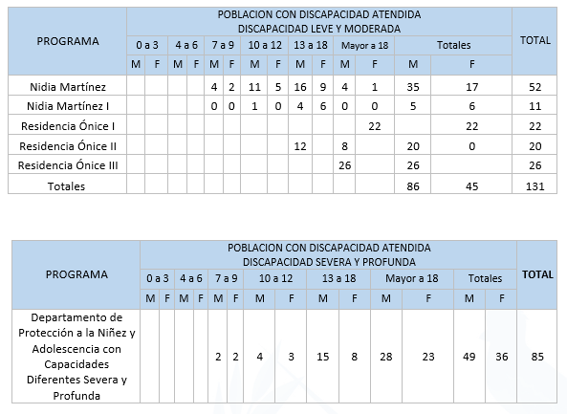
227. Special care services are provided to young and adolescent mothers held at the juvenile detention centre for girls to ensure that they and their children receive adequate preventive care.
228. As of June 2023, there are no pregnant adolescents at the juvenile detention centre for girls; however, a total of six infants and their adolescent mothers are receiving services at this centre.
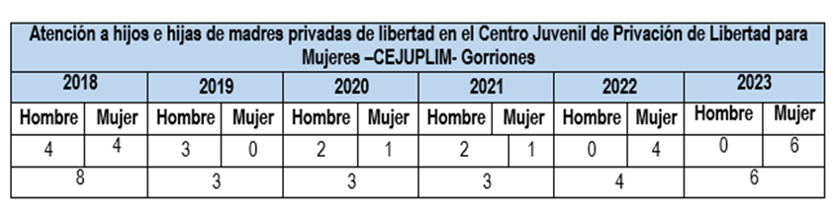
Source: Office of the Undersecretary for Social Reintegration.

Reply to the issues raised in paragraph 37
229. In 2022, accrued expenditure tagged as child-focused totalled Q 1,814 million, representing 17 per cent of total accrued expenditure for the year. The related programmes are: consular and migration services (Q 194.2 million), prevention of drug trafficking and consumption (Q 30.3 million), education (Q 552.8 million), reduction of mortality and malnutrition (Q 656.3 million), protection from violence and trafficking (Q 6.8 million), conditional transfers (Q 411.3 million), search and rescue (Q 41 million), processing of criminal complaints (Q 54.2 million), adoptions (4.7 million) and Office of the Ombudsman for Children (Q 0.7 million).

Reply to the issues raised in paragraph 38
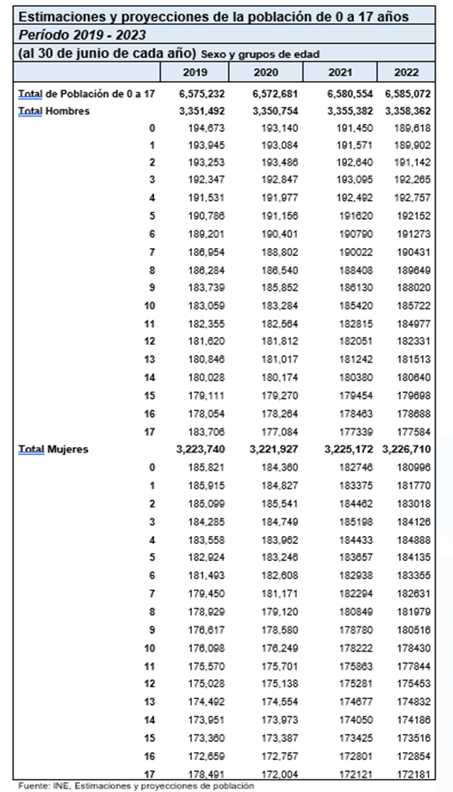

Republic of Guatemala
Proportion of population aged 0 to 17 years
(as at 30 June each year)
Period: 2018–2023
Year | Percentage
2018 | 40.3
2019 | 39.6
2020 | 39.0
2021 | 38.5
2022 | 37.9
2023 | 37.4
Source: National Institute of Statistics, population estimates and projections

Reply to the issues raised in paragraph 39
230. Between 1 January 2020 and 8 December 2022, the Public Prosecution Service reports that 687 complaints of discrimination were filed nationwide and 16 indictments were issued for that offence.

Reply to the issues raised in paragraph 40
231. Delayed registration of births can be carried out through administrative, notarial or judicial channels, depending on the context of each specific case. The administrative channel is promoted through the strategies described in the present report in reply to the issues raised in paragraph 15, under section C, “Civil rights and freedoms”, of the list of issues.
232. In notarial and judicial proceedings, the relevant legal opinion must be issued by the Counsel General’s Office and the case must meet certain requirements. Between 2019 and November 2022, the Counsel General’s Office processed 38 cases of this type.
233. Regarding statistics on unregistered births, it is important to note that the National Registry Office is the entity in charge of organizing and maintaining the central register for the identification of natural persons and registering events and acts related to their civil status, civil capacity and other identification data from birth to death, as well as issuing personal identification documents. The Office has data only on registered persons, which are stored and processed by the Directorate of Information Technology and Statistics.

Reply to the issues raised in paragraph 41
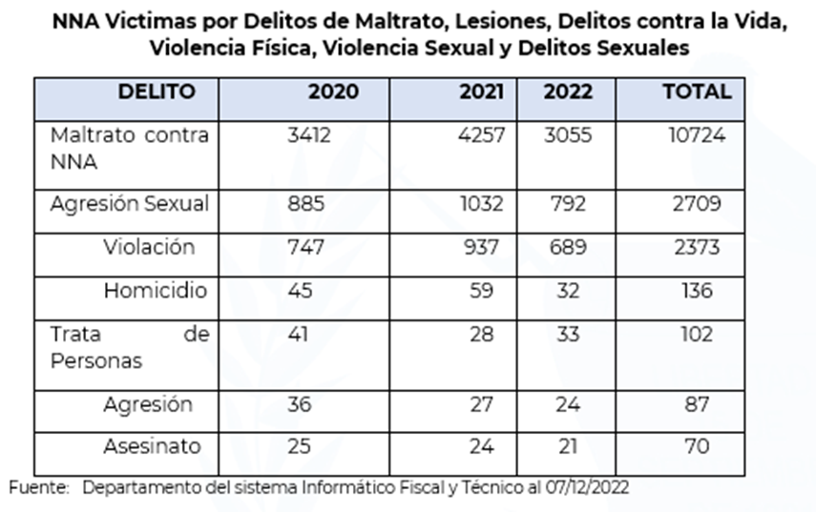
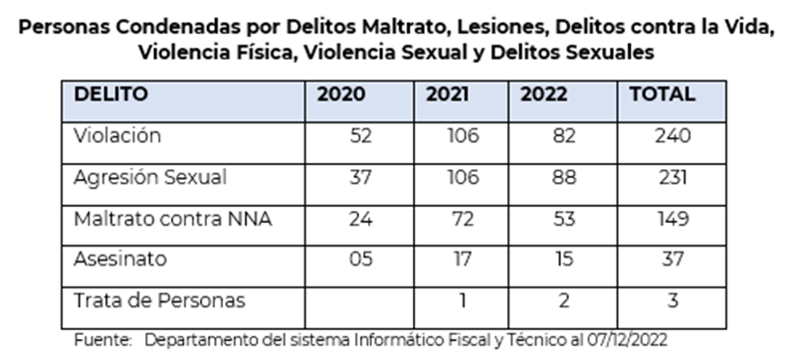
234. On identifying or learning of any situation in which the human rights of a child or adolescent in an institution are put at risk or threatened, the Office of the Advocate for Children and Adolescents takes steps to trigger general protection measures for the population accommodated in child protection facilities. Alongside other measures, this has allowed the Social Welfare Secretariat to make substantial changes to the care provided to children and adolescents and has facilitated inter-agency follow-up to the oversight of child protection facilities.
235. The National Adoption Council has implemented a protocol for immediate action in cases where the human rights of children and adolescents are threatened or violated, as determined by National Adoption Council professionals in the performance of their duties. The aim is to take or coordinate action or refer cases to the relevant entities at the request of professionals supervising entities or monitoring a child’s integration into a family, to guard against any type of threat to or violation of the rights of children and adolescents.
236. The National Registry Office database does not contain information on registrations of informal unions involving minors that were entered into after the adoption of Decree No. 8-2015 amending Decree-Law No. 106 of the Head of Government. The amendment prohibits the recognition of informal unions involving minors.

Reply to the issues raised in paragraph 42
237. The Ministry of Social Development reports the following information for the period 2018–2022, based on the National Social Information System, updated as at 7 December 2022: in 2018, 8 institutions, 57 programmes and 98 benefits; in 2019, 8 institutions, 57 programmes and 107 benefits; in 2020, 7 institutions, 57 programmes and 105 benefits; in 2021, 7 institutions, 58 programmes and 90 benefits; and in 2022, 8 institutions, 55 programmes and 98 benefits. Disaggregated by age, sex, language community, ethnic origin, disability and geographical location. The numbers of beneficiaries reported for 2018 are 1,540,151 female and 1,619,840 male; for 2019, 1,150,551 female and 1,196,547 male; for 2020, 938,172 female and 989,183 male; for 2021, 1,690,520 female and 1,738,699 male; and for 2022, 1,849,466 female and 1,862,021 male.
238. The Social Welfare Secretariat, through the Comprehensive Care Centres Programme, provided early childhood services to children and parents over the period 2018–2022 as follows:
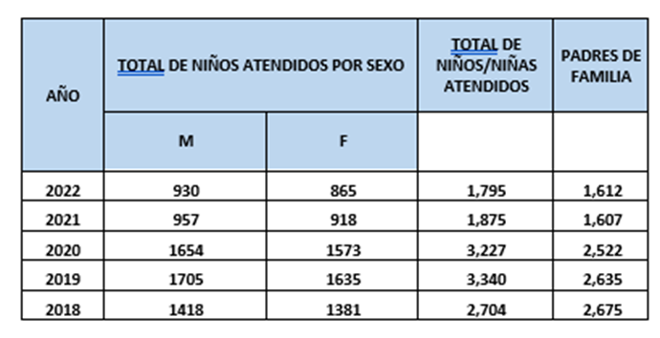
239. The Family Subsidies Programme provided benefits in the following departments:

2018
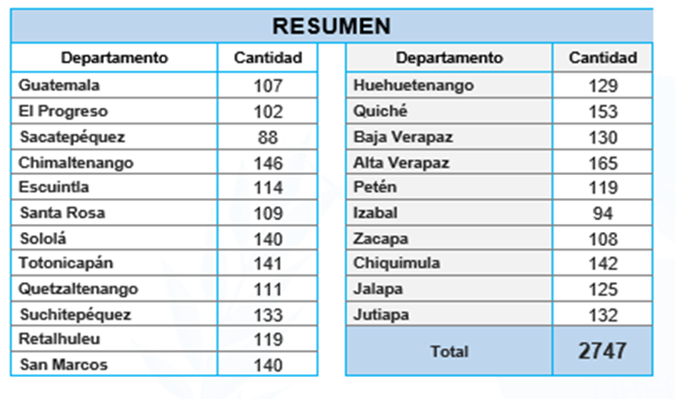

2019
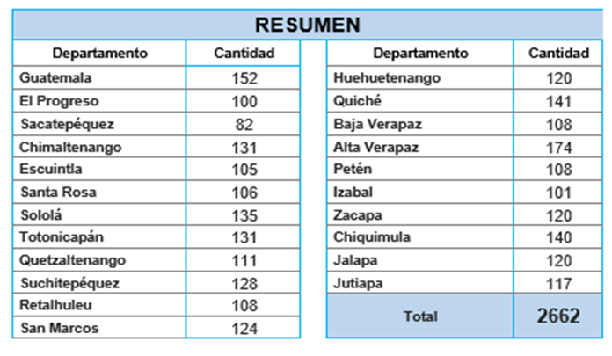

2020
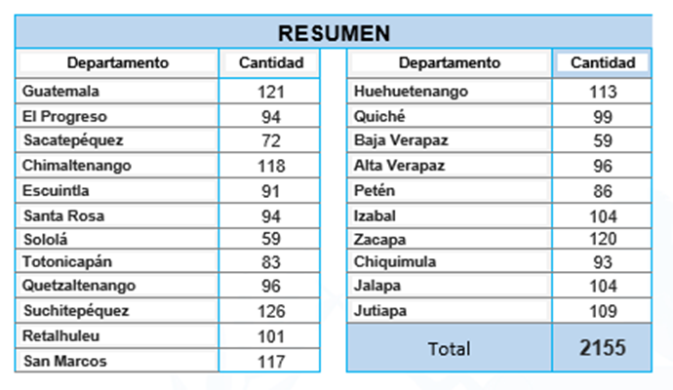

2021

2022
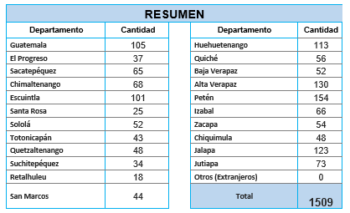
240. The following information is provided on the number of children who are or have been living in institutional care and the average length of stay, based on information collected for the period from 2019 to September 2022:
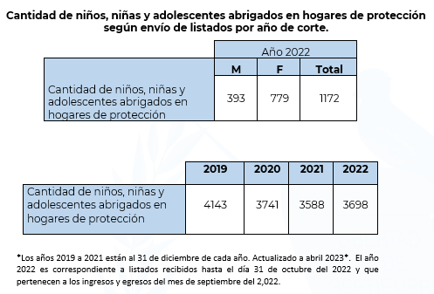
241. Concerning the average length of stay, in years, of children and adolescents living in child protection facilities as at 30 September 2022, by sex, the average length of stay in such facilities is 1 year and 7 months.
Female | 5.20 | 6.16
Male | 7.13 | 6.16
242. The Social Welfare Secretariat provided economic support in the form of subsidies to 64 children and adolescents in 2018; 77 in 2019; 119 in 2020; 141 in 2021; and 132 in 2022.
243. For the period from 2018 to 2022, the Social Welfare Secretariat reports that a total of 4,225 children and adolescents were living in family-based or community-based care.
244. The various actions carried out by the National Adoption Council through the Unit for Authorization and Oversight of Child Protection Facilities and International Agencies revolve around the authorization, registration, supervision and monitoring of child protection facilities that provide temporary accommodation and care for children and adolescents. Such facilities are subject to the quality standards for the care of children and adolescents in child protection facilities.
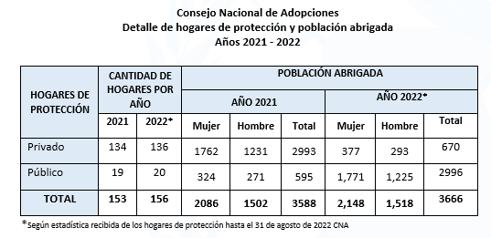
245. Below is a description of the population that received services in disability centres in 2023:
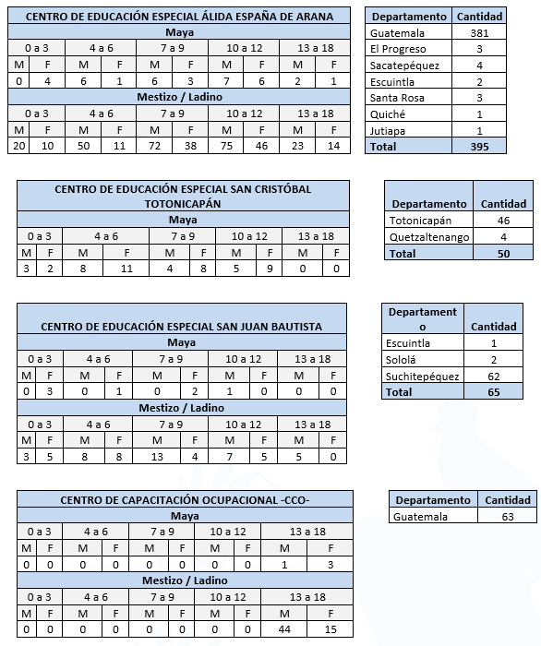
246. The Ministry of the Interior reports on the number of children living with their mothers deprived of liberty in remand centres and prisons under the responsibility of the Directorate General of the Prison System. In 2018, there were 101 such children, of whom 56 were boys and 45 were girls; in 2019, there were 117 (68 boys and 49 girls); in 2020, there were 82 (46 boys and 36 girls); in 2021, there were 92 (45 boys and 47 girls); and in 2022, there were 74 (36 boys and 38 girls).

Reply to the issues raised in paragraph 43

The National Institute of Statistics reports the following information:
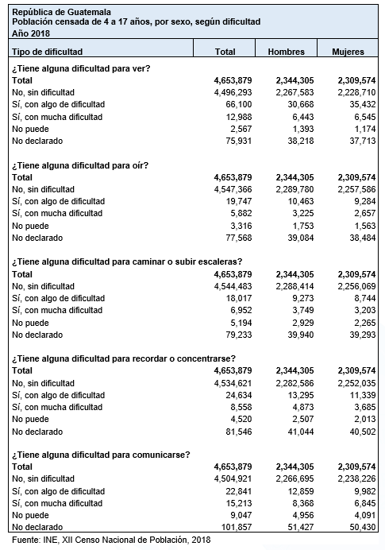
247. With regard to the care and protection of children and adolescents with disabilities, the Social Welfare Secretariat reports that in 2018 there were two beneficiaries; in 2019, five beneficiaries; in 2020, six beneficiaries; in 2021, seven beneficiaries; and in 2022, eight beneficiaries. Steps are also taken to promote the accreditation of foster families that offer to take in children and adolescents with disabilities. Meetings of the Congressional Committee on Human Rights were held and the Human Rights Advocate was elected.
248. The Social Welfare Secretariat reports that during the period 2018–2022, a total of 29 children and adolescents with some type of disability, of whom 24 were girls and 5 were boys, were in the family-based care programme.
249. The National Adoption Council reports that as at 5 October 2022 there were 306 children and adolescents who had been declared adoptable and were awaiting the restoration of their right to a family. Of these, 96 per cent (295 cases) were in the group deemed to have priority for adoption, mainly because they were more than 7 years old, were part of a group of siblings, had a disability or had a medical need, among other reasons. Of these 295 priority cases, approximately 33 per cent (97 cases) concern a child or adolescent with a disability.
250. In 2019, the Ministry of Education provided services to 2,464 students with disabilities in special schools, 21 in a transition centre and 9,679 in schools with inclusion practices. In 2020, 2,687 students with disabilities received services in special schools, 28 in a transition centre and 10,908 in schools with inclusion practices. In 2021, 2,677 students with disabilities received services in special schools, 14 in a transition centre and 11,179 in schools with inclusion practices. In 2022, 2,523 students with disabilities received services in special schools, 24 in a transition centre and 10,286 in schools with inclusion practices.
251. Priority is being given to the inclusion of more students with disabilities in the national education system and to the improvement of support programmes delivered to students with disabilities.
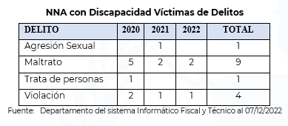
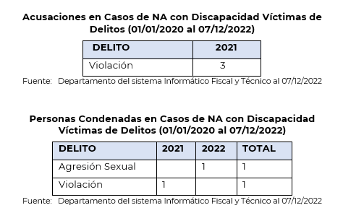

Reply to the issues raised in paragraph 44
252. Among the databases of the National Registry Office is a register of mothers between the ages of 13 and 17, disaggregated by age and year in which the birth was registered. 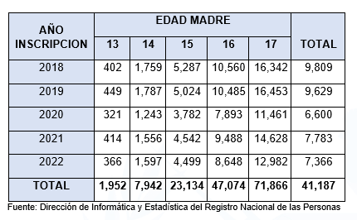
253. The Comprehensive Care Centres Programme of the Social Welfare Secretariat provides early childhood education services to girls and boys at the initial and pre-primary levels, as detailed below:
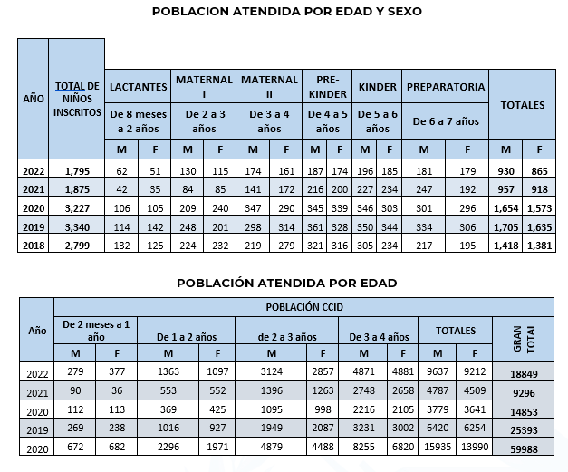
254. Statistical reports of the Department for the Regulation of Child Day-Care Centres, which is part of the Social Welfare Secretariat, show the following data on children attending child day-care centres, which offer early childhood education programmes at the initial level:
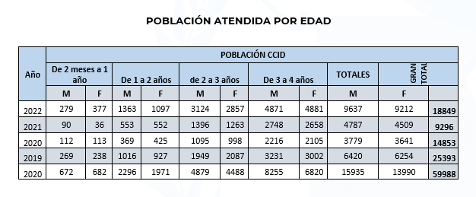
255. In special education centres, services are provided to children in the early childhood education programme, which offers children and mothers early stimulation strategies aimed at developing children’s cognitive, physical, mental, motor and neurosensory capacities to the fullest extent possible.
256. This programme includes close cooperation with the children’s mothers or caregivers. Parents, guardians and caregivers receive support and are educated about their child’s or relative’s disability. Children can remain in this programme for a maximum of six years.
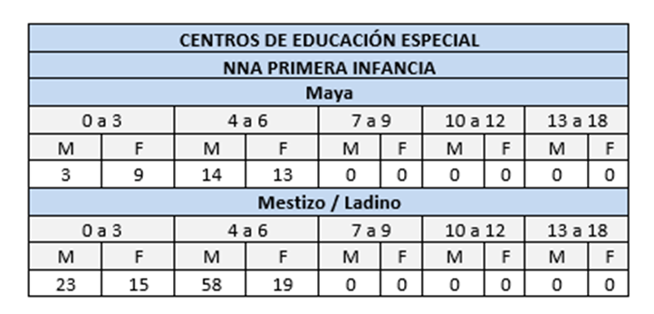

Reply to the issues raised in paragraph 45
257. In 2020, 939,469 students under the age of 18 were enrolled, of whom 461,589 were girls and 477,880 were boys. In 2021, enrolment in secondary education was 865,441, with 445,294 girls and 450,147 boys. In 2022, enrolment was 868,088, with 438,517 girls and 429,571 boys.
258. At the secondary education level, including both the basic and diversified cycles, 32,387 students under the age of 18 dropped out of the education system in 2020, including 13,441 girls and 18,946 boys. In 2021 the figure totalled 65,497 students, including 24,998 girls and 40,499 boys.
259. The Ministry of Education provides early childhood education in four stages: stage A (from 0 to 1 year), stage B (from 1 to 2 years), stage C (from 2 to 3 years) and stage D (from 3 to 4 years). Children’s average length of attendance at this educational level is four years. At the pre-primary education level, children from 4 to 6 years of age receive either monolingual or bilingual pre-primary education, divided into three grades: preschool 1 (for 4-year-olds), preschool 2 (for 5-year-olds) and preschool 3 (for 6-year-olds). Children’s average length of attendance at this educational level is three years.
260. Parents are made aware of the importance of early childhood and pre-primary education for children’s cognitive, social and emotional development, and of the importance of ensuring that children receive education in their communities and remain in the school system.
261. In 2020, 597,195 children were enrolled, of whom 294,750 were girls and 302,445 were boys. In 2021, enrolment in early childhood education totalled 632,213, including 312,379 girls and 319,834 boys. In 2022, enrolment was 700,142, including 343,784 girls and 356,358 boys.
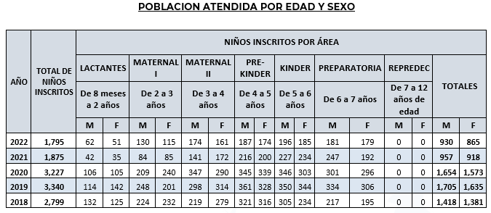

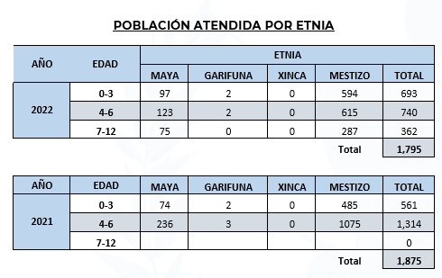
262. In 2020, 3,890,380 students were enrolled, including 2,913,695 in public schools, 811,162 in private schools, 151,718 in cooperative schools and 13,805 in municipal schools. In 2021, 3,925,673 students were enrolled, including 3,044,641 in public schools, 717,507 in private schools, 150,615 in cooperative schools and 12,910 in municipal schools. In 2022, 3,991,148 students were enrolled, including 3,120,504 in public schools, 709,571 in private schools, 148,937 in cooperative schools and 12,136 in municipal schools.

Reply to the issues raised in paragraphs 46, 47 and 48
263. For the period from 2019 to October 2022, figures from the Department of Statistics and Records of the Guatemalan Institute for Migration show that 1,297 children and adolescents applied for refugee status in Guatemala, 777 children and adolescents were returned by land to their country of origin and 30,416 children and adolescents were returned by air from Mexico and the United States.
264. The Government of Guatemala does not detain children or adolescents; rather, they are cared for by means of a protection system.
265. The Secretariat against Sexual Violence, Exploitation and Trafficking in Persons reports that, according to data for the period from 2018 to September 2022, the Public Prosecution Service reported a total of 1,345 complaints of trafficking in persons. For the same period, the Public Prosecution Service reported a total of 564 child and adolescent victims of trafficking in persons.
266. Comprehensive, differentiated and specialized care is provided to victims of trafficking in persons through programmes and services run by government institutions and civil society organizations.
267. According to statistical information from the Unit for Authorization and Oversight of Child Protection Facilities and International Agencies of the National Adoption Council, seven facilities that care for child and adolescent victims of trafficking have provided accommodation and services to 275 children and adolescents.
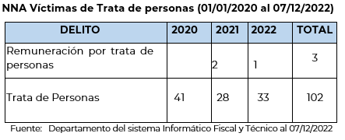
268. The Social Welfare Secretariat provides comprehensive services, either pursuant to a sentence or on a provisional basis, to adolescents in conflict with the criminal law who are at least 13 and under 18 years of age. Acts committed by a child under 13 years of age do not fall under this category and do not entail civil liability for the child. Such cases are dealt with before the competent courts.
269. When sentenced adolescents reach the age of majority, they remain within the system for adolescents in conflict with the criminal law, and thus remain in the centres, but are kept separate from minors.
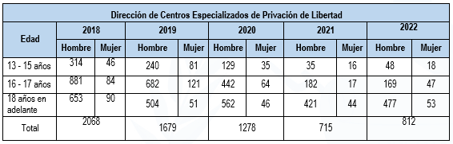
270. The Directorate of Socio-Educational Measures of the Social Welfare Secretariat is responsible for following up on and implementing socio-educational and other sanctions representing alternatives to deprivation of liberty that are imposed by judges on adolescents in conflict with the criminal law.
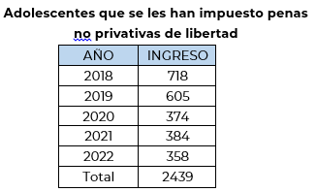
271. The Directorate of Tertiary Prevention provides all adolescents referred for post-sentence follow-up with comprehensive services to strengthen their reintegration into society. Accordingly, all such adolescents receive services from psychologists and social workers.
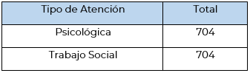
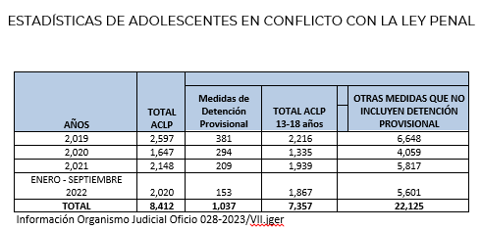

Reply to the issues raised in paragraph 49
272. The criminal division of the Office of the Advocate for Children and Adolescents distinguishes among different types of trafficking in persons, dividing reported cases into categories, including those related to sexual or economic exploitation, which, in turn, entail risks related to pornography, assault or rape and sexual harassment. During the reporting and verification process, the Counsel General’s Office flags the possible risk of this scourge for the child or adolescent, but it is the Public Prosecution Service, through its investigation, that will determine whether or not an offence of pornography has been committed.

Reply to the issues raised in paragraph 50
273. When a complaint is filed, the Counsel General’s Office may find that one of the risks presented by the child or adolescent concerned is the possibility of gang membership. Between 2020 and September 2022, the Office removed 16 children and adolescents from situations involving violations of this type.
274. Candidates for the police officer basic training course run by the Ministry of the Interior must meet several requirements, including the requirement of being between 18 and 30 years of age at the time they begin the course. The recruitment of minors under 18 years of age is prohibited.

* The present document is being issued without formal editing.
Presidential Commission for Peace and Human Rights.
Girls, boys and adolescents.
Directorate of Criminal Investigation.
United Nations Children’s Fund.
Department for the Regulation of Health-Care Programmes.
National Adoption Council.
Office of the Advocate for Children and Adolescents.
Act on the Comprehensive Protection of Children and Adolescents.
Presidential Secretariat for Planning and Programming.
National Commission on Children and Adolescents.
National Urban and Rural Development Council.
National Association of Municipalities.
Integrated Accounting System.
Government Decision No. 28-2020 of the Office of the President of the Republic.
School Meals Programme.
Parents’ organizations.
National Institute of Statistics.
Secretariat for Food and Nutrition Security.
Directorate General of Bilingual Intercultural Education.
Constitutional Court.
Training Unit of the Public Prosecution Service.
Unit on Community Prevention of Violence.
Intersectoral Commission on Information and Communication Technologies.
National Institute of Forensic Sciences.
National Civil Police.
Institutional Strategic Plan.
National education system.
Health Care Unit for Indigenous Peoples and Interculturalism in Guatemala.
Strategic Planning Unit.
Great national crusade for nutrition.
National core curriculum.
Juvenile detention centre for girls.
National Plan for the Prevention of Adolescent Pregnancy.
Comprehensive care centres.
Academic programme for the professional development of teaching staff.
The Migrant Children and Adolescents and International Abduction Unit of the Office of the Advocate for Children and Adolescents.
Ministerial Decision No. 1753-2019.
Ministry of the Environment and Natural Resources.
National Literacy Committee.
Inter-Institutional Coordinating Body against Labour Exploitation and Child Labour.
United States Bureau of International Narcotics and Law Enforcement Affairs.

