 | United Nations | CRC/C/DOM/6
 | Convention on the  Rights of the Child |  | Distr.: General  16 November 2022  English  Original: Spanish  English, French and Spanish only
Committee on the Rights of the Child

Sixth periodic report of the Dominican Republic due in 2020 under article 44 of the Convention*
[Date received: 10 January 2020]

Contents
Page
Introduction 3
A. General measures of implementation (arts. 4, 42 and 44 (6)) 3
B. General principles (arts. 2–3, 6 and 12) 7
C. Civil rights and freedoms (arts. 7–8 and 13–17) 9
D. Violence against children (arts. 19, 24 (3), 28 (2), 34, 37 (a) and 39) 11
E. Family environment and alternative care (arts. 5, 9–11, 18 (1) and (2), 20, 21, 25 and 27 (4)) 14
F. Disability, basic health and welfare (arts. 6, 18 ( 3), 23, 24, 26, 27 (1–3) and 33) 19
G. Education, leisure and cultural activities (arts. 28–31) 25
H. Special protection measures (arts. 22, 30, 32–33, 35–36, 37 (b)–(d) and 38–40) 31

Introduction
1. In 2015, the Committee on the Rights of the Child considered the combined third to fifth periodic reports of the Dominican Republic (CRC/C/DOM/3-5), adopted its concluding observations (CRC/C/DOM/CO/3-5) and invited the Dominican Republic to submit its sixth periodic report no later than 10 January 2020. The Government of the Dominican Republic is hereby fulfilling this request, providing in this document information about the main advances achieved in the implementation of the Convention on the Rights of the Child in the period 2015–2020.
2. To put together this report, the Government shared each of the Committee’s recommendations and suggestions in a series of workshops and meetings with groups of experts working in the government agencies and non-governmental organizations (NGOs) that make up the child protection system and collected up-to-date information to form the basis of its responses. The process was coordinated by the National Council for Children and Adolescents with technical and financial assistance from the United Nations Children’s Fund (UNICEF).
3. By virtue of the foregoing, the Executive President of the National Council for Children and Adolescents now has the honour to submit to the Committee this sixth periodic report, which sets forth in a succinct manner the main achievements of the Dominican Republic resulting from its efforts to uphold the fundamental rights of Dominican children and adolescents over the last five years.

A. General measures of implementation (arts. 4, 42 and 44 (6))

Section 1. Legislation

Response to the recommendations contained in paragraph 8 (a), (b), (c) and (d)
4. The Constitution of the Dominican Republic dated 13 June 2015 contains one of the most comprehensive bills of fundamental rights of any country in the Americas. Article 56, on the protection of minors, stipulates that the family, society and the State shall give priority to the best interests of the child and shall have an obligation to assist and protect them in order to ensure their harmonious and comprehensive development and the full exercise of their fundamental rights, in accordance with this Constitution and the law. This constitutionally established obligation provides the normative basis for the State’s work to ensure the comprehensive protection of children and adolescents and is interpreted by the Government as being applicable to the full set of fundamental rights enshrined in the Constitution and the international human rights framework.
5. The fundamental rights enshrined in both the Constitution and the Convention on the Rights of the Child are recognized in Act No. 136-03, establishing the Code for the Protection System and Fundamental Rights of Children and Adolescents (hereinafter the Children and Adolescents Code). The purpose of the Code is to guarantee for all children and adolescents in the country the exercise and full and effective enjoyment of their fundamental rights. To this end, the Code defines the fundamental rights, provides for their comprehensive protection and regulates the role of the State, society, families and individuals and their relationship with minors from birth to the age of 18.
6. Act No. 1-12, concerning the National Development Strategy to 2030, sets out the policy and programme framework of the Dominican State and the vision for the country that it is working to achieve. This governing framework is the result of a broad national consultation process in which a considerable number of adolescents and young persons from different parts of the country took part. The aim was to ensure that the needs of the younger population were taken into account and were reflected in the strategy ultimately adopted. The National Development Strategy sets forth the Government’s future vision of the country, has four strategic focus areas and includes 19 general objectives, 58 specific objectives, 460 lines of action and numerous indicators. In each strategic focus area, children and adolescents are a priority group. To ensure conformity with the provisions of the Constitution and the National Development Strategy, the legislative branch has embarked on a process of analysis and review of the entire national regulatory framework.

Section 2. Comprehensive policy and strategy

Response to the recommendation contained in paragraph 10
7. The institution responsible for policy and strategy is the National Council for Children and Adolescents and the legal foundation for its work is the Children and Adolescents Code. The National Council is the lead agency of the National System for the Protection of the Rights of Children and Adolescents.
8. The National System for the Protection of the Rights of Children and Adolescents is formed of the set of governmental and non-governmental institutions, agencies and entities that formulate, coordinate, oversee, supervise, execute and evaluate public policies, programmes and action at the national, regional and municipal levels designed to ensure that the rights of children and adolescents are fully protected. Its priority is to safeguard the rights of children and adolescents and to foster their comprehensive development through coordinated cross-sector and inter-agency policies and action. The National Council’s highest decision-making authority is its National Board of Directors, which is a pluralistic, cross-sector, deliberative, consultative and supervisory body composed of the heads of public and private institutions or else their designated representatives, provided they are senior officials with full decision-making power.
9. The National Council’s work is complemented and strengthened by that of two institutions that carry out their activities in a coordinated manner, namely, the Social Policy Coordination Office and the Directorate General for Special Programmes of the Office of the President. These two bodies are responsible for implementing government policies designed to ensure compliance with the National Development Strategy and the Sustainable Development Goals and thus to guarantee the comprehensive development of the country’s children and, by extension, the sustainable development of the nation.
10. Pursuant to Decree Nos. 28-01, 1082-04 and 1251-04, the Social Policy Coordination Office is responsible for coordinating the formulation, implementation, monitoring and evaluation of the various programmes forming part of the Dominican Republic’s Social Welfare System. The Social Welfare System is built on three core lines of action: conditional cash transfer programmes; human and social development programmes; and economic inclusion programmes.
11. The Directorate General for Special Programmes encompasses the institutions working to eradicate poverty and build the human capacity necessary for social development, namely, the Central Benefits System, the “Progressing with Solidarity” Social Welfare Programme and the Social Allowances Administration Office. The Directorate is composed of a technical division, an administrative division, the Civil Society Advisory Council and the State agencies that form part of or are affiliated to the Social Policy Coordination Office.
12. The Directorate General for Special Programmes was created by Decree No. 491-12 and is attached to the Office of the President. Its remit is to build capacities and opportunities that serve to reduce poverty and social exclusion by taking a systematic, holistic and rights-based approach that is regionally structured and underpinned by the notion of social co-responsibility and coordinated, concerted action across government bodies. The programmes created and implemented by the Directorate General of Special Programmes include the General Programme for a Poverty-Free Quisqueya (Quisqueya sin Miseria), which has three core components:
- the “Quisqueya Aprende Contigo” National Literacy Programme
- the “Quisqueya Empieza Contigo” Early Childhood Care Programme (see section of report covering early childhood)
- the “Quisqueya Somos Todos” National Plan for Comprehensive Local Development

Section 3. Allocation of resources

Response to the recommendations contained in paragraph 12 (a), (b), (c) and (d)
13. As the lead agency of the National Planning and State Investment System, the Ministry for the Economy, Planning and Development is responsible for coordinating the formulation, management, monitoring and evaluation of macroeconomic and sustainable development policies. The principle national planning instrument is the National Development Strategy to 2030. The National Multi-Year Plan for the Public Sector is the next most important instrument for the National Planning System and is based on the guidelines set forth in the National Development Strategy to 2030. The National Multi-Year Plan is fed by the strategic plans of the different institutions.
14. In February 2018, the Government published the results of a study analysing State investment in childhood and adolescence in the Dominican Republic in 2016, entitled “La inversión pública dirigida a la niñez y la adolescencia en la República Dominicana en 2016”. The study was conducted jointly by the Ministry of Finance, the General Budget Directorate and the Ministry for the Economy, Planning and Development, with the support and collaboration of UNICEF. Its purpose was to obtain more detailed information on public investment in children as an essential first step towards guaranteeing a more equitable budget allocation.
15. The findings of the study reveal that, in 2016, State investment in childhood and adolescence totalled 168,711.4 million Dominican pesos (RD$), or $3,660.5 million, which was equivalent to 5.1 per cent of the country’s gross domestic product, 23.7 per cent of total public expenditure and 55.8 per cent of public social expenditure. These funds were used to provide the goods, public services and opportunities that would help to uphold the rights of the children and adolescents who make up 34.6 per cent of the country’s population. An analysis of earlier studies shows that, as a percentage of gross domestic product, State investment in children and adolescents in the Dominican Republic increased by 1.5 percentage points in the period 2013–2016, from 3.6 per cent to 5.1 per cent.
16. Internal sources of funding covered 94.8 per cent of State investment in childhood and adolescence, with external sources providing 5.2 per cent. The general budget, and primarily tax receipts, was the source of 94.1 per cent of the total funds allocated, attesting to the sustainability of this level of investment. As regards the breakdown at the institutional level, 91.9 per cent of State investment in childhood and adolescence was made at the central government level, 5.6 per cent by decentralized and autonomous non-financial institutions and 2.5 per cent by State social security institutions. At the central government level, 94.3 cent of investment was made by ministries, specifically the Ministry of Education, accounting for 76.4 per cent, the Office of the President, accounting for 11.0 per cent, the Ministry of Health, accounting for 4.4 per cent, and the Ministry of the Interior and Police, with 2.5 per cent. As at 31 December 2016, 95.4 per cent of the budget allocated for State investment in childhood and adolescence had been applied.
17. Per capita investment in each child and adolescent was RD$ 48,387.0 ($1,049.8) per year) and RD$ 132.6 ($2.9) per day. Direct investment (i.e. investment to fund programmes, or component parts of programmes, designed specifically to promote the well-being of children and adolescents and uphold their rights) accounted for the lion’s share of this investment, at 76.9 per cent, with indirect investment making up 23.1 per cent. An analysis of the breakdown of expenditure by functional sector shows that 92.1 per cent was allocated to social services, 69.5 per cent to the education sector, 11.4 per cent to the social welfare system and 8.0 per cent to the health sector.
18. The percentage of expenditure allocated to health is relatively low compared to other countries in the region. Thus, the results of the study point up a need to continue increasing the budget allocated to health as well as a need for a more detailed disaggregation of the budget allocation by programme to increase visibility on the types of service provided and their beneficiaries. An analysis of direct investment by age group shows that early childhood services for children up to 5 years old received the lowest percentage of investment, at just 5.4 per cent, while services for children aged 6–12 received 46.7 per cent and services for adolescents aged 13–17 received 24.8 per cent.
19. There was a significant increase in expenditure on early childhood policies beginning in 2014, when comprehensive early childhood care programmes were introduced, notably the programmes run by the then newly formed and expanding National Institute for Comprehensive Early Childhood Care (see annex 5, Statistical Data, National Institute for Comprehensive Early Childhood Care, 2019).
20. As for the breakdown of public investment in children and adolescents by gender, in 2016 51.6 per cent of total expenditure was allocated to programmes benefitting boys and young men and 48.4 per cent to programmes benefitting girls and young women. This expenditure breakdown is similar to the gender demographics in the age group under analysis, in which 50.8 per cent of the population is male and 49.2 per cent is female, according to population projections for 2016 issued by the National Statistics Office. The most frequent outlays in terms of investment in childhood and adolescence were to cover the salaries of public servants who provide goods and services to children and adolescents (55.9 per cent) and transfers and grants, essentially current transfers (20.8 per cent), made through programmes designed principally to break the intergenerational poverty cycle.
21. As detailed above, the methodology used to measure public investment in childhood and adolescence incorporated an age perspective, a rights perspective and, for the first time in the country, a gender perspective. The study has served as a basis for reformulating public policies and implementing new ones focussed on specific age groups and designed to reduce gender inequality, and is proof of the State’s determination to improve the quality of investment in children and adolescents (see annex 1 for full report “La inversión pública dirigida a la niñez y adolescencia en la República Dominicana en el año 2016”).

Section 4. Independent monitoring

Response to the recommendations contained in paragraph 14 (a), (b) and (c)
22. The procedure to be followed for the appointment of the ombudsperson and his or her deputies is set forth in the Constitution and Act No. 367-09, which assign this responsibility to the National Congress. The appointment of a deputy ombudsperson specifically for children, or specializing in any other area, would thus require a constitutional amendment – a procedure that is highly politically sensitive in the country. However, the current mandate of the ombudsperson and his or her deputies ensures comprehensive protection for the rights of children and adolescents throughout the country without discrimination.
23. In follow-up to the recommendations of the Committee and other treaty bodies, the Ombudsperson’s Office is working with the United Nations system to bring its operations into line with the Principles relating to the Status of National Institutions (Paris Principles). This work is being carried out within the framework of a cooperation agreement with the United Nations Development Programme (UNDP) signed in November 2018 that envisages an investment of more than $3 million. These funds, which have already been set aside by the Ombudsperson’s Office and are currently deposited in a State bank, will be released progressively for use by UNDP through bank-to-bank transfers and are intended to be used to improve the Office’s infrastructure.
Nationwide training provided by the Ombudsperson’s Office
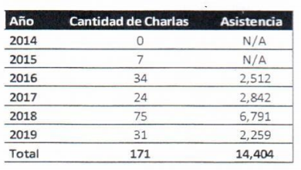
Source: Research and Education Directorate of the Ombudsperson’s Office.

Section 5. Cooperation with civil society

Response to the recommendations contained in paragraph 16
24. The Government of the Dominican Republic emphasizes that, in line with its commitment to implementing the National Development Strategy and achieving the Sustainable Development Goals, it has created multiple opportunities for consultation with and the involvement of civil society. These are all described in the corresponding sections of this report. A particularly important mechanism serving this purpose is the Civil Society Advisory Council, which was created in 2001. The Council is composed of civil society representatives who, as advisors and consultants on social policy matters, contribute to the formulation, development, implementation and monitoring of plans and programmes implemented in the Dominican Republic.
25. Another important mechanism is the National Pact for Educational Reform, which reflects one of the broadest consensus-building exercises carried out in recent years. Its particular aim is to guarantee the right of children and adolescents residing in the country to have access to a high-quality education geared towards building responsible citizens committed to national development.
26. Another achievement of note was the formulation of the National Human Rights Plan 2018–2022, which was the result of a broad consultation process involving various State institutions and civil society organizations. The Plan outlines the policy through which the Government will be working to promote and safeguard human rights, including the rights of children and adolescents, migrants and asylum seekers, and victims of trafficking, which constitute, respectively, the fourth, eighth and tenth lines of action envisaged under the Plan.

B. General principles (arts. 2–3, 6 and 12)

Section 1. Non-discrimination

Response to the recommendations contained in paragraph 18 (a), (b), (c) and (d)
27. The Ministry for Women is the national body charged with implementing the State’s policy for eliminating gender stereotypes in all social spheres. The Ministry is now in the process of releasing the third National Gender Equality and Equity Plan, which covers the period 2018–2030. This plan is the fruit of a participatory evaluation of the outcomes of the implementation of the second National Gender Equality and Equity Plan, which covered the period 2007–2017.
28. The Ministry of Education is the institution responsible for implementing educational policies that promote equality among children and adolescents and between men and women, starting in early childhood. To fulfil this mission, the Ministry issued Departmental Order No. 33-2019, which made the development and implementation of a gender policy at the Ministry a priority. The Order calls for a gender perspective to be applied at all levels of the school system and gives the Ministry’s Directorate for Gender Equity and Development responsibility for coordinating its implementation in schools and other regional and district-level bodies.
29. An external mechanism constituted by two prestigious national universities has been appointed to serve as a monitoring and accountability mechanism. Its objectives are to promote teaching tools that foster non-sexist education and ensure that educational curricula promote a gender perspective.
30. With regards to educational campaigns, the Ministry of Education’s Department for Education on Gender and Development is conducting a campaign on gender education aimed at preventing gender-based violence in schools and the educational community nationwide.
31. Through this educational campaign, the Ministry of Education is seeking to help to reduce gender-based violence in schools by promoting and instilling knowledge, values and attitudes that foster equitable and harmonious constructions of masculinity and femininity. The campaign provides tools to the entire educational community to help members to understand the phenomenon and act in an ethical manner conducive to well-being and harmonious existence.
32. So as to benefit society as a whole, by reducing levels of gender-based violence in homes, communities and schools, tools are also provided to children, teachers, parents, guardians and administrative and support staff.

Section 2. Best interests of the child

Response to the recommendations contained in paragraph 20
33. Article 56 of the Constitution enshrines minors’ right to protection and provides that the family, society and the State must give priority to the best interests of children and adolescents. Respect for the best interests of children and adolescents is also recognized as principle V of the Children and Adolescents Code.
34. The Dominican judiciary is committed to complying with both the Convention and the Children and Adolescents Code, particularly in terms of ensuring the best interests of the child in judicial proceedings before juvenile courts throughout the country and also in other courts.
35. Taking the best interests of the child as its basis, the judiciary has prepared a draft judicial policy on children and adolescents. The purpose of the draft policy, which is currently under review, is to safeguard the rights of minors and fulfil the international commitments undertaken by the Dominican Republic with respect to children and adolescents on the basis of its ratification of the Convention and the adoption of Act No. 136-03 and other laws on the matter.

Section 3. Right to life, survival and development

Response to the recommendations contained in paragraph 22
36. The State adopted Act No. 63-17 on Mobility, Ground Transportation, Traffic and Road Safety in the Dominican Republic in February 2017. The Act provides the new national regulatory framework for meeting the State’s obligation to prevent deaths of children and adolescents in road accidents.
37. Article 69 of the Act sets out rules for the transportation of children and adolescents and provides that children up to 12 years of age must be transported in the back seat of a vehicle unless the vehicle is a single-cab pickup truck. Children up to 6 years of age must be transported in special forward-facing child seats and children between 6 and 12 years of age must use booster seats that allow them to safely use the rear seat belt.
38. The 2017–2020 National Strategic Plan for Road Safety – a public policy instrument aimed at ensuring road safety in the country – sets out specific goals and objectives intended to make sure that national strategies and plans on road safety address the specific needs of children and adolescents.
39. In addition to efforts focused on prevention, the Attorney General’s Office and the courts work diligently to investigate accidents that result in the death of a child or adolescent, punish those responsible and provide reparation in accordance with the criminal provisions of Act No. 63-17.

Section 4. Respect for the views of the child

Response to the recommendations contained in paragraph 24 (a), (b), (c) and (d)
40. The judiciary has set up interview centres for persons in situations of vulnerability who are victims of crime or witnesses to it in order to ensure that the views of children are taken into account in administrative and judicial proceedings. These interview centres offer a safe space within which the revictimization of children and adolescents who have to give statements in connection with judicial proceedings can be prevented. Reflecting a specific effort by the Judicial Council to protect victims and their rights, and especially those of the country’s children and adolescents, nine interview centres for children and adolescents are now operating in the same number of courthouses around the country, namely, in the National District, Santo Domingo, San Cristóbal, Santiago, Puerto Plata, Samaná, Higüey, Valverde and, most recently, San Francisco de Macorís.
41. By the end of 2018, the centres in operation had provided services to some 5,000 people, 74 per cent of whom were female.

C. Civil rights and freedoms (arts. 7–8 and 13–17)

Section 1. Birth registration

Response to the recommendations contained in paragraph 26 (a), (b) and (c)
42. To guarantee the right of children and adolescents to recognition as a person before the law, the State is implementing a programme for timely birth registration, in compliance with the Inter-Institutional Cooperation Agreement on Timely and Late Registration in the Dominican Republic concluded on 7 August 2017 between the Ministry of Health and Social Welfare, the National Health Service, UNICEF, the Central Electoral Board and the Directorate General for Special Programmes of the Office of the President.
43. This agreement made it possible to identify the hospitals with the highest number of deliveries in the country, which, in turn, gave rise to a plan to increase timely registration through a network of outreach workers under the leadership of the Directorate General for Special Programmes. The outreach workers are responsible for making pregnant women aware of the importance of timely registration and of the mechanisms available through the hospital-based branch offices.
44. On 12 March 2018, 24 outreach workers and supervisors working on timely birth registration were officially placed in 21 priority hospitals in order to increase awareness and provide greater guidance to pregnant women, mothers, fathers and family members visiting doctors’ offices, diagnostic areas and antepartum and post-partum rooms in the hospitals. In this way, the births of newborns began to be registered in a timelier manner at the branch offices of the Civil Registry of the Central Electoral Board located in the hospitals involved.
45. The efforts of the outreach workers to encourage and raise awareness of birth registration had had an impact on more than 90,000 people in the 21 priority hospitals by December 2018.

Statistics on priority hospitals
Details |  |  | January–October 2019
No. | Hospital | Province/Municipality | Live births | Registrations | Coverage (%)
1 | Nuestra Señora de la Altagracia Maternity Clinic | National District | 8 502 | 5 960 | 70
2 | Los Mina Mother and Child Hospital Centre | Los Mina | 8 563 | 6 664 | 78
3 | Engombe Hospital Health Sub-Centre | Engombe | 1 100 | 936 | 85
4 | Dr. Reinaldo Almanzar Maternity Hospital | Villa Mella | 7 342 | 6 268 | 85
5 | Boca Chica Hospital | Boca Chica | 583 | 444 | 76
6 | Dr. Ángel Contreras Mejia Hospital | Monte Plata | 995 | 879 | 88
7 | Dr. Antonio Musa Regional Hospital | San Pedro de Macorís | 2 454 | 2 021 | 82
8 | Nuestra Señora de la Altagracia Hospital | Higüey | 3 474 | 2 934 | 84
9 | Dr. Leopoldo Martínez Hospital | Hato Mayor | 642 | 554 | 86
10 | Juan Pablo Pina Hospital | San Cristóbal | 3 302 | 2 746 | 83
11 | Nuestra Señora de Regla Hospital | Bani | 2 032 | 1 498 | 74
12 | Taiwan Hospital | Azua | 2 385 | 1 997 | 84
13 | Dr. Alejandro Cabral Hospital | San Juan de la Maguana | 2 177 | 2 023 | 93
14 | Rosa Duarte Hospital | Elías Piña | 773 | 544 | 70
15 | Jaime Sánchez Hospital | Barahona | 3 180 | 2 642 | 83
16 | Melenciano General Hospital | Jimaní, Independencia | 213 | 169 | 79
17 | Estrella Ureña Hospital | Santiago | 5 827 | 5 416 | 93
18 | Dr. Luis Manuel Morillo King Hospital | La Vega | 2 146 | 1 972 | 92
19 | San Vicente de Paul Hospital | San Francisco de Macorís | 1 419 | 1 298 | 91
20 | Dr. Ramón Matías Mella Hospital | Dajabón | 706 | 444 | 63
21 | José Francisco Peña Gomez Hospital | Valverde Mao | 1 542 | 1 441 | 93
Total |  |  | 59 357 | 48 850 | 82
Source: Central Electoral Board of the Dominican Republic.

Section 2. Name and nationality

Response to the recommendations contained in paragraph 28 (a), (b), (c), (d) and (e)
46. The Dominican Republic recognizes that one of children’s fundamental rights is the right to a name and a nationality. These rights are enshrined in international conventions and the country’s legal framework, including its Constitution.
47. In 2014, the Dominican Republic passed Act No. 169-14 in order to provide for: (a) a special regime for children who were born in the Dominican Republic to non-resident foreign fathers and mothers between 16 June 1929 and 18 April 2007 and whose births were registered in the books of the Civil Registry; and (b) the registration of children who were born in the Dominican Republic to foreign parents in an irregular situation and do not appear in the Civil Registry.
48. The Act orders that the Dominican nationality of persons covered by scenario (a) immediately be recognized and that their birth certificates be transcribed in the registries of the Central Electoral Board. By 2018, the Central Electoral Board had delivered birth certificates to a total of 61,132 persons.
49. Persons covered by scenario (b) are given the right to register with the registry of foreign nationals so as to regularize their migration status in accordance with Presidential Decree No. 327-13. Two years after regularization, they may apply for naturalization.
50. With the issuance of Decree No. 327-13 and the later passage of Act No. 169-14, the State launched its National Plan for the Regularization of Resident Foreign Nationals with an Irregular Migration Status, to be implemented by the Directorate General of Migration under the charge of the Ministry of the Interior and Police. Information from the Ministry indicates that the Plan has thus far allowed the migration status of 249,948 foreign nationals, including 9,044 children and adolescents, to be regularized.

Section 3. Right to privacy/access to appropriate information

Response to the recommendations contained in paragraph 30 (a), (b) and (c)
51. Information and communications technologies are essential tools for production and learning. According to the 2016 Multipurpose Household Survey, in the Dominican Republic that year, 89 per cent of households had a mobile telephone and 27 per cent had a desktop or laptop computer or tablet. In addition, 27 per cent had Internet service. Overall, 96.5 per cent of households had at least one information and communications technology medium or service.
52. There were mobile telephones in 90.6 per cent of urban households and 84.4 per cent of rural ones. However, the divide was greater for computer or tablet ownership and Internet service. The percentage of households in urban areas with a computer or tablet was more than double that in rural areas (31.6 per cent compared to 13.5 per cent) and the figure for Internet service was almost three times greater (29.8 per cent compared to 11.6 per cent).
53. In order to close these divides, a “Digital Republic” programme was adopted under Decree No. 258-16. It establishes the State policy for ensuring children’s equal access to new communications technologies as a path to increasing public participation in the public sphere. The Decree created the Digital Republic Presidential Commission as an inter-institutional forum responsible for designing, implementing and monitoring the programme.

D. Violence against children (arts. 19, 24 (3), 28 (2), 34, 37 (a) and 39)

Section 1. Freedom of the child from all forms of violence

Response to the recommendations contained in paragraph 32 (a), (b), (c), (d), (e), (f) and (g)
54. Two initiatives launched during the reporting period as part of State policy for combating sexual abuse and exploitation stand out: the National Campaign for the Promotion of Positive Parenting, headed by the National Council for Children and Adolescents; and the “Línea Vida” (Life) helpline run by the Attorney General’s Office.
55. The first came about as a response to the violence experienced by children and adolescents in the home. Positive parenting is one element of the commitment undertaken by the State in the National Road Map for the Prevention and Elimination of Violence against Children and Adolescents, which was extended until 2020 and aimed at expanding support and guidance for parents and families to enable them to be responsible parents and so help to reduce domestic violence.
56. Another initiative is a bill establishing a comprehensive system for the prevention, punishment and eradication of violence against women and the provision of assistance for victims, which is being discussed by the National Congress and is expected to be adopted. The bill sets forth important measures for the protection of the children of women who are victims of gender-based violence.
57. At the same time, with technical and financial cooperation from UNICEF, operational plans were prepared for key institutions in the implementation of the 2020 Road Map. As part of this process, visits and workshops were conducted to support 18 institutions, leading to the preparation of a total of 11 plans for key institutions in the implementation of the national strategy. In addition, the National Council for Children and Adolescents was given a greater role as part of the Presidential Commission of Experts responsible for the Comprehensive Early Childhood Assistance Plan.
58. In addition to these steps, the State, through the institutions comprising the National System for the Protection of the Rights of Children and Adolescents and the National Board of the National Council for Children and Adolescents, has taken sector-specific action to counter and eradicate violence against children and adolescents in the areas of health, education and justice and to build its capacity to develop policies and measures in these areas.
59. In this connection, the Ministry of Health and Social Welfare launched a 2016–2020 strategy to bolster the National Health System’s response to violence, with an emphasis on gender-based violence and violence against children, adolescents, women and older persons. The strategy is being applied across the entire organizational structure of the National Health System.
60. The Ministry of Education, for its part, adopted the Dominican Education System Standards for Harmonious Coexistence in Public and Private Schools. In addition, in 2017, it adopted a protocol on the promotion of a culture of peace and fair treatment in schools.
61. The judiciary carried out an extensive campaign on the prevention of child abuse, which involved educational materials, printed materials and the establishment of panels on the prevention of abuse in the northern, southern and eastern regions and Santo Domingo Province and targeted judicial officials, school directors, teachers, psychologists and parents.

Section 2. Sexual exploitation and abuse

Response to the recommendations contained in paragraphs 34 (a), (b), (c), (d), (e), (f), (g) and (h) and 36 (a), (b) and (c)
62. In connection with the implementation of the 2017–2020 National Action Plan against Trafficking in Persons and the Smuggling of Migrants and the National Road Map for the Prevention and Elimination of Violence against Children and Adolescents, the Attorney General’s Office and UNICEF have put in place a joint action plan to reduce sexual and commercial exploitation offences committed against children and adolescents in vulnerable areas of the country. One of the main measures taken under this collaborative plan was the creation, in 2013, of the Special Prosecutor’s Office for Offences of Migrant Smuggling and Trafficking in Persons, which is responsible for investigating and prosecuting offences of commercial sexual exploitation of children and adolescents. The creation of the Special Prosecutor’s Office has significantly increased the State’s capacity to carry out operations to rescue children and adolescents who are being or have been sexually exploited, without this offence being conflated with trafficking in persons for purposes of sexual exploitation, which may be committed using any form of violence in order to achieve total control over the victim, both physically and psychologically.
63. The second component of the plan includes measures aimed at reducing the commercial sexual exploitation of children and adolescents in the country’s tourist areas. This programme is being implemented in the tourist areas of Boca Chica in the south, Cabarete, Sosúa and Puerto Plata in the north and the colonial area of Santo Domingo through community and inter-institutional working groups on the prevention, investigation, prosecution and handling of these crimes. Also as part of the programme, informative material on the crime of sexual exploitation and the penalties under domestic law for those who commit it is posted for travellers at points of entry into the country, especially at airports.
64. Also under the programme, the State and UNICEF have jointly launched the “There Are No Excuses” (No hay excusas) Campaign, the aim of which is to highlight the problem and the responsibility that adults bear for the continued occurrence of conduct of this nature. The campaign conveys two key messages. Firstly, it informs the public about the problem, seeking to counter the normalization of the phenomenon, drawing attention to the fact that children and adolescents are vulnerable and placing responsibility with adults. Secondly, it raises awareness among potential “clients” of their role as exploiters when they pay to have sex with children and adolescents.
65. The Dominican Republic formally joined the WeProtect Global Alliance in order to establish and start implementing a national response for the prevention, investigation and prosecution of the online sexual exploitation of children and adolescents. A memorandum of understanding has been signed as part of a collective effort involving various sectors of Government and civil society that sets out the framework for cooperation and collaboration among the parties jointly implementing and executing the national response against online sexual exploitation.
66. The parties to the agreement are the Ministry of the Office of the President, the Ministry of Foreign Affairs, the Attorney General’s Office, the Ministry of Education, the National Council for Children and Adolescents, the Dominican Telecommunications Institute, Plan International, UNICEF and La Coalición de ONGs por la Infancia (Coalition of Children’s NGOs).
67. An innovative step taken under the WeProtect project was the formulation of two protocols for coordinated action in the prosecution of online child sexual exploitation and the provision of assistance to victims, which are designed to ensure a comprehensive human rights-based response for victims. These coordinated efforts define and reinforce the channels for the exchange of information among the institutions involved, resulting in interrelated and parallel processes that reduce the likelihood of victims’ spending too long in institutional care.
68. The protocols were approved by decision of the National Response Board and the Superior Council of the Public Prosecution Service. Seventy prosecutors and members of local protection boards nationwide were trained in the protocols. As the protocols were approved by decision of the Superior Council of the Public Prosecution Service, they fall within the scope of the regular curricula of the Service’s National School.
69. Lastly, it should be noted that the State makes available to the public the 809-200-1202 “Línea Vida” (Life) helpline of the Attorney General’s Office and the 809-200-7393 “Línea Llama y Vive” (Call and Live) helpline of the Special Prosecutor’s Office for Offences of Migrant Smuggling and Trafficking in Persons, which are also relevant measures.
70. These measures have significantly increased the capacity of the justice system to identify, prosecute and bring to trial cases of sexual exploitation of children and adolescents.
71. Regarding the trial of former nuncio Józef Wesołowski and former priest Wojciech Gil, the State reiterates that it was not possible to extradite Józef Wesołowski to the Dominican Republic because the Vatican City prohibits the extradition of its nationals. However, the Vatican City prosecuted and tried Józef Wesołowski for the crime of pederasty under its domestic laws, and he died in 2015.
72. As for Wojciech Gil, a court in Wolomin, Poland, tried and sentenced him to 7 years’ imprisonment for acts of sexual abuse committed against minors while he worked in the Dominican Republic and Poland. The Public Prosecution Service of the Dominican Republic cooperated throughout the investigation and trial through its Department of International Legal Cooperation and ensured that victims in the Dominican Republic received the compensation awarded in the legal proceedings held in Poland.

Section 3. Harmful practices

Response to the recommendations contained in paragraph 38
73. The State’s main avenue for eradicating child marriage is the amendment of its civil legislation. In January of this year, a bill amending the Civil Code was resubmitted to the Chamber of Deputies of the Dominican Republic. The bill would raise the minimum age for marriage to 18, with no exceptions. Although the National Congress is debating whether to include an exception allowing minors under 16 years of age to marry, the President of the Chamber of Deputies, several senators and the Attorney General’s Office have expressed their support for the total eradication of child marriage. This is a decisive first step towards the eradication of child marriage in the country.
74. In terms of public policy, a specific objective of the 2019–2023 National Plan for the Reduction of Adolescent Pregnancies, under the strategic focus area of prevention, is the introduction of processes for informing, educating and communicating with families and communities, outside of school, in order to stop the normalization of early unions with adults as a life path and highlight the consequences of such unions for the lives of children and adolescents. (See information on adolescents’ right to health).
75. In addition, through the Social Policy Coordination Office and the “Progressing with Solidarity” Social Welfare Programme, the State has concluded an agreement with UNICEF to organize a committee on the reduction of child marriage and early unions.

E. Family environment and alternative care (arts. 5, 9–11, 18 (1) and (2), 20, 21, 25 and 27 (4))

Section 1. Family environment

Response to the recommendations contained in paragraph 40 (a), (b), (c) and (d)
76. Article 59 of the Children and Adolescents Code protects the right of all children and adolescents to live, be brought up and develop within their family of origin. Exceptionally, in cases where this is impossible or contrary to their best interests, children are entitled to live, be brought up and develop in a substitute family, in accordance with the Code. Under no circumstances may lack of economic resources be considered grounds for separating children and adolescents from their family of origin.
77. Article 59 (1) stipulates that children or adolescents may be separated from their family only as a result of a court order and only in the situations provided for in the Code, when the family home is found not to offer an environment appropriate for their development and in keeping with their best interests.

Section 2. Children deprived of a family environment

Response to the recommendations contained in paragraph 42 (a), (b), (c), (d), (e) and (f)
78. The National Council for Children and Adolescents runs temporary shelters (hogares de paso) for children and adolescents who, for reasons of abandonment, physical violence or emotional abuse, require the assistance of the State. These are first reception centres for children or adolescents at personal, family or social risk who are living in an unsafe environment.
79. Children and adolescents may be placed in one of these shelters upon referral by the Public Prosecution Service, the 911 national emergency system or another authorized institution. To be admitted, the child or adolescent must either be in a situation in which his or her rights are being violated or in a situation of risk or have been abandoned or have been voluntarily surrendered to the care of the National Council for Children and Adolescents by his or her biological parents. Except in the case of voluntary surrender, admission is subject to the issuance of a protection order by the competent court.
80. Statistics on children and adolescents admitted to temporary shelters in 2018 are provided in the following tables.
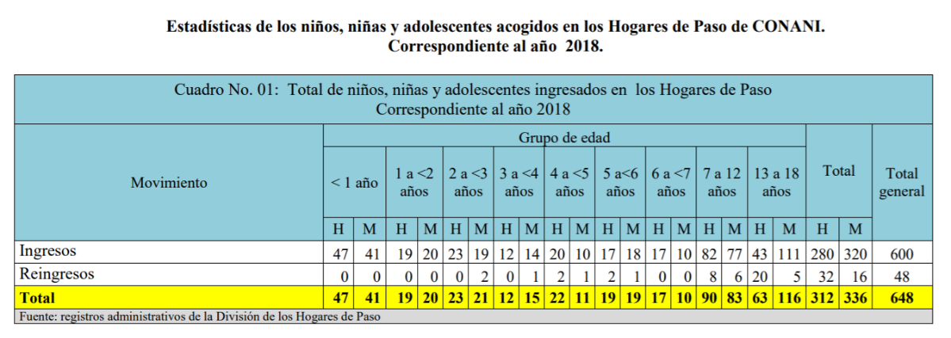

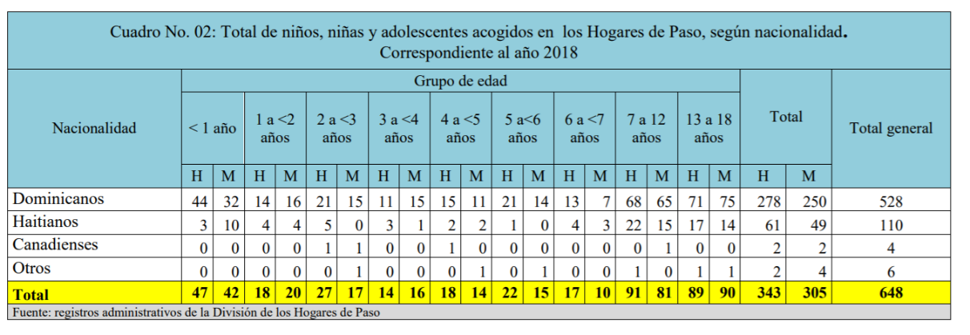
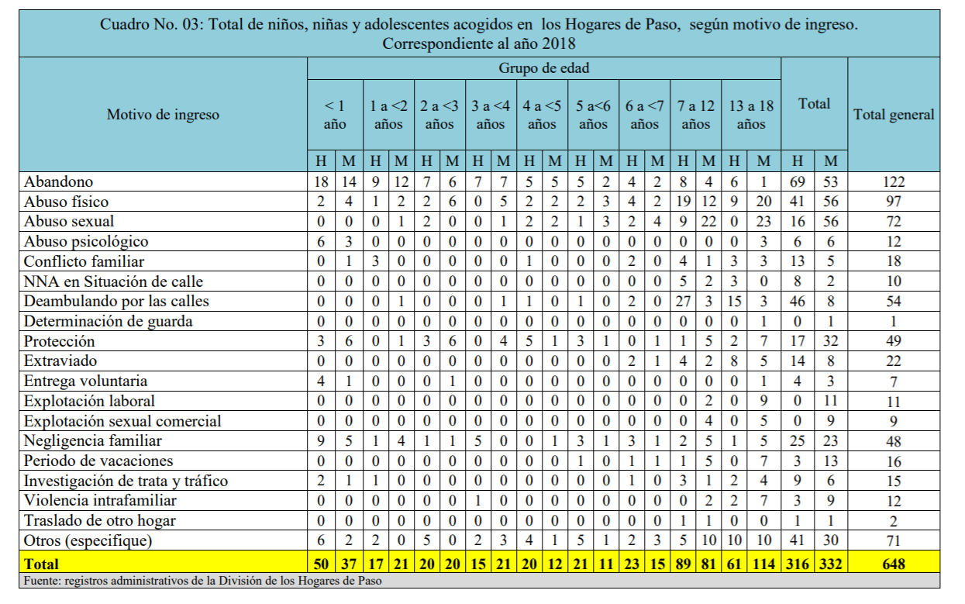
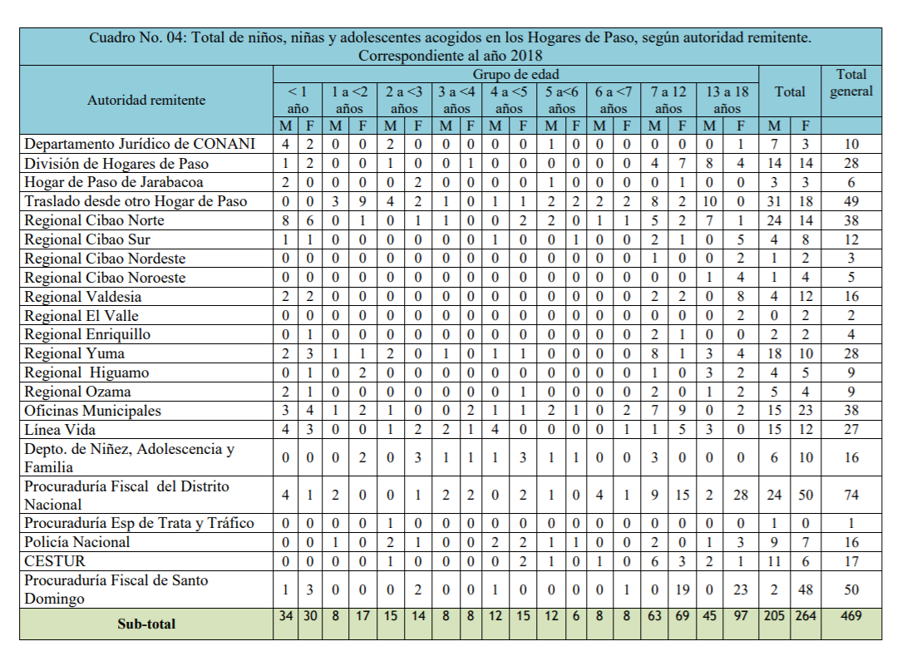
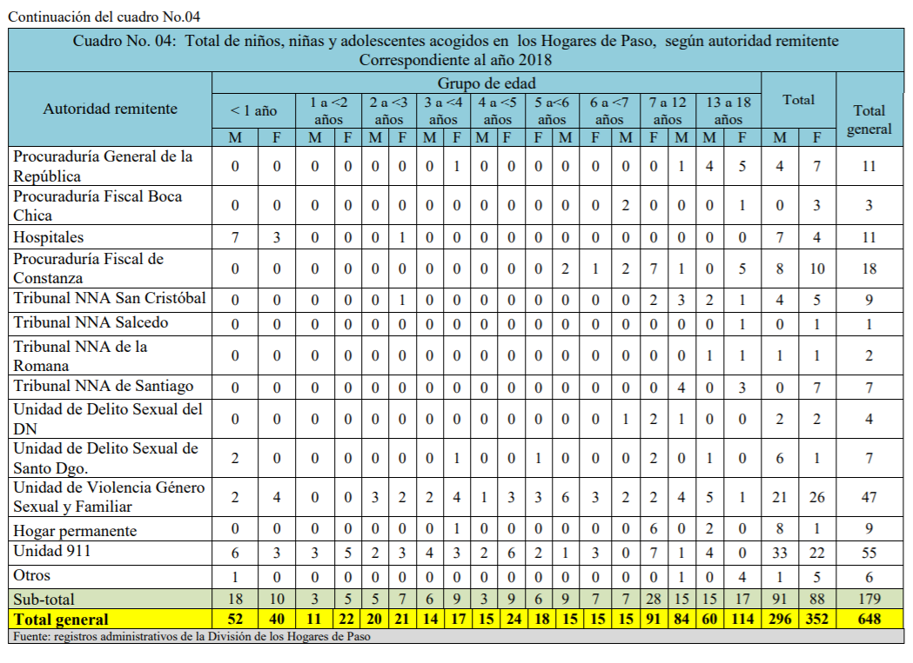
81. “Institutionalization is a traditional response that has evolved from the anachronistic charity-based approach that historically took the form of orphanages. In the Dominican Republic, the presence of children and adolescents in institutions outside the family environment is essentially a reflection of extreme poverty (families with no fixed income who lack basic social services). These are children and adolescents whose families, besides being poor, are highly dysfunctional and present a high risk of domestic violence, with the result that some of them are highly vulnerable and face formidable obstacles to the realization of their full potential in formal development spaces such as school and the community.”
82. In view of this situation, the National Council for Children and Adolescents has been pursuing a policy of deinstitutionalization and foster placement. In late 2019, it established a new department to implement the national foster care programme, which was developed on the basis of a two-year pilot project.
83. At the same time, using data from a national census of children deprived of parental care and living in institutions, the Council has been working with the organization Both Ends Believing on the “Children First Software” project, the aim of which is to develop an innovative tool to facilitate the timely registration of children in the care of the protection system and thus ensure that their right to live in a family can be guaranteed.

Section 3. Adoption

Response to the recommendations contained in paragraph 44 (a) and (b)
84. Domestic and inter-country adoption in the Dominican Republic is regulated by the Children and Adolescents Code. Article 11 of the Code defines adoption as “a public legal institution for the welfare of society that allows for the creation, by means of a judgment rendered for that purpose, of a voluntary bond of filiation between persons who are naturally unrelated”. Persons aged over 30 and under 60 years old may adopt, irrespective of their marital status, provided that the adopter is physically, morally, socially and sexually suitable to offer a child or adolescent a home that ensures his or her comprehensive well-being. The same qualities are required of joint adopters.
85. Up-to-date statistics on adoption procedures administered by the National Council for Children and Adolescents are provided below.
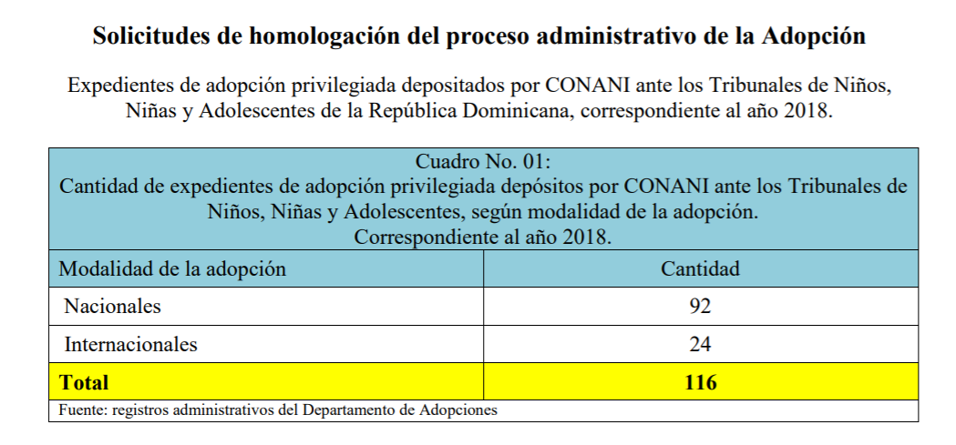
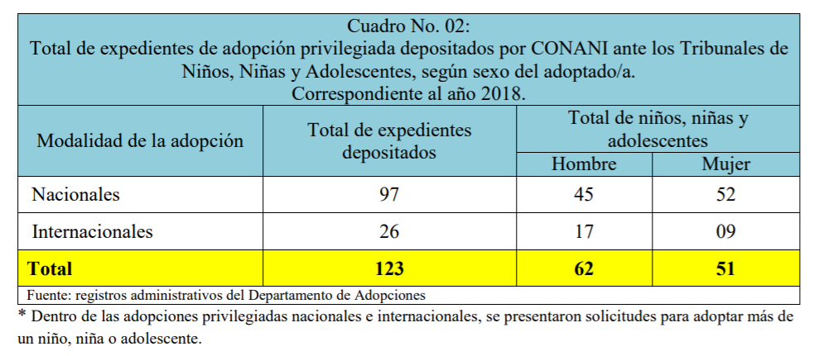
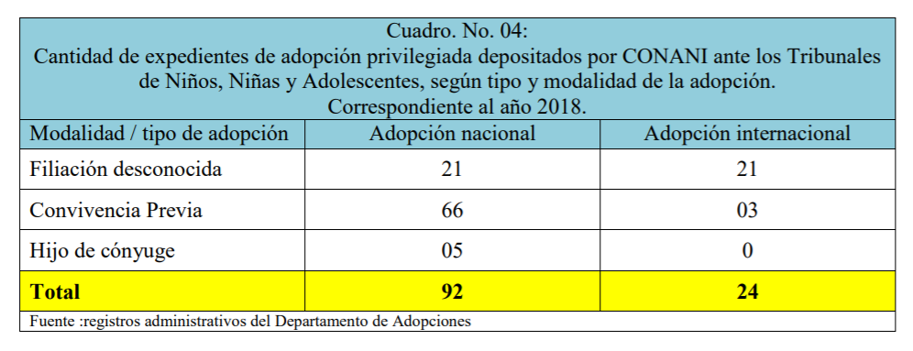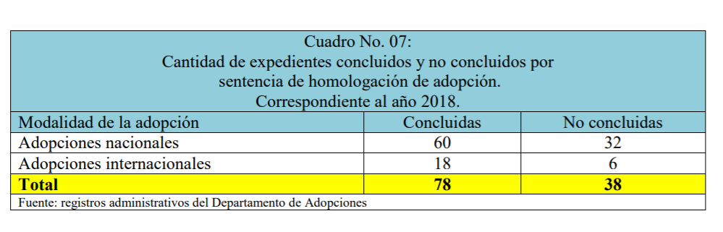

Section 4. Early childhood development

Response to the recommendation contained in paragraph 46
86. The Dominican Republic has a comprehensive early childhood care model covering the whole country that is designed to guarantee the rights of children up to 5 years of age, ensure their optimal development and improve their quality of life. Specific objective 2.3.4 of the National Development Strategy is “to protect children, adolescents and young persons” while Action 2.3.4.1 establishes a duty “to promote comprehensive early childhood care”.
87. Since 2013, this model has been implemented within the framework of the “Quisqueya Empieza Contigo” Early Childhood Care Programme, which forms part of the “Poverty-Free Quisqueya” strategy spearheaded by the Directorate General for Special Programmes attached to the Office of the President. The “Quisqueya Empieza Contigo” Programme was launched in April 2013 by Presidential Decree No. 102-13 in response to the considerable challenges faced by children up to six years of age in exercising their fundamental rights.
88. For 2020, the targets set for the “Quisqueya Empieza Contigo” Programme included:
- Care provided for 466,776 children up to 4 years of age (more than 50 per cent of the total)
- Care provided by 1,680 service units, including:
- 251 newly built childcare facilities
- 1,000 community centres
- 200 strengthened civil society initiatives
- 51 Comprehensive Early Childhood Care Centres
- 103 centres run by Administradora de Estancias Infantiles Salud Segura
- 75 centres run under the “Places of Hope” (Espacios de Esperanza) Programme
- Skills training for 373,420 families to improve protection and ensure comprehensive care
- Enrolment of 189,570 children aged 5 years old (90 per cent of the total) in Ministry of Education schools at the pre-primary level
89. This expansion of coverage was made possible by the establishment, in 2015, of the National Institute for Comprehensive Early Childhood Care, the government institution responsible for managing the comprehensive care services available for children up to 5 years old and members of their families and implementing the comprehensive care model. The Institute was established by Decree No. 102-13 (arts. 7 and 461-14), supplemented by Decree No. 498-14, declaring 2015 the Year of Comprehensive Early Childhood Care, as a functionally and geographically decentralized body attached to the Ministry of Education.
90. In 2018, about 22,000 children aged 5 years old were transferred from Comprehensive Care Centres administered by the Institute to initial education centres run by the Ministry of Education, thus freeing up space for other children to take their places. In addition to these places, the Institute’s capacity was extended to allow for a further 57,602 children to attend its centres. Overall, the number of places available nationwide increased by 31 per cent relative to the 2017 figure.
91. The Institute also opened 150 new Family and Infant Care Centres and 10 new Comprehensive Early Childhood Care Centres. As a result, the Institute now manages and provides services for 185,633 children from about 148,000 families through 111 Comprehensive Early Childhood Care Centres and 409 Family and Infant Care Centres. In addition, 330 service units managed by civil society organizations have been improved or extended, giving a total of 462 early stimulation facilities for children up to 2 years old and 591 initial education centres for children aged 3 and 4 years.

F. Disability, basic health and welfare (arts. 6, 18 ( 3), 23, 24, 26, 27 (1–3) and 33)

Section 1. Children with disabilities

Response to the recommendations contained in paragraph 48 (a), (b), (c), (d), (e), (f) and (g)
92. The adoption of the Disabilities Act (No. 5-13) laid the foundations for the creation and development of a disability care system geared towards making all parts of society more inclusive. Under this law, the State is pursuing a two-pronged policy in respect of children with disabilities that is based on early detection in the part of the education system administered by the National Institute for Comprehensive Early Childhood Care on the one hand and the provision of comprehensive care in the Comprehensive Care Centres for Children with Disabilities coordinated by the Office of the First Lady on the other.
93. In 2018, the Institute incorporated Resource Centres for Diversity Support into the care pathway open to children with disabilities leaving its centres and updated the protocol for children’s transition to the pre-primary grade of Ministry of Education schools to include children with disabilities.
94. In terms of early detection and addressing special educational needs and disability, the Institute is working to ensure that children with disabilities are recognized as subjects of rights with the capacity to develop and learn. To achieve this end, during 2018 it took steps to guarantee inclusion and effective work with these children, including strategic action to increase the visibility of the issue and the priority attached to it. As a result, 988 children with warning signs were admitted to the Institute’s services, with 902 of them receiving care from the Dominican Rehabilitation Association.
95. The Comprehensive Care Centres for Children with Disabilities cater for children up to 10 years of age with disabilities caused by autism spectrum disorder, Down syndrome, cerebral palsy and other conditions. Nationwide, there are four of these specialized centres providing services including paediatric and psychiatric evaluation and diagnosis, psycho-pedagogical support, early care, physiatry, hydrotherapy, behavioural intervention, group intervention, nutrition, dentistry, paediatrics, psychiatry, speech and language therapy, family therapy, physical therapy and occupational therapy. They also offer music therapy, theatre, dance and painting to foster creativity and a sense of achievement in the children under their care.
96. With regard to the number of children benefiting from these activities, in 2018, the West Santo Domingo Centre admitted 488 children and provided active therapies, clinical services and post-discharge follow-up for 624 children, while, in the north of the country, the Santiago Centre assisted 340 children and, in the south, the San Juan Centre assisted 232 children.

Section 2. Health and health services

Response to the recommendations contained in paragraph 50 (a), (b), (c), (d), (e) and (f)
97. The Ministry of Health and Social Welfare, the National Health Service and the national health insurance system are responsible for implementing the national health policy for the population in general, including for children and adolescents.
98. The Ministry of Health and Social Welfare is engaged in a plan to strengthen and support the reform of the national health sector, which is being implemented within the framework of the second strategic focus of the National Development Strategy, the aim of which is to build “a cohesive society, with equal opportunities and low levels of poverty and inequality” and thus achieve specific objective 2.2.1, which is “to guarantee the population’s right of access to comprehensive, high-quality care that is delivered with warmth and prioritizes health promotion and disease prevention by strengthening and streamlining the National Health System”, and specific objective 2.2.1.7, which is “to strengthen the oversight and guidance provided by the Ministry of Health and Social Welfare and its decentralized bodies in respect of the individual and collective health services offered by public and private service providers in order to ensure that such services meet quality standards”.
99. As part of this comprehensive reform, during the period 2012–2016 the Ministry of Health and Social Welfare implemented the National Strategic Plan for the Reduction of Maternal and Child Mortality. A 2017 evaluation of the Plan’s outcomes and a study of the avoidability of maternal mortality determined that 88 per cent of deaths were avoidable and 85 per cent of them were related to inadequate care. The main causes of neonatal death, accounting for 75 per cent of the total, were newborn respiratory distress syndrome, neonatal sepsis, hypoxia and asphyxia at birth, congenital pneumonia and unspecified congenital anomalies. The proportion of deliveries by caesarean section was 46 per cent in public hospitals and over 87 per cent in private ones, well above the 10 per cent rate recommended by the World Health Organization.
100. The 2016–2020 Presidential Goals took into account the importance of these indicators and set the following targets: a maternal mortality rate of 70 deaths per 100,000 live births; an infant mortality rate of 18 deaths per 1,000 live births; and an adolescent fertility rate of 20.
101. The Ministry of Health and Social Welfare and the National Health Service, with the support of international cooperation agencies, adopted and launched an updated action plan to accelerate the reduction of maternal and neonatal mortality during the period 2018–2020. This plan consisted of four strategic lines. The first was to expand effective coverage in reproductive, maternal and neonatal health, focusing on improving quality and on the main direct and indirect causes of maternal and neonatal morbidity and mortality. The second involved the availability of a network of qualified, integrated and adequately distributed human resources. The third entailed securing a budget for key interventions in the area of obstetric and neonatal emergency prevention, response and care. The fourth related to the introduction of a surveillance system.
102. The prevalence of breastfeeding in the Dominican Republic is very low and has declined in recent years. The 2002 Demographic and Health Survey revealed that, in that year, only 10.4 per cent of children were exclusively breastfed. This figure dropped to 7.8 per cent in 2007 and to 6.7 per cent in 2013 – one of the lowest rates in Latin America and the Caribbean. In 1995, promoting and encouraging breastfeeding was declared a national priority under Act No. 8-95, but the regulations implementing the Act were approved only recently, with the promulgation of Decree No. 142-18. These regulations designate the Ministry of Health as the entity responsible for promoting breastfeeding, in accordance with the Act, and make it mandatory for health personnel in public and private facilities to provide mothers with instruction on breastfeeding. A national commission on breastfeeding is being established to propose policies for the promotion and protection of breastfeeding.
103. As part of its reporting on the implementation of the Convention in relation to early childhood, the Government will provide the Committee with further information on the breastfeeding promotion strategies pursued by the Presidential Commission for Comprehensive Early Childhood Protection and Care in coordination with the Ministry of Health and Social Welfare and the National Commission on Breastfeeding.
104. With regard to child malnutrition, the prevalence of chronic undernutrition has declined significantly over the past quarter century. According to data from the Demographic and Health Survey and other sources based on National Center for Health Statistics, Centers for Disease Control and World Health Organization growth charts, in 1986, 20.8 per cent of children under 5 years old were suffering from chronic undernutrition. By 2013, this figure had fallen to 5.2 per cent. The sharpest reductions occurred between the mid-1980s and early 2000s, when prevalence fell below 10 per cent. This remarkable reduction allowed the country to comfortably meet one of the targets of Millennium Development Goal 1, namely, to halve, between 1990 and 2015, the proportion of undernourished children. This required the Dominican Republic to reduce prevalence from 19.4 per cent in 1991 to 9.7 per cent – a target that was achieved by the end of the 1990s.
105. In parallel, the Government adopted two important policy instruments on nutrition: Act No. 589-16, establishing the national system for food and nutrition sovereignty and security; and the National Plan for Food Sovereignty and Security. It has also adopted a strategic review and road map for the achievement of Sustainable Development Goal 2.
106. These instruments have contributed to some significant achievements. Between 1990 and 2015, the Dominican Republic outperformed both the Latin American and Caribbean region and the world as a whole in terms of the reductions in hunger and malnutrition achieved. Specifically, the prevalence of undernutrition was halved, with the proportion of underweight children under 5 years old falling from 10.4 per cent in 1990 to 5 per cent in 2013.

Section 3. Adolescent health

Response to the recommendations contained in paragraph 52 (a), (b), (c), (d) and (e)
107. The Ministry of Health and Social Welfare, the National Health Service and the national health insurance system are the institutions responsible for implementing national policy on adolescent health. They are supported by the Office of the Vice-President of the Republic, the Social Policy Coordination Office, the “Progressing with Solidarity” Social Welfare Programme, the Directorate General for Special Programmes of the Office of the President and the Ministry of Women’s Affairs.
108. The Ministry of Health and Social Welfare applies the national standards for the comprehensive health care of adolescents, which have been revised and updated during the process of reforming the National Health System. The standards establish general, technical and administrative criteria for the provision of comprehensive health care for adolescents and set out basic guidelines for the planning, execution and evaluation of actions aimed at adolescents in the areas of health promotion, disease prevention, care and rehabilitation. Placing an emphasis on sexual and reproductive health, the standards are based on a comprehensive, multidisciplinary, cross-sector approach that incorporates gender, human rights and social inclusion perspectives.
109. Within the framework of the National Programme of Comprehensive Health Care for Adolescents, the Maternal, Child and Adolescent Health Directorate and the National Standards Directorate of the Ministry of Health and Social Welfare are jointly responsible for overseeing, evaluating and monitoring the application of these standards, in coordination with the regional health services. Public hospitals have comprehensive health units for adolescents that provide advice and counselling on sexual and reproductive health and access to contraceptive methods.
110. Teenage pregnancy prevention campaigns have included the “I’m Going to Wait” (Yo decido esperar) Programme carried out by the Social Policy Coordination Office within the framework of the “Progressing with Solidarity” Social Welfare Programme with the aim of building capacities to prevent pregnancy and sexually transmitted infections among 13 to 18 year olds. In 2008, the theoretical and practical education programme known as “Baby? Think First” (Bebé, Piénsalo Bien) was launched to teach adolescents about the responsibilities that becoming parents at a young age entails. Participants received infant simulators and assumed the role of parents for three days. The programme had an impact on 39,233 adolescents from different provinces.
111. Moreover, in the period 2011–2016, in provinces and municipalities where offices of the Ministry of Women’s Affairs were implementing measures under the National Plan for the Prevention of Adolescent Pregnancies 2011–2016, 52 committees were set up that continue to design and carry out activities with the participation of young persons.
112. The Ministry of Youth has taken steps to prevent teenage pregnancy at the regional level (specifically in Azua Province), notably conducting the “It’s Not For You” (Tu no tá pa’eso) Training for Trainers Programme for young persons, which covers topics such as pregnancy prevention, building self-esteem, life projects and sexual and reproductive rights, and establishing youth centres (Casas de la Juventud) to provide local spaces for training, participation, health promotion and recreation.
113. During the reporting period, the Government’s main policy for reducing teenage pregnancy was the National Plan for the Prevention of Adolescent Pregnancies 2011–2016. The evaluation of this Plan found that its success had been limited by various factors, including budgetary constraints and a failure to set aside specific funds within the national budget. Furthermore, although the Plan was based on a comprehensive approach that involved different stakeholders, it did not address the various socioeconomic and cultural factors that influence teenage pregnancy and did not establish from the outset a system for monitoring the achievement of the strategic objectives, which hindered the State’s ability to continuously measure progress.
114. Nevertheless, the Plan yielded some valuable lessons that served as the basis for the development and adoption of a new national strategy. Thus, having recognized the need to develop new instruments, the Government, coordinated by the Office of the Vice-President, adopted the National Plan for the Reduction of Adolescent Pregnancies for the period 2019–2023 and a corresponding operational plan for 2019–2020 (see annex 7 of the Plan).
115. For its part, the Ministry of Women’s Affairs has taken measures to promote sexual health education and sexual and reproductive rights through the Centre for the Promotion of Comprehensive Adolescent Health, established in March 2015, which runs a comprehensive health programme based on a gender perspective and a values education approach. As at February 2018, the Centre had raised awareness of comprehensive adolescent health directly among 20,863 persons from 110 schools, clubs, foundations and churches, and indirectly among 208,630 persons.
116. With a view to preventing and addressing sexual violence, the Public Prosecution Service has established effective reporting, investigation and law enforcement mechanisms, such as the “Línea Vida” helpline, that adolescents can use to express their concerns and complain about their treatment without fear of retaliation. It has also led initiatives including a 2014 programme of school certification in preventing, detecting and responding to gender-based violence, domestic violence and sexual offences, and the National Road Map for the Prevention and Elimination of Violence against Children for the period 2015–2018.

Section 4. HIV/AIDS

Response to the recommendations contained in paragraph 54 (a) and (b)
117. HIV treatment is guaranteed for all those who need it, in accordance with the 2017 recommendations of the World Health Organization and the 2018 National Guide to the Care of Adults with HIV/AIDS. The Government is gradually implementing a “treatment for all” campaign with a view to meeting the 90-90-90 targets.
118. The National Council on HIV/AIDS is responsible for the national policy on preventing HIV/AIDS, including mother-to-child transmission, assisting HIV-positive persons, including children and adolescents, and upholding all their rights. The Council is composed of representatives of the Ministry of Health and Social Welfare; the Ministry of the Economy, Planning and Development; the Ministry of Education; the Ministry of Women’s Affairs; the Ministry of Labour; the Ministry of Youth; the Ministry of Higher Education, Science and Technology; the national health insurance system; the Essential Drugs Programme of the Logistics Support Centre; not-for-profit associations working to assist persons with HIV/AIDS, lesbian, gay, bisexual and transgender persons, children, adolescents and young persons, and women; the NGO coalition on HIV/AIDS; the business sector, workers’ unions and the Dominican Medical Association.
119. The Council is implementing the National Strategic Plan 2019–2023, the aim of which is to halve the rate of new infections in vulnerable and priority population groups. Within this framework, the country – which is recognized as a model for HIV care in the region – is working to steadily increase the number of people receiving antiretroviral treatment. In 2017, HIV incidence declined, with the number of new infections falling from 4,060 to 2,299. It is estimated that there are more than 67,000 people living with HIV in the Dominican Republic. Of these, almost 57,000 (approximately 85 per cent) know their serostatus and receive comprehensive care from one of 74 dedicated HIV services spread throughout the country, including 7 in primary care facilities, an arrangement that brings care closer to people in their communities.
120. With a view to preventing mother-to-child transmission, the national policy on health and prevention of HIV transmission provides for mandatory HIV testing for all pregnant women from the first prenatal visit. For HIV-positive women, the policy recommends admittance to the antiretroviral treatment programme, caesarean sections instead of vaginal delivery, and the feeding of babies with infant formula during the first six months of life.
121. The country’s programme for the prevention of mother-to-child transmission has achieved 83 per cent coverage and is operational in 133 hospitals, 90 per cent of which are able to perform caesarean sections. Antiretroviral drugs and infant formula are available free of charge at Comprehensive Care Centres and in the National Health System.
122. Regarding HIV/AIDS testing of pregnant women and of children, Ministerial Decision No. 000015 of 17 August 2017 authorized health personnel other than clinical laboratory professionals to carry out rapid HIV tests in health facilities and other institutions in order to maximize the number of people who know their serostatus, to enhance access to interventions to reduce HIV incidence, and to improve the health and quality of life of those affected.

Section 5. Drug and substance abuse

Response to the recommendations contained in paragraph 56
123. The National Drug Council is the State institution in charge of the national policy for the prevention of drug abuse and the protection of drug-dependent persons, including children and adolescents (in coordination with the National System for the Protection of the Rights of Children and Adolescents).
124. The Council is attached to the Office of the President of the Republic. It was established in 1988 by Act No. 50-88 to serve as the lead agency for drug abuse prevention policies. Its main functions are:
- To advise the executive branch on the drug problem in the Dominican Republic
- To design, review, develop and implement the national strategy and campaign against drug use, distribution and trafficking in the Dominican Republic
- To coordinate all public and private sector actors involved in the fight against drug trafficking at the national level
125. In terms of prevention, since 2017 the Council has made significant progress in all of the country’s provinces, guiding and motivating community leaders and raising awareness among national authorities with a view to involving them in prevention policies. The goal of community-level drug prevention is to empower communities by: providing them with skills and material and human resources; recording evidence to inform the formulation and update of national drug policies and strategies; integrating human rights, gender and social inclusion perspectives in all measures; creating coordination mechanisms; designing, implementing and evaluating plans, programmes and projects; and optimizing access to knowledge and scientific evidence through the exchange of experience and best practices in all national drug prevention activities.
126. Since 2017, the Council has been running the Provincial Preventive Meetings Programme, the Strong Families Programme and a programme for the training and certification of managers and staff of treatment facilities, coordinating efforts with all sectors involved under inter-agency cooperation agreements.
127. The Council and the United Nations Office on Drugs and Crime implement the Strong Families Programme jointly, which operates under the slogan “love without limits” and is aimed at parents of adolescents aged between 10 and 14 years old. The Programme curriculum is designed to develop the skills of parents, adolescents and the whole family through seven two-hour sessions in which the participants watch videos and take part in analytical workshops, educational games and family activities.
128. The Council’s Demand Reduction Directorate implements and evaluates strategies, measures and activities to reduce demand for drugs in the Dominican Republic. It oversees, directs and coordinates the plans, programmes and projects of the four departments under its responsibility, namely, the Department of Comprehensive Preventive Education, the Department of Prevention in the Community, the Department of Prevention in the Workplace and the Department of Prevention in Sport.
129. The Comprehensive Care Centre for Child and Adolescent Users of Psychoactive Substances is currently the only State institution providing outpatient care, in accordance with prevention and treatment policies, for the rehabilitation and social and family reintegration of child and adolescent users of psychoactive substances, most of whom come from the National District. It was established pursuant to an agreement signed in June 2013 by the National Drug Council, the Ministry of Health and Social Welfare, the National Council for Children and Adolescents, the Attorney General’s Office, the office of the mayor of the National District and the Ministry of Education.
130. The Centre applies the Dominican model of comprehensive care and works to achieve the biological, psychological, social and spiritual development of children and adolescents who are in situations of social and personal vulnerability due to their consumption of psychoactive substances through interventions tailored to their development (age) and profile (e.g. children in conflict with the law, living on the street, or suffering from mental illness). The aim is to reintegrate them, with assistance from the National Health System and the National System for the Protection of the Rights of Children and Adolescents, into their family, school and society.
131. By 2017, the Centre had a total of 342 users, having admitted 79 new users and carried out 400 consultations in the course of that year. This number, of whom 79.5 per cent were male and 20.5 per cent female, included children and adolescents aged 10 to 19 years olds with an average age of 16. In terms of schooling, 39.40 per cent were in secondary education and 5.37 per cent did not attend school.
132. An evaluation of the consumption of separate substances determined that 41.49 per cent of users consumed marijuana and 13.73 per cent alcohol. However, 26.57 per cent fell into the category of polydrug users, combining the use of alcohol, cocaine, crack and tobacco.
133. In terms of household composition, 48.06 per cent of these adolescents lived with a single mother, 9.55 per cent with a single father and 18.81 per cent with both parents. The remainder lived with other relatives, friends or other persons.
134. According to their admission forms, 70 per cent of users receiving care were born in the National District and half reside in Santo Domingo Province.
135. Statistics show that 47 per cent of adolescents admitted to the Centre are referred by Special Prosecutors’ Offices for Children and Adolescents, 1.79 per cent by the “Línea Vida” helpline, 1.79 per cent by the Specialized Tourism Security Corps, and 3.88 per cent by the National Directorate for the Comprehensive Care of Adolescents in Conflict with the Law, all of which are part of the juvenile justice system.

Number of individuals assisted by the Comprehensive Care Centre for Child and Adolescent Users of Psychoactive Substances, by sex, 2012–15 November 2017
136. Regarding social programmes for the prevention of drug use among children and adolescents, the Social Policy Coordination Office carries out specific activities in support of affected families through the “Progressing with Solidarity” Social Welfare Programme. Family members of child and adolescent victims of drug use and abuse are eligible for government grants and social transfers that they can use to pay for the child’s psychological and addiction treatment.
137. These households are identified through the Single System of Beneficiaries, which is the gateway to the social protection system. They are eligible for cash transfers for food and for the School Attendance Incentive, whereby families receive cash payments of 150 pesos per child, for up to four members. Relatives of child victims of sexual abuse and drug addiction also benefit from the “Family Schools” run under the “Progressing with Solidarity” Programme, in which support is provided by psychologists specializing in family restoration.

G. Education, leisure and cultural activities (arts. 28–31)

Section 1. Education, including vocational training and guidance

Response to the recommendations contained in paragraph 58 (a), (b), (c), (d), (e), (f) and (g)
138. The Ministry of Education is firmly committed to improving access to and the quality of education for all children and adolescents, without discrimination and under equal conditions. Between 2012 and 2016, the groundwork was laid for guaranteeing satisfactory educational provision and thus significantly improving access and retention rates and making better use of school time. The objective of the new National Strategic Plan 2017–2020 is to promote the quality of education.
139. In 2013, spending on education was doubled to 4 per cent of gross domestic product. Since then, the Dominican Republic has significantly stepped up its efforts to expand educational opportunities for the population. In 2016, 1,837,945 students were enrolled in the education system. Of these, 1,008,417 preschool, primary and secondary students, or 56 per cent of the total number of State school students, were benefiting from the extended schoolday programme (Ministry of Education, 2017). The number of schools covered by the programme increased from 21 in 2011/12 to 4,073 in 2017/18.
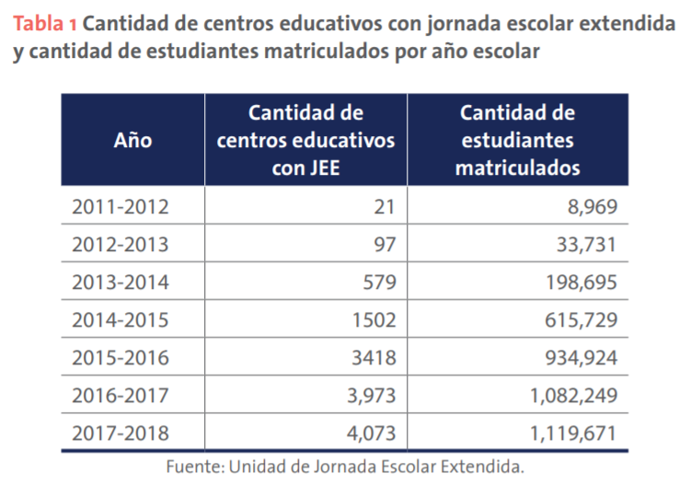
140. Studies comparing schools following the extended schoolday programme and schools following the half-day system were published by the Ministry of Education and the national NGO EDUCA (Acción para la educación básica)/Programme of Budgetary Support for the Education Sector II in 2015. The findings were as follows:
(a) At the middle-school level, the dropout rate is lower in extended-day schools (2.8 per cent) than in half-day schools (6.4 per cent); it is also lower at the primary level (3 per cent compared to 2.6 per cent);
(b) Students in extended-day schools are less likely to have to repeat grades;
(c) Average results in the first round of the national tests are higher in every subject in extended-day schools;
(d) Extended-day schools spend a greater proportion of time on educational activities (72 per cent) than half-day schools (68 per cent).
141. Another significant achievement is the sustained increase in the average number of years of schooling undergone by students aged 15 years and over, which rose from 8.6 years to 9.18 years between 2001 and 2016 (Ministry for the Economy, Planning and Development, 2016).
142. Improvements in access to education are also reflected in the increase in net enrolment rates at all levels over the last 10 years. According to the Ministry of Education, in the 2007/08 school year, net enrolment rates were 35.5 per cent for preschool, 92.3 per cent for primary school and 49.5 per cent for middle school.
143. For the 2015/16 school year, these rates increased to 47.2 per cent for preschool, 95.5 per cent for primary school and 60.7 per cent for middle school (Ministry of Education, 2017).
144. To accommodate the increase in educational coverage, between 2012 and 2016 steps were taken to construct and equip 14,810 buildings in application of the National Plan for School Buildings (Ministry of Education, 2017).
145. Since 2012, the Ministry of Education has made progress in reviewing and updating the curriculum, which now incorporates a skills-based approach. In 2013, the National Education Council adopted Ordinance No. 3-2013, on the new academic structure of the education system, which reflects the curricular update and international trends.
146. Between 2012 and 2016, the main advances made in the area of teacher training and career development were the adoption of professional and performance standards for the certification and professional development of teachers and regulations for ensuring quality teacher training in the Dominican Republic. In addition, the teacher selection system has been strengthened through the introduction of competitive examinations for teachers, counsellors, coordinators, assistant principals and principals in all schools.
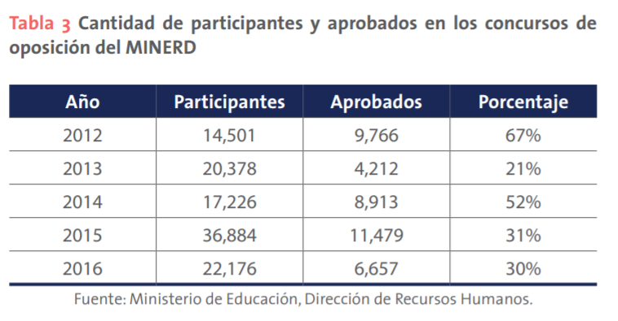
147. The strategic objectives of the Ministry of Education for the period 2017–2020 were focused on guaranteeing inclusive, equitable and quality education for the entire population of the Dominican Republic. The Dominican education system is facing the following significant challenges:
(a) Providing quality education that produces ethical, competent individuals who exercise their rights, fulfil their duties and create legitimate opportunities for progress and prosperity for every individual and for society as a whole;
(b) Guaranteeing access to education for vulnerable groups;
(c) Ensuring that students remain in school and complete their educational pathways, and that the internal efficiency of the education system is enhanced;
(d) Improving teacher training and teaching standards with a view to enhancing students’ learning opportunities;
(e) Improving educational coverage at the preschool and secondary levels;
(f) Increasing the efficiency of the Ministry of Education’s institutional management at the central, regional, district and school levels, increasing levels of decentralization, transparency, accountability and social participation in the education system.
148. In order to ensure that all children and adolescents in vulnerable situations are included and enjoy equal educational opportunities and that gaps in access, participation, retention and educational achievement are reduced, the 2017–2020 Plan was implemented through social programmes that support groups in vulnerable situations, including the following.
149. The School Food Programme, the purpose of which is to meet the nutritional requirements of school students and thus contribute to learning, performance and school retention. The programme has four components: the urban component, under which students are provided with bread, milk and juice; the border component, under which students in schools in the border area are provided with breakfast/lunch; the food rations with local foods component, under which students in rural schools are provided with breakfast and/or lunch; and the extended schoolday component, under which breakfast, lunch and snacks are served to students in schools around the country.
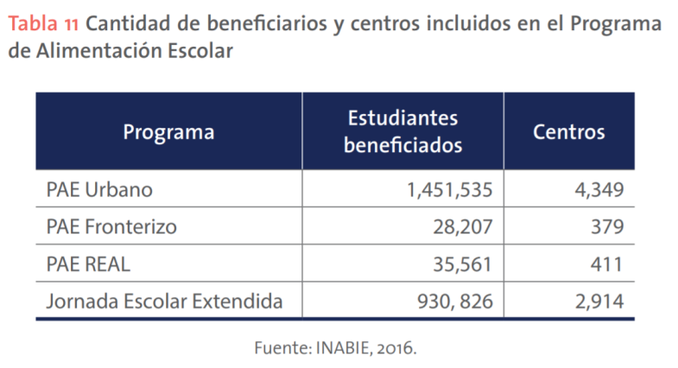
150. The School Health Programme, the purpose of which is to ensure that greater attention is paid to students’ health in the context of the learning process and the school environment. There are four subprogrammes, related to preventive health, dentistry, ophthalmology and hearing health.
151. In 2015 and 2016, care was provided to 1,684,059 preschool, primary and secondary students under the preventive health programme; 227,167 students under the oral health programme; 21,109 students under the hearing health programme, and 15,135 students under the visual health programme.
152. The Student Social Services Programme, the aim of which is to strengthen student engagement, promoting access to support services that improve their social and educational situation and thus help to ensure school retention. Among other things, students receive assistance with school materials and supplies, and access to science, technology and arts clubs, scholarships and transport.
153. The Student Support Services Programme, under which 750,000 school kits have been distributed to an equal number of students at the preschool and primary levels. The kits are made up of shoes, uniforms and backpacks containing school supplies and are provided to vulnerable students in all regional directorates and districts of the education system. Furthermore, 81 school cooperatives with 5,058 student members have been established in the Monte Plata (No. 17), San Cristóbal (No. 04) and La Vega (No. 06) regional education directorates.
154. The Programme for Students with Special Educational Support Needs, which is focused on children and adolescents with special educational support needs and their families, directly benefiting the entire educational community and society in general. Its purpose is to provide students with the resources and support necessary to ensure that barriers do not give rise to educational and social inequality. It consists of seven main lines of action: raising public awareness; expanding service coverage; strengthening institutions; promoting accessibility; training teachers and support staff; managing the curriculum; and involving families in their children’s learning processes.
155. In the 2015/16 school year, 1,916 psychological and educational assessments were conducted, direct follow-up was provided to students who required individual support plans, and speech therapy (covering the prevention, diagnosis, prognosis, treatment and comprehensive assessment of communication disorders, taking into account speech or language disorders) was provided to 860 students with language difficulties. A total of 32,955 students benefited from these measures.
156. The following facilities have been established to eliminate barriers to access, participation, learning and retention in the education system:
157. Resource Centres for Diversity Support, which have been established in 13 of the 18 regional education directorates (regional directorates Nos. 02-17).
158. Special classrooms for educational inclusion, which are spaces for the education of children and young persons with disabilities in mainstream schools that are staffed by two teachers and a psychologist. A total of 487 children who had previously been excluded from the education system are now being taught in the 31 special classrooms, allowing for an increase in coverage of 85 per cent in comparison with 2012. Six of the classrooms are for students with hearing impairments. The spaces have been positively assessed by the educational community and many of the children benefiting share the spaces with other students in the school.
159. Learning support spaces at the primary level and enrichment spaces at the secondary level, which provide support for students with reading and writing difficulties that may or may not be associated with a disability, enabling them to develop the cognitive skills needed to acquire curricular competencies. The spaces are aimed at students in the second cycle who are not yet able to read and write at the appropriate level. There are 86 learning support spaces in the primary schools covered by the Good Inclusive Practices Project in eight regional education directorates (Santo Domingo (No. 10) and Santo Domingo (No. 15), Santiago, Higüey, San Cristóbal, San Francisco, San Juan and Nagua), representing 17 per cent of the schools supported by the Resource Centres for Diversity Support. There are 19 enrichment spaces at the secondary level in three regional education directorates (San Juan, Nagua and San Francisco).
160. Resource centres for persons with visual impairments, which provide support for 495 blind students in 450 mainstream schools. In two studies, it was noted that there are insufficient numbers of itinerant teachers to assist the number of persons that they serve and insufficient support for students to become literate in Braille is provided in the early years of schooling. The survey conducted by the Directorate of Special Education identified 6,518 students with visual impairments, meaning that only a small proportion of them (7.5 per cent) are receiving support. In view of all the strategies and programmes available to the Directorate of Special Education, and taking into account the information gathered on students with signs of disabilities, it has been established that only 30 per cent of these students (8,142) are receiving direct support for their special educational needs.
161. A programme for students in situations of psychosocial risk, the purpose of which is to guide and oversee the implementation of the curricular guidelines, taking into account the psychological and educational perspectives and supporting the work carried out in schools, with measures targeted at the actors concerned, particularly measures focused on the comprehensive development of students and the promotion of preventive actions.
162. Counselling and psychological services, focused on addressing the full range of students’ special needs, which are related not only to learning but also to psychosocial and developmental issues. Together with the educational community, steps are taken to support the comprehensive development of students by creating psychologically and socially propitious learning environments, bolstering students’ self-esteem, promoting ethical and moral values and strengthening the development of a culture of peace in schools.
163. With regard to the protection of pregnant teenagers, in order to ensure that they remain in school, the Ministry of Education and the National Council for Children and Adolescents are implementing the Dominican Education System Standards for Harmonious Coexistence in Public and Private Schools, following a validation process carried out in schools, in the different agencies of the Ministry of Education and in civil society organizations active in this field.
164. The Standards establish the guiding, normative and operational framework for coexistence in public and private schools in the Dominican Republic. They are designed to foster an emotionally supportive environment that is conducive to learning for students, establishing disciplinary guidelines and measures within the framework of pedagogical processes that contribute to students’ all-round education and harmonious coexistence (art. 1).
165. Article 25 expressly prohibits the expulsion of pregnant teenagers, refusal to enrol them and harassment for the purpose of forcing them to drop out in public or private schools. Steps will be taken to ensure that pregnant teenagers remain in their current school and are motivated to continue their studies rather than being persuaded to change their schedules or switch to evening classes on the grounds that the academic burden is too great for them.
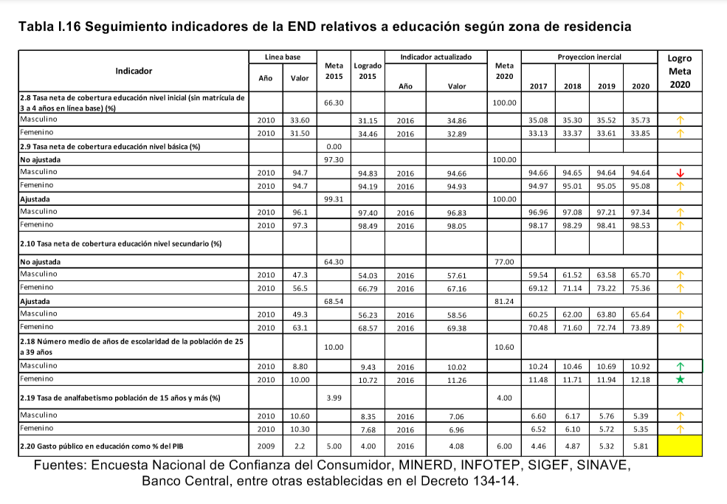

Quality of education
166. The National Covenant for Educational Reform in the Dominican Republic for the period 2014–2030 identifies several strategies for improving the quality of education, one of which is to establish a culture of comprehensive, systematic, ongoing and cross-cutting assessment in the education system.
167. In order to improve the quality of education, the Ministry of Education has adopted the 2015–2030 Strategic Plan for the Development of the National System of External Assessment of Learning Achievement in the Dominican Republic (National Tests, Diagnostic Assessments and International Studies). The Strategic Plan was conceived as a policy tool for promoting the implementation of the Covenant for Educational Reform in the area of learning assessment. It responds to the need to improve the use of evaluative information to inform policy and educational management and practice, to align assessments with the new curriculum, which uses a competency-based approach, and to define the grades to be evaluated in the light of the new structure that gradually came into effect between 2014 and 2017.
168. The plan sets out a series of recommendations for improving the Dominican assessment system, which are now being implemented. The main recommendations are:
- The twelfth grade national test should be maintained, and should continue to have consequences for students. The eighth grade national test should be abolished.
- Diagnostic assessments of all schools and students in the country should be conducted in the third, sixth and ninth grades (by census). It is suggested that one grade should be assessed each year, with the result that each grade is assessed every three years. The fourth and tenth grade diagnostic assessments should be abolished.
- The Dominican Republic should continue to participate, as a matter of course, in the international studies conducted by the Latin American Laboratory for Assessment of the Quality of Education of the UNESCO (United Nations Educational, Scientific and Cultural Organization) Office in Santiago de Chile, the Programme for International Student Assessment of the Organisation for Economic Co-operation and Development, and the International Civic and Citizenship Education Study of the International Association for the Evaluation of Educational Achievement.
- The dissemination and application of information on assessments of learning should be substantially improved. To achieve this end, various products (e.g. brochures, reports, videos) containing specific information for different actors (e.g. teachers, parents, the Ministry of Education) and different levels of the school system (e.g. the national, regional and school levels) should be published. It is also suggested that training should be made more active and personalized in order to create a culture of assessment in the country and foster collaboration between the different agencies of the Ministry of Education so that they can use the results of assessments to bring about improvements.
169. The State is aware that implementing the Strategic Plan requires substantial improvements to be made to the way in which the Ministry of Education’s Directorate for the Assessment of the Quality of Education currently operates. However, the measures that must be taken in order to meet this challenge are provided for in the Plan, especially measures relating to staff working in the area of assessment and their training needs. The Plan also provides for the establishment of the minimum necessary infrastructure, a significant increase in the budget for assessment and amendments to the current regulations.

Teaching quality
170. Since the development of the 10-Year Education Plan 1992–2002, teacher training has been a key goal of the Dominican education system. The importance of this goal was further consolidated by the adoption of the General Education Act (No. 66-97). However, it is only in the last decade, and especially since the adoption of the National Development Strategy, that enhancing teaching quality has become a central goal of the reform of the education system and the Programme for the Provision of High-Quality Teacher Training has been adopted.
171. The State is currently conducting a study of demand for teachers within the system over the next 10 years and an on-site audit of the Ministry of Education’s expenditure on teaching staff. The on-site audit of schools nationwide has established the number of available teachers, the number required to make up the shortfall and what the expected demand will be as the extended schoolday becomes universal.

Section 2. Rest, leisure, recreation and cultural and artistic activities

Response to the recommendations contained in paragraph 60 (a) and (b)
172. General objective No. 7 of the second strategic focus area of the National Development Strategy is to build a country in which sport and physical recreation are practised for human development. The Ministry of Sport, which is the agency chiefly responsible for State policy in this area, is pursuing the following lines of action for children:
- Fun breaks: qualified staff visit schools during break times and organize recreational activities once or twice a week, benefiting 1,000 children and adolescents per week
- Street recreation: qualified staff go to marginalized communities and organize recreational and sporting activities for young people and children of both sexes without any discrimination whatsoever
- Summer camp: every week, the regional directors nationwide select 10 young people from each region to make up groups of around 800 young people aged between 14 and 17 years, 30 per cent of whom are girls. The groups are brought to the Olympic Centre, where they practise a wide ranges of sports with qualified instructor.
- Let’s Go There (Vamos hacia allá) Programme: the Clubs and Leagues Directorate provides equipment to 2,500 out of the 4,500 clubs registered in the country, which means that 55 per cent of clubs and leagues benefit from this measure
- Health and Sports in Schools: under this programme, four permanent instructors are established in schools in the provinces of Bonao, Moca, Santiago Rodríguez and Barahona, benefiting more than 2,000 children and adolescents
- Health and Sports: a total of 38 instructors (19 women and 19 men) nationwide teach aerobics, Zumba and general physical exercise to 63,129 children in 55 locations across 26 provinces and 6 municipalities
- Sports Events: World Day for Physical Activity, Day of the Athlete with a Disability, Recreational Day with the Special Olympics, and the Fun Run with the Special Olympics Torch. The events in this category include activities that take place in schools and State institutions, such as events to recognize outstanding athletes
- Refurbishing the infrastructure of clubs and leagues: in the last three years, some 600 community fields and courts have been repaired, benefiting marginalized communities
173. Together with the Ministry of Sports, the National Institute of Physical Education is the body responsible for coordinating, supervising and assessing plans and programmes for the development of physical education and school sports in order to guarantee a comprehensive quality education in public and private preschools, primary schools and middle schools in the country.
174. The Ministry of Culture is the State institution responsible for formulating, implementing and regulating public policy on cultural matters, in a participatory, inclusive and diverse manner, safeguarding cultural heritage and creative expression with a view to preserving national identity and guaranteeing the Dominican people’s cultural rights in order to contribute to the sustainable development of the nation. The main objective and strategic focuses of the Ministry of Culture’s Institutional Strategic Plan are consistent with general objective No. 2.6 of the National Development Strategy to 2030, which concerns culture and national identity in a global world and establishes specific objectives and lines of action.
175. In addition, the following cultural and sports programmes are being implemented under the “Progressing with Solidarity” Social Welfare Programme.
176. BiblioBicis, a scheme under which staff travel by bicycle to hard-to-reach rural communities in order to promote and encourage reading, provide help with schooling and lend books. Through this programme, a large number of poor people receive educational services and materials to which they would otherwise not have access.
177. BiblioRuedas, a programme under which buses fitted out as libraries bring recreational, educational and play-based activities to families covered by the “Progressing with Solidarity” Social Welfare Programme in order to promote positive values and support schooling.
178. Sports for Peaceful Living, a programme that encourages young people to participate in sports and recreational activities at the grassroots level by promoting and supporting community sports initiatives and the formation of teams. Those participating in sports receive training in values, the prevention of violence, new forms of masculinity and the prevention of drug use, among other subjects.

H. Special protection measures (arts. 22, 30, 32–33, 35–36, 37 (b)–(d) and 38–40)

Section 1. Asylum-seeking and refugee children

Response to the recommendations contained in paragraph 62 (a), (b), (c) and (d)
179. The right to seek and obtain refuge has constitutional status in the national legal system, being enshrined as a fundamental right in article 46.2 of the Constitution. Therefore, pursuant to article 74 of the Constitution, this right must be interpreted in the manner most favourable to the individual, taking into account the criteria established in the human rights treaties ratified by the Dominican Republic.
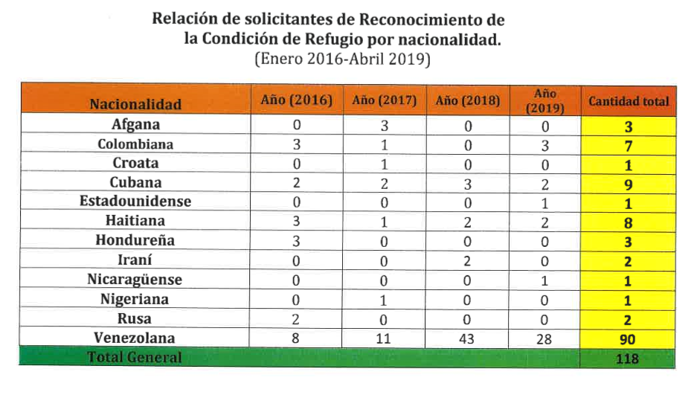
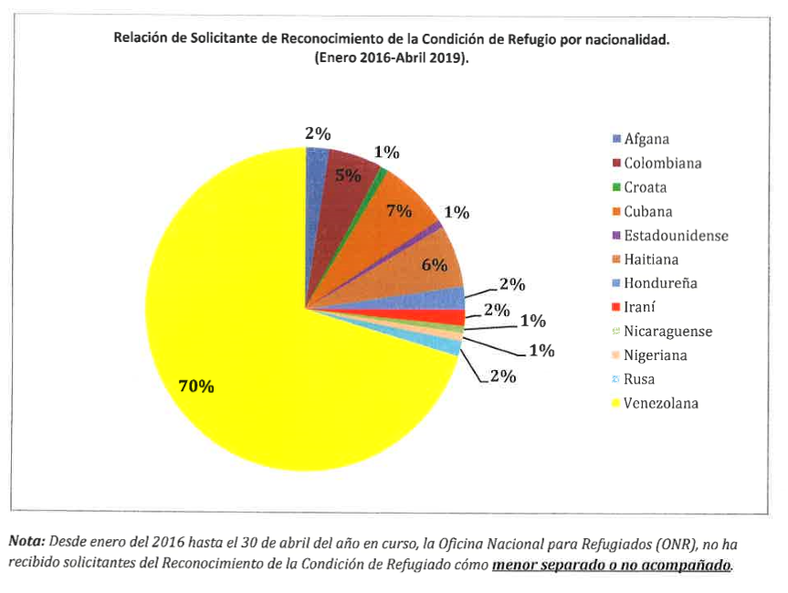

Section 2. Children in situations of migration

Response to the recommendations contained in paragraph 64 (a) and (b)
180. One of the key public policy achievements of the Dominican State during the reporting period is to have conducted a second national survey of immigrants. The production of reliable statistical information is an essential step towards designing efficient public policies. According to the National Immigrant Survey of 2017, the majority of persons of foreign origin in the country are young men (58.3 per cent, with women accounting for 41.7 per cent). A total of 39.5 per cent are between 20 and 34 years of age.
181. When the analysis is broken down by country of birth, 62.9 per cent of Haitian-born persons are men and 37.1 per cent are women, while 65.3 per cent are between the ages of 20 and 39 years. A total of 52.9 per cent of persons born in other countries are men, of whom 27.2 per cent are between 20 and 34 years of age and 15.2 per cent are between 60 and 70 years of age. A total of 47.1 per cent of persons born in other countries are women, of whom 35 per cent are between 20 and 34 years of age. A total of 51.4 per cent of persons of immigrant descent who were born in the Dominican Republic are men, while 48.6 per cent are women. In contrast to the other population groups analysed, 51.4 per cent of this group are children of 9 years of age or under (see figure 3.1).
182. Among the population of foreign origin, the majority of heads of household (62.8 per cent) are men. Taking country of birth into account, men head 80.2 per cent of households made up of Haitian-born persons and 72.3 per cent of households made up of persons born in other countries. A total of 22.6 per cent of households contain four habitual residents of the Dominican Republic, which was the most common number. According to the National Immigrant Survey of 2012, men also headed the majority of households made up of persons of foreign origin in that year. However, the National Immigrant Survey of 2017 shows that this proportion decreased slightly from 64.1 per cent in 2012 to 62.8 per cent and that this trend can also be observed when the figure is broken down by country of birth.
183. The National Immigrant Survey of 2017 was the first to include a section on the sexual and reproductive health of immigrant women and their descendants. Foreign women can be divided into two broad groups: those aged between 15 and 49 years (i.e. those of reproductive age) and those who are outside this age range. The former group comprised 207,172 women (58.5 per cent of the total), while the latter group comprised 146,675 women (41.5 per cent of the total). If the number of women of foreign origin who are of reproductive age is broken down by country of birth, a total of 150,165 women (72.5 per cent) were born in Haiti, 17,667 women (8.5 per cent) were born in other countries and 39,340 women (19 per cent) are of foreign descent.
184. A total of 96.6 per cent of women of foreign origin who were interviewed had undergone check-ups during their most recent pregnancy. This figure is to be welcomed as it shows that almost all of them attended a health-care establishment to receive the corresponding care. However, the data show that, generally speaking, there is no standard number of check-ups for pregnant women: 75.4 per cent of women received seven or more check-ups during their most recent pregnancy, i.e., they were checked regularly, while 17.1 per cent had fewer than one check-up per month.
185. Of the total number of women of foreign origin who received a prenatal check-up, 72.5 per cent lived in urban areas while 27.5 per cent lived in rural areas. The percentage of Haitian-born women of reproductive age who received prenatal care is very similar to the figure for women of foreign origin as a whole because they mostly live in urban areas.
186. With regard to the adoption of coordination protocols between the authorities responsible for the protection of children at the border between the Dominican Republic and Haiti, in 2018, the Ministry of Foreign Affairs and the National Council for Children and Adolescents signed an inter-agency collaboration agreement on coordinating with diplomatic and consular missions with a view to returning minors residing in the country or abroad to their parents or legal guardians.
187. In 2019, the National Institute of Migration of the Dominican Republic and UNICEF signed a memorandum of understanding to conduct research and develop public policy recommendations regarding migrant minors, especially unaccompanied minors and those in situations of extreme vulnerability. Within the framework of this agreement, measures concerning the design and implementation of training programmes on the rights of migrant minors, or minors in any other situation of mobility, were defined, as were measures for the provision of technical support in the preparation of studies and research contributing to the development of public policy proposals.
188. The National Institute of Migration is implementing an extensive training programme for public servants on migration, human rights, asylum, refuge, return, and the trafficking and smuggling of immigrants, among other subjects.

Section 3. Economic exploitation, including child labour

Response to the recommendations contained in paragraph 58 (a), (b), (c), (d), (e) and (f)
189. Article 56 (1) of the Constitution states that it is of the greatest national importance to eradicate child labour and any kind of ill-treatment or violence against minors. In addition to this constitutional protection, the Dominican State has ratified the International Labour Organization (ILO) Worst Forms of Child Labour Convention, 1999 (No. 182), the ILO Minimum Age Convention, 1973 (No. 138) and, most recently, the ILO Domestic Workers Convention, 2011 (No. 189). The State has also undertaken to fulfil Sustainable Development Target 8.7 on taking immediate and effective measures to eradicate forced labour, end modern slavery and human trafficking and secure the prohibition and elimination of the worst forms of child labour, including recruitment and use of child soldiers, and by 2025 end child labour in all its forms.
190. In line with this regulatory framework, the National Development Strategy is intended to protect children, adolescents and young persons, from early childhood onward, in order to promote their comprehensive development and social inclusion. In this connection, the eradication of child labour, including its worst forms, is established as a goal of the Strategy (2.3.4.4).
191. At the regulatory level, in order to comply with the objectives of the National Development Strategy in this area and Sustainable Development Target 8.7, the State issued Decree No. 286-13, establishing the Special Committee for the Revision and Update of the Labour Code. The Special Committee prepared and presented the first draft of the preliminary bill on the update of the Labour Code, which resulted from a broad national consultation process taking in the whole country, with the private and public sectors and male and female workers participating on an equal footing.
192. In 2014, the State conducted the National Multipurpose Survey/Multiple Indicator Cluster Survey, which was used to carry out a baseline assessment of the situation of child labour in the country. According to the National Multipurpose Survey/Multiple Indicator Cluster Survey conducted in 2014, 12.8 per cent of persons aged between 5 and 17 years were working, meaning that they undertook economic activities or household chores for a number of hours exceeding certain thresholds. A higher percentage of boys (16.5 per cent) than girls (8.7 per cent) were working. In the poorest regions and in rural areas, the incidence of child labour is higher than in the rest of the country, standing at 11.6 per cent in urban areas and 16.3 per cent in rural areas. The incidence of child labour is in inverse proportion to the mother’s level of schooling and the household’s level of wealth. The incidence of child labour is 25.2 per cent, or double the national average, among children whose mothers have no education and 20. 2 per cent in the poorest households (those who fall into the lowest quintile). By contrast, the incidence of child labour is 7.8 per cent among children whose mothers have a university education and 7.4 per cent in households in the highest wealth quintile (National Multipurpose Survey/Multiple Indicator Cluster Survey).
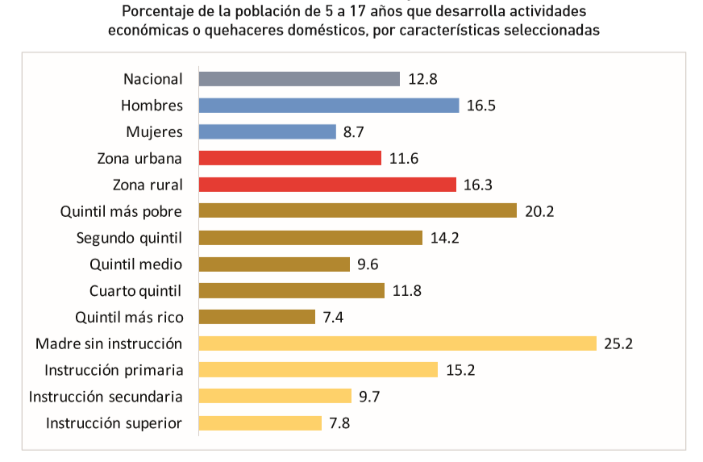
Chart source: National Voluntary Report.
193. At the institutional level, the State is drawing on these data to take different measures to eradicate child labour. The central strategy relies on the combined interventions of the Ministry of Labour, the Social Policy Coordination Office and the Ministry of Education.
194. The Ministry of Labour is responsible for coordinating strategies and actions to prevent and eradicate child labour. This function is carried out by the National Steering Committee on Combating Child Labour, which reports to the Ministry’s Directorate for the Eradication of Child Labour. The Steering Committee has been in operation since 2017 and is made up of representatives of the Ministry of Labour, ILO, the Ministry of Health and Social Welfare, the Ministry of Youth, the Ministry of Sports, the Ministry for the Economy, Planning and Development, the Ministry of Women, UNDP, the Social Policy Coordination Office and the business sector, among other institutions. It is legally required to hold ordinary meetings every two months for public information purposes. It is responsible for implementing the Road Map for a Dominican Republic Free from Child Labour, which is the national strategic framework for the fulfilment of the goals set out in “Decent work in the Americas: An agenda for the Hemisphere”.

Section 4. Children in street situations

Response to the recommendations contained in paragraph 68 (a), (b) and (c)
195. The National Council for Children and Adolescents conducted a municipal survey throughout the country to gather information on children and adolescents in street situations and/or engaged in the worst forms of child labour. The results of the survey have served to prioritize the social measures taken by the Council. The Council has also conducted an analysis of the provision of care for vulnerable children and adolescents in street situations and/or engaged in the worst forms of child labour in the Dominican Republic. In the course of this study, fieldwork was carried out and the findings were disseminated, making it possible to identify the key characteristics of the services provided to children and adolescents in street situations. Following this research, the Council established a major agreement for coordinated action and work with the main organizations active in this field.
196. To date, some 1,110 children in street situations have been assisted by the Council’s programmes and the measures that it takes in collaboration with non-governmental organizations that work with such children. By 2021, the process of organizing and fitting out the RENACER Project Centre, which reports to the Office of the First Lady of the Republic and will provide residential services and comprehensive care to some 100 children and adolescents, is expected to be complete.

Section 5. Sale, trafficking and abduction

Response to the recommendations contained in paragraph 70 (a), (b), (c), (d) and (e)
197. The Government of the Dominican Republic has been taking specific action to build capacity for combating human trafficking since 2012. This had included: establishing the Special Prosecutor’s Office for Offences of Migrant Smuggling and Trafficking in Persons; introducing a training curriculum for justice officials; drawing up a criminal prosecution policy and operational guidelines for investigations; formulating two protocols for identifying, referring and supporting victims and survivors, especially women, children and adolescents; and adopting the second National Plan of Action against Trafficking in Persons and Migrant Smuggling, which covered the period 2017–2020 and was a product of the lessons learned during implementation of the first National Plan against Trafficking in Persons and the evaluation conducted upon its conclusion.
198. The National Plan against Trafficking in Persons was drawn up by the Inter-Institutional Commission against Trafficking in Persons and Migrant Smuggling, which is chaired by the Ministry of Foreign Affairs and composed of representatives of fourteen other State institutions – namely, the Ministry of Labour, Ministry of Education, Ministry of Tourism, Ministry of Health and Social Welfare, Ministry for Women, Attorney General’s Office, Ministry of Defence, National Police, Special Tourist Security Corps, Office of the First Lady, Ministry of the Interior and Police, Directorate General for Migration, National Council for Children and Adolescents and the Navy of the Dominican Republic – as well as various other institutions, NGOs and international agencies that act as partners.
199. The Plan has three strategic focuses: prevention; investigation and prosecution; and victim support and protection. To achieve these aims, the following five programmes were implemented: awareness-raising and training; inter-institutional cooperation; emergency support; voluntary return and comprehensive reintegration; and social research and international coordination.
200. In 2018, there was an increase in the number of victims identified and assisted and in the number of convictions (see annex 9 on cases involving offences of trafficking in persons prosecuted in 2018). The Attorney General’s Office provides legal assistance to victims and has included requests for financial reparation in its litigation strategy. In addition, the first “Casa Malala” shelter for adult victims of trafficking is now operational, in addition to a number of temporary shelters for child victims run by the National Council for Children and Adolescents.
201. However, the State recognizes that the allocation of resources for helping victims and combating trafficking in persons and migrant smuggling remains one of the main limitations that it faces at present. However, this lack of resources has not diminished its preventive, protective and punitive efforts. The State has concluded numerous cooperation and collaboration agreements with the private sector, national NGOs, international NGOs and international organizations including the United States Agency for International Development and UNICEF, which have enabled it to continue implementing the National Plan despite its limited financial resources.
202. The main advances achieved in the areas of prevention, victim assistance and the prosecution of offences of trafficking in persons are described below.
203. To improve victim identification procedures, a victim identification form was approved by the Inter-Institutional Commission against Trafficking in Persons and Migrant Smuggling in 2014 and has been adopted for use by public officials. When police, immigration or other government officers identify a victim of trafficking, the completion of this form helps to ensure timely referral of the victim’s case to the Special Prosecutor’s Office and other government institutions with roles in the implementation of the National Road Map for the Prevention and Elimination of Violence against Children and Adolescents.
204. Officials involved in the process of referring identified cases of trafficking, whether the victims are adults or minors, are guided by two instruments. Firstly, there is the protocol for identifying, assisting and referring child and adolescent victims of trafficking in persons, which was published in 2015 and is a case referral mechanism designed to ensure effective and coordinated protection for minors.
205. Secondly, there is the protocol for identifying, assisting and facilitating the reintegration of adult survivors of trafficking in persons, also published in 2015. The two instruments serve as guides for government officials and civil society organizations involved in efforts to detect cases of trafficking. They set out the steps to follow when referring persons who have been trafficked and apply irrespective of whether the victims are Dominican or foreign nationals.
206. The two protocols are implemented in conjunction with NGOs and international organizations including the International Justice Mission, the International Organization for Migration, Destiny Rescue, the Dominican Conference of Religious Leaders (known as CONDOR), Operation Underground Railroad and Anti Trafficking Bureau, among others, which provide support in the form of facilities and other resources when a victim of trafficking is referred to them.
207. Victim support services are available for national and foreign victims through the victim support programme led and coordinated by the Special Prosecutor’s Office.
208. The Dominican Republic does not punish victims. Should persons involved in a case find themselves in a situation of risk, the prosecutor in charge is asked to take the necessary protection measures, and, after a risk assessment, to facilitate the regularization of their legal status, organize accommodation and make any other arrangements necessary to ensure their safety. Currently, the “Casa Malala” provides shelter for adult victims of trafficking while child and adolescent victims are housed in the temporary shelters run by the National Council for Children and Adolescents.
209. Victims of Dominican and foreign nationality have equal access to victim support services, the priority of the victim support and protection programme being to safeguard the fundamental rights enshrined in the Constitution.
210. Victims who are minors are cared for by the National Council for Children and Adolescents, as the lead body of the National System for the Protection of the Rights of Children and Adolescents, and are provided with food and accommodation in its temporary shelters. NGOs including International Justice Mission, Anti Trafficking Bureau, Destiny Rescue and Operation Underground Railroad also provide support, offering any additional specialized assistance that minors might need, depending on their specific case.
211. The expenses incurred by the State in ensuring care and protection for victims have not been calculated in figures because the cost was shared with national and international NGOs.
212. Another important advance achieved is that victims are now able to give their testimony in advance, either in a written statement or in a video recording, in all cases. The testimony is taken in an interview centre for persons in situations of vulnerability and victims and witnesses of crime using closed circuit television, a Gessell chamber or other technological means. Victims give their testimony once only, without being revictimized or traumatized during the judicial proceedings. The use of this method has enabled the State to tighten up investigations and ensure that traffickers are duly punished. Victims’ identities are not disclosed during the proceedings and only their initials are used when their cases are heard in court.
213. Victims also have the possibility of calling a free, confidential hotline, known as the “Call and Stay Alive” (Llama y Vive) line, if at any time they feel threatened or at risk in the course of the proceedings (see also the section of this report on measures taken to combat violence against children).
214. With regards to prevention and awareness-raising campaigns, the Attorney General’s Office and UNICEF are carrying out a programme of action to reduce offences involving the sexual exploitation and commercial sexual exploitation of children and adolescents in vulnerable areas of the country. The programme has included the nationwide “No Excuses” (No Hay Excusa) campaign, which continues to encourage the reporting of such offences and to enhance protection for victims. In the period covered by this report, community-based and inter-institutional consultations were organized in four provinces of the Dominican Republic – the National District, Puerto Plata, Sosúa and Cabarete – as part of the programme (see also the section of this report on protecting children from sexual exploitation and other forms of violence).
215. In addition, the National School of the Judiciary has included training on trafficking and smuggling in its academic offer for judges, aspiring judges, public defenders, lawyers in private practice and employees of the judicial service (see annex 8, report on recipients of training in trafficking in persons and people smuggling 2017–2018).
216. The Government of the Dominican Republic is continuing its efforts to prevent child sex tourism and the number of cases investigated and prosecuted in the country increased in 2018. In that year alone, two foreign nationals closely involved in child sex tourism were brought to justice, and four foreign nationals were convicted of the offence (see annex 9 on cases involving offences of trafficking, smuggling, sexual exploitation and pimping prosecuted in 2018).
217. With regard to the trafficking of children and adolescents at the Dominican-Haitian border and other border points, especially airports, in Haiti, there are an estimated 250,000 restaveks – the term used to describe children and adolescents who are sold for use in domestic labour. Due to the economic disparities between the two countries on the island, and since migration flows tend to be from less to more economically developed countries, the number of children moving from Haiti to the Dominican Republic tends to be much higher than vice versa and includes children moving for a wider variety of reasons. The United States Department of State reports that the Dominican Republic is a country of origin, transit and destination for children who are trafficked for the purpose of exploitation. including commercial sexual exploitation.
218. In this context, the National Council for Children and Adolescents and International Justice Mission have renewed their inter-institutional cooperation agreement with a view to enhancing training and establishing a national network of facilitators to support victims of commercial sexual exploitation.
219. Under the agreement, International Justice Mission undertakes to work with the National Council to carry out the actions envisaged in the National Action Plan against Trafficking in Persons and Migrant Smuggling 2017–2020, to implement the protocol for identifying, assisting and referring child and adolescent victims of trafficking in persons and to help to strengthen the National Council’s directory of georeferenced protection programmes and services, thereby enabling support facilitators to manage cases in a manner that results in optimal protection and prevents the revictimization of survivors of these violent offences. It also provides psychological assistance to victims of commercial sexual exploitation who are under the National Council’s protection in temporary shelters after being referred by International Justice Mission, using the model and forms developed for this purpose.
220. The National Council for Children and Adolescents, the Attorney General’s Office, UNICEF, the Ministry of Foreign Affairs, the Inter-Institutional Commission against Trafficking in Persons and Migrant Smuggling and the national airports operator, Aerodom, have entered into a national agreement on the prevention of child sexual exploitation in the Dominican Republic. Under this agreement, messages designed to prevent this type of child abuse and raise awareness of the penalties established in national legislation for those who commit it are displayed in airports in the country and in Dominican consulates abroad. It is hoped that travellers will thus be made aware of the diligence with which the Dominican authorities are monitoring the problem and that the Dominican Republic is a destination where sex tourism is not permitted.

Section 6. Administration of juvenile justice

Response to the recommendations contained in paragraph 72 (a), (b), (c), (d), (e), (f), (g), (h) and (i)
221. Act No. 136-03 establishes the criminal procedure applicable in cases involving adolescents, including the procedure for filing a writ of habeas corpus or a writ of amparo, as well as the corresponding penalties, which are divided into three categories: socioeducational measures; guidance and supervision orders; and custodial penalties. Socioeducational measures and guidance and supervision orders are designed to ensure the education, rehabilitation and social insertion of adolescents in conflict with the criminal law. Compliance with such measures, which can range from reprimands and warnings to an obligation to attend a given facility for medical treatment, is monitored by a judge.
222. Deprivation of liberty is ordered in exceptional circumstances only, when no other penalty is possible (Art. 336). In its ruling, the juvenile court must justify the decision to impose this form of penalty and must specify the form of deprivation of liberty, which is chosen from among the following: deprivation of liberty at home; deprivation of liberty during free time, or semi-liberty; and deprivation of liberty in specialized internment centres.
223. Custodial sentences have a duration of one to three years for adolescents between 13 and 15 years of age at the time of the offence and one to five years for adolescents between 16 and 18 years of age in similar conditions. Sentence execution and enforcement are under the responsibility of the National Directorate for the Comprehensive Care of Adolescents in Conflict with the Criminal Law attached to the Attorney General’s Office. The Office’s Alternative Penalties Coordinating Unit is responsible for monitoring and enforcing compliance with alternative penalties and measures imposed on adolescents by the country’s juvenile courts.
224. The Alternative Penalties Coordinating Unit manages around 900 adolescents. In the period from January 2016 to April 2018, a total of 416 juveniles, of whom 222 were boys aged 16 or 17 years old, received alternative penalties. The most common offences involved in these 416 cases were aggravated robbery (117 cases), drug-related offences (108), assault and battery (57), rape (57) and simple robbery (34).
225. All adolescents in conflict with the criminal law have the right to assistance from the National Public Defence Office, which has public defenders working in juvenile criminal matters who provide expert assistance to adolescents and currently cover more than 90% of cases heard in courts where a public defence service is available.
226. When a sentence of deprivation of liberty in specialized internment centres is imposed, the juvenile justice system’s care pathway operates in two phases: the judicial phase, which encompasses all proceedings that take place in court; and the institutional phase, which encompasses the process of enforcing and monitoring compliance with the penalties handed down in court and involves the National Directorate for the Comprehensive Care of Adolescents in Conflict with the Law, the National Council for Children and Adolescents and the sentence enforcement judge.
227. The institutional phase begins with the adolescent’s admission and the completion of a unified care protocol by a multidisciplinary team that carries out a full diagnostic evaluation of the adolescent. This evaluation serves as the basis for a comprehensive individual care programme, which includes an educational and psychological intervention plan tailored to the specific circumstances of each adolescent. The plan may or may not be opposed by the sentence enforcement judge. Adolescents in need of more specialized services, such as psychiatric or gynaecological care, are referred, subject to supervision, to external centres.
228. Halfway through the term of their sentence, adolescents may apply to the court for assisted release – an alternative measure involving release subject to certain conditions with which the juvenile must comply. Compliance with these conditions is monitored by the Alternative Penalties Coordinating Unit.
229. The Committee’s recommendation regarding the administration of interment centres. was fulfilled by Decree No. 154-15 of 29 April 2015, transferring the ownership, administration and management of all Centres for the Rehabilitation of Minors in Conflict with the Criminal Law from the Ministry of Health and Social Welfare to the Attorney General’s Office.
230. In respect of socioeducational initiatives and vocational courses for the social reintegration of juveniles, the relevant teams are currently working with 285 juveniles deprived of liberty.
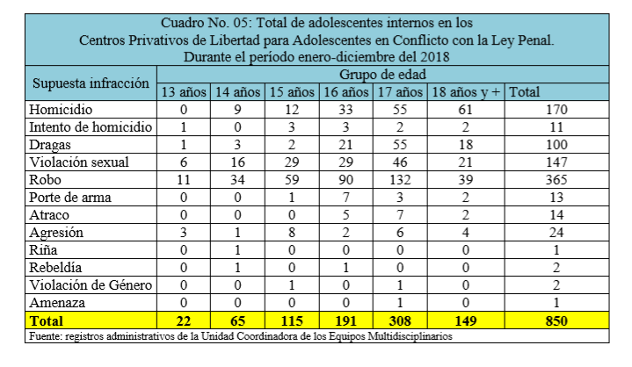
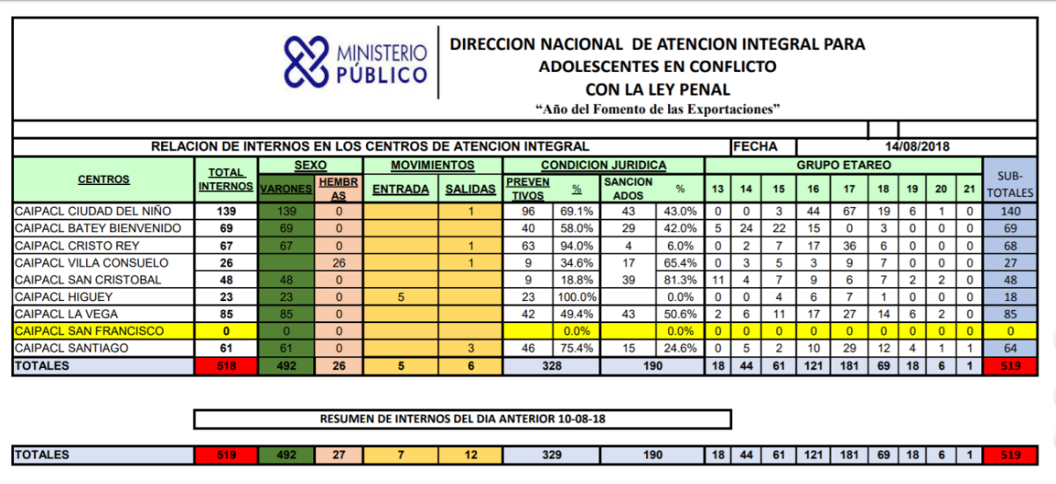
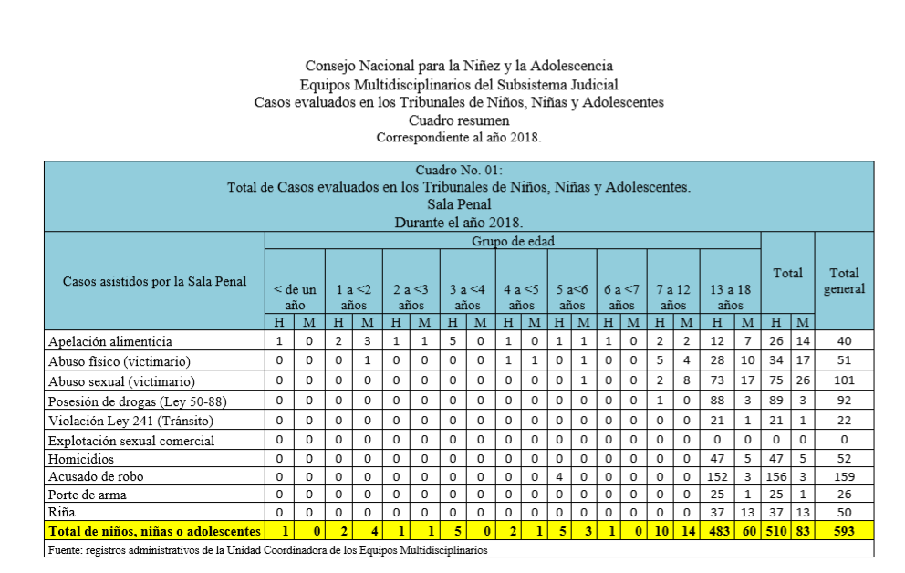
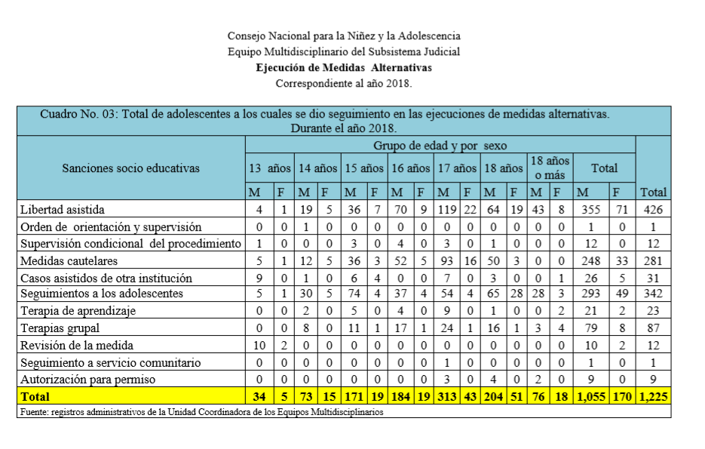

Section 7. Child victims and witnesses of crimes

Response to the recommendation contained in paragraph 74
231. The judicial branch has adopted a protocol for conducting interviews in interview centres for persons in situations of vulnerability and victims and witnesses of crime using closed circuit television, a Gesell chamber or other technological means.
232. The judiciary created these interview centres, which are attached to the Children and Adolescents Division of the Directorate for Family, Children, Adolescents and Gender, as a means to ensure that rights are respected and upheld. The centres facilitate access to justice for vulnerable persons who are victims or witnesses of crimes, especially children and adolescents, by providing appropriately equipped spaces fitted with technology that allows for victims or witnesses to be observed, listened to and recorded while making advance statements that will serve as their testimony in court.
233. The eight interview centres opened to date are located in the National District, San Cristóbal, Santiago, Puerto Plata, Samaná, Higüey, Santo Domingo Province and Valverde (see annex 10, list of centres opened). In January 2019, a new centre was opened in San Francisco de Macorís (see annex 11. Statistical table of activities of interview centres from opening until 2017).
234. The use of forensic technical media that allow for interviews to be conducted with vulnerable persons who are victims or witnesses of crime has enabled the interview centres to reduce, or at least minimize, secondary victimization. Statements are gathered through a single recorded interview that serves as an item of evidence to be presented at all stages of the criminal proceedings, guaranteeing the victims’ or witnesses’ protection and full respect for their rights.

* The present document is being issued without formal editing.
The terms sexual exploitation, commercial sexual exploitation and child sex tourism are used interchangeably in this document.

