 | United Nations | CRC/C/PRY/RQ/4-6
 | Convention on the  Rights of the Child |  | Distr.: General  14 March 2024  English  Original: Spanish  English, French and Spanish only
Committee on the Rights of the Child
Ninety-sixth session
6–24 May 2024
Item 4 of the provisional agenda
Consideration of reports of States parties

Replies of Paraguay to the list of issues in relation to its combined fourth to sixth periodic reports*, **
[Date received: 15 February 2024]

Introduction
1. The Republic of Paraguay, in accordance with its international obligations and reaffirming its commitment to the promotion and protection of the rights of children and adolescents, submits to the Committee on the Rights of the Child its replies to the list of issues prior to the constructive dialogue on its combined fourth to sixth periodic reports.
2. This document is the result of an inter-institutional data-collection process coordinated by the Ministry for Children and Adolescents with the help of the Recommendations Monitoring System Plus (SIMORE Plus), an online platform that takes coordinated action and assesses progress and challenges with input from the relevant public institutions, including those from the three branches of government and autonomous government bodies.
3. For ease of reference, the list of acronyms and abbreviations and the list of references are contained in annexes I and II, respectively.

Part I

Reply to paragraph 2 (a) of the list of issues in relation to the combined fourth to sixth periodic reports of Paraguay (CRC/C/PRY/Q/4-6)
4. The National Plan for Children and Adolescents is the public management framework that defines the priority actions to be taken by the State to guarantee, by adopting a comprehensive approach to the promotion and protection of rights and consolidating the National System for the Comprehensive Protection and Advancement of Children and Adolescents, decent living conditions for children and adolescents and to encourage the participation of children and adolescents on the basis of equality and without discrimination.
5. In 2018, on the adoption of Act No. 6174/2018, the National Secretariat for Children and Adolescents was made a government ministry, thus strengthening the institution responsible for coordinating government policy on children. In addition, the Ministry for Children and Adolescents has consolidated the National System for the Comprehensive Protection and Advancement of the Rights of Children and Adolescents, which is composed of councils for children and adolescents in 13 of the 17 departments, 119 municipal councils, and municipal offices for the rights of children and adolescents in 250 of the 263 municipalities, as shown in the following chart:
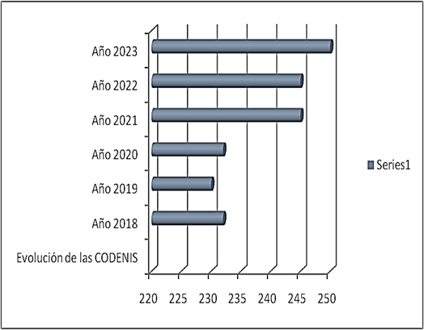
6. With regard to the first area of focus of the National Plan for Children and Adolescents, Act No. 6486/2020, which includes relevant human rights guidelines, prioritizes the right to live in a family setting and regulates alternative care and adoption, has been put into effect. In general, there have been significant moves to bring laws that address a broad spectrum of issues, which will be mentioned in part II, into line with international standards.
7. Under most of the laws, the State is obliged to set aside financial resources for application and sustainability, and results are assessed annually by the mechanisms established in the Constitution. The results of the relation between the National Plan for Children and Adolescents and the laws will be shown in each topic discussed in this report, and the rights of the children and adolescents whom they concern will continue to be made systematically effective, financial resources permitting.
8. The State has created the National Strategy for Comprehensive Early Childhood Care to ensure safe childbirth and access to essential services during the first thousand days of life. The Strategy starts during pregnancy, promoting prenatal check-ups and childbirth in medical facilities, and seeks to guarantee the right to identity and promote responsible parenting, including an emphasis on healthy eating and breastfeeding, an environment free from violence and timely development.
9. With regard to the second and third areas of focus, outreach initiatives involving awareness-raising campaigns, the provision of educational materials, influencers, workshops and community activities and thus the dissemination of the regulatory framework for the promotion of children’s rights have been organized, as described in annex III.
10. The Protected Job Training Programme of the Ministry of Labour, Employment and Social Security developed a practical on-the-job learning process in partnership with the private sector to promote labour market insertion for adolescents. From 2020 to November 2023, 4,075 adolescents, of whom 1,025 were female, completed the Programme.
11. The Ministry offered training as part of a programme for young people in search of their first jobs and the entrepreneurship programme of the National Employment Training System. From 2020 to 2023, 5,545 young people completed that training.

Reply to the request for information made in paragraph 2 (b) of the list of issues
12. The comprehensive protection of all children and adolescents involves institutional challenges for the State, and as a consequence its greatest efforts are required. In recent years, there has been a sustained increase in the budget of the Ministry for Children and Adolescents, the lead institution for the protection of children and adolescents, as shown below:
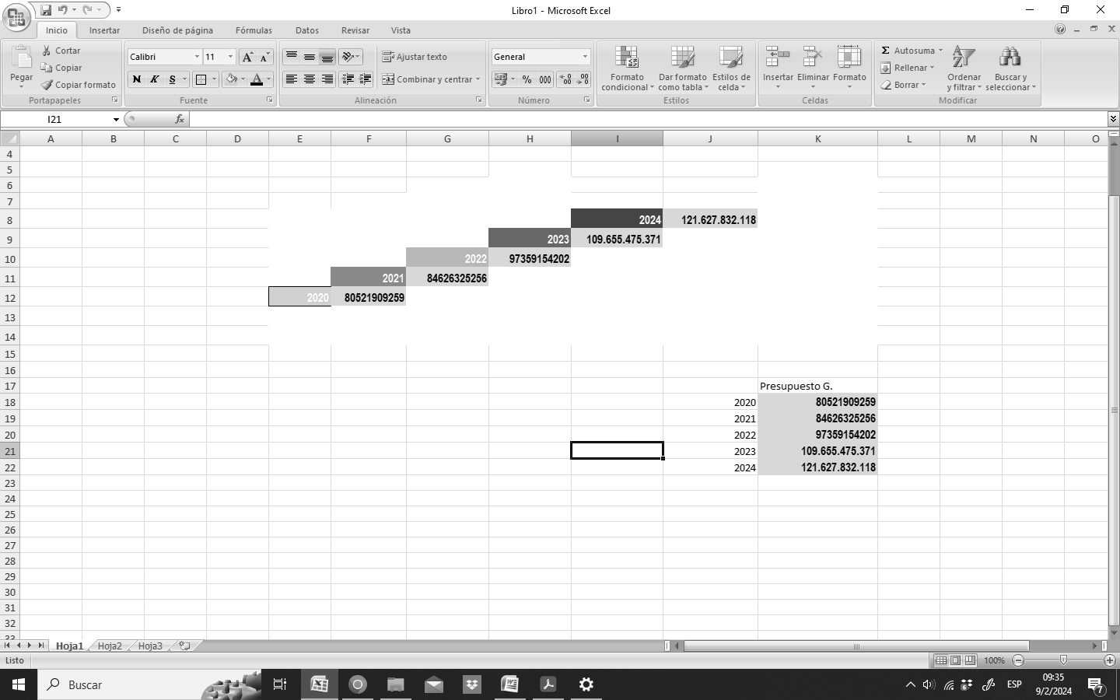

Reply to paragraph 2 (c) of the list of issues
13. To make State investment in the implementation of the Convention visible, the Ministry of Economic Affairs and Finance has, with the support of the United Nations Children’s Fund (UNICEF), completed an evaluation of the methods used to measure investment in children and adolescents in Paraguay and published a methodological guide to measuring investment in children and adolescents.³
14. Public policies for children require the State to measure and identify the resources set aside and expended, and for this purpose there are major categories of resources for persons under the age of 18 and pregnant mothers: direct, indirect and additional resources.
15. Under Act No. 5282/2014, all citizens are guaranteed access to reliable information on public spending, and information on budget execution must be published. Likewise, public institutions are obliged to publish an annual budget management report, which includes a description of the main activities and results and identifies the segments of the population covered by budgetary programmes or subprogrammes. Each institution has indicators and reports to the Results-based Planning System accordingly.

Reply to paragraph 2 (d) of the list of issues
16. Paraguay has an estimated total 6,109,644 people, of whom 29.1 per cent (1,775,767) are children and adolescents. The National Institute of Statistics is processing the preliminary results of the 2022 national population and housing census, some of which can be seen in the table below:
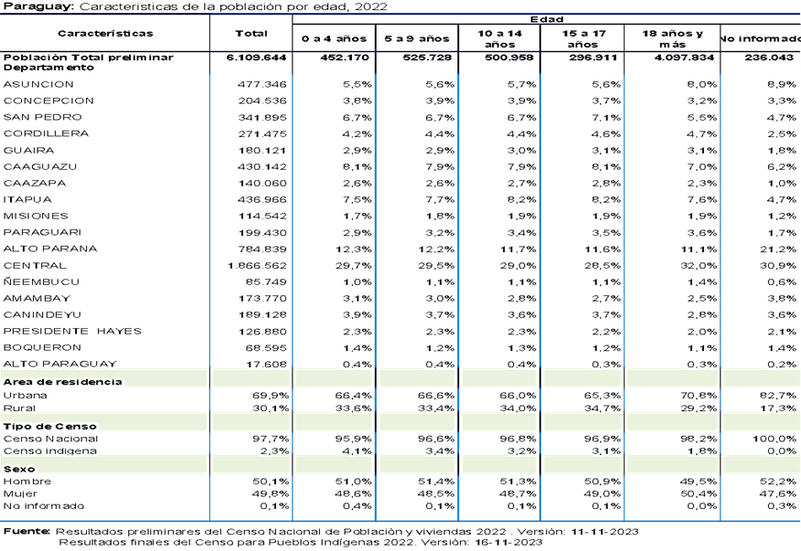
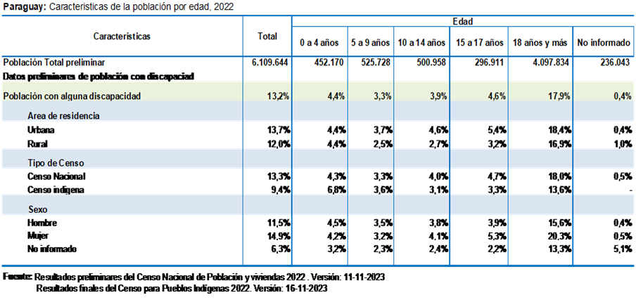

Reply to paragraph 2 (e) of the list of issues
17. The Office of the Ombudsman is responsible for channelling complaints, denouncing rights violations and coordinating action to ensure compliance with the national and international human rights instruments in force in Paraguay.

Reply to the issue raised in paragraph 3 of the list of issues
18. The Ministry for Children and Adolescents supported the research report, entitled “Invisibles a plena luz. Uniones tempranas y forzadas en Paraguay” (Hidden in plain sight: Early and forced marriages in Paraguay), produced by the United Nations Population Fund (UNFPA) and Plan International Paraguay with a view to shedding light on early marriage, which mainly affects adolescents, and making it an anomaly. The results of the research were distributed to public servants at various institutions to raise public awareness.

Reply to the issue raised in paragraph 4 (a) of the list of issues
19. The ongoing implementation of large-scale outreach and awareness-raising campaigns on the rights of persons with disabilities takes place within the framework of Act No. 6667/2021. Pursuant to Act No. 6808/2021, disability secretariats were established in departmental and municipal governments with a view to promoting support services, eliminating discrimination and guaranteeing the participation of persons with disabilities and their full enjoyment of their rights, including to employment. Municipalities are installing inclusive playgrounds to promote the right to play, non-discrimination and the prevention of violence.
20. The protection of the rights of children and adolescents in street situations and Indigenous children is one of the State’s priorities, and as a result it has redoubled its efforts to protect children and adolescents from child labour, sexual exploitation, street situations and other rights violations, developing mechanisms – such as the Comprehensive Programme for Indigenous Children and Adolescents, the Comprehensive Programme for Children and Adolescents Living on the Streets, the Abrazo Programme and the Immediate Response System – that guarantee equality, inclusion and the protection of Indigenous children and adolescents.
21. The National Plan for Indigenous Peoples,⁴ which has four areas of focus, the second of which is the protection of rights, including work on equality and non-discrimination, was adopted pursuant to Decree No. 5897/2021. The Plan is an instrument used to help State institutions fulfil their obligations to Indigenous Peoples.
22. Another example of affirmative action taken to counter discrimination against Indigenous Peoples is the application by State institutions and civil society organizations of Decree No. 1039/2018, further to which the protocol for the consultation and free, prior and informed consent of the Indigenous Peoples of Paraguay, to be followed for any action that directly or indirectly affects the rights of Indigenous Peoples, was adopted.
23. The Comprehensive Programme for Indigenous Children and Adolescents, the development of which was informed by the Committee’s general comment No. 11 (2009), was established pursuant to Order No. 910/2021 of the Ministry for Children and Adolescents. The aims of the Programme are to protect Indigenous families that are living in conditions of extreme vulnerability, improve the living conditions of children and adolescents and have a positive impact on their well-being and human development by recognizing their cultural rights, showing respect for their identity and ensuring that they participate in public life.
24. Officials from the Ministry and the Municipal Advisory Service on the Rights of Children and Adolescents receive training on a rights-based approach to children and adolescents in street situations. The Ministry helps the technical teams of the Advisory Service of seven municipalities with its interventions on the streets by facilitating the transfer of theoretical and practical knowledge.
25. A handbook on approaches to children and adolescents in street situations, prepared to promote uniform and technical criteria for an appropriate approach to and the protection of children as subjects of rights, was adopted pursuant to Ministry Order No. 605/2021. As a result of the Ministry’s influence, a participatory approach to the preparation of relevant protocols was taken in the municipalities of Encarnación and Ciudad del Este.
26. Between 2019 and 2022, the Ministry, in partnership with UNICEF and civil society organizations, held workshops, in which a total of 238 journalists participated, in a bid to ensure that children and adolescents were treated with dignity, respect and to promote their rights.
27. The Paraguayan State guarantees the right to education without discrimination and takes steps to make the national education system an inclusive educational model, including by removing barriers to participation and, with the assistance of qualified personnel and the use of adaptive technologies and universal design, providing access for students with specific educational support needs.
28. The Ministry of Public Health and Social Welfare, as part of a national programme to combat HIV/AIDS and other sexually transmitted infections, organizes awareness-raising workshops for health personnel on Act No. 3940/09 to encourage the actions taken by those who have the political capacity to influence changes in the behaviour of the public, to promote respectful treatment and to eliminate discrimination.
29. The Ministry has taken steps to provide support and care with a focus on rights, inclusion and non-discrimination; these steps include the following activities:
- Adoption of an approach to managing adolescents and their needs
- Creation of facilities for comprehensive adolescent services
- Development of an adolescent health application; preparation of a technical standard for comprehensive adolescent care in health facilities
- Drafting of a guide to comprehensive preparedness activities for youth clubs
- Development of the National Plan for the Comprehensive Care of Adolescents
2023–2030
- Comprehensive care for childhood illnesses
- Preparation of a guide to the detection of hearing loss in children under 5 years of age

Reply to the issues raised in paragraph 4 (b) of the list of issues
30. The principle of non-discrimination is enshrined in the Constitution, article 46 of which states that everyone is equal in dignity and rights and that there can be no discrimination against any of the people of the country. Although there is no law providing for the implementation of article 45 of the Constitution, the article provides that the absence of an implementing law may not be invoked to deny or limit any right or guarantee that, being inherent to human beings, is not expressly provided for in the Constitution.
31. The Paraguayan State applies article 2 of the Convention on the understanding that all the rights enshrined in the Convention apply, in line with the Paraguayan regulatory framework, to all children without exception. All children and adolescents in Paraguay have the right of access, without distinction, to education, health, identity, family life, food, recreation, culture, sporting activities, protection and legal aid. The State, acting through the three branches of government and autonomous agencies, takes measures within the framework of its competencies to protect all children and adolescents from all forms of discrimination.
32. Act No. 6940/2022 was put into effect in 2022 to establish mechanisms and procedures to prevent and punish acts of racism and discrimination against people of African descent.
33. Paraguay, a welfare State characterized by the rule of law, recognizes the rights of individuals, including in particular the right to equal treatment for the most vulnerable so that their fundamental rights are respected and they share in the country’s economic, social and cultural development. The multiple causes of the problems facing the country’s children are addressed according to their relative importance. The incorporation of such factors into legislative frameworks depends precisely on how those problems are addressed and on special characteristics and priorities on which statistical data shed light.

Reply to the issue raised in paragraph 4 (c) of the list of issues
34. Judicial officials make the best interests of the child a primary consideration in all decisions that affect children, thereby ensuring that proceedings are instituted in a way – immediately and without undue dilation – that minimizes the negative impact on the children and adolescents involved, avoiding revictimization, providing a safe environment conducive to their active participation, ensuring that they are adequately protected and taking special measures to guarantee their safety and well-being.
35. For example, the juvenile and other courts have spaces designed to ensure that hearings take place in a respectful environment, and that children and adolescents who are parties to judicial proceedings can be heard directly by the judge in appropriate spaces and with the support of the Justice Advisory Teams.¹¹
36. The Offices of the Public Defender for Children and Adolescents intervene when the rights of children and adolescents are violated, promoting dialogue based on the best interests of the child and attempting, if possible, to reach settlements or, if necessary, proposing that the courts take precautionary measures.
37. In the field of education, Order No. 203/2023 of the Ministry of Education provided for the adoption of a protocol for responding to situations of ill-treatment; the protocol contains guidelines for an approach to the problem, an intervention pathway in which the child is considered a subject of rights and provisions for active listening to aid decision-making and referrals to avoid revictimization.

Reply to the issues raised in paragraph 4 (d) of the list of issues
38. The social protection system “Let’s Go!”⁵ is in place in Paraguay. It is a comprehensive public policy that adopts a citizens’ rights perspective for the entire cycle of life and consists of three basic pillars: (i) social integration (ii) entry to the productive labour market and (iii) social welfare. Earmarks for high-priority social programmes have been protected since 2013; they cannot be reduced or set aside for other programmes or projects.
39. The Ministry of Social Development implements programmes, including Tekoporã, Tenonderã, Tekoha, the Community Canteen and Community Centre Programme, and a programme to help fishing communities, designed to protect poor and vulnerable population groups. Although each programme has its own eligibility criteria, the Ministry emphasizes the inclusion of Indigenous families, while respecting their cultural diversity and autonomy and guaranteeing their participation in the process through free and informed prior consultation.
40. A total of 30,757 Indigenous families representing a total of 91,289 people, of whom 50,138 are women, are registered with the Tekoporã Programme. Of the total, 41,528 are children and adolescents, 48,987 are between 18 and 64 years of age and 774 are older persons. There are also 32,940 people with disabilities, including 21,410 with severe disabilities and 628 from Indigenous communities.
41. The Community Canteen and Community Centres Programme, which saw to the distribution of 130,899 kg of non-perishable supplies, has ensured the food security of 7,984 people in 88 Indigenous communities to October 2023. In all, 2,635 of the Programme’s beneficiaries are children and adolescents, 991 are other young people, 758 are older persons, 3,543 are vulnerable youth and 57 are persons with a disability. The Tenonderã Programme provided protection to 79 Indigenous families in 17 communities.
42. The Ministry of Urban Planning, Housing and the Human Environment is responsible for the comprehensive project Che Tapýi, which involves the construction of low-cost housing for families living in poverty and extreme poverty, including in Indigenous communities. The Ministry of Urban Planning liaises with the Ministry of Social Development to help families become beneficiaries of social programmes. The Ministry of Urban Planning has seen to the completion of several housing projects, the results of which can be found in annex IV.
43. Paraguay faces the challenge of developing a system to identify children and adolescents who have been reported missing or who are unaccounted for and to follow up on their cases. Currently, there are no precise data on the number of children and adolescents who have disappeared because, although missing persons alerts are recorded, the return of missing children and adolescents is not reported to the competent authorities.
44. The Ministry for Children and Adolescents has signed a memorandum of understanding with the International Centre for Missing and Exploited Children for the provision of specialized technical assistance to strengthen the mechanisms to search for and locate missing children and adolescents. The Ministry for Women, with the support of the Ministry of Education, Itaipú Binacional and UNFPA, led the campaign “Stop Violence” to put the issue of dating without violence on the public and media agenda. The goal was to reach 2,500 students from public and private secondary schools in Asunción and seven departments in the interior of the country and to train 200 trainers.
45. The Ministry for Women developed the following campaigns:
- “Dating without Violence” (2015–2016), which reached 8,084 young people in 10 departments over a total of 46 training days in educational institutions in the country. In 2021–2023, at least 31,279 young people were reached, of whom 59.5 per cent were female and 40.5 per cent male.
- “Let’s Talk in Time” (2021), organized to foster intergenerational dialogue that would make it possible to identify different forms of violence.
- “Visible Violence” (2022), a campaign whose focus was detecting the first signs of violence and ways of involving society to help keep violence from seeming normal.

Reply to the issues raised in paragraph 4 (e) of the list of issues
46. The National Programme for Dialogue with Children and Adolescents, which seeks to promote the participation of children and adolescents within the framework of the National System for the Comprehensive Protection and Advancement of Children and Adolescents, encourage their involvement in the affairs of their municipalities and promote and protect their rights, was created pursuant to Order No. 905/2021 of the Ministry for Children and Adolescents.
47. Promoting a leading role for children and adolescents has helped make it possible for Paraguay to be represented, including by adolescents from Indigenous communities, at meetings of the Network of Child and Adolescent Correspondents (CORIA Network) and on the thematic working groups of adolescents of the Inter-American Children’s Institute (Organization of American States).
48. The initiative Niñ@ Sur, undertaken at the request of MERCOSUR, gives children and adolescents opportunities to participate in intergenerational dialogue with the authorities of the States members of the bloc.
49. With regard to good practices in Indigenous communities, the Ministry provided support to the Aché Indigenous People’s community Koetuvy, in Yby Pyta District, Canindeyú Department, with a view to promoting the participation of children and adolescents in efforts to disseminate information about their rights.
50. In 2023, the Ministry provided 32 training and participation opportunities involving a total of 506 children and adolescents in Central, San Pedro, Guairá, Paraguarí, Asunción and Presidente Hayes Departments.
51. The High Court of Electoral Justice, with the support of the United Nations Development Programme and the private sector, implemented the programme “Educate to Choose – Building my country” to promote democratic and civic practices among children and adolescents. In the national and departmental elections of 2023, children and adolescents were given the opportunity to vote in mock elections in which the candidates were the democratic values responsibility, commitment, tolerance, honesty and fairness; voters, of whom there was a total of 6,123, had to show their identity cards and be between 5 and 17 years of age.
52. The High Tribunal of Electoral Justice promotes civic education for children and adolescents, providing training on electoral processes and logistical support for elections for class and other student representatives in educational institutions.
53. The Ministry of Education, which set up a national technical committee that brings together ministerial authorities and student leaders from State institutions, facilitates participation. The Ministry also sponsors discussions with student leaders and thematic round tables and events such as the Departmental Forum for a Leading Role for Children and Adolescents, organized by Plan International Paraguay in collaboration with the Ministry, the departmental government of Caaguazú and civil society organizations. A total of 160 and adolescents children participated; more than 140 parents and guardians made proposals to officials from the National System for the Comprehensive Protection and Advancement of the Rights of Children and Adolescents.
54. In 2023, in a demonstration of the importance of guaranteeing the participation of children and adolescents in the development and improvement of educational programmes, the President of the country, together with the Minister of Education and the Minister for Children and Adolescents, took part in a meeting with more than 40 student leaders from various State institutions, representatives of secondary schools and students in the Indigenous school system and inclusive education.

Reply to the issue raised in paragraph 4 (f) of the list of issues
55. The Supreme Court has a justice education programme that includes educational visits to courthouses, the module “Justice as Our Goal” and the travelling workshop “The Judge I Want”, the aim of which is to bring judicial services closer to the public, with special emphasis on the educational sector.
56. The Public Defence Service schedules and organizes lectures throughout the country, including in educational institutions, to inform children and adolescents of their rights and of where to file complaints if their rights are violated.
57. Training activities, outreach and familiarization events and other activities related to the rights of children and adolescents take place within the framework of the National Dialogue with Children and Adolescents. In addition, intergenerational dialogue between the authorities and children and adolescents is encouraged.
58. The Technical College for Child and Adolescent Affairs has a “Good Neighbours” community training centre that promotes the rights of children and adolescents and empowers community members by enhancing their technical skills. A total of 991 people, of whom 542 were adolescents, 317 were younger children and 132 were adults, took part in promotional activities.

Reply to the issues raised in paragraph 5 of the list of issues
59. The Directorate General of the Civil Registry, a unit of the Ministry of Justice, organizes mass registration campaigns throughout the country, including in Indigenous communities and rural areas. These activities are complemented by those organized within the framework of the National Strategy for Comprehensive Early Childhood Care to ensure that births are registered in the newborn child’s first 30 days (annex V). The National Courthouse Programme, implemented by the Ministry of Justice, organizes mobile workshops in remote areas for the same purpose.
60. The Directorate General maintains a single register of persons, which facilitates the online registration of vital records in registry offices and health centres. Permanent birth registration offices were also set up in consulates.
61. The National Institute of Indigenous Affairs issues an ethnic identity card and works in cooperation with State institutions to ensure that members of Indigenous communities can exercise their right to identity.

Reply to the issues raised in paragraph 6 (a) of the list of issues
62. Since 2016, the Ministry of the Interior has been implementing a programme to monitor police stations and organizing workshops on the theory and practice of policing according to international standards with a view to strengthening the promotion of fundamental rights and preventing acts of torture or ill-treatment in police custody.
63. With regard to the extent to which action has been taken in follow-up to recommendations made by the national mechanism for the prevention of torture, the Public Defenders for Children and Adolescents and the Ombudsman’s Office rigorously monitor the situation of the persons they protect to ensure that the recommendations are effectively implemented. The aim is to ensure that facilities comply with international standards for the prevention of torture and cruel, inhuman or degrading treatment.
64. The Public Defence Service established mechanisms for action in cases of complaints of alleged acts of torture and cruel, inhuman or degrading treatment pursuant to Order No. 351/2022, and pursuant to Order No. 291/2023 it approved the use of the form on which public defenders made a record of such acts.
65. The national preventive mechanism, together with the non-profit Asociación de Tecnología, Educación, Desarrollo, Investigación, Comunicación, the Ministry of Justice and the Public Defence Service launched an application and digital platform referred to as the single register of torture and ill-treatment.
66. The Ombudsman’s Office, for its part, has a unit responsible for monitoring and making recommendations to the directors of juvenile detention facilities and for requesting the Ministry of Justice to take measures to improve the conditions of detention of adolescents in conflict with the law.
67. The Ministry of Justice set up the system Human Rights Online as a channel for the submission of complaints, other reports and requests by the families of persons deprived of their liberty. This initiative made it possible for all persons deprived of their liberty to ensure that their rights were protected during the coronavirus disease (COVID-19) pandemic. With technical assistance from the Office of the United Nations High Commissioner for Human Rights, it drew up a protocol for monitoring visits to prisons and educational centres throughout the country.
68. The Public Defence Service and the national preventive mechanism conducted training workshops as part of an educational and skills development programme on identifying and making a record of cases of torture and on interviewing victims in accordance with the Manual on the Effective Investigation and Documentation of Torture and Other Cruel, Inhuman or Degrading Treatment or Punishment (Istanbul Protocol) and other human rights instruments.

Response to the issues raised in paragraph 6 (b) and (c) of the list of issues
69. The State has informed the public of the high rates of reported violence in order to make this scourge visible and ensure that it is considered unacceptable, intensified the institutional response by strengthening the National System for the Comprehensive Protection and Advancement of Children and Adolescents and creating mechanisms and programmes, conducting prevention campaigns and encouraging, while combining such action with the promotion of positive parenting at the family and community levels (annex I).
70. The situations that most frequently lead to the activation of the National System for the Comprehensive Protection and Advancement of Children and Adolescents are ill-treatment, failure to provide due care, sexual abuse, neglect, exploitation and the presence of children in street situations. These situations are reported to police stations, on the helplines 911, 147 and 133 or to the Municipal Advisory Services on the Rights of Children and Adolescents, the prosecution service and the Public Defence Service.
71. The Immediate Response System of the Ministry for Children and Adolescents is activated in cases of violations of the rights of children and adolescents referred by the helpline 147. Service is provided 24 hours a day, 365 days a year.
72. The National Council for Children and Adolescents adopted an inter-institutional road map for a comprehensive response to the sexual abuse of children and adolescents, which was developed in a joint effort by the Ministry for Children and Adolescents, State institutions and civil society organizations, further to Order No. 04/2021. The road map establishes the stages of comprehensive care, including identification, protection and support, for children and adolescents who are victims of any type of sexual violence.
73. National Council Order No. 03/2023 provided for the adoption of a nationwide preventive programme for the comprehensive care of child and adolescent victims of sexual abuse. The aims of this programme are to prevent and reduce the sexual abuse of children and adolescents, coordinate the steps taken to provide comprehensive care to victims and ensure that their rights are restored.
74. The Public Defence Service has a multidisciplinary technical team that holds semi-structured interviews with children and adolescents in vulnerable situations to evaluate them and identify signs of abuse and vulnerability.
75. The prosecution service has a Gesell chamber for working with or interviewing child victims of abuse and cooperates with the State health service on the provision of psychological support. For its part, the Public Defence Service, further to Order No. 1519/2019, established the guidelines for the use of Gesell chambers by the Office of the Public Defender for Children and Adolescents within the framework of advance witness statements or criminal proceedings.
76. Pursuant to Order S.G. No. 784/2020, the Ministry of Public Health and Social Welfare adopted a national plan for the period 2020–2025⁷ under which the National Health System was made responsible for efforts to prevent and respond to gender-based violence; a handbook on the comprehensive care to be provided in the health system to victims of domestic, sexual and gender violence was adopted pursuant to Order No. 638/2021 to provide guidelines for the comprehensive care of women and children and adolescents who are victims of domestic, sexual and gender violence, including forced labour, trafficking in persons and child labour.
77. The handbook includes specific forms and instruments such as: (a) comprehensive care for child and adolescent victims of violence; (b) comprehensive care for women victims of domestic, sexual and gender-based violence; (c) a road map of care for children and adolescents; (d) a road map of care for women victims of violence; (e) informed consent in relation to cases of physical and sexual violence; (f) a chain of custody. All of them are endorsed by the Public Prosecution Service and the Ministry for Women.
78. Comprehensive care for Indigenous children and adolescents is on the public agenda. The National Council for the Health of Indigenous Peoples, for example, an autonomous body established in accordance with Act No. 5469/2015, the Indigenous Health Act, and on which 19 Indigenous Peoples are represented, made recommendations for State institutions to join forces with Indigenous communities in a bid to eradicate the sexual abuse of Indigenous children and adolescents.
79. Indigenous communities must be involved in efforts to address violations of the rights of Indigenous children and adolescents. With regard to sexual abuse and early pregnancies, a child and adolescent protection board was established in the Department of Caaguazú; the board, on which the Ministry for Children and Adolescents, the Public Prosecution Service, the Public Defence Service, the Ministry of Public Health and Social Welfare, the Ministry of Labour, Employment and Social Security, the Ministry of Social Development and local authorities were represented, began a dialogue with Indigenous leaders from 21 communities that culminated in an agreement on measures to protect children and adolescents in their communities.
80. In Boquerón Department, dialogues and workshops, which local authorities and representatives of the Ministry of Foreign Affairs, the Ministry for Children and Adolescents, the Ministry of Justice and the Public Defence Service attended, were held on trafficking and sexual exploitation; they culminated in an agreement by the municipalities on steps to prevent trafficking in persons and the sexual exploitation of children.
81. The Ministry for Children and Adolescents set up the Indigenous Foster Care Programme to respond to the separation of children and adolescents from their families as a result of rights violations. In 2023, with a view to preventing sexual abuse of Indigenous children and adolescents in the vicinity of the Asunción bus station and other areas of great social vulnerability, it launched Operation Mimbí. The work done to restore their rights and reintegrate them with their families and/or communities involves several State institutions and is complemented by action taken in communities of origin within the framework of the Programme of Comprehensive Care for Indigenous Children and Adolescents.

Reply to the issue raised in paragraph 6 (d) of the list of issues
82. In a bid to ensure that the rights of children and adolescents are restored and fully implemented, the Ministry for Children and Adolescents promotes efforts to prevent violence – with special emphasis on sexual abuse and its consequences, including pregnancy – early marriage and bullying in school, while also encouraging, through education, awareness, visibility and coordinated action, proper treatment and positive parenting in collaboration with social actors and the National System for the Comprehensive Protection and Advancement of Children and Adolescents. Between August and November 2023, 48 workshops, in which 1,762 children and adolescents participated, were held.
83. The opening of child development facilities, the provisions made for the work of travelling educators and the promotion of care and parenting skills are also valuable tools for the prevention of rights violations. From August to November 2023, 190 female leaders, all mothers, and 3,260 mothers and caregivers and 960 persons involved in the National System for the Comprehensive Protection and Advancement of Children and Adolescents were trained within the framework of the National Strategy for Comprehensive Early Childhood Care.
84. An outreach and advocacy campaign called “Igualdados” (Equality dice) was launched by the foundation Alda, together with the Spanish Agency for International Development Cooperation, the Ministry for Children and Adolescents and the Ministry for Women, with a view to promoting equal conditions and opportunities for girls and boys.
85. The Ministry for Children and Adolescents, the United Nations Children’s Fund (UNICEF) and Itaipú Binacional developed the project “Children and Adolescents Free from Violence” to strengthen mechanisms for protection from violence, exploitation, abuse and neglect.
86. For its housing projects, the Ministry of Urban Planning, Housing and the Human Environment holds workshops with the housing owners on harmonious coexistence with a view to maintaining harmonious relations in the community and engaging in dialogue to prevent violence and resolve disputes.
87. The Ministry of Social Development has a procedure, adopted pursuant to Order No. 837/2021, to facilitate the inclusion in social programmes of people affected by trafficking in persons and violence, people with chronic diseases, people in street situations and the families of adolescents in conflict with the law.

Reply to the issues raised in paragraph 6 (e) of the list of issues
88. The Ministry of Education is responsible for the initiative “Safe Educational Community”, as part of which there are courses for students, parents and teachers on subjects such as mental health, vocational guidance, positive parenting and family support.
89. In 2020, the Project Classrooms Free from Violence resulted in the production of handbooks on school coexistence and citizen safety, on the promotion of proper treatment in educational institutions and on school mediation and conflict resolution.
90. The Ministry established channels, including a portal accessible to all, for reporting rights violations in schools; such violations can also be reported in person at the Directorate General for the Protection and Promotion of the Rights of Children and Adolescents or other oversight bodies (or both), as well as by telephone or email.
91. Pursuant to Order No. 600/2023, the Public Defence Service, drawing on the principles set forth in Act No. 6486/2020, adopted guidelines for an approach to families and children and adolescents in their environments in the event of reported rights violations.
92. The Ministry of Public Health and Social Welfare has a national plan for the period 2020–2025 under which the National Health System is responsible for efforts to prevent and respond to gender-based violence. The strategies to be given priority as part of this plan are: the promotion of respectful parenting and good treatment for the prevention of violence, the timely identification of risk factors at all levels of the system and strategies for comprehensive victim care.
93. In 2022, as part of the project “Early Childhood on the Municipal Agenda”, the Ministry for Children and Adolescents led a workshop for parents and caregivers on parenting guidelines for the comprehensive development of children up to 4 years of age. In all, 1,028 people in 15 municipalities participated in the workshop.
94. Paraguay, which joined the Global Partnership to End Violence against Children as a pathfinding country, adopted a country plan for the period 2017–2022. Within this framework, several steps have been taken by State institutions and civil society organizations to strengthen the bonds between parents and children and between families and schools and to raise awareness of forms of discipline other than corporal punishment, as well as to provide parents, in a bid to prevent violence, with greater knowledge of the rights of children and adolescents.

Reply to the issue raised in paragraph 7 (a) of the list of issues
95. The protection of the family is enshrined in article 46 of the Constitution; the family includes the stable union between a man and a woman, the children and the family unit formed by either of their parents and their descendants are recognized.
96. In addition, article 51 of the Constitution provides for de facto marriages, which have legal effects similar to those of legal marriage, between men and women who are legally capable of marrying and whose union is stable and unique.
97. All people enjoy equal treatment, as well as access to justice, education, social programmes and respect for their fundamental rights without distinction.

Reply to the issue raised in paragraph 7 (b) of the list of issues
98. The juvenile courts are responsible for the Restorative Justice Programme, the aim of which is to avoid pretrial detention and take alternative measures such as the conditional suspension of proceedings, abridged proceedings accompanied by suspended sentences, the dismissal of proceedings, the exercise of prosecutorial discretion and pardons or remission.
99. In 2022, according to the Adolescent Offenders Welfare Service, 561 adolescents in conflict with the law were provided with assistance in educational centres. This figure is 47.5 per cent less than that of 2018, in which services were provided to a total of 1,180 adolescents. In 2019, the number of adolescents served was 1,030. This number dropped to 626 in 2020 and then rose to 780 in 2021 before falling again to 561 in 2022.
100. The Ministry of Justice has a protocol for responding to reports of torture. The Directorate General of Human Rights, with the informed consent of adolescents in conflict with the law, receives complaints of torture or other human rights violations, which are forwarded to the Internal Affairs and Anti-Corruption Directorate, a directorate that, to prevent and detect illicit acts and inform the competent authority, investigates potentially punishable acts by Ministry of Justice officials.
101. The Public Prosecution Service has a specialized human rights unit that is responsible for investigations and for developing strategic guidelines to prevent punishable acts that violate human rights and violence against adolescents deprived of their liberty.

Reply to the issue raised in paragraph 7 (c) of the list of issues
102. Act No. 1136/97, the Adoption Act, was repealed pursuant to Act No. 6486/2020. In addition to reducing time frames, the amendments that were made have simplified procedures, making adoption a more effective and expeditious mechanism for guaranteeing children their right to family life. The Board of Directors of the Adoption Centre, which includes representatives of the Public Prosecution Service, the Public Defence Service, the Minister for Children and Adolescents and civil society organizations, is responsible for authorizing applications for adoption and selecting the best family for the children and adolescents. The participation of these actors favours transparency in the adoption process.

Reply to the issue raised in paragraph 7 (d) of the list of issues
103. The Public Defence Service monitors the situation of children who are in the company of their mothers who are deprived of their liberty and takes the necessary steps before the judicial authorities to ensure that such children are placed with their extended families, while also taking measures to maintain the relationship between mother and child as long as it is in the best interests of the child.
104. The Ministry of Justice and the Ministry of Education work together to make available venues for the social and educational support, in detention contexts, and for the comprehensive care and early stimulation of children of women deprived of their liberty. In addition, improvements were made to the buildings, furnishings and teaching materials in prisons.
105. The Ministry for Children and Adolescents held workshops on positive discipline skills for daily parenting for women deprived of their liberty, and children were given opportunities to play to ensure participation.

Reply to the issue raised in paragraph 8 (a) of the list of issues
106. The State has taken the following legislative steps forward in terms of the rights of children with disabilities:
- Act No. 6103/18, pursuant to which the National Programme of Care for Autism Spectrum Disorders, designed to enable a comprehensive, interdisciplinary approach and social protection, was created
- Act No. 6292/19, pursuant to which the situation of persons with disabilities, for whom specific measures are to be taken, was declared an emergency
- Act No. 6305/19, under which article 5 of Act No. 4951/2013, the Youth Employment Act, was amended and the rules for work scholarships, first formal employment contracts and apprenticeships for young people with a disability rating of at least 33 per cent were established
- Act No 6.354/19, under which deaf persons and persons who are hard of hearing are guaranteed access to communication and information in government agencies
- Act No. 6556/20, under which Act No. 3365/2007 was amended and persons with visual impairments were exempted from paying ground transportation fares
- Act No. 6740/21, under which persons with disabilities were exempted from payment for renewal of identity cards and the issuance of certificates of good conduct

Reply to the issue raised in paragraph 8 (b) of the list of issues
107. Specific measures have been taken to promote inclusion and respect for children with disabilities, including training of government personnel through education and awareness programmes on disability and the review of legislation and public policies to eliminate offensive terminology and ensure respectful and non-discriminatory language (annex VI).

Reply to the issues raised in paragraph 8 (c) of the list of issues
108. In cooperation with the Inter-American Children’s Institute and the Organization of American States, the Ministry for Children and Adolescents has produced audiovisual material on children’s rights and positive parenting in Spanish, Guarani and sign language.
109. The Ministry for Children and Adolescents held a refresher course for administrative and judicial personnel on the Convention on the Rights of Persons with Disabilities and the right to family life of children with disabilities.
110. The Ministry of Public Health and Social Welfare has a guide to sexual and reproductive health care, care intended to be inclusive, for adolescents with disabilities.⁷
111. The helpline 147 makes a record of violations of the rights of children and adolescents with disabilities who are referred to the justice system; prevention strategies and actions are common to situations that affect the general public, but the approaches are specialized, according to specific care needs.

Reply to the issues raised in paragraph 8 (d) of the list of issues
112. Percentage of schools that admit students with disabilities:
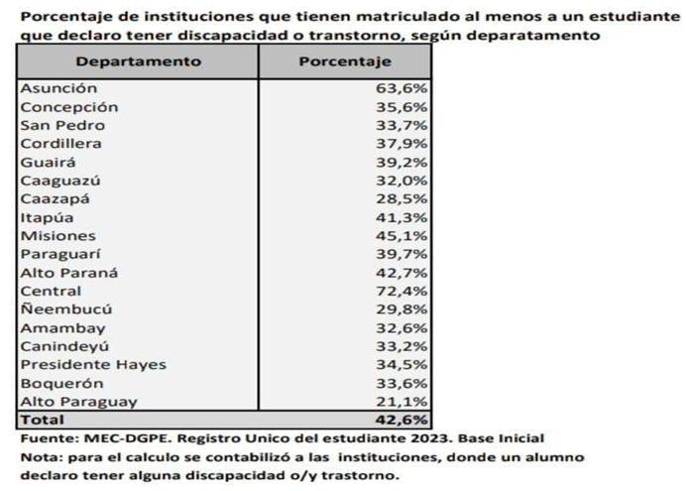
113. To promote the effective application of the Inclusive Education Act, the Ministry of Education has issued the following orders:
- Order No. 17267/2018, pursuant to which the guidelines for an inclusive educational system were adopted with a view to developing criteria for the effective inclusion of students with specific support needs
- Order No. 1188/2022, on procedures for the adoption of educational measures and curricular options for intellectually gifted students
- Order No. 31561/2018, under which the textbooks for all levels that are purchased by the Ministry of Education must be available in editable digital media in formats accessible to people with visual impairments and other persons who have difficulty reading printed matter
114. In 2023, students with visual impairments from 15 schools received material suited to their specific needs. In addition, documentation on the prevention of trafficking in persons was made available in Braille.

Reply to the issue raised in paragraph 9 (a) of the list of issues
115. The Ministry of Public Health and Social Welfare follows a model of universal comprehensive care based on the Primary Health-Care Strategy and provided by family health units; the aim is to improve the work of family health teams and the organization and processes of the units in terms of health promotion, education, assistance, recovery and rehabilitation and health surveillance.
116. Protocols for the care of children and adolescents with COVID-19, for the administration of albendazole as part of the campaign to treat infections caused by worms that was organized during the pandemic and for the care of pregnant women, women giving birth and newborn children during the pandemic were adopted against the backdrop of the COVID-19 pandemic.
117. The Ministry of Public Health and Social Welfare launched the project “Strengthening the Response to COVID-19”, which involved deploying a variety of strategies that culminated in the elaboration of a set of good practices to support vaccination for the operational level, a tool helpful for the Ministry’s vaccination campaigns (annex VII).
118. With regard to efforts to measure the impact of agricultural chemicals, the Secretariat of the Environment was, in accordance with Act No. 6123/2018, made a ministry and renamed the Ministry of the Environment and Sustainable Development in order to design, establish, monitor and evaluate the National Environmental Policy. The Ministry oversees the environmental impact assessments that take place in conjunction with projects involving the use of agricultural chemicals in rural areas.
119. The National Institute of Indigenous Affairs issues certificates of no impact to determine the proximity of stock-raising and crop-growing activities and obliges persons proposing activities in Indigenous communities to have the environmental impact of the proposed activities assessed; the Institute also monitors consultation and consent processes and takes part in the on-site visits made in follow-up to complaints submitted by the communities.
120. The Ministry of Education adopted a protocol for the protection of educational institutions from the risk of fumigation and intoxication by pesticides under Order No. 215/2023.

Reply to the issue raised in paragraph 9 (b) of the list of issues
121. The family health units of the Ministry of Public Health and Social Welfare, the providers of primary care, follow a model of comprehensive care for early childhood development. The Ministry also adopted guidelines for the epidemiological surveillance of maternal, fetal and neonatal morbidity and mortality⁸ to standardize the action taken by health professionals to monitor matters effectively and produce a sustainable, high-quality information system.
122. Efforts made within the framework of the National Strategy for Comprehensive Early Childhood Care focus on raising awareness of prenatal care for safe childbirth. An evaluation of the results of the Strategy, which will involve changes to consolidate it and enable it to expand, is under way.
123. Under Order No. 239/2023 and in the wake of the successful national campaign “No Preventable Deaths”, the Ministry adopted a plan to reduce maternal, fetal and neonatal mortality in Paraguay for the period 2023–2030⁹ with a view to implementing strategies to make the integrated network of health services and the monitoring of quality care for mothers and their newborn children more robust; against that backdrop, a number of measures are taken to prevent such mortality.
124. Specific measures for the prevention of, response to and monitoring of malnutrition, such as nutritional evaluation and education, body measurements, monthly delivery of nutritional supplements, comprehensive care and promotion of breastfeeding, were taken within the framework of the Comprehensive Nutrition Programme. In 2022, the Programme provided assistance to a total of 80,073 persons, of whom 60,767 were children under 5 years of age (annex VIII).

Reply to the issues raised in paragraph 9 (c) of the list of issues
125. Under Act No. 6453/19, the protection provided for in Act No. 5508/2015 was extended to mothers working in various State institutions. The Ministry of Public Health and Social Welfare has, for its part, taken the following steps:
- Adoption of guidelines for breastfeeding rooms under Order No. 291/18
- Creation of 110 breastfeeding rooms and the ongoing preparation of 29 more
- Implementation of mother- and child-friendly health services with the support of UNICEF and establishment of a network of human milk banks
- Delivery of a course on managing breastfeeding rooms
- Dissemination in and outreach to the family health units and State institutions with emphasis on the month of August
126. The Labour Affairs Service and the Office for the Response to and Prevention of Workplace Violence of the Ministry of Labour, Employment and Social Security provide relevant services, while the Ministry’s Directorate General for Inspection and Oversight is responsible for monitoring efforts.

Reply to the issues raised in paragraph 9 (d) of the list of issues
127. The Ministry of Public Health and Social Welfare has made sexual and reproductive health a priority, not least by making significant efforts to prevent unintended adolescent pregnancy, including strategies for access to long-acting reversible contraceptives (copper intrauterine devices, subdermal implants), work to prevent unintended pregnancies and HIV and other sexually transmitted infections, and health promotion activities such as orientation, education and training for community members and health-care personnel.
128. In 2019, in Caaguazú Department, where the rate of teen pregnancy was high, the Ministry of Public Health and Social Welfare, the Ministry for Children and Adolescents, the Ministry of Education, the Ministry of Labour, Employment and Social Security and UNFPA launched a project involving an intersectoral approach to preventing teen pregnancy and the sexual violence or abuse to which girls were subjected.

Reply to the issues raised in paragraph 9 (e) of the list of issues
129. The Ministry of Public Health and Social Welfare offers adolescent health services in family and hospitals to meet the public’s needs. Adolescent health services, such as clinics for adolescents and adolescent-friendly clinics, make it possible to offer multidisciplinary care, including preventive care, with particular emphasis on health promotion and disease prevention strategies.
130. Article 4 of the Constitution guarantees the protection of life in general, from the moment of conception, so abortion is permitted only when it is necessary or unavoidable to prevent a serious risk to the life or health of the mother.

Reply to the issues raised in paragraph 9 (f) of the list of issues
131. The Ministry of Public Health and Social Welfare has a national mental health policy defined in accordance with Act No. 7018/2022. The focus is on person-centred care, the person’s environment and rehabilitation, and the aim is to attain degrees of autonomy, participation and inclusion on the basis of a community model.
132. The mental health gap action programme of the World Health Organization has been initiated, as mental, neurological and substance abuse disorders account for 13 per cent of the disease burden. Of the persons with such disorders, 75–90 per cent do not receive the necessary treatment; this is the gap that gap action programme is intended to close.
133. The Ministry of Public Health and Social Welfare, the Ministry of Education, the Public Defence Service, the National Police and the Ministry for Children and Adolescents lead the campaign “Let’s Talk” and other workshops on suicide prevention, cyberbullying and psychological education with a focus on children and adolescents and on psychological education for teachers. Talks are also given at the national level in educational institutions on the risk of bullying and suicide prevention.

Reply to the issues raised in paragraph 9 (g) of the list of issues
134. The Ministry of Education, together with the Ministry of Public Health and Social Welfare, has, as part of a national programme to combat HIV/AIDS, led workshops in educational institutions in Asunción and in Central Department to make the national response to HIV of the health and education sectors more robust and to prevent cases of HIV and other sexually transmitted infections in adolescents. The number of public facilities for the comprehensive care of people with HIV and other sexually transmitted infections continued to increase.

Reply to the issue raised in paragraph 9 (h) of the list of issues
135. The National Drinking Water and Sanitation Plan, which is intended to promote access to water and sanitation for all inhabitants by ensuring that sustainable, high-quality services are provided, was adopted in 2023.
136. With the support of the Regional Disaster Assistance Programme of the Bureau for Humanitarian Assistance of the United States Agency for International Development, the Paraguay office of the Adventist Development and Relief Agency, a directorate general of the Ministry for Children and Adolescents and the municipality of Mariscal Estigarribia arranged for the installation, in coordination with the Secretariat for National Emergencies, of water reservoirs with a capacity of 100,000 litres for the benefit of the Indigenous communities of Campo Loa and Laguna Negra.
137. The Ministry of Public Works, with the support of the Spanish Agency for International Development Cooperation, completed a programme for sanitation and drinking water for the Chaco and the cities of the eastern region of Paraguay to improve the sanitary conditions of the Indigenous populations.
138. The National Institute of Statistics has a water information system¹⁰ that makes it possible to follow progress in the public water supply.

Reply to the issue raised in paragraph 10 (a) of the list of issues
139. Nineteen child development facilities, providing centre-based care to 1,118 children and home care to 1,776, were set up within the framework of the National Strategy for Comprehensive Early Childhood Care.
140. In addition, 19 toy libraries, designed for children up to 6 years of age, were set up in nine departments with a view to strengthening cognitive, social, emotional and linguistic skills through play and promoting the participation of children and adolescents in artistic and cultural activities in their communities.
141. The Ministry of Education has a national-level educational programme for the expansion of timely educational services for the comprehensive development of children up to 5 years of age. In addition, the diversified educational services provided to children up to the age of 5 by travelling educators or community facilitators have been made a valid educational option.

Reply to the issue raised in paragraph 10 (b) of the list of issues
142. The Ministry of Education is responsible for public remedial education programmes of a temporary nature accessible in the event that regular attendance is impossible and provides nutritional supplements to the educational offerings made available at inclusive educational institutions – that is, at the Educational Inclusion Support Centres and in the classrooms of the Remedial Education Service in Asunción. The School Meals Programme of Paraguay seeks to improve children’s academic performance and ensure that they stay in school.
143. UNICEF, the Ministry of Education and partner organizations are promoting the campaign “Let’s Go to School!” to encourage the return of children and adolescents to the education system.
144. In the period 2022–2023, the implementation of the Indigenous Peoples’ Multilingual Education Plan involved the provision of culturally relevant bilingual educational materials to 18 Indigenous Peoples. In all, 386 teaching guides for teachers and community educators were delivered, in addition to 1,066 collections of learning material for 3- and 4-year-old children, 990 literacy sets in Indigenous languages and Spanish, 10 language and literature podcasts, 10 podcasts on human rights and the rights of Indigenous Peoples and 310 supporting texts for mathematics learning circles.
145. The Tekoporã and Abrazo Programmes, as part of which cash transfers are conditioned on the fulfilment of the rights of children and adolescents, have a social and family support component to ensure that the participating families comply with their shared obligations in terms of access to health and education.
146. The National Institute of Indigenous Affairs supports Indigenous communities by financing community development projects and food security guarantees in a bid to prevent Indigenous students from dropping out of school.

Reply to the issue raised in paragraph 10 (c) of the list of issues
147. Paraguay, drawing on resources provided by the Fund for Excellence in Education and Research, has improved the infrastructure and equipment of educational institutions, enhanced the professional skills of educators and improved learning conditions and educational management by incorporating information and communication technologies into educational institutions and administrative units.
148. The Ministry of Education took a variety of measures during the pandemic, including developing the virtual platform “Your School at Home, broadcasting educational programmes intended to provide guidance to educational institutions and families on television, designing instructional strategies appropriately taking into account the greater vulnerability of students with specific educational support needs or with a disability or other condition and developing a protocol for a safe return to school.

Reply to the issues raised in paragraph 10 (d) of the list of issues
149. In addition to providing pregnant students with academic facilities in all educational institutions, the Ministry of Education guarantees that they may, in accordance with Act No. 4048/2010, enrol and remain in school. Permission to be absent from school for medical check-ups, childbirth, the postpartum period and breastfeeding is always given so that they can complete their studies without discrimination and in accordance with Order No. 1848/2015, which consists of a protocol for instructional support for children and adolescents at risk in preschool or in basic, secondary and continuing education learning institutions.

Reply to the issue raised in paragraph 10 (e) of the list of issues
150. The Ministry of Education adopted a guide for action in the educational environment in the event of the sexual harassment or abuse of children and adolescents. In addition, the Public Prosecution Service has a programme, “The Prosecution Service in Primary and Secondary Schools”, that is designed to raise awareness and prevent cybercrime. The Public Defence Service leads talks in educational institutions to inform children and adolescents of their rights, the leading role that they can play in efforts to assert their rights and where to turn when their rights are violated.

Reply to the issue raised in paragraph 11 (a) of the list of issues
151. The National Migration Directorate coordinates the execution of the migration policy with other government agencies. The Directorate’s handbook for border officials is an essential management tool ensuring that information on the current regulatory framework and best international migration practices is accessible and promoting knowledge of that information, thereby guaranteeing migration checks, of vulnerable migrants in particular, that are more agile and more respectful of human rights, in line with international principles. One of the main aims of this handbook is to help ensure that citizens are provided with greater guarantees of their rights and freedoms in respect of transit and security and that especially vulnerable groups are identified and protected more easily.

Reply to the issues raised in paragraph 11 (b) of the list of issues
152. The National Institute of Indigenous Affairs promotes the social and cultural preservation of Indigenous communities and access to land for such communities, whose members it helps to put down roots by making land claims, providing technical, social and economic assistance, allocating public land and acquiring private land, including by expropriation.
153. Within the framework of the Programme of Comprehensive Care for Indigenous Children and Adolescents, the Ministry for Children and Adolescents works to strengthen the organizational structure of Indigenous communities and provide financial assistance to families; it also has centres located in Indigenous communities, the residents of which are involved in matters of child and adolescent protection.
154. The objective of the Tekoha Programme is to guarantee access to landownership for vulnerable families living in poverty by legalizing and organizing the occupation of areas in and on the periphery of cities.

Reply to the issues raised in paragraph 11 (c) of the list of issues
155. The Ministry for Children and Adolescents consolidated the Abrazo Programme, a State programme to prevent and progressively eliminate child labour; a total of 4,225 families, including 11,500 children and adolescents, are registered with the Programme, which operates 59 care centres located in 46 districts of 11 departments.
156. In addition, a community model for the prevention and eradication of the labour of children and adolescents from communities of the Mbyá Indigenous People, which is centred on strengthening the community and its organization and enlists leaders to help with prevention, support and community reintegration efforts, was developed in the city of Caaguazú.
157. Together with civil society organizations, the Ministry implemented a strategic project to increase the income of and empower the women involved in the Abrazo Programme. In all, 1,000 mothers in vulnerable situations were able to create their own businesses. Child protection actors, relying on the Immediate Response System, the Programme of Comprehensive Care for Indigenous Children and Adolescents, the Comprehensive Programme for Children and Adolescents Living on the Streets and the Abrazo Programme, work together to take a comprehensive approach to children engaged in child labour.
158. The Ministry of Labour, Employment and Social Security, which monitors the indicators produced by the National Commission for the Eradication of Child Labour and the Protection of Adolescent Labour and the decentralization of the Commission – departmental commissions for the eradication of child labour have been created in nine departments – coordinates the National Strategy for the Eradication of Child Labour and the Protection of Adolescent Labour 2019–2024.
159. Work has been done to prevent hazardous child labour in the sugar cane and cotton value chains. Although there has been training on the issue of child labour, efforts to train inspectors to identify risky situations in rural work have been stepped up. The National Strategy for the Prevention and Eradication of Forced Labour 2021–2024 was adopted pursuant to Order No. 551/2021.
160. There are no updated data on the situation with regard to domestic work by children, so it is a challenge for the State to put the issue on the public agenda with a view to researching the persistence, magnitude and distribution of this scourge and adopting public policies to combat it. The Ministry of Labour, Employment and Social Security, the Ministry for Children and Adolescents and other State institutions have led communication campaigns and prevention and awareness-raising activities on domestic work by children (annex IX).

Reply to the issues raised in paragraph 11 (d) of the list of issues
161. Monitoring and outreach by social workers in Central Department are facilitated by the Immediate Response System; ongoing support is provided, and responses to violations of the rights of children and adolescents are timely.
162. According to data reported in 2023, 550 children and adolescents approached under the Immediate Response System are systematically engaged in some kind of street activity. Of 10 children and adolescents approached in the street, 7 are Indigenous, and 70 per cent of those Indigenous children and adolescents are ethnically Mbyá, a finding that indicates that the relevant programmes and services should be made more robust by integrating a community-based, comprehensive approach (annex X). To reduce the magnitude of or prevent this phenomenon, the Ministry for Children and Adolescents has taken several measures, including protection initiatives such as the creation of child development spaces, Abrazo Programme and the Comprehensive Programme for Children and Adolescents Living on the Streets.
163. The Ministry’s budget for 2021, 2022 and 2023 is shown in the following table:
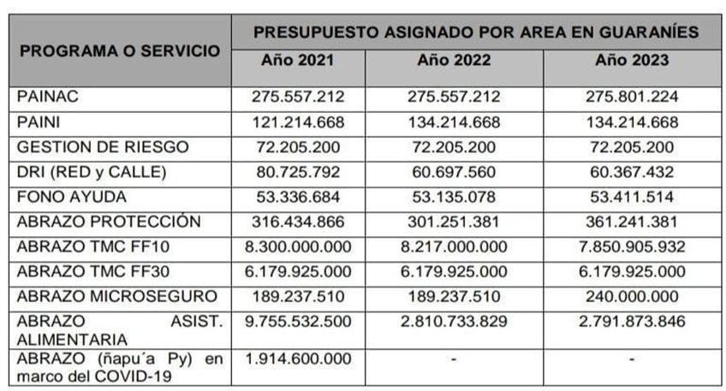

Reply to the issues raised in paragraph 11 (e) of the list of issues
164. An inter-institutional road map for a comprehensive response to the sexual abuse of children and adolescents was adopted, and a nationwide preventive programme for the comprehensive care of child and adolescent victims of sexual abuse, mentioned in paragraph 71, was created in accordance with Act No. 6202/2018.

Reply to the issues raised in paragraph 11 (f) of the list of issues
165. From January to October 2023, the Ethnic Rights Directorate of the Public Prosecution Service intervened, by its account, in 47 cases of sexual abuse of children involving children and adolescents who are members of Indigenous communities.

Reply to the issue raised in paragraph 11 (g) of the list of issues
166. The Ministry for Children and Adolescents, together with the Organization of American States and the Spanish Agency for International Cooperation Development, is promoting a project to prevent trafficking in children and adolescents and care for the victims in Asunción and in Central, Caaguazú, Itapúa and Alto Paraná Departments. The aim of the campaign launched with the hashtag #HayPromesasPeligrosas is to raise public awareness of trafficking in persons and organize workshops to reach out to adolescents in educational institutions.
167. The Programme for the Comprehensive Care of Child and Adolescent Victims of Trafficking in Persons and Sexual Exploitation has been made more robust. The National Migration Directorate has prepared a road map to combat trafficking in persons on the border and provides ongoing training to its officials with a view to combating this scourge.
168. The National Secretariat for Tourism promotes a code of conduct drawn up to combat trafficking in persons and the sexual exploitation of children and adolescents in travel and tourism and has managed to have 16 hotel companies agree to abide by the code.
169. Data from the Programme for the Comprehensive Care of Child and Adolescent Victims of Trafficking in Persons and Sexual Exploitation (and other rights violations) can be seen below:
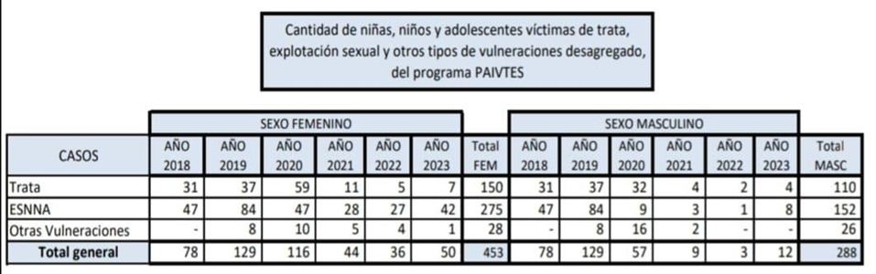

Reply to the issues raised in paragraph 11 (h) of the list of issues
170. The Ministry of Justice, focusing on restorative justice, takes strategic action to provide adolescents in conflict with the law with comprehensive care and promote their personal development, comprehensive health and education so that they can be rehabilitated and return to society.
171. In addition, building improvements have been made to educational centres for adolescents in conflict with the law with a view to respecting the dignity of those adolescents (annex XI); the Public Defence Service and the national preventive mechanism watch over their personal well-being and the progress of the judicial proceedings to which they are parties.
172. The Public Defence Services monitors the measures to which adolescents in conflict with the law are subjected monitors and ensures that the period for which the measures is in place and the severity are appropriate.

Reply to the issue raised in paragraph 11 (i) of the list of issues
173. The National Police have a protocol for police intervention with adolescents between 14 and 17 years of age in conflict with the law and for the police protection of children and adolescents at risk (annex XII).

Reply to the issue raised in paragraph 11 (j) of the list of issues
174. With support from the Spanish Agency for International Development Cooperation and the Organization of American States, the Adolescent Offenders Welfare Service of the Ministry of Justice implements a project to support strengthening the restorative approach to resolving matters involving adolescent criminal liability in Paraguay. The aims are to build the professional and institutional capacities to manage, assist and monitor adolescents in conflict with the law, while adopting a restorative perspective to respond to their individual and specific needs and to develop educational, comprehensive training and social reintegration programmes.
175. A model for the educational support of adolescents in conflict with the law and a protocol for custodial and non-custodial measures have been developed with the participation of such adolescents in the eight education centres.

Reply to the issue raised in paragraph 12 of the list of issues
176. The Directorate of Human Rights and International Humanitarian Law of the Ministry of Defence, together with the Directorate of Human Rights and International Humanitarian Law of the Office of the Chiefs of Staff of the Armed Forces, organizes periodic training for military personnel, and a human rights and international humanitarian law programme is part of the curricula of the military academies.

Part II

Reply to the issue raised in paragraph 13 (a) of the list of issues
177. See annex XIII.

Reply to the issue raised in paragraph 13 (b) of the list of issues
178. Secretariats under the Office of the President and other departments have been made ministries or modernized, and they are referred to by their new names, including the Ministry for Children and Adolescents, the Ministry of Urban Planning, Housing and the Human Environment, the Ministry of Social Development, the National Institute of Statistics and the Ministry of Economic Affairs and Finance.

Reply to the issue raised in paragraph 13 (c) of the list of issues
179. Recently adopted policies, programmes and action plans, which are financed by the State from its general budget, are mentioned throughout this report; they are implemented with the help of civil society, and accountability mechanisms, including results-based planning, are in place for impact assessments.

Reply to the issue raised in paragraph 13 (d) of the list of issues
180. No human rights instruments have been newly ratified.

Part III

Reply to the issues raised in paragraph 14 of the list of issues
181. The Paraguayan State recognizes the vital importance of investing in its human capital, children and adolescents, so comprehensive development and the creation of opportunities are now more important, as shown below:
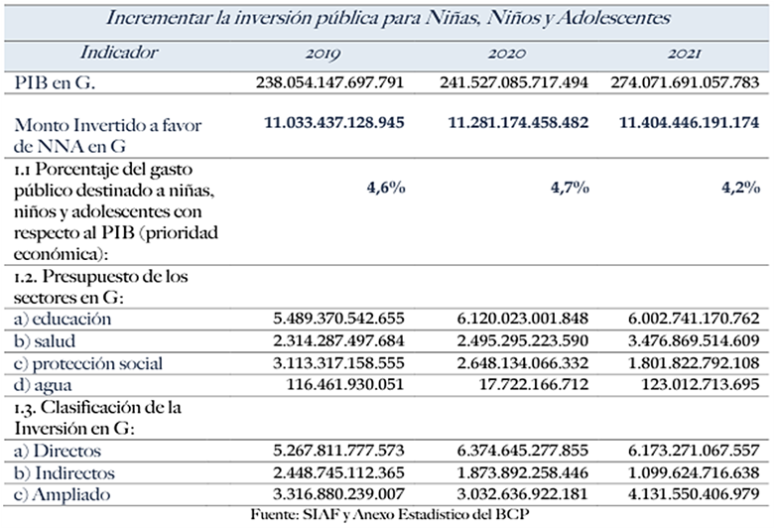
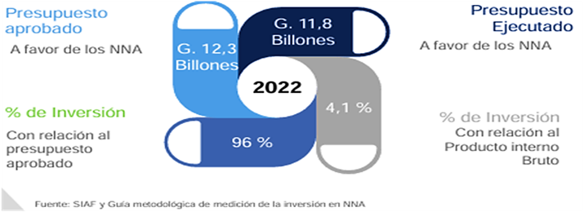
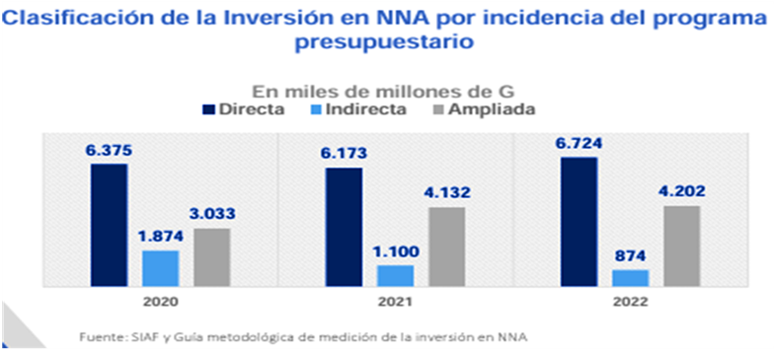
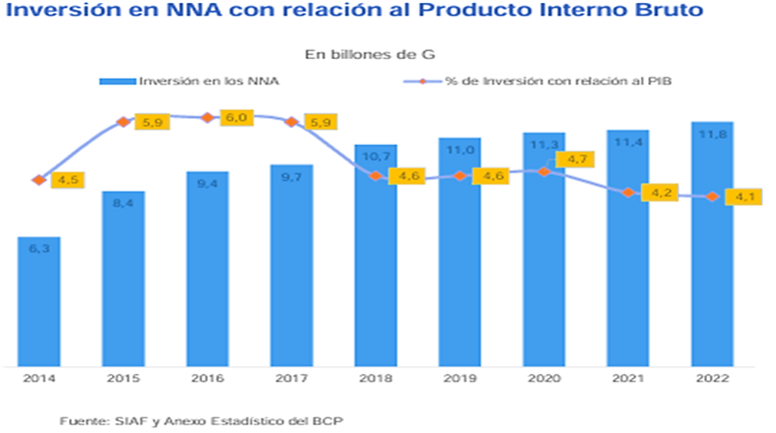
182. Spending on children and adolescents in 2022 is 3 per cent more than in 2021. Total expenditure in that respect amounted to 11.8 billion guaraníes, 96 per cent of the approved budget line. At the end of 2022, the country’s gross domestic product (GDP) was, according to the Central Bank of Paraguay, an estimated 288 trillion guaraníes, making spending on children and adolescents 4.1 per cent of GDP.

Reply to the issue raised in paragraph 16 (a) of the list of issues
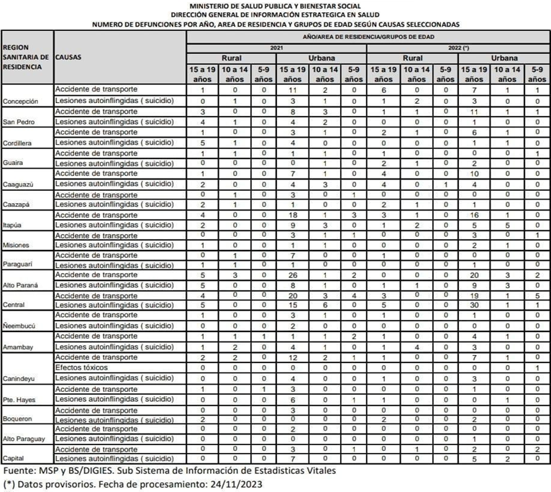

Reply to the issue raised in paragraph 16 (b) of the list of issues
183. Data provided by the Public Prosecution Service:
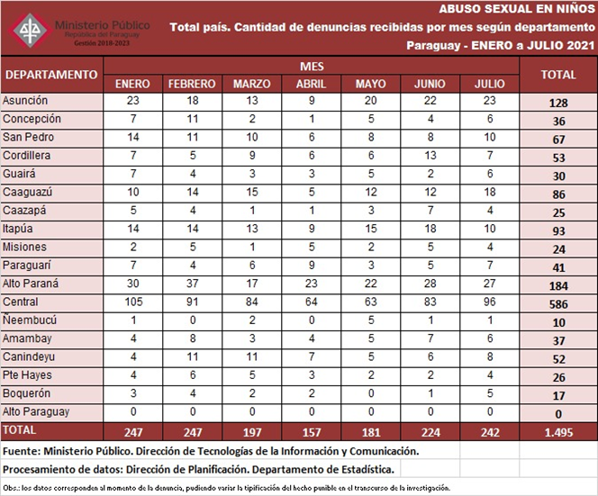
184. Information provided by the Supreme Court:
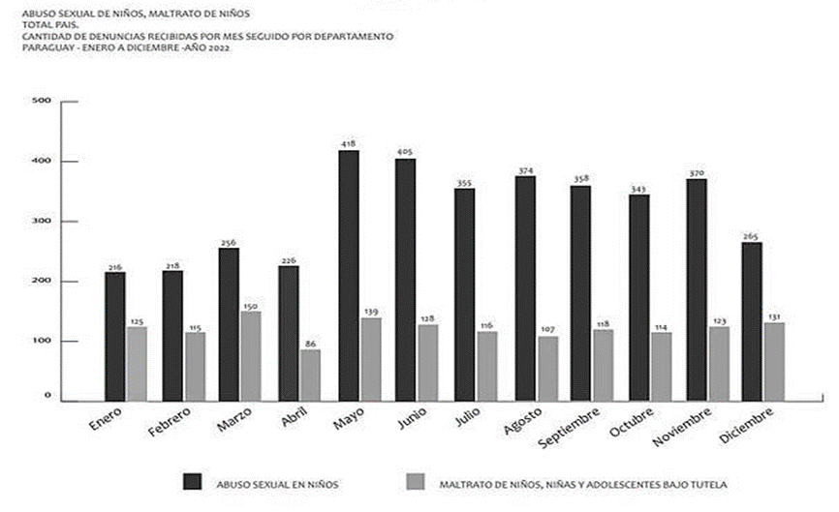
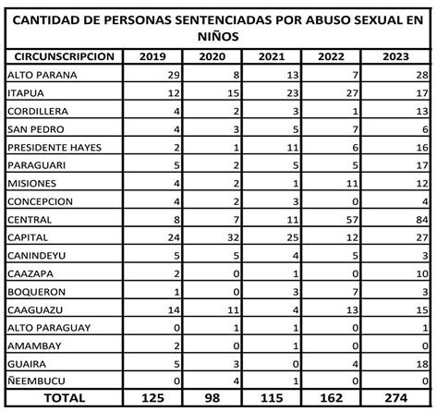

Reply to the issue raised in paragraph 16 (c) of the list of issues
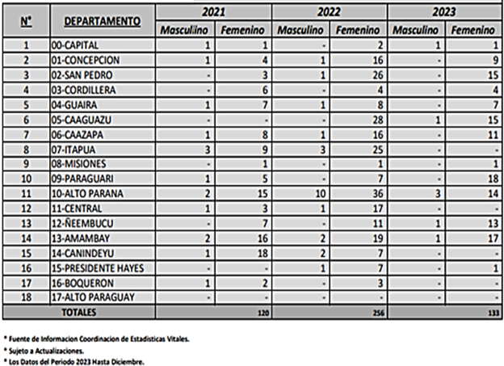

Reply to the issue raised in paragraph 16 (d) of the list of issues
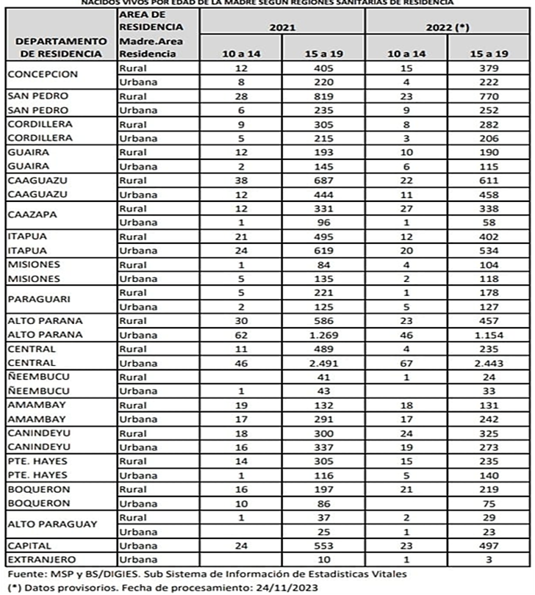

Reply to the issue raised in paragraph 16 (e) of the list of issues
185. Data in this regard can be found in annex XIV.

Reply to the issue raised in paragraph 16 (f) of the list of issues
186. There are no reports of harassment or persecution of children for having exercised their right to participate.

Reply to the issue raised in paragraph 17 (a) of the list of issues
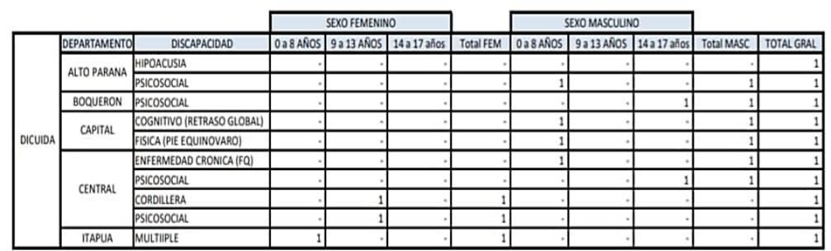
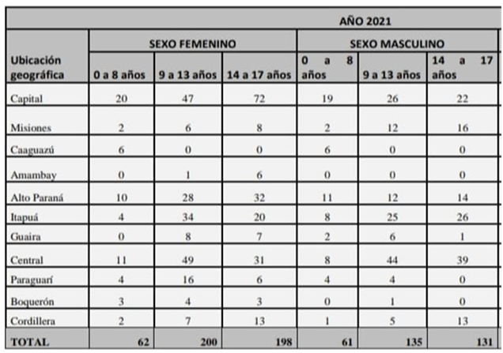
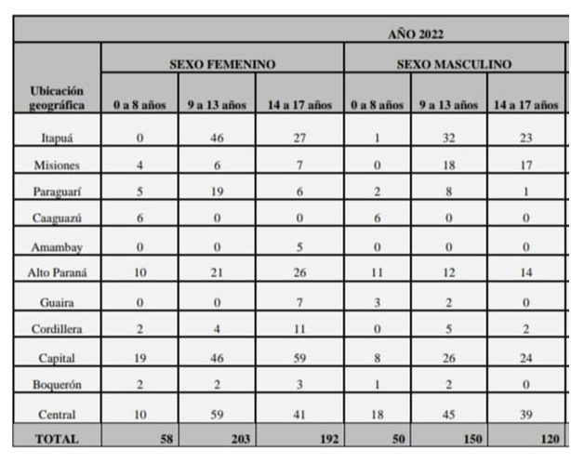
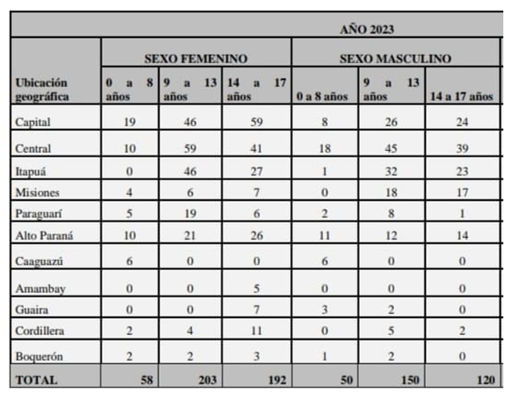

Reply to the issue raised in paragraph 17 (b) of the list of issues
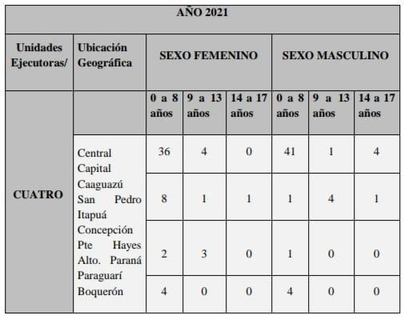
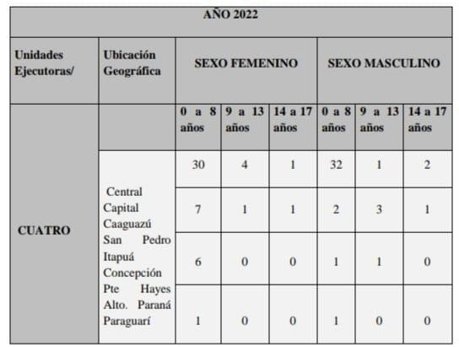
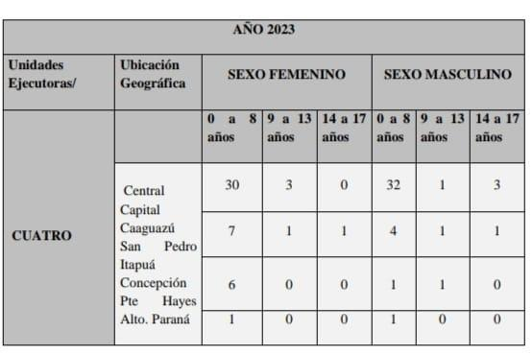
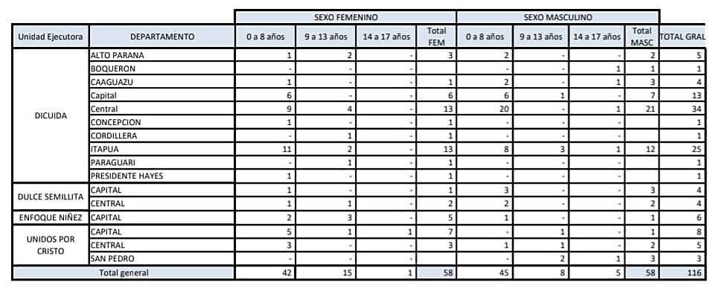

Reply to the issue raised in paragraph 17 (c) of the list of issues
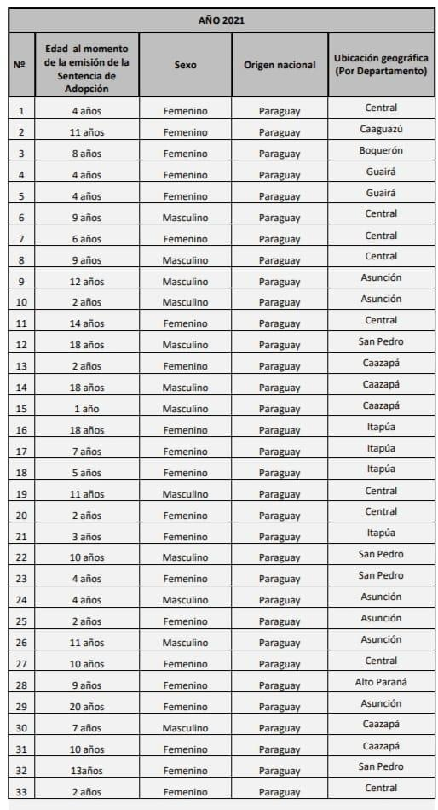
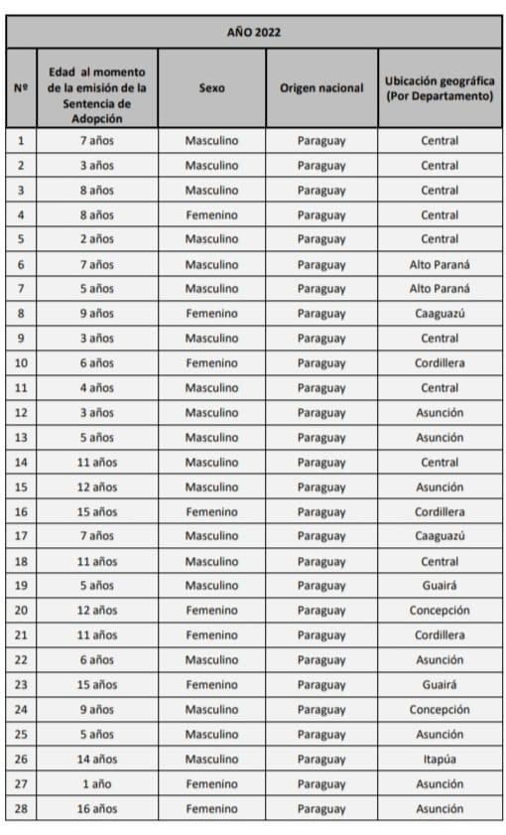
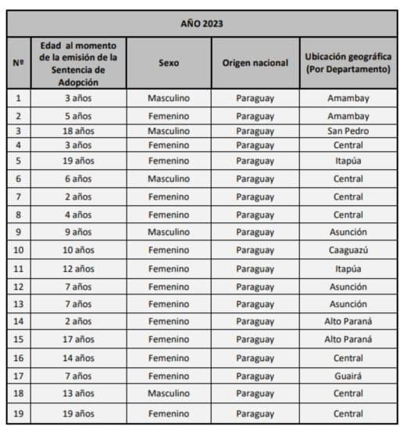

Reply to the issue raised in paragraph 18 (a) of the list of issues
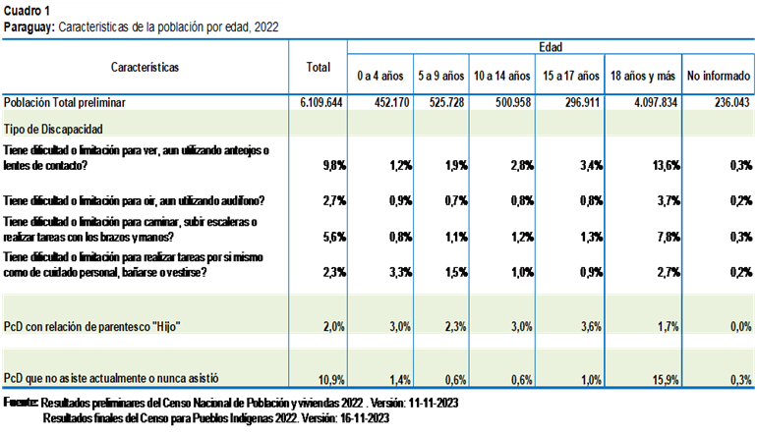

Reply to the issue raised in paragraph 18 (b) of the list of issues
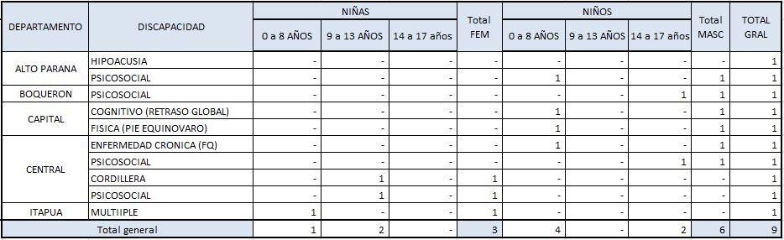

Reply to the issues raised in paragraph 18 (c) of the list of issues
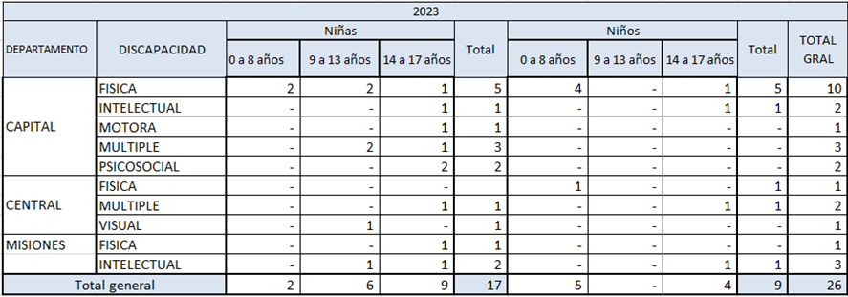

Reply to the issues raised in paragraph 18 (d)–(f) of the list of issues
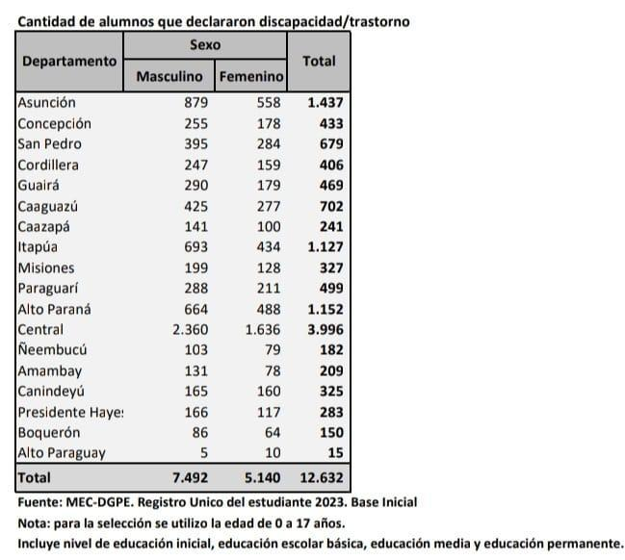
187. Disaggregated data may be found in annex XVI.

Reply to the issue raised in paragraph 18 (g) of the list of issues
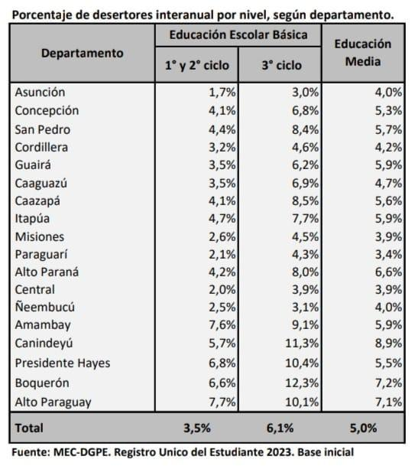

Reply to the issues raised in paragraph 19 of the list of issues
188. The National Commission on Stateless Persons and Refugees keeps a record of children and adolescents who are accompanied by their families and works in tandem with State institutions to ensure that they can exercise their rights. It is nevertheless a challenge to obtain statistical data on the social situation of asylum-seeking and refugee families and children (annex XVI).

Reply to the issues raised in paragraph 20 of the list of issues
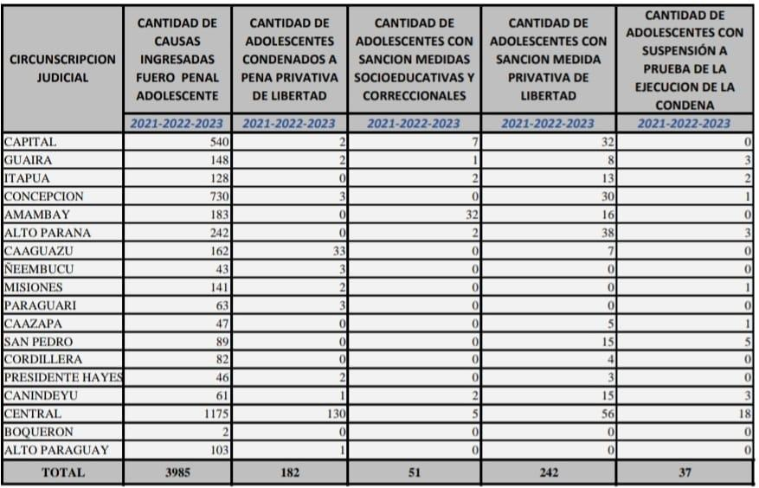
189. Further information may be found in annex XVII.

Reply to the issues raised in paragraph 21 of the list of issues
190. The annual planning of the activities of State institutions is oriented to the achievement of one or more sustainable development goals, linking them to the State budget and permitting an integrated view of the measures taken by public institutions and the investment represented by those measures.
191. The National Development Programme 2030, the equitable social development strategies of which include lines of action for the comprehensive development of children, was launched to facilitate the coordination of the steps taken by executive agencies, at the different levels of government, civil society organizations, the private sector and, possibly, the legislative and judicial authorities.
192. In the formulation of the lines of action and the National Plans for Children and Adolescents, national priorities, such as the need to focus on early childhood matters, education, health, violence prevention and services for children in vulnerable situations, are taken into account; in addition, the aim is to promote equal rights for boys and girls to guarantee their rights.
193. These measures are taken with children and adolescents in various participatory forums, such as Departmental and Municipal Councils for Children and other specific workshops held around the country on the rights enshrined in the Convention, thus ensuring that children and adolescents can exercise their right to participate in matters that concern them.

Reply to the issue raised in paragraph 22 of the list of issues
194. Changes, which do not affect the continuity of the programmes or measures mentioned in this report, had to be made to the organizational structure of the National Secretariat for Children and Adolescents when it was made a government ministry.

Reply to the issue raised in paragraph 23 of the list of issues
195. Paraguay intends to focus more closely on the following priorities or lines of action:
- Prevention, protection and restoration of rights in connection with all types of violence against children
- Early childhood services
- Measures to address the situation affecting Indigenous children
- Strengthening alternative care and adoption
- Prevention of and response to the use of psychoactive substances by children and adolescents and consolidation of the National System for the Comprehensive Protection and Advancement of Children and Adolescents with a view to breaking the cycle of poverty and taking the steps that will enable all children to enjoy all their rights.

* The present document is being issued without formal editing.
** The annexes to the present document may be accessed from the web page of the Committee.

