 | United Nations | CCPR/C/IRN/4
 | International Covenant on  Civil and Political Rights |  | Distr.: General  23 August 2021  Original: English  English, French and Spanish only
Human Rights Committee

Fourth periodic report submitted by the Islamic Republic of Iran under article 40 of the Covenant, due in 2014*, **

Contents
Page
Abbreviations 3
Preamble 4
Article 1 4
Article 2 5
Article 3 6
Article 6 8
Article 7 12
Article 8 14
Article 9 14
Article 10 17
Article 11 20
Article 13 20
Article 14 20
Article 15 23
Article 16 23
Article 17 23
Article 18 23
Article 19 26
Article 20 28
Article 21 29
Article 22 30
Article 23 31
Article 24 33
Article 25 33
Article 26 35
Article 27 39

Abbreviations
CAJ: Court of Administrative Justice
CBSPCRJ: Central Board for Supervising on the Protection of Citizens’ Rights of the Judiciary
CCP: Code of Criminal Procedure (2013)
FPL: Family Protection Law (2012)
FCC: Family Counseling Centers
ICCPR: The International Covenant on Civil and Political Rights
IPC: New Islamic Penal Code (2013)
IRI: Islamic Republic of Iran
JCPOA: Joint Comprehensive Plan of Action
MCT: Military Court of Tehran
PICF: Physical Injuries Compensation Fund
SPSCMO: State Prisons and Security and Corrective Measures Organizations
UCM: Unilateral Coercive Measures
USMC: Under 18 years old Sensible Mature Culprits

Preamble
1. The Islamic Republic of Iran is a country with a population of more than 81 million, located in West Asia with a history of several thousand years of civilization. Although different ethnicities and religions have lived in Iran for thousands of years, the nature of government formation in Iran has never been defined on the basis of the monopoly of a particular ethnicity and religion, and thousands of years of successful peaceful coexistence between Iranian ethnicities by adhering to the values stemmed from tolerance is a testament to the depth of these beliefs among the nation. This Republic follows the years of struggle of the Iranian nation to deny tyranny and backwardness, achieved independence and freedom as a resurgence after its efforts in the form of movements such as the Constitutional Movement and the National Oil Movement was suppressed, the latter of which failed due to the coup d’état of August 15, 1953 supported by the US-British governments. Finally overthrowing the last US-backed monarchy in Iran with a sweeping popular and religious revolution, and for more than 40 years now, religious beliefs and historical achievements has been able to establish a democratic system that can achieve great progress by pursuing the principle of neither East nor West and moving on the basis of dignity, expediency and wisdom.
2. For more than four decades, the IRI has acted well in accordance with the principles of the UN Charter and the Universal Declaration of Human Rights, and has had the active cooperation and interaction with international human rights organizations. It should be noted that the ideals of freedom-seeking and confrontation with domination, which was the basis of the Islamic Revolution, will chart a course that prioritizes combating human rights abuses and also seeks ways to prevent the degradation of human rights to a mere a political leverage by trying to prevent the promotion of double standards and marginalize the big powers from evaluating human rights records. Also, the IRI, like the 120 member states of the Non-Aligned Movement, believes that the universality of human rights should not be considered as ignoring the diversity of cultures and civilizations. The Universalist approach must also take into account the specific situation of societies and, while adhering to this issue, must exercise the necessary flexibility in the face of cultural diversity to use diverse and indigenous capacities for the better realization of human rights. Without considering cultural diversity, universal human rights cannot be considered completely.
3. Furthermore US political pressures and its unilateral illegal economic sanctions (named UCM) as the greatest impediment to higher protection of human rights of Iranians, specifically in scope of employment, welfare and health, will be expatiated under related articles.
4. This report, submitted under article 40 (1) of the International Covenant on Civil and Political Rights, the forth periodic report of the Islamic Republic of Iran has been drawn up, considering the compilation of guidelines on the form and content of reports to be submitted by States parties to the international human rights treaty bodies (HRI/GEN/2/Rev.6) and the guidelines for the treaty-specific document to be submitted by States parties under article 40 of the ICCPR (CCPR/C/2009/1).
5. The report covers the period from November 2009 to November 2020 and includes a description of events and advancements that have taken place since the submission of the third periodic report of the IRI.
6. The report takes into account the concluding observations of the Committee following its consideration of the third periodic report of the Islamic Republic of Iran (CCPR/C/IRN/CO/3).

Article 1
7. In line with the implementation of the obligations of the Islamic Republic of Iran in relation to Article 1 of this Covenant, detailed contents were presented in the third report on civil and political rights under Article 40. Considering the importance of the role of people in Islamic Revolution and the establishment as the result of it, in the present report it is mentioned again that the IRI was established by the people’s vote and has been managed on the basis of the people’s votes for more than 4 decades. All political leaders and officials are elected by the people in accordance with the Constitution.
8. Regarding clause 2 of Article 1 of the Covenant, it should be noted that according to Articles 46 and 47 of the Constitution, everyone is the owner of his legitimate business and no one can deprive others of the possibility of doing business. There are no legal impediments to the legal use of resources. The people of Iran, using their national resources, have developed their individual and national development indicators for more than 4 decades and by completing the National Cadastral Plan (aerial determination of land and property) have been able to provide the necessary legal facilities for development and as the result prevent any violation of the property rights of individuals. In this regard, 6,570 documents belonging to the villagers whose lands had been usurped by the former regime were returned to the owners.
9. It should be emphasized here that one of the main challenges to the realization and promotion of the economic rights of the people in Iran has been the subsequent withdrawal of the United States from the (JCPOA) and imposing unilateral illegal sanctions. It is certain that Unilateral Coercive Measures (hereafter UCM) violate this Article of the Covenant and have significantly damaged the Iranian nation’s exploitation of national resources and capacities. In General Assembly resolutions, including the one adopted on January 13, 2020, while expressing concern about the effects of UCM that deliberately target the economies and development of developing countries, it considers such actions as a “gross violation of the principles of international law”. The resolution calls on the international community to take the necessary steps to eliminate unilateral economic, financial and trade measures that are not approved by the competent international institutions (second executive paragraph). It then calls on the international community to condemn and reject the measures which aim to impose political and economic coercion against developing countries, since these measures prevent them from fully benefiting from economic and social development (third executive paragraph). The Special Rapporteur on UCM has repeatedly stated, including in clause 26 of his June 2018 report that UCM will in fact lead to the false and unreasonable results in peacetime, where those rights are guaranteed even in time of war. In humanitarian law, sanctions should not lead to starvation and “collective punishment,” so how war guaranteed rights can be violated in peacetime under the pretext of unilateral sanctions.

Article 2
10. Detailed cases regarding the fulfillment of the country’s obligations under Article 2 of the Covenant were presented in the previous report, during which the structure of the judiciary, types of courts, the manner of realization of justice, the Court of Administrative Justice (CAJ), the Attorney General, the Disciplinary Court of Judges, the General Inspection Organization and the relevant monitoring mechanisms were well introduced.
11. In response to the Concluding Observation No. 7, it should be noted that in the IRI, given the existing interagency and intra-organizational structures that have a broad agenda in the field of human rights and are planning and carrying out promotional measures in this area (such as the Human Rights Council, the Secretariat of Civil Rights, etc.), In practice, efforts have been made for independent reviews and monitoring to improve the human rights situation and the optimal use of human and financial resources to an appropriate degree. However, in order to centralize the structures and efforts as well as the recommended action, the draft bill for establishing the National Human Rights Institution has been drafted and made available to the public for comment and suggestions, and is currently being in complementary expert review phase.
12. During the reporting period, in addition to the measures and structures presented in the previous report, the following institutions have been established to promote, uphold and protect human rights.
13. Deputy of Public Rights Supervision in the Attorney General’s Office, The position of Assistant to the President in Citizenship Rights Affairs and Assistant to Citizenship Rights in all executive bodies, Deputy Minister of Human Rights and International Affairs in the Ministry of Justice, Secretariat of the Convention on the Rights of Persons with Disabilities, Deputy of Administrative Health and Protection of People’s Rights in the Administrative and Employment Affairs Organization of the country, National system for handling complaints and announcements in the General Inspection Office.
14. The examples of the performance of the CAJ in handling complaints and monitoring the performance of bodies documented in international instruments and the Covenant on Civil and Political Rights will be attached.

Article 3
15. In the previous report under this article, detailed information on the status of women in the family, socioeconomic development programs, women’s rights and social responsibilities, legal amendments for better realization of women’s rights, women’s economic responsibilities and their level of participation in politics and the high rate of their presence in educational and scientific topics were articulated. As mentioned, the IRI has considered the promotion of the cultural, social, economic and political status of women as a key element in its national policy, legislation and planning. In this section, new developments in this field are discussed.
16. One of the important axes of better realization of people’s rights is the legislative measures that have been adopted or are being finalized in order to protect and promote women’s rights, the most important of which are the following:
(a) Sixth Development Plan Law (2017–2021);
(b) Charter of Citizens’ Rights (2015);
(c) Government Resolution obliging the Ministry of Sports and Youth to promote the health and vitality of women and girls through sports, 1397;
(d) Amending the law of direct taxes: with tax exemptions for female-headed households and self-employed girls;
(e) Bill for ensuring the security of women and children against violence (2015–2016);
(f) Amending the Law on Determining the Obligation of Citizenship of Children Arising from the Marriage of Iranian Women to Foreign Men, 1398(2019);
(g) The Document of Vision of the IRI in the horizon of 1404 AH (2025).
17. New executive measures to ensure women’s rights and the country’s international obligations in the better manner:
(a) Memoranda of Understanding between the Vice President for Women and Family Affairs with the Social Affairs and Crime Prevention Department of the Judiciary and several other organizations in order to promote, strengthen and institutionalize gender justice in the family and balance and consolidate marital relations and promote Indicators related to women, children and family in the country;
(b) Amending and approving executive instructions to increase the use of women in managerial positions;
(c) Measures of the Vice President for Women and Family Affairs to promote the active presence of women in management levels, develop a comprehensive program for the development of women and family affairs, form a working group on management, political and social participation, and hold a training course to improve scientific and practical skills of women to participate in international forums;
(d) Increasing trend in the presence of women in higher education: In 1398(2019), 54.45% of the country’s students were women. In 1397(2018), the share of women in the faculty in the whole country was equal to 24%, which shows an increase of 8% compared to 1388(2009);
(e) Educating issues related to family health and sexual health of women, through the establishment of 17 family health clinics;
(f) Provide better judicial-civil protection services to women: Provincial offices for the protection of women and children of the Judiciary, working to secure their release through conditional amnesty, mitigation of warrant and changing the warrant, granting furlough and expediting proceedings, providing social assistance and holding courses to empower vulnerable women and children.
18. In the implementing Article 101 of the Sixth Development Plan Law and strengthening the institution of the family and the position of women in all areas, the office of the Vice President for Women and Family Affairs has prepared a document in consultation with civil society to promote the status of women and the family by determining gender balance indicators. The document has 8 categories and 28 main indicators.
19. Examples of promoting the position of women in the field of management in the reporting period:
(a) Development of the use of women’s intellectual and managerial abilities in various fields so that during the years 1392(2013) to 1395(2016) in the Ministry of Industry, Mines and Trade; The increase in female managers in the administrative affairs has been 42%, provincial organizations 26%, affiliated organizations 52% and finally the average in whole departments of the ministry is 44%. Furthermore, the number of faculty members of universities; experienced a significant increase. The total number of women faculty in universities reached 20,321 by 1396(2017). In public universities affiliated to the Ministry of Science, the number reached 2899 persons; in Payame Noor University 1125 ones; in University of Applied Science and Technology 14 ones; in the Technical and Vocational University 94 ones, in medical universities affiliated to the Ministry of Health 5068 ones, and 99 ones in scientific institutes affiliated with other executive bodies. There are 640 faculty members in non-governmental, non-profit higher education institutions; 8656 ones in Islamic Azad University and 228 in Farhangian University. From 2011 to 2017, 22% of the faculty members were women and this upward trajectory is continuously going on;
(b) In 1392(2013), the number of female managers in the Ministry of Interior and General Governor offices was 339, which increased to 697 in 1998, which shows a growth of 105%. Currently, 22% of managerial positions are held by women, which are shown in the table below. 52 district governor positions were available to women in 1396(2017), which was zero in 1392.
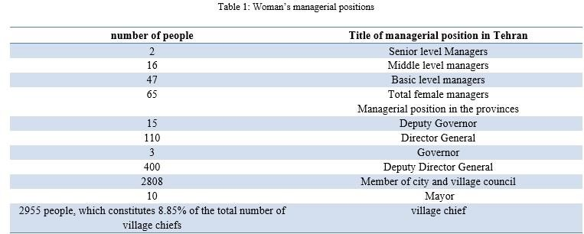
20. The rate of women’s economic participation in an upward trend has increased from 12.4% in 1392(2013) to 16.4% in 1397(2018). The number of women working in government has increased from 34.64% in 2009 to 41.67% in 1397(2018), which indicates an upward trend in the recruitment of women in governmental organizations. More than 4,000 women entrepreneurs are active. By 1397(2018), 223 centers have been established and are operating throughout the country, of which about 20% are managed by women entrepreneurs. Between 1390(2011) and 1398(2019), 523,371 companies and institutions were registered by women. In addition, 850,565 companies and institutions have board of directors consisting of women. Between the above years, 24,804 patents have been registered by women.
21. In order to combat violence, including domestic violence, the Social Affairs and Crime Prevention Department of the Judiciary, establishes the National Committee for the Prevention of Violence at the National Level and pursues several violent measures.
22. Citing the courts’ rulings on the Constitution, the ICCPR, the ICESCR and the Universal Declaration of Human Rights in the realization of women’s rights, some of which are as follows:
(a) Kermanshah Court of Appeal, Judgment, dated 13/3/1398 Overruled the initial verdict based on the Constitution, Article 3 and Article 17 of the ICCPR);
(b) Kermanshah Branch Family Court, Decision, dated 10/28/1398, overruled the initial verdict that issued in favor of the husband and necessity of obedience by wife which put the woman in an inappropriate circumstance.

Figure 1
The share of women of all persons with higher education
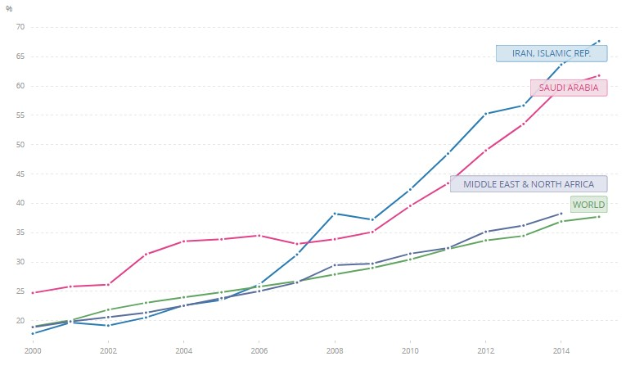

Source: World Bank

Article 6
23. In addition to what is presented in the previous report of the IRI under article 6, it is added that the right to life is the key right in Islamic teachings and the Iranian Constitution, so that, unjust killing of one person is considered synonymous with killing all human beings. In the penal laws of the IRI with the aim of protecting the right to life of human beings and important civil rights, the right of execution is prescribed to deal with who deprives other citizens of the right to life or violate it.
24. Most of the death sentences in Iran are due to the existence of large-scale drug trafficking and smuggling, which is often carried out through terrorist operations and carrying of semi-automatic firearms and during a dreaded security project. However, the Anti-Narcotics Law was amended in 1396(2017) that culminated with a reduction in executions (although it has had adverse effects on the increase of addicts and drug dealers, which should be pursued in its place), especially since this is an ex post facto law. According to the amended law, the issuance of the death sentence is determined in cases where a wider volume of drug trafficking has taken place, which is also recognized in accordance with clause 2 of Article 6 of the Covenant. It could be seen that with regard to direness of the mentioned offenses, the amended law has utmost consistency with exigencies of the Covenant. Implementation of this law in practice has led to a serious reduction in the issuance and execution of the death penalty, so that for example (information received from 7 units of the Tehran Judicial Execution as a sample province) 1053 cases of severe punishments had overtly mitigated, as a result of the amendment of Anti-Narcotics Law.
25. Another category that leads to the death penalty is premeditated murder, which is subject to the Islamic ruling of retribution (Qisas). In case of Qisas the relatives of the victim can demand the death penalty for the murderer. In the meantime, the judiciary through compromise and consultations and even religious guidance and in some cases financial assistance to the victim’s family, tries to gain the consent and forgiveness of victim’s heirs, and has also achieved many successes so far. Official policy of the country’s judiciary is to decrease the incidence of crime, especially the occurrence of serious crimes, and consequently reducing the number of death sentences.
26. According to the country’s criminal law (Article 384 of the new CCP), in the trial of those accused of serious crimes, the formalization of hearings is subject to the presence of a lawyer, and a hearing held without the presence of a lawyer has no legal effect. Any decision issued on this basis can be appealed, retried or even overturned by the Supreme Court. More importantly, after the proceedings and confirmation in the Supreme Court, the execution must be approved by the head of the judiciary because of the importance of the matter. It is reiterated that the national goal is to lessen the number of executions, and that the judiciary is trying to reduce the number of executions in various ways.
27. Regarding the right to life of Under 18 years old Sensible Mature Culprits (hereafter USMCs), it should be noted that the IRI, due to Islamic and humanitarian considerations, shows a lot of flexibility to them, including amending the CCP such as holding special courts and Penal Laws (use of alternative and light punishments). Regarding criminal sentences for children and adolescents, it should be acknowledged that the criminal law in this regard pursues a “Segregation Policy” regarding juvenile delinquents. The mechanisms of this approach are based on age and puberty variables to help resolving the problem of juvenile delinquency with a supportive approach and pave the way to help them return to normal life. These mechanisms include the establishment of juvenile court and tribunal, juvenile criminal court, the juvenile police, and the need to “establish a personality file” with the cooperation of experienced forensic experts. Determining the age of criminal responsibility is determined by considering the facts of mental and psychological development of children and adolescents. In the case of the crime of premeditated murder by USMCs, it is tried in the criminal court of the province with the presence of three judges. The detention site for criminals under the age of 18 is also a correctional center and separated from the adult prison.
28. It is noteworthy that in Qisas cases the substantial effort of the Judiciary is allocated to gain the satisfaction of the victim’s heirs. In addition to reconciliation process, the new IPC, has taken a big step forward by abolishing the death penalty for other criminal offenses committed by USMCs (Articles 88 and 89). Article 91 of the IPC stipulates that in the case of Hadds or Qisas, if who commit the crime does not understand the nature of the crime and its sanctity, or if there is doubt in their intellectual development, based on the committed crime, they will be sentenced to alternative punishment. The mental growth when the crime is committed is crucial, which must be detected by forensics.
29. Meanwhile, the duty of the government in the first step is to investigate and verify the intentionality of the murder and the correctness of its attribution to the accused. According to the existing procedure, even after the final verdicts of the courts and their confirmation in the Supreme Court, extensive efforts are made by the Reconciliation Commission to obtain the forgiveness of the victim’s heir by converting Qisas into paying restitution. In recent years, a significant number of people have thus been spared retribution. The principled policy of the IRI in this regard is to encourage reconciliation, even by providing monetary assistance for the payment of blood money. It should be noted that even during the trial, the capacity of NGOs, artists, clerics and athletes is used to reconcile and obtain the forgiveness of the victim’s heir.
30. Article 6 of the ICCPR authorizes the implementation of the death penalty for serious crimes in general and in accordance with the law. Of course, countries pay attention to the general comment of the Human Rights Committee regarding the definition of serious crimes or the comments of some international officials in this regard, but the general comment of the treaty committees should not create new obligations for member states beyond the framework and contents. Any new commitment must be ratified by the countries. In the laws of the country, those crimes that could be considered as “serious crimes” are clear, limited and compatible with the risks and jeopardy that they caused for the safety, security, public order and morals of the society.
31. The issue of realization of justice through the payment of blood money, reparations to victims and physical injury where the culprit or perpetrator is not available and the government (Ministry of Justice) compensates, the ones made during the reporting period are as follows.

Table 2
Total payments of the Diya Office from 2011 to 11 November 2016
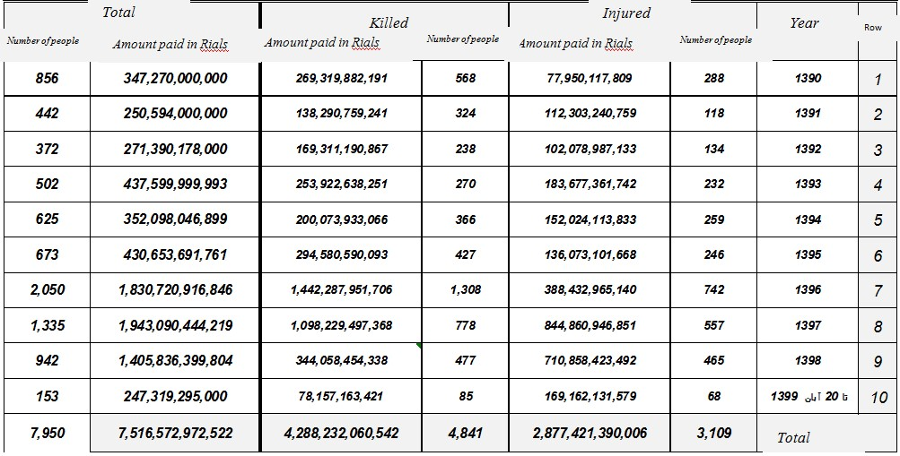
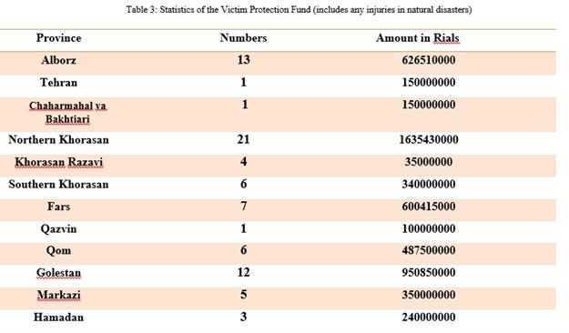
32. In order to provide better justice for physical injured persons, the PICF established and started to work. Based on the provisions of the note of Article 551 of the new IPC, which states: “In all crimes that victim is not male, the difference of the blood money to the man’s blood money will be paid from the PICF. The Fund has paid 608 billion Rials for 690 people.
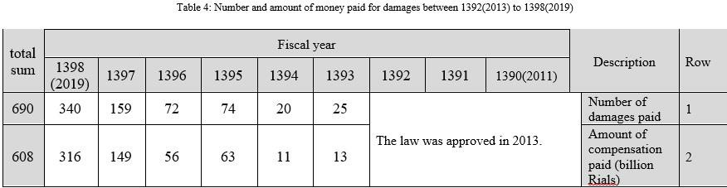
33. According to the provisions of Note 11 of the National Budget Law, which states, “PICF is obliged to pay the compensation of prisoners for unintentional driving accidents who are imprisoned due to any limitation of the liabilities of the insurance companies and the said fund and before the law on compulsory insurance for damages to third parties who have been imprisoned as a result of accidents caused by vehicles, so that they can be released free of charge after the introduction of the Diya Association(Setad-e Diya).” The fund has paid 386 billion Rials for 219 prisoners in traffic accidents and released them from prisons in the country.
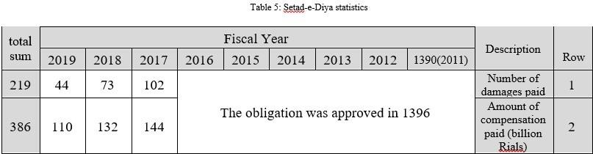
34. In response to the concluding observation No.12, the investigations show that according to the various stages of processing serious crime cases and the possibility of appeal, retrial and the obligation to have the Supreme Court confirmation in relation to death sentences, Articles 14 and 6 of the Covenant have been observed. In addition, Qisas verdicts are issued through lengthy judicial procedures and under difficult conditions, so that in the meantime conditions for mediation and alleviation the grief of the victim’s family would be prepared, and victim’s heirs are encouraged by law to pardon the offender or, by receiving the blood money, practically commute the punishment.
35. Also, in crimes punishable by death, all of which are serious crimes under Iranian law.)And in many other countries), it is possible for the government to grant amnesty or mitigate the punishment in the general dimension of punishment.
36. Given that international human rights instruments do not prohibit public executions; the Committee’s recommendation does not appear to have a world-wide and customary international legal basis. Given that some instances of crime or hooliganism leading to murder have severely hurt public sentiment or led to widespread insecurity, the execution of the death penalty in public can have a serious deterrent effect on the recurrence of such crimes. In rare cases have this punishment been carried out publicly. Regarding stoning, due to the approval of the IPC, the implementation of this punishment has been stopped; hence there is no report on rendering such judgments since 2007, when the Judiciary prevented stoning of two convicts in Qazvin. The answer to the concluding observation No. 13 on the death penalty for USMs is fully described in the current article.

Article 7
37. Extensive information is included in the third report under Article 7 on the prohibition of torture, how to deal with judges’ offences, judicial officers, law enforcement officers, during which it was observed that in addition to Article 38 of the Constitution and Articles 570, 578, 579 and 587 of Islamic Penal Code, the provisions of the single-subject rule on the observance of legitimate freedoms and protection of civil rights, perpetrators of torture and harassment will be severely punished.
38. Moreover, in order to monitor the proper implementation of above-mentioned law, according to Article 15 of the Executive Instruction, the CBSPCRJ, in cooperation with the provincial supervisory boards, conducts necessary inspections and deals with any violations. (The performance statistics of this board are listed in the table below). Also, consistent with Article 169 of the IPC, confessions that are subject to duress, coercion, torture or mental harassment have no value or validity. It should be mentioned that since July 2020 based on the order of the head of the SPSCMO a communication system under the title of “Mashal” has been launched. The contact phone number of the mentioned system, is provided to all prisoners and their families, as well as prison staff all over the country. This monitoring system is responsible for receiving news, information and complaints of prisoners, their families and prison staff of the country. The reported violation has been followed up. In addition, all sensitive areas inside the prisons are equipped with a camera and are monitored.
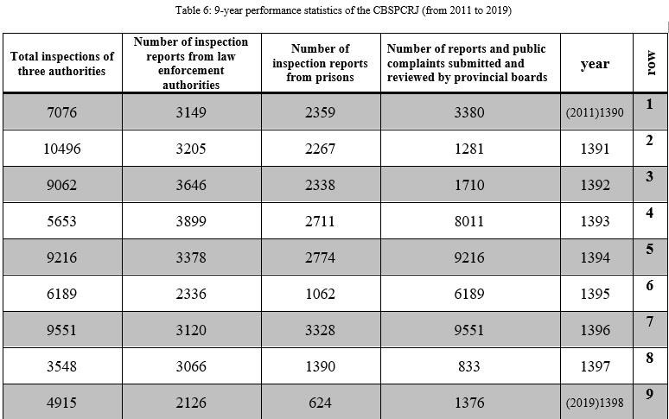
39. Each provincial judiciary and each provincial prosecutor has a deputy superintendent of prisons, who, along with judges, are required to regularly visit the detention centers and prisons under their supervision. Relevant statistics are given in the table below.
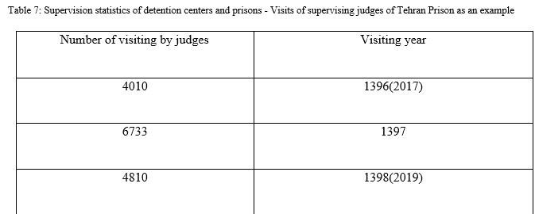
40. It is noteworthy that the Deputy for Prison Affairs of the Judiciary, while supervising the execution of the sentence, responds to the requests and complaints of the prisoners and follows their requests until the result is obtained.
Table 8
The statistics of the executive measures taken by the Office of Assessment, Investigation and Complaints (2014–2019)
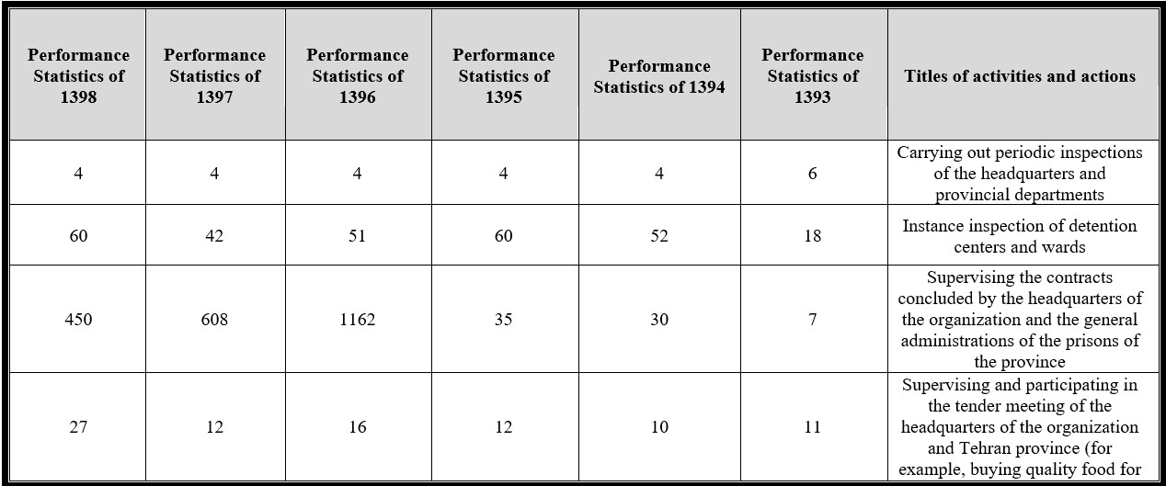
41. In addition to the periodic inspections, foreign officials visit is also possible, which during the reporting period some visits have taken place such as:
(a) 45 ambassadors residing in Tehran visited Evin prison in 2017 and they found the condition of the prison appropriate;
(b) A one-day visit to the Correctional Center by the Danish delegation on the sidelines of the third round of human rights dialogue between the Islamic Republic of Iran and Denmark – September 2015;
(c) Visit of Evin Prison by the Japanese delegations on the sidelines of the 11th specialized session of the Human Rights Dialogue that takes 4 hours, February 2016.
42. In response to concluding observation No. 14, a principled position on the prohibition of torture and how to deal with violations of these principles was presented by mentioning a few cases in the previous report. Furthermore, there are regular and periodic inspections by the prosecutor’s office in prisons and temporary police detention centers, in addition to other supervision mechanisms such as the Citizens’ Rights Supervision Board, that minimize the probability of torture and considering the legal mechanisms certain punishment has been defined for each crime. According to the law, the investigation of allegations of torture in any department begins with a complaint from a private or public plaintiff, and after filing in court, the offender will be tackled as soon as possible. As an example, adjudicating the allegation of torture against Tehran prosecutor in the aftermath of 2009 disorders.
43. Article 169 of the IPC states: “A confession obtained under duress, coercion, torture or mental or physical harassment has no value and validity and the court is obliged to re-investigate the accused” or in a note to Article 218 of the same law stipulates that “confession is legitimate when it is done before the judge in the court.” Clearly the concluding observation has been fully considered.
44. In response to concluding observation No. 15, all received cases have been lawfully and precisely judged. Also, those who damaged during the riots after the 2009 presidential election have been compensated, and offending officers and bailiffs have been dealt with legally. Article 6 states the table of payments of the Office of Diya includes the damages and crimes for which the culprit or offender is not available and the government has compensated. As the demonstrations or unrests might be caused physical damage or destruction of properties, the government has taken the responsibility for reparations. As an example in a set of cases, 400 billion Rials are paid to the victims.
45. In response to concluding observation No. 16, the former Islamic Penal Code is no longer valid and has been replaced by the IPC. On the subject of corporal punishment, it has been deleted. In Article 49 of the IPC and the word discipline has been used in Article 158 of the new law (old 59). The omission of the relevant note in the new Penal Code indicates that the meaning of discipline is other than corporal punishment. In the case of Article 1179 of the Civil Code (as in Article 158 of the IPC), the word “discipline” is used, which means to socialize the child and does not mean corporal punishment at all, also corporal punishment is completely forbidden in the school environment. According to the Law on the Protection of Children and Adolescents adopted in 1399, it has defined the mistreatment of children and adolescents, therefore, the border between mistreatment and discipline has been clearly defined. clause 4 of the first article summarizes as following: Abuse is “any kind of intentional act or omission that endangers the physical, mental, moral or social health of a child or adolescent; such as beatings, confinement, sexual abuse, insulting or threatening a child or adolescent, or placing him or her in a harsh or unusual circumstance, or refusing to help him or her.”
46. It is imperative to be announced that all Islamic punishments (Hodud) like flogging are not applied to children at all.

Article 8
47. Slavery is officially rejected in the Constitution and laws of Iran, which is expatiated in the third report of the IRI under this article.
48. In this regard, new forms of slavery are also being confronted, including in 1398(2019), the “Bill on Fighting Human and Human Organs Trafficking and punishment for illicit carriers that transport persons across the Borders of the Country” was drafted and has now been getting through the parliament. The provisions of this bill are in compliance with internationally recognized standards, in particular the Protocol to Prevent, Suppress and Punish Trafficking in persons; That is, the document is annexed to the Convention against Transnational Organized Crime.
49. Concluding observation No. 20 of the Committee was followed up. The Investigations show that despite the strict laws against human trafficking, in two cases organized gangs have succeeded in deceiving young girls and women and trafficking them to some neighboring countries that has been coped with seriously and persistently. The following statistics are related to the cases of courts across the country.
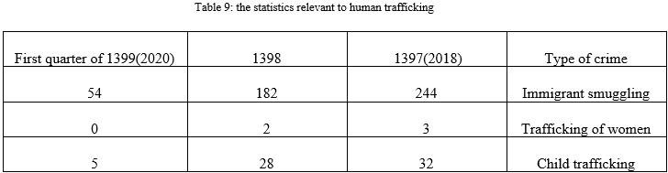

Article 9
50. The previous report of the IRI provided detailed information on legal cases to prevent arbitrary detention, including Article 32 (no one can be arrested except in the manner that is prescribed by law) and Article 37 of the Constitution (Article 9), The Presumption of innocence).
51. During the reporting period, the IRI has taken considerable steps to diminish the possibility of arbitrary detention, including Article 570 of the IPC, which reads: “each of the officials and agents affiliated with institutions and agencies of the government that, contrary to the law, deprives the people of their personal liberty or deprives them of the rights provided for in the constitution of the IRI, will be sentenced to two to three years in prison in addition to dismissal and exclusion of 1 to 5 years of official services.” In addition, in 1398 (2019), the “Procedure for the Protection of Dignity and Human Values” was announced by the Head of the Judiciary, which in the fourth and seventh articles specifically concentrates on arbitrary detention and measures to combat it.
52. Also, during the reporting period, the CCP was changed and approved in 1392(2013) and entered into force in 1394(2015), during which significant progress and consideration in the better realization of the rights of individuals during detention has been provided. In the following some of the cases are mentioned:
(a) Allocation of the right to compensation to the accused in the conditions of illegal detention;
(b) According to Article 171 of the Constitution, in case of the judicial error, the material or moral damages inflicted on the people by the erring judicial authority or the government must be compensated;
(c) Also, in order to summarize the laws and provide a single guideline to all courts, a “judicial security act” was approved in 1398(2019), which contains important articles, including Article 24: Prohibition of illegal and arbitrary detention, Article 27 of the special rights of prisoners and deprived of liberty and Article 28 The right to restoration of dignity and re-socialization of convicts.
53. In the matter of compensation, as an example, the lawsuit dated 22 January 2018, Criminal Court Two of province of Tehran, the defendants, who were acquitted of corruption and embezzlement, were given the opportunity to be compensated. In the court ruling, the judge reads: “According to Article 37 of the Constitution, Article 120 of the IPC, Article 4 of the CCP, a verdict of acquittal is issued, and since the accused persons have been detained for some time during the primary investigation to ensure that they are not involved in embezzlement, hence, the defendants can claim damages from the government within six months after the finality of acquittal in accordance with Articles 255 and 256 of the same law.
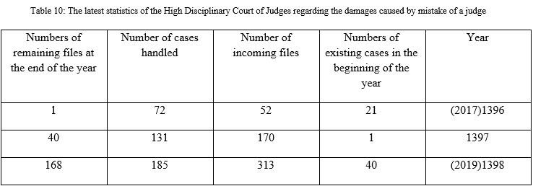
54. In addition, between 1391(2012) and mid-1399 (2020), due to the implementation of the new CCP, the detention rate has sharply decreased, the statistics are as follows.
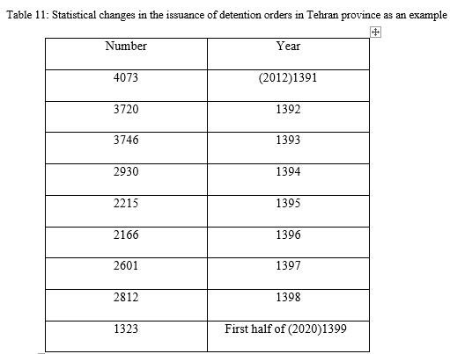
55. Requirements of concluding observation No.17, in view of the current laws the time as well as the new legal developments have been practically realized because, as mentioned, arbitrary detention is severely punishable in law and in the practice. As Article 168 of the new CCP, states: “The interrogator must not summon or arrest anyone as an accused without sufficient reason to justify the charge” or other relevant Articles such as 170, 172,173 could be mentioned. Therefore, issuing summonses or arrests in general (without the above details) is prohibited, and in case of violation, the offender will be prosecuted.
56. For example, a few rulings from different courts which issued in accordance with the new CCP are mentioned:
(a) The verdict of the Ninth Branch of the 1st MCT, the lawsuit dated: 2/31/1399(2020), regarding the charge of illegal detention and assault by law enforcement officers (after the agitation raised following a football match), the subject of the investigation and the relevant officers were found guilty and sentenced to seven and a half months in prison. Verdict of the 9th Branch of the 1st MCT the lawsuit dated 4/29/1390, regarding the charge of illegal detention of the plaintiff for 10 minutes, the offending officer was sentenced to imprisonment and a fine in exchange for imprisonment. The verdict of 12th Branch of the 2nd MCT, the lawsuit dated 5/5/1392(2013) concerning beating and illegal detention was raised and due to the lack of documents, the officer was acquitted of beating but charged with illegal detention according to Articles 583 and 585 of the Discretionary Punishments Law was sentenced to imprisonment. Verdict of the 8th Branch of the MCT, the lawsuit dated 10/9/2012 regarding the accusation of participating in the extortion and illegal detention of an Afghan citizen by a police officer who was found guilty and convicted under Article 583 and 585 of the IPC and the plaintiff got fined.
57. The issue raised in concluding observation No. 18 has been carefully regarded by the legislator in the IPC, and also in Article 242 of the new CCP, the temporary detention for serious crimes is restricted to 2 months and 1 month for others. If the prosecutor requests the extension of the period, the accused may appeal within ten days, after which the competent court will decide whether to extend the temporary detention period. Article 5 of CCP states: “The accused shall, as soon as possible, be aware of the subject matter and evidence of the attribution charge and enjoy the right of access to a lawyer and other defense rights mentioned therein.” Also, keeping the accused for more than twenty-four hours, without starting an investigation or assigning him or her, is considered an illegal detention and the perpetrator will be sentenced to the legal punishment (Note to Article 189 of the new Code).
58. Since many countries consider the General Comments of the Committees significant but non-binding recommendation, research shows that in most countries, the issue of the use of incommunicado has not categorically denied and each country has cases. In the IRI, in very limited cases, according to the law, Individual Suites is provided where equipped with the necessities of life. These suites are located in known and registered prisons, have access to doctors and medical facilities, and comparing to many countries these suites are higher in terms of quality and shorter time-limit rather than many countries (suite with an area of 12 square meters.
59. It should be noted that according to the new CCP, where a detention order is rendered, above-mentioned conditions about 10 must be taken into account and as soon as the conditions are resolved, the detention order will be converted. The result of this law in reduction of issuing temporary detention is undeniable that as reflected in table No. 11.

Article 10
60. In the third report under Article 10 on positive measures taken to improve the situation of prisons and prisoners, observance of civil rights in prisons, reform of prison laws, temporary detention, prison police, observance of humane treatment in prisons, sustainable monitoring of proper implementation of laws and regulations , observance of the separation of the accused from the convicts, minors from adults, prisoner employment and leave, assistance to the prisoners’ families, return of the prisoner to the society, how to handle complaints, treatment of convicts awaiting death, prisoners support association, correctional center for children, legal measures to enjoy respectful and humane treatment, the need to keep detainees in known places, health status, treatment and nutrition, assistance and furlough, participation of government institutions and NGOs, training and monitoring the behavior of prison officials are described in a detailed and documented way and thus here we avoid repeating them.
61. Responding to the concluding observation, No. 19 it should be reiterates that: In the IRI, all prisons and detention centers are registered and, consequently, are regularly and independently monitored by internal and external organizations. The relevant description and statistics are given in the description of Article 7. The law of the Sixth Development Plan obliges the SPSCMO to promote and improve the situation of prisoners, develop the necessary infrastructure with the cooperation of non-governmental and public organizations, help reducing the annual crime rate by ten percent through benefiting from new facilities such as suspension of prosecution or execution of sentences, postponement of ruling, parole and alternative punishments. In order to guarantee the rights of detainees and prisoners, the following measures have been taken:
(a) Conducting periodic inspections and supervision of prisoners by local prosecutors in order to review the condition of prisoners and supervise prisons with the supervising judge of the prison and the establishment of the position of prison deputy in the prosecutor’s offices;
(b) Conducting periodic inspections of prisons and detention centers by the Civil Rights Monitoring Board in order to monitor the implementation of the law in prisons and to observe the legal rights of the accused and convicts and to prevent any possible maltreatment and torture. (During the three-year statistics from 1394(2015) to 1397(2018), this board has carried out 28504 inspections of courts, prisons and detention centers);
(c) Increasing the number of prison doctors and equipping prison health centers and establishing appropriate clinics in large prisons, activating triangular clinics (reducing the outbreak of AIDS in prisons) and behavioral disorder consulting centers;
(d) The outbreak of HIV in the country’s prisons has decreased from 1.54% in 2009 to 0.65 in 2017.
(e) Facilitate the access to lawyer and benefit from legal advice services;
(f) Improving communication facilities for prisoners with outside of the prison and the possibility of visits (by phone, in person and privately);
(g) Holding cultural and sports programs in prisons;
(h) Providing facilities for socializing and retraining of convicts and empowering them to return to society;
(i) Providing prisoners with the opportunity to work.
62. One of the features and opportunities available to prisoners is the possibility of continuing their education, which presented in the following table.
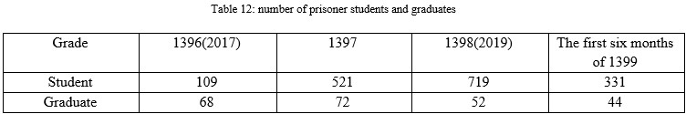
63. One of the special features of prisons in Iran is the existence of open wards in which a prisoner spends only part of the day in prison and the rest of the day would be doing economic activity or taking care of family outside the prison.
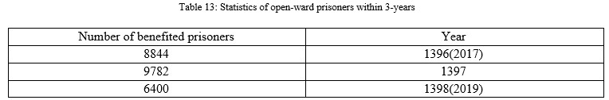
64. Thus, it can be seen that in amending of the executive regulations of the SPSCMO, it is tried to provide as much as possible the principles of Nelson Mandela and the minimum standards of the United Nations regarding the treatment of prisoners at a desirable level.
65. The latest measure undertaken by the SPSCMO to prevent the spread of viral and respiratory diseases and subsequently COVID-19 ever since its outbreak, are including preparation for emergency conditions, supplying disinfectants, daily visits twice a day during the morning and evening by general practitioners, identification of patients with fever in quarantine and sections besides routine visits totaling 2,035,517 visits, identifying 10,910 cases of fever, 55,681 persons under pharmaceutical treatment, 14,474 isolated cases, 13,592 cases under monitoring and 1,388 cases of referral to hospitalization of suspected Coronavirus cases due to fever, providing more than 9.336 Para clinical services, including but not limited to radiography, blood test, urinary test and so on from 22 Feb 2020, spraying and disinfecting prison sections and all inmates’ residence based on protocols, Training prisoners on pandemic, data gathering and analysis, furthermore In the light of putting a large number of prisoners on furlough and the necessity of providing sufficient space and residential area as well as screening and identifying patients amongst those returning from furlough, the urgency of preparations and needs was announced to the director of SPSCMO and director of COVID-19 taskforce of SPSCMO.
66. There is also systematic human rights training (including the issue of the prohibition of torture) to related staff, for example in 1392, 4 training courses with 137 participants, in 1394, 5 training courses with 228 participants, in 2016, 9 training courses with 109 participants, and in 2017, 39 training courses with 1330 participants were held.
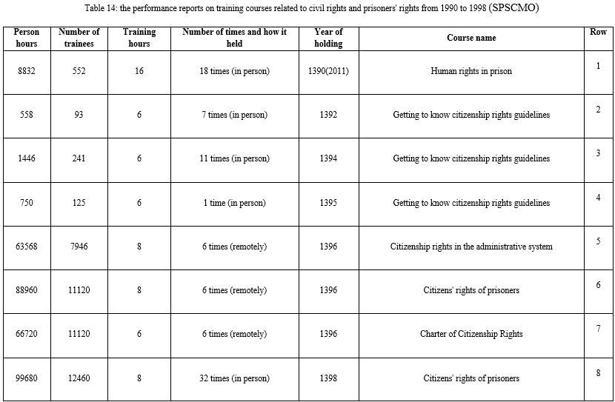
Table 15
Performance reports on training courses related to civil rights and prisoners’ rights from 1990 to 1998 (SPSCMO)
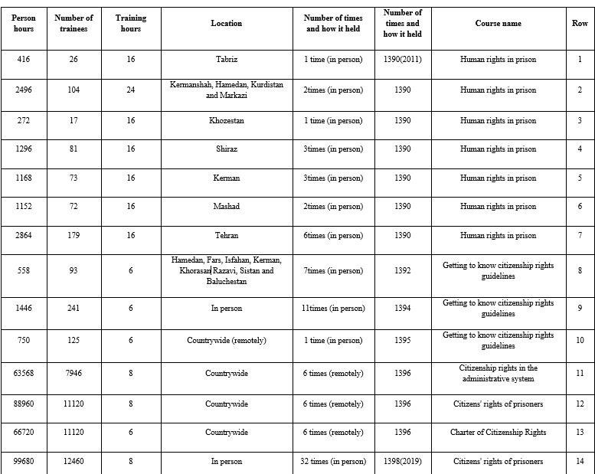

Article 11
67. The necessary information on how to implement Article 11 of the Covenant was provided in the previous report of the IRI, here refers to the developments that have taken place aiming to better the realization of these rights.
68. By the virtue of ratification of the law on the implementation of financial sentences in 1394, positive developments have taken place in favor of people with financial convictions. In a way that the term of imprisonment of financial crimes convicts is limited and shall have the insolvency proved in the court. More precisely, the scope of insolvency in the new law has expanded as a limiting factor. In this regard, NGOs have taken appropriate measures for the release of prisoners of unintentional crimes by helping them pay a Diya instead of imprisonment (Reparation). According to the report of the Diya Association (Setad), between 1390(2011) and the first half of 1399(2020), 83470 prisoners of the mentioned crimes have regained their freedom. In addition, the number of detainees due to inability to pay dowry has decreased from 450 in 1398 to 130 in the first half of 1399.

Article 13
69. The third report of the IRI to the Committee on Human Rights in fulfilling its obligations under Article 13 of this Covenant provides significant information, including the prohibition of forced deportation of refugees and the IRI’s obligations under the International Convention on Refugees, voluntary repatriation and positive performance.
70. Although the unjust and illegitimate sanctions have imposed, The IRI, with more than 950,000 refugees and two million illegal foreign nationals, is one of the most important countries in terms of accepting asylum seekers, and provides appropriate services in the fields of education, health, livelihood, housing and the like for them by allocating huge resources of the country. Meanwhile the International aid to Iran is minimal and covers only less than 3 percent of Iran’s spending. Therefore, it is necessary for the international community to adhere to its commitments to assist and cooperate with the host countries, given the principle of sharing responsibilities.
71. According to the “Law on Determining the Obligation of Citizenship of Children of Iranian Women Married to Foreign Men” which was approved by the Iranian Parliament in May 2019, permanent residence is permitted and could be granted to foreign husbands of Iranian women and they cannot be expelled, and they shall benefit from the citizen’s rights including work and education.
72. As an example of the realization of justice for asylum seekers, the lawsuit No. 623, the judgment of the CAJ on the appeal from the decision No. 5437/74 dated 3/18/89, can be mentioned. In the ruling of the CAJ, which was announced on 5/22/1393(2014), the verdict issued by the commission of article 12 of the Ministry of Interior (on the expulsion and prohibition of entry of an Afghan citizen) was overruled and declared null and void.

Article 14
73. In the third report of the IRI under Article 14 of this Covenant, regarding the judicial structure and rules of the country, including courts, tribunals, interrogation, court rulings, trial in absentia, political and journalism offenses, public trials, directives of the Head of Judiciary, presumption of innocence, the right to choose lawyer, inability to obtain a lawyer, the possibility of not understanding the language of the court, coercion to confess, lack of criminal responsibility of children, issue of appealing the sentences, issue of redress, compensation for damages caused by a judge’s error, guarantee of people’s rights in case of violations of the government employees in criminal law and the prohibition of double trial, sufficient content, sufficient information has been provided. During the reporting period, legal and executive developments have taken place that have resulted in better fulfillment of citizens’ rights as well as better implementation of the country’s obligations under Article 14 of the Covenant, which will be introducing below.
74. One of the important components of fair rules of procedure is the increase in accuracy and greater compliance with the rights of the accused when issuing a temporary detention order, which is enshrined in the new law. There are also significant highlights in the new Code of Judicial Procedure, including: announcing the details of the arrested person to the local court within one hour, the right to request a medical examination immediately after arrest.
75. Judicial officers, while monitoring the accused, are obliged to inform the accused regarding his/her right to have a lawyer, the right to defense, the right to meet with a lawyer (Articles 5 and 6) and the right to a written explanation (Article 52), the possibility of quick access to a lawyer, registration and numbering of the interrogation papers, prohibition of any kind of coercion, inculcation, asking misleading questions and of this sort from the arrested person it is possible for the lawyers to object to the act of inculcating or manipulating the accused (violation of the provisions of this law will result in a disciplinary punishment up to the fourth degree).
76. Article 242 also moves in the same direction and states: “if in the crimes subject to paragraphs (a), (b), (c) and (d) of Article (302) of this law up to two months and in other crimes up to one month, the accused is detained due to the issuance of a Bail decision and his/her case file does not lead to a final decision in the prosecutor’s office, the investigator is obliged to lift or reduce the Bail decision. In any case, the period of detention of the accused shall not exceed more than two years for the crimes leading to depriving the life and in other crimes more than 1 year.
77. The new law expands the right of access to a lawyer. Article 190 (and the Notes) of the CCP, allows the defendant to have a lawyer during the investigation, and the defendant must be briefed on this right before the investigation begins. According to Article 48 of the CCP, “once the defendant has been placed under surveillance, he/she can request the presence of a lawyer. The lawyer must meet with the person under observation, taking into account the confidentiality of the investigation and negotiations, and the lawyer can present his/her written considerations for inclusion in the case file at the end of the meeting with the accused, which should not be more than an hour. Deprivation of the right to a lawyer or failure to declare this right to the accused will result in disciplinary action against the judicial authority. It will guarantee the right to choose a lawyer in criminal cases, legal assistance in case of financial inability and refrain from convening a hearing without the presence of an optional or a substitute lawyer in very important crimes. In order for the parties to the case and their lawyers to access the contents of the case and to protect the privacy of the parties and to acceleration of the proceedings, an electronic system has been launched under the name of “SANA”. Also, the presence of lawyers in all judicial units, including prosecutor’s offices, courts (primary, appellate) and prisons, in cooperation with the Bar Associations, pave the ground for individuals (including defendants and suspects) to access to daily legal guidance and advice.
78. The Law on Civil Procedure (2000), which examines the legal process of pursuing legal cases, explicitly states the right to a lawyer in Article 31. However, the importance and sensitivity of the right to a lawyer is more prominent in the CCP, due to the imposition of penalties.
79. By the CCP the restorative justice mechanism in minor crimes established, according to which the judicial authority can create a compromise between the parties at the request of the accused and with the consent of the victim of the crime or the plaintiff. The investigator in the implementation of Articles 83 and 84 can also request referral to mediation or suspension of prosecution.
80. Another innovation of the new CCP, according to Article 66, is the recognition of the right to lodge a complaint for NGOs. They can prosecute crimes committed in the areas mentioned in the law and participate throughout the proceeding) to provide evidence and object to the rulings of judicial authorities.
81. Pursuant to Article 14 of the Political-Civil Covenant, the Kermanshah Family Court of Appeals in judgment dated 31/4/1398(2019), has overruled the trial court ruling due to non-compliance with the principle of a fair trial. Or in another case, Kermanshah Court of Appeal overruled the verdict of the court of first instance during the lawsuit dated 11/8/1398, due to the lack of full observance of the right of access to court and fair trial.
82. Responding to paragraph 21 part a of the Committee’s concluding observation regarding the details of the law on pre-trial detention, sufficient information was provided under Article 9 of this report and its repetition is avoided.
83. In response to part b, the briefing the charge in accordance with the law, during the detention and also at the first meeting with the judge (maximum after 24 hours of detention). In addition, according to Article 378 of the new CCP, all courts after conducting the hearing process are obliged to render the judgment within legal period that includes the nature and legal aspects of the case and then the parties shall be notified in practice, this part of the convicts’ rights is fully observed.
84. In response to part c, the issue of requiring a lawyer to appear in court and the interrogation process were well explained in this part of the report under the new rules.
85. In response to part d, the issue of the presumption of innocence as a definite presupposition in the consideration of the rights of the people in the Constitution and current laws of the country is final and binding.
86. In response to part e, in addition to the legal commitments to hold public trials, in the Constitution and current laws reflected in the previous report, Article 5 of the new Instruction of the Head of the Judiciary (entitled Preservation of Dignity and Human Values in the Judiciary 1398(2019)) is completely dedicated to this case. According to this article, in order to implement the one hundred and sixty-fifth principle of the Constitution, which is based on the principle of open trials, as well as responding to public opinion and inform them about the process of hearing of important cases (especially the cases are pertinent to the people’s rights), the bodies involved, as the case may require, are obliged to take the following actions:
(a) Providing the presence of individuals, especially the media, in court hearings in accordance with Article One Hundred and Sixty-Five of the Constitution, as well as paragraph 6 of Article 6 of the Press Law adopted in 1379(2000) and Articles 352, 353, 400 and 413 of the CCP, and providing a suitable place for hearings;
(b) Providing public access to lawsuits issued by judicial authorities by uploading the judgments in the Judicial Research Institute Database in cooperation with the Judiciary Statistics and Information Technology Center, in compliance with the principle of confidentiality and in order to preserve the dignity of individuals;
(c) Immediate publication of final sentence verdicts regarding crimes that are subject of the note of Article 36 of the IPC in the national media or one of the widely-circulated newspapers, as well as publication of final judgment) in one of the newspapers under this article and in one of the local newspapers if it does not disturb the public order or security;
(d) Holding regular meetings by the spokesman of the Judiciary with the media and informing the correspondents and civil society about the cases and other important news of the Judiciary along with the improvement based on the questions and answers of journalists and members of the media from the spokesman of the Judiciary.
87. The right to appeal is fully recognized, in the laws as well as in practice, in addition, there is no title of Mahdoor-al-Dam (deserving death) in the IPC. And the other cases mentioned in paragraph f from the concluding observations are also fulfilled in accordance with the law. In response to the suspicion raised in the concluding observations No. 22, the issue of the independence of judges in the laws has been raised and observed with great care and several guarantees. Another feature of Iranian law is the proper separation of power, so that even the executive department of the judiciary, which in many countries is at the disposal of the government and the executive branch, in Iran including the attorney general and the prosecutor’s office operate within the judiciary and are immune from any interference from other branches of power. It should also be noted that scientific reference to jurisprudential fatwas or academic legal doctrines is used in a limited way. In this regard, according to Article 3 of the Code of Civil Procedure, three points should be mentioned: First, as seen in the text of the article, in the absence of the positive law, the judge has the right to invoke sources outside the law in the case, thus, if provable defect is not in the law, the judge has no right to invoke Legal Principles and fatwas under any title. Second, even in case of lack of law the judge shall consider fatwas of great jurisprudent and legal principle simultaneously. The legal principles are what recognized and accepted by international legal systems, and thirdly, in practice, due to the adequacy of laws and coverage of all issues, the possibility of a judge referring to the above cases in very rare cases is conceivable.

Article 15
88. The Non-Retroactive Principle is stated in detail in the Third State Report and has been observed in practice. As an example, the new Anti-Narcotics Law retrospectively extended to all convicts at their convenience that leads to a significant reduction in the execution of severe punishment.

Article 16
89. As already stated in the third report, according to the Constitution and ordinary laws, the issue of equal recognition before the law and its implementation has been carefully considered. For example, the third principle of Article 14 of the Constitution. Also in Article 2 of CCP states: “Criminal procedures must be based on the law and shall guarantee the rights of the parties. Its rules shall apply equally to persons who are prosecuted on equal terms for committing the similar crimes”.

Article 17
90. The details of the status of the laws and obligations of the IRI appertaining to the subject matter of Article 17 of this Covenant have been stated in the previous reports. The new CCP covers the principle of privacy in detail, like Articles 4, 653, paragraphs T, 658 and 660. Furthermore, Article 17 of the Cybercrime Law (effective since 2009) states that: “anyone who publishes or leaks voice, video or private films or family films or other secrets of someone without his/her consent or make it available to others in a way that harms or degrades him/her will be punished.” Also, in the Charter of Citizen’s Rights (2016) under Articles 12, 13, 14, the privacy is precisely guaranteed and guarded. In addition, the privacy of citizens in cyberspace under Articles 33 to 39 and Article 41 is fully covered. For example Law case dated 2017, about unauthorized access to data and computer and telecommunication systems, dealt with in Branch 1036 of the 2nd Criminal Court and the culprit is sentenced to a fine in the amount of 20 million Rials.

Article 18
91. Introduction of the status of fundamental and current laws towards religious minorities in the IRI has been presented in previous reports, such as Article 23 of the Constitution on freedom of opinion and prohibition of inquisition, Principles 12 to 14 on Freedom of expression and Legal status and the need to observe justice for other religions, Article 19, prohibition of any form of discrimination. Here are the latest developments to promote the enjoyment of this section of society with the rights set forth in the domestic laws and international obligations of the IRI.

1. Development and provision of more places of worship for religious minorities
92. The per capita worship space of religious minorities, with a population of less than half a percent of the country, is nearly twice that of Muslims. Christians have more than 250 churches nationwide, and there is one church for a population of less than 500. Also, Jews have 16 synagogues and Zoroastrians have 78 places of worship. Since 2015, the equivalent of 115 billion Rials (3280000$), has been allocated to provide services and facilities to minorities. In 2016, Tehran Municipality built a stadium for Armenians with a budget of 22 billion Rials ($628000). According to statistics, Iran’s religious minorities have one association for every 2,600 people. Since 2015, 53 association licenses have been issued and renewed for their activities.

2. Strengthening intercultural relations with the presence of religious minorities
93. Articles 10, 33, 77, 97, and 110 of the Charter of Citizen’s Rights, which consolidate the rights of religious minorities, ethnicities, and social and political affiliations, emphasize the right to intercultural communication.
94. The most important measures taken are including to the law on the presence of religious minorities in the councils, approved in July 2018; Articles of the IPC (Tazirat part) bill that criminalizes the insult to the sanctities of the recognized religions and all forms of racial, ethnic and religious extremism engendering hatred and violence and any kind of financial assistance to these activities.
95. Religious minorities have the appropriate freedom to perform their religious and ethnic duties and rituals and to observe personal status; Allocation of 115 billion Rials special budget and various annual financial aids to special centers and special associations of religious minorities. In Iran, they have more than 80 NGOs in various fields and several research centers on theology. Despite having a population of 150,000, five seats in parliament have been allocated to them, and new 58 associations have been licensed for social, civil and cultural activities.
96. Having a special press and publications for the awareness of the community and their adherents. They also have 20 newspapers, weekly magazines, monthly magazines and 5 publishing centers named Nairi, Forouhar, Hirmaba, Barsom and Tehran Kalimian Association. This group of publications also benefits from special subsidies. In line with paying special attention to the media of religious minorities, the Press License Board shall, out of turn, grant licenses to these media. Moreover, in cyber space hundreds of sites and social networks, which are freely active in their own languages. Furthermore, there are 93 special schools for religious minorities to ensure their right to education in the country.

3. Efforts to improve the status of Islamic branches
97. Many promotion programs have been implemented for the benefit of different Islamic branches. Followers of different Islamic branches live in Iran while following their beliefs and access to full rights and enjoy promotion programs. As for the Sunnis in Iran, they are not considered religious minorities and, in fact, are considered part of the majority of the Muslims, and there are extensive programs, especially in recent decades, specifically in the Eleventh and Twelfth Governments, for their general well-being and the betterment of religious education is on the agenda. As of now, more than 238 registered Sunni media outlets are active. Sunnis in Iran have more than 15,000 mosques, which is much higher than the per capita Shiite mosques. Glancing at the Constitution of the IRI and the strategic approaches of political leaders and the actions and services of the Islamic Revolution to the Sunnis, it is easy to see existence and implementation of the principle of justice, equality, and unity among the people of Iran of any religion that will be mentioned hereunder.
98. The IRI does not consider Sunni Iranians as a minority, and the multiplicity of common principles and similar worships has caused Muslim Iranians to move between different Islamic schools, including the ease of marriage and family formation and the establishment of joint religious meetings. In the previous regime, the Sunni part of the Iranian society was in a very unfavorable situation, but during the 4 decades of the Islamic Republic’s services to the Sunnis of Iran in various fields (participatory, societal, legal, political, economic, cultural, educational, and ...) have been quantitatively and qualitatively improved as Sunnis elites acknowledged as well.
99. According to the Constitution, the followers of all religions are judged in Legal status such as marriage, divorce, inheritance, wills and the like according to the jurisprudential and legal issues of their religion and faith and have the freedom to act in this regard. Sunnis also have access to newspapers, magazines, websites and social and communication networks, and special assistance has been provided wherever is needed.
100. The movement to remove deprivation and providing services is carried out by the IRI without distinction and discrimination, and in the border areas, due to the deprivation imposed by the former regime, it has been considered by the Iranian government more than ever. Services of water supply, electricity, gas, insurance and construction, health, security, employment, etc. in the border areas have been considered more than the central areas of the country.
101. Sunnis have complete freedom in holding religious gatherings and ceremonies, and such gatherings are held throughout the year on various occasions in provinces. Sunni mosques, prayer halls and Friday prayers are active throughout the country.
102. According to the laws of the IRI, Sunnis are completely free in the field of education and training; the classic school, religious seminaries, university, cultural and educational centers have been widely provided by the Government of Iran and run and managed by the Sunni themselves. The number of schools, students and teachers of Sunni seminaries and the provision of educational services to Sunnis and comparative comparisons (before and after the revolution) are proof of this claim. In dealing with criminals and those who violate the order and security of the country, regardless of one’s religious affiliation and without discrimination between them, are judged equally within the framework of the law.
103. In the field of improvement of political participation, in addition to the presence of representatives of this segment of the Iranian people in the Parliament, the Assembly of Experts, city and village councils, courts, the Ministry of Intelligence, the Revolutionary Guards and the police during the reporting period of at least three Sunni ambassadors (two Kurds and one Baloch lady) have been appointed as the Ambassador of the IRI. Sunnis are also present at the level of deputy ministers. For example, in the Ministry of Oil and the Ministry of Cooperatives, Labor and Social Welfare, Sunni citizens have been appointed as Deputy Ministers. Following up the appointment of deputy governors, governors and district governors in Sunni-majority provinces, including Kurdistan, Hormozgan, Sistan and Baluchistan, and so on are of other measures which have been taken. The entry of worthy Sunni women into the domestic political apparatus, the Ministry of Interior, has been made possible, and two Iranian Sunni women (Baloch and Turkmen) have been elected governors and chairmen of the Security Council in Sistan and Baluchistan and Golestan. Also, a Sunni Iranian citizen has been appointed as an advisor of Minister in the Ministry of Sports and Youth.
104. The Council for the Reconciliation of Ethnicities and Religions has been formed in Tehran with the presence of their elites and political and religious activists.
105. Prohibition of insults and hatred towards Sunni symbols, the Supreme Leader, considering his religious and governmental position, has declared any insult and spreading hatred towards Sunni symbols religiously forbidden.
106. Responding to the concluding observation No. 23, first paragraph, it is stated that freedom of religion in Iran is guaranteed by the Constitution and current laws, and no one can be prosecuted merely for having an opinion or religion and converting it. In response to the second paragraph of this concluding observation, as already stated in response to the list of issues, there is no article in the IPC of Iran entitled apostasy and execution of apostates, and no one has been executed for apostasy. However, the logic of Article 225 of the old Islamic Penal Code has nothing to do with the claim and request made in the concluding observation No. 23, and the number of the article has mentioned incorrectly.
107. In response to the concluding observation No. 25, aiming to present the position of Sunnis in Iran and their presence in various social arenas, performing individual and collective ceremonies and rituals such as Eid al-Fitr, building mosques and seminaries, as well as civil lawsuits when the both parties of the dispute are Sunnis, have the choice between national civil law and their religious jurisprudence, as expatiated in Article 27 of the report.
108. Moreover, the large number of newly built mosques in provinces with a Sunni population increasingly proved that there are no restrictions on Sunnis and the construction of mosques is completely in accordance with the demographic needs of each region. In addition to the existing Sunni mosques, more than18 prayer halls have been allocated for Sunnis in Tehran province, which offer prayers with the Imam and cover various areas from Damavand to Shahriar. Heretofore, nonetheless, there was no special mosque for Sunnis in the capital; recently 9 mosques have been built in this province by the request of adherents.
109. In Sunni seminaries in the country, more than 12,000 students study Sunni jurisprudence (including Shafi’i and Hanafi). The number of t mosques, seminaries and scholars, as many Sunni prominent jurists have admitted, is 10 times more than the number before the Islamic Revolution of Iran. Moreover, according to the laws, any entity that reaches 150 applicants can establish a prayer hall with a permit, and this law does not differentiate between Sunnis and Shiites.

Article 19
110. In addition to the detailed contents provided in the previous report, the following new items are presented. As to the progresses made during the reporting in the area of freedom of press and media, in addition to the implementation of Articles 23 and 24 of the Constitution, is the new Press Law (2009) as one of the most progressive laws regarding the protection of freedom of expression, that has provided appropriate improvements and guarantees. According to Article 4 of this law, “neither governmental nor non-governmental official has the right to put pressure on the press or to censor and control publications because of publishing an article.” Note 1 of Article 5 of the same law states that in that case the official shall be sentenced to various punishments; including permanent dismissal from official services. Besides, there is no pre-publication oversight and checks on the Iranian media. One of the achievements in the reporting period is the encouragement of the private sector to involve media activities and the reduction of the share of government institutions. Due to the government’s policy of granting more licenses to private sector media, more than 80% of all media now belong to the private sector.
111. The total number of licensed media in Iran by the end of 1398(2019) is 11725 media, which includes 8123 print media and 3602 online media. 355 newspapers, 1388 weekly magazines, 688 bi-weekly magazines, 2354 monthly magazines, bi-monthly magazines and 3338 items also constitute other arrangements for publishing licensed print media. Among them, various media (multimedia, film, website, book publishing) are active in the field of children, adolescents, women, people with disabilities, etc., and more than 44 written publications as of daily, biweekly, monthly and quarterly are published for children and adolescents.
112. In the field of publishing rights and cases relevant to women, 36 publications are aimed at women and about 20 percent of the country’s media executive managers are women.
113. The negative impacts of unilateral sanctions on the enjoyment of the human rights of the Iranian people, especially after the withdrawal of the United States from the JCPOA, is a very important issue that must be seriously addressed. Banking sanctions can have a profound effect on the Iranian public and their right to access to a wide range of human rights issues, particularly economic and social rights and the right to life. Illegal sanctions have created greater barriers to access to and distribution of essential medical and pharmaceutical equipment and supplies by potentially preventing financial transfers, which could potentially increase mortality. UCM have prevented the people of the country from achieving the right to development, the right to access to the science and technology, the right to employment, the right to health and even the right to access to the medicine. These sanctions have had a great impact on the communication development programs in the country as well.
114. Despite the above problems, valuable cooperation has been established with foreign countries in the field of better realization of freedom of communication. For instance, in 1397(2018), 866 press-related visas have been issued. There are currently 177 foreign media outlets in Iran with 336 active journalists, one-third of who are foreign nationals. The exchange of knowledge and information with foreign partners has been progressive in recent years. While in 1391(2012), the statistics of foreign books and publications cleared and distributed through the points of entry into the country was 1/997/347 volumes; in 1396 it reached 3/790/000 volumes. Iran is an active member of the AsiaPacific Broadcasting Union (ABU) and makes great efforts to shatter the restrictions imposed by the worldwide news empires.
115. As to the comprehensive approach to supporting the languages and dialects in Iran and efforts to preserve and support them, have resulted in issuing activity licenses for more than 600 media in Armenian, Assyrian, Azeri, Kurdish either monolingual or multilingual media.
116. In response to concluding observation No.24, issues related to the Baha’i’s are adequately addressed in the following paragraphs.
117. The general status of the Baha’is and their enjoyment of citizenship, social and economic rights, as well as cultural facilities in accordance with the laws and obligations of the IRI are available in official and international reports. For the sake of brevity, Iran’s report submitted to the UNESCO (2011-2014) in which their economic, citizenship, cultural and social status is explained. These reports show that Baha’is in Iran enjoy all the fundamental rights and freedoms enshrined in the Constitution, the Charter of Citizens’ Rights adopted in 2016, and other laws (Reflected on reports from international bodies such as the International Labor Organization Special Rapporteur on the 2008 report).
118. Regarding the allegation of judicial discrimination against Baha’is, it should be noted that investigations show that there is no discrimination in existing cases just because they are Baha’is. For example, during the reporting period, in a case a Muslim culprit was convicted and sentenced to punishment because of kidnapping a child from a Baha’i family (daughter of Mr. Farahmand Kazemi in Mazandaran province). It is obvious that alike other citizens, the legal process was conducted and the kidnapper arrested, punished and extorted money was taken back.
119. The structure of the Baha’i formation in Iran is based on control over personal thoughts, behavior, and legal status, and decisions are authoritatively instructed by members of the Beit-Al Adl and they are required to implement them. Sociologically and conceptually, Baha’i’ is considered as a cult, and the cult’s organized and authoritarian actions and control exclude them from religions and beliefs. (what Ms. Dayan Alaei, the Representative of the Bahai’s in Geneva confirms in a letter dated June 22, 2015, Correspondence 219 conceded, which literally follows), though it does not fully reveal the dimensions of comprehensive oversight of Bahai’ formation over the followers, is the first time that officially announce the supervision of the formation over its adherents:
“Baha’i International Community, UNESCO, 22 June 2015
... “It is true that where Baha’i administration can be practiced, certain actions may be taken in cases where individuals bring harm to the community by violating religious or civil laws, but such sanctions are no more than the removal of certain privileges of membership in the community, such as participation in Baha’i elections, attendance at administrative meetings, or the rights to contribute to the Baha’i Fund”.
120. Unfortunately, the reality is something else, and the Baha’i formation deprives the adherents of living freely through its supervision, punitive and inquisition mechanisms.
121. The Baha’i formation and some famous Baha’is had cooperated extensively with the Pahlavi dictatorship regime, and in addition to participating in major crimes, torturing and harassing the Iranian people, and holding the position of head of the Shah’s dreaded security organization (SAVAK), consequently they acquired illegal property through many illegal means such as encroachment upon Anfal (public natural resources and environment). Part of this illegal windfall property was discovered after the Islamic Revolution and recovered based on the prosecution of a prosecutor or a private plaintiff and at the discretion of the court.
122. Bahai’s in Iran, like many Islamic countries, face limitations in the mere propagation of their formation, for two main reasons: numerous teachings of the Bahai’s founders and leaders are in contradiction to the accepted values of either international community and Iranian society (the Iranian government imposes such restrictions in line with its obligations under Article 18 Paragraph 3 and Article 19 paragraphs 1 and 3 of the ICCPR), second reason is that Bahai cult systematically controls and supervises its members personal and family behavior, while inquiring their beliefs, encourage them to gather information from their surroundings. Therefore, supporting the actions of this cult and its promotion is contrary to Iran’s obligations under the second paragraph of Article 18 of the ICCPR.
123. In response to concluding observation No. 27, it should be given out that, first, as statistics show; the press operates independently and extensively in Iran. During the riots of 1388(2009), according to the crisis management instructions, people were arrested at the scene of riots and destruction, some of whom were journalists, but others for spreading false news intending to disrupt the stability and order of society and incite destruction and wrongdoing were prosecuted. These individuals were released if they have no criminal records and/or a minor offence was committed. A small number of those who have committed more serious offences have been sent out to the court in accordance with the law. According to available documents, no one has been convicted or imprisoned in those riots just for being a journalist.
124. Having considered the rule of law in dealing with the crimes of these individuals, if the persons mentioned in this concluding observation have any evidence of innocence or arbitrary detention, they can refer to judicial review such as the CAJ, or other oversight mechanisms like Parliament Commission on Article 90 of the Constitution, Human Rights Headquarters, Headquarter of citizens’ rights protection of the Ministry of Interior. In accordance with the law, if innocence is proven, incurred damages will be compensated.
125. The Ministry of Communications and Information Technology, in order to implement Article 46 of the Fifth Development Plan Law on the creation and development of a national information network, to provide access to highspeed Internet to all citizens, has designed and implemented the required infrastructure, which unfortunately haven’t come to fruition, as a result of UCM illegal sanctions that slowed down the development process.
126. It is worth mentioning that the number of Internet users has increased from 32811284 in 1394(2015) to 46315545 in 1396. Also, the number of sites and blogs in the country has increased from 857149 in 2016 to 1011114 in 1397. Also, in order to improve the quality and level of people’s access to the Internet and provide services, bandwidth has been increased and mobile services have been provided via the third generation and above.
127. Also, advances in the field of media and Internet access are practically followed in accordance with the general comment 34 approved by the Human Rights Committee, especially Articles 14 to 19, and according to the law and like many countries, only in cases where public security or morality requires, some temporary restrictions are set, which is specified in paragraph 21 of the general comment.

Article 20
128. The IRI has never propagated war or violence in its history. The country’s strategy has always been defensive. It is noteworthy that the “Dialogue of Civilizations project” proposed by the IRI was welcomed by the world. Also, despite of the obvious peaceful nature of the nuclear program, Iran has always fully cooperated with the United Nations watchdogs and continued its transparent negotiations within the framework of international standards, which eventually culminated in a JCPOA which approved by the UN Security Council (Resolution 2231). The IAEA has repeatedly confirmed and verified the peaceful nature of Iran’s activities.
129. Iran’s peace initiative was the WAVE, resolution of World Against Violence and Extremism, which was proposed by the President of the IRI in 2013 and unanimously approved by the UN General Assembly. One of Iran’s peace initiatives and peacekeeping initiatives has been the fight against terrorism and Takfirist (Islamic extremists) groups, which have endangered world peace, stability and security.
130. Also in line with seeking peace and considering the existence of regional tensions, Iran called on the Persian Gulf countries to sign the Hormoz Peace Endeavour (so-called HOPE), thereby maintaining the peace and security throughout the Persian Gulf. All of these show that peace has been at the heart of Iranian politics. Unfortunately, in recent decades, the US administrations and the Israeli regime have repeatedly threatened Iran to launch military action. The latest example of such threats was the tweet of the incumbent President of the USA on January 4, 2020. He has threatened to target 52 Iranian cultural centers following the illegal and targeted assassination of Iran’s top antiterrorism commander, General Soleimani, and his entourage. The tweet raises the question of why one state should allow itself to threaten another country with an action that is considered a war crime in international documents!

Article 21
131. In addition to the legal principles upon ensuring the freedom of peaceful assembly outlined in the third report under Article 21, new issues that have arisen in the development of legal protections as well as executive policies during the reporting period are set out here: Charter of Citizen’s Rights adopted in 1395 has paid special attention to the promotion of the realization of the right to peaceful assembly. Article 46 of the Charter of Civil Rights states that it is the right of citizens to freely and in accordance with the law to organize gatherings and marches and participate in them, to enjoy the neutrality of the responsible bodies and to protect the security of communities. Several measures have been exercised to manage the workers’ rallies and properly ensure the right to peaceful assembly. For example, the protests were held by the workers in Haftappe and Hepco companies. All the arrested workers were immediately released and those who had even disturbed the security and order of the place were pardoned and released after a while. Thus, the legal developments and positive actions that have been taken as yet indicate that the requirements of concluding observation No. 26 have been met.
132. In particular, the IRI has shown considerable tolerance within the last two years facing with hundreds of labor and civil protests, largely due to economic problems caused by unilateral US sanctions. At the same time, despite the efforts of some foreign powers to threaten the security of the country or make a tumultuous atmosphere by imposing unilateral coercive measures on Iran, the government has tried to strictly observe the line between providing security, fulfilling the civil rights of the people and has taken as much civil and tolerant approach to control the demonstrations as it could. Unfortunately, in some cases, terrorist groups of foreign origin or who enjoyed foreign support threatened and killed people and abused their right to peaceful assembly by carrying weapons, firing bullets and bombing leading to seriously undermine the public security and order (such as the case of Khuzestan in September 1397(2018) or the actions of the Rigi terrorist group in Sistan and Baluchestan province in 1389(2010)), but the government is still protecting the possibility of exercising the right to peaceful assembly. For example, according to the available information, the case of the workers of Haftappe Company has been pardoned by the Supreme Leader and they have been released from prison. Also the intensified consequences of UCM for workers, the new incapable management and defective privatization process of the company which has caused workers’ dissatisfaction that has been followed up by the parliament. According to the statistics of the Ministry of Interior, 900 populated assemblies have been held, besides thousands of sparsely populated assemblies have taken place in front of governor’s office, Parliament, Judiciary, city councils and the like that led to realization of their rights.
133. In Iran, a large number of social and human rights activists work freely. Unfortunately, the term of “human rights defender” is used in some cases with carelessness or for political purposes; by extension in some cases terrorists are also included. In addition, it is unfair to name the individuals as “Human Rights Activists”, who, commit antisocial behavior, illegal acts and breach the norms of society, while enjoying unspecified financial resources, and is such a cruelty to true human rights defenders (as many countries have announced their reservations on the Human Rights Defenders’ resolutions).
134. Obviously, carrying out peaceful human rights activities and exercising the right to freedom of expression and peaceful assembly is never a reason to persecute and detain individuals in Iran, on the other hand, the exercise of these rights and freedoms cannot be a pretext for crime and breach of security of the society. In the IRI, freedom of opinion and expression and freedom of peaceful assembly have always been protected and the Constitution has specified such freedoms in various principles. Also, no member of civil society is excluded from the protection of the law as long as he/she observes the legal rules and does not commit illegal acts under the guise of an active member of civil society. Freedom of expression and constructive criticism are also enshrined in the Press Law, subject of the avoidance of insults, humiliation, vandalism, defamation and violation of public and private rights. It should be noted that these restrictions also comply with Articles 18 and 19 of the ICCPR.
135. The claim that lawyers are imprisoned without mentioning their allegations is not fair; Because a lawyer cannot perform an act that is outside the scope of his/her power of attorney, and if the lawyer violates the legal duties and acts that are contrary to the duties of the power of attorney, he/she will be subject to disciplinary prosecution. And the indictment will be considered punishable by the court according to the legal regulations after the verdict is issued.
136. In dealing with allegations of recent riots and illegal gatherings which violated the public order, the courts have shown necessary flexibility. A court rulings will be followed:
“Branch 1167 of the 2nd Criminal Court of Tehran during the lawsuit dated 24/2/1399 regarding the charge of disturbing public order and comfort by participating in illegal gatherings of Mr. A. B. states that the defendant had implicitly confessed to participating in the rallies and throwing stones to the officers. The charge is based on Article 618 of the IPC, and the accused is sentenced to one year in prison. However, considering the conditions of the perpetrator, the court issues a postponement of the execution of the sentence according to the prescribed conditions”.
137. In response to the concluding observation No. 26, as noted, despite economic pressures and illegal sanctions, which the Americans presume crippling, the IRI respects the right to peaceful assembly, except for those who carry and use weapons, vandalize, commit terrorist offences and the like; no one will be prosecuted or convicted. Also, any complaint of torture or violations of rights if registered in the judicial system will be dealt with in accordance with the law.
138. There are several statistics provided in this report that the enjoyment of right to peaceful assembly has been shown therein (para 126).
139. Based on the available investigations and information, the alleged allegation in the concluding observation that there is a High Supervision Committee on NGOs, including the Basij, the IRGC and other security agencies, is fundamentally incorrect and such committee has never come into existence there is no such committee.

Article 22
140. In addition to the legal issues mentioned in the previous report under Article 22, which carefully enumerate the scope of the rights of political activities, individuals, parties, associations and religious minorities, here the new developments and positive actions will be presented as follows.
141. According to Article 43 of the Charter of Citizen’s Rights approved in 1395(2016), citizens have the right to form, join and operate in parties, associations, social, cultural, scientific, political and trade associations and nongovernmental organizations in accordance with the law. No one shall be prevented from participating in or compelled to participate in one of them ... According to Article 44, citizens have the right to participate effectively in policymaking, decision-making and law enforcement in the form of unions, associations and trade union systems. Article 45 states that civil activities in the field of civil rights are the right of every citizen.
142. Also, based on the recent developments regarding the law of “Activity of parties, associations and trade unions and religious minorities” amended in 1395(2016), any social activity in the form of forming a party, community or association will be done after obtaining permission from the Article 10 Commission. In addition, paragraph 5 of Article 73 of the Law on the Fifth Development Plan (1389(2010)-1394) emphasizes the strengthening of labor and employers’ organizations and guarantees the legal right to protest for such organizations; therefore, as long as the rules are observed by the organizations, they will be under the protection of the ongoing law.
143. According to paragraph (g) of Article (105) of the Sixth Development Plan Law, the government is obliged to design the necessary planning for political development in such a way that by the end of the Sixth Plan, political parties and organizations are supported by the legal rules approved by the Parliament. In 1396(2017) and 1397, twenty billion and six thousand million Rials have been paid to the parties and according to the legal process, 120 parties and political groups have received activity licenses and 1100 city offices and 145 provincial branches of parties have been established, and House of Parties of Iran has established in the Capital and 20 provincial branches.
144. The practical progress of the country in the observance of labor rights is sent constantly in the annual reports to the International Labor Organization which indicates the realization of their rights to form associations, hold peaceful gatherings, betterment of payments and access to adequate health insurance. Unfortunately, during the last 4 years, and especially since May 2018, at the same day of the Labor Day, extensive and illegal US sanctions were imposed on Iran and gradually became an approach to pressure other countries to cut off their economic cooperation with Iran, resulting in serious blows to the employment rights, unemployment and health insurance facilities, and the annual increase in their salary. In this regard the official statistics confirm the downward trajectory.

Article 23
145. In addition to the detailed items of the previous report under item 23, which includes the requirements of the Constitution and the Civil Code to ensure strict observance of the rights of individuals in marriage, childbearing, family survival, dissolution of marriage, divorce, custody of children, special role of mothers in strengthening the family, age of custody. Here are the new legal and executive developments are raised according to the concluding observation No.28 of the esteemed committee:
(a) Family Protection Law (FPL) approved in 1391(2012) in which the following progress can be seen;
(b) According to Article 2 of this law, the Family Court must be formed with the presence of two judges, one of whom is a female counsel judge, and the opinion of the counsel judge has an effect on the rendering the judgment;
(c) In Article 4 and its details in other articles of this law, including the creation of new and up-to-date competencies in family matters such as facilitating permission in marriage, embryo donation, the need to determine the custody of children in family court rulings, legal change of gender identity, adjustment of arbitration mechanism and its elimination from consensual divorce and the like;
(d) Enabling all female plaintiffs to litigate free of charge, while they need to have the solvency proven before 2012;
(e) Possibility of filing a lawsuit by the woman at her domicile instead of the defendant’s domicile (according to the general rules) in order to support the women;
(f) Establishment of FCC under the supervision of the Welfare Organization, the legality of the judgments over the family issues is completely tied up with the consultative comments of FCC and psychologists;
(g) Possibility of filing an alimony lawsuit of the minor and mentally incapacitated child against the father by the mother,
(h) Prohibition of the presence of children under 15 in family court;
(i) Child Protection Act for Unsupervised or Ill-supervised, approved in 1392(2013);
(j) Law on Protection of Children and Adolescents approved in 1399(2020).
146. Holding a series of scientific meetings of the National Reference of the Convention on the Rights of the Child of the Ministry of Justice entitled “The Role of Religious Leaders in the Prevention of Violence and subsequently the outcome of the meeting was provided to the relevant executive authorities in the form of a handbook.”
147. Regarding the issue of denial of violence against women and children, the actions of the judiciary in the raised issues are described in response to Article 3.
148. In response to the concluding observation No. 28, it is added that there are several legal and administrative guarantees to prevent early or forced marriage, which are also controlled by conducting periodic inspections and legal strictures on practice. In addition, due to the importance of the family in Iranian society and the general indecency of illegitimate sexual acts outside the marriage, furthermore, no need to be mentioned that the legislature is obliged to make appropriate laws, thereby meeting the natural needs of all citizens therefore marriage of adults who are under 18 should not be denied (unlike some countries that illegalized the marriage under 18. These restrictions would encourage the youth in open sexuality and early fornication as it can be seen in some western societies. This approach would end up increasing unwanted pregnancy and abortion rate for adolescents, which would be inflicting utmost pain and hardship upon adolescents who have not even reached 18 The registration of such marriages is also done in order to protect the rights of women and children resulting from the marriage, because by declaring these cases completely illegal, the unregistered marriages that occurred based on tribal or Islamic traditions will be uplifted and eventually women and their children will be deprived of the legal protections.
149. It should be noted that the inclusion of the phrase “Standard Minimum age of Marriage” in this consideration is not recommendable, as this standard is not found in international documents. In this regard, the use of standards that do not have a customary basis or a treaty or a global consensus should not be the basis for a recommendation. In different countries with different climates and cultures, the age of marriage has been set differently. Even some European countries have agreed to permit marriage under the age of 18 in some occasions. It should also be noted that according to the custom of nomads and some villages, many cases of marriage at a young age are without intercourse and consummation is postponed to older ages. It should be noted that a main part of the statistics of young marriages take place in this cultural and customary framework. The judiciary systematically monitors this group of marriages in accordance with the law. These supervisions are based on Articles 646 of the Islamic Penal Code (approved in 1375(1996)), the provisions of Article 1041 of the Civil Code and Article 50 of the FPL. Also, according to Article 56 of the recent law, any official notary public who registers a marriage without obtaining a certificate or in violation of the provisions of Article 1041 of the Civil Code is sentenced to a fourth-degree deprivation of service, the subject of the IPC Article 45 of the same law states: The observance of the expedience and interests of children and adolescents is mandatory in all decisions of the courts and executive authorities, and usually the courts do not easily approve the requested marriages in order to protect the best interests of adolescents.
150. Owing to the cultural, social and economic changes in the cities, the age of marriage has practically increased. The latest statistics show that this age is 25.5 years of age for girls and 28.5 years for boys.
151. Temporary marriage has no customary precedent for girls, but for widows it is also possible according to the law based on the consent of the parties and legal registration, which prevents promiscuity and its inappropriate consequences.

Article 24
152. In the third report, following Article 24, in the first part, the situation of children in the civil rights system and in the second part in the penal system of the IRI, as well as the law on protection of children and adolescents, the bill for the protection of children and adolescents, changes in the IPC, the Cybercrime bill, as well as numerous initiatives and innovations are described in detail.
153. Here is a selection of new developments in the reporting period:
(a) Compilation of a comprehensive document on the rights of the child (1394(2015));
(b) In order to prevent and ban violence against children, the “Law for the Protection of Children and Adolescents adopted in 1399(2020)” has been ratified, which in Article 1, any kind of abuse, economic exploitation, trade trafficking, prostitution and any sexual exploitation, any obscene, and pornographic are defined and criminalized based on Articles 10 et seq;
(c) A working group was set up to combat child abuse in June 1396(2017). Also, in order to identify cases of child abuse, the Ministry of Education designed “NAMAD” project;
(d) Special investigative branches were established in the criminal court to investigate the crimes related to child abuse in the judiciary;
(e) “Law on determining the citizenship of children born in a family includes an Iranian woman and a foreign man” approved in 1398(2019);
(f) The Law on the Protection of Children and Adolescents, which came into force in 1399 (2020), describes protective measures in the field of child labor in dangerous conditions and all forms of exploitation and violence, prohibition of employment and lower wages, and punishment of perpetrators;
(g) Establishment of the “Child Friendly Cities” by Tehran municipality in cooperation with Office of the UNICEF.
154. By enactment of the IPC and the CCP, special protections, compatible with the international obligations of the IRI towards children have been anticipated in judicial proceedings.

Article 25
155. In the previous report of the IRI detailed information has been provided on the observance of the right of the people to vote in the presidential, parliamentary and urban and rural elections, the participation of women in elections and religious minorities. As mentioned, election laws and regulations in Iran are such that the right of the people to vote and be elected is well respected. In this regard, it should be noted, first of all, given that in all countries there is a mechanism to check the moral, financial and professional qualifications and the like for candidates for official positions, and in the Iranian system, these competencies are reviewed in several stages and announced in the final list, which can be challenged in each stage. Secondly, in the case of the presidential election, the Constitution has designated specific powers for the Guardian Council to exercise oversight and review the qualifications of candidates. In practice, the decisions of this council have been made in such a way that all the political and economic orientations of the people have been involved, and the circulation of power between political parties and groups has been observed in accordance with popular support. Third, concluding observation No. 29 considers the inflamed atmosphere of the 2009 elections, which, according to official statements by US officials, was an attempt to repeat the velvet revolutions in Iran, and history has shown that despite of the external pressure and intensive propaganda, the 2009 elected government enjoyed the popular support in different junctures and in the 2013 elections (11th government) the people had an exclusive and extensive presence in the elections, the candidates were from a broad spectrum of political parties and the winner of the elections was selected from the opposite end of the spectrum.
156. Responding to concluding observation No.29, and as stated in response to paragraph 31 of the list of issues, it is noted that in all countries that hold democratic elections, the law sets out the conditions for candidacy. Eligibility is sometimes verified by the Supreme Court or the Supreme Constitutional Court (similar to the Guardian Council in Iran), or by parties. The diversity of process means the diversity of methods of achieving democracy. What can be seen in more than 42-year history of the IRI is holding elections with the presence of all the tastes of the people and within the framework of the constitution. In the 12 presidential elections, the circulation of power according to the people’s choice between the parties, groups and individuals has caused this election to be widely welcomed by the people, as in the election year of 1388(2009), the high turnout of 85% was recorded in the next elections, this enthusiasm and participation is still observed. The glorious welcome of the people and the presence of experienced representatives of the main political tendencies of the society for the top management of the country show the efficiency of the electoral system employed in Iran.
157. Paragraph 2 of the same concluding observation, in all elections held in Iran, a large number of journalists and local and foreign media are invited to attend and report the event. The popular composition of the members of the election branches (local trustees, school staff, class members, etc.) and supervision carried out by the executive branch of government along with the Guardian Council inspectors to ensure the proper and accurate conduct of the elections. Besides, all candidates can send out representative to the polling stations to monitor the conduct and accuracy of the elections. There are few countries in the world that allow foreign observers to meddle in the election process, either due to weaknesses in the executive system or the fragile surveillance power. Hence, it could not be prescribed for other countries.
158. Responding to paragraphs 3 and 4, all communication facilities before the mentioned elections were fully available and election carnivals were held freely. Only in the aftermath of street riots happened after the election some restrictions were temporarily in place exercised to ensure security and public order. Clause 4 is also biased and neglects the riots and destruction after the election, and the march on December 30, 1388(2009) showed well that all sections of society, including politicians, religious people, ethnicities, students, trade unions and women’s rights activists and the like, approved the election results. The majority of detainees during the riots were released, and only a few of those who played a role in the riots and sabotage and illegal activities were prosecuted.
159. Clause 5 of the same concluding observation, notwithstanding the recommendation made by the Committee, no evidence of early approval of the election by the said authority has been found prior to the approval of the Guardian Council.
160. Clause 6 of the same consideration, it should be noted that in Iran’s electoral system, unlike some European countries, elections are not compulsory and people can avoid participating in elections and according to the law, people are not required to vote in a specific place (people only need valid identification documents to participate in elections) and according to the date of the mentioned elections (Friday (weekend) in spring), in provinces such as Mazandaran where most travellers chose to go there in weekends, there is a possibility of more participation than the native people. The examination of ballot papers in the mentioned provinces has confirmed the correctness of the presence of non-native persons.
161. In response to the concluding observation No.29, the equivalent translation of Articles 3 and 28 of the Islamic Parliament Election Law is provided below. It can be seen that these articles include the monitoring the proper conduct of the elections and have no contradiction or conflict with Article 25 of the ICCPR. (Article 3- Supervision of the parliamentary elections is the responsibility of the Guardian Council). This general supervision is present in all matters related to the current elections. (Article 28 - The judicial organization of each constituency, in order to prevent the occurrence of crime, in coordination with the supervisors of the Guardian Council and the Executive Board, shall take the necessary measures within the scope of the usual regulations).

Article 26
162. Extensive content is reflected in the third report under this article, which indicates the prohibition of discrimination at all legal and administrative levels. Due to the fact that the State Report under the ICERD is being drafted. New developments such as the criminalization of racial discrimination and hatred in the amendment to the IPC will be avoided to prevent further duplications.
163. In response to the implementation of concluding observation No. 8 and the promotion of women in decision making, it should be noted that in accordance with the amendment and approval of executive instructions on how to select and appoint professional managers of all ministries, government agencies, government companies, public nongovernmental organizations approved in 1396(2017) by Supreme Administrative Council, according to the proposal of the Administrative and Employment Organization of the country with the aim of utilizing the capabilities of talented women and youth in the country to hold professional management positions and increase their share and role in the executive management of the country in Note 2 of Article 5 of the above amendment, requests for an increase of 30 Percentage of women management positions by the end of the Sixth Five-Year Development Plan.
164. Women can also join the Assembly of Experts if they win the vote in the elections. In 1398(2019), Ms. Zohreh Sefati passed the scientific exam and the Guardian Council approved her qualification and she entered the election of Assembly of Experts. There is no ban on the presence of women experts in the Assembly of Constitutional Experts (such as Ms. Monireh Gorjifard).
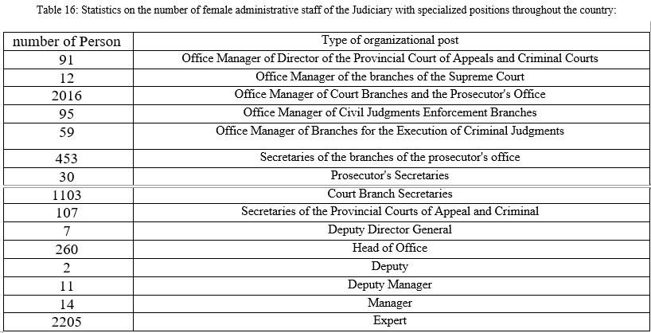
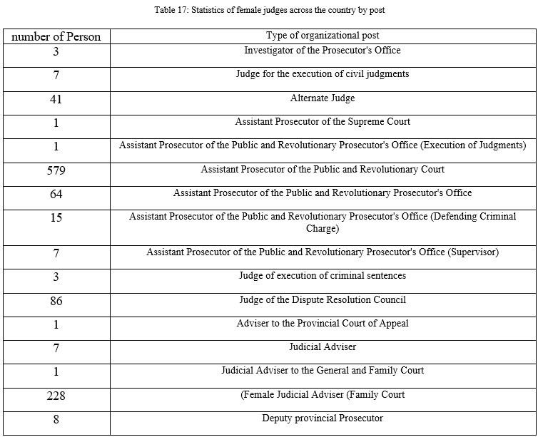
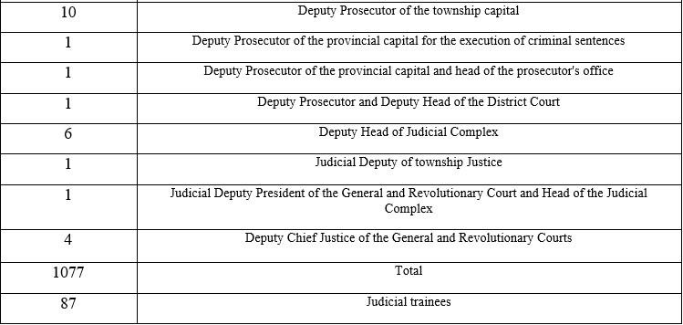
165. The number of female candidates and elected officials in the fifth round of council elections (2017) was respectively 15491 and 4029. Nearly a third of the female candidates have won the seats. Currently, 14 parties have been established and licensed by women. The number of women members in political parties and groups is more than 15,000.
166. Responding to the concluding observation No. 9, in the opinion of the IRI and according to the existing laws, men and women have exactly equal rights to choose a spouse and marry. The only issue of marriage for girls for the first time is the domestic law, which is based on Islamic law and is accepted by the vast majority of society. Obviously, according to the law (in Article 1043 of the Civil Code before the amendment of 1370), if the father’s obstruction is not based on expediency, the daughter can register the marriage by approval of the court.
167. In response to Section b of the same concluding observation, according to the laws of the IRI, men and women can have equal rights to enter or terminate a marriage contract in such a way that women can assert those rights in signing stage. At the same time, in general, if a woman did not stipulate this condition at the time of the marriage contract, the current civil law has well protected their rights, for example: for women, easy conditions for divorce are provided. Including hardship, any harassment and misfortune that is an example of hardship, such as imprisonment for more than 5 years. Besides, the request for divorce by men are subject to the conditions such as court rulings and the need to pay all of a woman’s financial rights for example, new contract’s articles include transition of half of the man’s property in addition to the Mehriyah). These laws show the balance of rights and duties of both parties and cause the preservation of couples and families within the framework of common values and culture.
168. In response to the section c, Article 43 of the FPL stipulates: The custody of children whose father has died is with their mother, unless the court, at the request of the guardian or the prosecutor, finds that granting the custody to the mother is against the child convenience (such as mother addiction, mental disorder, and inability to care for the child).
169. The issue of custody is a matter that concerns the interests of the child, and for this reason, in the laws of the IRI, this issue includes inequality in different ages of the child. For example, in the first seven years, when emotional needs and serious physical care are required, mother has priority over father, as though the custody unequally granted to woman, and in the next age period, when most of the economic and social care costs are high, the priority is with the man. In case of disagreement, the competent court will consider the interests of the child (1173). In any case, choosing the custodian (as soon as the child reaches puberty) is up to the adolescent.
170. In response to section d, by the adoption of the new FPL, which in Article 43 states that “custody of children whose father has died is with their mother” the aim is fulfilled.
171. In response to section e, in addition to the detailed material presented in response to the esteemed committee’s question in the previous round, information on the social and economic characteristics of women was presented; It is added that the right of inheritance is a personal right of individuals, which means that if a person donates any amount of his property to relatives or other persons before his death in good health, it is irrevocable. In addition, if during his lifetime he makes any amount of his property in the form of a Solh Contract and postpones the date of access to after death; he can inherit all his property in any way he wants. The laws of the country, which are based on the prevalent Islamic custom and norms, would be applied to people who have not already set up a will. In other words, the silence of individuals and non-submission of a will means their definite confirmation of inheritance based on custom and norm which is common in society.
172. In response to section f, the issue of the wife’s obedience to her husband is not raised in the law, but according to the law (1103 and 1104), couples are obliged to manage their lives with good company, cooperation and tolerance. On the one hand, the main task of financing the family is the responsibility of the husband, even in case of financial ability of the wife, and on the other hand, the role of the wife in matters related to managing the internal affairs of the family, nutrition and raising the child is more important than the father. Division of labor means completion of tasks and in any division of labor, the difference in tasks is inevitable. In the matter of meeting sexual needs, the two sides have a common and equal responsibility. In particular, in Islamic and Iranian law, sexual relations out of wedlock and the family are condemned, and the two parties who have voluntarily joined the marriage contract and are trying to preserve it in good faith will also be bound by other requirements of this relationship.
173. In response to section g, one of the cases in which women can stipulate in the marriage document is that they do not need the consent of their husbands to leave the country. Of course, in order to better ensure the rights of women, there are new ideas that are being considered in the parliament and its reform has no legal or principled obstacles.
174. In response to section h, according to Article 16 of the FPL and Article 645 of the IPC, polygamy is prohibited in Iran, except under special circumstances where both parties do not wish to divorce and on the other hand continue to live as before is not possible for some reason. Also, in common practice, polygamy is condemned in a large part of Iranian society and is rarely observed in practice.
175. Responding to the first part of section h, according to the Civil Code article 1117, the employment of men and women must be in accordance with their social status; otherwise it can be prevented from both parties to continue a work that considered disgraceful by another party. If the woman is employed at the beginning of the marriage, no prohibition on continuing her work is possible except with the above condition. Furthermore, if every woman asserts her absolute right to work, this condition, like all other conditions, is binding on the man. In the marriage contracts of recent decades, the assertion of these rights by women is quite common and their implementation is the responsibility of men according to the law. In order to fulfill the requirements of the concluding observation in practice, for example, the verdict of the Mazandaran Court of Appeals, the lawsuit dated 27/8/1396(2017) (overruled the initial verdict based on the Constitution, Article 3 and Article 17 of the ICCPR); in this vote, the woman’s right to employment is recognized.
176. In response to the second part of section h, from the same concluding observation, as mentioned above, Iranian law has made many improvements to ensure more citizens’ rights on the agenda, for example during the reporting period, the bill of the possibility of granting citizenship to children of Iranian mother who married to a foreigner has been legally ratified. Thus, it will be implemented after the signature of the President.
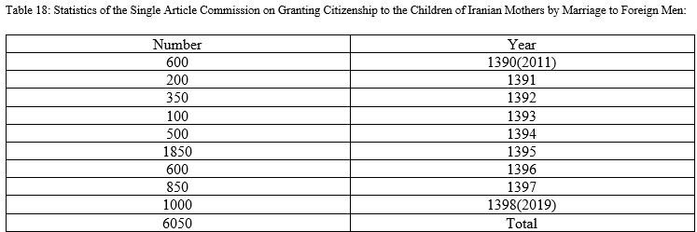
177. In response to concluding observation, No.10 of the Committee, Article 26 of the Covenant prohibits any discrimination against members of society, and there is no law in the laws of the IRI that leads to discrimination based on sexual orientation or identity.
178. In Islamic societies, especially in the IRI, the framework of sexual relations is emphasized in the legal framework of marriage. In addition to meeting these needs, the purpose of marriage is to form a family as an important social institution and the maintenance of the population. At the same time, according to Article 102 of the new CCP, judges and judicial officers are prohibited from conducting any investigation and prosecution of crimes against chastity. Questioning anyone in this regard is not permitted unless it happens publicly or there is a private plaintiff or it is organized, violent or forced.
179. According to the current laws, the government does not have the right to interfere in the personal affairs of individuals. Therefore, the sexual orientation is a personal matter, the government has no right to enter this field, and the legislation is not allowed to violate privacy and increases the government’s authority in the area of citizens’ personal lives, which is against the principles of the constitution.
180. Most of the cases of court rulings that are already reflected in international documents by the IRI, have been related to cases such as rape, assault and abuse of children or the formation of sexual abuse gangs, that are severely punishable by the law. Obviously these cases would be inflicting social, personal and physical wounds on the victims that would never be healed.
181. In many countries, including the IRI, there is a clear demarcation between sexual promiscuity and abnormal sexual orientation. For example, in Iran, efforts have been made to introduce the status of Transgender or people who has changed their gender.
182. For the possibility of gender reassignment surgery, there are requirements such as a request from the individual and the approval of the forensic expert commission (after conducting the necessary investigations and according to the protocols of active countries in this field), and then this gender reassignment is done by the court decision. In this regard, in addition to the extensive financial, psychological and medical support provided to these individuals in accordance with existing procedures in Iran. Besides, cultural activities such as publishing articles, films and series have been produced and published and would be continued, with the aim of preventing any insults or discrimination and promoting public knowledge and awareness about Transgender citizens.
183. Regarding the implementation of concluding observation, No.11 and the prohibition of domestic violence, in addition to what was mentioned in the previous report (Articles 622, 619 and 647 of the former Islamic Penal Code, social emergency, safe houses for women and children, etc.) During the reporting period, positive developments have taken place in dealing with possible cases of violence against women or children in the country. The IPC and FPL, Crime Prevention Law (2015), Articles 54 and 91 of the Charter of Civil Rights, Article 66 of the CCP, Law on the Protection of Children and Adolescents, Articles from the bill amending the Penal Code (1397(2018)), the final draft of the National Document on the Security of Women and Children in Social Relations (1394(2015)) are of the measures taken or being pursued to better ensure the rights of children.
184. The Social Affairs and Crime Prevention Department of the Judiciary, in order to combat violence, including domestic violence has established the National Committee for the Prevention of Violence at the National Level (2015) and pursues several measures. In this regard, the organization has developed and published a guideline for specialized interventions in safe houses to support women under domestic violence, as well as a guide for specialized interventions in cases of child abuse.
185. The Vice President for Women and Family Affairs, in cooperation with the NGOs, introduced the projects of “National Family and Intergenerational Dialogue” and “Empowerment and Improvement of Social Sustainability in Local Communities” and holding “Four rounds of Peace Workshops” as preventive action against violence. The Vice President for Women and Family Affairs has so far concluded 304 memoranda of understanding for joint cooperation with NGOs throughout the country from the second half of 1392(2013) to 1396. In these memorandums, various issues of cooperation based on request and capacity of these organizations have been considered.
186. Regarding the other part of the concluding observation, Article 630 of the new IPC does not mention “suspicion of an illegitimate relationship”, and according to the law, the suspicion is not only a sufficient reason for such a rare act, but only if the act of infidelity in front of the husband is done, he has the right to react. Due to the sensitivity of Iranian society and public culture to the chastity and fidelity of spouses to each other and the rejection of any kind of cheating on spouses, if the husband commits adultery, he will also be sentenced to a severe punishment as well. It should be added that following an inquiry from the judiciary, there has been no case under Article 630 in recent years, and this article is deemed an abolished-in-practice.

Article 27
187. Basically, Iran is a country in which nation-building has not been in any way ethnic or religious and never based on dichotomy of majority-minority, and especially the category of ethnic discrimination and differences in this country is largely meaningless and unknown, and any attempt to portray ethnicity from Iran and the introduction of ethnicity as an issue does not correspond to the realities of Iran. Politics during 5,000 years old history have not been processed and defined based on ethnicity and due attention has been paid to the minorities. Religious minorities have a special place in political jurisprudence, positive law, the Constitution, and civil law. Religious minorities participate in determining their own destiny and enjoy the freedom of religion, the freedom to performing appropriate religious and cultural ceremonies and rituals. They have several structures and associations. They have a special representative in the parliament. They hold their special festivals and programs in comfort and freedom.
188. According to Article 13 of the Constitution, religious minorities are free to write and teach religious textbooks based on their religious books, conduct rituals and traditions in their schools under the supervision of education. Accordingly, in the National Curriculum of the IRI, approved by the High Council of Education on 28/6/91, in the footnote of paragraph 7, special permission for religious education to the followers of official religions has been granted. Since its inception, the Literacy Movement Organization has taken a unified approach in providing services to all its audiences regardless of religion and religious affiliations.
189. Helping to solve the problem of Sabein Mandai Monastery and Cultural Center in Ahvaz (in cooperation with Khuzestan Governor’s Office).
190. Participation of state officials in religious and cultural ceremonies of minorities, such as participation in churches, synagogues, as well as joint meetings and conferences held for interfaith proximity and dialogue. In religious celebrations and festivals such as Christmas, Century, Mehregan and dozens of other joint meetings and seminars.
191. Closing of schools on Saturday for Jewish special schools (February 7, 2014).
192. In response to the Concluding observation No. 30, according to the Constitution of the IRI, the official language of the country is Persian (Article 15) “The official and common language and script of the people of Iran is Persian. Documents, correspondence, official texts and textbooks must be in this language and script, but the use of local and ethnic languages in the press and mass media and the teaching of literature are free in schools, alongside the Persian language.”
193. Eradication of illiteracy is one of the major goals of the country and by carrying out strike projects such as the acceleration of literacy in border provinces including Kurdistan, Sistan and Baluchestan, Kermanshah, West Azerbaijan, which are mainly Sunnis, over 103 thousand people in 1396 were covered in literacy courses (about 27.1% of the total activity of 31 provinces) and by adopting appropriate methods and local content, the courses train this group of audience by using appropriate and local contents. All Sunni students can study alongside other school students across the country without any restrictions, and there does not seem to be a need for segregation or enumeration separately from other students.
194. As mentioned before, teaching of Kurdish, Balochi and Azeri languages has been launched in the universities of Kurdistan, Sistan and Baluchistan and East and West Azarbaijan provinces.
195. Since Arabic is the language of the Quran and Islamic theology and Persian literature is somehow mixed with it, this language should be used after the elementary level until the end of the course. Secondary education should be taught in all classes and in all disciplines (Principle 16). In this regard, in addition to the existence of various media, paper, radio and television in the languages of the ethnicities, which are described in Article 18, the chair of languages of the ethnicities and religions has also been established in the country’s universities.
196. Regarding schools, considering that it is possible to continue studying in science and technology and major disciplines for all ethnicities in the whole country, teaching Persian language comprehensively and in the direction of eliminating illiteracy in the whole country is on the agenda. So that, the literacy rate before the revolution in 1355(1976) was about 48.8 percent, and according to the 1395(2016) census, this figure has reached 94.7 percent, and this figure has increased to 96.6 percent in 1399(2020). At the same time, local and ethnic culture and literature education is done selectively (by students) in schools, and due to the common script and the profound impact of Persian education on familiarity with other ethnic languages, people with basic literacy are competent to study ethnic texts, poems and literature. In addition, with the expansion of access to the Internet and social networks provided by the government, especially through the last decade, for a very large segment of society, shortcomings in the field of ethnic culture and language education have been minimized. Thousands of years of interaction between Iranian ethnicities have made them integrated into a harmonious nation, and a common legacy, culture and literatures handed down to the current generation strengthen their ties. Moreover, diversity within unity has been cherished and followed by the government’s policies through holding exhibitions, festivals and making documentaries aiming to augment the self-esteem and self-awareness of Iranians.

* The present document is being issued without formal editing.
** The annex to the present report may be accessed from the web page of the Committee.
A/RES/74/200, 13 January 2020.
https://www.tasnimnews.com/fa/news/. (June 2017).
For example, the supremacist, extremist, and hateful teachings could be found in the writings of Hossein Ali Nouri, a Novel book in response to the judge’s request, page 140, consider non-Baha’is as inferior to human beings, or Abdul Hamid Ishraq Khawari, in the book Maeda Asmani, vol4. Page 355 calls those opposing Baha’is as misbegotten. Similarly, Abbas Effendi, in the book of Speeches (Khetabat), vol. 2, p. 237, orders looting the property of the non-Baha’is, Al-Bayan, Mohammad Ali Bab P.18 line 153.

