 | United Nations | CERD/C/ECU/FCO/25
 | International Convention on  the Elimination of All Forms  of Racial Discrimination |  | Distr.: General  27 October 2025  English  Original: Spanish  English, French and Spanish only
Committee on the Elimination of Racial Discrimination

Information received from Ecuador on follow-up to the concluding observations on its twenty-fifth periodic report*
[Date received: 16 October 2025]

I. Introduction
1. The Committee on the Elimination of Racial Discrimination considered the twenty-fifth periodic report of Ecuador during its meetings on 26 and 27 November 2024.
2. The Committee adopted its concluding observations on the twenty-fifth periodic report and recommended that the State Party submit its combined twenty-sixth and twenty-seventh periodic reports, in a single document, by 1 January 2028, in line with the reporting guidelines adopted by the Committee at its seventy-first session, addressing all issues raised in the concluding observations.
3. Pursuant to the Committee’s request in its concluding observations, the State Party provides below follow-up information relating to paragraphs 35, 37 and 47. This information was prepared through an inter-institutional process and compiled by the Ministry of the Interior.

II. Additional information relating to the concluding observations (CERD/C/ECU/CO/25)

A. Information relating to paragraph 35 (d)
4. By Resolution No. 063-FGE-2023 of 20 September 2023, the Attorney General’s Office established the Specialized Unit for the Investigation of Illegitimate Use of Force, comprising eight prosecutor’s offices: six in Pichincha Province, one in Guayas Province and one in Azuay Province.
5. These new prosecutor’s offices were incorporated into the specialized human rights units that had been handling cases referred by the Truth Commission, except for the office in Guayaquil, which was established separately. Under article 5 of Resolution No. 063-FGE-2023, the Directorate for Human Rights and Citizen Participation is responsible for coordinating the Specialized Unit for the Investigation of Illegitimate Use of Force.
6. Under article 1 of Resolution No. 063-FGE-2023, the Unit has jurisdiction over high-impact and particularly sensitive offences, including genocide, ethnocide, extermination, slavery, deportation and forced population transfer, enforced disappearance, extrajudicial execution, persecution, apartheid, aggression, crimes against humanity, torture and abuse of authority. It is mandated to address cases involving these offences as of 23 October 2022.
7. The Unit’s coordinator has begun assigning investigators from the Human Rights Department of the National Investigation Unit of the Attorney General’s Office. According to current planning, the prosecutor’s offices will be located in Quito, Cuenca and Guayaquil and will handle cases arising within their respective geographical jurisdictions.
8. Given the nature of the offences falling within its mandate, the Specialized Unit for the Investigation of Illegitimate Use of Force must be staffed with specialized personnel who are properly trained to carry out investigative fieldwork, including evidence collection, witness location and the safeguarding of material according to chain-of-custody standards, in strict compliance with articles 456 and 458 of the Comprehensive Organic Criminal Code.
9. In accordance with the principles established in the Minnesota Protocol – an international human rights instrument which, under the Constitution, is directly applicable and binding in Ecuador – investigations into potentially unlawful deaths or other offences attributable to personnel of the National Police, the Armed Forces or the Prison Security and Surveillance Corps must be fully independent. To this end, arrangements have been made with the National Police for the assignment to such cases of investigators from the National Investigation Unit, who operate under the direct supervision of the Attorney General and enjoy functional autonomy.
10. The figures below, supplied by the Statistics Directorate of the Attorney General’s Office, concern cases of enforced disappearance, extrajudicial execution, abuse of authority and torture committed against persons belonging to Indigenous Peoples and nations, persons of African descent and persons from Montubio communities.

Offences disaggregated by the population groups of the victims
Source: Statistics Directorate of the Attorney General’s Office.
11. With the aim of safeguarding access to justice, due process, judicial independence and other principles enshrined in the Constitution and the Comprehensive Organic Criminal Code, the judicial institutions, within the limits of their respective mandates, have taken measures to enhance the effectiveness of judicial mechanisms, including:
(i) Administrative policies aimed at transforming the judiciary to provide timely, efficient and high-quality services that meet the needs of justice system users;
(ii) Economic policies focused on responsible budget management to support the timely planning and execution of investments in physical and operational infrastructure, thereby optimizing available resources;
(iii) Human resources policies intended to strengthen the judicial, prosecutorial and public defender career streams, reinforce the Judicial Training Academy and ensure safe and dignified working conditions for personnel;
(iv) Independence policies designed to promote and safeguard the individual autonomy of judicial personnel and the internal and external independence of the judiciary as a whole.
12. In this context, the National Directorate for Access to Justice of the Council of the Judiciary is responsible for developing and implementing initiatives that promote effective access to judicial services for all persons, while the National Subdirectorate for Access to Justice and Legal Pluralism works to advance a justice system that is fair, inclusive and intercultural.
13. With respect to the incorporation of an intercultural approach in the administration of justice, it is worth noting Judgment No. 112-14-JH/21, issued on 21 July 2021 by the Constitutional Court in a case concerning the deprivation of liberty of several members of the Waorani nation in Orellana Province.
14. In that judgment, the Constitutional Court – the highest constitutional oversight body – affirmed the State’s obligation to ensure differentiated treatment for Indigenous persons, particularly those belonging to recently contacted Peoples, in judicial proceedings involving deprivation of liberty.
15. The Constitutional Court held that the ordinary justice system must effectively incorporate an intercultural approach, in accordance with the Constitution and the State’s duty to guarantee collective rights. It further instructed the Council of the Judiciary, in coordination with the Public Defence Service, the Attorney General’s Office and the Ombudsman’s Office and with the participation of Indigenous authorities and organizations, to develop a participatory plan to strengthen the intercultural approach.
16. To comply with this directive, the Council of the Judiciary has adopted the following measures:
(a) Intercultural habeas corpus protocol:
Development of a normative instrument for handling habeas corpus actions brought by members of Indigenous Peoples, including recently contacted Peoples, ensuring differentiated treatment that respects their world view;
(b) Intercultural coordination and dialogue mechanism:
Establishment of a permanent mechanism for interaction between the ordinary justice system and Indigenous justice, formalized through Resolution No. 053-2023 of the plenary Council of the Judiciary, which provides for:
(i) A permanent, technical and localized mechanism: The mechanism is composed of officials of the ordinary justice system, Indigenous authorities and actors from the rights-protection system, thereby ensuring institutionalized and stable cooperation;
(ii) Progressive activation through provincial intercultural working groups: Technical, locally based working groups will serve as operational coordination spaces, with priority given to provinces with the largest Indigenous populations;
(iii) Incorporation of adopted normative instruments: The Resolution incorporates, as part of its operative framework, the Protocol for Coordination between Justice Systems in Procedural and Intercultural Matters and the Methodological Guide for Coordination and Interaction between the Indigenous Justice System and the Ordinary Justice System, as binding technical tools to guide judicial action in intercultural contexts;
(iv) A differentiated approach: Recognizing the historical inequality and exclusion faced by Indigenous Peoples and communities, the Resolution establishes culturally appropriate measures to ensure equitable access to justice. This includes respect for the autonomy of Indigenous Peoples and nations, recognition of their own forms of administering justice and the adaptation of institutional procedures to their world views;
(v) Multisectoral composition: The mechanism is open to participation from judges, prosecutors, public defenders, Indigenous authorities, representatives of rights-protection institutions, academia and international cooperation agencies, applying criteria of parity and territorial representation;
(vi) A gender-sensitive and collective-rights approach: The Resolution adopts an intersectional perspective that recognizes the particular vulnerabilities of Indigenous women, peoples living in voluntary isolation and other historically marginalized groups.
(c) Methodological Guide for Coordination and Interaction and the Protocol for Coordination between Justice Systems in Procedural and Intercultural Matters:
Guidance on the mechanism for coordination and cooperation between authorities of the Indigenous and ordinary justice systems in interjurisdictional proceedings, adopted through Resolution No. 053-2023, establishes the normative and operational framework for resolving cases involving Indigenous Peoples, nations, communes and communities through coordinated and cooperative action involving the Indigenous and ordinary justice systems.
This mechanism is implemented through a range of tools and practices, including:
• Intercultural expert assessments, which provide technical and cultural input to ensure that the facts of a case are interpreted in accordance with Indigenous world views
• Declination of jurisdiction at the request of Indigenous authorities, in accordance with article 345 of the Organic Code of the Judicial Branch, which provides that “judges who become aware that a case is being heard by an Indigenous authority shall decline jurisdiction if the Indigenous authority so requests”
• Procedural intercultural dialogue, which facilitates direct communication and mutual understanding between ordinary justice officials and Indigenous authorities
• In situ visits, conducted to verify local, community and cultural contexts relevant to judicial proceedings
These practices have already produced tangible results, including the correct application of jurisdictional declination and the coordinated resolution of interjurisdictional cases, thereby strengthening legal pluralism and the protection of the collective rights of Indigenous Peoples and nations;
(d) Training of justice officials:
Training has been provided to judges, prosecutors, public defenders, and other justice-sector personnel to ensure the practical application of legal pluralism (Constitution, arts. 1 and 171).
Between 2023 and 2025, a total of 3,755 people, including judges, prosecutors, public defenders, court clerks, judicial and prosecutorial assistants, lawyers and students, participated in training on the application of legal instruments relevant to ethnic and racial matters and on the analysis of collective rights and crimes of discrimination and hatred. Of those 3,755 participants, l,623 were trained in 2023, 1,300 in 2024 and 1,832 in 2025.
(e) Dissemination of the judgment:
Wide dissemination of the judgment nationwide and among institutions to ensure that justice officials and the public have clear information about its scope and about the mechanisms available for the protection of collective rights;
(f) Programme to increase the number of intercultural experts:
Constitutional Court Judgment No. 112-14-JH/21 requires that the Council of the Judiciary carry out a programme to increase the number of intercultural experts, applying differentiated and geographical criteria for their accreditation.
Accordingly, since 2021, the Council of the Judiciary, through the National Directorate for Access to Justice and the National Subdirectorate for Access to Justice and Legal Pluralism, has undertaken a range of actions to incorporate an intercultural approach into its Unified Expert System.
Among the main measures implemented, the following stand out:
- Creation of the “Interculturality” speciality: On 29 October 2021, “Interculturality” was officially added to the public catalogue of expert specialities on the institution’s online expert platform
- Differentiated accreditation criteria:
Unlike other specialities, a university degree is not required for accreditation in interculturality; instead, applicants must submit a certificate issued by a community authority that:
- Confirms the applicant’s membership of their People or nation; and
- Recognizes the applicant as a knowledgeable practitioner of that community’s practices, knowledge and traditions
This approach reflects input gathered through dialogue with representatives of Indigenous Peoples and nations, who stressed that expertise in Indigenous justice is not necessarily reflected in formal academic credentials.
- Recognition of community-based mechanisms of legitimacy:
This measure marks progress in acknowledging the validation mechanisms intrinsic to Indigenous communities and strengthens intercultural coordination within the justice system by ensuring that experts are grounded in, and recognized by, the world views and legitimacy structures of their communities of origin.
- Specialities that are central to the intercultural approach:
The Unified Expert System currently recognizes three specialities that are central to incorporating an intercultural perspective:
- Anthropology, drawing on academic analysis of sociocultural practices and contexts
- Ancestral languages, focused on ensuring linguistic interpretation in judicial proceedings; and
- Interculturality, enabling the participation of members of Indigenous Peoples and nations, who contribute their own experience and world view to the intercultural interpretation of the law
Intercultural experts come from the communities concerned, reinforcing the legitimacy and relevance of their contributions and supporting coexistence among diverse legal systems on the basis of equality and respect for cultural identity.
- Statistical data on intercultural expert assessments:
The Council of the Judiciary has recorded a steady increase in the appointment of experts in interculturality, anthropology, sociology and ancestral languages.

Data 2022–2024
Source: Automated Judicial Procedure System, Unified Expert System of the Judicial Branch.
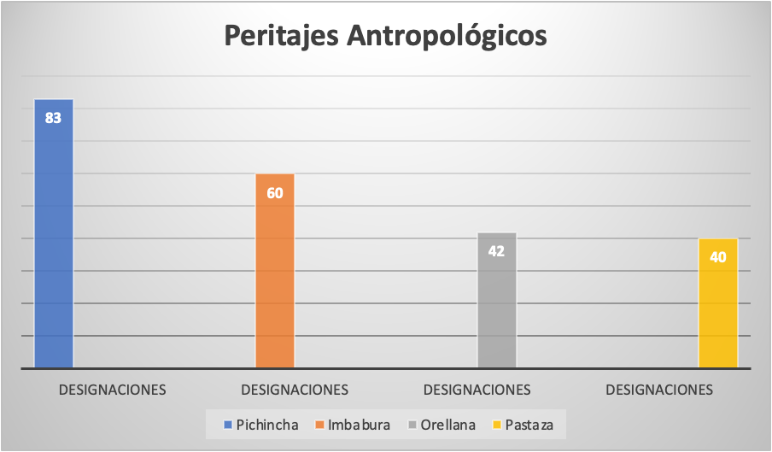

Source: National Directorate for Innovation, Development and Continuing Improvement of the Judiciary.
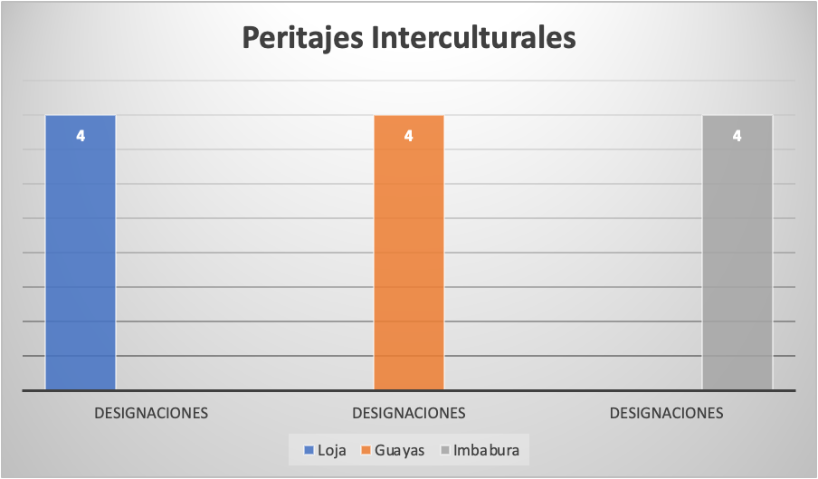
Source: Automated Judicial Procedure System, Unified Expert System of the Judicial Branch.
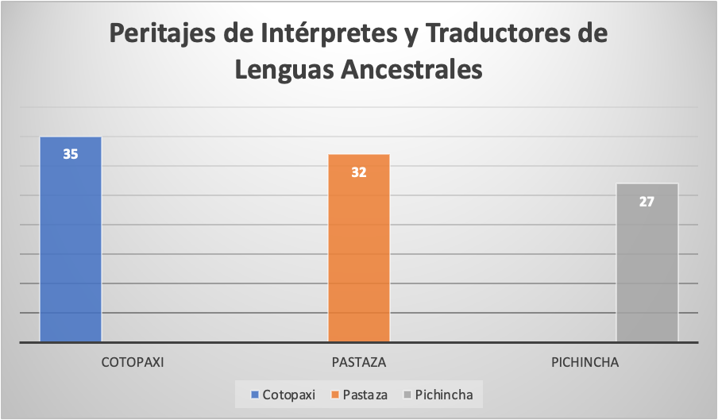
Source: National Directorate for Innovation, Development and Continuing Improvement of the Judiciary.
17. The institutional portal of the Council of the Judiciary includes a public section that provides up-to-date statistical information on the appointment of experts.

B. Information relating to paragraph 37 (a)
18. Regarding efforts to prevent and address racial profiling by law enforcement officers, the National Police has developed methodological tools to translate the legal framework into concrete operational guidance, in compliance with the Constitution and international human rights instruments. These tools improve police techniques, tactics and strategies, ensuring effective, efficient and transparent action consistent with democratic principles and the public interest.
19. In line with its institutional mandate, and pursuant to article 158 of the Constitution, which provides that the National Police must operate on the basis of democracy and human rights, the following measures have been implemented:
(a) Update to the Human Rights Handbook for Police Officers: This handbook is one of the most comprehensive tools available to police personnel. It frames all police actions in accordance with national and international human rights standards and reinforces institutional self-regulation consistent with the police’s role as a guarantor of rights;
(b) Enactment of the Organic Act on the Legitimate Use of Force of 2022: This law, adopted following a rigorous legislative analysis, incorporates national and international standards on the appropriate and lawful use of force in police operations. Promoted by the Ministry of the Interior and the National Police, it provides a legal framework that both supports police action and safeguards the rights of the public. A key feature of the law is its anti-discrimination focus, reflected in article 10 (f), which expressly prohibits the use of force in a discriminatory manner on grounds such as ethnicity, sex, gender identity, sexual orientation, socioeconomic status, disability or other protected grounds. This principle reaffirms the institution’s commitment to equality and non-discrimination – cornerstones of any democratic society;
(c) Adoption of the regulations to the Organic Law on the Legitimate Use of Force: A specialized technical commission was established to develop the regulations, initially led by the Ministry of the Interior and the National Police, which were later joined by the Armed Forces and the Prison Security and Surveillance Corps. The regulations were issued through Executive Decree No. 755 of 2 June 2023 and published in Official Gazette No. 323, thereby consolidating a comprehensive regulatory framework for the legitimate use of force;
(d) Ongoing training for police personnel: Since 2020, through the Continuing Comprehensive Training Programme, police training has been strengthened in areas such as human mobility, international refugee law, prevention of sexual exploitation and abuse, application of a human rights approach, amendments to the Comprehensive Organic Criminal Code, gender equality and the collective rights of Indigenous Peoples and nations, persons of African descent and Montubio communities, among others.
- 2021: Incorporation of content on gender, workplace violence, discrimination, harassment, sexual abuse and collective rights
- 2022: Training on gender-related issues (empowerment, awareness-raising and urgent actions), legal pluralism and social protest
- 2024: Inclusion of an analysis of national and Inter-American court judgments, operational protocols for persons requiring priority care and safeguards in situations of deprivation of liberty
- 2025: Focus on human rights, human dignity, non-discrimination and international standards governing the treatment of vulnerable persons deprived of liberty, with a particular emphasis on gender, migrants and LGBTI+ persons
20. The regulations governing careers in the National Police establish specific provisions on training processes to ensure that the continuing training of police personnel is relevant, rights-based and aligned with national and international standards.

Article 45
21. The Comprehensive Continuing Training Programme is mandatory for all police personnel, from officer to colonel, and is designed to develop competencies, skills, practical abilities and strategic knowledge in line with the guidelines set by the governing authority. It is updated annually by the National Police Training Centre, and updates must be approved by the National Directorate for Education. In duly justified cases, personnel who are unable to attend may complete the Programme at a later time, subject to the submission of a substantiated request. Completion of the Programme is taken into account in the annual competency-based performance evaluation, and all related information is recorded in the institutional information system of the National Police.

Article 67
22. The Comprehensive Continuing Training Programme is a mandatory, ongoing training scheme for all police personnel. Implemented annually, it covers police procedures, institutional doctrine, human rights, gender perspectives and other relevant topics. Its implementation is coordinated with the governing body for citizen security, internal protection and public order, with the aim of strengthening the competencies and skills required for police personnel to fulfil their institutional mandate.
23. The Ministry of Defence, in coordination with the Armed Forces Joint Command, which represents the Army, Navy and Air Force, has prioritized the development of eight training courses, outlined below:
(i) Right to Equality and Non-Discrimination on Racial Grounds;
(ii) The Armed Forces and Their Core Mission in Relation to the Sovereignty of Ecuador (endorsed by the Ombudsman’s Office);
(iii) Human Rights;
(iv) International Humanitarian Law;
(v) Legitimate Use of Force and the Corresponding Regulations: Legal framework governing the legitimate use of force;
(vi) Procedures for Interacting with Vulnerable Persons;
(vii) Legitimate Use of Force by All Ranks of Professional Military Personnel
(viii) Methods and Techniques for Physical Restraint in the Application of the Legitimate Use of Force.
24. Each branch of the military conducts the “Right to Equality and Non-Discrimination on Racial Grounds” course in accordance with its internal planning, as follows:

Navy
25. The course consists of 20 hours of virtual instruction and is to run from 12 August to 17 November 2025. To date, 2,211 of the 9,000 professional military personnel targeted for training have completed the course, representing 25 per cent of the Navy’s total professional military personnel.

Air Force
26. The course consists of 20 hours of virtual instruction and was delivered in May 2025. During that month, 5,316 of the 6,000 professional military personnel targeted for training completed the course, representing 89 per cent of the Air Force’s total professional military personnel.

Army
27. In accordance with internal planning, the Army will deliver the course virtually beginning in January 2026, in three cycles – January to April, May to August and September to December – to all of its professional military personnel.
28. Other training programmes on human rights and the legitimate use of force, implemented as part of ongoing capacity-building efforts, are being carried out simultaneously to strengthen the competencies of military personnel. Together, these comprehensive efforts help to consolidate professional, well-trained Armed Forces fully aligned with constitutional principles and international human rights standards, thereby ensuring more effective fulfilment of the missions entrusted by the State.

Conclusions
29. Significant progress has been made in implementing two of the recommendations and a road map has been outlined, as the measures taken are continuing and progressive in nature.
30. The State of Ecuador undertakes to submit the follow-up report on the recommendations by 1 January 2028 at the latest, reaffirming its commitment to fulfilling its international obligations.

* The present document is being issued without formal editing.

