 | United Nations | CRPD/C/BOL/1
 | Convention on the Rights  of Persons with Disabilities |  | Distr.: General  28 September 2015  English  Original: Spanish  English, French and Spanish only
Committee on the Rights of Persons with Disabilities
Consideration of reports submitted by States parties under article 35 of the Convention
Initial reports of States parties due in 2011
Plurinational State of Bolivia*
[Date received: 31 December 2013]
Contents
Page
I. Introduction 4
II. Legislative progress in the disability field 4
III Statistical data 6
IV. Disability and poverty 20
V. Institutional aspects 21
VI. Civil society organizations providing services in the disability field 24
VII. Specific information relating to implementation of the Convention 25
General provisions of the Convention (arts. 1 to 4) 25
Article 5: Equality and non-discrimination 27
Article 6: Women with disabilities 28
Article 7: Children with disabilities 31
Article 8: Awareness-raising 33
Article 9: Accessibility 35
Article 10: Right to life 36
Article 11: Situations of risk and humanitarian emergencies 37
Article 12: Equal recognition before the law 38
Article 13: Access to justice‬ 40
Article 14: Liberty and security of the person 43‬‬‬‬‬‬‬‬‬‬‬‬‬‬‬‬‬‬‬‬‬‬‬
Article 15: Freedom from torture or cruel, inhuman or degrading treatment or punishment 45
Article 16: Freedom from exploitation, violence and abuse 47
Article 17: Protecting the integrity of the person 48
Article 18: Liberty of movement and nationality 49
Article 19: Living independently and being included in the community 49
Article 20: Personal mobility 50
Article 21: Freedom of expression and opinion, and access to information 51
Article 22: Respect for privacy 52
Article 23: Respect for home and the family 52
Article 24: Education 54
Article 25: Health 63
Article 26: Habilitation and rehabilitation 65
Article 27: Work and employment 67
Article 28: Adequate standard of living and social protection 72
Article 29: Participation in political and public life 74
Article 30: Participation in cultural life, recreation, leisure and sport 74
Article 31: Statistics and data collection 75
Article 32: International cooperation 76
Article 33: National implementation and monitoring 78
I. Introduction
1. Having ratified the Convention on the Rights of Persons with Disabilities (hereinafter “the Convention”), the Plurinational State of Bolivia submits to the Committee on the Rights of Persons with Disabilities its initial report on the measures it has taken to comply with its obligations under article 35, paragraph 1, of the Convention.
2. The report has been drawn up and structured in accordance with the guidelines on treaty-specific documents to be submitted by States parties under article 35, paragraph 1, of the Convention (CRPD/C/2/3).
3. The drafting of the initial report was coordinated by the Directorate-General for Persons with Disabilities attached to the Office of the Deputy Minister of Equal Opportunities under the Ministry of Justice.
4. Extensive consultations were held with the relevant ministries, principally the Ministry of Education, Health and Sports, the Ministry of Labour, Employment and Social Welfare, the Ministry of the Interior, the Ministry of Public Works, Services and Housing, the Ministry of the Office of the President, the Ministry of Foreign Affairs, the Ministry of Cultures and the Ministry of Economic Affairs and Public Finance. Other institutions that contributed to this report include the Office of the Ombudsman, the Bolivia Office of the United Nations High Commissioner for Human Rights and the “Fe y Alegría” Movement.
5. Public consultations also took place with non-governmental organizations and other members of civil society involved with the topic of disability. The preparation of this report represents the start of a process of retrospective analysis of public policies and legislation for persons with disabilities, as well as an opportunity to promote strategic changes with a view to the implementation of a national policy guaranteeing persons with disabilities full exercise of their rights, without distinction of gender, colour, age, origin, culture, nationality or economic or social condition.
6. Throughout the report, the Plurinational State of Bolivia provides an honest account of the progress, challenges and difficulties in this field, recognizing those areas in which, for various reasons, the expected achievements have not materialized.
II. Legislative progress in the disability field
7. The adoption in 2009 of the Political Constitution of the Plurinational State of Bolivia, article 70 of which recognizes the right of persons with disabilities to be protected by the State and to develop their individual potential, represents a historical landmark for the Bolivian people.
8. According to article 71, paragraph II, of the Constitution, “The State shall adopt measures of affirmative action to promote the effective integration of persons with disabilities in the productive, economic, political, social and cultural sphere, without any form of discrimination and “shall create the conditions that enable with disabilities persons to develop their individual potential”.
9. The Act of 22 January 1957, the oldest with regard to disability in Bolivia, established the Bolivarian Institute for the Blind as a public-law body with legal personality, enjoying autonomy of technical and administrative management and whose central objective is the protection of unsighted persons.
10. On 23 April 2002, the former Bolivian National Congress approved the ratification of the Inter-American Convention on the Elimination of All Forms of Discrimination against Persons with Disabilities, which was promulgated by Act No. 2344 of 26 April 2002. Under the powers conferred by article 59, paragraph 12, of the Constitution, the Act’s single article approved the Inter-American Convention to which Bolivia had subscribed on 7 June 1999 on the occasion of the General Assembly of the Organization of American States (OAS).
11. Another important legal provision in Bolivia is Folic Acid Act No. 3022 of 15 March 2005, which states that: “The executive branch shall provide for the mandatory inclusion of folic acid in all flours produced and sold in the country with the aim of preventing the birth of children with congenital malformations such as neural tube defects, abortions, premature births and low birth weight”.
12. Act No. 3925, adopted on 21 August 2008, provides that “the resources accruing annually from the elimination of State funding to political parties, civic associations and indigenous peoples shall be used for the benefit of people with disabilities” and created the National Solidarity and Equity Fund.
13. Act No. 4024 was adopted on 25 March 2009 by the former National Congress of Bolivia — today the Plurinational Legislative Assembly — and promulgated on 15 April 2009 by the President. In accordance with article 158, paragraph 14, of the Constitution, the Act approved the Convention on the Rights of Persons with Disabilities and its Optional Protocol, which was opened for signature at United Nations Headquarters from 30 March 2007 and signed by Bolivia on 13 August 2007.
14. Under the “Andrés Ibáñez” Autonomy and Decentralization Act No. 31, economic resources are decentralized to the autonomous departmental and municipal governments. These are currently drafting statutes of autonomy and organizational charters, with a focus on disability, and are also implementing programmes and projects on disability with resources drawn from the National Treasury.
15. The Act on the Elimination of Racism and All Forms of Discrimination, adopted on 8 October 2010, seeks to establish mechanisms and procedures to prevent and punish acts of racism and all forms of discrimination in the framework of the Bolivian Constitution and international human rights treaties.
16. The General Persons with Disabilities Act No. 223 (hereinafter General Act No. 223), adopted on 2 March 2012, aims to enable persons with disabilities to exercise their rights and discharge their duties fully on the basis of equal conditions, equal opportunities and preferential treatment through a comprehensive protection scheme consistent with the approach, model and principles of the Convention.
17. The National Equal Opportunities Plan, adopted by Supreme Decree No. 28671 of 7 April 2006, establishes a State policy aimed at ensuring full exercise of the rights of persons with disabilities
18. Supreme Decree No. 29272 of 12 September 2007 approved the National Development Plan and prescribed for “Bolivia Digna” a policy of solidarity in the health sector based on measures to guarantee the right of persons with disabilities to integration in society.
19. Supreme Decree No. 328, adopted on 14 October 2009, is aimed at recognizing Bolivian sign language as a means of communication for the deaf in Bolivia and creating mechanisms to increase its use through the establishment of the National Sign Language Council.
20. Supreme Decree No. 29409, adopted on 9 January 2008, exempts unsighted temporary teachers currently in service from spending a number of years in the provinces and provides for their reclassification.
III Statistical data
21. Analysis and understanding of disability in Bolivia are hampered by the lack of adequate data on the subject. It is not that there have been no studies on the subject but rather that these have not been part of a sustained and coherent policy.
22. For a start, the information is varied and of uneven quality. There is a significant difference between the results of the censuses and those of the more specialized surveys. Furthermore, the information has been collected at different times and at varying intervals. As a result, it is not possible to standardize the data, although some comparisons can be attempted despite these shortcomings.
23. However, over the last 10 years or so, particularly since the adoption of the Convention, there has been an increase in the concern about the need to obtain fuller and, above all, better quality data and in the attempts made to do so.
24. There are five sources of information on disability: three censuses (carried out in 1900, 1950 and 2001 respectively) and two surveys, namely the 1998 National Demographic and Health Survey (ENDSA) and the 2001 Household Survey, Programme for the Improvement of Surveys and the Measurement of Living Conditions in Latin America and the Caribbean (MECOVI).
Censuses and studies on disability
Statistical operation | Types of questions | Classification | Unit of observation | Operational procedure | Aim of the questions
1900 census | Closed | Inability to work | Person | Direct observation of persons with a physical or mental deficiency preventing them from working | “Deficiencies” that preclude normal physical and mental functioning and prevent persons from working and supporting themselves readily
1950 census | Open | Inability to work | Person | Is the person unable to work? | Economically inactive population
2001 census | Closed | Permanent physical disability | Household | How many persons in this household are blind, deaf mutes, paralysed and/or lacking an arm or leg? | Identifying the number of persons with disabilities by household
ENDSA 1998 | Closed | Extreme disability | Person | Has the person some form of extreme impediment? | Identifying types of disability among members of the household
MECOVI 2001 | Open | Permanent disability | Person | Does the person have some form of permanent disability? | Identifying types of disability among members of the household
Source: Prepared by the Directorate-General for Persons with Disabilities (DGPCD) on the basis of information supplied by the National Institute of Statistics (INE)
25. The above table shows that the first two censuses focus on a single aspect of disability, namely whether the person concerned has a “deficiency” (1990) or “disability” preventing him or her from working (1950).
26. In the first census, the number of persons recorded as having some form of “deficiency” was only 13,674, or 0.9 per cent of the total Bolivian population at the time, whereas it was 10.5 per cent in the 1950 census.
27. The 2001 census went further and attempted, through a specific questionnaire attached to the census form, to classify the persons with disabilities as blind, deaf and dumb, paralysed and/or lacking an arm or leg.
2001 census form and questions on disability
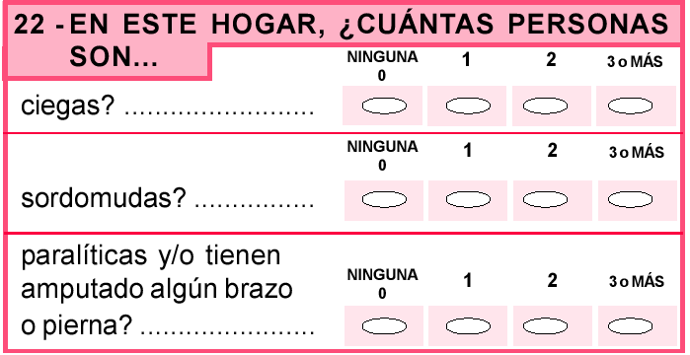
28. The 2001 census form posed two problems. Firstly, the above classification was incomplete and incorrect since it did not correspond to the types of disabilities that are now recognized by Act No. 223 and internationally, namely visual, auditory, physical, intellectual, mental or psychological and multiple disabilities, according to the categories of the International Classification of Functioning, Disability and Health of the World Health Organization.
29. Secondly, this census sought to establish, in general terms only, whether a member of the family had some form of disability, but without identifying it, which excluded the possibility of correlating disability with other census variables such as sex, age, education or economic activity. The “proportion of persons with disabilities” according to the 2001 national population and housing census was 1.18 per cent.
30. The 1998 National Population and Health Survey (ENDSA) included the question of whether the person had “any extreme physical impediment”, with a choice of seven replies: “deaf and dumb, mentally retarded, deaf, dumb, blind, paralytic and lacking an arm or leg”. This instrument suffers from the same conceptual problems as the 2001 census with regard to the classification of disability.
31. The most successful instrument in conceptual terms for classifying persons with disabilities is without doubt the 2001 Household Survey (MECOVI), based on field work carried out between October and November 2001.
32. Question 9 of the MECOVI survey asked whether the interviewee had “any kind of permanent disability”. This was the first time that a national survey or census had used the term “disability”, defined in the corresponding interviewer’s manual as: “Any restriction or absence, due to a deficiency, of the ability to carry out an activity in the manner and within the parameters of what is considered normal for a human being”.
33. So, of the five instruments mentioned, the 2001 census and the 2001 MECOVI survey could serve as a baseline for establishing the prevalence and other data on disability. However, we prefer the second on the grounds that, while no less recent than the first, it is conceptually more rigorous and informative on the subject, which translates into more reliable data.
34. The 2001 MECOVI survey will thus serve as our point of reference for establishing the prevalence and other statistical data on disability in Bolivia. Prevalence measures the proportion of persons with disabilities within a specific geographical area and time frame. It is calculated by dividing the number of persons with disabilities by the total number of inhabitants. Prevalence multiplied by 100 gives us the percentage of persons with disabilities.
35. As regards the prevalence of disability in Bolivia, there is a large discrepancy between the 2001 census and the 2001 MECOVI survey. The first puts the figure at 1.18 per cent and the second at 3.8 per cent. Each of these is far below the figures for the various countries of the region, e.g. Argentina 7.1 per cent, Brazil 14.5 per cent, Chile 12.9 per cent, Ecuador 12.1 per cent, Peru 8.7 per cent, Colombia 6.3 per cent, and Venezuela 7.6 per cent.
36. As already mentioned, various disability programmes, such as the National Plan on Equality and Equal Opportunities (PNIEO), therefore prefer simply to apply the global average disability prevalence of 10 per cent established by the World Health Organization (WHO).
37. None of the three possibilities for establishing the prevalence of disability in Bolivia is reliable, whether it is the 1.18 per cent of the 2001 census, the 3.8 per cent of the 2001 MECOVI survey or the WHO 10 per cent average. It therefore remains an open question – one that could be settled when the official results of the 2012 census are published in July.
Types of disability
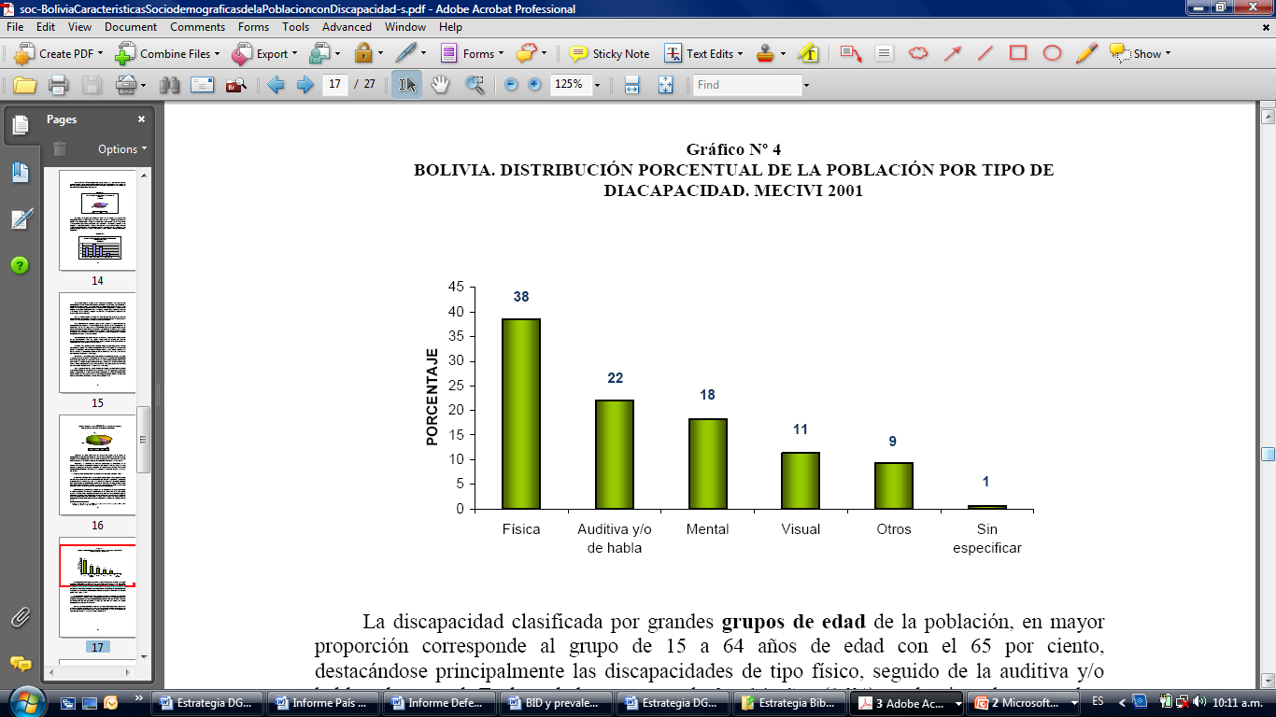
Source: Original tabulation based on INE 2001 data.
38. Physical disability shows the highest incidence (38 per cent of all persons with disabilities), followed by hearing, mental, visual and other forms of disability. In this regard, it is increasingly clear that acquired disability is far more frequent than disability at birth, by as much as 9 to 1, mainly as the result of traffic, work and other types of accident.
Disability by sex
Source: Original tabulation based on INE 2001 data.
39. Fifty-four per cent of persons with disabilities are men, and 46 per cent women. This means that for every 100 women with disabilities there are 117 men. As for types of disability, the order of prevalence in men is physical, mental, auditory and visual disabilities, while in women it is physical, auditory, visual and mental.
Disability and literacy
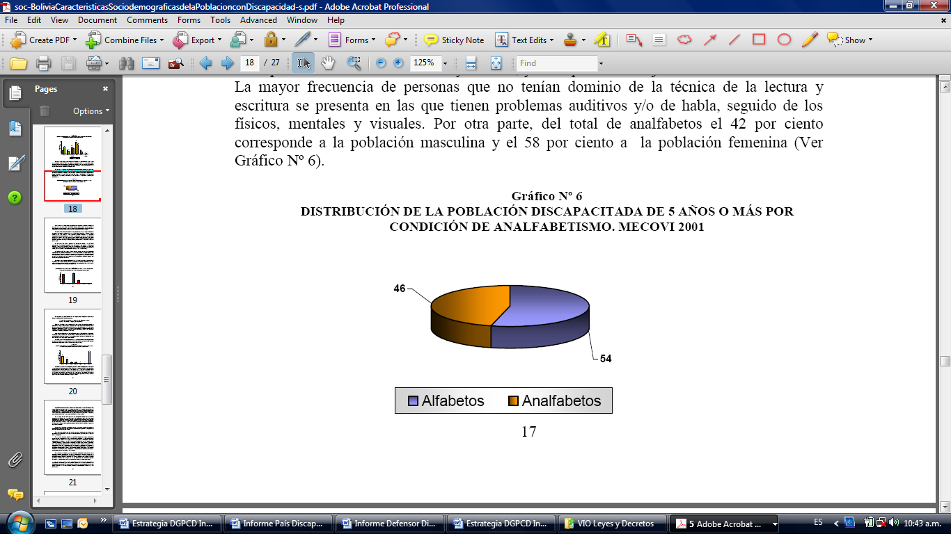
Source: Original tabulation based on INE 2001 data.
40. Among persons with disabilities over the age of five, 54 per cent of those questioned said they were able to read and write, while 46 per cent said they could not, which represents a very high rate of illiteracy. Of this illiterate 46 percent, 42 per cent were men and 58 per cent women.
Disability and educational level
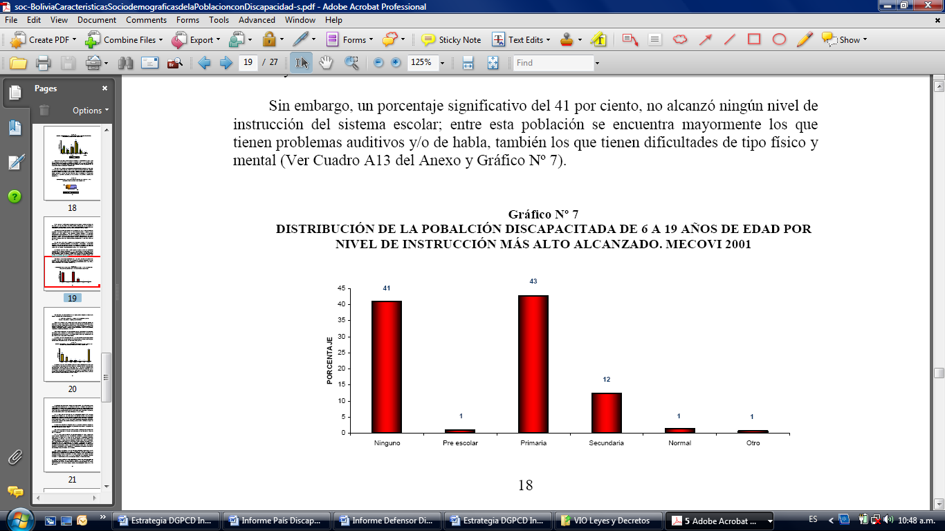
Source: Original tabulation based on INE 2001 data.
41. The 2001 MECOVI survey yielded various data relating to disability and educational level. Firstly, with regard to the school attendance rate of pupils aged 5 years or above, 59 per cent of the school-age population (aged 6 a 19) reportedly attended an education centre. The 41 per cent who had dropped out mentioned that they had problems, mainly physical, hearing and speech difficulties. Twenty-three per cent of those attending classes were men and 77 per cent women.
42. As regards persons’ levels of education, most persons with disabilities completed the primary level (43 per cent), whereas only 12 per cent progressed to the secondary level and 1.4 per cent to higher education (in most cases, teacher training colleges). Forty-one per cent did not complete any educational level, with most of the members of this group being persons with physical, hearing or intellectual disabilities.
Disability and age
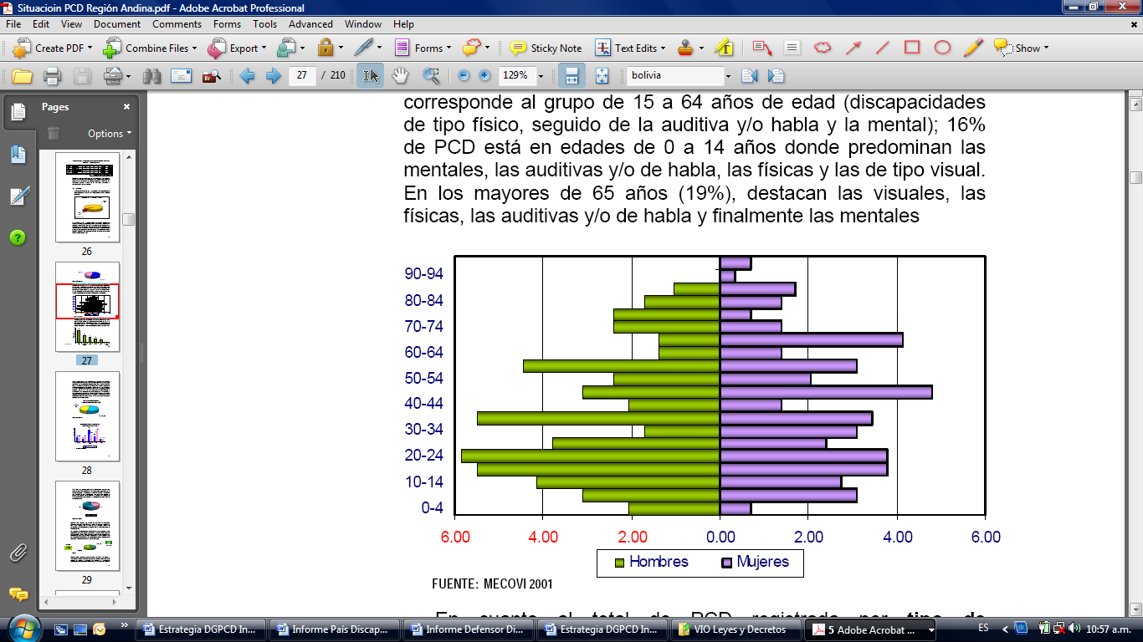
Source: Original tabulation based on INE 2001 data.
43. Sixty-five per cent of disability is concentrated in persons aged between 15 and 64 (the majority with physical disabilities, followed by hearing and/or speech difficulties and by mental problems), which is fairly consistent with the age pyramid of the population in general. However, only 16 per cent of persons with disabilities is aged between 0 to 14 years (with mental, hearing and/or speech, physical and visual problems predominating), which supports the thesis that disability is to a large extent acquired rather than congenital. Older persons with disabilities represent only 19 per cent of the total number (with, in order of frequency, physical, auditory and/or speech, and mental disabilities).
Disability and geographical area
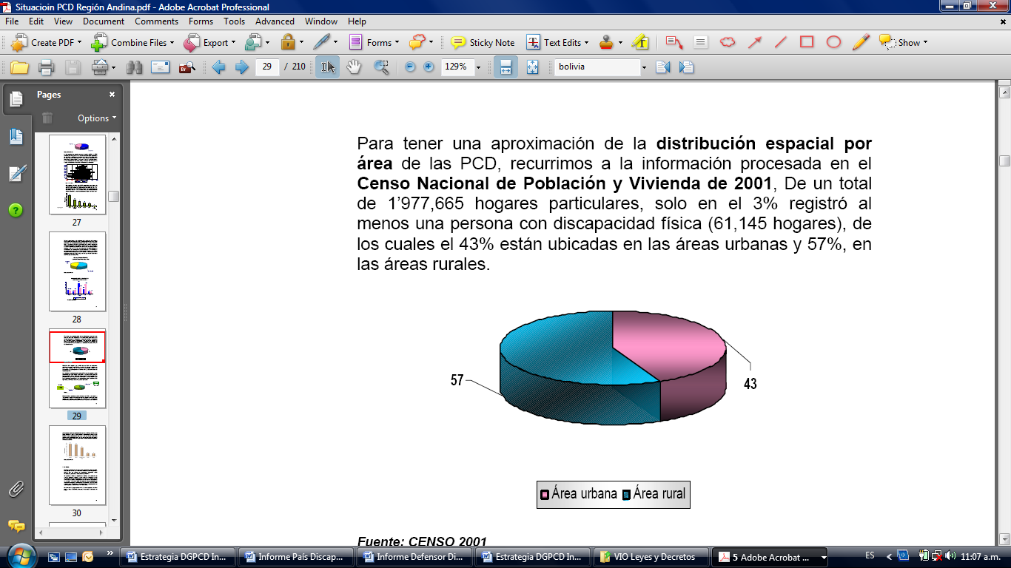
Source: Original tabulation based on INE 2001 data.
44. For these data we have drawn on the 2001 census, which indicates that 57 per cent of persons with disabilities live in rural areas, compared with 43 per cent in urban areas.
Disability and income
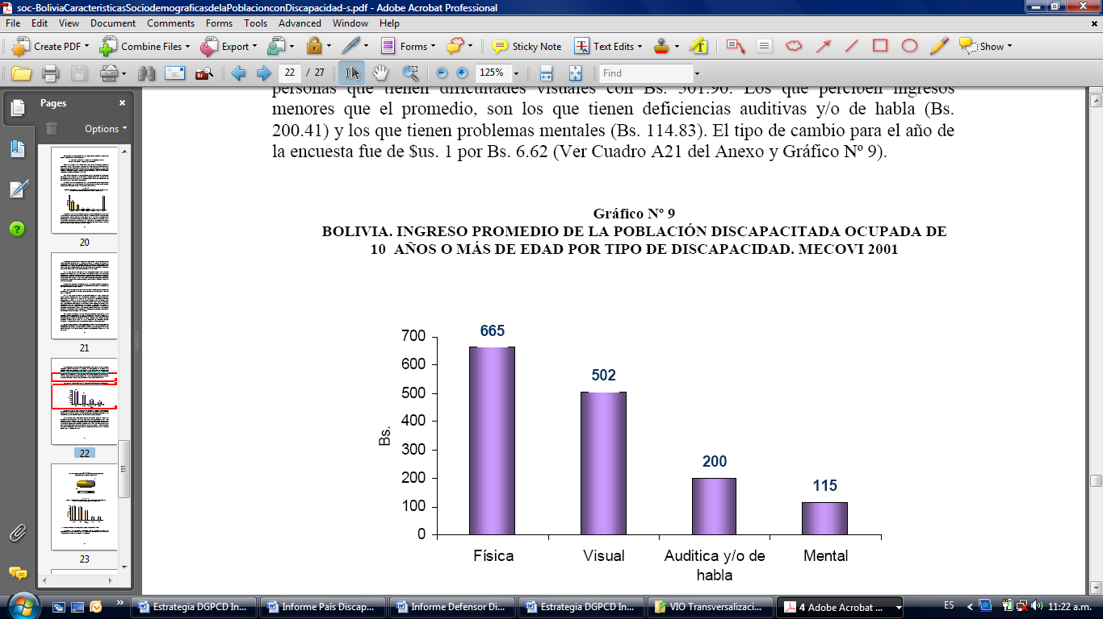
Source: Original tabulation based on INE 2001 data.
45. The average income of persons with disabilities is very low compared to the population as a whole. It amounts to Bs. 49.76, the largest sum received by persons with disabilities being Bs. 64.53. This income is at the level of the national minimum wage and only benefits 43 per cent of persons with disabilities of working age, since the remaining 57 per cent is unemployed. Sixty-four per cent of those in work are men and 36 per cent women, while 44 per cent have physical problems and 22 per cent hearing or speech difficulties. Thirty-eight per cent of persons with disabilities said they were self-employed, while 22 per cent were registered as “wage earners” (9 per cent manual and 13 per cent clerical workers).
Disability and poverty
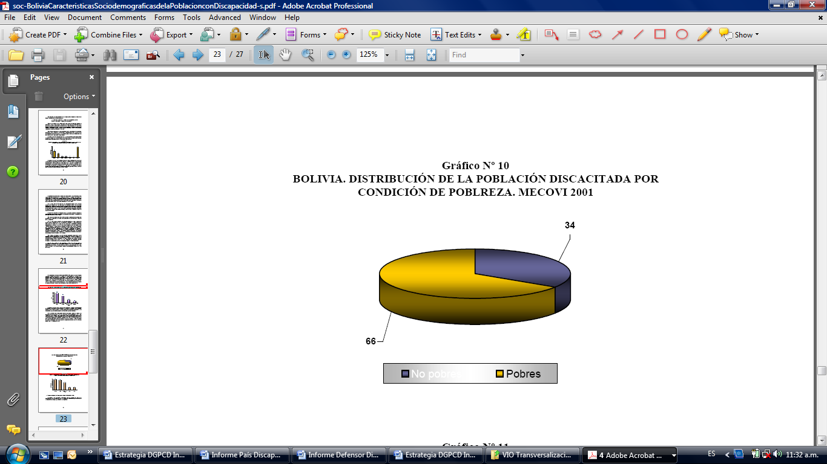
Source: Original tabulation based on INE 2001 data.
46. Finally, disability is associated with poverty, which affects two thirds of the disabled population. Only 34 per cent of these consider themselves not poor. The highest proportion of poor individuals is found among persons with mental disabilities (38 per cent), followed by persons with physical disabilities (36 per cent) and those with hearing problems (27 per cent). The lowest proportion of poor individuals is found among those with visual disabilities (9 per cent).
47. According to the demographic projections of the National Institute of Statistics. (INE), the population of Bolivia totalled 10,027,644 this year. In 2007, the population nationwide was shown to be 9,827,522, with La Paz being the most populated region and Santa Cruz having the most rapid population growth.
Population projections at national and departmental level
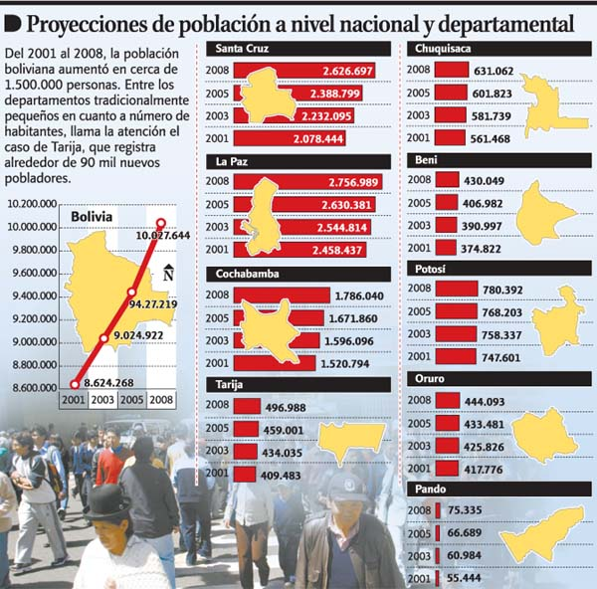
Source: Original tabulation based on INE 2001 data.
48. This information is contained the Departmental Population Projection Map of Bolivia 2000–2010, published by INE. The document shows that in 2001 Bolivia had 8,624,268 inhabitants, which means that the population increased in seven years by 1,403,376 or about one and a half million. International bodies estimate that 10 per cent of the population has some form of disability, which is the figure on which the following table is based.
Percentage of the population with disabilities, according to INE estimates (2009)
Place | Inhabitants | Persons with disabilities | Percentage
Bolivia | 10 027 644 | 1 002 764 | 100.00%
La Paz | 2 756 989 | 275 699 | 27.49%
Santa Cruz | 2 626 697 | 262 670 | 26.19%
Cochabamba | 1 786 040 | 178 604 | 17.81%
Potosí | 780 392 | 78 039 | 7.78%
Chuquisaca | 631 062 | 63 106 | 6.29%
Tarija | 496 988 | 49 699 | 4.96%
Oruro | 444 093 | 44 409 | 4.43%
Beni | 430 049 | 43 005 | 4.29%
Pando | 75 335 | 7 534 | 0.75%
Total | 10 027 645 | 1 002 765 | 100.00%
Source: Original tabulation by DGPCD.
Percentage of the population with disabilities, according to INE estimates
49. However, in February 2013 the National Institute of Statistics issued preliminary results based on the 2012 census:
Preliminary results of the 2012 population and housing census, by department and gender
Department | 2012 census
Department | Women | Men | Total
Bolivia | 50.07% | 49.93% | 10 389 913
Santa Cruz | 49.28% | 50.72% | 2 776 244
La Paz | 50.50% | 49.50% | 2 741 554
Cochabamba | 50.56% | 49.44% | 1 938 401
Potosí | 50.42% | 49.58% | 798 664
Chuquisaca | 50.34% | 49.66% | 600 728
Tarija | 50.32% | 49.68% | 508 757
Oruro | 50.45% | 49.55% | 490 612
Beni | 49.45% | 50.55% | 425 780
Pando | 45.75% | 54.25% | 109 173
50. The Programme on the Central National Register of Persons with Disabilities (PRUNPCD), currently being implemented by the services of the Ministry of Health and Sports, was adopted by Supreme Decree No. 28521 of 25 August 2006, which provides for the establishment of the National Register of Persons with Disabilities, aimed at supplying the information required to design and implement health policies for persons with disabilities. A pilot phase of PRUNPCD was launched in 2006 in the model areas of the departments of La Paz y Tarija.
51. On the basis of the pilot experience of the Ministry of Health and Sports and in coordination with the Ministry of Justice and the Ministry of Planning and Development, it was decided in 2007 to implement the programme nationwide through the Disability Unit of the Ministry of Health and Sports.
52. Doctors, social workers and psychologists from the nine departments who participated in the 2007 exercise later staffed the teams responsible for evaluating training in the methodology of disability assessment.
53. In 2008, the disability assessment programme was launched nationwide. PRUNPCD represents an important step in ensuring that reliable and timely information is available on the real situation of persons with disabilities with a view to developing and applying public policies in this area. The table below charts the progress with regard to disability assessment.
Number of persons qualified, registered and issued with identity cards under the Central National Register of Persons with Disabilities Programme
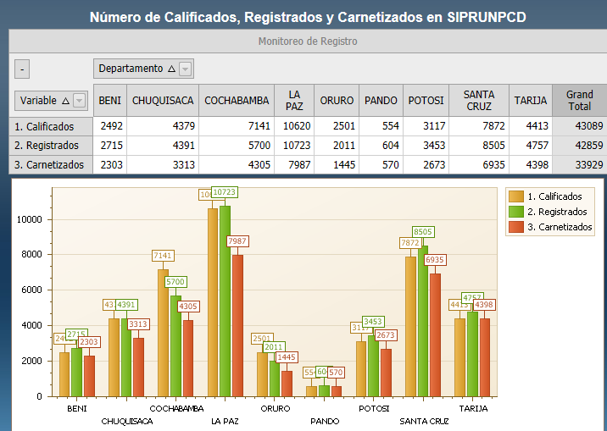
Source: PRUNPCD computerized data system.
Percentage distribution, by type of disability
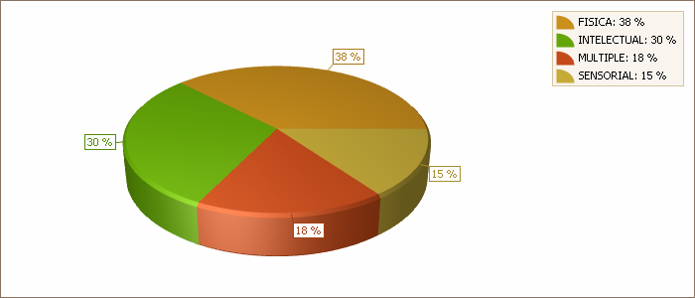
Source: PRUNPCD computerized data system.
Percentage distribution of persons with disabilities, by degree of disability
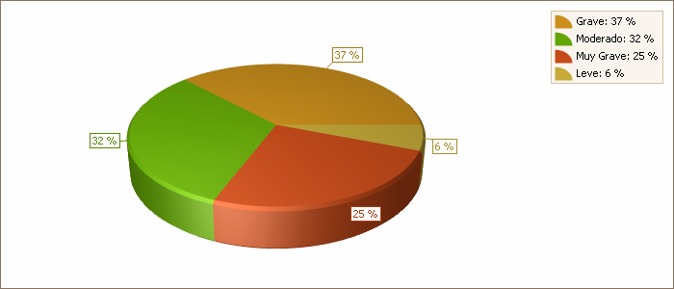
Source: PRUNPCD computerized data system.
Percentage distribution of persons with disabilities, by age group
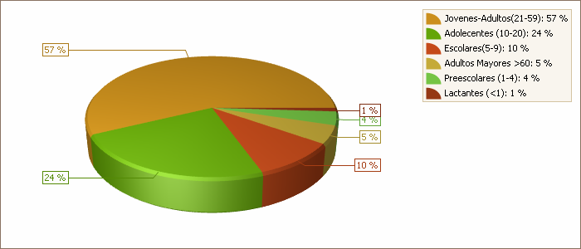
Source: PRUNPCD computerized data system.
Percentage distribution of persons with disabilities, by gender
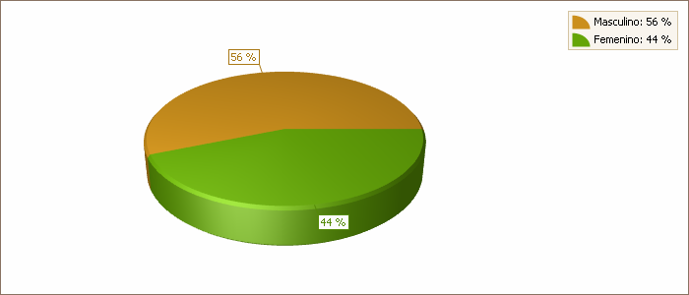
Source: PRUNPCD computerized data system.
Assistive technologies required by persons with disabilities
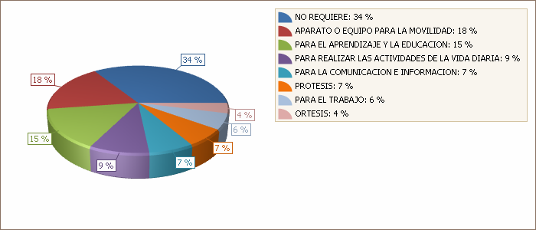
Source: PRUNPCD computerized data system.
Priority recommendations concerning persons with disabilities
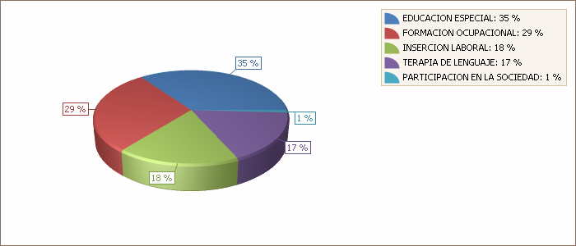
Source: PRUNPCD computerized data system.
Persons with disabilities, by educational level
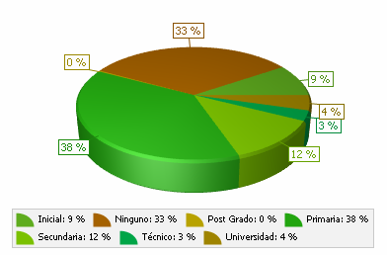
Source: PRUNPCD computerized data system.
Persons with disabilities, by occupation
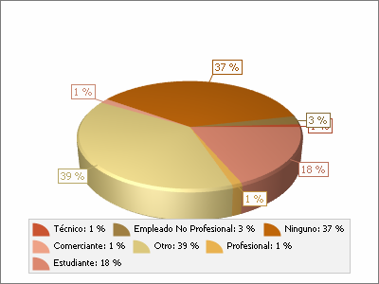
Source: PRUNPCD computerized data system.
Data on the “Moto Méndez” Solidarity Mission
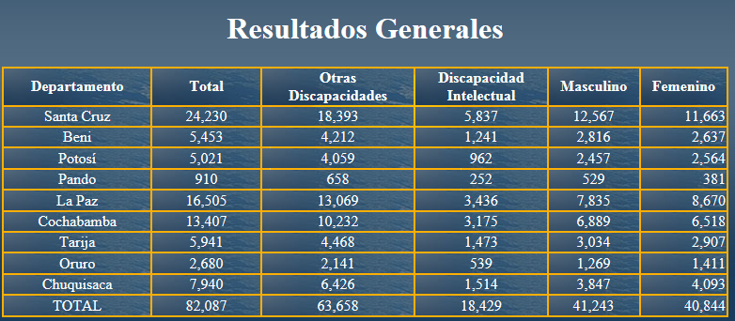
Source: PRUNPCD computerized data system.
54. Finally, the subject of statistical data is a major concern, which will be addressed by a study on disability in Bolivia to be undertaken when the official results of the 2012 census are published.
IV. Disability and poverty
55. The incidence of disability varies according to the characteristics of the populations in question. Disability depends not only on medical conditions but also on the interaction between physical, mental, intellectual or sensory impairments and a person’s environment.
56. In other words, disability is more serious when people are denied the opportunity to access the labour market, public services or simply education, thereby preventing them from being productive. Poverty generally affects the families of persons with disabilities, depriving them of decent housing, decent work and health care.
57. A World Bank document states that among the poorest people in the world, i.e. those living on less than a dollar a day and who are unable satisfy their basic needs including food, drinking water, clothing and housing, one in five is a person with disabilities.
58. It is important to note that the Government of Bolivia is working in disadvantaged areas of the country on programmes to combat poverty among persons with disabilities, such as the Community Intercultural Family Health–Community-Based Rehabilitation policy in the health sector.
59. In Bolivia, 10 per cent of the population faces some form of disability. Seventy-eight per cent of these people are living in a state of poverty and only 22 per cent are able to satisfy their basic needs; 95 per cent of them lack access to education. This is an alarming figure since it means that only 5 per cent have access to any form of study while in other cases they are obliged to drop out from school for a variety of reasons.
60. Poverty and discrimination are among the reasons why persons with disabilities cannot study; most of them drop out of school because they are not treated on equal terms.
61. The most worrying cases are found in rural areas since families prefer that children with some form of disability remain apart from society, with the result that they are generally not cared for adequately.
62. In the words of one person with disabilities who preferred to remain anonymous: “One of the difficulties that prevents us from pursuing our studies is discrimination by the teachers themselves, who think that because we need support, we are different, which is untrue since we are all special.”
63. It was also pointed out that persons with disabilities have few opportunities to secure a job and therefore have to create their own work, mostly by finding a niche in the commercial sector in order to provide for their families.
64. In Bolivia, levels of poverty and extreme poverty persist in the education and health sectors and in the area of environmental protection. Despite improvements, the country still suffers from very great inequalities.
65. In recent years, Bolivia has achieved a significant reduction in poverty and extreme poverty. However, over half the population (51 per cent or 5.2 million people) live in poverty and a quarter in extreme poverty (26 per cent or 2.7 million).
66. Persons with disabilities living in extreme poverty are mostly young. Hearing disabilities are more marked among women and intellectual and psychological disabilities among men.
V. Institutional aspects
67. The year 2009 marked a milestone in the history of the Plurinational State of Bolivia: for the first time, the people, exercising its sovereignty through a free and direct vote, decided to approve the new State Constitution, drafted by the Constituent Assembly and amended by the National Congress, and move towards the collective construction of a unitary, social, plurinational, communitarian, democratic, intercultural and decentralized, State, governed by the rule of law and with autonomous entities that deepen and consolidate a Bolivia whose watchwords are dignity, sovereignty, productivity and democracy.
68. At all levels of State — the Presidency, the Vice-Presidency, the executive branch and the established authorities — responsibilities and powers are regulated by the Constitution, the Framework Act on Autonomies, the General Persons with Disabilities Act and Supreme Decree No. 29894 (Organization of the Executive Body). Under the legislation, responsibility for the topic of disability is delegated to the different levels of State, in particular to the Ministry of Justice through the Office of the Deputy Minister of Equal Opportunities and its Directorate-General for Persons with Disabilities, established by Supreme Decree No. 29894 with effect from 2009.
69. The Directorate-General for Persons with Disabilities contributes to the construction of a country that takes increasing account of the disabled population within a State that guarantees respect and equality for all and a society that places great value on life and continually promotes participation. It plays the leading role in promoting the full respect and defence of the rights of persons with disabilities, believing that their dissemination is fundamental to the democracy, well-being and prosperity of society as a whole. Its action is founded on respect and equality for all in keeping with the principles of sovereignty, dignity, complementarity, solidarity, harmony and equity.
70. It also operates in the framework of articles 45 and 46 of General Act No. 223 and Supreme Decree No. 1457 of January 2013, which establishes and regulates the organizational structure of the National Committee for Persons with Disabilities (CONALPEDIS), a decentralized body attached to the Ministry of Justice.
71. For its part, the Ministry of Health and Sports, through the Office of the Deputy Minister of Health and Promotion and the Directorate-General for Health Promotion and its disability, rehabilitation and bio-psycho-social habilitation unit, has the following powers and responsibilities:
• Developing health policies, projects and programmes for persons with disabilities;
• Reintegrating persons with disabilities in society and guaranteeing their equal right to health without discrimination;
• Promoting the development of physical culture and sports at the preventive, recreational, formative and competitive levels for persons with disabilities through education, recreation and public health policies.
Responsibilities
• Assessing and monitoring health provision for persons with disabilities;
• Serving as the official representative of the Ministry of Health and Sports on the National Council for the Blind and the National Committee on Persons with Disabilities;
• Ensuring that persons with disabilities receive due care and attention and promoting their comprehensive rehabilitation, taking full account of the threefold dimension of the person with disabilities as a biological, psychological and social being;
• Providing for the assessment and registration at the national level of all persons with any degree of disability;
Activities
• Responsibility for the Central Register of Persons with Disabilities;
• Assessment of disabilities;
• Framing the proposal for community-based rehabilitation.
72. The Ministry of Education, through the Office of the Deputy Minister of Alternative and Special Education and its Directorate-General of Special Education, is responsible for children, adolescents, young people and adults with special educational needs in the national education system.
Responsibilities
• Framing policies in special and inclusive education;
• Guaranteeing permanent access to education for persons with disabilities;
• Ensuring follow-up and monitoring of the subsystem of alternative and special education in public, private and contract-based institutions;
• Promoting the continuing education of children and adolescents with disabilities.
Activities
• Preventing deficiencies and disabilities;
• Strengthening special education centres;
• Educational integration;
• Curriculum development;
• Overseeing the National Commission responsible for developing the special education curriculum.
73. The Ministry of Labour, Employment and Social Welfare, through the Office of the Deputy Minister for Employment, the Civil Service and Cooperatives and its Directorate-General for Employment and employment exchange in the field of disability, is responsible for the following:
Objectives
• Coordinating measures for reintegration in the labour market based on offer and demand and creating a special section for persons with disabilities;
• Promoting respect for the labour rights of workers and ensuring that employment is decent;
• Implementing policies and programmes for integration in the labour market and non-discrimination.
Activities
• Regulating private employment agencies to safeguard the social and labour rights of persons with disabilities.
74. The Ministry of the Office of the President through the Executive Unit of the National Solidarity and Equality Fund for Persons with Disabilities implements programmes and projects financed under Act No. 3925.
75. The Bolivian Institute for the Blind, a decentralized body with managerial autonomy, is responsible for developing plans, programmes and projects for the blind at national level, through its directorates in the country’s nine departments.
76. Title I, article 300, of the Constitution states: “The autonomous departmental governments have exclusive responsibility for the following activities within their jurisdiction: […] 30. The promotion and development of projects and policies for children and adolescents, women, the elderly and persons with disabilities”. There are departmental committees responsible for persons with disabilities (CODEPEDIS) in the nine departments.
77. Title I, article 302, of the Constitution states: “The autonomous municipal governments have exclusive responsibility for the following activities within their jurisdiction: […] 39. The promotion and development of projects and policies for children and adolescents, women, the elderly and persons with disabilities”. Municipal units responsible for persons with disabilities (UMADIS) are being created in all the municipalities.
VI. Civil society organizations providing services in the disability field
78. Civil society organizations play an important role in Bolivia in providing services for the integration of persons with disabilities.
79. Agreements for the allocation of resources (financial, material, human) are concluded with the Government in the framework of private initiatives and external cooperation activities. Most of these initiatives and activities concern not-for-profit civil associations subject to existing legislation. Other organizations form training institutions entitling them to conclude agreements with the State.
80. Major institutions concerned with disability that have successful experience in the field include.
Office of the Ombudsman
81. The Office of Ombudsman is a State body that works to ensure compliance with the rights of the persons with disabilities by following up complaints against public servants who violate those rights.
Permanent Human Rights Assembly of Bolivia
82. The Permanent Human Rights Assembly of Bolivia is a civil society organization that safeguards and defends human rights, concerning itself among other things with violations of the human rights of persons with disabilities.
83. Networks and alliances committed to improved monitoring of compliance with regulations and service delivery in the disability field include the Equity Network, comprising organizations and institutions working in the disability field and with its headquarters in La Paz, and the Country Programme consisting of organizations and institutions of persons with disabilities in receipt of external funding.
84. Other service delivery institutions have also developed successful experiments in Bolivia.
Development of Social Cooperation for Persons with Disabilities
85. Development of Social Cooperation for Persons with Disabilities (DECOOPSO) is an organization of and for persons with disabilities, created to support the development of social work cooperatives. It provides advice and guidance on joint working, aimed at developing shared paid work in a democratic and mutually supportive environment.
Bolivian-German Orthopaedics – orthoses and prostheses
86. Bolivian-German Orthopaedics (OBA) was created eight years ago and owes its name to the use of German technology and products such as replacement upper or lower limbs. Following four and a half years’ training in orthopaedics with “Fe y Alegría”, the founders formed a company providing La Paz with an additional facility in the sector.
87. Its most important function is the rehabilitation of persons with disabilities, whose everyday limitations prevent them from helping themselves a glass of water or going to the canteen, whereas with an artificial limb they can circulate and pursue their activities normally.
Chiqui-Trab, Educational Games
88. This is an organization that aims to provide children with disabilities with training in productive activities. Its educational resources project comprises a strong social component and commitment since without the cooperation of all there can be no future for our children.
“Fe y Alegría” Occupational Training Proposal
89. The Fe y Alegría movement promotes technical training for young people with special educational needs associated with disability in occupational workshops in special education centres by means of an occupational training programme.
Technical work training programme for school leavers, Education for Development Foundation (FAUTAPO)
90. The Foundation is developing a strategy to increase the employment opportunities, on an employee or self-employed basis, of school leavers of both sexes from low-income families faced by difficulties in integrating into society and the world of work. It involves training and work experience activities based on relevant linkages between the demand for labour and training opportunities.
91. The youngsters take on a new role, including shared responsibility for training activities.
VII. Specific information relating to implementation of the Convention
General provisions of the Convention (arts. 1 to 4)
92. The Bolivian State fully shares the aims of the Convention, which is the leading universal instrument for the promotion, protection and effective exercise, on the basis of equality, of all the human rights and fundamental freedoms of persons with disabilities.
93. The Bolivian State ratified the Convention by means of Act No. 4024 of 15 April 2009, having for the first time in its history incorporated the rights of persons with disabilities in the Constitution adopted in February 2009.
94. Based on the Convention and the Constitution, the General Persons with Disabilities Act No. 223 was promulgated by the Plurinational State of Bolivia on 2 March 2012.
95. The Act is aimed at establishing and strengthening a system of comprehensive protection for persons with disabilities by providing them with medical care, education, physical, psychiatric, social, economic and vocational rehabilitation, health cover including medical care and free medicines, integration in the labour market, decent work, solidarity and other allowances, and incentives that compensate for the disadvantages caused by disability and enable them to play a role in society in the same way as other people.
96. The definition of disability in General Act No. 223 may be said to be consistent with that contained in the Convention. Thus article 5 (a) of the Act defines disability as “the result of the interaction of a person having long-term or permanent physical, psychological, intellectual and/or sensory impairments with various physical, psychological, social, cultural and communicational barriers” and defines a person with disabilities as someone “with long-term or permanent physical, psychological, intellectual and or sensory impairments which, in interaction with various barriers, may hinder his or her full and effective participation in society on an equal basis with others”.
97. This definition can be seen to include both physical impediments (motor, sensory organic, visceral) as well as mental ones (intellectual and mental or psychological).
98. The public policies that the State has formulated to meet the needs of persons with disabilities are focused on the “long term”, as urged by the Committee.
99. Consistent with this long-term perspective, the Bolivian State advocates a unified approach to classifying, treating and caring for persons with disabilities.
100. It has given effect to the general principles and obligations established under articles 3 and 4 of the Convention, in particular the principle of non-discrimination.
101. Through the adoption of General Act No. 223, the principles set out in the Convention have been incorporated in the country’s legal system.
102. Act No. 2344 likewise incorporates in the domestic legal order the Inter-American Convention on the Elimination of All Forms of Discrimination against Persons with Disabilities.
103. In 2006, the executive branch initiated the National Plan on Equality and Equal Opportunities, adopted by Supreme Decree No. 28671 of 7 April 2006 (reflecting the approach to rights established in the Convention), which has as its focal points: universal accessibility; community and territory; gender, generations and ethnicity; culture, sports, tourism and recreation; education and employment; training, research and dissemination; and psychosocial health and rehabilitation.
Involvement of persons with disabilities, including women and children with disabilities, in the formulation, implementation and evaluation of legislation and policies to introduce the Convention.
104. The State acknowledges that there have been few specific measures to facilitate the participation of persons with disabilities, especially women and children, in framing legislation and policies on disability, in particular the General Persons with Disabilities Act No. 223.
105. The organizational structure of the National Committee for Persons with Disabilities (CONALPEDIS), adopted in the framework of General Act No. 223, provides for the participation in the Committee’s governing body of nine delegates from the Bolivian Confederation of Persons with Disabilities (COBOPDI). The Confederation’s membership includes all the departmental federations and municipal associations representing persons with disabilities and the different types of disability, which are gradually acquiring legal status in accordance with the right to free legal personality established by General Act No. 223.
106. The Directorate-General for Persons with Disabilities, established by Supreme Decree No. 29894 of March 2009, is structurally dependent on the Office of the Deputy Minister of Equal Opportunities, to which are attached the Directorate for Combating All Forms of Gender Violence and the Directorate for Children, Youth and the Elderly. The latter are responsible for implementing programmes aimed at recognizing the rights of children, young people and women, which include the topic of disability, and for developing strategies for preventing violence, particularly against children and women with disabilities. The programmes involve coordination between the Directorates concerned and the departmental and municipal governments.
Greater protection of the rights of persons with disabilities than those established under the Convention
107. Since the adoption of the Constitution, international conventions aimed at safeguarding human rights are given the highest priority. Article 256 of the Constitution provides that: “International human rights treaties and instruments signed, ratified or acceded to by the State, where they confer more favourable rights than those contained in the Constitution, take precedence over the latter”. This could be interpreted as meaning that human rights conventions such as the Convention on the Rights of Convention on the Rights of Persons with Disabilities rank higher than the Bolivian Constitution.
Article 5
Equality and non-discrimination
108. Article 71 of the Constitution prohibits any kind of discrimination, mistreatment, violence or exploitation directed at persons with disabilities. The State has also adopted affirmative action measures to promote the effective integration of persons with disabilities in the productive, economic, political, social and cultural sphere without discrimination.
109. The Act on the Elimination of Racism and All Forms of Discrimination No. 45, adopted on 8 October 2010, is aimed at establishing mechanisms and procedures to prevent and punish acts of racism and all forms of discrimination in the framework of the Bolivian Constitution and international treaties.
110. In Bolivia, when a person with disabilities finds that his or her rights have been infringed, the problem is resolved in the first instance by means of reconciliation; if this does not result in a satisfactory solution, the next step is for the person to have recourse to legal action in the same way as everyone else, since no other special provision exists in this regard.
111. Over the last three years, the executive branch has taken measures through the directorates responsible for the topic of disability to prevent discrimination, with particular reference to:
• Architectural accessibility, public buildings, transport, communications, information and public spaces;
• The right to education on an equal basis;
• The right to decent work and fair remuneration in accordance with the capabilities and potential of the person concerned;
• The right to communication in an alternative language;
• The right to decent treatment and equal opportunities in the productive, economic, political, social and cultural domain without discrimination of any kind.
Article 6
Women with disabilities
112. On the question of gender equality, the State recognizes that women and girls with disabilities are subject to multiple discrimination, which is the reason for the adoption in 2008 of the National Equal Opportunities Plan “Women Building a New Bolivia for Good Living” including six development priorities, namely education, health, gender violence, institutional reinforcement, citizenship and political participation, and economic, productive and employment rights.
113. The Constitution promulgated in 2009 contains various articles on women’s rights, including:
• Article 8 (II): “The State is founded on the values of unity, equality, inclusion, dignity, liberty, solidarity, reciprocity, respect, interdependence, harmony, transparency, equilibrium, equality of opportunity, social and gender equality in participation, common welfare, responsibility, social justice and the distribution and redistribution of social goods and assets, for Good Living”;
• Article 11 (I): “The State adopts a participatory, democratic, representative and communal form of government, based on equality between men and women.
• Article 14 (II): “The State shall prohibit and punish all forms of discrimination based on sex, colour, age, sexual orientation, gender identity, origin, culture, nationality, citizenship, language, religious belief, ideology, political or philosophical affiliation, marital status, economic or social status, occupation, level of education, disability, pregnancy or any other ground that has the purpose or effect of nullifying or impairing the equal recognition, enjoyment or exercise of the rights of all people”;
• Article 15 (II): “All persons, in particular women, have the right to be free from physical, sexual or psychological violence, in both the family and society”; (III): “The State shall take the necessary steps to prevent, eliminate and punish gender-based and generational violence, as well as any act or omission that is intended to debase the human condition or cause death, pain and physical, sexual or psychological suffering, in both the public and the private sphere;
• Article 26 (I): “All citizens have the right, individually or collectively, to participate freely in the formation, exercise and control of political power, directly or through their representatives. Participation by men and women shall be equitable and on an equal basis;
• Article 45 (I): “Every Bolivian has the right to social security”; (II): “Social security benefits shall be based on the principles of universality, comprehensiveness, fairness, solidarity, equal treatment, economy, timeliness, interculturality and efficacy. The social security system shall be managed and administered by the State with the supervision and participation of society”; (III): “The social security system shall cover: treatment for sickness, epidemics and catastrophic illnesses; maternity and paternity; occupational hazards and hazards related to farming; disability and special needs; unemployment and loss of work; orphanhood, widowhood and widowerhood, old age and death; housing, family allowances and other forms of social provision”; (V): “Women have the right to safe maternity, with due attention being paid to intercultural views and practices. They shall receive special assistance and protection from the State during pregnancy and childbirth and in the prenatal and post-natal periods”;
• Article 48 (V): “The State shall promote women’s employment and shall guarantee them the same remuneration as men for work of equal value, in both the public and private sectors”; (VI):”Women may not be discriminated against or dismissed on account of their marital status, pregnancy, age, physical traits or number of children. Pregnant women and parents enjoy security of employment until their child has reached one year of age;
• Article 66: “Women and men are guaranteed exercise of their sexual and reproductive rights”;
• Article 300: “The autonomous departmental governments have exclusive authority over the following activities within their jurisdiction (…) 30: “Promotion and development of projects and policies for children and adolescents, women, the elderly and persons with disabilities”;
• Article 302: “The autonomous municipal governments have exclusive responsibility for the following activities within their jurisdiction (…) 39: “The promotion and development of projects and policies for children and adolescents, women, the elderly and persons with disabilities”.
114. In 2009, Supreme Decree No. 29894 on the organizational structure of the executive branch established the Office of the Deputy Minister of Equal Opportunities under the Ministry of Justice, with the following functions:
(a) Formulating, directing and coordinating policies, regulations, plans, programmes and projects to promote equal opportunities for women and men, children, adolescents, young people, the elderly and persons with disabilities;
(b) Promoting compliance with the Constitution and international instruments on equitable treatment regardless of gender, age or disability status;
(c) Proposing and furthering the integration of the principle of equal opportunity in the autonomous territorial entities;
(d) Evaluating and monitoring the execution and fulfilment of gender equality and equal opportunity plans, programmes and projects by autonomous territorial entities;
(e) Promoting gender mainstreaming and intergenerational equality of opportunity in sectoral and public management policies in collaboration with State bodies and civil society organizations;
(f) Formulating, coordinating and implementing national policies with the autonomous territorial entities to defend, protect and promote the rights of women, children, young people, the elderly and persons with disabilities;
(g) Formulating rules and standards to strengthen mechanisms for preventing and punishing gender and generational violence and institutional abuse and for protecting, caring and rehabilitating victims;
(h) Coordinating, managing and supervising in the autonomous territorial entities the allocation of economic resources for implementing policies, plans, programmes and projects with a gender focus and projects aimed at children, adolescents, young persons, the elderly and persons with disabilities.
(i) Coordinating, developing and monitoring, with the autonomous territorial entities, policies and standards for safeguarding the rights of women, men and families and the best interests of children and adolescents.
115. Three national offices have been established to perform the duties assigned to the Office of the Deputy Minister of Equal Opportunities:
(a) The National Office for Persons with Disabilities;
(b) The National Office for Children, Young People and the Elderly;
(c) The National Office for the Prevention and Eradication of Any Form of Gender or Generational Violence.
116. The topic of disability, as well as that of gender, children, adolescents, young people and the elderly, has been mainstreamed in all three offices.
117. The Plurinational State of Bolivia has also incorporated in Act No. 026 on the electoral register articles promoting the participation of women:
• Article 1 (Purpose);
• Article 2 (Principles of intercultural democracy) (h);
• Article 4 (Political rights) (c), (d), (e) and (h);
• Article 6 (Intercultural democratic culture);
• Article 11 (Equal conditions) (a), (b) and (c);
• Article 54 (Election of senators) (paras. I and II);
• Article 58 (Election of members of the Chamber of Deputies from multi-member districts) (paras. I and II);
• Article 62 (Forma of election);
• Article 79 (Organization of voting):
• Supreme Court of Justice;
• Agricultural and Environmental Court;
• Council of the Judiciary;
• Plurinational Constitutional Court;
• Article 91 (Foundation);
• Article 92 (Supervision);
• Article 93 (Guarantees for community democracy);
• Article 112 (Precepts of electoral propaganda);
• Article 139 (Voting slip) (d);
• Article 158 (Order of voting).
118. A range of other legislative provisions guarantee the implementation of measures to ensure that women and girls with disabilities achieve their full development and to enable them to exercise and enjoy the human rights and fundamental freedoms laid down in the Convention. The statutes concerned are those included in the Compendium of Gender Laws and Norms in the Plurinational State of Bolivia produced by the Ministry of Justice, namely:
• Act No. 045 against racism and all forms of discrimination (2010);
• Act No. 018 on the plurinational electoral body (2010);
• Act No. 243 against harassment and political violence (2012);
• Comprehensive Act No. 263 on human trafficking and smuggling (2012);
• General Act No. 223 on persons with disabilities;
• Comprehensive Act No. 348 guaranteeing women a life free from violence (2013);
• Supreme Decree No. 29850 of 10 December 2008 adopting the Equal Opportunities Plan;
• Supreme Decree No. 1053 on the National Day against All Forms of Violence against Women (2011);
• Supreme Decree No. 1022 on the Day to Combat Homophobia and Transphobia (2011);
• Supreme Decree No. 1363 on the Committee to Combat All Forms of Violence against Women (2012).
119. Comprehensive Act No. 348 guaranteeing women a life free from violence, promulgated on 9 March 2013, is mainly aimed at eradicating and preventing all kinds of violence against women. Despite all these measures, the State recognizes that the programmes and projects designed to ensure gender equity have not been specifically focused on women with disabilities.
120. It should also be recognized that while the promotional material produced and distributed regarding persons with disabilities has included women with disabilities, the measures taken remain inadequate to bring into focus and safeguard the rights of this population group.
121. The leadership role of women in the organization of persons with disabilities has however been spotlighted. For example, three of the four top posts in the governing body of the Bolivian Confederation of Persons with Disabilities (COBOPDI), the main organization representing this community, are occupied by women. The Presidents of the National Federation of the Blind in Bolivia (FENACIEBO) and the Bolivian Federation of the Deaf (FEBOS) are also women, with hearing and visual disabilities respectively.
122. In its 2011 report, the Ombudsman’s Office also included a study on the human rights situation of women with disabilities. This new line of work by the Ombudsman’s Office is aimed at providing public and private institutions and the public in general, with information on the situation of women with disabilities in a world marked by exclusion, discrimination and silence
123. There is an urgent need, then, to find ways of protecting women with different types of disability so that they can exercise their rights in an unfavourable context where their situation is made worse by being a woman and, above all, a woman with disabilities.
124. Finally, the promulgation in March 2012 of Act No. 223 established a set of general principles, rights and duties with regard to women with disabilities. The Directorate for Persons with Disabilities coming under the Ministry of Justice has proposed a draft plurinational public policy for persons with disabilities, including women.
Article 7
Children with disabilities
125. Bolivia has taken measures to ensure that children enjoy all their rights, ensuring that those with disabilities have the same rights to freedom and equal opportunities as other children of the same age. The State, society and the family thus have a duty to safeguard the best interests of children and adolescents. Those interests include the pre-eminence of their rights, priority protection and assistance in all circumstances, preferential care by public and private services, and swift and timely access to the administration of justice with the help of specialized staff.
126. The Bolivian State has taken measures that demonstrate its strong commitment to legislative change in furtherance of “Good Living” and reflect the spirit of transformation regarding the situation of children.
127. Thus the Constitution, in articles 58, 59, 60 and 61, recognizes and raises to constitutional rank the rights of children and adolescents. It stresses the right to family, to comprehensive development, to parenthood without discrimination and to identity; it also prohibits and punishes any form of violence, forced labour and exploitation with regard to children and adolescents. It likewise affirms the principles of shared responsibility, noting that the State at all levels, society and the family have a duty to safeguard the best interests of children and adolescents, meaning the pre-eminence of their rights, priority protection and assistance in all circumstances, preferential care by public and private services, and swift and timely access to the administration of justice with the help of specialized staff.
128. Article 58 of the Constitution provides that children and adolescents have the inherent right to comprehensive development and the satisfaction of their needs, interests and aspirations, while article 59 in its five paragraphs states that every child has, among other things, the right to comprehensive development, to family life, to identity and to political, social, economic, cultural and cultural activity without discrimination.
129. Article 60 of the Constitution refers to the duty of the State, society and the family to ensure the primacy of the best interests of the child.
130. Article 61 of the Constitution prohibits and punishes any violation of statutory rights.
131. With regard to age range or age, the law considers any child or adolescent to be a minor, understood as someone under 18 years of age. Some clarification of terminology is necessary here for while the law and some areas of legal doctrine insist on using the terms “child and adolescent”, the Constitution refers to a “minor” since it considers that the term is in no way derogatory or pejorative but simply denotes the situation of a person who has not yet attained the age of majority.
132. In the legislative sphere, mention should be made of Act No. 2026 on the Children’s Code and Supreme Decree No. 26086 regulating the text. The Code establishes and regulates the system of prevention, protection and comprehensive care that the State and society should guarantee to every child and adolescent to ensure their physical, mental, moral, spiritual, emotional and social development in conditions of freedom, respect, dignity, equity and justice.
133. The State adopted these principles in compliance with the commitments made when ratifying the Convention on the Rights of the Child, an international instrument that because of its binding nature obliges the State to guarantee children and adolescents the means for enforcing their rights. On the occasion of Children’s Day, the Ministry of Justice, Cecilia Ayllón, accordingly submitted to the nation a “preliminary draft of the Children’s Code”, which guarantees minors full exercise of their rights to comprehensive development. Once adopted and promulgated, it will provide for the protection of children and adolescents with disabilities, as well as those whose parents are in detention. It also includes provisions on the right to nationality, identity and parentage, the protection of adolescents in the workplace, access to justice and protection against violence, and it seeks to regulate the system of prevention, protection and guardianship regarding those rights and to assign the corresponding responsibilities.
134. The draft bill likewise defines the powers of the departmental governments, the central government and the municipalities, in keeping with the provisions of the Constitution and the Framework Act on Autonomous Entities. It provides for the distribution of the related powers and responsibilities through a system of protection for children and adolescents that rests essentially on the competencies of central government, the departmental and municipal governments and the autonomous territorial governments of the indigenous and aboriginal campesino peoples and nations.
Article 8
Awareness-raising
135. The Bolivian State is committed to implementing measures to raise awareness throughout society of the rights of persons with disabilities and to foster respect for their dignity.
136. Since 2009, the Directorate-General for Persons with Disabilities has introduced measures to combat stereotypes, prejudices and harmful practices relating to persons with disabilities.
137. These measures are strongly reinforced by the presence throughout the country of bodies responsible for the human rights and protection of persons with disabilities, acting in coordination with autonomous territorial entities such as the departmental and municipal governments.
138. The Ministry of Justice, through the Directorate-General for Persons with Disabilities, has drawn up a nationwide plan applicable in each department and has defined an approach involving crosscutting measures by the different bodies operating in the autonomous territorial entities. Specific work on disability has also been carried out in the Ministry of Health and Sports, the Ministry of Labour, the Ministry of Education, the Ministry of the Office of the President, the Ministry of Public Works, Services and Housing, the Ministry of Foreign Affairs and the Ministry of Communications.
139. This inclusive approach has also made it possible to coordinate measures with civil society through the equity network of institutions and organizations working with persons with disabilities.
140. These activities have been strengthened by the structural and administrative organization of the Ministry of Justice, which includes among its services the Directorate-General for Persons with Disabilities and which is also responsible for the decentralized National Committee for Persons with Disabilities (CONALPEDIS). In each department of the country there is a Departmental Committee for Persons with Disabilities (CODEPEDIS), with a director and a governing body. At the municipal level, units responsible for caring for persons with disabilities are being set up in keeping with Act No. 223.
Training on aspects of disability
141. A project on the development of technical capacities for inclusive rehabilitation in Bolivia has been implemented with the tripartite cooperation of Chile, Bolivia and Japan. Its executing agency is the Universidad Mayor de San Andres in La Paz, which in 2001 inaugurated speech and occupational therapy courses in the Faculty of Medicine in coordination with staff from the disability, habilitation and rehabilitation unit of the Ministry of Health and Sports. These degree-level courses cater for future specialists in the habilitation and rehabilitation of persons with disabilities.
142. In 2010, a human resources training programme was implemented by health-care specialists in coordination with the Ministry of Health and Sports and with the support of the sister Republic of Cuba. Forming part of the Bolivarian Alternative for the Americas (ALBA) Solidarity Mission, it involved the training of human resources in genetics counselling and comprehensive care for persons with disabilities.
143. The second session of the training course took place this year in Santa Cruz. Steps are now underway to enable these professionals to specialize in physical medicine and rehabilitation.
144. The Directorate-General for Persons with Disabilities is also developing a strategy to promote awareness of the rights of persons with disabilities through information workshops on disability regulations. The workshops are aimed at training and sensitizing departmental and municipal authorities and leaders to the issue of social inclusion, with or without disability. The aim is to build capacity throughout the departments and different population groups so that people, particularly in the municipalities, can make the strategy their own and become promoters of rights, in their families, their neighbourhoods and their communities.
145. In addition, the Directorate-General for Persons with Disabilities is continually engaged in activities, including talks, seminars, lectures and debates, to raise awareness of the regulations concerning disability, in coordination with non-governmental organizations, universities, training centres and organizations of persons with disabilities.
146. In 2011, a communication campaign on the rights of persons with disabilities was broadcast on a national radio station in a programme called “Let’s talk about disability”. Thirty mini-programmes were also broadcast on all community radios stations in the three main indigenous languages, i.e. Quechua, Aymara and Guaraní. The prevention of disability and the rights of persons with disabilities were also the subject of television spots that were well received by the general public. Authorities from many sectors, including health, education, labour, justice, the police and public transport, participated in the campaign, which received wide coverage in the national media.
147. The Bolivian State, through its various agencies, is also conducting awareness campaigns to focus attention on the situation of persons with disabilities. For example, the Directorate-General for Persons with Disabilities is pursuing strategies through the media (television, radio, street adverts, the press, leaflets and posters) to inform the public about the rights of persons with disabilities and bring about a change of social attitudes and behaviour, starting with the elimination of discriminatory language still found in certain media.
Public awareness campaigns
148. Activities to mark the National Day of Persons with Disabilities, established by Supreme Decree No. 27837 of 12 November 2004, include the organization of events in most of the country’s municipalities to foster reflection, awareness and recognition with regard to persons with disabilities. The activities last for the most part throughout the week or month of this important date (15 October). Other major awareness activities take place on the International Day of Persons with Disabilities with the participation of public and private organizations, firms and the media, which organize activities every year to promote the integration of persons with disabilities in society, education, culture and the workplace. Fairs and festivals for persons with disabilities have been organized in the last three years, the Ministry of Labour having declared 15 October to be a rest day for Persons with Disabilities as well as for the parents or guardians of children with disabilities.
149. The media, specifically national television programmes, have also carried reports and testimonies by persons with disabilities who, through their tireless efforts, skills and initiatives, have overcome the adversities and difficulties confronting them, One example of these programmes paying tribute to the initiatives of persons with disabilities is the “Bolivianos de Oro” programme broadcast daily by the UNITEL national television network.
Dissemination of the Convention
150. The Convention has been disseminated in various forums, in particular the workshops to publicize the instrument organized in 2009 and 2010 in all the departmental capitals and the country’s main municipalities. Forty workshops were held for different target groups, mainly civil society organizations, and specialists in fields relating to disability were invited to attend. These workshops were very useful in the drafting of the General Act No. 223, which has already come into force; work on its implementing decree is still in progress.
151. An inter-agency and civil society consultation is taking place in all departments on the drafting of the Plurinational Plan on Disability, based on the articles and aims of the Convention.
152. Awareness-raising campaigns have been undertaken in the main cities of Bolivia financed by resources from the budgets of the respective municipal governments, including those of La Paz, Cochabamba and El Alto, and the departmental governments of La Paz, Cochabamba, Beni and Chuquisaca. Some 60 per cent of the municipalities and nine departmental governments have made budgetary provision in their annual operating plans for activities to promote awareness of the rights of persons with disabilities.
153. In addition, copies of the Convention in Braille and digital format for blind and deaf persons have been distributed by the Ombudsman’s Office and the Office of the United Nations High Commissioner for Human Rights, together with an audio description version of the Convention.
Article 9
Accessibility
154. The State has taken the following measures to enable persons with disabilities to live independently. Article 21, paragraph 7, of the Constitution provides that all Bolivians have the right to freedom of residence, sojourn and movement throughout Bolivian territory, including the right to leave and enter the country.
155. Accessibility has been regulated through General Act No. 223, which states that “The Plurinational State of Bolivia at all levels guarantees the right of persons with disabilities to special programmes and projects for decent and adequate housing”.
156. The State guarantees the right of persons with disabilities to enjoy conditions of accessibility enabling then to make independent use, despite their disability, of the infrastructure and services of public and private institutions, public spaces, media, communication systems, technologies and transport and to require that State institutions adopt affirmative action measures to facilitate exercise of this right.
157. All State bodies at the different levels as well as public and private institutions must, following the promulgation of this Act, progressively adapt their architectural structures, systems, media and transport facilities to guarantee access by persons with disabilities.
158. New constructions, systems, media and transport facilities must meet the accessibility requirements stipulated in this Act following its promulgation.
159. The necessary measures must likewise be taken to earmark a percentage of the social housing budget for the adaptation of accommodation to meet the needs of persons with disabilities, in which connection the Ministry of Public Works, Services and Housing has implemented a pilot phase of the PROESHA project.
160. Specific legislative measures on accessibility are currently being drafted with regard to urban architecture and transport. These policies and their implementation are governed by General Act No. 223, of which paragraph III of article 37 (Accessibility of infrastructures and other rights) provides that new constructions, systems, media, communication media and transport systems must comply with accessibility standards.
161. Public institutions, private services and educational establishments are obliged to provide alternative means of communication and Bolivian sign language interpretation for persons with hearing disabilities. This measure is being implemented through the Ministry of Education in coordination with the Bolivian Sign Language Council forming part of the Bolivian Federation for the Deaf.
162. Similarly, pursuant to article 36 of General Act No. 223, drafting is taking place of the regulations applicable to public and private media, providing for the inclusion of Bolivian sign language interpretation in programmes of general, cultural, recreational, political, educational and social interest, and for the use of appropriate technology as a substitute for sound information in programmes for which the Ministry of Communication is responsible.
163. In the case of, the Financial System Supervisory Authority (ASFI), the regulation is aimed at defining questions relating to the responsibility of internal oversight bodies for monitoring financial intermediation institutions and auxiliary financial services in accordance with articles 28, 97, 98 and 108 of the Banking and Financial Entities Act and the relevant provisions of the Commercial Code.
164. In accordance with ASFI resolution No. 796/2012, the regulations are applicable to all the financial intermediation institutions and auxiliary financial services possessing an operating licence issued by the Office of the Superintendency of Banks. They stipulate that measures must be taken to ensure the accessibility of premises for persons with disabilities, including infrastructure modifications to reduce architectural obstacles by means of signage systems and alternative forms of communication adapted to persons with disabilities. The provisions also set a September 2013 deadline for the adoption of the measures.
165. With the aim of eliminating financial exclusion, article 25 of General Act No. 223 also requires the State to promote access by persons with disabilities to credit and/or microcredit programmes for business and self-employment projects, in which connection ASFI should adapt the loan policy of the financial institutions accordingly.
Article 10
Right to life
166. The Bolivian Constitution guarantees the protection of fundamental rights: the right to life and to physical, psychological and sexual integrity; no one may be tortured or subjected to cruel, inhuman, degrading or humiliating treatment; and there is no death penalty
167. The Constitution protects all people, particularly women, who cannot be subjected to physical, sexual or psychological violence, whether in the family or in society.
168. General Act No. 223, adopted on 2 March 2012, guarantees the right to life from conception to persons with disabilities, as to all other persons.
169. In addition, the Bolivian State is a party to international treaties that guarantee this fundamental right.
Article 11
Situations of risk and humanitarian emergencies
170. The Ministry of Defence was established in 2009 following the promulgation of the Constitution. In accordance with Ministerial Resolution 1267/2005, the responsibilities attaching to the defence portfolio under the powers assigned to central government by the Constitution include:
• Guaranteeing effective action by the Armed Forces in maintaining the independence, security, sovereignty and territorial integrity of the Plurinational State; furthering the presence of the Armed Forces in the border security areas to ensure territorial integrity and the preservation of strategic natural resources; and participating in the inclusive and sustainable development policies of these areas.
171. In this connection, the Ministry of Defence is also responsible for formulating and proposing policies and international agreements aimed at promoting a culture of peace and the right to peace by ensuring regional defence and security of the continent. In accordance with Supreme Decree No. 29894, the Ministry incorporates two deputy ministries: the Office of the Deputy Minister of Defence and Cooperation for Comprehensive Development and the Office of the Deputy Minister of Civil Defence, comprising the Department of Emergencies and Assistance and the Department of Prevention and Reconstruction. The Ministry also has a Directorate-General for Human Rights and Interculturality in the Armed Forces.
172. The functions of the Office of the Deputy Minister of Civil Defence include:
• Proposing risk management policies and strategies for incorporation in the National Planning System and the Public Investment Programme;
• Planning and coordinating risk prevention and reduction measures in conjunction with departmental, regional and municipal governments, representatives of the indigenous and aboriginal campesino nations and peoples, and national and international public and private bodies;
• Planning and implementing planning, warning, response, rehabilitation and reconstruction activities in case of emergency situations and natural, technological and man-made disasters, in coordination with departmental, regional and municipal governments, representatives of the indigenous and aboriginal campesino nations and peoples, and national and international public and private bodies;
• Systematizing and administering information on risk reduction and emergency and disaster response;
• Directing the Technical Secretariat of the National Council for Disaster Reduction and Emergency Response (CONARADE);
• Coordinating with the Ministry of the Economy and Public Finances and the Ministry of Development Planning the channelling of technical and financial cooperation for the development programmes and projects for civil defence in emergency and disaster situations.
173. In this connection, the Office of the Deputy Minister of Civil Defence provides humanitarian aid each year to thousands of families affected by floods, droughts, hailstorms, landslides, forest fires and other natural disasters.
174. It also trains its staff and populations living in the most vulnerable municipalities in the prevention and reduction of all kinds of risks and humanitarian emergencies.
175. Under the National Contingency Plan, prepared by each department, the Office of the Deputy Minister of Civil Defence through its supplies and emergency and rescue services is the coordinating body responsible for comprehensive disaster risk management at the different territorial levels, with the participation of sectoral, public and private bodies and national and international organizations, in the service of civil society, vulnerable groups and families affected by disasters..
176. Since the beginning of January, humanitarian assistance by the Office of the Deputy Minister of Civil Defence under the 2013 Contingency Plan has focused on the distribution of 162 tonnes of food, supplies and working tools to municipalities affected by rain, hailstorms and floods in the departments of La Paz, Cochabamba, Tarija and Potosí.
177. The Civil Defence report for the month of January recorded over 6000 families affected by hailstorms, floods and overflowing rivers; they have been assisted with tents, cooking utensils and seeds in regions where the potato, bean, papa liza, maize, corn and fruit crops have been lost.
178. The work of organization and coordination with the autonomous municipal and departmental governments has also begun in regions most vulnerable to the effects of the rainy season in order to direct prevention and rapid response activities by the civil defence in risk situations and humanitarian emergencies.
179. In this respect, the Office of the Deputy Minister of Civil Defence has no specific protocols for dealing with persons with disabilities; however, under Act No. 223 and in coordination with the Human Rights Directorate, ministerial resolution 0755 has been drafted authorizing the Directorate-General responsible for the territorial army to issue a free military passbook stamped “disabled” to persons with disabilities requesting it
180. The Ministry of Defence is able in this way to coordinate with institutions specializing in disability.
Article 12
Equal recognition before the law
181. For the first time in the country’s history, the Bolivian Constitution includes provisions on the rights of persons with disabilities.
182. All persons with disabilities have the right to protection by their family and the State; to free education and comprehensive health care; to an alternative language of communication; to adequate working conditions, in keeping with their possibilities and abilities, together with fair remuneration enabling them to live decently; and to the development of their individual potential.
183. It also requires the State to ensure that persons with disabilities receive comprehensive prevention and rehabilitation services as well as other legal benefits.
184. The Bolivian Civil Code, which has yet to be brought into line with the Constitution, contains a number of examples of discriminatory terminology that serves to restrict the rights of persons with disabilities, namely:
• Unable to work: minors and persons subject to interdiction;
• On the ability to conclude a contract, the Civil Code establishes that any legally competent person can conclude a contract;
• Minors, persons subject to interdiction and, in general persons legally prohibited from giving their consent are unable to conclude a contract;
• A contract concluded by a person not subject to interdiction but incapable of informed consent at the time the contract was signed is considered to have been made by a legally incompetent person where the said contract results in serious damage to its author or if there is bad faith on the part of the other contracting party.
185. On the ability to make a donation, the Civil Code provides that any person having the capacity to dispose of their property may make a donation. In the case of a donation by someone “incapable of informed consent”, which become discriminatory terms, the Civil Code provides that a donation made by an adult who, while not subject to interdiction, is proved to have been incapable of informed consent when doing so, can be annulled at the request of the donor, his or her heirs or successors.
186. The Civil Code also contains a provision prohibiting donations by, and limiting the capacity to receive donations from, persons declared legally incompetent, stipulating that parents and guardians representing the legally incompetent person cannot make donations or accept them on behalf of the incompetent person they represent if the said donations are subject to conditions and obligations, except where the transaction serves the interest of the legally incompetent person and the judge grants permission.
187. On the capacity to grant a mandate, the Code provides that the principal must be legally competent to authorize the act in question. Mandatory power can be vested in anyone capable of entering into a contract, except where the law imposes special conditions. It can even be vested in a person who is legally incompetent to enter into a contract but who is capable of informed consent.
188. The Code of Civil Procedure provides that legally incompetent persons can only make statements during legal proceedings through their parents or guardians. If during the proceedings incompetent persons become capable, the proceedings will continue with their participation. If persons acting on their own behalf should die or become legally incompetent, the judge having ascertained the fact will suspend the proceedings and order the heirs or guardian to attend the court and assume the defence within 30 days, the trial being resumed at the stage that it had reached. On the expiry of the time limit, if the legally incompetent person has no guardian, the judge will appoint one ad litem
189. With regard to witnesses, the Code of Civil Procedure provides that any person over 14 years of age can be proposed as a witness and has the duty to appear and make a statement. No credence shall be given to witnesses suffering from insanity or to blind or deaf persons in relation to facts perceptible by sight or hearing. In the case of deaf, mute or deaf-mute persons, interpreters shall be appointed to question those who can only make themselves understood through gesture or a specialized language. These terms will be modified in the new Code of Civil Procedure, which will be drafted in accordance with the provisions of the existing Constitution.
190. Others identified as being incapable of testifying are: minors below the age of 16; persons subject to interdiction; persons who are not of sound mind, for whatever reason, when taking the oath; and deaf-mute or dumb persons unable to write. These wholly discriminatory terms used to describe persons with hearing disabilities have been modified by article 38 of the General Persons with Disabilities Act (Access to justice), which provides: “The Plurinational State of Bolivia shall ensure that persons with disabilities have access to justice and psychological, social and communicational help on an equal basis with others by mainstreaming legal provisions to facilitate their effective role as direct and indirect participants, including as witnesses, in all legal proceedings”.
191. To ensure that persons with disabilities have effective access to justice, the State will encourage the training of judicial personnel and administrators, including police officers and prison staff.
192. In any case, domestic jurisprudence and the Civil and Civil Procedure Codes are advancing in keeping with the Constitution and international norms, as evidenced by constitutional court judgements that have enabled persons with disabilities, following a series of studies, to exercise their rights and intervene in legal proceedings as witnesses.
193. Pursuant to General Act No. 223, persons with disabilities in Bolivia have a right to poverty reduction policies, economic advancement, access to loans, self-organization in cooperatives, and microfinance for businesses in the social economy – rights regulated by the appropriate government bodies. They also have an equal right not to be arbitrarily deprived of their property.
194. Persons with disabilities exercise their citizenship fully and without restriction in accordance with constitutional provision.
Support in the exercise of legal capacity
195. The Ministry of Justice and the Ministry of the Office of the President provide free legal advice services to persons with disabilities. The aim of these services is to ensure that the legal capacity of persons with disabilities is recognized, and various rulings of the courts are designed to ensure that rights are not restricted unnecessarily.
196. These services deal with complaints and requests by persons with disabilities and members of their families for guidance concerning their rights. They also handle issues such as domestic violence, family assistance, discrimination, tax exemptions on the import of assistive technologies and procedures for founding civil associations of and for persons with disabilities.
197. Currently persons with disabilities can exercise the right to elect and be elected in accordance with article 18 of General Act No. 223, which includes the right to enter the voting booth accompanied by a person of their choice in order to obtain the necessary help.
Article 13
Access to justice
198. Article 72 of the Constitution states: “The State shall guarantee comprehensive prevention and rehabilitation services to persons with disabilities, as well as other benefits established by law”. In compliance with this constitutional provision, General Act No. 223 provides a guarantee of the exercise of this right in article 38 (Access to justice).
199. Article 179 of the Constitution establishes that the judiciary is a single entity, ordinary jurisdiction being exercised by the Supreme Court of Justice. Article 30 of the Judiciary Act defines the principles of ordinary jurisdiction, establishing in principle 9 (Accessibility) that every person, indigenous and aboriginal campesino nation or people, citizen or intercultural and Afro-Bolivian community shall have access to the courts in order that justice may be done.
200. In accordance with these articles and in view of the special characteristics of persons with disabilities, the Supreme Court is currently drafting provisions, based on its rules of procedure, establishing the conditions governing access to justice by persons with disabilities. For example, a decision of the plenary chamber of the Supreme Court will be issued stating that persons with disabilities can participate in judicial proceedings as witnesses, with the exception of those with severe or acute disabilities requiring the presence of another person to carry out their everyday activities; moreover, in application of General Act No. 223, training workshops on alternative means of communication — such as Bolivian sign language for the deaf and the Braille system for the blind — will be organized for judicial personnel and administrators.
201. Article 38 (Access to justice) of General Act No. 223 provides that the State will ensure that persons with disabilities have access to justice — including psychological and social assistance and aids to communication — on an equal basis with others. This provision will be mainstreamed to enable those concerned to participate, directly and indirectly in all legal proceedings, including as witnesses.
202. To ensure that persons with disabilities have effective access to justice, the State will promote appropriate training for judicial personnel and administrators, including police officers and prison staff.
203. This legal provision recognizes the right of persons with disabilities to have effective access to justice on equal terms with others, without being excluded from judicial procedures.
204. Regarding the legal institution of marriage, mental health is one of the requirements for entering into marriage. Under the Family Code, a person subject to interdiction on account of mental illness cannot enter into marriage.
205. If the request for interdiction is pending, celebration of the marriage is suspended until the judgement is delivered and has become enforceable.
206. The Family Code provides that the parents or guardians are responsible for the protection and assistance of legally incapable persons within the family circle, in the manner specified by the Code. The authority of the parents and the guardianship is exercised in the interest of the legally incapable persons and in accordance with the interests of the family and society. Adults or emancipated minors suffering from permanent mental illness that renders them incapable of looking after themselves and their possessions must be made subject to interdiction and a guardian must be appointed, even if they have lucid intervals. Non-emancipated minors can be made subject to interdiction in their last year as a minor, in which case the interdiction takes effect when they reach the age of majority. The request for interdiction can be made by the spouse, the guardian, a relative or the Ministry of the Interior.
207. In appointing the guardian, the judge shall give preference to a spouse who is not legally separated, to the father or mother, to the adult son or brother or to the person designated by the last parent. The income and, where necessary, the capital of the person concerned should preferably go towards his or her treatment and recovery.
208. Where necessary, persons can also be interned, subject to authorization or with their consent, in a specialized establishment or private home, depending on their condition and what is best for their treatment. Where they cannot afford their treatment, mentally ill persons may be interned in a State-run asylum. With regard to the terms used in these provisions, the modified texts currently being drafted will eliminate terminology not in keeping with the Constitution and the Convention.
209. The existing Family Code also provides that guardians, when submitting their annual report, will attach a medical certificate signed by two doctors testifying to the state of health of the person subject to interdiction, and the judge will take steps, ex officio or at the request of the Public Prosecutor, to ensure that the person concerned enjoys the best possible care, verifying where appropriate the latter’s situation and calling for reports where necessary.
210. Nobody, except the spouse, ascendant and descendant relatives and the brother, is obliged to continue to act as the guardian of a person subject to interdiction for more than three years, following which the individual may ask to be replaced.
211. To ensure compliance with the legal provisions concerning disability, the Directorate-General for Persons with Disabilities implemented in 2009, 2010 and 2011 the “Good Living” programme of legal aid and training in defence of the rights of persons with disabilities. The programme was a response to the concerns and demands of persons with disabilities faced by the ignorance, lack of opportunities, exclusion and other legal problems relating to the defence of their rights.
212. To this end, coordination and strategic links were established between the National Programme of Access to Justice, the Directorate-General for Persons with Disabilities attached to the Office of the Deputy Minister of Equal Opportunities under the Ministry of Justice, national and departmental federations of persons with disabilities, and institutions concerned with disability under the powers and responsibilities conferred on them by Supreme Decree No. 29894 of 7 February 2009 with the aim of contributing to a new plural, participatory, transparent, community-based and equitable system of justice and training on the rights of persons with disabilities.
213. By knowing their rights and duties, persons with disabilities can effectively exercise the rights inherent in full citizenship. They have the same rights and responsibilities as other members of society and are entitled to the same social, cultural, economic and political opportunities. They are likewise agents of their own destiny and have no need of being patronized. Authorities and organizations should integrate this approach in their “inclusion and human rights” policies and programmes.
Code of Criminal Procedure
214. Article 5 of the Bolivian Code of Criminal Procedure provides that any person believed to have committed an offence has the right to be treated with due respect for his or her dignity as a human being.
215. Article 35 of the same statute stipulates that minors and persons subject to interdiction can only institute criminal proceedings through their legal representatives.
216. Article 86 contains provisions on insanity.
217. If it becomes apparent during the trial that the accused is suffering from mental illness that prevents him or her from understanding the court proceedings, the judge or the court can order, ex officio or at the request of a third party, a psychiatric examination. Where this proves positive, the judge will decree the suspension of the proceedings for so long as the incapacity persists.
218. This decision does not prevent the facts from being investigated or the trial from continuing as far as the co-defendants are concerned.
219. The judge or court can order the accused to be freed, leaving the person in the care of his or her parents, guardian or person responsible when there is no danger of self-harm or harm to other people. Otherwise, the accused will be remanded to a suitable institution, and the director of that institution is to provide information at least once every three months on the patient’s mental state.
220. In both cases, the patient will be examined at least once every six months by experts appointed by the judge or court. If the medical reports show that the patient has recovered his or her mental health, the judge or court will order the case to be resumed.
Brasilia Rules on Access to Justice for Persons in Vulnerable Situations
221. The Supreme Court was officially represented at the summit that drew up the Brasilia Rules on Access to Justice for Persons in Vulnerable Situations, adopted at the Fourteenth Meeting of the Latin American Judicial Summit. The Rules must be followed, where possible, as a guide to the matters to which they refer.
222. The Rules represent an important step forward in the identification and systematization of the basic tenets of a model for the administration of justice that is equally accessible to all and that devotes particular attention to the most vulnerable sectors of the population while attempting to mitigate the difficulties and overcome the barriers preventing those concerned from fully exercising the rights to which they are legally entitled within the judicial system.
223. Rules 3 to 23 include as beneficiaries those who, for reasons of age, gender, physical or mental state, or as a result of social, economic, ethnic and/or cultural circumstances, find it especially difficult to fully exercise the rights to which they are legally entitled within the justice system. They include: children and adolescents, persons with physical or mental disabilities, people belonging to indigenous communities, victims of crimes, migrant workers, forcibly displaced persons, persons living in poverty, persons subject to discrimination or abuse on grounds of gender, persons belonging to an ethnic or religious minority and persons deprived of liberty. Indeed, the document contains a set of rules applicable to any vulnerable person participating in judicial proceedings, whether as the party bringing the action or the party defending his or her rights against an action, whether as witness, victim or in any other capacity. It affirms the principle of the dignity of the vulnerable person, who is to be respected and granted specific treatment according to his or her special circumstances (Rule 50).
224. An Action Plan for Access to Justice of Persons with Disabilities is currently being drawn up in light of the articles of the Convention.
The Training of Judiciary and Prison Personnel
225. The Brasilia Rules, according to Rule 24, are addressed to: (a) those responsible for designing, implementing and evaluating public policy within the judicial system; (b) judges, prosecutors, public defenders, attorneys and other civil servants who work in the justice administration system, in accordance with the domestic legislation of each country; (c) lawyers and other law professionals, as well as societies and associations of lawyers; (d) people who work in ombudsmen’s offices; (e) the police and prison services; (f) and, in general, all those working in the judicial system or involved with it in one way or another.
226. So far, interpreters or persons with a basic grasp of sign language are not present in all courts or prisons. In their absence, deaf persons face a disadvantage in judicial proceedings.
Article 14
Liberty and security of person
227. The Civil Code, the Criminal Code, the Code of Civil Procedure and the Code of Criminal Procedure guarantee the right of all persons who feel that their human rights have been violated to bring legal action in the courts, not only under the above-mentioned statutes but also under the Constitution, including habeas corpus, amparo, action for protection of privacy, constitutional review, procedure of mandamus and actio popularis.
228. With reference to persons with disabilities deprived of their liberty, the Directorate-General of Persons with Disabilities has made recommendations concerning the establishment of instruments enabling sentences to be served by other means than confinement within a penitentiary system. There are real-life experiments which show that persons sentenced to substitute measures or measures that involve serving their sentences outside a closed environment or directly outside the prison do not reoffend. The provision of adequate resources for the prison social services, close cooperation with other community services and trust on the part of judges and prosecutors are essential for the proper functioning of measures of this kind.
229. There is a need to extend the experiments in regulated cooperation between the autonomous administrations and the prison authorities within the bounds of their autonomous powers and corresponding responsibilities. Given that the social, educational and health services are decentralized to the autonomous communities, the establishment of joint initiatives on the part of these administrations and the prison authorities, together with funding from outside donors working with the prison system, will provide mechanisms for ensuring equal treatment and equal opportunities for detainees.
230. This will require implementation of the mechanisms foreseen in chapter 3 of the Constitution, article 14 of the Convention on the Rights of Persons with Disabilities, ratified by Bolivia, and article 38 of Act No. 223 having regard to the Code of Criminal Procedure providing for the application of non-custodial security measures and specialized alternative measures. It will also call for open cooperation and coordination between the social structures concerned, in the framework of compliance with the law and of the procedures relating to equality of opportunity (general and specific to disability), and the prison social services as regards non-custodial sentencing.
231. It is essential to include basic information on disability in prison statistics, at least as regards basic sociodemographic variables such as persons with disabilities who have been classified, registered and issued with disability cards and persons with disabilities who have benefited from substitute measures.
232. The following conclusions may be drawn from the documents presented by the Department of Social Rehabilitation of the Directorate-General of Prisons.
233. In keeping with the legislative framework in the country, the State will adopt positive discrimination measures to promote the effective integration of persons with disabilities, without discrimination, in the productive, economic, political, social and cultural sphere.
234. Ratification of the Convention on the Rights of Persons with Disabilities and its Optional Protocol, a treaty with binding force on national legislation, commits the Plurinational State of Bolivia to promote, protect and ensure full exercise of the rights of persons with disabilities.
235. The following suggestions have been made for pursuing this work.
236. In accordance with Supreme Decree No. 29894, the Ministry of the Interior should be asked to ensure compliance and punish non-compliance with the relevant regulations.
237. In this regard, while it is true that coordination between the different ministries responsible for justice, health, education and the interior is vital, the ministries must also cooperate effectively with the autonomous territorial entities, which have specific legal responsibilities in the sphere of disability.
Article 15
Freedom from torture or cruel, inhuman or degrading treatment or punishment
238. Title II (Fundamental Rights and Guarantees), article 13(iv), of the Constitution states that: “International treaties and agreements ratified by the Plurinational Legislative Assembly that recognize human rights and prohibit their restriction in states of emergency shall take precedence over domestic legislation. The rights and duties enshrined in this Constitution shall be interpreted in conformity with the international human rights treaties ratified by Bolivia.
239. Article 14 of the Constitution states:
“I. Every human being, without distinction, shall have legal personality and capacity under the law and shall enjoy the rights recognized by this Constitution.
II. The State shall prohibit and punish all forms of discrimination based on sex, colour, age, sexual orientation, gender identity, origin, culture, nationality, citizenship, language, religious belief, ideology, political or philosophical affiliation, marital status, economic or social status, occupation, level of education, disability, pregnancy or other grounds that have the purpose or effect of nullifying or impairing the recognition, enjoyment or exercise, on an equal footing, of the rights of any person.”
240. Article 64 provides: “I. Spouses and partners must, on the basis of equality and through joint efforts, maintain and take responsibility for the home and for the education and all-round upbringing of their children while they are minors, or if they have any disability.”
241. Article 70 establishes: “All persons with disabilities enjoy the following rights:
1. To be protected by their family and by the State.
5. To develop their individual potential.”
242. Article 71 states: “I. Any kind of discrimination, mistreatment, violence and exploitation involving persons with disabilities shall be prohibited and punished.”
243. Relevant measures taken by the Plurinational State of Bolivia include the declarations foreseen under articles 21 and 22 of the Convention, forming part of the Convention document of 14 February 2006, and the ratification of the Optional Protocol to the Convention on 23 May 2006.
244. In its concluding observations on the second periodic report of the Plurinational State of Bolivia (CAT/C/BOL/CO/2), the Committee against Torture noted with satisfaction that, since its consideration of the initial report in May 2001, the State of Bolivia had ratified or acceded to the following international human rights instruments:
• The Optional Protocol to the Convention on the Rights of the Child on the sale of children, child prostitution and child pornography (3 June 2003);
• The Optional Protocol to the Convention on the Rights of the Child on the involvement of children in armed conflict (22 December 2004);
• The Protocol to Prevent, Suppress and Punish Trafficking in Persons, Especially Women and Children, supplementing the United Nations Convention against Transnational Organized Crime (18 May 2006);
• The International Convention for the Protection of All Persons from Enforced Disappearance (17 December 2008);
• The Convention on the Rights of Persons with Disabilities and the Optional Protocol thereto (16 November 2009).
245. The Committee welcomed the reforms of the State party’s legislation, in particular:
• The promulgation, on 9 February 2009, of the Constitution, which establishes the overall framework for the protection of human rights, notably in title II, which deals with fundamental rights and guarantees;
• The promulgation, on 17 April 2013, of Act No. 358, whereby the State party ratified the Second Optional Protocol to the International Covenant on Civil and Political Rights, aimed at the abolition of the death penalty;
• The promulgation, on 27 February 2013, of Comprehensive Act No. 348, guaranteeing women a life free from violence;
• The promulgation, on 31 July 2012, of the Comprehensive Anti-Trafficking in Persons Act No. 263;
• The promulgation, on 20 June 2012, of the Refugee Protection Act No. 251 and the adoption of its implementing regulations (Supreme Decree No. 1440 of 19 December 2012), and the promulgation, on 8 May 2013, of the Migration Act No. 370;
• The Jurisdiction Demarcation Act No. 075 of 29 December 2010;
• The Anti-Racism and Anti-Discrimination Act No. 045 of 8 October 2010;
• The Judiciary Act No. 025 of 24 June 2010;
• Act No. 3760 of 7 November 2007, incorporating the United Nations Declaration on the Rights of Indigenous Peoples into Bolivian law;
• The adoption, on 11 March 2004, of Act No. 2640, which provides for special compensation for victims of political violence during periods of unconstitutional government, amended on 30 April 2012 by Act No. 238; and the adoption, on 6 November 2008, of Act No. 3955, which provides benefits for victims of the events of February, September and October 2003.
246. The Committee welcomed the reforms of the State party’s legislation, in particular:
• The promulgation on 9 February 2009 of the Constitution, which establishes the overall framework for the protection of human rights, notably in title II, which deals with fundamental rights and guarantees;
• The promulgation, on 17 April 2013, of Act No. 358, whereby the State party ratified the Second Optional Protocol to the International Covenant on Civil and Political Rights, aimed at the abolition of the death penalty;
• The promulgation, on 27 February 2013, of Comprehensive Act No. 348, guaranteeing women a life free from violence;
• The promulgation, on 31 July 2012, of Comprehensive Anti-Trafficking in Persons Act No. 263;
• The promulgation, on 20 June 2012, of Refugee Protection Act No. 251 and the adoption of its implementing regulations (Supreme Decree No. 1440 of 19 December 2012), and the promulgation, on 8 May 2013, of Migration Act No. 370;
• The Jurisdiction Demarcation Act No. 075 of 29 December 2010;
• The Anti-Racism and Anti-Discrimination Act No. 045 of 8 October 2010;
• The Judiciary Act No. 025 of 24 June 2010;
• Act No. 3760 of 7 November 2007, incorporating the United Nations Declaration on the Rights of Indigenous Peoples into Bolivian law;
• The adoption, on 11 March 2004, of Act No. 2640, providing for special compensation for victims of political violence during periods of unconstitutional government, amended on 30 April 2012 by Act No. 238, and the adoption, on 6 November 2008, of Act No. 3955, providing for benefits for victims of the events of February, September and October 2003.
247. The Committee also commended the State party’s efforts to modify its policies and procedures so as to afford greater protection for human rights and facilitate the application of the Convention, in particular the adoption of the National Human Rights Action Plan for 2009–2013 through Supreme Decree No. 29851 of 10 December 2008.
Article 16
Freedom from exploitation, violence and abuse
248. Bolivia has adopted legislative, administrative, social and educational measures to protect persons with disabilities, both within and outside the home, from all forms of exploitation, violence and abuse, including their gender-based aspects, by establishing Comprehensive Act No. 348 guaranteeing women a life free from violence.
249. It has also taken appropriate measures to prevent all forms of exploitation, violence and abuse. Article 14, paragraph 1, of the Constitution and articles 13, 23 and 34 of General Persons with Disabilities Act No. 223 ensure, inter alia, appropriate forms of gender- and age-sensitive assistance and support for persons with disabilities and their families and caregivers or guardians. Data on the employment situation of persons with disabilities is held by the Ministry of Labour, Employment and Social Welfare, which is also responsible for training human resources, having regard to individual potential. The implementing regulations of Act No. 223, currently in preparation, are aimed at avoiding, identifying and reporting of acts of workplace discrimination, exploitation, violence and abuse, ensuring that protection is gender- and age-sensitive.
250. In order to prevent the occurrence of cases of exploitation, violence and abuse, the State ensures that all facilities and programmes designed to serve persons with disabilities are effectively monitored by the Ministry of Labour, Employment and Social Welfare.
251. The State has taken appropriate measures to promote the physical, cognitive and psychological recovery, rehabilitation and social reintegration of persons with disabilities who become victims of exploitation, violence or abuse, including through the provision of protection services regulated by the Criminal Code and the Employment Act. Their recovery is the shared responsibility of various services, such as health insurance, which seek to ensure that reintegration fosters the well-being, self-esteem, equality or equality of opportunity, dignity and autonomy of the persons concerned and takes account of gender- and age-specific needs.
252. The State, through the Ministry of Labour, Employment and Social Welfare, has put in place effective legislation and policies, raising norms previously having the status of supreme decrees to the rank of laws in order to ensure stricter enforcement of their provisions. Regulatory supreme decrees in the process of being drafted will support gender- and age-sensitive policies focused on persons with disabilities and their families to prevent cases of exploitation, violence and abuse against persons with disabilities that involve women and children.
Legal framework of the Plurinational State of Bolivia
253. Mention should be made of the following:
• Constitution of the Plurinational State of Bolivia;
• General Persons with Disabilities Act No. 223 (2012);
• General Employment Act;
• Act No. 1970 adopting the Code of Criminal Procedure;
• Comprehensive Act No. 348 guaranteeing women a life free from violence;
• Optional Protocol to the Convention on the Rights of the Child on the sale of children, child prostitution and child pornography (25 May 2000);
• Act No. 263 against trafficking in persons;
• Act No. 045 against racism and all forms of discrimination;
• Judiciary Act No. 025 (24 June 2010).
Article 17
Protecting the integrity of the person
254. Bolivia guarantees every person with disabilities the right to respect for his or her physical and mental integrity on an equal basis with others.
255. The Constitution, as noted in relation to the right to life, guarantees the right to personal integrity, without discrimination, as a positive obligation.
256. Regarding protection of the integrity of the person, article 2 (Aims) of General Act No. 223 establishes and regulates the promotion and protection measures necessary to ensure full enjoyment of human rights and fundamental freedoms and to further respect for the dignity of the person. Paragraphs I and II of article 18 specify that every person with disabilities, particularly women and children, has a right to respect for his or her physical and mental integrity. Women and men with disabilities, their families and any person who works with women, children and adolescents with any kind of disability must be fully informed of the precautions to be taken to avoid sexual abuse.
257. To guarantee and protect human rights directly related to public safety, Bolivia has formulated the Code of Criminal Procedure and provisions that can be analysed from two legal standpoints and offer the possibility of availing oneself of the rights of persons with disabilities. The first has to do with the effects of acts of violence or delinquency committed by individuals. The second consists in viewing the actions of specific legal subjects in response to vulnerability, particularly in those cases falling into the category of violence, torture and cruel, inhuman or degrading treatment, described and punished by Act No. 045 against Racism and All Forms of Discrimination.
Article 18
Liberty of movement and nationality
258. With regard to liberty of movement and nationality in Bolivia, there are no limitations or special requirements relating to nationality for persons with disabilities: all people are treated on an equal basis
259. Article 141 of the Constitution provides that Bolivian nationality is acquired by birth and by naturalization. Persons born on Bolivian territory — except the children of foreign staff of diplomatic missions — and persons born abroad to a Bolivian mother or father, have Bolivian nationality.
260. Under the existing regulations, foreigners legally resident in the country for over three years under the supervision of the State can acquire Bolivian nationality by naturalization if they express the wish to do so and if they meet the relevant legal requirements.
261. Article 14 of General Act No. 223 guarantees the right of persons with disabilities to identity, entailing respecting for their multiculturalism, name and nationality and the right to be registered immediately after birth or when they request it like any other persons, without any form of discrimination.
262. Article 19, paragraph III, of the Personal Identity Service Act No. 145, adopted on 27 June 2011, states that an identity card will be issued for an indefinite period to Bolivians over the age of 58 and to persons with serious or very serious disabilities on presentation of a disability card issued by the institutions responsible for persons with disabilities.
263. Article 49, paragraphs I and II, of General Transport Act No. 165, adopted on 16 August 2011, provides that the competent authorities in coordination with the staff and administrators responsible for infrastructures will promote public policies to improve the accessibility of public transport for persons with disabilities. All forms of transport should offer fare reductions, approved by the relevant authorities under a specific regulation, to persons with serious or very serious disabilities on presentation of a disability card. A majority of persons with disabilities enjoy this benefit in air and land transport.
264. Under administrative regulation TR-334/2010, issued by the Telecommunications and Transport Monitoring and Social Control Authority, persons with serious or very serious disabilities are entitled to a 50 per cent discount on all forms of public air or land transport.
Article 19
Living independently and being included in the community
265. Bolivia has legal provisions guaranteeing the inclusion in society of persons with disabilities, such as article 19 of the Convention on the Rights of Persons with Disabilities ratified by Act No. 4024 of 12 April 2009 recognizing the equal right of all persons with disabilities to live in the community, with choices equal to others in the civil, political, economic, social and cultural spheres.
266. Respect for the inherent dignity, individual autonomy, freedom to make their own choices and independence of persons with disabilities likewise represents a principle of the Convention.
267. One of the aims of General Act No. 223 is to improve the lives of persons with disabilities by reducing the incidence of poverty and social exclusion currently affecting over 80 per cent of them.
268. Measures in favour of persons with disabilities in Bolivia include and involve persons with disabilities themselves, so that they are regarded as a social group.
269. There are still persons with disabilities who do not recognize their situation and who do not know their rights. As a result, they often call for the improvement of existing social services or the creation of rehabilitation centres managed by non-disabled persons, which in many cases have a medical care approach. In addition, there are no associations created and managed by persons with disabilities themselves offering social services for people like themselves.
270. The type of care given to persons with disabilities therefore tends to be inadequate and the gap between the services they require and those they currently receive continues to widen, a fact reflected in the social discontent among this population group.
271. Through the Public Management School (EGPP) and the Japanese International Cooperation Agency (JICA), Bolivia offers a course on independent living for persons with disabilities, and in October 2011 a member of the Sucre-Bolivia Nueva Esperanza Association participated in a training programme on independent living for persons with disabilities organized by the Main Stream Association in Osaka (Japan) and financed by JICA.
272. In October 2012, two persons with physical disabilities, one from Tarija and the other from Potosí, received grants to attend the same course. The independent living approach known to these three Bolivian former scholarship holders resulted in a radical change in the way of thinking about living with disability, since it involves taking decisions about one’s own life and being responsible for those decisions. It empowers persons with disabilities on the topic of disability itself and subsequently contributes to the construction of an inclusive society, which was the goal that those concerned were seeking through their work.
273. Convinced that the philosophy of independent living forms part of a strategy enabling persons with disabilities to have access to a dignified and human existence, the three former scholarship holders organized the first national workshop on independent living, which was attended by 40 participants from eight departments in Bolivia and which received support from the Main Stream Association of Osaka (Japan), the Directorate-General for Persons with Disabilities and the Association of Former JICA Scholarship Holders.
274. Following this first national workshop, independent living associations are being set up in the nine departments of the Plurinational State of Bolivia. The first, established in Sucre under the title of the Nueva Esperanza Association for Persons with Physical Disabilities, has launched socialization activities on the philosophy of independent living in Potosí, Monteagudo and Cochabamba. Through these independent living associations, whose members are wheelchair users with physical disabilities, this social group is becoming a leading actor in a social change of which it is a part.
275. All this has enabled the Directorate-General for Persons with Disabilities, in coordination with the Nueva Esperanza Association for Persons with Physical Disabilities, to coordinate activities and develop a public policy based on living independently with inclusion in the community.
Article 20
Personal mobility
276. The State has taken effective measures to ensure personal mobility with the greatest possible independence for persons with disabilities.
277. Article 21, paragraph 7, of the Constitution guarantees the right of every Bolivian citizen to personal mobility throughout the territory of Bolivia; and articles 17, 20 and 37 of General Act No. 223 guarantee freedom of accessibility, decision-making and circulation of the person and define the responsibility for regulating, implementing and monitoring the elimination of barriers in all spheres so as to fully guarantee the right to personal mobility.
278. The responsible authorities are concurrently engaged in drafting, in accordance with normal procedure, the implementing regulations for the General Persons with Disabilities Act with regard to accessibility, circulation, habitability and infrastructures for persons with disabilities.
279. The Ministry of Economy and Finance is currently drafting regulations that will exempt assistive technology and mobility aids from import duties under General Act No. 223.
280. The Directorate-General for Persons with Disabilities, in coordination with the Public Management School of the Ministry of Education, has formulated and is currently implementing a training policy for civil servants with and without disability to provide better facilities and improved accessibility for persons with disabilities within the civil service. .
281. The unit responsible for the National Solidarity and Equality Fund for Persons with Disabilities attached to the Ministry of the Office of the President is in the process of implementing a project for orthotics and prosthetics schools, wheelchair factories and other workshops aimed specifically at providing services for persons with disabilities and their families.
Article 21
Freedom of expression and opinion, and access to information
282. Article 70, paragraph 1, of the Constitution guarantees the right to an alternative language of communication for persons with disabilities. Article 85 also states: “The State shall promote and guarantee the continuing education of children and young people who suffer from disabilities or who are especially gifted, based on the regular structure, principles and values of the education system, and shall establish and develop a special curriculum”.
283. Articles 11 and 36 of General Act No. 223 guarantee communication in alternative languages or through alternative systems; while, in accordance with Supreme Decree No. 328 of 14 October 2009 approving the introduction of sign language, all public and private institutions will include sign language interpretation in the development of their activities.
284. This being the case, public institutions, private enterprises and educational centres in Bolivia are gradually incorporating alternative forms of communication and Bolivian sign language interpretation for persons with hearing difficulties at events of national, departmental and municipal significance.
285. The Bolivian Institute for the Blind (IBC) is a public body established by law on 22 January 1957 and by Supreme Decree No. 08083 with the purpose of planning State activities to address the issue of persons with visual disabilities and their family circle and to oversee all organizations of and for the blind. It is in the process of being established as decentralized public body under the supervision of the Ministry of Health and Sports.
286. The Institute provides services in the areas of habilitation, rehabilitation, training, legal, psychological and social assistance, academic support, educational and workplace inclusion, production of educational materials in Braille and hearing aids. It also provides specialized help in the form of access to information through libraries and internet centres to ensure that all persons with visual impairments are fully integrated in society. Through specialized centres, the Institute also rehabilitates blind persons by helping them to read and write in Braille and by providing them with computer training under its Jaws programme. With this knowledge, they are gradually able to enrol in education centres, higher education institutes, public and private universities and technical institutions to receive vocational training and subsequently enter the labour market.
287. Under Supreme Decree No. 0328 on Bolivian sign language, adopted in October 2009, sign language interpretation is gradually being introduced in all television programmes and in national, departmental and municipal events with the aim of integrating persons with hearing disabilities in society with all their rights and duties as persons.
288. Sign language education is a right enjoyed by students in the education system who require it. The teaching of sign language forms part of the regulatory multilingual training of teachers.
Article 22
Respect for privacy
289. With regard to the protection of privacy, the Constitution provides for legal action for protection of privacy applicable to the disabled community on an equal basis with all the country’s inhabitants.
290. The right to protection of personal data is inherent in the human person and is therefore included in article 130 of the Constitution.
291. An action for protection of privacy may be brought by any natural or legal person who believes that he or she has been wrongfully or unlawfully prevented from having access to, challenging, deleting or correcting data that have been recorded by any physical, electronic, magnetic or computerized means and stored in public or private archives or databanks, or that may affect the basic right to personal or family privacy or his or her own image, honour and reputation.
292. An action for protection of privacy is brought under the procedure applicable to the constitutional remedy of amparo.
293. If the competent court or judge declares the action admissible, an order will be made for the disclosure, deletion or correction of the contested data record.
294. The decision is subject to automatic review by the Constitutional Court within 24 hours of the judgement being delivered, without suspensive effect.
295. The final decision handed down in the action for protection of privacy is executed immediately and without comment. In the case of non-compliance, the Court will issue a habeas corpus notice. Any judicial authority that fails to act in accordance with the provisions of this article will be subject to the sanctions prescribed by the law.
Article 23
Respect for home and the family
296. Chapter II (Rights and responsibilities of persons with disabilities) of General Act No. 223 states:
• Article 7 (Right to family protection), paragraphs 1 and 2: “The family, as the main focus of inclusion, has a duty to ensure the protection and well-being of persons with disabilities by promoting their autonomy and respecting their self-determination. Protection of the family can in no case be understood as a restriction of the rights and duties of persons with disabilities”.
• Article 8 (Right to establish a family). The right of persons with disabilities to found their own family, accepting their parental and conjugal responsibilities, is recognized.
297. The highest importance is therefore attached to the central role of the family in safeguarding the rights and ensuring the full protection of children and young people. Public policies as a whole must make provision for strengthening and protecting the independence of families so that they can guarantee the rights of their members. In this regard, the Ministry of Justice has produced a guide to roles and functions to serve as a working tool for specialists in the offices of the Ombudsman for Children and Adolescents in rural and urban areas, whether attending to cases or preventing any act liable to violate the rights of children and adolescents.
298. The drafting of the document “Guide to the Roles and Functions of the Offices of the Ombudsman for Children and Adolescents, completed in 2010, was a process involving a collective effort by the technical team responsible for children and adolescents in the Directorate-General for Children, Adolescents and the Elderly and a team from UNICEF.
299. The process, which considered the needs, demands and difficulties of the Offices of the Ombudsman for Children and Adolescents (DNA) from a State and public policy perspective, involved the following stages:
• A situational diagnosis of the demands placed on the Ombudsman’s offices;
• An event organized with the participation of DNA officials in various departments of the country to gather information on the requirements and good practices of the offices in urban and rural settings;
• The integration of these inputs in a preliminary version, which was submitted for validation to two regional seminars;
• After revision, drafting of the final version of the Guide with the aim of strengthening the technical and management capacities of the protection services, bearing in mind that the Ombudsman’s Offices are a free, public service for the promotion, protection and defence of the psychological, social and legal rights of children and adolescents.
300. The Office of the Deputy Minister of Equal Opportunities has begun a process of reforming and updating the Code on Children and Adolescents to bring it into line with the Constitution and has undertaken consultations with different actors in various regions of the country (Chaco, Altiplano, Valle, Llano and Amazonia) to remedy the lack of focus on plurinational and community diversity.
301. The targets so far achieved are as follows:
• Proposals for the Code on Children and Adolescents based on the local experience and perspectives of the indigenous and aboriginal campesino nations and peoples in the country’s four regions, reflecting the views of 716 children and adolescents and 499 parents and representatives of public and private institutions, chosen on a gender-sensitive, age-sensitive and intercultural basis;
• Proposals by key local institutions based on their experience of approaches to restoration the rights of children and adolescents;
• Community experience of approaches to social involvement in the restoration of the rights of children and adolescents;
• Involvement of children, adolescents and adults in the drafting of the Code on Children and Adolescents as part of an inclusive process providing guidance to the Ministry of Justice;
• Views and experience of public and private institutions working on the topic of children and adolescents, aimed at evaluating the successes and difficulties that will feed into the draft Code in the areas of health, education, participation, violence, ill-treatment, child labour, adolescent pregnancy, alcoholism, duties, values, etc.;
• Experience of the Offices of the Ombudsman for Children and Adolescents operating in rural areas, aimed at evaluating successes and difficulties in the defence of rights;
• “Altiplano Regional Workshop”: 8 workshops held in Cacachacas and Challapata in the department of Oruro and in Jesús de Machaca in the department of La Paz;
• “Valles Regional Workshop”: 12 workshops held in Tarabuco, Padcaya, Tiraque and Koari in the departments of Chuquisaca, Tarija and Cochabamba respectively;
• “Llanos-Amazonía Regional Workshop”: 12 workshops held in Urubicha, Gran Kaepependi, Karovaicho (GKK), Campo Bello–Comunidad Chiman in the department of Santa Cruz and in San Borja in the department of Beni;
• “Chaco Region Workshop”: 8 workshops held in Camiri and Chirigua in the Department of Santa Cruz.
302. Finally, reference should be made to article 41 of Act No. 223:
• Article 41 (Free delivery of civil registry documents): “The Plurinational Electoral Body will implement measures to enable any person with serious or very serious disabilities to enjoy free delivery of birth, marriage and death certificates”.
303. The Directorate-General for Persons with Disabilities — in cooperation with the Supreme Electoral Court of the Plurinational Electoral Bureau and in accordance with the implementing regulation for the above-mentioned article, currently under discussion in plenary session — will coordinate the relevant measures to give effect to this regulation, which will enable persons with serious or very serious disabilities to benefit from free delivery of birth, marriage and death certificates.
Article 24
Education
304. The provisions governing the policy of inclusive education include the Constitution, Education Act No. 70 (“Avelino Siñani-Elizardo Pérez”) and General Act No. 223 of 2 March 2012.
305. The measures taken and successes achieved in fostering the development of inclusive education for persons with disabilities in the plurinational education system and the changes introduced in the institutional and educational management of the education centres are aimed at ensuring the quality and relevance of learning processes for all students, including those with disabilities. The educational changes relate to management, curriculum, training, the role and performance of teachers and the school surroundings and environment.
Constitution
306. Article 70 of section VIII (Rights of persons with disabilities) provides:
Every person with disabilities has the following rights:
1. To protection by his or her family and by the State;
2. To free and comprehensive education and health care;
3. To communication in an alternative language;
4. To work in appropriate conditions, consistent with his or her possibilities and abilities, with fair remuneration ensuring a decent life;
5. To development of his or her individual potential.
The Education Act and inclusive education policies
307. The State and society are the custodians of the education system, which consists of general, alternative and special education and higher vocational education. The education system is based on the criteria of harmony and coordination. (Constitution, art. 17; Act No. 70, art. 1).
308. The education system is inclusive, reflecting the diversity of the country’s population groups, and provides an education that is appropriate and relevant to the needs, expectations and interests of all the Plurinational State’s inhabitants, based on equal opportunities and conditions and without discrimination ,in accordance with article 17 of the Constitution (Act No. 70, art. 3).
309. The right to enrol and remain in education on the basis of full equality is guaranteed (Act No. 70, art. 4). Educational policies are geared to promoting continued access to the education system by persons with educational needs associated with disability and to raising social awareness of their need for comprehensive care, without any form of discrimination (Act No. 70, art. 5).
310. Students in the education system who require it have the right to be taught in sign language. It forms part of the multilingual training of primary school teachers (Act No. 70, art. 7).
311. Persons with disabilities are guaranteed appropriate, relevant and comprehensive educational provision, characterized by equality of opportunity and equal conditions, through the development of inclusive education policies, plans, programmes and projects and the exercise of their rights.
312. The goal is the promotion of an education and culture that are inclusive of persons with disabilities, learning difficulties and exceptional abilities (Act No. 70, art. 17).
313. This involves the use and correct application of methods, instruments and systems of communication specific to education for persons with disabilities, learning difficulties and exceptional abilities (Act No. 70, art. 17)
314. Special education comprises: (a) education for persons with disabilities; (b) education for persons with learning disabilities; and (c) education for persons with exceptional abilities (Act No. 70, art. 26).
The General Persons with Disabilities Act No. 223, in relation to inclusive education policies
315. General Act No. 223 is aimed among other things at:
- Promoting public policies for persons with disabilities in the fields of health, education, sport, recreation, employment and economic, cultural, political and social development (General Act No. 223, art. 2, Purposes);
- Guaranteeing to students with disabilities the right to enrol and remain in the plurinational education system, in the framework of inclusive and comprehensive education (General Act, No. 223, art. 10, Right to education);
- Training of multidisciplinary teams for the care and inclusion of persons with disabilities in the plurinational education system;
- Training of teachers for personalized learning by all students with disabilities;
- Elimination of all the architectural, psycho-educational and communicational barriers in the existing Bolivian education system;
- Provision of the educational and communication resources necessary for teaching students with disabilities;
- Provision for curriculum accommodations;
- Provision for appropriate evaluation tools, Braille support tools and sign language interpreters;
- Promoting the learning of sign language;
- Facilitating higher education studies: admission, scholarships, discount schemes, graduation, etc. Act No. 223, art. 10, Right to education, states that: “The Plurinational State of Bolivia guarantees students with disabilities the right to enrol and remain in the plurinational education system, in the framework of inclusive and comprehensive education”.
316. The State guarantees the training of multidisciplinary teams to care for and integrate persons with disabilities in the plurinational education system (art. 31).
317. The State guarantees the lifelong educational development of the individual potential of persons with psychosocial disabilities through continuous training at all levels of the system in the effective nurturing of this potential.
318. The State will introduce instruction in personalized learning for students with disabilities in all psycho-educational curricula for trainee teachers.
319. In coordination with the autonomous municipal governments, the State encourages and guarantees the elimination of all architectural, psycho-educational and communicational barriers in the existing educational system and will gradually require the elimination of architectural barriers from the plans of any educational centre under construction, the responsibility resting with the institutions according to their field of competence.
320. The State will further the provision of all necessary instructional and communication resources for teaching students with disabilities in general, alternative and special education centres, teacher training colleges and public and contract-based technical institutions.
321. The State will ensure the rational introduction of multidisciplinary courses for meeting the biological, psychological and social needs of persons with disabilities.
322. The State will organize courses to train serving teachers in the psycho-educational techniques necessary for teaching students with disabilities so that their free entry into the university is matched by curriculum accommodations enabling them to attend classes regularly, graduate appropriately and enjoy quality teaching in public and private universities.
323. All public and private universities should deliver national academic diplomas and degrees free of charge to persons with disabilities.
324. Technical institutes, further education colleges and public and private universities should ensure that applicants and students with sensory disabilities have appropriate evaluation tools, in particular Braille support devices and sign-language interpretation. There is also a need to promote the teaching and learning of sign language in the different disciplines.
325. The national private university system should draw up specific plans for reducing tuition fees at all levels and make provision for scholarships for persons with disabilities.
326. The State university system should draw up specific plans for exempting persons with disabilities, their children and the parents of children with disabilities from the payment of tuition fees all levels.
Organization and functioning of the National Solidarity and Equity Fund for persons with disabilities and other sources
327. Act No. 3925 of 21 August 2008 eliminated State financing for political parties and established the National Solidarity and Equity Fund for persons with disabilities, with an annual grant of Bs. 40 million. Supreme Decree No. 256 of 19 August 2009 regulates the use of the Fund’s resources for the benefit of persons with disabilities under various programmes implemented by seven ministries.
328. In accordance with Supreme Decree No. 256 and Supreme Decree No. 445 of 10 March 2010, the Ministry of Education is responsible for implementing the following projects: “Helping persons with hearing disabilities to enrol and remain in the plurinational education system” and “Productive training project for persons with intellectual disabilities”.
329. Contributions were also obtained from the Canasta Fund, through the Ministry of Education, for the purchase of computers and from the programme in support of alternative education in Bolivia (PREABOL) for the purchase of educational materials.
Productive workshop equipment and educational materials for distribution nationwide to students with disabilities and special education centres (1)
Productive workshops: machinery, tools and basic supplies
Project | Details |  | Amount in Bs. | Source of financing
Project | Number | Workshop | Amount in Bs. | Source of financing
Helping persons with hearing disabilities to enrol and remain in the plurinational education system | 5 | Reinforced paper bags | 1 581 061 | National Solidarity and Equity Fund
 | 2 | Industrial sewing |  | National Solidarity and Equity Fund
 | 1 | Industrial fabrics |  | National Solidarity and Equity Fund
 | 4 | Computing |  | National Solidarity and Equity Fund
 | 2 | Hand weaving |  | National Solidarity and Equity Fund
 | 1 | Confectionery and bakery |  | National Solidarity and Equity Fund
Productive workshop equipment and educational materials for distribution nationwide to students with disabilities and special education centres (2)
Educational and teaching materials
Project | Details |  | Amount in Bs | Source of financing
Project | Number | Educational material | Amount in Bs | Source of financing
Helping persons with hearing disabilities to enrol and remain in the plurinational education system | 44 000 | Bolivian sign language (LSB) modules: Modules I, II, III and IV | 1 374 636 | National Solidarity and Equity Fund
 | 4 000 | LSB dictionaries | 1 374 636 | National Solidarity and Equity Fund
 | 15 000 | Bilingual LSB and Spanish teaching modules for deaf students | 1 374 636 | National Solidarity and Equity Fund
 | 15 000 | Practical manuals for bilingual LSB and Spanish teaching | 1 374 636 | National Solidarity and Equity Fund
 | 6 000 | LSB dactyl alphabet posters | 1 374 636 | National Solidarity and Equity Fund
Productive workshop equipment and educational materials for distribution nationwide to students with disabilities and special education centres (3)
Computer workshops
Project | Details |  | Amount in Bs | Source of financing
Project | Number | Educational material | Amount in Bs | Source of financing
Canasta Fund in support of the education sector  Phase I | 60 | Computers (in 10 computer workshops) | 642 816 | CANASTA fund
Canasta Fund in support of the education sector  Phase I | 60 | Computer furniture | 642 816 | CANASTA fund
Canasta Fund in support of the education sector  Phase I | 2 500 | LSB dactyl alphabet banners | 642 816 | CANASTA fund
Computer workshops
Project | Details |  | Amount in Bs | Source of financing
Project | Number | Educational material | Amount in Bs | Source of financing
PREABOL | 34 | Sets of educational games for special education centres | 110 955 | PREABOL
Summary –Total Bolivia
`` Provision of workshop materials and equipment
Productive workshops or educational materials | Amount in Bs | Source of financing
15 productive workshops | 1 581 061 | FNSE
44.000 LSB modules: Modules, II, III y IV | 1 374 636 | FNSE
4.000 bilingual LSB and Spanish dictionaries
15.000 bilingual teaching modules (first and second language) for deaf students
15.000 practical manuals for bilingual teaching
6.000 LSB dactyl alphabet posters | 1 374 636 | FNSE
2.500 LSB dactyl alphabet banners
60 computers (for 10 computer workshops) | 642 816 | FONDO CANASTA
60 computer furniture items
34 sets of LSB educational games | 110 955 | PREABOL
Total | 3 709 468
Summary – Total Bolivia
Beneficiaries of the financing
330. Some 12,000 students with disabilities and 3000 students in teacher-training colleges will benefit directly from the financing.
Details | Beneficiaries
Productive workshops | 15 special education centres, 14 municipalities
LSB education materials | 30 special education centres, all catering for students with hearing disabilities
 | 490 inclusive education centres
 | 20 teacher training colleges
 | 14 organizations of persons with hearing disabilities: Bolivian Federation of the Deaf and Departmental Associations of the Deaf
Computer workshops | 10 special education centres for students with hearing disabilities in seven cities in Bolivia
Educational materials | 34 special education centres for students with disabilities
331. According to the report of the “Fe y Alegría” movement, the situation of special education in Bolivia is the following:
1. General coverage
Special education centres and inclusive education establishments
Departments | Special education centres | Children and young people with disabilities | Educators | Inclusive education units | Children and young people with disabilities | Integration educators/  specialists
El Alto – La Paz | Madre Ascensión Nicol Alternative Education Centre | 74 | 13 | 17 | 238 | 6
Trinidad Pampa (Nor Yungas) |  |  |  | 1 | 3 | 1
Potosí | San Juan de Dios Rehabilitation Institute | 274 | 33 | 2 | 39 | 6
Cochabamba | Audiology Institute | 112 | 23 | 10 | 159 | 8
Cochabamba | Fe y Alegría Special Education Programme | 86 | 13 | 10 | 159 | 8
Tarija | Tarija Learning Difficulties Programme |  |  | 11 | 39 | 7
Sucre | Audiology Centre | 32 | 14 | 3 | 8 | 2
Santa Cruz |  |  |  | 8 | 73 | 2
Total |  | 578 | 96 | 52 | 559 | 32
2. Support for learning difficulties (urban and rural)
Departments | Number of education units | Children with learning difficulties treated at the regular primary level
La Paz | 11 | 491
Trinidad Pampa (Nor Yungas) | 1 | 39
Tarija | 8 | 55
Cochabamba | 10 | 369
Santa Cruz | 7 | 63
Total | 37 | 1 017
Interdisciplinary support teams for diagnosis and treatment of educational needs related to disability and learning difficulties
Cochabamba | ALTIORA Centre for Specialized Hearing, Learning and Language Services | 1,421 screenings for hearing problems and ear infections  1,588 hearing tests (audio metrics, otoacoustic emissions.)  44 hearing aids distributed
Santa Cruz | “MariaOtaegui” Centre for Educational Diagnostics and Support | 45 psycho-educational diagnoses  24 teaching aids  5 psychological aids
Sucre | School of Audiology | 7 early stimulation interventions  178 audiometric tests  25 language therapy treatments  15 psychological support measures
Young people with disabilities in Santa Cruz:
• 13 young men and women enrolled in technical education;
• 20 young men and women placed in work practice (12 firms);
• 22 young men and women in the process of integration in the labour market.
3. Progress
332. Contribution to the inclusion of deaf children in education and society through the strengthening of the Fe y Alegría Audiology Centre – Deaf children in Sucre:
• Formation of an interdisciplinary team, consisting of a speech therapist, a psychologist and a deaf educator, responsible for early stimulation. Teaching materials were supplied and a work strategy was devised to provide comprehensive support to deaf children whose disability had been detected in the community at an early age (0 to 4 years);
• Contacts were made with other health and audiology centres to seek support for complementary diagnoses such as evoked potentials and neurological studies of the centre’s patients;
• The audiology centre was equipped with a soundproof cabin for Sucre and the rural populations to isolate sounds and enable more accurate sound measurements to be made;
• At the end of the year, a child protection policy had been developed for Fe y Alegri based on a diagnosis of deaf students, which revealed a lack of knowledge about their rights and limited protection by their families. It is important therefore to spread the information within the institutions to ensure that it is acted upon;
• Awareness and information activities were launched in two education centres and an evening centre for the inclusion of deaf children. Action plans were drawn up in each centre;
• Under this project, a major study on the educational situation of the deaf population in Bolivia was carried out in Fe y Alegría centres in La Paz, Potosí, Sucre and Cochabamba and in other public centres.
333. Support for children with learning difficulties and disabilities in the Trinidad Pampa Education Unit – Educo Barcelona Trinidad Pampa:
• 185 primary-school pupils participated in psychomotor classroom sessions involving various activities to stimulate body-map, spatial and laterality awareness and motor coordination;
• Educators received 120 hours of practical training in developing strategies for regular classroom cognitive support and for developing their own teaching materials;
• During the year, the hearing aids of a secondary school girl were improved as part of the project support;
• Some parents took part in their children’s educational support activities, thereby enriching the support.
334. Integration of youngsters with disabilities in the education system and the workplace – CBM Santa Cruz:
• Teamwork in coordination with teachers in adult technical colleges has assisted, supported and guided the teachers themselves and has contributed to the inclusion of young people;
• The training of professional staff from special education centres has made it possible to take advantage of their diagnoses in the referral of young people to the integration service;
• The importance for young people with disabilities, educated in special education centres or inclusive educational units, of developing and strengthening their adaptive capacities to foster their integration in the world of work has been highlighted once more, as has the need for continuous education with the support of families.
Public action and inter-institutional relationships in the special education field
335. It should be noted that:
- The Ministry of Education, through the Office of the Deputy Minister of Alternative and Special Education, presided over a ceremony to deliver diplomas, medals and special prizes to the winners of the plurinational competition “Real-life Testimonies: Inclusive Education and Education for Social Transformation”, at which the work of Fe y Alegría in the field of inclusive education was commended;
• An award ceremony was held to honour 39 firms, 14 of which were placed in the first category of “Inclusive Firms, Pride of Santa Cruz”, having included young workers with disabilities in their workforce for a period of over four months, and 25 in the second category of “Solidarity Institutions, Pride of Santa Cruz”, having supported the work of integrating persons with disabilities. The event was organized by Fe y Alegría in association with the Governor’s Office and the Municipality of Santa Cruz;
• In October 2012, Queen Sofia of Spain paid a visit to the PREEFA centre in Santa Cruz, which has for many years received the support and advice of Fe y Alegría, on which occasion the Spanish cooperation agency praised the important work being done with the disabled population and reaffirmed its support for special and inclusive education;
• Fe y Alegría’s extensive experience in the integration of young people with disabilities in society and the workplace was discussed at public meetings such as the 12th International Congress of the Federation “Inclusive Education and Its Challenges”, held in Cochabamba in November, and the Third Alternative and Special Education Encounter – “Educational Methodologies for Transformation and Inclusion”, organized by the Ministry of Education in December in La Paz, with the participation and in the presence of leading social actors;
• The experience of Fe y Alegría in the integration of children in regular education was shared at the first Congress of Special and Inclusive Education held in Quito, Ecuador, in December and organized by Fe y Alegría, Ecuador, with the active support of the Counterpart Network;
- Young men and women from the “Madre Ascensión Nicol Alternative Education Centre” in El Alto, La Paz, produced 500 Christmas cards, which were placed on sale at the Saint Joseph University in Philadelphia (United States), which has close links with Fe y Alegría Bolivia. Those concerned are counting on this project, begun in the course of the year, to raise funds for the Centre.
Article 25
Health
336. Article 12 of General Act No. 223 establishes the right to free, comprehensive health services. The State guarantees access by persons with disabilities to free, quality, patient-friendly health care through promotion, prevention, treatment, rehabilitation and habilitation services at the three levels of care within the public service network.
337. Article 32 (Health Sector) of the same Act specifies the health services for persons with disabilities in terms of the following general measures.
338. The State will formulate, implement and evaluate plans and projects for training personnel in the public health service network so as to provide quality, patient-friendly services responsive to the needs of persons with disabilities in the areas of promotion, prevention, and rehabilitation.
339. The State will provide persons with disabilities with free medicines and regularly needed supplies when they have no other means of obtaining them, subject to regulation.
340. The State, through the Ministry of Health and Sports and in coordination with the autonomous territorial entities and municipal authorities, will maintain and rationally assign multidisciplinary teams for the continuous assessment of all persons with disabilities.
341. The Ministry of Health and Sports will train staff from the municipal services caring for persons with disabilities to enable them to contribute to the work of the assessment teams.
342. The State will guarantee persons with disabilities access to sexual and reproductive health information throughout the public health network, protecting their sexual and reproductive rights against compulsory sterilization or obligatory contraceptive devices and establishing specialized family planning services offering guidance on the prevention of unwanted pregnancies.
343. It will implement plans and programmes to prevent all forms of disability and higher levels of disability.
344. Pursuant to these statutory provisions on the health of persons with disabilities, Ministry of Health and Sports has the mission of guaranteeing, together with other authorities, compliance with the rights and knowledge of the obligations of persons with disabilities and/or their family members.
345. In accordance with its functions, the Ministry contributes to the comprehensive development, full inclusion and overall social integration of persons with disabilities, improving their quality of life and proposing and promoting health policies through plans, projects and programmes undertaken with the participation of the public and private sectors as a whole.
346. It also contributes to the elimination of social exclusion and all forms of discrimination towards persons with disabilities.
347. Its aim is to put in place policies, plans, projects and programmes for persons with disabilities and/or their family members that include the aspects of health promotion, disability prevention, rehabilitation and bio-psycho-social habilitation.
348. The Ministry of Health and Sports comprises a disabled persons unit responsible for the Programme on the Central National Register of Persons with Disabilities (PRUNPCD); this programme is undertaken in compliance with Supreme Decree No. 28521 of 25 August 2006 which established the National Register in question.
349. The aim of the Register is to generate the necessary information for devising and implementing health policies for persons with disabilities.
350. The pilot phase of PRUNPCD was launched in the departments of La Paz and Tarija. In 2006–2007, the Ministry of Health and Sports decided to implement the programme nationwide. In 2007, it was joined by specialists from the nine departments, who subsequently formed the team responsible for training in the methodology of disability assessment. In 2008 the disability assessment programme began at national level. PRUNPCD represents a fundamental step in the collection of reliable data on the current situation of persons with disabilities, which will subsequently be of great use in formulating and implementing public policies in this sector.
351. The classification of disability is carried out by multidisciplinary teams consisting of a doctor, a psychologist and a social worker trained in the proper evaluation of disability. In focusing on the physical, psychological and social factors, they determine the type, degree and percentage of disability, which serve as the basis for the bio-psycho-social classification.
352. The classification scale is an official instrument approved by the Ministry of Health and Sports for classifying persons with disabilities using the form of the Central National Register of Persons with Disabilities, the forms used in medical, psychological and social work, and the PRUNPCD manual and guide. See paragraph 53 above and the corresponding tables.
353. In April 2008, the Ministry of Health and Sports, through the bio-psycho-social disability, rehabilitation and habilitation unit and with the support of the National Health Charity Lottery (LONABOL), began the process of donating wheelchairs for persons with disabilities.
354. The National Technical Aids Programme is designed to improve the quality of life of low-income persons with disabilities who require these devices to perform an action, activity or movement more easily and more safely. The International Committee of the Red Cross (ICRC) and the Plurinational State of Bolivia, through the Ministry of Health and Sports, have signed an agreement for the donation of artificial lower limbs for economically disadvantaged persons with disabilities.
Assistive technologies 2008–2012
Year | Type of technical aid provided | Total
2008 | Wheelchairs  Crutches  Quad walking sticks  Walker | 83
2009 | Wheelchairs  Adult and child crutches  Quad walking sticks  T-handle walking sticks  Canadian walking stick | 402
2011 | Wheelchairs for adults and children with neurological impairments  Adult crutches  Four-pronged sticks  Canadian walking stick
 | Walker  Other types of technical aids  Artificial upper limbs  Artificial lower limbs  Hearing aids  Talking clocks  Folding sticks | 3 413
2012 | Canadian walking stick  Walker  Crutches  Four-pronged sticks  T-handle sticks  Wheelchairs for children | 198
Strategic health guidelines for persons with disabilities 2012–2015, adopted by Ministerial Resolution No. 1340 of 28 October 2010
Overall objective
355. The objective is to develop processes of bio-psycho-social prevention, rehabilitation and habilitation and equality of opportunity to enable persons with disabilities in Bolivia to live well through the application of a strategic guidelines document that extends and improves health service access and problem-solving capacity at all levels of complexity within the framework of the Intercultural Community Family Health Programme (SAFCI) and in close coordination with public, private and international cooperation sectors.
356. It is also to contribute to equality and equality of opportunity in the health sector for persons with disability by extending and improving, in close coordination with public and private sectors and in the framework of international cooperation, the accessibility, problem-solving capacity, quality of care and educational communication of the health services at all levels of complexity, based on the SAFCI model.
Article 26
Habilitation and rehabilitation
357. The project for strengthening the comprehensive community rehabilitation centres was initiated in 2010 in accordance with Supreme Decree No. 0256 of 19 August 2009 regulating use of the resources of the National Solidarity and Equity Fund in support of persons with disabilities.
358. Under this project, rehabilitation centres have been strengthened in nine departments through the supply of equipment. As a result, eight of the rehabilitation centres are providing services free of charge to persons with disabilities.
Rehabilitation centres in Bolivia
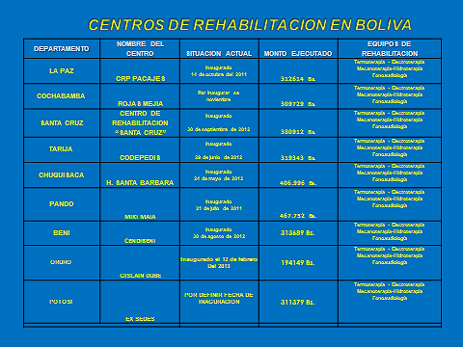
Proposal for integration
359. The proposal consists in providing comprehensive specialized rehabilitation services and implementing policies, programmes and activities that foster the prevention, promotion, rehabilitation and integration of disability on the basis of equity, quality and integrity.
360. The aim is also to ensure full exercise of the right to health, inclusion, multiculturalism, integrality, dignity, respect and solidarity in the context of the intercultural community family health programme and to offer an excellent rehabilitation and habilitation service staffed by highly trained health professionals in order to contribute to equality and equal opportunities for persons with disabilities.
361. The city of La Paz has public services providing multidisciplinary rehabilitation for adults and children, namely the Child Rehabilitation Institute, the Child Adaptation Institute and the Erick Boulter Institute. These are dependent on the La Paz departmental authorities and cater for a large number of persons with disabilities. There is no network of rehabilitation centres providing continuous care at the first, second and third levels of disability. The task of coordinating and supplementing the care provider services of the Ministry of Health and Sports is progressing slowly, although overlapping and inadequate coverage due to lack of resources is a continuing problem.
362. The Gregorio Pacheco Psycho-Educational Institute located in Sucre has come to be regarded as the leading centre for the rehabilitation of persons with mental disability. It is a public body under private law and consists of various institutions exercising legal responsibility in the area of mental health. It has its own rehabilitation services in mental health and related fields, and there are also psychiatric institutes in Cochabamba and La Paz.
363. Article 32, paragraph V, of General Act No. 223 states that the Plurinational State of Bolivia will include a community-based rehabilitation strategy in its social, cultural, intercultural and economic policies for persons with disabilities, drawing on the successful experiments of non-governmental organizations that have implemented such a strategy in the departments of La Paz, Cochabamba, Chuquisaca, Potosí, Oruro, Beni and Santa Cruz. These have resulted in persons with disabilities being rehabilitated and integrated in the everyday activities of their communities, neighbourhoods and education centres.
364. Article 28 of General Act No. 223 provides for the payment of a solidarity allowance of Bs. 1,000 annually to persons with serious and very serious disabilities. Since 2012, the Ministry of Health and Sports has been responsible for making these payments, amounting to Bs 20 million, with resources from the National Solidarity and Equity Fund.
Article 27
Work and employment
365. Under the Constitution and General Act No. 223, persons with disabilities are guaranteed access to employment and decent work of all kinds, fairly remunerated, through public policies of social and workplace inclusion based on equality of opportunity.
366. Article 34 of General Act No. 223 states that the Plurinational State of Bolivia will incorporate at all levels of government plans, programmes and projects for inclusive, community-based development geared to economic development aimed at creating jobs for persons with disabilities.
367. The Act also guarantees security of employment for persons with disabilities, their spouses and parents and for the guardians of children with disabilities, provided they comply with current legislation and there are no grounds for their dismissal.
368. Supreme Decree No. 27477 is aimed at promoting, regulating and protecting inclusion, advancement and stability in the job market and in the provision of manual, technical and professional services under existing legislation, as well as the encouragement of self-employed production initiative by person with disabilities, having regard to the skills and aptitudes of those concerned.
369. Article IV of Supreme Decree No. 27477 stipulates that priority must be given to persons with disabilities when recruiting to public institutions such as the executive branch, decentralized self-governing bodies and autonomous departmental and municipal governments, which should ensure that a minimum of 4 per cent of their total staff consists of persons with disabilities.
Measures taken under the existing regulations in favour of persons with disabilities
370. From 2009–2011, a vocational training project for persons with disabilities was implemented through the Department of Employment of the Ministry of Labour, Employment and Social Welfare. Under this programme, training was provided in ten cities to 720 women and men over the age of 18 with physical and/or sensory disabilities and the guardians of persons with serious or very serious disabilities, who at the end of the project had acquired the necessary tools to set up businesses and/or secure employment in the labour market.
• At least 70 per cent of the participants completed the five-month course successfully and belong to a productive association or are employed in wood or textile handicrafts, fabric weaving, semi-industrial garment making, bakery and dairy processing in the country’s nine department capitals;
• In October 2011, a cooperation agreement was signed between the Ministry of Labour, Employment and Social Welfare and the Organization of Ibero-American States for Education, Science and Culture (OEI) aimed at implementing specific technical cooperation programmes with a direct bearing on human rights issues relating to child labour, forced labour and gender. Under this agreement and in coordination with the General Directorate for Employment, OEI organized a work project for persons with disabilities in El Alto in the Department of La Paz, at which 30 participants with disabilities received training in fabric weaving and industrial garment making. On completion of the training course, they were admitted to the employment support project (PAE) to improve their skills and productive enterprises.
371. On 15 April, a woodcarving and pottery training course for persons with disabilities, attended by 30 participants, was held in the municipality of Porvenir – Pando under a cooperation agreement between the Ministry of Labour, Employment and Social Welfare and OEI.
372. Measures were taken by the Ministry to promote the protection from dismissal of persons with disabilities.
373. The Ministry, in keeping with its functions and responsibilities, undertook various activities to promote the labour-market inclusion of the disabled population through the plurinational employment service.
374. In this connection, social awareness workshops and seminars were held for heads of human resources departments in State institutions to draw their attention to the requirement under article 4 of Supreme Decree No. 27477 to integrate 4 per cent of persons with disabilities in the workforce, and to the provisions of Supreme Decree No. 29608 concerning protection from dismissal. In the cities of La Paz and Cobija, 80 heads of human resources in 70 public bodies received awareness training in compliance with the above decrees on preferential recruitment to the workforce of persons with disabilities.
375. Awareness events were also organized at national level for the heads of human resource department in public and private institutions in the framework of the seminar “From Disability to Inclusion in the Workforce”.
376. The Ministry of Labour, Employment and Social Welfare, through the Directorate-General for Employment, is responsible for monitoring and following up application of the law. One of the Ministry’s functions, as laid down article 86 (c) of Supreme Decree No. 29894 of 7 February 2009, is to “guarantee integration in the workforce of the population as a whole, having regard to gender equity and the equality of persons with disabilities, unfair dismissal being prohibited”.
377. Another of its functions is to “develop instruments for promoting inclusion in the labour-market and security of employment for persons with disabilities, in both public and private sectors, and to ensure follow-up and monitoring of the existing regulations by the Directorate-General for Employment.
Employment situation of persons with disabilities in Bolivia
In the private sector
378. Supreme Decree No. 24807 of 4 August 1997 mandated the Ministry of Labour, Employment and Social Welfare to monitor and implement the regulations and procedures laid down in the Labour Act and its regulatory decree, the Hygiene, Occupational Safety and Social Welfare Act and its associated regulations, and the General Persons with Disabilities Act No. 1678, and to monitor compliance with the labour rights of persons with disabilities, ensuring that they receive fair remuneration for the work they perform.
379. Supreme Decree No. 29894 of 7 August 2009 empowers the Ministry of Labour, Employment and Social Welfare to ensure compliance with labour and social regulations concerning decent work and to guarantee integration in the workforce and job security for the population as a whole, having regard to gender equity and the equality of persons with disabilities, unfair dismissal being prohibited”. “.
380. In accordance with the provisions of the abovementioned Supreme Decrees, labour and technical inspections are carried out at national level through the departmental and regional labour offices to verify compliance with the labour and safety-at-work rights of workers as a whole, including persons with disabilities in a dependent or subordinate position in relation to an employer.
381. Details of these inspections are provided below.
Inspection statistics
Type of inspection | Purpose of inspection |  | Results of the inspection |  | Observations
Labour |  | Verification of compliance with workers’ labour rights recognized under the Constitution, the Labour Act and its regulations; and with supplementary regulations concerning signed labour contracts; payroll records; long and short-term social security contributions; end-of-year bonuses, etc. |  | The relevant labour inspection report is drawn up and a fine is proposed when breaches of social legislation are found to have occurred. The fine is referred to the judicial authorities for collection in accordance with the procedure stipulated in the Code of Labour Procedure | It should be noted that not all firms include persons with disabilities in their staff. Where the inspected firm employs persons with disabilities, a check is made to verify compliance with all the labour rights to which workers are entitled.
Technical |  | Verify compliance with the rights recognized under the Health, Occupational Safety and Social Security Act regarding preventive measures to be adopted to safeguard the life and health of workers, such as the provision of work clothes and personal protection gear; fire prevention measures; anti-noise measures; protection against vibrations; suspended particles, etc. |  | The relevant technical inspection report is drawn up along with the relevant recommendations and the employer is informed of the deadline set in the report for complying with the recommendations. Once the deadline has expired, a technical re-inspection takes place to verify compliance with the recommendations and, in the case of non-compliance, a fine is imposed for a breach of | It should be noted that not all firms include persons with disabilities in their staff. Where the inspected firm employs persons with disabilities, a check is made to verify compliance with all the preventive measures necessary to safeguard their life and health.
 |  |  |  | social legislation. The fine is referred to the judicial authorities for collection in accordance with the procedure stipulated in the Code of Labour Procedure | .
382. The present Government also issued Supreme Decree No. 0288 of 9 September 2009, which established the Compulsory Register of Employers (ROE) under the Ministry of Labour, Employment and Social Welfare and applicable to commercial firms, individual businesses, cooperative societies, civil societies, civil associations and public enterprises.
383. In the ROE registration form, the employer declares the type of activity carried out; how many persons with different functions are employed in the firm’s offices as a whole and whether they have long or short-term social insurance cover. The information contained in the declaration has the status of a sworn statement.
384. Analysis of the information contained in the Compulsory Register of Employers up to 17 June 2011 reveals the following:
Persons with disabilities, by type of activity
Activity | Total with disabilities declared at national level
Activities of private households as employers and undifferentiated activities of private households as producers | 1
Real estate, business and renting activities | 14
Public administration, defence and compulsory social security | 136
Agriculture, stock raising, hunting and forestry | 14
Wholesale and retail trade; repair of motor vehicles, motorcycles and personal and household goods | 76
Construction work | 31
Education | 24
Mining and quarrying | 2
Hotels and restaurants | 28
Manufacturing | 149
Financial brokerage | 14
Fishing | 0
Extra-territorial organizations and bodies | 2
Community, social and personnel services | 32
Health and social work | 18
Electricity, gas and water supply | 37
Transport, storage and communication | 70
Overall total | 640
385. Employers registered with the Compulsory Register of Employers must submit their payroll records every three months in strict compliance with Ministerial Decision No. 448/08 by filling in the form for returning the quarterly salary and wages and work accidents record, which has the status of a sworn statement.
386. On the form, the employers report the amount received by their workers by way of remuneration, including basic pay, long-service bonus, overtime pay and other allowances. This information enables the Ministry of Labour, Employment and Social Welfare to check the wages paid to workers and whether the amounts correspond to the type of work being done.
387. Supreme Decree No. 445 adopted on 10 March 2010 mandated the Ministry of Labour, Employment and Social Welfare to implement the Vocational Training Project for Persons with Disabilities. The project, developed jointly with the Ministry of Productive Development through Pro Bolivia, consisted in training for the creation of productive enterprises, to be financed by the Ministry.
388. The project resulted in the creation of 17 cooperatives and two associations of persons with disabilities.
389. Ministerial Resolution No. 083/11 of 7 February 2011, issued by the Ministry of Labour, Employment and Social Welfare, authorized the Department of Cooperatives to exempt the fledgling cooperatives from taxes during the first stages in the acquisition of legal personality. These bodies must be composed 100 per cent of persons with disabilities and/or duly accredited guardians, subject to administrative decision in each case.
390. After reviewing the documents and on the basis of legal and technical reports, the legal unit issues the recommendation on the granting of legal personality to the established cooperatives, subject to compliance with the requirement and provisions of the Cooperative Societies Act of 13 September 1958 and other applicable legal texts.
Managing compliance with the 4 per cent requirement relating to public bodies
391. In accordance with Supreme Decree No. 29894 of 7 February 2009, the Ministry of Labour, Employment and Social Welfare is responsible, inter alia, for “Promoting and monitoring compliance with domestic legislation and international instruments on employment matters” and for “Guaranteeing integration in the workforce and job security of the population as a whole, including persons with disabilities, unfair dismissal being prohibited”. Article 70 and 71 of the Constitution stipulate that the State should adopt positive discrimination measures to promote the effective integration of persons with disabilities in the productive sector, without any form of discrimination, one of their rights being to work in suitable conditions consistent with their possibilities and abilities and to be paid a fair wage enabling them to live decently, any kind of discrimination, mistreatment, violence and exploitation being prohibited.
392. The Ministry of Labour, Employment and Social Welfare has assumed responsibility for monitoring and ensuring compliance with the requirement that 4 per cent of the staff of public bodies should consist of persons with disabilities, in accordance with existing legislation.
393. In this regard, the Ministry of Labour, Employment and Social Welfare through the Department of Employment is systematizing information on the occupational profiles of persons with disabilities to enable public or private institutions to recruit human resources in keeping with institutional needs and having regard to the occupational abilities and skills of those concerned. This work has been assisted by the provisions of article 87(b) and 88 (d) of Supreme Decree No. 29894, consistent with article 54 of the Constitution.
394. In accordance with article 13 of Supreme Decree No. 29894 of 7 February 2009, notes were issued to the ministers of state of the executive branch to attend an initial meeting on 28 September 2009 in order to collect information on:
• The total number of their full-time staff;
- Persons with disabilities working in the ministries;
• Documents attesting to the status of persons with disabilities.
395. Those responsible for human resources in the entities concerned were responsible for sending the information or introducing it into the system managed by the Department of Employment.
Article 28
Adequate standard of living and social protection
396. Under Act No. 3025 of August 2008, the current Government allocated a budget of Bs. 40 million for persons with disabilities. The same Act abolished State subsidies for political parties, civic associations and indigenous peoples in election and non-election years and established the National Solidarity and Equality Fund for Persons with Disabilities, financed by an annual allocation of Bs. 40 million from resources provided by the National Treasury.
397. This Fund is regulated by Supreme Decree No. 0256 of August 2009, which approved the financing of 10 specific programmes for persons with disabilities, including those indicated below.
398. The skills training and labour-market integration programme is aimed at improving the chances of workforce inclusion, employment or self-employment of persons with disabilities
399. The productive enterprise programme “Let’s Produce Together” seeks to include persons with disabilities in the productive matrix of the State.
400. The “Good Living” programme of legal aid and skills training in support of the rights of persons with disabilities is aimed at developing public policies for defending, promoting and protecting exercise of the fundamental rights of persons with disabilities established by the Constitution.
401. The programme for strengthening and equipping rehabilitation centres at departmental level is aimed at reinforcing the national network of rehabilitation centres to improve accessibility for persons with disabilities, initially in the departments of Pando, Beni, Oruro and Potosí.
402. The programme of occupational and productive training according to type and degree of disability is aimed at including persons with disabilities by providing them with qualifications and integrating them in the labour market in each of the country’s nine departments.
403. The programme for the inclusion of persons with disabilities in the plurinational education system is designed to detect deaf and visually impaired children and adolescents entering the mainstream education subsystem in the departments of Pando and Beni and in the city of El Alto.
404. The housing improvement/expansion programme for persons with disabilities is aimed at helping to improve the quality of life of those concerned by giving them access to adequate housing, in keeping with the regulations of the Social Housing Programme.
405. The programme of organizational reinforcement is aimed at improving the organization of persons with disabilities by strengthening their institutions and providing them with equipment and office furniture.
406. Supreme Decree No. 1133 of 11 February 2012 provides for the payment of a solidarity allowance to persons with serious and very serious disabilities in possession of a disability card. This benefit is applicable only to persons with a disability card issued by the Ministry of Health and Sports. Up to December 2012, 13,000 persons with disabilities had benefited from this allowance, which amounts to Bs. 1,000 annually paid in a single instalment.
407. Supreme Decree No. 1498 of 20 February 2013 regulates payment of the solidarity allowance for persons with serious or very serious disabilities with effect from 2013 and defines the institutional framework and financing, in accordance with article 28, paragraph 1, of General Act No. 223 of 2 March 2012. From January to May 2013, 10,000,868 persons with disabilities reported to the relevant financial bodies to claim the Bs. 1,000 allowance.
408. The Bolivian Institute for the Blind is a public body established on 22 January 1957 and by Supreme Decree No. 08083. It has the task of planning action by the State to address the problem of persons with visual impairments and members of their family and to supervise all the institutions of and for the blind. It is a decentralized public body coming under the Ministry of Health and Sports.
409. Persons with visual impairments are all members of the Bolivian Institute for the Blind and are organized in nine departmental associations. All these associations are affiliated to the Bolivian National Federation of the Blind, a network organization through which, in the 1970s, they were awarded an annual bonus deriving from the National Treasury. This bonus has been increased every year and in 2013 a total of 4573 blind persons received the sum of Bs. 5,200 per person in a single annual payment.
410. In accordance with article 31 of the Pensions Act No. 065 adopted in December 2013 in Bolivia, the general risks invalidity benefit is granted where a person suffers partial or total invalidity as the result of an accident or illness not arising from occupational hazards or workplace risks.
411. The general risks invalidity benefit includes payment of:
• A general risks invalidity pension in favour of the insured person;
• Ten per cent (10 per cent) monthly of the updated amount of the basic salary paid into the personal welfare account, in the case of total invalidity; or 10 per cent monthly of the updated invalidity benefit paid into the personal welfare account, in the case of partial invalidity;
• Life or temporary pensions, as appropriate, paid to rights holders in the first or second degree on the death of the insured person in receipt of an invalidity pension.
412. The Government of the Plurinational State of Bolivia promotes and guarantees the human rights of persons with disabilities and seeks to ensure that social assistance becomes a tool for generating opportunities for the development and social integration of persons with disabilities. These actions are aimed at producing an overall improvement in the situation of persons with disabilities and for this reason include promotion, protection and rehabilitation measures.
Article 29
Participation in political and public life
413. The Constitution guarantees persons with disabilities political rights and the opportunity to enjoy them on an equal basis with others.
414. Persons with disabilities can effectively and fully participate in political and public life on an equal basis with others, directly or through freely chosen representatives, including the right and opportunity to vote and be elected, inter alia, through voting procedures, facilities and materials guaranteed to be appropriate, accessible and easy to understand and use.
415. The Constitution guarantees to persons with disabilities the right to vote by secret ballot in elections and public referendums without intimidation, and to stand for elections, effectively hold office and perform all public functions at all levels of government, with the help of assistive and new technologies where appropriate; it likewise guarantees the free expression of the will of persons with disabilities as electors and to this end, where necessary, at their request, allows assistance in voting by a person of their choice.
416. The State promotes effective equality of opportunity for persons with disabilities in an environment in which they can participate fully and effectively in the conduct of public affairs, without discrimination and on an equal basis with others, and encourages their participation in public affairs and social control through non-governmental organizations and associations concerned with the public and political life of the country, including the related activities and administration.
417. The programme for strengthening the social organizations of persons with disabilities under the Ministry of the Office of the President provides support to institutions caring for persons with disabilities. Its overall objectives are to foster the development of civil society organizations in order to promote an improved quality of life for persons with disabilities; and to maximize the capacity for self-management of organizations associated with social programmes.
Article 30
Participation in cultural life, recreation, leisure and sport
418. Under sectoral development policy No. 4 on health promotion, the Ministry of Health and Sports, through the Office of the Deputy Minister of Sports, proposes restoring State responsibility for a culture of comprehensive health care and quality of life, aimed at ensuring coordinated action by the health sector and other government departments to address key factors of social exclusion in the health field by providing better public access to basic services such as education, recreational activities, sport, decent work, security, clean energy, housing, basic sanitation, nutrition and health under the Good Living strategy.
419. This strategy is being pursued through an “intersectorality” programme in the form of inclusive, coordinated and sustainable measures to help improve the State’s capacity to tackle the problems of the different social groups by improving the quality of life and contributing to national dignity by transcending exclusive interests to establish equity.
420. The “Health through Sport” programme places the emphasis on the training and comprehensive development of the Bolivian people through physical activity in a process that guarantees the integration of active and healthy lifestyles and the development of a “culture of winners”. It will entail: the creation of a national sports fund (support and incentives for top athletes); the development of sporting infrastructures; policy formulation; the creation of schools for beginners and sports institutions nationwide; the encouragement of sports for persons with disabilities; the prioritization and promotion of participation by Bolivian sportsmen and women in international competitions through a system of moral and material incentives; and the construction of high-performance mini-centres by sporting discipline.
421. Under its political and social mandate to promote the construction of a multinational, intercultural, decolonized and communitarian Bolivian identity, the Ministry of Culture possesses three deputy ministries responsible for culture, decolonization and interculturality respectively.
422. However, Bolivia does not yet have a social tourism programme providing accessible accommodation, meals and recreation services for persons with disabilities.
Article 31
Statistics and data collection
423. The Department for Persons with Disabilities under the Ministry of Justice has undertaken a diagnosis of disability in Bolivia in the form of statistical data. However, it must be recognized that no specific census on disability exists, so that data on the subject is lacking and it is not possible to devise public policies, programmes and specific projects for persons with disabilities.
424. There are five sources of information on disability in Bolivia: three censuses and two surveys. The censuses were carried out in 1900, 1950 and 2001, and the surveys are the 1998 National Demographic and Health Survey (ENDSA) and the 2001 Household Survey under the Programme for the Improvement of Living Conditions (MECOVI).
425. The National Demographic Health Survey included the question of whether the person had “any extreme physical impediment”, with a choice of seven replies: “deaf and dumb, mentally retarded, deaf, blind, paralytic and lame/one-armed”. This instrument suffers from the same conceptual problems as the 2001 census as regards the classification of disability.
426. The most successful instrument conceptually speaking for identifying persons with disabilities is doubtless the Programme for the Improvement of Living Conditions (MECOVI), based on fieldwork carried out between October and November 2001.
427. Question 9 of the MECOVI survey asked whether the interviewee had “any kind of permanent disability”. This was the first time a national enquiry or census had used the term “disability”, defined in the corresponding interviewer’s manual as “Any restriction or absence, due to a deficiency, of the ability to carry out an activity in the manner and within the parameters of what is considered normal for a human being
428. So, of the five instruments mentioned, the 2001 census and the 2001 MECOVI survey could serve as a baseline as regards the prevalence and other data on disability. However, we prefer the second of these instruments since, apart from being as recent as the first, it is conceptually more rigorous and informative on the topic, and therefore offers more reliable data.
429. Some of the programmes and projects implemented by the Ministry of Justice have taken as their point of reference the demographic projections of the National Statistics Institute (INE). In 2009, the population of Bolivia totalled 10,027,644, which is to say that the population had increased by 1,403,376 in seven years. According to international organizations, 10 per cent of the population is in some way disabled, so that according to these figures 1,002,764 persons in Bolivia have some form of disability.
430. However, in February 2013 the National Institute of Statistics submitted the preliminary findings of the 2012 Population and Housing Census, which showed Bolivia to have a population of 10,389,913.
431. Mention should also be made of the implementation, currently in progress, of the Programme on the Central National Register of Persons with Disabilities (PRUNPCD), attached to the Ministry of Health and Sports and adopted by Supreme Decree No. 28521 (see para. 53 supra and the corresponding tables).
432. It should be mentioned, finally, that the topic of statistical data is a major concern of the Plurinational State of Bolivia, which is awaiting the official results of the 2012 census in order to launch a study of disability in the country.
Article 32
International cooperation
433. The Department for Persons with Disabilities of the Ministry of Justice, as the lead entity in the field of disability in Bolivia, participates in meetings on disability and human rights organized by international organizations.
434. It participated in El Salvador in the First Special Meeting on the elimination of all forms of discrimination against persons with disabilities. Since that meeting, Bolivia has been a member of the Commission.
435. It also participated in Argentina in the Third Forum on Disability and Development – Meeting of the Partnership for Disability and Development (GPDD-LI) in the context of framing public policies on disability. Recently, the Ministry of Justice through the Department for Persons with Disabilities participated in the Regional Consultation of the Americas on Disability and Development held in Salvador de Bahía (Brazil), at which progress and achievements in improving the situation of this population group were reported.
436. Delegates from Argentina, Bolivia, Colombia, Cuba, Chile, El Salvador, Guatemala, Honduras, Mexico, Panama, Paraguay, Uruguay, Peru, Jamaica and Dominican Republic, together with representatives of international organizations and civil society, took part in the event, which discussed among other topics the construction of a regional agenda for sustainable, inclusive and accessible development.
437. International cooperation is required to complement the work being carried out in association with the Japan International Cooperation Agency (JICA). The slogan of this bilateral cooperation agency is “Everyone benefits from inclusive dynamic development”. Work has been in progress since 2009 based on the discussion agreement signed by the representatives of JICA and the Bolivian authorities.
438. With the support of JICA, progress has been made on the preliminary draft of the new legal provisions concerning persons with disabilities (now the General Persons with Disabilities Act No. 223). This cooperation has taken the form of technical assistance, online consultations over a two-year period, equipping and strengthening of the Department for Persons with Disabilities, communication workshops, transport and other activities at departmental and national level. From 2006 to 2012, JICA also assisted in implementing the programme on the Central National Register of Persons with Disabilities, in cooperation with the Ministry of Health and Sports.
439. Since 2010, various activities have been undertaken in coordination with international bodies such as the United Nations Association International Service (UNAIS), a British international development NGO. This advocate for human rights defends the view that to deny people their basic rights is to deny them the opportunity to achieve their potential and trap them in a circle of poverty and inequality. Its goal is to provide people with practical support in understanding and enforcing their rights in order to help them change their lives for the better. Its vision is that of living in a world in which all people have the chance to prosper and achieve their potential in different ways, with particular reference to the promotion of the human rights of persons with disabilities.
440. Another partner is Handicap International, an international solidarity organization specializing in the field of disability. A non-governmental, non-religious, non-political and non-profit organization, it works alongside persons with disabilities to help them achieve independence. It has played a coordinating role in information activities relating to Act No. 223 and in organizing workshops on protecting and promoting knowledge of the rights of persons with disabilities.
441. The Bolivia Country Programme (Sweden) includes eleven disabled persons’ organizations at national and regional level, namely: the Bolivian Deaf Federation (FEBOS); the Bolivian Sports Federation for the Deaf (FEDEBOISO); the Federation of Sightless People of Bolivia (FENACIEBO)-Bolivian National Commission for Sightless Youngsters; the Association of Parents and Friends of Children, Adolescents and Young People with Intellectual Difficulties and Other Development Disorders (DESPERTARES); the Association of Parents of Children with Disabilities (ASPAHIDI); the Association of Persons with Psychological and Family Difficulties (PARASOLL); the Cochabamba Association of the Deaf (ASORCO); the La Paz Municipal Sports Federation for the Deaf (AMUDESORPAZ); the Bolivian Association of Parents and Friends of Persons with Mental Disabilities (APANH); and Development of Social Cooperatives (DECOOPSO). All these organizations are concerned to promote, influence and follow up legislation and policies on disability at the local, regional and national level.
442. Since 2010, the Department for Persons with Disabilities of the Ministry of Justice has been responsible for coordination with the País Bolivia programme. This programme has played a leading role in the incorporation of various articles in Act No. 223, in particular those relating to psychological and hearing disabilities. It has also organized various training, information and other workshops on national and international standards concerning persons with disabilities.
443. The Department is also coordinating with CBM, a private entity providing community-based rehabilitation, and is cooperating with projects being developed in the departments of Chuquisaca, La Paz and Tarija. It is moreover working with MYRIGHT to empower persons with disabilities, in particular through the transmission of knowledge and experience gained with persons with disabilities in Sweden.
444. It should finally be mentioned that the Department for Persons with Disabilities forms part of the Equity Network, comprising over 40 private/public institutions dedicated to ensuring the full inclusion of persons with disabilities.
Article 33
National implementation and monitoring
445. Since the entry into force of the Convention, no specific measures have been taken to designate a national authority responsible for implementing and monitoring the international instrument. However, as reported previously, the State of Bolivia considers that, in accordance with General Act No. 223, this task comes within the remit of CONALPEDIS, a decentralized body responsible for defending the human rights of persons with disabilities. CONALPEDIS, which enjoys managerial and budgetary autonomy under the supervision of the Ministry of Justice, is in charge of strategic planning in the field of disability.
446. The functions of CONALPEDIS are as follows:
• To take measures to promote equality of opportunity for persons with disabilities;
• To ensure that the rights of persons with disabilities are fully exercised and are enforceable in the courts;
• To promote and coordinate with other State institutions measures to develop physical infrastructures in public facilities and the technical, material and human resources to address the needs of persons with disabilities;
• To promote and encourage an approach to disability with a social and human rights focus through awareness campaigns geared to social inclusion in the framework of a culture of dignity and respect for persons with disability;
• To take measures to ensure compliance with international and regional legal instruments on disability;
• To publicize and monitor compliance with obligations contracted with governments and entities in other countries and international organizations working in the field of disability;
• To establish relations with the Bolivian police on questions relating to public security for persons with disabilities and on preventive measures;
• To distribute, promote and publish texts and works on matters coming under Act No. 223;
• To serve as the consultative and advisory body for agencies and ministries of the executive branch responsible for programmes and projects relating to persons with disabilities;
• To register non-governmental organizations, foundations and non-profit civil associations working with programmes and projects in the area of disability;
• To establish and maintain an up-to-date register of public and private programmes providing social, religious, contractual and mutual help services for persons with disabilities;
• To develop draft provisions for adapting the present Act in all areas.
447. In adopting the General Persons with Disabilities Act No. 223, Bolivia designated CONALPEDIS as the lead agency in the field of disability, notably by making it responsible for implementing national policies and plans.
448. In addition to the duties assigned to CONALPEDIS under the General Persons with Disabilities Act, which correspond to the terms of article 33, paragraph 2, of the Convention, attention should be drawn to the provisions of Act No. 223, under which the adoption and ratification of the Convention entail the commitment that civil society, in particular persons with disabilities and their representative bodies, will be integrated and participate fully in all aspects of social control. In this regard, CONALPEDIS is the sole entity charged with this function.

* The present document is being issued without formal editing.
Data compiled by the Inter-American Development Bank on the basis of national censuses and surveys in the various countries.
The only exception is Paraguay, which reports 1 per cent prevalence of disability.
It is also the case that some newborns with disabilities are “left to die” by their parents, particularly in rural areas.
Ann Elwan, “Poverty and disability: a survey of the literature”, 1999. Available at: http://siteresources.worldbank.org/INTPOVERTY/Resources/WDR/Background/elwan.pdf.
Imprenta Simmer, Salón Pippo, Belcorp, Hotel Las Palmas, Supermercados Fidalga I y II, Promociones Gloria, ABC Color, Memorial Park, Burger King, Technos Aluminio, Home Center and Karamelle.

