 | United Nations | CERD/C/SMR/1
 | International Convention on  the Elimination of All Forms  of Racial Discrimination |  | Distr.: General  19 December 2022  Original: English  English, French and Spanish only
Committee on the Elimination of Racial Discrimination

Initial report submitted by San Marino under article 9 of the Convention, due in 2003*
[Date received: 2 December 2022]

I. Replies to the list of issues prior to reporting (CERD/C/SMR/QPR/1)

A. Reply to paragraph 1 of the list of issues

General information
1. As of December 2021, there were 6,688 foreigners legally residing in San Marino (i.e. holding a stay or residence permit) out of a population of 34,976, representing approximately 20% of the population. Despite the wide variety of national origins (86 countries), almost 80% of foreign citizens are Italian. The rest are Ukrainians (391), Romanians (272), Russians (88), Albanians (83), Moldovans (69), Argentinians (54), Brazilians (51), Poles (40) and Cubans (26), as well as a small number of citizens of other countries. Information on the composition of the population of the Republic of San Marino is updated on a monthly basis. We provide information on the population by registry status and citizenship as of 31 December 2021: see attached a courtesy translation into English of the tables from the IT, Technology, Data and Statistics Office.
2. The Republic of San Marino does not systematically collect data on the various religious groups. The vast majority of the population is Catholic but there are followers of other religious faiths, primarily Jehovah’s Witnesses, Baha’i, Islam, Jews, Orthodox Christians and Waldesians.
3. The Republic of San Marino is an enclave within the territory of Italy, with which it shares the language and ethnic origins; there are no native language groups.

B. Reply to paragraph 2 of the list of issues

Article 1
4. San Marino has a comprehensive legislation and active policy to promote the equality of all persons before the law and equal treatment in all areas. In particular, Article 4 of the Declaration on Citizens’ Rights and Fundamental Principles of San Marino Legal Order enshrines the fundamental principle of equality before the law. Following a confirmative referendum in 2019, Article 4 was amended by expanding the application of the principle of equality - which already excluded discriminations based on gender, personal, economic, social, political and religious conditions - by expressly excluding discriminations based on sexual orientation. The confirmative referendum was approved with a 71.46% majority of votes in favour.
5. In order to implement international commitments on the principle of non-discrimination, on 28 April 2008, the Great and General Council approved Law no. 66 “Provisions against racial, ethnic and religious discrimination”. It introduces in the San Marino Criminal Code, under Article 179 bis, the crime of racial discrimination and punishes the dissemination, by any means whatsoever, of ideas based on racial or ethnic superiority or hatred, anyone who encourages someone to commit, or commits discriminatory acts on the grounds of race, ethnicity, nationality, providing for the prosecution ex officio of this crime. Article 179 bis was later amended by Law no. 57/2016 to include reference to discriminatory acts based on gender identity. The Law also establishes as an aggravating circumstance the commission of an offence for discriminatory purposes.
6. The Authority for Equal Opportunities, established by Law no. 97 of 20 June 2008, is competent to receive any report of abuse or illegal acts related to discrimination and is attributed a wide range of powers, to intervene effectively on services, institutions or bodies that may be involved. The Commission for Equal Opportunities, established by Law no. 26 of 25 February 2004, has the main task of fully implementing the provisions on equality and non-discrimination contained in the Declaration on the Citizens’ Rights.
7. The Republic of San Marino has long developed a comprehensive system of social protection for all ethnic, national or linguistic minorities, particularly focused on the labour sector. A consolidated and widespread trade union system provides appreciable and efficient protection to meet any needs or in case of any complaint. With particular reference to the work sector of care for the elderly, which primarily involves workers having a foreign nationality, language and origin, important steps have been taken for the integration and facilitation of the authorisation procedures. A helpdesk was set up at the Social Security Institute for the recruitment of caregivers to the elderly in Italian, English and Ukrainian, which helps families and caregivers to obtain the authorisations necessary to enter into a proper and controlled employment contract. To promote the linguistic integration of this category of workers, the Ministry of Education organises regular evening Italian language courses for foreigners.

C. Reply to paragraph 3 of the list of issues

Article 2
8. There are no direct applications of the Convention provisions in specific judgements issued by the San Marino Court. Since the Convention is an integral part of the corpus juris, it must necessarily be known by the judiciary and professionals in the field, in accordance with their legal obligation to participate in refresher courses.

D. Reply to paragraph 4 of the list of issues

Article 2
9. With regard to the fight against all forms of racial discrimination, the Republic of San Marino has decided to protect the principle of equality in all its forms. In this regard, Article 4 of the Declaration on Citizens’ Rights and Fundamental Principles of San Marino Legal Order enshrines the fundamental principle of equality before the law:
“All shall be equal before the law, without any distinction based on sex, sexual orientation or personal, economic, social, political and religious status”. All citizens shall have access to public services and elective posts, in accordance with the procedure laid down by law”.

E. Reply to paragraph 5 of the list of issues

Article 2
10. San Marino authorities have already explained the difficulty of setting up a new national institution for the promotion and protection of human rights, not so much because of the costs it might entail, but because of the lack of experts and professionals with relevant experience in the field of human rights defence within the country. Conversely, the experts and professionals from outside the Republic of San Marino would lack knowledge of the local situation, both in terms of the extent of the phenomenon and of the identification of possible solutions.
11. Our existing control bodies, (from the Captains Regent to the Township Councils, the police forces, trade unions, non-governmental associations, central and peripheral institutions), which are effective, timely and efficient in protecting other guarantees, have no record of complaints of racial discrimination.

F. Reply to paragraph 6 of the list of issues

Article 3
12. As mentioned on other occasions, the Republic of San Marino, due to its geographical size and location, its history and the number of its inhabitants, is characterised by strong and close social relations, which persist despite being less intense than a few decades ago. The territory of San Marino is then divided into 9 districts (Townships), headed by a mayor (Head of the Township Council) and a city council (Township Council). Institutions are therefore very close to citizens and easily accessible. The Captains Regent (Heads of State) receive citizens once a week; any citizen can ask to talk with them for all kinds of petitions and this generally happens weekly without delay.
13. Since 1955 health care has been free for all San Marino citizens or residents. The Social Security Institute (SSI) is responsible for health and social welfare and provides a wide range of both health services and economic benefits such as sick pay, family allowances, pharmaceutical assistance, social and health care, pensions. In addition to managing the State Hospital, located in a central position, SSI provides public health territorial services, located in several areas of the Republic (3 Health Centres, a Centre for women’s health, 7 pharmacies spread over the territory, a Mental Health Centre, a Minors’ Service, a Service for people with disabilities and residential care, a Residential Elderly Care Centre, a Home Care Service with two Centres).
14. In San Marino there are three major trade unions (the Democratic Confederation of San Marino Workers, the San Marino Labour Confederation, the San Marino Union of Workers), which, in addition to their institutional role of defending worker’s rights, provide citizens with various support services and point of contact dedicated to specific issues.
15. A very lively and dynamic sector in San Marino is that of associations in all fields of civil activity, which gathers at least 183 associations (this is the number of associations recorded in 2020 which benefited from the voluntary contribution deriving from general income tax; such figure, however, does not include the associations which have not benefited from it and de facto associations).
16. For the above-mentioned reasons, any case of racial segregation of people and vulnerable groups seems unlikely at present.

G. Reply to paragraph 7 of the list of issues

Article 4
17. Art. 179 bis of the Criminal Code provides that:
“Anyone disseminating by any means ideas based on racial or ethnic superiority or hatred, or encouraging someone to commit, or committing discriminatory acts on the grounds of race, ethnicity, nationality, religion or sexual orientation and gender identity, or encouraging someone to commit, or committing violence or acts instigating to violence on the grounds of race, ethnicity, nationality, religion or sexual orientation and gender identity, shall be punished with second degree imprisonment.
The offences aggravated by discrimination on the grounds of race, ethnicity, nationality, religion or sexual orientation and gender, as referred to in Article 90, paragraph 1, point 1, shall be prosecuted ex officio in any case.”

H. Reply to paragraph 8 of the list of issues

Article 4
18. Among the aggravating circumstances of the crime, and as circumstances in the presence of which the judge may apply the higher punishment, Article 90 of the Criminal Code provides: “for discrimination on the grounds of race, ethnicity, nationality, religion or sexual orientation”.

I. Reply to paragraph 9 of the list of issues

Article 4
19. At the moment, with regard to the application of Article 179 bis of the Criminal Code (Discrimination, hatred or violence on the grounds of race, ethnicity, nationality, religion or sexual orientation and gender identity), the following results emerge from the Criminal Records and the Register of Notitia Criminis:
- Criminal proceedings no. 544/2013 terminated during the investigation stage.
- Criminal proceedings no. 244/2018 terminated during the investigation stage.
- Criminal proceedings no. 348/2018 indicted and with relevant final judgement passed on 22 December 2021 and filed on 19 October 2022. The conviction imposed is a daily fine of Euro 600 with transmission to the investigating judge for the assessment of the acts on the basis of new evidence and the possible identification of other perpetrators.
- Criminal proceedings no. 371/2018 terminated on 23 July 2019.
- Criminal proceedings no. 47/2019 terminated during the investigation stage on 28 April 2021.
- Criminal proceedings no. 441/2022 terminated during the investigation stage on 28 September 2021.
- Criminal proceedings no. 453/2022 currently in the investigation stage.

J. Reply to paragraph 10 of the list of issues

Article 4
20. Given the low number of incidents, no statistics are processed.

K. Reply to paragraph 11 of the list of issues

Article 5
21. New types of residence permits have recently been introduced for resident foreigners; for these types, holders are required to bear the costs of health care in the manner determined by the Social Security Institute. Workers who are not San Marino citizens and who are holders of a residence or stay permit in San Marino are treated in the same way as San Marino workers with regard to access to medical assistance.
22. As already mentioned, the Republic of San Marino is committed to combating all forms of discrimination first and foremost by ensuring absolute equality before the law for all.
23. By Law no. 118 of 30 July 2015 - Amendment to Law no. 118 of 28 June 2010, and subsequent amendments (Law on the entry and stay of foreigners in the Republic of San Marino), the period of stay in the territory for caregivers to the elderly who hold temporary stay permits for work reasons was extended to 12 months (instead of the previous 11) and consequently the obligation for the aforementioned workers to return to their own country was repealed.
24. By Delegated Decree no. 21 of 24 February 2016, the “Help Desk for the Recruitment of Caregivers to the elderly” was established at the Territorial Domiciliary Service of the Social Security Institute.
25. A specific helpdesk for caregivers to the elderly has been established both at the San Marino Labour Confederation (https://www.cdls.sm/index.php/sportello-badanti) and at the San Marino Union of Workers (https://www.usl.sm/servizi/badanti-e-assistenza-alla-famiglia/).
26. The category of caregivers to the elderly is also well-organised and is strongly interconnected through the increasing use of social media. At present, there are no exploitation or distortion issues, since demand is greater than supply. The caregivers can therefore obtain decent and satisfactory conditions and treatment.
27. With regard to resident foreigners, new types of residence permits have recently been introduced; holders are in any case required to bear all the costs of health care in the manner determined by the Social Security Institute.

L. Reply to paragraph 12 of the list of issues

Article 5

Para. 12 (a)
28. The Republic of San Marino is not a State Party to the Convention relating to the Status of Refugees, due to the characteristics of its territory – i.e., it is an enclave of the Italian Republic – and of its borders, which are unprotected and therefore freely accessible.

Para. 12 (b)
29. As mentioned above, the size, population and resources of the Republic of San Marino impose certain choices in the area of accession to international treaties or conventions. The Conventions in question are not considered a priority.

Para. 12 (c)
30. The extraordinary stay permit for humanitarian needs of social protection was introduced by Law no. 118 of 28 June 2010, finally transposing into law a centuries-old custom that has always characterised the Republic of San Marino’s traditional reception policy.
In the last five years, the following permits have been granted:
- 2018 – 5 permits;
- 2019 – 9 permits;
- 2020 – 3 permits;
- 2021 – 6 permits;
- 2022 – 3 permits.
31. No requests for extraordinary permits for humanitarian needs were rejected, they were all accepted.
32. During the Russian-Ukrainian conflict, the Republic of San Marino welcomed around 400 Ukrainian refugees fleeing the conflict, introducing a special stay permit for them. All refugees were hosted in public facilities, or by families and hotels that made themselves available. All were provided with food and basic necessities. They received a monthly contribution, calculated on the basis of household members. Healthcare, social-health assistance, the right to education, sports and arts in general, and other welfare services deemed necessary for the entire period of their stay were guaranteed free of charge. The procedures for access to work have been facilitated.

M. Reply to paragraph 13 of the list of issues

Article 5
33. In managing the Sars-Covid 19 emergency, the San Marino administration never even considered diversifying in any way the treatment of citizens, residents, or people staying in the Republic, all of whom were considered and treated equally and were guaranteed the necessary care. The therapeutic treatment was provided absolutely without distinction of status, and vaccines were administered giving priority to the weak and the elderly, and then gradually continuing with all population groups, following the order of telephone bookings.
34. On 28 April 2022, the collaboration with the Italian OSCAD (Observatory for Security against Acts of Discrimination) was made concrete in an event entitled “Le vittime dell’odio” (The Victims of Hatred), a high-level conference with the participation of qualified experts in the field and of the highest Institutions of the State.

N. Reply to paragraph 14 of the list of issues

Article 6
35. As mentioned above, given the scale of the phenomenon, it was deemed useful not to divert human and professional resources from sectors and issues that instead affect San Marino in a far more incisive and severe manner.
36. Magistrates and Law Enforcement are required to be continuously up to date at a professional level and to know the laws that are enacted. Given the size of the country and of the administration, the relevant regulations that are issued each year are so few in number that they do not require specific training.

O. Reply to paragraphs 15 and 16 of the list of issues

Article 7
37. There were no specific school projects dedicated to human rights education; the topic is covered across the board by almost all subjects of study. Almost all the textbooks adopted in the San Marino school system deal with this topic, which is regularly addressed through readings, discussions and by watching videos. It is a very broad subject that therefore can be explored in depth across the board and in an interdisciplinary manner by all teachers.
38. The Curricula for San Marino schools and, in particular, the Curricula for Citizenship Skills, adopted by all school levels in 2018, contain the central topic of “respect for diversity”, which has precisely the objective of “helping pupils to recognise their distinctive and unique personality traits and to recognise those that they share with others. The schools’ proposal focuses on “comparative pedagogy”, which encourages to overcome stereotypes and prejudices and promotes mutual knowledge and self-criticism”.

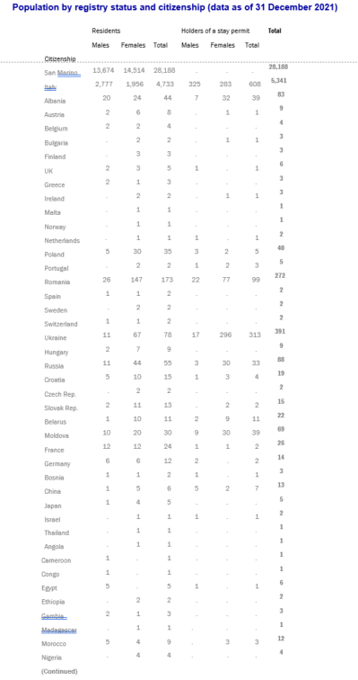
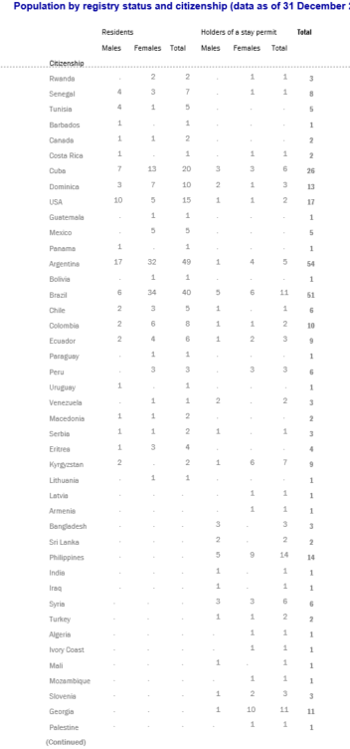
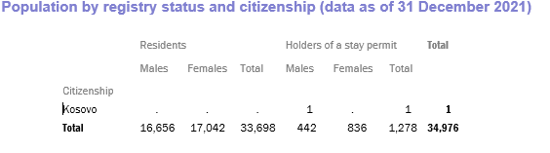

* The present document is being issued without formal editing.
More information about residence and stay permits in San Marino on the Ministry of Foreign Affairs website: https://www.esteri.sm/pub2/EsteriSM/en/Servizi-per-utenza/Permessi-di-Soggiorno-e-Residenze.html.
Original tables in Italian language on IT, Technology, Data and Statistics Office website: https://www.statistica.sm/contents/instance15/files/document/14130611Pop_posizione_Ci.pdf.
http://www.iss.sm/on-line/home/chi-siamo.html.

