 | United Nations | E/C.12/PAN/3
 | Economic and Social Council |  | Distr.: General  24 June 2020  English  Original: Spanish  English, French and Spanish only
Committee on Economic, Social and Cultural Rights
Third periodic report submitted by Panama under articles 16 and 17 of the Covenant, due in 2004*, **
[Date received: 27 April 2020]

Introduction
1. The present document contains the third periodic report of the State of Panama on the implementation of the International Covenant on Economic, Social and Cultural Rights. It is being submitted in accordance with article 16 of the Covenant.
2. The report addresses the observations adopted by the Committee on Economic, Social and Cultural Rights on 27 August 2001 (E/C.12/2001/SR.51).
3. The third periodic report was prepared by means of a participatory process coordinated by the National Standing Committee on compliance with and follow-up to the national and international human rights commitments of Panama.
4. The National Standing Committee set up a working group to prepare the report. The group comprised representatives of the Ministry of Foreign Affairs (which chaired the group and served as the technical secretariat), the Ministry of the Interior, the Ministry of Education, the Office of the President, the Ministry of Health, the Ministry of Labour and Workforce Development, the Ministry of Social Development, the National Assembly, the Supreme Court of Justice, the Ombudsman’s Office, the National Statistics and Census Institute of the Office of the Comptroller General, the National Institute for Women and the National Secretariat for Children, Adolescents and the Family.
A. Specific information on the implementation of the Covenant
Article 1
Right of peoples to self-determination
Provisions on self-determination
5. The current Constitution contains various articles relating to the identity and government of indigenous peoples; these articles protect the rights of indigenous peoples, their social and spiritual identity (art. 90), their languages (art. 88), their right to education (art. 108), and their autonomy and lands (arts. 124, 126 and 127).
Autonomy of indigenous peoples
6. The indigenous regions (comarcas) are protected by law. Their authorities are elected in accordance with indigenous customs, and government bodies are required to coordinate their activities with these authorities, in accordance with article 127 of the Constitution and the laws of each indigenous region.
Government and self-determination, including consultation
7. Panama has other provisions that build on the constitutional principles concerning the self-determination of indigenous peoples in the areas of environmental protection, the promotion of traditional medicine, the recognition of intellectual property, the promotion and development of indigenous handicrafts, the strengthening of the indigenous economy and the right of indigenous peoples to development. Details of these provisions are provided below.
8. Under article 127 of the Constitution, the lands needed to ensure the economic and social well-being of indigenous communities are reserved for and owned by these communities. The general congresses of these peoples are responsible for reviewing and approving productive and extractive activities carried out in their territories. The functions of the congresses are determined by the communities’ internal laws.
9. The right of indigenous peoples to be consulted is governed by laws on environmental matters and transparency in public administration, namely the General Environment Act (Act No. 41) of 1998 and Act No. 6 of 2002, which contains provisions on transparency in public administration. Pursuant to these acts, indigenous peoples must be consulted on legislative initiatives that may affect their rights. See annexes 1 and 2.
Judiciary
10. Under the Code of Criminal Procedure, indigenous courts are competent to adjudicate, in accordance with “indigenous law”, on matters involving offences committed in indigenous regions, except in cases of homicide, drug-related offences, organized crime, offences against the public administration and offences against the national economy. For the relevant provisions of Act No. 63, see annex 3.
Indigenous Peoples’ Access Unit within the judiciary
11. In 2009, the judiciary established the Indigenous Peoples’ Access Unit, through which interpretation services and alternative means of dispute settlement are provided for the benefit of indigenous groups in Panama. The services are provided by a specialized department under the direct coordination of the judiciary’s Gender and Access to Justice Unit.
Article 2
Safeguards concerning the rights recognized in the Covenant and non-discrimination. Reply to the issues raised in paragraphs 9 and 25 of document E/C.12/1/Add.64
12. Article 12 of the Constitution remains in force. However, in 2004, article 19 of the Constitution, concerning the principle of non-discrimination, was amended to include disability among the prohibited grounds of discrimination.
13. Article 17, meanwhile, provides for the protection of the human rights of all persons in the national territory without discrimination of any kind.
14. Article 17 establishes that State authorities have a responsibility to protect the “life, honour and property of nationals, wherever they may be, and of aliens who are under their jurisdiction; give effect to individual and social rights and obligations; and comply with the Constitution and the law”.
15. Article 4 of the Constitution provides that the State must abide by the rules of international law. The Supreme Court, meeting in plenary session, handed down a decision on this matter on 21 August 2008, ruling that human rights treaties in force have the same rank as the Constitution.
Article 3
Equal right of men and women to the enjoyment of economic, social and cultural rights. Reply to the issues raised in paragraph 17 of document CCPR/C/PAN/CO/3
Implementation of the Covenant (E/C.12/1/Add.64, paras. 9 and 25)
16. The second paragraph of article 17 of the Constitution establishes that the rights and guarantees enshrined in that instrument should be regarded as minimum standards that are without prejudice to other provisions relating to fundamental rights and human dignity.
17. On the basis of the 21 August 2008 decision of the plenary of the Supreme Court, it was established that all human rights treaties in force in Panama have the same rank as the Constitution. The decision states that, pursuant to article 17, the remedy of amparo can be invoked in defence of the rights recognized by law, including laws through which international human rights conventions were adopted. Human rights instruments of any kind that have been ratified by Panama can thus be invoked by the courts in their decisions. See annex 4.
18. Section III of the Constitution establishes individual and social rights and obligations, including the right to work, the right to education, the right to health, the right to social security and social assistance, the right to culture and the right to family life.
19. These constitutional norms serve as the foundations of the organic laws, ordinary laws and other norms that regulate the public administration and public policy on economic, social and cultural development.
National human rights plan (E/C.12/1/Add.64, paras. 10 and 26)
20. The Panamanian State recognizes the need to make progress in the preparation of a national plan of action for human rights.
B. Implementation, in law and in practice, of articles 1 to 5 of the Covenant
Article 1
Right to self-determination
Indigenous peoples
21. Building on the constitutional framework, Panama has developed a legal framework that regulates collective lands and the protection of the environment, the promotion of traditional medicine, the recognition of intellectual property, the promotion and development of indigenous handicrafts, the strengthening of the indigenous economy, the right to intercultural bilingual education and the right of indigenous peoples and communities to development.
Collective lands
22. Article 127 of the Constitution provides that the State must reserve the necessary lands and guarantee their collective ownership for the economic and social well-being of indigenous peoples. Article 5 establishes the political composition of the State of Panama and recognizes five indigenous regions or territories. Three of them are classified as indigenous provinces, namely Guna Yala, Embera-Wounaan and Ngobe-Buglé, and two are classified as municipalities (corregimientos), namely Guna de Madungandí and Guna de Wargandí.
23. Land rights were also recognized in the Supreme Court ruling of 23 March 2001, which affirmed that the political and administrative organization of the indigenous regions is distinct from and independent of that of the districts and municipalities. Indigenous regional laws recognize the right of the indigenous peoples to collective ownership within their regions, and contain other provisions relating to natural resources, government, the administration of justice, the economy, culture, education, health and more. Act No. 72 of 2008 establishes the special procedure for awarding collective ownership of land to indigenous peoples outside the five indigenous regions. This Act provides that titles to collective land are imprescriptible, non-transferable, protected from seizure and inalienable, and safeguards the economic, social and cultural well-being of indigenous peoples living in indigenous communities.
24. In compliance with the above-mentioned Act, collective property titles were granted in respect of the territories of Puerto Lara and Caña Blanca, which together cover 1,382 hectares, thus guaranteeing the local population ownership and enjoyment of their ancestral lands. See annexes 5 and 6.
25. In 2014 and 2015, collective property titles were awarded by way of administrative decision in respect of the territories of Piriatí, Ipeti Embera, Arimae and Embera Puru. See annexes 7, 8 and 9.
26. As a whole, the indigenous regions and municipalities cover 15,103.4 km² of the country’s total area of 75,517 km², representing 20 per cent of the national territory.
27. Further applications for collective land titles, including in respect of the territories of Pijivasal, Río Hondo and Río Platanares, Bajo Lepe, Maje Drua and Maje Cordillera, Mercadeo, Aruza, Bribri, and Ella Drua, have been referred to the Ministry of the Environment, in strict compliance with the legislation governing collective lands (Act No. 72 of 2008 and Executive Decree No. 223 of 2010), and are currently pending approval.
Self-government, self-determination and informed consent
28. The indigenous regions are governed by their own special institutions. Pursuant to a ruling of the Third Chamber of the Supreme Court of Justice of 6 December 2000, the consent of indigenous peoples is required for all projects planned in their regions. See annex 10.
29. Under Act No. 37 of 2016, which establishes a requirement to consult with and obtain the free, prior and informed consent of indigenous peoples, it is mandatory to consult with indigenous peoples regarding the potential impact of construction work or other projects in their communities. See annex 11.
Right to intercultural bilingual education, respect for traditions and culture
30. Act No. 88 of 2010 recognizes the languages and alphabets of the indigenous peoples of Panama and provides that intercultural bilingual education is mandatory in all public and private schools in indigenous regions and collective territories; such education is being provided in indigenous communities. See annex 12.
31. The 2010 National Population and Housing Census found that there were 611 schools and 687 teachers in the indigenous regions; the number of students was estimated at 13,208.
32. In the period 2014–2019, a project to replace shack classrooms in the indigenous regions was carried out. The project extended to 189 schools and had a budget of 296.4 million balboas (B/. 296.4 million).
Right to health and traditional health care
33. To reduce inequity and poverty, Decision No. 322, adopted in 2005, provides that health care provided by the Ministry of Health and the Social Security Fund is free of charge for people living in poverty and extreme poverty in the indigenous regions. There is also the Traditional Medicine of Indigenous Peoples Programme.
34. In order to overcome gaps in health-care coverage, most of which arise as a result of the remoteness of certain locations, the objectives of the Development Project for Indigenous Peoples include improving health infrastructure and incorporating an intercultural approach into health services, in order to adapt the existing health-care model and health infrastructure to the needs and world view of indigenous peoples.
Recognition of traditional justice
35. According to the Code of Criminal Procedure, the traditional indigenous authorities have jurisdiction in respect of certain categories of cases established by the Constitution and the law. Since 2009, in criminal cases that have to be tried through the ordinary justice system, the judicial authorities and the courts are obliged to take due account of the cultural diversity of the parties.
36. Under the Code of Criminal Procedure, indigenous courts are competent to adjudicate, in accordance with “indigenous law”, on matters involving offences committed in indigenous regions, except in cases of homicide, drug-related offences, organized crime, offences against the public administration and offences against the national economy.
Right to one’s traditional name
37. Persons of indigenous origin have the right to register their children in the civil register under the child’s indigenous name and in their people’s or ethnic group’s region, even if the child was not born in an indigenous region.
Strengthening the institutional framework
38. In 1995, the Legislative Assembly set up the Indigenous Affairs Committee to provide expert input on legislative initiatives relating to indigenous affairs (General Regulations governing the Indigenous Affairs Committee, arts. 46 (17) and 66).
39. In 2013, the Office of the Deputy Minister for Indigenous Affairs was established within the Ministry of the Interior as a high-level political and administrative authority whose role is to plan, direct and coordinate national policy that affects indigenous peoples (Act No. 64 of 20 September 2013).
Right to social welfare and efforts to reduce inequity
40. To respond to indigenous peoples’ considerable development needs and to eliminate existing inequities, the Government has undertaken to implement the Comprehensive Development Plan for Indigenous Peoples, an initiative sought by indigenous peoples and agreed upon with the Government during a broad process of dialogue and consultation. Implementation is scheduled to begin in mid-2018 with a loan of $80 million from the World Bank.
41. The Plan focuses on four main areas: (a) social issues; (b) economic issues; (c) political issues; and (d) special issues, including the administration of justice, governance by traditional authorities, institution-building in the territories, authorities, and food security.
Consultations on the Comprehensive Development Plan for Indigenous Peoples
42. In preparation for the implementation of the Comprehensive Development Plan for Indigenous Peoples, the Ministry of the Interior conducted several parallel consultation processes in order to identify activities with the greatest potential to bring about a systematic and sustainable transformation in the provision of basic infrastructure and services and in the area of governance for the indigenous peoples of Panama.
43. The first process involved the broad participation of indigenous communities and authorities with a view to ensuring the relevance, quality, results and ownership of the Plan. The process was carried out through 30 territorial consultation workshops in which around 2,000 active members of the indigenous communities participated, contributing their vision, needs and proposals.
44. The results of the workshops were translated into matrices for each territory, in which the details of priority projects by sector (water/sanitation, health, education and governance) are set out.
Article 3
Equal opportunities for men and women (E/C.12/1/Add.64, para. 27)
45. Act No. 4 of 1999 concerns the establishment of equal opportunities for women. Since then, specific measures have been taken to implement the Act. For example, implementing regulations were adopted through Executive Decree No. 53 of 2002, allowing for the development of concepts, institutional coordination mechanisms and procedures for implementing the legal framework established by the Act. See annexes 13 and 14.
Public policies and the strategic plan
46. In 2002, the State designed the Plan for Equal Opportunities for Women, 2002–2006, which defines the institutional commitments of the 44 governmental mechanisms for women in the areas of the economy and employment, education, culture and sport, the family, health, housing, the environment, legal equity, and action to address violence against women.
47. Subsequently, the National Institute for Women designed the Public Policy on Equal Opportunities through a participatory process of national consultation; the Policy was adopted through Executive Decree No. 244 of 2012. See annex 15.
48. In order for women and girls to be properly included in the production system and in the sustainable economic and social development of the country, it is indispensable that they have access to education, career paths traditionally reserved for men, appropriate and comprehensive health care, decent working conditions and representation in political and economic decision-making processes.
Main advances
49. In July 2018, the Gender Parity Initiative was launched in cooperation with the Inter-American Development Bank and a group of strategic allies. The Gender Parity Initiative is a public-private partnership, one of whose objectives for achieving gender parity is to take specific and committed action to close the wage gap. The National Council on Gender Parity was established to provide legal support to the Gender Parity Initiative.
50. Another initiative launched is the Gender Equality Seal, which is implemented by the Ministry of Labour and Workforce Development with the support of the United Nations Development Programme. This initiative aims to ensure that men and women enjoy equitable working conditions in their place of employment. The Women’s Empowerment Principles, a call to action in the private sector, were also launched.
Legislative measures
51. Act No. 27 of 2017 promotes work-life balance and shared responsibility through the establishment of paternity leave for workers in private companies and the public sector. See annex 16.
52. Act No. 29 of 2017 provides that political parties have an obligation to ensure gender parity in their electoral lists; this obligation was reiterated through the Executive Decree on the Organization of General Elections. See annex 17.
53. Act No. 56 of 2017 makes it compulsory for the governing boards of public bodies to reserve 30 per cent of their seats for women. This Act enables more women to contribute to national development and to participate in important decision-making processes related to the formulation and implementation of national policies. See annex 18.
C. Specific rights
Article 6
Labour rights (E/C.12/1/Add.64, paras. 13–15, 17, 29–30 and 32)
Article 6 (Right to work), article 7 (Right to just and favourable conditions of work), article 8 (Trade union rights)
Minimum wage
54. The minimum wage in Panama is, in principle, governed by article 66 of the current Constitution, which provides that the periodic adjustment of the minimum wage is governed by the law.
55. Articles 172 to 180 (chap. II, sect. III) of the Labour Code establish the mechanisms by which the minimum wage is set, ensuring that it covers basic needs. The minimum wage is revised every two years on the basis of a recommendation from the National Minimum Wage Commission, which is issued through an executive decree and takes into account the particular conditions of each region, each industrial, commercial and agricultural activity and each profession or trade.
56. The National Minimum Wage Commission takes into account various data in the formulation of its recommendations on the minimum wage rates, including the outcome of consultations carried out with employers and workers throughout Panama and information on the country’s social and economic conditions. These data are previously approved by the commissioners and presented by the Technical Commission.
57. In 1999, the minimum wage was B/. 224.64, rising to B/. 253.76 in 2002, then to B/. 264.16 in 2003. By 2014, it had risen to B/. 488.88.
58. Through the Agreement of 18 December 2015, the fourth consensus on the minimum wage was reached between business owners, workers and the Government, benefiting 340,000 workers throughout the country, without discrimination, and leading to the promulgation of Executive Decree No. 293 of 22 December 2015, which set the national minimum wage at B/. 530.40. This decree increased the minimum wage by 8.5 per cent, making it the highest in Latin America. See annex 19.
59. The cost of the basic family food basket was B/. 282.81 in December 2010, B/. 2.89 or 1 per cent more than in the previous month. Compared to the same month in 2009, that represented an increase of B/. 15.93 or 6 per cent. Until July 2010, the cost of the basic family food basket was considerably more stable than it had been the previous year.
60. The cost of the basic family food basket rose by B/. 5.84 in August and has not since returned to the stability of 2009, despite being lower in September and October.
61. In June 2016, the cost of the basic family food basket in the districts of Panamá and San Miguelito was B/. 307.10 a month, and B/. 280.17 a month in the rest of the country.
Relationship between the minimum wage and the basic family food basket
62. A comparison of the cost of the basic family food basket and the adjustment of the minimum wage reveals a positive trend beginning in 2003, when the cost of the basket could be covered with 70 per cent of the minimum wage; in 2002, 87.9 per cent of the minimum wage had been required to cover the cost. As a result of changes to the contents of the basic family food basket, in 2014 the cost of the basket could be covered with 67.4 per cent of the minimum wage.
63. In 2015, the Ministry of Economic Affairs and Finance introduced further changes to the contents of the basic family food basket, which, together with an increase to the minimum wage, meant that the proportion of the minimum wage required to cover the cost of the basket decreased to 57.9 per cent.
Unemployment, labour protections, employment (paras. 14 and 30)
64. Between 2001 and 2013, the unemployment rate fell by more than nine percentage points. The unemployment rate stood at 4.8 per cent in 2014 and at 5.5 per cent in August 2016, showing a slight increase, attributable primarily to the global economic slowdown.
65. The female unemployment rate stood at 6.7 per cent in August 2016, having decreased considerably from 18.0 per cent in 2001. The male unemployment rate stood at 4.7 per cent in August 2016, compared to 11.0 per cent in 2001, reflecting better job opportunities for men, primarily in the areas of construction, transport, mining and quarrying.
66. The total unemployment rate for women decreased considerably between 2004 and August 2016, falling from 16.3 per cent to 6.7 per cent over that period. The total unemployment rate for men decreased from 9.0 per cent to 3.3 per cent over the same period. In 2013, the number of people in work throughout the country increased by 79,089; women benefited most from the increase, with 44,497 of them joining the labour market, compared to 34,142 men.
67. The number of economically active persons aged between 15 and 29, i.e. youth employment, has decreased in recent years. In March 2015, the number of persons aged between 15 and 29 who were economically active was 511,929, representing an overall participation rate of 55.7 per cent; the participation rate stood at 69.5 per cent for men and 42.3 per cent for women. The number of young people in employment was 451,556, of whom 284,865 were men and 166,691 were women, representing 90.4 per cent and 84.7 per cent, respectively.
68. According to the Labour Market Survey of August 2015, Panama has an economically active population of 1,826,111 persons, 1,733,851 of whom are in employment. However, 39.9 per cent of the employed population, or 575,415 persons, are employed in the informal sector; 57.5 per cent, or 330,754 persons, are men, and 42.5 per cent, or 244,661 persons, are women.
Work contracts, labour inspections and trade union rights (paras. 15 and 29). Labour inspections (para. 15)
69. The Directorate of Labour Inspection of the Ministry of Labour and Workforce Development is responsible for monitoring compliance with labour regulations, laws, international agreements and conventions of the International Labour Organization (ILO) relating to occupational safety and decent working conditions. It promotes guidelines and policies relating to labour, maritime labour and migration inspections, and exercises its authority to protect the Panamanian labour force throughout the country.
70. The Directorate of Labour Inspection is working to strengthen and increase its staff of inspectors, and made provision for the appointment of more labour inspectors in its 2017 budget. There are currently 97 inspectors at the national level.
71. To ensure compliance with legal regulations, the Ministry of Labour, through the Directorate of Labour Inspection, carries out regular unprompted inspections and keeps its staff trained and up to date on issues relating to occupational health and safety.
72. The Ministry of Labour also promotes good labour relations between employers and workers through the “I Follow the Rules” (Yo Sí Cumplo) programme, which is intended to incentivize employers to commit to the objectives of the law, to adopt a more positive attitude that stimulates dialogue between employers and workers on the need to improve working conditions, and to foster a work environment in which best practices are respected; it also provides guidance to workers and employers by giving them appropriate information and advice regarding compliance with legislation and regulations. See annex 24.
Right to join or form a trade union (paras. 15 and 29)
73. According to information provided by the Ministry of Labour and Workforce Development, there are currently 421 registered trade unions with a total of 268,046 members in the database of the Department of Social Organizations.
74. Article 68 of the Constitution and articles 331 to 397 of the Labour Code establish the requirements and procedure for forming a trade union and explicitly recognize the right of both workers and employers to join a trade union.
75. In accordance with amendments made to article 344 of the Labour Code by Act No. 44 of 12 August 1995, at least 40 prospective members are required for the establishment of a new trade union and at least 50 prospective members are required for the establishment of a new association of public servants.
76. In terms of substantive requirements, trade unions must have as their purpose the study, improvement, protection and defence of their members’ respective common economic and social interests, and no more than one company union may operate within the same business (in practice, in many businesses there is a company union and an industrial union). The establishment of a union may be denied, annulled or refused if these requirements are not fulfilled.
Article 10
Right to family life
Elimination of child labour and the worst forms of labour. Child labour and domestic work (paras. 17 and 34)
General data on child labour in Panama
77. The first child labour survey was conducted in 2000; since then, a further five surveys have been conducted, with a period of two years between each survey.
78. A total of 47,976 persons under 18 years of age were engaged in child labour in 2000; this figure had fallen to 26,710 by 2014. Of the minors concerned, 67.8 per cent were boys and 32.2 per cent were girls.
79. Although child labour has decreased over time in rural and indigenous areas, it remains most highly concentrated in these areas; in fact, 75 per cent of workers under 18 years of age are to be found in these areas.
Hazardous work
80. In the 2008 survey, new variables were introduced to calculate the prevalence of hazardous child labour. The survey revealed that approximately 44,859 child and adolescent workers were engaged in hazardous work. By 2014, this figure had fallen to 18,277.
81. The decrease in the number of minors engaged in child labour is the result of sustained measures carried out over time that have now been codified in State policy, which has helped to achieve these results and to place child labourers into programmes and projects developed by the Government, the private sector, trade unions and civil society.
Minimum age for admission to employment
82. The Constitution prohibits the employment of minors under 14 save for exceptions provided for by law (Constitution, art. 70).
83. Article 117 of the Labour Code prohibits the employment of children under the age of 14 and children who are 15 years old who have not completed primary education. Article 46 of the Organic Act on Education provides that no child under 15 may engage in any work or activity that inhibits his or her enjoyment of the right to education.
84. In view of the above, work is prohibited for children under the age of 14 and children who are 15 years old who have not completed basic general education.
Strengthening of inter-agency action, and results achieved
85. The Committee for the Elimination of Child Labour and the Protection of Adolescent Workers was established in 1997. Its composition and the nature of its operations have changed over time with the aim of achieving broad institutional and multisectoral participation by key actors in order to effectively implement national policy on the elimination of child labour. This has led to the establishment of better coordination mechanisms, which has in turn facilitated the implementation of specific measures to eliminate child labour. Around 25 governmental and non-governmental organizations, including trade unions and businesses, are represented on the Committee.
86. The Committee for the Elimination of Child Labour and the Protection of Adolescent Workers designed the National Plan for the Elimination of Child Labour and the Protection of Adolescent Workers and is currently coordinating its implementation. The Plan covers the period from 2007 to the present.
Direct action programmes
87. The progress made in reducing child labour in Panama is the result of the implementation since 2000 of phases one and two of the Panama Country Programme to Combat the Worst Forms of Child Labour, in cooperation with the ILO International Programme on the Elimination of Child Labour.
88. Under phases one and two of the programme, the problem of child labour has been brought into public view, awareness-raising and training activities have been carried out, institutional capacity has been increased, coordination mechanisms have been established, a national strategy has been launched and direct action programmes directly benefiting child workers have been introduced over time.
89. The key to this process has been the successful transfer of knowledge management to the local level; the implementation of direct action programmes by non-governmental organizations through social responsibility projects; and the implementation of government programmes with local budgets.
90. This process has been accompanied by the launch of the National Scholarship Programme for Eliminating Child Labour by the Institute for Human Resources Training and Development.
Commercial sexual exploitation
91. Panama has ratified the Optional Protocol to the Convention on the Rights of the Child on the sale of children, child prostitution and child pornography. Act No. 4 of 2016 facilitated the incorporation of the Optional Protocol into national law, establishing a legal framework for the articulation of national policy on the prevention of commercial sexual exploitation and the definition of commercial sexual exploitation offences.
92. In compliance with the Optional Protocol, the National Commission for the Prevention of Sexual Exploitation was established in 2005. It is a permanent expert administrative body responsible for evaluating, coordinating and implementing policies for the prevention and elimination of the commercial sexual exploitation of children and adolescents and setting up mechanisms for preventing and eliminating sexual exploitation offences.
93. The National Plan for the Prevention and Elimination of Commercial Sexual Exploitation, which covers the period from 2008 to the present, is currently being implemented.
94. The Criminal Code defines the corruption of minors and commercial sexual exploitation as criminal conduct. The penalties range from 5 to 10 years’ imprisonment for basic offences to up to 15 years’ imprisonment where there are aggravating circumstances (Criminal Code, arts. 179–191).
95. Child abuse is also criminalized. The situations specified as constituting abuse include forcing children to beg and employing or acquiescing to the employment of children in forms of work that are prohibited or that endanger their life or health. The penalty is 2 to 4 years’ imprisonment or 3 to 6 years’ imprisonment where there are aggravating circumstances (Criminal Code, arts. 202 and 203).
96. The work of the institutions represented on the Committee for the Elimination of Child Labour and the Protection of Adolescent Workers has led to the adoption of focused programmes intended to tackle national challenges in addressing child labour at the provincial level, with the objective of taking effective measures in the different areas of the country.
Data from the child labour survey
Office of the Comptroller General, by survey year
Year | Number of children and adolescents
2000 | 47 967
2008 | 89 767
2010 | *60 702
2012 | *50 410
2014 | *26 710
Source: National Statistics and Census Institute-Office of the Comptroller General.
97. Thanks to the tripartite efforts of the Committee for the Elimination of Child Labour and the Protection of Adolescent Workers, there has been a decrease in child labour at the national level. Moreover, Panama has adopted various national laws and adhered to international agreements. In 2000, Panama ratified the Minimum Age Convention, 1973 (No. 138), and the Worst Forms of Child Labour Convention, 1999 (No. 182), of the International Labour Organization.
98. In ratifying the Minimum Age Convention, Panama established the minimum age for admission to employment for adolescents at 14, provided that the environment in which the adolescent is to carry out his or her work affords comprehensive protection to adolescent workers and meets the requirements for the issuance of adolescent work permits.
99. While articles 119 and 123 of the Labour Code establish criteria under which it is permitted for children aged 12 or over to perform light work in the agricultural sector and domestic work, they stipulate that such activities may not be performed without the prior authorization of the Ministry of Labour and Workforce Development.
100. After ratifying ILO Conventions Nos. 138 and 182, Panama, through the Committee for the Elimination of Child Labour and the Protection of Adolescent Workers, adopted a list of the forms of work prohibited for children and adolescents, referred to as the worst forms of child labour, by Executive Decree No. 19 of 12 June 2006.
101. These jobs are prohibited and hazardous for children and adolescents. In January 2016, Executive Decree No. 1 of 5 January 2016 was published in the Official Gazette. This Decree modified and added articles to Executive Decree No. 19 of 12 June 2006 adopting the list of hazardous forms of work considered to be the worst forms of child labour. Article 2 of the Decree contains the list of hazardous forms of work.
102. Panama ratified ILO Convention No. 182 on 31 October 2000. After the Convention had been ratified, Executive Decree No. 19 of 12 June 2006 adopting the list of hazardous types of work considered to be the worst forms of child labour was adopted. The contents of the list were agreed upon by the government institutions and the employers’ and workers’ organizations represented on the Committee for the Elimination of Child Labour and the Protection of Adolescent Workers.
Combating violence (E/C.12/1/Add.64, paras. 16 and 33)
103. Panama adopted Act No. 38 of 2001 on Domestic Violence and later adopted Act No. 82 of 2013, which provides for measures to prevent violence against women and amends the Criminal Code to introduce a definition of femicide and to punish violence against women.
104. In May 2015, the Special Police Service for Combating Gender-based Violence was established, pursuant to Act No. 82 of 2013; the service has trained 190 police units to deal with cases of violence against women.
105. Geographical coverage has been expanded, with a national presence in the 10 provinces and 2 indigenous regions, through the 14 centres of the National Institute for Women, which provide free and personalized comprehensive care for women whose rights have been violated.
106. In Panama, marriage between persons under the age of 18 is prohibited by Act No. 30 of 5 May 2015, which amends and repeals provisions of the Family Code that permitted women to marry from the age of 14 and men from the age of 16. The Act established the minimum legal age for marriage in Panama at 18.
107. The Ministry of Public Security, specifically the Office of Comprehensive Security, and the Security Cooperation in Panama project are developing prevention programmes as part of a model for the comprehensive care of victims of domestic and gender-based violence and the national network for the prevention of domestic violence.
Article 11
Right to an adequate standard of living
Efforts to reduce poverty and social exclusion (E/C.12/1/Add.64, paras. 18 and 31).
108. Between 1991 and 2005, rates of extreme poverty in Panama exceeded 20 per cent. However, after this period, a number of significant public policies were introduced to reduce poverty in general and extreme poverty in particular.
109. A change in the trend was observed in 2006 when the rate of extreme poverty fell to 17.6 per cent following the roll-out of the Opportunities Network Programme. Between 2007 and 2008, the levels of extreme poverty gradually declined and, in 2009, the proportion of persons living in extreme poverty stood at 15.3 per cent.
110. In 2010, the extreme poverty rate fell further still to 12.2 per cent. This positive outcome was achieved thanks to the introduction of a series of social policies that improved individuals’ well-being. Although the policies began to be introduced in 2009, as was the case for the “100 at 70” programme (now known as the “120 at 65” programme), they had a greater impact in 2010 thanks to their more extensive coverage. At the same time, the first universal education grant payments were made and the Opportunities Network Programme continued to be implemented.

Table 2
Proportion of the population below the general poverty line by area, province and indigenous region, 1991, 1995, 2000 and 2005–2015
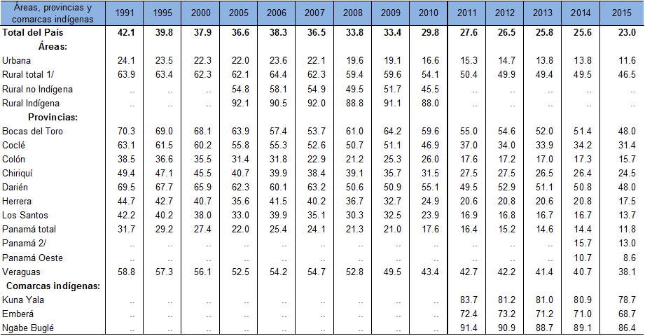
Proportion of the population below the extreme poverty line, by area, province and indigenous region, 1991, 1995, 2000 and 2005–2015
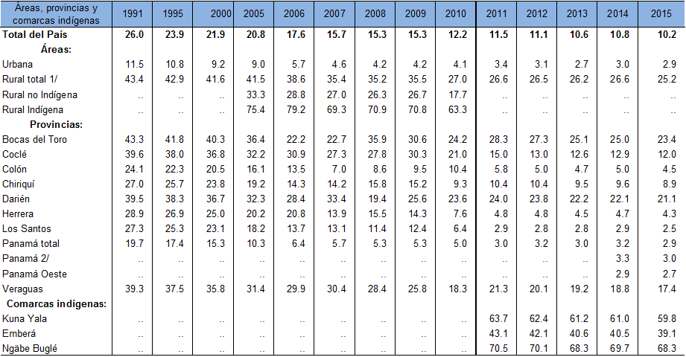
111. According to the fourth report of Panama on the Millennium Development Goals, dated 2014, the target of halving the proportion of people living on less than a dollar a day was met, since that figure fell from 29.2 per cent in 1991 to 9.7 per cent in 2012 as a result of sustained economic growth, minimum wage increases and beneficial labour policies.
112. Between 1991 and 2014, the overall poverty gap index decreased from 26.4 per cent to 10.5 per cent and the extreme poverty gap index fell from 16.1 per cent to 4.4 per cent.
113. Although there has been no significant positive change in the measure of income concentration – the Gini coefficient – since 1991, there has been an improvement in the distribution of household income. In 2014, the coefficient was 0.49, the first time it had dipped below the average value of 0.50 in 23 years. The coefficient remained at 0.49 in 2015.

Table 4
Gini coefficient of household income, by area, province and indigenous region,
1991, 1995, 2000 and 2005–2015
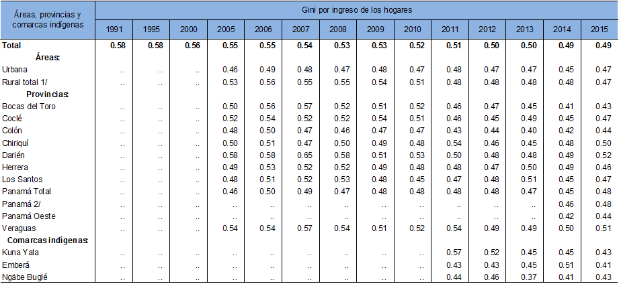
114. The achievements of Panama in reducing poverty between 2005 and 2013 can be attributed to factors such as an average economic growth rate of 8 per cent, a drop in unemployment from 9.8 per cent to 4.1 per cent, and a 67.5 per cent increase in the average wage, which rose from $322.3 to $539.7. Another factor was the introduction of non-contributory transfer programmes, the Social Protection System, conditional cash transfers and subsidies for poor families.
115. The Ministry of Social Development runs programmes to support development and the inclusion of vulnerable groups and minorities in order to improve their quality of life.
116. The Ministry has regional and indigenous regional offices that serve as an initial point of contact for the public and that handle applications for assistance under all programmes.
117. Among the programmes and policies that have had the greatest impact in eradicating poverty and hunger is the Opportunities Network Programme. With 65,042 beneficiary households in provinces, indigenous regions, districts and municipalities nationwide, the programme had a budget of over $250 million in 2016. See annex 26.
118. The Programme was launched in April 2006 to confront the causes of poverty by promoting social organization, community strengthening, the development of productive skills for income generation among households in extreme poverty, and access to social services and to the opportunities that will be created gradually through the development and implementation of programmes in the areas of agricultural production and productivity, agricultural land titling and division into plots, nutrition, and income generation and employment.
119. In this context, a national strategy for the alleviation and reduction of extreme poverty was conceived to support a comprehensive set of development policies aimed at reducing extreme poverty, enhancing human development, strengthening capacities and creating opportunities to increase equity and reduce social exclusion.
120. According to the Programme outcomes for the period up to 2016, beneficiary households received the following services:
• Health
• Education
• Human capital development and strengthening for social and productive inclusion

121. The “120 at 65” programme is a cash transfer programme under which the sum of B/. 120 is provided to Panamanian adults over the age of 65 who do not have retirement or other pensions and who are socially at risk, vulnerable, marginalized or poor. The programme is national in scope and in 2016 had an annual budget of $106 million. See annex 27.

122. The “100 at 70” programme was created by Act No. 44 of 4 August 2009 and is implemented by the Ministry of Social Development. In 2015, non-repayable cash transfers were provided to 126,559 persons aged 65 or older in situations of poverty, marginalization, social risk or vulnerability due to the lack of a retirement or other pension. See annex 28.
123. Act No. 44 of 2009 was replaced by Act No. 86 of 2010. New amendments were subsequently introduced by Act No. 117 of 11 December 2013, which increased the amount of the transfer to B/. 120, and finally by Act No. 15 of 2014, which extended the coverage to adults over 65 years of age.
124. The name of the programme was changed to “120 at 70” in 2014, and was changed again in August of that year to reflect the payment of B/. 120 at the age of 65.
125. The programme’s aim is to ensure that economic growth contributes to sustainable development and poverty reduction. Panama first included cash transfers – which are conditional on the take-up of health, education and capacity-building services – in one of its programmes in 2006, together with the implementation of a family support strategy. It also introduced the Guardian Angel Programme, created by Act No. 39 of 14 June 2012 as a special financial assistance programme for people with severe disabilities who are dependent on others and who live in extreme poverty, in order to promote, protect and ensure, in equal conditions, their full enjoyment of human rights and fundamental freedoms. See annex 29.
126. Under the Guardian Angel Programme, a monthly sum of B/. 80 is allocated to the beneficiaries through their parents, guardians or legal representatives, with payments disbursed every two months through various mechanisms.
127. The Programme was launched in August 2013 with a beneficiary population of 1,657. By 2016, it had 16,107 beneficiaries throughout the country, including in the various indigenous regions, where assistance is provided to many vulnerable and poor individuals.
128. Additional support to enhance beneficiaries’ quality of life, such as through housing improvements and the provision of assistive devices, is managed under a cross-cutting approach coordinated with institutions such as the National Secretariat for Persons with Disabilities, the National Charity Lottery and the Office of the First Lady of the Republic. Other initiatives include:
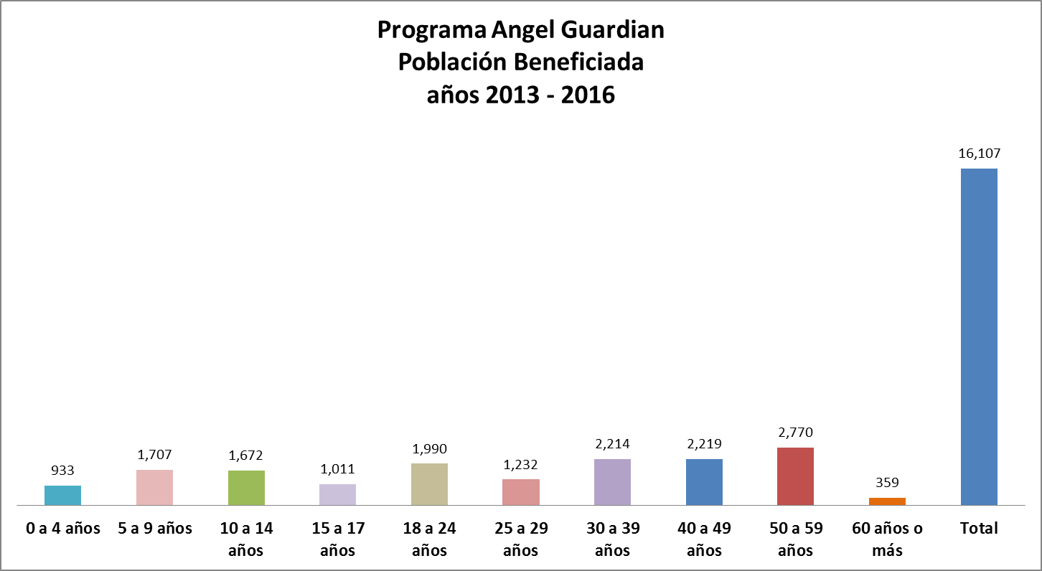
• Family food vouchers: Under this programme, families receive food vouchers worth $50.00 per month. Created by Act No. 89 of 28 December 2012, the programme, which now has 10,000 participating families, helps reduce malnutrition levels and increase school enrolment. Beneficiaries can use the vouchers to buy 22 products from the basic family basket, including 18 food products and 4 personal hygiene products.
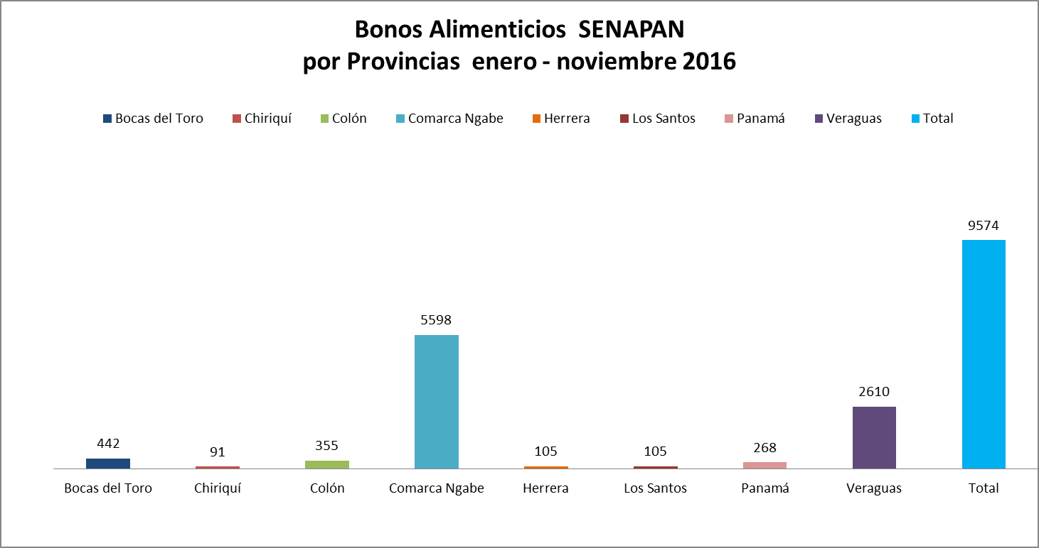
• Territorial Networks Programme: This programme is administered by the Directorate of Investment for Social Capital Development. Its purpose is to increase social inclusion and combat poverty among the most vulnerable population groups by promoting children’s and young people’s accumulation of human capital and the employment and self-management of adult household members through applied training that develops their productive skills with a view to income generation. The Programme, which was created by Executive Decree No. 9 of 3 March 2008, has an annual budget of $300,000, covers the whole country and includes indigenous and other ethnic minority families.
• National Plan for the Prevention and Control of Micronutrient Deficiencies 2008–2015: The aim of the Plan is to prevent and reduce vitamin and mineral deficiencies in the population, avoiding dietary excess and imbalance, with an emphasis on vulnerable and excluded groups.
• Supplementary food programme of the Ministry of Health: The aim of this programme is to improve the nutritional status of children under 5 years old, pregnant and breastfeeding women, and tuberculosis patients receiving strictly supervised treatment. Under this programme, Ministry of Health facilities throughout the country distribute a fortified food (Nutricereal), targeting indigenous regions and priority districts. The programme reaches about 44,000 beneficiaries a year.
• Supplementary food programme of the Ministry of Education: By providing schoolchildren with food supplements, this programme aims to improve their nutritional status and enable them to make the most of educational activities.
129. Under the Ministry of Education programme, snacks are distributed to schools in three formats: (a) milk and biscuits in schools located in urban and marginal urban areas and district capitals; (b) a fortified cream dessert and biscuits in schools located in indigenous rural areas, where a greater caloric intake is provided in accordance with the principle of targeting poverty and extreme poverty; and (c) a fortified cream dessert in other schools. This national programme covers all State primary schools and also supports the Child Guidance Centres of the Ministry of Social Development, Casa Esperanza (an NGO working with child workers) and children’s centres of the Catholic Church.
Literacy
130. According to the 2000 national census conducted by the Office of the Comptroller General, there are 148,747 people in Panama who cannot read or write, 2.4 per cent of whom are young people between the ages of 15 and 24.
131. Most of these Panamanians live in indigenous, rural and marginal urban areas and the majority were unable to attend school owing to a lack of economic resources or the absence of infrastructure. The cycle of poverty is closely linked to illiteracy, which is why the “Get Moving for Panama” (Muévete por Panamá) literacy project forms an integral part of the strategy to combat poverty, together with the Opportunities Network Programme, which promotes the full enjoyment of rights and access to basic services.
132. In keeping with the Government’s commitment to reduce illiteracy, the “Get Moving for Panama” project (formerly known as “Yes I Can”) is implemented at the national level so that all Panamanians can exercise the right to education.
133. The project was launched in 2007 further to a cooperation agreement signed by the Ministry of Education of Cuba and the Ministry of Social Development of Panama. It has an annual budget of B/. 600,000.
134. The project uses a flexible method that allows students to learn from experience. Literacy and numeracy teaching are combined with video lessons to ensure that classes are entertaining. To extend coverage and create learning environments in hard-to-reach areas, the State has counted on the support and assistance of 5,000 volunteers who have given their free time to become facilitators of literacy classes for members of their community.
135. To ensure that every Panamanian can access the right to education, the Ministry of Social Development has set up learning environments in different parts of the country, in buildings ranging from shanties to schools, which are equipped with the necessary resources for classroom teaching. Each learning environment is equipped with a chalkboard, chalk, a television and a DVD player. Students participating in the literacy project are provided with primers, pencils and exercise books so that they can fully assimilate the lessons.
136. As the national executing agency of “Get Moving for Panama”, the Ministry of Social Development conducts periodic visits to the learning environments to monitor the implementation of the methodology and the participation of persons in need of literacy training. It keeps statistical records, which are updated monthly, to track progress at the national level, and film and photographic records of the learning environments and of the participants’ gradual progress as they acquire basic reading and writing skills. The State maintains a partnership with the United Nations Educational, Scientific and Cultural Organization, which is providing technical advice for the smooth running of the project and for reducing illiteracy in Panama.
137. “Get Moving for Panama” is a comprehensive project that promotes individuals’ well-being and social inclusion. For that reason, it is being implemented in parallel with the Operation Miracle programme, an initiative that provides people with free eye tests and glasses so that they can read and write without discomfort.
138. Approximately 70 per cent of the project’s beneficiaries are female.
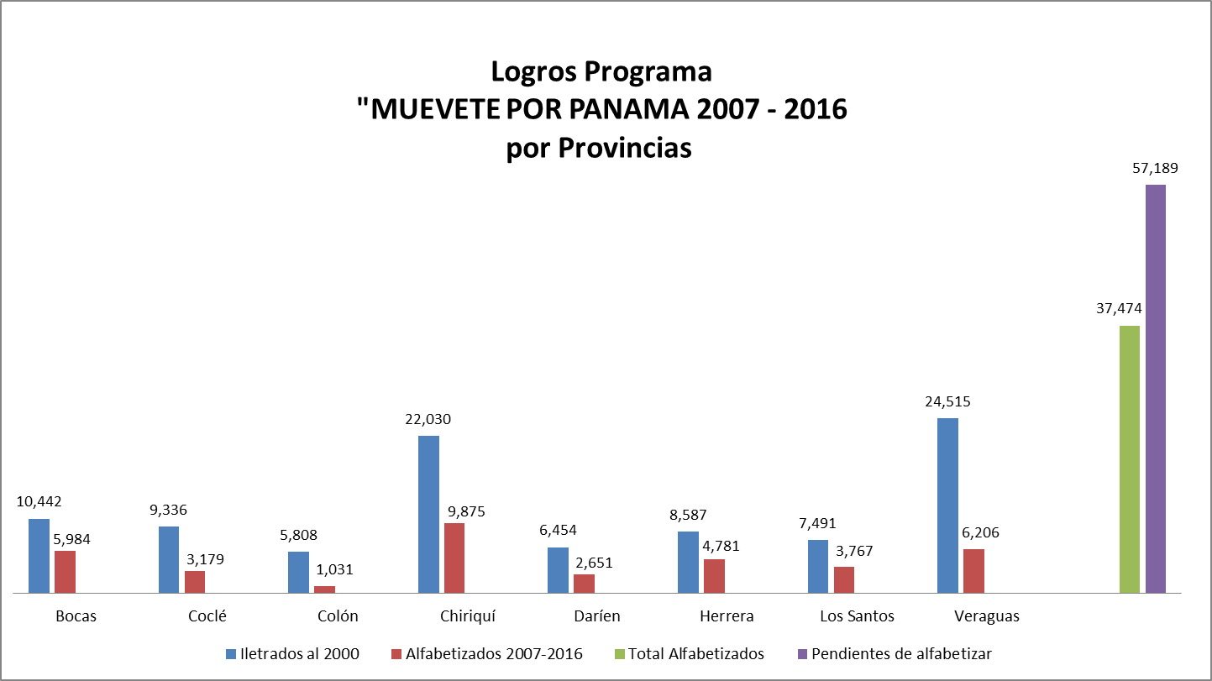

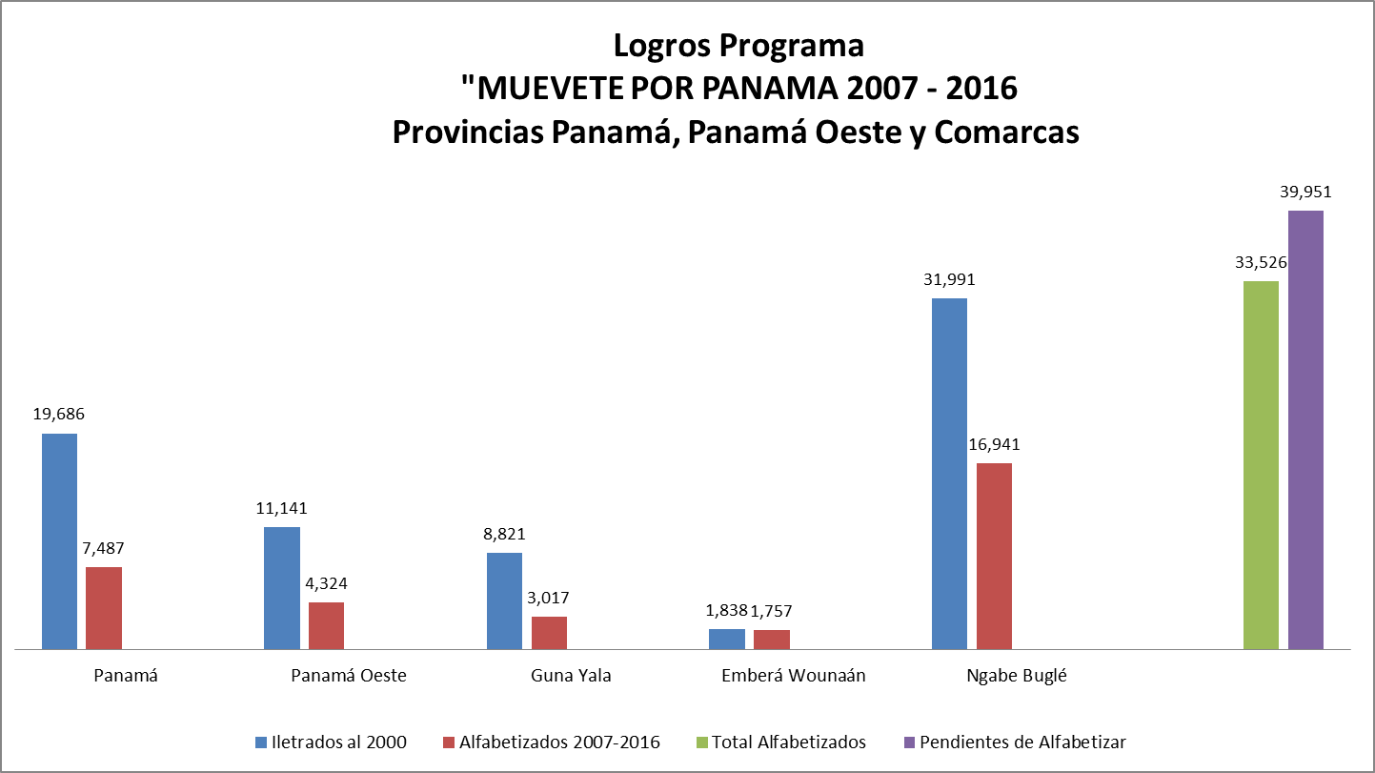
Article 11
Right to an adequate standard of living
Right to housing (E/C.12/1/Add.64, paras. 19 and 35)
139. Under Act No. 61 of 23 October 2009, repealing Act No. 9 of 25 January 1973, the Ministry of Housing was reorganized. Its purpose is to formulate, coordinate and effectively implement a national housing and land management policy to secure the enjoyment of this social right by the entire population, especially lower-income groups, as provided in article 117 of the Constitution.
140. The Directorate of Social Development of the Ministry of Housing and Land Management conducts socioeconomic surveys and studies, including population and housing surveys of informal settlements and communities in need of housing, so as to detect actual housing demand.
141. The State allocates funding for an intermediate housing census (taken five years after the main census) to collect housing data and devise the required strategies.
142. Different administrations have implemented a variety of social housing schemes, such as a programme of the Ministry of Housing and the Inter-American Development Bank that provided subsidies to enable middle-income households to access housing or purchase construction materials.
143. The housing sector has grown in recent years as a result of the good performance of the Panamanian economy and the impact that Act No. 3 of 1985, the Preferential Interest Act, as amended by Act No. 50 of 27 October 1999 and Act No. 63 of September 2013, had on housebuilding and the growth of mortgage lending in the financial system.
Indigenous peoples (E/C.12/1/Add.64, paras. 12 and 28). Poverty and literacy among indigenous people
144. According to the fourth report of Panama on the Millennium Development Goals, Panama met the target of halving the proportion of people living on less than B/. 1 a day, thanks to sustained economic growth, minimum wage increases and labour policies beneficial to the population, including indigenous peoples (see annex 30, figure II.1).
145. Similarly, through the implementation of various government programmes, by 2011 Panama had managed to virtually close the significant gender gap in literacy rates that was observed in 2006. This achievement highlights the success of the national literacy programmes of the Ministry of Education and the Ministry of Social Development, notably the “Get Moving for Panama” project, which, through volunteering, has brought literacy to people, especially women, living in areas that were lagging behind (see annex 30, figure II.23).
Land rights
146. Regarding the land rights of indigenous peoples, Panama has made progress through the enactment of laws such as Act No. 72 of 2008, which establishes a special procedure for awarding collective land titles to indigenous peoples who are not within the indigenous regions, and Act No. 34 of 25 July 2000, which created the fifth indigenous region, Guna de Wargandí. Under Act No. 72, the representatives of the Embera and Wounaan indigenous communities have completed or are preparing applications for land title; the titles to 1,382 hectares were awarded to indigenous people in Puerto Lara and Caña Blanca, thus guaranteeing them the ownership and enjoyment of their ancestral lands.

Table 5
Percentage of the population below the extreme poverty line, by area, province and indigenous region, 1991, 1995, 2000 and 2005–2015
147. In 2010, 96.4 per cent of non-indigenous people reported that they were able to read and write, with men and women having very similar percentages, surpassing those recorded in 2000. The literacy rate of the indigenous population located outside the indigenous regions rose from 75.9 per cent in 2000 to 83.7 per cent in 2010, with the male rate increasing by 6.8 percentage points and the female rate by 9.3 percentage points.
148. The indigenous population located in the indigenous regions also showed an improvement in the literacy rate, from 54.8 per cent in 2000 to 69.2 per cent in 2010, with male literacy up by 12.6 percentage points and female literacy up by 16.0 percentage points.
Access to drinking water
149. In 2000, 34.7 per cent of homes located in the indigenous regions were connected to a water supply, a figure that stood at 42.4 per cent in 2010.
150. The proportion of indigenous homes in indigenous regions that obtained water from pumped, artesian or shallow wells rose from 31.9 per cent in 2000 to 34.7 per cent in 2010. During the same period, the proportion of homes in indigenous regions that used water from rivers, streams or lakes fell from 33.0 per cent to 20.5 per cent, while the share of homes supplied by rainwater doubled.
Health
Education
151. The proportion of indigenous people with no formal education decreased by 40.5 per cent, while that of indigenous people having completed only one or more years of primary education fell by 18.2 per cent. The proportion having completed at least one year of secondary education rose by 36.8 per cent, while the proportion having completed at least one year of university education expanded greatly, by 211.3 per cent.
International Labour Organization (ILO) Indigenous and Tribal Peoples Convention, 1989 (No. 169)
152. Panama has taken strides towards the ratification of ILO Convention No. 169, having established a technical committee for the review of the Convention in 2016.
Progress
153. To improve indigenous communities’ poverty and literacy rates and their access to drinking water, employment, health, education and other basic social services, and to implement the provisions of the Constitution relating to indigenous peoples (articles 88, 90, 108, 124, 126 and 127), the following legislation has been enacted:
• Act No. 20 of 2000, establishing special intellectual property rules regarding the collective rights of indigenous peoples to the protection and defence of their cultural identity and traditional knowledge (see annex 31).
• Act No. 64 of 2013, establishing the Office of the Deputy Minister for Indigenous Affairs within the Ministry of the Interior and assigning it the functions of planning, directing and coordinating the indigenous policy of Panama (see annex 32).
• Act No. 72 of 23 December 2008, establishing five indigenous regions with an indigenous administrative system and providing for the free award of collective land titles to indigenous peoples who do not live in the indigenous regions (see annex 33).
• Act No. 37 of 2 August 2016 on the Consultation and Free, Prior and Informed Consent of Indigenous Peoples, which paves the way for the ratification of ILO Convention No. 169 (see annex 34).
Education
154. In 2007 the Ministry of Education created the National Directorate of Intercultural Bilingual Education to provide education programmes for indigenous peoples in accordance with their cultural patterns.
155. The Ministry has also established regional education directorates, which in 2012 assisted 42 Embera and Wounaan schools and 369 Ngobe Buglé schools in implementing intercultural bilingual education programmes. In 2013, it developed a peer-to-peer project (Entre Pares Panamá) in which teachers, head teachers and supervisors working in rural and indigenous schools are trained in the pedagogical use of new educational technologies. It has also carried out several programmes to improve education in multigrade schools in rural and indigenous areas through teacher training and other initiatives.
156. The State has also implemented an intercultural bilingual education programme under Act No. 88 of 22 November 2010, which recognizes the languages and alphabets of the indigenous peoples of Panama and sets standards for intercultural bilingual education. See annex 35.
Article 11
Right to an adequate standard of living
Right to private property and land tenure (E/C.12/1/Add.64, para. 36)
157. By Act No. 59 of 8 October 2010, Panama established the National Land Management Agency, which harnesses the powers of various public institutions (the National Cadastre Directorate, the National Directorate of Agrarian Reform, the National Land Management Programme and the Tommy Guardia National Geographical Institute) in order to facilitate and expedite land titling procedures and establish the boundaries of indigenous regions. It is the only State agency that is competent to formulate, monitor and enforce laws and regulations and recommend the adoption of national policies on the subject of land.
158. Act No. 72 of 2008, regulated by Executive Decree No. 223, “establishes a special procedure for awarding collective land titles to indigenous peoples who are not within the indigenous regions”. This Act provides that titles to collective land are imprescriptible, non-transferable, protected from seizure and inalienable, and safeguards the economic, social and cultural well-being of indigenous peoples living in indigenous communities.
159. Act No. 20 of 27 March 2009, regulated by Executive Decree No. 19 of 30 April 2009, establishes “a special procedure of extraordinary expropriation for the designation and regularization of established community settlements”, among other provisions. See annex 36.
160. Some evictions have occurred in section 42 of estate 102, which is the property of the company Ganadera Bocas, S.A., specifically in the part of the estate on which Naso families had trespassed. The Ombudsman’s Office, which is an institution that upholds human rights, has been present throughout the proceedings related to this case.
161. According to a report of the National Commission on Administrative Boundaries and the National Land Management Programme, only 12 houses were found on the estate. Representatives of the Naso group acknowledge that only 29 people were affected by the eviction in March 2009.
162. In order to resolve the land dispute, government bodies working in this field, with direct input from the National Land Management Programme, engaged in a lengthy process of addressing concerns, making proposals, verifying and validating boundaries and holding direct dialogue with those affected in the disputed area. This process resulted in the following measures:
• A government proposal that an agreement be entered into between the Government and the Naso indigenous families was put forward. In the proposed agreement, the Government undertook first and foremost to relocate and build homes for the 18 families that would be affected. However, this proposal did not come to fruition, as it was rejected by the representatives of the Naso persons involved in the case.
• On 18 July 2008 a certificate was issued by the National Commission on Administrative Boundaries of the Ministry of the Interior and Justice to formally attest to the location of the area in question.
163. Thematic maps were developed, with data illustrating: (1) the areas occupied and proposed for occupation by the Naso community, in relation to the land in question proposed by the National Directorate for Indigenous Policy and the National Commission on Administrative Boundaries as an alternative solution to the dispute; (2) the proposed boundary of the Naso territory, as verified by the National Commission on Administrative Boundaries, in relation to the dispute over the land in question; and (3) the decision of 7 May 2006 issued by the office of the mayor of Changuinola, which calls for the suspension of all activity by the citizens of San Tigra and San San Druy in the part of estate 102 that they have occupied.
• A technical report detailing the outcome of the consultation meeting and field day and the technical proposal to facilitate dialogue and resolution of the dispute between the Naso Tjër Di people and the Ganadera Bocas company in the area of San San and San San Druy was drawn up by the National Directorate for Indigenous Policy, the National Directorate of Local Governments, the National Commission on Administrative Boundaries, the Electoral Court and the Tommy Guardia National Geographical Institute, dated 13 to 21 August 2006.
• The then Deputy Minister of the Interior, together with the National Directorate for Indigenous Policy and the Indigenous Affairs Commission of the National Assembly, invited representatives of the Naso people to discuss the establishment of a working group for the demarcation of their territory.
164. As to the implementation of the recommendations made by the Committee following its 1995 technical assistance mission, the Ministry of Housing has rolled out several housing rehabilitation and construction programmes in Colón and Panama City under successive governments. These included the Curundú Urban Renewal Project, the housing component of which consists of 62 four-storey buildings with eight apartments on each floor; the apartments have an interior area of 45.6 m² plus a balcony and are equipped with electricity, sanitation and telephone services. Furthermore, the Colón Urban Renewal Project is creating housing opportunities to reduce the housing deficit in that province, particularly in the municipalities of Barrio Norte and Barrio Sur.
165. The Ngobe Buglé indigenous region was established and other measures were taken pursuant to Act No. 10 of 7 March 1997.
166. Article 4 of Executive Decree No. 55 of 25 August 2009, amending Decree No. 35 of 2006 and establishing a housing solidarity fund, sets out the minimum requirements of housing projects, namely that housing units must have an interior area of at least 36 m².
167. To accelerate and extend the policy of regularizing property ownership, the National Land Management Agency was established under Act No. 59 of 8 October 2010. The Agency harnesses the powers of various public institutions (the National Cadastre Directorate, the National Directorate of Agrarian Reform, the National Land Management Programme and the Tommy Guardia National Geographical Institute) in order to facilitate and expedite land titling procedures and establish the boundaries of indigenous regions.
Article 12
Right to health (E/C.12/1/Add.64, paras. 20–21 and 37–39)
Infant and maternal mortality (paras. 20 and 37)
168. The maternal mortality ratio has shown a downward trend, falling from about 1.4 deaths per 1,000 live births in 1970 to about 0.6 deaths per 1,000 live births in 2012, a drop of 57 per cent. During the period 1990–2012, the ratio remained stable in the range of 0.6 deaths per 1,000 live births.
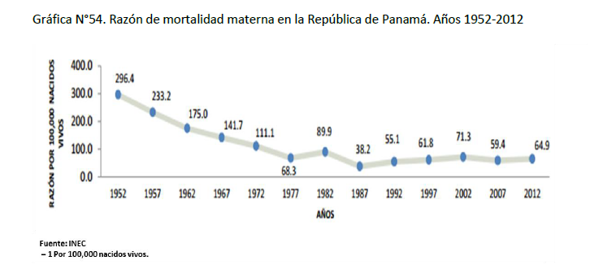
169. Forty maternal deaths were reported in 2015, for a ratio of 52.7 deaths per 100,000 live births. Panamá Province had the most deaths linked to obstetric causes (10 deaths, or 25 per cent of the total), followed by the Ngobe Buglé indigenous region (8 deaths, or 20 per cent) and Colón Province (5 deaths, or 12.5 per cent).
170. To illustrate the maternal mortality ratio in Panama, by area, in 2000, 2005, 2010 and 2015.
171. In 2015, the infant mortality rate was 12.5 per 1,000 live births. The main cause of death among children under 1 year of age was “certain conditions originating during the perinatal period”, which claimed 391 lives and accounted for 41.1 per cent of deaths among this group; the second most common cause of death was “congenital malformations, deformities and chromosomal anomalies”, which accounted for 30.0 per cent.

Figure 3
Infant, neonatal and post-neonatal mortality rates, 1960–2015
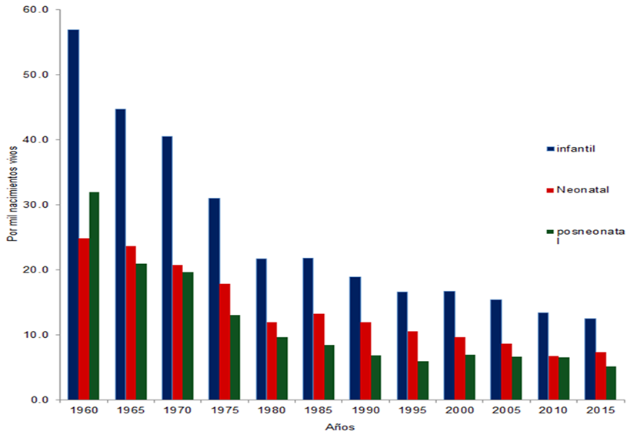
172. To evaluate progress towards universal access to reproductive health, it is recommended that four indicators be monitored: the contraceptive prevalence rate, the adolescent birth rate, antenatal care coverage and unmet need for family planning.
173. According to the 2009 national survey on sexual and reproductive health, 72.9 per cent of female respondents aged 15 to 49 years stated that they had used modern or traditional methods of contraception at least once.
174. The 2013 multiple indicator cluster survey found that the contraceptive prevalence rate, which refers to the percentage of women aged between 15 and 49 who are currently married or in a union and who are using (or whose partner is using) a modern or traditional method of contraception, had fallen to 62.8 per cent.
175. In 2012, the adolescent birth rate was 90.2 births per 1,000 women aged 15 to 19, as compared with 79.8 in 2002, indicating an increase in teenage pregnancy.
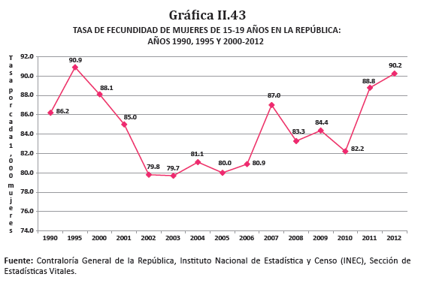
176. National data from the Department of Health Records and Statistics of the Ministry of Health show that antenatal care coverage (at least four visits) in Ministry of Health facilities exceeded 80 per cent in 2012.
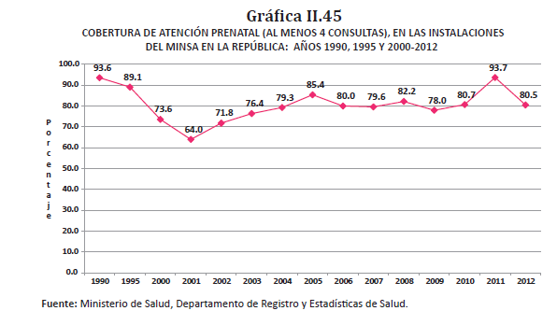
177. Pursuant to the Committee’s recommendation to take measures aimed at reducing the maternal mortality rate and to expand the availability and accessibility of reproductive and sexual health information and services, the following developments deserve mention:
• The drafting of the Strategic Plan for the Reduction of Maternal and Perinatal Morbidity and Mortality 2006–2009, the aims of which are to reduce maternal and perinatal morbidity and mortality by three quarters by 2015, in accordance with the relevant Millennium Development Goal, and to reduce gaps in maternal and perinatal health by targeting strategies at the most disadvantaged and vulnerable rural areas and indigenous peoples and improving the quality of care provided by the health service network.
• The formation, by Executive Decree No. 2 of 9 February 1999, of the National Sexual and Reproductive Health Commission, comprising representatives of relevant institutions and groups: the Ministry of Health, the Ministry of Education, the Ministry of Social Development, the Office of the First Lady, the Social Security Fund, the National Secretariat for the Social Integration of Persons with Disabilities, the University of Panama, various NGOs working in this field, the Coordinating Agency for the Integral Development of Women, the Parents Federation, the Senior Citizens Federation, the Guna Yala and Ngobe Buglé communities, the National Youth Council, the Ecumenical Council and the Archdiocese of Panama. The Commission has met each month since 2005 to prepare a draft framework law on sexual and reproductive health, bill No. 61, as the basis for comprehensive health education, care and promotion policies. The bill is still pending discussion in the National Assembly.
• The drafting of the National Sexual and Reproductive Health Plan (1999).
• The issuance of Executive Decree No. 428 of 2004, providing for free maternity services and assistance in Ministry of Health facilities. Antenatal check-ups are a shared responsibility under the Opportunities Network Programme and verified attendance at check-ups is required for the payment of cash transfers to beneficiary families.
• The establishment of a sexual and reproductive health programme within the organizational and functional structure of the Ministry of Health, under the Subdirectorate General for the Health of the Population.
• The existence of the Inter-Agency Thematic Group on Health.
178. The Ministry of Health has a Family Planning Programme, the general purpose of which is “to provide the population with abundant information and quality services to enable it to achieve its reproductive ideals” (Comprehensive Health Care for Women Programme, 2002).
179. In 2010, the Health Planning Directorate of the Ministry of Health drew up the National Health Policy 2010–2015 following a consultation process with institutional, sectoral and other actors. In terms of structure, the Policy has 3 key components, 9 policies, 39 strategic objectives and 125 lines of action designed to give direction to activities undertaken in the health sector.
180. Component 1, “Protecting the public by regulating and managing the health system”, included policies 1, 2, 6, 7 and 8. Component 2, “Improving the quality of and access to health services”, was comprised of policies 3, 5 and 9. Component 3, “Promoting health with social participation”, consisted only of policy 4.
181. In July 2015, the Ministry of Health performed an evaluation of the implementation of the National Health Policy and Strategic Guidelines 2010–2015 in order to determine the extent of progress in strengthening its own stewardship and capacities as national health authority. The outcomes of this exercise facilitated the formulation, validation and dissemination of the National Health Policy 2016–2025.
182. The National Health Policy 2016–2025 is structured around 3 key components, covering 9 health policies with 40 strategic objectives and 200 lines of action, as shown in the table below.
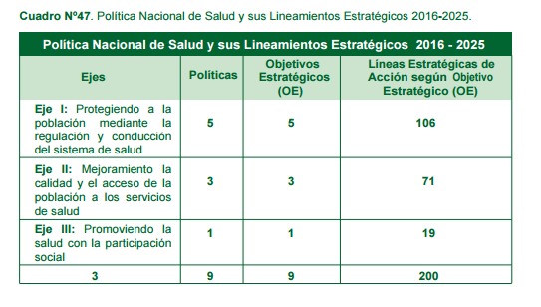183. The Ministry of Health led the preparation of the road map and plan of action for implementation of the Strategy for Universal Access to Health and Universal Health Coverage. The road map was prepared with the participation of stakeholders and is comprised of four strategic areas.
184. To achieve Millennium Development Goals of reducing maternal mortality by three quarters, reducing child mortality by two thirds and achieving access to health, Panama has implemented programmes and projects such as:
• Component 3 of the Social Protection Programme/Opportunities Network Programme. Its objectives are to expand the coverage of preventive maternal and child health services for children under 5 years of age and pregnant and breastfeeding women in indigenous regions, and to improve the quality of services by introducing activities aimed at changing eating habits and improving childcare practices at home and in the community.
• The Health Equity and Performance Improvement Project (2009–2014), whose aims were to improve equity in health by increasing access to and the use and quality of health services in the indigenous regions and bordering rural areas, and to reduce maternal and child mortality rates and chronic malnutrition. The programme had three components: (1) health protection for vulnerable populations; (2) strengthening the services network for the health protection of vulnerable populations; and (3) strengthening the stewardship capacity of the Ministry of Health.
• A project to build shelters for mothers and children in the Ngobe Buglé indigenous region, with the goal of lowering the maternal and child mortality rate in this area of extreme poverty. It was implemented by the Ministry of Health and the Office of the First Lady.
• The National Neonatal Screening Programme. The aim of this hospital-based prevention programme is the early detection of metabolic disorders in newborns.
185. Statistics show that as a result of these efforts, Panama has managed to improve the obstetric care provided by trained personnel and to expand the coverage of antenatal check-ups, essentially through the services provided by the public health system (the Ministry of Health and the Social Security Fund). However, the actions undertaken have not been sufficient to improve maternal health, and so challenges remain.
186. With regard to terminations of pregnancy, the National Statistics and Census Institute of the Office of the Comptroller General recorded 9,474 fetal deaths in Panama in 2015 – an increase of 3.2 per cent over the 2014 figure – with a fetal mortality rate of 124.8 deaths per 1,000 live births.
187. One measure for reducing the number of terminations is the classification of abortion as an offence under articles 141 to 144 of the Criminal Code. Any woman who self-induces or consents to an abortion is liable to 1 to 3 years’ imprisonment. Anyone who performs an abortion without the woman’s consent is liable to 4 to 8 years’ imprisonment, rising to 5 to 10 years in the event of the woman’s death.
188. Abortion is permitted under article 144 when it is the result of rape or for medical reasons, provided that the woman consents to the abortion. Act No. 14 of 18 May 2007 introduced an amendment to the Criminal Code whereby an additional paragraph was inserted under article 144.
Article 12 (Right to health)
HIV/AIDS (paras. 21 and 38)
189. In 2013, 574 new cases of AIDS were recorded by the monitoring system, bringing the cumulative total to 13,079 cases over the period from September 1984 to December 2013. Cases are determined in accordance with the criteria laid down by the Atlanta Centers for Disease Control and Prevention in 1993.
190. The annual AIDS incidence rate trended downward in the period 2004–2013. The trend was similar for both men and women: the annual incidence rate, which in 2004 was 31.2 for men and 12.4 for women, fell significantly by almost 10 cases per 100,000 inhabitants for men and 4 cases per 100,000 inhabitants for women.
191. See below for AIDS incidence rates by gender in the period 2004–2013.

Figure 5
AIDS incidence rate, by gender, 2004–2013
192. In 2013, HIV testing coverage among pregnant women reached 83.9 per cent. Of the three modes of HIV transmission, mother-to-child transmission accounted for 2.7 per cent of all infections between September 1984 and September 2014. At the end of that period, 316 cases of AIDS were reported in children in the 0–4 age group, and 81 cases in the 5–9 age group.
193. In 2012, 6,411 people were receiving antiretroviral treatment (260 under 15 years old and 6,151 aged 15 or over).
194. The health response is focused on prevention and care, with strong civil society support and the free provision of antiretroviral treatment.
195. In terms of measures adopted, Panama has a legal framework on sexually transmitted infections and HIV/AIDS, consisting of Act No. 3 of 5 January 2000, regulated by Executive Decree No. 119 of May 2001. The Decree designates the Directorate General of Public Health of the Ministry of Health as the authority responsible for the intra- and inter-institutional and intersectoral coordination of the National Programme on Sexually Transmitted Infections and HIV/AIDS. In that framework, the Directorate General is tasked with recommending gender-sensitive policies and strategies, issuing national technical standards and establishing intra- and inter-institutional and intersectoral commissions and other means of ensuring the broad participation of civil society to support and guide State policy in this area.
196. The National Multisectoral Strategic Plan on HIV/AIDS 2014–2019 sets out the HIV/AIDS situation in Panama, the resources available at the national level to combat HIV/AIDS, strategic variables, areas of focus, lines of action, a budget and a monitoring plan. See annex 37.
197. Panama is currently the beneficiary of the programme “A collaborative initiative between most-at-risk populations and the public sector through community strengthening to scale up Panama’s national response to HIV”, which takes an innovative approach to prevention among most-at-risk populations and is financed by the Global Fund to Fight AIDS, Tuberculosis and Malaria.
198. The Ministry of Health runs “friendly clinics” which offer health services to most-at-risk populations in areas prioritized under the National Programme on Sexually Transmitted Infections and HIV/AIDS. In December 2013, four friendly clinics were in operation.
199. Prevention measures carried out under the National Programme on Sexually Transmitted Infections and HIV/AIDS include:
• The distribution of 4,000 posters aimed at preventing the mother-to-child transmission of HIV and syphilis in the country’s 14 health regions.
• The preparation and implementation of a national plan for the prevention of mother-to-child transmission of HIV and syphilis; workshops on pre- and post-HIV-test counselling aimed at personnel in all health regions, in which 717 health professionals received training.
• Workshops on pre- and post-HIV-test counselling aimed at the staff of the University of Panama, the Technological University of Panama, the Ministry of Economic Affairs and Finance and the Panamanian Institute for Special Training, which are members of the continuous comprehensive care network for HIV.
• Promotional and preventive activities in the context of World AIDS Day, aimed at the general public and most-at-risk populations. Activities included media interviews, Masses, marches, rapid HIV testing with pre- and post-test counselling, the mass distribution of condoms and water-based lubricants and the distribution of literature on the prevention of sexually transmitted infections and HIV.
200. To enhance the comprehensive care of people affected by HIV/AIDS, the following developments are noteworthy: the expansion of coverage through the opening of 16 antiretroviral therapy clinics in different health regions, 14 of which are operated by the Ministry of Health and 2 by the Social Security Fund; the distribution of antiretroviral drugs and HIV test reagents to all health regions; the provision of baby formula for infants born to HIV-positive mothers in all health regions; the training of personnel working in antiretroviral therapy clinics in the use of antiretroviral treatment monitoring software; and the updating of the Guide to Counselling and Psychological Support in relation to HIV and AIDS.
201. Panama has adopted the 90-90-90 target, which consists of diagnosing 90 per cent of people living with HIV in the country, referring 90 per cent of those diagnosed as HIV-positive to antiretroviral therapy clinics and suppressing the virus among 90 per cent of those receiving treatment.
202. A legal framework is currently being developed to guarantee the implementation of the State policy on HIV/AIDS, ensuring improvements in diagnosis, prevention, epidemiological surveillance and control of biomedical waste.
203. As of May 2019, Panama is on the World Health Organization (WHO) list of 13 countries in the Americas that are close to achieving elimination of mother-to-child transmission of HIV. Panama has an HIV mother-to-child transmission rate of between 4 per cent and 5 per cent; the target set by WHO is 2 per cent. This progress in the fight against HIV is due to the checks carried out during pregnancy and the provision of free virus testing, which ensures detection and treatment before the baby is born, with a view to preventing transmission.
Article 12
Right to health
Welfare and access to health (para. 39)
204. In keeping with its objective of ensuring basic primary health care, the Ministry of Health published Políticas y Estrategias de Salud 2000–2004 (Health Policies and Strategies 2000–2004) as guidance for activities, plans, programmes and projects intended to promote a new decentralized care model emphasizing a primary care strategy and to strengthen the Ministry’s regulatory role.
205. The State subsidizes the cost of health care so that users do not pay the true cost of services. Act No. 51 on the Social Security Fund stipulates that all workers and their dependents have the right to be treated free of charge.
206. To ensure access to health-care facilities, goods and services, the State operates 910 health facilities, of which 831 belong to the Ministry of Health and 79 to the Social Security Fund. These include:
• 18 hospitals run by the Ministry of Health, 15 by the Social Security Fund and 4 by patronatos (trusts).
• The Social Security Fund has 15 local primary health-care units, 23 health-care, promotion and prevention centres and 26 polyclinics.
• The Ministry of Health has 7 reintegration centres, 2 national institutes, 11 innovative primary health-care centres, 8 health promotion centres, 6 policentros (health centres providing secondary care), 4 health facilities in prisons, 179 health centres (plus 2 that are not operational), 116 health sub-centres (plus 7 non-operational) and 473 health posts (plus 70 non-operational).
207. The Ministry of Health has adopted the National Health Policy and Strategic Guidelines 2016–2025, which include a road map and a plan of action for implementing the Strategy for Universal Access to Health and Universal Health Coverage. The road map was prepared with the participation of stakeholders and is comprised of four strategic areas.
208. As a State member of the Pan-American Health Organization (PAHO/WHO), Panama is implementing the Strategy in primary health care. The aim is to ensure that all people and communities have access, without any kind of discrimination, to comprehensive, appropriate, timely, quality health services, while ensuring that the use of such services does not expose users to financial difficulties.
209. In its Decision No. 632 of 30 June 2009, the Ministry of Health adopted a national drug policy based on seven basic components: access to medicines; quality, safety and efficacy of medicines; rational use of medicines; research; human resources; intellectual property; and monitoring and evaluation of the implementation of the policy.
210. The main function of the National Medicines Commission created in 2011 is to prepare the national list of essential medicines and the list of specialized medicines that are costly and difficult to obtain, on the basis of established criteria.
211. Together with other Central American countries and the Dominican Republic, Panama participates in the joint price negotiation and medicine procurement mechanism of the Council of Central American Ministers of Health, which allows it to purchase high-cost and difficult-to-obtain medicines at lower prices than those available through national procurement. Similarly, Panama obtains better prices for vaccines through the PAHO Revolving Fund for Vaccine Procurement, and for drugs for neglected diseases through the PAHO Strategic Fund.
Food and nutrition
212. In recent years, Panama has made significant progress in reducing hunger, malnutrition and extreme poverty. The proportion of Panamanians who are undernourished has fallen from 27.6 per cent in 2001 to 9.5 per cent today, while overall poverty has fallen from 36.6 per cent to a projected 22.3 per cent in 2017–2021. This progress is the result of a serious national commitment undertaken by governments, legislators, civil society organizations and the private sector, among others, which has been acknowledged by international organizations such as the Food and Agriculture Organization of the United Nations.
213. Panama is currently implementing its National Food and Nutrition Security Plan 2017–2021 in response to the need to accelerate activities to achieve the Sustainable Development Goals. The Plan is supported by a pre-existing institutional framework for pursuing policies and programmes to eradicate hunger and malnutrition.
214. The Plan promotes food and nutrition security through the intersectoral and inter-institutional coordination of food- and nutrition-related programme activities so that the entire Panamanian population, especially vulnerable groups, can enjoy the right to food. These vulnerable groups are concentrated mainly in indigenous regions and rural areas and are largely dependent on family farming.
215. To ensure their food and nutrition security, the Plan includes measures to strengthen social protection systems through contributory and non-contributory protection instruments and to improve productive opportunities.
216. Progress has also been made through institutional strengthening. The National Secretariat for the Food and Nutrition Security Plan, established by Executive Decree No. 171 of 18 October 2004, is working to develop food and nutrition security policies and the food and nutrition security monitoring system approved in August 2007.
Access to safe and potable water and adequate sanitation
217. The Ministry of Health, with non-reimbursable cooperation funding from the Cooperation Fund for Water and Sanitation of Spain, runs a water and sanitation programme in rural and indigenous areas, particularly targeting the five indigenous regions (Embera-Wounaan, Wargandí, Madungandí, Guna Yala and Ngobe Buglé). Activities are planned through a participatory process of free and informed decision-making by priority communities and are agreed upon with the administrative and indigenous regional authorities and the beneficiary communities themselves. It is estimated that 24,671 people from 5,370 households in 65 communities will directly benefit, with the designs and feasibility studies for projects in 25 communities being completed by 2019.
218. Under the programme’s main component, it is envisaged that activities will be carried out to promote community participation in all processes for the management of potable water services, including training in the operation, maintenance and administration of systems, in the rational use of water, in protection of the environment, natural resources and water sources, and in household waste management and home hygiene. Methods to reduce water wastage include the promotion of micro-metering to create awareness of water saving and rational use and of the joint payment of community tariffs.
219. The Directorate for the Potable Water and Sanitary Sewerage Subsector has drafted and issued new decrees and regulations and has forged strategic partnerships with other actors in the subsector with a view to formulating a policy with guidelines for consideration in the context of a sectoral reform. The aim of such a reform would be to enhance the coordination, information systems and planning capacity of key actors, whether for urban or rural water or sanitation systems.
220. Other goals include building capacity to provide technical assistance to rural water management boards and increasing the frequency of sampling and quality monitoring of untreated water and drinking water supplied to communities.
221. The Department for the Quality of Potable Water of the Ministry of Health, the Ministry of the Environment and the Institute of National Aqueducts and Sewers have developed a national plan for water quality monitoring in rural communities, which will form the basis for establishing water quality monitoring follow-up strategies in the rural-indigenous sector in the short term.
222. Since 2014, the “Basic Sanitation: 100 Per Cent Safe Drinking Water/Zero Latrines” Programme has been carried out to provide 24-hour drinking water and sanitation facilities throughout the country, improving the coverage of sewerage networks and eliminating latrines, and replacing them with hygienic toilets. It is estimated that the Programme will improve the quality of life of more than 1 million people, achieving 98 per cent coverage in urban areas, 90 per cent in rural areas, 70 per cent coverage of sewerage networks, and improved sanitation facilities in the form of 300,000 hygienic toilets in rural areas.
223. The Programme is administered by the National Council for Sustainable Development, while the Secretariat of Presidential Goals – in accordance with Executive Decree No. 1221 of 2 July 2014 – is responsible for coordinating all institutions working in the water and sanitation subsector. Both the Council and the Secretariat are attached to the Ministry of the Presidency.
Article 13
Right to education (E/C.12/1/Add.64, paras. 22 and 40)
Literacy (paras. 22 and 40)
Literacy
224. Statistical tables based on the eleventh national population census, conducted in 2010, show that, out of the total population aged 10 years or over (2,727,168 people), the population with literacy skills consists of 2,573,311 people, of whom 1,293,163 are men and 1,280,148 are women. The population without literacy skills totals 148,747, of whom 67,102 are men and 81,645 are women. According to these figures, the illiteracy rate in Panama is 5.5 per cent.
225. This first level of education (literacy) is currently under the responsibility of the Ministry of Social Development, which is in charge of monitoring and evaluation. Since 2009, the Directorate of Youth and Adult Education of the Ministry of Education has been responsible for assigning a team of teachers to deal with the issue of literacy at the national level.
226. Although some young people and adults have yet to receive literacy training, since 2008 the Ministry of Education, through the Educational Development Project, has been working alongside the Ministry of Social Development to help young people and adults to strengthen their literacy skills under the Post-Literacy Project, the aim of which is to serve large populations that have fallen behind in their education and to provide training that follows on from primary education. The annual goal is to reach 4,500 young people and adults, with 126 facilitators in 124 centres located throughout the country. Since each grade is promoted on a quarterly basis, 38 to 40 per cent of the target number are served per quarter.
227. As Panama is determined to reduce illiteracy in the country, the Ministry of Social Development is implementing the “Get Moving for Panama” literacy project nationwide to enable all Panamanians to exercise their right to education.
228. The “Get Moving for Panama” project uses a flexible method that allows students to learn from experience. Literacy and numeracy teaching are combined with video lessons to ensure that classes are entertaining. To extend coverage and create learning environments in hard-to-reach areas, the State has counted on the support and assistance of 5,000 volunteers who have given their free time to become facilitators of literacy classes for members of their community.
229. “Get Moving for Panama” is a comprehensive project that promotes individuals’ well-being and social inclusion. For that reason, it is being implemented in parallel with the Operation Miracle programme, an initiative that provides people with free eye tests and glasses so that they can read and write without discomfort. Approximately 70 per cent of the project’s beneficiaries are female.
Article 13
(Right to education) and article 14 (Right to free education)
Universal primary and secondary education (paras. 23 and 41)
230. Between 1990 and 2012, Panama maintained net enrolment rates of close to 90 per cent in primary education through specific programmes and actions aimed at keeping all girls and boys in the education system. Official data from the Department of Statistics of the Ministry of Education show that the net enrolment rate in primary education was 91.5 per cent in 1990 and 92.5 per cent in 2012.
231. The most significant achievements include universal coverage in primary education, reduction of the dropout rate, increased retention of children in the system, initiation of early childhood care and education, and improved gender parity in primary education. Literacy levels, the average number of years of schooling completed and the number of teachers with higher education have all increased. To improve the quality of tertiary education, a university evaluation and accreditation process has been initiated in the country.
232. In order to ensure that students whom the psychopedagogical services have identified as having socioeconomic problems do not drop out of school, and to counteract this phenomenon, Act No. 40 of 2010 created the Universal Scholarship Programme to provide students with financial support to help them meet their basic school expenses. The goal is to raise school enrolment and attendance rates by giving scholarship opportunities to primary-, middle- and secondary-school students who maintain the academic average required by this law over the current school year.
233. In 2016, a national committee for dialogue on the national commitment to education was established. This body consisted of eight key sectors identified by all the actors consulted during the exploratory phase. The plenary committee identified the need to create a Permanent Multisectoral Council for the Implementation of the National Commitment to Education to follow up and monitor the implementation of the policies and actions agreed upon by all sectors during the dialogue.
234. Educational policies and actions are based on five key themes:
• Education quality
• Equity in education
• Training of educators
• Education management
• Investment in education
235. The purpose of this mechanism is to ensure that Panama has a State policy on education and an education system that guarantees and promotes the effective exercise of all Panamanians’ right to quality education with equity.
Right to culture
236. The National Institute of Culture is the government institution in charge of coordinating and promoting activities relating to culture and folklore throughout the country. It also manages 23 dedicated arts centres where a variety of art forms are taught, organizes competitions, and awards literary scholarships. It operates 13 regional centres, manages the Anita Villalaz Theatre, the National Theatre and the Balboa Theatre, coordinates the Symphonic Orchestra and the National Ballet, and maintains 18 museums, including the Museum of Religious Art, the Reina Torres de Araúz Anthropological Museum and the Afro-Antillean Museum.
237. The role of the National Directorate of Historical Heritage of the National Institute of Culture is to oversee, conserve, study, safeguard, administer and enrich the nation’s historical heritage, including monuments, historical monuments, archaeological sites, national museums, movable property of historic value, and any object or item that constitutes documentary evidence of the country’s historical past in general.
Right to social security
238. The Republic of Panama, through the Social Security Fund, provides social security coverage to formal-sector workers who are affiliated with the system, but not to informal-sector workers, who do not pay contributions. A minimal percentage of contributions to the system are paid by informal-sector workers in the form of voluntary insurance payments. The coverage provided includes benefits for old-age retirement, illness, maternity, disability, family allowances, widowhood, orphanhood, funeral assistance, work accidents and occupational diseases, in accordance with the terms, limits and conditions established in the Constitution and in Act No. 51 of 2005 (art. 2), and with the financial capacity of the institution. Unemployment insurance is not included in this system.
239. Act No. 51 of 2005 lays down the conditions and the minimum and maximum amounts of disability and old-age pensions (arts. 177–178, as amended by Act No. 70 of 2011). These amounts are reviewed periodically under article 192 of Act No. 51 of 2005, as amended by Act No. 70 of 2011. In addition, article 193 of Act No. 51 establishes an annual bonus for disability and old-age pensioners.
240. As to whether these payments are sufficient to ensure an adequate standard of living for beneficiaries and their families, this is relative, since the system comprises the individual contributions of each insured person and operates on that basis. The Panamanian social security system does not include non-contributory social assistance allowances for disadvantaged and marginalized individuals and families, as they are not covered by the contributory schemes. However, the State helps to guarantee social assistance to such groups of people who have not paid into the system by implementing special programmes such as “120 at 65”.
241. The State also provides support to low-income families in rural areas through the Opportunities Network system.
242. In order to ensure the financial health of the Social Security Fund, a change was made in the basic law governing the institution. Following a national dialogue on the subject, Act No. 51 of 27 December 2005 was adopted. Among the most important developments was the creation of a second pillar within the disability, old-age and death benefits programme.
243. This new law establishes two subsystems within the disability, old-age and death benefits programme. The first is the exclusively defined benefit subsystem, which is simply an actuarial financial regime of coverage capital distribution, in which all current insured persons over the age of 35 who have ever contributed to the system are included. The second is the mixed subsystem, which is made up of two components. One is the defined benefit component, which is operated and managed under an actuarial regime of coverage capital distribution in which contributions are paid only on monthly earnings up to a ceiling of B/. 500; the other is the personal savings component, in which the main difference from the first component is that contributions are managed in individually capitalized savings accounts.
244. Through these drastic changes, the Panamanian social security system has joined the new global trend, which is to manage retirement funds through investment in the flourishing capital market. In Panama, however, this new law does not provide for the possibility of handing over these monies to private management. Instead, it directs the Social Security Fund itself to create an investment entity within that institution, and provides for the structural and technological adaptation of the National Directorate of Economic Benefits to become the account-keeper and payor.
Reporting and dissemination (E/C.12/1/Add.64, paras. 24 and 42–43)
245. In 2016, the National Commission for the Follow-up of Human Rights Recommendations undertook a process of awareness-raising and public information on the International Covenant on Economic, Social and Cultural Rights, the recommendations of the Committee on Economic, Social and Cultural Rights and the action taken in response to those recommendations. This work was carried out with the support of the Office of the United Nations High Commissioner for Human Rights (OHCHR) Regional Office for Central America and the Caribbean. The public was also informed of the Committee’s observations through the process of consultation with civil society during the preparation of the present report.

List of Annexes
Anexo 1: Ley 41 de 1998
Anexo 2: Ley 6 de 2002
Anexo 3: Ley 36 de 2008
Anexo 4: Sentencia del 21 de agosto del 2008
Anexo 5: Resolución No. 5-0727
Anexo 6: Resolución No. 5-0728
Anexo 7: Resolución ADMG-164-2014
Anexo 8: Resolución ADMG-012-2015
Anexo 9: Resolución ADMG-229-2015
Anexo 10: Fallo Sala Tercera 6 de Diciembre de 2000
Anexo 11: Ley 37 de 2016
Anexo 12: Ley 88 de 2010
Anexo 13: Ley 4 de 1999
Anexo 14: Decreto Ejecutivo No. 53 de 2002
Anexo 15: Decreto Ejecutivo No. 244 de 2012
Anexo 16: Ley 27 de 2017
Anexo 17: Ley 29 de 2017
Anexo 18: Ley 56 de 2017
Anexo 19: Decreto Ejecutivo 293 de 2015
Anexo 20: Ley 132 de 2013
Anexo 21: Ley 130 de 2013
Anexo 22: Ley 129 de 2013
Anexo 23: Ley 135 de 2013
Anexo 24: Programa YO SI CUMPLO
Anexo 25: Decreto Ejecutivo No. 1 de 2016
Anexo 26: Programa Red de Oportunidades
Anexo 27: Ley 15 de 2014
Anexo 28: Ley 44 de 2009
Anexo 29: Ley 14 de 2012
Anexo 30: IV Informe de Panamá ODM 2014
Anexo 31: Ley 20 de 2000
Anexo 32: Ley 64 de 2013
Anexo 33: Ley 72 de 2008
Anexo 34: Ley 37 de 2016
Anexo 35: Ley 88 de 2010
Anexo 36: Decreto Ejecutivo No. 19 de 2009
Anexo 37: Plan Estratégico nacional Multisectorial de VIH-Sida 2014-2019

* The present document is being issued without formal editing.
** The annexes to the present report are available on the Committee’s web page.
Executive Decree No. 7 of 2012. Gaceta Oficial (Official Gazette) No. 26953-A.
Act No. 2 of 1938; Act No. 16 of 1953, Gaceta Oficial No. 12042; and Act No. 99 of 1998, Gaceta Oficial No. 23701.
Act No. 22 of 1983, Gaceta Oficial No. 19976.
Act No. 10 of 1997, Gaceta Oficial No. 23242.
Act No. 24 of 1996, Gaceta Oficial No. 22951.
Act No. 34 of 2000, Gaceta Oficial No. 24106.
Act No. 63 of 2008 adopting the Code of Criminal Procedure, art. 48.
Act No. 31 on the Civil Registry of 25 July 2006, consolidated text, arts. 45 and 47.
Ministry of Economic Affairs and Finance, Economic and Social Analysis Directorate, Cost of the basic family food basket, December 2010. Common core document.
The average number of persons per household in the districts of Panamá and San Miguelito is 3.5.
3.6 persons per household.
Child labour surveys of 2000 and 2014, National Statistics and Census Institute.
Ibid.
This Committee was established in 1997.
Source: Economic and Social Analysis Directorate of the Ministry of Economic Affairs and Finance, based on the labour market surveys conducted in August each year by the National Statistics and Census Institute of the Office of the Comptroller General.
Source: Economic and Social Analysis Directorate of the Ministry of Economic Affairs and Finance, based on the labour market surveys conducted in August each year by the National Statistics and Census Institute of the Office of the Comptroller General.
Combined fifth and sixth periodic reports of Panama to the Committee on the Rights of the Child, submitted in 2016 (CRC/C/PAN/5-6), and fourth report of Panama on the Millennium Development Goals, 2014.
Update on the fourth report of Panama on the Millennium Development Goals, August 2015.
Source: Economic and Social Analysis Directorate of the Ministry of Economic Affairs and Finance, based on the labour market surveys conducted in August each year by the National Statistics and Census Institute of the Office of the Comptroller General.
CRC/C/PAN/5-6.
A/HRC/WG.6/22/PAN/1.
Source: Economic and Social Analysis Directorate of the Ministry of Economic Affairs and Finance, based on the labour market surveys conducted in August each year by the National Statistics and Census Institute of the Office of the Comptroller General.
National Statistics and Census Institute of the Office of the Comptroller General, Diagnóstico de la Población Indígena de Panamá con base en los Censos de Población y Vivienda de 2010.
Ibid.
Ibid.
Executive Decree No. 323 of 18 October 2007.
https://www.panamatramita.gob.pa/institucion/autoridad-nacional-de-administraci%C3%B3n-de-tierras.
Gaceta Oficial No. 23242 of 11 March 1997.
Ministry of Health, Análisis de situación de salud. Panamá 2015.
HRI/CORE/PAN/2017.
Conducted by the Gorgas Memorial Institute of Health Studies in cooperation with the Ministry of Health. This survey does not include data from the Guna Yala indigenous region owing to the refusal of the indigenous regional authorities to allow the Guna population to participate in the research; however, it does include information from the surrounding areas.
2013 multiple indicator cluster survey.
Fourth report of Panama on the Millennium Development Goals, 2014.
Fourth report of Panama on the Millennium Development Goals, 2014.
CEDAW/C/PAN/7.
Fourth report of Panama on the Millennium Development Goals, 2014.
CEDAW/C/PAN/7.
CEDAW/C/PAN/7.
Ministry of Health, National Health Policy 2016–2025.
Fourth report of Panama on the Millennium Development Goals, 2014.
HRI/CORE/PAN/2017.
HRI/CORE/PAN/2017.
Ministry of Health, Análisis de situación de salud. Panamá 2015.
Ministry of Health, Department for the Surveillance of Protective Factors, Health Risks and Diseases, 2013.
Ministry of Health, National Programme on Sexually Transmitted Infections and HIV/AIDS, Informe de logros más trascendentales periodo 2014–2015.
CRC/C/PAN/5-6.
Education for All 2015 national review. Panama.
La educación en Panamá: 5 metas para mejorar.
Sixto Barriga Arosemena, Las Reformas de la Seguridad Social en Centroamérica y su impacto en el desarrollo del mercado de capitales.

