 | United Nations | E/C.12/UKR/7
 | Economic and Social Council |  | Distr.: General  3 December 2019  Original: English  English, French and Spanish only
Committee on Economic, Social and Cultural Rights
Seventh periodic report submitted by Ukraine under articles 16 and 17 of the Covenant, due in 2019*
[Date received: 31 October 2019]

Reply to paragraph 1 of the list of issues (E/C.12/UKR/QPR/7)
1. As of August 29, 2019, 1 404 926 internally displaced persons (hereinafter - IDPs) were registered in the Unified Information Database on Internally Displaced Persons. These include 199 434 children, 50 050 persons with disabilities, 704 201 pensioners.
2. The biggest number of IDPs were concentrated in Donetsk region - 494 574; Lugansk - 274 264; Kharkiv - 131 048; Dnipropetrovsk - 69 773; Zaporozhia - 55 285; Kyiv - 152 062.
3. In April 2019, a study on the situation of IDPs in IV quarter of 2018 conducted by the International Organization for Migration together with the Ministry of Temporarily Occupied Territories and Internally Displaced Persons of Ukraine and the Ministry of Social Policy of Ukraine (Round 12 of regular surveys) was presented.
4. According to the survey, the proportion of IDPs integrated into the local community was 50%, with another 34% of IDPs partially integrated. The total proportion of IDPs who reported a certain level of integration was slightly higher than in the previous round: 84% versus 79%. The proportion of IDPs who reported that they were not integrated was 14% in Round 12.
5. The proportion of IDPs that felt discriminated due to IDP status was 5% (decrease at 6% compared to previous round). The discrimination or unfair treatment indicated by IDPs mainly concerns housing 31%, health care 31%, employment 30%, interaction with the local population 26%, and administrative services 21%.
6. The main conditions for successful IDPs integration, according to interviewees, were housing 87%, steady income 77% and employment 48%, the figures that do not change throughout all surveys.
7. Trust between IDPs and the host community is quite strong. 63% of IDPs reported locals at their current place of residence "trustworthy". The share of IDPs reporting trust to locals is higher among IDPs living in villages 74% and large cities 65% compared to IDPs living in small towns 59%. 21% of all IDPs surveyed reported relying on the local population in their routine errands "always" or "often", while 38% of all IDPs who participated in the survey responded "rarely" or "never".
8. The State Target Program for Recovery and Peacebuilding in the Eastern Regions of Ukraine provides for boosting the socio-economic development of territorial communities to raise the standard of living of the population and social stability, increase economic activity.
9. The Program builds on a comprehensive approach to solving the problem of reconstruction and peacebuilding in Donetsk, Luhansk, Kharkiv, Dnipropetrovsk and Zaporizhzhya regions.
10. The program includes the restoration of critical infrastructure and social services in the fields of education, health, social protection, energy, transport, water and sanitation, ecology and environmental protection, physical culture and sports. Economical restoration of the conditions for increasing the employment rate of the population, providing support to micro, small and medium-sized businesses and expanding access to financial services, development of industry, construction, agriculture is also planned.
11. The Cabinet of Ministers Resolution № 280 of 24.04.2019 approved the allocation of the state budget subvention to the local budgets for the creation of the infrastructure of united territorial communities in 2019. The amount of the subvention was UAH 2.1 billion. The funds were distributed between the budgets of 806 united territorial communities proportionally to both their surface area and the rural population amount.
12. The Action Plan for the Implementation of the Strategy of Integration of Internally Displaced Persons and Implementation of Long-Term Solutions to Internal Displacement until 2020 envisages social activities for the development of internally displaced youth in host communities, establishment of dialogue between the local population and IDPs, development of common Ukrainian cultural space.
Reply to paragraph 2 (a) of the list of issues
13. Article 24 of the Law "On Employment" and the Cabinet of Ministers Resolution № 696 of 08.09.2015 provide for:
• Compensation to a registered unemployed IDP of the actual transportation costs for moving to another administrative-territorial unit, place of employment, as well as of the expenses for passing the preliminary medical and narcological examination if deemed necessary for the employment;
• Compensation to an employer of expenses for remuneration of a registered unemployed IDP;
• Compensation to an employer of the expenses for retraining of a registered unemployed IDP.
14. In 2014-2019, 104600 IDPs profited from services of the State Employment Service, including: received unemployed status 83000 persons, received unemployment assistance 61300 persons, received professional training 10.000 persons, received employment with the assistance of the State Employment Service 38000 persons.
15. As of August 1, 2019, 2700 IDPs had unemployed status, of which 2000 received unemployment benefits with the average monthly amount of UAH 3644.
16. The pilot project "Arm of assistance" has been implemented since 2016 in Kharkiv, Poltava and Lviv oblasts, and since 2018, in territorial communities of Zhytomyr, Donetsk and Chernihiv oblasts by the Ministry of Social Policy with the support of the World Bank. The purpose of the project is to help IDPs and low-income families get a job or start their own businesses. The number of persons wishing to start their own business among IDPs and members of low-income families exceeds 600 persons.
17. The project offers various job opportunities, in particular, with the assistance of employment centers, 1307 IDPs and members of low-income families found permanent employment.
18. The Action Plan for the Internally Displaced Persons Integration Strategy and the Implementation of Long-Term Solutions to Internal Displacement until 2020 foresees measures for the creation of jobs for IDPs (with due consideration of gender, age and specific needs of certain categories of persons).
Reply to paragraph 2 (b) of the list of issues
19. Cabinet of Ministers Resolution № 365 of 08.06.2016 approved the procedure for assigning (renewing) social payments to IDPs and the procedure of control over these payments.
20. In order to simplify the mechanism of social payments to IDPs, the Cabinet of Ministers Resolution № 689 of 13.09.2017 amended the Procedure for control over the social payments to IDPs at their actual place of residence. Accordingly, the following categories were released from verification of their actual place of residence:
• IDPs working in state or local self-government bodies;
• Servicemen from among IDPs, who defend the independence, sovereignty and territorial integrity of Ukraine and take part in the anti-terrorist operation, being directly in the territory of conducting the anti-terrorist operation, and posess a relevant military service certificate. 2479544 applications for the assignement (renewal) of social benefits have been submitted to the social protection bodies from June 2016 to July 2019.
21. Social payments commissions made decisions on assignment (renewal) or refusal of assignment (renewal) on applications payments of 2478042 IDPs, or 99.9% of the applications: positive decisions on the applications of 2116040 IDPs (85.3% of the submitted applications), including 868 261 pensions applications; refusals on the claims of 362002 IDPs (14.6% of the submitted applications), including on 260515 pensions claims (on the grounds provided by the current legislation).
Reply to paragraph 2 (c) of the list of issues
22. On January 17, 2018, the Cabinet of Ministers decided to amend the Procedure for the Formation of Housing Funds for Temporary Residence and the Procedure for Granting and Using Residential Premises for Temporary Housing, approved by the Cabinet of Ministers Resolution № 422 of 31.03.2004.
23. With the changes, IDPs will be able to obtain temporary housing from the funds for temporary residence in the host territorial communities. Also, the procedure for collecting the necessary documents for registration and obtaining housing was simplified. The same rules were extended to IDPs who own dwellings in a government-controlled territory that were not habitable.
24. Cabinet of Ministers Resolution № 769 of 04.10.2017 approved the Procedure and conditions for granting a subvention from the state budget to local budgets for the implementation of measures to support the territories that were affected by the armed conflict in eastern Ukraine.
25. The subvention should be intended for:
• Construction, reconstruction, major rebuilding of communal property housing facilities, including social housing, to provide housing for IDPs;
• Reconstruction, rebuilding of communal property housing facilities for temporary use by IDPs;
• Purchase of housing into communal property for temporary use by IDPs.
26. The Ministry for Temporarily Occupied Territories and IDPs was allocated from state budget:
• In 2017 - UAH 17.0 million for the implementation of measures to support the territories affected by the armed conflict in eastern Ukraine, fully funded. In particular, for the city of Mariupol in the amount of UAH 15.0 million (42 apartments purchased into communal property for temporary use of IDPs) and the city of Pokrovsk in the amount of UAH 1.3 million (9 apartments purchased);
• In 2018 - UAH 34.0 million, financed in full: 116 apartments for temporary residence of IDPs purchased in settlements of Donetsk, Luhansk and Dnipropetrovsk regions. According to the results of the distribution of purchased apartments, temporary housing was planned for more than 400 IDPs;
• UAH 34.0 million in 2019.
The Cabinet of Ministers Resolution № 819 of 10.10.2018 approved the Procedure for providing state support and affordable housing for citizens, including IDPs.
27. The Ministry of Regional Development, Construction and Housing and Communal Services of Ukraine, for the budget program “Provision of state support for construction (purchase) of affordable housing”, was allocated:
• In 2017 - UAH 30.0 million (fully funded);
• In 2018 - UAH 100.0 million; UAH 85.3 million was used; state support for the construction (purchase) of affordable housing provided for 171 families (440 IDPs);
• In 2019 - UAH 100.0 million.
28. International support to Ukraine for the housing needs of IDPs. With the help of the German Government through KfW Bank:
• 7 buildings - reconstructed for social housing for IDPs;
• 9 buildings - reconstruction at the final stage;
• 120 people settled;
• 595 people received housing in May 2019.
Reply to paragraph 3 (a) of the list of issues
29. The Law “On Amendments to the Civil Procedure Code of Ukraine on Establishing the Birth or Death of a Person in the Temporarily Occupied Territory of Ukraine” establishes a simplified procedure for considering applications, in particular, on establishing the fact of the birth of a person in a temporarily occupied territory. It allows parents, relatives, or other legal representatives of a child to apply to any Ukrainian court, regardless of their place of residence. Based on the results of the application examination, the court immediately decides to establish the fact of birth of the person, indicating the information required for state registration. A copy of the court decision must be issued immediately after the announcement of such decision or immediately sent by the court to the state registration authority of the civil status acts at the place of the decision for state registration of the person's birth.
30. The Law № 2268 provides for the state registration of the facts of birth in temporarily occupied territories of Ukraine on the basis of documents confirming the fact of birth or death of a person in the temporarily occupied territories.
31. The Resolution of the Cabinet of Ministers № 1004 of 08.08.2007 "On Carrying out the Examination of the Value of Documents" regulates the issue of the confirmation of birth in the territory temporarily not under control of the Government.
Reply to paragraph 3 (b) of the list of issues
32. Ensuring payments of pensions to the residents of the temporary occupied territory who have not registered as IDPs will be possible in case of the resumption of work of Pension Fund bodies, the State Treasury, postal service and banks on that territory.
33. As of August 2014, 1278200 pensioners were in the temporarily occupied territories, including 767300 persons in Donetsk region and 510900 persons in Lugansk regions. Of these, 1154600 pensioners, or 90.3%, applied at least once for pensions payment in the government-controlled territory.
34. According to estimated data, since the termination of pension payments in the temporarily occupied territories (August 2014), 123600 pensioners have remained there and have never applied to renew pension payments in the government-controlled territory. However, there is no data available on these pensioners being alive, residing at the same address or having left for other countries. Check also the answer to questions 4.
Reply to paragraph 3 (c) of the list of issues
35. According to the Law № 1706 of 20.10.2014 "On Ensuring Rights and Freedoms of Internally Displaced Persons", the basis for registration of an IDP is to reside in the territory referred to in Article 1, at the moment of the occurrence of relevant circumstances, including armed conflict, temporary occupation, widespread violence and human rights violations and abuses as well as nature or technogenic disasters.
36. According to the Law, the pension rights of IDPs shall be implemented in accordance with the legislation of Ukraine.
37. The Cabinet of Ministers Resolution № 788 of 21.08.2019 introduced a new mechanism of pension’s payment:
• To persons who, in accordance with the law, have refused the certificate of registration as an IDP, the pension shall be paid by the extraterritorial principle, regardless of the change of residence in the future;
• The place of residence shall be determined on the basis of the information contained in the Unified Information Database on IDPs;
• In the process of assigning (restoring, extending the payment of) pensions the information contained in the Unified Information Database on IDPs and received from law enforcement agencies shall be used.
Reply to paragraph 3 (d) of the list of issues
38. The departments (executive offices) of the Social Insurance Fund of Ukraine accrue insurance payments to victims at work and their family members in a timely and complete manner. However, as of today it is technically impossible to deliver funds to the temporarily occupied territories. Check also the answer to questions 4.
Reply to paragraph 4 of the list of issues
39. The Law № 1706 of 20.10.2014 "On Ensuring Rights and Freedoms of Internally Displaced Persons" provides for the rights of registered IDPs for pensions and state-guaranteed social insurance. The IDPs registration is carried out in accordance with the Cabinet of Ministers Resolution № 509 of 01.10.2014 (amended).
40. The procedure for assignment (renewal) and realization of social benefits, including IDPs pensions, is defined by the Cabinet of Ministers Resolution № 637 of 05.11.2014 „On the Realization of Social Payments to internally displaced persons” (amended) and № 365 of 06.08.2016 „Some Issues of the Realization of Social Benefits for Internally Displaced Persons” (amended). Check also the answer to questions 4, paragraph c.
41. According to the Law № 1058-IV "On Compulsory State Pension Insurance" of 09.07.2003, the pension shall be paid at the place of actual residence within Ukraine. As of today, the document confirming the place of actual residence in government-controlled territories of a person registered in the temporarily occupied territories is a certificate of IDP registration.
42. The bodies of the Pension Fund of Ukraine do not operate in temporarily occupied territories. At present, it is impossible to provide pension payments in accordance with the procedure established by law in the territories where the illegal armed entities control access to payment facilities of banking institutions and post offices.
43. From September 2017, the Cabinet of Ministers Resolution № 637 of 05.11.2014 regulates the issue of pension payments delivery to IDPs with disabilities (group I) and persons who, according to the opinion of the medical-advisory commission, are incapable of self-care and are in need of permanent external assistance. Upon receiving written statements from such persons, their pensions are paid by “Ukrainian Post” with delivery to home at the actual place of residence.
44. The Law “On the peculiarities of State policy on ensuring Ukraine’s State sovereignty over temporarily occupied territories in Donetsk and Luhansk regions” establishes that the Russian Federation as an occupying State in accordance with the IV Hague Convention on the Laws and Customs of War on Land and the Annex thereto: The study of the laws and customs of war on land (October 18, 1907), with the Geneva Convention to the Protection of Civilian Persons in Time of War (August 12, 1949) and the Additional Protocol to the Geneva Conventions with regard to the protection of victims of international armed conflicts (Protocol I of June 08, 1977) as well as in accordance with customary international humanitarian law, shall bear responsibility for violating the rights of civilians.
Reply to paragraph 5 of the list of issues
45. With the aim to establish a procedure for recognizing a stateless person, a draft Law № 9123 of 21.09.2018 "On Amendments to Certain Legislative Acts on Recognizing a Stateless Person" elaborated by Verkhovna Rada of Ukraine committees was registered.
46. According to the Action Plan for Implementation of the Strategy for Protection and Integration of the Roma National Minority into Ukrainian Society for the Period up to 2020, the State Migration Service of Ukraine assists persons belonging to the Roma national minority and have legitimate grounds to stay on the Ukrainian territory, in obtaining identification and citizenship documents.
47. The State Migration Service Order № 15 of 31.01.2014 introduced the record keeping of Roma having Ukrainan citizenship. In 2017, 3222 persons and in 2018 - 3673 persons have obtained Ukrainian citizenship.
48. The Law "On the Fundamentals of Social Protection of Homeless Persons and Shelterless Children" had a positive impact on the issues of Roma minority documentation and registration of their place of residence. Due to this law provisions, Roma minority can resolve the issue of documenting and registering their place of residence at the addresses of social institutions for homeless. One of the grounds for obtaining the Ukrainian passport is a certificate of registration for homeless persons.
49. The most problematic part in the process of documenting Roma is not the identification of a person but establishing the fact of belonging to Ukrainian citizenship. As of today, the belonging to and acquisition of Ukrainian citizenship are established based on the Law "On the Citizenship of Ukraine" and can be linked to the fact of permanent residence on the territory of Ukraine during certain period of time.
Reply to paragraph 6 (a) of the list of issues
50. The Poverty Assessment Criteria are defined by the Poverty Reduction Strategy approved by the Cabinet of Ministers Resolution №161 of 16.03.2016.

Table 1
Indicators of implementation of the Poverty Reduction Strategy for 2014-2018
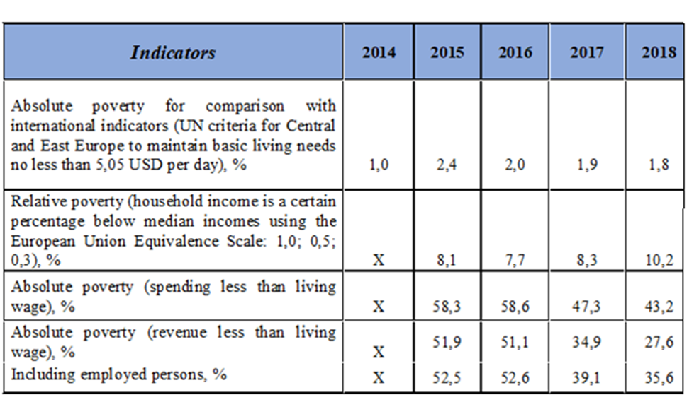

Table 2
Indicators of implementation of the Poverty Reduction Strategy for 2014-2018
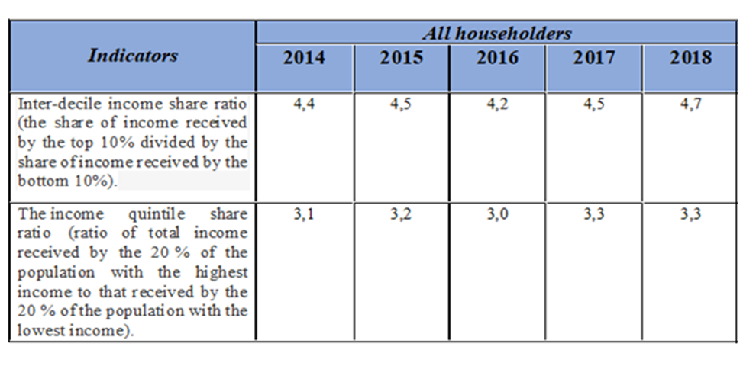
Reply to paragraph 6 (b) of the list of issues

Table 3
The ratio of the public revenue to gross domestic product (GDP) and the proportion
of public revenue financed through taxes
Indicators | 2014 | 2015 | 2016 | 2017 | 2018
GDP, million UAH | 1586 915,00 | 1988 544,00 | 2 385367,00 | 2 983882,00 | 3558706,00
State Budget of Ukraine Revenues, million UAH | 357 084,20 | 534 694,80 | 616 283,20 | 793 441,90 | 928 114,90
Share in GDP,% | 0,23 | 0,27 | 0,26 | 0,27 | 0,26
Tax revenues, UAH million | 280 178,30 | 409 417,50 | 503 879,40 | 627 153,70 | 753 815,60
Share in GDP,% | 0,18 | 0,21 | 0,21 | 0,21 | 0,21
Reply to paragraph 6 (c) of the list of issues
51. Corporate income tax rates are set by Article 136 of the Ukraine Tax Code. The basic (main) corporate income tax rate is 18 percent. Taxation of insurance activity is carried out at the basic (main) rate of corporate income tax with the simultaneous payment of income tax at following rates:
• 3% - the insurance contracts of the subject of taxation for the insurer, defined by the Code;
• 0% - long-term life insurance contracts, voluntary health insurance contracts and non-state pension insurance contracts, including supplementary pension insurance contracts, and others specified in Article 14 of the Code.
52. The taxation of non-residents and equivalent persons for the incomes originated in Ukraine is carried out at the rates 0, 4, 6, 12, 15 and 20%.
53. Betting activity taxation is carried out on the basic (main) rate of corporate income tax with the simultaneous payment of income tax at the rates in the following amounts:
• 10% - for income received from gambling using slot machines;
• 18% - for income received from betting activities, gambling (including casinos), except income derived from gambling using slot machines, reduced by the amount paid to the player.
54. Value added tax rates are defined in Article 193 of the Ukraine Tax Code and are set at the following tax rates:
• 20% - (basic tax rate) for operations carried out in the customs territory of Ukraine;
• 0% - for export of goods;
• 7% - for operations on the supply in the customs territory of Ukraine and the importation into the customs territory of Ukraine of medicinal products authorized for production and use in Ukraine and listed in the State Register of Medicines;
• Supply in the customs territory of Ukraine and import into the customs territory of Ukraine of medicines, medical devices and/or medical equipment, authorized for use within the limits of clinical trials, the permission for which is given by the central body of executive power, which ensures the formation of the state policy in the field of health care.
55. Tax rates individuals' income from 2014 to the present:
• In 2014, there was a base tax rate of 15 percent for incomes that did not exceed 10 minimum wages per month and 17 percent for income over 10 minimum wages;
• In 2015 - 15 percent for revenues that did not exceed 10 minimum wages per month and 20 percent - for income over 10 minimum wages;
• Starting from 2016 till currently, the single basic tax rate on personal income is 18 percent.
Reply to paragraph 6 (d) of the list of issues
56. The concept of reforming the State Fiscal Service envisages the separation of departments into tax and customs services. Competitions for positions of the heads of newly created services were held and competitive recruitment is underway. Since April 1, 2017 the system of automatic VAT refund has been successfully operating. Businesses have the opportunity to plan their costs and processes and expect regular VAT refunds. During the new VAT refund procedure, the Treasury reimbursed 60.7 billion UAH (60 705 810 787 UAH), including 141 taxpayers in “automatic mode” 3.7 billion UAH (3 699 777 174 UAH).
57. The effectiveness of budgetary VAT refunds can be demonstrared by the first months of functioning of the Register of refund applications of VAT. Almost 90 percent of the budgeted amount claimed each month were returned within 30 days.
58. In August 2017, UAH 10.6 billion were claimed for compensation and as of 3 October 2017 UAH 9.2 billion were reimbursed to the payer. Thus, 88% of the amount claimed for compensation was reimbursed. For the comparison, in the same period last year (August 2016), UAH 7.6 billion was claimed for compensation and as of 03 October 2016 only UAH 3.6 billion was reimbursed to the payer. Therefore, previously, only 50% of the amount claimed was reimbursed.
59. The functioning of the new VAT reimbursement procedure demonstrated that the current reimbursement system provides for businesses to receive VAT into their accounts in the amounts claimed before the reimbursement, enabling them to plan their business processes in a transparent manner.
Reply to paragraph 6 (e) of the list of issues

Table 4
Social spending in State Budget in 2014-2018 (functional classification
of expenditures according to the reports of the State Treasury Service of Ukraine)
in billion UAH
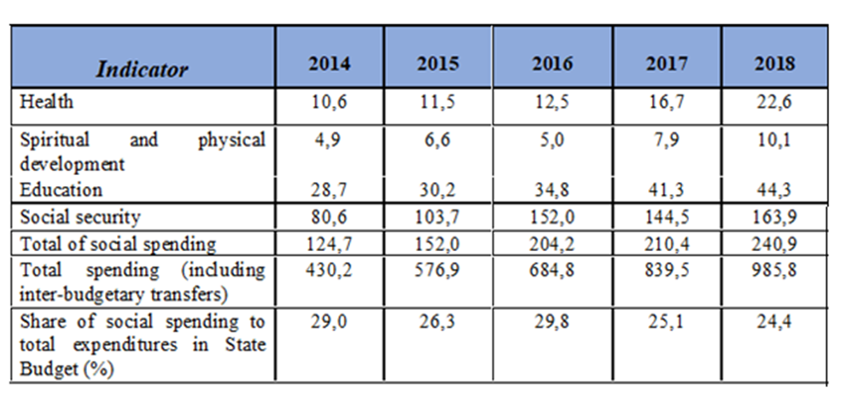
Reply to paragraph 7 of the list of issues
60. From 01.01.2019, people started receiving housing subsidies in cash. 2.2 million families receive state social support in Ukraine, or 39% of all Ukrainian families with children under 18.
61. In 2016–2017 the country's economy has begun to show steady growth, which in turn has had a positive impact on the employment sector and the labor market.
62. In 2018 compared to 2017:
• The number of employed people in Ukraine aged 15-70 increased by 204.5 thousand people and reached 16.4 million;
• The employment rate of those aged 15-70 increased from 56.1% to 57.1%;
• The number of unemployed people aged 15-70 according to the ILO methodology decreased by 119.4 thousand to 1.6 million;
• The unemployment rate of the population aged 15-70 decreased from 9.5% to 8.8% of the economically active population.
63. The number of employed people in 2018 compared to the previous year increased in all types of economic activity, except:
• Education - the number of employed decreased by 6900 to 1416500;
• Industry - the number of employed decreased by 14600 to 2426000 people;
• Health care - the number of employees decreased by 18200 to 995400 people;
• Public administration - the number of employees decreased by 40400 to 939300.
64. Economic and financial policy priorities in the framework of the Stand-By Arrangement with the IMF launched in December 2018 reflected in the Letter of Intent of the Government of Ukraine and the National Bank of Ukraine to the International Monetary Fund and the Memorandum of Economic and Financial Policies of 05.12.2018. In particular, the key conditions in the area of budgetary policy are defined in Chapter 5 of the Memorandum:
„Fiscal policy in 2018 and 2019 will continue to be anchored by our medium-term consolidation path aimed at ensuring fiscal sustainability. We will limit the general government budget deficit to no more than 2,5 percent of GDP in 2018 and 2,25 percent of GDP in 2019.”

Table 5
Information on the amount of funds provided in the general fund from state budget
for the implementation of social support programs (thousand UAH)
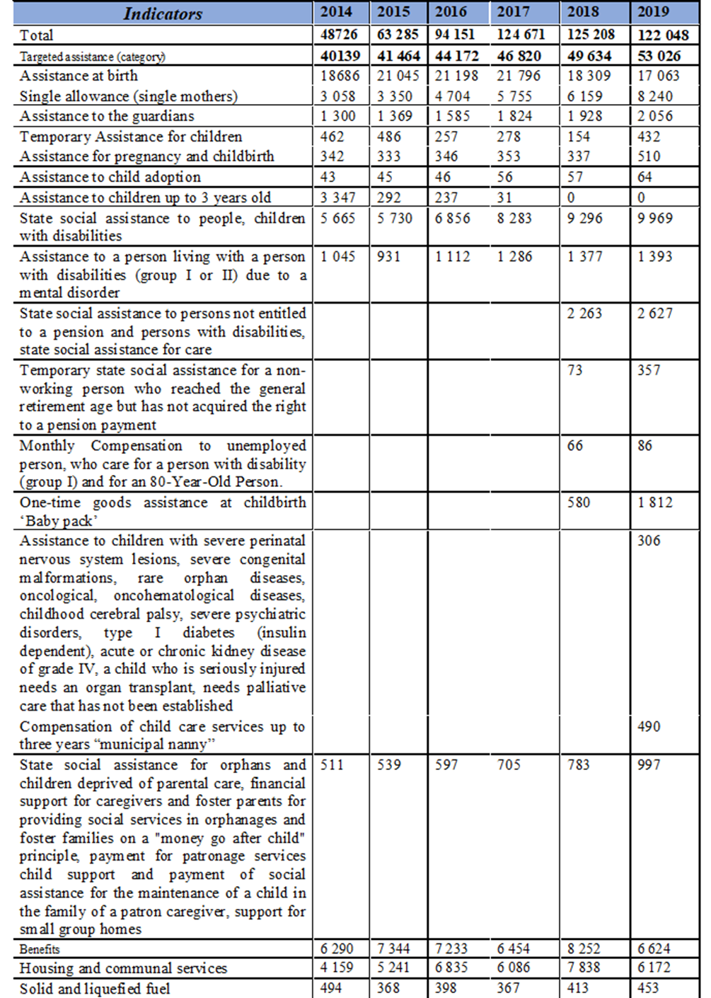
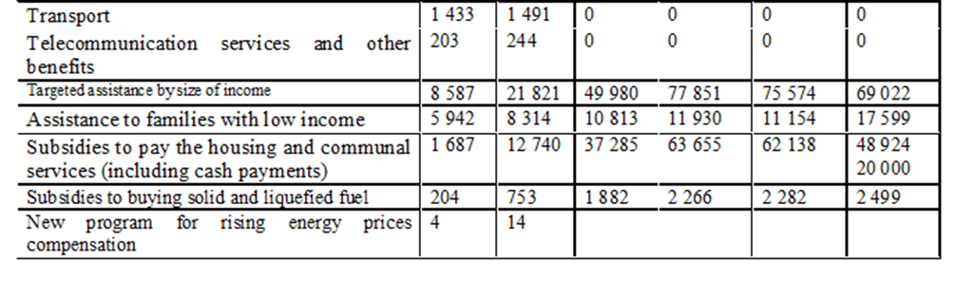
Reply to paragraph 8 of the list of issues
65. In 2018, more than 1.295 million users registered in the Declaration Register, with more than 2.885 million electronic documents filed available.
66. By the end of 2018, the National Agency on Corruption Prevention based on the facts of violation of the Law № 1700 “On the Prevention of Corruption” drafted and forwarded to court 471 protocols on administrative offenses related to corruption, of which with the qualifications:
• 459 protocols of requirements violation for prevention conflict of interest (Article 1727 of the Code of Administrative Offenses of Ukraine);
• 9 protocols of requirements violation on compatibility with other activities (Article 1724 of the Code of Administrative Offenses of Ukraine);
• 3 protocols of requirements violation regarding gifts (Article 1725 of the Code of Administrative Offenses of Ukraine).
67. In 2018, the National Agency on Corruption Prevention filed 5 claims to the Kyiv District Administrative Court on invalidation of acts of local self-government bodies adopted as a result of violation of the anti-corruption legislation requirements.
68. As a result of the full declarations verification, approved findings that sent to specially authorized government agencies in the field of combating corruption, of which:
• 89 cases on the declaring false information in excess of 250 subsistence minimums;
• 5 cases on the unjust enrichment;
• 149 cases on the deliberate failure to file a declaration.
69. The number of protocols on administrative offenses sent to court on the facts of committing administrative offenses, of which:
• 154 protocols on the late filing of declarations;
• 136 protocols on the non-notification or untimely notification about significant changes in property status;
• 20 protocols on declaring false information.
70. The Law “On Prevention of Corruption” has started the Institute of Whistleblowers, which has been implementing by the National Agency for the Prevention of Corruption of Ukraine for the last two years.
71. Guarantees of whistleblowers protection in Ukraine include: the ability to report corruption anonymously; information about whistleblowers can only be disclosed with their consent; if there is a threat to life, housing, health or property of whistleblowers or persons close to them, appropriate protection measures by law enforcement agencies shall be applied; protection of the labor rights of whistleblowers; defending whistleblowers in court.
72. A system of accessible and secure communication channels provided to obtain information from the whistleblowers: through a secure e-mail and through the official website of the National Agency on Corruption Prevention on Ukraine.
73. The National Agency on Corruption Prevention controls the compliance of state and local government bodies with the provision of the Law “On the Prevention of Corruption” in terms of providing conditions for execution of notification of corruption by whistleblowers. In cases of violation of the provision of the Law an order requiring the removal of a violation is issued to the head of the government body. The National Agency on Corruption Prevention is engaged in 24 court cases dealing with violations of whistleblowers' rights.
74. In September 2019, the High Anti-Corruprion Court of Ukraine became operational.
Reply to paragraph 9 of the list of issues
75. In 2018, according to the State Judicial Administration of Ukraine, 6 cases dealing with the Article 161 of the Criminal Code of Ukraine “Violations of the Equality of Citizens Depending on their Racial, National Identity or Religion” were filed in the courts of Ukraine. Sentences were issued in 2 cases with the approval of a reconciliation agreement.
76. During 2018, the Ombudsman received 616 reports on cases of discrimination and violation of the principle of equality, including 38 reports on gender equality issues, 29 reports on discrimination on the grounds of sexual orientation and gender identity, and 28 proceedings on this issue.
77. The Cabinet of Ministers implements anti-discrimination policy. The amendments of 30.01.2013 introduced the obligatory anti-discrimination examination of all legal acts.
78. The Cabinet of Ministers Resolution № 997 of 28.11.2018 introduced the mandatory conduct of gender expertise of legislation and draft legal acts in all spheres of legislation and approved the relevant Procedure.
79. On 16.02.2016 the Parliament of Ukraine adopted in first reading the draft Law "On Amendments to Certain Legislative Acts of Ukraine (Concerning Harmonization of Legislation in the Field of Prevention and Combating Discrimination with the Law of the European Union)" the provisions of which include the definitions of "discrimination by association", "multiple discrimination", "victimization", clarifies the powers of the Ombudsman to prevent and combat discrimination. According to the Resolution of the Parliament of Ukraine № 2679 of 07.02.2019, the draft was included in the agenda of the Verkhovna Rada of Ukraine, but as of 19.07.2019 it was not considered in the second reading.
80. The Ministry of Social Policy is the authorized central body of executive power on the issues of equal rights and opportunities for women and men, including combating all forms of gender discrimination.
81. Within the framework of decentralization reform, local authorities have an opportunity to influence information policy in the regions, including preventing of discriminatory advertising in the information space.
82. Within the framework of the project "Development and implementation of a mechanism for preventing the appearance of discriminatory advertising in the information space", the Ministry of Social Policy of Ukraine, the Industrial Gender Advertising Committee and the Friedrich Ebert Foundation conducted a series of seminars on the topic "Preventing Sexist Advertising: Local Government Tools and Engaging with Civil Society" in 13 regional cities.
83. The results of the seminars are creation of regional Expert Councils on the prevention and combating of gender-based discrimination.
84. In order to respond to citizens complaints and appeals on gender discrimination, an advisory body - the Expert Council on the Prevention and Combating of Gender-Based Discrimination (hereinafter – the Expert Council) was established at the Ministry of Social Policy of Ukraine. Most complaints are about discriminatory advertising.
85. Based on the consideration of such appeals, the Expert Council issues recommendations for relevant media, broadcasting and advertising agencies. The recommendations aimed to minimize the factor of gender stereotypes and sexism in the media space.
86. The Ministry of Social Policy, based on the results of the work of the Expert Council on the Prevention and Combating of Discrimination on the basis of sex, made proposals that were supported by the Ukrainian MPs. The Verkhovna Rada of Ukraine registered the draft law № 8558 "On Amendments to the Law of Ukraine "On Advertising" on Anti-Discrimination". The draft law envisages an increase in the amount of penalties for discriminatory advertising, the determination of the perpetrator of discriminatory advertising and the granting of broader powers to the central body of executive power, which implements state policy.
87. State Social Program on Providing Equal Rights and Opportunities for Women and Men up to 2021 contains section III "Combating gender discrimination and discrimination on more than one basis".
88. The Ministry of Social Policy, together with the Office of the United Nations Population Fund in Ukraine, continues the implementation of the information campaign "Happiness in 4 hands", which aims to overcome the stereotypes established in the Ukrainian society regarding the traditional division of family responsibilities.
89. The National Sustainable Development Goals (Goal 5 "Gender Equality") includes task "Promoting shared responsibility of parents in domestic work and childcare ".
90. The Ministry of Social Policy of Ukraine and the United Nations Population Fund in Ukraine conducted a research “Masculinity Today: Men's Attitudes To Gender Stereotypes And Violence Against Women”. Instead, anti-gender movements based on gender stereotypes intensified in Ukraine recently.
Reply to paragraph 10 of the list of issues
91. It is forbidden in the job advertisements to specify the age of candidates; to offer jobs only to women or only to men, except for specific work that can be done only by certain gender; to make requirements that favor one of the gender; and to require providing of personal information.
92. The Law „On Advertising” defines restrictions on the content in the job advertisements and liability for violations of the established order of their distribution.
93. The Ministry of Social Policy’s advisory body, the Expert Council (see p.84), provides recommendations for media and advertising agencies.
94. In 2017, the Expert Council considered 24 complaints: 7 advertisements recognized non - discriminatory; 6 - recognized discriminatory and removed; 11 - recognized sexist and provided relevant expert recommendations. Upon expert recommendations, 3 complaints were directed to the court.
95. In 2018, Expert Council considered 78 complaints from Ukrainian citizens dealing with discrimination against women and men in advertisements, as a result, 35 discriminatory advertising removed.
96. In the first half of 2019, Expert Council considered 24 applications for expert evaluation of discrimination. Upon examination, 14 advertisements recognized as discriminatory; 8 - recognized non-discriminatory and 2 complaints were not within the competence of the Expert Council. Overall, 9 advertisements removed, and 8 complaints directed to the court.
97. The system of free primary and secondary legal assistance is in place in Ukraine, which provides for the protection of human rights by ensuring equal access to legal information and broad access to justice, enhancing the legal capacity of representatives of socially vulnerable groups as well as territorial communities.
Reply to paragraph 11 of the list of issues
98. An interactive map of Roma public associations is created. Regular meetings of the Permanent Working Group on Law Enforcement and Migration are held, and work is underway to develop a draft algorithm of action, in case of detecting informal settlements of Roma minority.
99. In collaboration with Roma public associations, information materials on Roma issues are being developed. Within the Media Without Bias project, a communication campaign is underway to strengthen national unity and promote tolerance in Ukrainian society "We are different but we are united".
100. In May 2019, with the support of the UN Women, a gender-responsive evaluation of the Strategy for Protection and Integration of the Roma National Minority Society into Ukrainian society up to 2020 and the related National Action Plan was conducted. The purpose of the evaluation was to elaborate recommendations and proposals for the drafts of the Strategy and the related Action Plan up to next period (after 2020), as well as to include in these documents the issue of protection of the Roma women rights.
101. In order to strengthen the institutional capacity to implement the state policy in the sphere of inter-ethnic relations, religion and protection of the rights of national minorities, in June 2019 the Cabinet of Ministers established the State Service of Ukraine for Ethno-Politics and Freedom of Conscience.
102. The Centers of Social Services for Family, Children and Youth of Ukraine are working to identify and reach out with social services for families with children who are in difficult circumstances, including the Roma minority. In 2018, this work covered 3000 Roma families (including 8700 children). According to the need assessment, these families were provided with different types of social services.
103. The largest number of Roma families provided with social services were in Transcarpathian (890 families), Dnipropetrovsk (251 families), Odesa (164 families), Donetsk (161 families) and Volyn (108 families) regions. According to the results of the work:
• 1400 families received psychological assistance;
• 1600 families received humanitarian aid;
• 1300 families received legal aid;
• 1200 families established relationships with family members and the community;
• 809 persons renewed official documents, including for the purpose of social payments;
• 634 families solved housing problems;
• 215 persons registered at the place of residence;
• 273 persons received medical treatment and rehabilitation;
• 64 people employed.
104. In 2018, 281 persons of the Roma minority benefited from a housing subsidy.
105. Explanatory work was carried out to inform about timely medical treatment, individual and collective hygiene, preventive examination on various diseases.
106. When setting up primary health care centers, information on their locations, and the procedure for accessing them, was communicated to the public. Information on the promotion of healthy lifestyles were distributed among the Roma minority. Health care centers were provided with booklets, flyers, stands, updated periodically with relevant thematic information.
Reply to paragraph 12 (a) of the list of issues
107. According to the Law "On Ensuring Equal Rights and Opportunities of Women and Men" for responding to citizens complaints and appeals on the grounds of gender discrimination, since 2012 the Expert Council (see p.84) works under the Ministry of Social Policy. Since 2016, the Expert Council agenda includes reviewing gender discrimination complaints and eliminating the abuses, identifying the causes of discrimination and issues to develop methods for preventing gender equality violations.
108. The main topic of applications that come to the Expert Council is advertising that imposes or promotes negative stereotypes about the social and gender roles of women and men. Based on the consideration of such complaints, the Expert Council makes recommendations to the relevant media, broadcasters and advertising agencies. The recommendations are aimed at eliminating gender stereotypes and sexism in the media space.
109. Six meetings of the Expert Council took place in 2018-2019. 102 appeals of Ukrainian citizens with regard to discrimination against women and men in outdoor advertisements considered. As a result of consideration of complaints by members of the Expert Council, 49 advertising objects withdrawn from circulation, and 7 appeals filed in the court.
110. In addition, the Ministry of Social Policy developed a draft Instruction on the Integration of Gender Approaches during the development of legal acts. Implementation of such approaches creates conditions for achieving gender equality in all spheres of life in accordance with the Law "On Ensuring Equal Rights and Opportunities of Women and Men".
111. The Government improved the procedure for conducting competitions for civil servant positions on categories "A", "B" and "C". Competency requirements were complemented by the ability to assess gender impact in the process of formulating, implementing, and evaluating public policy; ability to carry out gender analysis in the process of preparing proposals and decisions, generalizing information, including gender data.
112. In December 2017, the Law "On Ensuring Equal Rights and Opportunities of Women and Men" was amended with the definitions of:
• Concepts related to gender-based violence;
• The range of actors involved in preventing and combating gender-based violence;
• Responsibility of coordinators for ensuring equal rights and opportunities of women and men, prevention and counteracting gender-based violence in executive and local government bodies, as well as centers for providing legal assistance and specialized support services for victims.
113. For practical application of the Law in various spheres of society, the Government of Ukraine approved:
• National Action Plan on the implementation of the recommendations set out in the concluding observations of the UN Committee on the Elimination of Discrimination against Women to the Eighth Periodic Report of Ukraine on the Implementation of the Convention on the Elimination of All Forms of Discrimination against Women for the Period up to 2021 (Resolution of the Cabinet of Ministers № 634 of 05.09.2018);
• State Social Program for Ensuring Equal Rights and Opportunities for Women and Men for the Period up to 2021 (Resolution of the Cabinet of Ministers № 273 of 11.04.2018);
• Amendments to the National Action Plan for implementation of UN Security Council resolution 1325 "Women, peace, security" for the period up to 2020 (Resolution of the Cabinet of Ministers № 637 of 05.09.2018);
• The National Sustainable Development Goals (Goal 5) includes the task of "Creating conditions for the elimination of all forms of discrimination against women and girls" (indicator - the number of legal acts revised or adopted to ensure equal rights and opportunities for women and men and non-discrimination for women and girls).
114. The Law "On Amendments to Certain Laws of Ukraine on Ensuring Equal Rights and Opportunities for Women and Men During the Military Service in the Armed Forces of Ukraine and Other Military Entities" (2018) was adopted. According to the law, the persons of both sexes have equal opportunities to conclude a military service contract by determining that women may enter into a military service contract until they reach the limit of military service. It also establishes the principle that women may serve in the military on an equal basis with men, including equal access to positions, military ranks and an equal amount of responsibility in the performance of military service.
115. In 2017, the Ministry of Health by its Order № 1254 of 13.10.2017 canceled the Order № 256 of 29.12.1993 “On Approval of the List of Hard Work and Work with Harmful and Dangerous Working Conditions, for which the use of women's work prohibited”. The only exception was the chapter on mining, which expires on the date when Ukraine completes the denunciation procedure of the Convention concerning the Employment of Women on Underground Work in Mines of all Kinds № 45.
116. The procedure for gender expertise, which shall be conducted by all developers of legal acts, was improved by the Cabinet of the Ministres Resolution № 997 of 28.11.2018. The implementation of gender budgeting continues.
117. The Ministry of Finance approved the methodological recommendations for the implementation of a gender budgeting (Order № 1 of 02.01.2019).
118. The gender component was taken into account in the Action Plan for the implementation of State Policy Strategy for healthy and active longevity of the population for the period up to 2022, approved by the Cabinet of Ministers Resolution № 688 of 26.09.2018.
119. The application of the Law "On Ensuring Equal Rights and Opportunities of Women and Men" and the Convention on the elimination of all Forms of Discrimination Against Women in courts is insufficient. Therefore, the State Social Program for Equal Rights and Opportunities for Women and Men for the period up to 2021 includes measures for training judges, collecting data on the number of lawsuits filed by judicial bodies by category, and the type of gender discrimination complaints.
120. The National Action Plan on the implementation of the recommendations set out in the concluding observations of the UN Committee on the Elimination of Discrimination against Women, to the eighth periodic report of Ukraine on the implementation of the Convention on the Elimination of All Forms of Discrimination Against Women by 2021, includes measures to develop the gender competency requirement to the general criteria for the hiring process and annual evaluation of the performance of judicial, prosecutorial, investigative and police human resources as well as analysis of the inclusion of gender component in study programs of special training of candidates for the posts of judge, systematic monitoring of court decisions and court processes for compliance to ensure the systematic dissemination of case law on the application of the principle of gender equality in the administration of justice.
Reply to paragraph 12 (b) of the list of issues
121. The State Social Program on Equal Rights and Opportunities of Women and Men for the period up to 2021 envisages:
• Taking into account the gender component in programs of economic and social development, with due regard to the actual needs of industries and regions;
• Expanding the list of gender-disaggregated statistics by other main features (age, place of residence, disability, socio-economic status, etc.);
• Reducing gender imbalances in public service and human resources management;
• Introducing the issues of ensuring equal rights and opportunities for women and men into the programs of training courses for civil servants and local government officials;
• Overcoming gender stereotypes;
• Improving the mechanism for exercising the right to protection against gender discrimination and discrimination on several grounds, one of which being gender, examining such discrimination cases and taking appropriate action;
• Increase in the number of women among members of the Ukrainian Parliament, members of regional and local councils;
• Reducing the pay gap etc.
122. The Program is financed from the state budget, local budgets and other sources not prohibited by law.
123. Funding of the Program from the state budget from 2018 to 2021 is 255000 UAH annually. The estimated amount of local budget expenditures:
• In 2018 - UAH 1492000;
• In 2019 - UAH 1617000;
• In 2020 - UAH 1737000;
• In 2021 - UAH 1896000.
124. The main indicators of the program's tasks are:
• The number of legal acts, in which the gender component included;
• The proportion of economic and social development regional programs, which include gender component;
• he number of legal acts adopted in order to improve gender expertise;
• The number of specially trained persons responsible for conducting gender-legal expertise during the development of legal acts for ministries and other executive bodies, local government bodies;
• The number of reports with gender data;
• The number of comprehensive counseling services provided to gender discrimination victims;
• The number of measures taken to overcome gender stereotypes;
• The number of women among members of Ukrainian Parliament, members of regional and local councils;
• The number of women in senior civil service positions;
• The ratio of the average wage of women and men;
• The number of men among persons on maternity leave before children reaching 3 years old;
• The number of activities and projects implemented jointly with NGOs.
125. To increase the regions’ capacity in achieving equal rights and opportunities of women and men 5 regional workshops were held under the chairmanship of Vice Prime Minister for European and Euro-Atlantic Integration with the participation of deputy ministers, deputy heads of regional state administrations, heads of structural units responsible for the implementation of state policy on equal rights for men and women, representatives of international organizations and NGOs.
Reply to paragraph 13 of the list of issues

Table 6
Information on the provision of services by the State employment service of Ukraine
to persons under the age of 35 (thousand, people)
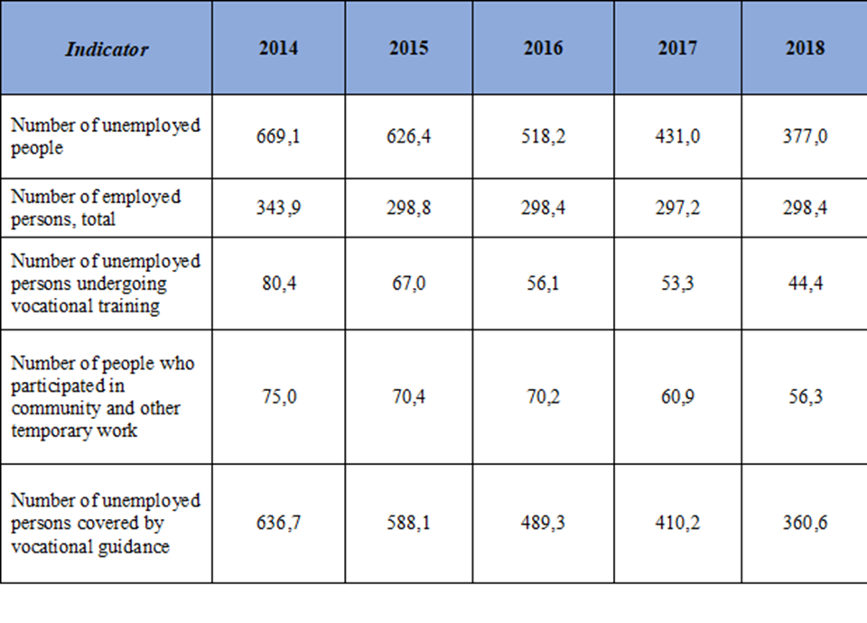

Table 7
Information on the provision of services by the State employment service of Ukraine
to women (thousand, people)
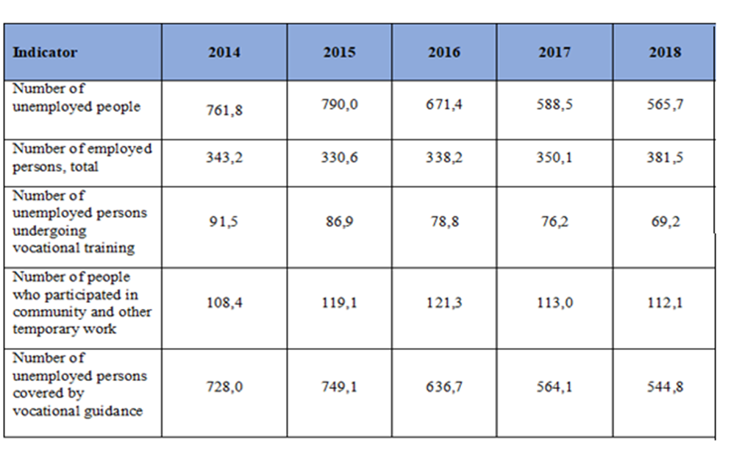

Table 8
Information on the provision of services by the State employment service of Ukraine
to women among them by age group on 01.01.2019 (thousand, people)
Indicator | 2015 | 2016 | 2017 | 2018 | 2019
Number of unemployed people | 275,4 | 276,8 | 196,6 | 189,5 | 184,0
15-24 | 41,6 | 34,4 | 18,5 | 14,7 | 11,9
25-29 | 44,7 | 41,6 | 26,7 | 23,3 | 20,0
30-34 | 42,8 | 44,7 | 31,8 | 30,5 | 28,4
35-44 | 71,9 | 74,8 | 55,8 | 54,9 | 53,9
45-54 | 67,2 | 66,6 | 48,4 | 46,4 | 45,8
55 and older | 7,2 | 14,7 | 15,4 | 19,6 | 24,0

Table 9
Information on the provision of services by the State employment service
of Ukraine to men (thousand, people)
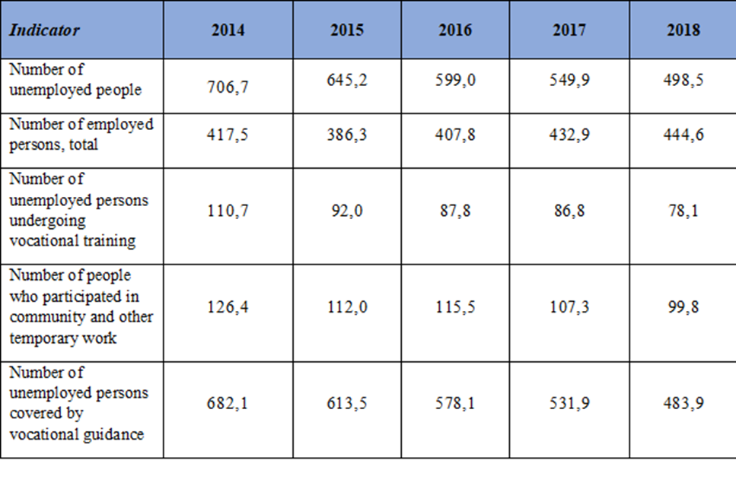

Table 10
Information on the provision of services by the State employment service of Ukraine
to men among them by age group on 01.01.2019 (thousand, people)
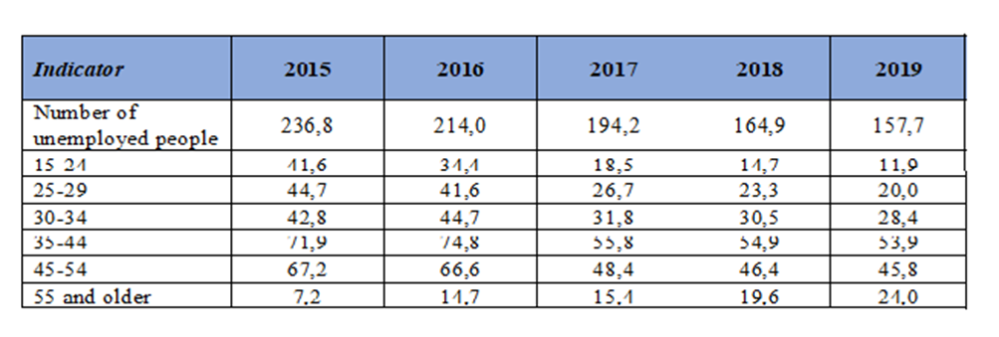

Table 11
Information on the provision of services by the State employment service of Ukraine
to IDP’s (thousand, people)
Indicator | 2014 | 2015 | 2016 | 2017 | 2018
Number of unemployed people | 22,5 | 38,5 | 21,6 | 14,8 | 12,6
Number of employed persons, total | 5,9 | 11,3 | 6,8 | 5,9 | 5,6
Number of unemployed persons undergoing vocational training | 0,8 | 3,1 | 2,3 | 2,1 | 1,9
Number of people who participated in community and other temporary work | 1,0 | 4,2 | 2,7 | 1,8 | 1,4
Number of unemployed persons covered by vocational guidance | 15,3 | 36,7 | 20,9 | 14,1 | 12,1

Table 12
Information on the provision of services by the State employment service of Ukraine
to IDP’s (thousand, people)
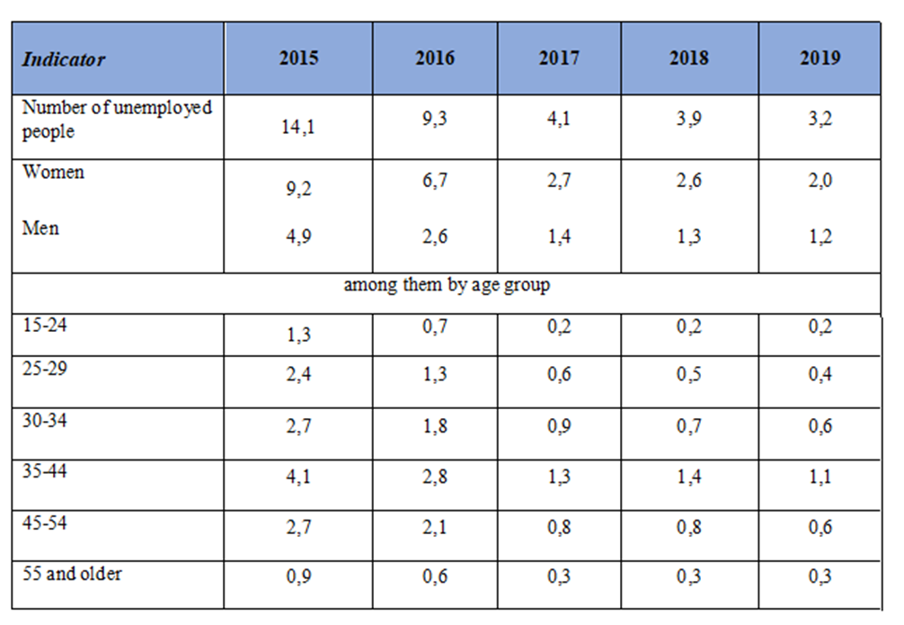

Table 13-14
Information on the provision of services by the State employment service of Ukraine
to persons among the military personnel who participated in the antiterrorist operation
(the operation of the joint forces) (thousand, people)
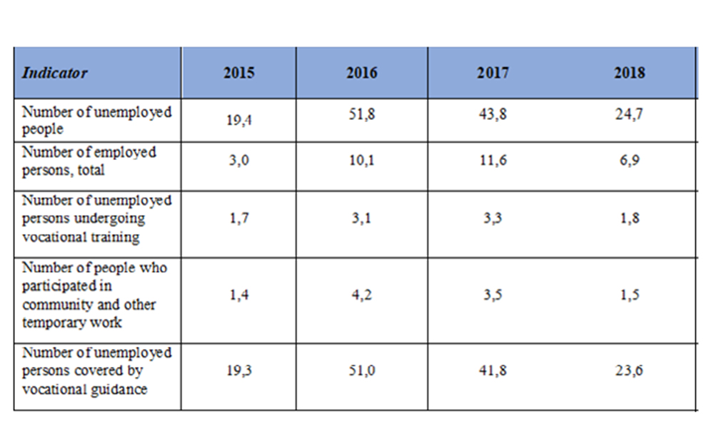
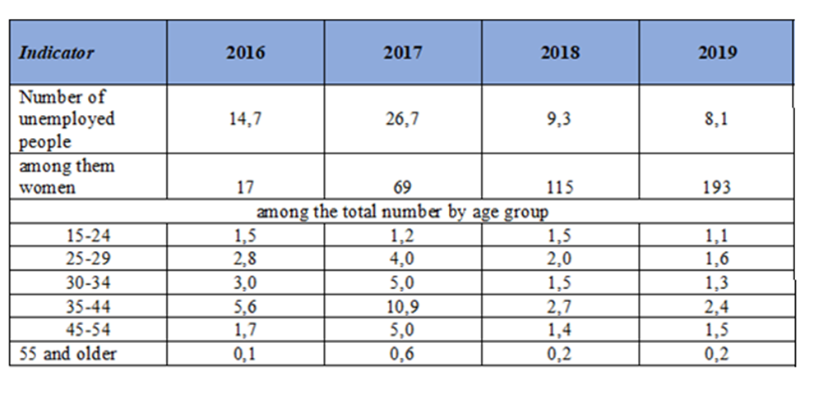

Table 15
Information on the provision of services by the State employment service of Ukraine
to persons with disability (thousand, people)
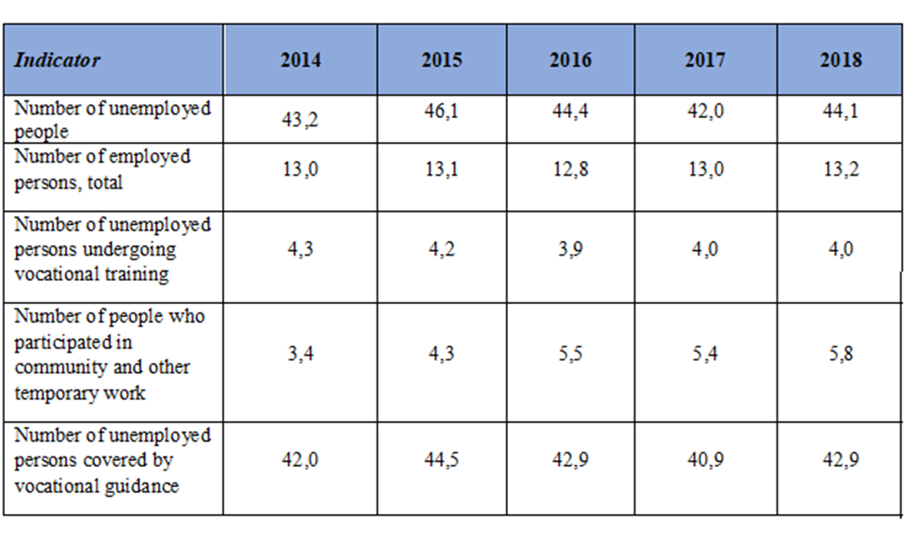

Table 16
Number of unemployed people by gender
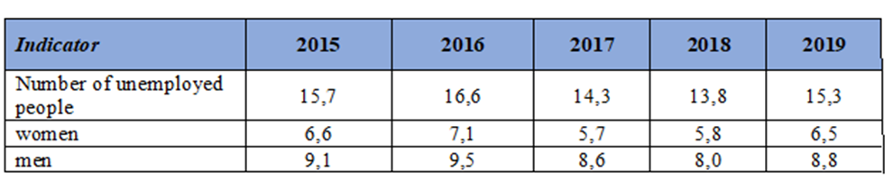
Regarding access to employment promotion programs, including support and vocational training, to address unemployment for vulnerable and marginalized groups
126. Within the realization of the Cabinet of Ministers Resolution № 792 of 19.09.2018 „On approval of the Procedure for registration, re-registration of unemployed persons and keeping records of people seeking work” (hereinafter - the Procedure), the institution of „career adviser” was introduced in the work of the State Employment Service.
127. Career adviser is a specialist in the public employment service who helps to increase the targeting of employment assistance services. Career adviser provides each client with an individual approach to solving employment issues, examines all circumstances relevant to effective employment, assesses the risks and opportunities associated with employment, conducts profiling, which determines the set of services that are recommended to a person.
128. Based on profiling, a career adviser, together with the person looking for the employment, draws up an Individual Employment Plan, which is a program of action for the unemployed until employment.
129. In January-June 2019, thanks to the introduction of the career adviser institute, the number of persons employed assisted by the State Employment Service increased by 2.8% from the previous year.
Concerning the promotion of youth employment
130. According to the legislation, the State Employment Service ensures the implementation of the constitutional right of unemployed young citizens and social protection against unemployment.
131. Young people applying to the State Employment Service are assisted in finding employment, including temporary job, assistance in starting business, information and vocational guidance in their choice of work; they are invited to participate in job fairs, various seminars aimed at raising awareness of the realities of the labor market and developing skills that help in employment.
132. In January-June 2019, 213300 people under the age of 35 were unemployed (32.4% of the total unemployed). With the assistance of the State Employment Service, 149300 people under the age of 35 found employment.
133. The Law „On Employment” establishes additional guarantees for the promotion of employment of citizens who are uncompetitive in the labor market, including young people who have graduated from or stopped studying in general, vocational, technical and higher educational establishments, dismissed from the compulsory military service or alternative service and are hired for the first time. The law establishes quotas for employers to employ citizens of such categories.
134. Among the young people who have additional guarantees in favor of employment, the State Employment Service employed 454 unemployed persons for the first job in January-June 2019.
135. In addition, when recruiting young people who have graduated from or stopped studying in general, vocational, technical and higher educational establishments, dismissed from the compulsory military service or alternative service and are hired for the first time, there are compensation for the employer in the amount of the actual cost of a single compulsory state social security contribution for the person concerned.
136. This compensation is paid monthly during one year from the date of employment of the person, if his/her employment maintained for two years. During January-June 2019, 91 persons from the above-mentioned youth categories were employed with compensation for employers.
137. Relevant compensation is also provided when employing of unemployed young people in a new workplace by small business entities engaged in priority economic activities.
138. To develop and support entrepreneurial initiative among the unemployed the State Employment Service pays one-time unemployment assistance to starting business. During January-June 2019, 568 people under the age of 35 received this assistance.
139. One of the effective forms of financial support for the unemployed is the organization of public and other temporary work. During January-June 2019, 29900 young people were involved in such work.
140. Vocational training carried out in vocational school and higher education institutions, enterprises, institutions and organizations regardless of ownership, type of activity and management. During January-June 2019, 27300 registered unemployed people under the age of 35 attended vocational training.
Concerning the promotion of employment of Roma people
141. With the aim of social protection and integration into the Ukrainian society of the Roma national minority the State Employment Service takes measures to inform the public about the situation on the labor market, the organization of employment, the ability of the employment service to meet the demand for labor and the selection of suitable work.
142. Finding employment for citizens who appeal for employment services is carried out in accordance with their education, profession, qualifications, work experience, duration of unemployment, as well as the needs of the labor market.
143. During the first half of 2019, 340 persons of Roma nationality, including 151 women, 143 of them registered as unemployed, including 89 women, applied for assistance in employment to the State Employment Service. In total, 158 Roma people, including 48 women, were employed with the assistance of the employment service.
144. 288 unemployed Roma people, including 124 women, received vocational-guidance services. Vocational training/retraining was completed by 8 Roma people, including 7 women.
145. 55 members of the Roma national minority, including 26 women, have been involved in temporary and community work.
146. During the first six months of 2019, 33 information and consultation activities (press conferences, round tables, briefings, press tours, job fairs, field consultations) were carried out, including using mobile media, in settlements with a large number of Roma minority families, with more than 800 Roma nationals participating.
Concerning promotion of employment of IDP’s
147. Since 2014, the State Employment Service has been providing comprehensive outreach to IDPs regarding the conditions of receiving social services. The procedures for obtaining and renewing the status as unemployed for IDPs were simplified, as well as providing social services and financial support, also the list of valid reasons for not appearing at an employment center was supplemented by cases of an emergency.
148. During January-June 2019 9400 IDPs received services in the State Employment Service, 6600 people among them had unemployed status.
149. With the assistance of the State Employment Service, 2200 IDPs were employed, among them 42 IDPs started their own business by getting a one-time unemployment benefit, 34 IDPs were employed with compensation to employers of a single compulsory state social security contribution.
150. The State Employment Service facilitated vocational training of 834 unemployed IDPs.
151. Since September 25, 2015, a mechanism for employing IDPs was implemented, which means the compensation to employers of the costs of remuneration for the employing of unemployed IDP, and if necessary - reimbursement of costs for retraining or refresher training of them.
152. Also, registered unemployed persons from IDPs can be compensated for the actual costs of moving to another administrative-territorial unit of the place of employment and the expenses for passing a medical examination, if it is necessary for employment. During January-June 2019, 500 IDPs employed through compensation to employers for their wage costs. The costs for retraining or refresher training and medical examination were not requested.
153. 586 unemployed IDPs were engaged to community work or temporary work during January-June 2019. 6100 registered unemployed IDPs received vocational guidance services from the State Employment Service during the same period.
Concerning providing employment guarantees to participants of the anti-terrorist operation (Joint Force Operations) (hereinafter referred to as ATO and JFO)
154. In January-June 2019, 16300 unemployed participants of ATO and JFO used the services of State Employment Service.
155. The Law „On Employment” establishes additional guarantees in facilitating employment for the combatants referred to in the Law of Ukraine „On the status of war veterans, guarantees of their social protection”.
156. With the assistance of the State Employment Service, in January-June 2019, 3700 people were hired, including 75 people recruited for new jobs through compensation of a single contribution to employers, and 216 people received unemployment benefits to start business.
157. In January-June 2019, 900 participants of ATO and JFO were engaged in public and other temporary works.
158. During January-June 2019, 1163 participants of ATO and JFO took part in vocational training facilitated by the State Employment Service, 819 of them were employed.
159. The State Employment Service of Ukraine provided social services to ATO participants, including information and vocational guidance services. Services are provided within the first days after their registration, and in the future, when needed or upon request, using an individual approach. Optionally, ATO participants are provided with individual counseling services with psychodiagnostic tests.
160. During January-June 2019, 15400 unemployed ATO participants received vocational guidance services.
161. In order to raise awareness of ATO and JFO participants about the services provided by the State Employment Service, information materials have been posted in the military commissariats, in the centers of social services for families, children and youth, social welfare departments, in the employment centers. In addition, media and web resources used extensively be the State Employment Service. Also, the State Employment Service offices regularly hold The Day of ATO/JFO Participant.
162. Within the framework of these days, the specialists of the employment centers present employers looking for personnel, taking into account the professional and qualification composition of the unemployed ATO and JFO participants. Government representatives and social partners from public and voluntary organizations join these events.
163. Partnerships and cooperation agreements are concluded with civic and volunteer organizations that provide assistance to participants of ATO and JFO, resulting in joint events, meetings, roundtables, trainings etc.
Concerning provision of social services to persons with disabilities
164. The State Employment Service of Ukraine promotes the labor rehabilitation and employment of persons with disabilities by creating and adapting of workplaces for them in enterprises, taking into account the recommendations of the medical and social expert commission.
165. All employment centers have a unified procedure for servicing people with disabilities. In particular, information corners are provided and constantly updated, containing normative documents and address information about social protection and rehabilitation, employment and training opportunities, including information materials in Braille. There are equipped places for independent work with free access to job search sites and the State Employment Service website, upgraded for visually impaired users.
166. During January-June 2019, 31200 persons with disabilities used the services of the state employment service. In total, 6900 people of this category were employed during this period with the assistance of employment centers, 127 of them started their own business, having received one-time unemployment benefit. 3300 persons with disabilities were engaged in public or temporary work.
167. In case if finding a suitable work for person with a disability is impossible due to lack of profession, loss of ability to perform a job in a previous profession or lack of work that corresponds to her or his professional skills, the State Employment Service offers her or him to undergo vocational training and retraining taking into account the recommendations of the medical and social expert commission and individual rehabilitation program for the person with disabilities, including in the workplace. During January-June 2019, 2200 persons with disabilities were vocationally trained directed by the State Employment Service, of which 1800 persons were employed after graduation.
168. In order to facilitate the integration of persons with disabilities to society an inclusive approach to provision of vocational guidance services and different activities is used targeted only at persons with disabilities.
169. During January-June 2019, 29700 registered unemployed persons with disabilities received vocational guidance services at the State Employment Service, including professional counseling services with the use of psychodiagnostic techniques (at will), which are aimed of determining inclinations and professionally important qualities for certain types of professional activity.
Reply to paragraph 14 of the list of issues
170. The State Statistics Service of Ukraine calculates monthly unemployment rates for people aged 15-70, using the International Labor Organization methodology used by many other countries.
171. According to the data presented in the statistical report "Economic Activity of the Population in Ukraine", the number of informally employed people in 2014-2018 was:

Table 17
Persons employed in the informal economy (thousand people)
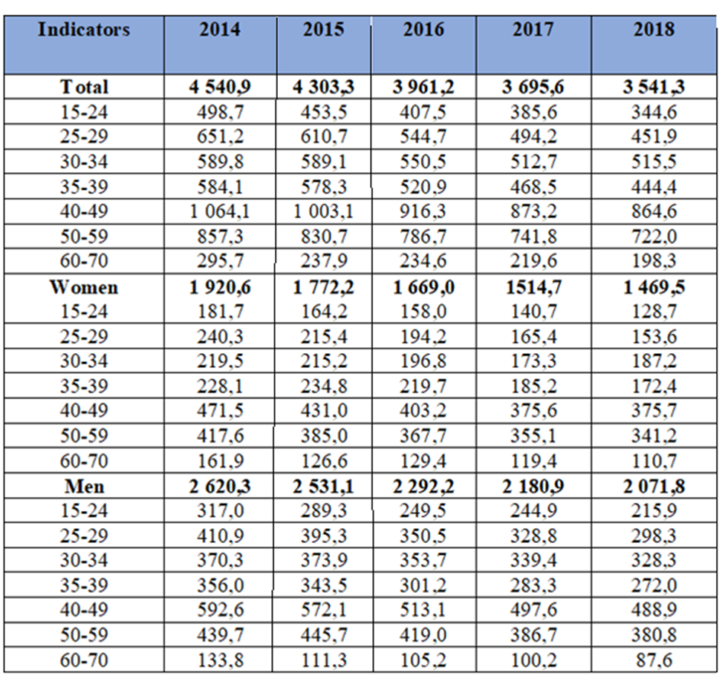
172. Labor inspectors can only impact employment in the informal economy through information activities.
173. With the goal to prevent offenses, in 2018 labor inspectors conducted 40724 visits to enterprises to inform employers and employees about the benefits of formal employment. 21770 measures related to the clarification and promotion of labor legislation were undertaken, 3104 of them in the media.
174. Labor inspectors ensured regular control over the registration of labor relations with employees at enterprises, institutions, organizations of all forms of ownership and types of activity and entrepreneurs.
Reply to paragraph 15 of the list of issues
175. The Cabinet of Ministers Resolution № 634 of 05.09.2018 provides for the revision of the list of forbidden professions and sectors, encourage and give women access to previously forbidden professions by improving working, health and safety conditions, within which it is planned:
• To develop recommendations for educational institutions at all levels of education (except pre-school) on women's access to previously prohibited professions (during 2020);
• Introduce a mechanism for informed consent between the employer and the employee on the health hazards of certain types of work (during 2019);
• Compulsory monitoring of compliance with ecological labour standards.
176. The Ministry of Social Policy drafted the draft Law „On amendments to certain legislative acts of Ukraine (on providing additional guarantees related to the combination of family and work responsibilities)" (registered in Verkhovna Rada of Ukraine №9045 of 05.09.2018). The draft law proposes to amend Articles 175-177 of the Labor Code of Ukraine, which as of now prohibit night-time, overtime and weekend work and business trips for pregnant women only. The suggested amendments foresee that engaging other workers (regardless of gender) with a child under the age of fourteen or a child with a disability in such types of work shall happen with their consent only. The draft is currently under consideration of the Committees of the Verkhovna Rada of Ukraine.
Reply to paragraph 16 of the list of issues
177. State labor inspectors conduct state control over the observance of labor law by legal entities (including their structural and separate non-legal entities) and by individuals (registered as entity) who employ hired labor.
178. According to the State Statistics Service of Ukraine, at the beginning of 2019, there were 1289400 such entities.
179. As of December 31, 2018, the planned number of posts of labor inspectors of territorial bodies of the State Labor Service of Ukraine was 1003 persons (in fact - 710 persons), local self-government bodies - 612 persons (in fact - 531 persons).
180. During 2018, labor inspectors conducted 20442 inspection visits and 436 on-site inspections at 19997 enterprises.
181. Most of violations were found on the following issues: wages - 18135; employment contract - 6377; work and rest time - 4701; rules for keeping the work records - 3023. The largest numbers of these violations belong to enterprises, organizations and institutions of private ownership, and by types of activity - to the enterprises of wholesale and retail trade.
182. To eliminate identified violations, labor inspectors issued 14082 orders for employers. 10305 orders were implemented in due time, eliminating violation of rights of 206175 employees.
183. As a result of control measures, 5695 cases of administrative offenses were filed to court, of which 3688 decisions were ruled, including 2193 on imposing of penalties on officials guilty of violation of the labor legislation, in the total amount of UAH 2047000. Labor inspectors directly issued 627 resolutions under article 188-6 of the Code of Administrative Offenses (failure to fulfill the legal requirements of the officials of the central executive body implementing the state policy on supervision and control over the observance of the legislation on labor, or creating obstacles to the activity of this body) with imposition of penalties in the total amount of 641435 UAH.
184. According to Article 265 of the Labor Code of Ukraine, 9674 resolutions were issued on imposing penalties for UAH 1650000000, of which UAH 46605000 were paid.
185. 1101 files on control measures were sent to the law enforcement agencies, of which 132 files submitted to the unified state register of pre-trial investigations, 7 suspects informed of the suspicion, 74 files directed to court. 1853 motions were made to managers and business owners to bring officials guilty of labor law violations to disciplinary actions, of which 425 satisfied.
186. According to the data of local executive authorities as of January 21, 2019, arrears of wages in Ukraine amounted to UAH 2199800000 at 735 debtor enterprises.
187. Of the total amount of debt 410 economically active enterprises accounted for UAH 1356300000 (61.7%); 234 bankrupt companies - UAH 793200000 (36.1%); 91 economically inactive enterprise - UAH 50300000 (2.2%).
188. By the type of ownership, of the total amount of debt, UAH 585900000 (26.6%) is accounted for 97 state-owned enterprises; UAH 23500000 (1.1%) - for 25 municipal enterprises; UAH 1590400000 (72.3%) - for 288 enterprises of other ownership.
189. During 2018, labor inspectors carried out inspection visits to 1015 debtors who had arrears of wages and salaries in the amount of UAH 5393000000 to 254754 employees.
190. On the results of inspection visits to debtors, labor inspectors filed 453 protocols on administrative offense to court. On 161 protocols the courts ruled imposing penalties on officials guilty of violating the legislation on remuneration, in the total amount of UAH 94118 hryvnias. 210 rulings in accordance with Art. 188-6 of the Code of Administrative Offenses imposed penalties in the total amount of UAH 225049. In accordance with Article 265 of the Labor Code of Ukraine, 1714 rulings were issued on the imposition of financial sanctions in the total amount of UAH 20180000, of which UAH 10343000 were paid.
191. 223 motions for disciplinary action were submitted to managers and owners of entities, 18 of them were satisfied.
192. The files of 315 inspection visits were submitted to the law enforcement agencies, 68 files – submitted to the unified state register of pre-trial investigations, 7 suspects were informed of the suspicion, 10 files directed to court.
193. Upon requests of labor inspectors, 554 debtors paid off wage arrears in the total amount of UAH 640669000, thus enterprises fully or partially settled arrears with 104249 employees.
194. In order to facilitate timely payment of salaries and increase its level, there are temporary commissions on issues of wage arrears, pensions, scholarships and other social payments, created at the central and local executive bodies, which include representatives of the departments of the State Labor Service of Ukraine.
195. In 2018, 737 files of inspection visits conducted by the territorial bodies of the State Labor Service of Ukraine were considered at the meetings of the temporary commissions.
196. Since the beginning of 2018, the temporary commissions have held 4979 meetings, resulting in warnings of the disciplinary responsibility to 6794 executives. During 2018, contracts with 18 debtor executives were terminated (heads of enterprises within the sphere of management of ministries and other bodies of state executive power in case of failure to fulfill their tasks to reduce wage arrears).
197. On the demands of labor inspectors, 473 enterprises approved schedules for paying off arrears of wages, of which - 256 (54%) implement the approved schedules.
198. Since 2018 the ILO project „Wages in Ukraine: technical assistance to overcome wage debt, set minimum wage and equal remuneration” has been running.
Reply to paragraph 17 of the list of issues
199. In February 2019, Batkivska Turbota Foundation appealed to the Grand Chamber of the Supreme Court with the claim of judicial review of the Judgment of the Supreme Economic Court of Ukraine of July 24, 2014 on case № 48/340 with regard to the exceptional circumstances. Due to the ruling of an international judicial body, which jurisdiction is recognized by Ukraine, on Ukraine's violation of international obligations in the above case, the Foundation claimed for recognition of property rights, invalidating an agreement and return of the property.
200. On July 2, 2019, the Grand Chamber of the Supreme Court considered the Batkivska Turbota Foundation claim a public trial and ruled in favor of applicant’s claim. The judgments of the Commercial Court of Kyiv City of September 19, 2011, of the Kyiv Commercial Court of Appeals of April 1, 2014 and of the Supreme Economic Court of Ukraine of July 24, 2014 in case No. 48/340 were cancelled by the same ruling.
201. The State Property Fund of Ukraine drafted a draft Law "On Amendments to the Law of Ukraine "On Trade Unions, Their Rights and Guarantees". The draft Law foresees the establishment of the legal basis for determining the ownership of the property of trade unions or their associations including that formed during the former Soviet Union and the former Ukrainian SSR, which is located in Ukraine and which, as of August 24, 1991, was in their ownership, possession and/or use of property.
Reply to paragraph 18 of the list of issues
202. State support for families includes universal (guaranteed) social benefits, which may be paid to all Ukrainian citizens, foreigners, stateless persons who reside in the territory of Ukraine, as well as persons who are recognized as refugees in Ukraine or who need additional protection, and a targeted assistance to low-income families, which is provided taking into account the family's total income, wealth and status.
203. Universal (guaranteed) social security benefits include pregnancy and giving birth benefits (paid to working women and to women who are not insured in the compulsory state social insurance system); benefit at birth (adoption) of a child; benefits to children with serious illnesses who have not been diagnosed with disabilities; benefits to persons with childhood disabilities and to children with disabilities.
204. Targeted social benefits include assistance to low-income families; children of single mothers; children under care and ward; children raised in foster care or in family-type homes; children whose parents avoid paying alimony; pay for housing and communal services.
205. As of January 1, 2019, about 2200000 families receive state social support, of which 1451900 - recipients of assistance for families with children, including:
• 1104200 - childbirth allowance;
• 287200 - child support for single mothers;
• 32600 - allowances for children under ward or care;
• 24600 - assistance on pregnancy and childbirth;
• 3300 - benefits for adopted children;
• 424000 – benefits for persons with disabilities since childhood and children with disabilities;
• 270200 - benefits for low-income families;
• 10200 - benefits for children whose parents avoid paying alimony.
206. A housing subsidy for housing and communal services in December 2018 was received by 3.9 million households.
207. The system of compulsory state social insurance of Ukraine includes the following types of insurance: in case of unemployment, in connection with temporary disability, from industrial accidents and occupational diseases, pension insurance.
208. All persons who work on an employment contract or on other legitimate grounds or are self-employed, including entrepreneurs, farmers, etc. (about 13 million insured persons) are covered by insurance. The amount of insurance payments depends on insurance period (except occupational accident insurance) and the wages from which insurance contribution are paid.
209. Insured citizens of Ukraine as well as foreign nationals, stateless persons and their family members who live and work in Ukraine, unless otherwise provided for in an international treaty that Ukraine is a party to, have the right to insurance for all types of insurance under the law.
210. Unemployment insurance includes unemployment assistance (including one-time payment for business activities), assistance for the burial in the case of death of the unemployed and social services at the expense of the State Social Security Fund in the case of Unemployment, managed by the State Employment Service.
About indexing
211. When calculating targeted state social benefits, the subsistence level for the main social and demographic groups is used. State support shall increase proportionally to the increase in the subsistence level.
212. The subsistence level is reviewed with reference to the rise in the consumer price index together with the refinement of the State Budget of Ukraine for the respective year. State social assistance is set at a new rate from the date of entry into force of the law on State Budget of Ukraine (on raising the subsistence level).
Reply to paragraph 19 of the list of issues
213. The Law № 2148 of 21.10.2017 "On Amending Certain Legislative Acts of Ukraine to Increase Pension" introduced pension reform in Ukraine:
• Since October 2017, previous pensions of 10200000 people were recalculated;
• Uniformed rules for determination of pension payments established;
• The special procedure for payment of pensions for working pensioners was cancelled;
• The current retirement age maintained and flexible retirement conditions for getting pensions established, which depend on the length of the insurance period;
• The mechanism of annual indexation (recalculation) of pensions was defined;
• A new social guarantee established - minimum pension at 40% of the minimum wage for individuals over 65, with at least 30 years of work record for women and 35 years for men.
214. Pensions to former servicemen (privates and officers) were increased:
• Since January 1, 2018 for almost 500000 persons, the average increase - UAH 1476;
• From January 1, 2019 for 455000 people, the average increase - UAH 763.48.
215. From January 1, 2019, the minimum pension for people over 65 was raised by UAH 180 for 2000000 people with at least 30 years of work record for women and 35 years for men amounting to UAH 1669 (40% of the minimum wage).
216. From March 1, 2019:
• The first automatic indexation of pensions for 10200000 pensioners was carried out, the Government determined the procedure for annual indexation and established the 1.17 rate of increase of the average wage (income) in Ukraine, from which insurance premiums are paid and which used to calculate the pension;
• A lump sum supplementary for pension increased for 2184400 pensioners, who have full insurance period and their pension amount as of 01.03.2019 was less and/or equal to UAH 1,669.2. The amount of the supplement is equal to the subsistence minimum for disabled persons, established on 01.01.2019, increased by a factor of 1.61 (UAH 2410).
217. From July 1, 2019:
• A pension payment of at least UAH 2,000 established for 2500000 people with long insurance period (men - 35 years, women - 30 years);
• 33145 servicemen - persons with disabilities who participated in the liquidation of the Chernobyl disaster, receive the pension starting from five minimum wages (from UAH 5883 to UAH 10589);
• 43530 persons with disabilities as a result of a war (wars, military conflicts, ATO/JFO) receive increased pension from UAH 5630 to UAH 10166.
218. Raise in the subsistence level for the people who lost their capacity to work, the amount of which approved annually in the law of Ukraine on the state budget for the respective year, determines the recalculations of minimum amounts of pensions and allowances (supplements, increases, financial assistance, etc.).
219. The average pension increased from UAH 1703 in April 2016 to UAH 3006 in July 2019 with the increase of 76.5%.
Reply to paragraph 20 of the list of issues
220. According to the Cabinet of Ministers Resolution № 38 of 31.01.2018 „Some issues of social support for persons who have been unlawfully deprived of liberty”, the Ministry for Temporary Occupied Territories and Internally Displaced Persons of Ukraine was authorized to provide in 2018 the payment of one-off financial assistance to persons deprived of liberty at the expense of the separate State budget program.
221. According to the Order of Ministry for Temporary Occupied Territories and Internally Displaced Persons of Ukraine № 36 of 12.04.2018 „On Approving Forms of Lists of persons who have been unlawfully deprived of liberty, who have been assigned one-off financial assistance”, 71 persons applied for financial assistance. As of December 2018, the Ministry transferred funds to registration accounts of social protection bodies of districts and cities for UAH 7100000.
222. On April 18, 2018, the Cabinet of Ministers adopted Resolution № 328 „On approving the procedure of using the funds provided in the state budget for the implementation of measures for protection and providing of rights and interests, social rehabilitation of persons who have been unlawfully deprived of liberty by illegal armed forces, occupation administration and/or the authorities of the Russian Federation at the temporarily occupied territories of Ukraine and/or the territory of the Russian Federation in connection with the public or political activities of such persons, and support for these individuals and their families, including reimbursement of expenses associated with their visit, providing persons deprived of their personal liberty and their families with legal aid, medical and social services, and the payment of stipend named after Levko Lukyanenko”.
223. 7 meetings of the Commission on consideration of assistance to persons who have been deprived of liberty by illegal armed forces, occupation administration and/or authorities of the Russian Federation at the occupied territories of Ukraine and/or the territory of the Russian Federation in connection with the public or political activities of such persons, as well as the support of those individuals and their families, were held.
224. As a result of the meetings of the Commission, the amount of UAH 100000 was paid to 77 applicants for a total amount of UAH 7700000.
Reply to paragraph 21 of the list of issues
225. The implementation of the Poverty Reduction Strategy approved by the Cabinet of Ministers Resolution № 161 of 16.03.2016, as well as the implementation of annual action plans approved by the Cabinet of Ministers Resolution № 99 of 14.02.2018, improved the living standards and poverty in Ukraine.
226. The focus was on the implementation of tasks to promote employment and labor market reform; creating a fair pension insurance system; ensuring effective state social support for the population; development of social and rehabilitation services in territorial communities; protection of children's rights.
227. Citizens' incomes increase in a stable way. In 2018, nominal household income increased by 21.4% compared to 2017. The disposable income that can be used by the population to purchase goods and services increased by 21.9%, while the real disposable income, determined by the price factor, increased by 9.9%.
228. State social standards and guarantees are ensured, in particular the level of the subsistence minimum in 2018 increased by 9.0%, and the minimum wage by 16.3%.
229. Increase in subsistence minimum results in proportionate increase of the size of state social guarantees and other social benefits. The average monthly wage in 2018 increased by 24.8%, real wages increased by 12.5%.
230. Due to the increase in work income, the structure of income improved. In particular, the share of wages in the structure of household income for 2018 was 47.4% compared to 45.6% in 2017.
231. The average size of the pension together with the targeted financial assistance as of January 1, 2019 was UAH 2646, which is 6.7% more than the average pension as of the beginning of 2018 (UAH 2480).
232. The situation in the labor market in 2018 showed an increase in employment and a decrease in unemployment, which was observed for the first time since 2013.
233. The number of employed people in 2018 compared to 2017 is 204500 more and reached 16400000. The employment rate during this period increased from 56.1% to 57.1%.
234. The number of unemployed aged 15-70 in 2018, according to the ILO methodology, decreased by 119400 compared to the previous year. The total number of unemployed people was 1600000 in 2018. The unemployment rate of the population aged 15-70 decreased during this period from 9.5% to 8.8% of the economically active population of the relevant age.
235. In 2018, a system of social service delivery to different segments of the population, innovative social services and standardize social services to meet citizens' needs for services, ensure their accessibility and quality continued to develop. The average coverage of social services was 88.6% versus 87.1% in 2017.
236. State support for vulnerable segments of the population is maintained by financial assistance from the State Budget of Ukraine in the form of subsidies to local budgets.
237. As of January 1, 2019 1452300 persons received State aid to families with children, 270200 low-income families received relevant state social assistance, 424000 persons received state social assistance to persons with disabilities from childhood and legal representatives of children with disabilities; more than 10200 recipients received temporary child support when one of the child's parents evading or unable to pay alimony.
238. In the context of rising prices and tariffs for housing and communal services, the main mechanism for ensuring social protection of the population is the Housing Subsidy Program, which has repeatedly proven effective. The mechanism of providing housing subsidies to the population was improved, which made it more efficient to provide this type of social support, made it impossible to provide subsidies to households able to pay for services without the assistance of the state.
239. Poverty monitoring in 2018 shows the positive dynamics of poverty reduction observed since 2017. The implementation of the objectives and measures identified in the Poverty Reduction Strategy contributed to improving the poverty situation.
240. In 2018 compared to 2017, there is a significant decrease in absolute poverty indicators. Thus, in 2018, at the cost of below the subsistence minimum, poverty dropped by 4.1 percentage points to 43.2%.
241. In terms of incomes below the actual subsistence level, the poverty rate decreased by 7.3 percentage points, reaching 27.6% against 34.9% in 2017. Poverty reduction by this criteria is also observed among different population groups, including:
• Employees - from 23.7% to 18.2% (men from 24.6% to 19%, women from 22.8% to 17.4%);
• Persons of retirement age (unemployed) from 40.0% to 34.3% (men from 37.1% to 31.5%, women from 41.4% to 35.6%);
• Children (0-17 years) from 45.2% to 35.0%;
• Households without children from 26.1% to 21.5%;
• Households with children - from 42.5% to 32.9%.
By type of settlement, the poverty rate decreased in urban areas from 34.2% to 25.6% or for 8.6%, and in rural settlements - from 36.3% to 31.5% or for 4.8%.

Table 18
Poverty level by region of Ukraine for 2015-2018,% * by absolute income criteria
below actual living wage
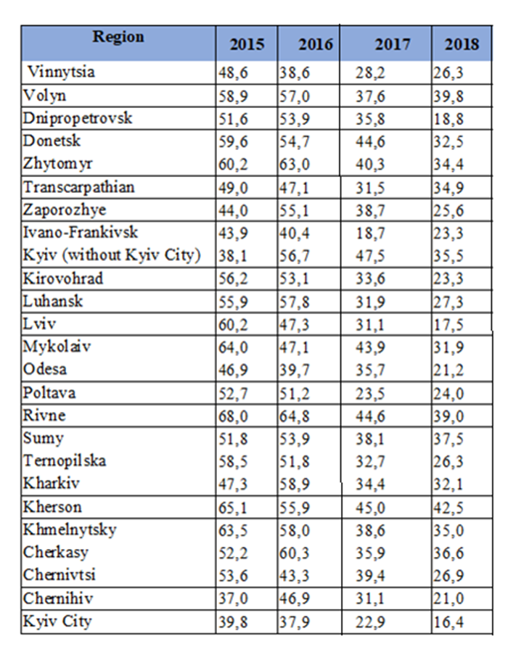
Reply to paragraph 22 (a) of the list of issues
242. As of January 1, 2015, according to the State Statistics Service of Ukraine, 657200 families and single citizens were on the housing register, of which 423000 families and single citizens have been in the housing register for more than 10 years, 113000 for more than 6-9 years, 106500 for more than 1-5 years.
243. Starting from 2015, the statistical survey “Housing register and housing allocation” is not carried out.
Reply to paragraph 22 (b) of the list of issues
244. The Cabinet of Ministers Resolution № 819 of 10.10.2018 “Some issues of providing citizens with affordable housing” provides for state support in form of payment:
• 30% of the cost of construction (acquisition) for affordable housing and/or the provision of preferential mortgage home loans;
• 50% of the cost of construction (acquisition) for affordable housing and/or preferential mortgage housing loans for persons covered by certain provisions of the Law of Ukraine "On the Status of War Veterans, Guarantees of their Social Protection";
• 50% of the cost of construction (acquisition) of affordable housing and/or preferential mortgage loans for persons dealing with the Law of Ukraine “On Ensuring the Rights and Freedoms of Internally Displaced Persons”.
245. State support for the construction (acquisition) of affordable housing is a one-off payment to families and single persons. The right to state support have:
(1) Persons who are in register for citizens in need of better living conditions and their family members who are also in register;
(2) Persons who have no living space and their families members also, in condition if such persons and their families have not owned the living space during the last three years before the application;
(3) Persons and their family members who own a living space not exceeding 13,65 square meters;
(4) Persons whose data, in accordance with the requirements of the Law of Ukraine "On Ensuring the Rights and Freedoms of Internally Displaced Persons", is included in the Unified Information Database of Internally Displaced Persons, unless such persons own or have owned for the last three years a residential real estate other than that, which is located in a temporary occupied territory or which was destroyed or became unusable as a result of the ATO.
IDPs receive state support for affordable housing, taking into account the place of residence, as evidenced by certificate of IDP registration.
Reply to paragraph 22 (c) of the list of issues
246. One of the ways to improve the living conditions of the participants of the anti-terrorist operation is budget housing programs, which are under the supervision of the Ministry of Regional Development, Construction and Housing and Communal Services of Ukraine, namely:
• Granting preferential long-term loans to young families and single young citizens for construction (reconstruction) and purchase of housing. The procedure is regulated by the Cabinet of Ministers Resolution № 584 of 29.05.2001) “On the Procedure of Granting Preferential Long-Term Loans to young people for construction (reconstruction) and purchase of housing”;
• Providing state support for the construction (purchase) of affordable housing. Acording to the Cabinet of Ministers Resolution № 819 of 10.10.2018 “Some issues of providing citizens with affordable housing”;
• Granting of long-term loans to individual housing developers in the countryside, according to the requinments of the Cabinet of Ministers Resolution №1597 of 5.10.1998.
247. The Ministry of Social Policy, within the framework of programs (subvention) financed by the budget, also provides housing for citizens who have the status of ATO/JFO participant or equivalent and in need of better living conditions.

Table 19
Number of purchased housing
The number of the program | 2015 |  | 2016 |  | 2017 |  | 2018 |  | 2019
The number of the program | Assigned financial compensation (families) | Housing units purchased | Assigned financial compensation (families) | Housing units purchased | Assigned financial compensation (families) | Housing units purchased | Assigned financial compensation (families) | Housing units purchased | Assigned financial compensation (families)
2511120 | 638 | 368 | 609 | 609 | 579 | 579 | 635 | 563 | 279
2505140 | - | 48 | - | 53 | - | - | - | - | -
2511190 | - | - | - | - | - | - | 52 | 50 | 24
2511200 | - | - | - | - | - | - | 204 | 191 | 165
2511210 | - | - | - | - | - | - | - | - | 24

Reply to paragraph 22 (d) of the list of issues
248. Living space provided to citizens for accommodation must be well-maintained to the conditions of this settlement, meet the established sanitary and technical requirements according to the Article 50 of the Housing Code of the Ukrainian SSR.
249. Requirements for residential buildings are set by the State Building Norms of the State DBN B.2.2-15-2005 „Residential buildings. Substantive provisions". These Standards apply to the design of new and renovation of residential buildings: single and multi-dwelling, including specialized apartment buildings for the elderly and families with disabilities and dormitories, and take into account measures to ensure the sanitation and fire safety.
250. These Standards also set up apartment parameters and levels of comfort, requirements for the engineering equipment of buildings, including water supply, sewerage, heating, ventilation, air conditioning, gas supply, electrical appliances, communications and alarm systems.
251. On April 1, 2019, new state building norms (DBN) came into force for mandatory barrier-free space in Ukraine for low-mobility groups. The new DBN “Buildings Inclusivity” contains about 100 changes for the safety and comfort for people with illnesses related to musculoskeletal, vision, hearing, mental activity and other low-mobility groups: elderly people, parents with young children, pregnant women.
252. In accordance with the Law "On Ensuring the Sanitary and Epidemic Safety of the Population", the Decree of the Ministry of Health of Ukraine № 173 of 19.06.1996 approved the State Sanitary Rules of the Planning and Development of Settlements (DSP 173-96), which include basic hygiene requirements for planning and construction of both new and existing urban and rural settlements in Ukraine.
Reply to paragraph 23 of the list of issues
253. The Action Plan for the implementation of the National Human Rights Strategy provides for the implementation of comprehensive measures for support and social adaptation of Ukrainian citizens who moved from the temporarily occupied territory of Ukraine and areas of ATO to other regions of Ukraine. In particular, in order to implement the Action Plan, by order of the Ministry of Regional Development, Construction and Housing and Communal Services of Ukraine № 69 of 25.03.2016, a working group was formed to develop a procedure for compensation for property damaged as a result of the ATO.
254. The Verkhovna Rada of Ukraine registered draft laws: “On Compensation for Damage to the Housing of the Population During the Anti-Terrorist Operation” № 6001 of 30.01.2017, “ On compensation for damage caused to citizens by a terrorist act and as a result of conducting an anti-terrorist operation” № 6041 of 07.02.2017, “On compensation for damage caused by a terrorist act” № 4328 of 29.03.2016; “On providing housing assistance to Ukrainian citizens whose housing has been destroyed or damaged as a result of the armed aggression by the aggressor state” № 6472 of 18.05.2017. The adoption of these Laws will ensure compensation for citizens, whose housing was lost or damaged as a result of the Russian aggression in the East of Ukraine.
255. On March 30, 2017, Ukraine and Georgia signed the Memorandum of Understanding on Co-operation. One of the main goals of the Memorandum is to include worldwide practice in protection of human rights of IDPs.
256. The Ukrainian Parliament Commissioner for human rights established the Coordination Council for the Respect of Rights of IDPs and persons residing in the temporarily occupied territory. The Coordination Council will develop legislative proposals, provide consultative and expert assistance on the observance of the rights and freedoms of IDPs and persons residing in the temporarily occupied territory. Since May 2019, a working group within the Coordination Council has been preparing a mechanism for assessing the damage caused to persons whose real estate was damaged or destroyed as a result of hostilities in eastern Ukraine.
257. The authority to arrange a survey on suitability for living of housing units is vested in the executive committee of a relevant local council. Thus, according to the legislation in place, the fact of fixing the destruction of housing is confirmed by the executive committee of the respective local council or the relevant military-civil administration.
258. The Plan of Actions for the Implementation of the Comprehensive State Program for Support, Social Adaptation and Reintegration of Ukrainian Citizens who Migrated from the Temporarily Occupied Territory of Ukraine and Areas of Anti-Terrorist Operation to Other Regions of Ukraine for the period up to 2017 determines the list of objects of social, road and transport infrastructure, housing and communal services, housing stock that require priority rehabilitation and determines the financial cost of carrying out for necessary works.
259. The Law “On the peculiarities of state policy on ensuring Ukraine’s State sovereignty over temporarily occupied territories in Donetsk and Luhansk regions” (hereinafter - the Law) provides that responsibility for material or other damage caused to Ukraine as a result of armed aggression of the Russian Federation rests with the Russian Federation, in accordance with the principles and norms of international humanitarian law.
260. Individuals irrespective of their registration as IDPs or acquiring special legal status as well as legal entities retain ownership, other real rights to property, including real estate, in particular land, in the temporarily occupied territories in Donetsk and Luhansk regions, if such property was acquired in accordance with the laws of Ukraine.
261. Ukraine does not bear responsibility for the illegal actions of the Russian Federation or its occupation administration in the temporarily occupied territories in Donetsk and Luhansk regions or their illegal decisions.
262. The Cabinet of Ministers Resolution № 1059 of 12.12.2018 established the Interagency Commission on summarizing the legal position of the state in the issue of repelling and restraining the armed aggression of the Russian Federation and preparing a consolidated claim of Ukraine to the Russian Federation for the implementation of international legal responsibility for Ukraine (hereinafter - Interagency Commission).
263. The consideration of the issue of compensation for damaged or destroyed property due to the armed aggression of the Russian Federation (including the mechanism of its evaluation) will be carried out within the work of the Interagency Commission.
Reply to paragraph 24 of the list of issues
264. According to the UN report “Overview of Humanitarian Needs in Ukraine, 2019”, significant humanitarian needs remain unmet with some 558000 people severely and moderately food insecure in non-government-controlled territory (NGCT), a decrease from 800000 people in 2017. Of them, around 103000 people are severely food insecure across NGCT. Overall, moderate and severe food insecurity was recorded at 17.4 per cent in October 2017, while of these some 3.2 per cent are severely food insecure, a decrease to two per cent from 5.2 per cent in June 2017.
265. Overall in Donetsk and Luhansk oblasts, food insecurity decreased from 410000 people in 2017 to 267000 in 2018. Among those, around 13000 are still severely food insecure. The reduction of food insecurity in government-controlled territory is also a result of the economic improvement in the country, including a significant increase of real salary levels reaching pre-crisis levels of 2013 as well as pension reform.
266. In cooperation with the UN Office for the Coordination of Humanitarian Affairs in Ukraine, Ministry of temporary occupied territories and internally displaced persons of Ukraine is actively involved in the developing of the Ukraine Humanitarian Response Plan.
267. The Ukraine Humanitarian Response Plan is a consolidated analytical framework for strategic planning, monitoring and priority areas for addressing the humanitarian crisis, such as health and safety, water, nutrition and housing, education, social adaptation.
268. In 2016, the following humanitarian assistance was delivered: 473 tons of chemical reagents for water purification in Donetsk; 38 plants for the production of chlorine at the water treatment plant of the municipal enterprise "Water of Donbass" in Donetsk; vital medicines, reagents and spare parts for medical equipment to four doctors in Donetsk; 245 tons of chemical reagents to the structural subdivision of water utility Donbass in Krasnoarmeysk, Donetsk region; medical equipment to provide general medical care to patients in Kurakhove, Donetsk region.
269. During 2017, the following humanitarian assistance was delivered: 1635 tons of chemical reagents for water treatment at water treatment plants of the municipal enterprise "Water of Donbass"; 4 generators of energy supply; food kits to Avdiivka including 10 tons of food and food kits for 5 thousand people (based on one package for two persons).
270. In 2018, 17 MAXI WATA electrolysis plants installed at the sewage facilities in Pokrovsk, to dispose of the wastewater.
271. During 2019, with the assistance and coordination of the Ministry of temporary occupied territories and internally displaced persons of Ukraine, the 10th Humanitarian Mission to Eastern Ukraine was carried out by the Swiss Humanitarian Aid Unit of the Swiss Agency for Development and Cooperation from 21 May to 5 June 2019. The humanitarian cargo consisted of chemical reagents for water treatment, which will be used at water treatment plants of the municipal enterprise "Water of Donbass" and medical equipment.
272. The Law № 2710-VIII ratified the Framework Agreement between the Government of Ukraine and the Government of the French Republic on the official support of the project for the supply of drinking water in Mariupol, which entered into force on 06 June, 2019.
273. The Ministry of temporary occupied territories and internally displaced persons of Ukraine implemented a mechanism for rapid response to humanitarian crises in Donetsk, Luhansk and Kherson regions, which defines an algorithm for crisis response, gathering information on humanitarian assistance needs, communication with humanitarian organizations about humanitarian needs.
Reply to paragraph 25 (a) of the list of issues
274. In order to prevent and combat HIV/AIDS and TB, the Government endorsed the Strategy for ensuring a Sustainable Response to the Tuberculosis and HIV/AIDS epidemics for the period up to 2020 (hereinafter - Strategy). The strategy focuses on enhancing the ability of the state to effectively implement priority measures to address TB and HIV/AIDS epidemics in the context of a gradual transition in 2017 from donor funding (mainly the Global Fund) to funding from state and local budgets without stopping implementation of such measures or deteriorating the quality of their implementation.
275. In order to provide services in 2018 and implement the first phase of the Plan, the Public Health Center of the Ministry of Health of Ukraine (hereinafter -Center) developed two models of service delivery. According to the models planned to reach 20% of target groups receiving prevention services, HIV care and support.
276. According to the centralized model, the Center conducted an open competition and selected national coordinators: HIV prevention among key population groups (winner - "Alliance for Public Health"); care and support for HIV; support for patients with tuberculosis, including multidrug-resistant (winner - All-Ukrainian Network of PLWH).
277. The winners of the competition accordingly had the right to offer the coverage areas of the service, subject to proving previous successful experience of implementation of the relevant programs in the regions and the possibility of providing services according to the requirements of the competition.
278. Thus, according to this model, service providers, selected by the winners of the competition, provide services: HIV prevention - in Vinnitsa, Zhytomyr, Transcarpathian, Zaporizhia, Odesa regions; HIV care and support services in Dnipropetrovsk, Mykolaiv, Odesa and Kyiv; TV support - in Vinnytsia, Volyn, Dnipropetrovsk, Donetsk, Zhytomyr, Transcarpathian, Zaporizhia, Kirovograd, Kyiv, Lugansk, Lviv, Mykolayiv, Odesa, Rivne, Ternopil, Kharkiv, Kyiv.
279. According to the decentralized model, regions with significant successful experience in advocating local budget allocation and social order execution were selected in Sumy and Poltava oblasts. In these regions contracts were signed on the basis of the sub-grant, namely the State Institution "Sumy Regional Center of Public Health" (hereinafter - SSGZ) and the Poltava Regional State Administration. The coverage under the decentralized model is 5%, or 20% of the 20-50-80 Plan in 2018.
280. Both models will be analyzed, the case studies will be presented, which will be evaluated by national experts and international partners in order to select a single model for further service delivery. As of today, two models - centralized and decentralized - ensured continuity of service.
Reply to paragraph 25 (b) and (c) of the list of issues
281. According to the observations of the Committee of Ministers of the Council of Europe in 2010, which emphasized that Council of Europe member states should review their legislation to remove the complications of recognizing gender change as well as the report of the UN Committee on Human Rights, issued in July 2013, where reservations were made against compulsory sterilization of transgender persons in Ukraine, and in the implementation of the National Human Rights Strategy for the period up to 2020, the Ministry of Health of Ukraine cancelled its previous Order № 60 of 03.02.2011 "On Improvement of Medical Assistance to Persons in Need of Changing Sex".
282. A multidisciplinary working group on the elaboration of medical-technological documents on the standardization of medical care on the topic "Transgender" was created according to the Order № 738 of 10.11.2015 of the Ministry of Health of Ukraine.
283. The issue of intersex persons was included in the programs of advanced training of obstetricians, gynecologists, neonatologists, geneticists.
284. In order to ensure equal access of the population to medical services, including transgender persons, intersex persons and sex workers, the Law “On State Financial Guarantees of Public Health Care” was adopted in 2017.
285. Accordingly, every citizen of Ukraine has the right to receive medical services and the free choice of a primary care by making a declaration at any health care institution that has an agreement with the National Health Service of Ukraine.
Reply to paragraph 26 of the list of issues
286. Paragraph 12 of the Action Plan for 2019-2020 on the implementation of the State Drug Policy Strategy provides for creating conditions and ensuring guarantees of medical care for persons with mental and behavioral disorders due to the use of psychoactive substances. In particular: approval and implementation of standards of care for people with mental and behavioral disorders due to substance use; introduction of complex-integrated medical care for the treatment of persons with mental and behavioral disorders due to the use of psychoactive substances; developing a list of health and social services for people with mental and behavioral disorders due to substance use, taking into account gender identity, belonging to vulnerable groups and age characteristics.
287. Paragraph 13 of the Plan provides for the implementation of measures for motivation and desire for treatment of patients with mental and behavioral disorders.
288. Paragraph 14 envisages: drafting a bill to amend legislative acts to determine the type of activity related to the provision of rehabilitation and re-socialization services for persons with behavioral disorders due to the use of psychoactive substances; development of the state standard of social service of social and psychological rehabilitation of persons with mental and behavioral disorders; ensuring the development of infrastructure for providing comprehensive social, pedagogical and psychological assistance to children and their parents.
289. The Ministry of Social Policy approved the Order № 1275 of 03.09.2018 "About approbation of the draft of the State standard of social service for social and psychological rehabilitation". The testing was carried out in the centers of re-socialization of drug-addicted youth of Donetsk, Mykolaiv and Khmelnitsky regions. NGOs, including Alipia Rehabilitation Centers, the New Family Charitable Foundation were involved.
Reply to paragraph 27 of the list of issues
290. The psychological rehabilitation of ATO participants is underway since 2015. According to the budget program, expenditures in the amount of UAH 109021800 were foreseen for 2018.
291. Order № 425 of 22.03.2019 of the Ministry of Social Policy establishes the limit of costs of service for psychological rehabilitation in 2019 for one person from among the victims of the Revolution of Dignity, ATO participants and persons who took measures to ensure national security and defense, the repelling and restraining of the armed aggression of the Russian Federation.
292. In 2019 service for 1920 recipients was planned. During January - May 2019, 2171 persons applied for services, 722 contracts were signed, 396 persons received psychological rehabilitation services.
293. The Cabinet of Ministers Resolution № 1021 of 05.12.2018 approved the state target program till 2022 on physical, medical, psychological rehabilitation and social, labor readaptation of ATO participants and persons who participated in measures to ensure national security and defense, the repelling and restraining of the armed aggression of the Russian Federation in Donetsk and Lugansk region.
294. Ministry of Social Policy and the National Guard of Ukraine, according to the Memorandum of Interaction and Cooperation, have organized 15 visits for psychological rehabilitation on the Decompression Program (more than 400 guardsmen enlisted).
295. The victims of the conflict registered as IDPs receive systematic assistance in all regions of Ukraine in centers of social services for families, children and youth.
296. During 2019, 12860 internally displaced families raising 16078 children received social services according to their needs. As a result 4106 families received psychological assistance, 3298 families - humanitarian aid, 111 people - employment assistance, 3728 families - assistance in the processing / recovery of documents and 119 families were provide with housing. 10026 families raising 12648 children resolved their issues.
297. In addition, according to the Law „On Rest and Recreation of Children”, children registered as IDP are considered those who need special social attention and support and have the right on preferential provision of necessary health and recreation services (vouchers with a partial payment of 30 percent of the cost).
298. According to the information from Children's Service of the Donetsk Regional State Administration, in order to support children of Donetsk region who received the status of a child affected by war and armed conflicts, the Head of the Regional State Administration adopted the Order № 493/5-18 on allocation of funds from the regional budget for the provision of one-time financial assistance to children in the amount of five subsistence minimums for children of the appropriate age (one-time financial assistance for children who received the status of a child affected by war and armed conflict in the territory of Donetsk region in connection with the receipt of injuries, physical, sexual violence, abduction or illegal export from Ukraine; participation in actions of militarized or armed formations; illegal detention, including captivity). During 2018, one-time financial assistance provided to 63 children who had received the status of a child affected by war and armed conflict (UAH 5760900 from oblast budget).
299. As of May 1, 2019, 22846 children were registered in the status of a child affected by war and armed conflicts (according to the Cabinet of Ministers Resolution № 268 of 05.04.2017). Among them 22789 children experienced psychological abuse; 2 children physical and sexual abuse; 85 children injured, mutilated.
Reply to paragraph 28 (a) of the list of issues
300. One of the priorities of the state since the beginning of the Russian aggression against Ukraine is to preserve the life and health of children and ensure their right to education. The Government of Ukraine has taken a number of measures to receive Ukrainian education for temporary occupied territory children. In particular, a person at educational institutions in a controlled area may obtain a lost educational document. This allows continuing their studies in higher education institutions or VET institutions. For schoolchildren leaving the uncontrolled territories conditions for continuing education at the place of new living or sojourn were created.
301. The Order № 369 of 13.03.2017 of the Ministry of Education and Science approved a new wording of the Regulations on Externships in General Educational Institutions, which regulates the provision of general secondary education by persons who reside in uncontrolled territory, the provision of them certain prerogatives and benefits for receiving external education.
302. For children who live on the territory along the contact line measures are taken to ensure the right to education. In the so-called „gray zone”, 178 educational institutions continue to operate, in which nearly 20000 children enrolled. Frequent shelling is one of the reasons to stop studying in the schools dealing with significant danger for children.
303. In the 2018-2019 academic year, on the territory along the contact line in the Donetsk region 112 educational institutions, in particular, 52 secondary schools worked. Through on-going armed conflict in Eastern Ukraine 2 secondary schools in Avdiivka, 3 in the Volnovakha district, 2 in the Yasynuvata district and regional boarding school № 3 suspended.
304. In 52 secondary schools, 12289 pupils are studying, and 1279 teachers provide educational services.
305. There are 66 educational institutions located in the territory along the contact line in the Lugansk oblast. Institutions of pre-school education – 23; secondary schools – 37; VET institutions – 4; institutions of regional communal property – 2. In educational institutions 8321 children are studying: in the pre-school education – 1341 children; in the secondary schools – 5922 children; in the VET institutions – 754 students; in the institutions of regional communal property – 304 children. The total number of pedagogical staff - 1085 persons, of which 721 persons work in the secondary schools.
Reply to paragraph 28 (b) of the list of issues
306. Access to higher education for persons whose place of residence is the temporarily occupied territory of the Autonomous Republic of Crimea and the Сity of Sevastopol. The Law „On Ensuring Civil Rights and Freedoms, and the Legal Regime on the Temporarily Occupied Territory of Ukraine” established the Procedure for Higher and VET-educations for Persons Residing in the Occupied Territory of Ukraine (hereinafter – Procedure). The Procedure defines the peculiarities of obtaining the documents on secondary education and the peculiarities of the conditions for admission to higher educations and VET-educations of persons residing in the temporarily occupied territory of the Autonomous Republic of Crimea.
307. Activities for the implementation of this Procedure are organized in Crimea-Ukraine Educational Centers (hereinafter – Educational Centers) in the cities of Kyiv, Berdiansk, Dnipro, Zaporizhia, Izmail, Lviv, Melitopol, Mykolaiv, Odessa, Kharkiv and Kherson.
308. Right to education through Educational Centers is entitled to persons who have a Ukrainian Certificate of Secondary Education, passed Independent External Evaluation, and have appropriate certificates.
309. A person who does not have a Ukrainian Certificate of Secondary Education can apply to one of the Educational Centers for the annual assessment, State Final Certification and admission to higher education under the simplified procedure.
310. Applicant from the temporarily occupied territory of the Autonomous Republic of Crimea and the city of Sevastopol, which has a Ukrainian Certificate of Secondary Education and positive results of the Independent External Evaluation, has the opportunity to enter any university of Ukraine to participate in the general competition for the public funding.
311. The Order of the Ministry of Education and Science № 537 approved the Procedure of Passing the Attestation for Recognition of Qualifications, Training Results and Periods of Study in the Higher Education System Obtained in the Temporarily Occupied Territory of Ukraine after February 20, 2014.
312. Applicant who have resided and studied in higher education institutions in the temporarily occupied territory of Ukraine have the right to apply to any higher education institutions of Ukraine in which training in the relevant specialty carried out, with a statement on passing such Attestation. Exclusively the management of the appropriate higher education institutions makes the decision on the possibility of conducting such Attestation.
313. Attestation is carried out only if the Applicant has a Certificate of Secondary Education of the state sample. In the absence of such a Certificate, the Applicant applies to the Secondary Education Institutions, where he/she enrolls in the external form of education.
314. Access to higher education for persons whose place of residence is the temporarily occupied territory of Donetsk and Luhansk oblasts. The Law of Ukraine „On Amendments to Some of the Laws of Ukraine on Ensuring the Right to Education for Persons Residing in the ATO Territory” approved the Procedure for Higher and VET-educations for Persons Residing in the ATO Territory. The Procedure defines the peculiarities of passing the state final attestation, obtaining the document of the state sample on the secondary education and peculiarities admission to higher educations and VET-educations of persons residing in the ATO Territory.
315. Activities for the implementation of this Procedure are organized in Donbass-Ukraine Educational Centers in 17 cities of Ukraine.
316. The Order of the Ministry of Education and Science of Ukraine № 74 approved the Procedure of Continuation of Education of Persons Studying in Higher Education Institutions located in the Temporarily Occupied Territories in Donetsk and Luhansk oblasts. To continue education at a higher education institutions (retaining a specialization) located in other territorial unit of Ukraine, an applicant is enrolled for education by renewal.
317. Applicant from the temporarily occupied territory of the Autonomous Republic of Crimea, or a temporarily occupied territory of Donetsk, Lugansk oblasts, which has a Ukrainian Certificate of Secondary Education and positive results of the Independent External Evaluation, has the opportunity to enter any university of Ukraine. Any educational certificates issued in the temporarily occupied territory of the Autonomous Republic of Crimea and city of Sevastopol and the temporarily occupied territories in Donetsk or Luhansk oblasts are not considered valid.
Reply to paragraph 29 (a) of the list of issues
318. In the 2018-2019 academic year, 4016488 pupils enrolled in general secondary education institutions, including 73161 children with a disability, representing 1.8 percent of the total number of children. Of these, 19909 students with disabilities and special educational needs (0.5% of the total) study at special secondary education institutions (total - 37787), special classes of general secondary education institutions (total - 6230) and inclusive classes (total 11839). There are 1091 children with disabilities in the Donetsk oblast (0.027%) and 3362 children with disabilities in Luhansk oblast (0.083%).
319. The Law „On Education” № 2145 provides for the right to inclusive education and the right to education for persons with special educational needs. In the 2018-2019 academic years, 11839 children with special educational needs enrolled in inclusive classes, which is 65% more than in the previous academic year. The number of teacher's assistants increased by 104% (from 3788 in 2017-2018 to 7633 in 2018-2019 academic years).

Table 20
Data on inclusive and special classes in Ukraine during 2016-2019 academic year
Academic year | Inclusive classes |  |  |  | Special classes
Academic year | Number of pupils | Number of classes | Number of schools | Teacher's assistants | Number of pupils | Number of classes | Number of schools
2016-2017 | 4180 | 2715 | 1518 | 1825 | 5669 | 490 | 126
2017-2018 | 7179 | 5033 | 2620 | 3732 | 5918 | 557 | 141
2018-2019 | 11839 | 8401 | 3788 | 7633 | 6230 | 577 | 152
320. In 2018, following the Law "On General Secondary Education" and the Cabinet of Ministers Resolution № 545 of 12.07.2017 "On Approval of the Regulations on Inclusive-Resource Center", the development of a network of inclusive-resource centers started. Centers provide psychological and pedagogical support for children with special educational needs from 2 to 18 years old.
321. As of January 1, 2019, 516 inclusive resource centers in the regions were established (500 centers were planned to be open in 2018).
322. The Cabinet of Ministers Resolution № 88 of 14.02.2017 approved the Procedure and Conditions for subvention from the state budget to local budgets for the provision of state support to persons with special educational needs.
323. In 2018, the subvention was directed to provision of corrective-developmental services and purchase of corrective training facilities for students enrolled in special and inclusive classes of general secondary education institutions - UAH 304000000; equipping of inclusive-resource centers - UAH 100000000.
Reply to paragraph 29 (b) of the list of issues
324. Roma children of pre-school and school age are educated in pre-school and general secondary education institutions together with children of other nationalities. Roma children, as well as children of representatives of other nationalities, are guaranteed the right to receive pre-school, general secondary and higher education, to choose the appropriate form of education and educational establishment in accordance with the Constitution of Ukraine, the Law № 2145 "On Education" and other normative documents.
325. The legal documents do not provide opportunity to collect records of pupils and students on a national basis by the education authorities, so there is no official statistical information on the number of Roma pupils who have received a complete general secondary education or Roma students.
Reply to paragraph 29 (c) of the list of issues
326. According to the Law № 2145 “On Education”, Ukraine provides equal conditions for access to education. Nobody can be restricted in the right to education. The right to education is guaranteed regardless of age, gender, race, health status, disability, nationality, place of residence, the language of communication, origin, social and property status, criminal record, etc.
327. On December 18, 2018, the Verkhovna Rada of Ukraine adopted the Law "On Amendments to Certain Legislative Acts of Ukraine on Combating Bullying (Harassment)". According to the Law administrative responsibility for bullying cases is imposed, which secures responsibility for actions at the legislative level or inactivity in cases of bullying.
Reply to paragraph 30 of the list of issues
328. In places of traditional residence of national minorities, educational institutions continue to operate: pre-school, general secondary, higher education with the curricula in the languages of national minorities or in which children study the languages of national minorities. Pre-school institutions provide education in six languages (Ukrainian, Moldovan, Polish, Russian, Romanian, Hungarian).
329. General secondary education provides studying in six languages (Ukrainian, Moldovan, Polish, Russian, Romanian, Hungarian), in elementary school in eight languages (Ukrainian, Bulgarian, Moldavian, Polish, Russian, Romanian, Slovak, Hungarian), 30 languages are available as a study object.
330. The state, educational authorities, educational institutions have created the proper conditions for the functioning of these educational institutions. Information about studying in languages of national minorities or the study of these languages in educational institutions are presented in the tables.

Table 21
Data on the number of pre-school education institutions and the distribution
of their pupils by language of education on 01.01.2018
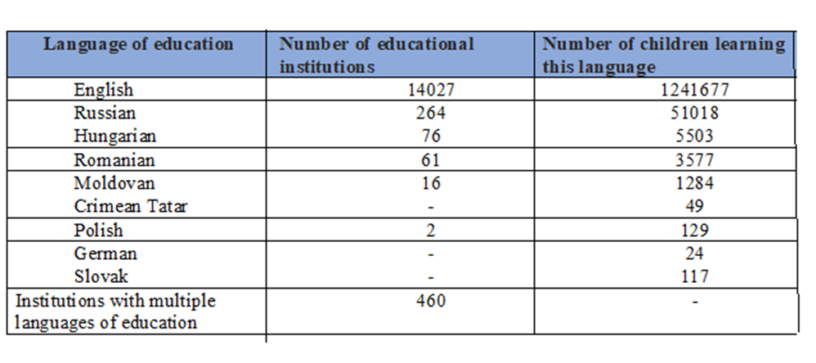

Table 22
Data on the number of students of higher education institutions
(colleges and VET institutions) studying in the respective language in 2017-2018 years
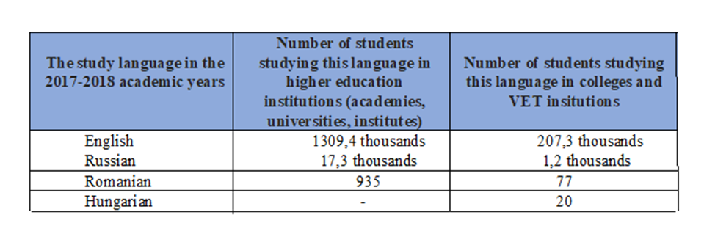
331. In September 2017, Ukraine directed the Law "On Education" for the expertise to the European Commission "For Democracy through Law" (Venice Commission). Ukraine has publicly pledged to follow the recommendations of the Venice Commission and has already taken many steps in this direction. Ministry of Education developed a roadmap for the implementation of Article 7 "Language of Education" of the Law № 2145, reflecting the key recommendations of the Venice Commission set out in paragraph 126. The roadmap contains a draft article on the language of education in general secondary education institutions and a draft amendment to the Law № 2145 on the continuation of transitional the period of implementation of Article 7 to the 2023 year. The electronic version of the roadmap is available on the Ministry of Education website.
Reply to paragraph 31 of the list of issues
332. Ministry of Culture does not have any ability for permanent, systematic and independent observation of the objects of cultural heritage that are located in the temporarily occupied territory of the Autonomous Republic of Crimea due to the armed aggression of the Russian Federation, including objects created because of cultural traditions of the Crimean Tatar people.
333. Ministry of Foreign Affairs and UNESCO World Heritage Centre are working on the issue of direct monitoring of the objects of cultural heritage located in the temporarily occupied territory of the Autonomous Republic of Crimea.
334. Ministry of Culture monitors media about the situation at the temporarily occupied territory of the Autonomous Republic of Crimea due to the armed aggression of the Russian Federation.
335. Ministry of Culture together with the Ukrainian National Committee of the International Council on Monuments and Sites (ICOMOS) and the International Centre for the Study of the Preservation and Restoration of Cultural Property (ICCROM) sent a joint statement to UNESCO Director-General, Audrey Azoulay, about uniting efforts to protect Ukraine's cultural heritage placed at the temporarily occupied territory of the Autonomous Republic of Crimea, including the monument of national importance „Khan's Palace” which is part of the historical environment of the capital of the Crimean khans in the city of Bakhchisaray, which is on the UNESCO World Heritage List and is in danger of total destruction.
336. Ministry of Culture of Ukraine has the information about manifestations of religious and national intolerance towards Ukrainian citizens remaining at the temporary occupied territory of the Autonomous Republic of Crimea. The most common offenses are related to: „Abduction and torture”, „Occupation of cult houses, defilement”, „Damage or destruction of religious shrines”, „Arrests and detention”, „Prohibition of religious activity”, restrictions on religious activity and persecution of individual representatives and religious organizations (Orthodox, Muslim, Protestant, and Jewish). The data is obtained from the citizens and electronic media.
337. Mostly Muslims with active civic positions are prosecuted. At the framework of administrative cases, Muslims are searched and their computers, cell phones, and religious literature are confiscated.
338. The State Enterprise „Crimean House” has been operating in Ukraine since 2014, which takes care of the issues of the indigenous peoples of the Autonomous Republic of Crimea, their psychological rehabilitation through culture and science, under the conditions of them being forced to leave the temporarily occupied Autonomous Republic of Crimea.
339. Since 2017, the Ministry of Culture conducting an annual all-Ukrainian festival of national cultures.
Reply to paragraph 32 of the list of issues
340. The Cabinet of Ministers Resolution № 27 approved the Concept of reforming the system of providing the population with cultural services (hereinafter - the Concept).
341. The main task of reforming the system of providing the population with cultural services is to approve minimum standards for providing citizens with cultural services; reforming the financial support of the cultural services system; implementation of the policy of modernization of the existing infrastructure for the provision of cultural services; creation of conditions for formation of high-quality (highly qualified) human resources support of the system of rendering cultural services; developing a system for monitoring and evaluating the quality of cultural services.
342. The implementation of the Concept will contribute to the protection of cultural rights of the population of Ukraine, including in the context of the division of functions between the Ministry of Culture and local authorities in the field of culture. A corresponding draft action plan for the implementation of the Concept is prepared and will be approved by the Government.
343. The Cabinet of Ministers Resolution № 77 of 23.01.2019 approved the Plan of actions for the implementation of a new stage of reforming local self-government and territorial organization of power in Ukraine for 2019 - 2021. The Resolution provides for the transfer (decentralization) of powers of executive bodies to local self-government bodies and their delimitation on the principle of subsidiarity with the implementation of appropriate measures and creation of a proper resource base for exercising the powers of local self-government bodies. To accomplish these tasks, amendments to the Laws of Ukraine "On Central Bodies of Executive Bodies", "On Local State Administrations", "On Local Self-Government in Ukraine" are envisaged.
344. In the context of the above, the division of functions between the central executive authorities and local self-government bodies, including in the sphere of culture, is going on.
Reply to paragraph 33 of the list of issues
345. Ukrainian Government focus on stabilization resulted in economy growth. The realization of the Government policy also positively impacted employment sector and labour market.
346. For the first time since 2013, there has been an increase in employment and a decrease in unemployment: the number of employed people in 2018 increased by 205000 compared to 2017, amounting to 1600000 people. Accordingly, the employment rate increased from 56.1% to 57.1%. The employment rate increased in all Ukrainan regions.
347. The number of unemployed in 2018 (ILO methodology) of the population aged 15-70 compared to 2017 decreased by 119000 people, to 1600000 people in 2018. The unemployment rate of the population aged 15-70 decreased during this period from 9.5% to 8.8% of the economically active population.
348. In 2018, the number of people employed for new jobs posisitions increased for 1.6 times compared to 2017 amounting to 615000 people, the highest figure since 2013.
Strengthening the social protection of migrant workers rights
349. The Strategy of the State Migration Policy of Ukraine for the period up to 2025 and the Plan of Measures for Implementation 2018-2021 were adopted.
Strengthening the social protection of labor rights
350. According to the data, there are 13300000 employed people in Ukraine: 10300000 work as employees, 1300000 as entrepreneurs. This data indicates a low level of labor relations registration.
351. Government is working on reducing the level of informal employment and updating labor legislations. Ukraine undertook obligations to achieve high standards of decent work (ILO Agreement). As a result, illegal employment decrease to 3400000 people in the first quarter of 2019, the number of insured persons increased by 273600 people amounting to 13300000 people in June 2019.
(1) Measures were approved aimed to reduce the level of informal employment by the Cabinet of Ministers Resolution № 649 of 05.09.2018 and:
• 17322000 employees, which work without appropriate employment agreements, were identified; with 21034000 employees, which performed work without proper registration of labour relations, labour agreements were concluded;
• Since the beginning of the 2019, employers have concluded 82200 employment agreements with employees, or almost 4 times more than in the appropriating period of the 2018 (21100 employment agreements).
(2) The Concept of Reforming the System of Management of Occupational Safety and the Plan of Measures for Implementation was adopted by the Cabinet of Minister Resolution № 986 of 12.12.2018).
(3) Draft laws were drafted on implementation of ILO Recommendation 198, ILO Convention № 131, № 95, №173, № 187 and Directive 89/39/EEC.
352. The adoption of these draft laws will increase the efficiency of protection of employees’ rights, will facilitate the official registration of labor relations, protection of the right to timely payment of wages, ensuring proper, safe and healthy working conditions, strengthening the role of social dialogue in determining the minimum wages.
Providing effective social support to the population
353. The objective of this priority is to ensure targeted approach to providing social assistance to low-income citizens and to implement a comprehensive approach to social integration of marginalised and disadvantages individuals, groups, and eradication of poverty.
354. Measures to ensure a decent living of marginalised and disadvantages individuals and groups are implemented through providing financial aid at the expense of the State Budget of Ukraine and subsidies to local budgets.
355. State support is increasing every year. In 2018, UAH 57900000000 was earmarked for this purpose, in 2017 -UAH 51600000000, in 2016 - UAH 47200000000. As of July 1, 2019, 2100000 people received State financial assistance.
Implementation of pension reform
356. The pension reform was initiated with the adoption of the Law № 2148 “On Amendments to Certain Legislative Acts of Ukraine on Raising Pensions” of 3.10.2017, according to which:
• Since October 2017, previously assigned pensions for 10200000 persons were updated and recalculated;
• New mechanism for determining the amount of pension payments was established;
• Another mechanism of annual indexation (recalculation) of pensions was introduced;
• A new social guarantee was ensured – a minimum pension is 40% of the minimum wage for persons over 65 years, with a minimum of 30 years of work record for women and 35 years for men.

Raising the level of pension income
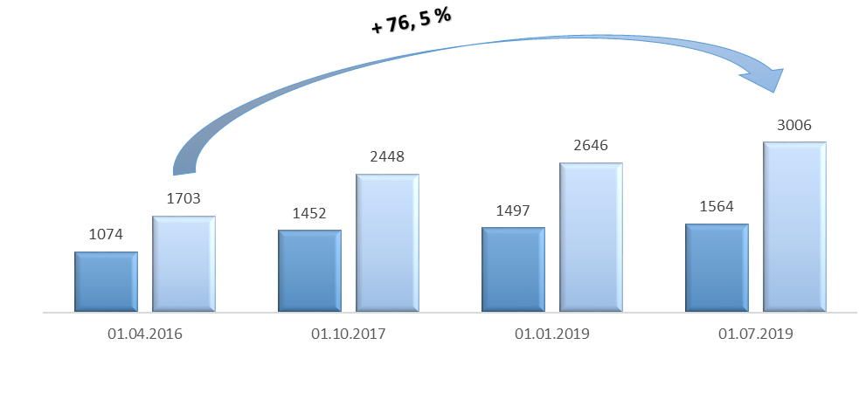
▪ Minimum pension amount, .UAH thousand
▪ Average pension amount, .UAH thousand
Developing social and rehabilitation services in local territorial communities
357. In January 2019, the Verkhovna Rada of Ukraine adopted a new version of the Law of Ukraine “On Social Services”. An extensive network of Institutions Providing Social Services for about 3 million people was created.
Reform of the Penitentiary System and Probation
358. The reform consists of three components: reform of the medical service (goal: to ensure the independence of the doctor from the head of the penitentiary institution and to establish modern quality standards of care); to create a system of probation (goal: re-education of offenders without isolation from society and placement in a prison environment); restructuring of the penitentiary system (goal: to change the punitive function to a system that re-educates and re-socializes convicts).

* The present document is being issued without formal editing.

