 | United Nations | CRC/C/ARG/7
 | Convention on the  Rights of the Child |  | Distr.: General  9 February 2024  English  Original: Spanish  English, French and Spanish only
Committee on the Rights of the Child

Seventh periodic report submitted by Argentina under article 44 of the Convention, due in 2024*, **
[Date received: 7 December 2023]

Introduction
1. The Convention on the Rights of the Child, adopted in 1989, was the first universal legal code to protect the rights of children and adolescents. In Argentina, the approval of the Act for the Comprehensive Protection of the Rights of Children and Adolescents (Act No. 26061) represented a milestone of great educational value and political impact in terms of the implementation of the rights-based approach to the protection of children and adolescents introduced by the Convention.
2. The Argentine Republic approved the 2030 Agenda for Sustainable Development in September 2015. The country develops comprehensive public policies for children and adolescents on an ongoing basis in line with the Agenda while also ensuring that the required public investment is made.
3. The present Administration, which took office in December 2019, is committed to the effective realization of the rights of children and adolescents and has established a number of public policies as an absolute priority for accelerated action. More details on these policies are included below as requested by the Committee on the Rights of the Child.

I. New developments

Reply to paragraph 2 (a) of the list of issues prior to reporting (CRC/C/ARG/QPR/7)
4. The State has enacted laws and developed national public policies in coordination with local jurisdictions for the full implementation of the Convention and its Optional Protocols. For example, the State has established the National Plan to Prevent and Reduce Unintended Pregnancy in Adolescence, the National Early Childhood Plan, the “Right Click” Programme and the “Growing up with Rights” Initiative. It has introduced a universal allowance for children who are not being cared for by their parents and has promulgated the Thousand Days Act and Decree No. 840/2020. In addition, it has approved the “Play” Programme, the “Let’s Participate” Programme, a support programme to help ensure that students graduate, an economic reparations programme for children of victims of gender-based violence and the Care Infrastructure Plan.

Reply to the question raised in paragraph 2 (b) of the list of issues
5. The State has made a determined effort to address the adverse effects of the coronavirus disease (COVID-19) pandemic, with special emphasis on the children and adolescents of Argentina. The various facilities at the local level, including protection agencies and care facilities whose work has been adversely affected by staff shortages, have been provided with guidance by the National Secretariat for Children, Young Persons and the Family (SENAF) on how to best serve children and adolescents who lack parental care during lockdowns.
6. Recommendations on the protection of rights during the COVID-19 pandemic were published for institutional facilities. Two “Games and Care” resource guides in the context of COVID-19 prevention measures have been published for residential and family-based facilities for children who lack parental care, and 33 training sessions were carried out.
7. The AUNAR Familias (Uniting families) Initiative developed by SENAF and the United Nations Children’s Fund (UNICEF) reached more than 10,000 boys and girls living in provincial and municipal institutions and social organizations throughout the country. The recipients were provided with financial assistance by the Argentine Government to strengthen action to halt the COVID-19 pandemic. The second tranche reached 438 households, home to 3,247 girls and boys aged from 6 to 17 years who were subject to exceptional measures.

Reply to the question raised in paragraph 2 (c) of the list of issues
8. Virtual training sessions were held in accordance with the regulations governing COVID-19 lockdowns for children whose designated carers were deprived of liberty.
9. A document was drafted on the impact of the COVID-19 pandemic and the adaptive responses of health services to guarantee the right to sexual and reproductive health in Argentina from March to August 2020.
10. Subsidies were introduced for children’s homes and child development centres. The Emergency Family Income Programme and the Emergency Assistance Programme for Work and Production were established and regulations were issued for the transfer of children and for communication with parents who did not live with their children.

Reply to the question raised in paragraph 3 of the list of issues
11. Since December 2019, the new Administration, which is committed to the effective realization of the rights of children and adolescents, has identified the expansion of the national food security and nutrition plan as an absolute priority for swift action and has introduced food cards for this purpose.
12. The Argentina Plan against Hunger is receiving increased support from the National Food and Nutritional Security Programme. This involves promoting and improving access to the basic food basket, and the food card is one of the tools for accomplishing this. Work is also being undertaken with the with the marketing channels for what is known as “the social economy”, which means that the grass-roots economy, cooperatives and family agriculture will be central actors in the application of these public policies.

II. Rights under the Convention and the Optional Protocols thereto

Legislation

Reply to the question raised in paragraph 4 (a) of the list of issues
13. With regard to the adaptation of laws and regulations to bring them into conformity with the Convention and Act No. 26061 on comprehensive protection, in all provinces of the country and the City of Buenos Aires, 23 of the 24 jurisdictions have implemented a full set of regulations and statutes, in addition to the existing national laws and constitutional provisions. However, the Province of Formosa is still in the process of enacting a bill.
14. The following legislation has been enacted: Act No. 27576, amending article 44 of Act No. 26061 and establishing easily accessible digital platforms on violence prevention; Act No. 27590, known as “Mica Ortega’s Law”, which protects children and adolescents from grooming; and Act No. 27709, also known as “Lucio’s Law”, establishing the federal training plan for ongoing mandatory training on the rights of children and adolescents.

Reply to the question raised in paragraph 4 (b) of the list of issues
15. The bill on a comprehensive care policy system in Argentina that would entail the modification of the maternity, paternal and parental leave regimes, was approved by a majority vote in August 2023. The challenges and obstacles are detailed in the record of proceedings No. 734 dated 29 August 2023, which sets out the dissenting opinions expressed in committee debates.

Comprehensive policy and strategy

Reply to the question raised in paragraph 5 of the list of issues
16. The National Plan of Action for the Rights of Children and Adolescents 2016–2019 aims to guide public policies, programmes and national, provincial, municipal, civil society and private sector action on behalf of children and adolescents living in the Argentine Republic. The Federal Council and SENAF, which are responsible for evaluating and formulating the next national plan, were negatively affected by the pandemic, as they had to devise ways of guaranteeing the rights of children and adolescents throughout the country during the health emergency.
17. They nevertheless drew up guidelines for the following initiatives: the National Plan for Childhood and Family Training; the National Early Childhood Plan; the National Programme to Reduce Unintended Pregnancy in Adolescence; Adolescent Forums; the promotion of legal counsel for children; the promotion of the right to an identity; addictions; child labour; adoption under the new Civil and Commercial Code of the Nation; violence and child abuse; the third Optional Protocol to the Convention on the Rights of the Child on a communications procedure; the 102 hotline; a guide for child and adolescent migrants from the Southern Common Market (MERCOSUR) countries in relation to the Sustainable Development Goals; systems for registering early childhood facilities; monitoring of the criminal justice system; and the Supporting Graduation for Young People Without Parental Care Act; the board of the One Thousand Days Programme and the participation of the Anti-Suicide Commission.

Coordination

Reply to the question raised in paragraph 6 of the list of issues
18. The Federal Council for Children, Adolescents and the Family was created by Act No. 26061 and held 12 sessions from December 2019 to December 2023.
19. At the thirty-sixth session, on 15 April 2020, a Federal Council for Children, Adolescents and the Family agreement was concluded on the tasks under development and future courses of action during the COVID-19 emergency.
20. At the thirty-seventh session, on 21 October 2020, the members of the Council signed a pledge to establish a single, consolidated national register along with a declaration concerning the first five years of the application of the Comprehensive Protection of the Rights of Children and Adolescents Act (Act No. 26061).
21. At the thirty-eighth session, on 3 December 2020, discussions were held on the agreement concerning solidary action for children and adolescents residing in homes of the Foundation of the Banco de la Nación Argentina and a federal agreement to promote, extend and improve the 102 hotline.
22. At the thirty-ninth session, on 10 May 2021, an agreement was concluded concerning the action to be taken immediately upon the arrest and deprivation of liberty of adolescents.
23. At the fortieth session, on 7 July 2021, federal agreements were concluded on updating comprehensive protection agreements and implementing the Unite card initiative.
24. At the forty-first session, on 5 November 2021, a federal agreement was signed on updating comprehensive protection agreements.
25. At the forty-second session, on 11 March 2022, federal agreements were signed on quality of care for the special protection of children and adolescents; the coordination of the 102, 144 and 911 hotlines; and proposed amendments to the Implementing Decree for the Graduation Support Programme Act (Act No. 27364).
26. At the forty-third session, on 13 June 2022, an agreement was concluded on restorative justice in the juvenile criminal justice system.
27. At the forty-fourth session, on 31 August 2022, an agreement was concluded on the transfer or reassignment of benefit entitlements (Addendum 63).
28. At the forty-fifth session, on 25 November 2022, members signed a pledge to join the World Congress for the Rights of Children and Adolescents and a document recognizing the struggle of the Plaza de Mayo Grandmothers and its legislative impact on children’s issues.
29. At the forty-sixth session, on 17 March 2023, an agreement was reached on a bill to establish a federal training plan dealing with the rights of children and adolescents.
30. At the forty-seventh session, a federal agreement on quality of care in special protection cases was signed, along with an agreement for the implementation of Act No. 27709.
31. At the forty-eighth session, on 2 November 2023 a declaration on the humanitarian crisis resulting from the military conflict in the Middle East was approved and a federal agreement was concluded on quality of care in special protection cases in institutional facilities for family-based care.

Resource allocation

Reply to the question raised in paragraph 7 (a) of the list of issues
32. In Argentina, the national civil service is organized into jurisdictions. A breakdown of SENAF programmes and those of other ministries is provided in the following paragraphs. The SENAF budget has been increased since 2017 as shown below.
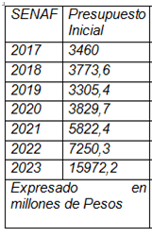
33. The Ministry of Education distributes instructional materials to all schools in the country, including for the members of the student body with disabilities, and funds are transferred to the jurisdictions for the implementation of agreed actions. Special needs education, as a cross-cutting component of all educational levels and programmes, is an integral part of educational planning schemes, and budget lines are allocated to guarantee the inclusion of all students with disabilities at the schools they attend.
34. State social security benefits include an allowance for a disabled son or daughter, a family allowance for a disabled son or daughter and a maternity allowance if a child is born with Down syndrome.
35. Work is being undertaken with the Ministry of Land Development and Housing to incorporate this perspective into federal housing plans using universal design features.
36. The budget for the National Disability Agency entails a cross-cutting analysis of a number of different programmes; in all, the budget allocations for 54 activities/works were identified and are analysed in this report.
37. Finally, it should be noted that the entire national budget is made public and that budget information is readily accessible to the general public online.

Reply to the question raised in paragraph 7 (b) of the list of issues
38. In Argentina, social protection linked to monetary income protection for children is structured in the following way. First, workers in the formal sector with incomes below certain thresholds receive family allowances (through the family allowance system under Act No. 24714 for workers in the private sector and under other specific systems for workers in the national, provincial or municipal public sectors). Second, a non-contributory subsystem of the universal child allowance for social protection system has been in place since 2009 under Decree No. 1602/09. The programme establishes health and education requirements that must be met in order to heighten the system’s long-term impacts and end the intergenerational cycle of poverty.

Universal child allowance amounts
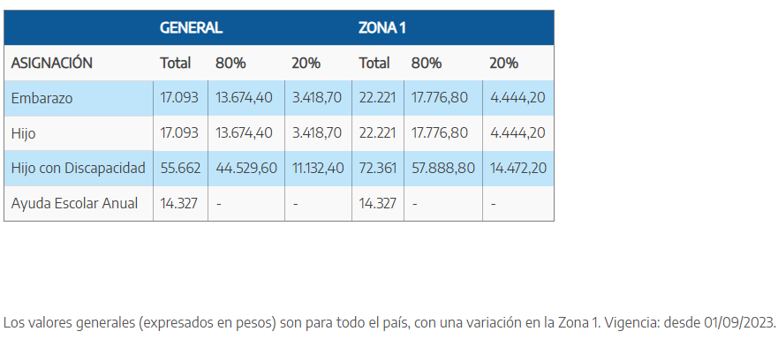
39. The Argentina Plan against Hunger has been bolstered by the strengthening of the National Food and Nutritional Security Programme. The Plan promotes and increases access to the basic food basket. The Alimentar food card helps to ensure access for all to that basket. It can be used to purchase of all types of food other than alcoholic beverages. Almost 1 million cards have now been delivered throughout the country.
40. The AUNAR Familias (Uniting Families) Policy aims to promote alternative and provisional care arrangements with extended family members and/or designated carers for children and/or adolescents subject to exceptional protection measures. To this end, an allowance is paid to persons who have ties to the child or adolescent through blood or marriage or other members of the extended family who have assumed temporary care of the child or adolescent and need this resource to fulfil the care responsibilities that they have undertaken.
41. This allowance is equivalent to 50 per cent of the adjustable minimum living wage. In the case of a group of three or more siblings, in order to make sure that they can live together, the allowance is raised to 80 per cent of the adjustable minimum living wage.
42. The State has introduced public procurement procedures for entering into contracts for the provision of public goods and services and allocates funds for programmes to support the effective exercise of children’s rights at the national, provincial and local levels. The State ensures that the funds are fully and efficiently invested in accordance with the laws in force.

Reply to the question raised in paragraph 7 (c) of the list of issues
43. In Argentina, participation in all aspects of public life is promoted by the State. Children and adolescents from the age of 16 on can vote in all elections at all levels, and there is a law on student associations that encourages their participation in decisions that concern them in all schools in the nation.
44. Finally, participatory budgeting is practised at the municipal level, and young people from the age of 16 can take part.

Data collection

Reply to the question raised in paragraph 8 of the list of issues
45. For strategic planning purposes, the State uses a national statistical system coordinated by the National Institute of Statistics and Censuses and the Permanent Household Survey, which provides a view of the progression in key indicators on different issues that may influence the comprehensive development of the young population.
46. In 2020, Argentina appointed an Ombudsperson for the Rights of Children and Adolescents. The Ombudsperson’s Office has developed an open-access dashboard that shows the main indicators concerning children and adolescents.
47. SENAF is implementing a centralized national registration system (RUN) for children and adolescents under comprehensive and exceptional protection measures at the provincial level. This system is a tool for recording and managing data on children and adolescents whose rights have been violated and on the related actions carried out by the teams working to restore those rights. Thanks to the standardization and consolidation of information at the national level, national data was published for the first time in 2021.,
48. The Federal Care Map is a digital mapping tool that contributes to the visibility and accessibility of care services by enabling people to locate the care and training services available closest to their homes in a simple and dynamic way. The map includes different types of public, private and community services. It draws on information from 32,000 care facilities and almost 1,000 caregiving training sites, as well as educational and other service institutions.

Independent monitoring

Reply to the question raised in paragraph 9 of the list of issues
49. As of August 2023, the Office of the Ombudsperson has a highly professional staff, of whom 72 per cent have a university degree. Completion of secondary education is a requirement to work for the Office of the Ombudsperson.
50. The offices have Wi-Fi connectivity, network cabling, printer services and a telephone exchange with connectivity for online calls. They also have a server for the administration of microservices, technological equipment for mobile telephones, cloud hosting services and financial resources with their own financial administrative service payment function (SAF 385), guaranteeing the timely availability of financial resources for the fulfilment of the missions and functions entrusted to the Ombudsperson by law.
51. Many recommendations have been made to various agencies and on various topics. In addition, numerous declarations and annual reports have been issued.
52. The following provinces have Offices of the Ombudsperson: the City of Buenos Aires, the Province of Buenos Aires, Chaco, Córdoba, Corrientes, Chubut, Formosa, Rio Negro and Tucumán. In addition, there are Offices of the Ombudsperson for the Rights of Children and Adolescents in the provinces of Córdoba, Santa Fe, La Pampa, Misiones, Santa Fe and Santiago del Estero.

Children’s rights and the business sector

Reply to the question raised in paragraph 10 of the list of issues
53. The State has conducted public and private dialogues with a view to fostering shared responsibility in the promotion and protection of all of the rights of all children and adolescents in Argentina.
54. Childcare at the workplace: The implementing regulations for article 179 of the Employment Contracts Act (Act No. 20744) provide that establishments with more than 100 employees must offer childcare facilities for of workers, regardless of gender, during their working hours for children aged from 45 days to 3 years.
55. It has also established guidelines, networks and other activities for fostering a dialogue with enterprises and the media and for monitoring actions that may affect this group and other sectors.,
56. The Ministry of Foreign Affairs, International Trade and Worship of the Argentine Republic developed its first national action plan on business and human rights for 2023. SENAF added 9 measurable commitments to a total of 282 commitments under the plan approved by Decree No. 624/2023.

Non-discrimination

Reply to the questions raised in paragraph 11 (a) of the list of issues
57. The National Discrimination Map is based on a survey carried out periodically by the National Institute to Combat Discrimination, Xenophobia and Racism to collect information about ways in which discrimination is manifested in Argentina.
58. SENAF has developed a campaign entitled “Chineo is child sexual abuse #stop chineo”, and has been undertaking a range of actions to this end at the local level in Rivadavia Banda Norte, Province of Salta, since 2021. The territory of Santa Victoria is receiving support in the different programmatic areas of the Office of the Undersecretary for the Rights of the Child, Adolescents and Family. A wide array of measures (see the footnote) have been taken on the ground in this area under various cooperation agreements.

Reply to the question raised in paragraph 11 (b) of the list of issues
59. According to the database of the Victim Assistance Office of the National Institute against Discrimination, Xenophobia and Racism, from 2 February 2017 to 29 September 2023 a total of 36,334 complaints were received, of which 594 were classified as based on “age (children)”. Complaints concerning discrimination against children were the second-largest category of complaints concerning age-based discrimination, accounting for 37.26 per cent of the total. The 1,594 complaints of discrimination against children based on age accounted for 4.39 per cent of the total of all complaints.
60. In terms of affirmative action policies to prevent and eradicate discrimination against children, adolescents and young people, the National Institute against Discrimination, Xenophobia and Racism has been implementing the Discrimination-Free Schools Programme, which reached 7,078 teachers and school administrators and 5,769 students between 2021 and 2023. In addition, the Youth Free from Discrimination Programme involved 375 young people and 306 youth leaders in 2023.

Reply to paragraph 11 (c) of the list of issues
61. In line with the consultations held in Congress on a bill for the approval of the Inter-American Convention against All Forms of Discrimination and Intolerance, that bill was approved by the Chamber of Deputies on 29 October 2021. It was then passed to the Senate, which referred it to the Committee on Foreign Affairs and Worship for processing (CD-28/21).

Reply to the question raised in paragraph 11 (d) of the list of issues
62. Act No. 26160 has been extended by Decree No. 805-2021 until 2025, and for the budget period there is an allocation of 290 million pesos (Arg$) for the special fund established under article 4 of the Act.
63. The Land and National Registry Office of the National Institute of Indigenous Affairs is responsible for implementing the National Programme for the Indigenous Communities Land Survey, through which technical, legal and cadastral surveys of Indigenous territories are carried out.

Reply to the question raised in paragraph 11 (e) of the list of issues
64. Resolution No. RESOL-2021–1461-APN-SENNAF#MDS established an agreement with the Indigenous Children’s Area of the Indigenous Rights Directorate of the National Institute of Indigenous Affairs. The purpose of that agreement is to achieve the full and effective enjoyment throughout the country of the rights enshrined at the national and international levels of children and adolescents who are members of Indigenous Peoples. Implementation of the agreement will be carried out under special arrangements establishing the specific objectives and work plans, the necessary human, technical and financial resources, the coordination arrangements to be made, as well as any other necessary inputs, and the specific requirements of each plan or project.

Reply to the question raised in paragraph 11 (f) of the list of issues
65. SENAF has established the Technical Advisory Commission on Gender and Diversity, whose overarching objective is to promote the recognition and mainstreaming of a gender and diversity perspective in the design, implementation and monitoring of public policies for children, adolescents and families and in the work environment and labour relations within SENAF. A guide on gender mainstreaming in policy design has been prepared.

Reply to the question raised in paragraph 11 (g) of the list of issues
66. The Ministry of Health has developed recommendations on comprehensive health care for trans, cross-dressing and non-binary children and adolescents.
67. Since the passage of Act No. 26743 in 2012, the State has recognized gender identity as a human right.

Right to life, survival and development.

Reply to the question raised in paragraph 12 of the list of issues
68. In Argentina, the infant mortality rate fell from 9.2 per 1,000 live births in 2019 to 8.4 per 1,000 live births in 2020. This represents a reduction of almost a full percentage point in the deaths of children under 1 year of age.
69. In total, 4,505 child deaths were recorded over the year, representing a 22 per cent reduction compared to 2019. Of these deaths, 3,303 were neonatal (in the first month of life) and 1,202 were post-neonatal (from the start of the second month of life to age 1), for decreases of 15 per cent and 35 per cent, respectively.
70. There was a decrease in most causes of infant mortality. Deaths caused by diseases of the respiratory system fell by 64 per cent (from 375 deaths in 2019 to 136 in 2020). The number of deaths due to external causes fell by 39 per cent (from 137 to 84 deaths). There was also a decrease in mortality due to congenital malformations, especially those of the nervous system, which saw a 37 per cent reduction.
71. On the other hand, a total of 30 infant deaths caused by COVID-19 were recorded. The number of deaths caused by respiratory distress in newborns grew year-on-year from 318 to 378. The number of deaths from haemorrhagic and haematological disorders increased from 111 in 2019 to 136 in 2020.
72. Act No. 27611 on Comprehensive Health Care and Assistance during Pregnancy and Early Childhood, or the One Thousand Days Act, which entered into force on 14 January 2021, aims to protect, strengthen and support comprehensive care to protect the life and health of pregnant persons and children up to 3 years of age. Within this framework, a tender offer was posted for 25,000 breastfeeding kits developed by the Ministry for Women, Gender and Diversity. The kits are designed to promote joint responsibility for breastfeeding.
73. Official data on suicides from the Department of Health Statistics and Information indicate that 3,183 deaths were recorded in 2018 in the country among people in the 10-to-19 age range out of a population of 7 million. External causes (related to situations of violence resulting in intentional or unintentional injuries, whether self-inflicted or inflicted by third parties) accounted for 6 out of every 10 of these deaths. Suicide accounted for 24.6 per cent of these deaths, meaning that 1 out of every 4 deaths from external causes was a suicide.
74. For this reason, the Ministry of Health, together with UNICEF and the Argentine Society of Paediatrics, presented a document setting out a comprehensive approach to teen suicide prevention as a strategy for primary care and health teams working with adolescents and young people.

Right to be heard

Reply to paragraph 13 (a) and (b) of the list of issues
75. The National Programme for the Right of Children and Adolescents to Citizen Participation (“PARticipamos”) has been established by resolution No. RESOL-2021-62-APN-SENNAF#MDS. The aim of the programme is to promote participation by children and adolescents. Relevant training has been provided through the SENAF virtual campus.
76. The SENAF Adolescents’ Advisory Council has been established to help to ensure that children and adolescents are able to exercise their right to citizen participation. The Council, which is composed of 48 young persons between 13 and 17 years of age, has developed a podcast entitled “Tirando la Posta” (“Telling the truth”); contributed to communication campaigns, including the “Yo opino” (“I think”) series on democracy, and to the report on the work of regional round tables addressing child sexual abuse and forced pregnancy; and participated in the 35th meeting of the MERCOSUR Permanent Commission of the Niñ@Sur Initiative and the Third World Forum on Human Rights. The Council also participated in a panel organized by Télam, the national news agency, at the forty-seventh Buenos Aires International Book Fair.
77. The Legal Assistance and Interdisciplinary Advisory Programme for Child and Adolescent Victims of Sexual Abuse (PatrocinAR Programme) of the National Victims Assistance Directorate is based on a public policy of the Federal Ministry of Justice and Human Rights, which takes a human rights approach that encompasses a child and gender perspective.
78. The legal requirement for judges to hear the views of children is not a mere formality, as it also ensures that what children have to say is taken into consideration (Judgment No. 344:2669). The bar associations of the different provinces have begun to keep registries of lawyers who represent children and adolescents.
79. Act No. 26877 on student councils establishes student centres as democratic bodies for student representation.
80. The PakaPaka Children’s Council is a forum for the creation of cultural content by children between 7 and 11 years of age. The Children’s and Adolescents’ Advisory Health Council has been established and involves young people from across the country.

Reply to paragraph 13 (c) of the list of issues
81. The actions described above are fully compatible with the Convention on the Guidelines for School Coexistence adopted by resolution No. 643/MEGC/18.

Birth registration

Reply to paragraph 14 (a) of the list of issues
82. In Argentina, all persons are to be issued their first identity card at birth so that they can be registered in the National Registry of Persons database and thus be able to prove their identity throughout their lives. The first identity card is free of charge and is processed quickly.

Reply to paragraph 14 (b) of the list of issues
83. Jurisdictions that do not have permanent registry offices have permanent birth registration mechanisms with public schedules that may be consulted online.
84. SENAF has its own Genetic Fingerprint and DNA Analysis Laboratory, which assists and supports children, adolescents and their families during procedures to determine their identity, origins and information about their ancestry.
85. The One Thousand Days Act broadens rights and ensures access to a comprehensive system of policies on income, identity, health, social development, education, protection, gender and culture.

Right to access to appropriate information

Reply to paragraph 15 (a) of the list of issues
86. SENAF has taken several measures to promote and protect the rights of children and adolescents in the field of communication. It is represented in the National Communications Authority and on the Advisory Council on Audiovisual Communication and Children, among other bodies. It has provided training to journalists, teachers and students of the University of Buenos Aires, communication teams and local workers.
Several resources have also been developed: recommendations for the treatment in the media of sexual violence against children and adolescents and the legal termination of pregnancy have been developed and published in conjunction with the Office of the Ombudsperson (2020); recommendations for responsible journalistic coverage of children and/or adolescents in conflict or alleged conflict with the law have been developed and published in conjunction with the Office of the Ombudsperson (2021); and recommendations for communications regarding the adoption of children and adolescents in the Argentine Republic (2022) have been developed and published, as have recommendations for responsible communication about children and adolescents (2023).
87. Also in the field of children and the media, the Cinema Advisory Commission of the National Institute of Cinema and Audiovisual Arts of Argentina classifies all film content shown in theatres across the country in order to uphold the rights of children and adolescents and protect them from developmentally inappropriate content.

Reply to paragraph 15 (b) of the list of issues
88. According to the report [1] of the National Institute of Statistics and Censuses on access to and use of information and communication technology, by the fourth quarter of 2022, 92.1 per cent of households had access to the Internet either through a fixed or mobile network. SENAF also launched the AUNAR Familias (Uniting families) Initiative in 2021 in collaboration with UNICEF. As part of this initiative, electronic tablets were provided to children and adolescents living in foster homes or other residential care facilities in order to give them Internet access and promote the right to education, communication and recreation during the COVID-19 pandemic.
89. Since 2022, SENAF has been the authority responsible for enforcing Act No. 27590 of 2020, known as “Mica Ortega’s Law”, which establishes the National Programme for the Prevention and Awareness of Grooming or Cyberbullying of Children and Adolescents in order to combat these crimes against persons under 18 years of age. In 2022, SENAF designed “Right Click” (“Clic Derechos”), a national programme for implementing the Act.
90. The following training courses and talks have been delivered to more than 1,000 participants from key sectors, such as the staff of the 102 hotline, local workers, and adolescents and other young people: “National guidance on violence in the digital environment for operators of the 102 hotline”; “What is grooming?”; “Internet use as a right: Opportunities and caution online”; and “Digital citizenship and violence in the digital environment”.
91. Written materials include publications on the following topics:
- An exploratory study on adolescents’ knowledge and perceptions of grooming, produced in conjunction with the Faro Digital Association
- A guide for supporting children in the digital environment, produced in conjunction with the Faro Digital Association
- A guide for supporting adolescents in the digital environment, produced in conjunction with the Faro Digital association;
- A guide for responsible journalism in cases of digital violence and grooming, produced in conjunction with UNICEF and the Faro Digital association. This guide is forthcoming (2023).
92. Social media posts for International Girls in ICT Day were produced in collaboration with the Ministry of Education and the Ministry of Women, Gender and Diversity, and Internet Day was celebrated in May., , , , , , ,
93. The Digital Rap Contest was held in coordination with UNICEF in 2021, 2022 and 2023. This competition is open to adolescents across the country and is a means of implementing a cultural strategy, through rap, to raise awareness of online risks and to contribute to work on digital citizenship (2021), grooming (2022) and digital environments (2023).

Corporal punishment, torture and institutional violence, abuse and neglect

Reply to paragraph 16 (a) of the list of issues
94. On 7 October 2014, Argentina enacted the National Civil and Commercial Code by Act No. 26994. Article 647 of that instrument explicitly prohibits corporal punishment and ill-treatment.
95. Act No. 27709, passed unanimously by the National Congress in response to the formation of a social movement to combat domestic violence against children and adolescents, establishes a federal training plan on the rights of children and adolescents.
96. The 102 hotline for children is responsible for promoting dialogue between SENAF and provincial governments regarding 102 hotlines for children and adolescents throughout the Argentine Republic. Service coverage is guaranteed in the 23 provinces in which the 102 hotline is operational.
97. With regard to respectful parenting, SENAF launched a campaign to promote parenting practices based on love, empathy and support, which teaches parents that shaking, slapping, beating, hitting and yelling are all forms of violence and are unacceptable, as are threats, belittling, punishment, neglect, indifference and failure to accept children as they are. The campaign uses the hashtag #positivetreatment and teaches that positive treatment is needed to rear happier children and adolescents and that this is the responsibility of the whole community.
98. The Victims Against Violence Programme, created in 2006, is currently operating under the Ministry of Justice and Human Rights. Its nationwide 137 hotline is free of charge and operates 24 hours a day, every day of the year, offering an effective institutional response to situations of family and sexual violence, especially when directed against children and adolescents.
99. Since 2005, the “We support parenting” National Early Childhood Development Programme has provided training on topics such as: comprehensive child development, interculturality, gender and parenting, early childhood play, comprehensive sexual education, early readers, etc. Its aim is to strengthen the parenting skills of families with children from 0 to 4 years of age and socially vulnerable pregnant persons.

Reply to paragraph 16 (b) of the list of issues
100. As part of the National Plan for Gender and Diversity Policies in Public Health, the Federal Board of Gender and Diversity Policy Management was founded in 2020 to identify signs or indications of possible cases of gender-based violence directed against children, adolescents, women and pregnant persons.
101. SENAF has held several workshops and talks on the topics of promotion and prevention. It has also carried out activities such as “Stop the ball”, a workshop for the promotion of positive treatment and the prevention of violence, in which 200 young people participated; an event entitled “Let’s talk about cyberbullying”; training on the prevention of grooming and violence against children and adolescents and the use of new technologies; and a training course entitled “Safeguarding the rights of children and adolescents in sports clubs”, organized for local sports clubs by SENAF and the Sports Secretariat.

Reply to paragraph 16 (c) of the list of issues
102. The National Action Plan for Combating Gender-Based Violence 2022–2024 is the road map for the work of the Ministry for Women, Gender and Diversity in addressing gender-based violence affecting women and members of the LGTBI+ community. It incorporates 100 short-, medium- and long-term measures assigned to 20 ministries and 5 national decentralized agencies.
103. To provide assistance in times of heightened vulnerability, the Urgent Support and Immediate Comprehensive Assistance Programme [] has been established.
104. A compensation programme has been set up under the terms of Act No. 27.452, commonly known as “the Brisa Law”, which establishes that the children of female victims of femicide or homicide in the context of domestic and/or gender-based violence must be protected in order to grow up in a healthy and violence-free environment. They are therefore entitled to receive a monthly allowance, access to comprehensive health insurance and comprehensive support throughout their upbringing.
105. A total of 326 applications under the compensation programme were received in 2021, out of a total of 1,360 applications submitted since the law was first implemented (February 2019 to 30 November 2021).
106. Between February 2019 and November 2021, compensation was awarded to a total of 1,029 children and adolescents. Of this total, 123 people stopped receiving compensation because they had reached the age of majority (21 years of age) or had died; 20 persons with disabilities are receiving this entitlement.
107. The purpose of the Urgent Support Programme is to provide direct support to family members and other dependants of victims of femicide, transvesticide and transfemicide. In 2022, 289 family members and other dependants of victims of extreme gender-based violence received comprehensive support. Financial assistance was provided to 202 family members and other dependants of victims of extreme violence. A total of Arg$ 32,715,000 in economic support was allocated to the families and other dependants of victims of extreme violence. Since the programme’s establishment, 665 family members and other dependants of victims of extreme gender-based violence have received comprehensive support. Financial assistance has been provided to 450 family members and other dependants of victims of extreme violence.
108. Awareness-raising and prevention campaigns are also being conducted for the early detection of situations of violence aimed at violating reproductive freedom and freedom of choice in matters relating to childbirth.
109. The National Action Plan for Combating Gender-Based Violence 2022–2024 also provides for the national “Argentina against Gender-Based Violence” prevention campaign. The Ministry of Women, Gender and Diversity relaunched the campaign in 2022 to increase the visibility of gender-based violence, to acknowledge its existence and to promote discussion on the problem. In 2022, 84 workshops and awareness-raising sessions on masculinity were held, with more than 2,500 participants, and more than 130 workshops, local activities and awareness-raising sessions on responsible and diverse relationships and early signs of gender-based violence were held, with the participation of more than 9,100 people from across the country. More than 30 communication and awareness-raising materials were produced on the prevention of different types and patterns of gender-based violence. A total of 1,717,129 responses were elicited by the #ArgentinaSinViolencia (#ArgentinaWithoutViolence) campaign on social media.

Reply to paragraph 16 (d) of the list of issues
110. The 144 hotline is the official helpline for assisting and advising women and members of the LGBTI+ community in situations of gender-based violence. According to official data, 96 per cent of the people who have called the hotline are women; 137 calls have been from transgender women, transgender men or transgender, transvestite, intersex and queer persons. Of the total number of people who have contacted the hotline, 64 per cent were between 15 and 44 years of age. A total of 1 per cent (359) were pregnant and 580 (2 per cent) had a disability. The perpetrator was male in 86 per cent of cases. The perpetrator was a former partner in 48 per cent of cases and a current partner in 34 per cent of cases. In 2022,[2] the 144 hotline of the Province of Buenos Aires received a total of 135 calls from girls and adolescents up to 17 years of age concerning 117 people in a situation of gender-based violence. Of those calls, 57 per cent were made by girls and adolescents in situations of violence, 35 per cent were made by their family members and 3 per cent were made by others. Of those who contacted the hotline, 76 per cent did so to request information and/or advice; 22 per cent did so in emergency situations.

Reply to paragraph 16 (e) of the list of issues
111. The Office of the Undersecretary for Crime Policy reports that the Ministry of Security has drawn up a protocol specifying how federal police and security forces are to conduct themselves during interventions involving children and adolescents. Its purpose is to provide general guidelines for action and specific guidelines for the application of police procedures concerning children and adolescents purportedly involved in the alleged commission of crimes and for interventions regarding possible rights violations. SENAF actively participated in developing this instrument and provides relevant training to security forces.
112. The National Secretariat for Human Rights has indicated (see communication No. NO-2023–88338483-APN-SSPYEIDH#MJ) that, with regard to the measures taken to put a stop to the disproportionate use of force by security forces against children and adolescents, the National Directorate of Policies to Combat Institutional Violence has a complaints centre to receive complaints of abuse by security forces from anywhere in the country.

Reply to paragraph 16 (f) of the list of issues
113. The Office of the Undersecretary for Crime Policy reports on the work of the public prosecution unit responsible for the investigation of sex crimes against children. This unit is attached to the Public Prosecution Service, which conducts all preliminary investigations into actions or omissions that may constitute crimes against the sexual integrity of victims under 13 years of age in the Autonomous City of Buenos Aires. The Service takes these measures without prejudice to any possible interjurisdictional implications and files any relevant criminal complaints.
114. The Legal Assistance and Interdisciplinary Advisory Programme for Child and Adolescent Victims of Sexual Abuse (- Programme) reports that the investigation of crimes of sexual abuse against children and adolescents in Argentina varies depending on the particularities of the judicial powers of each province. In some provinces, judicial bodies conduct comprehensive investigations, while in other jurisdictions, victims or their designated carers must join criminal proceedings as plaintiffs.

Sexual exploitation and abuse and harmful practices

Reply to paragraph 17 (a) of the list of issues
115. According to information provided by the PatrocinAR Programme, in some cases there are barriers to access to justice, specifically with regard to the right of children to be heard, such as in cases of forced reintegration or when children must recount events to multiple agencies because of the fragmented way in which cases are handled. This also occurs when children, as appropriate for their age and progressive autonomy, express their desire to put an end to legal proceedings and the reasons why are not examined, which denies them a comprehensive response and new forms of reparation.

Reply to paragraph 17 (b) of the list of issues
116. Article 30 of Act No. 26061 establishes that all public officials at all levels of government are obligated to report cases of rights violations to the local administrative offices for the protection of rights. Article 31 of the Act establishes that all public officials must receive any complaint and process it free of charge. Hospitals and schools have specific protocols for such cases.
117. With regard to monitoring, the Domestic Violence Office of the Supreme Court of Argentina collects and organizes information on cases of domestic violence throughout the country. It recorded the following data regarding children and adolescents in 2018: 32 per cent of victims assessed by the Domestic Violence Office were children or adolescents, of which 53 per cent were girls or female adolescents and 47 per cent were boys or male adolescents; 15 adolescents were pregnant when their case was reported. A high concentration of cases occurred in 4 of the 15 municipalities of the City of Buenos Aires. Of the affected children and adolescents, 9 out of every 10 are of Argentine nationality. The most common forms of violence were psychological (94 per cent) and physical (45 per cent). Injuries were found in the cases of 111 children and adolescents, 42 per cent of whom had a history of physical injuries. The alleged perpetrator was male in 73 per cent of cases. The children and adolescents had a filial relationship with the alleged perpetrator in 8 out of 10 cases and, in 50 per cent of the cases, lived with that person. The Office’s interdisciplinary teams determined that 53 per cent of cases were very high-risk or high-risk situations. Of cases involving children and adolescents, 99 per cent were referred to the civil courts.
118. The 2020–2021 report on children and adolescents affected by domestic violence (“Niñas, niños y adolescentes afectados por situaciones de violencia doméstica 2020 2021”) has provided a great deal of relevant data.

Reply to paragraph 17 (c) of the list of issues
119. Act No. 27611 on Comprehensive Health Care and Assistance during Pregnancy and Early Childhood, enacted in January 2021, provides for strengthened comprehensive care to protect the health and life of pregnant women and other persons and young children, in line with the State’s commitments regarding public health and the human rights of women, people with gestational capacity of other gender identities and their children, in order to reduce mortality, malnutrition and undernourishment; comprehensively protect and stimulate early physical and emotional bonds, development and health; and prevent violence.
120. In 2021, the Ministry of Health developed a guide on assisting adolescents for members of health-care services and other agencies of the System of Comprehensive Protection of the Rights of Children and Adolescents, such as teachers and operators from different sectors who are responsible for identifying and assisting pregnant children and adolescents.

Reply to paragraph 17 (d) of the list of issues
121. With regard to sexual exploitation and abuse and harmful practices, SENAF strives to raise awareness about the practice of chineo, give visibility to the problem and eradicate the practice. In this connection, it focuses its work on the promotion and protection of the rights of members of communities in the north of Argentina.
122. In response to the aforementioned problem, and in line with the work that SENAF carries out in this area in coordination with the Diocese of Orán, the first phase of the “chineo is child sexual abuse #stop chineo” campaign was carried out in 2022.

Reply to paragraph 17 (e) of the list of issues
123. At the local level, the National Congress passed two laws that introduced grounds for suspending the beginning of the limitations period for prosecution of crimes against the sexual integrity of victims who are minors. Act No. 26705 was amended by Act No. 27206 (Official Gazette dated 10/11/2015), currently in force, which provides that the start of the computation of the period allowed before the statute of limitations would enter into effect for those crimes is to be deferred so long as the victim is a minor and until such time as he or she files a complaint after reaching the age of majority.
124. The bill on the right to time is being processed under file No. 0508-D-2022 and is currently before the Criminal Legislation Committee, which will issue an opinion on the bill before it is considered by Congress in plenary.

Reply to paragraph 17 (f) of the list of issues
125. Article 25 of Act No. 26994, the new National Civil and Commercial Code, establishes that a minor is a person under 18 years of age and that an adolescent is a minor aged 13 years or above. Article 403 establishes that being under 18 years of age is an impediment to marriage.
126. Under article 404, when one of the parties is under 16 years of age, the only way to celebrate marriage is with the approval of a judge, as authorization from legal guardians is insufficient. The minor party must appear with legal counsel and, if he or she does not have legal counsel, will be assigned a public defender. For those over 16 years of age, authorization from their legal guardians is sufficient.
127. Under article 409, the use of violence, defined in a broad sense, constitutes a defect in consent and is grounds for annulment. However, Argentine law does recognize different types of exploitation, such as forced marriage and any type of forced union, in article 140 of the Criminal Code.
128. The forced marriage of children and adolescents is not a culturally, socially or legally accepted practice in Argentina, as demonstrated by the legislation described above and the nationwide public policy on rights violations in Argentina.

Reply to paragraph 17 (g) of the list of issues
129. For Argentina, children and adolescents are subjects of rights, and their rights are human rights. This includes the rights to personal development, identity, physical integrity, the highest attainable standard of health and equal treatment and the right to be different. Interventions should therefore not be carried out on the bodies of newborn intersex persons. No irreversible sex assignment treatment should be performed until the person makes that decision for himself of herself, unless urgent intervention is necessary to prevent severe harm to the person’s body or health. An informative and practical guide to that effect has been prepared.

Reply to paragraph 18 of the list of issues
130. One of the objectives of SENAF is to protect the rights of children and adolescents who have been removed from their parents or household under the terms of an exceptional protection measure issued by the administrative body responsible for rights protection (Act No. 26061, articles 39 ff.) and placed in any of the three arrangements for their care (residential, foster care, placement with extended family members or other relatives) that are provided for at the federal level in such cases. Every effort is made to exhaust all possibilities of arranging for their care with members of their extended families or relatives is made, in order to further the restoration of their rights.
131. Regarding the situation of children and adolescents with disabilities who lack parental care in Argentina (2019), the national survey of 2022 shows that 7.9 per cent of all children, adolescents and young people housed in care facilities, or 774 such persons in absolute terms, have some certified disability or permanent illness.
132. Regarding the situation of children and adolescents who lack parental care, a survey was carried out in 2020 that showed that 6,400 children and adolescents who are the subject of an exceptional protection measure are living with extended family members and/or other relatives while 9,031 are in formal care.
133. Twenty jurisdictions reported that there are no children or adolescents housed without legal oversight in a form of residential or family care; three jurisdictions reported that there are children and adolescents housed without legal oversight in some type of residential or family facility; one jurisdiction did not provide data.
134. SENAF is actively participating at the federal level in developing its consolidated register (RUN-SENAF)and the consolidated centralized national register (RUN-NAC) of protection measures. Efforts are under way to ensure that all 24 jurisdictions have registered 100 per cent of active exceptional protection measures and analyse their reports, data quality and follow-up of exceptional protection measures, in particular, in order to strengthen those measures in accordance with Act No. 26061.
135. Regarding exceptional protection measures and family care arrangements, the use of alternative and temporary family care arrangements for children and adolescents subject to exceptional protection measures has been monitored and discussed at a technical level with provincial protection agencies. Technical opinions have been issued on bills or regulatory frameworks emanating from different jurisdictions (Río Negro, City of Buenos Aires), and guidelines have been published on working with families that care for children and adolescents who have been separated from their own families as part of an exceptional protection measure.
136. Regarding exceptional protection measures in residential care facilities, documents have been prepared on quality institutional care for children and adolescents in formal residential care facilities and on spaces and living conditions in residential care facilities for children and adolescents who lack parental care.
137. The national census of residential care facilities for children and adolescents gathers information from 23 jurisdictions of the country on the conditions and care practices of residential institutions that accommodate children and adolescents who have been temporarily separated from their families as an exceptional protection measure owing to a serious violation of their rights.
138. In Argentina, children and adolescents who have been removed from their family environment as an exceptional protection measure and remain in residential care facilities or in family care facilities (for example, foster families, temporary care families, supportive families, etc.) enjoy the right to receive monthly social security (Decree No. 5/2023) benefits equal to 100 per cent of the base value of the universal social protection child allowance for children and adolescents aged 17 years and under, or 100 per cent of the universal child allowance for children with disabilities, for those with a valid disability certificate.
139. National guidelines had been prepared on care and support for children and adolescents living in residential facilities as an exceptional protection measure, on the right of children and adolescents to privacy and the protection of personal data and on confidentiality of information in residential living environments. The guide on quality of care for children and adolescents living in residential facilities as an exceptional protection measure has been updated. Regarding training materials, a document has been prepared on spatial considerations and living conditions in residential care facilities. Regarding guidance material for refurbishing physical spaces in residential facilities, a document on quality of care for children and adolescents living in residential facilities as an exceptional measure was presented and approved at the forty-seventh session of the Federal Council for Children, Adolescents and the Family as a guide for completing ongoing refurbishments.
140. Under the Uniting Families Policy, a financial allowance is also available for extended family members or relatives temporarily caring for children or adolescents who have been separated from their nuclear families under an exceptional protection measure owing to the violation of their rights. As of August 2023, there were 489 such beneficiaries.
141. Documentation on inclusive practices has included the first national survey of children and adolescents with disabilities who lack parental care and are housed in care facilities; an updated national survey on the situation of children and adolescents who lack parental care in Argentina; and the national census of facilities for children and adolescents who lack parental care.
142. The graduation support programme for young people who lack parental care was established by National Act No. 273641. The implementing decree establishes SENAF as the authority responsible for running the programme. It also establishes the right to personal and individualized support and the right to a monthly financial allowance equal to 80 per cent of the adjustable minimum living wage (Arg$ 23,328 in February 2022). The programme is aimed at adolescents and young people who lack parental care who are between 13 and 21 years of age (and up to 25 years of age if they are studying or in training).
143. Programme counsellors have been trained, with 26 groups of applicants being trained in 2019–2022. By the end of 2023, 33 groups had been trained. There have been 2,419 successful applicants.
144. The Ministry of Foreign Affairs of Argentina has been designated as the Central Authority for Argentina for the Hague Convention on the Civil Aspects of International Child Abduction of 25 October 1980 and for the 1989 Inter-American Convention on the International Return of Children. Regarding restitution and refuge, in July 2023, the Ministry of Foreign Affairs consulted the Regional Office of the Hague Conference on Private International Law to ensure the proper implementation of relevant international instruments.
145. SENAF has worked with the central register of applicants for guardianship with the aim of adoption and launched the national campaign “Growing up in a family is a right. I chose to adopt” to increase adoption in Argentina, in particular by building the capacity of persons included on the register to complete adoption procedures.

Children with disabilities

Reply to paragraph 19 (a) of the list of issues
146. The disability certificate is a document that attests to the presence of a disability and guarantees access to a wide range of rights and services everywhere in Argentine whenever necessary. It allows for the exercise of the rights and access to the benefits provided for in National Acts No. 22431 and No. 24901.
147. With regard to the provision of support and reasonable accommodation, inclusive support teachers in schools affiliated with the Special Education Modality Unit work with institutions at different educational levels to provide the necessary institutional support and, where required, to furnish students with disabilities with individualized education plan to ensure that they progress and complete their studies. In addition, laptops and assistive technology tools are provided to students with disabilities under the Connect Equality Programme.
148. The Ministry of Education produces accessible materials such as “We’re talking about sexual abuse” and “We’re learning to make our own decisions” to strengthen the exercise of the rights of children and adolescents. The “Books to Learn and Stories to Read” Programme provides schoolbooks and literature to every student in the country, including students with disabilities, regardless of the school they attend and provides multimedia versions in Argentine Sign Language.
149. In 2022, the National Disability Agency granted resources from the National Fund for the Social Inclusion of Persons with Disabilities to educational institutions as part of a programme to improve infrastructure in schools attended by students with disabilities. The infrastructure of eight schools across the country was strengthened at a total cost of Arg$ 19 million.
150. Under the Technical Support Programme for People with Disabilities, more than 80 Braille typewriters were provided to students in primary schools (from 5 to 8 years of age) with visual impairments.

Reply to paragraph 19 (b) of the list of issues
151. Networks of outreach workers have been established at the provincial level. For example, the Province of La Pampa has home-based teaching assistants who are trained in disability issues and directly funded by the province.

Reply to paragraph 19 (c) of the list of issues
152. Higher teacher training institutes are established at the provincial level. At the level of the Ministry of Education, the National Institute for Teacher Training is the body responsible for planning, developing and promoting policies for the higher education teacher training system by strengthening ties between the teacher training system and other levels of the education system.
153. Augmentative and alternative communication systems are also in place to provide resources and tools to mainstream public primary schools have students persons with disabilities.
154. A register of assistive products for use in inclusive education has also been established so that information can be made available to families on companies and other sources that manufacture and sell assistive products for inclusive education.
155. There is also a register of non-teaching personal assistants, teachers and support teachers. The City of Buenos Aires has a registry of non-teaching personal assistants to help families find such professionals and also organizes monthly workshops and admission exams for the enrolment of new professionals.
156. The State is currently developing a federal scheme to be approved by each province.
157. The National Institute for Teacher Training has launched a postgraduate training course on educational approaches for students with disabilities. In 2021 and 2022, materials were issued on initial literacy for students with sensory disabilities, Braille music notation and tools for teaching music to blind students, the right to physical education of students with disabilities, and comprehensive sex education and disability.

Reply to paragraph 19 (d) of the list of issues
158. The work of the Training Unit, under the Executive Directorate of the National Disability Agency, was formalized by resolution No. 596/2021. A disability perspective, particularly with regard to children and inclusive education, and teaching methods and approaches that promote diversity are being developed.

Health, health services, mental health and adolescent health

Reply to paragraph 20 (a) and (b) of the list of issues
159. The State has developed the Federal Strategy for a Comprehensive Approach to Mental Health to strengthen existing actions of the Ministry of Health. The telehealth network will be expanded to allow professionals in provinces participating in the Strategy to consult on the treatment of complex cases. A remote consultation programme is being developed in the model of the Federal Tele-Mental-Health Programme, which was piloted in four provinces in 2021. Twelve new interdisciplinary mental health residencies will be introduced in Buenos Aires, Córdoba, La Pampa, Formosa, Neuquén, San Juan, San Luis, Santa Cruz, Santiago del Estero, Tucumán, Tierra del Fuego and Jujuy. At that point, they will be available in all 24 jurisdictions.

Reply to paragraph 20 (c) of the list of issues
160. The National Plan to Prevent and Reduce Unintended Pregnancy in Adolescence was established in 2017 as an intersectoral initiative coordinated by SENAF, under the direction of the Ministry of Health and Social Development, and other ministries to facilitate general access to contraceptive methods in all 24 jurisdictions of the country.
161. Efforts are under way to guarantee free access to contraception, comprehensive sex education and counselling in schools, reproductive health counselling, community outreach activities and a consistent approach to the legal termination of pregnancy.
162. In Argentina, 91,600 adolescents and 2,500 girls under the age of 15 years gave birth in 2016, representing 13.4 per cent of all births that year. In recent years, this percentage has remained stable at around 15 per cent. Priority has therefore been given to work in the 12 provinces and 36 local departments facing critical situations in this respect: Jujuy, Salta, Tucumán, Formosa, Chaco, Catamarca, La Rioja, Santiago del Estero, Misiones, Corrientes, Entre Ríos and Buenos Aires. In the Province of Tucumán, specifically, the departments of Capital, Cruz Alta and Tafí Viejo have been prioritized.
163. The “Menstruar” Programme is based on a comprehensive policy on support and advisory services for local governments to help them strengthen their menstrual management programmes. In 2022, 6,429 menstrual cups were handed out in the provinces of Buenos Aires, Catamarca, Jujuy, Misiones and Tierra del Fuego, the Antarctic and the South Atlantic Islands. A total of 1,625 local community workers were trained.

Reply to paragraph 20 (d) of the list of issues
164. SheDecides is a global movement working to promote the sexual and reproductive health and rights and bodily autonomy of women and persons with diverse gender identities. Focused on decision-making, it works to ensure that women can make their own decisions and have access to information and support services, including access to safe and legal abortion.

Impact of climate change on children’s rights

Reply to the question raised in paragraph 21 (a) of the list of issues
165. The objective of Act No. 27592 (known as “the Yolanda Law”) is to ensure that people working in the public sector receive comprehensive environmental training based on a sustainable development perspective and a special emphasis on climate change.
166. In December 2019, the Minimum Climate Change Adaptation and Mitigation Budgets Act (Act No. 27520) was promulgated to ensure that appropriate climate change mitigation and adaptation actions, instruments and strategies are established throughout the country.
167. Article 2 of this law provides for the creation of the National Climate Change Cabinet, which coordinates the work of the various government agencies, the Federal Environmental Council and different civil society actors to devise consensual public policies strategically aimed at reducing greenhouse gas emissions and generating coordinated climate change adaptation responses for vulnerable sectors. As a result of this coordinated effort, the law provides for the development and implementation of the National Climate Change Adaptation and Mitigation Plan.
168. Act No. 27520 provides for the creation of an external advisory council composed of researchers and representatives of trade unions, Indigenous communities and peoples, environmental organizations, universities, academic and business entities, public and private research centres, and political parties represented in the Congress.

Reply to the question raised in paragraph 21 (b) of the list of issues
169. In 2022, the first National Action for Climate Empowerment Strategy was formulated by means of a wide-ranging participatory process involving public and federal stakeholders.
170. At the national level, the Strategy is made up of several instruments, including: General Act on the Environment No. 25.675, under which environmental education is established as a fundamental tool for raising awareness in the community; the Minimum Climate Change Adaptation and Mitigation Budgets Act (No. 27520); and the Comprehensive Environmental Education Act (No. 27592) (“the Yolanda Law”), which provides for the National Strategy for Comprehensive Environmental Education.

Reply to the question raised in paragraph 21 (c) of the list of issues
171. The Ministry of the Environment and Sustainable Development has put in place a citizen participation mechanism. The mechanism is open to all civil society organizations, networks of organizations, federations, trade unions, universities and professors, thematic groups and youth organizations that may wish to contribute to the design of the national climate policy coordinated by the Cabinet. Anyone who submits the form will receive a written response from the technical coordination office within 15 working days.

Nutrition and standard of living

Reply to the question raised in paragraph 22 (a) of the list of issues
172. The State has developed the Food Security and Sovereignty Policy. The overall aim of the Policy is to guarantee food security and sovereignty for everyone in Argentina, with a particular focus on the most economically and socially vulnerable sectors.
173. Food security policies are intended to benefit socially vulnerable people affected by food insecurity and families and communities living in poverty. Priority is given to households of recipients of the universal child allowance with children up to 14 years of age, pregnant women and persons with disabilities.
174. The aim of the food security component is to guarantee access to food for the most vulnerable families. It includes the food allowance and vouchers for school canteens, lunchrooms and community kitchens, as well as the direct delivery of food packets and other initiatives for people with specific characteristics.
175. Implementation of the food allowance as a public policy started in December 2019 and, by April 2020, it had been rolled out across all 24 provinces. As at June 2023, 2,337,867 people had registered for the food allowance, which represented an investment of Arg$ 51,910,422,000. The 3,892,369 beneficiaries included 3,764,369 children under 14 years of age, 64,342 children with disabilities and 63,658 pregnant women. A total of Arg$ 858.608 billion was invested in the food allowance between the launch of the policy, in December 2019, and June 2023. In April 2023, in accordance with its guidelines and planned public policies, the executive branch increased the food allowance by an average of 35 per cent, with the result that payments for one child increased from Arg$ 12,500 to Arg$ 17,000, payments for two children increased from Arg$ 19,000 to Arg$ 26,000 and payments for three or more children increased from Arg$ 25,000 to Arg$ 34,000, effective from May 2023.
176. School canteens. The aim of the school canteens initiative is to strengthen school meal services by providing funding to improve the diets of children attending school who are at socioeducational risk, in accordance with the criteria established for funding projects under provincial programmes. As at April 2023, 15,977 school canteens were receiving assistance, and the amount invested in 2023 has reached Arg$ 29,863,609,467. Overall investment stands at Arg$ 70,147,045,264. In June 2023, 1,580 community kitchens provided services to 321,395 people and, to support the work of civil society organizations, 839,897 dry food rations were distributed at 1,238 locations throughout the country. Between January and June 2023, Arg$ 16,069,000,000 were transferred for these purposes. In 2022, resources amounting to Arg$ 1,896,894,719 were transferred to 2,010 soup kitchens and lunchrooms located in all 24 provinces under the Strengthening Community Kitchens and Lunchrooms Action Plan, which focuses on the purchase of fresh food.
177. Transfers for food and hygiene items. In the context of a food emergency made worse by the difficulty of earning a living in the labour market at a time of compulsory social distancing, the Ministry of Social Development made extraordinary transfers to provincial and municipal governments for the purchase of food products and cleaning and hygiene supplies. As at May 2022, Arg$ 12,055,388,247 had been provided for the purchase of food and sanitary items; 35 per cent of that amount was sent to the provinces and 65 per cent to municipalities.

Reply to the question raised in paragraph 22 (b) of the list of issues
178. The number of children and adolescents covered by the universal child allowance reached 4,391,512 in December 2021 (49 per cent of women were girls and 51 per cent boys). In 2020, pursuant to Decree No. 840/2020, coverage was extended to larger families (with six or more children), the residency requirement was made more flexible, and the payment suspensions imposed on children who had failed to present their identity documents were lifted. Out of the total number of beneficiaries, 4,339,386 are children and adolescents under 18 years of age (99 per cent) and 52,126 receive the universal child allowance for children with disabilities (1 per cent). There is no upper age limit to receive the latter.
179. The pension uprating formula established under Act No. 26417 of 2008 has been particularly successful. The implementation of the formula gave greater predictability to beneficiaries and, addressing the State’s historic failure to uprate pension benefits, resulted in an increase of 26 per cent in real terms.
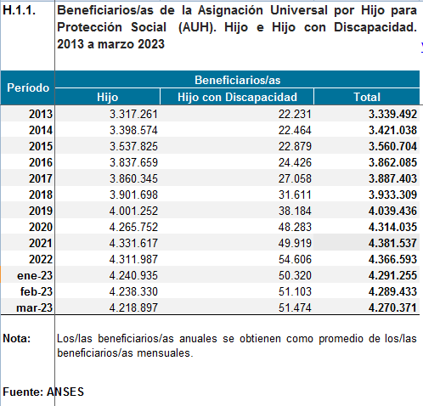
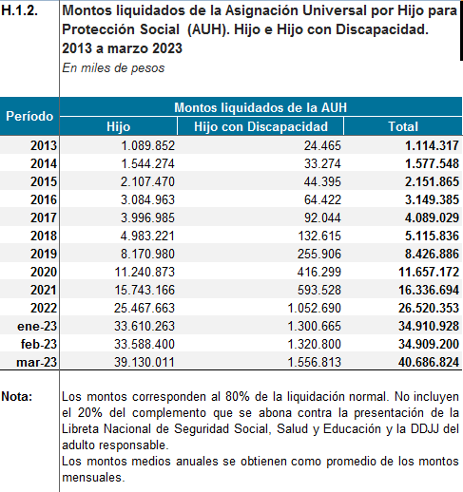

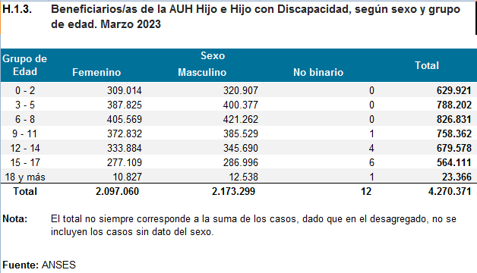

Education, including vocational training and guidance

Reply to the question raised in paragraph 23 (a) of the list of issues
180. The most important piece of information to report regarding the demographic composition of the student body is that the number of people in the compulsory education age group has stabilized, as the number of people between the ages of 5 and 19 years grew by only 2 per cent between 2010 and 2020.
181. According to the annual survey for 2020, the national education system is made up of 63,000 schools comprising 76,000 service units that deliver education services at different levels (preschool, primary, secondary and higher) and in different branches (the common system, courses for young people and adults, special education and others). These schools are attended by approximately 13 million students, not including the more than 2 million young people who are registered with the university system.
182. In accordance with the National Education Act (No. 26.206), preschool education is a separate pedagogical unit for children aged between 45 days and 5 years. The final two years of preschool education are compulsory.
183. The State, the provinces and the Autonomous City of Buenos Aires are responsible for guaranteeing the universality of education services for children from the age of 3 onward.
184. Rates of access to the system are very high – nearly 100 per cent – from the final year of preschool to lower secondary education. Universal attendance can be said to have been achieved for the 5-to-14 years age group. School dropout rates, which are computed for children aged 15 and over, are dependent on factors such as region (more prevalent in the Norte Grande region), social group (more prevalent among working-class sectors) and gender (more prevalent and at an earlier age among males). Preschool is attended by 44 per cent of 3-year-olds and 91 per cent of 4-year-olds, for whom attendance has been compulsory since 2014. The proportion of children aged between 15 and 19 who either attend compulsory education or have completed their secondary education stands at 91 per cent.

Resources allocated to achieve universal access to education

Reply to the question raised in paragraph 23 (b) of the list of issues
185. Investment in education, particularly in the case of federal government spending, decreased towards the end of the reporting period. Between 2015 and 2019, federal government spending on education fell from 1.6 per cent to 1.1 per cent of gross domestic product (a decrease of 33 per cent), while spending by the provincial governments and the Autonomous City of Buenos Aires fell from 4.5 per cent to 3.8 per cent of gross domestic product (a decrease of 16 per cent). Federal government spending on education therefore fell twice as much as investment in education by the provinces and the Autonomous City of Buenos Aires.
186. Under the “Books to Learn” Programme, books are handed out to each student of State-run and private schools that are free to attend or that are considered to be the only school available to children in a given area.

Policies and actions taken to reduce the school dropout rate

Reply to the question raised in paragraph 23 (c) of the list of issues
187. In terms of educational trajectories, the indicators show a very high level of grade progression in primary school (97 per cent) and minimal levels of grade repetition (2 per cent) and a low dropout rate between grades (1 per cent), the three indicators of school enrolment and progression that together add up to 100 per cent. The equivalent figures for secondary education – a lower level of overall grade progression (83 per cent) and higher levels of grade repetition (9 per cent) and a higher dropout rate between grades (8 per cent) – indicate that issues with school enrolment and progression currently affect secondary school pupils to a greater degree. As of 2019, the completion rate, including students who may have repeated grades one or more times, was 54 per cent, while the rate of completion without repetition, that is, excluding students who repeated one or more grades, was 29 per cent.
188. Anyone aged between 16 and 24 years can apply to receive the Progress (“Progresar”) Scholarship, a monthly payment of Arg$ 20,000 designed to help students complete their studies. It is important to note that 80 per cent of the scholarship is paid during the period of study and the remaining 20 per cent is transferred upon confirmation of the recipient’s attendance for the year or the duration of the course. The monthly amount includes Arg$ 1,000 for the purpose of maintaining connectivity.
189. Lastly, the Primary and Secondary School Completion Plan (FINES) is available for those who have turned 18 and have either not started or not finished their compulsory studies. During preregistration, applicants can select the nearest participating school.

Reply to the question raised in paragraph 23 (d) of the list of issues
190. Within the framework of the “Macachas and Remedies” (“Macachas y Remedios”) programme of popular schools for gender and diversity training, several projects intended for Indigenous people or migrants and/or addressing the issue of gender and diversity education in school curricula have been carried out. The target audience is women and LGBTI+ migrants. There are nine partner organizations.
191. Under Act No. 27499 (known as “the Micaela Law”), an awareness-raising session was held for the most senior figures of the National Migration Directorate of the Ministry of the Interior in August 2020; this programme was certified in November 2021.

Reply to the question raised in paragraph 23 (e) of the list of issues
192. This policy was developed in 2020 with the aim of preventing children and young people from being excluded from the education system because of the pandemic. In 2020, 1.8 million students participated in the “Support: A Bridge to Equality” (“Acompañar: Puentes de Igualdad”) programme. Under the programme, Arg$ 2,194,499,995 from the education budget was distributed among local authorities in all jurisdictions.
193. As at December 2021, more than 10,900 educators, community teachers, bilingual intercultural instructors, socio-community coordinators, workshop leaders, coordinators of local bureaux, socioeducational promoters, local technical and pedagogical assistants and institutional tutors were working on the second phase of the programme at over 16,000 schools and the offices of over 2,500 civil society organizations to support more than 1.8 million students in their schooling at the initial, primary and secondary levels all over the country.

Reply to the question raised in paragraph 23 (f) of the list of issues
194. As far as educational materials are concerned, 3,989,234 students benefited from the 11,533,551 books delivered to 21,312 primary schools under the Books to Learn Programme in 2023. A total of 1,160,173 secondary school students have benefited from 4,226,782 books delivered to 10,228 schools across all provinces and the Autonomous City of Buenos Aires.
195. According to the annual survey for 2020, the proportion of schools with Internet connectivity, while uneven across the different educational levels, had risen by between 2 and 7 per cent in the previous year: from 62 per cent of preschools in 2019 to 69 per cent in 2020; from 68 per cent to 73 per cent of primary schools; from 68 per cent to 73 per cent of secondary schools; and from 85 per cent to 87 per cent of higher education establishments.

Reply to the question raised in paragraph 23 (g) of the list of issues
196. The Ministry of Education, Culture, Science and Technology and the provinces are working together to develop an increasingly inclusive education system that opens up opportunities for everyone. Within this framework, “Learn Connected” (“Aprender Conectados”), a digital literacy initiative aimed at enabling students at all levels to acquire the skills they require to live in today’s world, is encouraging women to study or become more involved in programming, robotics and the digital world. “Women Programmers” (“Mujeres Programadoras”) and the National Programming and Robotics Marathon have been established to attract more girls and young women to these areas of knowledge, which are in great demand in the labour market throughout Argentina and all over the world. Primary and secondary students attending public schools throughout the country can now register for the second National Programming and Robotics Marathon, organized by the Ministry of Education, Culture, Science and Technology within the framework of the “Aprender Conectados” plan. Students can register in groups of three, with a teacher and a head teacher as references, and registration was to remain open until 21 June 2019 via the following link.
197. Gender equity in technical education. Currently, only 32.5 per cent of students attending secondary technical schools are female. The National Institute for Technological Education therefore established the Gender Equity Committee with the aim of increasing the number of women in secondary technical education. The rectors of the Inter-University Council took the decision to comply with the Micaela Law at their last meeting.

Reply to the question raised in paragraph 23 (h) of the list of issues
198. Comprehensive sexuality education is a means to ensure that children and young people throughout the country acquire the knowledge and skills they require to make conscious and critical decisions concerning the care of their bodies, interpersonal relationships and the exercise of sexuality and their rights. Various policies are carried out under the National Comprehensive Sex Education Programme, such as robust in-person teacher training and digital follow-up sessions, systematic monitoring and evaluation, and activities conducted under the guidance of UNICEF, which has also developed a monitoring system at the national and provincial levels. In addition, several national meetings have been held with representatives of the provinces.
199. Throughout the year, schools organize “Educate in Equality” (“Educar en Igualdad”) days with the support of the corresponding education department. The “Educar en Igualdad” booklet has been drawn up to offer guidelines and didactic proposals on gender-based violence.

Reply to the question raised in paragraph 23 (i) of the list of issues
200. The Government recommends the use of inclusive language throughout the country in order to promote communication that is free from sexist expressions and that facilitates the progression from the masculinization of language towards inclusive language that is free from discrimination and addresses all genders. In doing so, it has developed a number of official guides and recommendations on the subject of communication with a gender perspective.

Reply to the question raised in paragraph 23 (j) of the list of issues
201. Act No. 26892 is aimed at promoting good interpersonal relations and reducing conflicts in the educational community. It sets out criteria for dealing with conflicts in school settings at all levels of the national education system.
202. The “Argentina against Bullying” (“Argentina contra el Bullying”) campaign has been launched to promote awareness-raising, dissemination and training and to tackle bullying at the national level. The campaign is intended for adults and the media, as well as boys and girls.
203. We have also created a space for coordination with civil society organizations working on this issue.

Asylum-seeking and refugee children and children in situations of migration

Reply to the questions raised in paragraph 24 (a) of the list of issues
204. SENAF has a representative who sits on the National Committee for Refugees, which participates in the institutional meetings where decisions are taken on the handling of specific situations. It also provides the National Migration Directorate with technical assistance on situations involving children and adolescents and takes action – either directly or in coordination with provincial children’s services – on cases of unaccompanied children or children accompanied by adults who are unable to provide evidence of their relationship. Argentina respects the principle of non-refoulement, and Decree No. 70/2017 has been repealed.

Reply to the questions raised in paragraph 24 (b) of the list of issues
205. In accordance with Act No. 26061, all unaccompanied children and adolescents receive protection under the system established for that purpose, without discrimination and regardless of their nationality or migratory status. To this end, the system’s stakeholders include local administrative protection agencies that step in and arrange for an unaccompanied child to be accommodated in a residential hostel close to where he or she has been found until the situation has been resolved by locating relatives or other adults responsible for the child, repatriating the child or reuniting the child with his or her family, as appropriate.

Reply to the question raised in paragraph 24 (c) of the list of issues
206. SENAF participates in the committee that addresses the specific situations concerning Venezuelan children with the aim of regularizing their documentation and ensuring their access to legal residence in the country. In such cases, the implementing authority – the National Migration Directorate – works in collaboration with all the agencies involved in child protection, as well as representative organizations of Venezuelan migrants in Argentina.

Economic exploitation and trafficking

Reply to the questions raised in paragraph 25 of the list of issues
207. The National Commission for the Eradication of Child Labour is in the process of implementing the National Plan for the Prevention and Eradication of Child Labour and the Protection of Adolescent Labour 2018–2022.
208. The Provincial Commissions for the Prevention and Eradication of Child Labour coordinate the activities that are carried out by each jurisdiction (23 provinces and the Autonomous City of Buenos Aires) within the framework of the National Plan. They are also responsible for granting permits for children to work in the arts or in family businesses.
209. SENAF has participated in the formulation of international cooperation agreements and the National Plan. Between 2018 and 2023, it has held 16 training sessions for, among others, various associations and unions. Over the same five years, as a result of the cooperation agreements signed in relation to childcare facilities and protection for adolescent workers, 9,304 children and adolescents in different parts of the country benefited from these types of arrangements, which help to ensure their development and protection. It has also collaborated with the National Commission for the Eradication of Child Labour and the International Labour Organization on various studies concerning child labour in Argentina. Protocols have so far been put in place in 13 of the 24 jurisdictions.

Reply to the questions raised in paragraph 26 of the list of issues
210. The 2020–2022 National Plan to Combat Human Trafficking and Exploitation was formulated by the Executive Committee for the Fight against Human Trafficking and Exploitation and for Victim Protection and Assistance, a national interministerial body specialized in combating trafficking and exploitation of persons. A total of 100 actions have been planned, of which 67 are being implemented and 33 remain pending. Out of the 67 actions that are under way, 24 are related to prevention, 15 to assistance, 10 to prosecution and 18 to institutional strengthening and coordination. Based on the above, as at 30 September 2021, 67 per cent of the National Plan had been implemented.
211. Operating under the aegis of the Ministry of Health and the Ministry of Social Development, SENAF works in coordination with each of the provinces and the Autonomous City of Buenos Aires to ensure that crime victims who have provided a witness statement receive assistance.
212. A set of guidelines for the National Assistance Protocol have been signed, setting out the functions and powers of national and provincial focal points.
213. In 2023, the Consolidated Coordination Protocol was updated to streamline and coordinate the actions of all the entities involved.

Administration of juvenile justice

Reply to the questions raised in paragraph 27 (a) of the list of issues
214. Decree-Law No. 22.278 is still in force. However, provincial authorities have adopted alternative measures to the deprivation of liberty based on a specialized justice system for children and adolescents in conflict with the criminal law.

Reply to the question raised in paragraph 27 (b) of the list of issues
215. The use of deprivation of liberty as a measure of protection for children over 16 years of age runs counter to both articles 36 and 41 (e) of Act No. 26061 and the constitutional principle of the best interests of the child. SENAF regularly surveys all the mechanisms for the criminal prosecution of adolescents up to 18 years of age who are criminal offenders or alleged criminal offenders that have been put in place by, among others, federal, national and provincial courts and tribunals based in the different provinces and in the Autonomous City of Buenos Aires.
216. In relation to arrest procedures, a training course on policing with a child perspective has been created to ensure that security forces in different jurisdictions fully apply the precepts contained in the Convention on the Rights of the Child and other standards recognized by Argentina. Since its creation, 21 groups have taken the course in 8 provinces (Santiago del Estero, Formosa, Catamarca, Chubut, Neuquén, Santa Cruz, San Juan and La Rioja) and over 4,500 members of the security forces have been trained.
217. To help to ensure that detention is used only as a measure of last resort and for the shortest possible period of time, SENAF is promoting the creation and strengthening of mechanisms for the application of community-based correctional measures. Most of the country’s jurisdictions have put this type of mechanism in place, and around 80 per cent of adolescents convicted of a criminal offence are sentenced to complete community-based correctional programmes of this type. The results of the surveys also reveal a steady decline in the juvenile prison population between 2015 and 2022. The number of children held in centres of deprivation of liberty fell by nearly 40 per cent during that period. Since 2020, 18 funding agreements for the creation and strengthening of mechanisms for the application of community-based correctional measures have been signed with provinces, municipalities and non-governmental organizations. These agreements cover a total of Arg$ 98,998,480 in funding.

Reply to the question raised in paragraph 27 (c) of the list of issues
218. Since its creation in 2020, the Restorative Justice Unit of SENAF has provided 1,071 members of the children’s services teams in 21 provinces with intensive training on restorative justice and has carried out awareness-raising activities for more than 1,300 people throughout the country and Latin America. Several documents have also been published to raise awareness and disseminate information on the subject, and a joint project has been carried out with the National Council for Scientific and Technological Research. Lastly, an agreement on restorative justice in the juvenile criminal system was drafted and presented at the forty-third meeting of the Federal Council for Children, Adolescents and the Family.
219. In quantitative terms, the first seven groups that completed the new training course on the system of juvenile criminal responsibility from a restorative perspective between 2020 and 2022 included people in strategic positions in 21 of the 24 provinces of Argentina. Most of the 526 participants were people working in the juvenile criminal justice system or for children’s agencies that deal with juvenile offenders.

Optional Protocol on the sale of children, child prostitution and child pornography

Reply to the questions raised in paragraph 28 of the list of issues
220. With regard to the criminalization of the offences referred to in articles 2 and 3 of the Optional Protocol, it should be noted that the Criminal Code prohibits the promotion and facilitation of prostitution of children and adolescents (arts. 125 bis, 126 and 127) and the production, financing, offering, commercialization, publication, facilitation, dissemination and/or distribution of any representation of a child or adolescent engaged in sexually explicit activities or any representation for primarily sexual purposes (art. 128).
221. The National Directorate for Promoting and Strengthening Access to Justice of the Office of the Undersecretary for Access to Justice has established the Victims against Violence Programme, although a formal agreement has yet to be signed. In 2019 and 2023, the Women’s Association of Tourism Company Managers, a member of the International Federation of Associations of Tourism Company Managers, invited participants in the Victims against Violence Programme to take part in the online training of instructors on the protection of the rights of children and adolescents in the areas of travel and tourism as part of a training module entitled “Sexual Exploitation of Children and Adolescents”.
222. Penalties for child prostitution and child pornography are set out in the Criminal Code.
223. Argentina has enacted various laws to address, prevent and punish violations of the rights of children and adolescents covered by the Optional Protocol.
224. Lastly, in October 2022, the Senate Committee on Justice and Penal Affairs advised that the proposed amendment of the Criminal Code to modify the legal definitions of the crimes of the purchase and sale of children and mediation activities in relation to such acts, as submitted by the President in August of the same year, should be approved.

Optional Protocol on the involvement of children in armed conflict

Reply to the questions raised in paragraph 29 of the list of issues
225. There have been no armed conflicts on Argentine territory since the start of the democratic era in 1982; therefore, the rights of children and adolescents have not been affected by any such events.
226. The National Education Act (No. 26206) establishes that education is compulsory up to 18 years of age and that it must be directed towards peaceful coexistence, tolerance and respect for human rights.
- Children must not be recruited by an armed force of any nature.
227. The Federal Council for Children, Adolescents and the Family has also issued several statements repudiating such activities.
228. The curricula are officially approved and conform to the legal framework established under the Education Act (No. 26206). All qualifications obtained are certified by the Ministry of Education. In this way, the Ministry of Defence aims to guarantee that all children attending military educational institutions receive an education in conformity with the principles of the Convention and its Optional Protocols and with Act No. 26061.
229. In view of the above, SENAF, under the direction of the Ministry of Social Development, is responsible for ensuring that the rightful place of boys and girls is at school, in public squares, at clubs, with their families and with their community.

III. Statistical information and data

Reply to the question raised in paragraph 32 of the list of issues
230. The total national budget expenditure projected for 2023 is Arg$ 37,827,522,000,000. Of this figure, Arg$ 24,029,557,800,000, equivalent to 63.52 per cent, was allocated to social services.
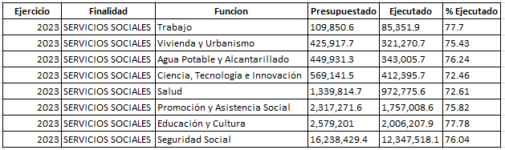
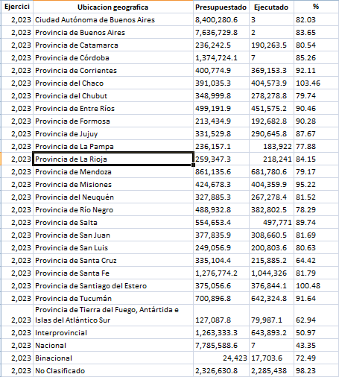
231. For 2023, the Ministry of Social Development was assigned an initial budget of Arg$ 1,153,182,600,000. The Ministry runs Programme 51, providing support for the National Early Childhood Plan. This programme was assigned an initial budget of Arg$ 4,640,400,000, since raised to Arg$ 9,267,800,000, of which Arg$ 6,559,200,000 has been expended to date.
232. SENAF was assigned an initial budget of Arg$ 15,972,200,000.
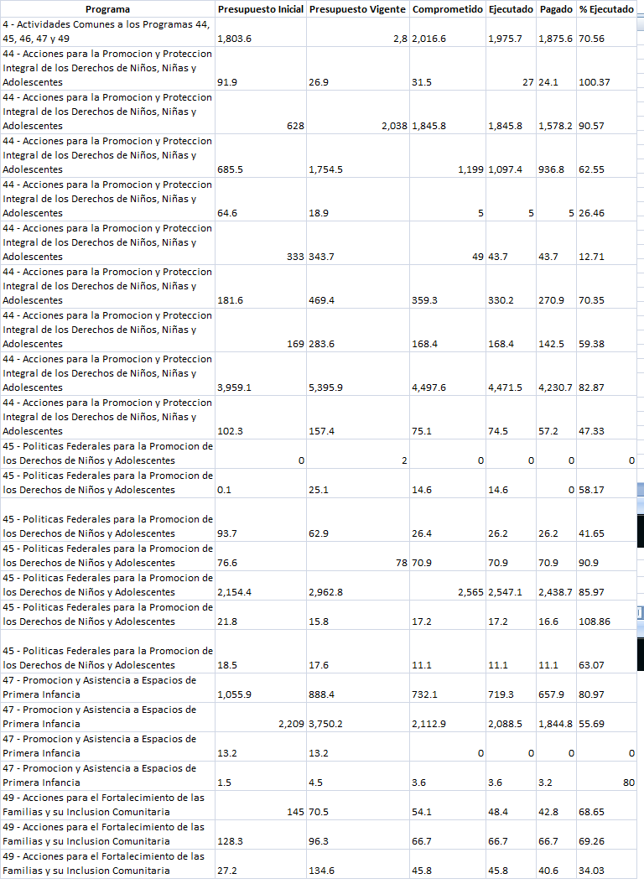

Reply to the questions raised in paragraph 33 (a) of the list of issues
233. Of the total number of people questioned in a survey on perceptions of discrimination, 87 per cent mentioned discrimination against fat persons, 85 per cent mentioned discrimination based on racial appearance, 85 per cent mentioned discrimination against transgender persons, 83 per cent mentioned discrimination against persons with disabilities, 79 per cent mentioned discrimination against gay, lesbian and bisexual persons, 79 per cent mentioned discrimination against people living in poverty and 77 per cent mentioned discrimination against women. Although 44 per cent said that discrimination against children and adolescents existed, it should be noted that the identities of children and adolescents are intersectional, meaning that, rather than constituting a discrete group, they belong to more than one category or group.
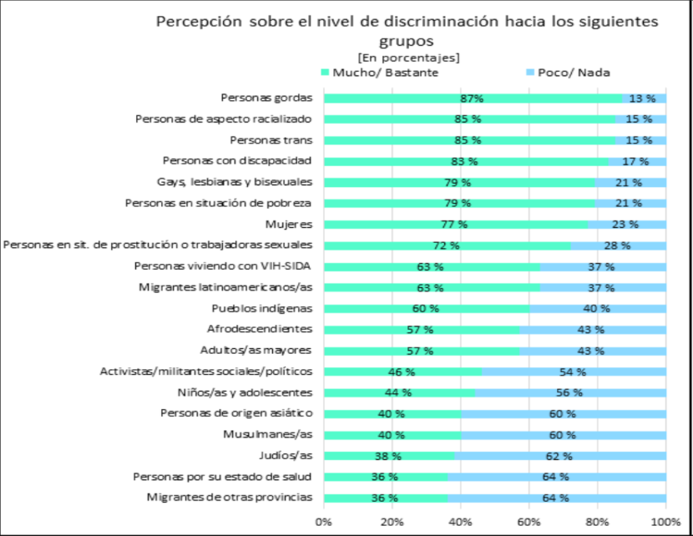
234. Among the forms of discrimination experienced, the findings reveal that 24 per cent of those interviewed claimed to have experienced at first hand discrimination based on appearance, while 2 per cent stated that they had been discriminated against for being children and/or adolescents.
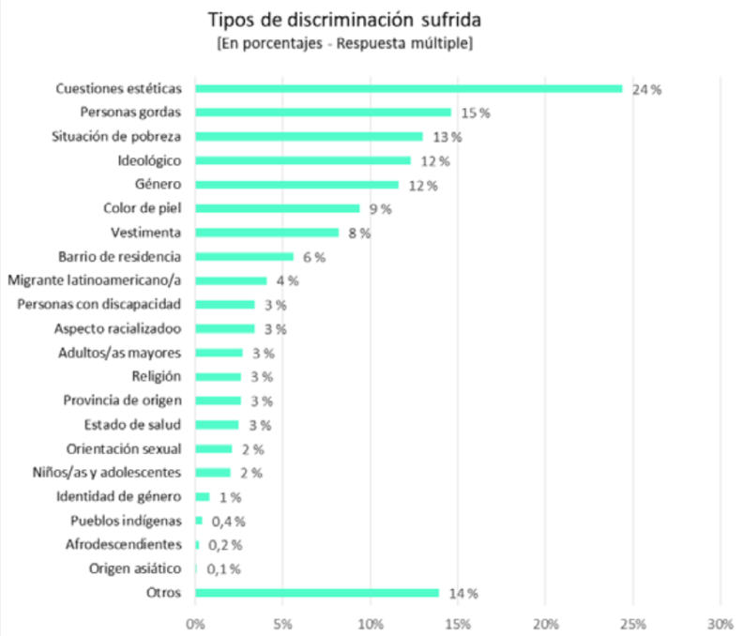
235. The most common setting in which discrimination occurs, accounting for 41 per cent, is in school.
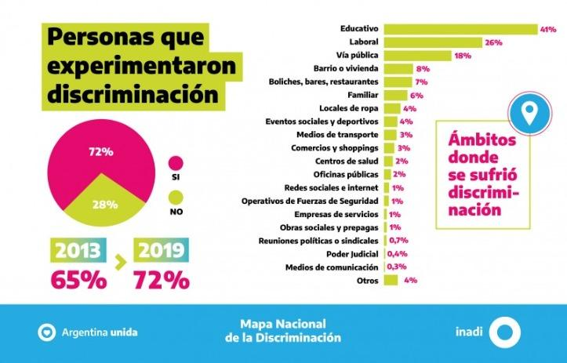
236. Out of a total of 36,334 complaints received by the National Institute to Combat Discrimination, Xenophobia and Racism between 2/02/2017 and 29/09/2023, 594 concerned discrimination on grounds of age, specifically for being children.

Reply to the question raised in paragraph 33 (b) of the list of issues
237. The main causes of child mortality in 2019, based on cause of death codes as per the tenth revision of the International Statistical Classification of Diseases and Related Health Problems: P07: Disorders related to short gestation and low birth weight, not elsewhere classified (18 per cent); Q24: Other congenital malformations of heart (7 per cent); P36: Bacterial sepsis of newborn (6 per cent); P22: Respiratory distress of newborn (6 per cent); Q89: Other congenital malformations, not elsewhere classified (4 per cent); P77: Necrotizing enterocolitis of fetus and newborn (2 per cent); Q79: Congenital malformations of the musculoskeletal system, not elsewhere classified (2 per cent); R95: Sudden infant death syndrome (2 per cent); J69: Pneumonitis due to solids and liquids (2 per cent); Q00: Anencephaly and similar malformations (2 per cent); P29: Cardiovascular disorders originating in the perinatal period (2 per cent); P96: Other conditions originating in the perinatal period (2 per cent); and J18: Bronchopneumonia, unspecified (2 per cent).

Reply to the question raised in paragraph 34 of the list of issues
238. According to a report analysing birth trends in Argentina in the period 2012–2021 based on data for the period drawn from the National Register of Persons, there has been a general decline in the number of births in the country, with a decrease of 33.3 per cent for the period as a whole and a significant acceleration in the rate of decrease from 2018 onward: between 2018 and 2021 the birth rate dropped by 26.4 per cent, whereas between 2012 and 2018 the decline was 9.4 per cent.
239. Although the overall birth rate was similar to the rate seen in 2020, in 2021 there was a further decline in the rate of adolescent pregnancy, from 15.4 per 1,000 girls aged between 10 and 19 years old in 2020 to 13.7 per 1,000 girls in 2021. This corresponds to a decrease of 1.7 percentage points in one year.

Reply to the question raised in paragraph 35 (a) of the list of issues
240. According to the National Victims Assistance Directorate, 672 persons involved in a total of 691 cases were admitted to the PatrocinAR Programme between 13 May 2022 and 30 June 2023.

Reply to the question raised in paragraph 35 (b) of the list of issues
241. Between July 2017 and June 2023, the specialist team providing advice and support through the 137 telephone helpline fielded 7,029 calls related to situations of commercial sexual exploitation of children and adolescents, the use of children and adolescents in pornography and grooming. Of this number, 41 per cent concerned grooming, 5 per cent were about the use of children and adolescents in pornography, 9 per cent concerned sexual exploitation and abuse, 13 per cent related to cyberbullying of adults and 32 per cent were about other forms of cyberviolence (business scams, hacking of social media accounts, etc.) that, although not involving sexual exploitation of children or adolescents, were nonetheless consultations through which related guidance, support and counselling were provided.

Reply to the question raised in paragraph 35 (c) of the list of issues
242. From 2017 to June 2023, 15,699 cases in which children and adolescents were victims of sexual violence were recorded.
243. In the period 2017–2021, there was a steady year-on-year increase in the number of children and adolescents who suffered sexual abuse. Between 2017 and 2022, the increase was 91 per cent.
244. Girls accounted for 77.6 per cent of victims of sexual violence against children and adolescents, boys for 21.2 per cent and transgender children and adolescents for 0.08 per cent. Information on the sex of the victim is not available in 1.1 per cent of the cases.
245. In 83.9 per cent of cases (excluding those for which these data are unavailable), the abuser formed part of the victim’s circle of trust, being either a family member or acquaintance.
- In those cases where there was a family relationship between the abuser and the child victim, fathers were the most frequent abusers, followed by stepfathers and other unspecified family members.
246. Overall, 43.4 per cent of the victims reported having been sexually touched or having endured attempted sexual touching and 20.5 per cent reported having suffered rape or attempted rape.
247. In 25.4 per cent of cases involving child victims, the mother is the main point of contact and principal interlocutor. Police officers and other relatives of the victim are the main point of contact in 22.8 per cent and 19.2 per cent of cases, respectively.
248. With regard to settings, 46.4 per cent of sexual abuse of children and adolescents took place in the home of the victim, the abuser or a family member.
- 15.2 per cent took place over social networks
- 2.6 per cent took place in public places (in the street, in squares and other open areas).

Reply to the question raised in paragraph 35 (c) of the list of issues
249. Number of girls in child marriages or who are cohabiting with older men.
250. Multiple Indicator Cluster Surveys (MICS) indicator PR.5 - Young women aged 15 to 19 years currently married or in a union: 7.7 per cent.
251. MICS indicator PR.4a - Child marriage (before age 15); Sustainable Development Goal 5.3.1: 2.4 per cent.

Reply to the question raised in paragraph 36 (a) of the list of issues
252. There are 9,031 children and adolescents subject to extraordinary protection measures in institutional care facilities.

Reply to the question raised in paragraph 36 (b) of the list of issues
253. According to published data, there are 6,400 children and adolescents subject to extraordinary protection measures living with extended family members or a person of trust.

Reply to the question raised in paragraph 37 (a) of the list of issues

Children and adolescents with certified disabilities
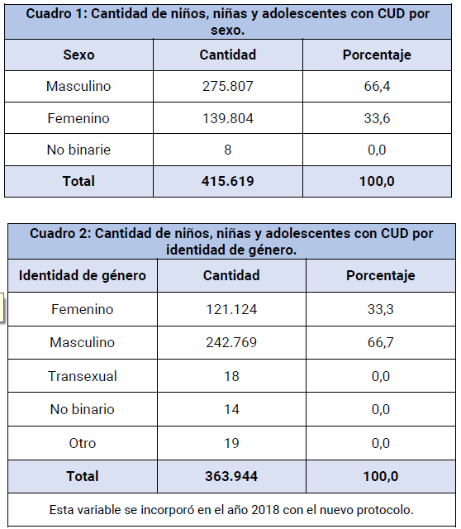
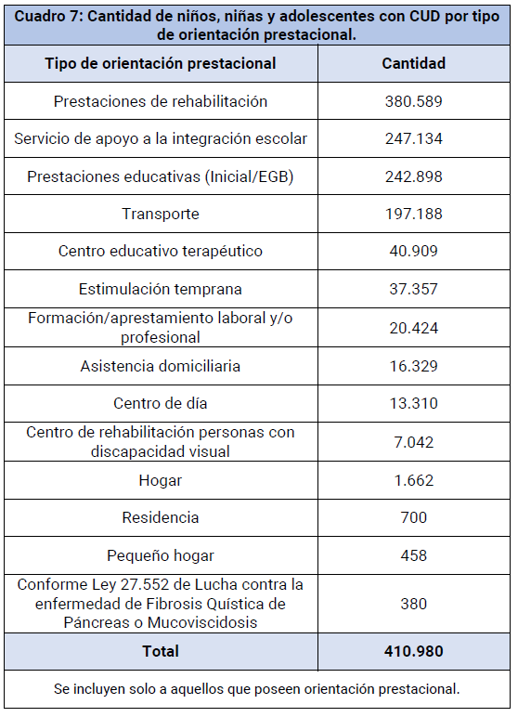
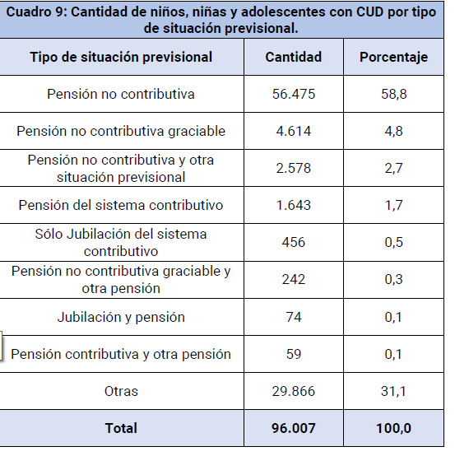

Reply to the question raised in paragraph 37 (b) of the list of issues
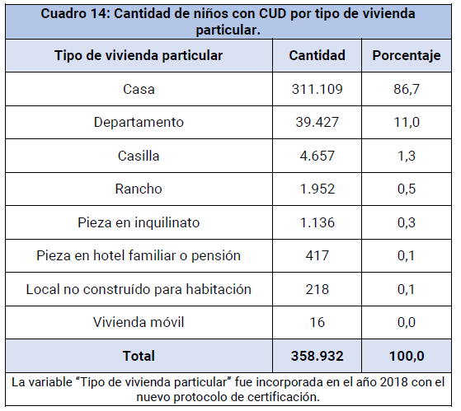

Reply to the question raised in paragraph 37 (c) of the list of issues
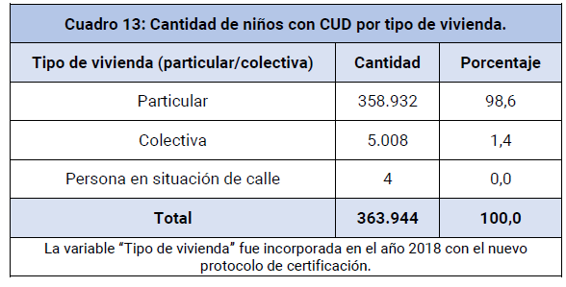

Reply to the question raised in paragraph 37 (d) of the list of issues
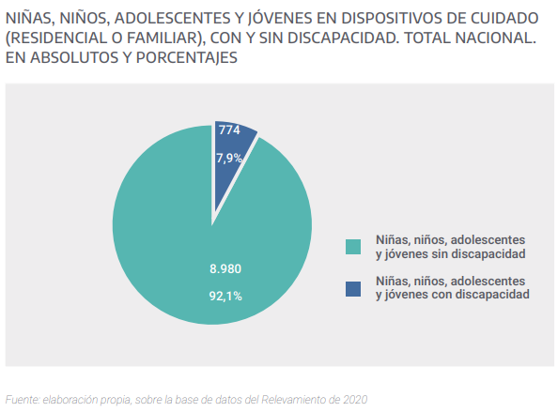
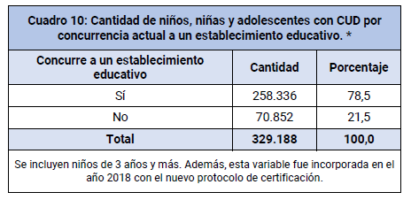

Reply to the question raised in paragraph 37 (e) of the list of issues
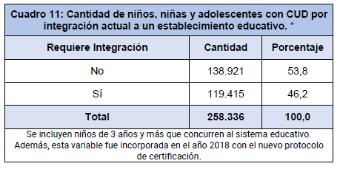

Reply to the question raised in paragraph 37 (f) of the list of issues
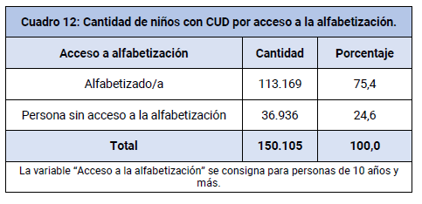

Reply to the question raised in paragraph 37 (g) of the list of issues
254. Of 432 children and adolescents admitted to the PatrocinaAR Programme, only 9 were reported to be children or adolescents with disabilities at the time of admission.

Reply to the question raised in paragraph 38 (a) of the list of issues
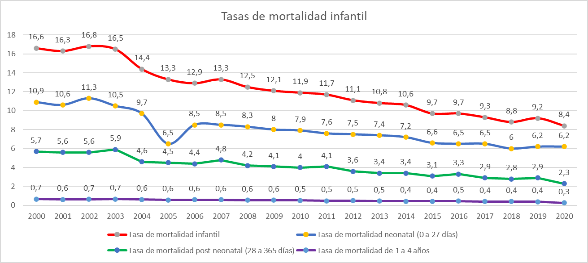

Reply to the question raised in paragraph 38 (b) of the list of issues

Estimated rate of child malnutrition based on hospital discharges and deaths attributed to this cause
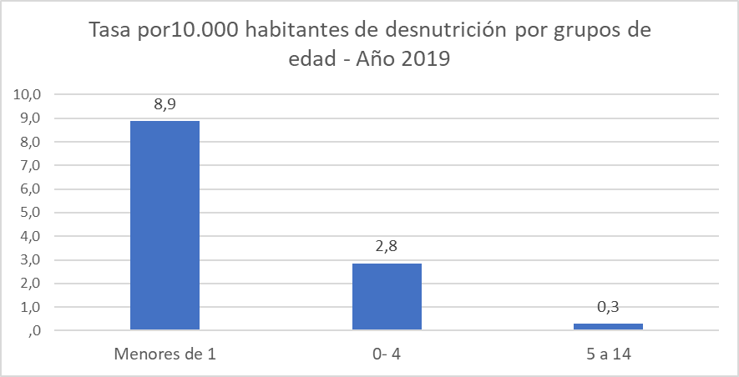
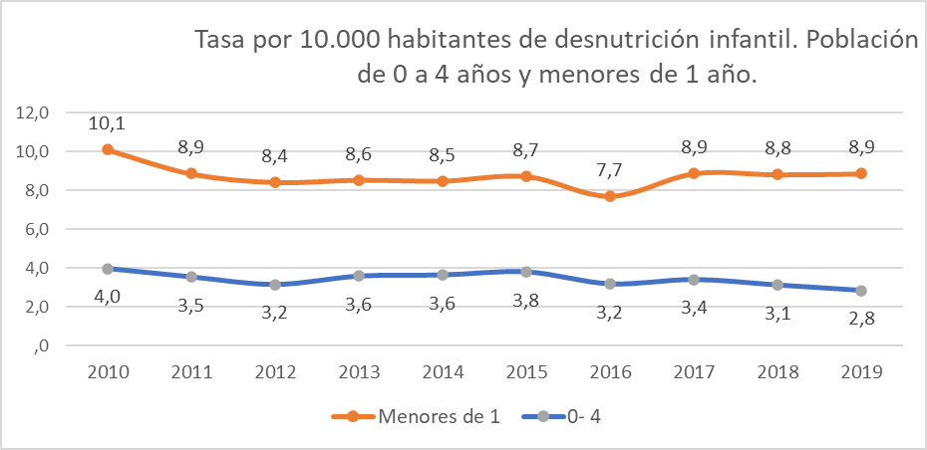
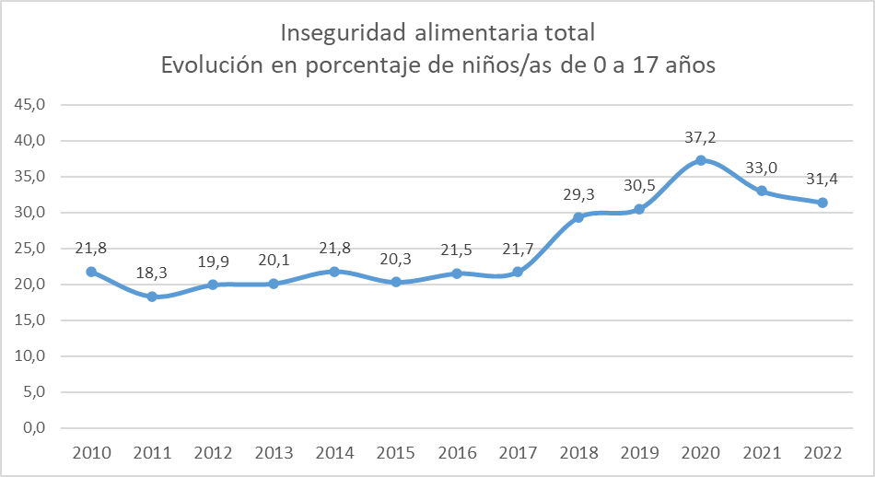

Reply to the question raised in paragraph 38 (c) of the list of issues
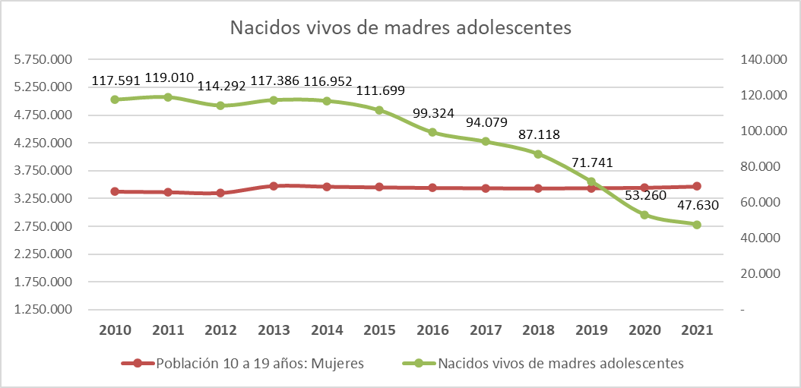
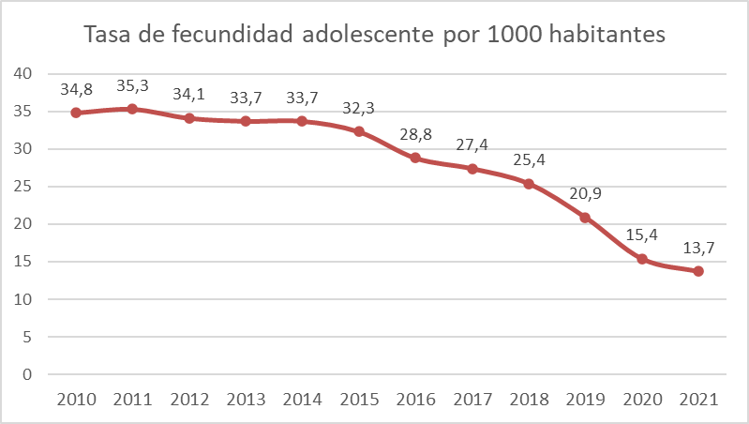
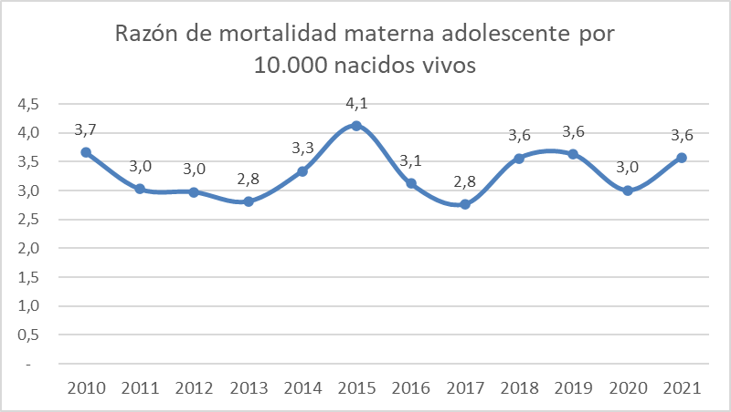

Reply to the question raised in paragraph 38 (d) of the list of issues
255. According to the National Institute of Statistics and Censuses, as of 1 July 2022 there were 7,181,745 persons between 10 and 19 years of age in Argentina, accounting for 16 per cent of the total population. Of this number, 51 per cent were in the 10-to-14 year age bracket and the remaining 49 per cent were in the 15-to-19 year age bracket. By sex, the breakdown was 3,688,983 boys (51 per cent) and 3,492,762 girls (49 per cent). With regard to type of health cover, 53 per cent of the adolescent population (3,783,387 persons between 10 and 19 years of age) have public sector cover only (according to data from the Sumar Programme for 2022) while 47 per cent have some form of cover through the private sector or a social insurance company.
256. As at the end of July 2019, according to the National Plan to Prevent and Reduce Unintended Pregnancy in Adolescence, long-acting contraceptive devices had been dispensed to 33,392 girls and adolescents in 36 prioritized departments in 12 provinces. In total, 25,214 unintended pregnancies were prevented and 29,968 teenage girls were effectively protected from the risk of falling pregnant.
257. Achievements under the National Plan include:
- 1,709 schools provided with teaching assistants
- 11,313 teachers trained in comprehensive sexuality education
- Comprehensive sexuality education provided to 282,939 students under the Plan
- Comprehensive health counselling services provided in 1,245 schools
- 611 health services available through the comprehensive health counselling service
- Contraceptive methods and counselling on reproductive and sexual health provided to 116,978 adolescents

Reply to the question raised in paragraph 38 (e) of the list of issues

In 2014, there were 35 paediatricians for every 1,000 children under 15 years of age.
258. According to the national census of health centres, 97.1 per cent accept adult patients, with this percentage dropping to 84 per cent in the case of patients aged 13 to 17 years old. Only 49.4 per cent of health centres admit children under 13 years of age. About 80 per cent of the centres admit adults in street situations and around 52.1 per cent accept children in street situations. Nearly 70 per cent of the centres stated that they are equipped to receive pregnant women and/or women with children who need to stay with them during the treatment or consultation.
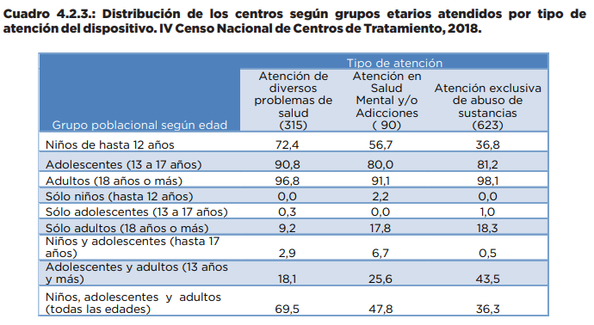

Reply to the question raised in paragraph 38 (f) of the list of issues
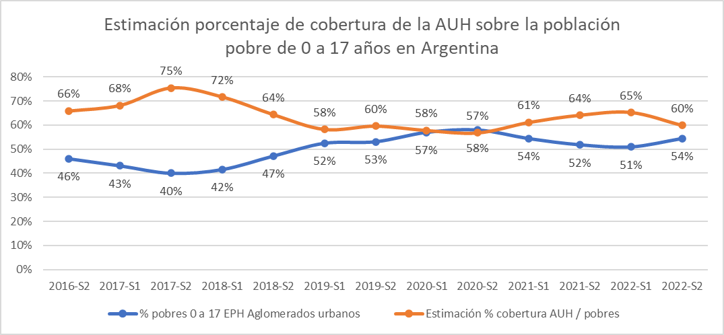
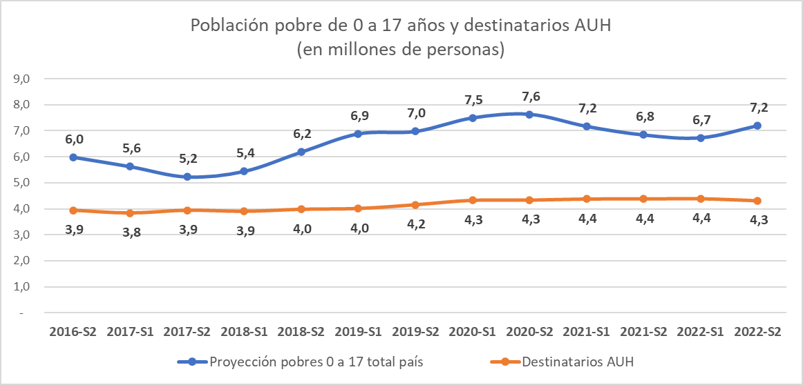

Reply to the questions raised in paragraph 39 (a) of the list of issues
259. As for educational trajectories, the indicators show a very high level of grade progression in primary school (97 per cent) and minimal levels of grade repetition (2 per cent) and dropout rates between grades (1 per cent), the three indicators of school enrolment and progression that together add up to 100 per cent. In secondary school, the overall grade progression rate is lower than in primary school (83 per cent), with figures for grade repetition (9 per cent) and the dropout rate (8 per cent) somewhat higher.
260. As of 2019, the completion rate, including students who may have repeated grades one or more times, was 54 per cent, while the rate of completion without repetition, that is, excluding students who repeated one or more grade, was 29 per cent. Overall, 71 per cent of young persons between the ages of 20 and 24 have managed to complete their secondary education.

Reply to the question raised in paragraph 39 (b) of the list of issues
261. In 2022, there were 15,954 schools – 6,780 primary schools, 4,660 secondary schools, 2,875 preschools and 1,639 other institutions – with Internet connections through the National School Connectivity Plan.

Reply to the question raised in paragraph 39 (c) of the list of issues
262. The 102 hotline fielded 68,000 calls related to children and adolescents in 2022 and 2023 combined.
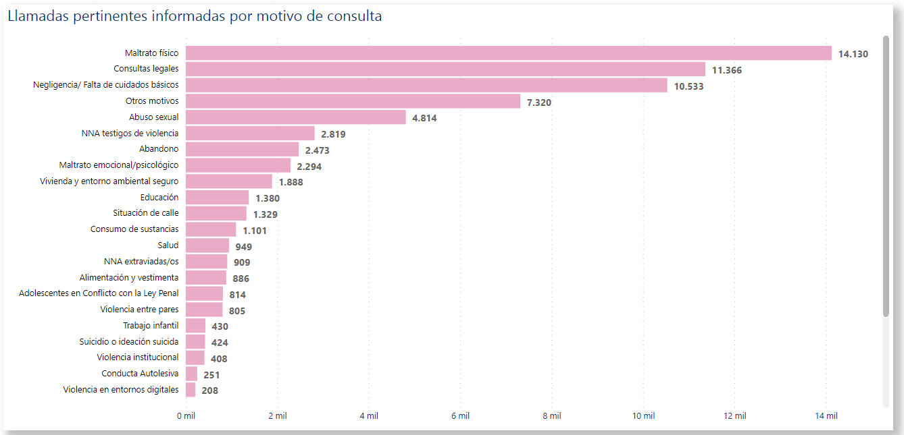
263. The hotline maintains a constantly updated dashboard through which data desegregated by subject matter and province can be consulted.

Reply to the question raised in paragraph 40 (a) of the list of issues

Applications for recognition of refugee status
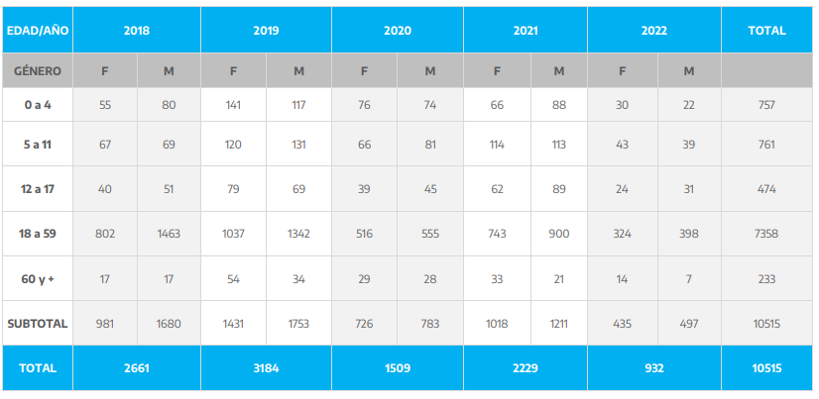
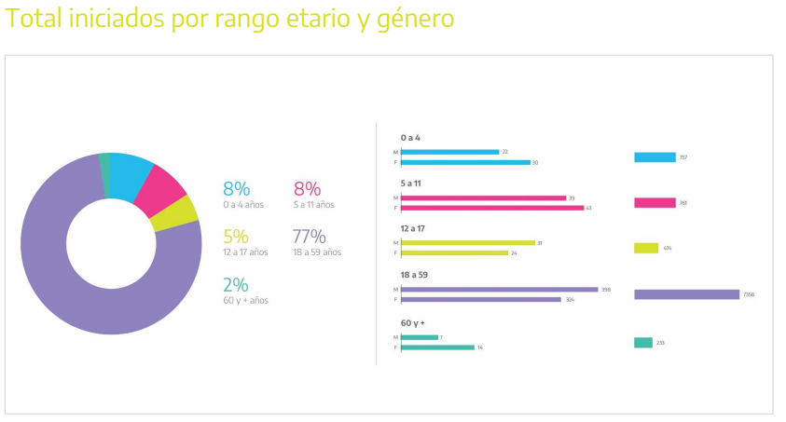

Applications for recognition of statelessness
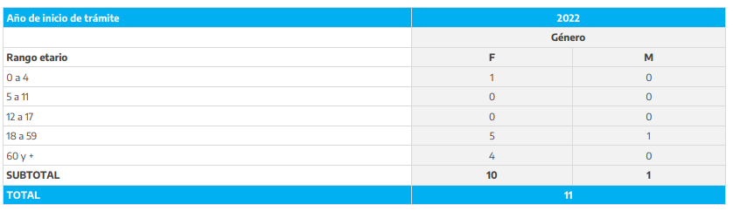

Reply to the question raised in paragraph 40 (b) of the list of issues
264. In Argentina, education and health are individual and collective rights guaranteed by the State, the provinces and the Autonomous City of Buenos Aires. Migrants and refugees living in Argentina enjoy these rights on an equal footing with nationals.

Reply to the question raised in paragraph 41 (a) of the list of issues
265. In the five years from 2018 to 2023, SENAF ensured that 9,304 children and adolescents in different parts of the country had access to care facilities suited to their developmental and protection needs.

Reply to the question raised in paragraph 41 (b) of the list of issues
266. The data presented in this section are based on the interventions of the National Rescue and Assistance Programme for Victims of Trafficking Offences in the period from April 2008 to 31 August 2019 inclusive.
267. A total of 14,505 victims were rescued and/or received assistance.
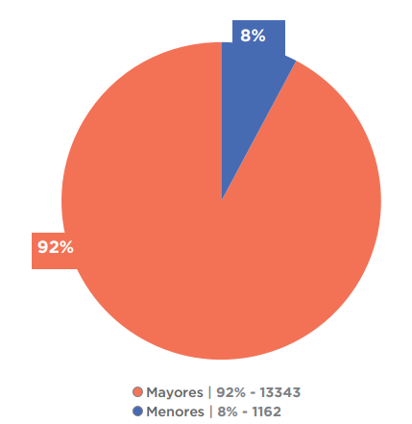

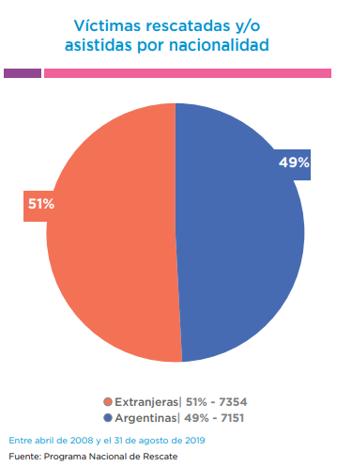

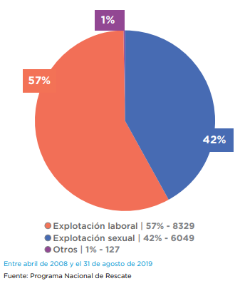

Reply to the question raised in paragraph 41 (c) and (d) of the list of issues
268. According to the national survey, as at 31 August 2020 there were 178 registered facilities and programmes for young offenders nationwide. Of this total, 77 were centres administering community-based correctional measures (42 per cent), 28 were open or semi-open institutions (16 per cent), 58 were closed institutions (33 per cent), 7 were specialized detention facilities (4 per cent) and 8 were specialized custody facilities in police stations (4 per cent).
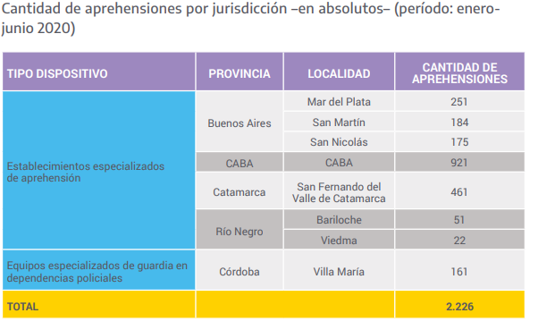
269. Admissions to specialized detention facilities:
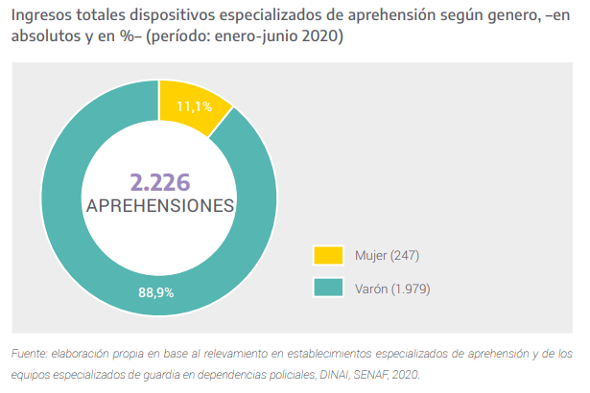
270. The graph below shows the period of time that children and adolescents admitted to specialized detention facilities remained in the facility. They spent less than 24 hours in the facility in 82 per cent of cases and less than 12 hours in just over two thirds (68.1 per cent) of cases. According to the 2018 annual survey of arrests and detentions, 44 per cent of children and adolescents arrested and detained in police stations (without the involvement of a specialized custody team) were detained for less than 24 hours, 31.5 per cent were detained for between 24 hours and 7 days, and 12 per cent were detained for between 7 and 30 days.
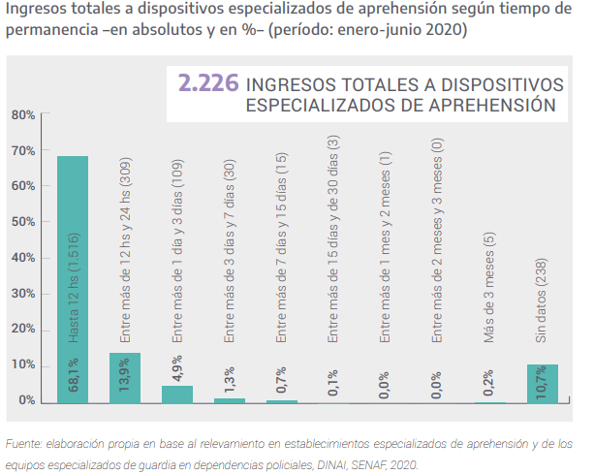
271. Offences against property accounted for the majority of alleged offences (63.3 per cent), with offences of endangerment of public health in second place, accounting for 9 per cent. Upon discharge, 103 of 112 adolescents who completed their sentence were placed with their family or a person of trust, 7 returned to their own homes and 2 were placed in the care of the Human Rights Protection and Promotion System.
272. Nationwide, a total of 2,221 young offenders or alleged offenders in conflict with the law under 18 years of age were placed in institutions or were ordered to comply with community-based correctional measures by the juvenile justice system. This figure is equivalent to less than 0.1 per cent of the total number of adolescents between 14 and 17 years of age in Argentina, according to population projections by age for 2020 produced by the National Institute of Statistics and Censuses. The majority of these 2,221 adolescents (1,994 or 89.8 per cent) were either 16 or 17 years old, meaning that, if the offences of which they were charged were prosecutable offenses carrying a penalty of at least 2 years’ imprisonment, they were considered to be punishable under the criminal laws in force. However, 10.2 per cent (227) of these adolescents were under 16 years old and therefore not punishable owing to their age.

Reply to the question raised in paragraph 41 (e) of the list of issues
273. Only 4.2 per cent of the total number of children and adolescents who spent time in specialized detention facilities were referred to the juvenile justice system. Most of those who were arrested were released into the care of a family member or person of trust (78.5 per cent) or were referred to a provincial office of the Human Rights Protection and Promotion System (8.7 per cent).

Reply to the question raised in paragraph 41 (f) of the list of issues
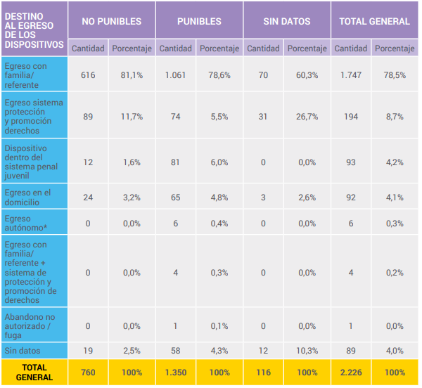

Optional Protocol on the sale of children, child prostitution and child pornography

Reply to the question raised in paragraph 42 (a) of the list of issues
274. Between 13 May 2022 and 30 June 2023, 672 persons involved in a total of 691 cases were admitted to the PatrocinAR Programme.
275. From 2017 to June 2023, 15,699 cases in which children or adolescents were victims of sexual violence were registered. The breakdown by year is shown below.
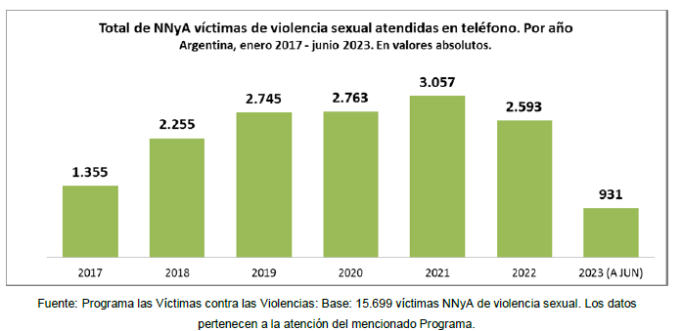
276. Over the period 2017–2021, there was a steady year-on-year increase in the number of children and adolescents who suffered sexual abuse. Between 2017 and 2022, the increase was 91 per cent.

Reply to the question raised in paragraph 42 (b) of the list of issues
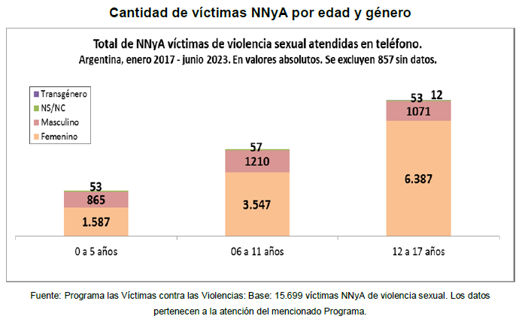
277. Girls accounted for 77.6 per cent of victims of sexual violence against children and adolescents, boys for 21.2 per cent and transgender children and adolescents for 0.08 per cent. Information on the sex of the victim is not available in 1.1 per cent of cases.
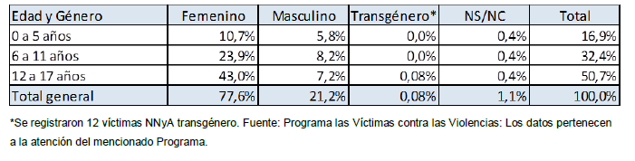
278. In 25.4 per cent of cases involving child victims, the mother is the main point of contact and principal interlocutor. Police officers and other relatives of the victim are the main point of contact in 22.8 per cent and 19.2 per cent of cases, respectively.
279. With regard to settings, 46.4 per cent of sexual abuse of children and adolescents took place in the home of the victim, the abuser or a family member.
280. Social networks were the setting for 15.2 per cent of cases of sexual abuse.
281. Public places (in the street, squares and other open areas) were the setting for 2.6 per cent of cases.
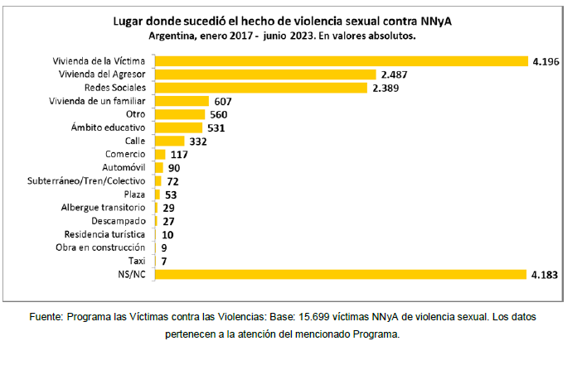
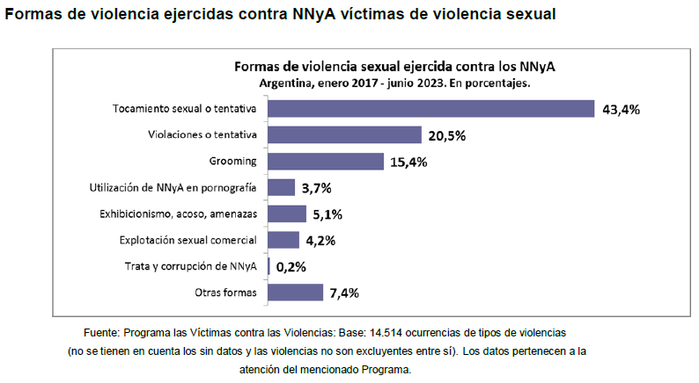

Optional Protocol on the involvement of children in armed conflict

Reply to the questions raised in paragraph 43 (a) of the list of issues
282. No cases have been recorded.

Reply to the question raised in paragraph 43 (b) of the list of issues
283. No cases have been recorded.

* The present document is being issued without formal editing.
** The annexes to the present document may be accessed from the web page of the Committee.
See annex 1.
See: www.argentina.gob.ar.
Tucumán (April and July 2022, quality of care standards and exceptional protection measures), La Pampa (2023), Santa Fe and Rosario (69 professionals), Entre Rios (April 2022), Misiones (May 2022, 16 professionals), Santiago del Estero (June 2023), Tierra del Fuego (2019), Chubut (2019), Province of Buenos Aires (2019), La Rioja (2019), Corrientes (2019), Formosa (2022, 19 professionals), San Juan (2022, 49 professionals), Catamarca (2022 quality of care standards and exceptional protection measures), training on “Taking care of our particular needs” (2022–2023, 318 personnel) in facilities in Santa Fe, 11 training sessions through the SENAF platform, training in the Province of Chubut (2021) on building practices from a rights perspective: contributions for discussion with other areas of the National Programme for the Protection of Rights including support for graduation, violence and child raising. Twelve virtual training sessions using Zoom in: Salta (exceptional protection measures), La Rioja (exceptional protection measures), Corrientes (quality of care standards and exceptional protection measures), Tierra del Fuego (exceptional protection measures), Chubut (exceptional protection measures), Santa Fe (exceptional protection measures), San Luis (exceptional protection measures), Jujuy (exceptional protection measures), La Pampa (exceptional protection measures and for operators of residential care facilities), Province of Buenos Aires (exceptional protection measures, municipal services and residential care facilities), Santiago del Estero (exceptional protection measures), Tucumán (exceptional protection measures) and Formosa (exceptional protection measures).
With an investment of Arg$ 48,730,000, the Unite card was issued to institutions in the provinces of Santa Fe, Catamarca, Salta and Misiones, and in the coming weeks it will be incorporated into the care systems of Tucumán, Santiago del Estero, Buenos Aires, San Juan, San Luis and Córdoba.
Training for the early childhood centre of the Prison Service of the Province of Misiones in collaboration with the early years programme and for the technical team for children, internal security personnel and teaching staff of unit 31 of the Federal Prison Service.
See: https://bancos.salud.gob.ar/recurso/impacto-de-la-pandemia-covid-19-y-respuestas-adaptativas-de-los-servicios-de-salud-para.
An Arg$10,000 voucher to alleviate the impact of the sanitary emergency on the economic situation of the most affected Argentine families.
See: https://www.argentina.gob.ar/economia/politicatributaria/covid19/trabajoyproduccion.
See: https://www.anses.gob.ar/tramite/tarjeta-alimentar.
See annex 2.
See annex 3 for provincial laws.
To create free and readily accessible technology interfaces and digital platforms to provide information and advice on dealing with violence, mistreatment, abuse and other rights violations against children and adolescents and to promote their participation.
See: https://www.argentina.gob.ar/desarrollosocial/grooming/conoce-la-ley-mica-ortega#:~:text=Sus%20objetivos%20son%3A%20proteger%20del,y%20d%C3%B3nde%20denunciar%20los%20casos.
https://www4.hcdn.gob.ar/dependencias/dcomisiones/periodo-141/141-734.pdf.
See: https://www.argentina.gob.ar/desarrollosocial/cofenaf/balanceyactas.
See: https://www.argentina.gob.ar/sites/default/files/gasto_vinculado_discapacidad-trimestral-informe_2023_1.pdf.
See: https://www.presupuestoabierto.gob.ar/sici/destacado-explorador-programas#.
See: https://www.anses.gob.ar/asignacion-universal-por-hijo.
See annex 4.
See annex 5.
See: https://www.anses.gob.ar/tramite/programa-alimentar.
See: https://comprar.gob.ar/.
See: https://gualeguaychu.gov.ar/presupuestoparticipativo.
Education statistics covering a 25-year period based on the Annual Survey 1996–2020 2021 National Survey on Time Use. Final results of the 2022 National Breastfeeding Survey.
The monitoring system of the Office of the Ombudsperson for the Rights of Children and Adolescents.
See: https://www.unicef.org/argentina/media/5221/file/INC-RUN201.pdf.
Registros Nominales de las Áreas de Niñez de Argentina.
See: https://mapafederaldelcuidado.mingeneros.gob.ar/.
See: https://defensoraderechosnnya.gob.ar/informacionutil/recomendaciones-de-la-defe/.
See: https://defensoraderechosnnya.gob.ar/informacionutil/pronunciamientos-de-la-defe/.
See: https://defensoraderechosnnya.gob.ar/informacion-util/informesanuales/.
See: https://www.argentina.gob.ar/sites/default/files/2020/07/lct_art179_mmgyd.pdf.
See: https://www.argentina.gob.ar/sites/default/files/recomendaciones_para_el_tratamiento_ mediatico_acerca_de_la_violencia_sexual_contra_ninas_ninos_y_adolescentes_e_interrupcion_legal_del_embarazo.pdf.
See: https://www.argentina.gob.ar/sites/default/files/declaracion_organismos_23_de_ marzo_2021.pdf. and https://www.argentina.gob.ar/sites/default/files/2020/09/dinai-com_2021_recomendaciones_coberturas_periodisticas_adolescentes_infraccion_penal.pdf.
On child labour in relation to responsible tourism and codes of conduct, see: https://www.argentina.gob.ar/content/turismo-responsable-e-infancia; https://turista.defensoria.org.ar/firman-codigo-conducta-la-proteccion-derechos-ninos-viajes-turismo/.
See: https://www.argentina.gob.ar/desarrollosocial/senafcampus/biblioteca
See: https://www.cancilleria.gob.ar/userfiles/recursos/plan-de-trabajo_pnaedh-2023.pdf.
See annex 6.
In 2022, through the development of a comprehensive project for the establishment of spaces for development, inclusion, gatherings and community care, technical and financial support was provided for the refurbishment and enhancement of the OtamsekWetIs cultural centre, inaugurated in July. This helped to ensure access to cultural activities and recreation for children, adolescents and their families. At the same time, access to recreation, games and sports activities was provided through the sports schools supported by the Santa Victoria Este Club, reaching a population of 17,000 children and adolescents in the area. In 2023, the Centre for Access to Justice under the Ministry of Justice and Human Rights and a community childcare zone of the Directorate for the Promotion of Family Upbringing in Community Settings were added to the OtamsekWetIs cultural centre. This was made possible by coordination between SENAF and the government agencies and civil society organizations operating in the area.
See annex 7.
See annex 8.
See annexes 9 and 10.
See annexes for the 2022 national discrimination map; the programme for schools free from discrimination and the programme for youth free from discrimination.
https://www.senado.gob.ar/parlamentario/comisiones/verExp/27.21/CD/PL https://www.senado.gob.ar/micrositios/nota/20064/noticias.
https://www.boletinoficial.gob.ar/detalleAviso/primera/253065/20211118.
See: https://www.argentina.gob.ar/sites/default/files/2020/09/jga-2023-perspectiva-de-genero-diversidad-ii-guia-politicas-publicas.pdf.
See: https://bancos.salud.gob.ar/sites/default/files/2021-06/2021-06-24-recomendaciones-para-la-atencion-integral-de-la-salud-de-nineces-adolescencias-ttnb.pdf.
See: https://www.unicef.org/argentina/media/11246/file/Abordaje%20integral%20del%20suicidio %20en%20las%20adolescencias.pdf.
See annex for participating jurisdictions.
https://www.argentina.gob.ar/sites/default/files/2020/09/2023-dnsp-derecho-a-la-participacion-ciudadana-ninas-ninos-adolescentes.pdf.
http://capacitacion.senaf.gob.ar/moodle/.
https://www.argentina.gob.ar/desarrollosocial/consejoconsultivo/materialesydocumentos.
“Tirando la posta - A 10 años de la Ley Nacional de Centros de Estudiantes - Episodio 1”, available at https://youtu.be/3XtBiWhHspw.
https://fb.watch/lHUgRORBvL/.
https://bit.ly/42Ppc0g.
https://www.youtube.com/live/YJuFluf8_BU?feature=share.
See annex 11.
[2] Supreme Court case No.1813/208/RH1, P. B., E. G. v. B., K. E. concerning precautionary measures, 7 October 2021.
3] www.calp.org.ar/registro-aanna/ www.calz.org.ar/abogado-del-nino/ http://www.casi.com.ar/sites/default/files/LISTADO%20ABOG%20DEL%20NI%C3%91O%20-WEB%202%2007%202019.pdf www.cpacf.org.ar/ntica/4420/abogados-amigos-de-los-ninos http://registrosnaf.chaco.gob.ar/registro2.html?fbclid=IwAR2CtaYI2UFcizNyMbQ7iNGmCiU-5jZljF9dsgwMVya_PWZchOh5_Mdzors https://jusnoticias.juschubut.gov.ar/index.php/inicio/actualidad/1701-crean-el-registro-de-abogado-a-del-nino-a-y-adolescente https://caer.org.ar/abogado-del-nino/ https://colabogadosjujuy.com/creacion-del-registro-de-abogados-as-del-nino/ https://abogadosdesalta.org.ar/abogado-del-nino-2/.
https://www.argentina.gob.ar/justicia/derechofacil/leysimple/centros-de-estudiante.
https://www.argentina.gob.ar/interior/dni/cronograma-de-operativos.
The Laboratory studies DNA polymorphisms to establish different types of biological links and to reveal biological identity, in accordance with the provisions of the national and provincial justice systems and the requesting public agencies https://www.argentina.gob.ar/desarrollosocial/laboratoriodehuellas.
“Communication with a child’s and adolescents’ rights perspective”, “Participation of children and adolescents in the media”, “Caring for children and adolescents when communicating”, “The communication rights of children and adolescents in media coverage: tools for their promotion and protection”, “Training on the promotion and protection of children’s and adolescents’ rights in communication”, “Tools for human rights-based communication about children and adolescents” and “Considerations for including children in communications”.
https://www.argentina.gob.ar/sites/default/files/2020/09/dinai-com_2021_recomendaciones_coberturas_periodisticas_adolescentes_infraccion_penal.pdf.
https://www.argentina.gob.ar/sites/default/files/2020/09/recomendaciones_para_comunicar_sobre _adopciones_-_comunicacion_-_mds_-_mjydh_-_senaf.pdf.
https://www.argentina.gob.ar/sites/default/files/recomendaciones_para_el_tratamiento_mediatico _acerca_de_la_violencia_sexual_contra_ninas_ninos_y_adolescentes_e_interrupcion_legal_del_embarazo.pdf.
https://www.argentina.gob.ar/sites/default/files/2020/09/2023-senaf-recomendaciones-comunicacion-responsable-sobre-infancias-adolescencias.pdf.
https://www.argentina.gob.ar/sites/default/files/2020/09/dnpypi-2021-iniciativa-aunar-ciudadania-digital.pdf.
https://www.argentina.gob.ar/sites/default/files/2020/09/senaf-clicderechos-farodigital-estudioexploratoriosobreelconocimientoylaspercepcionesdelasadolescenciasrespectoalgrooming.pdf.
https://www.argentina.gob.ar/sites/default/files/2020/09/guia_-_infancias_-_faro_digital_-_jga-_senaf.pdf.
https://www.argentina.gob.ar/sites/default/files/2020/09/guia_-_adolescencias_-_faro_digital_-_jga_-_senaf._pdf.pdf.
https://www.facebook.com/SenafArgentina/posts/266192038442372 https://www.argentina.gob.ar/desarrollosocial/linea102.
https://www.facebook.com/SenafArgentina/posts/311231763938399 https://www.facebook.com/SenafArgentina/posts/327126115682297.
https://www.instagram.com/p/Cnj_1nNs_w4/?igshid=OGQ2MjdiOTE %3D.
https://www.instagram.com/p/Cmt5a2Nr0dN/?igshid=NjcyZGVjMzk=.
https://www.instagram.com/reel/Ck5xKRvDf1m/?igshid=NjcyZGVjMzk=.
internet? https://www.instagram.com/p/CdqYMaWuNf1/?igshid=NjcyZGVjMzk=.
https://www.instagram.com/p/CbinpZaJrrR/?igshid=NjcyZGVjMzk=.
https://www.instagram.com/p/Cl6PHpkPapP/?igshid=NjcyZGVjMzk=.
https://www.youtube.com/watch?v=O1bbS25JngQ.
https://www.rap-digital.com.
http://servicios.infoleg.gob.ar/infolegInternet/anexos/235000-239999/235975/norma.htm.
https://www.argentina.gob.ar/desarrollosocial/crecer-con-derechos.
https://www.argentina.gob.ar/desarrollosocial/linea102.
https://bancos.salud.gob.ar/sites/default/files/2022-01/1.presentacion-plan-nacional-politicas-genero-diversidad-salud-publica.pdf.
“Prevention and detection of violence against children and adolescents”, delivered in person. Target audience: Scout Group 32 of the Santa Rita District, Autonomous City of Buenos Aires. Number of participants: 65 persons. Date: 6/5/23; “Promotion of positive treatment” workshop for adolescents. Promotion of positive peer-to-peer treatment and prevention of violence in sexual and emotional relationships. San Pedro District, Province of Buenos Aires, in coordination with the “Activate Rights” Unit. Participants: 20 young persons. Date: 8/5/23; Workshop on sexual and emotional relations: prevention of violence in adolescent relationships. Delivered in person at the “Madres y Abuelas de Plaza de Mayo” Secondary School in the Francisco Álvarez District, Province of Buenos Aires. Participants: 70 young persons.
https://www.argentina.gob.ar/generos/plan-nacional-de-accion-contra-las-violencias-por-motivos-de-genero-2022-2024.
https://www.argentina.gob.ar/desarrollosocial/programas/rennya.
https://www.argentina.gob.ar/generos/plan_nacional_de_accion_contra_las_violencias_ por_motivos_de_genero/programa-para-el-apoyo-urgente-y-la-asistencia-integral-inmediata.
Information: https://www.argentina.gob.ar/sites/default/files/2022/08/pna_2022_2024.pdf.
https://www.argentina.gob.ar/sites/default/files/2023/05/mmgyd-informe-gestion-2022.pdf.
https://www.argentina.gob.ar/generos/linea-144/datos-publicos-de-la-linea-144-2022.
https://ministeriodelasmujeres.gba.gob.ar/gestor/uploads/ INFORME %20NI %C3 %91AS %20Y %20ADOLESCENTES.pdf.
https://www.argentina.gob.ar/sites/default/files/2023/03/protocolo_de_actuacion_para_las_ffss_ en_intervenciones_con_nnya_version_digital.pdf.
https://www.mpf.gob.ar/ufisex/.
https://www.ovd.gov.ar/ovd/estadisticas/detalle/3908.
In 2020 and 2021, 32 per cent of the persons in question were children or adolescents. Of this total, 53 per cent were girls or female adolescents and 47 per cent were male. • At the time of reporting to the Office, 10 girls or female adolescents were pregnant. • A high concentration of cases occurred in 4 of the 15 municipalities of the City of Buenos Aires. • Of the children and adolescents concerned, 9 out of every 10 are of Argentine nationality. • The most common forms of violence are psychological (95 per cent) and physical (43 per cent). • Injuries were found in the cases of 214 children and adolescents, of whom more than half (55 per cent) had a history of physical injuries resulting from previous situations of violence. • The alleged perpetrator was male in 73 per cent of the cases. • The children and adolescents had a filial relationship with the alleged perpetrator in 8 out of 10 cases and, in 47 per cent of the cases, lived with that person. • Episodes of violence occurred daily or weekly in 58 per cent of the cases. • The Office’s interdisciplinary teams determined that 48 per cent of the cases in question involved very high-risk or high-risk situations. • Of the cases involving children or adolescents, 99.9 per cent were referred to the nation’s civil courts. • The national civil courts ordered a total of 6,006 protection measures for children and adolescents.
https://www.boletinoficial.gob.ar/detalleAviso/primera/239809/20210115.
https://bancos.salud.gob.ar/sites/default/files/2020-09/atencion-embarazo-adolescente-21-9-2020_1.pdf.
The practice known as “chineo” refers to the rape of girls from Indigenous communities, mostly in the northern provinces of the country. Many of these criminal and aberrant acts are committed by groups of men, with the rape typically taking place when the girl is at the onset of puberty and has had her first menstrual period.
https://drive.google.com/file/d/1d-W0OvX1aHv4COTI4bCj6cxrLPhMDkME/view Annotated National Civil and Commercial Code, Volume II.
https://www.argentina.gob.ar/sites/default/files/2020/09/situacion_de_nnya_sin_cuidados_ parentales_-_2020_03.05_1.pdf.
https://www.argentina.gob.ar/sites/default/files/2020/09/editorial.publicacion_pae_senaf_v07.pdf.
See annex 12.
Attached is a graphic showing case statistics.
For further information, see annexes I, II, III and IV.
https://www.argentina.gob.ar/planenia.
https://www.argentina.gob.ar/ambiente/ley-yolanda.
https://www.argentina.gob.ar/ambiente/cambio-climatico/gabinete-nacional-de-cambio-climatico/accion-para-el-empoderamiento https://www.argentina.gob.ar/sites/default/files/informe_del_proceso_participativo_enace _argentina.pdf https://www.argentina.gob.ar/sites/default/files/enace-_informe_consulta_publica.docx_1.pdf.
https://www.argentina.gob.ar/ambiente/cambio-climatico/participacion-ciudadana.
https://www.anses.gob.ar/observatorio/ley-de-movilidad-de-la-seguridad-social https://www.anses.gob.ar/sites/default/files/archivo/2022–07/Informe %20of %20Stats %C3%ADsticas %20of %20la %20SS %20IV %20Trimestre %202021.pdf.
https://www.argentina.gob.ar/educacion/programas-educativos/libros-para-aprender/libros-para-aprender-2023.
https://www.argentina.gob.ar/educacion/progresar.
https://www.argentina.gob.ar/educacion/fines.
These include a guide to communication with a gender perspective by the Ministry for Women, Gender and Diversity; a guide to recommendations for gender equality in the capital market by the Ministry for Women, Gender and Diversity and the National Securities Commission; a practical guide to gender-sensitive communication in transport by the Ministry of Transport; a document on the promotion of the use of non-sexist and inclusive language and communication by the Ministry of Health; a document on the promotion of the use of non-sexist and inclusive language and communication by the Ministry of Public Works; a manual on communication with a gender and diversity perspective by the Matanza Riachuelo River Basin Authority; style guidelines for inclusive language by the National Institute of Partnerships and Social Economy of the Ministry of Productive Development; a guide to good commercial practices on gender and diversity issues by the Domestic Trade Secretariat of the Ministry of Productive Development; a guide to inclusive communication by the Central Bank; and a guide to the use of non-sexist and egalitarian language in the Chamber of Deputies by the Chamber of Deputies.
https://www.argentina.gob.ar/justicia/derechofacil/lenguaje-inclusivo.
https://www.argentina.gob.ar/justicia/derechofacil/leysimple/bullying https://www.argentina.gob.ar/normativa/nacional/ley-26892-220645.
Many organizations are active in this space, including UNICEF, the National Scouts’ Association of Argentina, Libres de Bullying, the UNESCO Chair on Education for Peace and International Understanding, the School Coexistence Observatory of the Catholic University of Cuyo, the Anti-Bullying Argentina Team, Si nos reímos, nos reímos todxs, Hablemos de Bullying, Vínculos Sin Bullying, the Anti-Bullying Argentina Community, the Argentine Association for Stuttering and the Family and Youth Observatory of the Chamber of Deputies.
https://www.argentina.gob.ar/bullying http://www.bnm.me.gov.ar/giga1/documentos/EL008048.pdf.
Cooperation agreements with the Vamos a Andar Foundation for three childcare facilities in the towns of Monte Rico, La Cocha and Chicoana in Jujuy, Salta and Tucumán. Cooperation agreements with Cámara del Tabaco de Salta for 10 facilities in the towns of Rosario de Lerma, La Merced, Chicoana, Coronel Moldes, La Viña, Guachipas, El Bordo, El Jardín and El Tala. Cooperation agreement with the Provincial Undersecretary for Children, Adolescents and the Family of Santiago del Estero for one childcare facility in the town of La Banda. Cooperation agreements with the Confluence Union of Argentine Educators of the Province of Chaco for four facilities in the towns of Sauzalito, Villa Angela, Nueva Pompeya and Machagai. Cooperation agreement with Fundación Compañía Tabacalera de Misiones for one facility in the district of Dos de Mayo. Cooperation agreements with the Asociación de Productores Yerbateros del Norte for two facilities in the towns of Comandante Andresito and Wanda. Cooperation agreements with Fundación Kairós for one facility in Mendoza in the district of Maipú. Cooperation agreement with the Ministry of Labour, Employment and Social Security of the province of Santa Fe to strengthen 13 facilities in Child and Family Care Centres. Cooperation agreement with Fundación La Alameda for two facilities in Buenos Aires, in the district of General Pueyrredón. Cooperation agreement with Asociación Civil Empleo Joven for one facility in Buenos Aires in the district of San Isidro. Cooperation agreement with the Provincial Commissions for the Prevention and Eradication of Child Labour of Buenos Aires for 10 facilities in the districts of Mar del Plata, Las Heras, La Plata, Lomas de Zamora, San Martin, Florencio Varela, Almirante Brown, Berazategui and Bahía Blanca. Cooperation agreement with Mesa Campesina del Norte Neuquino for one facility in Neuquén, in the district of Chos Malal. Cooperation agreements with the Unión Obrera Ladrillera de la República Argentina for five facilities in Buenos Aires, San Juan, La Rioja, Misiones and Entre Ríos. Cooperation agreements with the Asociación Civil Amanecer de los Cartoneros for three facilities in the Buenos Aires Metropolitan Area, in the districts of Villa Fiorito and Constitución. Cooperation agreement with the Asociación Civil El Puente 26 Luchando Contra la Desocupación for 11 facilities in Autonomous City of Buenos Aires and Greater Buenos Aires, in the districts of La Plata, Avellaneda, Ezeiza, Quilmes, Florencio Varela, Constitución, Barracas and Barrio 21–24.
https://www.argentina.gob.ar/sites/default/files/plan_2020-2022_digital_1.pdf https://www.argentina.gob.ar/sites/default/files/2021/11/1er._informe_de_ejecucion_plan_ biennial_2020–2022.pdf.
https://www.argentina.gob.ar/desarrollosocial/senafcampus/biblioteca.
Autonomous City of Buenos Aires, Catamarca, Chaco, Córdoba, Entre Ríos, Formosa, Jujuy, La Pampa, La Rioja, Mendoza, Neuquén, Buenos Aires, Río Negro, Salta, San Juan, San Luis, Santa Cruz, Santa Fe, Santiago, Tierra del Fuego, Tucumán.
http://servicios.infoleg.gob.ar/infolegInternet/anexos/15000-19999/16546/texact.htm.
Act No. 26904 of 2018 incorporating article 31 on the crime of grooming into the Criminal Code. Act No. 27436 of 2018 on the possession of sexual abuse materials relating to children and adolescents, replacing article 128 of the Criminal Code. Act No. 27590 of 2020 creating the Prevention and Awareness Programme on Grooming and Cyberbullying of Children and Adolescents (“Mica Ortega’s Law”).
“El Servicio Cívico Voluntario puede atentar contra los Derechos de los Niños y las Niñas” (Voluntary civic service may infringe on the rights of children), 12 October 2010. Por la Erradicación de las Policías y/o Gendarmerías ‘Infantiles’” (Eradicating “child” police and/or gendarmerie), 12 October 2010. “Avances y desafíos por la erradicación de las gendarmerías y/o policías ‘infantiles’” (Progress and challenges in eradicating “child” police and/or gendarmerie), 9 August 2012.
Some national budget expenditure can be attributed to a specific province or to the Autonomous City of Buenos Aires. Other expenditure cannot be disaggregated geographically, as it corresponds to interprovincial, national or binational expenditure.
https://www.presupuestoabierto.gob.ar/sici/destacado-explorador-programas# https://www.presupuestoabierto.gob.ar/sici/home.
See annex 13.
The City of Buenos Aires is the only place in which the birth rate declined throughout the period. Most provinces saw a slight increase in births in 2014; within this group, some provinces (Buenos Aires, Córdoba, Mendoza, Neuquén, Salta and Entre Ríos) then experienced declining birth rates until the end of the period, while other provinces (Chaco, Corrientes, Santiago del Estero, Jujuy, Formosa, Catamarca, Santa Fe, Tierra del Fuego, Tucumán, Misiones and San Juan) experienced further increases in the years that followed. Another group of provinces (Chubut, La Rioja and La Pampa) experienced an increase in the birth rate in 2013 but then experienced a decrease until the end of the period. In San Luis, Santa Cruz and Río Negro, the number of births increased until 2015, then decreased until 2021.
Source: National Survey of Children and Adolescents: Argentina, 2019–2020 MICS - UNICEF.
http://deis.msal.gov.ar/causasegresos/; https://datos.gob.ar/dataset/salud-defunciones-ocurridas-registradas-republica-argentina.
Source: Social Debt Observatory of the Catholic University of Argentina/ Barometer of Social Debt in Childhood/Statistical Document No. 01| 2023.
https://bancos.salud.gob.ar/sites/default/files/2023-06/paquetes-prestacionales-de-salud-para-adolescentes.pdf.
https://www.sap.org.ar/observatorio.php?indicador=35.
https://www.argentina.gob.ar/sites/default/files/2020/11/oad_2018._censo_nacional_de_centros_ de_tratamiento_iv_censo_nacional_en_centros_de_tratamiento_argentina_2018.pdf.
https://www.argentina.gob.ar/sites/default/files/informe_nacional_indicadores_educativos_ 2021_2_1.pdf.
https://www.argentina.gob.ar/sites/default/files/informe_nacional_indicadores_educativos_ 2021_2_1_1.pdf.z
https://app.powerbi.com/view?r=eyJrIjoiMjQwYWMzNTktZDI3ZS00MmUzLTlh MWQtMDE2ZjRkNTM5OGExIiwidCI6IjEyYmY0NGQ1LTIzYTMtNDE5Ny1hZjYyLWU4Mjg0NWJmZDIyMyJ9.
https://www.argentina.gob.ar/sites/default/files/estadisticas_conare-2018-2022-rectificado_07-07.pdf.
https://www.argentina.gob.ar/sites/default/files/estadisticas_trata_2008_31agosto2019pdf.pdf.
https://www.argentina.gob.ar/sites/default/files/2020/09/relevamiento_penal_2020.pdf.

