 | United Nations | E/C.12/IDN/1
 | Economic and Social Council |  | Distr.: General  29 October 2012  Original: English
Committee on Economic, Social and Cultural Rights
Implementation of the International Covenant
on Economic, Social and Cultural Rights
Initial reports submitted by States parties under articles 16 and 17 of the Covenant
Indonesia*
[23 January 2012]
Contents
Paragraphs Page
I. Introduction 1–8 3
II. Implementation of specific provisions of the Covenant 9-284 4
A Right to self-determination 9–22 4
B. International cooperation, technical and economic assistance, and national
Development 23-32 6
C. Limitation of rights 33-35 9
D. Development without discrimination and with priority for vulnerable
groups 36-39 10
E. Gender equality 40-47 10
F Right to work 48–83 12
G. Freedom of association and collective bargaining of the workers 84-95 21
H. Social insurance 96-117 22
I. Right to establish a family 118-143 29
J. The right to continuous improvement of living conditions 144-155 34
K. Right to food 156-171 37
L. Right to water and sanitation 172-185 41
M. Right to adequate housing 186-201 44
N. Right to health 202-231 48
O. Right to education 232-270 58
P. Right to culture 271-284 70

I. Introduction
1. This report was drafted in accordance with the general guidelines of the Human Rights Committee regarding the form and content of periodic reports to be submitted by States parties (E/C.12/2008/2).
2. The Government of the Republic of Indonesia ratified the International Covenant on Economic, Social and Cultural Rights on 28 October 2005 by Law No. 11 of 2005. The Government deposited that ratification to the United Nations Secretary General in New York on 23 February 2006.
3. Although the Government has just become State party to the Covenant since May 23, 2006, but the commitments to implement genuine and sustained efforts in promoting and protecting human rights as stipulated in the Covenant has become an important part of the ideals of the proclamation of Indonesian independence on 17 August 1945. Preamble of the 1945 Constitution confirmed the purpose of establishing the State Government of Indonesia to "... protect all the people of Indonesia and the land that has been struggled for, and to improve public welfare, to educate the life of the people and to participate toward the establishment of a world order based on freedom, perpetual peace and social justice”. The people of Indonesia has determined “social justice for all the people of Indonesia” as one of the foundations of Pancasila, five basic principles, as well as national development for Indonesian people and nation.
4. Economic, social and cultural rights for every person in Indonesia have been guaranteed in the 1945 Constitution, as stipulated in article 27, paragraph 2; article 28A; article 28B, paragraphs 1 and 2; article 28C, paragraphs 1 and 2; article 28D, paragraph 2; article 28H, paragraphs 1 and 3; article 28I, paragraphs 2 and 3; article 31, paragraphs 1, 2, 3, 4, and 5; article 32, paragraphs 1 and 2; article 33, paragraph 3, and article 34, paragraphs 1, 2, and 3.
5. In order to fulfil the mandate of the 1945 Constitution, the Government has developed a number of legislations related to the promotion, respect, protection, and fulfillment of economic, social and cultural rights, among others: Law No. 32 of 2004 in lieu with Law No. 8 of 2005 in lieu with Law No. 12 of 2008 on Regional Government, Law No. 32 of 2009 on the Protection and Management of Environment, Law No. 27 of 2007 on Management of Coastal Areas and Small Islands; Law No. 33 of 2004 on Fiscal Balance between the Central Government and the Regional Governments; Law No. 39 of 1999 on Human Rights; Law No. 40 of 2008 on the Elimination of Racial and Ethnic Discrimination; Law No. 24 of 2007 on Disaster Relief; Law No. 13 of 2003 on Manpower; Law No. 20 of 2008 on Micro, Small and Medium Enterprises; Law No. 39 of 2004 on the Placement and Protection of Indonesian Workers Abroad; Law No. 3 of 1992 on Labor Social Security; Law No. 11 of 1992 on the Pension Fund; Law No. 21 of 2000 of Trade /Labor Union; Law No. 40 of 2004 on National Social Security System; Law No. 4 of 1965 on the Livelihood Assistance to the Elderly; Law No. 52 of 2009 on Population Growth and Family Development; Law No. 23 of 2002 on Child Protection; Law No. 4 of 1979 on Child Welfare; Law No. 11 of 2009 on Social Welfare; Law No. 13 of 1998 on the Elderly Welfare; Law No. 36 of 2009 on Health; Law No. 44 of 2009 on Hospital; Law No. 4 of 1997 on People with Disability; Law No. 7 of 1996 on Food; Law No. 16 of 2006 on Dissemination System for Agriculture, Fisheries and Forestry; Law No. 41 of 2009 on the Protection of sustainable crops farmland; Law No. 3 of 2005 on National Sports System; Law No. 41 of 1999 on Forestry; Law No. 15 of 1997 on Transmigration; Law No. 4 of 1992 on Housing and Settlements: Law No. 16 of 1985 on Flats; Law No. 7 of 2004 on Water Resources; Law No. 12 of 1992 on Plant Cultivation System; Law No. 5 of 1990 on Conservation of Biological Resources and Ecosystems; Law No. 25 of 2009 on Public Service; Law No. 18 of 2004 on Plantation; Law No. 20 of 2003 on National Education System; Law No. 25 of 1992 on Cooperatives; Law No. 19 of 2002 on Copyrights; Law No. 5 of 1992 on Cultural Heritage Objects; Law No. 11 of 2009 on Tourism.
6. The Government implements sustainable national development through the National Long Term Development Plan (Rencana Pembangunan Jangka Panjang Nasional/RPJPN) and further implements in the National Medium Term Development Plan (Rencana Pembangunan Jangka Menengah Nasional/RPJMN) for each 5 years. The National Long Term Development Plan of 2005-2025 aims at building a self-reliant, advanced and prosperous Indonesia with 8 development targets, among others: to become a competitive nation by prioritizing qualified and competitive human resources development; to achieve equal distribution of development by enhancing the regional development; to reduce social inequalities; to prioritize vulnerable community and groups, and disadvantage region/area; to significantly alleviate poverty and unemployment; to provide equal access for social services and facilities and economic infrastructures; and to eliminate discrimination in every aspect including gender.
7. The National Medium Term Development Plans of 2004-2009 and 2009-2014 prioritize on the improvement of people's welfare through sustainable development toward a prosperous Indonesia; strengthening democracy by continuing the development of democratic, civilized, dignified society, nation and states, who uphold fundamental freedom and human rights; and also strengthening justice in all areas through fair and equitable development for all the people of Indonesia.
8. The National Medium Term Development Plan of 2010-2014 determines 11 national development priorities, including: (1) bureaucratic and governance reform, (2) education, (3) health, (4) poverty reduction, (5) food security; (6) infrastructure, (7) investment and business climate; (8) energy, (9) environment and disaster management; (10) marginalized, frontier, outermost, and post-conflict areas; and (11) culture, creativity, and technological innovation; which essentially a commitment of the Government in the effort to fulfil the economic, social and cultural rights.
II. Implementation of specific provisions of the Covenant
A. Right to self-determination
9. The Preamble of the 1945 Constitution explicitly declared "that freedom is the inalienable right of all nations...” and “.... people of Indonesia hereby declare their independence...”. It is clear that the independence of Indonesia is a manifestation of political self-determination which is fully attained through the struggle of Indonesian people. After the end of the colonization era in 1945, Indonesia has the full freedom to manage its natural resources for the maximum benefit of all Indonesian people.
10. The Government of Indonesia is of the view that the term ‘self-determination’ as stated in article 1 of the Covenant do not apply to a section of people within a sovereign and independent State, and cannot be construed as authorizing or encouraging any action which would dismember or impair, totally or in part, the territorial integrity or political unity of sovereign and independent states. This provision has been declared by the Government of Indonesia during the ratification of the Covenant. Such declaration is also consistent with the United Nations Declaration on the Granting of Independence to Colonial Countries and Peoples, and Declaration on Principles of International Law concerning Friendly Relations and Cooperation among States, and the relevant paragraphs of the Vienna Declaration and Program of Action of 1993.
11. With regard to the abovementioned declaration, The Government of Indonesia stands on the principle that there are two aspects in the implementation of the first paragraph of article 1 of the Covenant. The first aspect is the right to determine political status related to the determination of the status and position as an independent State in the world. The second aspect is the right to develop economic, social and cultural potentials related to the implementation of the right to territorial development within a sovereign and independent State. This view is in accordance with the common view of the international community as contained in general comment No. 21 of the Committee on the Elimination of Racial Discrimination.
12. The right to self-determination is implemented by Indonesia through the Proclamation of Independence in 17 August1945, after a long period of foreign occupation. Such proclamation is the consensus of all Indonesian people, composed of many ethnic groups and religions. It is a fact that all these ethnic groups are fully committed to be united and develop one state and one nation, Indonesia. This awareness is manifested in the struggle for independence that reached its peak at the end of the Second World War. Indonesian founding fathers proclaimed Indonesia independence which was immediately followed by other States’ recognition, especially Asian and African countries.
13. Furthermore, the embodiment of internal aspect of the right to self-determination in order to develop economic, social and cultural potentials is demonstrated through Article 18, 18A and 18B of the 1945 Constitution. Those articles regulate regional governments to exercise the regional autonomy.
14. The regional autonomy is implemented through Law No. 32 of 2004 in conjunction with Law No. 8 of 2005 in conjunction with Law No. 12 of 2008 on Regional Governance. Law No. 32 of 2004 regulates that the central government has the authority on issues related to foreign policy, defence, security, judicial, monetary, fiscal and religion. Therefore, regional government from the Provincial to regency/municipality level has immense authority in managing the livelihood and statehood of the community, including economic affairs, regional income and natural resources management. Regional government also has the authority in managing regional finance as regulated in Government Regulation No. 55 of 2005 on Balance Funds.
15. Regional government together with Regional People’s House of Representative have the authority to compose regional regulation and other rules according to Law No.10 of 2004 on the Formulation of Legislations, Presidential Decree No 61 of 2005 on the Procedure of the Formulation and Management of National Legislation Program, and also Presidential Decree No 68 of 2005 on the Procedure of Preparing Bill, Regulation in lieu of the Law (Perpu), Government Regulation and Presidential Decree.
16. Based on the regulation of regional autonomy, every region can govern itself, to issue regional laws and rules, with the exception of the issues under the authority of central government as regulated by law, to democratically elect its own head and deputy, as well as members of its regional parliament in every province and district/municipality. The election is conducted through direct, free, confidential and accountable general election, as regulated in Government Regulation No. 49 of 2008 on the Third Amendment of Government Regulation No. 6 of 2005 on the Election, Approval, Appointment, and Dismissal of the District Head and Deputy.
17. Furthermore, Law No. 32 of 2004 on Regional Government enables the merger and expansion of new administrative region, which are conducted on the basis of people’s will. This is intended to improve the performance and effectiveness of regional governments. Between 2004-2009, 205 new autonomous regions were established. In total, there are 524 autonomous regions in Indonesia, consist of 33 provinces, 398 districts and 93 municipalities.
18. In order to optimize the implementation of regional autonomy and considering the condition of certain regions, the Government of Indonesia also accorded special autonomous status to regions in Papua, West Papua and Nanggroe Aceh Darussalam Provinces.
19. Special autonomy policy is regulated in Law No. 35 of 2008 on the Determination of the Regulation in lieu of the law (Perpu) No. 1 of 2008 on the Amendment of Law No. 21 of 2001 on the Special Autonomy for Papua Province. Law No. 21 of 2001 consists of, inter alia, affirmative action requiring that Governor and Regent/Mayors must be from Papua origin; the establishment of Papua People’s Assembly, a representation of several ethnic, religion, and women groups located in Papua; and bigger budget allocation in which the average of 80 per cent Papuan income is re-allocated to Papua. Through this special autonomy, since 2003, Papua Province has been expanded into two, which are Papua and West Papua Provinces. For the budget allocation, data has shown that during 2002-2010, the budget for Papua and West Papua development amounted to almost 28.504 trillion Rupiah.
20. The second special autonomy is applied in Nanggroe Aceh Darussalam Provice. Having reached the peace settlement, the government is committed to accelerate development through special autonomy that recognizes the cultural and economic privileges of Nanggroe Aceh Darussalam Province, particularly its Islamic values, ​​adopted by Law No. 11 of 2006 on Aceh Government. The Law includes the establishment of a number of Islamic-based institutions that remain subject to national law. Those are Sharia Court, Ulama's Consultative Assembly, Qanun and Sharia police, as well as Wali Nanggroe institution as a cultural symbol. The Law also regulates the establishment of Aceh-based political parties, Independent Election Commission (KIP) and the management of natural resources by the Aceh government. To date, Aceh has conducted governor / vice governor elections and 20 district regents / mayors elections that were held simultaneously in 2006 for the period 2006 - 2011 and was considered fair, honest and democratic. In terms of local financial management, Aceh has managed its budget with the amount of Rp 11.009 trillion since 2008 to 2010.
21. Although the implementation of these special autonomies has been going well, there are challenges in optimizing its achievement. For example, the special autonomy in Papua province has not yet been able to produce Provincial Regulations and Special Regional Regulations as technical guidelines for the implementation of special autonomy. Meanwhile in Aceh, the various local institutions, such as political parties, still require capacity building assistance.
22. To overcome these challenges, the Central Government continues to monitor and evaluate the implementation of these special autonomies. Currently, the Central Government is undertaking performance evaluation and financial audit as a whole for Special Autonomy in Papua and West Papua Province. As for Special Autonomy in Aceh, the Government provides assistance to fields that are deemed required, such as the study of limited revision on government regulation on financial assistance to local political parties.
B. International cooperation, technical and economic assistance, and national development
23. The implementation of economic, social and cultural rights in Indonesia is integrated into the national development plan. Indonesia’s national development plan in the field of economy covers the following priority policies for the empowerment and the improvement of: investment; export; tourism competitiveness; citizens’ purchasing power; public finance; monetary stability; stability of financial sector; revitalization of industry; labour competitiveness; cooperatives and micro, small and medium enterprises; and social security. In addition, the priorities in the field of social and culture comprise of: controlling the number of population; increasing access to and quality of health services; increasing access to, quality and relevance of education; increasing youth participation, culture and sports achievements; increasing the quality of religious life; enhancing national identity and preserving culture; increasing access to and quality of social welfare services; and enhancing gender equality, women empowerment, and child protection.
24. The financial resources of national development are the State’s revenue and international assistance, such as loans and grants. Programs and project from foreign loans come from multilateral, bilateral and commercial donors. The sources of funding for grants are international development partners, which include States and international institutions/organizations. External funding from foreign loans and grants (Pinjaman dan Hibah Luar Negeri – PHLN) are utilized by prioritizing national interests and enhancing the effectiveness of budget allocation.
25. Recognizing the future economic consequences of Indonesia’s external loans, the Government of Indonesia undertakes measures to ensure that the budget is allocated properly and effectively in order to achieve development priorities. In this context, the budget allocation should: (1) provide better public services; (2) encourage the utilization of domestic products and services; (3) provide a wide-range of benefits and innovations that can be replicated using domestic funding and other funding means; (4) encourage economic growth (pro growth),creation of job opportunities (pro job), poverty reduction (pro poor) in a measurable way, and/or support development sustainability (pro environment); (5) reduce development gaps among regions; and (6) provide knowledge and technology transfer.
26. The utilization of external grants is directed to support the implementation of development agenda in accordance with Indonesia’s economic and social development priorities. It is also prioritized for poverty alleviation, environmental and climate change management, transfer of science and technology, good governance, natural disasters, and humanitarian relief efforts. Furthermore, it also supports the implementation of global agendas, such as achieving the Millennium Development Goals (MDGs). It is necessary to maintain a flexible and favourable mechanism in managing external grants while meeting the accountability.
27. The Government is committed to continuously reduce its dependence on international financial assistance for its national development, in order to reduce its vulnerability in facing future external economic turmoil, such as global financial crisis, extreme fluctuations of foreign currency rates, etc. Data shows that Indonesia, in general, has successfully reduced its foreign debts, as seen on the declining Net Foreign Financing from 10,272 billion Rupiahs in 2005 to 609.5 billion Rupiahs in 2011.
28. To reduce the burden of government debt, the ratio of government debt stock to the GDP, including foreign debt, is consistently reduced and expected to reach up to 24 per cent at the end of 2014, while maintaining negative net transfer. The reduction of the ratio is followed by the reduction of foreign debt stock. Currently, the financing of the national budget deficit mostly depends on domestic sources. This condition has significantly contributed to the success of overcoming the global financial crisis impact. The crisis which has plagued the world since 2008 has not affected Indonesia’s ability to continue its national development, including its programmes for the fulfillment of economic, social and cultural rights.
Revenues and financing in the Indonesian Central Government budget-2005-2011 (in Billion Rupiah)
 | 2005 | 2006 | 2007 | 2008 | 2009 | 2010 | 2011
Budget (Expenditures) | 509,632.4 | 667,128.7 | 757,649.9 | 985,730.7 | 937,382.1 | 1,126,146.5 | 1,229,558.5
Surplus/Deficit | (14,408.2) | (29,141.5) | (49,843.8) | (4,121.3) | (88,618.8) | (133,747.7) | (124,656.5)
Revenues & Grants | 495,224.2 | 637,987.2 | 707,806.1 | 981,609.4 | 848,763.2 | 992,398.8 | 1,104,902.0
Domestic Revenue | 493,919.4 | 636,153.1 | 706,108.3 | 979,305.4 | 847,096.6 | 990,502.3 | 1,101,162.5
Grants | 1,304.8 | 1,834.1 | 1,697.7 | 2,304.0 | 1,666.6 | 1,896.5 | 3,739.5
Financing | 11,121.2 | 29,415.6 | 42,456.5 | 84,071.7 | 112,583.2 | 133,747.7 | 124,656.5
Domestic Financing | 21,393.2 | 55,982.1 | 69,032.3 | 102,477.6 | 128,133.0 | 133,903.2 | 125,266.0
Net Foreign Financing | (10,272.0) | (26,566.5) | (26,575.8) | (18,405.9) | (15,549.8) | (155.5) | (609.5)
Source: Ministry of Finance of the Republic of Indonesia, State Budget Basic Data 2005 – 20011
29. In general, the Central Government’s budget allocation to the implementation of economic, social and cultural rights has increased during the period of 2005-2011, as shown in the following graphic.
Central government budget in the areas of economic, social and cultural-2005-2011(in billion rupiah)
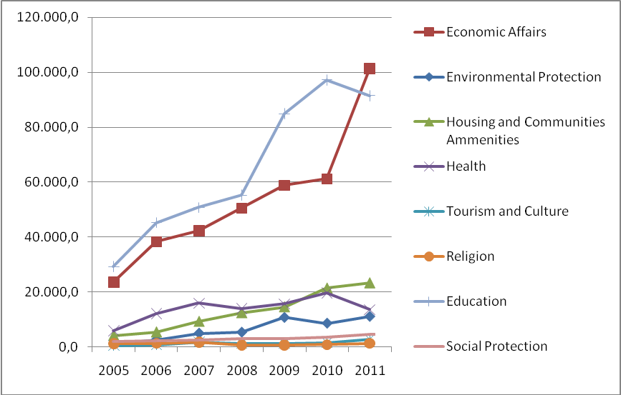
Source: Ministry of Finance of the Republic of Indonesia, State Budget Basic Data 2005-2011, 2011
30. Indonesia has also received technical and capacity building assistance from various donor countries in the field of economic, social and culture, which cover a wide range of sectors, including education, economy, health, disaster management, climate change, etc. Indonesia has benefited directly from the enhancement of technical cooperation. Indirectly, there is also a development performance increase that contributed to the enhancement of fulfillment of economic, social and cultural rights of the Indonesian people, including to accelerating the achievement of the MDGs.
31. In 2006-2009, the proposals for technical cooperation project assistance have reached USD 13.19 billion, which comprised 194 project assistance activities valued USD 11.48 billion and 228 technical assistance activities valued USD 1.71 billion. As for the year 2010-2014, the Government of Indonesia projected the technical cooperation assistance amounting to USD 26.9 billion for 243 project assistance activities and 198 technical assistance activities in various fields of development.
32. On the other hand, Indonesia also actively provides technical cooperation assistance, especially for developing countries and LDCs, in the sectors of investment, renewable energy, SMEs creative industry, SMEs incubator, microfinance, women empowerment, agriculture, media, disaster risk management, fishery, irrigation and forestry. The budget allocated for the technical cooperation programme has increased from USD 544,000 in 2008 to USD 733,000 in 2010.
C. Limitation of rights
33. The Government is committed to continuously improve its efforts to fulfil the economic, social, and cultural rights in all national development aspects for all people of Indonesia and others in Indonesian territory. Those efforts were conducted by considering the budget capacity and government resources. The Government of Indonesia does not and has no intention in limiting, prohibiting, or depriving the fulfillment of economic, social, and cultural rights.
34. Nevertheless, individual rights and freedom are regulated by article 28J paragraph (2) of the 1945 Constitution which states that “In exercising his/her rights and freedoms, every person shall have the duty to accept the restrictions established by law for the sole purposes of guaranteeing the recognition and respect of the rights and freedoms of others and of satisfying just demands based upon considerations of morality, religious values, security and public order in a democratic society”.
35. Like other countries, Indonesia also implements limitation of some rights to foreign citizens, including the rights to employment and rights to ownership of land and/or building. For the rights of employment, foreign workers can only work in Indonesia after obtaining license from Indonesia’s Ministry of Labor. Among the requirements that have to be fulfilled in employing foreign workers is that the workers can only be employed on certain positions and in a certain period of time, by considering the condition of national labour market demands. Aside to that, foreign workers are not allowed to establish a foreign labour union, but they can be members of any labour union that have been established, including the union founded in their offices. The foreign citizens are only allowed to own land and/or building for a period of 25 years, which is extendable for another 20 years and renewable for another 25 years, so that the maximum total period of ownership is 70 years.
D. Development without discrimination and with priority for vulnerable groups
36. The Government of Indonesia is committed to guarantee that all individuals in its territory obtain all their economic, social, and cultural rights without any discrimination, so as to achieve “social justice for all”. The 1945 Constitution emphasizes that every person has the same rights and obligations and guarantees that there shall be no person in Indonesia treated discriminatively based on any reason, regardless of race, skin color, sex, language, religion, place of birth, political orientation, social status, prosperity level, or any other status. Article 28I paragraph (2) of the 1945 Constitution stipulated that “Every person shall have the right to be free from discriminative treatment based upon any grounds whatsoever and shall have the right to protection from such discriminative treatment.”
37. The Government’s commitment to eliminate discrimination based on any reasons is further confirmed through the implementation of Law No. 29 of 1999 on the Ratification of International Convention of the Elimination of Any Form of Racial Discrimination 1965 and Law No. 40 of 2008 on the Elimination of Racial and Ethnic Discrimination.
38. Law No. 39 of 1999 on Human Rights further guarantees non-discrimination in the fulfillment of economic, social and cultural rights. In this case, the Government of Indonesia is subject to the provision of article 1, paragraph 3 which explains the definition of discrimination: ”...all limitations, affronts or ostracism, both direct and indirect, on grounds of differences in religion, ethnicity, race, group, faction, social status, economic status, sex, language, or political belief, that results in the degradation, aberration, or eradication of recognition, execution, or application of human rights and basic freedoms in political, economic, legal, social, cultural, or any other aspects of life”.
39. Several special commissions have been formed, through Presidential Decrees, to ensure the prevention and elimination of discrimination which often experienced by vulnerable groups. Those commissions are, among others, National Commission on Violence against Women (Komnas Perempuan), Indonesian Child Protection Commission (Komisi Perlindungan Anak Indonesia), and National Committee for Elderlies (Komite Nasional Lanjut Usia).
E. Gender equality
40. Articles 45-51 of Law No. 39 of 1999 on Human Rights specifically emphasized women’s rights as a part of human rights and also gender equality that guarantees the rights of women, including their economic, social, and culture rights.
41. Indonesia has ratified Convention on the Elimination of All Forms of Discrimination Against Women through Law No. 7 of 1984, and ILO Convention No. 111 of 1956 on Discrimination in Employment and Occupation. Both ratifications are meant to guarantee the principle of equality between women and men in every aspect of life, especially concerning the protection of economic, social, and cultural rights. In the effort to eliminate discrimination, several bills that are being finalized incorporate non-gender bias articles. Such effort is also supported by information dissemination, advocacies, education and training on gender equality, especially in the bill formulation process. Furthermore, in order to affirm and reinforce the implementation of the Convention on the Elimination of All Forms of Discrimination against Women, Indonesia is currently in the process of drafting Law on Gender Equality.
42. The Government has implemented various gender equality policies. The implementation of those policies are carried out through, among others, the establishment of Junior Ministry for Women Affairs in 1978, which was then transformed into the Ministry of Women Empowerment with the main task to formulate policies to empower women in various aspects of life.
43. In 2009, the Government established the Ministry of Women Empowerment and Child Protection based on Presidential Regulation No. 47 of 2009. The Ministry is specifically responsible for the implementation of the elimination of all forms of discrimination against women and enhancement of the role and status of women in Indonesia. Since its establishment, the Ministry has provided regular report on the progress in implementing the provisions of the above-mentioned Convention to the Committee on the Status of Women (CSW). The Ministry also serves as a focal point in policy making, facilitating cooperation and initiating mechanisms for the protection of women and girls. The Ministry’s establishment is followed by the issuance of Presidential Instruction No. 9 of 2000 on Gender Mainstreaming in National Development.
44. The Government has issued various policies, as stated in the State Policy Guidelines from 1978 – 2004, to ensure the development and enjoyment of justice and gender equality for both men and women. In order to implement the Gender Mainstreaming Strategy, the Government has strengthened sustainable gender responsive policies, in line with the implementation of good governance and sustainable development principles as emphasized and stipulated in Medium Term National Development Plans of 2004-2009 and 2010-2014.
45. In order to optimize the efforts in eliminating discrimination and violence against women and enhancing women's role and status in Indonesia, various Government institutions in central and regional levels have carried out independent as well as integrated programmes. In line with the target of Millennium Development Goals (MDGs), efforts to empower women are conducted by implementing Gender Responsive Budget (GRB) policy, integrated in the government budgeting planning. GRB promotes equality for women and men in gaining access, benefits, and participation in decision-making and control over resources, as well as equal opportunity and chance in selecting and enjoying the development benefits. The GRB is formulated by utilizing gender analysis in preparing the Terms of Reference (ToR), considering the issues of gender disparity and its possible improvements in Gender Budgeting, and preparing Gender Budget Statement (GBS) according to the Ministry of Finance Regulation No. 104 of 2010 on Guidelines for Establishment and Review of Budgeting Planning for Ministries/Institutions 2011.
46. The promotion of women’s role in development, particularly in public, and gender mainstreaming as development strategy have shown significant increase. This includes active participation and leadership of women in the Government, private sector, and social organizations. Numerous special facilities designated for women, such as Integrated Service Center for the Empowerment of Women and Children, Integrated Crisis Center, and Special Service Area have been built by the Government in several provinces and districts/municipalities, which will be expanded to all areas in Indonesia.
47. Nevertheless, the efforts to promote gender mainstreaming have been continuously supported by intensive human resources capacity enhancement and institutional building. This is conducted through advocacy, dissemination, and assistance in gender-based technical training as well as gender responsive planning and budgeting, both to the central and regional government, law enforcement agency, legislative, and community participation. These efforts have been conducted at the central level in all Ministries and Institutions, as well as regional level through Regional Working Unit in all provinces, districts, and municipalities. Moreover, monitoring and evaluation efforts are also implemented, including by awarding reward to Ministry/Institution and regional government that shows outstanding achievement in the implementation of gender mainstreaming that can be taken as best practices for other Ministries/Institutions and other regions.
F. Right to work
48. Article 27 paragraph 2, of the 1945 Constitution stipulates that each person has the right to work and to earn humane livelihood. This right is further enforced by article 28D paragraph 2 which states that every person shall have the right to work and to receive fair and proper remuneration and treatment in employment. In this regard, the Government of Indonesia has set out directives for labour market sector in the National Long Term Development Plan of 2005-2025, namely: (a) creating the highest number of formal work, (b) increasing informal workers’ welfare, (c) creating harmonious industrial relationship with decent protection, (d) proper worker security, (e) finalization of industrial process that satisfy all parties, (f) high productivity in order to be able to compete in earning high added value, (g) training management and strategic training programme support, and (h) debriefing of workers’ competence acknowledgement in accordance with the dynamic of industrial need and global competition.
49. In order to achieve the directive of the labour market policy, the Government of Indonesia has improved the labour and investment climate, enhanced manpower quality, increased employment opportunities, finalized labour regulation, improved manpower migration, and taken other measures supporting the labour markets. In its development, Indonesian labour market has shown significant improvement for the past five years, including the declining number of open unemployment, the increasing level of worker’s education, expansion of employment opportunities, improvement of numbers of formal workers compared to informal workers, and extension of working hours.
50. The National Medium Term Development Plan of 2004-2009 had established three economic development strategies, which are pro growth, pro jobs, and pro poor. Through pro growth strategy, growths with equity have been achieved in line with the economic acceleration. Economic acceleration is indicated by the increasing of job opportunities which gives hope to Indonesian families to cope with poverty as well as to strengthen the economy in times of crisis. These strategies have given a proper development framework and concrete result. The main target of the National Medium Term Development Plan of 2010-2014 is to decrease the open unemployment percentage to 5-6 per cent by the end of 2014.
51. The result of implementation of the pro job strategy is decreasing unemployment. In 2001-2004, the annual work force increase was 1.72 million, while the annual availability of job opportunities was only 970,000. In the period of 2005-2009, the annual work force increase reached 1.99 million, while the annual availability of work force was 2.73 million. Therefore, unemployment had been decreased from 10.25 million in 2004 to 8.96 million in 2009, while the open-unemployment percentage had decreased from 9.86 per cent to 7.87 per cent. In post-crisis 2008, job opportunities were still created although layoffs still frequently took place. There had been an increase in the number of formal work force at 3.26 million and informal work force at 7.65 million. Conversion of ‘work force surplus’ from informal sector to formal sector, which is more productive and has higher salary, is the main objective of development cycle, economic growth, and poverty eradication.
52. Indonesian man power condition in the period of 2005-2009 showed improvement in general, with the increasing number of employment and the decrease of percentage of unemployment and open-unemployment.
53. Although current government policies reflect positive results, the government is still facing obstacles and challenges in decreasing unemployment, which comprise:
(a) The high number of unemployed people from early productive age and it is predicted to increase in the next five years;
(b) The high percentage of informal workers which reached 69.1 per cent;
(c) Absorption of work force in formal economic activities that is not optimum;
(d) How education level of workers, where 72 per cent of the work force are elementary and junior high graduates, and only 28 per cent are high school and university graduates;
(e) Wage gap among workers that is rather influenced by the increasing price of goods than the increase of productivity;
(f) The 2008 global economic crisis, which at certain point had caused the decrease employment until early 2009, especially export-oriented industry;
(g) Minimum quality of work force skill and the mismatch between employment market demand, and demand driven-based job training system;
(h) Limited capacity of competence-based training institutions, as a result of Human Resources Development limited budget; and
(i) Suboptimal level of investment, which directly influences the creation of job opportunities.
Total labour force, employed workers, and open unemployment-2004-2009
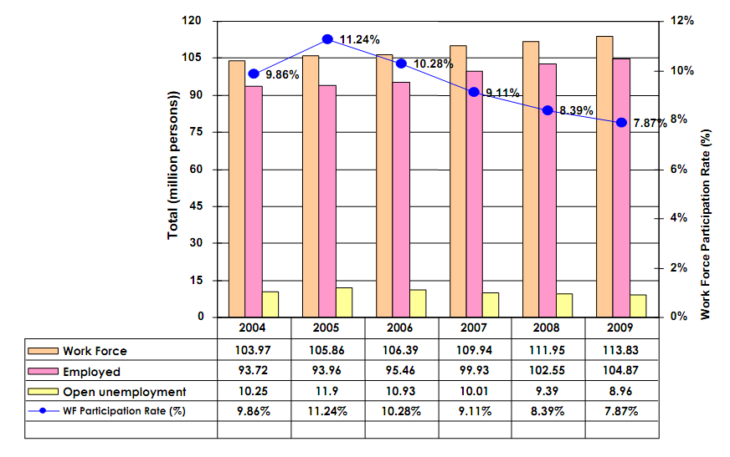
Source: Ministry of National development Planning/National Development Planning Agency of the Republic of Indonesia, Book I National Medium-Term Development Plan of 2010-2014, 2010
54. In tackling these problems and challenges, the Government of Indonesia has taken necessary steps to expand opportunities for better jobs and decrease levels of early productive age open unemployment; improve the quality of the work force through cooperation between governments, social counterparts, educational institutions and training providers; strive for the stability of minimum wage, which shall not increase beyond inflation rate, and encourage collective negotiation on individual wage agreements; create a balance between employment creation and social protection; equip workers with the competencies, certified in accordance with the needs of the labour market/industry; establish competency-based job training institutions according to labour market needs, and improve the investment climate.
55. Termination of employment which resulted in the increase of unemployment was prevalent in the beginning of the global economic crisis. The crisis impact on the real sector also resulted in the decline of employment. In late 2008, the layoffs started happening in various business sectors, especially industries, and multiplied in early 2009, concurrent with the expiration of production contracts, especially in the sectors with export orientation. Four ministers have issued a Joint Regulation concerning Maintenance of National Economic Growth Momentum in Anticipating Global Economic Development. The joint regulation is intended to avoid mass layoffs and encourage bipartite negotiations to resolve labour problems.
56. The Government also issued policy providing tax incentives for companies to avoid layoffs. Companies are also required to take measures such as the rearrangement of working hours (defensive restructuring) and conducting training for their workers so workers are ready to work with better productivity. Accordingly, the Government has encouraged the settlement of severance pay, and other worker rights to be negotiated jointly between unions and employers in the process of layoffs.
57. The number of small/medium enterprises reaches 3,755,238 million units, while big industrial enterprises are around 2,867 units. Industries in Indonesia composed of natural resource-based industries (45 per cent), labour-intensives industries (17 per cent), and capital-based, science-based and differentiated-based industries. Indonesia's industrial development is aimed at creating balance between small-medium scale and large industries. The development of capital-intensive and technology-based industries is to balance the labour-based and natural resources-based industries.
58. The informal sector, which is unorganized, unmanaged, and unregistered, has a major role in developing countries like Indonesia. It has several characteristics, such as smaller scale in business units, ownership by individuals or families, simple and labour-based technology, low education and low skills, low labour productivity, and relatively lower wages compared to the formal sector. Workers’ motivation in the informal sector is just to have income to sustain their life. Informal sector often supports formal sector by providing inexpensive inputs. It sometimes even subsidizes the formal sector workers with inexpensive goods and services.
59. The informal sectors that absorb a lot of labour in Indonesia are agriculture and trade. In this regard, the Government of Indonesia strives for better condition for workers engaged in these sectors, so that they can contribute more to development. It is conducted through labour-intensive programme for currently unemployed workforce in the agricultural sector, as well as efficient use of technology and entrepreneurial creation for employment in the trade sector.
60. Most of informal businesses fall under the micro, small and medium scale enterprises sector. In 2008, this sector employs 90,896,270 or 97.04 per cent of the market ability to absorb the workforce. This consists of the contribution of micro scale business (83,647,711 employees or 89.30 per cent), small scale business (3,992,371 employees of 4.26 per cent), and middle scale business (3,256,188 employees of 2.96 per cent). The absorption of micro, small and medium scale enterprises according to the sectors of economy in 2008 is as follows:
(a) Agriculture, livestock breeding, forestry and fishery: 42,460,064 employees;
(b) Mining and excavation: 641,463 employees;
(c) Processing industry: 10,463,416;
(d) Electricity, gas and clean water: 102,536;
(e) Building industry: 766,095;
(f) Trade, hospitality, and restaurant: 3,753,683;
(g) Transportation and communication: 3,753,683;
(h) Finance, Lease and company service: 2,657,545;
(i) Service: 5,737,406.
61. Measures taken to empower informal sector employees to be able to work in the formal sector include, inter alia, induction on basic sciences such as marketing techniques, basic financing, basic entrepreneurship (micro knowledge), business planning and etc. Ministry of Manpower and Transmigration has played an important role in providing the induction programme through training and competency enhancement in the Vocational Training Center (BLK). Moreover, the informal workers’ groups are also encouraged to establish a legal entity such as cooperatives to improve their condition.
62. Gender mainstreaming is one of the strategies used in reaching the goal and aim of the labour sector. In this regard, Minister for Manpower and Minister for Women Empowerment and Child Protection have signed a Memorandum of Understanding on the enhancement of the gender mainstreaming efficiency in the field of Manpower. This MoU aims at increasing efficiency of the programme planning, gender responsive activities and budget as well as their implementation, and the special measures promoting women’s right in the field of manpower. In terms of capacity building for labour, gender issues have become one of the factors to consider in deciding the participants of education programmes or trainings.
63. Various measures to reach gender equality in the field of manpower include the enactment of Law No. 13 of 2003, article 5, which guarantees that every worker has an equal opportunity to obtain employment without discrimination, and Article 6, which provides every worker the right to equal treatment without discrimination from employers. In addition, the Government of Indonesia also applies inter alia:
(a) Protection Policies, aiming at the protection of female reproductive function, such as menstruation and maternity leave, health protection as well as work safety for women;
(b) Corrective Policies, aiming at the enhancement of the position of female workers, such as the prohibition to lay off women for the reason of marriage, pregnancy or delivering baby;
(c) Non-discriminative Policies, aiming at reaching the equality of rights and responsibilities between male and female workers, such as wage, official work and etc.
64. The share of women in wage employment in the non-agriculture sectors has shown an increasing trend. Women in wage employment in non-agriculture sectors include those who are categorized as employees and casual employees not in agriculture. Based on Sakernas data, the share of women in wage employment in the non-agricultural sector has increased from 29.02 per cent in 2004 to 33.45 per cent in 2009. The total share of women in wage employment in both agricultural and non-agricultural sectors also increased from 29.55 per cent in 2004 to 33.45 per cent in 2009. The total number of women employees increased from 7.8 million in 2004 to 10.5 million in 2009. In the agricultural sector, women casual employee in agriculture increased from 1.6 million to 2.1 million, whereas those in the non-agricultural sector rose from 0.5 million to 0.9 million during the same period.
65. For persons with disability, State and private companies provide fair treatment and opportunity by employing them according to the degree of their disability, education level and capability. The job formation is adjusted to availability and qualification of the company, as stipulated in Law No. 4 of 1997 on persons with disability, particularly Article 14, and its elucidation. Indonesian Disabled People's Association noted that of the 6.7 million people with disabilities, the ratio of employed disabled persons in Indonesia prior to 2010 has reached only 0.5 per cent. In this connection, in 2011, the Government is committed to increase the number of jobs for persons with disabilities in society, in order to achieve a ratio of 1 per cent (one disabled workers for every 100 workers). In addition, the Government continues to encourage companies to provide employment for people with disabilities, both in formal and informal sectors, in accordance with the Law No. 4 of 1997.
66. On the other hand, older persons who have the potential to work are also offered to further use their knowledge, skills, abilities, and experience, as regulated in the Law 13 of 1998, especially article 15, for the welfare of older persons. Employment services were held in the formal sector and non-formal education, through individuals, groups/organizations or institutions, both by the Government and society. National Socio Economic Survey (Susenas) noted that the total number of older persons in 2009 reached 23 million people or 10 per cent of the total population of Indonesia. Elderly Commission on the study in 2010 noted that the Labor Force Participation Rate (LFPR) of older people is still quite high, as shown in the following table:
Participation level of elderly work force
Sex | General work force Participation level | Household workforce Participation level | Active in social activities
Male | 63.1% | 7.6% | 28.7%
Female | 33.6% | 45.6% | 20.5%
Source: Komnas Lansia/ Elderly Commission , 2010
67. With regard to workers’ social security, Law No. 3 of 1992 on workers’ social protection states that all employees are entitled to obtain protection through non-discriminative social safety programme, for both informal and formal workforce, aside from the social insurance for the poor which has already been regulated. In this regard, PT Jamsostek, a State-owned company tasked to administer the employee social insurance programme as promulgated by Law No.3 of 1992, has widen the scope of service and social safety scheme to informal workers (non-industrial relationship). The potential participants from informal workers are expected to reach approximately 67.86 millions. It is much larger than only 30 million formal workers. But until now, informal workers who participate in social safety programme of PT Jamsostek has just reached 223,000 workers. The lack of participation by workers in the informal social insurance is particularly caused by the absence of fixed-income for workers in the informal enterprises. The Government, in cooperation with PT Jamsostek, continues to encourage greater participation of workers in the informal social insurance by facilitating provision of membership and the payment procedure.
68. Chapter XII of Law No. 13 of 2003 regulates provisions on dismissal, for businesses with or without legal status, belonging to an association or to a legal entity, State, private, or social and other activities, which have management and employ labourers with salary/wage, or other forms of reward. Provisions in that Law are aimed at, inter alia, providing protection for workers from unfair dismissal and this mechanism is specifically regulated in article 151 Law No. 13 of 2003, which states:
(a) The entrepreneur, the worker/labourer and or the trade/labour union, and the government must make all efforts to prevent termination of employment.
(b) If the termination of employment remains inevitable, the intention to continue the layoffs must be negotiated between the entrepreneur and the trade/labour union, in which the affected workers/labourers are member, or between the entrepreneur and the affected workers/labourers who are not union members.
(c) If the negotiation mentioned under subsection (b) fails to result in any agreement, the entrepreneur may only terminate the employment of the workers/labourers after receiving a decision from the institution for industrial relations disputes settlement.
69. For workers who are dismissed unfairly, they can go through the process of industrial relations disputes settlement according to the mechanism stipulated in Law No. 2 of 2004, in conjunction with article 151 and article 155, paragraph 1, Law No. 13 of 2003. Other related matters are also regulated in the Minister for Manpower Decree No. Kep-150/Men/2000 on the Settlement of Dismissal and the Arrangement of Severance Pay, Reward and Compensation, and the Minister for Manpower and Transmigration Regulation No. Per.05/Men/III/2010 on Financial Support for Participants of the Social Insurance Program who are Dismissed.
70. To increase the quality of labour, the Government of Indonesia carries out various technical and vocational training programmes through Vocational Training Centers (Balai Latihan Kerja/BLK) under several technical Ministries, including the Ministries of Industry, National Education, Health, and Manpower and Transmigration. The entrepreneurship trainings are specially mandated within the National Medium Term Development Plan of 2010-2014. The technical and vocational trainings are designed to empower labourers, especially marginalized individuals, in order to enter or re-enter the labour market. Those include Competence-Based Trainings, Society-Based Trainings, Subsidized-Program Trainings, Internship Programs, Entrepreneurship Trainings, and Trainings for Transmigrants. To support the programme, the Government has revitalized BLK throughout the provinces in Indonesia by providing funds up to 5 trillion Rupiahs. Data from the Ministry of Manpower noted that in 2010, 8 institutions at the central level, 10 Centre Technical Implementation Units and 271 the Regional Technical Implementation Units, including BLK, Regional Productivity Training Institute and Transmigration Regional Training Center in 32 provinces have been revitalized.
71. To ensure the quality of labour entering the labour market, a number of standardizing programmes has been developed, such as Indonesian National Standard of Working Competence (Standar Kompetensi Kerja Nasional/SKKNI), Professional Certification Agencies (Lembaga Sertifikasi Profesi/LSP) and Labor Certification (Sertifikasi Tenaga Kerja/STK). National Council of Professional Standards (Badan Nasional Standarisasi Profesi/BNSP) established by the Government to handle labour certification has set its objective to provide certification for 5 million workers in Indonesia, throughout 2010 to 2015. Until 2010, BNSP have certified at least 861,442 Indonesian labour and 1,143,099 workers placed abroad.
72. To improve the capabilities of trainers in every training programme, several capacity building programmes have also been established, among others Mover Training Organizations (Pelatihan Penggerak Swadaya Masyarakat/PSM), Private Instructors Training, Basic Training and Upgrading Training for Trainers. Ministry of Labor stated that in 2010, there were 3,391 trainers and 7,138 intructors who were involved in ensuring the success of capacity-building programmes mentioned above.
73. Law No. 13 of 2003 guarantees that every worker has the right to decent income in order to have an adequate standard of living. To achieve that, the Government has enacted policies on minimum wage, overtime pay, and wage or salary rates to workers absent from work, wage for severance pay, and wage for the calculation of income tax.
74. To establish a decent income for labour, the Government has regulated Minimum Wage as stipulated in Minister of Manpower’s Regulation No. Per-01/MEN/1999 (Permenaker) in lieu of Minister of Manpower’s Decree No. KEP-226/MEN/2000 on Minimum Wage. The Regulation does not regulate minimum wage within a national scale, but regulates minimum wage regionally and locally, which consists of: Provincial Minimum Wage (Upah Minimum Propinsi); Municipality/District Minimum Wage (Upah Minimum Kabupaten); Provincial Sectoral Wage (Upah Minimum Sektoral Propinsi); and Municipal/District Sectoral Minimum Wage (Upah Minimum Sektoral Kabupaten). Such arrangement is conducted to anticipate the gap of needs and appropriate standard of living among regions.
75. The category of labour regulated in the minimum wage mechanism as stipulated in Minister of Manpower’s Regulation No. 1 of 1999 are workers working in industrial relations with entrepreneurs (companies). The Regulation has not covered informal workers, including domestic workers. Informal workers, including domestic workers, generally do not work under the contract, and relies on customs and local conditions. The Government continues the efforts to include informal workers, including domestic workers, in industrial framework.
76. The UMP and UMK are decided by the Governor based on the proposal of the Commission on Wage Research and Social Insurance of the Local Manpower Council, as the result of consultation with entrepreneur organizations, labour union (trade union), and related agencies in the local level. The UMP and UMK will then be examined annually by the National Research and Waging Council. The Government of Indonesia continually supports the improvement and increase of minimum wage to fit an appropriate living standard. The following table draws the increasing salary of workers in area of industry:
Average salary of workers under supervisor in industry by regions
2004-2009
(in thousand rupiah)
Region |  |  | West Java, Jakarta and Banten | Central Java and Yogyakarta | East Java and Bali | Others
2002 |  |  | 828.8 | 412.3 | 557.3 | 763.7
2004 | Quarterly | I | 1116.8 | 463.8 | 655.0 | 771.9
2004 | Quarterly | II | 1164.2 | 502.7 | 666.2 | 861.0
2004 | Quarterly | III | 1131.4 | 498.8 | 652.4 | 916.0
2004 | Quarterly | IV | 1072.6 | 525.9 | 690.6 | 940.6
2005 | Quarterly | I | 1098.6 | 553.3 | 661.3 | 1058.3
2005 | Quarterly | II | 1155.3 | 583.0 | 696.7 | 1005.0
2005 | Quarterly | III | 1152.3 | 639.5 | 695.6 | 1057.6
2005 | Quarterly | IV | 1116.6 | 671.7 | 658.5 | 1041.0
2006 | Quarterly | I | 1165.4 | 605.1 | 772.3 | 1160.9
2006 | Quarterly | II | 1176.1 | 681.4 | 848.9 | 1210.4
2006 | Quarterly | III | 1131.9 | 676.1 | 794.3 | 1298.1
2006 | Quarterly | IV | 1100.9 | 674.3 | 811.8 | 1273.1
2007 | Quarterly | I | 1190.4 | 698.6 | 826.2 | 1453.7
2007 | Quarterly | II | 1178.2 | 743.8 | 816.9 | 1283.2
2007 | Quarterly | III | 1259.0 | 689.4 | 788.1 | 1385.9
2007 | Quarterly | IV | 1322.2 | 673.2 | 819.0 | 1383.5
2008 | Quarterly | I | 1268.2 | 780.3 | 937.9 | 1280.5
2008 | Quarterly | II*) | 1225.3 | 758.2 | 955.3 | 1352.1
2008 | Quarterly | III*) | 1228.0 | 757.2 | 954.3 | 1340.9
2008 | Quarterly | IV*) | 1213.2 | 762.7 | 955.7 | 1354.5
2009 | Quarterly | I*) | 1242.7 | 793.7 | 967.5 | 1363.0
2009 | Quarterly | II*) | 1301.0 | 789.7 | 975.9 | 1334.1
2009 | Quarterly | III**) | 1344.4 | 791.5 | 992.1 | 1304.7
Notes: (*) temporary; (**) very temporary
Source: Central Board of Statistics of the Republic of Indonesia, 2010
77. Law No. 13 of 2003 guarantees the creation of decent working conditions for labour, which include guarantee and arrangements on working opportunities, industrial relations, protections, payment of wage, and prosperity.
78. Article 77 states that the accumulation of working hour is as many as 7 hours a day and 40 hours a week for 6 working days in a week, or 8 hours a day and 40 hours a week for 5 working days a week. Article 78 furthermore regulates that employers who require their workers/labourers to work longer than the regular working hours have to pay overtime as stated in Law No. 13/2003. Article 85 also states that workers/labourers who work on formal public holidays are entitled to receive overtime payment.
79. The workers are given the rights to take paid period of rest and leave as regulated in the articles 79-84 Law No. 13 of 2003, covering:
(a) The rest period between working hours at least half an hour after working for four hours consecutively and this period of rest shall not be inclusive of working hours;
(b) The weekly rest period is one day after six workdays in a week or two days after five workdays in a week;
(c) The annual leave is 12 workdays after the workers/labourers work for 12 months consecutively;
(d) A long period of rest of no less than two months shall be awarded in the seventh and eighth year of work each for a period of 1 month to workers/labourers who have been working for six years consecutively at the same enterprise, on the condition that the said workers/labourers will no longer be entitled to their annual period of rest in two current years. This provision shall henceforth be applicable every six years of work;
(e) Adequate opportunity to perform their religious obligations;
(f) Female workers/labourers are entitled to a 1.5 month period of rest before the time at which they are estimated to give birth to a baby and another 1.5 month period of rest thereafter;
(g) A female worker/labourer who has a miscarriage is entitled to a period of rest of 1.5 months;
(h) Proper opportunities to female workers/labourers whose babies still need breastfeeding to breast-feed their babies during working hours.
80. Government of Indonesia ensures that women, who have the same job qualifications, will not accept lower payments than male workers. In this regard, the Government of Indonesia has ratified ILO Convention 100 on Convention concerning Equal Remuneration for Men and Women Workers for Work of Equal Value through Law No. 80 of 1957, and ILO Convention 111 on Discrimination in Respect of Employment and Occupation through Law No. 21 of 1999.
81. Law No. 13 of 2003 gives protection to female workers from sexual harassment. In this regard, article 76 regulated that it is prohibited to employ female workers/labourers aged less than 18 years of age between 11 p.m. until 7 a.m. Meanwhile, the employers are obliged to ensure the security and decency/morality in the workplace for female workers who work in those hours.
82. In order to increase the protection of female workers against sexual harassment, the Ministry of Labor has compiled a guideline to prevent sexual harassment at work to be disseminated to all province and municipality/district manpower offices. National Commission on Violence against Women also has complaint service programme for abuses, including sexual harassment for domestic workers. In 2008, National Commission on Violence against Women has received 89 complaints but decreased in 2009 to 35 cases.
83. The Government has also enacted various laws and regulations to guarantee and improve safe and healthy working condition, such as the following:
(a) Law No. 1 of 1970 on work safety that regulates the work safety and health at the work place whether it is on the ground, at sea, and on air.
(b) Law No. 13 of 2003 on Employment, particularly article 86, where every worker/labourer has the right to receive protection on occupational safety and health, protection against immorality and indecency, and treatment that shows respect to human dignity and religious values. Moreover, article 87 stipulates that every enterprise is obliged to apply an occupational safety and health management system.
(c) To guarantee safe and healthy working condition, medical check-up shall be conducted at the beginning of the employment, annually, and post employment.
(d) For high risk equipments such as boiler, crane, etc, checks and tests need to be conducted in order to obtain permission on the usage.
(e) The operator of the said equipments shall be provided with adequate training and certification.
(f) The Threshold Limit Value (TLV) for physical agents as well as chemical substances at the work place is regulated to ensure safe working environment. For example: industrial company is obligated to equip its workers with earplugs to reduce noise or other self protecting tools.
(g) Occupational safety and health experts have been appointed in every company and Occupational Health and Safety Committee is established.
(h) The effort to implement those regulations is conducted by the labour inspector. Sanction to those who violate it shall be in a form of imprisonment or fine.
G. Freedom of association and collective bargaining of the workers
84. Freedom of association and the right to organize is stated in the 1945 Constitution, in particular article 28 E (3) that states: “every person have the right to unite, gather, and express their thoughts.” Specifically, Indonesia has also ratified ILO Convention No. 87 on Freedom of Association and Protection of the Right to Organize, also Law No. 21/2000 on Worker/Labor union , and the Decision of the Minister of Labor no. Kep. 16/MEN/2001 on the guidelines of workers/labour union registration. In these regulations, worker union can be formed by at least 10 workers in one company, but there are also some which are formed outside the company.
85. Article 28 of Law No. 21 of 2000 on Labor Union states that persons are prohibited from preventing workers to form, join or leave a union, or carry out union activities. The prohibition includes: dismissal, suspension, or otherwise prejudicing a worker in his/her employment; withholding or reducing wages; intimidation; campaigning against the establishment of a union.
86. Sanction for the violation is regulated in the Law No. 21 of 2000, article 43, which is:
(a) Anyone who obstructs or forces the worker will be given a prison sentence of 1 to 5 years and/or a fine of Rp 100,000,000.00 to Rp 500,000,000.00;
(b) The violation is categorized as a crime.
87. The establishment of tripartite and bipartite cooperation institution empowers workers unions to represent workers in collective bargaining. Government Regulation no. 46 of 2008 in lieu of Government Regulation no. 08 of 2005 regulates the working guidelines and the organization structure of the Tripartite Cooperation Institution. Up to 2010, 380 units of Bipartite Cooperation Institution, 1 units of Tripartite Cooperation Institution at the national level, 31 units of Tripartite Cooperation Institution at the provincial level, and 310 units of Tripartite Cooperation Institution at the municipality/district level have been formed.
88. Prior to 1998, monolithic system was widely known. There was only one labour union in Indonesia, namely Indonesian Labor Union (Serikat Pekerja Seluruh Indonesia/SPSI). Pluralistic system has been applied since the reformation era. Currently, there are 3 labour union confederations, namely Confederation of Indonesian Trade Union (Konfederasi Serikat Pekerja Indonesia/KSPI), Confederation of All Indonesian Trade Union (Konfederasi Serikat Pekerja Seluruh Indonesia/KSPSI), and Confederation of Indonesia Prosperity Trade Union (Konfederasi Serikat Buruh Sejahtera Indonesia/KSBSI) along with 91 federations and 11 PUK Employment Board Unit with 3,414,455 members. Labor unions have the right to, inter alia: formulating a memorandum of understanding with the company, representing labour and workers in industrial and employment relations.
89. The right to strike is regulated by law, particularly Law No. 13 of 2003, chapter 8 on Institutions/Agencies for the Settlement of Industrial Relation Disputes, article 137 to 145. Article 137 states that work strike as an impact of negotiation failure is a basic right of labour and the unions as long as it is conducted in a legal, peaceful and orderly manner. The legal condition of conducting a work strike is also regulated in article 139 and 140. Work strike that does not fulfil the stated prerequisite is an illegal strike. The right to strike has been conducted by several labour unions in Indonesia.
90. The limitation on work strike is regulated in Law No. 13 of 2003 article 139, which stated that “The implementation of strike staged by the workers/labourers of enterprises that serve the public interest and/or enterprises whose types of activities, will lead to the endangerment of human lives, shall be arranged in such a way so as not to disrupt public interests and/or endanger the safety of other people.”
91. The regulation of Indonesian Police Chief No. 1 of 2005 on Police guidelines in industrial relations disputes also regulates police authority to deal with work strike.
92. In the efforts to guarantee the protection against unfair dismissal, the government ratified the ILO Convention No. 98(1949) on Right to Organise and Collective Bargaining Convention through Law No. 18 of 1956, and enacted Law No. 2 of 2004 on Industrial Relations Disputes Settlement, which is the follow up of Law No. 13 of 2003.
93. Collective negotiating mechanism is further regulated in the Law No. 13 of 2003, which focuses on the bipartite principle in any industrial relations disputes settlements. One of its articles stipulates that the industrial relations disputes settlements put the principle of bipartite as its priority. If an agreement could not be reached, the settlement will undergo the mechanism that is regulated in the Law No. 2 of 2004, which covers four kinds of disputes: (1) disputes on rights; (2) disputes on interest; (3) disputes on dismissal; and (4) disputes between workers/labour union in a company. Parties to settle the industrial relations disputes include the mediator, the conciliator, and the arbitrator.
94. In that regard, the Government also encourages that the settlement of severance pay and other labour rights related to the layoff process to be discussed among the labour unions and the employers. The role of the Government is limited to facilitating the negotiation related to policies, which require further discussion between the Government, employers, and labourers, as stipulated in Government Regulation No. 46 of 2008 in conjunction with Government Regulation No. 08 of 2005 on Working Procedure and Organizational Structure of the Tripartite Cooperating Institution. The Government has also completed a regulation on the Implementation of Labor Social Insurance through the enactment of Government Regulation No. 01 of 2009 in conjunction with Government Regulation No.14 of 1993.
95. The number of industrial relations disputes has decreased significantly. Statistics of the Ministry of Empowerment and Transmigration noted that in 2009 discharged labourers case in industrial relations settlement is around 4,879 cases involving 30,181 labourers. Meanwhile, in 2010 the number decreased to 1,432 cases involving 16,393 labourers. The number from the perspective of discharged labour has also declined significantly. In 2005, the number of discharged labourers is around 109,382 persons whereas in 2010 the number declined to 85.01 per cent or around 16,393 labourers. This number shows conducive relations between employers and labourers. However, the number of industrial relations mediators which are only 1,198 persons to settle 214,936 companies remains an obstacle.
H. Social insurance
96. Article 28H, paragraph 3 of the 1945 Constitution ensures that everyone has the right to social insurance, which enables oneself to develop fully as a dignified human being. Article 34 paragraph 2 further states that the State shall develop social security system for all citizens and empower the poor and less fortunate in accordance with human dignity. The 1945 Constitution also compels the State, through Article 34 paragraph 1, to care for the poor and abandoned children.
97. To implement the guarantee of such right, the Government has stipulated Law No. 40 of 2004 on National Social Security System and further strengthened by Law No. 11 of 2009 on Social Welfare, which replaces Law No. 6 of 1974 on Basic Provisions of Social Welfare.
98. Law No. 40 of 2004 sets up National Social Security System as a social protection to ensure the fulfillment of basic needs for a decent life for every participant and/or family member. The system is expected to fulfil the basic public services, including: health insurance, work accident insurance, pension, and life insurance. For workers who cannot afford the premiums for social insurance, Law No. 11 of 2009 has guaranteed that the Government provides social welfare insurance premiums, which are paid by the Government, as well as sustainable direct assistance.
99. Health insurance is conducted nationally on the basis of social insurance and equity principles. Health insurance is aimed at ensuring that participants obtain health care benefits and protection in fulfilling basic health needs. The participant of health insurance is any person who has paid insurance premium or whose premiums are covered by the Government. Families of participants are also eligible to receive health insurance benefits. Each participant can also include other dependent family members with the additional premium.
100. Participation of health insurance is valid for no longer than 6 months since the participant is laid-off. If the participant is poor and has not been able to get a new job, premium will be paid by the Government. Premium will also be paid by the Government for participants who experienced a total permanent disability.
101. The health insurance benefits are provided in the form of individual services, that comprise promotion, prevention, curative and rehabilitation health care services, including consumable drugs and medical materials. Health insurance benefits are provided at the State health facilities as well as private facilities participating in the Social Security System. In an emergency, the services referred to may be given to the health facilities that are not in the Social Security System. If the eligible health facilities which meet the medical needs of a number of participants are not available at certain areas, the National Social Security System must provide compensation.
Variations in the benefit package of social health insurance programmes in Indonesia
Benefits | Health Insurance Programme | Health Insurance Programme at District Level | Health Insurance | Employment Social Insurance
First Level of Outpatient | Covered | Covered | Covered | Covered
Advanced Level of Outpatient | Covered | Covered | Covered | Covered
First Level of inpatient | Covered | Covered | Covered | Covered
Advanced Level of inpatient | Covered | Covered | Covered | Covered, 60 days annually per disability
Catastrophic Benefits (hemodialisis, heart surgery, etc) | Covered | Covered, except if tools/experts are not available in the facilities | Covered | Not covered
Particular Benefits | Eyeglasses, hearing aid, mobility aid/wheelchair etc | Eyeglasses, hearing aid, mobility aid/wheelchair etc | Eyeglasses, hearing aid, mobility aid/wheelchair etc | Eyeglasses, hearing aid, mobility aid/wheelchair etc
Exceptions | Services not in accordance with the procedures, infertility, cosmetics, natural disasters, social services, dental protesis | Services not in accordance with the procedures, infertility, cosmetics, natural disasters, social services, dental protesis | Services not in accordance with the procedures, infertility, cosmetics, | Services not in accordance with the procedures, infertility, cancer therapy, hemodialicis, etc
Thalasemia Benefits | Covered, including for non-participants | No information but explicitly not mentioned in the exception sections. | Covered | Not covered due to congenital abnormalities
Source: End of year report on poverty assessment programme for poor families in the health sector, TNP2K Vice President Secretariat, Jakarta, 2010
Variations in access to health insurance programme on health-care facilities
Benefits | Health Insurance Program | Health Insurance | Employment Social Insurance
First Level of Outpatient | Centre for Community Health, Village Midwife, and village policlinic | Centre for Community Health and family clinic | Centre for Community Health, clinic and physician
Advanced Level of Outpatient | Municipal/District, Provincial, and National General Hospitals | Municipal/District, Provincial, National General Hospitals, and Private Hospitals | Municipal/District, Provincial, National General Hospitals, and Private Hospitals
First Level of inpatient | Centre for Community Health and village policlinic | Centre for Community Health, with bed | Centre for Community Health, with bed
Advanced Level of inpatient | Municipal/District, Provincial, and National General Hospitals | Municipal/District, Provincial, National General Hospitals, and Private Hospitals | Municipal/District, Provincial, National General Hospitals, and Private Hospitals
Catastrophic Benefits (hemodialisis, heart surgery, etc) | Municipal/District, Provincial, and National General Hospitals | Municipal/District, Provincial, and National General Hospitals | Not covered
Particular Benefits | Municipal/District, Provincial, and National General Hospitals | Municipal/District, Provincial, National General Hospitals, and Private Hospitals | Municipal/District, Provincial, National General Hospitals, and Private Hospitals
Source: End of year report on poverty assessment programme for poor families in the health sector, TNP2K Vice President Secretariat, Jakarta, 2010
102. Since 2005, The Government of Indonesia has developed health insurance programme for society through Health Insurance for the Poor (Asuransi Kesehatan Masyarakat Miskin/ASKESKIN). In 2008 until recently, the programme has been changed to National health security programme (Jaminan Kesehatan Masyarakat/JAMKESMAS). The aim of JAMKESMAS program is to increase the access and quality of health services for all communities that are very poor, poor and incapable to achieve optimal health standard, effectively and efficiently (quality and cost controllable). Budget resources of JAMKESMAS is allocated through State Budget (APBN) in the form of social aid through social insurance mechanism.
103. The Government targets universal coverage on health insurance in 2014 with the main programme for 76.4 million population. That figure includes 60.4 million of poor population; 2.6 million populations in prisons, child nursing home and displaced person without identity; and 13.4 million poor people that is not covered by the JAMKESMAS quota. Statistics of Ministry of Health noted that the health insurance membership in June 2010 amounted to 43.98 per cent. Furthermore, the statistics noted that JAMKESMAS has been conducted in 250 municipalities/districts, 185 of them cooperate with the Health Insurance LLC (PT. Asuransi Kesehatan/PT. Askes) and 45 manage independently. Four provinces have reached universal coverage namely South Sumatera, South Sulawesi, Bali and Nanggroe Aceh Darussalam.
104. The Government has made continuous efforts to improve the implementation of JAMKESMAS program, from increasing its service quality and access, accountability of budget, to the transparent and clean administration arrangement. Budget for JAMKESMAS Program has increased significantly. In 2005, the Government supplied budget up to Rp 2.1 trillion and increased to Rp 5.125 trillion in 2010. Furthermore, during 2008-2010, JAMKEMAS has increased its referral service facility.
Budget allocation for national health security programme (JAMKESMAS)-2005-2010 (in trillion rupiah)

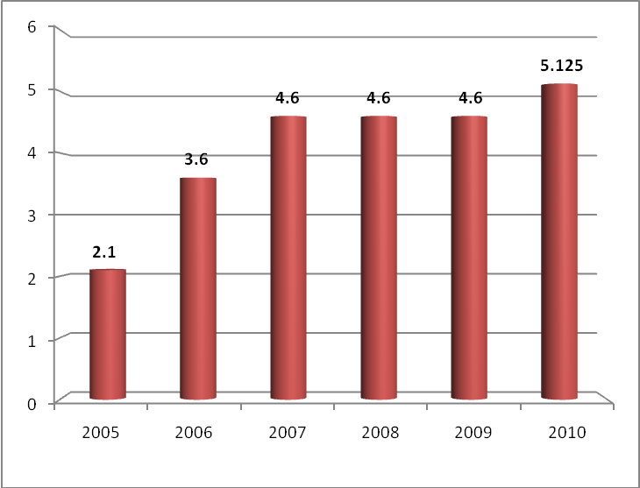
Source: Ministry of Health of the Republic of Indonesia, Presentation in National Meeting on Family Hope Program Regional 1 Yogyakarta, 21 March 2011
Health services access of JAMKESMAS-2008-2010
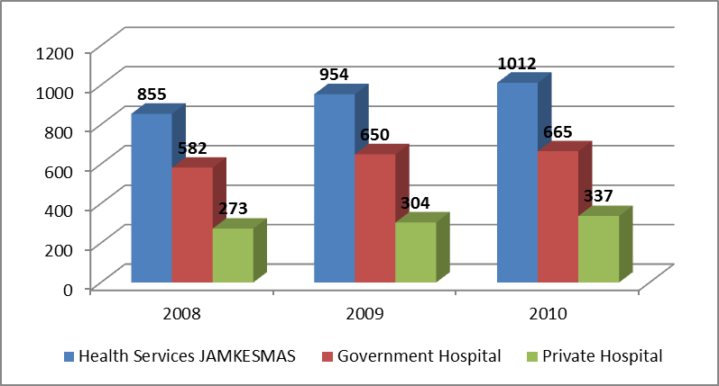
Source: Ministry of Health of the Republic of Indonesia, Presentation in National Meeting on Family Hope Program Region 1 Yogyakarta, 21 March 2011

105. Work accident insurance is organized nationally based on the social insurance principle. Participants who suffer occupational injuries are entitled to health service based on their medical needs and receive benefits of compensation, if such accident has caused a permanent disability or death. Insurance benefits for fatal work related accidents are transferred to the worker’s inheritor. The medical benefits are delivered through health facilities belonging to the Government or private companies that are under the scope of National Social Security System (Sistem Jaminan Sosial Nasional/SJSN). In an emergency situation, the service is still provided by health facility that is not covered by the SJSN system. In case of occupational accident occuring in certain areas that has no standardized health facility, SJSN must provide compensation to meet the medical needs of the participants.
106. Old age insurance/pension organized nationally based on the social insurance principle or compulsory saving. Pensions were held with the aim to ensure that participants maintain an adequate standard of living and receive compensation when they enter their retirement age, experiencing total permanent disability or death. The benefit of old age insurance in the form of cash will be paid when participant enters the age of retirement, death, or experiences total permanent disability. The amount of pension insurance is determined based on the entire accumulated premium that has been deposited including the interest/investment benefits. Payment of the pension benefit may be granted partly to a certain limit, if the membership has lasted for at least 10 years. If the participant passes away, his/her heir has the right to receive the benefit of old age insurance.
107. Pension insurance is held based on certain benefit, in monthly cash payment with these conditions:
(a) Old age pension, received by the participant after they retired until they died;
(b) Safety pension, received by the participant that has become defected due to accident or illness;
(c) Pension for widow/widower, received by widow/widower of the participant until they die or remarry;
(d) Pension for children, received by the participant’s children until they are 23 years old, employed or getting married; or
(e) Pension for parents, received by the parents of the unmarried participant until certain time limit that is determined by law.
108. Benefit of pension is compensated for the participant that has reached retirement age based on the determined formulas. If the participant passes away and has accomplished period of membership for 15 years, their inheritor has the right to receive pension. If the participant reached pension age before the membership period of 15 years, then they have the right to get all the accumulation of their premium including the interest. Right of the inheritance will be over if the child got married, is employed, or turns 23 years. Participants who experience total permanent disabilities even though they have not entered their pension age are entitled to receive pension benefits.
109. Law No. 11 of 1969 on Pension for Civil Servants and the Widow/Widower stated clearly that there is no difference between rights received by women or by men. Every civil servant has right for pension according to the law, inter alia:
(a) Civil servants who have received honorable discharge are entitled to receive employee pension if, at their termination of service, they have reached the age of 50 years at the minimum.
(b) Civil servant whose service has been terminated or discharged from his/her job due to the deletion of his/her position (as a result of restructurization), employee rotation, arrangement of State officials, or for other official reasons, and consequently this employee is no longer hired as civil servant, he/she has the right to receive employee pension with a condition that the employee has reached the minimum age of 50 years and has worked for 10 years at the minimum.
(c) Civil servant who has finished his/her official duty and no longer hired as civil servant has the right for pension if he/she has been honorably discharged and at his/her termination of service has reached the minimum age 50 years and has worked for at least 10 years.
110. The pension which will be received by the civil servant every month is 2.5 per cent of the base pension for every working year, with the conditions that:
(a) The pension of a civil servant ranges from 40 per cent to 75 per cent of the base pension;
(b) The monthly pension as stipulated in Article 9 (1) letter b of Law No. 11 of 1969 is maximum 75 per cent of the base pension;
(c) Monthly pension of a civil servant shall not be less than the lowest basic salary which is stipulated in a Government Regulation on salary and rank for the particular civil servant.
111. Life insurance is aimed at giving compensation that will be paid to the successor of late participants. Benefit of death insurance can be paid in cash within 3 working days after the claim is received. The amount of this life insurance is determined based on the certain amount agreed.
112. In performing SJSN as mentioned above, Government has created National Social Insurance Council and Social Security Organizing Board (Badan Penyelenggara Jaminan Sosial/BPJS) that consists of:
(a) PT Jamsostek (Workers Social Insurance);
(b) PT Taspen (Civil Servant Old Saving Scheme);
(c) PT ASABRI (Armed Forces Social Insurance Scheme);
(d) PT Askes (Health Insurance).
113. The Law establishing the BPJS was passed by the Parliament on 28 October 2011. The endorsement of the BPJS Law makes it the country’s first social security programme representing universal health insurance coverage. The law will create a single State entity in 2014 that will cover health care. Those with a regular income will have to pay monthly premiums, while the Government will pay premiums for people who are poor or unemployed. In 2015 a second BPJS will cover life insurance, work accident insurance, civil service pensions and old-age pensions. Under the law, workers and the poor will be provided full protection and coverage even for severe or complicated illnesses. The BPJS Law requires that the four existing State-owned insurers — Askes, ASABRI, Jamsostek and Taspen — make fundamental changes in their operations in order to qualify as BPJS social security providers, including greater budgetary transparency and a change to non-profit status.
114. Law No. 3 of 1992 on Social Insurance for Labor regulates that all labourers are entitled to have protection from JAMSOSTEK program. JAMSOSTEK consist of Pension Insurance (Jaminan Hari Tua/JHT), Occupational Accident Insurance (Jaminan Kecelakaan Kerja/JKK), Life Insurance (Jaminan Kematian/JK) and Health Care Insurance (Jaminan Pemeliharaan Kesehatan/JPK) for labour in formal and informal sectors and construction services (contract/casual/seasonal labour). The number of labour membership in JAMSOSTEK Program during 2006-October 2010 has increased as shown in this statistic:
Participants (workers) of JAMSOSTEK, 2006 – October 2010
Programme | 2006 | 2007 | 2008 | 2009 | Oct 2010
JKK, JHT, JKM
Active | 7,719,695 | 7,941,017 | 8,219,154 | 8,495,732 | 9,225,079
Non-Active | 15,361,672 | 15,788,933 | 18,407,661 | 20,534,941 | 22,191,573
Total | 23,081,367 | 23,729,950 | 26,626,815 | 29,030,673 | 31,416,652
JPK
Workers Single | 519,083 | 659,211 | 823,285 | 695,309 | 811,235
Workers Married | 767,250 | 948,503 | 1,089,759 | 1,176,113 | 1,340,110
Workers Family | 3,063,820 | 3,597,177 | 2,279,417 | 2,531,103 | 2,831,910
Total | 4,350,153 | 5,204,891 | 4,192,461 | 4,402,525 | 4,983,255
Construction Service | 2,681,635 | 3,332,959 | 3,627,721 | 5,167,848 | 3,081,803
Source: PT JAMSOSTEK, Partcipants of JAMSOSTEK 2006-2010
115. Social Insurance for Civil Servant managed by PT. Taspen in form of Saving and Insurance consists of Pension Saving (Tabungan Hari Tua/THT), including Life Insurance and Pension Program. Statistics of PT. Taspen noted that the number of THT participants has increased annually by 1 per cent-5 per cent, and until the end of 2010 has reached 4,702,103 participants, composed of 4,582,574 Civil Servants, and 119,529 State-Owned Enterprise Officials. The number of Civil Servant receiving pension is 2,361,408 persons.
116. Social Insurance for Military and Police Members as well as Civil Servants in the Ministry of Defence managed by PT. ASABRI in form of Social Insurance including the old-age savings (THT), Death/Accident Benefit and Pension Program. Statistics of PT. ASABRI noted that in the end of 2008 the number of participants of THT was 854,854 persons and the number of paid pension amounted to 284,836 persons. The number of THT participants had increased to 832,948 persons in 2010 and 872,522 persons in 2011, while the number of persons receiving pension also increased to 300,885 in 2010 and 309,182 in 2011.
117. Civil Servants as well as Military and Police Members including their families are also covered by health insurance managed by PT Askes.
I. Right to establish a family
118. Article 28B of the 1945 Constitution guarantees the right of any person to form a family and to continue their family line through a legitimate marriage. Furthermore, the Government guarantees the right of all, particularly women, to wed and form a family according to his/her will and without any force. That guarantee is stipulated in Article 6 (1) of Law No. 1 of 1974 on Marriage, which states that Marriage is formed by the agreement between the groom and bride and reiterated in Article 10 of the Law No. 39 of 1999 on Human Rights.
119. According to article 5 sub paragraph (a) of Law No. 52 of 2009 on Population Growth and Family Development, men and women have the equal right to marry without any discrimination. It is also stated that to be legally married the minimum age for men is 19 years old and for women is 16 years old.
120. Article 2 (2) Law No. 1 of 1974 states that any marriage shall be registered according to current applicable law. The Government Regulation No.9 of 1975 Article 2 (1) on the Marriage Registration stipulates that the aim to register a marriage is to provide legal certainty and guarantee of the implementation of rights and responsibilities of husband and wife in a family, including the guarantee of the rights of women and children in the family.
121. In addition, to provide protection of women’s rights in a marriage, Presidential Instruction No. 1 of 1991 on the Compilation of Islamic Law is enacted. The Instruction outlines, inter alia, the right of women as stated in article 16 (1): marriage is based on the agreement between bride and groom. Article 17 (2) further states that if the marriage does not obtain agreement from both sides, the marriage shall not proceed. This regulation also accommodates the interest of person with disability, as stated in article 17 (3): To the bride or groom with hearing and speaking disability, their agreement can be in the form of an understandable writing or sign language. Article 79 stipulates that the wife and the husband have an equal rights and position in the household and community.
122. Furthermore, Law No. 12 of 2006 on Citizenship guarantees the dual citizenship for children from mixed marriage until the age of 21 years old. The Law provides guarantee for Indonesian women who marry a foreign citizen to keep or follow their husband citizenship. So far, the implementation of the Law is considered effective. Data from Indonesian representatives abroad shows that the registration of children from mixed marriage has been increasing. This generates a positive impact which is the sense of psychological certainty for the Indonesian women who marry a foreign citizen in order to anticipate and guarantee the children born from the marriage.
123. In terms of efforts to provide social service for family, from 2007 the Ministry of Social Affairs has enacted the Family Hope Program (Program Keluarga Harapan/PKH), focusing on poor families, and covers special scheme for pregnant mother, breastfeeding mother or mother with school-aged children amounted to 2.2 million per household. The Government targeted PKH for 1.17 million poor families in 2014 with budget amounted to Rp 1.765 trillion. The Government had increased PKH budget from Rp 1 trillion in 2007 to Rp 1.61 trillion in 2011. Statistic of Ministry of Social noted that the number of PKH beneficiary had increased from 387,928 families in 2007 to 830,484 families in 2010 and currently, it is being implemented to achieve 1,020,484 families in 2011.
Family hope programme-2007-2011
Source: Ministry of Social Affairs of the Republic of Indonesia, 2011
124. The Government also provides various assistance programmes aiming at supporting family, which include, inter alia, Rice for the Poor, Community Health Insurance, School Operational Assistance, and Direct Cash Assistance. There are also programmes for community empowerment through National Program for Community Empowerment (PNPM Mandiri), and development for micro, small, medium and cooperative business through providing credit guarantee scheme, which goal is to increase the family welfare. PNPM Mandiri consists of the Programs to Develop Subdistricts, Programs to Eradicate Poverty in Cities and the Acceleration of Development in the Special and Underdeveloped Areas. From 2008, this programme is expanded to cover the Program to Develop Regional Social and Economic Infrastructure.
125. In order to achieve the MDGs target for accelerated reduction in Maternal Mortality Rate (MMR) and Infant Mortality Rate (IMR), the Government of Indonesia made a breakthrough by establishing the Delivery Insurance Program (Jaminan Persalinan/Jampersal). Delivery insurance is a guarantee of financing for antenatal services, delivery assistance by health personnel, and postpartum services, including maternal care of newborns, postpartum family planning services, and exclusive breastfeeding counseling. The programme is targeted to all pregnant women who do not have health insurance and who want to use basic service facilities, such as delivery personnel, community health centres and their networks, as well as third-class hospital referral.
126. For Civil Servants, maternity leave is given for 3 months, as stipulated by article 19 of Government Regulation No. 24 of 1976 on Leave of Civil Servants. The length of maternity leave is one month before and 2 months after delivery. The Article states that for the first, second, and third delivery a female civil servant is entitled to maternity leave. For the fourth delivery and so on, the female civil servant is entitled to obtain unpaid leave of absence.
127. Maternity leave for female workers of the private sector is stipulated in article 82 of Law No. 13 of 2003 on Labor, which states that female workers are entitled to maternity leave for 1.5 months before and 1.5 months after delivery. Female workers who experience miscarriage are also entitled to have a leave of absence for 1.5 months.
128. Paternity leave has not been specifically addressed in the regulations in Indonesia. Nevertheless, many private companies have accommodated these arrangements through their respective regulations referring to the Law No. 13 of 2003. One example is article 93 of Law No. 13 of 2003 which guarantees the right to time offs when his wife is giving birth or experiencing miscarriage (leave of absence paid for two days).
129. The minimum age for admission to employment for children in Indonesia is 15 years, in accordance with Law No. 20 of 1999 on the Ratification of ILO Conventions No. 138 on Minimum Age for Admission to Employment. The minimum age requirement is in fact the age of children who have completed 9 years compulsory education. Law No. 13 of 2003 prohibits employers to hire and involve children in the worst forms of labour.
130. In the effort to protect the rights of children and youth, the government has set and taken strategic measures through the formulation and adoption of various National Action Plans, as follows:
(a) National Action Plan on Elimination of Commercial Sexual Exploitation of Children;
(b) National Action Plan on Elimination of Trafficking in Women and Children;
(c) National Action Plan on Elimination of Worst Forms of Child Labour;
(d) National Action Plan on Education for All in the Year of 2015;
(e) The National Program for Indonesian Children 2015;
(f) The Vision of Healthy Indonesia 2010; and
(g) National Action Plan on Youth Reproductive Health.
131. In regard to the protection of the rights of refugees, in many cases Indonesia provides humanitarian assistance to refugees and their families who often made Indonesia as their transit country. Even though Indonesia is not a Party to the 1951 Geneva Convention and 1967 Protocol, Indonesia respects the fundamental rights of the refugees, including their rights to reunification with their families, as well as the interest of their children. Data of the Directorate General of Immigration, Ministry of Law and Human Rights, indicates that there were 1,178 refugees who entered Indonesia in 2009, and 1,245 in 2010.
132. Efforts to eliminate domestic violence are stipulated in Law No. 23 of 2004 on the Elimination of Domestic Violence, which is implemented by a number of national, provincial and regional policies. Government Regulation No. 4 of 2006 on the Implementation and Cooperation for the Recovery of Domestic Violence Victims is a guideline for the implementation of the efforts. The Government of Indonesia has also established a coordinated network for the elimination of domestic violence through the State Minister Regulation No. 1 of 2007. This regulation enables cooperation between Special Service Unit (now called the Children and Women’s Service Unit) at the national and local level, as well as Integrated Crisis Centres at hospitals. The State is equipped with the rules and policies, as well as the establishment of various treatment centres and service institutions to eradicate domestic violence. The rules, policies and programmes also provide opportunity for the community to participate actively in fighting domestic violence.
133. To strengthen the legal foundation for transnational crime involving violence or exploitation against human, Indonesia has enacted Law No. 5 of 2009 on the Ratification of the UN Convention against Transnational Organized Crime. Indonesia has also ratified the Protocol to Prevent, Suppress and Punish Trafficking in Persons, Especially Women and Children by Law No. 14 of 2009, and the Protocol against the Smuggling of Migrants by Land, Sea and Air, Supplementing the United Nations Convention against Transnational Organized Crime by Law No. 15 of 2009, as an embodiment of the commitment to prevent and combat transnational organized crime, including smuggling of migrants.
134. In order to strengthen the efforts to the prevention, treatment, and settlement of trafficking cases, Indonesia has completed relevant legislations on trafficking in persons by enacting Law No. 21 of 2007 on Combating Criminal Act of Trafficking in Persons. The Law governs the fulfillment of the victim’s right to justice. The Law regulates a number of sanctions, both administrative sanction (for the corporation perpetrator) and sanction of imprisonment and fine. The Law also protects children from criminal acts of trafficking in persons as defined in Article 5 and 6, which regulate the crime of trafficking in persons for the purpose of adoption and internal and external child trafficking. This provision strengthens article 13 b Law No. 23 of 2002 on Child Protection, which provides protection of children from exploitation, both economically and sexually.
135. To increase its protection, the Government of Indonesia has established Special Task Force to Combat Trafficking in Persons based on Presidential Regulation No. 69 of 2008. In addition, Government Regulation No. 9 of 2008 is enacted to provide integrated procedures and mechanisms for the treatment of witnesses and victims of trafficking in persons.
136. To date, there have been 20 Task Forces established in provincial levels, and 72 in district/municipal level. There are 7 major concerns of the Task Force, namely: (i) Prevention and Child Participation, (ii) Rehabilitation of Health, (iii) Social Rehabilitation, Repatriation and Reintegration, (iv) Development of the Rule of Law; (v) Law Enforcement, (vi) Commercial Sexual Exploitation of Children, (vii) Coordination and Cooperation. Those tasks are carried out by prevention strategies with activities such as dissemination, advocacy; indictment and mediation service; and empowerment by rehabilitation, reintegration, and reunification.
137. The Government has also established various institutions to support those Task Forces, one of which is the Integrated Services Center for Women and Children Unit (P2TP2A). The agency provides integrated activities and services for victims of trafficking and violence.
138. Another institution which provides services to victims of trafficking in persons is the Ministry of Social Affairs. This Ministry focuses on the recovery of the victim’s physical and psychological condition. To date, the Ministry of Social Affairs has established service centres for victims of trafficking in persons, consisting of Trauma Center and Safe Houses (RPTC), Shelters for Women (RPSW), and Shelters for Children (RPSA).
139. In addition to government agencies, there is an independent national commission that handles victims of trafficking, namely the National Commission on Violence against Women (Komnas Perempuan). The Commission is in charge of creating the conditions for the elimination of all forms of violence against women and for the enforcement of women's rights. The Commission has developed a complaint mechanism for women victims of trafficking, called the Reference-Only Complaint Unit (UPR). Not only does this unit do direct assistance to victims who made complaint, but also identify their needs and refer them to agencies that can provide further assistance.
140. The Government of Indonesia has established a National Action Plan on Combatting Trafficking in Persons. The Plan comprises actual steps which include medical rehabilitation, social rehabilitation repatriation, and reintegration, development of legal norms and law enforcement for the traffickers. The Plan has become the basis of various regional action plans that will be implemented at the regional level, in accordance with typical problems in the area. For example, the Regional Action Plan proclaimed by Sumbawa Regency Decree No. 12 of 2010 contains efforts to prevent trafficking and care for victims in the area.
141. Records and reports on trafficking cases have been conducted in 15 provinces and 242 districts/municipals. From March 2005 to June 2010, the number of victims identified and assisted was 3,642 people, consisting of 3,298 female victims (nearly 90 per cent). The Government has also launched a website (www.gugustugastrafficking.org) to provide information about trafficking cases.
142. The support from central and regional government to fight trafficking is implemented by the allocation of special funds to deal with female victims and policies that support special services. Government agencies such as police and hospitals, independently or in cooperation with other parties, have made some forms of capacity building by preparation of guidelines for victim services, prevention and treatment guidelines, training, handling of victims of violence, the development of community health centres capable of managing cases of gender-based violence, and training of law enforcement in handling cases of violence. In addition, the Government also conducts capacity-building for the immigration officials at the embarkation and debarkation as well as analyzing human rights basis for legislation and MoU on Labor.
143. In order to complement efforts at the national level, The Government of Indonesia, along with the governments of Australia, initiated the Bali Process on People Smuggling and Combating Trafficking in Persons since 2002. This process is the only process in the Asia-Pacific region handling the problem of human smuggling by involving the countries of origin, transit, and destination. Since its establishment, the Bali Process has conducted 3 meetings of Bali Process Regional Ministerial Conference (BRMC). Since the third BRMC, Bali Process began to move towards practical and concrete action. This can be seen from a number of action items agreed such as, the establishment of networks of immigration officials at major airports in the Asia Pacific region (Regional Immigration Liaison Officers Network)/RILON; the improvement of the integrity of visa services, and increasing cooperation to address the problem of people’s smuggling by the sea. In addition, the Bali Process Ad Hoc Group meeting has also established several principles that need to be put forward in an effort to strengthen cooperation among countries of origin, transit, and destination. The principles are shared responsibility and consistent approach in the protection, resettlement, and repatriation, including the need to criminalize people smuggling and trafficking in persons consistently among countries in the region.
J. The right to continuous improvement of living conditions
144. The Government of Indonesia is committed to improve the living condition of its people as mandated in the 1945 Constitution article 28H (1), which states that every person shall have the right to live in physical and spiritual prosperity, to have a home and to enjoy a good and healthy environment, and to obtain medical care.
145. The Government defines citizens living under the poverty based on the USD 1.00 Purchasing Power Parity indicator per capita per day. The impact of economic crisis in 1997-1998 as well as the rocketing prices of fuel and other basic needs in 2006 have doubled the poverty rate to 24.2 per cent in 2008. In the same year, the growth rate of Indonesia’s Gross Domestic Income was negative. This has widened the gap between the average expenses of the poor towards the national poverty limit.
146. Nevertheless, Indonesia has successfully reduced its extreme poverty from 20.6 per cent in 1990 to 8.5 per cent in 2006 and 5.9 per cent in 2008, or over MDG’s Target 1 for extreme poverty eradication (10.30 per cent). As Indonesia’s economy is recovering and poverty eradication programmes are implemented, the national poverty rate has successfully been reduced to 13.33 per cent in 2010. In addition, Indonesia’s Human Development Index continues to increase from 65.8 in 2002 to 70.10 in 2006 and 71.76 in 2009.
147. Indonesia’s poverty gap has also decreased from 3.40 per cent in 2006 to 2.21 per cent in 2010. However, it is recorded that there is still a significant inter-provincial poverty rates disparity in Indonesia. Of the 33 provinces, 17 provinces are below the national average poverty rate. In addition, poverty rate in rural areas (16.56 per cent, 2010) is generally higher than those of urban areas (9.87 per cent, 2010) in Indonesia.
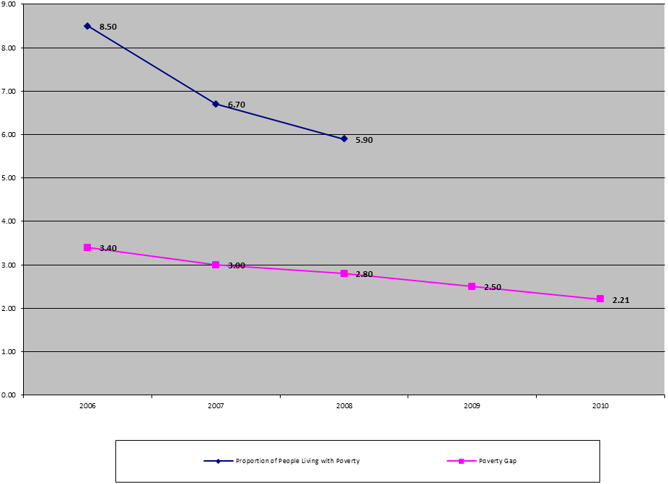Source: Ministry of National development Planning/National Development Planning Agency of the Republic of Indonesia, The Roadmap to Accelerate Achievement of the MDGs in Indonesia, 2010
People living in extreme poverty
People living in extreme poverty and poverty gap
2006-2010
148. In achieving the target for poverty reduction in 2015 and to narrow the poverty gap between provinces and inter-municipal/district, the Government is challenged to be able to maintain a high economic growth rate. This is needed to expand employment opportunities, increase the availability of education and health services as well as social protection for the poor. In this regard, decentralization has brought new challenges both for the central and regional governments to effectively coordinate programmes aimed at poverty reduction and to utilize effective fiscal resources to encourage inclusive growth, empower poor communities, and improve public service.
149. The national priority to reduce poverty is conducted through 2 main policies, providing productive employments and affirmative actions, which consist of 3 clusters, namely:
(a) Strengthening social service and protection, through National health security programme (Jaminan Kesehatan Masyarakat/Jamkesmas), Family Hope Program (Program Keluarga Harapan/ PKH) and Scholarships for Poor Children.
(b) Empowering the community in order to support the acceleration of poverty reduction through National Program for Community Self-Empowerment (Program Nasional Pemberdayaan Masyarakat /PNPM Mandiri).
(c) Provide more facilities to improve the capacities of SMEs and cooperatives through entrepreneurship and the reinforcement of business management capacities, the provision of information service and business consultation, and the expansion of People-Based Small Business Loan Program (Kredit Untuk Rakyat /KUR).
150. The Government has formulated a national action plan to eradicate poverty and achieve the national development goals as mandated in Presidential Regulations No. 5 of 2010 on the National Medium Term Development Plan of 2010-2014. The implementation of the Plan is expected to reduce national poverty rate to 8-10 per cent by 2014. In addition, the Government of Indonesia accelerates the realization of MDGs within the next 5 years as mandated by Presidential Instruction No.3 of 2010 on Just Development Programs. This includes, among others, the formation of a Roadmap for the Acceleration of MDGs Realization by the Central and Provincial Governments, which are used as the bases for planning, improving coordination of efforts to reduce poverty, and improving prosperity.
151. A National Team led by the Indonesian Vice President monitors the implementation of the mentioned plans and strategy, as stipulated in Presidential Regulation No.15 of 2010 on the Acceleration of Poverty Reduction. This team consists of related technical ministries, including the Coordinating Minister for People’s Welfare, Coordinating Minister for Economic Affairs, Minister for Health Affairs, Minister for Education and Culture, Minister for Social Affairs, Minister for Finance, Minister for Cooperatives and Small and Medium Enterprises and Minister for National Development Planning/Chief of the National Development Planning Agency (Bappenas).
152. These efforts are supported by the improvement of the capacities and functions of various technical ministries and government offices at the national level, as well as the coordination of implementation in all provinces and municipalities/districts by the Coordinating Team for Poverty Reduction. These integrated efforts also involve private partnerships through CSR and other forms of funding such as zakat (the giving of a fixed portion of one's wealth to charity in islamic tradition) and infaq and sodaqoh (donations). In addition, the team also conducts local capacity buildings, policy and fiscal instruments revisions, as well as updating targeted households in the poverty reduction programmes every three years.
153. The Government of Indonesia is implementing policies and programmes on poverty reduction that prioritize the poor and marginalized people, especially ethnic minority, rural population, and urban slum dwellers. The policies and programmes also prioritize vulnerable groups, including women and children. Such prioritization is necessary to fulfil the fundamental rights and provide greater access to development benefits of vulnerable and marginalized groups of the Indonesian society.
154. To support the poverty reduction programmes, the Government of Indonesia carries out various special programme by providing financial assistance (food, seeds, and fertilizer subsidies, as well as loan programme); National Health Security Program (JAMKESMAS), School Operational Assistance (BOS) for all types of schools including Islamic schools, Islamic dormitories, and non-Muslim religious schools, that conduct the 9 year compulsory basic education programme, as well as scholarship for poor students in all education level. In addition, the Government also established the Family Hope Program (PKH); Direct Cash Assistance Program (BLT); credit guarantee fund/funding for the Micro, Small and Medium Enterprises, and cooperation through the People-Based Small Business Loan Program.
155. The National Program for Community Self-Empowerment (PNPM Mandiri) is also expected to increase the quality of life of the poor. In 2007, implementation of PNPM made use of the Sub-district Development Program (PPK) for village areas and the Urban Poverty Countermeasures Program (P2KP) with the total distributed aid of 3.8 trillion rupiahs (approximately 432 million US dollar). In 2008, PNPM Mandiri was prioritized for poverty reduction in underdeveloped areas and was expanded through the Special and Underdeveloped Areas Development Program (P2DTK), the Regional Social Economic Infrastructure Development Program (PISEW), and the Villages Infrastructure Development Program (PPIP). This was also reinforced by other social empowerment programmes carried out by related sectoral ministries/institutions that reached even the remote areas. The budget for 2008 reached almost 6.7 trillion rupiahs (approximately 762 million US dollar). In 2009, with the expanded PNPM’s target, which also include the Rural Agribusiness Enterprise Development Program (PUAP) and the Villages’ Economy Institutional Strengthening through the Community-Based Independent Institutions (LM3). Beside developing the PUAP and LM3, the Government also carries out extension activities and agricultural human resource development aimed at improving the capacity and skills of farmers, which in the long run will increase the farmers’ welfare. The amount of budget spent has reached 11.01 trillion rupiahs (approximately 1.25 billion US dollar), consisting of 7.65 trillion rupiahs (approximately 869 million US dollar) from the national budget and 3.36 trillion rupiahs (approximately 382 million US dollar) from provincial budgets.
K. Right to food
156. The Government of Indonesia is committed to ensure the availability food to meet the basic nutritional needs, both at central and regional levels, especially to reduce disparities between regions. This commitment is shown by the issuance of Government Regulation No. 68 of 2002 on Food Security, which requires the Government to ensure that basic food necessities in regular households is met and affordable, as reflected in the availability of sufficient food in terms of both quantity and quality. Efforts are made through programmes to improve agricultural productivity, distribution, access and system for handling food problems, as well as specific assistance to the poor for provinces and districts with high prevalence of malnutrition.
157. The proportion of the population with a daily kcal intake of less than 2,000 calories is still high. Based on the average daily dietary energy consumption intake per capita, there has been a significant improvement in reducing undernourishment in Indonesia. The Susenas 2002- 2008 data showed that the average dietary calorie intake in 2002 was 1,986 kcal per capita per day which was below the minimum requirement of 2,000 kcal per capita per day. However, it increased to 2,038 kcal per capita per day in 2008, as shown in the figure below.
Trends in the average calory consumption in rural and urban household

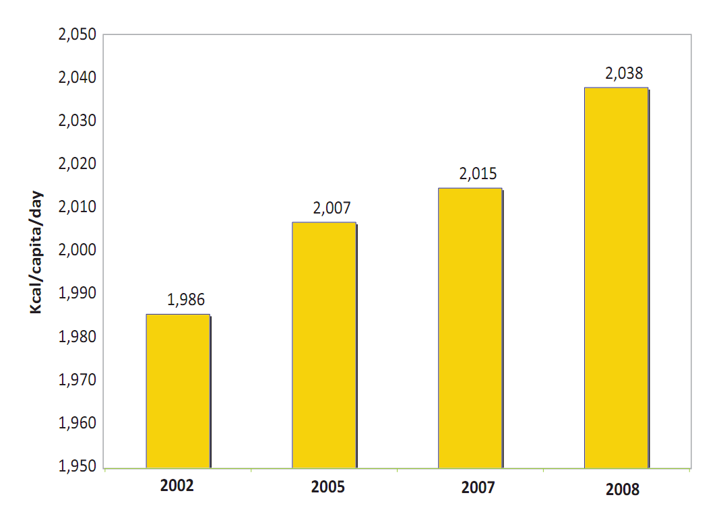
Source: Ministry of National development Planning/National Development Planning Agency of the Republic of Indonesia, The Roadmap to Accelerate Achievement of the MDGs in Indonesia, 2010
158. In the National Medium Term Development Plan of 2010-2014, the Government had set the development target to reduce the prevalence of child malnutrition to be less than 15 per cent. This is conducted through the improvement of: (a) intake of macro-nutrient (carbohydrate, protein, fat) and micro-nutrient (vitamin A capsule, iron (Fe), iodine salt, etc.); (b) surveillance of food and nutrition; (c) community’s knowledge on healthy lifestyle and balanced nutrition; (d) exclusive breastfeeding up to six month; (e) breast-feeding food supplement for 6-24 months infants, and food supplement for pregnant women with chronic energy deficiency; (f) infant growth monitoring during the first two years; (g) society based nutrition-related activities in integrated health post (Posyandu) and nutrition-aware family programme; (h) fortification; (i) food supplement for the recovery of infants with malnutrition; (j) emergency nutrition handling; (k) Standard Operating Procedures on handling infants with malnutrition during the first 59 months; and (l) quantity, quality, and distribution of nutritionist.
159. With such effort, the nutrition level has shown an improvement by the decreased infant malnutrition prevalence from 21.6 per cent in 2000 to 17.9 per cent in 2010. In addition, the average calory and protein consumption of the Indonesian population in 2010 respectively was 927.05 kcal for calory and 21.76 grams for protein (rice), and 37.05 kcal for calory and 0.32 grams for protein (non-rice). With such improvement, MDGs target as much as 15.5 per cent can be achieved by 2015.
Prevalence of underweight children under five years of age, 2000-2010

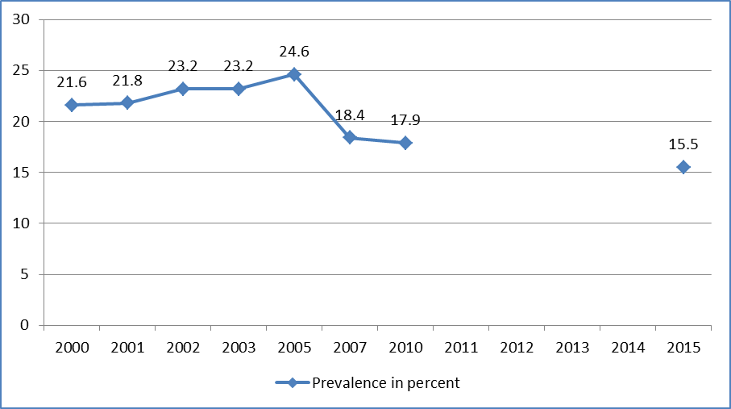
MDGs Target

Source: Ministry of National development Planning/National Development Planning Agency of the Republic of Indonesia, The Roadmap to Accelerate Achievement of the MDGs in Indonesia, 2010
160. Presidential Instruction No. 3 of 2010 requires a National Action Plan for Food and Nutrition as well as a provincial Action Plan, which involves the districts/municipalities. Based on the Instruction, the Food and Nutrition Action Plan 2011 - 2016 was developed containing action-oriented programmes that are structured and integrated in the five pillars of the action plan. The pillars are efforts to improve the community’s nutrition level; increase food accessibility; improve quality control and food security; improve clean and healthy lifestyle; and strengthen food and nutrition institutions. This action plan was developed as guidance and direction in the implementation of food and nutrition development at the central, provincial and municipal/district levels, both for government and community institutions, as well as other parties concerned. As a supplement to this action plan, a regional action plan guideline that is clear, operational and aligned with national policy was made.
161. In disseminating knowledge about food, the Government has made efforts to empower communities to strengthen related programmes at the grassroot level. This was implemented inter-alia through the revitalization of integrated health post through community empowerment in monitoring child growth and development, integrating nutrition services in early childhood education, and developing nutrition activities in the community by empowering local groups, such as study groups and women organizations. Another strategy, which is also being developed, includes promotion and advocacy of healthy lifestyle, exclusive breastfeeding and proper infant and children feeding.
Key policies to improve nutrition for children
162. Current child health policy and strategy in Indonesia focuses on providing core interventions, such as immunizations; Integrated Management of Childhood Illness (IMCI); essential nutrition interventions; and measures to reduce environmental risk factors, notably in water supply, sanitation and indoor pollution. Key drivers for channeling interventions measures are to continue to expand service coverage and improve service quality, and in particular measures to promote family and community level care, to delivering immunizations, antenatal care and simple medical care, as well as promotion of healthy practices (clean and healthy behavior). Indonesia has adopted the IMCI approach to manage diarrhea, pneumonia, malaria, measles and malnutrition – which are the most common causes of child mortality. The approach includes combined treatment of major childhood illnesses with aspects of nutrition, immunization and disease prevention, and health promotion elements. It also includes counseling of caregivers, and improved quality of care for sick children at the referral level. In the home setting, it promotes improved nutrition and preventive care, appropriate care-seeking behavior, and correct implementation of prescribed care. IMCI is one of the most cost–effective ways to deal with childhood illnesses.
163. Good nutrition is critical for child health and survival with effective strategies based on “good infant feeding practices”. Cost-effective, feasible and widely applicable nutrition interventions are those that protect, promote and support exclusive breast-feeding for about six months; appropriate complementary feeding and continued breast-feeding for two years; adequate nutritional care during illness and severe malnutrition; adequate vitamin A intake, adequate iron intake, and adequate iodine intake.
164. The key strategies through which these outcomes will be addressed are breast-feeding and child growth promotion, and communication for behavioral change. However, some 18.4 per cent of children under-ﬁve manifest under-nutrition, while micronutrient deﬁciencies, as represented by vitamin A intake in children aged 6-59 months in the last 6 months, declined from 75 per cent in 2002/03 to 68.5 per cent in 2007.
165. Breast feeding has been proven to reduce Infant Mortality Rate (IMR). The health benefits of breastfeeding for both mother and child are undisputed and they are influenced by both the duration and intensity of breastfeeding. The age at which a child starts receiving complementary foods also influences its nutritional status. Breastfeeding is practiced almost universally in Indonesia, with 95 per cent of children under-five having been breastfed for some period of time. However, only 44 per cent of babies benefit from early initiation of breastfeeding, and a total of 62 per cent of babies are breastfed within the first day after birth.
166. Strategies to address the key nutritional concerns so as to achieve the national target to reduce stunting in under-five children from 36.8 per cent to 32 per cent by 2014 are as follows:
(a) Emphasize exclusive breast-feeding and appropriate complementary feeding; adequate nutritional care during illness and severe malnutrition, and adequate micronutrient intake;
(b) Promote child growth aimed at providing basic information for households and communities about feeding, childcare and health care seeking. Promotion will emphasize: (i) recommendations on individual childcare; and (ii) activity plans for the community to support families to maintain the growth of their children;
(c) Introduce communication for behavior change, overcome resistance and motivate desired practice, through interpersonal and mass-media communication;
(d) Pursue micronutrient interventions. These are among the least expensive child health interventions, and a combination of three main strategies (increased dietary intake, food fortification and direct supplementation) that have a significant impact on reducing child morbidity and mortality; and
(e) Pursue food supplementation strategies. Food supplementation is an important measure in situations where vulnerable groups experience malnutrition caused by inadequate access to food. However, it is a relatively costly intervention and is best seen as a complement to other interventions.
167. In the National Medium Term Development Plan 2010-2014, the Government set the new target of reducing undernourishment of children under five years of age to less than 15 per cent. Actions to be carried out include: (i) expansion of exclusive breast-feeding; (ii) complementary and supplementary feeding for children 6-24 months old; (iii) supplementary feeding for pregnant and lactating mothers; (iv) strengthening community-based nutrition programme through integrated health post; (v) nutrition education; (vi) strengthening malnutrition mitigation management in primary health centres (Puskesmas) and hospitals; and (v) strengthening the food and nutrition surveillance system. In line with the above policies and strategies, the National Medium-Term Development Plan 2010-2014 sets up the programmes and targets to address malnutrition particularly among children under ﬁve years of age.
General strategies and programmes to promote and protect the right to food
168. Efforts to ensure access to food for disadvantaged and marginalized individuals and groups, including farm labourers and minority groups are conducted through the provision of land through resettlement; near-forest land utilization through National Program of Community Self-Empowerment on forestry, microcredit, cooperatives and SMEs; acceleration of local resource-based food consumption diversification through cultivation technology improvement, food processing technology, and intercropping; rice subsidies for the poor; and Direct Cash Assistance Program. Agencies at both central and local are established to implement those efforts. The agencies, with support from the Ministry of Health, the Ministry of Agriculture, the Food Resilience Agency, State Logistics Agency (Badan Urusan Logistik/BULOG), and the National Agency of Drug and Food Control (Badan Pengawas Obat dan Makanan/BPOM), are responsible for food and nutrition security in the region.
169. The Food Aid Program was a continuation of the Special Market Operation (Operasi Pasar Khusus/OPK) programme conducted in 1998. OPK had become the pioneering programme for other social aid programmes in the form of Social Safety Net (Jaring Pengaman Sosial/JPS). One of the considerations to deliver rice as the implementation of the Food Aid Program is the fact that rice is the staple food of majority of Indonesians. Furthermore, the biggest proportion of poor households’ expense is on food spending. BULOG data stated that in 2007, the Government conducted the Raskin Program for 15.8 millions Poor Households. In 2009 the number increased to 19.1 million households. It is estimated that 1.6-3.2 million tons were distributed in 2005-2009 in the implementation of the programme. In 2011 the Government targeted 17.5 millions households with 3.15 million tones of rice allocated.
170. In addition, since 2005 the Government had also developed the Government Rice Reserve (Cadangan Beras Pemerintah/CBP), which aimed to fulfil food needs in the event of emergency such as disaster, and to maintain the stability of the price of rice in order to be available to all layers of society. The initial amount of CBP is 350 thousand tons and will be increased up to the ideal amount of 750 thousand – 1.25 million tons.
171. The Government had also joined and contributed in ASEAN Emergency Rice Reserve in its efforts to guarantee the national food supply in case of crisis.
L. Right to water and sanitation
172. The Government of Indonesia has recognized the right to water as part of Indonesian social welfare and wellbeing, an essential part of human rights, as mandated by Indonesian Constitution in article 33 paragraph 3, which states that “the land and the waters as well as the natural riches therein are to be controlled by the State and to be exploited to the greatest benefit of the people”. This Article is the basis of the issuance of Law No. 7 of 2004 on Water Resources, which become the basis for the State in implementing its obligation to respect, protect and fulfil the right to access to water. Specifically, article 5 of the Law states that the State guarantees the right of every person to water in fulfilling their minimum daily basic need to live a healthy, clean, and productive life. In executing its obligation, the Government had conducted several activities, such as: (1) policy formulation, (2) water maintenance, (3) water regulation, (4) water management, and (5) water controlling. The main priority in providing water resource is to fulfil daily basic need and irrigation for farming, as regulated in Law No. 7 of 2004 article 29 paragraph 3.
173. With regard to the responsibility of regional government, article 16 paragraph h of Law No. 7 of 2004 stated that districts/municipalities government have the responsibility to fulfil minimum daily basic need of water of people in their region. Nevertheless, central and provincial government is also obliged to implement programmes and activities to guarantee the right to water. To provide basic regulation to implement districts/municipalities’ obligation, the central government has enacted Regulation of Minister of Public Works No. 14 of 2010 on Minimum Service Standard in Public Works and Planology. The said regulation has set the minimum standard of clean water for each person, which is 60 liter per day. The Government is aiming to reach minimum service standard of water supply to 68.8 per cent of residents in all districts/municipalities by 2014.
174. Activities on clean water supply also referred to the Strategy of Acceleration of MDGs Target Achievement 2015. The activities are carried out through communication, information and education, improvement of access to drinking water and basic sanitation, developing hygienic and sanitary lifestyle through Community Based Total Sanitation, and increasing campaign and community empowerment activities on healthy environment.
175. With regard to the acceleration programme, healthy environment activities are also supported by several organizations such as ADB, KFW German, WHO, and World Bank, in which those programmes were implemented through CWSH, Pro Air, WHO, WSLIC-2 and The Program of Drinking Water Supply and Community Based Sanitation (PAMSIMAS) activities that include activities on educating and supplying drinking water facilities and rural basic sanitation to poor people with the objective to leverage health status, productivity, and life quality of low income society in rural areas, especially in fulfilling the need of safe drinking water and sanitation.
176. The Drinking Water Supply and Community Based Sanitation Program is aimed to rapidly fulfil the need of drinking water, hygiene sanitation (conducted through responsive approach to community’s need) and hygiene lifestyle. Pro Air is a grant project on drinking water and sanitation focusing on the readiness of community to manage their own regional water and sanitation, the flexibility and dynamism, as well as the adjustment to the planned approach and activities.
177. The proportion of total household in the urban and rural areas which have access to decent drinking water resources in Indonesia has increased from 37.51 per cent in 2000 to 44.19 per cent in 2010, while in urban areas the proportion has increased from 46 per cent to 49.82 per cent and in rural areas from 31.3 per cent to 45.72 per cent . Many efforts are still needed to be done in order to achieve MDGs target of 68.87 per cent. Decent drinking water resources consist of household water tap, public water tap, drill or pump water well, protected water well, protected spring water, and rain water. Bottled water, water from unprotected well and springs are not included as resources.
178. The proportion of households that have access to improved sanitation facilities has also increased. It increased from 32.73 per cent in 2000, to 35.03 per cent in 2006 and 55.53 per cent in 2010.
Proportion of households with access to adequate sanitation in urban and rural areas-2000-2010
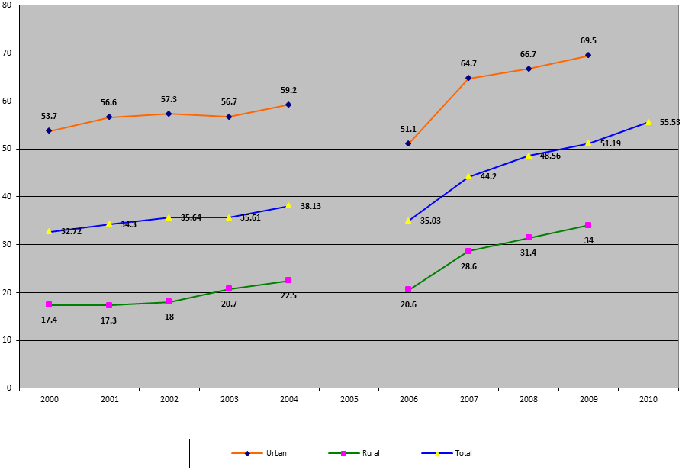
Source: Ministry of National Development Planning/National Development Planning Agency of the Republic of Indonesia, The Roadmap to Accelerate Achievement of the MDGs in Indonesia, 2010 and Central Board of Statistics of the Republic of Indonesia, Indicators of Housing 1993-2010
179. In order to expand the access to water, the Government has conducted several efforts which include providing sets of rules at the central and regional level to support drinking water services; improving the development of water supply system through the formulation of a master plan; improving water management through the preparation of business plans; implementation of asset management, and human resources capacity building, both by institution and society; and increasing intergovernmental cooperation, among government, society and private sectors; and optimizing the utilization of funds.
180. The funding allocation from Central Government is prioritized for the poor. Moreover, the Central Government also encourages and facilitates the provision of drinking water for middle class communities by improving the performance of the operator service (PDAM), which is done through the provision of technical assistance, programmes, and finance. In addition, the Government has established a special fund (Dana Alokasi Khusus - DAK) for drinking water, aimed at optimizing the existing drinking water infrastructure services as well as the construction of new systems in small towns, remote, coastal and rural areas.
181. In addition, the Government has also increased its regional investment spending for the improvement of drinking water access for urban residents, especially the poor, and the improvement of investment climate that supports development towards stimulating the participation of private and public sectors in Public Private Partnership (PPP) and Corporate Social Responsibility (CSR).
182. Efforts to control water quality have been conducted through the improvement and development of installation as well as of transmission and distribution network, especially in urban areas. The development of community-based drinking water supply in rural area has been conducted jointly by the Ministry of Public Works and the Ministry of Health. Furthermore, the use of ground and surface water are controlled in order to avoid domestic and industrial pollution, by increasing the coverage of sanitation services, as well as the utilization of technology development and application of alternative water sources, including reclaimed water.
183. In order to ensure the availability of drinking water, the Government has also increased the development of national water supply infrastructure, which has been included as one of the priorities in infrastructure development.
184. Education has been one of the means to promote the use of hygienic water, protection of water sources and methods to minimize wastage of water. It has been conducted by integrating learning models regarding the effective use, conservation and preservation of water resources, as well as environmental science learning. Some examples of those models include the implementation of "Green School" activities in all level of education; Environment Online Program and “Tree Planting Day”, which involve students from approximately 3,651 schools in May 2010; as well as Boy Scouts activities and Ecotourism Programme (Wisata Cinta Alam) for Primary and Secondary School Students.
185. Furthermore, there is a need to increase public awareness and understanding on the importance of clean living and healthy behavior. The Government continues its efforts to increase the awareness of hygienic behavior and healthy, clean living for students and communities through campaign and education, as well as development of drinking water and sanitation infrastructures in schools.
M. Right to adequate housing
186. To meet the demand for adequate, safe and affordable housing, efforts have been carried out comprehensively by focusing on meeting the need of the poor and low income citizens. This is because there is still 17 per cent or at least 8.8 million households of the total 52 million that do not own or still rent a house, with majority living in urban areas. Such trend has not changed in the last few years. The backlog of housing development has increased from 5.8 million units in 2005 to 7.4 million units in 2009. On the other hand, there is an addition of 700,000 new households every year. Almost 80 per cent of the fulfillment of the demand for new housing has been met by the people’s own effort. However, there are signs of positive improvement with regard to access to electricity, which has increased from 90.62 per cent in 2006 to 94.15 per cent in 2010.
Indicators of housing
2000-2010
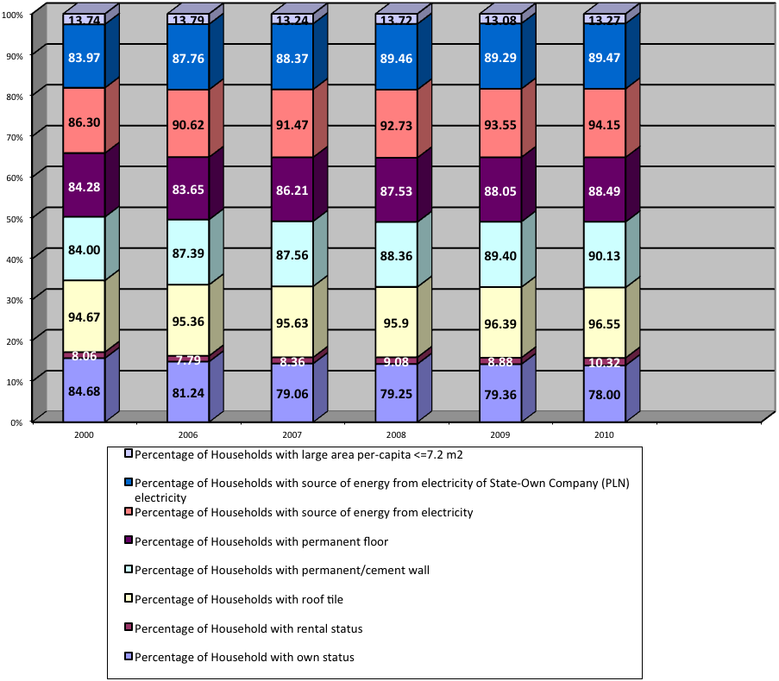

Source: Central Board of Statistics of the Republic of Indonesia, Indicators of Housing 1993-2010
187. Approximately, 12.12 per cent of households in Indonesia still live in slum areas. However, the proportion of households living in urban slums in Indonesia has declined by 8.63 percentage points from 20.75 per cent in 1993. Many initiatives have been carried out to improve the welfare of urban households, such as the Kampung Improvement Program (KIP), urban renewal, the Urban Poverty Project (UPP), the Community-Based Initiatives for Housing and Local Development (CoBILD), and the Neighborhood Upgrading and Shelter Sector Program (NUSSP). In addition, several initiatives to empower those who live in urban slums are being implemented, including through the PNPM Mandiri.
188. The major challenges in reducing the proportion of urban slum households in Indonesia are:
(a) Limited access of low-income households to land for housing in urban areas;
(b) Limited access to housing finance;
(c) Limited capacity of the government and the private sector to build affordable houses;
(d) Limited provision of basic facilities for urban settlements; and
(e) Previous programmes have produced less than optimal results in improving the lives of slum dwellers.
189. Several steps have been taken to improve the provision of decent and affordable housing for low-income communities through development of public housing for rent, facilitation of development of new housing and, quality improvement of self-build housing and the provision of infrastructure, facilities and utilities for self-build housing, as well as facilitating the provision of land. Additional initiatives will increase access of low income households to decent and affordable housing through a liquidity facility, and microcredit for housing and national housing savings. Other priorities are to improve the quality of residential environments through the provision of infrastructure, basic facilities, and adequate public utilities, integrated with real estate development to realize cities without slums.
190. In supporting the effort of the Government to fulfil the right of adequate housing in Indonesia, Law No. 1 of 2011 on Housings and Residential Areas is enacted. The law regulates the development system of housing and residential area as an integrated system which provides basic infrastructures. The law aims to guarantee the sustainable and integrated planning and development of housing and residential areas that are adequate and affordable, within a healthy, secure, harmonious, and prosperous environment. The development of residential areas/housing has to be performed also in accordance with Law No. 26 of 2007 on Spatial Structuring and Spatial Planning. Measures to guarantee access to affordable housings involve the concepts of arrangement, nurturing, and monitoring. Arrangement is conducted through the provision of national policy on the management of slum areas in urban and coastal areas. Nurturing is conducted through the improvement of regional capacities, whereas monitoring is performed by controlling the management of slum areas at the national level.
191. In implementing the development of public infrastructure such as roads, dams, irrigation, housings and residential areas, the Ministry of Public Works refers to Law No. 1 of 2011 on Housing and Residential Areas, Law No. 28 of 2002 on Buildings, Law No. 7 of 2004 on Water Resource, Law No. 38 of 2004 on Roads, and Law No. 16 of 1985 on Apartments.
192. The Government of Indonesia has carried out efforts to increase the availability of financial resources for housing that supports and facilitates the secondary mortgage facilities, through the issuance of Presidential Regulation No. 19 of 2005 as amended by Presidential Regulation No. 1 of 2008 on Secondary Mortgage Facilities for Housings. As a supplementary effort, the Government has established PT. Sarana Multigriya Finansial based on Government Regulation No. 5 of 2005 on the Inclusion of State Funding for the Establishment of Companies in the Field of Secondary Mortgage Facilities for Housings.
193. In addition to secondary mortgage facility, there is primary mortgage facility that benefits the community better, that is through Mortgage Liquidity Facilities (FLPP). This facility has much lower interest rate than the conventional People’s Housing Loan (KPR) that has been operating since the issuance of the Minister for Finance’s Regulation No. 185/PML.05/2010 dated 15 October 2010 on Service Charge of Public Service Agency (BLU) on Mortgage Center. The accumulation of FLPP fund from 2010 to 2011, which amounted to Rp. 6.25 trillion, is expected to support the target for People’s Housing Loan in 2011 by as much as 134 thousand housing units and 50 thousand affordable housing units.
194. The policy for accelerating the development of affordable subsidized apartments has been set by Presidential Decree No. 22 of 2006 on Coordinating Team on the Acceleration of the Development of Apartments in Urban Areas (PPRSKP), which is followed up by the establishment of Executing Team and Working Group in Central Government and Regional Coordinating Team in various provinces and municipalities/districts. The PPRSKP Program is well known as the 1000-Tower-Development, which started in 2006. The latest data shows that the realization of this programme only reached 497 apartment towers:
(a) 85 towers (42 low cost apartments – rusunami – and 43 low cost rental public apartments – rusunawa) had been resided;
(b) 37 low-cost apartments have been topped off;
(c) 30 low-cost apartments are still developed;
(d) 4 low-cost apartments are at the groundbreaking stage;
(e) 341 low-cost apartments are still in the process of acquiring permission and formulating Detail Engineering Design (DED).
195. The Government has taken necessary measures to fulfil the increasing need for adequate housing and demand for an increasing quality of residential areas through the development of subsidized Small Healthy House (RSH), RSH, and non subsidized apartments, special housings, and post-disaster housings as many as 1,241,118 units; the development of 37,709 units of low-cost public rented apartments; the development of 6,716 units of low-costs apartments involving private sectors; the development of 3,659,037 self-supported housing units; and, spatial planning for 8,182 Ha large-scale areas and special areas.
196. The Government has also made several legislative efforts aimed at ensuring that the residences are not built in or located near polluted areas, as stipulated in Law No. 26 of 2007 on Spatial Planning (UUPR) and Presidential Regulation No. 15 of 2010 on the Implementation of Spatial Planning which mandates that spatial use (residential development) should observe the standards for environmental quality, financial-economic adequacy, technical adequacy, and minimum service.
197. Some efforts undertaken are the proclamation of National Movement of One Million Houses Development (Gerakan Nasional Pengembangan Sejuta Rumah/GNPSR) to improve the availability of basic infrastructures for simple house and healthy simple house area, as well as people based housing development. Furthermore, there will be developments on micro-credit, new subsidy patterns, and institutions responsible for housing development to improve the accessibility of low-income communities to house repairs and procurement. Along with the improvement, the development of housing finance is conducted through the establishment of secondary mortgage facility (SMF) and the establishment of supporting legislations.
198. To accelerate the development of adequate housing and also to increase the quality of residential environment for the poor and those who do not have a permanent source of income, the Government is currently preparing Highly Affordable and Affordable House Program. The programme is divided into 4 clusters, namely Highly Affordable House Program through social assistance, National Community Empowerment Program (PNPM Mandiri) for the extremely poor and the poor with financial assistance of Rp 5-10 million/household, Affordable House Program with financial assistance of Rp 20-25 million/household for non-bankable SMEs, and Housing Program of Rp 20-25 million for bankable SMEs. To further increase the of effectiveness of the programmes, the Ministry of Housing is preparing and coordinating efforts, which include the determination of location/target group, technical planning, decision on implementation scheme (availability and certification, infrastructure, society empowerment) and the financing of the programmes (FLPP, etc).
199. In addition, the Government is currently developing fiscal incentives and simplifying the procedure for development of housings, among others by omitting the Value-Added Tax (PPN) and reducing the Income Tax (PPH) to 1 per cent for the development of Small Healthy House (RSH) and Low-Cost Apartments (Rusuna).
200. To further enhance respect of the right to legally-acquired land and legal certainty in land acquisition for the development of public infrastructure, the Ministry of Public Works conducts land acquisition for public infrastructure in accordance with Presidential Regulation No. 36 of 2005 on Land Acquisition for the Development of Public Infrastructure. Forced eviction will not occur as long as the residents own a legal evidence of ownership on the land/building they reside in. For land owners whose land is designated for the development of public infrastructure, they have the right to negotiate equitable compensation, in accordance with applicable provisions of the Presidential Regulation.
201. The amendment of the Basic Agrarian Law No. 5 of 1960 to accommodate land acquisition for development is currently underway and has become the initiative of the House of Representatives. The amendment aims to ensure that land acquisitions for public interest or private business, including its compensation, comply with the principles of fairness, certainty, transparency, mutual benefit, mutual agreement, inclusiveness, welfare, sustainability, and harmony. The payment of compensation can be in the form of money, new land, resettlement, and other forms agreed by the parties entitled to the compensation, or a mix of two or more options of compensation.
N. Right to health
202. The right of everyone to obtain the highest standard of physical and mental health (the right to health) is acknowledged and guaranteed by the Government of Indonesia, as stated in the 1945 Constitution Chapter XA on Human Rights Article 28H paragraph 1, that “every person shall have the right to obtain medical care” and chapter XIV on social welfare article 34, paragraph 3, that “the state shall have the obligation to provide sufficient medical and public service facilities”.
203. In implementing the mandate of the 1945 Constitution, the Government has issued Law No. 36 on 2009 on Health, and also various regulations and other relevant Laws, among those are Law No. 29 of 2004 on Medical Practice, Law No. 35 of 2009 on Drugs, Law No. 44 of 2009 on Hospital, and Law No. 52 of 2009 on Population Growth and Family Development.
204. Health development in Indonesia is based on human rights, humanity, empowerment and independence, justice, prioritization and benefit, with special attention given to vulnerable groups, such as mothers, infants, children, senior citizens, and poor families. In addition, the promotion and protection of the right to health are implemented without discrimination and applicable to all.
205. To achieve healthy, self-reliant and just society, the Government strives to continuously increase the degree of health of the society that is holistic, just, equitable, and of high quality. The government also guarantees the availability and equality of health resource for all societies.
206. National development on health puts special attention to vulnerable residents, such as mothers, infants, children, senior citizens, persons with disabilities, residents living in disaster-prone area and poor families. The priorities of health development are:
(a) Improvement of maternal, infant, children and family health, as well as family planning;
(b) Improvement of public nutrition;
(c) Control of communicable and non-communicable diseases and environmental restructuring;
(d) Fulfilment, development and empowerment of human resources on health;
(e) Improvement of availability, affordability, equity, safety and quality of medicine, as well as drug and food supervision;
(f) Improvement of health insurance system;
(g) public empowerment, including in the management of disaster and health crisis;
(h) Improvement of primary, secondary, and tertiary health services.
207. To implement national development on health, the Government has been continuously increasing its national budget on health over the last couple of years. In 2003, budget allocation for health was Rp 6.63 trillion (around US$ 0.74 billion), while in 2010 it increased to Rp 21.95 trillion (around US$ 2.377 billion). Indonesian public health expenditure has achieved 70 per cent of the WHO recommendation, which is USD 35-40 per person per year.
Health budget allocation
2003-2010 (in US$ billion)

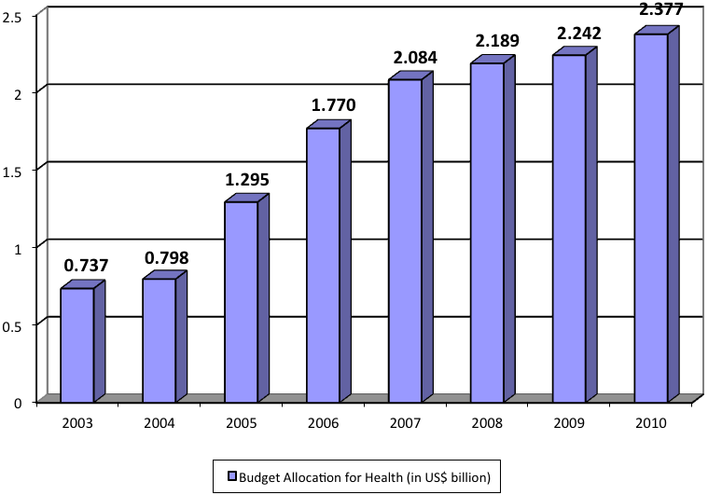

Source: Ministry of Health of the Republic of Indonesia, Basic Health Research of Indonesia 2010
208. Most of the health budget allocation increase is used for
(a) National health security programme for the Poor (Jaminan Kesehatan bagi Masyarakat Miskin/Jamkesmaskin);
(b) development of basic health service in Primary Health Center (Pusat Kesehatan Masyarakat/Puskesmas);
(c) Puskesmas Supporting Units (Puskesmas Pembantu/Pustu);
(d) Village Health Post (Pusat kesehatan Desa/Poskesdes);
(e) Integrated Health Post (Pos Pelayanan Terpadu/Posyandu);
(f) Improvement of health care referral in hospitals including regional government’s hospitals;
(g) Provision and distribution of medicine, vaccine, and health tools; and,
(h) Improvement, development, and empowerment of health resources.
Most of the health fund is also used for revitalization programme on Family Planning.
209. Along with the increase of health budget, health services for the poor through Jamkesmas programme had increase significantly from 36.4 million in 2005 to 76.4 million in 2009.
210. Nationally, health service and facilities have risen continuously although the accessibility of health facilities for the poor is still limited especially in remote, border, and disadvantaged island area. The ratio of Puskesmas to the population had increased from 3.6 per 100,000 populations in 2007 to 3.78 per 100,000 populations in 2009. Furthermore, the number of Pustu and Mobile Primary Health Center (Puskesmas Keliling/Pusling) had increased continuously. Public access to basic health services is fairly well: 94 per cent are able to access health facility less than 5 kilometres in distance based on the Basic Health Research (Riset Kesehatan Dasar/Riskesdas) in 2007. Public access to the Effort of Community Based Services (Upaya Kesehatan Bersumberdaya Manusia/UKBM) was also fairly well, whereby 78.9 per cent of households are located less than 1 kilometre from UKBM facility. Recently, there are 183 underdeveloped districts spread in 27 provinces, 38 of which are located in the border areas and outer islands, 19 districts are land borders with neighboring countries, and 21 districts covering 92 small outer islands in critical points of the State border (34 of which are populated). The underdeveloped districts have become the priorities of the Ministry of Health during 2010-2014 programmes.
Development of public hospitals and private hospitals, 1998 – 2009

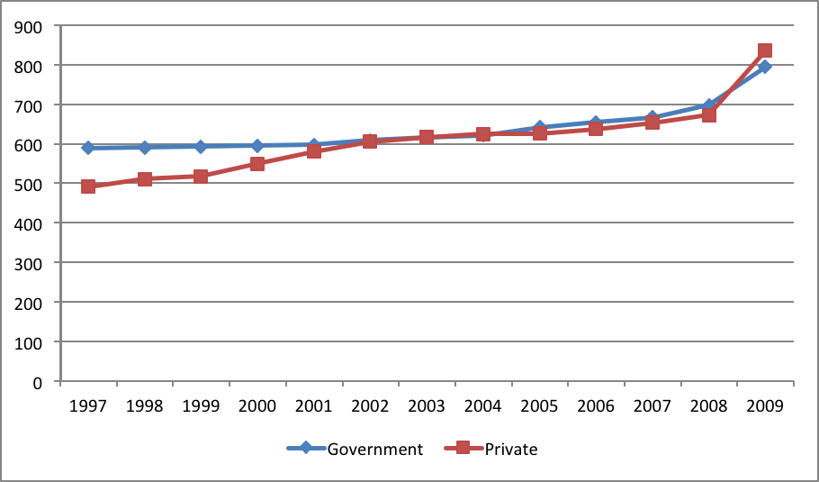

Source: Ministry of Health of the Republic of Indonesia, Basic Health Research of Indonesia 2010
211. The figure above shows an increasing trend of the number of public and private hospitals. For the last 10 years, private hospitals in Indonesia have grown more rapidly up to 2.91 per cent in average per year, while the public hospitals have grown by 1.25 per cent in average per year. Public hospitals consist of Central and Regional Hospitals, Indonesian National Military (Tentara Nasional Indonesia/TNI) hospitals, Indonesian Police (Kepolisian Republic Indonesia/Polri) hospitals, State-Owned Enterprise and other Ministries hospitals. In 2009 the total number of hospitals is 1,632 units.
212. According to Riskesdas of 2007, life expectancy age in Indonesia had increased from 68.6 years in 2004 to 70.5 years in 2007. This life expectancy is expected to increase by 72 years in 2014. The number of elderly in 2007 is 18.86 million and increased to 20,547,541 in 2009. Those life expectancy improvements are as the result of the Government’s adoption of International Plan of Action in Ageing in 1980. Indonesia also supports the UN Resolution No. 045/026 of 1991 which sets 1 October as the International Day for the Elderly and has announced that 29 May is the National Day for the Elderly. The Government of Indonesia has also established the National Commission on Elderly through Presidential Decree No. 52 of 2004. The Central Government, in collaboration with Regional Governments, has developed special assistance facilities for the elderly in hospitals through the Geriatric Polyclinic since 2000. The principles of geriatric services in those hospitals are holistic, covering physical, psychological and socio-economic environment aspects, through the cross-sectorial agencies/ institutions mechanism for the purpose of promotion, prevention, curative and rehabilitation. Geriatric Clinic has now been developed at least in five public hospitals and several private hospitals. In Primary Health Centers (Puskesmas), special assistance for elderly has been implemented, namely Puskesmas for elderly which are held in 102 Puskesmas in 33 provinces. Even though there are limitations, the Central Government has provide up to Rp 12.6 billion in 2007 to support elderly people in 10 provinces, then Rp 18 billion in 2008 for the similar programmes in 15 provinces.
213. As stipulated in article 42 of the Law No. 39 of 1999 on Human Rights, Government of Indonesia is responsible for the development of social welfare of people with disabilities, both mentally or physically. The Government has to ensure the rights of people with disabilities to education, employment, equal treatment, accessibility, rehabilitation, social assistance, including equal right to talent, skill, and social life development. Based on the National Socio-economic Survey (Survei Sosial-Ekonomi Nasional/SUSENAS) in 2009, there were approximately 2.1 million (0.92 per cent) people with disabilities in Indonesia, which consists of children, persons with common disabilities, and persons with chronic disabilities. The Government provides special funding for their health care up to Rp. 21. 6 billion.
214. The number, type and quality of health resources continue to rise, although it is not yet evenly distributed. The ratio of health resources such as doctors, specialists, dentists, nurses, and midwives per 100,000 populations had increased during 2004 to 2008, as shown in the Table and Figure below. However, the deployment of doctors is still predominant in the island of Java and Bali. Even though the ratio of doctors to population is relatively balanced between Java-Bali islands and non-Java-Bali Islands (18.5 compare to 18.1 per 100,000 population), the complexity of geographic characteristics outside Java and Bali is contributing to the difficult access to health resources condition.
Ratio of health resources per-100.000 population, 2004-2008

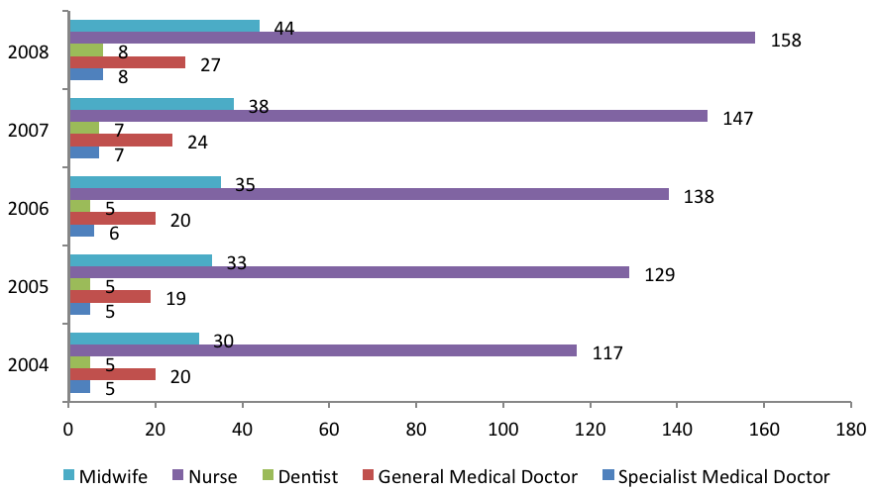

Source: Ministry of Health of the Republic of Indonesia, Basic Health Research of Indonesia 2010
215. To address health disparities between urban and rural areas in terms of number and ratio, the Government continues to improve the deployment of health resources in remote, underdeveloped and border areas. The Government had successfully deployed 1,025 specialist doctors, 3,905 doctors/dentists, and 18,317 midwives in 2007.
216. The availability and distribution of medicines and health supplies continue to improve. The availability of essential medicine at community health-care centres had reached more than 80 per cent. Until now, there are about 16,000 registered drugs and 400 types of drugs listed in the List of National Essential Drugs (Daftar Obat Esensial Nasional/DOEN), 220 of which are the essential generic drugs. In addition, Indonesia is also able to provide vaccines both for domestic and export demand. Nevertheless, the affordability and the use of medicines, as well as the control of drugs and foods remain less than optimal.
217. Traditional medication sector in Indonesia is quite varied and substantial. It is widely used, especially in rural areas. Home production of traditional medicine has been developed into an industry with more than 900 small industries and 130 medium industries, 69 of which have received certifications of Good Traditional Medicine Manufacturing Practice (GTMMP). The development of traditional medicine industry is supported by the 9,600 types of herbs that are medicating, 300 of which have been used for industrial raw materials.
218. In terms of distribution, currently there are 2,600 medicine wholesalers operating in various districts and cities, affiliated to 10 national distributors. Medicines are available in many outlets. There are approximately 8,300 registered pharmacies and 6,600 registered drug stores. Essential medications for basic health care are also available at all Primary Health Centers (Puskesmas) and both private and public hospitals. The number of pharmacists has increased to 14,600 in estimation, with an addition of 3,000-4,000 fresh graduates annually from 60 educational institutions.
219. To maintain the affordability of drugs, the Government has made a policy on price setting for essential drugs. The pricing mechanism of non-generic drugs is left to the market as it is a trade commodity. Although the price of drug is relatively affordable, the threat of currency fluctuation remains high, mainly due to the high dependency of imported materials, which is around 80-85 per cent. In addition, the drug prices remain high due to transportation cost.
220. In terms of drug use, efforts to educate and disseminate information for the correct and rational use of drug have been conducted. The efforts also aim at avoiding the abuse and misuse of drugs. The Government, through the National Agency of Drug and Food Control (BPOM) also conducts strict surveillance and monitoring towards circulation, quality assurance and the expiry of the drugs.
221. The use of generic medicine in community health centres is high (90 per cent), while the use in the hospital and pharmacy is low (public hospital 66 per cent and private hospital and pharmacy 49 per cent). The Government’s efforts for the rational use of medicine are conducted through the implementation of essential medicine, the use of generic medicine and the promotion/ information of the rational use of drug in the form of List of National Essential Drugs.
222. Mother and child health is significant indicator of health development. In addition to indicating the performance of National Health Service, it also shows Indonesia’s international commitment in achieving MDGs (goal 4 and 5). The degree of mother’s health is indicated by Maternal Mortality Ratio that in the last four years has decreased significantly from 307 per 100,000 life births (Indonesia Demographic Health Survey/IDHS, 2002-2003) to 228 per 100,000 life births (IDHS 2007). However, it is recognized that there are still efforts to be made in order to achieve MDGs to have 102 per 100,000 life births by 2015.
Percentage of delivery by health personnel in 2010
Source: Ministry of Health of the Republic of Indonesia, Basic Health Research of Indonesia 2010

223. Maternal mortality in Indonesia mainly caused by low quality of health service and inadequate access. Those conditions create reluctance among mothers to take care of their health. In 2010, the percentage of delivery which is assisted by trained health personnel in Indonesia reached 82.2 per cent, with the highest percentage of assisted delivery in Yogyakarta (98.6 per cent) and the lowest in North Maluku (26.6 per cent). Aside from that, the high rate of mother mortality is affected by the low nutrition, the limited infrastructure of the Basic Emergency Neonatal Service (PONED), Comprehensive Emergency Neonatal Obstetric Service (PONEK), Village Delivery Center (POLINDES) and blood transfusion unit. In addition, the percentage of mother who deliver babies in health facility is only 55.4 per cent (Riskesdas, 2010) because of distance and cost issues as well as local tradition issues.
224. Child health is indicated by the decreasing infant mortality rate (AKB) and neonatal mortality rate (0-28 days-old) in the last four year. Indonesian Doctor’s Competence Standards (Standar Kompetensi Dokter Indonesia/SKDI) data shows the decrease of AKB from 35 to 34 per 1,000 life births in 2007. However, this data is still below MDGs’ infant mortality target from 46 to 44 per 1,000 life births in 2007. Meanwhile, neonatal mortality decreased slightly from 20 to 19 per 1,000 life births in 2007. Neonatal mortality contributed to two-third of the infant mortality, which means that the attention should be directed to the efforts to decrease the neonatal mortality rate. The cause of high infant and neonatal mortality is closely related to the limited scope and low quality of immunization.
225. The scope of complete immunization for under-five children increased from 51.5 per cent (IDHS, 2002-2003) to 58.6 per cent (IDHS, 2007), as shown in the table below. The quality of immunization service still needs to be enhanced since the level of drop-out for DPT1 to DPT3 is 12 per cent. Immunization on the right time is still 54 per cent for DPT3 and 46 per cent for measles, according to the national survey of immunization coverage 2007. The Government of Indonesia continues to improve the coverage of immunization through the National Movement of Immunization Acceleration to reach the Universal Child Immunization (GAIN UCI) aiming at accelerating the achievement of UCI in every village in Indonesia by 2014.
Coverage of immunization of 12-23 month-old children inIndonesia-2002/2003 – 2007
Immunisation | IDHS 2002/2003 | IDHS 2007
BCG | 82.5 | 85.4
DPT1 | 81.4 | 84.4
DPT2 | 71.1 | 75.7
DPT3 | 58.3 | 66.7
Polio1 | 87.3 | 88.8
Polio2 | 79.6 | 82.6
Polio3 | 66.1 | 73.5
Polio4 | 46.2 | 55.5
Measles | 71.6 | 76.4
Full Immunization | 51.5 | 58.6
Without Vaccination | 10.2 | 8.6
Hepatitis B1 | 70.9 | 80.5
Hepatitis B2 | 58.1 | 71.7
Hepatitis B3 | 45.3 | 60.3
Source: Ministry of Health of the Republic of Indonesia, IDHS 2002/2003 and IDHS 2007
226. The malnutrition of under-five children has decreased, but it still persists as a problem of public health. Prevalence of malnutrition of under-five children is about 17.9 per cent, which consists of poor nutrition (13.0 per cent) and bad nutrition (4.9 per cent) (Riskesdas, 2010), with more attention should be paid to the disparity between provinces and between socio-economic groups. Malnutrition that occurs for a long time has caused the high prevalence of under-five children with short legs, which reached 35.6 per cent in 2010. Moreover, the malnutrition of pregnant mothers has also caused the high rate of underweight newborn baby (BBLR), which is about 11.1 per cent in 2010. Meanwhile, prevalence of over nutrition of under-five children has shown an increasing trend from 4.3 per cent (2007) to 5.8 per cent (2010).
Number of malnutrition of under-five children per province
2010

Source: Ministry of Health of the Republic of Indonesia, Basic Health Research of Indonesia 2010
227. In handling the nutrition issue, few factors are at play, which are, inter alia, the high incidence of poverty; poor sanitation; lack of intersectoral and inter-programme coordination; lack of community participation; limited family access to food; inadequate maternal parenting; and low family access to basic health services. Efforts to increase nutrition intake have been conducted through, inter alia, nutrition education, growth monitoring through weighing of under-five children in integrated health service post, responding to malnutrition cases, providing supplementary food for breastfeeding, exclusive breast-feeding, providing vitamin A for under-five children; and providing Fe tablets for pregnant mothers.
228. Communicable disease is still a major public health problem, while there is an increasing trend of non-communicable disease, as shown in the table below. Some communicable diseases that persist as main problems are, inter alia, Dengue Fever, diarrhea, malaria, TB, HIV and AIDS. Moreover, zoonotic diseases in last few years have caused major public health problems, which potentially turn into pandemic such as bird flu and a new A type influenza (H1N1 virus). The number of cases of H1N1 had increased rapidly, while the level of malignancy is lower than of the bird flu. Indonesia still faces neglected infectious diseases such as leprosy, framboesia, filariasis, and schistosomiasis. Non-communicable diseases show an increasing trend, particularly hypertension, coronary heart, cancer, mental and emotional disturbance and trauma.
Diseases’ contribution to mortality in Indonesia

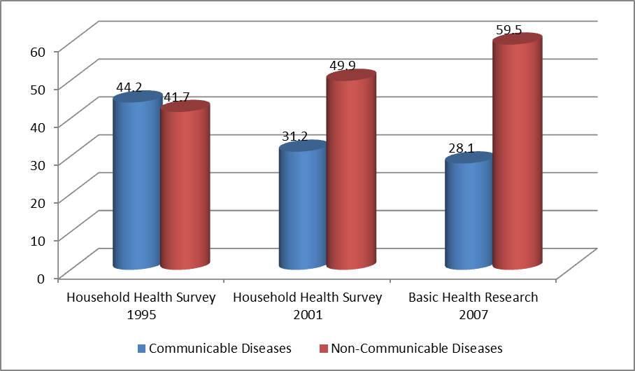
Source: Ministry of Health of the Republic of Indonesia, Basic Health Research of Indonesia 2010
229. Status of communicable and non-communicable diseases is shown in the table below:
Communicable and non-communicable diseases that cause major public health issue

No | Type of Disease | Indicator | 2009 | Current Status
A | Communicable Disease
1 | Malaria | Annual Parasite Index (API) per 1,000 population | 1.85 | 1.96 a)
2 | Tuberculosis | Rate case finding /Case Detection Rate (CDR) TB (percent) | 73.1 | 74.68 a)
 |  | Treatment success rate / Success Rate (percent) | 91 | 86.41 a)
3 | HIV dan AIDS | Number of case | 19,973 | 24,131 b)
 |  | Prevalence of HIV (percent) | 0.2 | 0.2 c)
B | Non-Communicable Disease
1 | Hypertension | Prevalence of hypertension (based on blood pressure measurement) (percent) |  | 31.9 d)
2 | Coronary Heart | Prevalence of conorary heart (persen) |  | 7.2 d)
3 | Diabetes mellitus | Prevalence of diabetes melitus (persen) |  | 1.1 d)
4 | Tumor | Prevalence of cancer/tumor per 1.000 population |  | 4.3 d)
5 | Emotional mental disorders | Prevalence of emotional, mental disorders in population aged more than 15 years (percent) |  | 11.6 d)
6 | Accident | Case of accident (percent) |  | 25.9 d)
Source: Ministry of Health of the Republic of Indonesia, Basic Health Research of Indonesia 2010
230. The remaining high figure of mortality and morbidity due to infectious and non-infectious diseases mostly caused by poor environmental health conditions, people’s behavior that do not follow clean and healthy living behavior, and the diseases prevention that has not been undertaken optimally. The main risk factor for infectious diseases, among others, unhealthy eating behavior, lack of physical activity, and smoking habit (29.2 per cent). Poor environmental health condition characterized by only 44.19 per cent household has access to sustainable source of drinking water, while only 55.53 per cent household has access to improved sanitation facilities (MDGs Report, 2010). This condition is also influenced by global climate change which triggered the increasing risk factors on infectious diseases.
231. In order to increase the capacity and awareness of the people to independently maintain the quality of healthy living, health promotion and increasing community based health efforts (UKBM) have been undertaken by establishing Integrated Health Post (Posyandu) and Village Health Post (Poskesdes). In 2009, the number of community based health efforts (UKBM), which plays important role in the health service, has reached 266,827 units (Posyandu) and 51,996 units (Poskesdes). The role of Posyandu in this system is very important, especially to support the vaccination programme, nutrient, mother and child healthcare (KIA), family planning programme, prevention of diarrhea, and community health education. The Posyandu activities, integrated with other activities such as PAUD, BKB and TPA need to be improved in order to develop early childhood comprehensive and integrated care to improve child health. It’s noted that the goal of achieving a clean and healthy behaviors target at the household level has reached 48.47 per cent.
O. Right to education
232. The right to education in Indonesia is protected and guaranteed by the 1945 Constitution as contained in Article 31, as follows:
(a) Every person has the right to receive education.
(b) Every person has the obligation to undertake basic education, and the Government has the obligation to fund this.
(c) The Government shall manage and organize one system of national education, which shall enhance the level of spiritual belief, devoutness and moral character in the context of national development and shall be regulated by law.
(d) The State shall prioritize the budget for education to a minimum of 20 per cent of the State Budget and of the Regional Budgets to implement the national education.
(e) The Government shall advance science and technology, which respects religious values and national unity, for the advancement of civilization and prosperity of humankind.
233. Furthermore, Indonesian Constitution, article 28C stated that every person shall have the right to develop him/herself through the fulfillment of his/her basic needs, the right to get education and to benefit from science and technology, arts and culture, for the purpose of improving the quality of his/her life and for the welfare of the humankind.
234. In practice, the fulfillment of the right to education is stipulated in Law No. 20 of 2003 on National Education System. Article 1 guarantees that every person has equal right to obtain quality education and article 4 paragraph 1 stipulates that education shall be held democratically, equitably and free from discrimination, to uphold human rights, religious values, cultural values, and pluralism of the nation.
235. In an effort to achieve the targets set forth in the said arrangements, the education development policy since 2007 covers:
Expansion of access to education
236. Such effort is done through the expansion of access to quality basic education, which is spread equally, by means of formal and informal channels, with greater consideration for the poor and people living in rural, disadvantaged, remote, conflicted and archipelagic areas, as well as the disabled, through the provision of School Operational Assistance (Bantuan Operasional Sekolah), scholarships, construction of education infrastructure and facilities, including the construction of primary-secondary schools and primary-secondary Islamic schools under one roof school system, and the construction of student dormitories and teachers living quarters in remote areas.
Improvement of education quality and relevance
237. Such effort is carried out by improving equitable access, quality and relevance of higher education through the strengthening of higher education institutions’ autonomy, improving curriculum, increasing lecturers’ quality, based on the academic qualification and standard of competence in accordance with the applicable regulation via continuation of study, professional courses and training, certification and improving literate culture.
Improvement of good governance
238. Such effort is carried out by increasing the national budget for education to reach 20 per cent of the total national and regional budget in accordance with the 1945 Constitution and Law No. 20 of 2003 on the National Education System, implementation of autonomy and decentralization in education management, and strengthening of education service management.
239. In order to realize the mandate of the 1945 Constitution and Law No. 20 of 2003 on the National Education System, and in order to fulfil the people’s need for education, the Government of Indonesia has significantly increased the education budget of Rp 29.308 trillion (around US$ 3.408 billion) in 2005 to Rp 97.236 trillion (around US$ 11.306 billion).
Education budget allocation, 2005 – 2010
(in US$ billion)
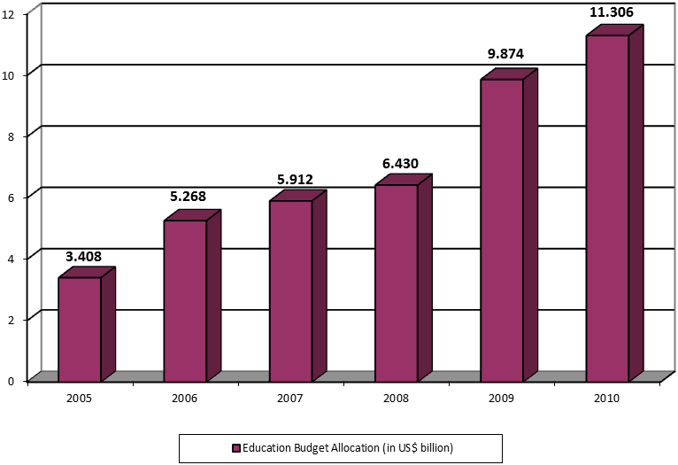
Source: Ministry of National Education of the Republic of Indonesia, 2010
240. National education is based on the principle of national unity in social, cultural, economic and political aspects to preserve the integrity of the nation in the framework of nation and character-building. With regard to inclusive education, every child has the right to receive education, regardless of gender, social origin, economic status, ethnicity, religion, and health status (with regard to disability or even HIV/AIDS).
241. Formulation of national education policy refers to various related international conventions, such as Education For All, the Convention on the Rights of the Child, and commitments set in the MDGs and the World Summit on Sustainable Development.
242. One of the Government’s efforts in promoting the right to education for all people is the 9-year compulsory education programme as the basic education. Compulsory education is the responsibility held by the Government’s educational institutions, local governments, and the society. This policy is stipulated in Law No. 20 of 2003 on National Education System, which states that every person aged 7-15 years is required to pursue compulsory primary education (art. 6, para. 1). In this regard, the Central Government and local governments must ensure the availability of funds for the implementation of education for every person aged 7-15 years (art. 11, para. 2).
243. The results of 9-year Compulsory Education Programme shows a rising trend of School Enrollment Rate (SER), Gross Enrollment Rate (GER) and Net Enrollment Rate (NER), both for formal education for ages 7-12 years (primary school) and age 13-15 years (junior high school) and non-formal education for ages 7-12 (Package A) and aged 13-15 years (Package B), as seen in the following table:
School enrollment rate
9-year compulsory education (age 7-15 years) 2000-2010
ENROLLMENT RATE | 2000 | 2006 | 2007 | 2008 | 2009 | 2010
Formal Education
School Enrollment Rate (SER) Age 7-12 Years | 95.50 | 97.39 | 97.60 | 97.83 | 97.95 | 97.96
SER Age 13-15 Years | 79.58 | 84.08 | 84.26 | 84.41 | 85.43 | 86.11
Gross Enrollment Rate (GER) Elementary School | 107.68 | 109.96 | 110.35 | 109.41 | 110.35 | 111.63
GER Primary School | 77.62 | 81.87 | 82.03 | 81.38 | 81.09 | 80.35
Nett Enrollment Rate (NER) Elementary School | 92.28 | 93.54 | 93.75 | 93.99 | 94.37 | 94.72
NER Primary School | 60.27 | 66.52 | 66.64 | 66.98 | 67.4 | 67.62

ENROLLMENT RATE | 2000 | 2006 | 2007 | 2008 | 2009 | 2010
Formal and Non-Formal Education
SER Age 7-12 Years | n.a | n.a | 97.64 | 97.88 | 97.95 | 98.02
SER Age 13-15 Years | n.a | n.a | 84.65 | 84.89 | 85.47 | 86.24
GER Elementary School/Package A | n.a | n.a | 112.19 | 111.12 | 110.42 | 111.68
GER Primary School/Package B | n.a | n.a | 86.37 | 86.86 | 81.25 | 80.59
NER Elementary School/Package A | n.a | n.a | 93.78 | 93.99 | 94.37 | 94.76
NER Primary School/Package B | n.a | n.a | 66.90 | 67.39 | 67.43 | 67.73
Source: Central Board of Statistics of the Republic of Indonesia, Indicators of Education 1994-2010
244. The Government of Indonesia established the School Operational Assistance (Bantuan Operasional Sekolah/BOS) to support the implementation of the 9-year Compulsory Education Programme, through the Government Regulation No. 17/2010 on the Education Management and Operation and the Presidential Decree No. 48/2008 on Education Funding.
245. The BOS programme is one of the Government’s signiﬁcant policy reforms in ﬁnancing education. The programme was initiated in 2005 and supported by savings from a reduction on the fuel subsidies and was developed based on lessons learned from international experience and a number of previous Government programmes, including the Scholarships and Grants Program (SGP) and the School Improvement Grant Program (SIGP) to reduce the negative impact of the Asian economic crisis on student enrollment and drop-outs. BOS assistance is intended to reduce the burden of education costs, especially for poor communities. Under the programme, block grants are disbursed to all primary and junior high schools based on a per-pupil formula which provides incentives for school principals and teachers to focus on maintaining and increasing enrollment. Funds are directly channeled to the schools, which enables school administrators to choose how to best allocate the BOS grants. All primary and junior high schools providing the 9-year compulsory education are eligible for BOS funding, including public, private or religious schools under the auspices of the Ministry of National Education and the Ministry of Religious Affairs.
246. The BOS programme covered around 34.5 million students in 2005, which was increased to 41.9 million students in 2008 (estimated based on Susenas data). Since 2006, the allocation for BOS has increased in nominal terms and remained relatively constant through 2009 as a share of total education spending which indicated the sustainability of the BOS programme. The budget allocation for BOS programme has increased signiﬁcantly from only Rp 4.8 trillion in 2005 to Rp 12.5 trillion in 2008 which represent approximately 18 and 23 per cent of central government’s education allocations, respectively. In 2009 around Rp 19.1 trillion was allocated for the BOS programme due to increase in per student allocation and is estimated to cover 42.6 million students. The BOS programme distributed 73 per cent of its funds to the primary level and the remaining 27 per cent to the junior high school level. The per-pupil BOS allocation has increased from Rp 235,000 to Rp 254,000 per primary student and from Rp 324,500 to Rp 354,000 per junior high school student per year during 2005-2008. In 2009, the budget contains signiﬁcant increases to Rp 397,000-400,000 per primary student and Rp 570,000-575,000 per junior high school student.
247. The Government of Indonesia endeavores to minimize school costs by:
(a) Exempting all students in public primary school/Madrasah Ibtidaiyah (SD/MI) and public junior high school/Madrasah Tsanawiyah (SMP/MTs) from school operational fee, except for Pioneering International School (Rintisan Sekolah Bertaraf Internasional/RSBI) and International School (Sekolah Bertaraf Internasional/SBI);
(b) Exempting all poor students from all forms of collection, both in public and private schools;
248. In addition to BOS programme, Government also provides other programmes such as:
(a) Scholarships to help pay for operational fee for poor students and 2,040,000 students annually;
(b) Supplementary Food for Students (Pemberian Makanan Tambahan Anak Sekolah/PMTAS), which was distributed to 1.2 million students annually;
(c) Retrieval programme, where school-age children are accommodated in special-care classes to prepare them to return to regular classes.
249. Although the Government of Indonesia has continually increased the fund for implementing the BOS Programme, there were still indirect costs charged by schools with the consent of School Committees and District/City Education Offices, such as for the purchase of textbooks. To overcome the problem, the Government has optimized the utilization of BOS Programme budget for the following purposes:
(a) Purchasing textbooks for Elementary Schools and Junior High Schools;
(b) Financing all requirements for the admission of new students, such as administration and registration process, form reproductions, re-registration process, etc;
(c) Financing remedial classes, enrichment classes, exam preparations, sport activities, art activities, scientific work, scouts, Red Cross activities, School Health Center and many more;
(d) Financing daily exam, general exam, school exam and student study report;
(e) Purchasing consumable materials such as notebooks, chalks, pencils, markers, papers, practicum materials, student registration books, inventories books, educational newspaper/magazine subscriptions, and office equipment parts;
(f) Financing power and services subscriptions, such as electricity, water, telephone, internet, including network installation around school, and even for purchasing electricity generators for schools without electricity network;
(g) Financing school maintenance and repair;
(h) Financing monthly pay for honorary teacher and honorary teaching personnel, as well as honorary administration personnel particularly in elementary schools;
(i) Improving teacher professional capacity;
(j) Paying for the transportation costs of poor students. If considered more economical, it is possible to buy simple means of transportation which become part of school inventory (bicycles, etc.);
(k) Financing of BOS operational costs;
(l) Purchasing computer (desktop/work station) and printer for student learning activities.
250. If all of the above have been financed by BOS and there are still funds remaining, then the remainder can be used to buy teaching props and media, typewriter, school furniture and School Health Center equipments.
251. Some municipalities/districts in Indonesia actively develop innovative programmes to support Compulsory Education Program and fulfil the right to education for the people, such as providing 20 per cent of the total regional budget for education; enacting regional regulations on education (for instance in the City of Malang, District of Pare-Pare and South Sulawesi Province), establishing Ready to Help School program (Siap Aktif Bantu Sekolah/SABAS), providing kindergarten-primary school under one roof and primary-junior high school under one roof (for example in Temanggung District in the Central Java Province).
252. Even though the Compulsory Education Program has been optimized sustainably, the number of dropouts of 13-15 year old children or could not obtain formal education in junior secondary level remain high:
(a) The number of 13-15 year old children who could not obtain formal education in junior high school/Madrasah Tsanawiyah (SMP/MTs) is 14.78 per cent.
(b) Transition rate from primary school/Madrasah Ibtidaiyah (SD/MI) to SMP/MTs is 83.38 per cent.
(c) Dropout rate in SMP/MTs is 2.74 per cent.
253. The Government has undertaken the following efforts to reduce dropout rate in primary and secondary education:
(a) Giving scholarships to poor students;
(b) Implementing retrieval and remedial programmes;
(c) Implementing special education in remote, marginalized, natural and social disaster areas, and for economically disadvantaged families;
(d) Providing A, B and C Packages which are equivalent to primary school (Package A), junior high school education (Package B), and senior high school education (Package C), for those who do not have an opportunity to obtain formal education;
(e) Inclusive education programme for children with special needs.
Realization of programmes to reduce drop out rate in primary and secondary education level, 2010
Source: Ministry of National Education of the Republic of Indonesia, 2010
254. Beside compulsory education programme, the Government provides technical and vocational education, which can be accessed by the public. In Indonesia’s education system, there is vocational formal education in senior high school level, namely Vocational Secondary School (Sekolah Menengah Kejuruan/SMK) managed by the Government or private sectors. Generally, participation rate in senior high school and vocational education has improved as shown as follows:
School enrollment rate, secondary and vocational 2000-2010
ENROLLMENT RATE | 2000 | 2006 | 2007 | 2008 | 2009 | 2010
Formal Education
SER 16-18 years old | 51.17 | 53.92 | 54.61 | 54.70 | 55.05 | 55.83
SER 19-24 years old | 12.31 | 11.38 | 12.20 | 12.43 | 12.66 | 13.67
GER Senior High School | 50.22 | 56.69 | 56.71 | 57.42 | 62.37 | 62.53
GER University | 10.26 | 12.16 | 13.31 | 14.42 | 14.59 | 16.35
NER Senior High School | 39.33 | 43.77 | 44.56 | 44.75 | 45.06 | 45.48
NER University | 7.95 | 8.87 | 9.64 | 10.07 | 10.30 | 11.01
Formal and Non-Formal Education
SER 16-18 years old | n.a | n.a | 55.49 | 13.29 | 12.72 | 13.77
SER 19-24 years old | n.a | n.a | 13.08 | 13.29 | 12.72 | 13.77
GER Senior High School/Package C | n.a | n.a | 59.46 | 59.06 | 62.55 | 62.85
NER Senior High School/Package C | n.a | n.a | 44.84 | 44.97 | 45.11 | 45.59
Source: Central Board of Statistics of the Republic of Indonesia, Indicators of Education 1994-2010
255. The improvement of vocational secondary education is also based on local competence and taking into account the most prospective field of business and industry, so that students can obtain education and skills that will contribute to self-improvement, independence and competence required in labour market.
256. To support vocational education for the people, the Ministry of Manpower and Transmigration through its local offices from provinces to districts, cooperate with the local government in providing Training Centers (Balai Latihan Kerja/BLK), spread in various provinces in Indonesia. The Government also provides free technical and skill trainings for vocational secondary school graduates. Available technical and skill trainings in BLK are, among others, automotive mechanics, woodwork, masonry, electricity, fashion and garment. For those who intend to participate in BLK shall follow placement test. The Government has provided BLK revitalization with budget allocation up to Rp 5 trillion.
257. Currently, there is no free higher education. However, the Government strives to provide wider higher education access by giving scholarships for poor college students with excellent academic performance. Other effort is by encouraging private sectors to provide free education until the concerned student graduate. Nineteen ministries/institutions provide educational budget for school with service obligation programme, including for higher education. Meanwhile, for public universities in 2011-2012, the Government had proclaimed a 20 per cent quota for new college students from poor families (Government Regulation No. 66 of 2010 as amended by Government Regulation No. 17 of 2010 on Management and Implementation of Education) and additional scholarships.
258. The Government of Indonesia strives to provide a wide opportunity to obtain free education for Senior High School and higher education, through several forms of financial assistance such as:
(a) Scholarship for Poor Students, start from primary education to higher education. In 2010, the targeted senior high school students amounted to 248,124 students per 3 months with budget allocation Rp 193.54 billion per year. While, targeted vocational students amounted to 200,000 students with budget allocation amounted to Rp 160.6 billion. Furthermore, targeted Master Program amounted to 320,000 students with budget allocation Rp 243.5 billion;
(b) Social assistance for skills programme such as learning life skills-oriented women's empowerment. Its application timescales is different. Budget alocation in 2011 for 7,000 people @ Rp 1 million;
(c) Set up cooperation with entrepreneurs to implement Corporate Social Responsibility (CSR);
(d) Company Scholarship through CSR in proper course and training institutions for the people;
(e) Scholarship of Student Aid Costs, amounted to Rp 250,000 per month;
(f) Academic Achievement Support amounted to Rp 250,000 per month, managed by Directorate General of Higher Education;
(g) Scholarship for poor students with academic competence. Its budget allocation amounted to Rp 5 million per semester per students and was given to 19,632 students in 2010. This Scholarship was also given to private university students, through distribution via Coordination of Private Universities (Kopertis);
259. There are also scholarships from local governments whose amount depends on the policy of the local government. Furthermore, the Government also set up Operational Support Quality Management (Bantuan Operasional Manajemen Mutu/ BOMM) for education.
260. With the above efforts, the university participation rate considered to be increased both on SER, GER and NER as follows:
University enrollment rate, 2000-2010
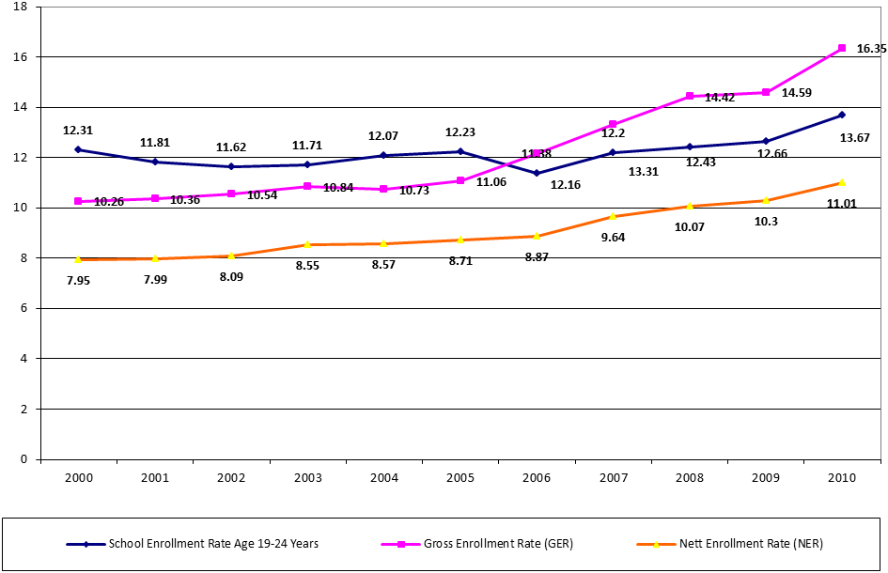Source: Central Board of Statistics of the Republic of Indonesia, Indicators of Education 1994-2010
261. The Government of Indonesia also strives to ensure that the right to education of Indonesian citizens living abroad, including Indonesian migrant workers, is fulfilled. This is done through, among others:
(a) Indonesian schools for Indonesian citizens overseas, including for families of migrant workers;
(b) Schools for the children of migrant workers in oil palm plantations in Tawau, Malaysia, start from primary school/Madrasah Ibtidaiyah (SD/MI/Package A), junior high school/Madrasah Tsanawiyah (SMP/MTs/Package B), and senior high school/Madrasah Aliyah (SMA/MA/Package C);
(c) Community Learning Centre for Indonesian Migrant Workers in Kinabalu, Malaysia
(d) Scholarships for the poor especially 2,000 children of migrant workers in for as much as Rp 360,000/year (as applied in Indonesia);
262. The Government of Indonesia continues to promote sustainable education for literacy for adults, through life skill programmes. Government in this regard has set up Presidential Instruction No. 5 of 2006 on the National Movement for the Completion of Nine-Year Compulsory Education and the Eradication of Illiteracy.
263. Such efforts are carried out through the functional literacy approach, that is by familiarizing the targeted adults with letters, reading, writing, arithmetic, listening, and communicating in Bahasa Indonesia (Indonesian language). Upon graduation, they shall take up advanced literacy program (literacy with orientation on family, independence), conducted by Community Learning Centre, and through the establishment of Public Reading Clubs.
264. In general, literacy rate for all age groups in Indonesia has increased during the period of 2005-2010. Such increase can be observed for both male and female. For male, literacy rate has increased from 94.34 per cent in 2005 to 95.35 per cent in 2010, whereas for female, the rate has also increased from 87.54 per cent in 2005 to 90.52 per cent in 2010.
Literacy rate by age group and by gender (per cent), 2005 – 2010
Age Group | 2005 | 2006 | 2007 | 2008 | 2009 | 2010
15 – 19 | 98.86 | 98.92 | 98.96 | 99.60 | 99.64 | 99.56
20 – 24 | 98.62 | 98.60 | 98.70 | 99.31 | 99.28 | 99.42
25 – 34 | 97.85 | 97.87 | 97.88 | 98.67 | 98.53 | 98.55
35 – 49 | 92.40 | 92.95 | 92.73 | 95.11 | 94.84 | 95.09
50 + | 72.64 | 74.89 | 78.03 | 75.73 | 77.82 | 78.46
Male | 94.34 | 94.56 | 95.22 | 95.38 | 95.65 | 95.35
Female | 87.54 | 88.39 | 88.62 | 89.10 | 89.68 | 90.52
Source: Central Board of Statistics of the Republic of Indonesia, National Socio-Economic Survey 2010
265. The literacy rate is lower in rural than in urban areas. In 2006 and 2007, the literacy rate in most age groups in urban areas increased - with the exception of the 45-49 years age group. In the same period, in rural areas, there is a decline in literacy rates in the age group 25-29 up to 45-49. At the end of 2010, the proportion of the population that is still not literate stood at 5.03 per cent.
Illiteracy rate by age group in urban and rural areas (per cent), 2006 – 2008
Age Group | Urban |  |  | Rural |  |  | Urban + Rural
 | 2006 | 2007 | 2008 | 2006 | 2007 | 2008 | 2006 | 2007 | 2008
15 – 19 | 0.48 | 0.40 | 0.12 | 1.54 | 1.54 | 0.68 | 1.08 | 1.04 | 0.40
20 – 24 | 0.57 | 0.42 | 0.15 | 2.19 | 2.16 | 1.32 | 1.40 | 1.30 | 0.69
25 – 29 | 0.70 | 0.65 | 0.24 | 2.93 | 2.97 | 1.99 | 1.86 | 1.87 | 1.08
30 – 34 | 0.89 | 0.75 | 0.42 | 3.72 | 3.79 | 2.77 | 2.41 | 2.38 | 1.58
35 – 39 | 1.84 | 1.69 | 0.81 | 6.00 | 6.55 | 4.47 | 4.14 | 4.37 | 2.67
40 – 44 | 4.15 | 3.78 | 3.00 | 10.15 | 11.02 | 8.93 | 7.49 | 7.75 | 5.95
45 – 49 | 5.60 | 5.68 | 3.38 | 13.89 | 14.33 | 9.38 | 10.35 | 10.51 | 6.48
50 + | 16.10 | 13.92 | 16.67 | 31.25 | 27.44 | 30.62 | 25.11 | 21.97 | 24.27
Average  Indonesia | 4.72 | 4.31 | 4.56 | 11.60 | 11.23 | 10.97 | 8.55 | 8.13 | 7.81
Source: Central Board of Statistics of the Republic of Indonesia, 2009
266. The basis for equal treatment is contained in Law No. 20 of 2003 on National Education System, in article 4 paragraph 1, which states that "education was held in a democratic and fair and not discriminatory to uphold human rights, religious values​​, cultural values, and pluralistic nature of the nation.”
267. As an effort to enhance gender equality, the Government of Indonesia carries out sustainable policies to bring about justice and gender equality in all lines and levels of education, family education based on gender, and provision of teaching materials that are not gender biased. Equality of treatment for boys and girls in education is reflected in the table below, which shows the amount of participation of boys and girls (in percentage) is essentially balanced. The School Committee will encourage schools to pay attention to girls' education.
Gender parity index in the field of education, 1993-2009
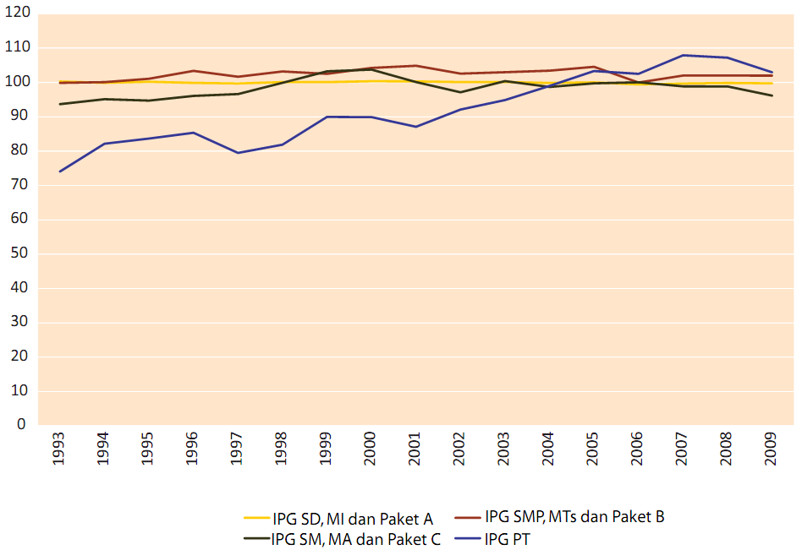
Source: Central Board of Statistics of the Republic of Indonesia, National Socio-Economic Survey 2009
268. Gender equality in the field of education has gained a significant progress. When measured with Gender Parity Index (GPI), the NER of women compare to men has shown a significant progress in the field of education. Based on the data of the Statistics Indonesia’s Socio-economic Survey from 1993 to 2009, GPI for NER at primary and secondary education levels is in the range of 95-105. In 2009, GPI at the level of primary education has reached 99.73, at junior high school level was 101.99, at senior high school level was 96.16, and at university level was 102.95 (National Socio-Economic Survey 2009).
269. With regard to human rights education, the Government of Indonesia also provides educational materials on the rights of the economic, social and cultural education from an early age, studying the major thematic of content issues, in accordance with the Law No. 20 of 2003. The Government is committed to the education of human rights and the process of acculturation of the values of justice to develop cultural dignity.
270. The development of education in Indonesia still faces challenges, in particular:
(a) Gap between the number of population and the availability of education services and facilities;
(b) Gap of the level of education between rich and poor, between the male and female, between urban and rural populations, and between regions;
(c) Distribution of educational service facilities that is still not yet spread equally, in particular at villages, rural areas and small islands, causing difficulties of access for children;
(d) Existing need to improve quality of education to enhance students’ competency;
(e) The need for more funding;
(f) Distribution of teaching staffs that is still not yet spread equally, both in terms of quality and quantity.
P. Right to culture
271. The Government of Indonesia recognizes the right of people to cultural life, science and all that derived from their development. Fundamentally, as stated in article 28C (1) of the 1945 Constitution, the Government ensures: “Every person shall have the right to develop him/herself through the fulfillment of his/her basic needs, the right to get education and to benefit from science and technology, arts and culture, for the purpose of improving the quality of his/her life and for the welfare of the human race”. Article 32 of the 1945 Constitution specifically states that: “(1) State shall advance the national culture of Indonesia among the civilization of the world by assuring the freedom of society to preserve and develop cultural values; (2) State shall respect and preserve local languages as national cultural treasures.”
272. To comply with those mandates, the Government established the Ministry of National Education and Culture which is responsible for the promotion of the values of Indonesian culture with its programmes to empower national and local governments and the people to increase respect and preserve culture and traditional knowledge.
273. The Government of Indonesia seeks to preserve Indonesian cultural heritage by enacting Law number 11 of 2010 on Cultural Heritage, in conjunction with Law number 5 of 1992 on Objects of Heritage. This Law regulates the Government’s responsibility in protecting, developing and utilizing Indonesian cultural heritage. Following the law, currently Indonesia has preserved a number of 8,863 sites and objects of cultural heritage, and 146 conservation areas.
274. UNESCO proclaimed some of Indonesian cultural heritages as the Masterpiece of Oral and Intangible Heritage of Humanity, namely Indonesian kris and Indonesian wayang puppet theatre (2008), Indonesian batik (2009), and Indonesian angklung (2010). In 2011, UNESCO also recognizes that Saman dance from Aceh satisfies the criteria for inscription on the List of Intangible Cultural Heritage in Need of Urgent Safeguarding.
275. One of the measures taken by the Government of Indonesia in educating and improving people’s understanding about Indonesian culture and history is through the development of museums. The Government recognizes the importance of museum as a medium to learn the magnificent Indonesian culture and history. Currently, around 80 State museums spread across most provinces in Indonesia. Some of the museums show rise in the visitor numbers, among others Museum Negeri Adityawarman in West Sumatera, Museum Negeri Balaputra Dewa in South Sumatera, and National Museum Jakarta.
276. The Government of Indonesia through the Language Development Agency of the Ministry of National Education and Culture has been conducting a research and preparing a map of languages to indicate the data of local languages in Indonesia, including their spread area. Based on the map, currently a number of 442 local languages that are still being used by Indonesian people are registered.
277. Most of the Indonesian local languages, especially those spoken by minorities, have been continuously inherited. Based on that research, now at least 10 local languages in North Maluku and Papua are alleged to have become extinct and 32 others are endangered because of the number of native speakers is less than 100 people. Those extinct languages are Bahasa Ibu (North Maluku), and nine languages in Papua, among others: Bapu, Darbe and Wares (Sarmi); Taworta and Waritai (Jayapura); Murkim and Walak (Jaya Wijaya); Meoswar (Manokwari); and Loegenyem (Raja Ampat). Meanwhile, there are 32 endangered languages namely: Bonerif and Foya (Foja); Itik, Liki, Mander, Maremgi and Massep (Potafa); Pawi and Yoki (Sarmi); Usku, Narau, Kapori, Tafanma, Dabra and Kwerisa (Jayapura); Kofei, Sauri, Awera, Burate, Tafaro, Woria and Saponi (Waropeng); as well as Pyu, Kosare and Kembra (Jayawijaya).
278. In view of the fact that there are many local languages in Indonesia, it is feared that such languages share the risk of being endangered, including those that are used in areas that have not yet been taken into account in the research. Native speakers and local authorities are the key to the sustainability of regional languages in Indonesia. To preserve regional languages, the Government has undertaken local language teaching programmes for students in formal education, in addition to learning the national language (Bahasa Indonesia) and foreign languages.
279. The Government of Indonesia ensures the right of access to internet and social media. The number of internet users in Indonesia has reached 55 million people. Overall, 23 per cent of Indonesian people have been actively accessing the internet, mostly those living in big cities. The Government also established the ‘internet goes rural’ programme, to ensure those living in villages and rural area can also enjoy information and internet access.
280. As an effort to protect intellectual property rights (IPRs), the Government of Indonesia has enacted national legislations on IPRs that have existed since the Minister of Justice issued an announcement No. JS 5/41 dated 12 August 1953 and No. JG 1/2/17 dated 29 August 1953 on Temporary Patent Registration. Furthermore, the Government has enacted Law No. 21 of 1961 on Trademark in conjunction with Law No. 19 of 1992 and in conjunction with Law No. 15 of 2001. For copyrights, the Government of Indonesia has enacted Law No. 6 of 1982 in conjunction with Law No. 19 of 2002 on Copyright. In terms of patent, the Government has enacted Law No. 6 of 1989 in conjunction with Law No. 14 of 2001 on Patent. In addition, the Government has also enacted Law No. 30 of 2000 on Trade Secret, Law No. 31 of 2000 on Industrial Design, and Law No. 32 of 2000 on Layout Design of Integrated Circuit.
281. The Government of Indonesia has ratified international conventions on IPRs, among others:
(a) Paris Convention for the protection of Industrial Property and Convention Establishing the World Intellectual Property Organizations, through Presidential Decision no. 15 of 1997 on the Amendment of Presidential Decree No. 24 of 1979;
(b) Patent Cooperation Treaty (PCT) and Regulation under the PCT, through Presidential Decree No. 16 of 1997;
(c) Trademark Law Treaty (TML) through Presidential Decree no. 17 of 1997;
(d) Bern Convention for the Protection of Literary and Artistic Works through Presidential Decree No. 18 of 1997;
(e) WIPO Copyrights Treaty (WCT) through Presidential Decree No. 19 of 1997.
282. Efforts to protect national culture have been pursued by related ministries/institutions. Some forms of incentives have been implemented with regard to IPR, among others: IPR Center Incentive Program; Incentive Program by Patent; Technology and Insurance Incentive Program; and Incentive Program for the Protection of Traditional Knowledge. The main objective of such programmes is IPR management with the purpose of providing space to manage IPR and to enhance new innovations with IPR values, so as to increase the number of patent applications, both domestically and internationally.
283. The Government of Indonesia also develops IPR Centers in university campuses, which are meant to facilitate students and teaching staff to make patent out of the outcomes of their works or research. The presence of IPR Centers in campuses is meant to shorten the steps to undergo in processing IPR certificates. Currently, IPR certificates are produced solely by the Directorate General of IPR of the Ministry of Law and Human Rights. However, there are also several IPR institutions that possess international qualification from several countries, such as the US and Australia. IPR Centers in campuses only serve as facilitators for researchers or inventors to process their IPR certificates.
284. The Government of Indonesia has taken measures for the realization of the preservation of national culture so as not to be claimed and exploited by foreign parties. Steps taken include, among others, by performing the traditional culture at every opportunity, directly or through mass media; by including local cultural development in the curriculum at elementary and secondary school levels. Further, the Government also welcomes cultural exchanges and activities of people to people contact between nations in various fields with the purpose of increasing mutual understanding and respect, notably through the introduction of the national cultural wealth.
Indonesian central government's economic, social and cultural expenditures
2005-2011
(billion rupiah)
SECTOR |  | 2005 |  | 2006 |  | 2007 |  | 2008 |  | 2009 |  | 2010 | 2011
Economic Affairs |  | 23,504.0 |  | 38,295.6 |  | 42,222.0 |  | 50,484.8 |  | 58,845.1 |  | 61,203.9 | 101,414.5
Commercial, cooperation and smal medium enterprise |  | 1,572.0 |  | 2,055.9 |  | 1,765.7 |  | 1,597.4 |  | 1,783.0 |  | 1,834.5 | 2,279.5
Labour affairs |  | 441.1 |  | 978.1 |  | 970.2 |  | 1,070.1 |  | 1,473.4 |  | 1,566.9 | 1,398.0
Agriculture, forestry, fishing, and marine |  | 4,959.3 |  | 8,345.7 |  | 7,570.3 |  | 11,241.8 |  | 8,716.8 |  | 10,155.0 | 15,920.6
Irrigation |  | 3,355.0 |  | 5,311.1 |  | 4,231.8 |  | 4,980.0 |  | 7,135.5 |  | 5,542.2 | 12,140.9
Fuel and energy |  | 2,126.6 |  | 3,065.1 |  | 2,900.7 |  | 3,324.6 |  | 4,705.2 |  | 3,841.0 | 10,866.5
Mining |  | 686.0 |  | 1,160.0 |  | 1,086.7 |  | 1,353.1 |  | 1,205.5 |  | 2,714.1 | 1,303.7
Industries and construction |  | 476.3 |  | 119.4 |  | 1,270.0 |  | 1,432.8 |  | 1,425.7 |  | 1,697.9 | 2,561.5
Transport |  | 9,087.4 |  | 14,287.1 |  | 16,647.6 |  | 24,730.0 |  | 31,218.6 |  | 31,068.2 | 46,979.1
Telecommunication |  | 262.1 |  | 950.1 |  | 472.8 |  | 546.5 |  | 949.5 |  | 2,404.7 | 1.9
R & D defense |  | 170.0 |  | 241.7 |  | - |  | - |  | - |  | - | 2,232.3
Economic affairs n.e.c. |  | 368.2 |  | 781.4 |  | 5,306.4 |  | 208.5 |  | 232.0 |  | 379.3 | 5,730.4
Environmental Protection |  | 1,333.9 |  | 2,664.5 |  | 4,952.6 |  | 5,315.1 |  | 10,703.0 |  | 8,585.8 | 11,069.6
Waste management |  | 314.7 |  | 325.6 |  | 348.0 |  | 478.4 |  | 525.2 |  | 557.4 | 3,016.5
Waste water management |  | - |  | 35.1 |  | - |  | - |  | - |  | - | -
Pollution abatement |  | 110.8 |  | 179.1 |  | 189.9 |  | 206.1 |  | 155.9 |  | 158.4 | 220.3
Natural resources conservation |  | 519.5 |  | 1,669.2 |  | 3,176.6 |  | 3,150.3 |  | 4,518.7 |  | 5,378.5 | 4,528.8
Spatial planning and land |  | 388.2 |  | 413.6 |  | 961.7 |  | 1,351.9 |  | 1,412.3 |  | 2,290.0 | 2,891.3
R & D |  | - |  | 0.6 |  | - |  | - |  | - |  | - | -
Environmental protection n.e.c. |  | 0.7 |  | 41.2 |  | 276.5 |  | 128.4 |  | 4,090.9 |  | 201.6 | 412.7
Housing and Communities Amenities |  | 4,216.5 |  | 5,457.2 |  | 9,314.6 |  | 12,448.7 |  | 14,648.5 |  | 21,509.0 | 23,425.3
Housing development |  | 432.1 |  | 1,005.8 |  | 1,130.9 |  | 1,616.4 |  | 1,958.9 |  | 1,460.0 | 1,625.1
Community development |  | 599.8 |  | 1,232.8 |  | 2,435.3 |  | 2,083.5 |  | 3,415.6 |  | 3,226.5 | 3,379.8
Water supply |  | 477.9 |  | 860.7 |  | 1,425.7 |  | 2,138.7 |  | 3,163.7 |  | 3,338.5 | 3,092.8
Street lighting |  | - |  | - |  | - |  | - |  | - |  | - | -
R & D |  | - |  | - |  | - |  | - |  | - |  | - | -
Housing and community ammenities n.e.c. |  | 2,706.7 |  | 2,358.0 |  | 4,142.8 |  | 6,610.0 |  | 6,110.3 |  | 13,484.0 | 15,327.6
Health |  | 5,836.9 |  | 12,189.7 |  | 16,004.5 |  | 14,038.9 |  | 15,743.1 |  | 19,801.5 | 13,649.4
Medical product, appliances, and equipment |  | 359.2 |  | 924.0 |  | 884.6 |  | 1,388.6 |  | 1,274.5 |  | 1,410.1 | 1,786.8
Individual public health services |  | 2,093.1 |  | 4,839.2 |  | 8,070.3 |  | 8,780.6 |  | 9,765.2 |  | 11,945.6 | 7,698.3
Society public health services |  | 3,053.7 |  | 4,152.4 |  | 3,348.1 |  | 1,715.7 |  | 2,712.1 |  | 3,391.9 | 855.7
Population and Family planning |  | - |  | 329.2 |  | 433.8 |  | 479.7 |  | 623.8 |  | 807.2 | 2,413.2
R & D |  | 65.0 |  | 144.9 |  | 197.7 |  | 198.5 |  | 134.1 |  | 160.3 | 414.0
Health n.e.c. |  | 265.8 |  | 1,799.9 |  | 3,070.0 |  | 1,475.9 |  | 1,233.3 |  | 2,086.5 | 481.3
Tourism and Culture | 588.6 |  | 905.4 |  | 1,851.2 |  | 1,293.7 |  | 1,406.2 |  | 1,530.5 |  |  | 2,901.4
Tourism and culture development | 301.1 |  | 510.2 |  | 492.8 |  | 611.6 |  | 602.1 |  | 936.4 |  |  | 1,422.1
Youth and sport development | 251.4 |  | 308.0 |  | 536.6 |  | 571.9 |  | 668.1 |  | 6.5 |  |  | -
Broadcasting and publishing services | 2.3 |  | 77.1 |  | 442.8 |  | 110.2 |  | 136.0 |  | 157.0 |  |  | 8.4
R & D | - |  | - |  | - |  | - |  | - |  | - |  |  | 71.0
Development of sport achievement | - |  | - |  | - |  | - |  | - |  | 430.6 |  |  | 965.5
Tourism and culture n.e.c. | 33.8 |  | 10.2 |  | 379.0 |  | - |  | - |  | - |  |  | 434.5
Religion | 1,312.3 |  | 1,411.2 |  | 1,884.2 |  | 745.7 |  | 773.5 |  | 943.1 |  |  | 1,397.3
Enhancement Religious life | 1,186.8 |  | 1,289.6 |  | 419.6 |  | 607.8 |  | 689.1 |  | 839.9 |  |  | 718.5
Development of harmonism between religion | 72.7 |  | 34.7 |  | 24.4 |  | 20.6 |  | 28.7 |  | 30.5 |  |  | 65.3
R & D | 8.7 |  | 16.9 |  | 20.0 |  | 44.9 |  | 30.2 |  | 33.0 |  |  | 78.1
Religion n.e.c. | 44.1 |  | 70.0 |  | 1,420.2 |  | 72.4 |  | 25.4 |  | 39.6 |  |  | 535.4
Education | 29,307.9 |  | 45,303.9 |  | 50,843.4 |  | 55,298.0 |  | 84,919.5 |  | 97,235.7 |  |  | 91,483.0
Pre-primary education | 281.7 |  | 306.3 |  | 444.1 |  | 496.2 |  | 612.4 |  | 1,327.7 |  |  | 367.8
Primary Education | 12,310.4 |  | 22,773.9 |  | 22,494.5 |  | 24,627.5 |  | 37,205.7 |  | 34,735.1 |  |  | 10,348.8
Secondary education | 3,963.0 |  | 4,703.9 |  | 4,118.3 |  | 3,842.7 |  | 7,346.3 |  | 7,610.5 |  |  | 3,929.0
Formal and informal education | 1,207.2 |  | 837.3 |  | 1,202.8 |  | 779.4 |  | 1,265.2 |  | 1,218.0 |  |  | 4,279.9
In-Service Education | 659.0 |  | 722.2 |  | 213.1 |  | 274.3 |  | 160.8 |  | 196.4 |  |  | 520.5
University | 7,055.7 |  | 9,729.0 |  | 6,904.4 |  | 13,096.4 |  | 22,189.3 |  | 29,666.2 |  |  | 35,211.5
Subsidiary services to education | 2,564.3 |  | 3,863.5 |  | 5,078.4 |  | 11,089.7 |  | 14,984.8 |  | 19,002.3 |  |  | 16,651.7
Religion education | 69.7 |  | 2,081.5 |  | 192.4 |  | 287.7 |  | 607.2 |  | 771.5 |  |  | 3,183.9
R & D | 1,020.0 |  | 259.8 |  | 550.8 |  | 803.5 |  | 547.9 |  | 814.1 |  |  | 1,259.2
Youth and sport founding | - |  | - |  | - |  | - |  | - |  | 1,893.8 |  |  | 1,742.2
Education n.e.c. | 177.0 |  | 26.5 |  | 9,644.6 |  | 0.8 |  | - |  | - |  |  | 13,988.5
Social Protection | 2,103.8 |  | 2,303.3 |  | 2,650.4 |  | 2,986.4 |  | 3,102.3 |  | 3,611.4 |  |  | 4,585.5
Sickness and disability | 18.1 |  | - |  | - |  | - |  | - |  | - |  |  | 257.8
Old age | 2.0 |  | - |  | - |  | - |  | - |  | - |  |  | 101.1
Protection and social services for families of national heroes | 19.6 |  | 27.0 |  | - |  | - |  | - |  | - |  |  | -
Family and children | 421.4 |  | 72.0 |  | 719.9 |  | 679.6 |  | 716.1 |  | 782.1 |  |  | 458.9
Women empowerment | 91.6 |  | 93.3 |  | 116.4 |  | 95.8 |  | 83.5 |  | 123.9 |  |  | 120.5
Counseling and social giudance | 17.4 |  | 29.4 |  | 480.3 |  | 481.1 |  | 539.2 |  | 559.1 |  |  | -
Housing | - |  | - |  | - |  | - |  | - |  | - |  |  | -
Social Security | 723.4 |  | 691.3 |  | 1,148.8 |  | 1,546.7 |  | 1,563.0 |  | 1,928.0 |  |  | 80.7
R & D | 48.1 |  | 64.6 |  | 87.0 |  | 65.3 |  | 73.6 |  | 81.3 |  |  | 236.2
Social protection n.e.c. | 762.2 |  | 1,325.7 |  | 98.0 |  | 117.8 |  | 126.7 |  | 137.0 |  |  | 3,330.3

SECTOR | 2005 | 2006 | 2007 | 2008 | 2009 | 2010 | 2011
Tourism and Culture | 588.6 | 905.4 | 1,851.2 | 1,293.7 | 1,406.2 | 1,530.5 | 2,901.4
Tourism and culture development | 301.1 | 510.2 | 492.8 | 611.6 | 602.1 | 936.4 | 1,422.1
Youth and sport development | 251.4 | 308.0 | 536.6 | 571.9 | 668.1 | 6.5 | -
Broadcasting and publishing services | 2.3 | 77.1 | 442.8 | 110.2 | 136.0 | 157.0 | 8.4
R & D | - | - | - | - | - | - | 71.0
Development of sport achievement | - | - | - | - | - | 430.6 | 965.5
Tourism and culture n.e.c. | 33.8 | 10.2 | 379.0 | - | - | - | 434.5
Religion | 1,312.3 | 1,411.2 | 1,884.2 | 745.7 | 773.5 | 943.1 | 1,397.3
Enhancement Religiouslife | 1,186.8 | 1,289.6 | 419.6 | 607.8 | 689.1 | 839.9 | 718.5
Development of harmonism between religion | 72.7 | 34.7 | 24.4 | 20.6 | 28.7 | 30.5 | 65.3
R & D | 8.7 | 16.9 | 20.0 | 44.9 | 30.2 | 33.0 | 78.1
Religion n.e.c. | 44.1 | 70.0 | 1,420.2 | 72.4 | 25.4 | 39.6 | 535.4
Education | 29,307.9 | 45,303.9 | 50,843.4 | 55,298.0 | 84,919.5 | 97,235.7 | 91,483.0
Pre-primary education | 281.7 | 306.3 | 444.1 | 496.2 | 612.4 | 1,327.7 | 367.8
Primary Education | 12,310.4 | 22,773.9 | 22,494.5 | 24,627.5 | 37,205.7 | 34,735.1 | 10,348.8
Secondary education | 3,963.0 | 4,703.9 | 4,118.3 | 3,842.7 | 7,346.3 | 7,610.5 | 3,929.0
Formal and informal education | 1,207.2 | 837.3 | 1,202.8 | 779.4 | 1,265.2 | 1,218.0 | 4,279.9
In-Service Education | 659.0 | 722.2 | 213.1 | 274.3 | 160.8 | 196.4 | 520.5
University | 7,055.7 | 9,729.0 | 6,904.4 | 13,096.4 | 22,189.3 | 29,666.2 | 35,211.5
Subsidiary services to education | 2,564.3 | 3,863.5 | 5,078.4 | 11,089.7 | 14,984.8 | 19,002.3 | 16,651.7
Religion education | 69.7 | 2,081.5 | 192.4 | 287.7 | 607.2 | 771.5 | 3,183.9
R & D | 1,020.0 | 259.8 | 550.8 | 803.5 | 547.9 | 814.1 | 1,259.2
Youth and sport founding | - | - | - | - | - | 1,893.8 | 1,742.2
Education n.e.c. | 177.0 | 26.5 | 9,644.6 | 0.8 | - | - | 13,988.5
Social Protection | 2,103.8 | 2,303.3 | 2,650.4 | 2,986.4 | 3,102.3 | 3,611.4 | 4,585.5
Sickness and disability | 18.1 | - | - | - | - | - | 257.8
Old age | 2.0 | - | - | - | - | - | 101.1
Protection and social services for families of national heroes | 19.6 | 27.0 | - | - | - | - | -
Family and children | 421.4 | 72.0 | 719.9 | 679.6 | 716.1 | 782.1 | 458.9
Women empowerment | 91.6 | 93.3 | 116.4 | 95.8 | 83.5 | 123.9 | 120.5
Counseling and social giudance | 17.4 | 29.4 | 480.3 | 481.1 | 539.2 | 559.1 | -
Housing | - | - | - | - | - | - | -
Social Security | 723.4 | 691.3 | 1,148.8 | 1,546.7 | 1,563.0 | 1,928.0 | 80.7
R & D | 48.1 | 64.6 | 87.0 | 65.3 | 73.6 | 81.3 | 236.2
Social protection n.e.c. | 762.2 | 1,325.7 | 98.0 | 117.8 | 126.7 | 137.0 | 3,330.3

* In accordance with the information transmitted to States parties regarding the processing of their reports, the present document was not edited.
Further data in the table attached
Further Data can be accessed at the website of Information and Data Center, Ministry of Manpower : http://pusdatinaker.balitfo.depnakertrans.go.id
BNSP is an independent body established by the Government based on Law no 13of 2003 on Employment. By providing certificates, this body is responsible in ensuring the competency level and quality, as well as acknowledgement of the employees from all sectors and professions.
Further data at website Central Board of Statistics of the Republic of Indonesia: www.bps.go.id.
Central Board of Statistics of the Republic of Indonesia, National and Regional Human Development Index 1996 – 2009.
Central Board of Statistics of the Republic of Indonesia, Indonesian Chosen Consumption Index, 2002-2008
Ministry of National Development Planning/National Development Planning Agency of the Republic of Indonesia, The Roadmap to Accelerate Achievement of the MDGs in Indonesia, 2010 and Central Board of Statistics of the Republic of Indonesia, Indicators of Housing 1993-2010
Survey by MarkPlus Insight, 2011.

