 | United Nations | CRC/C/GNB/2-4
 | Convention on the  Rights of the Child |  | Distr.: General  7 December 2011  Original: English
Committee on the Rights of the Child
Consideration of reports submitted by States parties under article 44 of the Convention
Combined second, third and fourth periodic reports of States parties due in 2007
Republic of Guinea-Bissau*
[11 December 2009]

Contents
Paragraphs Page
Abbreviations 6
I. Introduction 1–6 8
II. The country 7–7 9
A. Geographic and demographic context 7–9 9
B. Political and economic context 10–17 10
III. Definition of a child 18–59 10
A. Full legal age/adult – legal and customary base 20–24 11
B. Employment/child labour 25–30 11
C. Militarization/draft (minimum age of recruitment) 31 13
D. Marriage and sexual practices 32–33 13
E. Adoption, guardianship or custody 34–35 14
F. Human trafficking 36–39 14
G. Criminal responsibility 40–43 15
H. Consumption of alcohol or drugs 44 15
I. The right to education 45–50 15
J. Prevention of cruel treatment of children 51–55 17
K. Participation in the political life 56–59 17
IV. General measures of implementation 60–113 18
A. Implementation procedures, political/legislative harmonization 60–77 18
B. Policy coordination, network and monitoring mechanisms. 78–83 20
C. Participation of children 84 20
D. Dissemination of Convention 85–96 21
E. Cooperation with NGOs 97–108 25
F. Decentralization of the measures regarding the protection of children 109–113 27
V. General principles 114–134 28
A. Non-discrimination 114–119 28
B. Children’s best interest 120–124 29
C. The right to life, survival and development 125–127 30
D. Respect for children’s opinions 128–134 30
VI. Civil rights and liberties 135–149 32
A. Birth certification/registration 135–141 32
B. Freedom of expression 142 34
C. Freedom of association 143–144 34
D. Cult, consciousness and religion 145–147 35
E. Access to appropriate information and right to privacy 148 36
F. Prevention against torture, inhuman and degrading treatment 149 36
VII. Family environment and alternative guardianship 150–162 36
A. Paternal responsibilities, rights and duties 150–155 36
B. Security and social reinsertion of children 156–159 37
C. Homes for children: rehabilitation, re-education and reintegration
of vulnerable children and youth in conflict with the law 160–162 38
VIII. Basic health and well-being 163–206 38
A. Child survival and development 164–168 38
B. Disability and deficiency 169–172 39
C. Infant and maternal health 173–178 40
D. Family planning, regulation of harmful traditional and cultural practices
(female genital mutilation, early/forced marriage) and trafficking 179–192 42
E. HIV/AIDS, and other STDs: prevention, control and treatment 193–200 45
F. Nutrition and food security 201–203 46
G. Services that guarantee children’s care 204–206 47
IX. Education, leisure and cultural activities 207–214 48
A. Strategy/national policy on education 207–211 48
B. Challenges and perspectives 212 49
C. Promotion of recreational, leisure and cultural activities 213–214 49
X. Special protection measures/children in emergency situations 215–223 50
A. Disarmament, demobilization and reintegration of children incorporated in
defence and security forces 215 50
B. Reinstallation and reintegration of displaced and returned children 216–220 50
C. Protection of children victims of kidnapping and sexual abuse 221–223 50
XI. Children in conflict with the law 224–233 51
A. Political and other actions and legal reforms 224–228 51
B. Expectations/follow-up and legal support for children 229 51
C. Reform, rehabilitation and institutionalization of the protection
of affected children 230 51
D. Alternative legal mechanisms/institutions 231–233 52
XII. Environmental protection 234–239 52
A. The right to a safe and healthy environment 234–237 52
B. Protection of street and vending children 238–239 53
Conclusion 240–260 53
A. Challenges and perspectives 255 54
B. Regarding the report 256–260 56
Bibliography 57
List of Graphs
Graph I Demographic distribution per region 9
Graph II Correlation between parent/guardian’s socio-professional situation and
amount of time children devote to other types of work 12
Graph III Children who are students and workers 13
Graph IV Children enrolled in an educational institution from age 6 16
Graph V Parity between sexes in the education system 16
Graph VI Correlation between level of education of the parent/guardian responsible
for the child’s education and knowledge about the Convention 21
Graph VII Parent/guardian’s place of residence and means used to gain knowledge
about the Convention 22
Graph VIII Sources of information based on place of residence 23
Graph IX Means of information about the Convention in group of regions 23
Graph X Correlation between the region where the parent/guardian responsible for
the child’s education live and means by which he/she learned about
the existence of the Convention 24
Graph XI Rate of efficacy of the different means of information dissemination
in the regions 25
Graph XII Distribution of the responses on the question whether children’s opinion
is considered 31
Graph XIII Correlation between the parents/guardians’ ethnicity and taking into account
children’s opinions 31
Graph XIV Index of consideration of children’s opinions (country = 100) 32
Graph XV Number of children registered in the household 33
Graph XVI Age at which children were registered 33
Graph XVII Correlation between the participation of children in meetings and their
parents/guardians’ religion 35
Graph XVIII Infant and juvenile mortality rate....... 39
Graph XIX Children vaccinated in the households 40
Graph XX Staff who providing prenatal consultations 41
Graph XXI Family planning 42
Graph XXII Female genital mutilation 43
Graph XXIII Early marriage 44
Graph XXIV Total number of women between 15–19 years of age who had sexual
relationship before they were 15 years old 46
Graph XXV Spread of HIV and psychological burden during prenatal consultations 46
Graph XXVI Evolution of the school population per age group 49
List of Tables
Table I Vaccination during the first year of the child’s life 41
Table II Infant malnutrition 47
Table III Evolution of the school population 7–17 years of age 48
Abbreviations
AGRICE Association for the reintegration of the blind
AGUIBEF Association for the Family Well-Being
AMIC Association of Children’s Friends
ANP National’s People Assembly
ASGB Association of the Deaf in Guinea-Bissau
BO Official Gazette
CC Civil Code
CP Penal Code
CPP Code of Penal Procedure
CADBC African Charter on the Rights and Well-Being of Children
CAIA Office for the Evaluation of Environmental Impacts
CDC Convention on Children’s Rights
CEDAW Convention for the Elimination of All Forms of Discrimination against Women
CNPN National Committee against Harmful Practices
CRGB Constitution of the Republic of Guinea-Bissau
DUDH Declaration of Universal Human Rights
EMVN Average Life Expectancy at Birth
HIPD Human International Partnership for Development
IGT General Inspectorate for Labour
ILO International Labour Organization
IMC Women and Children’s Institute
INDE Inter-cooperation and Development
INEC National Statistical and Census Institute
ISF Index for the Synthesis of Fecundities (ISF)
LBA Basic Environmental Law
LGT General Labour Law
LOTS Organic Law of Sectorial Courts
MGF Female Genital Mutilation
MSSFLP Ministry of Social Solidarity, Family and Fight against Poverty
NGO Non-governmental Organization
NUNATIS National Nucleus of Technicians on Social Intervention
OIM International Organization for Migration
PAIGC African Party for the Independence of Guinea and Cape-Verde
PFCDC Facultative Protocols of the Convention on Children’s Rights
REJE Network of Young Educators
RENLUV National Network for the Fight against Violence
SAB Autonomous Sector of Bissau
SNTLS National Secretariat of National Technicians for the fight against AIDS
SRLS Regional Secretariat for the Fight against AIDS
UEMOA Economic and Monetary Union of African States
UNDM National Union for the Disabled Children (UNDM)
UNESCO United Nations Fund for the Advancement of Science and Culture
UNICEF United Nations Fund for Children
UNFPA United Nations Population Fund
UNHCR United Nations High Commission for Refugees
HIV Human Immunodeficiency Virus
WFP World Food Programme
WHO World Health Organization

I. Introduction
1. This report is aimed at analysing the applicability of the Convention on the Rights of the Child (CDC) in Guinea-Bissau, based on the terms of article 44 of this Convention, which expects each State to compile reports every five years regarding the applicability of this instrument for the protection of children in their respective territories. Due to various reasons, the country only managed to compile its first report in 1997, which was only discussed in 2001, due to the military conflict that the country faced then.
2. In this context, the current document, which is the second report from Guinea-Bissau, aims at equally being a facilitating tool for the wider understanding of the obstacles and challenges faced by the Government of Guinea-Bissau in implementing the policies and mechanisms aimed at protecting children as expected in the CDC.
3. It is important to note that the CDC was adopted by the United Nations General Assembly on 20 November 1989 and ratified by Guinea-Bissau, through Resolution 6/90 of 18 April 1990, by the State Council. The Convention recognizes the right of children to be protected against any form of exploitation and not be subject to any type of work that can expose them to health risks, as well as their protection against all forms of violence. The Optional Protocols to the Convention on the Rights of the Child (CDC) which specify the types of protection for underage children, i.e. Convention No. 182 of the International Labour Organization (ILO) on the interdiction of the worst forms of child labour, are among the many instruments put in place to defend and protect underage children. However, the need for the protection of minors was already established in the Geneva Declaration of Human Rights in 1924 and equally recognized by the Universal Declaration of Human Rights (DUDH) as well as by the Statutory Instruments of Specialized Agencies of International Organizations, which are concerned with children’s well-being.
4. At the local level, the country not only has institutions that defend and protect children at various levels, but also internal legal instruments which acclaim precepts in favour of children, namely the country’s Constitution, the Penal Code and the Organic Law of the Judicial Sector.
5. Thus, in this evaluation of the applicability of the Convention, we analyse the use of these instruments by various institutions in the country that defend and promote the rights of children. This evaluation was carried out by interviewing leaders of some public institutions and NGOs that work on children issues, and it aimed at gathering information about actions taken towards raising awareness about the CDC. In addition to this information, a survey targeting families was carried out, and information aimed at evaluating their knowledge about the CDC was collected and analysed.
6. The report is structured in 11 parts, and each part is comprised of several topics. In the first part, an attempt is made to introduce, in a synthesis format, the country’s context and background, in the second part, the focus is on the definition of the child, before laying out in the third part, the general measures for the implementation of the CDC. The general principles are dealt with in the fourth part, followed by the civil rights and liberties in the fifth part. The issue of family environment and guardianship are addressed in the sixth part. The seventh part deals with basic health and well-being issues, while the eighth part addresses the issue of education, leisure and cultural activities. The issues of special measures that protect children in emergency situations and children in conflict with the law are addressed in the ninth and tenth parts, respectively. Finally, the eleventh and last part of the report focuses on environmental protection.

II. The country

A. Geographic and demographic context
7. Guinea-Bissau is a small Portuguese-speaking country located on the west coast of the African continent in the Sahel region, with the Republic of Senegal to the North and the Republic of Guinea (Conakry) to the South. The country’s total area is about 36,125 m2, with an estimated population of 1,295,000 inhabitants. The population is spread over nine administrative regions, namely Bafatá, Biombo, Bissau, Bolama-Bijagós, Cacheu, Gabú, Oio, Quinara and Tombali. Each region is divided into Sectors and these make a total of 38. The Sectors are in turn structured into villages, which are estimated at more than 3,000. The country’s territory is comprised of two distinct parts: continental (land) and insular (water), with approximately 50 islands, some of which are not inhabited.
8. The majority of the population resides in rural areas, but about one third live in the Autonomous Sector of Bissau (31 per cent). The populations of the Autonomous Sector of Bissau (SAB) is followed by Gabú (16 per cent), Oio (15 per cent) and Cacheu (14 per cent). Bolama-Bijagós and Quínará are less populated with 2 per cent and 4 per cent respectively. In 2005, the country’s total population was estimated at approximately 1,295,840 inhabitants.
9. Based on the Human Development Report (2007/2008), the population below the age of 15 represents 47.4 per cent of the total population. Infant mortality rates are at 124 ‰ while the mortality rate of infants under 5 years is 2,000 ‰. Maternal mortality rate is 910, the Synthesis of Fecundity Index (ISF) is 7.4 children/woman, while the average life expectancy is 45.8 years.

Graph I

Demographic distribution per region
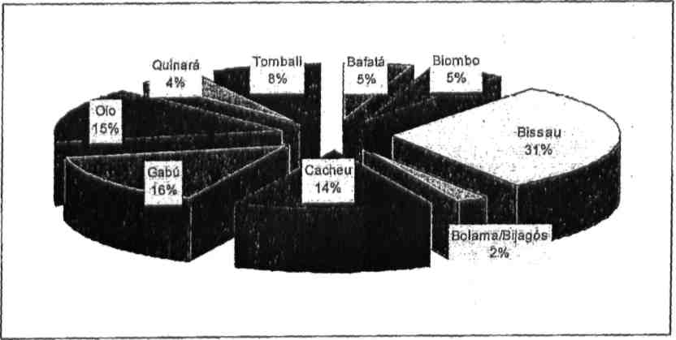
Source: INEC – 2004 Estimates.

B. Political and economic context
10. Guinea-Bissau unilaterally proclaimed its independence from Portugal on 24 September 1973, after a long armed struggle that lasted about 11 years.
11. As a consequence of the armed struggle, the territory was ruled by one party which was the same movement that oversaw the Colonial War with the characteristic “sui generes” of being the only Party to oversee two States: Guinea-Bissau and Cape Verde. However, five years into its independence, the country faced a coup d’état, which led to the end of the union that existed between the two countries.
12. In 1991, like most countries south of the Sahara, Guinea-Bissau started a democratization process by revising its Constitution which ended recognition of PAIGC as the only political power overseeing Guinea-Bissau’s society. As a result, the country’s first multiparty elections took place in 1994, where PAIGC and its presidential candidate were victorious and governed till May 1999. Due to a conflict between a military junta and other government institutions, the former dissolved the Constitution’s powers. This fight left the country on the verge of collapse and the economic damage was estimated at about
US$90 million.
13. During the 11 months that the country was involved in the civil war, the economy, which exhibited some signs of growth, was paralysed and its basic social infrastructure ceased to function normally. Despite the presidential elections in 1999 and the legislative elections in 2000, the country did not stabilize politically as it experienced many problems which limited its ability to restart its cooperation with international partners.
14. In 2004, with legislative elections followed by presidential elections in 2005, the country witnessed similar actions that were interrupted when a military coup took place in 2003. Endless efforts have been made to regain the support of the international community and these are aimed at improving the development indicators which are conditioned by public reform and, above all, reform of the security and defence forces, public administration and justice sectors.
15. In 1997, Guinea-Bissau became a member of UEMOA (Economic and Monetary Union of Western African States), sharing the same currency (Franc CFA) with seven other countries of the subregion.
16. It is important to note that the country has been regaining its former cooperation status with the Bretton Woods institutions, while attempting to scrupulously implement a much more rigorous macroeconomic management policy aimed at accelerating its economic growth, while reducing the level of poverty. The Government was recommended to adopt a strategy geared towards eliminating its budget deficit.
17. According to the Human Development Report (2007/2008), in 2005, the Human Development Index was 0.374, public and private expenditure represented 1.3 per cent and 3.5 per cent respectively and debt servicing was at 10.8 per cent.

III. Definition of a child
18. The notion of a child should not be limited on the basis of age in which a person ceases to be a child due to the fact that he/she has achieved the full legal age/adulthood. The different legal implications of the age in the rights and obligations of people, combined with the special attention that an individual must enjoy at a specific age group, seems to be the best way to have a more encompassing notion of what a child really means.
19. In this respect, we will follow the guidelines expected in terms of the set provisions contained in the Convention, which also allow us to determine whether the different services and administrative institutions apply or not the set definition of article 1 of the CDC.

A. Full legal age/adult – legal and customary base
20. The definition of a child adopted in the Guinea-Bissau legal system is not different from that of article 1 of the CDC, since the national law adopted the exclusionary method which considers children as being those who have not yet achieved the full legal age/adult age, by the determination of article 122 of CC, which serves as a by-law of article 130 of the same decree pursuant to the fixed composition by the Law No. 5/76 of 3 May published by the Official Gazette No. 18, adopted before the CDC.
21. Despite this coincidence, the different solutions adopted by the legal system allow for situations that may lack clarification in terms of the scope of their protection, which must be further analysed in greater detail.
22. In this view, the first question has to do with the period from when the status of a child ends, since the Civil Code as well as the Law No. 5/76 of 4 May establishes the age when an individual ceases to be a child at 18 years, as it is also established by the Convention, although the latter leaves it to the discretion of the States parties.
23. If we consider article 66 of the CC which states in its first paragraph that “Legal personality is obtained at the time of total birth and with life”, then we can understand that an individual is considered a child from the time he/she is born until he/she reaches 18 years of age; and the foetus also has rights, although these are subject to certain conditions as they are born. Furthermore, if we analyse what is contained in article 2033/2 of the CC, protection begins before conception, in other words, when the law attributes the legal passive capacity to the unborn of having successive inheritance benefits.
24. Based on these analyses, we can conclude that the legal system in Guinea-Bissau considers a child, for the purpose of protection, although conditionally, from the time of conception. Insofar as customary and current practices are concerned, the condition in which a person is considered a child or an adult depends on several factors, among them the evolution of their physical aspects and mental aptitude, the ability to follow certain rituals, such as marriage or circumcision, among others. The bottom line is that no traditional practice defines an age from which a person is considered an adult or ceases to be a child.

B. Employment/child labour
25. Regarding the use of child labour, the General Labour Law (LGT) establishes 14 years as the minimum age, combining this provision with what is contained in the Civil Code (CC) (arts. 123 to 125). Despite the fact that child labour is permitted, the child continues to lack the capacity to exercise his/her rights which means that he/she continues to need the follow-up protection of his/her interests since all the legal businesses that may have been entered into alone and which result in him/her became a victim, are nullified, except those actions that were authorized.
26. In this context, it is important to underline that the limit established by law refers only to subordinate work because it is difficult to control the informal activities carried out by an underage child. The period which a child begins to work in the household depends on several factors namely, the family structure, the habits and customs and economic factors. For example, in a large household, children may begin to undertake house/family chores later in their childhood than in a household with few members.

Graph II
Correlation between parent/guardian’s socio-professional situation and amount of
time children devote to other types of work
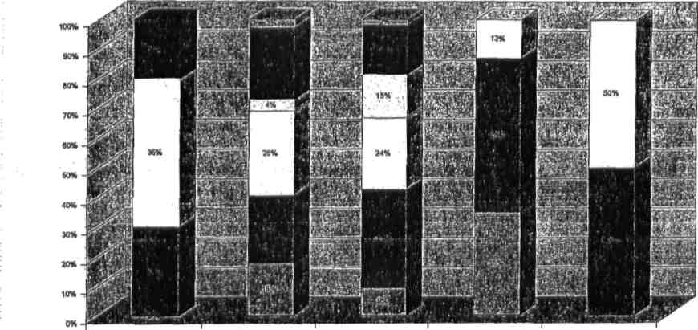
None 1 to 2 hours 3 to 4 hours 5 and more hours Does not know

□Unemployed ■Self-employed □Employed by someone □Peasant ■Domestic ■Student
Source: Data from the survey carried out as part of the compilation of this report.
27. Graph II shows that regardless of the professional situation of the parents/guardians, apart from studying, children devote a portion of their time carrying out other chores. Thus, 52 per cent of the cases where children work five or more hours per day, their parents/guardians are self-employed, followed by the unemployed and finally by those employed by other people. On the other hand, children who work between one to two hours per day are, in their majority, children or students whose parents/guardians work for another person (28 per cent), followed by domestic workers and the self-employed.
28. Insofar as the employment or placement of children in a situation in which their health and physical integrity is in jeopardy, despite the fact that the General Law in force in the country does not specify this aspect, the country adopted the main conventions on the subject particularly the ILO instruments regarding woman and child labour.
29. Taking into consideration the fact that the Constitution of the Republic of Guinea-Bissau is open, in terms of welcoming international norms related to fundamental rights, as in article 29, the General Labour Inspectorate (IGT) continuously monitors the labour conditions of different services, private and public companies which, in case they are found in violation, face the possibility of huge fines.
30. Graph III shows that the South is the area of the country which has a high percentage of children studying and working simultaneously (49 per cent), followed by the North (47 per cent), then the East with 43 per cent and SAB with only 14 per cent. The low figures shown below are registered in Bissau, maybe because it is a privileged area due to the intervention of some NGOs which implement projects that focus on young children who are workers. Another explanation might have to do with the fact that most educated people live in the capital and this situation does not allow their children to study and work at the same time because it may reflect negatively in their school performance.

Graph III
Children who are students and workers
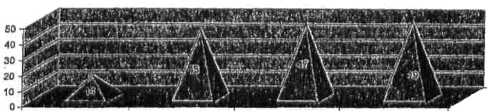

Total number of children
in percentage

Bissau
East

North

South

S1

Source: MICS 2006.

C. Militarization/draft (minimum age of recruitment)
31. The compulsory nature of the military service as prescribed in Law No. 3/80, 2 Supplement of the Official Gazette No. 20 of 17 May and detailed in Law No. 4 /99 of 7 September, does not include people who are under 18 years of age. Only from this age (18), a person may be enlisted, in other words, only those at the age of 18 and above have the obligation to serve in the military service because, in this regard, the notion of a child, as contained in the CDC and in the civil legislation, is not prejudiced by these special situations. However, it is important to state that after the compilation of the first report on the application of the CDC, the country was affected by a civil war, more concretely in 1998/99. Despite the fact that this was evidently a situation that initially opposed a regular army against a group of dissidents, its length forced another characteristic which, was beyond conventional patterns. This situation led to the indiscriminate use of children in various spheres and war efforts, in addition to other direct consequences, With this scenario, on institutional normalization, the militarization of people became a legal order, which means that only adults (aged 18 or above) could be incorporated into the regular security and defence forces. However, due to the inexistence of credible forms of identification, it is difficult to prove people’s real age, which allow for the possibility that indeed children are being used as part of the military forces.

D. Marriage and sexual practices
32. For the purpose of marriage, the law has established 16 as the age limit (art. 1602 a) CC), for both sexes in obedience to the principle of equality as established by the CRGB (Constitution of the Republic of Guinea-Bissau). Despite the fact that the Law does not allow for marriage of people who are under 16 years of age, this can only be celebrated with the consent of their representatives (parents or guardians). Thus, an underage child who marries without the consent of his/her representatives remains unable to administer the assets that he/she may have taken into the union (art. 1649 CC).
33. Regarding sexual practices, the penal law (art. 134 CP) does not consider relevant the consent of a minor until he/she reaches the age of 16 and it establishes a scale of aggravated charges varying with the phases of being a minor. Thus, the penal structure for those who engage in sexual relations with an underage child at the age of 12, ranges from 2 to 10 years in prison, and for those engaging in sex with an underage child under 12 years of age, the maximum prison limit is 5 or 8 years, depending on the intensity of the sexual abuse. For an underage child who is more than 16 years old, the law considers relevant his/her consent; however, it always takes into account his/her experiences and psychological capabilities.

E. Adoption, guardianship or custody
34. In order for a child to be legally entrusted to people with whom he/she does not have any parental links, the national law establishes various situations according to the condition and the age of the child. For the purpose of adoption, the Civil Code (CC) establishes two modalities, full and restricted adoption, requiring in both cases a maximum age of 14 years (art. 1974 CC). Full adoption refers to a case where the minor who is being adopted is in the same condition as that of a son/daughter, including in the quality of legitimate heir. By law, this option is only allowed for orphaned children or children from unknown parents and the adopting parents must not have natural children (art. 1982 CC). Restricted adoption is aimed only at protecting an underage child in terms of security, provision of food and education. In this adoption option, the adopting parents do not gain legal rights to prevent the adopted child from maintaining a legal bond with his/her natural family and the former are allowed to have natural children.
35. The difficulties in adopting through legal means make people resort, in some instances, to alternatives that include the falsification of the real parents’ identification. According to information gathered from the registrar and civil court’s employees, several cases of this nature have taken place and the facts often lead to conflicts.

F. Human trafficking
36. The penal legislation in Guinea-Bissau does not allow any type of human trafficking, regardless of age. In the case of child trafficking, this is not specifically typified in the Law, but it is encompassed in the category of crimes against freedom namely, kidnap and abduction (articles 124 and 125 of the Penal Code, respectively).
37. The lack of classification of some of the most serious causes of child trafficking, such as sexual exploitation and/or extraction of organs, is due to its low occurrence. Nevertheless, crimes of this nature are considered within the general scope of the criminalization involved in trafficking, sexual abuse and exploitation of third parties, namely in articles 134 and 135 of the Penal Code.
38. In this regard, article 134 of the Penal Code presents a classification of abuse of children based on their age. Article No. 3 of the above-mentioned legal provision, considers that until the age of 10, a child has been taken advantage of due to his/her incapacity. This means that such cases, without reasonable doubt, involve a situation where a child has been abused. Therefore, the victim’s willingness and consent is irrelevant.
39. From the age of 12, the legislator considers the willingness of the underage child or his/her intellectual or psychological evolution and, the age limit serves as a factor when determining higher charges. From age 16, the law does not consider a person a minor to the extent of deserving penal protection. In such a situation, the penal legislation tries to match the civil law that establishes 16 as the nuptial age.

G. Criminal responsibility
40. According to the penal law, “individuals are only liable to criminal responsibility from 16 years of age” (art. 10 CP).
41. This precept indicates that only those who are less than 16 years of age are not subject to criminal responsibility. However, the penal law establishes a classification that includes underage children starting from this age, for reasons of special protection, more concretely for those that the Penal Code considers young delinquents (children above age 16 but less than 20), for whom special consideration regarding their punishment is expected.
42. Regarding children that reveal certain dangerous tendencies, the law establishes the possibility of applying security measures namely, placing them in special boarding institutions so as to prepare their reintegration.
43. The truth of the matter is that the country does not have any specialized centre to host children or youth who need to be sheltered due to conflict with the law.

H. Consumption of alcohol or drugs
44. Legally, the sale and consumption of alcohol to an underage child is not permitted and this prohibition is based on a generic law, which is incorporated in the incapacity of a minor. Regarding the consumption of drugs, Decree No. 2-B/93 of 28 October forbids its production, sale and consumption to all individuals. However, when such substances, which are considered illicit, are destined or given to children the legal charges are aggravated. In that context, the notion of a child is extended to the beginning of his/her full legal age/adulthood.

I. The right to education
45. According to the Constitution of the Republic of Guinea-Bissau (CRGB), “every citizen has the right and the obligation to education” (art. 49.1). Within the scope of the same provision, it is established as an obligation of the State to promote free and gradual access to all levels of education. Due to the country’s economic situation, different governments have established in their programmes only the basic level of education as a priority; consequently, it is the only level that is considered of free access. In the last couple of years, there have been efforts made by the Government, including the supply of some school materials. Considering the fact that the age group expected to pursue the basic level of education ranges from 7 to 12 years of age, the scenario is that for the purpose of the right to education, the Government takes responsibility for the access of education of 46.3 per cent of children until the age of 17, since there is no guarantee of preschool education.
46. The country’s socio-economic situation in the last couple of years has made it difficult to offer the possibility of school access even for the age group that was established as a priority, since the expenditure for this sector was only 5.2 per cent of GDP from 2002 to 2005. As a result, the enrolment rate was 45 per cent in 2006 and the combined rate of enrolment for the primary, secondary and tertiary levels was 36.7 per cent, according to the Human Development Report (2007/2008).
47. However, graph IV shows that 94 per cent of children from the age of 6 who are part of the household are enrolled at school while only 5 per cent is outside the school system. It is important to note that this data is evidence of the efforts made not only by the Ministry of Education, but also by private schools in involving more students, particularly from those families that sustain the educational costs of their children.

Graph IV

Children enrolled in an educational institution from age 6
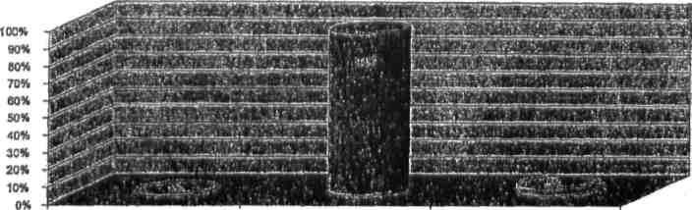
No
Yes
Does not know

Source: Data from the survey carried out as part of the compilation of this report.
48. Educational efforts were also made as part of the need to promote equality in girls’ access to education. Thus, graph V provides evidence that in all the regions of the country there is some predominance of boys, with the exception of the eastern region where the liquidity rate of girls’ enrolment (49.3 per cent) is superior to that of boys’ (46.8 per cent). The disparity among the sexes is much more expressive in the Autonomous Sector of Bissau where 67.8 per cent of girls are enrolled as compared to 73.3 per cent of boys.
49. Regarding the situation in the northern region, the enrolment rate of girls is 47.8 per cent against 50.5 per cent of boys, while in the South, 48.9 per cent are girls against 53.7 per cent of boys.
50. It is important to note that the figures registered in the eastern region may be explained by the Government initiatives to place female instead of male teachers in this region as a way to stimulate girls’ education. Similarly, the actions implemented by Guinea-Bissau’s Plan of Action in the Bafatá Region and the school canteen programmes promoted by the WFP (World Food Programme) explain the reversal of poor female participation due to sociocultural and religious factors.

Graph V

Parity between sexes in the education system
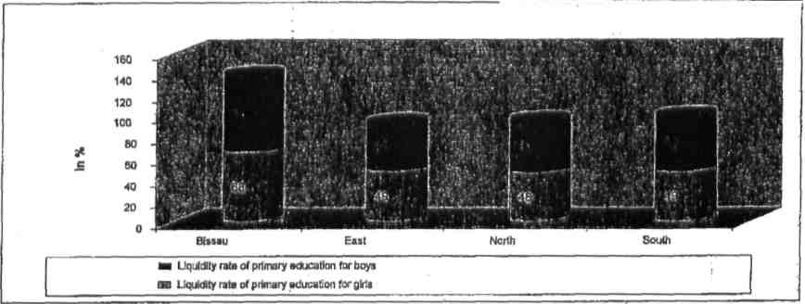
Source: MICS 2006.
J. Prevention of cruel treatment of children
51. The judicial system in general adopts provisions that forbid any type of cruel or inhumane treatment against a human being, and when this pertains to a child, the sanction and the reaction of the institutions tend to be more severe.
52. Despite that, the parents’ consent continues to be relevant for the placement of children in certain situations which puts the children’s rights at risk, particularly when they are living in camps where circumcision or incision (fanado) is carried out. Even knowing of the inhumane conditions of these places or the type of treatment that the children endure, public authorities remain passive out of their respect for tradition.
53. The same issue pertaining to the relevance of the parents’ consent is observed in the case of the need for health care. Thus, in many instances, the authorities wait for the parents/guardians’ authorization before providing medical intervention; unfortunately in some cases, the patient’s family opts for traditional treatment and remove their child(ren) from hospital, thereby exposing their lives to risk.
54. Some advocates of children’s rights are questioning the semi-public nature of some crimes against underage children. As a consequence, there are already proposals for legislative revision, promoting the possibility of society taking on the role that normally only parents take, in the case of the parents not playing that role conveniently.
55. It is important to note the international cooperation in the fight against the ill-treatment of children. In this context, in 2006, Interpol, through a partnership with the Government, opened an office in Bissau with the objective of, among others, facilitating coordinated actions to combat cross-border crimes.
K. Participation in political life
56. In the case of voting or being elected, children cannot participate, actively or passively, in political life.
57. The electoral law provides for only those who are adults, in other words, from 18 years of age, without any exception permitting the participation of minors, even if these are emancipated.
58. For eligibility for election, the restriction is greater for citizens. It is impossible for people above a certain age to be elected for certain positions; for instance, persons less than 24 years of age are not eligible to be elected to the National Assembly, just like those less than 30 years of age cannot run for the Presidency of the country.
59. Children can, however, participate in political life through manifestations or meetings that are constitutionally guaranteed to every citizen (arts. 54 and 55); it was in this view that the Children’s Parliament was created to allow them to express their opinions. For its smooth operation, the National Assembly provided two offices and a budget of 1 million FCFA.

IV. General measures of implementation

A. Implementation procedures, political/legislative harmonization of national rights with the CDC
60. Despite efforts developed since 1997 in favour of harmonization, the National Assembly only resumed, in 2001, the process of ratifying the Optional Protocols to the Convention on the Rights of the Child (PFCDC) having, in 2003, initiated due diligence to harmonize national legislation on issues of women and children with the legal instruments at the international level.
61. To that effect, in 1997, a study coordinated by the Centre for the Study and Support of Legislative Reforms at the Law School in Bissau was launched; it was financed by various partners especially UNICEF. The study concluded that, taking into account Law No. l/73 of 24 September, many laws that were active during the colonial period remained current. Despite being currently inactive, these established rules were contrary to international instruments.
Regarding the harmonization procedures, the following instruments were taken into account: 62. the Civil Code, in force since 1967, with emphasis on the Family and Succession Books; the Civil Procedure Code, the Penal Code, the Penal Procedure Code, the General Labour Law, the Jurisdictional Statutory for the Assistance of Children, the Civil Register Code and the Organic Law of the Sectoral Courts.
63. The result of this harmonization process culminated with the presentation of some proposals for legislative revision as summarized below:

Civil Code
64. Taking into account that the previous Civil Code set the adult age from 21 years, and Law No. 4/76 of 3 May set it at 18 years, similar to what it was established by the CDC, necessary adaptations were introduced so as to make the new rule executable, namely, for the purposes of emancipation, marriage, adoption, among others. Furthermore, proposals for in-depth revision of the Family Book were made, taking into account the need to update the provisions that discriminated against children that were born within or outside the marriage, the norms for civil marriage, impediments for marriage involving minors, which previously could be until the age of 14, contradicting current provisions.
65. Regarding successions, discrimination against the sharing of assets with girls and illegitimate daughters, which was previously reserved only for boys and legitimate sons, was eliminated.

Code of Civil Procedure
66. It was revised and agreed upon that the norms related to access to justice in situations where children’s interest is at risk, such as legitimacy, could be extended to other members of the family, and more attention paid to children’s opinion and the norms that facilitate the creation of a section on Family and Underage Children in places where the conditions to create a particular jurisdiction do not exist. Thus, concessions from representatives from the Public Ministry, such as the curator of minors were expected, such as more privileges in terms of demanding and arbitrating cases of exercising paternal power and temporary guardianship of minors, as well as the decision on what their food should be. All that came to facilitate the protection of children in many ways.

Penal Code and the Penal Procedure Code
67. Since international instruments, especially the CDC, recommend the abolition of all forms of abuse and the deprivation of children’s freedom, it was proposed that the penal structure be reinforced on crimes against children such as violation, sexual abuse, trafficking, torture, kidnapping, among others.
68. Furthermore, it was proposed that all crimes that affect children, directly or indirectly, be classified as public crimes and that their procedures would not depend on reporting by their representatives, but by anybody who is aware of certain situations related to the violation of children.
69. It is also expected the concession of facilities, in terms of constitution of assistants for the processing of crimes, without any cost, in cases involving children, for their representatives, and paying much more attention to the ways of treatment, particularly in those cases that may affect the physical and intellectual growth of the child.

General Labour Law
70. The existing legislation is not up-to-date regarding the international evolution of labour rights. Thus, efforts were made to harmonize, not only to meet the provisions of the CDC, but above all, the ILO conventions that the country ratified.
71. The minimum age at which a child could be employed and the conditions for which that could take place, in terms of physical and learning evolution, was elevated.

Jurisdictional Statutory Assistance to Minors
72. The proposal for the Jurisdictional Statutory Assistance to Minors is in place to adopt a whole range of procedures that regulate the access, treatment, application of certain measures and, above all, the way minors are kept in boarding institutions, shelters or rehabilitation centres, when they are in conflict with the law, while taking into account not only the respect for the rights embedded in the CDC, but also the international norms on the subject.

Code of Civil Registry
73. The rules regarding the registration of children, which are currently in force in the country, are not only difficult to apply, hence the reason why many people stay away, but they are also in disunity with the reality.
74. To facilitate the concession of more rights to children and the acquisition of citizenship, in-depth changes were proposed to the Code, ranging from the way births are declared, the composition of names, the relevant authorities, the rates and the actual validity of the provisional registries.

Organic Law of Sectoral Courts
75. This Decree is included in a list of sources, which must be adapted to the new rules that protect minors because it provides for the possibility of judges in such courts applying local uses and customs where they exist. The fact is that many local customs contradict the positive right currently in force, such as the actual CDC. Thus, limitations on the application of customary norms that put at risk the rights of children were imposed.
76. The expected changes are important in the Statutes of the Sectoral Courts because these are the judicial institutions that are more approachable and much closer to the people.
77. The dissolution of the ANP (National People’s Assembly) in 2003, made approval of the above-mentioned proposals impossible, but the current legislature resumed the same work with the necessary updates and has submitted them; they are only waiting to be amended and approved.

B. Policy coordination, network and monitoring mechanisms
78. The Ministry of Social Solidarity, Family and the Fight against Poverty (MSSFLP) is a governmental institution responsible for creating, implementing and following up Government policy in the areas of family and the fight against poverty.
79. Despite the fact that MSSFLP contemplates in its organizational chart, the General-Directorate of Social Solidarity and Family, whose attributions confine the problem of social protection of vulnerable groups, in 2001, the Government decided to create the Women and Children’s Institute (IMC) in order to give special visibility to this problem. This Institute has, as its priority, the policy coordination and the implementation of government strategies regarding the promotion of women and children’s rights.
80. In this perspective, the Institute tried to harmonize all national laws concerning women and children with the international treaties in order to perform its activities in the most effective and efficient way. In its implementation policy, the Institute gives prominence to its collaboration with NGOs and National Associations and develops partnerships with UNICEF through a five-year plan for cooperation (Programme for the Protection and Promotion of Rights). The areas of intervention and support are not limited to protection but they are equally extended to the promotion of gender equality and the relinquishing of harmful practices namely, female genital mutilation and forced or early marriages. In this context, many NGOs benefit from funding aimed at implementing their action plans.
81. Despite the fact that MSSFLP faces difficulties in terms of human, material and financial resources, this institution has been promoting the discussion and the definition of policies and strategies for the promotion of children’s rights and gender equality. Currently, the priorities of this Ministry regarding the Protection of Children are focused primarily on orphan and vulnerable children, with particular emphasis on children who are affected by HIV, the trafficking of minors and the relinquishing of harmful traditional practices.
82. The execution of the measures envisaged in the CDC and the mechanisms for its monitoring are not only the responsibility of the public institutions but also of national NGOs (AMIC, RENLUV, REJE, SOS, SOS Talibé, Casa Emanuel, Missão cató1ica) as well as international organizations (Plan Bissau-Bissau, Portuguese Inter-cooperation) and some multilateral agencies (WHO, UNICEF and UNFPA).
83. The country has available a large network of organizations which mobilize efforts aimed at promoting children’s rights. However, the duplication of activities pertaining to children, due to the lack of coordination between various stakeholders, leads to a waste of resources and contributes to weaker implementation, awareness-raising and monitoring of the CDC.

C. Participation of children
84. The participation of children in the implementation of the CDC has been a reality in Guinea-Bissau, since children participate in many projects implemented by some NGOs; they receive information about themselves on the content of the CDC, and it makes them the main promoters of the CDC within their families. Thanks to the support of these NGOs, children’s groups were created in order to facilitate their participation in the promotion of their rights in their respective communities through development activities, education and culture. For example, the Children’s Parliament and sensitization through artistic and cultural representation of issues are some of the means by which children expose their aspirations, thus contributing to the implementation of the CDC. It is also important to emphasize that children participate in the activities of certain organizations or partners at the level of the central and regional Government.

D. Dissemination of the Convention
85. Regarding dissemination, this is very limited because successive governments have not been able to translate the CDC into traditional/national languages. However, this limitation has been mitigated through the activities of some NGOs, whose work focuses on children. These NGOs work closely with the population and they make available animateurs that work in the communities through focal groups who enunciate the precepts of the CDC in local languages. Still, with regard to dissemination, radio was the means of communication mentioned by the majority of the population, both in rural and urban areas, as their main source of knowledge about the CDC. This is not surprising if we take into account the characteristics of the population in Guinea-Bissau, which is, for the most part, illiterate. Most information is conveyed by radio and by the actions of NGOs, since other means of mass communication are limited to a small percentage of the population, due to reasons stated above.
86. Graph VI shows that the dissemination of the CDC was intense, since 86 per cent of those surveyed stated that they had knowledge of the existence of this instrument against only 14 per cent who indicated that they were not aware of its existence. This result is very important since the majority of those who responded to the survey (55.6 per cent), were illiterate or only possess primary education. It is important to point out that the high percentage reflects the country’s reality. Regarding the responses obtained, it was noted that the parents or guardians responsible for their children’s education are themselves illiterate; those that are enrolled in religious (Islamic) schools and/or have completed the basic level of education (high school) are among the people who are least knowledgeable about the existence of this Convention.

Graph VI
Correlation between level of education of the parent/guardian responsible for the child’s education and knowledge about the Convention
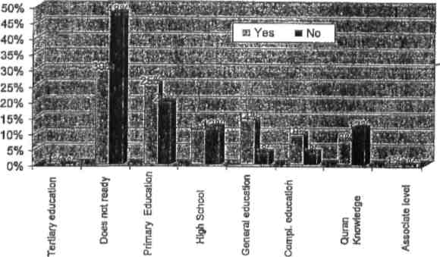
Source: Data from the survey carried out as part of the compilation of this report.
87. Regarding the means of understanding about the existence of the Convention, the radio constituted one of the most privileged sources with more than 90 per cent both in the rural areas and in the cities. Based on the graph below, the television ranked second place for those who live in urban areas, followed by the NGOs, newspapers and finally, public institutions. Regarding the parents or guardians responsible for a child’s education who live in rural areas, public institutions occupy second position followed by television, NGOs and the newspapers, as the last means by which they gain knowledge about the CDC. The fact that the newspapers figure in last place is justified not only by the level of illiteracy among the inhabitants, but also due to the lack of accessibility of newspapers outside of the capital.

Graph VII
Parent/guardian’s place of residence and means used to gain knowledge about the Convention
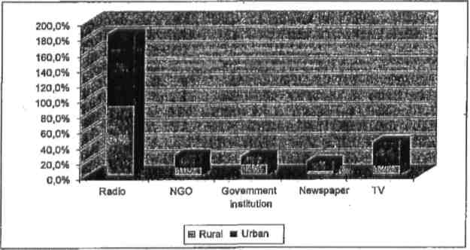
Source: Data from the survey carried out as part of the compilation of this report.
88. An analysis of the means of communication and information can be made through graph VIII, which shows the estimated index based on the average situation in the country (100). Thus, one can see that the efficacy of the radio does not show diversion in relation to place of residence of those surveyed. On contrary, the efficacy of television (130) is more expressive in the city, than in the country’s average, followed by the newspapers (128) and NGOs (116). On the other hand, public institutions, as a means of information dissemination, show an efficacy rate superior to the average in the rural areas.

Graph VIII

Sources of information based on place of residence
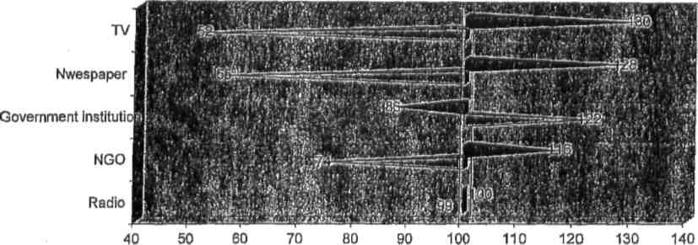
   Rural ■ Urban
Source: Data from the survey carried out as part of the compilation of this report.
89. This exercise allows us to develop actions aimed at sensitizing people, by resorting to means that are relatively more effective, and in line with the audience that is being targeted.
90. Regarding the regions as a group, it can be seen that radio continues to be the most privileged means, with 61 per cent of the parents/guardians responsible for their children’s education stating that they gained knowledge about the Convention through this means. This is followed by television (16 per cent), NGOs (9 per cent), public institutions (8 per cent) and finally the newspapers (6 per cent).

Graph IX

Means of information about the Convention in group of regions
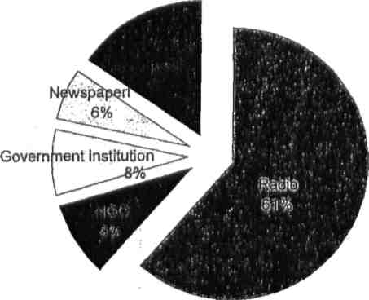
Source: Data from the survey carried out as part of the compilation of this report.
91. Graph X, shows that radio is a means of social communication mentioned by the majority of those surveyed in almost all regions, as the source by which they gained knowledge about the existence of the CDC, with the exception of the Oio region and large percentages in the Bolama-Bijagós region (100 per cent), followed by Cacheu (89 per cent), Biombo in third place (82 per cent), Gabú in fourth place (55 per cent), SAB (51 per cent), Bafatá (41 per cent) and finally the Oio region (29 per cent).
92. Regarding NGOs as a means of information dissemination, this is recognized by 17 per cent of those surveyed in the Bafatá region (17 per cent), followed by Gabú (16 per cent), in third place Oio region (14 per cent), then SAB (8 per cent) and Cacheu (5 per cent). This means of information dissemination was not mentioned by any parent/guardian responsible for their children’s education residing in the South (Bolama-Bijagós and Quinara) or in the Biombo region. This situation may be attributed to the fact that there is little NGO intervention in these regions, particularly by those working on children’s issues. The highest figure that the NGO had in the Bafatá region, as the means by which they gained knowledge about the CDC can be explained by the fact that Plan Bissau-Bissau, being an NGO that has been developing many activities, exclusively caters to this region, focusing on children’s development in this region.
93. Regarding the public institution, this was mentioned by the majority of the inhabitants of Oio region (36 per cent), followed by those in Gabú (13 per cent), Biombo (12 per cent), Bafatá (9 per cent) and SAB (3 per cent) in last place.
94. Television was mentioned by the majority of the inhabitants of the SAB region (25 per cent), followed by those in Bafatá (22 per cent), Gabú (16 per cent) and Oio (14 per cent), with insignificant results in other regions. The fact that TV had higher percentages in the capital is not strange, given the factors associated with its use, which requires good financial means given the almost inexistence of electricity throughout the country.
95. The newspaper had a higher percentage in the SAB region, followed by Bafatá, and Oio in third place.

Graph X
Correlation between the region where the parent/guardian responsible for the child’s education live and means by which he/she learned about the existence of the Convention
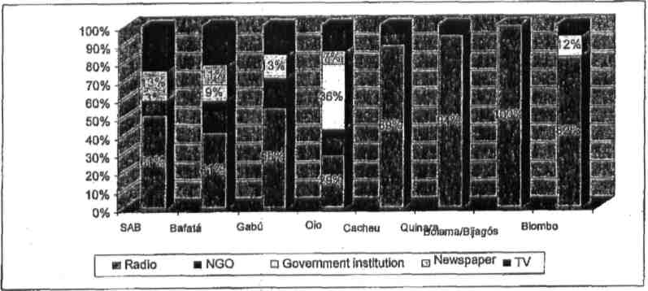
Source: Data from the survey carried out as part of the compilation of this report.
96. An analysis of Graph XI reveals that the radio was relatively a more efficient means of disseminating the Convention in the regions of Cacheu, Quinara, Bolama-Bijagós and Biombo and, relatively less effective in the remaining regions. It is important to note that Oio is the region where public institutions are, in relation to the average situation in the country, more efficient and where the radio is less efficient.

Graph XI

Rate of efficacy of the different means of information dissemination in the regions
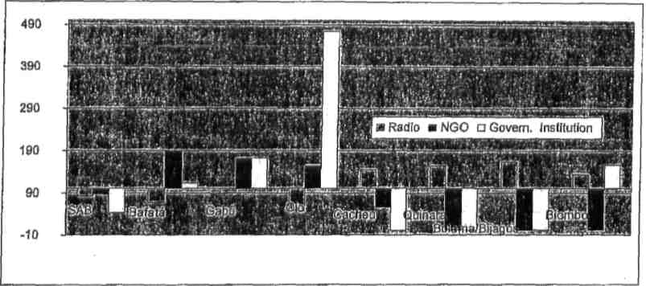

Source: Data from the survey carried out as part of the compilation of this report.

E. Cooperation with NGOs
97. MSSFLP and the IMC face many difficulties in terms of human, material and financial resources to effectively carry out their activities. The State annual budget, which is below the country’s needs, has resulted in many of its activities having to be funded by the Cooperação Portuguesa (Portuguese Cooperation), UNICEF, Plan Guinea-Bissau and other partners, depending on the situation. The financial and technical incapacity that these institutions show makes it imperative that they collaborate with NGOs.
98. The inter-NGO cooperation between these and public institutions as well as multilateral organizations is a visible reality in Guinea-Bissau. Thus, there are certain areas of the country where little Government intervention focusing on children is seen and this has been compensated by the activities of NGOs.
99. Plan Bissau-Bissau is an NGO that has been cooperating with various institutions, including the National Parliament, in the revision and harmonization of the national legislation regarding the CDC. It also collaborates with AMIC, UNICEF and IMC and other national and international organizations that carry out activities that benefit children. For example, in 2007, it developed a decentralized model for the registration of children, which was implemented as a pilot project in partnership with the Ministry of Justice in the Bafatá region. Similarly, to better understand its target population which is mostly Islamic, Plan Bissau-Bissau carried out a study aimed at further understanding the female incision phenomenon which represents one of the forms of violations of children’s rights. Still, within the scope of cooperation, the NGO Sinimira Nassiquê and the Women and Children’s Institute (IMC) developed actions aimed at fighting against harmful traditional practices such as female genital mutilation and early/forced marriage. In the specific case of incision, an alternative practice was created; however, this has not been effective since this praxis does not seem to have been reduced.
100. AMIC (Association of Children’s Friends) is an organization that focuses on children; and, it was the first in this area, where it has been developing its activities since 1984. This organization implemented a project for working children and youth in collaboration with SAVE CHILDREN SUED. Although some efforts dedicated to children by some organizations in the country have been successful, these are far from providing the answers to the problem due to the increasing economic vulnerability faced by the households in Guinea-Bissau. This reality has been increasingly pushing children and youth towards small trade as a way of contributing to the family income. It is in this context that AMIC implemented the Children and Youth Worker’s Project, aimed at providing education and healthcare to children since, these are the basis on which a harmonious and sustainable development of a society must begin. In addition to the areas of support mentioned above, the project provides children with sports and cultural activities as well as sessions aimed at sensitizing the participants about children’s rights. Furthermore, AMIC hosted two programmes:
- One about the repatriation of children victims of trafficking and their families, as well as socio-professional reinsertion following the repatriation of about 135 children from Senegal to Guinea-Bissau between 2005 and 2007. This was carried out in collaboration with the Swiss Foundation (Fundação Suíça) and IOM;
- The other programme, which focused on school canteens, was developed in collaboration with the US-based Human International Partnership for Development (HIPD), which is active in 300 schools with a total number of 58,000 students, covering six regions of the country and the Autonomous Sector of Bissau (SAB).
101. SOS-Crianças, is a philanthropic institution that hosts orphan (partial and/or total) children, while providing them a new home. This organization began its operations in Bissau in 1994, and in 2006 it extended its activities to Gabú and Canchungo. It is structured into children’s villages (social centre, park and youth residence), Hermann Gmeiner primary schools and a pilot school. The children are monitored during their stay and after their departure from the village (when they reach adulthood) where they are provided with an allowance/scholarship to help their social integration (designated partial insertion).
102. INDE works on the issue of child labour in a transversal way (education, literacy, health, HIV/AIDS, among others). It collaborates with different national and international NGOs such as AMIC, REJE, and SAVE THE CHILDREN SUED. INDE is an NGO that focuses its activities on educating and sensitizing children involved in small trade, which represents a category of vulnerable children.
103. Cooperation towards the implementation of CDC is not only taking place at the NGO level and public institutions but also at the level of national and international NGOs. For example, AMIC and Plan Guinea-Bissau implemented a programme in the Gabú region on Children’s Carnival.
104. S.O.S Talibé, REJE and AMIC cooperate in the area of Talibé children. Whenever S.O.S Talibé identifies children victims of trafficking, it communicates to REJE and AMIC, which are responsible for looking for the parents of the children identified. After finding the parents, the children can stay in the hosting centres that S.O.S Talibé has in Gabú, which also has an Islamic school (madrassa) where children can learn the Koran if their parents wish.
105. RENLUV is an organization that has been carrying out many activities on the issue of children’s protection. It promotes marches and campaigns aimed at sensitizing Parliament on children’s rights. The study carried out by UNICEF in 2007 on the institutional analysis of the social protection structures in Guinea-Bissau, revealed that the employees of this institution have been, in many instances, hosting many children who are victims of violence and harmful traditional practices who have sought support from the organization. While they carry out due diligence or make contact with the relevant authorities to solve the cases, the children live at the houses of the organization’s employees, due to the lack of hosting centres.
106. REJE is an organization that deals with community problems particularly those related to education (diagnostics and school insertion), health (medical care and treatment), legal protection (sensitizing and informing about the danger posed by mild, cruel physical punishment, sexual abuse). In addition, it provides instructions on how to open a legal process). Similarly, it works with working children and youth (informal traders), by providing them with family support while sensitizing them and their families about the danger that they are exposed to in their daily lives. REJE, in partnership with IMC and UNICEF, carried out training sessions for Police and Public Safety Officers (POP), equipping them with instruments that allow them to register every type of violence to children, who then are taken to the police station. Along the same line of concern for the protection of children, this network has developed working partnerships with INDE and AMIC and also collaborates with the Ministry of Local Administration, Ministry of Justice, Ministry of Health, Ministry of Education as well as the Ministry of Higher Education.
107. Regarding cooperation, it was concluded that this is evident among various Government institutions, as well as international and multilateral organizations. The study carried out by UNICEF on the Institutional Analysis of the Structures of Social Protection and Support to Children in Guinea-Bissau, provided evidence to this fact. For example, IMC collaborates with UNICEF, UNFPA, “Action Aid” and SNV on the elaboration of strategic plans and the compilation of the five-year plan on the protection of children, which equally includes the concerns of NGOs that develop their activities around children’s issues. Meanwhile, they also develop partnerships with youth associations, offices created in some government structures particularly at the Ministry of Local Administration through its office in charge of women and children affairs and, through that the General Directorate of the Judicial Police through deals with cases involving minors and adolescents.
108. Even with the efforts mobilized in favour of promoting the rights of children, there are, still, many things lacking in this field and, this is further compounded by the absence of a national plan of action on infancy/childhood.
F. Decentralization of the measures regarding the protection of children
109. The decentralization of the measures of protection of children is manifested in the fact that the MSSFLP (Ministry of Social and Family Solidarity and the Fight against Poverty) has created the General-Directorate for Social and Family Solidarity, whose activities are aimed at providing social protection to vulnerable groups. This Directorate is divided into two services: the Social Solidarity Service, which supports old-aged people, handicapped and orphaned children; and the Family Protection Service, which supports very poor families and single parents. Still, in the context of promoting decentralization, as carried out by the Government, MSSFLP has gone further and created the Women and Children’s Institute (IMC) whose objectives are targeted especially towards women and children. However, the lack of regional representation of MSSFLP and IMC limits their efficacy because their services are inaccessible to a large percentage of the population.
110. One other manifestation of the decentralization of protection measures promoted by the Government is the Ministry of Home Affairs’ creation of an office which focuses solely on problems affecting women and children, and the Regional Commissions which have an available service focusing solely on protection. The Ministry of Justice, through the creation of a special section dealing with family and employment issues, solves legal problems involving minors, and an office for minors and adolescents in conflict with the law has been created through the General Directorate of the Judicial Police.
111. The decentralization of children’s protection measures is not confined only to public institutions but equally to non-governmental and multilateral organizations. For example, AMIC extended its activities throughout all regions of the country through regional networks. In other words, representatives of this organization were placed away from headquarters and tasked with pursuing the organization’s objectives (defend children’s rights and promote training activities for children about their rights). The study carried out by UNICEF and IMC in 2006 on the abuse and exploitation of children provided evidence that the employees of these regional networks report many cases of violence against children. In Gabú, this organization has a temporary shelter for Talibés children returning to Guinea-Bissau from other countries in the subregion. These children remain in this shelter while efforts to identify their parents are made. The School Canteens programme (IPHD), which AMIC hosted, covers 300 schools some of which are located in the regions.
112. REJE, such as AMIC, also have regional representations. Similarly, SNTLS (National Technical Secretariat in the Fight against AIDS) has regional representations through SRTLS (Regional Technical Secretariat in the Fight against AIDS), although this does not cover the whole national territory.
113. The Catholic and evangelic missions develop actions focusing on protecting children and women. Their activities, in the context of Guinea-Bissau, assume a real position in the decentralization, because they develop actions in the villages. Their activities include weighing children to check if their weight corresponds to the ideal weight of a child. They also provide care to children who are suffering from diseases. The interventions of this institution are also visible in the field of education because the organization invests in children’s parks and primary schools. The Government also cooperates still with other religious organizations, namely Casa Emanuel and Islamic organizations that care for orphaned children.
V. General principles
A. Non-discrimination
114. CRGB established in its article 24 that “all citizens are the same before the law, they enjoy the same rights and they are subject to the same obligations with no discrimination based on race, sex, social, intellectual and cultural status, religious creed or philosophical conviction”.
115. The Constitutional consecration of this principle has been facilitating the general view that defends equality among human beings:
116. At the infra-Constitutional level, there were situations of inequality in the ordinary laws, for example, discrimination against children born out of the wedlock compared to benefits to those born within a marriage, the differences between men and women in terms of their rights and obligations both at the family level as well as in other situations, as a result of the maintenance of colonial laws regarding national order, the emanation of Law No. 1/73 of 24 September. As a result, there was prohibitive legislation on discrimination such as Law No. 4/76 of 4 May which forbids discrimination between legitimate and illegitimate children as well as the use of any discriminatory designation. The collection of reforms initiated since 1997 and which has already reached the ANP was carried out in order to eliminate all negative discrimination among children. These are aimed at harmonizing the national right, not only with the principles consecrated in the CDC, but also with other instruments such as the CEDAW, the African Charter on Human Rights and that of people, among others.
117. Regarding the application of the principle of non-discrimination, since this is a principle that relates to fundamental human rights, the application of international legal instruments has been guaranteed at a practical level, independently from the ratifications or not of those materials. Taking into account that there is an open provision in article 29 of the CRGB which states the following: “The fundamental rights enshrined in the Constitution does not exclude any other constants of the many laws of the Republic and the applicable rules of International Rights.”
118. In this context, some measures have been taken aimed at eliminating the practice of discrimination, such as the concession of more facilities for the education of girls. Thus, many programmes count on the support from international and non-governmental partners in order to correct the huge disparity that exists between men and women (see graph), which are the result of obstacles that women face in accessing education, caused essentially by sociocultural factors.
119. From an economic perspective, many initiatives have been implemented with the view of reducing the strong dependence of women in relation to men, essentially in the promotion of economic activities through microcredit; since 2004, there has been a unit in the Ministry of Economy which is responsible for this initiative.
B. Children’s best interest
120. The measures related to the application of the principle of children’s best interest refer to cases of their parents’ separation, adoption and legal guardianship.

Parents’ separation
121. In the case of parents’ separation, frequently there are disagreements regarding the custody of children who are minors. The previous law was not clear in this regard and this has conditioned children to be kept by the more responsible parent or based on his/her economic power. A long time ago the practice was that a child was always entrusted to the mother until the age of seven, but this practice was removed from the system and replaced with the rule that custody of the child would go to the parent who could offer better protection to the child, which, in some cases, is not necessarily either parent. The courts and administrative institutions have been considering the child’s best interest both in terms of the arbitration of food as well as in the attribution of privileges in their favour.

Adoption
122. The norms related to adoption have been a subject of attention since it constitutes an alternative for a child. It was concluded that the existing legislation does not facilitate the process due to the fact that it is very limited, particularly regarding who can adopt or can be adopted. Debates around the subject have been organized, but fears of legal facilities being taken advantage of in order to promote child trafficking, due to the weaknesses that the country faces, have been contributing to the non-presentation of a more liberal proposal, thus the continued application of the existing legislation. However, its efficacy has been according to international instruments, especially the Convention on the Protection of Children and Co-operation in Respect of Intercountry Adoption of 29 May 1993, which establishes a regime of cooperation based on the principle of superior interests of children (see article 1).

Jurisdictional guardianship
123. Knowing that children do not have the capacity to represent themselves, the Public Ministry guarantees the defence of their (children) interests based on its position as the Curator of the Minor Children. In this regard, more than one magistrate has been appointed in order to conveniently administer processes in which the interests of the minors are in question.
124. Furthermore, legal reforms have been expected in the penal process so that cases that involve minors are pursued in a way that does not affect their physical and intellectual development. To that effect, if necessary, the processes can be pursued secretly.
C. The right to life, survival and development
125. A child’s right to life is part of the general rule that all human beings have the right to life, physical integrity, honour, etc.
126. In the specific case of children, given their condition of fragility, society should assume a role that guarantees the materialization of that principle which has, as its main tenets the right to protection, the right to a good health condition and, the right to live in a healthy environment that allows for harmonious development.
127. Based on this principle, many actions were developed and structures for protection created in the specific institutions, for example, in the field of health, education, infrastructures, which deserve to be discussed in detail.
D. Respect for children’s opinions
128. In order to guarantee the application of the rights consecrated in the CDC in general, on February 2000, the Government created the Women and Children’s Institute (IMC), attributing its necessary administrative and financial autonomy so as to effectively meet its objectives.
129. IMC has a special department that focuses on children’s affairs and this has been developing various children’s inquiry activities namely the creation of the Children’s Parliament, which was, before its sessions, been anticipated by that of the regional parliaments. The Children’s Parliament not only provides possibilities to children to expose their viewpoints, but also the opportunity to meet the country’s President and the Regional Governors.
130. Children’s fortnight sessions take place in June, a period in which several activities are developed aimed at gathering children’s opinions and, frequently other activities are carried out to allow the children’s parents to learn how to respect their children’s opinions on matters that are of concern to them.
131. In jurisdictional terms, the dynamism showed by the Curator of Minors, allows for children’s (minors) opinions to be taken into account every time their interests are at stake, namely in cases of choosing who should gain custody of the children in the event of their parents separations as well as in cases of adoption.
132. According to the data from the survey carried out as part of this study, 56 per cent of those surveyed stated that “sometimes” they consider children’s opinions against 27 per cent that rarely do and, 12 per cent said that they never considered.

Graph XII
Distribution of the responses on the question whether children’s opinion is considered
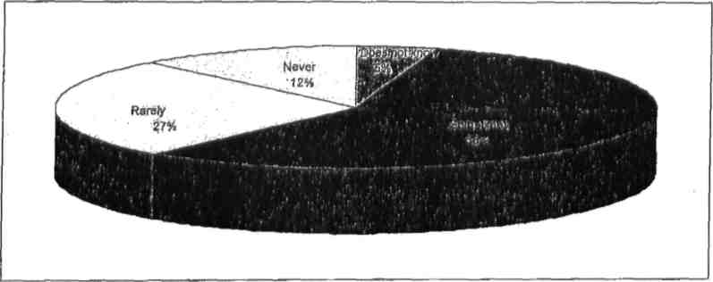
Source: Data from the survey carried out as part of the compilation of this report.
133. Even with several actions developed and aimed at respecting children’s opinion, graph XIII confirms that parents/guardians of almost all ethnic groups, with the exception of the Mansoancas and the Nalús, stated that sometimes they take into consideration children’s opinions on issues of their concern. Those who “rarely” consider children’s opinion came second, although this is highlighted by the total number of those surveyed who are of Nalu ethnicity. Those who stated that they “never” respected children’s opinions are poorly represented, however, mentioned in total by those surveyed of Mansoanca ethnicity. This shows a progressive and positive evolution about the respect that adults have for children’s rights. However, more work still needs to be done insofar as sensitizing, because the sociocultural values that provide the framework and guidelines for the behaviour of the majority of the inhabitants of the country are not commensurate with the principles enshrined in the national and international legal instruments on children’s rights.

Graph XIII
Correlation between parents/guardians’ ethnicity and taking into account children’s opinions
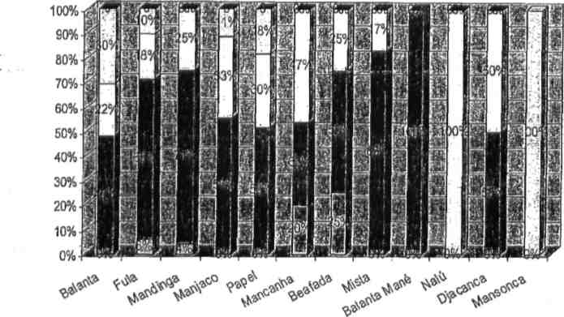
⁭ N/A ■ Sometimes ⁭ Rarely ⁭ Never ■

Source: Data from the survey carried out as part of the compilation of this report.
134. In order to refine the analysis, once again a synthetic indicator was developed which shows the situation in each region in relation to the country’s average. Thus, all the indicators below 100 indicate the regions where the situation is inferior to the national average and vice versa. For example, those surveyed who are of Mansoanca ethnicity, contrary to other ethnicities, declared that they never listened to children’s opinions. On the other hand, the Nalus are, according to this indicator, the ethnicity which children are least listened to.

Graph XIV

Index of consideration of children’s opinions (country = 100)
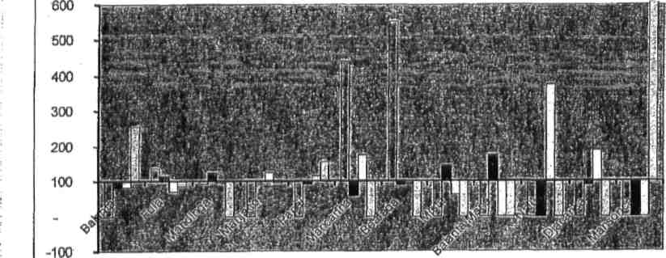
⁭ N/A ■ sometimes ⁭ Rarely ⁭ Never
Source: Data from the survey carried out as part of the compilation of this report.
VI. Civil rights and liberties
A. Birth certification/registration
135. The rules regarding the certification/registration of births which took place during the colonial period did not correspond to the country’s sociocultural reality, favouring those children born in hospitals and those children born of parents who were legally married.
136. Understanding the situation, the Government of Guinea-Bissau took measures aimed at promoting birth certification of as many people as possible by abolishing the tax that was charged based on the Decree No. 04/02 of 25 April. However, the costs involved in not declaring the birth of a child within 30 days of verification continued to discourage birth certification within the expected period of time. Thus, some measures aimed at promoting the right to birth certification were taken, namely:
• Decree No. 09/04 of 9 December issued by His Excellency, the Minister of Justice which determines that “The acts of certifying/registering the birth of a child between 0 and 3 years of age are free of charge;”
• Decree No. 06/06 of 7 August extends the period within which a child’s birth registration/certification is free of charge to 5 years of age, invoking that this measure is aimed at providing the right to a name and identity as expected in the CDC.
137. To complement these measures, free birth registry/certification campaigns for children aged between 0 and 10 years were periodically organized, with the support of major partners who operate in this domain, with UNICEF and Plan/GB as the highlight.
138. These free registration campaigns allowed for a greater number of children, especially Talibés, refugees and workers to be registered. A chance for these children to obtain identification cards (IDs) was provided and the acquisition process is being facilitated not only in Bissau, but also in rural areas.
139. Graph XV shows the results of the data from the survey applied to families; in some households, 60 per cent of the children were all registered, while in 35 per cent of the households, only some were registered and in 4 per cent of the households, no children were registered.

Graph XV

Number of children registered in the household
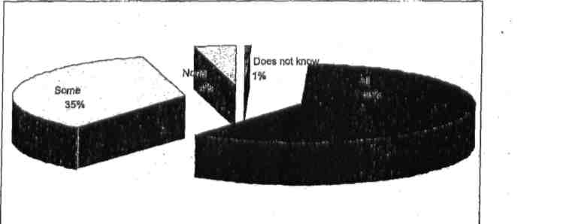
Source: Data from the survey carried out as part of the compilation of this report.
140. Graph XVI shows evidence that most children are registered between the ages of 2 and 6 years which represents 34 per cent. This situation reflects the mentality of most parents who normally register their children only when they begin school because enrolment at any educational institution requires that a birth certificate be presented. Children who are registered between the ages of 2 months to 1 year represent 24 per cent and those who are registered between 1 week and 1 month of age represent only 20 per cent.

Graph XVI

Age at which children were registered
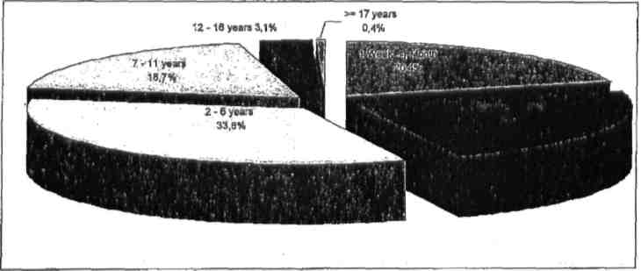
Source: Data from the survey carried out as part of the compilation of this report.
141. Still, on the issue of children’s registration, data from MICS (2006:82) illustrate that at the country level, 38.9 per cent of children who are less than 5 years of age were registered at birth. Among the total number of children registered at birth, 40.4 per cent are males, while 37.4 per cent are females; 53 per cent of these children live in urban areas, while 33.1 per cent live in rural settings; 16.8 per cent belong are between 0 and 11 months of age, 34.5 per cent are between 12 and 23 months and 51.3 per cent are between 48 to 59 months. The percentage of registered children whose mothers have completed higher and tertiary education represent 60 per cent, those whose mothers have completed primary level of education represent 50 per cent and only 33.4 per cent are children whose mothers do not have any education. Regarding the place of residence, 57 per cent live in SAB, 47 per cent in the North and, 20 per cent in the South. In summary, the registration frequency is influenced by the age of the child, the means and place of residency and the level of education of the mother. As a result, older children who live in urban areas and whose mothers have higher levels of education have greater probabilities of being registered.
B. Freedom of expression
142. Freedom of expression, consecrated in article 13 of CDC, comes to reinforce a series of rights enshrined in the Universal Declaration of Human Rights and in the International Covenant on Civil and Political Rights. In Guinea-Bissau, since the ratification of the CDC, one of the more frequent initiatives was the promotion of children’s freedom of expression through the creation of means that would allow them to manifest their ideas. These are, namely, the promotion of debates between children in the Children’s Parliament (regional and national), organization of thematic meetings about children, radio programmes, the creation of a Network of Children Friendly Journalists (Rede de Jornalistas Amigos da Criança) and the organization of poetry sessions and exhibition of children’s drawings.
C. Freedom of association
143. Article 15 of the CDC defends freedom of association and the ability of people to gather peacefully. This is also consecrated in the Constitution of the Republic of Guinea-Bissau in its articles 54.1 and 55. In the country, there is no legal restriction in terms of constituting an association; however, there are difficulties, which are of a financial nature. Since the Decree No. 4/02, the financial demands for constituting an association for public use were taken into consideration resulting in the abolition of the mandatory deposit of a certain amount that was required for its legalization. Article 55.3 of the CRGB establishes restrictions for the creation of associations that promote tribalism and racism as well as those of military and paramilitary nature. The freedom consecrated in the national legal instruments regarding the constitution of associations is manifested through the proliferation of associations in the country be they of religious, cultural, recreational and/or community-related in nature. IMC has assisted many of them.

Graph XVII
Correlation between the participation of children in meetings and their parents/guardians’ religion
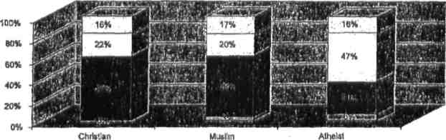
■ N/A ■ Restricted ⁭ Unrestricted ⁭ None

Source: Data from the survey carried out as part of the compilation of this report.
144. According to data from the survey on freedom of association and as summarized in graph XVII above, it is concluded that parents/guardians who are atheists are more likely to allow their children to participate in associations. As a result, 47 per cent of atheists surveyed stated that they do not place any restriction on their children’s participation in meetings and/or public associations, against 20 per cent of Muslims and 22 per cent of Christians.
D. Cult, consciousness and religion
145. The CRGB defends, in article 52.1, the inviolability of freedom of thinking and religion and article 52.2, it recognizes the freedom of cult as long as it does not violate the fundamental principles of the constitution. In the international legal instruments applicable in the country, the freedom of cult, thinking and religion are guaranteed. In this context, children, according to their capacities and guidance from their parents and guardians, are guaranteed the exercise of these rights. It is also important to note that the last parliamentary session in 2007 ratified the African Charter for the Rights and Welfare of the Child (CADBC), an important legal instrument that consecrates all the civil rights and liberties adopted in the CDC. As a result, article 52.3 of the CRGB goes further in the sense that it authorizes the teaching of religion as long as this is practised within the respective congregation. This issue is stated in article 14 of the CDC, in particular 14.3 where it establishes limitations about religious freedoms to children in the following instances: “subject only to such limitations as are prescribed by law and are necessary to protect public safety, order, health or morals, or the fundamental rights and freedoms of others.”
146. The articles in the country’s Constitution, which are mentioned above, demonstrate that children are active members of society and it also provides evidence about the harmonization between the CDC and the Constitution. However, in practice, the application of such harmonization faces tremendous difficulties due to sociocultural values governing the behaviour of the majority of the inhabitants in the country. For example, as part of the tradition of the majority of all ethnic groups in Guinea-Bissau, children cannot voice their opinion when adults are discussing issues, even when those issues are of their concern. In addition, there are rare occasions in which children can choose a religion that they want to profess, since there is a tendency for children to automatically follow their parents’ religion with some exceptions (e.g., children who adopt Christianity while their parents are atheists). The difficulty insofar as the religious freedom of children is concerned is seen mainly among children whose parents are Christians and who want to adopt the Islamic religion and vice versa. As a result, despite the difficulties identified in the examples provided as evidence, there has been an effort by families to adopt the norms enshrined in the Constitution. There is awareness about the fact that a child is not only a member of society with duties to fulfil but also that a child has rights.
147. The relevant public institutions in coordination with the NGOs and the families have made efforts to create conditions to enable children to exercise their rights, classifying as progress and positive the attitude of adults towards children. This position is justified by the existence of a host of associations created in different cities and villages. Beside these associations, currently the children of Guinea-Bissau have a Parliament where they have the opportunity of expressing their thoughts and defending their interests.
E. Access to appropriate information and right to privacy
148. Children should be provided with information that does not prejudice their evolution. In this context, there are certain guidelines to the media, particularly those, which are public in nature, to take into account in their programmes, the most appropriate content for children. The same applies to the control of access by children to movies and shows where there must be an age restriction. It is important to note that in this regard the fragility of the control institutions that are supposed to enforce the law is recognized. However, there has been an effort to increase the intensity of the inspections while applying severe penalties to the offenders. The revisions made to the civil process and penal codes, provide privacy guarantees in the treatment of issues pertaining to children, as the situation requires it, so as to avoid that the intellectual development of the child is affected.
F. Prevention against torture, inhuman and degrading treatment
149. In order to warn the authorities against the ill-treatment of children, an Office for Women and Children’s Affairs was created within the Police and Public Order Central Commission, Ministry of Home Affairs. This office aims at not only acting to prevent, but also to train police officers. This training focuses on ways these officers must deal with vulnerable segments of society, how to organize interrogation sessions and how to host children who are victims of ill-treatment. At the level of the judicial police, an office to deal with children and adolescents who are in conflict with the law was created. This office’s mission consists of providing more protection to this category of children.
VII. Family environment and alternative guardianship
A. Paternal responsibilities, rights and duties
150. The households in Guinea-Bissau are, for the most part, large. In other words, they are not only made up of parents and their respective children. The polygamous forms of marriage that are polygenic in nature are characteristic of all ethnicities in the country, contrary to the civil legislation inherited from the colonial era, which was designed in the context of the nuclear family constituted according to the European model.
151. From the beginning of independence, it was noticed that there were situations which did not fit in with the country’s reality. It was in this context that Law No. 4/76 of 3 May was adopted, which abolished the discrimination between illegitimate and legitimate children based on the marital status of the parents.
152. The elimination of discriminatory designations did not resolve all the legal problems, because civil law was inappropriate to the national reality. This was the reason why more in-depth reforms, aimed at harmonizing the national law with the international legal instruments, were carried out.
153. In this context of revising the proposal, the first step began by changing all the provisions which differentiated the rights and duties of both the father and the mother towards their children to allow both to have the same rights and obligations towards their children, regardless of their marital status or social conditions. Similarly, the provisions which offered doubts about the power of the parents, such as in the case of article 1884 of the CC which established that the parents could “moderately correct their child when he/she made mistakes”, were eliminated.
154. These provisions had been interpreted as permission for light physical punishment as a way for parents to educate their children. Thus, these provisions were changed so as to resemble the obligation of the parent to educate and to guarantee the best environment for the child’s development.
155. Also in the chapter related to successions, rules that guarantee equality between siblings, regardless of the circumstances in which they were born, whether within marriage or out of wedlock, were established. In this regard, it is important to highlight the commitment of the Curator for Minors at the Regional Family Court Section in promoting and defending children’s rights when their interests are at stake.
B. Security and social reinsertion of children
156. Both the national and international human rights laws do not allow that children are separated from their parents, unless it is concluded that it is best for their well-being, namely, when the security and development of the child is at risk.
157. More complicated cases are those which involve parents who are separated. The application of the principle of the child’s best interest ends up determining who should gain custody of the children. It may not be any of the parents, in the case that neither of them meets the conditions, material and/or moral, so that custody of the child can be granted.
158. In this regard, the availability of collaboration between the National Nucleus of Technicians for Social Intervention (NUNATIS), which works in partnership with the MSSFLP and the Curator of Minors at the courts, is extremely important.
159. Despite the abolition by the State of children’s homes previously controlled by the former Institute Amizade (Friendship Institute), increased partnerships with private initiatives for the hosting and the reinsertion of children have been witnessed. Among these partnerships, the collaboration between the MSSFLP and other Government institutions with the SOS villages, Casa Emanuel Orphanage, SOS Talibés Children, AMIC, and many other organizations, mainly those linked to religious institutions, should be highlighted.
C. Homes for children: rehabilitation, re-education and reintegration of vulnerable children and youth in conflict with the law
160. The new Statutory Law on Jurisdictional Assistance to Minors establishes new rules for the placement of children in homes. The innovation in this instrument is the relevancy given to the different specialists, namely psychologists, sociologists, social workers, in the implementation of plans for the placement of children.
161. The placement of a minor in a home as a last resort measure was also considered, taking into account international practices, which always privilege the reinsertion of minors in the family life.
162. The last overall Government budget included funds to assist social institutions, which host or support children. Despite the fact that the public finance situation made it difficult to completely follow up this provision, there were some instances where financial support was provided and tax exemption given towards the assets and services rendered by these institutions.

VIII. Basic health and well-being
163. Basic health and well-being are conditions without which the survival and development of a child becomes difficult. As a result, when a country manages to equip itself with medical infrastructures, with all the necessary instruments that allow for the diagnostic and treatment of diseases, that means well-being. However, well-being does not end there, as it also requires that the child has good nutrition.
A. Child survival and development
164. Survival and development are aspects on which Guinea-Bissau must make additional efforts, particularly the Government. Although the Government improved the conditions at Simão Mendes Hospital, the main maternity centre in the country, regional maternity centres around the country continue to face many problems. A similar situation is faced by paediatric units as well as infant-maternal health centres. Another aspect which should be highlighted in this report is related to the examination and treatment of children and pregnant women; a large part of this target population do not seek a hospital due to the fact that they lack financial means. The most severe problem relates to pregnant women who need surgical intervention (caesarean) and they are requested to pay an exorbitant amount of money, without taking into account the average salary of a Guinea-Bissau citizen.
165. The maternity and paediatric centres throughout the country are not equipped with the material and human means to guarantee the basic health and well-being of children and women due to, among others, a lack of recycling training for both the medical and paramedical personnel which results in their inability to follow up the evolution of diseases and the necessary medication for their treatment. When a person goes to the hospital he/she is forced to buy almost all the materials, from simple materials (such as gloves, wound dressing) to more complex ones (such as medication).
166. Another problem seen in every hospital is the inexistence of specialists in some medical fields. In order to treat certain diseases, it is necessary to obtain a joint medical report or to have means to seek treatment overseas.
167. Graph XVIII shows that the above-mentioned shortages at various levels of the health system reflect the high infant and juvenile mortality rates, with the highest rates in the eastern region of the country, 152 and 257 respectively, and the lowest in Bissau, at 89 and 143, respectively. This situation can be justified by the fact that most of the equipment from public and private hospitals is located in the Autonomous Sector of Bissau (SAB).
168. According to the human development report (2007/2008), the public health expenditure in Guinea-Bissau represents only 1.3 per cent of the GDP.

Graph XVIII

Infant and juvenile mortality rate
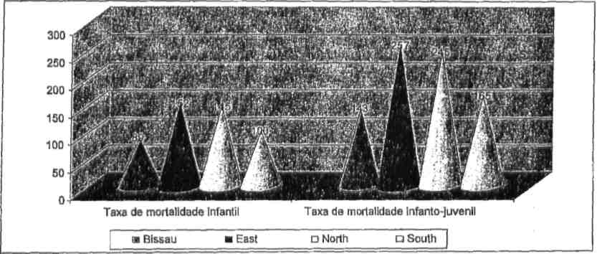
Source: MICS 2006.
B. Disability and deficiency
169. Before we discuss this part of the work, it is important to distinguish the concept of disability from that of deficiency. While disability reports several functional limitations which people are subject to, that can be physical, intellectual or sensorial in nature, deficiency refers to restriction to the possibility of participating in the collective life in similar circumstances with other people.
170. In Guinea-Bissau, there are a significant number of children who are disabled and deficient. These illnesses can have several origins, above all the lack of treatment of some diseases which children carry in the first phase of their lives or even during the pregnancy. This is also a result of the fact that many pregnant women in the country do not go to a hospital because they lack the necessary means and/or because they live in a village which does not have medical equipment, thus standing a great chance of delivering a child with a disability or deficiency. Article 23 of the CDC defends that disabled or deficient children must benefit from life conditions which favour their autonomy, thus facilitating their active participation in the collective life. It also provides for special treatment to this category of children, in which the support that is given to them should enable their effective access to various services.
171. The Government of Guinea-Bissau does not have the necessary equipment to respond to the needs of this category of children. In the country, there are only two associations catering for the blind and deaf-mute, namely the ASGB (Association of the Deaf of Guinea-Bissau) and AGRICE (Association for the Reinsertion of the Blind). There is one school for each of these categories of children. The school for the deaf and mute is situated at the former Salvador Allende School, and that for the blind is Begala Branca in Plaque. The Government did not totally engage in the functioning of these schools, having only provided the space, the hiring of teachers and the provision of tax exemptions and other fiscal benefits in favour of these institutions. The rest of the expenditure is funded by the Portuguese Cooperation (Cooperação Portuguesa).
172. It is important to note that these schools only exist in Bissau, which means that all the children who are in this situation and live in the regions are deprived of the right to education. In addition, children with physical disabilities do not have access to many places given the fact that until now, there is no appropriate infrastructure designed specifically for this category of children. As a consequence, this reality prevents these children from actively participating in the community life. The special measures to assist parents and guardians who have the responsibility of caring for these vulnerable children are inexistent in the country and this limits their access to many services.
C. Infant and maternal health
173. In Guinea-Bissau, access to infant-maternal health care is not a condition guaranteed to all children and pregnant women although Government efforts in this specific area should not be minimized. In the country, infant-maternal health-care centres are extremely limited infrastructures and those that exist have little equipment available. The consultation that services provided are not free, thus extremely limiting access by this special category of users of such centres. As a result, the country faces both high maternal and infant mortality rates (see graph XVIII).
174. Graph XIX shows a positive spectrum in relation to the vaccination of children where 62 per cent of children that constitute the households have been vaccinated, 36 per cent received some vaccines and only 2 per cent did not get any vaccine. This data confirms the Government effort, with support from UNICEF, in promoting vaccination campaigns.

Graph XIX

Children vaccinated in the households
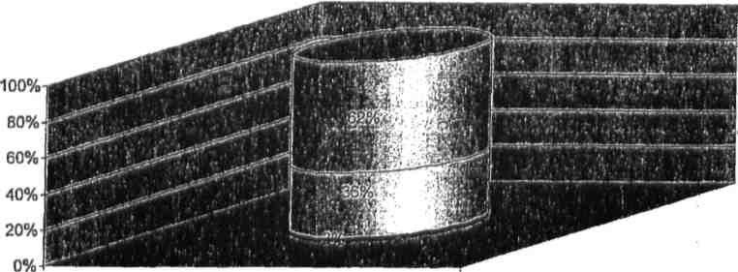
■ Does not know ■ None ⁭ Some ⁭ All
Source: Data from the survey carried out as part of the compilation of this report.
175. Table I shows the distribution of vaccinations during the first year of the child’s life, based on the child’s vaccination card and the mother’s statement. Regarding children who have a vaccination card confirming that they have received a BCG and polio 1 vaccination, these account for 70 per cent, while those who have the mother’s statement, represent only 13 per cent of those who received these vaccines. In almost all the categories with the exception of the mother’s statement category, greater percentages received different vaccines.
Table I

Vaccinations during the first year of the child’s life
 | BCG | DTC 1 | DTC 2 | DTC 3 | Polio 0 | Polio 1 | Polio 2 | Polio 3 | Measles | All | None | Number of children from 12–23
Vaccination card | 75.7 | 70.2 | 65.1 | 57.4 | 56.2 | 73.4 | 67.2 | 61 | 63.5 | 49.6 | 0.4 | 1 275
Mother’s statement | 13.2 | 12.5 | 9.6 | 5.4 | 7.9 | 13.6 | 9.5 | 3.1 | 12 | 0.6 | 7.3 | 1 275
Vaccination card/mother’s statement | 88.9 | 82.7 | 74.7 | 62.8 | 64.1 | 87 | 76.7 | 64.1 | 75.5 | 50.2 | 7.7 | 1 275
Vaccine before 12 months | 87.1 | 80.1 | 72.2 | 59.1 | 62.8 | 84.9 | 74.1 | 59.7 | 71.2 | 39.9 | 7.9 | 1 275
Source: MICS 2006.
176. Regarding the staff providing prenatal care, midwives have almost 61 per cent lead in the South as shown in graph XX, 52 per cent in Bissau, 48 per cent in the North and 36 per cent in the East. Medical doctors are more represented in the capital with 25 per cent, followed by 17 per cent in the North, 11 per cent in the South and only 5 per cent in the East.
177. Regarding assistant midwives as prenatal caregivers, these have higher expression in the eastern, northern and southern regions of the country.
178. Women who do not resort to any prenatal care are registered in all regions. However, the East has the higher rate with 17 per cent, followed by those in the South at 14 per cent and in the North, almost 20 per cent and Bissau with 6 per cent. These figures reinforce the situation described at the beginning of this section regarding the existence of pregnant women who do not go to the hospital during their pregnancy.

Graph XX

Staff providing prenatal consultations
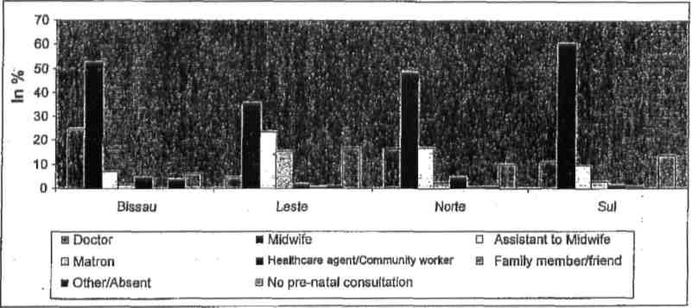
Source: MICS 2006.
D. Family planning, regulation of harmful traditional and cultural practices (female genital mutilation, early/forced marriage) and trafficking
Family planning
179. The Guinea-Bissau Association for Family Planning and Well-Being (AGUIBEF) is an NGO, created in 1986, that develops activities in the area of family planning. Its activities are extended throughout some regions and the awareness it promotes is carried out in traditional languages by animators. The work of this organization does not end in the cities but it is also carried out in villages. Family planning activities are also carried out by infant-maternal health centres.
180. The adoption of family planning by spouses and the elimination of harmful traditional practices face difficulties, due to sociocultural factors which legitimize such practices. In the villages as well as in the cities, it is difficult to convince some people to adopt a certain behaviour that would limit the number of children a woman bears, due to their belief that only God can determine such limit. In addition, the idea that the higher the number of children, the more hands to work and therefore more wealth still persists.
181. Despite the difficulties mentioned above, many women in agreement with their spouses opt for family planning.
182. Graph XXI shows that almost all regions of the country represent a satisfactory demand for family planning, except in the East. The capital hosts 48 per cent of the women surveyed who stated that their needs regarding family planning had been satisfied, 31 per cent in the South and North, while only 9 per cent in the East.
183. Regarding the need for contraception not being totally satisfactory, highest figures were registered in the East as was expected since this region has the lowest percentage of women whose demand for contraceptives is met satisfactorily. It is also the region where few women use contraceptives.

Graph XXI

Family planning

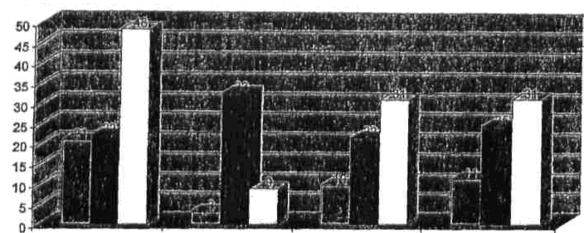
Bissau East North South
■ Used ■ Need/demand not satisfied ⁭ Demand satisfied
Source: MICS 2006.
Traditional practices
184. Regarding harmful traditional practices, despite the work carried out by the NGOs that operate in this field, cases of such practices do not seem to have reduced. Sinimira Nassiquê, an organization whose area of intervention consists in fighting against female genital mutilation and early marriage faces constraints. Its activities have not been visible due to financial limitations and the weak strategies and approaches that they have adopted. Thus, the work of the NGOs in these aspects, in synergy with IMC, did not manage to influence the attitude of the promoters of such practices. It is important to note that since 2000, the National Committee against Harmful Practices (CNCPN) has not developed more actions, and in terms of legislation, there is no law that prohibits this practice. These practices represent a violation of children’s rights, but are compulsory in Islamic ethnic groups; people from other ethnicities, due to individual freedom and cultural assimilation, also advocate such practices. According to a study carried out in 2002 (Jakobsen et al.), 83 per cent of the girls who have undergone FGM represent in total 83 per cent of the Islamic ethnicities in Guinea-Bissau. Many practioners of this practice had surrendered their knives and promised not to have them back and have resorted to alternative practices; however, the incision of girls has continued. The compulsory nature of this practice in Islamic communities is justified by the fact that it is the condition upon which a girl is eligible to marry and participate in cultural and religious ceremonies.
185. After a reflection workshop on the definition of strategies aimed at abandoning harmful practices in the country, the Government and other stakeholders decided to adopt new approaches and strategies that included the use of local languages as a vehicle as well as a collective perspective. These focused on community appropriation and the network of Islamic religious leaders with the aim of demystifying the litigation between FGM and religion, which would be followed by the approval of a law prohibiting this practice.
186. Graph XXII provides evidence that female genital mutilation is a practice that exists in all the regions in the country. The eastern region leads in this practice with 92.7 per cent. This percentage is not surprising since this is the area where the majority of Muslims live and this practice is part of their customs. The southern region occupies second place with 36.3 per cent, as it is also a region where many Muslims live. Bissau comes third as it is an ethnic mosaic where all the ethnicities are represented, including those that profess the Islamic religion. In last place is the northern region where the majority of the population is atheist, with the exception of those in Oio. These figures show that despite various efforts to abolish this practice, it continues to be intact in Guinea-Bissau.

Graph XXII

Female genital mutilation
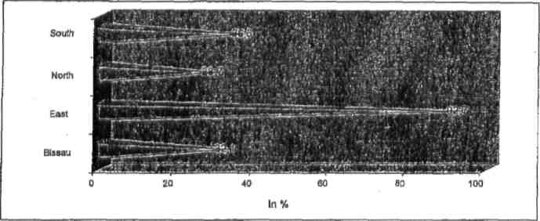
Source: MICS 2006.
187. Graph XXIII shows that the northern region of the country has the highest rate of women who were married before the age of 15 (10 per cent) in relation to the total number of married women, followed by the SAB with 5.8 per cent, the East with 5.7 per cent and lastly the South (4.8 per cent). This data contradicts the preconceived notion that in the East girls get married early.
188. The figures that the graph provides as evidence should not be ignored due to multidimensional consequences that this practice can have in a child’s life. One of the dimensions to highlight is that she is obliged to abandon her education much earlier, thereby blocking her chances of obtaining a higher level of education that could allow her to get a job and economic independence. Another consequence that can result from an early marriage is that the child has to start a sexual life much earlier, since marriage also implies the susceptibility of engaging in sexual relations with the spouse, which may lead to premature pregnancy. If the girl is not sufficiently mature, this may have implications before and after the delivery.

Graph XXIII

Early marriage
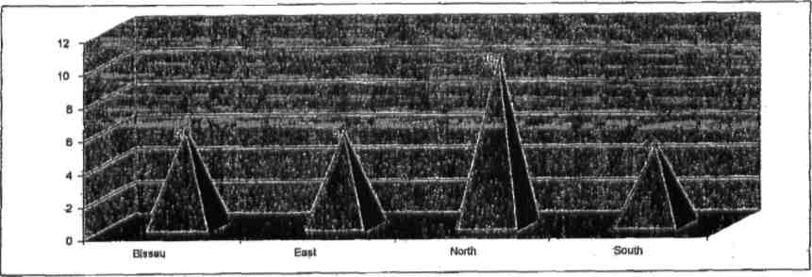
Source: MICS 2006.
189. Regarding the Talibé children, two studies carried out in 2006 by INEP, UNICEF/Women and Children’s Institute, revealed that there is great mobility of children to study the Koran, making this phenomenon in a pendulum dynamic for the recruitment of children to Islamic schools in Senegal, Gambia and/or Guinea-Conakry.
190. It was also concluded that normally there are intermediaries that contact and recruit male children through their parents and/guardians, by first making alluring promises such as the opportunity of their children to study the Koran overseas. Thus, several families trust the intermediaries who then take the children and later on, their masters exploit them. It is important to highlight that the learning of the Koran represents, in part, the preservation of the Islamic culture since it allows for the transmission of its consecrated values. The number of Talibé children from Guinea-Bissau who live in Senegal is estimated to be about 120,000.
191. The study about the sexual abuse and exploitation of minors emphasizes that these schools do not have the necessary conditions and they are far from being Islamic schools, resulting in these children being transformed into slaves where they have to endure daily hard and heavy work for their ages. The children have confirmed that they endure sacrifices and misery and that they never have any contact with the Islamic school. They also stated that they spend most of the time begging for money in the streets which they then give to the adults and they are also made to do hard work.
192. In summary, FGM, early marriage and the phenomenon faced by the Talibé children takes different forms of violation of children’s rights namely, violence, abuse and economic exploitation.

E. HIV/AIDS and other STDs: prevention, control and treatment
193. Since 1986, Guinea-Bissau has been mobilizing tremendous efforts to address HIV/AIDS, having created a National Commission for the Monitoring of the Epidemiological Fight against AIDS. In 1987, the National Programme for the Fight against AIDS (PNLT) and later in 1992, the National Committee for the Fight against AIDS were created. Currently the National Secretariat for the Fight against AIDS is the institution that coordinates all the activities related to AIDS in the country, being a structure that apart from mobilizing financial resources, also carries out sensibility campaigns, information dissemination and monitors activities related to HIV/AIDS. Furthermore, it also collaborates with NGOs that operate in this field as well as with youth associations and groups linked to evangelic and Catholic churches.
194. The study carried out by the Secretariat for the Fight against AIDS highlighted that despite the fact that the Government has created structures that devote their attention to the HIV problem, it did not mean that this was relevant in the Ministry of Health’s budget, particularly between the end of the 1980s and the beginning of 1990, since during this period the country depended on external assistance. Despite the efforts made in the fight against HIV/AIDS, this problem continues to manifest increasing tendencies and Guinea-Bissau is a country where both types of the virus (HIV 1 and HIV 2) are spread. The rate of prevalence of the virus was estimated based on a study on the monitoring of the epidemiology among pregnant women above 15 years of age and who use infant-maternal services in some regions of the country.
195. The same study concluded that in 2001, the rate of prevalence of HIV, including double infection, was estimated at about 4 per cent among sexually active people, with more that 15 years of age, and those with HIV 2 were about 2.7 per cent.
196. Various studies show that HIV transmission in a country like Guinea-Bissau occur mainly through contact with heterosexual individuals who have the infection, vertical transmission from mother to child through the placenta, and through blood contact with infected midwives during delivery.
197. On the other hand, sociocultural factors from different ethnicities, namely female incision (fanado) and the levirate, also contribute.
198. Graph XXIV provides evidence that women begin to engage in sexual relationships very early, which also contributes to the increase in the rate of incidence of HIV since unprotected sex represents one of the ways of contracting the virus. Bissau has the greatest number of women who begin to have sexual relationships before the age of 15 (28.1 per cent), which may be explained by the sexual freedom and little influence of sociocultural factors in the SAB. The South comes in second place (23.3 per cent), followed by the North (20.3 per cent) and lastly the East (13.8 per cent). The lower percentage identified in the eastern region of the country is justified by the veneration in preserving virginity, a requirement that Islamic ethnicities demand before marriage. This does not mean that other ethnicities do not have such a requirement, although the level of demand is different.
Graph XXIV
Total number of women between 15–19 years of age who had sexual relationships before they were 15 years old
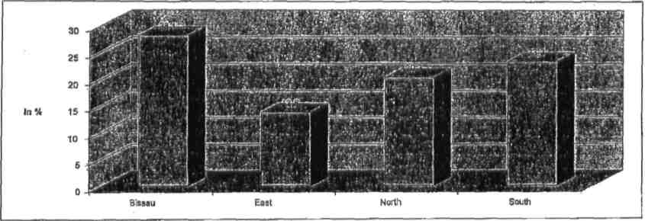
Source: MICS 2006.
199. Regarding the percentage of women who received prenatal care during their last pregnancy, 84 per cent live in the capital, 82 per cent in the North, 80 per cent in the South and 64 per cent in the East, according to graph XXV. The same graph shows that women who received information about HIV prevention during prenatal consultations, 58.2 per cent live in Bissau, 41.1 per cent in the North, 32.6 per cent in the South and 17.8 per cent in Gabú.
200. Women who took the HIV test during their last prenatal consultation and that received their results were only registered at the Sector Autónomo de Bissau (SAB) and in the northern region. This shows, as it has already been mentioned in this report, that equipment is more concentrated in these regions. It is important to highlight in this regard that the South/South Cooperation, by which Guinea-Bissau benefits from paediatric anti-retrovirals provided by the Brazilian Government, has allowed 41 children to get the treatment and expects to cover more than 100 children in the coming years.
Graph XXV
Spread of HIV and psychological burden during prenatal consultations
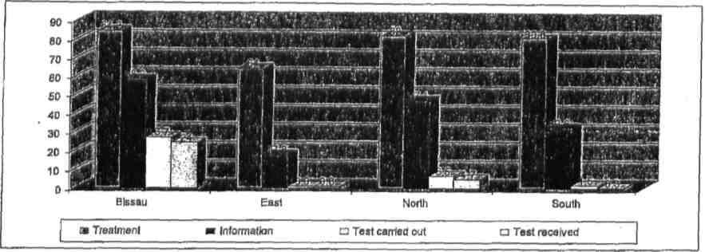
Source: MICS 2006.
F. Nutrition and food security
201. The situation regarding nutrition and food security is a problem that deserves to be highlighted in Guinea-Bissau, especially children’s nutrition. During pregnancy, most of the mothers do not have access to a good and balanced food diet, which contributes to their children being born with low weight and an inappropriate development due to the state of poverty that many families face. Another factor that contributes to malnutrition is the lack of means to preserve food such as fruits and vegetables. There are products that are in abundance in certain seasons of the year only, but if there were means to preserve them, they could be kept for longer periods of time without going bad. Thus, the availability of such products is reduced. The country faces periods of food shortages and there are households which only have one meal a day in addition to the lack of diversity in that meal.
202. Government units that exist in many villages do not have sufficient means to meet the needs of children and pregnant women. As a result, there are private organizations, namely the Catholic missions that have been making tremendous efforts in the area of health. Thus, in addition to supporting government units, it sells medication at a reasonable cost, provides training to the matrons and sensitizes women to have children at the hospital. The Catholic mission is an organization that once it identifies children who suffer from malnutrition it takes them and their respective mothers where the latter are thought to prepare the food for their children through with a more nutritive composition based on local products while providing a more diversified food diet.
203. Table II provides evidence of the number of children born with low weight and height in the different regions. These are concentrated at the Sector Autónomo de Bissau (SAB) (9.2 per cent), East (1.9 per cent) and South (2.2). The cases of malnutrition identified in the North are only 0.5 per cent, which can be justified by the fact that there is a Home which hosts children suffering from malnutrition, which was created by the Catholic mission in Bula. The situation at the Sector Autónomo de Bissau can be explained by the concentration of people in the capital where there are heads of households who are unemployed and without an income to provide food to their families. This situation is not only faced in this socio-professional category of the heads of households but also among those who work in the public sector where their salaries are not only paid late but they are also extremely low thus, not allowing them to guarantee the monthly expenditures.
Table II
Infant malnutrition
Region | Children not weighed | Weight/ height | Missed month or year of birth | Other cases excluded | Number of cases excluded from the analysis | Number of children
Bissau | 3.6 | 9.2 | 1.2 | 11.2 | 25 | 1 107
East | 0.9 | 1.9 | 6.4 | 16.3 | 25.3 | 1 451
North | 0.4 | 0.5 | 3.2 | 16.6 | 20.7 | 2 576
South | 2.1 | 2.2 | 10.2 | 32.8 | 47.3 | 711
Source: MICS 2006.
G. Services that guarantee children’s care
204. Despite the fact that we have highlighted in this report the services that guarantee children’s care in Guinea-Bissau, in this section we will discuss these services in a summarized form.
205. The Ministry of Social Solidarity, Family and Fight against Poverty (MSSFLP), being the institution that was designated by the Government to deal, in general, with the problems facing a family, the Women and Children’s Institute came later to deal specifically with children and women’s problems. In order to effectively pursue with its objectives, the Institute collaborates directly with UNICEF, which provides assistance and funds for its activities. The studies carried out by IMC on the Koranic schools (madrassa) and the Talibé children both in 2006 and in 2007, the study on the institutional analysis of the structures of social protection and assistance to children in Guinea-Bissau show the commitment of this institution in attempting to better understand the problems facing children so as to define realistic strategies and action plans.
206. Other social services that focus on assisting children are the Ministry of Education, through its preschool and basic levels of education; the Ministry of Public Health, through the infant-maternal services; the Ministry of Justice, through the decrees that provide incentives for the registration of children; the office for children and adolescents at the General Directorate of the Judicial Police; the Ministry of Home Affairs, through the office of women and children; and the department of protection at the regional police commissions.
IX. Education, leisure and cultural activities
A. Strategy/national policy on education
207. The country defined as its priority basic education for all, despite the difficulties faced in terms of material and financial resources. The political measures assumed in the last couple of years were meant to guarantee children aged between 6 and 16 years old access to school, which depended on tremendous support from the Government’s international partners.
208. Despite the fact that a lot still has to be done in terms of guaranteeing the education of all children at school age, a lot of progress has been accomplished. For example, the actions taken in the context of the basic education project known as “Firkidja”, which allowed for the recovery of school infrastructures that were destroyed after the political-military conflict of 1998–1999, the construction of new schools, training and the increase in the number of teachers, provision of school materials, among others.
209. It is important to remember that the implementation of the children’s free access to basic school policy was followed by the supply of school materials, which was made possible by the tremendous support from UNICEF. In addition, this United Nations agency provided funds that continue to support the training of 1,500 teachers each year.
210. The application of this political strategy at the level of basic education allowed for an average annual growth of 2.8 per cent for the age group between 7 and 12 years, against 3.3 per cent for the age group between 13 and 17 years, as shown in the table III and graph XXVI below.
Table III
Evolution of the school population 7–17 years of age
 | 1999 | 2000 | 2001 | 2002 | 2003 | 2004
7–12 years | 216 481 | 222 054 | 228 215 | 234 589 | 241 184 | 248 008
13–17 years | 124 231 | 130 265 | 134 075 | 138 025 | 142 118 | 146 362
Total | 340 712 | 352 319 | 362 290 | 372 614 | 383 302 | 394 370
Source: Bureau of Studies and Planning — FIRKIDJA — Ministry of Education.

Graph XXVI
Evolution of the school population per age group
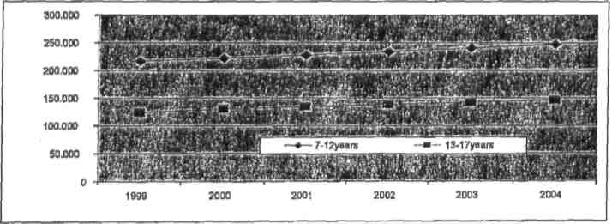
Source: Bureau of Studies and Planning — FIRKIDJA — Ministry of Education.
211. Based on policies aimed at improving the access and quality of education, it is important to highlight the implementation of the Unified Basic Educational system (EBU), which allowed students to enrol to sixth grade without having to abandon their place of residence. It is also important to note that even though the funding for Project “Firkidja” by the World Bank came to an end, the free access to Unified Basic Education continued to be guaranteed thanks to the support of other partners namely, UNICEF, Plan/GB and WFP, World Bank, UNESCO and the Portuguese Cooperation, despite some difficulties. Meanwhile, a new instrument of support to education designated “Education III” was conceived.
B. Challenges and perspectives
212. Considering the number of children who may be outside the school system, both at the public and private levels, the challenge for the Government of Guinea-Bissau continues to be the ability to have every child at the school age enrolled as a way to combat illiteracy. Another important challenge is to increase the rate of school enrolment for girls, which continues to be penalized by the structures and traditional practices, thereby affecting the exercise of their rights. Based on these challenges, the Education Sectoral Plan (PSE), an instrument, which will serve as a support to all actions in an interconnected way to the policies of the educational sector, is currently being elaborated. The draft Basic Law of Education (LBE), which will be the legal support to different structures and actors in the education arena, so as to guarantee not only the massive access of children to school, but also provide them with a quality education, has been concluded.
C. Promotion of recreational, leisure and cultural activities
213. The efforts that had been made in terms of creating sports and leisure facilities for children was not successful due to the lack of care in the use and maintenance of such facilities. It is important to recognize that there are tremendous shortages in terms of parks for leisure and sports’ facilities adapted for children. Private and community initiatives that came to minimize these shortages were extremely valuable in the last couple of years, although the Government on its part has assured the carrying out of massive sports activities such as School Games, Children’s Carnival, among others.
214. The institutionalization of the Children’s Fortnight, from June 1 to 15 of each year, was an important factor in the promotion of children’s rights, in that several sports, cultural and social activities are carried out, all in reference to the rights consecrated in the CDC.
X. Special protection measures/children in emergency situations
A. Disarmament, demobilization and reintegration of children incorporated in defence and security forces
215. In legal terms, the recruitment of children for defence is forbidden. Law No. 3/80 of 5 May and Decree No. 20/83 of 9 June, which defends a Compulsory Draft, established 18 years as the minimum age. However, since the country was affected by an unconventional civil war, underage children were used during the 1998–1999 conflicts. For this reason, some actions to regulate the situation were implemented, namely, the process of integrating people who adhered to the forces in conflict irregularly. Priority in this process was given to underage and disabled children.
B. Reinstallation and reintegration of displaced and returned children
216. Given the fact that Guinea-Bissau is located in an area where conflicts continue to take place, the country has been hosting displaced persons from Liberia, Sierra Leone and southern Senegal; these refugees always come with children.
217. In this regard, the Government of Guinea-Bissau, in collaboration with its partners, mainly the United Nations High Commissioner for Refugees (UNHCR) and UNICEF, have been providing the means to host these people, including hosting centres (refugee camps) created around Bissau, Bôr, the Cacheu region and in Bachil and Jolmete. In addition to hosting infrastructures, they have provided facilities to maintain the children in school, taking into account the model used in their places of origin.
218. In this regard, it is important to emphasize the actions in 2006, by the Ministry of Social Solidarity, Family and Fight against Poverty insofar as mobilizing and providing means for the displaced persons in the Sector of São Domingos, who were affected by the cross-border conflict in Casamance (southern Senegal) and in the North of Guinea-Bissau.
219. The services of the Ministry of Health have also been supportive by providing basic care to the refugees and displaced persons; they have carried out vaccination campaigns in order to avoid major epidemics.
220. In the country, there is a National Commission for Refugees, chaired by a Government representative who is responsible for coordinating activities that support refugees and displaced people not only in material ways, but also by providing them with the necessary documentation to facilitate their movements, access to schools and registration of their children.
C. Protection of children victims of kidnapping and sexual abuse
221. The country does not have specialized hosting centres for children victims of kidnapping and sexual abuse. However, public institutions created specialized services for the treatment of cases of kidnapping and violation of children. Apart from the creation of the Women and Children’s Institute and the Curator for Minors at the Regional Court of Bissau, a Judicial Police, a Bureau for the Protection of Minors and Adolescents and a Bureau for Women and Children’s Affairs at the Police and Public Order Commission were also created.
222. These services act in collaboration with NGOs and some families in terms of hosting affected children and also take responsibility for their protection and monitoring. These are equipped with human resources who may, in some cases, not have specialized training in the field but somehow provide some special attention to the victimized children.
223. In addition, as referred earlier, revisions to the proposed penal law were made aimed at reinforcing the sanctions to crimes of this nature and facilitating legal procedures.
XI. Children in conflict with the law
A. Political and other actions and legal reforms
224. Children in conflict with the law refer to all underage children whose situations require the application of general norms of prevention or penalization in force in the hierarchy of the judicial system. Due to the specificity of these children, who are recognized by the law, the rules cannot be applied in the same way as they would be applied to adults as legal provisions.
225. In this context, since the 1970s, in the hierarchy of the judicial system, the Jurisdictional Statutory Assistance to Minors was created.
226. The evolution on the forms of treatment, both at a process as well as at the social reinsertion level, demanded the adoption of new rules. Thus, a new draft law was presented which aimed at, above all, demanding a multidisciplinary follow-up of minors who are in conflict with the law, giving more weight to civil society’s intervention through organized groups or NGOs that work towards protecting children.
227. Despite the fact that up until now no specialized hosting centre has been created, public institutions have been providing the means to temporarily host the children. Concretely, the IMC, the Judicial Police and other institutions have always hosted children temporarily while looking to find more secure solutions for their development.
228. In this perspective, the penal law does not admit the application of effective punishment, even imputable, but security measures that allow for their reinsertion in order to eliminate their criminal tendencies.
B. Expectations/follow-up and legal support for children
229. The creation of a section for minors and the attribution by the Public Ministry of a mandate to the Curator of Minors are essentially to provide, at the courts, a permanent legal follow-up of children’s affairs. These services not only follow-up their situation during the development of activities pertaining to the process within the courts, but they also follow up the relations that the children establish in the social arena where they are placed. To that effect, the Attorney General’s Office has been trying to place in these services, magistrates with some special preparation and sensitivity in relation to children’s affairs.
C. Reform, rehabilitation and institutionalization of the protection of affected children
230. In this case, it is important to emphasize that the situation of the children who are in conflict with the law was not a problem of great concern, but today there are several judicial cases that involve minors not only as victims, but also as perpetrators of crime. This has not only worried the Government, but also society as a whole. Therefore, the possibility of creating and institutionalizing the treatment of these children is increasingly being considered. The fact that there are no public institutions that are specialized in the social reinsertion of affected children has led the Government to try to establish partnerships with private institutions that are social in nature, such as those linked to churches.
D. Alternative legal mechanism/institutions
231. Apart from the classical institutions of judicial protection for minors in the legislature from 2000 to 2003, an ad hoc Commission for Women and Children was created by the ANP, whose main task was to gather information, present proposals for legislative revision with the aim of harmonizing children’s rights at the national level with international legal instruments.
232. During the 2004–2008 legislature, the country’s Members of Parliament understood that due to the importance and the need to establish greater protection and, above all, better application of the CDC, a Specialized Commission for Women and Children’s Affairs had to be created. This Commission was restructured and entrusted with more powers of intervention, therefore it is able to act outside the parliamentary sessions on issues and with initiatives favouring children. This Commission established partnerships with other institutions concerned with women and children’s affairs.
233. The activities of the Specialized Commission of the ANP (People’s National Assembly) also extended to the exercise of “advocacy” along with the international partners, aimed at sensitizing society as a whole not only in the promotion of social rights (children’s health and well-being), but also in combating against harmful practices such as FGM and early marriage.
XII. Environmental protection
A. The right to a safe and healthy environment
234. Until recently, environmental protection focused fundamentally and solely on international principles. The evolution of natural phenomenon, which is typical of the geographic region where the county is situated, namely the Sahel region, with strong threats such as desertification, allowed for the adoption of some measures that ensure a better future for children.
235. In the context of the measures taken, the creation of natural wildlife zones in the islands of Bijagós, the Cacheu region, the regions of Quinara and Tombali should be highlighted. Provisions were also introduced in both the Hunting Law and the Penal Code to penalize damaging practices to the environment, for example, wildfires.
236. Considering that major damages to the environment have to do with human actions, primarily industrial projects, such as those validated by the Government, since 2006, the Evaluation Unit for Environmental Impacts (CAIA) has been in existence. This unit is connected to the Prime Minister’s Office and is responsible for monitoring all the studies being carried out such as those that determine indispensable conditions for the attribution of licences for the execution of any project.
237. In order to carry out environmental protection plans, a series of legal instruments were adopted. Among these, the elaboration and technical validation and the national Basic Environmental Law (LBA), which expressively defends the principle that guarantees a safe and healthy environment should be highlighted. Also worth highlighting is the fact that all those who have been practising damaging acts against the environment have to, compulsory, take civil responsibility so as to guarantee a sustainable future for children.
B. Protection of street and vending children
238. Since the end of the civil war of 7 June 1998, the country has been witnessing a phenomenon of street children, which has been a source of major concern for the general community. Since this is a relatively new phenomenon, public institutions do not have structures ready to respond to this problem. Thus, efforts have been focused on maintaining the places where these children are (normally in commercial areas) in good hygienic conditions.
239. In addition, disabled children are subject to particular attention although there is a shortage of means to cater for them, as well as an absence of specialized institutions. In this regard, the Government tries to reinforce partnerships with initiatives from NGOs that operate in this field, by providing facilities to these organizations both in terms of acquisition of means as well as by protecting the places where these children stay. Partnerships that are worth highlighting are, for example, those established between the National Union of Disabled Minors (UNDM) and the Association “Bengala Branca”, which have been operating at Government infrastructures while supporting the social reintegration of disabled children.

Conclusion
240. Assuming as a challenge, the promotion of all the rights consecrated in the Convention on the Rights of the Child, the Government has been reinforcing mechanisms for its maximum application, thus providing children with a better future.
241. Considering the facts narrated in the first report pertaining to the application of the Convention, we can affirm that despite moments of instability which the country has been facing, there has been some progress in terms of its application, namely in the following areas:
242. Non-discrimination: adoption of legislative measures that are aimed at facilitating the establishment of paternity of children regardless of the marital status of their progenitors. The promotion of greater protection of female children against risks of violence; the promotion of special programmes that provide incentives for the enrolment of children at school and the establishment of partnerships with civil society organizations aimed at promoting and socially integrating disabled children.
243. Regarding the principle of the best interests of the child, provisions that are aimed at having consideration for children’s particularities in the processes that these are involved, were adopted in the project of the Jurisdictional Statutory Assistance to Minors, namely their protection by the Public Ministry. Similarly, the need to take into account children’s interests in cases of adoption and the parents separation, were expressly consecrated having also received the delegations from the Public Ministry at the courts in order to privilege the interests of minors in the establishment of elements in their favour.
244. In terms of the dissemination of the Convention, it was concluded that there has been sensible progress, thanks to the propagation by the media, mainly radio, through which the majority of the population have been hearing about children’s rights.
245. The creation of the Women and Children’s Institute itself was a determinant factor in the promotion and defence of children’s rights.
246. The several campaigns for the registering of children upon birth which took place in various parts of the country, with the support from Government partners, the progressive exemptions of registration tax payments, allowed for an extension on the number of children that benefit from the right to identity and its corollary that is embedded in the Convention.
247. The institutionalization of the Children’s Parliament and the organization of special programmes related to the rights of children, the provision of airtime in the media, allowed for the extension of the rights to freedom of expression, the inquiry on children’s opinion and above all the consecration of the freedom of thinking and consciousness.
248. Administrative measures and awareness campaigns that allowed for greater recognition of freedom of association of children were also taken/carried out and, greater acceptance of this right both within the family as well as in the traditional institutions were observed.
249. The reforms of the Penal Code and that of the Penal Procedure Code were essentially aimed at not only protecting the right of the physical integrity of children against torture and other forms of ill-treatment, but also guaranteeing the protection of their privacy so that their future would not be prejudiced. Given the fact that the Government does not have the conditions to guarantee the integral promotion of the Convention, close partnerships with civil society organizations, international partners aimed at guaranteeing greater protection of children mainly those who are not rooted in a family environment, refugees and displaced persons, were established.
250. Regarding the access to health, the national policy wager on health was on prevention. Therefore, the majority of children at the country level were vaccinated. According to the vaccination programme at the Ministry of Health, most children were vaccinated at least once and the majority has completed their doses. The national policy also waged in health education, which was implemented in all health centres and this has been helping tremendously in the dissemination of information about basic health care, hygiene and prevention.
251. In terms of the right to education, progress has been made, not only has the gradual access of school population increased, but also a growing number of people have enrolled much earlier in the school system and the unification policy of basic education has allowed children to have more years of schooling in their own communities.
252. In terms of leisure and free playing time, it is recognized that children have few moments and means of leisure and free time to play, mainly insofar as having access to sports facilities, because there was very little investment or because those in existence were not recovered or maintained. It is important to emphasize the efforts and interest of national institutions in the adoption of international conventions related to the protection of children.
253. Lastly, it is important to mention that the difficulties faced in following the Convention are not only due to the situations and the conditions of public institutions but also to some sociocultural and religious practices, such as the FGM, forced and/or early marriage, among others. The inexistence in the country of a national policy on social protection limits the achievement of initiatives implemented in the area of protection of children’s rights.
254. The activities coordinated by the MSSFLP are deficient in that this institution never invited major partners and many other organizations that intervene in the area of children’s protection to meet and deliberate, reflect and gain mutual knowledge about the problem facing children, with the objective of creating synergies and improving coordination activities.
A. Challenges and perspectives
255. Based on the evidence gathered, the country must increase significantly the level of application of the rights consecrated in the Convention, which will have to necessarily go through the following points:
(a) Promote greater stability of the institutions in the country and increase Government participation and contribution towards the promotion of children’s rights to education and health, without forgetting to reinforce the collaboration with civil society organizations and international partners.
(b) Guarantee more legal protection of children through the organization of the Curator of Minors at the courts by providing more protection to children in conflict with the law through the placement of specialists in others fields, such as social workers and child psychologists, among others.
(c) Adapt legislation to the developments in terms of protection of children, particularly in cases of adoption and the transference of children; conclude bilateral and multilateral agreements with other countries in order to combat the trafficking and violation of children.
(d) Extend prevention and treatment activities to children in vulnerable situations.
(e) Adopt education strategies that allow for greater involvement of children.
(f) Adopt legal and administrative measures aimed at facilitating the registration of children born outside urban areas and of parents with weak economic power.
(g) Continue to sensitize legal measures aimed at combating traditional practices that are harmful to a child’s health and development.
(h) Since the MSSFLP and the IMC do not have means to decentralize their activities, they could create protocols with the Ministry of Health and Education, given the fact that the latter has regional representations throughout the country. This would allow them to create focal points to exercise their activities outside the capital.
(i) Create a national system for the protection of children, a database with strategic information about vulnerable children and develop systematic mechanisms for the gathering of indicators for the protection of children.
(j) Promote the carrying out of tests to determine the spread of HIV in pregnant women in all regions of the country in order to identify those who are positive and provide them with a service for the prevention of vertical transmission; similarly, provide quality health care to recently born babies who are also HIV infected.
(k) Constitute a community network for the protection of children in order to prevent their sexual abuse and exploitation, child labour and trafficking.
(l) Finalize the harmonization at the national level of legislation on children so as to bring it closer to CDC recommendations, follow-up and supervise its applicability.
(m) Allow other stakeholders to denounce the worst forms of violation of women and children to the relevant authorities.
(n) Promote the capacity of professionals involved in the network for the protection and defence of women and children.
(o) Focus on dissemination campaigns, which highlight children’s rights, practices that violate children’s rights, with specific emphasis on the protection of children’s life.
(p) Create a technical structure for the coordination and monitoring of activities, which do not depend on political willingness but on the professional commitment.
(q) Reinforce awareness activities targeting community opinion leaders, namely religious leaders and elders (imams, priests and respected old men) and, civil society organizations on the importance of the Convention, the involvement of the community and national media. For better dissemination of the Cconvention, it should be translated into simplified national languages.
B. Regarding the report
256. Despite the delay in the presentation of the second report relative to the submission of the first report, the effort was made in this report to incorporate all the accomplishments from 2001 to 2008.
257. In addition, an effort was made in this report to advance aspects related to the perception of the material content of the Convention itself and that of documents related to it.
258. In order to provide consistency in this report, an extensive discussion of the document was carried out through debates, in which almost all entities that directly or indirectly deal with the issue of children’s rights participated, including, public institutions, non-governmental organizations as well as civil society in general.
259. As part of that process of validation, it is important to highlight the sessions that were undertaken publicly in Bissau in October 2008, where a restricted group of technocrats introduced all the suggestions gathered during the public consultations on 12 December.
260. We thank all those who participated and contributed in one way or the other to the conclusion of this report.

Bibliography
AMIC (2006), Annual Report on the Activities of the Child and Youth Workers Project, Bissau
AMIC (2006), Report on the Training Activities for Civil Servants on the Issue of children’s rights, Bissau
CISSE-NIANG, Aminata (s/d) L’interdiction Internationale du Travail des Enfants — Université Cheik Anta Diop — Dakar
CMAJ (2005), La situation des enfants dans le monde : la contribution dérisoire du Canada à l’aide internationale – CMAJ • JULY 5, 2005; 173 (1)
Civil code of The Republic of Guinea-Bissau
Penal code of The Republic of Guinea-Bissau
Coghlan Benjamin, et al. (2006), Mortality in the Democratic Republic of Congo: a nationwide survey – Centre for International Health, Burnet Institute, Melbourne, Australia
Comité des droits de l’enfant (2003), Droits de l’enfant en Haïti : Rapport sur 1’application de la Convention relative aux droits de l’enfant par la République d’Haïti — 32e session — Genève, 13–31 Janvier, 2003

Constitution of the Republic of Guinea-Bissau
ECPAT (2001), Questions et Réponses sur L’Exploitation Sexuelle des Enfants à Des Fins Commerciales – ECPAT International, Thaïlande
ECPAT (2005), La violence contre les enfants dans le cyberespace : Une contribution à l’étude mondiale des Nations Unies sur la violence à l’égard des enfants – Thaïlande
ECPAT – USA (2002), Child Prostitution, Child Pornography, and Trafficking of Children for Sexual Purposes — 157 Montague — Brooklyn, NY 11201
Faleiros, Eva T. Silveira et al. (2000) reiterating the concepts of violence, sexual abuse and exploitation of children and adolescents — CECRIA/MJ/SEDH-DCA/FBB/UNICEF — Brasilia

Ferreol, Gilles et al. (1991) Dictionnaire de Sociologie – Armand Colin Éditeur, Paris
Human Rights Watch (2002), Violence sexuelle contre les femmes et les filles dans l’est du Congo – La Republique Démocratique du Congo La Guerre Dans la Guerre
ILO (2004), Child Labor in Latin America and the Caribbean — International Labour Office IPEC Projects — 2004–05
ILO (2004), Helping hands or shackled lives? Understanding child domestic labour and responses to it — International Programme on the Elimination of Child Labour (IPEC) — Copyright © International Labour Organization
Jakobsen, et al. (2002), Sexual habits and behaviour among the youth in Bissau — Project Health of Bandim — Republic of Guinea-Bissau
Leal, Maria Lúcia Pinto et al. (2005), “traffic of women, children and adolescents for sexual commercial exploitation: A Transnational Phenomenon” — No. 4/2005 — SOCIUS Working Papers – Lisbon
Organic Law of Sectorial Courts – Guinea-Bissau
MICS (2006), Survey of Multiple Indicators — Guinea-Bissau — UNICEF
OMD (2004), Report on the Objectives of the Millennium for the Development of Guinea-Bissau – UNDP, Ministry of Social Solidarity, Family and Fight against Poverty
OMS (2002), World Report on the Violence and Health — World Health Organization — Geneva
OMS (s/d) Recherche Qualitative pour les Programmes de Santé — Division de la Santé mentale — Organisation Mondiale de la Santé
Plan Guinea-Bissau (2007), Report on the Activities Undertaken for the Promotion of the CDC, Bissau
Rapports de Recherche en Bref et Recommandations (2004), Impacts Socioeconomiques du VIH/SIDA, sur les Enfants (le Casdu Sénégal) — University Cheikh Anta Diop de Dakar — Série de Sahara, Numéro 1 Septembre
Recenseamento Geral Da Population E Habitation (1991) Definitive Results Volume I National Level; Volume I Bissau’s Level

Human Development Report (2007/2008), UNDP
Renluv (1996), “Legal Instruments for the protection against gender and sexual violence” – Bissau
UNICEF (1996), Violences faites aux femmes en Afrique de L’Ouest et du Centre – Bureau Régional pour L’Afrique de L’Ouest et du Centre
UNICEF/Radda Barnen (1996), “Convention of Children’s Rights in the legal system of Guinea-Bissau” Faculty of Law of Bissau – Bissau
UNICEF/LGDH (1999), “Guinea-Bissau: legal protection of children in the positive right”, Faculty of Law of Bissau – Bissau
UNICEF (2005), L’enfance en péril. La situation des enfants dans le monde 2005. Disponible à l’adresse: www.unicef.org/french/sowc05/index.html
UNICEF (2006), Fiches d’informations sur la protection de l’enfant – 1946–2006 Unissons-Nous pour les Enfants

UNICEF (2006), La Situation des enfants dans le mode 2006: exclus et invisibles
UNICEF (s/d), Convention on Children’s Rights — United Nations Fund for Children — Novagráfica, Lda., Bissau

STNLS/INEP (2005), A socio-cultural dimension of behavior due to AIDS in Guinea-Bissau
UNICEF/IMC (2006), Abuse and Sexual Exploitation of Minors in Guinea-Bissau, INEP, Bissau
UNICEF/IMC (2006), Study on Koranic Schools, Madrasses and Talibé Children in Guinea-Bissau, INEP, Bissau
UNICEF/MSSFLP (2007), Institutional Analysis of the Social Protection Structures and Assistance to Children in Guinea-Bissau, Bissau
Williams, Lucia Cavalcati de Albuquerque (s/d) Child sexual abuse — Federal University of São Carlos — Department of Psychology
Other documents consulted:
• Synthèse et recommandation de la conférence Arabo-Africaine contre 1’exploitation, la violence et l’abus sexuels des enfants
• Exploitation sexuelle des enfants (Rapport de la Guinée-Bissau) — Institut de la Femme et de L’enfant, Ministère de la Solidarité Sociale, de la Famille et de la Lutte contre la Pauvreté — Avec l’appui UNICEF Bissau
• Report on the protection of children in Guinea-Bissau — Revision in Pairs on the situation of children in the CEDEAO space — Ministerial Meeting, Dakar, September 2003
• Cases of flagrant violation of children’s rights — data gathered at police stations of Bissau (August 2003 to November 2004) — Network of Young Educators (REJE), Guinea-Bissau
• Étude du Secrétaire Géneral de L’Organisation des Nations Unies sur la Violence contre les Enfants — Questionnaires à l’intention des gouvernements — Guinée-Bissau.
• Information requested for the regional Strategy Paper on Child Protection – UNICEF, Guinea-Bissau.
• Essential information on sexual abuse and exploitation of minors – organized by Sónia Polónio (UNICEF, Bissau)
• Facultative Protocol for the Convention on Children’s Rights related to the sale of children, prostitution and child pornography
• Prohibition of the worst forms of child labour and the immediate action for the elimination of its elimination, convention No. 182 and recommendation No. 190 – ILO
• Minimum age for admission to work, convention No. 138 – International Labour Organization
• Convention on the elimination of all forms of discrimination against women
• Legal instruments on the protection and violence (VBSG) – Fodé Abulai MANÉ (Jurist, INEP)
Websites (consulted) linked to children:
www.unicef.org
www.kidsbehindbars.org
www.ilo.org/childlabour
www.unfpa.org
www.jubileeaction.co.uk
http://ceecis.org
http://ceecis.org/childprotection
www.childinfo.org
www.childinfo.org/areas/fgmc/profiles.ph

* In accordance with the information transmitted to States parties regarding the processing of their reports, the present document was not formally edited before being sent to the United Nations translation services.
Based on estimates by INEC for 2004, taking into account the fact that no regular census was carried out. However, the last census carried out in 1999 estimated that the population could be around 1,500,000 inhabitants
Those conceived but not yet born.
Those that have not yet been conceived; but there is a possibility that two people of opposite sex in a relationship may create a human being. In this regard, it may expect to have rights.
According to data from the Ministry of Education (GIPASE) for the 2004/05 school years.
Despite the fact that the country is not party to nor has ratified this instrument, article 29 of the CRGB allows for its inclusion.

