Committee on the Elimination of Discrimination against Women

Seventy-seventh session
26 October–5 November 2020
Item 4 of the provisional agenda

Consideration of reports submitted by States parties under article 18 of the Convention on the Elimination of All Forms of Discrimination against Women

Replies of Maldives to the list of issues and questions in relation to its sixth periodic report*

* The present document is being issued without formal editing.
[Date received: 2 July 2020]

Reservations

A. Reply to paragraph 1 of the list of issues (CEDAW/C/MDV/Q/6)

1. On 24 December 2019, the Cabinet decided to lift the reservations to paragraph 1 subsections (b), (e), (g) and (h), and paragraph 2 of Article 16 of CEDAW. On 2 February 2020, the decision was forwarded to the People’s Majlis (parliament) for endorsement. On 24 February 2020, the People’s Majlis endorsed the partial lifting of reservations and on the same day, the Government of Maldives notified the Secretary-General of its decision.

Legislation and definition of discrimination

B. Reply to paragraph 2 of the list of issues

2. Article 93 subsection (a) of the Constitution stipulates that treaties entered into by the Executive in the name of the State with foreign states and international organizations shall be approved by the People’s Majlis, and shall come into force only in accordance with the decision of the People’s Majlis. Subsection (b) of the Article further stipulates, that despite the provisions of subsection (a), citizens shall only be required to act in compliance with treaties ratified by the State as provided for in a law enacted by the People’s Majlis.
3. As such, objectives of enacting the Law Number 18/2016 (Gender Equality Act) includes, facilitating all steps towards prevention of discrimination based on gender, and prevention of all ideas, and practices that promote discrimination between men and women, and to ensure that women enjoy equal terms with men, human rights, fundamental rights and equal opportunities in their economic, social, cultural, civil and political life in the Maldives, in conformation with the CEDAW and the CEDAW Optional Protocol.
4. Therefore, as per the aforementioned Constitutional arrangement, enactment of the Gender Equality Act allows individuals to invoke principles of the Convention through the domestic legislation, in the private sphere as well as against the State, and creates obligations over parties other than the State institutions to uphold the principles of the Convention as reflected in the Act.
5. The Gender Equality Act will, however, be interpreted in conformity with the Constitution and principles of Islam, to uphold the principles stipulated in CEDAW and CEDAW Optional Protocol, the conventions and treaties Maldives is party to, and in a manner that promotes the values that underlie in an open democratic society. The Act mandates accounting for Maldives’ reservations under conventions and treaties in its implementation.
6. As per Law Number 18/2016 (Gender Equality Act) the definition of discrimination based on gender encompasses both indirect, direct and discrimination based on circumstances.
7. Section 8 (a) of the Act states that the use of discriminatory system to allocate certain types of jobs for a specific gender and the subsequent exclusion of a specific gender from opportunities as a result of the systemic discrimination will constitute a discrimination in contravention of the Act.
8. Systemic discriminations are defined as systems designed to maintain through laws, policies, culture and practices, unjust beliefs in society on the role of a specific gender based on social circumstance. Further, Section 9 (a) prohibits discrimination based on circumstances such as pregnancy or the possibility of pregnancy, childbirth or the possibility of childbirth, and breastfeeding or the possibility of breastfeeding. Additionally, Section 9 (b) of the Act also prohibits discrimination on the basis of sex, marital status, family responsibility, qualities attributed or not attributed by the society to a specific gender, roles attributed or not attributed by the society to a specific gender, established practices that diminish the dignity of a specific gender, and social and cultural beliefs that a specific gender is superior or inferior. Section 9 (c) further elaborates on discrimination based on circumstances by stating that for a person unjustly blamed forcing to carry a burden or difficulty or, denial of a profit, gain, ease or opportunity for a provision stated in the article through action or inaction of an individual, law, regulation, policy or general practice shall constitute discrimination.
9. Section 10 (a) of the Act defines direct discrimination as the blatant discrimination between men and women in the realization of rights guaranteed by a regulation or in the implementation of a mandate by an institution through the relevant procedures, or under any such circumstance. Further, Section 10 (b) states that the inferior treatment of an individual based on the quality for which provisions are provided in the Act or that inherent to the individual will also constitute a direct discrimination for the purposes of the Act.
10. Concerning indirect discrimination, Section 11 (a) of the Act provides instances which would constitute indirect discrimination as per the Act. Section 11 (a) (1) states that inequality to a specific gender caused by the neglect to adequately consider and address injustices that had occurred prior to the implementation of a regulation, policy or procedure, despite the superficial presence of promotion of equality evident in the regulation, policy or procedure would be considered as indirect discrimination and subsection (2) provides that an individual afforded the protection of the Act being subjected to unjust harm due to the manner of enforcement or due to the result of conditions set to achieve a specific objective or due to the imposition of qualities made mandatory or due to the manner an action is implemented would be considered as indirect discrimination.
11. Efforts are currently underway to review the Family Act in force that was enacted in 2000. The new Bill is expected to revamp and replace the current legal regime governing family matters in the Maldives. The process of formulation of a new Bill will comprise of focus group discussions to ensure that it better meets the needs of members in the community, and has the necessary buy in from all relevant stakeholders.

Access to justice

C. Reply to paragraph 3 of the list of issues

12. The Gender Equality Act provides the avenues of redress available for victims of gender discrimination. The Act mandates all the public and private sector employees to establish a complaints mechanism through which the victim may submit a complaint of a non-compliance on the part of the employer as stipulated in Section 29 of the Act. Where such a complaint has been submitted, the Act obligates the employer to investigate the matter and arrive at a decision within 30 (thirty) days of receiving such a complaint. Where the complainant is not satisfied with the decision made by the employer or if the decision exceeds the 30 (thirty) day period, Section 29 (d) allows the complainant to submit the matter to the Employment Tribunal.
13. As per Section 30 of the Act, where entities fail to establish the aforementioned complaints mechanism within the stipulated time frame in the Act, the Minister upon such information is empowered to (a) publicize information of the non-compliant authority, (b) impose a fine not exceeding Maldivian Rufiyaa 25000 on public and private sector entities.
14. Section 31 of the Act also allows the victim to raise charges against the perpetrating entity, and either request for a claim of compensation of a request for a review of actions committed by the perpetrating entity.
15. A total of 43 public sector institutions have established a complaints mechanism, and there has been no complaints received by all 43 institutions as of 2019. The Ministry of Gender, Family and Social Services has also not received any complaint with regard to non-compliance as of 30 June 2020. However, the review does not extend to the private sector.
16. Ensuring the independence of the Maldivian Judiciary to attain speedy and quality delivery of justice was one of the most important reform works conducted by the Government. In that regard, numerous achievements have been made, to instil public confidence in the Maldivian judicial system.
17. In that regard, during early 2019, an assessment was conducted with the assistance of UNDP Maldives to identify the deficiencies of the Maldivian judiciary and assess the feasibility of the Government’s reform proposals in this area. The study that concluded in August 2019, indicated an urgent need to ensure independence of court’s internal administration, the importance of impartial and efficient functioning of the Judicial Service Commission and the need to ensure gender parity within the judiciary.
18. To bring about some of these changes, a second amendment was brought to Law Number 10/2008 (Act on Judicial Service Commission) on 3rd September 2019. The Amendment introduced detailed investigative procedures to address disciplinary issues of judges, stipulated specific ethics and rules of conduct that must be upheld by the members of the Judicial Service Commission. In line with the recommendation to ensure independency in the court’s internal administration the Amendment also established the Department of Judicial Administration as a separate body, with a Chief Judicial Administrator empowered to oversee the daily administrative tasks of the judiciary.
19. Further, during 2019, five Supreme Court Justices were investigated for abuse of power and professional breach of conduct, and four of the Justices were impeached by an overwhelming majority in the Parliament. Additionally, the first female Justices were appointed to the Supreme Court of Maldives in 2019, followed by a complete reconstitution of the Maldivian Supreme Court’s bench of Justices. Further development in this area include, Judicial Service Commission’s ongoing efforts to conduct a full appraisal of all sitting Judges in the Maldives.
20. The Government acknowledges that there is an overwhelming need to enhance the capacity of judges in the Maldives and ensure continuous professional development training. While the aforementioned appraisal will indicate the needs in this area, the Judicial Service Commission continues to collaborate with international organizations and neighbouring countries through bilateral partnerships to facilitate training opportunities for Maldivian judges. The Maldives Judicial Academy, as the institution responsible for conducting trainings and awareness programs for judges, conducted a Judicial Symposium on Family Justice in September 2019 to train 40 Magistrates.
21. The Judicial Academy is currently formulating a training programme for judges, which includes sensitization on gender equality.

D. Reply to paragraph 4 of the list of issues

22. Statistics indicate that 81 protection and emergency orders were issued nation-wide since 2015. However, a general reluctance by victims to seek, and hesitation by judges to issue, such orders remain cause for concern.
23. In 2019, a DV database was established within the Family Protection Authority, and a coding guideline was devised to harmonize the procedures followed by all referral bodies in addressing cases of GBV and DV. The DV module was also included in the DHS 2016/1724 and in 2019 the first national baseline research on DV was initiated by the Family Protection Authority
24. The Family Protection Authority has provided the number of reported cases of Domestic Violence between 2014–2019:

Year | 2014 | 2015 | 2016 | 2017 | 2018 | 2019
No. of DV cases reported | 149 | 438 | 642 | 818 | 647 | 515

25. The Ministry of Gender, Family and Social Services has also provided disaggregated data on the number of cases of Gender-Based Violence between 2016 and 2019:

Year | Male | Female | Total
2016 | 12 | 91 | 103
2017 | 63 | 362 | 425
2018 | 36 | 347 | 383
2019 | 55 | 378 | 433

26. The number of investigations of crimes against women, as provided by the Maldives Police Service, is as follows:

Details | 2015 | 2016 | 2017 | 2018 | 2019
Logged | 736 | 846 | 875 | 767 | 790
Sent to Prosecutor General’s Office | 66 | 90 | 87 | 59 | 68

27. Disaggregated data by the Prosecutor General’s Office on cases of sexual abuse and domestic violence is as follows:

Year | Total No Cases |  |  | Prosecuted |  |  | Sent back to complete the Investigation |  |  | Declined/Sent back |  |  | Convicted |  |  | Acquitted
Year | Sexual Abuse | DV | Sexual Abuse |  | DV | Sexual Abuse |  | DV | Sexual Abuse |  | DV | Sexual Abuse |  | DV | Sexual Abuse |  | DV
2015 | 111 | 36 | 62 |  | 25 | 4 |  | 0 | 45 |  | 11 | 17 |  | 10 | 17 |  | 4
2016 | 133 | 22 | 89 |  | 17 | 0 |  | 0 | 36 |  | 5 | 24 |  | 1 | 28 |  | 4
2017 | 43 | 18 | 37 |  | 11 | 1 |  | 1 | 10 |  | 5 | 6 |  | 6 | 4 |  | 1
2018 | 15 | 2 | 14 |  | 2 | 0 |  | 0 | 1 |  | 0 | 2 |  | 0 | 2 |  | 1
2019 | 60 | 16 | 60 |  | 16 | 0 |  | 0 | 0 |  | 0 | 0 |  | 3 | 0 |  | 0
Total | 362 | 94

28. The existing Evidence Act dates back to 1976 and requires extensive revisions to enable its application today. The Evidentiary Act Bill was sent to People’s Majlis in February 2017. The same year, bill was referred to the relevant committee in the People’s Majlis for research and proposal of amendments. The Bill lapsed with the expiration of the previous parliament’s term. However, it has been earmarked for submission during the first session of the Parliament in 2020.
29. In practice, equal weightage is given to the testimony of both men and women in all criminal offences except for the offence of Fornication/Adultery. This is the only Shari’ah based offence where four male eye witnesses are required to prove the offence. For the majority of the cases, testimonies by both males and females are considered equal.
30. Case number 2010/SC-A/02 determined by the Supreme Court of the Maldives establishes that in civil matters, the onus to meet the burden of proof lies with the asserter of the fact. In matters concerning judicial review as well, as determined by Case number 2014/SC-A/29 of the Supreme Court of the Maldives, the asserter of the fact is required to establish the facts so as to prove the elements of the judicial review. However, in cases concerning termination of employment, Law Number 2/2008 (Employment Act) states that the burden of proof will lie with the employer.
31. These procedures are detailed in the first Civil Procedure Code of the Maldives, which has been formulated and submitted to the Parliament by this administration on 6 December 2019.
32. As per the Domestic Violence Prevention Act and to strengthen the measures of addressing Domestic Violence and Gender-Based Violence, a dedicated helpline is to be established at the Ministry of Gender Family and Social Services (MoGFSS) to enable victims or any individual who wishes to report a case to come forward in a safe manner.
33. The Maldives Domestic Violence Prevention Strategic Plan 2017–2021 provides a strategic guideline and identifies national priorities for the effective implementation of the Prevention of Domestic Violence Act. The Strategic Plan was further condensed into stakeholder specific goals through the Maldives Domestic Violence Prevention National Action Plan 2018–2021, which is currently in implementation.
34. Awareness efforts on domestic violence have been conducted in all inhabited islands in the Maldives. Information sessions on Risk Assessment, Safety Planning and Protection Orders, and capacity building programmes were conducted for stakeholders and law enforcement officers.
35. In other measures to remove barriers preventing women from reporting domestic violence, the National Conference on Research in Domestic Violence was convened in 2018, and the public forum with Islamic Scholars conducted in 2017 provided a platform for religious scholars to actively advocate and engage in the prevention of domestic violence.
36. The Witness and Victim Support Unit at the Prosecutor General’s Office provides information to victims regarding court procedures, court outcomes, as well as prepares them for the court process and accompanying them to court when possible.
37. However, there are numerous challenges in this area. Intimidated victims/witnesses are not defined by any law; neither witness protection nor its categories are stated in any legislation. The courts play a crucial role in providing protection and safeguarding the victims. However, many judges and courts lack the capacity to provide such services to the victim at present. There is also a delay within the criminal justice process and pre-trial visits for victims to court, so that they may be familiar with the court room and the roles of court personnel, are not arranged. There is also a need to amend the criminal procedures code to introduce comprehensive special measures for the victims and witnesses, as well as for their rights to be stated which would set a standard procedure for the criminal justice system.
38. In addition, the Family Protection Authority provides guidance in filling up the application form for Protection Orders, applying for divorce, and on issues of child custody, staff from FPA will guide the victims in filling up the application forms and other court procedures.
39. Article 53 of the Constitution stipulates that every individual has the right to retain and instruct legal counsel at any instance where legal representation is required, and provides that in serious criminal cases the State shall provide a lawyer for an accused person who cannot afford to engage one.
40. In that regard, while there is no specific arrangement to provide legal aid specifically for women, state sponsored legal representation is provided for those accused of serious criminal offences who are economically under privileged to hire lawyers.
41. The Government aims to formulate a Legal Aid Bill, to establish the specific institution to provide and oversee the quality of legal aid services, and broaden the type of cases covered to include victims of domestic violence and trafficking.
42. The Government continues to undertake efforts to enhance awareness and instil the required training within the judiciary to deal with such cases. As such, Maldives Judicial Academy reports to have conducted Judicial Symposium on Family Justice in September 2019 to train 40 Magistrates.
43. Up until the publication of the Domestic Violence Prevention Act (DVPA) on 23 April 2012, judges did not have the power to prevent friendly settlements or conciliation in cases of gender-based violence against women. Section 49 (b) of the DVPA amended section 28 of the Family Act to add instances of domestic violence described in section 48 of the DVPA as instances where the judge adjudicating the case will have the power to grant the divorce without forwarding the case for reconciliation. In instances where women have filed for divorced under the DVPA, the judge has the power to grant the divorce without having to go through the reconciliation process if there is apparent violence as per sections 47, 48 and 49 of the DVPA.
44. Having noted that the Government acknowledges that there is an overwhelming need to sensitize and inform judges and magistrates on issues of human rights, gender related issues and the sensitivities surrounding domestic violence and Gender-Based Violence.
45. The Family Protection Authority has provided details of trainings for government officials throughout the Maldives:

Trainings and Workshops, and Awareness Sessions Conducted | No. Conducted | Atolls Covered
Capacity Building Training for Stakeholders on DV Prevention | 8 | Hdh. Atoll, Gdh. Atoll, Addu City, Male’, Sh. Atoll, Th. Atoll, GN. Fuvahmulah, Lh. Atoll
Healthy Relationship Workshops (Youth) | 5 | GN. Fuvahmulah, Hdh. Atoll, K. Atoll and Male’
Combatting Domestic Violence- Training of Trainers Workshop | 1 | Male’
Role of Men in ending Domestic Violence | 4 | Male’
Awareness Sessions on DVP Act, DV, GBV and Gender Concepts to difference sectors and general public | 67 | B. Atoll, F. Atoll, Adh. Atoll, Gdh. Atoll, K. Atoll, Dh. Atoll, V. Atoll, Lh. Atoll, Sh. Atoll, Male’

Training and Workshops
Type of Training | Details | Year Conducted | Duration
1. Capacity Building Training for Stakeholders on DV Prevention | 1.1. Target group: Magistrates, Council Members, Health professionals, Social Workers, Prosecutors, Police Officers and Teachers.  Location: H.Dh Kulhudufishi (11 islands) | 9th–13th August 2015 | 05 days
 | 1.2. Target group: Council Members, Health professionals, Social Workers, Prosecutors, Police Officers and Teachers.  Location: GDh.Thinadhoo (09 islands) | 4th–8th October 2015 | 05 days
 | 1.3. Target group: Council Members, Health professionals, Social Workers, Prosecutors, Police Officers and Teachers.  Location: Addu City (06 islands) | 25th–29th October 2015 | 05 days
 | 1.4. Target group: Social Workers  Location: Male’ | 17th–20th January 2016 | 03 days
 | 1.5. Target group: Council Members, Health professionals, Social Workers, Prosecutors, Police Officers and Teachers.  Location: Sh.Funadhoo (30 participants from 12 islands) | 7th–11th August 2016 | 05 days
 | 1.6. Target group: Council Members, Health professionals, Social Workers, Prosecutors, Police Officers and Teachers of Th. Atoll  Location: Th. Veymandoo (37 participants from 13 islands) | 25th–29th September 2016 | 05 days
 | 1.7. Target group: Council Members, Health professionals, Social Workers, Prosecutors, Police Officers and Teachers.  Location: Gn.Fuvamulah (40 participants from 08 Wards) | 3rd–7th April 2017 | 05 days
 | 1.8. Target group: Council Members, Health professionals, Social Workers, Police Officers and Teachers of Lh. Atoll  Location: Lh. Naifaru (24 participants from 04 islands) | 5th–7th August 2018 | 03 days
2. Healthy Relationship Workshops | 2.1. Pilot Workshop targeting Youth/Gn. Fuvahmulah  Participants: 11 | 29th–30th July 2016 | 2 days
2. Healthy Relationship Workshops | 2.2. Target Group: Youth/Hdh. Kulhudufushi  Partner Organization: UNDP | 11th July 2017 | 01 day
2. Healthy Relationship Workshops | 2.3. Target Group: Youth/K.Guraidhoo  Partner Organization: UNDP | 1st Nov 2018 | 01 day
2. Healthy Relationship Workshops | 2.4. Target Group: Youth/K. Thulusdhoo  Partner Organization: UNDP | 8th Nov 2018 | 01 day
2. Healthy Relationship Workshops | 2.5. Target Group: Youth members and volunteers of RAFY NGO  Partner Organization: UNDP and RAFY NGO | 15th Nov 2018 | 01 day
3. Combatting Domestic Violence Training of Trainers Workshop | 3.1. Target Group: Frontline Service Providers (Police, Social Workers, Health Professionals, Prosecutors)  Partner Organization: UNDP | 10th–14th December 2017 | 04 day
4. Role of Men in ending Domestic Violence | 4.1. Target Group: Men  Partner Organization: SHE | 10th October 2016 | 01 day
4. Role of Men in ending Domestic Violence | 4.2. Target Group: Men  Partner Organization: SHE | 15th November 2016 | 01 day
4. Role of Men in ending Domestic Violence | 4.3. Target Group: Men  Partner Organization: SHE | 14th December 2016
4. Role of Men in ending Domestic Violence | 4.4. Target Group: Men  Partner Organization: SHE | 17th July 2018 | 01 day

Awareness Sessions on DVP Act, DV, GBV and Gender Concepts
Type of Session | Details | Year Conducted | Duration
5. Awareness Sessions on DVP Act, DV, GBV and Gender Concepts to difference sectors and general public | 5.1. Target Group: Religious Scholars | January 2013 | 1 day
 | 5.2. Target Group: Policy and Technical staffs of Ministry of Health and Gender | 25th February 2013 | 1 day
 | 5.3. Target Group: Addu City Council Members, Women’s Committee members | 08th–11th March 2013 | 04 days
 | 5.4. Target group: Island council members  Partner organization: Institute of Governance in Atolls | 12th March 2013 | 01 day
 | 5.5. Target group: Island council members  Partner organization: Institute of Governance in Atolls | 21st April 2013 | 01 day
 | 5.6. Session on Social Inclusion and Development at Youth Leadership Camp 2013  Target Group: Youth  Partner Organization: Democracy House | 03rd December 2013 | 01 day
 | 5.7. Target group: Girls  Partner organization: Hope for Women at Girls Leadership Camp | 07th January 2014 | 01 day
 | 5.8. Target Group: Senahiyaa Staffs, Maldives National Defense Force | 19th March 2014 | 01 day
 | 5.9. Target group: Staffs of Education Sector  Partner organization: Society for Health Education (SHE) | 02nd April 2014 | 01 day
 | 5.10. Target group: Women in B. Eydhafushi  Partner organization: Ministry of Law and Gender | 17th–21st August 2014 | 01 day
 | 5.11. Target group: Maldives Police Service Staffs at ‘Family and Child Centered Investigation Training’ | 31st August 2014 | 01 day
 | 5.12. Target group: Maldives Police Service Staffs at ‘Family and Child Centered Investigation Training’ | 04th September 2014 | 01 day
 | 5.13. Target group: Maldives Police Service, Officers of Victim Supports Unit  Partner Organization: SHE | 09th September 2014 | 01 day
 | 5.14. Target group: FCSC’s Staffs of Ministry of Law and Gender/Refresher Workshop  Partner Organization: Ministry of Law and Gender | 21st September 2014 | 01 day
 | 5.15. Target group: Students of Maldives National University enrolled in the program “Social Service Work”  Partner Organization: Faculty of Health Sciences/Maldives National University | 30th September 2014 | 01 day
 | 5.16. Target group: Students of Maldives National University enrolled in the program “Social Service Work”  Partner Organization: Faculty of Health Sciences/Maldives National University | 08th October 2014 | 01 day
 | 5.17. Target group: Students and Parents of Adh.Dhangethi School | 16th–18th October 2014 | 03 days
 | 5.18. Target group: Women’s Development committee  Partner Organization: Ministry of Law and Gender | 28th–30th October 2014 | 03 days
 | 5.19. Target group: G.Dh Gahdhoo Island  Partner Organization: UNDP | 13th–16th November 2014 | 04 days
 | 5.20. Target group: Participants of Domestic Violence National conference  Partner Organization: Gender Advocacy Working Group | 29th–30th November 2014 | 02 days
 | 5.21. Target group: Youths  Partner Organization: Hope for Women | 20th December 2014 | 01 day
 | 5.22. Target group: Maldives Police Service Staffs at ‘Family and Child Centered Investigation Training | 20th January 2015 | 01 day
 | 5.23. Target group: He for She Campaign participants  Partner Organization: Ministry of Gender and Family | 17th Feb 2015 | 01 day
 | 5.24. Target group: Social workers from Male’ and FCSCs (Capacity Building Training in K. Male’) | 29th March 2015 | 01 day
 | 5.25. Target group: Police officials of Addu City  Partner Organization: Maldives Police Service | 23rd April 2015 | 01 day
 | 5.26. Target group: Frontline Police officers  Partner Organization: Human Rights Commission of The Maldives | 28th April 2015 | 01 day
 | 5.27. Target group: Police Regional commanders  Partner Organization: Maldives Police Service | 21st May 2015 | 01 day
 | 5.28. Target group: Staffs of SHE  Partner Organization: SHE | 22nd June 2015 | 01 day
 | 5.29. Target group: Maldives Police Service Staffs at ‘Family and Child Centered Investigation Training | 18th August 2015 | 01 day
 | 5.30. Target Group: Front-line Police Officers in Kaafu Atoll  Partner Organization: Maldives Police Service, Location: K. Male’ | 23rd August–1st September 2015 | 06 days
 | 5.31. Target group: Staffs of ‘Kudakudhinge Hiyaa’  Partner Organization: Ministry of Gender and Law | 16th–17th September 2015 | 02 days
 | 5.32. Target group: Youth Volunteers | 2nd October 2015 | 01 day
 | 5.33. Target group: Social Workers  Partner Organization: Ministry of Gender and Law | 19th November 2015 | 01 day
 | 5.34. Target group: Victim Support Unit Officers  Partner Organization: Maldives Police Service | 24th November 2015 | 01 day
 | 5.35. Target Group: Victim Support Unit Officers  Partner Organization: Maldives Police Service | 07th Dec 2015 | 01 day
 | 5.36. Target group: Staff of MTCC, K. Male’  Partner Organization: MTCC | 22nd August 2016 | 1 day
 | 5.37. Target group: Staff of MTCC, K. Male’  Partner Organization: MTCC | 29th August 2016 | –
 | 5.38. Target group: General public (Purple Campaign in Sh. Atoll – Funadhoo, Milandhoo, Foakaidhoo, Kanditheemu) | October 2016 | –
 | 5.39. Target group: Social Workers of Ministry of Gender and Family  Partner Organization: Ministry of Gender and Family | 15th March 2017 | 01 day
 | 5.40. Target group: Male’ Women’s Committee members  Partner Organization: Hope for Women | 28th March 2017 | 01 day
 | 5.41. Target group: Participants of Voices Against Violence Training in K. Male’  Partner Organization: Maldives Girl Guide Association | 09th May 2017 | 01 day
 | 5.42. Target group: Male’ Women’s Development Committee Members  Partner Organization: Hope for Women | 14th May 2017 | 01 day
 | 5.43. Target group: General public (Ilmy Foavahi)  Partner Organization: MNU | 17th May 2017 | 01 day
 | 5.44. Target group: Hope for Women Executive Committee Members  Partner Organization: Hope for Women | 19th July 2017 | 01 day
 | 5.45. Target group: Participants of Voices Against Violence Training in K. Male’  Partner Organization: Maldives Girl Guide Association | 05th August 2017 | 01 day
 | 5.46. Target group: Police Officers in Dh. Atoll  Partner Organization: Ministry of Gender and Family | 07th August 2017 | –
 | 5.47. Target group: Social Workers of Ministry of Gender and Family  Partner Organization: Ministry of Gender and Family | 10th September 2017 | –
 | 5.48. Target group: Students of ADh.Thohdoo School  Partner Organization: ADh. Thoddoo School | 29 September 2017 | –
 | 5.49. Target group: Parents of AA.Rasdhoo School  Partner Organization: Maldives Police Service | 29 September 2017 | –
 | 5.50. Target group: Social Workers  Partner Organization: Ministry of Gender and Family | 26 February 2018 | –
 | 5.51. Target group: Students of ‘Bachelor of Social Worker’ course at Faculty of Health Sciences, Maldives National University | 14 March 2018 | –
 | 5.52. Target group: Social workers from Male’ and FCSCs (Capacity Building Training in K. Male’)  Partner Organization: Ministry of Gender and Law | 15th March 2018 | 01 day
 | 5.53. Target group: Health and Social Sectors in F. Atoll (PDT for Elderly and Victims of Abuse) in F. Nilandhoo  Partner Organization: Ministry of Gender and Family & WHO | 12–18 March 2018 | 02 days
 | 5.54. Target group: Women’s Development Committee members  Partner Organization: Transparency Maldives | 26 March 2018 | –
 | 5.55. Target group: Health and Social Sectors in ADh. Atoll (PDT for Elderly and Victims of Abuse) in ADh. Mahibadhoo  Partner Organization: Ministry of Gender and Family & WHO | 8–12 April 2018 | 02 days
 | 5.56. Target group: General public  Partner Organization: Benefit (NGO) | 12 April 2018 | –
 | 5.57. Target group: Health and Social Sectors in ADh. Atoll (PDT for Elderly and Victims of Abuse) in ADh. Mahibadhoo  Partner Organization: Ministry of Gender and Family & WHO | 12–18 March 2018 | 02 days
 | 5.58. Target group: Health and Social Sectors in Addu City (PDT for Elderly and Victims of Abuse) in S. Hithadhoo  Partner Organization: Ministry of Gender and Family & WHO | 6–10 May 2018 | 02 days
 | 5.59. Target group: Staff and volunteers at Institute of Mental Wellbeing  Partner Organization: IMWB | 8 May 2018 | 01 day
 | 5.60. Target group: Women Development Committees in V. Atoll, held in V. Fulidhoo  Partner Organization: Hope for Women | 28 July 2018 | 01 day
 | 5.61. Target group: Parents and Teachers in B. Eydhafushi  Partner Organization: B. Eydhafushi Council | 8–9 August 2018 | –
 | 5.62. Target group: Staff of B. Eydhafushi Hospital  Partner Organization: B. Eydhafushi Council and Hospital | 8–9 August 2018 | –
 | 5.63. Target group: Youth at International Youth Day Safe Spaces Session, held in Billabong School  Partner Organization: SHE, UNFPA | 12 August 2018 | –
 | 5.64. Target group: Deaf Community (Empowerment Program for Persons with Disabilities)  Partner Organization: Ministry of Gender and Family, Deaf Association of Maldives | 12–13 August 2018 | 02 days
 | 5.65. Target group: Mental Health Service Providers (On the Occasion of World Mental Health Day)  Partner Organization: – | 15 October 2018 | 01 day
 | 5.66. Target group: Interns working at FPA (Intern Orientation Program)  Partner Organization: – | 30 October–1 November 2018 | –
 | 5.67. Target group: Staff at Auditor General Office  Partner Organization: Auditor General Office | 25 November 2018 | –

Year | Trainings and Workshops Conducted | Awareness Sessions on DVP Act, DV, GBV and Gender Concepts
2013 | 0 | 6
2014 | 0 | 15
2015 | 3 | 14
2016 | 7 | 03
2017 | 3 | 11
2018 | 5 | 18
Total | 18 | 67

National machinery for the advancement of women

E. Reply to paragraph 5 of the list of issues

46. The MoGFSS is in the process of reinstating focal points once the Gender Equality Action Plan is finalized. In 2019, the Ministry, with UN WOMEN’s support, piloted a project on empowerment of women in Baa Atoll with the focus on getting women’s engagement in the tourism sector where Women’s Development Committee took the lead in getting women within the island to have skills training.
47. The Budget Allocation of MoGFSS for 2020:
• Recurrent (including Salaries) – MVR 34,197.581.00;
• Capital – MVR 297,500.00.
48. Budget Allocation for Family and Children Service Centres for 2020:
• Recurrent (including Salaries) – MVR 28,358.382.00;
• Capital – MVR 690,285.00.
49. No of staff at MoGFSS (including Kudakunhinge Hiya and Fiyavathi): 326.
50. No of staff at 19 total Family and Children Service Centres: 176.
51. With the latest amendment to the decentralization act, 5% of the island/council’s budget will be allocated for the WDC.
52. In comparison, the MoGFSS received 0.77% of the State Budget in 2020.
53. The MoGFSS and the National Bureau of Statistics has been working in establishing indicators on gender statistics as an initial point which will later on facilitate MoGFSS in ensuring gender sensitive budgeting. Gender has been taken as a cross cutting issue throughout the Government’s Strategic Action Plan and reporting sex disaggregated data.
54. A validation workshop on the National Gender Equality Action Plan (GEAP) was conducted on 17th October 2019. The stakeholders were Attorney General Office, Prosecutor General Office, Ministry of Environment, Ministry of Economic Development, Family Protection Authority, Ministry of Health, Ministry of Education, Ministry of Fisheries and Agriculture, Local Government Authority and Human Rights Commission of the Maldives. The Ministry is in the process of hiring a local consultant on aligning the GEAP with the Government’s Strategic Action Plan (SAP).
55. In the absence of primary data indicating the types and geographical distribution of PWDs and women with disabilities in the Maldives, stakeholder institutions are unable to effectively devise and conduct skills and other development programs in a timely manner. The current register of PWDs maintained by National Social Protection Agency is incomplete and burdensome, as it places the onus on PWDs to get registered through voluntary initiation. The Government’s Strategic Action Plan includes the development of a National Registry of PWDs by 2023. MoGFSS is also formulating a classification guideline in relation to PWDs. Upon completion of these instruments, stakeholders would be able to better attend to the needs of women with disabilities country wide. Currently, a monthly allowance of MVR 2000 (USD 130) is given to all PWDs registered with NSPA. By 2018, 7771 PWDs were registered to receive the allowance across Maldives.
56. The Government allocated housing units under “Hiyaa” social housing scheme for single parents and parents of children with special needs and the Single Parent Allowance offered through the social protection scheme was revised in 2019 to increase its limit from MVR 3000 (USD 195) to MVR 10,000 (USD 649).
57. Despite no legal mechanisms existing for asylum seeking and refugee women, the Government will ensure the principle of non-refoulement is upheld.

National human rights institution

F. Reply to paragraph 6 of the list of issues

58. Between 2016–2019, 22 cases of domestic violence were lodged at the Commission. It should be noted that the perpetrators in most of these cases were either the victim’s husband or an ex-husband.
59. Activities centred on promoting and protecting rights of women are planned and rolled out as an integral part of the Commission’s annual work plan. As such, a two-year advocacy strategy was initiated in 2019 to promote women’s rights and women’s participation in politics. Awareness raising activities were conducted in collaboration with NGOs via media outlets.
60. While there were plans for awareness raising sessions in the atolls on gender equality, these had to be cancelled due to budgetary constraints. The Human Rights Commission of the Maldives has faced challenges in terms of a lack of financial resources and technical capacity to carry out visits to place of incident and fulfil its duty to receive and investigate complaints. The lack of resources is compounded by the geographical dispersion of the islands in the Maldives.
61. In 2020, raising awareness on political participation of women was integrated into the Commission’s Voter Education Campaign for the Local Council Election.
62. In addition to this, awareness raising sessions were also conducted on gender-based violence, sexual harassment and gender equality. An awareness raising session on Sexual Abuse and Sexual Harassment Act was conducted for the management and staff of Public Service Media, Family Court and Maldives Police Service. These topics are also covered in any session facilitated by the Commission. Budgetary restraint is one of the key challenges to the Commission’s work to promote and protect human rights.
63. Additionally, checking for gender-based discrimination is factored into the monitoring process of the National Preventive Mechanism; to this end checking for gender based discrimination or factors that may lead to gender based discrimination are factored in to all the interviews conducted during these visits, observation of material conductions of the facilities and evaluation of documents of the facilities. In the instances where NPM identifies such systemic discrimination, it is brought to the attention of the relevant authorities and recommendations are issued to ensure equal rights for persons deprived of their liberty and are kept under State care. In the instances where individuals have specific complaints of discrimination, the Commission opens investigations into these cases. NPM also conducts training sessions for staff of these facilities; information pertaining to gender-based discrimination is incorporated into these sessions.
64. Furthermore, monitoring the status of rights ensured to women under legislative and human rights treaty bodies are incorporated into the systemic monitoring process

Temporary special measures

G. Reply to paragraph 7 of the list of issues

65. Decentralisation act was amended in December 2019 to reserve 33% seats of councils for women. [Law 24/2019 (8th Amendment to Decentralisation Act) Section 6. Clause 44]. The elections have been postponed due to the COVID-19 pandemic.
66. The Government’s Strategic Action Plan also envisages introducing temporary special measures to internal primaries of political parties to further improve the participation of women in the political arena.
67. As per the government Strategic Action Plan 40% of the SME Development Finance Corporation loan portfolio would be allocated to women, youth and persons with disabilities. As of date 86 loans amounting to MVR93.0 million has been approved for female entrepreneurs.
68. At the end of May 2018, the National Disability Registry had 3056 women registered as Persons with Disabilities. The registry also indicates that the number of women claiming a disability allowance is less than men in the Maldives. All initiatives in favor of persons with disabilities however, equally apply to and cover men, women and children.
69. Article 17, the non-discrimination clause of the Constitution specifies that everyone including those with mental or physical disability is entitled to the rights and freedoms included in the Constitution without discrimination of any kind, including, amongst other things, sex, age, mental or physical disability. Moreover, it also reaffirms that any measures undertaken to ensure equality in practice, will not be considered as a violation of the principle of equality in the Maldives. Section 29 (a) of the Disabilities Act further guarantees special assistance and protection to women and children with disabilities.
70. A significant measure to ensure equal participation of women in the political life is through the amendment brought to the Decentralization Act, which seeks to allocate 33% of all local council’s seats exclusively for women councillors. This measure will incentivize women to contest for elected office, and allow a platform for women to emerge as leaders. As a result, at least 384 women will be elected to local councils nationwide when elections take place.
71. The temporary special measures are applied across the board and beneficial to women in the islands too. The empowerment of the WDCs through the amendment to the Decentralisation Act allows women to assume leadership roles within their own communities.
72. In 2017, the Government of Maldives launched the “Equal Opportunity to Everyone Policy” declaring 157 job opportunities for Persons with Disabilities (PWDs). 260 PWDs were afforded employment from State-Owned Enterprises in 2018, and 273 PWDs are still employed and two are in paid internships facilitated by MoGFSS.

Stereotypes and harmful practices

H. Reply to paragraph 8 of the list of issues

73. As stated in the Paragraph 17 of the Sixth Periodic Report on the Convention on the Elimination of all forms of Discrimination against Women, there are a few ‘conservative factions’ that use social media to propagate their interpretations of various sources of Islamic Jurisprudence.
74. The Ministry of Islamic Affairs, in collaboration with other government institutions, are taking steps to curb the issue. The Ministry conducts lectures for the general public to educate them on the correct teachings of Islam. Scholars of the Ministry travel to atolls on a regular basis where lectures are conducted, and the people can interact with the scholars to clarify any doubts.
75. Rules and regulations are also in place regarding religious propagation. Scholars who are alleged of breeding hatred and who propagates extreme views about Islamic principles are reprimanded by the Ministry. On failure to rectify, the Ministry has also revoked the permit of some scholars on various occasions.
76. In light of published articles on the review of the books and learning materials, Ministry of Education and Ministry of Islamic affairs collaborated to see what aspects of the learning/teaching materials can be changed in order to more accurately reflect current practices and Islamic principles and align it with non-discriminatory language and concepts especially with regards to girls and women. The exercise is completed and based on the findings the relevant changes will be brought about for when reprinting of the materials.
77. Furthermore, organized sessions for teachers, and parents are being conducted regionally, in collaboration with NCTC, to reach out to the schools and to parents on clearing of myths and radicalized thinking about Islamic Principles and in general girls and women. Ministry of Education have also been collaborating with Ministry of Islamic Affairs and Maldives Police service in facilitating sessions for the whole school community on increasing social cohesion and social responsibility and towards creating a more tolerant society.
78. The Demographic Health Survey of 2016/2017 has indicated the prevalence of female genital mutilation in Maldives. This has also been reflected in various surveys conducted by local and multilateral groups focusing on women welfare in the Maldives. Even though evidence towards its prevalence is primarily anecdotal, the Government takes this issue very seriously and is committed to bring about necessary legislative changes to address this issue.
79. Article 10 (b) of the Maldivian Constitution prohibits enactment of law the Maldives which is in contravention of any tenet of Islam. While polygamy is an accepted practice in Islamic Sharia, and there are no explicit prohibitions against polygamy in domestic legislation, in allowing polygamous marriages the courts take into account the financial and economic capacity of the husband in catering for the families including child support.
80. Similarly, there is no explicit prohibition in the law against flogging. However, it is important to note that Law Number 18/2019 (Juvenile Justice Act) stipulates a specific set rules to be followed where a minor is accused of an offence for which hadd punishment is prescribed in Islamic Sharia. This special procedure prioritizes minors to be treated as such, and emphasizes the importance of meeting the requirements stipulated in Islamic Sharia in proving the offence. The Act also requires Department of Juvenile Justice to provide psychosocial support at all times and protect the interests of the child throughout the process.
81. Furthermore, although Maldivian criminal legislations allow imposition of hadd punishments, actual implementation of these punishments are at the discretion of the Judge. Maldives has undertaken a massive judicial reform initiative which aims to restore accountability of judges, impartiality within the judiciary, transparency of processes and an overall strengthening of the justice sector.
82. It must be noted that the penalty of flogging cannot be abolished without preceding domestic legislation from the Parliament, or wider public consultation on the issue. The move towards a new position must be constitutional and must reflect the wishes of the Maldivian people.
83. Girls who drop out from school are given access to accelerated learning programmes or alternative opportunities to continue their education. The Ministry of Education, in collaboration with other relevant stakeholders, works to ensure that all children who may have dropped out of school due to attempts of being radicalised, are brought back to school.
84. The Ministry of Education also has an attendance policy to identify such situations early on. The Ministry would work with the family to prevent such cases. School counsellors also actively work to enable early detection.
85. There is no assigned dress code particularly for women that might restrict and stereotype them.
86. The MoGFSS initiated gender sensitization sessions in 2019 for State-Owned Companies
87. The new syllabus in the Maldives education system cover gender rights and information on the gender related national and international laws. This has stimulated debate and paved way to discussions and awareness about gender equality.
88. A sensitization programme aimed towards media personnel was attempted during 2019, in collaboration with UN Women and FPA, however the programme was unsuccessful due to the low turnout.

Gender-based violence against women

I. Reply to paragraph 9 of the list of issues

89. Local councils are mandated to take necessary measures to prevent and stop domestic violence and provide protection to such victims. Recent amendments brought to the Decentralization Act in December 2019 mandates local councils to maintain register of vulnerable groups in the society and conduct routine visits (4 times a year) to these families and report to relevant authorities.
90. Gender Based Violence component was included in the gender sensitization sessions conducted by MoGFSS. During 16 Days of Activism, awareness sessions and door to door campaigns (components included Violence Against Women, Domestic Violence and Gender Based Violence) were carried out in 2016 and 2017. In 2016 LH. Naifaru atoll were covered. In 2017 K. Atoll Thulusdhoo and Kaashidhoo was covered.
91. In 2018 in collaboration with American Centre Maldives, in order to promote safe space, discussions were carried forwarded themed as Violence is never the answer. In addition, awareness sessions on Violence against Women were conducted for staff of Maldives Monetary Authority, VilliMale’ Youth and students Maldives National University. Furthermore, in 2018 MoGFSS conducted a session for Filipino community in Maldives on Domestic Violence and Gender Based Violence, specifically labour related concerns including sexual harassment and Domestic Violence. Panel discussions relating to the theme Violence against Women were held in 2018 and 2019. Moreover, awareness sessions on Violence against Women were held in Male’ City in 2019 in addition to Domestic violence sessions aimed for parents in R.Atoll.
92. However, the following challenges were identified:
• Lack of functional shelters (physical setups are there but does not provide any other additional services) to give immediate protection to DV survivors;
• Lack of trained social workers and mental health workers to cater to the needs of domestic violence survivors;
• Lack of human capacity to cater to the needs of perpetrator rehabilitation;
• Lack of social welfare schemes that can cater to the financial and housing needs of DV survivors;
• Lack of coordination between different service providers (collaborative mechanism needs to be in place so service provision can be more effective);
• Lack of a common DV database management system among the service providers;
• Lack of a Court Regulation. Court regulation which has to be developed under the DVP Act should come into place in order to ensure uniformity across all courts when issuing protection orders and dealing with DV cases and to ensure that protection orders are issued without delay in cases that require immediate protection;
• Health Sector guideline in Responding to GBV should be adopted and acted upon by all health centers/hospitals across the country as DV reporting is very weak across health sector;
• Nationwide awareness campaigns are generally difficult to conduct. Budgetary restrictions paired with the scattered geography creates limited opportunities to conduct such sessions in a feasible manner;
• Lack of human resources at the Authority creates limits the flexibility of staff to facilitate sessions;
• Lack of role clarity between the MOGFSS and FPA is also a challenge in the implementation of the DVP Act;
• Lack of knowledge and sensitivity to the issue of DV among service providers.
93. The Maldives Police Service (MPS) would not intervene in case a protection order has been issued unless it is violated by either of the parties. If a person violates the protection order MPS would then investigate and take charges against whoever violated the protection order.
94. MoGFSS will consistently work with the victims and monitor their safety. If there is a violation of the protection order, MoGFSS will immediately report to MPS and work together to ensure protection of the victim.
95. Safe homes are located in H.Dh Kulhudhuffushi, G.DH Thinadhoo, Sh. Funadhoo and S. Hithadhoo.
96. The Ministry ensures wellbeing of the victim through her family support system as well as if required they conduct outsource sessions to Society for Health Education and also Center for Mental Health at the Indhira Gandhi Memorial Hospital (IGMH).

Statistics of reported cases of Gender Based Violence/Domestic Violence to MoGFSS from 2016–2019

Year | Male | Female | Total
2016 | 12 | 91 | 103
2017 | 63 | 362 | 425
2018 | 36 | 347 | 383
2019 | 55 | 378 | 433

97. In majority of cases the perpetrator is a family member of the victim or a known person.

2015
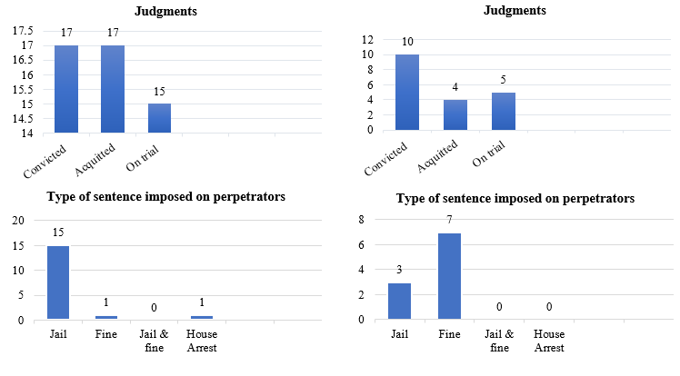
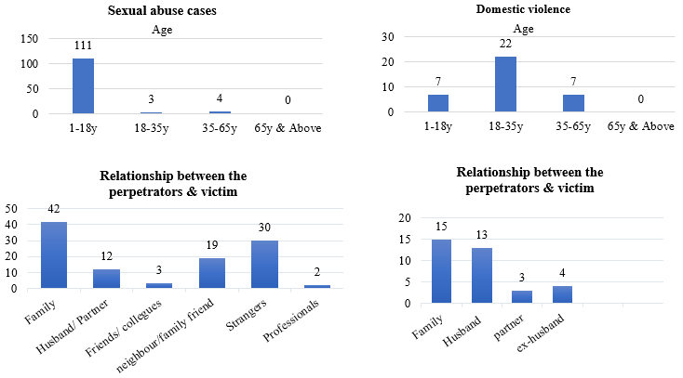

2016
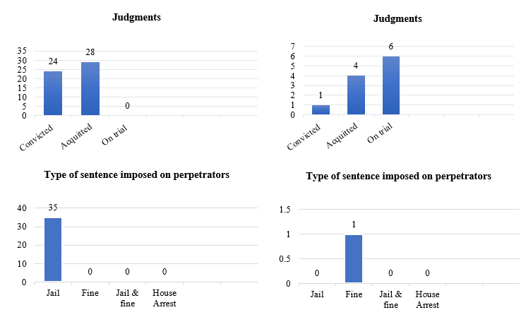
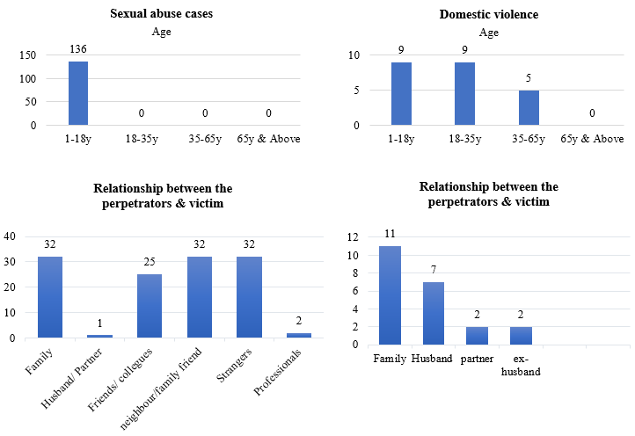

2017
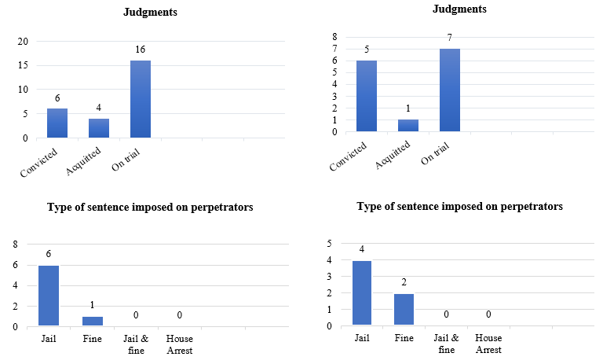
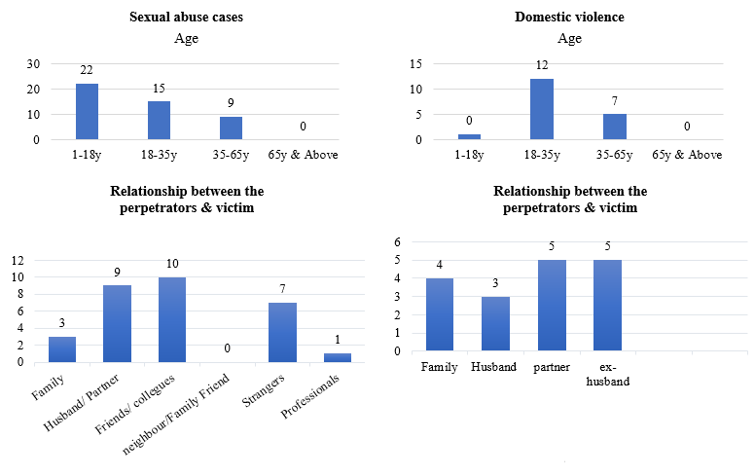

2018
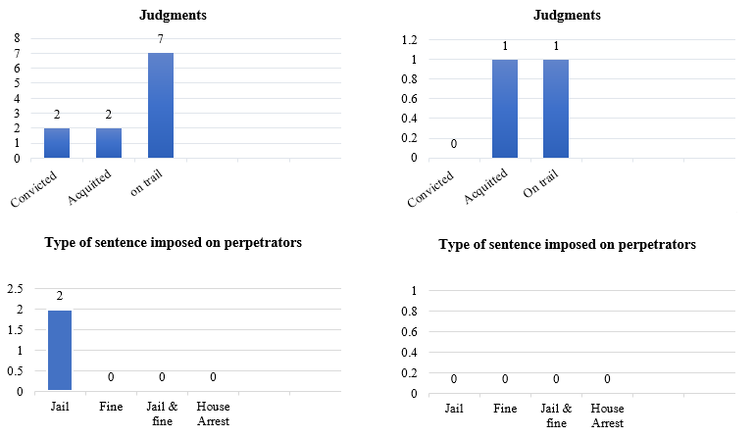
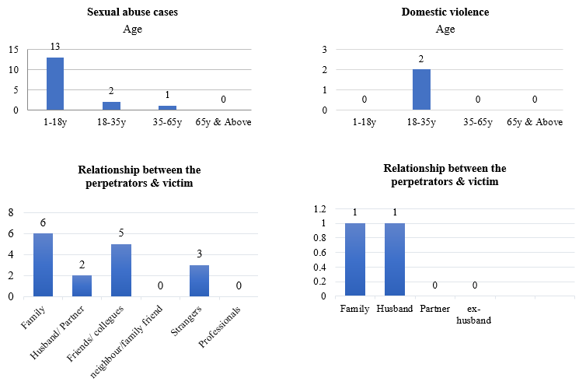

2019
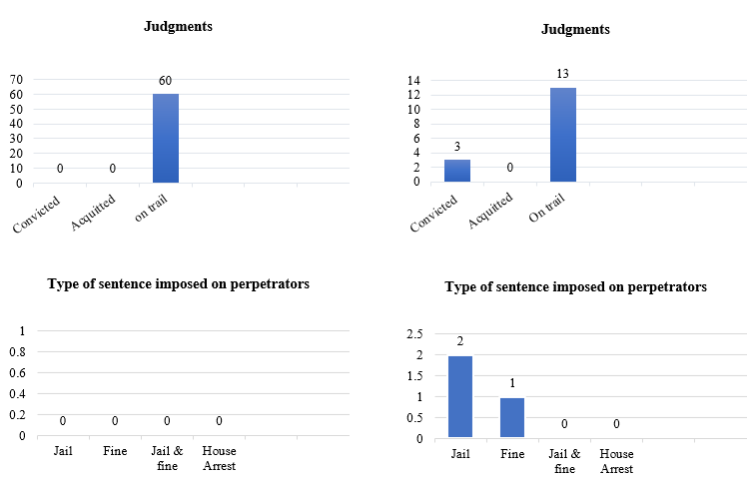
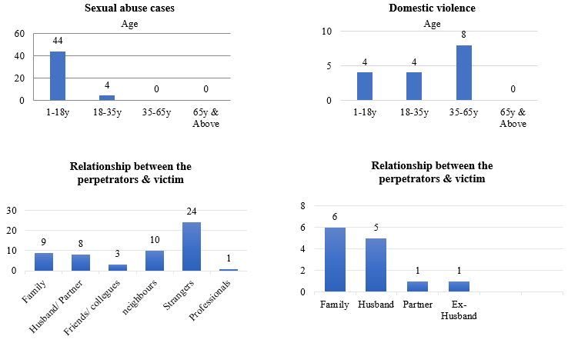

98. Section 130 of the Penal Code provides that a person commits an offence if he engages in sexual intercourse without consent, and provides a rebuttable presumption where the person engages in sexual intercourse with his spouse, that subject to rebuttal, that consent existed.
99. As per the First Amendment to the Penal Code, a special caveat was created for laws stipulating specific offences, to supersede the provisions of the Penal Code. Law number 17/2014 (Sexual Offences Act) is one such law that will be prioritized over the Penal Code in application, concerning cases of sexual offences.
100. Section 20 of the Sexual Offences Act provides that non-consensual sexual intercourse between spouses where the spouses are in the process of judicial separation, where the husband has the knowledge of and has contracted a sexually transmitted disease, where the spouses are living separately under a specific agreement to that effect, would constitute marital rape.
101. The Act also provides consent will be negated where it was obtained through threat to kill, infliction of torture, threat to inflict torture, threat to kill or torture a family member. It also provides that consent based on misrepresentation of facts and misrepresentation as to the nature of the act will be negated for the purposes of the offence.
102. As per Section 20 subsection (c), the penalty for marital rape is 1–3 years imprisonment that maybe aggravated to 3–5 years of imprisonment where the offence was committed with a dangerous weapon.

Trafficking and exploitation of prostitution

J. Reply to paragraph 10 of the list of issues

103. The new National Action Plan sets out a clear direction for the anti-human trafficking efforts of the Maldives, starting from 30 March 2020 to 31 December 2022. The main goal of the Maldives National Anti-Human Trafficking Action Plan 2020–2022 is to accelerate efforts to eliminate Trafficking in Persons (TIP) in the Maldives. In realizing this goal, the Plan aims to achieve 3 outcomes and complete 11 action items as relevant to the outcomes.
104. The outcomes are:
1. Enhanced Anti-TIP Legislations & Policies (LEG);
2. Enhanced Anti-TIP Sensitization & Awareness (SAW);
3. Enhanced Anti-TIP Monitoring, Enforcement & Training (MET).
105. Although MVR 2 million was earmarked for the implementation of the National Action Plan this year, the budgetary commitment towards it now remains uncertain, due to COVID-19 and the ensuing lockdown. However, the Government of Maldives is fully committed to implementing the Plan to the fullest, once the lockdown is lifted.
106. Few information/awareness sessions were carried by the PGO for Police and some other state institutions. Limited works have been done to strengthen Prosecution focused specifically on Human Trafficking. However, this is a key area where PGO has identified as significant area for capacity building for prosecutors. PGO has been given an opportunity to participate in a training (covers some aspects of human trafficking) scheduled for February 2020.
107. A new Action Plan was passed by the President’s Office where newly appointed Steering Committee is working to find ways and assign tasks in the Action Plan. MPS lacks experienced trainers in the field. The new steering committee has requested for a temporary budget to work and implement the Action Plan.
108. In the past year 2019, By AHTU/ MPS following work/trainings were conducted for capacity building:
• Conducted 3 training with Police academy in TTIP (Training on Trafficking In Person) and trained 75 police officers Conduct awareness sessions to 250 police officers on TIP and SOM;
• Conduct awareness 2 sessions in Ha.Ihavandhoo and Aa.Rasdhoo for the public and stake holders which more than 50 were been aware on TIP;
• Information related to TIP is been delivered by the officers of AHTU to the public through media channels TV/RADIO;
• Develop a case management system and website (www.helpvot.gov.mv) related to the TIP by MPS to help officers to have the initial screening of Victims Of Trafficking (VOTs). This also website helps public to submit complaints on the related issues direct to the MPS/AHTU.
109. At the moment, the Maldives has a temporary shelter for victims of trafficking. This temporary shelter is managed by the Ministry of Defence and Maldives Immigration. Psycho-social support is provided and interpreter services are available for the victims with the help of the Maldives Police Service and civil society organisations. The newly adopted National Anti-Human Trafficking Action Plan details plans to establish a permanent shelter for victims of trafficking with the assistance of the International Organisation for Migration (IOM).
110. In order to ensure effective provision of legal aid by the State, a Legal Aid Bill1 was formulated in consultation with all stakeholders, and has been included in the Legislative Agenda. The proposed mechanism will extend legal representation to victims of domestic violence and human trafficking.
111. The lack of technical expertise in investigation, prosecution and within the judiciary continues to impede successful prosecutions. Limited availability of translators, lack of legal representation in courts and delay in prosecution, results in infringement of victims’ rights. Budgetary constraints, the absence of a permanent shelter and victim support also pose obstacles to effective combatting of human trafficking.
112. The National Anti-Human Trafficking Action Plan envisages the establishment of a permanent shelter for victims of trafficking.
113. The following are details of Victims of Trafficking in the Maldives since 2016.

# | Number of Victims | Sex | Nationality | Age | Geographical area of crime | Form of exploitation
Case 01-2016 | 2 | Male | Bangladesh | 22 | Male’ | Recruitment and receipt of victims in to Maldives by receiving benefits and payments from the victims under the pretence of domestic employment and upon arrival victims’ travel documents were confiscated and subjected to forced labour
Case 01-2016 |  | Male | Bangladesh | 19
Case 02-2016 | 3 | Male | Bangladesh | 28 | Male’ | Recruitment and receipt of victims in to Maldives by receiving benefits and payments from the victims under the pretence of employment and confiscation of victims’ travel documents
Case 02-2016 |  | Male | Bangladesh | 24
Case 02-2016 |  | Male | Bangladesh | 30
Case 03-2016 | 1 | Male | Bangladesh | 23 | Male’ | Recruitment and receipt of victim in to Maldives by receiving benefits and payments from the victim under the pretence of domestic employment
Case 04-2016 | 1 | Male | Bangladesh | 27 | Male’ | Recruitment and receipt of victim in to Maldives, unlawful restraint of the victim and extortion when the victim requested to be returned to his home country
Case 01-2017 | 1 | Female | Kenyan | 29 | Male’ | Forced prostitution (for a period of 2 weeks)
Case 02-2017 | 1 | Male | Bangladesh | 40 | Male’ | Recruitment and receipt of victim in to Maldives by receiving benefits and payments from the victim under the pretence of domestic employment
Case 01-2019 | 1 | Female | Bangladesh | 24 | Male’ | Subjected forced prostitution by victim’s husband
Case 02-2019 | 1 | Male | Maldivian | 15 | Male | Removal of victim from the State residential care facility for children and concealing victim

114. Article 35 of the Constitution states that children and young people are entitled to special protection and special assistance from the family, the community and the State. The Article further states that children and young people cannot be harmed, sexually abused, or discriminated against in any manner and shall be free from unsuited economic and social exploitation. As per the Article, no person shall obtain undue benefit from their labour.
115. The Child Rights Protection Act enacted in November 2019 sets the legal age of marriage at 18 years, and prohibits child marriages. In application, the provisions of Child Rights Protection Act will supersede all the other provisions relating to child rights mentioned in Acts enacted previously. Therefore, with the operation of the current law, the perpetrators of child marriages would not be exonerated under Law no: 12/2009. (Special Provisions Act to deal with Child Sex Abuse Offenders)
116. Further, Law Number 2/2008 (Employment Act) states that no minor shall be employed in any work or employment or in conditions of work or employment, that may have a detrimental effect on his health, education, safety and or conduct. Act further states that minors under the age of 16 shall not be employed except in connection with training associated with their education or deportment. And where a minor (below 18 years of age) is engaged in work, it can only be done through written approval of the legal guardian, in accordance with other provisions in the Act governing the matter.
117. Although there are no specific bilateral or multilateral agreements on cooperating to combat trafficking in women and girls, the crime is adequately covered by the following:
• The Maldives’ Mutual Legal Assistance Treaty with India;
• Memorandum of Understanding between Maldives Police Service (MPS) and Australian Federal Police (AFP) on Combatting Transnational Crimes and Developing Police Cooperation;
• Memorandum of Understanding between Maldives Police Service (MPS) and Sri Lankan Police Force on Combatting Transnational Crimes and Developing Police Cooperation;
• Security Cooperation Agreement between the Government of the Republic of Maldives and the Government of the Republic of Turkey.

Participation in political and public life

K. Reply to paragraph 11 of the list of issues

118. Following amendments to the Decentralisation Act, 33% of all local council seats will be allocated for women.
119. Women Development Committees (WDC) are established within councils in all islands and cities to ensure realization of women rights and women development. The Local Government Authority (LGA) is mandated to provide orientation and required trainings to the development of these committees.
120. In order to empower WDC’s financially, as per the amendment to the Decentralization Act, local councils are mandated to allocate 5 percent of its grant amount to the functioning of WDC’s. Relevant stakeholders are also working on revising allowance structure of WDC members.
121. A Councils Performance Index was established by LGA to rank the performance councils every year incorporates promotion of women development, women involvement in council decision making under its participation sub index. This is to encourage and promote participation of women and WDCs in local council activities and decision-making process.
122. In order to bring gender balance and increase women participation in trainings, forums and workshops and other initiatives conducted by LGA, a special focus has been given to include female participants in these initiatives.
123. Women Empowerment Workshop was conducted in the island of ADh. Mahibadhoo on 4–5 December 2019 to increase women’s engagement in public life, capacity and empower them in their communities.
124. The Government’s Strategic Action Plan contains policies to introduce temporary special measures in internal primaries of political parties to ensure more women are able to run for office and serve in leadership positions.
125. The amendment, the Decentralization Act now provides local councils with more fiscal and legal autonomy and allocates a third of council seats for female councillors.
126. Temporary Special measures for 50% women on boards, to increase women’s leadership in political parties as well as to improve women’s representation in the environment sector are highlighted in the thematic areas for continued efforts and national level prioritization to achieve the objectives of the Beijing Platform for Action in the next 5 years.
127. In September 2019, for the first time ever, two female justices were appointed to the Supreme Court of Maldives. 35% of Cabinet Ministers, 40% of Ambassadors, and 23.5% of State Ministers in the current Government are all women. While women representation in the current Parliament is only 4.7%, Government is committed to establish quotas for women within political parties’ internal elections. A total of 38 out of 633 elected local councillors are currently women. With the confirmation of appointments of Heads of Diplomatic Missions, the Maldives will achieve gender parity amongst the Heads of Diplomatic Missions for the first time in history.
128. The Government of Maldives has emphasized that equal gender representation within the tourism industry is a key objective for the ministry. As such, the Ministry of Tourism conducted a conference with senior stakeholders from the industry in 2019 to discuss this issue. Based on the existing data it was found that the representation of women within the industry is currently at 4% in total. Some of the strategies discussed within the conference to address these issues include:
• Conduct a national awareness drive to ensure proportionate female representation;
• Trainings and curriculum to strengthen to ensure female participation;
• Enhanced career development and enabling environment for women;
• Implement a quota system based on the number of registered beds.
129. This was further highlighted in the initial phase of developing the Fifth Sustainable Tourism Master plan. A key component of the new master plan is ensuring equal gender representation within the tourism industry. This includes stakeholder consultation to identify measures which can be implemented to achieve targets. Proposed measures up for discussion include implementation of quotas to ensure that desired objectives are achieved.
130. Furthermore, training programs are being designed to provide for the development of skills required by the industry. The Ministry envisions that the development of skills will create more opportunities for equal participation for women in the industry. Additionally, the Ministry is also undertaking stakeholder consultations required for policy changes which will mandate the creation of harassment committees in the resorts to address concerns of harassment which have been highlighted as a major issue in our prior findings.
131. The lack of accurate data on employment which is a major challenge in framing and implementing policies especially with regard to employment. Therefore, as part of the Government’s digitalization, innovation and automation drive, the Ministry of Tourism is in the final stages of developing a mobile application which will enable tourism sector employees to be registered with the Ministry and provide a platform for collecting accurate data with respect to employment. The collection of data will enable the Ministry to identify key challenges and frame better policies to address issues especially with respect to key concerns such as increasing women’s representation in the industry.
132. In September 2019, for the first time ever, two female justices were appointed to the Supreme Court of Maldives.
133. 35% of Cabinet Ministers, 40% of Ambassadors, and 23.5% of State Ministers in the current Government are women.
134. While women representation in the current Parliament is only 4.7%, Government is committed to establish quotas for women within political parties’ internal elections. A total of 38 out of 633 elected local councillors are currently women.
135. 14 judges out of 186 are female, meaning that only 7.52% of judges are female. Out of the 14 judges, 2 Justices are appointed to the Supreme Court, 1 judge to Family Court, 4 judges to the Civil Court and remaining 7 judges have been appointed to Magistrate Courts (B. Eydhafushi (1), S. Feydhoo (1), Gn. Fuvamulak (2), ADh. Mahibadhoo (1), Hulhumale’ (1), Lh. Naifaru (1)

Women human rights defenders

L. Reply to paragraph 12 of the list of issues

136. Article 27 of the Constitution enshrines the right to freedom of expression and Article 30 (b) stipulates that everyone has the freedom to form associations and societies.
137. The aforementioned provisions apply equally to both men and women, in allowing protection of their fundamental freedoms.
138. The Government has submitted a revamped Associations Bill to the parliament, to further enhance the protection afforded to CSOs and NGOs in conducting their work.
139. Article 27 and Article 30 (b) of the Constitution ensures the right to freedom of expression and freedom of association to everyone.
140. The Associations Act currently in force, allows CSOs and other associations, equal space to conduct their activities. To further enhance the protection afforded to the work of CSOs and ensure independency, Government has submitted a revamped Associations Bill to the parliament in 2019.
141. The HRCM has regularly conducted information session on the relevant laws and regulations to different institutions. HRCM’s human rights monitoring efforts determines the extent to which women’s freedom of association and expression as well as gender equality and women’s rights are guaranteed. The institution highlights issues and provides recommendations to the State.
142. Despite the lack of a specific tool to provide an online safe space, the Maldives Police Service investigates any complaints of harassment and threats against Civil Society Organizations. The following are statistics from the Maldives Police Service of cases of harassment reported by associations and Civil Society Organizations. These cases have been investigated or are under investigation:

Case reported by: | Case reported on: | No of cases
Netball Association of Maldives | 18/05/2013 | 1
Th. Family and Children Service Center | 24/04/2015 | 1
Ministry of Tourism | 23/11/2015 | 1
Gn. Atoll Family and Children Service Center | 20/03/2016 | 1
Human Rights Commission of the Maldives | 21/02/2016 | 1
Ministry of Gender and Family | 27/02/2017 | 1
Maldives Quality Seafood Private Limited – K.Himmafushi | 17/05/2017 | 1
Villimale’ Police Station | 12/09/2017 | 1
Ministry of Education | 16/11/2017 | 1
Radiant Heat Maldives Private Limited | 23/11/2017 | 1
Noonu Family and Children Service Center | 11/03/2018 | 1
Th.Thimarafushi Police Station | 28/03/2018 | 1
A Dh. Family and Children Service Center | 04/06/2018 | 1
L.Kunahandhoo Council | 23/07/2018 | 1
A.Alif Thoddoo Council | 07/08/2018 | 1
B.Kudarikilu Council | 14/10/2018 | 1
Individual | 18/10/2018 | 1
G.Alif Dhaandhoo Health Center | 30/10/2018 | 1
Lh. Felivaru Fisheries Complex | 03/01/2019 | 1
Ministry of Gender, Family and Social Services | 01/04/2019 | 1
Dh. Family and Children Service Center | 09/04/2019 | 1
A Dh. Family and Children Service Center | 18/07/2019 | 1
G.Dh Fiyori School | 23/10/2019 | 1
Judicial Service Commission | 24/10/2019 | 1
Th. Kandhoodhoo Council | 28/11/2019 | 1
Lux South Ari Atoll | 30/11/2019 | 1
Judicial Service Commission | 12/12/2019 | 1
A Dh. Family and Children Service Center | 24/01/2020 | 1
Sh. Family and Children Service Center | 30/01/2020 | 1
B. Family and Children Service Center | 03/02/2020 | 1
Th. Family and Children Service Center | 06/02/2020 | 1
Noonu Family and Children Service Center | 06/02/2020 | 1
G.Dh Nadella Island Council | 08/02/2020 | 1
Human Rights Commission of the Maldives | 16/02/2020 | 1
Police Intelligence | 15/03/2020 | 1
Human Rights Commission of the Maldives | 16/03/2020 | 1
National Drug Agency | 24/03/2020 | 1
Ministry of Gender, Family and Social Services | 08/04/2020 | 1
Ministry of Education | 05/05/2020 | 1
Total |  | 39

Nationality

M. Reply to paragraph 13 of the list of issues

143. The vital registration system of the Maldives is well established and monitors all birth and deaths in the country as mandated by the regulations.
144. All births are registered in the country regardless of whether a child is born out of wedlock or not. The guardian of the child submits the Birth Registration form and Request for Birth Certificate from the respective City and Island Councils mandated with issuing of birth Registration and birth certificates. The Department of National Registration also plays an important role, in issuing the National Identity cards to children and all the citizens. The National Identity Cards are issued only when the vital information on each citizen including children are entered to the National Registration database maintained at DNR. If a child is born out of wedlock, father's information will be missing and indicated as such in the database, however to prevent discrimination against any child or citizen this information is not printed in the National Identity Card issued to Maldivian citizens. Regardless of the parent’s marital status, equal rights are ensured when registering children and other citizens.
145. The Constitution of the Republic of Maldives clearly provides that children born to the citizens of Maldives would be considered as a Maldivian citizen. As such, regardless of the place of birth, children born to Maldivian parents will become Maldivian citizens as per Article 9 (a) subsection (2) of the Constitution.
146. As for the situation of stateless persons in the country, there are procedures in place to address the issue, regardless of gender. If the parents of a child cannot be identified, the State will assume legal guardianship of the child and a court process will be completed to provide citizenship.

Education

N. Reply to paragraph 14 of the list of issues

147. All children in all islands, small or large, have access to education. For the very few islands where there are no schools on the islands, organized transport is provided to all students where these students commute to schools in a nearby island via a ferry service every day, there are no disparities between men or women.
148. Nevertheless, the survival rate to the end of primary and the NER for lower secondary is lower for girls than boys. A study to look into the reasons for this difference has been planned, in collaboration with UNICEF and the Global Partnership for Education.
149. Further stringent measures of attendance have been put into place since 2018, in the form of an attendance policy, where unexcused attendance is tracked and intervened at school level, and a referrals mechanism is established where with the school–level intervention, the child is still not attending school, then Ministry of Education, in collaboration with other partner agencies organises targeted interventions.
150. The Education Sector Plan 2019–2023 is intended to increase skills for young people and adults through equitable expansion of the TVET programmes. It aims to expand TVET programs so that every student has the opportunity to enrol in a skills development program for both girls and boys.
151. The World Bank’s project Enhancing Employability through Human Capital and Entrepreneurship Development (approved in June 2019) will focus on strengthening TVET skills development programs and youth’s perception of employment.
152. After the review of the textbooks, revision of the current syllabus and other learning material has been earmarked for implementation in early 2021. The review and revision of the textbooks and learning materials is currently underway.
153. Higher Education Institutions have developed rapidly over the past years. Since the development of Higher Education Institutions by the government and private sector, continuing education opportunities are available for Maldivians of any age without any gender disparity through Higher Education Institutions and Tertiary Education Institutions offering various specialization programmes. These programmes are conducted in various fields tailoring to the needs of the community.
154. Scholarship opportunities and loan opportunities are open equally to both men and women.
155. The following tables show the statistics of loan and scholarship opportunities offered by Ministry of Higher Education within the past years.

Statistics of Higher Education Loan opportunities provided (Gender)

Year | Male | Female | Total
2017 | 285 | 282 | 567
2018 | 471 | 450 | 921
2019 | 113 | 137 | 250

Statistics of Scholarship opportunities offered

# | Year | Male | Female | Total
1 | 2017 | 45 | 78 | 123
2 | 2018 | 81 | 138 | 219
3 | 2019 | 73 | 89 | 162

Bachelor’s Degree Grant Scheme | Male | Female | Total
Selected students in 2019 | 1 462 | 3 313 | 4 775
Selected students in 2020 | 467 | 788 | 1 255
Total | 1 929 | 4 101 | 6 030

156. Bachelor’s Degree grant scheme is a new initiative by the present government to offer continuing free education of Bachelor’s degree programmes to all Maldivians (without gender disparity) who complete high school and would want to pursue their first degree in the Maldives from available fields of study.
157. The enactment of the Attendance Policy means that any student who has not been to school without a valid excuse will be tracked and every effort will be made to bring them back to school.
158. If a student is away from school because of a pregnancy, the student will still have access to education and in 2018, two students sat the end of year ten national exams while they were pregnant. However, the stigma around this issue still persists.
159. However, the lack of child care available for young teenage mothers who come from vulnerable families has proven to be a challenge in completing their education. In response to this, the Ministry of Education has been providing alternative forms of education, such as providing opportunities for young mothers to enrol in skills education programs or on the job training with flexible working hours. However, this too provides its own unique challenges and retention rates remain low.
160. The Ministry of Education, in collaboration with Society for Health Education (SHE), has been conducting workshops and seminars for higher secondary students on Sexual Reproductive Health rights. However, the topic itself is taboo which proves to be challenging.
161. A renewed Health Master Plan (2016–2025) was finalized in 2017, which emphasizes improving knowledge and access to SRH services. The National Family Planning Guideline is non-discriminatory, and facilitates easy access to services. SRH programs are devised to ensure that services are accessible to all individuals. A gap analysis was undertaken to identify the themes that are currently side-lined from mainstream SRH discussions.

Employment

O. Reply to paragraph 15 of the list of issues

162. Civil Service Commission/Civil Service Training Institute currently have one training program exclusively focused on women empowerment and gender equality which has components like economic empowerment of women, women in leadership roles and role of women in civil Service along with women’s rights in Maldives. This program was developed in collaboration with Ministry of Gender, Family and Social Services. The program is facilitated by trainers from Gender Ministry, HRCM and relevant NGOs.
163. In addition, equal and fair opportunities are given to women to participate in all the trainings and as well as opportunities for women to be actively engaged in all the areas of Civil Service is facilitated.
164. Ministry of Tourism is in the process of establishing a mechanism of collecting data and statistics regarding employment in the tourism sector. At the moment, there is a lack of accurate data to drive policy and programs to increase female participation in the tourism industry. Additionally, the ministry is in the process of formulating the 5th Sustainable Tourism Masterplan which will address issues related to increasing women representation in the industry.
165. The Salary and Wage Advisory Board was established in 2019 with the mandate to advise the Minister of Economic Development on the recommended amount and the establishment of the minimum wage in Maldives. The Board submitted its recommendation report to the Minister of Economic Development on 19 December 2019. The Ministry in turn has sent the report to the Economic Affairs Committee of the Parliament for their feedback, along with a review report by the Ministry.
166. The Government, to protect and preserve family unity, introduced six months maternity leave and one-month paternity leave for new parents, implemented in all Government agencies and 77.4% of all SOEs. The Government has also allocated a Public Sector Investment Programme project to establish a child care facility in Male’, in the 2020 state budget.
167. The MoGFSS has been collaborating with National Bureau of Statistics in addressing women in the informal sector. Maldives Pension Administration Office is also working to include those women in the informal sector into the National Pension Scheme.
168. Efforts are underway to review the Employment Act, Foreign Employment Regulation, Employment Approval Policy and corresponding procedures to streamline the rights and responsibilities relating to migrant workers. Furthermore, work is underway to develop a Standard for migrant workers’ accommodation. In mid-2019, the Labour Relations Authority (LRA) established an online portal to facilitate local councils in maintaining a registry of expatriates.
169. A total of 200+ inspections were carried out across the country in different sectors within the reporting period. This covered over 16,500 employees, of which more than 2,500 were women. However, no specific inspections were carried out which were targeted to domestic workers. This is due to challenges faced by the Labour Relations Authority (LRA) in terms of lack of employees and insufficient budget for inspections, which forces to focus on sectors where more employees are employed, in order to ensure our reach to the greatest number of workers. Nevertheless, the LRA conducts social media awareness so that all workers are able to access the information and are informed on the channels in which they can reach LRA to submit a complaint or clarify information.
170. The Human Rights Commission of the Maldives will receive such cases if a victim lodges a complaint. Furthermore, if HRCM identifies such cases, the Commission will initiate investigation in to these cases. The HRCM provides free legal aid in accordance with the Legal Aid Regulation of the Commission and this applies to cases relating to abuse and labour exploitation of women migrant workers.
171. In addition to routine inspections by Labour Relations Authority, any employee can lodge complaints at Labour Relations Authority, including women migrant workers and domestic workers. Mechanisms such as complaint submission via the Authority’s website, via email and via complaint forms have been set up to easily enable any employee to lodge complaints. No information of any employee who submits a complaint will be shared to the employer or any other party, without prior consent of the employee. Any actions against the Employment Act will be thoroughly investigated, and proper administrative action will be taken in accordance with the Employment Act. This includes imposing fines of MVR 500 to MVR 50,000 and blacklisting employers on Ministry of Economic Development’s Expatriate Management System. If any further additional issues are observed, they will also be referred to the relevant authorities
172. The Maldives has been party to all eight fundamental conventions of the International Labour Organizations since January 2013. The Government of Maldives is considering its position on the Domestic Workers Convention and the Violence and Harassment Convention.

Health

P. Reply to paragraph 16 of the list of issues

173. Emergency obstetric care services at the island level: The health care structure in the Maldives conforms that all basic health care including maternal and child health services are provided in every island – a medical officer, nurses and primary health care workers at health care facilities in the islands. In terms of obstetric care, basic obstetric services are available in the island facilities. Pregnant women have easy access to the services from their inhabited locations. Referral to higher service centres are always organized especially for safe delivery as well as with the indications of high-risk pregnancies.
174. Emergency obstetric care services are established from the secondary level and higher health facilities. Every atoll has either an atoll hospital or regional hospital (13 atoll hospitals and 6 regional hospitals) along with the referral mechanism to tertiary level hospitals at the central level.
175. Status of new Reproductive Strategy: The new National Reproductive, Maternal, Newborn, Child and Adolescent Health (RMNCAH) Strategy and Action Plan 2020–2025 has been developed and is now in the process to be finalized and start implementation during March 2020. This strategy includes reproductive needs of adolescent and women and their wellbeing, focusing to expand availability quality SRH information and services that are responsive to the needs of adolescents, youth and women. The new strategy also gives emphasis to increase awareness of and empowerment of adolescents and youth, migrant population, community leaders, parents, teachers, health service providers and religious leaders on the importance of SRH issues and addressing the negative consequences of teen pregnancy and STIs, including HIV.
176. Measures taken to prevent early pregnancies: The National Family Planning program is designed in such a way that a range of contraceptives are available in all islands of the nation. The Reproductive Health Program of the Health Protection Agency procures and distributes contraceptives to all atolls. In accordance to the national logistic guideline for management of contraceptives, the Atoll health facilities manage logistics of contraceptives at atoll level. A continuous coordination mechanism exists to ensure proper management of contraceptive logistic at all levels of the country.
177. The National family planning guideline states that ‘All clients have the right to receive services from Family Planning Program regardless of their social status, economic status, economic situation, ethnic origin, geographical location or any other characteristics which may place individuals in certain groups. This means all are given the right to access to family planning services through various health care providers as well as other service delivery systems. Family Planning programs should take necessary steps to ensure that services will reach to all eligible individuals who need them, even those for whom the normal health services are not easily accessible.
178. The National family planning guideline states that Informed consent is sought to ensure that the client takes voluntary decision to undergo or not to undergo a surgical sterilization procedure, in full possession and understanding of the relevant facts. In Maldives, the informed consent should be signed by the client and is the legal authorisation for performing the procedure. Therefore, service providers should ensure that client have signed the informed consent form with full understanding. In special cases where the client is mentally disabled the guardian can give consent.
179. Often, programs are conducted to provide information on Reproductive and maternal health including family planning to unmarried youths and young adults. Recently standards have been developed to provide adolescent friendly health services and preparatory work is ongoing to establish Adolescent Friendly Health Services.
180. Ongoing training programs and refresher programs were conducted for health personnel to prevent gender-based violence and to strengthen reporting of these cases. Circulars are sent to all relevant for regular, and consistent reporting process
181. Abortion services: In IFA/2013/03 dated on 11th December 2013. the Government’s council of religious scholars, known as the Islamic Fiqh Academy, released a fatwa (Islamic Ruling) which expanded the conditions under which abortion is permitted:
• Under the circumstance where a mahram (kin with whom marriage is unlawful) man commits forceful adultery with his kin – the termination of the consequent fetus within 120 days of gestation;
• Under the circumstance where a non-mahram (a person with whom marriage is lawful) man commits forceful adultery with a woman – the termination of the consequent fetus within 120 days of gestation;
• Under the circumstance where a man commits forceful adultery with a physically weak or under aged girl – the termination of the consequent fetus within 120 days of gestation;
• Under the circumstance where in a lawful marriage, the conceived fetus is believed to be a thalassemic major, sickle cell major or the fetus is believed to be physically or mentally deformed at the time of its birth and that it will not be cured by any means – the termination of the fetus within 120 days of gestation;
• Under the circumstance where the life of a pregnant woman is in danger – the termination of the fetus or administration of an induced abortion even after 120 days of gestation.
182. No study has yet been conducted to identify prevalence of unsafe and clandestine abortion in the Maldives hence an accurate figure cannot be provided. But there are mechanisms in place to detect the occurrence of unsafe abortion and provide safe abortion services at the health facility when needed.
183. The new National Reproductive, Maternal, Newborn, Child and Adolescent Health (RMNCAH) Strategy and Action Plan 2020–2025 has been developed and is now in the process to be finalized and implementation was planned for March 2020.
184. This strategy includes reproductive needs of adolescent and women and their wellbeing, focusing to expand availability of quality SRH information and services that are responsive to the needs of adolescents, youth and women. The new strategy also places emphasis to increase awareness of and empowerment of adolescents and youth, migrant population, community leaders, parents, teachers, health service providers and religious leaders on the importance of SRH issues and addressing the negative consequences of teen pregnancy and STIs, including HIV
185. However, due to the COVID-19 pandemic, the finalisation and implementation is pending.
186. The National Family Planning program is designed in such a way that a range of contraceptives are available in all islands. The Reproductive Health Program of the Health Protection Agency procures and distributes contraceptives to all atolls. In accordance to the national logistic guideline for management of contraceptives, the Atoll health facilities manage logistics of contraceptives at atoll level. A continuous coordination mechanism exists to ensure proper management of contraceptive logistic at all levels of the country.
187. The National family planning guideline states that ‘All clients have the right to receive services from Family Planning Program regardless of their social status, economic status, economic situation, ethnic origin, geographical location or any other characteristics which may place individuals in certain groups. This means all are given the right to access to family planning services through various health care providers as well as other service delivery systems. Family Planning programs should take necessary steps to ensure that services will reach to all eligible individuals who need them, even those for whom the normal health services are not easily accessible.
188. The National family planning guideline states that informed consent is sought to ensure that the client takes a voluntary decision to undergo or not to undergo a surgical sterilization procedure, in full possession and understanding of the relevant facts. In the Maldives, the informed consent should be signed by the client and this is the legal authorization for performing the procedure. Therefore, service providers should ensure that client have signed the informed consent form with their full understanding. In special cases where the client mentally unfit to make an informed decision, the guardian can give consent. Often, programmes are conducted to provide information on reproductive and maternal health including family planning to unmarried youths and young adults.
189. Programmes are conducted to provide information on reproductive and maternal health including family planning to unmarried youths and young adults. Standards have been developed to provide adolescent friendly health services and Adolescent Friendly Health Services have been established in 2 regions (B. Eydhafushi and HDh. Kulhuduffushi) and also in Dhamanveshi in Male’ City.
190. Ongoing training programs and refresher programs were conducted for health personnel to prevent gender-based violence and to strengthen reporting of these cases. Circulars are sent to all relevant health facilities for regular, and consistent reporting process.
191. At central level, Family Protection Units (FPU) are established in 2 tertiary hospitals to provide indiscriminatory, prompt services to victims of GBV.
192. There have not been any studies carried out to identify prevalence of unsafe and clandestine abortion in the Maldives. Hence, an accurate figure cannot be provided.
193. In Maldives the abortion services are provided by tertiary hospital according to the Fatwa no: IFA/2013/03 dated on 11 December 2013. The Government’s council of religious scholars, known as the Islamic Fiqh Academy, released a Fatwa (Islamic Ruling) which expanded the conditions under which abortion is permitted:
• Under the circumstance where a mahram (kin with whom marriage is unlawful) man commits forceful adultery with his kin – the termination of the consequent foetus within 120 days of gestation;
• Under the circumstance where a non-mahram (a person with whom marriage is lawful) man commits forceful adultery with a woman – the termination of the consequent foetus within 120 days of gestation;
• Under the circumstance where a man commits forceful adultery with a physically weak or under aged girl – the termination of the consequent foetus within 120 days of gestation;
• Under the circumstance where in a lawful marriage, the conceived foetus is believed to be a thalassaemic major, sickle cell major or the foetus is believed to be physically or mentally deformed at the time of its birth and that it will not be cured by any means – the termination of the foetus within 120 days of gestation;
• Under the circumstance where the life of a pregnant woman is in danger – the termination of the foetus or administration of an induced abortion even after 120 days of gestation.

Economic empowerment of women and social benefits

Q. Reply to paragraph 17 of the list of issues

194. The 33% quota allocated for women in the next local council elections will help integrate gender perspectives into public policies to eradicate poverty.
195. The Island Development Plans already have components that encourage gender mainstreaming and facilitate the participation of women in the communities. Under the amendment, WDCs are given an advisory role as well pertaining to gender-related issues in the community. WDCs will have an increased role in contributing to the plan and its overall development.
196. The Business Centre Corporation (BCC) is the national SME development organisation of the country. The BCC has been working on devising plans to increase women participation in entrepreneurship and improve their access to finance. Some of this include endorsing and accrediting POS systems and working closely with Maldives Monetary Authority (MMA) and the Ministry of Economic Development (MED) to formulate and implement necessary legal and operational framework.
197. Furthermore, SME Development Finance Corporation (SDFC) allocates forty percent of their loan portfolio to women, youth and persons with disabilities. In this regard, out of loans amounting to MVR93.0 million which has been approved for female entrepreneurs/ female shareholding businesses, 36 applicants carry out their business operations in islands across the country.
198. Approximately 34% of the loan recipients from SDFC in 2019 comprised of women and youth. Work is underway to develop more loan schemes and non-banking financial mechanisms to assist female entrepreneurs.
199. According to the Household Income and Expenditure Survey conducted in 2016, 81% of home-based workers are women, and more than 40% of women work in the informal sector. It also indicated that more women prefer home-based work and manual jobs, and 75% of women declined jobs either because they did not want to work or due to low pay. The female labour participation rate (LFPR) in the Maldives is 44% at present, according to the International Labour Organisation (ILO). This is a huge gain compared to the LFPR in 1990, which was 20%. However, now the International Monetary Fund (IMF) estimates a significant contraction in the global output in 2020, and while ILO projects COVID-19 would affect 81% of the global workforce, the possibility of a roll back in the fragile gains made in LFPR by Maldives is immense.
200. Most of the occupations such as sewing, vegetable and fruit processing, rope weaving and making spice products fall under small-scaled employment or home-based employment in Maldives. The income they receive from these activities are subject to the market dynamics such as demand from the local resort islands and other inhabited islands across the country. Factors such as limited opportunity to grow in the market, time-consuming household responsibilities, land, assets, equipment and machinery not being registered under their name are some of the reasons why they are hindered from earning a reasonable income. Even if such assets are registered to their name, formal banking sector and financial institutions not accepting such assets is a huge obstacle woman face in business.
201. The Ministry of Economic Development will be undertaking a technical feasibility on the exportability and marketability of the handicraft and unique traditional Maldivian products in the international market. The feasibility report and its recommendations would advise the Government on possible export opportunities and would open doors to many MSMEs, especially female home-based workers and freelancers who are seeking an avenue to showcase and sell their products. Based on the feasibility study, the Government would formulate methods to hand-hold such enterprises through the export procedure and in finding a suitable market for them.
202. We are currently working on setting up a packaging facility in the city of Addu City. The importance of proper product packaging has always been undervalued and often overlooked by most MSMEs, and even large corporations in the Maldives. Quality product packing can go a long way in securing good first impressions in the wider market. While most occupations such as sewing, vegetable and fruit processing, rope weaving and making spice products are undertaken by female home-based workers, a packaging facility would be a value addition to their product, while increasing the possibility of such products reaching bigger markets such as the U.S, EU and China. The lack of a packaging facility in the country has been a major obstacle for small enterprises in marketing their products in the international market.
203. A Business TV Channel, which is intended to reach all islands in the Maldives, has been proposed as a means to improve financial literacy.
204. The Ministry of Economic Development is currently working on establishing a mechanism to allow online business consultations for MSMEs with industry experts to provide them with the most practical knowledge, information and advice they require before undertaking risks, decisions and investments.
205. Marketing campaigns such as “buy local”, “wear Maldivian” and “eat Maldivian” will be conducted by the Ministry of Economic Development to promote domestic products with an emphasis on certain categories such as handicraft, local delicacies and clothing. While such campaigns itself might not affect the purchasing behaviour of consumers, complementary additions such as product packaging (Packaging Facility) and quality control (Product Certification Facilitation Unit) might affect the general perception that locally-made or locally-grown products could be of higher quality than foreign-made products, and thus increase the willingness to buy and pay for local products. These campaigns should be structured and well-organised, and must be run in collaboration with Government marketing agencies to ensure MSMEs in all islands are provided maximum exposure both locally and internationally.
206. Single Parent Allowance: Allowance provided under Social Protection Act (2/2014) and regulation 2016/R-39 to children of single parents living in poverty. A monthly allowance of MVR 1000 is provided per child up to a maximum of 10 children per single parent, based on a voluntary application by single parent.
207. Foster Parent Allowance: Allowance provided under Social Protection Act (2/2014) and regulation 2016/R-38 to children being taken care of by foster parents living in poverty. A monthly allowance of MVR 1000 is provided per child and an additional MVR 500 is provided for each foster parent, based on a voluntary application by foster parent.
208. Food Subsidy: Allowance provided under Social Protection Act (2/2014) and regulation 2016/R-23 to households in poverty towards purchasing of staple foods. A monthly allowance of MVR 40 is provided per person per household up to a maximum of 6 persons per household, based on a voluntary application
209. Disability Allowance: A monthly allowance of MVR 2000 provided under Disability Act (8/2010), to all persons with disabilities who voluntarily apply for the allowance.
210. In addition, financial assistance is provided for therapeutic services and to obtain assistive devices for PWDs.

Rural women

R. Reply to paragraph 18 of the list of issues

211. Land for economic activities such as agriculture, residential, commercial or industrial uses are allocated on lease basis through the respective Island Councils and such land lease are available to all, irrespective of gender.
212. Development and infrastructure projects are undertaken as per land use Plans prepared by the Island Councils and approved from the Ministry of National Planning and Infrastructure. Tourist resort developments are undertaken through land lease on uninhabited islands by the government through the Ministry of Tourism.
213. There are no evictions from any land since infrastructure or other development projects are carried out generally on unused or vacant land.
214. Residential land plots or social Housing Units are allocated by the Government through the respective Island Councils under allocation guidelines and criteria developed and approved by the Ministry of Housing & Urban Development. To ensure a fair and transparent process, a complaint and addresses period is set for each such programme in the islands prior to handover of housing units to Beneficiaries.
215. There is no specific legislation to promote gender equality by foreign companies. The Capital Market Development Authority’s Corporate Governance Code which is mandatory for public companies imposes a mandatory requirement for Public Companies to formulate a Board Diversity Policy to ensure women candidates are given the Opportunity to server on the Board of Directors. Public companies similarly maintain gender diversity policies. Some private companies including foreign companies voluntarily follow these guidelines as well.
216. Article 23 of the Constitution of Republic of Maldives addresses the obligation on the Government of Maldives for the provision of safe water supply and adequate sanitation facilities to all. It is the Government’s pledge that these services will be provided to all inhabited islands on an equal basis irrespective of the size of population, culture, nationality or gender.
217. The National Water and Sewerage Policy NWSP specifically does not particularly include a gender focused policy or strategy. However, this gap does not provide any differentiation in the provision of water and sewerage services or restrictions in the engagement of gender at various level of the operation from management to technical level.
218. To attain the Sustainable Development (SDG) Goal 5: gender equality into effect, the Water and Sanitation Department under the Ministry of Environment mandated for policy, planning and regulating the water and sewerage service sector, intends to develop a gender focused policy into effect at the earliest possible. The objective would be to establish a clear vision and make commitments to guide the process of gender mainstreaming and women empowerment to influence policies, procedures and practices, which will accelerate the achievement of gender equality, gender justice, non-discrimination and fundamental human rights in Maldives.
219. In addition, gender-specific perspectives have been brought into effect via incorporation of gender action plans into water and sewerage project carried out. As a trial, the Green Climate Fund (GCF) project “Supporting Vulnerable Communities in Maldives to Manage Climate Change-Induced Water Shortages” has developed a gender action plan with specific target timelines tied with project implementation.

Women with disabilities

S. Reply to paragraph 19 of the list of issues

220. The following legislation and policies promote the inclusion of women and girls with disabilities:
• Disability Act (8/2010);
• Regulation on determining Persons with Disabilities and compiling of Disability Registry (2011/R-2);
• Regulation on protection of rights of Persons with disabilities and provision of financial assistance (2011/R-3);
• National social health insurance Act (15/2011);
• Social Protection Act (2/2014);
• Social Protection – General Regulation (2016/R-22);
• Single Parent Allowance regulation (2016/R-39).
221. Currently, there is a total 78 women (31 Women with disabilities 31, 13 above 65 years and 34 with mental disabilities) are given shelter at the Home for People with Special Needs (HPSN) on the island of K. Guraidhoo. As the HPSN is a state-run institution, there are various programmes targeted for all who are looked after which ensures their physical and mental wellbeing.

Migrant, refugee and asylum-seeking women

T. Reply to paragraph 20 of the list of issues

222. Maldives is not yet party to either of these conventions. However, steps are being taken nationally to address the rights of the migrants through enhanced implementation of national laws and regulations. While the issues concerning migrant workers continue to be a challenge to the Maldives, the Government is committed to introduce and implement mechanisms to ensure the protection of their basic rights.
223. In that regard, to address the issue of undocumented workers, Ministry of Economic Development as the main stakeholder agency pertaining to expat labour, on 17 September 2019 established a National Taskforce on Issues Related to Migrant Workers to revisit and formulate coherent policies on all issues relating to migrant workers.
224. A Regularization program was initiated in September 2019 as well, and by December 2019, 14056 migrant workers had requested registration through the programme. The Regularization Program enables undocumented workers to return to the legalized process and reintegrate with new employers. Through the program, registered workers will be issued a temporary card until the verification process is completed to ensure unhindered and continued access to services such as healthcare.
225. At the moment the Maldives is not party to the Convention relating to the status of Refugees and there is no legislative framework pertaining to asylum seekers or migrant women. That said, Law number 13/2013 (Anti Torture Act) and Law Number 1/2015 (Extradition Act) upholds the principle of non-refoulement by preventing repatriation of individuals in situations where they may be subjected to the conditions prohibited in the specific laws including torture, capital punishment and suppression for political motives. However, these laws are restricted to the purpose of extradition and prevention of torture, and would not extend to individuals seeking refuge in the Maldives for reasons beyond that.
226. As noted above, even though there is no specific legal framework in the Maldives pertaining to asylum seekers Maldivian authorities collaborate with international organizations and third-party countries through bilateral channels to facilitate successful resettlements. In that regard Maldives have till date conducted 2 successful resettlement processes with the assistance of UN High Commissioner for Refugees, and the International Organization for Migration. The Maldives also seeks international cooperation from the International Labour Organisation and the International Organisation for Migration to protect the rights of women migrant workers.
227. In 2018, MOGFSS conducted a session for the Filipino community in the Maldives on domestic violence and gender-based violence, specifically labour-related concerns including sexual harassment.
228. At present, HRCM is investigating 2 cases involving Maldivian women in refugee camps.
229. As per the information HRCM has received from Maldives Police Service, the two women are well, however they need proper rehabilitation before they can be reintegrated in to the community. As such, they will be brought back to Maldives once a proper rehabilitation mechanism is in place. HRCM has monitored the rehabilitation facility established by the government and issued recommendations, several of which concerned protecting the interests of women, that need to be fulfilled prior to opening the facility.

Climate change

U. Reply to paragraph 21 of the list of issues

230. In situations of disasters and climate change, as women, who often face barriers to accessing justice, may encounter significant difficulties in claiming compensation and other forms of reparation to mitigate their losses and to adapt to climate change. The recognition of legal capacity identical to that of men and equal between different groups of women, including women with disabilities and indigenous women, as well as equal access to justice are essential elements of disaster and climate change policies and strategies'
231. All climate change policies/plans are a result of intensive stakeholder consultations. Maldives ensures that a broad spectrum of stakeholders are engaged in these processes. Hence, women are engaged in all stages of the decision-making process and this is reflected in Strategy 7 under 6.2.5 of the Maldives Climate Change Policy Framework.
232. The Maldives Climate Change Policy Framework is the principle policy document that addresses and mainstreams climate change issues in the country. One of the guiding principles for the Maldives Climate Change Policy Framework (2015) is ‘Ensuring Intergenerational Equitability.’ Hence, at all stages of the formulation of this policy framework, priority was given to ensure equitable development between population groups through recognition of the unique nature of each of the atolls, diversity of needs and access to opportunities, services and goods. Particular attention was also paid to towards respecting human rights, the rule of law, gender equality and sensitivity.
233. This is reflected in the Policy no 6.2.5. in this Framework; Fostering Sustainability “Foster sustainable development while ensuring security, and economic, social and environmental sustainability and sovereignty, from the negative consequences of changing climate”. One of the key strategies under this policy is (5) Consider the National Climate Change Policy in legislative review processes and develop cooperative and coordinated agreements between sectors to ensure respect for human rights, the rule of law, gender equality and sensitivity.
234. In addition to this, Gender issues are also addressed in the Maldives Nationally Determined Contributions (NDCs) prepared as part of the country’s commitment to the Paris Agreement in 2015.

Marriage and family relations

V. Reply to paragraph 22 of the list of issues

The number of marriage applications from minors from 2016–date

Year | 2020 |  |  | 2019 |  |  | 2018 |  |  | 2017 |  |  | 2016
Gender | F | M | F |  | M | F |  | M | F |  | M | F |  | M
Magistrate courts | Data not available
Family courts | 1 | 0 | 8 |  | 0 | 15 |  | 0 | 16 |  | 1 | 8 |  | 0
Total | 1 |  | 8 |  |  | 15 |  |  | 17 |  |  | 8

235. The Supreme Court has stated that it has only received two applications from the Family Court pursuant to the Second Amendment to the Family Regulation on 20 September 2016, asking for the permission of the court to solemnize the marriage of minors. Both the applications were submitted on 26 March 2017. The Justice’s Council denied permission for both applications based on the child’s social condition stated in the Assessment Report prepared by the MoGFSS.
236. Prior to the new Child Right Protection Act of 2019, the Ministry helped in conducting social inquiry assessment of the child and his/her family whereby after completion Ministry would suggest its opinion through an assessment based on the child’s development milestone.

The number of such applications granted since 2016 (para. 146) – 2019

Year | 2019 |  |  | 2018 |  |  | 2017 |  |  | 2016
Gender | F | M | F |  | M | F |  | M | F |  | M
Magistrate courts | 0 | 0 | 0 |  | 0 | 0 |  | 0 | 1 |  | 0
Family Court | 0 | 0 | 0 |  | 0 | 0 |  | 0 | 6 |  | 0
Total | 0 |  | 0 |  |  | 0 |  |  | 7

237. Pursuant to the enactment of the Child Rights Protection Act which entered into force on 20 February 2020, the solemnization of marriages of any person under the age of 18 years is prohibited as per section 25 of the Act.
238. There are no legal measures in place to prohibit polygamy. However, the Court ascertains the fulfilment certain conditions in respect of the man’s financial situation before allowing polygamous marriages.
239. The Second Amendment to the Family Act enables judicial recognition of prenuptial agreements, facilitating equitable distribution of property acquired within a marriage, upon its dissolution.

Sustainable Development Goals

W. Reply to paragraph 23 of the list of issues

240. Gender equality lies at the heart of the 2030 Agenda for Sustainable Development, which recognizes that achieving gender equality is a matter of human rights and is crucial to progress across all the goals and targets.
241. While being a goal in its own right, gender equality cuts across all 17 Sustainable Development Goals and is reflected in 45 targets and 54 indicators for the SDGs. Furthermore, gender equality can be a catalytic policy intervention that triggers positive multiplier effects across the spectrum of development. These include promoting social and economic growth and labour productivity, reducing poverty, enhancing human capital through health and education, attaining food security, addressing climate change impacts and strengthening resilience to disasters, and ensuring more peaceful and inclusive communities. It therefore argues that accelerating gender equality in all spheres of society leads to a more rapid increase in progress towards achieving the 2030 Agenda and needs to be embedded in other sector's policy formulation and actions taken to achieve the 2030 agenda.
242. The Ministry of Gender, Family & Social Services is the lead agency for Goal 5, but many of the other goals impact gender in their actions and demands gender disaggregated data for many targets and indicators as mentioned above, and the lead agencies and support agencies have been identified for these with input from MoGFSS.
243. The SDGs are integrated into the Government’s Strategic Action Plan (SAP). The SAP reflects the importance of gender equity and empowerment in it and is acknowledged as a crosscutting factor among many areas.
244. Gender disaggregated data and information is one of the main challenges in reporting the SDGs and for informed policy formulation to address the various issues related to gender, both directly and indirectly. The National Bureau of Statistics and MoGFSS have been working with relevant UN agencies and civil society in this area to improve gender statistics and data needed for SDGs reporting and sound policy formulation.

