|  |  |  |  |
| --- | --- | --- | --- |
|  | United Nations | HRI/CORE/LUX/2020 | |
| _unlogo | **International Human Rights Instruments** | | Distr.: General  5 May 2020  English  Original: French |

Common core document forming part of the reports of States parties

Luxembourg[[1]](#footnote-2)\*

[Date received: 24 January 2020]

Contents

*Page*

I. General information about the Grand Duchy of Luxembourg 3

A. Demographic, economic, social and cultural characteristics 3

B. Constitutional, political and legal structure of the State 17

II. General framework for the protection and promotion of human rights 27

A. Acceptance of international human rights norms 27

B. Legal framework for the protection of human rights 29

C. Framework within which human rights are promoted at the national level 31

D. Reporting process at the national level 34

III. Information on non-discrimination and equality 35

I. General information about the Grand Duchy of Luxembourg

A. Demographic, economic, social and cultural characteristics

1. Demographic information

1. Located in the heart of Western Europe, between Belgium, France and Germany, the Grand Duchy of Luxembourg has been an independent State since the Treaty of London of 19 April 1839. Since the end of the Second World War, Luxembourg has relied on international cooperation as the best way to maintain its sovereignty and promote its development. Thus, over the years, it has become a member – often a founding member – of a large number of international organizations and institutions. Luxembourg has also played a leading role in the process of European integration.

2. The surface area of Luxembourg is 2,586 km2. Bordered by Germany to the east, Belgium to the west and France to the south, the national territory is divided for administrative purposes into 102 communes spread across 12 cantons.

3. As at 1 January 2019, the total population of the Grand Duchy is estimated at about 613,894 inhabitants, of whom 291,464, or 47.5 per cent of the country’s population, are foreign nationals. Since the 1980s, Luxembourg has experienced significant demographic growth, mainly as a result of immigration.

# Table 1

**Number of inhabitants and population growth rate**

| *Year* | *2013* | *2014* | *2015* | *2016* | *2017* |
| --- | --- | --- | --- | --- | --- |
| Average population | 543 360 | 556 319 | 569 604 | 583 458 | 596 336 |
| **Total rate of growth** | **2.3%** | **2.4%** | **2.3%** | **2.0%** | **2.1%** |

# Table 2

**Population by nationality**

| *Year* | *2015* | *2016* | *2017* | *2018* | *2019* |
| --- | --- | --- | --- | --- | --- |
| Population as at 1 January | 562 958 | 576 249 | 590 667 | 602 005 | 613 894 |
| Nationals of Luxembourg | 304 279 | 307 074 | 309 170 | 313 771 | 322 430 |
| Foreign nationals | 258 679 | 269 175 | 281 497 | 288 234 | 291 464 |
| Foreigners as a percentage of the total population | 45.9 | 46.7 | 47.7 | 47.9 | 47.5 |
| Citizens of the European Union | 222 192 | 229 506 | 240 290 | 244 400 | 246 053 |
| European citizens as a percentage of the total number of foreigners | 85.9 | 85.3 | 85.4 | 84.8 | 84.4 |

4. With regard to international migration flows, there were positive net migrant inflows of 10,548 persons (24,379 arrivals and 13,831 departures) in 2017. Since 2014, the French have outnumbered the Portuguese, who previously had been consistently in the lead in terms of migratory flows. The percentage of Portuguese in total net immigration fell by more than 8 percentage points, from 16.9 per cent in 2014 to only 8.4 per cent in 2017. The French are in the lead, accounting for 18.6 per cent of net immigration in 2017. The migration flows of Italians, who were strongly affected by the crisis, made up 9.9 per cent of the total migration surplus in 2017, up from 3.9 per cent in 2010. With regard to the two other countries that share a border with Luxembourg, the share of Belgians in net immigration in 2017 was 5.7 per cent, while that of Germans was 2.8 per cent.

# Graph 1

**Proportion of different nationalities in the total population as at 1 January 2018**

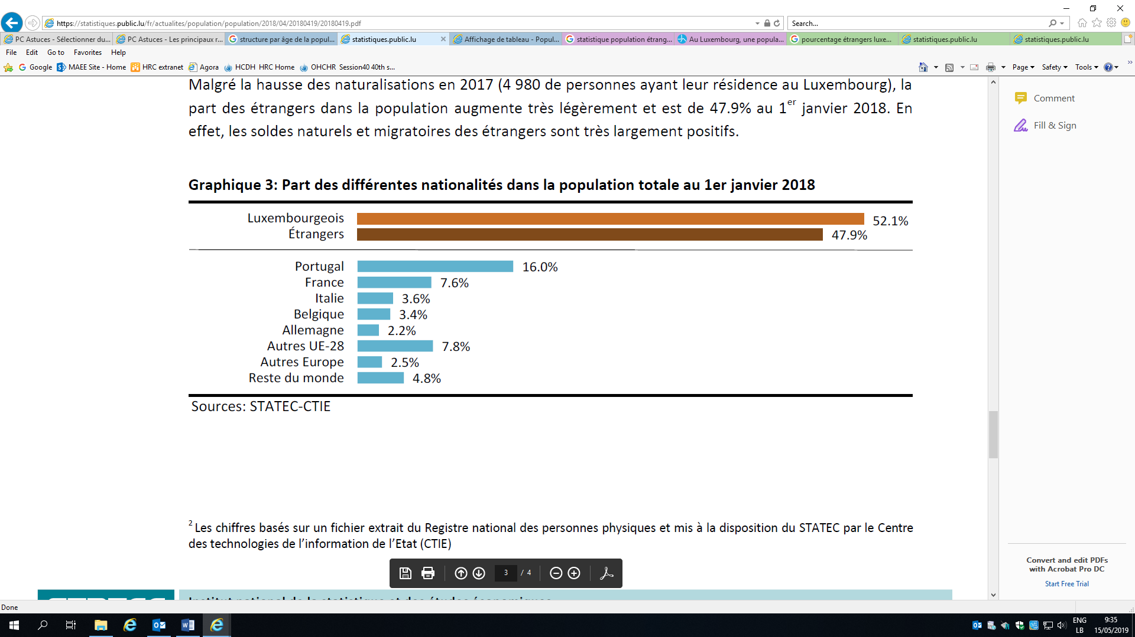

# Graph 2

**International migration by nationality in 2017**

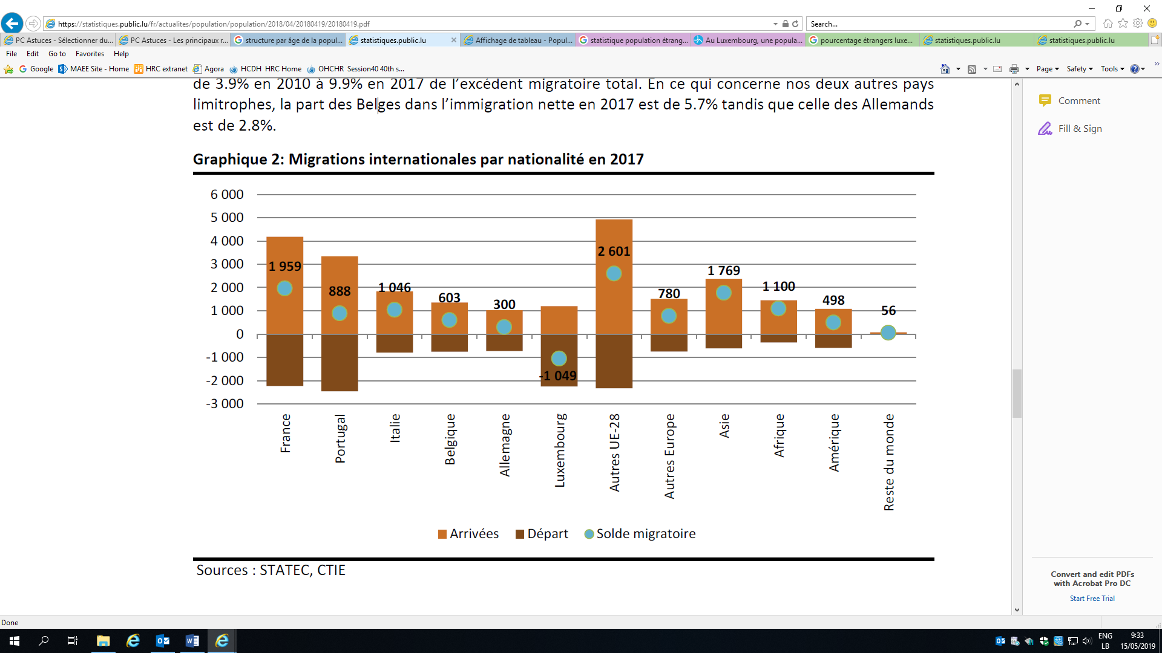

5. In 2018, the average population density was 233 persons per km2. However, this figure masks strong regional disparities, with densities ranging from 53 inhabitants per km2 in the rural canton of Clervaux to 766 inhabitants per km2 in the canton of Luxembourg.

# Table 3

**Proportion of the population in rural and urban areas**

| *Year* | *2013* | *2014* | *2015* | *2016* | *2017* |
| --- | --- | --- | --- | --- | --- |
| Population living in urban areas | 10.4% | 10.1% | 9.8% | 9.5% | 9.3% |
| Population living in rural areas | 89.6% | 89.9% | 90.2% | 90.5% | 90.7% |

*Source*: World Bank.

# Table 4

**Population distribution by level of urbanization 2013–2017**

| *Year* | *2013* | *2014* | *2015* | *2016* | *2017* |
| --- | --- | --- | --- | --- | --- |
| Urban areas | 14.6 | 14.5 | 13.0 | 15.7 | 15.5 |
| Intermediate areas | 38.0 | 36.6 | 38.5 | 36.4 | 38.7 |
| Rural areas | 47.4 | 48.9 | 48.5 | 47.9 | 45.9 |

*Source*: Eurostat.

6. From a structural perspective (the density and extent to which an area is built up) and a functional perspective (proportion of commuters working in an urban area), the Grand Duchy of Luxembourg has three major urban areas, namely, the City of Luxembourg; a southern urban area, in the former mining basin, comprising the towns of Esch-sur-Alzette, Differdange and Dudelange; and a northern urban area, “Nordstad”, comprising the towns and communes of Bettendorf, Diekirch, Erpeldange-sur-Sûre, Ettelbruck, Schieren and Colmar-Berg. The City of Luxembourg is clearly asserting itself as the country’s dominant urban area, while the other two urban areas represent medium-sized development centres that are shaping their respective regions.

7. The urban centre referred to as the City of Luxembourg comprises the City of Luxembourg and the eight suburban communes (Hesperange, Walferdange, Strassen, Bertrange, Steinsel, Lorentzweiler, Niederanven and Sandweiler), all of which are densely built up in a continuous fashion from the capital. High percentages (>40 per cent) of commuters live in the first district, or “ring” of communes surrounding the City of Luxembourg. These peri-urban spaces, which extend from the City of Luxembourg in a more sprawling manner, are less densely built up, and have lower populations and fewer jobs.

8. The southern part of Luxembourg is highly urbanized and much more heavily populated than the rural areas in the centre and north of the country. The cantons of Luxembourg and Esch are the most densely populated, with 182,607 and 176,820 inhabitants, respectively. They alone account for about 60 per cent of the national population. The other cantons have fewer inhabitants, ranging from 8 per cent of the total population living in Capellen to 0.86 per cent in Vianden.

# Table 5

**Population by canton as at 1 January 2018**

| *Canton* | *Absolute numbers* | *Percentages* |
| --- | --- | --- |
| Canton of Luxembourg | 182 607 | 30.3 |
| Canton of Esch | 176 820 | 29.4 |
| Canton of Capellen | 48 187 | 8.0 |
| Canton of Diekirch | 32 543 | 5.4 |
| Canton of Mersch | 32 112 | 5.3 |
| Canton of Grevenmacher | 29 828 | 5.0 |
| Canton of Remich | 22 366 | 3.7 |
| Canton of Echternach | 18 899 | 3.1 |
| Canton of Redange | 18 664 | 3.1 |
| Canton of Clervaux | 18 081 | 3.0 |
| Canton of Wiltz | 16 735 | 2.8 |
| Canton of Vianden | 5 163 | 0.9 |
| Grand Duchy of Luxembourg | 602 005 | 100.0 |

9. The latest statistics on the religious composition of the population of Luxembourg date from the 1970 population census. Since 1979, the law has prohibited the inclusion of any question concerning religion in population censuses.

10. The proportion of women and men in the total population of Luxembourg is more or less the same. The life expectancy of women at birth is higher than that of men (84.8 years for women compared to 80.2 years for men in 2013).

# Graph 3

**Population pyramid as at 1 January 2018**

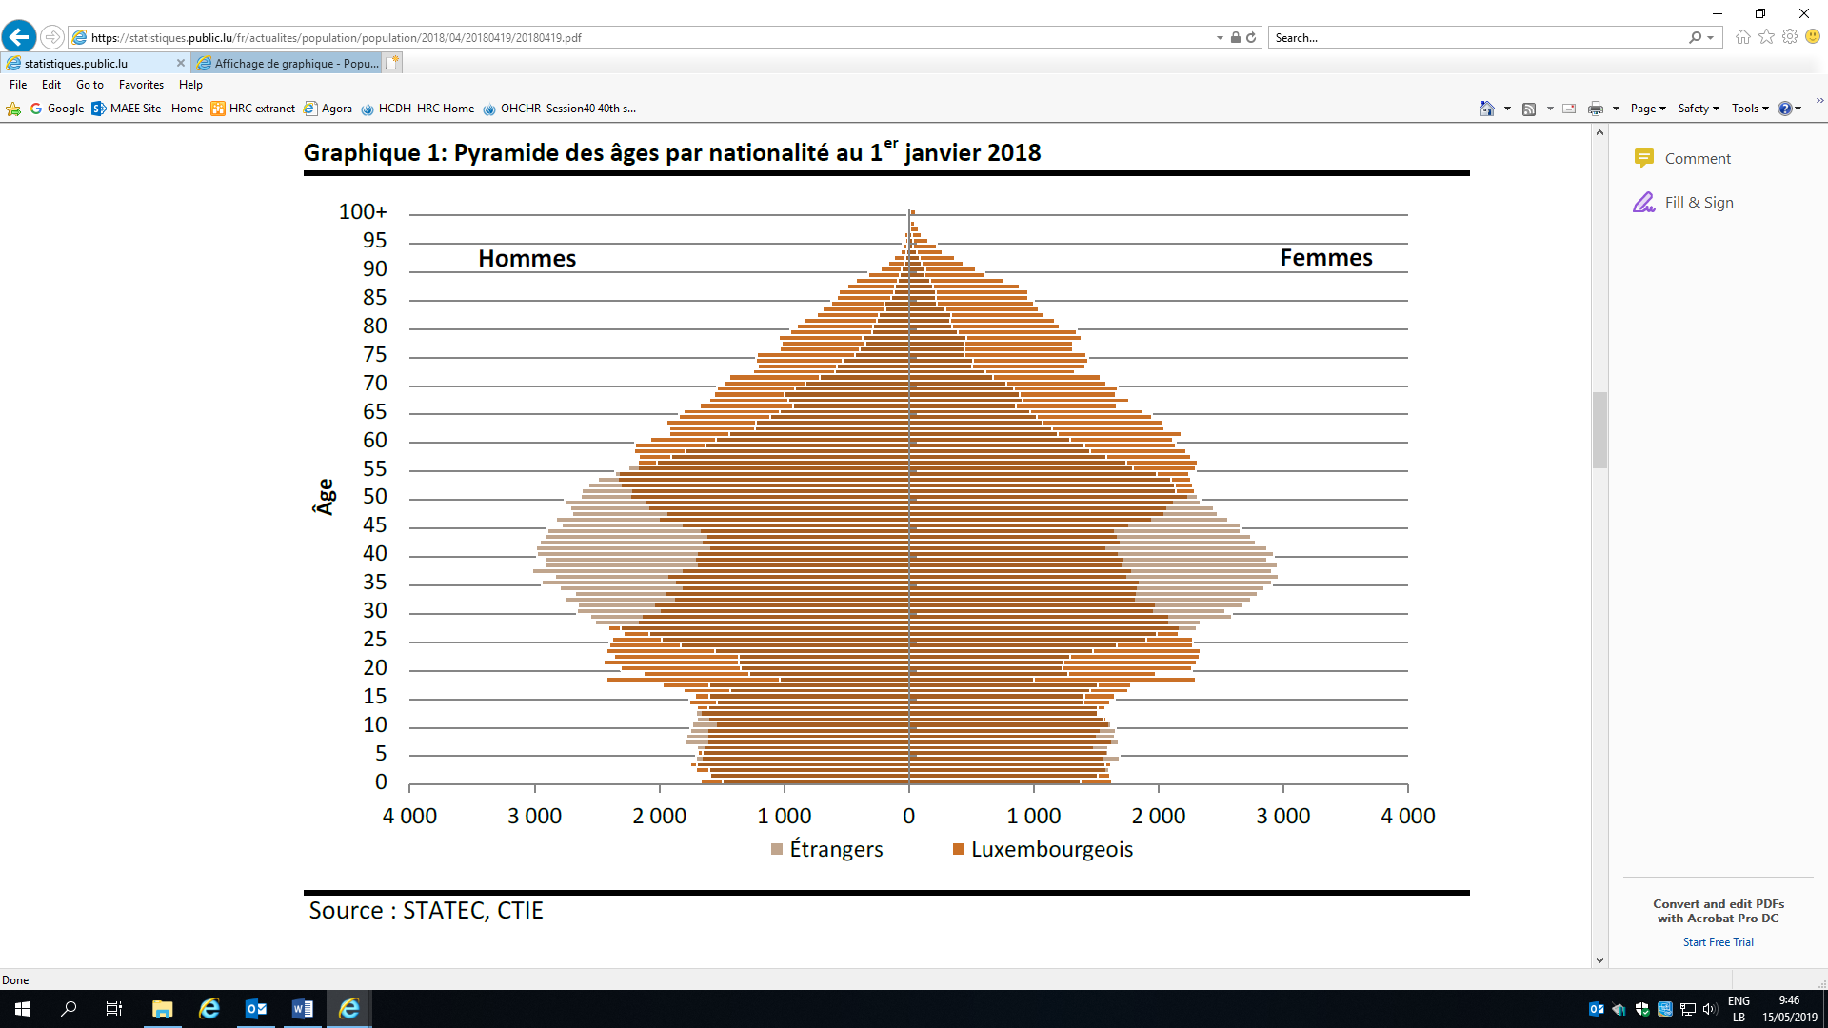

# Table 6

**Population by age and sex as at 1 January 2015–2018**

| *Year* | *2015* | | *2016* | | *2017* | | *2018* | |
| --- | --- | --- | --- | --- | --- | --- | --- | --- |
| *Sex* | *Men* | *Women* | *Men* | *Women* | *Men* | *Women* | *Men* | *Women* |
| 0–4 years | 16 256 | 15 428 | 16 475 | 15 551 | 16 419 | 15 644 | 16 494 | 15 763 |
| 5–9 years | 15 812 | 15 063 | 16 222 | 15 580 | 16 551 | 15 704 | 16 861 | 15 923 |
| 10–14 years | 16 085 | 15 103 | 16 076 | 14 987 | 16 442 | 15 163 | 16 570 | 15 511 |
| 15–19 years | 16 671 | 15 918 | 17 096 | 16 090 | 17 004 | 16 244 | 16 999 | 16 114 |
| 20–24 years | 17 807 | 16 896 | 17 944 | 17 433 | 18 912 | 18 128 | 19 403 | 18 433 |
| 25–29 years | 20 378 | 19 818 | 21 481 | 20 427 | 22 000 | 21 165 | 22 830 | 21 894 |
| 30–34 years | 21 721 | 21 634 | 22 279 | 22 122 | 22 805 | 22 648 | 23 245 | 23 027 |
| 35–39 years | 21 704 | 21 589 | 22 389 | 22 183 | 23 165 | 22 941 | 23 677 | 23 442 |
| 40–44 years | 22 113 | 21 290 | 22 405 | 21 551 | 22 610 | 21 766 | 23 010 | 22 245 |
| 45–49 years | 23 483 | 21 878 | 23 532 | 22 072 | 23 850 | 22 444 | 23 782 | 22 420 |
| 50–54 years | 21 823 | 20 357 | 22 741 | 20 937 | 23 604 | 21 499 | 24 102 | 21 988 |
| 55–59 years | 18 210 | 17 160 | 19 033 | 17 884 | 19 810 | 18 605 | 20 514 | 19 220 |
| 60–64 years | 14 618 | 14 303 | 15 088 | 14 714 | 15 763 | 15 650 | 16 280 | 16 050 |
| 65–69 years | 11 793 | 11 819 | 12 353 | 12 407 | 12 799 | 12 773 | 13 035 | 13 112 |
| 70–74 years | 8 686 | 9 735 | 8 869 | 9 735 | 9 464 | 10 063 | 9 855 | 10 373 |
| 75–79 years | 6 830 | 8 683 | 6 951 | 8 805 | 6 970 | 8 885 | 7 113 | 8 964 |
| 80–84 years | 4 847 | 7 144 | 4 876 | 7 069 | 4 823 | 6 989 | 4 967 | 7 035 |
| 85–89 years | 2 430 | 4 801 | 2 630 | 5 062 | 2 820 | 5 084 | 2 924 | 5 093 |
| 90–94 years | 611 | 1 974 | 635 | 2 034 | 684 | 2 135 | 788 | 2 263 |
| Over 95 years | 94 | 393 | 118 | 413 | 146 | 496 | 131 | 555 |

11. Following a decrease in 2016, the number of births began to rise again in 2017, from 6,050 in 2016 to 6,174 in 2017 (+2.0 per cent). This increase was mainly due to births of Luxembourg nationals (+4.9 per cent compared to 2016), while the number of newborn foreign nationals decreased slightly (-1.0 per cent). Despite the increase in births, the birth rate, i.e. the ratio of births to the total population, remained stable compared to 2016. In 2017, it was 10.4 per cent.

12. From a statistical point of view, women have 1.4 children and the average age at which they have their first child is 30.6 years (in 2017). Male and female births are well balanced. While in the 1990s birth out of wedlock was rare, in 2016 the number of births out of wedlock reached 42.6 per cent. This reflects the fact that births out of wedlock have increasingly become planned births to women who are generally unmarried and in consensual or civil unions.

# Table 7

**Birth rate**

| *Year* | *2014* | *2015* | *2016* | *2017* |
| --- | --- | --- | --- | --- |
| Birth rate (%) | 10.9 | 10.7 | 10.4 | 10.4 |

# Table 8

**Life expectancy at birth**

| *Year* | *2011–2013* | *2012–2014* | *2013–2015* | *2014–2016* | *2016–2018* |
| --- | --- | --- | --- | --- | --- |
| Men | 78.9 | 79.3 | 79.6 | 79.7 | 80.0 |
| Women | 83.4 | 84 | 84.2 | 84.6 | 84.5 |

13. The fertility rate,[[2]](#footnote-3) which had been stable since 2000, began a downward trend in 2011, but has been relatively stable in recent years. At present, the fertility rate is relatively low in Luxembourg for two reasons: women are having children increasingly later than they did in previous generations and they also are having relatively few children.

# Table 9

**Fertility rates by age group**

| *Year* | *2013* | *2014* | *2015* | *2016* | *2017* |
| --- | --- | --- | --- | --- | --- |
| Live births per 1,000 women aged | 5.2 | 5.7 | 5.6 | 4.9 | 4.2 |
| 15–19 years | 34.1 | 33.5 | 30.8 | 28.1 | 24.2 |
| 20–24 years | 85.1 | 76.4 | 77.6 | 70.2 | 67.0 |
| 25–29 years | 107.6 | 104.3 | 103.1 | 99.8 | 105.4 |
| 30–34 years | 63.7 | 66.8 | 64.6 | 62.5 | 61.9 |
| 35–39 years | 14.0 | 12.1 | 12.9 | 15.4 | 15.4 |
| 40–44 years | 53.7 | 52.2 | 51.6 | 49.6 | 49.5 |
| Average rate (15–44 years) | 5.2 | 5.7 | 5.6 | 4.9 | 4.2 |

14. From 2016 to 2017, the number of deaths increased by 7.5 per cent to 4,263. Although the absolute number of deaths among foreign nationals is very low, owing to the large proportion of very young foreign nationals, the number of deaths among this group increased by 9.0 per cent between 2016 and 2017, with 897 deaths in 2016 and 979 in 2017. Deaths of Luxembourg nationals increased by 7.0 per cent: 3,070 deaths in 2016 and 3,284 in 2017.

# Table 10

**Mortality rate**

| *Year* | *2014* | *2015* | *2016* | *2017* |
| --- | --- | --- | --- | --- |
| Mortality rate | 6.9% | 7.0% | 6.8% | 7.1% |

Table 11  
Infant mortality rate (per 1,000 live births)

| *Year* | *2013* | *2014* | *2015* | *2016* | *2017* |
| --- | --- | --- | --- | --- | --- |
| Infant mortality | 0.28 | 0.304 | 0.287 | 0.285 | 0.31 |

*Source*: World Bank.

# Table 12

**Maternal mortality ratio (per 100,000 live births)**

| *Year* | *2011* | *2012* | *2013* | *2014* | *2015* |
| --- | --- | --- | --- | --- | --- |
| Infant mortality | 11 | 11 | 10 | 10 | 10 |

*Source*: World Bank.

15. Cardiovascular diseases are the most frequent cause of death in Luxembourg, accounting for one third of deaths. The next most common causes are cancer and diseases of the respiratory system. However, before the age of 50, the main cause of death is most often related to external causes, in particular transport accidents and suicide. Deaths related to mental and behavioural disorders have been on the rise since 2011, from 99 cases in 2011 to 233 cases in 2016.

# Table 13

**Deaths by cause of death, 1998–2016**

| *Cause of death* | *1998* | *2000* | *2010* | *2011* | *2012* | *2013* | *2014* | *2015* | *2016* |
| --- | --- | --- | --- | --- | --- | --- | --- | --- | --- |
| Diseases of the circulatory system | 1 562 | 1 442 | 1 256 | 1 292 | 1 237 | 1 200 | 1 189 | 1 187 | 1 264 |
| Tumours | 1 008 | 991 | 1 061 | 1 091 | 1 121 | 1 059 | 1 164 | 1 108 | 1 121 |
| Diseases of the respiratory system | 314 | 288 | 270 | 311 | 285 | 278 | 265 | 323 | 298 |
| External causes of mortality | 255 | 293 | 283 | 283 | 269 | 294 | 261 | 285 | 267 |
| Mental and behavioural disorders | 73 | 92 | 90 | 99 | 165 | 190 | 185 | 231 | 233 |
| Diseases of the digestive system | 184 | 204 | 164 | 171 | 181 | 151 | 172 | 168 | 207 |
| Diseases of the nervous system | 120 | 109 | 150 | 162 | 171 | 176 | 153 | 184 | 171 |
| Symptoms, signs and abnormal clinical and laboratory findings not classified elsewhere | 114 | 111 | 112 | 113 | 111 | 101 | 95 | 121 | 124 |
| Endocrine, nutritional and metabolic diseases | 50 | 63 | 100 | 86 | 91 | 114 | 128 | 123 | 107 |
| Diseases of the genitourinary system | 47 | 36 | 71 | 64 | 57 | 58 | 79 | 72 | 62 |
| Certain infectious and parasitic diseases | 42 | 36 | 93 | 90 | 92 | 87 | 53 | 69 | 52 |
| Diseases of the blood and blood-forming organs and certain disorders involving the immune mechanism | 12 | 8 | 18 | 21 | 12 | 20 | 16 | 20 | 24 |
| Diseases of the musculoskeletal system and connective tissue | 14 | 9 | 17 | 16 | 16 | 14 | 19 | 26 | 17 |
| Certain conditions originating in the perinatal period | 15 | 10 | 9 | 9 | 6 | 11 | 12 | 6 | 15 |
| Congenital malformations, deformations and chromosomal abnormalities | 4 | 2 | 9 | 5 | 3 | 12 | 7 | 9 | 13 |
| Diseases of the skin and subcutaneous tissue | 7 | 14 | 7 | 6 | 3 | 2 | 4 | 4 | 3 |
| Pregnancy, childbirth and the puerperium | 1 | 1 | 1 | - | 1 | 1 | - | - | - |

*Source*: Department of Health.

# Table 14

**Population by age and dependency ratio**

| *Year* | *2015* | *2016* | *2017* | *2018* |
| --- | --- | --- | --- | --- |
| Working age population (15–64 years) | 69.1% | 69.3% | 69.5% | 69.5% |
| Children (0–14 years) | 16.7% | 16.5% | 16.2% | 16.1% |
| Older persons (65 years and over) | 14.2% | 14.2% | 14.2% | 14.3% |
| Dependency ratio | 30.9% | 30.7% | 30.5% | 30.4% |

2. Social data

16. As at 1 February 2011, 208,565 private households were registered in Luxembourg. A total of 503,280 persons live in private households, which means that the average household size in Luxembourg was 2.41 persons in 2011. A total of 16.6 per cent of inhabitants were considered to be living in non-family households (83,726 persons) as opposed to 83.4 per cent (419,554 persons) who were living in so-called family households.

# Table 15

**Private households by type of household, number of persons and average size, as at  
1 February 2011**

| *Household type* | *Private households* | *%* | *Persons* | *%* | *Average household size* |
| --- | --- | --- | --- | --- | --- |
| Non-family households | 76 027 | 36.5 | 83 726 | 16.6 | 1.1 |
| *Single-occupancy households* | 69 529 | 33.3 | 69 529 | 13.8 | 1.0 |
| *Multi-occupancy households* | 6 498 | 3.1 | 14 197 | 2.8 | 2.2 |
| Family households | 132 538 | 63.5 | 419 554 | 83.4 | 3.2 |
| *Single-family households* | 120 856 | 57.9 | 366 152 | 72.8 | 3.0 |
| *Couples without children* | 41 094 | 19.7 | 82 188 | 16.3 | 2.0 |
| *Couples with child(ren)* | 63 139 | 30.3 | 242 244 | 48.1 | 3.8 |
| *Single fathers* | 2 740 | 1.3 | 6 658 | 1.3 | 2.4 |
| *Single mothers* | 13 883 | 6.7 | 35 062 | 7.0 | 2.5 |
| *Two-or-more-family households* | 11 682 | 5.6 | 53 402 | 10.6 | 4.6 |
| **Total persons** | **208 565** | **100** | **503 280** | **100** | **2.4** |

17. In 2016, the largest expenditure for households in Luxembourg was “housing, water, electricity, gas and other fuels”, accounting for 35.7 per cent of all expenditures. A large share of household expenditures was also devoted to transport, including the purchase, use and maintenance of vehicles and public transport, which accounted for 13.4 per cent of average spending. This was followed by food costs (8.6 per cent) and hotels, cafes and restaurants (8.3 per cent). The share of the latter expenditure varied greatly depending on households’ financial means.

# Table 16

**Average annual expenditures per household (National Institute of Statistics and Economic Research)**

| *Year* | *2012* | *2013* | *2014* | *2015* | *2016* |
| --- | --- | --- | --- | --- | --- |
| **Total** | **€57 135** | **€58 185** | **€58 752** | **€59 937** | **€62 134** |
| Food and non-alcoholic beverages | €4 936 | €5 037 | €5 079 | €5 222 | €5 348 |
|  | 8.6% | 8.7% | 8.6% | 8.7% | 8.6% |
| Alcoholic beverages and tobacco | €801 | €789 | €779 | €792 | €847 |
|  | 1.4% | 1.4% | 1.3% | 1.3% | 1.4% |
| Clothing and footwear | €3 226 | €3 234 | €3 211 | €3 211 | €3 291 |
|  | 5.6% | 5.5% | 5.5% | 5.4% | 5.3% |
| Housing, water, electricity, gas and other fuels | €20 289 | €20 504 | €20 675 | €20 946 | €22 188 |
|  | 35.5% | 35.2% | 35.2% | 34.9% | 35.7% |
| Furnishings, household equipment and general housekeeping | €3 566 | €3 659 | €3 692 | €3 768 | €3 913 |
|  | 6.2% | 6.3% | 6.3% | 6.3% | 6.3% |
| Health | €1 404 | €1 417 | €1 394 | €1 438 | €1 576 |
|  | 2.5% | 2.4% | 2.4% | 2.4% | 2.5% |
| Transport | €8 132 | €8 549 | €8 438 | €8 379 | €8 344 |
|  | 14.2% | 14.7% | 14.3% | 14.0% | 13.4% |
| Communications | €1 305 | €1 385 | €1 445 | €1 512 | €1 609 |
|  | 2.3% | 2.4% | 2.5% | 2.5% | 2.6% |
| Recreation and culture | €4 104 | €4 148 | €4 214 | €4 160 | €4 020 |
|  | 7.2% | 7.1% | 7.2% | 6.9% | 6.5% |
| Educational services | €261 | €353 | €398 | €467 | €493 |
|  | 0.5% | 0.6% | 0.7% | 0.8% | 0.8% |
| Hotels, cafes and restaurants | €4 189 | €4 385 | €4 585 | €4 963 | €5 199 |
|  | 7.3% | 7.5% | 7.8% | 8.2% | 8.3% |
| Other goods and services | €4 919 | €4 720 | €4 839 | €5 076 | €5 303 |
|  | 8.6% | 8.1% | 8.2% | 8.4% | 8.5% |

18. In 2017, the at-risk-of-poverty line was €1,804 per month, compared to €1,691 in 2016.

19. In 2017, 109,600 people were living below the poverty line of €1,804 per month for a single adult. For the sake of comparison, on 1 January 2016, the minimum pension for a single adult was €1,721 and the guaranteed minimum income for the first adult in a household was €1,348. The at-risk-of-poverty rate was 18.7 per cent, meaning that 18.7 of people had a monthly standard of living below the €1,804 threshold, representing an increase of 2.2 percentage points compared to 2016. Overall, the poverty situation has steadily deteriorated in Luxembourg, with a 7.7 point increase in the poverty rate between 1996 and today, when it is at its highest level.

# Table 17

**Risk-of-poverty indicators**

| *Year* | *2013* | *2014* | *2015* | *2016* | *2017* |
| --- | --- | --- | --- | --- | --- |
| At-risk-of-poverty line (60 per cent of the national median income) | €1 665 per month | €1 716 per month | €1 763 per month | €1 691 per month | €1 804 per month |
| Risk-of-poverty rate | 15.9% | 16.4% | 15.3% | 16.5% | 18.7% |
| Risk-of-poverty rate by gender |  |  |  |  |  |
| Men | 15.7% | 16.1% | 15.0% | 15.6% | 17.9% |
| Women | 16%. | 16.6% | 15.7% | 17.5% | 19.4% |
| Risk-of-poverty rate for children | 23.9% | 25% | 21.5% | 21.8% | 22.8% |
| Poverty rate for those 65 years and over | 6.2% | 6.3% | 7.9% | 9.0% | 12.1% |
| Working poor | 11.2% | 11.0% | 11.6% | 12.0% | 13.7% |
| Single-parent families | 46.1% | 44.6% | 44.9% | 46.0% | 46.2% |

# Table 18

**Food insecurity**

| *Year* | *2012* | *2013* | *2014* | *2015* | *2016* |
| --- | --- | --- | --- | --- | --- |
| Individuals living in households who report that they cannot afford a meal with meat, fish, chicken or vegetarian equivalent every second day | 1.4% | 2.4% | 2.5% | 2.2% | 2.6% |

20. Income inequality in Luxembourg is very sensitive to changes in high incomes. The wealthiest 20 per cent have an average income that is five times higher than that of the poorest 20 per cent.

21. In 2017, the Gini coefficient in Luxembourg was 0.31, remaining stable compared to the previous year. The contribution of social transfers (family benefits, housing and education grants, minimum social benefits) to inequality is negative, demonstrating the redistributive impact of such transfers. The Gini coefficient before and after social transfers is 0.31 if all social transfers, including pensions, are taken into account. If social transfers except for retirement pensions are excluded, the coefficient increases to 0.36. If pensions are also excluded, the coefficient rises further, to 0.50.

# Table 19

**Indicator of income inequality**

| *Year* | *2012* | *2013* | *2014* | *2015* | *2016* |
| --- | --- | --- | --- | --- | --- |
| Gini coefficient | 0.28 | 0.304 | 0.287 | 0.285 | 0.31 |

22. In Luxembourg, schooling is compulsory from 4 to 16 years of age and includes a minimum number of years of primary and secondary education.

23. Primary education consists of four cycles: cycle 1 for children aged 4 and 5 (the first year of early education from the age of 3 is free, but enrolment is optional), cycle 2 for children aged 6 and 7, cycle 3 for children aged 8 and 9 and cycle 4 for children aged 10 and 11.

24. Secondary education consists of two tracks: standard secondary education, which lasts seven years, culminates in a secondary school diploma and prepares students primarily for university; and general secondary education, which comprises various training programmes lasting six to eight years depending on the specialty chosen, including vocational training.

# Table 20

**Net enrolment rate**

| *Year* | *2011* | *2012* | *2013* | *2014* | *2015* |
| --- | --- | --- | --- | --- | --- |
| Primary education | 92.1% | 92.8% | 92.5% | 93.0% | 94.6% |
| Secondary education | 86.5% | 85.8% | 85.5% | 84.6% | 84.1% |

*Source*: United Nations Educational, Scientific and Cultural Organization (UNESCO).

25. In primary schools, teaching is provided mainly by teachers who have passed a competitive examination linked to their posts. A licence (three-year university degree) in education or an advanced teacher training degree recognized by the Ministry of National Education, Children and Youth is a prerequisite for taking the competitive examination for cycle 1 teaching posts. A higher education degree of at least three years recognized by the Ministry of National Education, Children and Youth is a prerequisite for taking the competitive examination for teaching posts in cycles 2 to 4.

26. In secondary and technical secondary schools, teaching is provided mainly by teachers who have successfully completed their teacher placement. This placement is possible only once a candidate has successfully passed a competitive recruitment process in his or her respective speciality. A four-year higher education degree recognized by the Ministry of National Education, Children and Youth is required to register for the competitive examination.

# Table 21

**Number of students per teacher**

| *Year* | *2011* | *2012* | *2013* | *2014* | *2015* | *2016* |
| --- | --- | --- | --- | --- | --- | --- |
| Primary education | 8.99 | 8.37 | 8.14 | 8.17 | 8.46 | 8.30 |
| Secondary education | 8.62 | 7.88 | 7.95 | 9.12 | 9.45 | 8.83 |

*Source*: UNESCO.

27. Schools in Luxembourg adopted specific measures and provide special classes at each level of education to support and educate foreign students.

28. In addition, children with disabilities or special educational needs are either integrated into mainstream schools or enrolled in a differentiated education establishment or service.

29. The multilingual tradition of Luxembourg is an essential feature of its education system. Luxembourg is a trilingual country: Luxemburgish is the national language, French is the legislative language and Luxemburgish, French and German are the administrative and judicial languages. Language teaching therefore occupies a central place in the education system and the teaching provided is plurilingual, involving all three of the country’s languages. While German is the main language of instruction in primary school and in the lower classes of secondary school, most subjects are taught in French in the upper classes of secondary school. Public school also offers international classes, including in French and English.

30. One of the main causes of school dropout is failure or anticipated failure at school. As a result, some students leave school to seek out different types of training which they hope will give them a better chance of success. Inadequate guidance at school is also often cited as a reason for dropping out. Among those students who dropped out, some indicated that they had not liked the training that they were receiving, had not succeeded in obtaining the desired training (the training was not taught at their school or they failed to be admitted to it), or that there had been a lack of available apprenticeships.

31. Personal reasons, such as those related to family or health, also cause a number of students to drop out of school.

# Table 22

**Dropout rates in public education**

| *School year* | *2010/2011* | *2011/2012* | *2012/2013* | *2013/2014* | *2014/2015* |
| --- | --- | --- | --- | --- | --- |
| Number of dropouts | 644 | 649 | 779 | 991 | 1 007 |
| Theoretical dropout rate[[3]](#footnote-4) | 9.0% | 9.2% | 11.6% | 13.0% | 13.5% |

*Source*: Ministry of National Education.

# Table 23

**Dropout rates by gender**

| *Gender* | *Total students* | *Dropouts* | *Percentage of total students by gender* | *Percentage of dropouts by gender* |
| --- | --- | --- | --- | --- |
| Female | 19 837 | 390 | 49.9 | 38.7 |
| Male | 19 922 | 617 | 50.1 | 61.3 |
| **Total** | **39 759** | **1 007** | **100.0** | **100.0** |

*Source*: Ministry of National Education.

# Table 24

**Career paths of dropouts by gender**

| *Occupation after dropping out* | *Female* | *Male* | *Total* | *%* |
| --- | --- | --- | --- | --- |
| In search of training/school/apprenticeship | 173 | 246 | 419 | 41.6 |
| In search of a job | 56 | 108 | 164 | 16.3 |
| In search of employment | 61 | 72 | 133 | 13.2 |
| Participating in an employment support programme | 32 | 50 | 82 | 8.1 |
| Doing something different | 36 | 60 | 96 | 9.5 |
| Waiting to join the army/police (age, entrance exam results, etc.) | 7 | 70 | 77 | 7.6 |
| Recovering from illness, accident/in therapy | 12 | 11 | 23 | 2.3 |
| Pregnant, caring for a child | 13 | - | 13 | 1.3 |
| **Total** | **390** | **617** | **1 007** | **100.0** |

*Source*: Ministry of National Education.

3. Economic information

32. Since 2002, the unemployment rate, which had hitherto been relatively low, rose steadily before falling again from 2014 onwards. The unemployment rate, which was 5.9 per cent in 2017, is below the European average.

# Table 25

**Unemployment rate**

| *Year* | *2013* | *2014* | *2015* | *2016* | *2017* |
| --- | --- | --- | --- | --- | --- |
| Unemployment rate | 6.8% | 7.1% | 6.8% | 6.3% | 5.9% |

33. The employment rate is highest for the 30 to 50 age group, which accounted for 82.62 per cent of unemployment in 2016, peaking around the age of 33. At the age of 50, the employment rate starts to fall slowly and then more sharply; by the age of 57, less than half of people are still working and, by the age of 61, only a quarter are still working.

34. In 2017, for the 55 to 64 age group, Luxembourg had one of the lowest employment rates in the European Union at 39.8 per cent compared to the European average of 57.1 per cent.

# Table 26

**Employment rate of persons aged 20 to 64 (%)**

| *Year* | *2012* | *2013* | *2014* | *2015* | *2016* |
| --- | --- | --- | --- | --- | --- |
| Age | 71.4 | 70.6 | 71.3 | 71 | 70.68 |
| 20 to 64 | 64.3 | 63.7 | 64.9 | 65.1 | 65.04 |
| Women | 78.3 | 77.4 | 77.7 | 76.7 | 76.15 |
| Men | 59.9 | 55.8 | 58.7 | 63.9 | 63.23 |
| 20 to 29 | 57.7 | 52.5 | 58.3 | 61 | 62.35 |
| Women | 62 | 59.1 | 59.1 | 66.8 | 64.08 |
| Men | 84 | 84.2 | 83.9 | 83 | 82.62 |
| 30 to 54 | 75 | 76.1 | 75.7 | 75.8 | 75.74 |
| Women | 92.6 | 92 | 91.8 | 90.1 | 89.26 |
| Men | 40.8 | 40.7 | 42.6 | 38.2 | 39.49 |
| 55 to 64 | 34.3 | 33.5 | 35.2 | 33.4 | 32.32 |
| Women | 47.2 | 47.6 | 49.9 | 42.9 | 46.35 |
| Men |  |  |  |  |  |
| Level of education | 60 | 58.5 | 56.8 | 58.5 | 56.51 |
| International Standard Classification of Education (ISCED) 0–2 | 52.9 | 50.1 | 50.2 | 50.9 | 47.84 |
| Women | 67.6 | 67.1 | 64.8 | 65.9 | 65.1 |
| Men | 66.8 | 65.3 | 66.2 | 67 | 65.98 |
| ISCED 3–4 | 60.2 | 57.9 | 58.9 | 60.6 | 60.2 |
| Women | 73.6 | 72.8 | 73 | 73.2 | 71.35 |
| Men | 83.6 | 82.7 | 82.8 | 83.3 | 80.12 |
| ISCED 5–8 | 77.3 | 77.6 | 78.5 | 79.2 | 79 |
| Women | 89.1 | 87.4 | 86.7 | 87.4 | 81.41 |
| Men |  |  |  |  |  |
| Country of birth | 68.7 | 67.9 | 69.3 | 68.8 | 68.97 |
| Luxembourg | 62.1 | 62.2 | 63.3 | 63.9 | 64.28 |
| Women | 74.9 | 73.4 | 75.3 | 73.7 | 73.65 |
| Men | 74 | 73.2 | 73.4 | 72.3 | 72.33 |
| Abroad | 66.3 | 65.1 | 66.5 | 65.9 | 65.79 |
| Women | 81.6 | 81.2 | 80.1 | 78.6 | 78.49 |
| Men | 71.4 | 70.6 | 71.3 | 71 | 70.68 |

35. The Luxembourg labour market is an international and multicultural working environment, with an exceptionally high proportion of foreign and multilingual workers and a predominant tertiary sector. The transformation from an industrial economy largely dominated by the steel industry to a service economy led by the financial sector was completed in a single decade starting in the mid-1970s. The desire to diversify services from the 1980s onwards resulted in the creation and development of activities in the field of insurance and reinsurance, transport, trade, tourism, telecommunications, electronic commerce, audiovisual services and business services.

# Table 27

**Distribution of the workforce by sector in the first trimester of 2018**

| *Manufacturing* | *Construction* | *Trade, transport, accommodation and food* | *Information and communications* | *Finance and insurance* | *Specialized activities and support services* | *Government and other public services* | *Other activities* |
| --- | --- | --- | --- | --- | --- | --- | --- |
| 37 293 | 44 136 | 95 209 | 18 283 | 48 339 | 67 037 | 84 891 | 20 385 |
| 9.0% | 10.6% | 22.9% | 4.4% | 11.6% | 16.1% | 20.4% | 4.9% |

36. In Luxembourg, there are two types of employee representation: membership in one of the five trade associations is required, and employees also have the option of seeking membership in one of the trade unions. The unionization rate of employees in Luxembourg is around 35 per cent (2014).

# Table 28

**Unionization rates**

| *Unionization rates* | *2010* | *2011* | *2012* | *2013* | *2014* |
| --- | --- | --- | --- | --- | --- |
| Administrative data | 35.1% | / | 35.3% | / | 34.1% |
| Survey data | 40% | 36.6% | 35.2% | 34% | 36.3% |

*Source*: Organization for Economic Cooperation and Development (OECD).

37. For 2018 as a whole, economic expansion was driven mainly by non-financial services – especially in the areas of business services, health and social work and trade – as well as by the buoyancy of the construction sector. The growth of the gross domestic product (GDP) in 2018 was also due to the significant increase in private household consumption expenditure. Indeed, in 2018, household consumption grew by around 4 per cent, compared to 3 per cent in 2017, and well above the average of 2.5 per cent of the past 20 years. This is partly due to the substantial increase in household disposable income in 2017 and, to a lesser extent, in 2018. A stable labour market, a high level of consumer confidence and low interest rates have also led households to save less.

# Table 29

**GDP at market prices**

| *Year* |  | *2014* | *2015* | *2016* | *2017* | *2018* |
| --- | --- | --- | --- | --- | --- | --- |
| Current prices, millions of euros |  | 49 824.5 | 51 578.9 | 53 303.3 | 55 299.4 | 58 869.2 |
| Current prices, millions of standards of purchasing power |  | 41 674.0 | 44 094.7 | 43 858.2 | 45 234.8 | 47 821.5 |

*Source*: Eurostat.

Table 30   
**Annual growth rate of real GDP**

| *Year* | *2014* | *2015* | *2016* | *2017* | *2018* |
| --- | --- | --- | --- | --- | --- |
| GDP (in volume) | 4.3 | 3.9 | 2.4 | 1.5 | 2.6 |

38. In 2016, the GDP of Luxembourg, expressed in purchasing power standards, stood at 267 per cent of the European average, according to Eurostat figures. This high level of per capita GDP is largely attributable to the fact that cross-border workers account for a substantial share of total employment and contribute to national GDP but are not considered part of the resident population. It is therefore better, for the purposes of comparison, to use gross national income (GNI) per capita, which excludes income transferred into or out of the country. Luxembourg nonetheless remains one of the countries with the highest levels of GNI per capita, according to OECD figures.

# Table 31

**Gross national income (current US$)**

| *Year* | *2013* | *2014* | *2015* | *2016* | *2017* |
| --- | --- | --- | --- | --- | --- |
| GNI | 41 234 842 180 | 42 922 224 641 | 38 311 270 081 | 39 875 552 272 | 43 727 291 084 |

*Source*: World Bank.

# Table 32

**Gross national income per capita (current US$)**

| *Year* | *2013* | *2014* | *2015* | *2016* | *2017* |
| --- | --- | --- | --- | --- | --- |
| GNI per capita | 63 614 | 67 048 | 69 498 | 71 089 | 76 220 |

*Source*: OECD.

39. In December 2018, the national consumer price index fell by 0.3 per cent compared with the previous month. This downward movement was caused by a 5.8 per cent drop in the price of petroleum products, while prices for goods and services excluding petroleum products stayed the same as in November.

40. Between February and March 2019, the annual inflation rate in Luxembourg rose by 0.3 percentage points while eurozone inflation slowed slightly by 0.1 percentage points. With an inflation rate of 2.4 per cent (in March 2019), Luxembourg is one of the nine European countries where price increases are felt most, according to Eurostat figures. The euro area annual inflation rate was directly impacted by increases in the prices of energy, services, food, alcohol, tobacco and non-energy industrial goods.

# Table 33

**Consumer price index**

| *Year* | *2014* | *2015* | *2016* | *2017* | *2018* |
| --- | --- | --- | --- | --- | --- |
| Consumer price index | 0.6 | 0.5 | 0.3 | 1.7 | 1.3 |

41. For several years now, Luxembourg has endeavoured to meet the target of allocating 1 per cent of its gross national income to official development assistance. This target is reaffirmed in the new coalition agreement for 2018–2023.

# Table 34

**International assistance provided, as a percentage of gross national income**

| *Year* | *2013* | *2014* | *2015* | *2016* | *2017* |
| --- | --- | --- | --- | --- | --- |
| International assistance as a percentage of GNI | 1.00 | 1.06 | 0.95 | 1.00 | 1.00 |

*Source*: OECD.

42. The Government has set itself the goal of keeping the public debt below 30 per cent of GDP. In 2018, Luxembourg had a budgetary surplus of 2.4 per cent of GDP and a public debt of 21.4 per cent of GDP.

# Table 35

**Public debt (€ millions)**

| *Year* | *2014* | *2015* | *2016* | *2017* | *2018* |
| --- | --- | --- | --- | --- | --- |
| General government gross debt | 11 330.5 | 11 446.9 | 11 024.4 | 12 697.1 | 12 586.6 |

*Source*: National Institute of Statistics and Economic Research.

B. Constitutional, political and legal structure of the State

1. Political system and institutions

43. The Grand Duchy of Luxembourg is a representative democracy in the form of a constitutional monarchy, whose Crown is hereditary in the Nassau family. Luxembourg has been a sovereign and independent State since the Treaty of London of 19 April 1839.

44. The Grand Duke is the Head of State. He embodies the country’s independence and the continuity of a State that has been strongly marked by the vicissitudes of history. Sovereign power resides in the nation and its exercise is entrusted to the Grand Duke. The Grand Duke has no powers other than those expressly conferred upon him by the Constitution and by law. His role thus strictly adheres to the maxim that “the sovereign reigns but does not rule”.

45. The Constitution of Luxembourg dates from 17 October 1868 and it has undergone several revisions since then. It is a “rigid” written Constitution which, because of its fundamental nature, is more stable than ordinary law. The current Constitution is composed of 121 articles, divided into 12 chapters. It describes the foundations of the State, the guarantee of citizens’ rights and freedoms and the organization of the public authorities. The Chamber of Deputies is currently working on a general overhaul of the Constitution. This is considered necessary to “modernize” the basic law, given that it was originally drafted in 1868, and adapt it to the needs of a modern democracy.

46. The organization of the State is based on the principle that different functions must be divided among different authorities. As in many other parliamentary democracies, in Luxembourg the separation of powers is flexible. Indeed, there are many relationships between the executive and legislative branches, although the judiciary remains totally independent. Legislative power is exercised jointly by the Chamber of Deputies, the Government and the Council of State. The Grand Duke and the Government form the constitutional body that holds executive power. The courts and tribunals are constitutionally mandated to exercise judicial power and are independent in the exercise of their functions.

47. Under the Constitution, executive power is vested in the Grand Duke. To exercise it, he issues the regulations required to implement legislation. In practice, however, this task is carried out by the Government. The Constitution also gives the Head of State complete freedom to choose Government ministers. However, democratic principle requires that members of the Government must enjoy not only the confidence of the Head of State, but also that of a parliamentary majority. Consequently, the Grand Duke respects the results of parliamentary elections by appointing a formateur who then seeks to form a Government that will gain the support of most deputies. As the body holding executive power, the Government is responsible for the general administration of public affairs. Each member of the Government is appointed by the Grand Duke to take charge of at least one ministry. The Government also has the right to introduce legislative proposals. The Government Council discusses bills that will be submitted to the Chamber of Deputies and decisions are taken by a majority vote. The Government administers the State budget, which is put to an annual vote of the Chamber of Deputies.

48. The Chamber of Deputies is the parliament of the Grand Duchy of Luxembourg. It is composed of 60 deputies, who are elected for five years on the basis of straightforward universal suffrage and proportional representation. The most recent parliamentary elections were held on 14 October 2018, and the next elections will be held in 2023. Luxembourg has a unicameral parliamentary system, in which the Chamber of Deputies, the Government and the Council of State are all involved in the legislative process. The main function of the Chamber of Deputies is to vote on bills and legislative proposals. Deputies have the right to introduce legislation, in the form of legislative proposals, although this right is exercised somewhat sparingly. The Constitution also reserves certain powers for the Chamber in financial matters and confers on it a right to oversee the acts of the Government. The consent of the Chamber is necessary for an international treaty to take effect within the territory of Luxembourg. The Chamber sits in the capital and its meetings are public.

49. The Council of State is an independent institution which, under the Constitution, is called upon to exert the moderating influence of a second chamber in the unicameral system of Luxembourg. It is composed of 21 councillors. Councillors are formally appointed and dismissed by the Grand Duke at the recommendation of the Government, the Chamber of Deputies or the Council of State itself. They serve a non-renewable 15-year term, unless they first reach the age limit of 72 or accept a post incompatible with membership. The Council acts as an advisory body in the legislative process. Indeed, it is required to give its opinion on all bills submitted by the Government and all legislative proposals put forward by the Chamber of Deputies. In preparing such opinions, it is required to examine the conformity of the draft legislation with the Constitution, international conventions and general principles of law.

2. Electoral system

50. In Luxembourg, the universal right to vote and stand as a candidate in elections was introduced on 26 October 1919. Voting is a compulsory civic act and a refusal to vote may be punished by a fine. Parliamentary elections are held every five years and communal elections every six years. Six Luxembourg representatives are elected to the European Parliament, by direct universal suffrage, every five years.

51. Because voting is compulsory in Luxembourg, voter turnout for the different types of elections is high. At the last European elections in 2019, the turnout in Luxembourg was one of the highest in the European Union, at 84.24 per cent. For the 2018 parliamentary elections, the national turnout was 89.66 per cent.

# Table 36

**Voter turnout for the 2018 parliamentary elections, by constituency**

| *Constituency* | *South* | *Centre* | *North* | *East* |
| --- | --- | --- | --- | --- |
| Turnout (%) | 90.01 | 87.13 | 91.89 | 91.05 |

52. To qualify as a voter in parliamentary elections, a person must be a citizen of Luxembourg, be over 18 years of age on voting day, enjoy their civil and political rights and be domiciled in the Grand Duchy. Luxembourg nationals who are domiciled abroad are allowed to cast a postal ballot in parliamentary elections. Other European Union nationals who reside in the Grand Duchy may take part in European and communal elections. Communal elections are also open to non-European Union foreign nationals. The law on communal elections allows all foreign nationals to run for local office, including the offices of mayor and alderman. Candidates must have resided in Luxembourg for at least 5 years – of which the last year of residence must be uninterrupted – and have been living in the commune for at least 6 months.

53. Elections for the Chamber of Deputies are held by direct universal suffrage to appoint the 60 deputies who will make up the national parliament under the unicameral system. For parliamentary elections, the Grand Duchy is divided into four constituencies. Deputies are elected by the list system. In each constituency, the political groups must draw up lists of candidates, whose number may not exceed the total number of deputies to be elected in that constituency. The seats are distributed according to the rules of proportional representation and in conformity with the principle of the smallest electoral quotient. Parliamentary elections are held by law every five years, and most recently took place on 14 October 2018.

54. Political parties or political groups are defined under the Act of 21 December 2007 on political party funding. Under the Act, political parties or groups are associations of natural persons, whether or not the association is recognized as having legal personality, that participate, in accordance with the fundamental principles of democracy, in the expression of universal suffrage and the popular will in the manner set out in their statutes or programme. In the interest of creating a better balance between men and women in decision-making processes, in December 2016 the Act was amended to stipulate that the funding allocated to political parties could be reduced by specific amounts if their lists failed to meet certain thresholds for the inclusion of candidates of the underrepresented sex.

55. Currently, a dozen political parties are active in Luxembourg. The current coalition government is made up of three parties. Since the 2018 parliamentary elections, seven parties have been represented in the Chamber of Deputies. Here is a list of political parties, in alphabetical order: Alternativ Demokratesch Reformpartei, Chrëschtlech-Sozial Vollekspartei, Déi Gréng, Déi Lénk, Demokratesch Partei, Fräi Sozial Alternativ, Fräi Wieler, Kommunistesch Partei Lëtzebuerg, Lëtzebuerger Sozialistesch Aarbechterpartei, Partei fir Integral Demokratie, Piratepartei and Sozialliberal Partei Lëtzebuerg.

56. The distribution of seats in the Chamber of Deputies after each of the last five parliamentary elections was as follows:

# Table 37

**Distribution of seats in the Chamber of Deputies following parliamentary elections, 1999–2018**

| *Year* | *1999* | *2004* | *2009* | *2013* | *2018* |
| --- | --- | --- | --- | --- | --- |
| Chrëschtlech-Sozial Vollekspartei | 19 | 24 | 26 | 23 | 21 |
| Demokratesch Partei | 15 | 10 | 9 | 13 | 12 |
| Lëtzebuerger Sozialistesch Aarbechterpartei | 13 | 14 | 13 | 13 | 10 |
| (Déi Gréng | 5 | 7 | 7 | 6 | 9 |
| Alternativ Demokratesch Reformpartei | 7 | 5 | 4 | 3 | 4 |
| Déi Lénk | 1 | - | 1 | 2 | 2 |
| Piratepartei | - | - | - | - | 2 |
| All parties | 60 | 60 | 60 | 60 | 60 |

57. For the communal elections of 8 October 2017, the number of voters registered on the electoral rolls of the 105 communes of Luxembourg was as follows:

# Table 38

**Voters registered for the 2017 communal elections**

| Luxembourg nationals | 249 943 |
| --- | --- |
| Foreign nationals | 34 634 |
| **Total number of registered voters** | **284 577** |

58. Fifteen of the 60 representatives elected to the Chamber of Deputies in the 2018 parliamentary elections were women (25 per cent). In order to move towards parity in national politics, a quota applies to party lists for parliamentary and European elections. A law adopted in late 2016 established a minimum 40 per cent quota for each gender and introduced financial penalties for parties that fail to meet the quota. The further a party deviates from the 40 per cent threshold, the greater the financial penalty that will be imposed upon it.

3. Administration of justice

# Graph 4

**The judicial system**

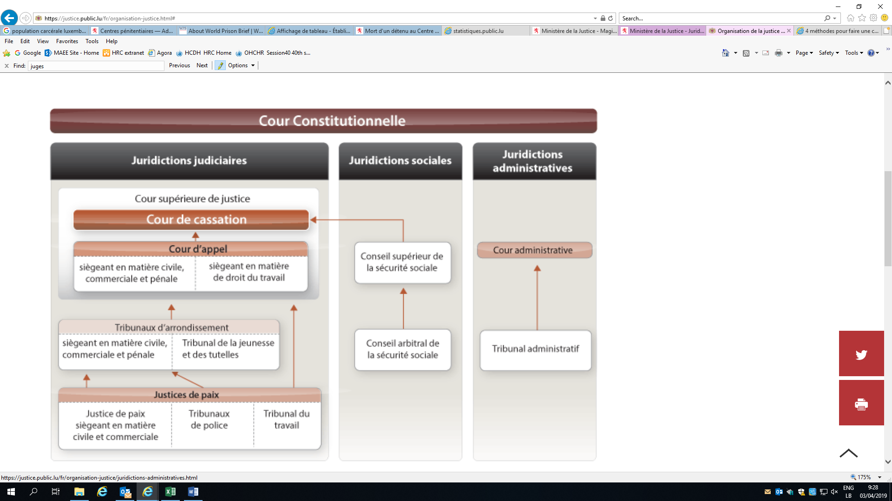

(a) Judicial institutions

59. In Luxembourg the judiciary is organized into two branches, the ordinary and the administrative courts. This organizational structure reflects different types of disputes. The ordinary courts consist of three magistrates’ courts, two district courts, the Court of Appeal and the Court of Cassation. These courts essentially hear disputes under civil, commercial, criminal and labour law. The administrative branch consists of the Administrative Tribunal and the Administrative Court, which settle disputes of an administrative or fiscal nature. The Constitutional Court is composed of judges from the ordinary courts and the administrative courts. It examines the compliance of laws with the Constitution, which is the supreme law of the land.

(i) The Constitutional Court

60. The Constitutional Court adjudicates on the constitutionality of laws, except those regarding the adoption of treaties. When a litigant raises a question relating to the constitutionality of a law before an ordinary or administrative court, that court must bring it before the Constitutional Court, unless it deems that: (a) a decision on the matter is not necessary for it to hand down judgment; (b) the claim is unfounded; or (c) the Constitutional Court has already ruled on a case with the same subject matter.

61. The Constitutional Court is composed of the president of the High Court of Justice, the president of the Administrative Court, two associate judges of the Court of Cassation and five judges appointed by the Grand Duke on the joint recommendation of the High Court of Justice and the Administrative Court. It sits in a five-member panel.

(ii) Ordinary courts

The High Court of Justice

62. At the apex of the ordinary court system is the High Court of Justice, which is composed of the Court of Cassation, the Court of Appeal and the Chief Public Prosecutor’s Office.

63. The Court of Cassation, which consists of one division with five judges, mainly hears applications for the annulment or judicial review of decisions handed down by the various divisions of the Court of Appeal and last-instance judgments. Representation by a lawyer is compulsory.

64. The Court of Appeal consists of nine divisions, each with three judges. It hears civil, commercial and criminal matters, as well as cases tried by the labour courts in the country’s two judicial districts. Representation by lawyer is compulsory in all cases, except in criminal cases and urgent applications. The criminal division of the Court of Appeal hears appeals against the judgments of the criminal divisions of the district courts. It has five judges.

District courts

65. The country is divided into two judicial districts, Luxembourg and Diekirch, each of which has a district court. The two district courts are divided into sections each of which is assigned three judges, and each court has a prosecution team composed of a public prosecutor and a number of substitute prosecutors. Investigating judges at each district court are responsible for conducting pretrial judicial inquiries into serious offences and, where appropriate, lesser offences carrying a sentence of up to 5 years’ imprisonment.

66. In civil and commercial matters, the district court is the court of general jurisdiction; it hears all cases other than those falling expressly within the jurisdiction of another court by reason of the nature or the amount of the claim.

67. It has jurisdiction *ratione valoris* in claims in excess of €10,000.

68. District courts have exclusive jurisdiction to hear cases which, due to their nature, are specifically assigned to them by law. They alone can consider applications for authority to enforce judgments handed down by foreign courts and legal instruments authenticated by foreign public officers. They also exercise non-contentious jurisdiction, for example in regard to adoption, guardianship and emancipation of minors.

69. District courts hear appeals against first-instance decisions by the magistrates’ courts located in the judicial district.

70. Proceedings before the district court are as a rule initiated by a writ of summons, which is served on the opposing party by a bailiff.

71. The presidents of the district courts, or the judges replacing them, hear urgent applications for interim measures, both in civil and commercial matters.

72. District courts exercise criminal jurisdiction through their criminal divisions. They are competent to try all lesser offences carrying a sentence of up to 5 years’ imprisonment, as well as serious offences, where the case is referred to them by the judges’ council chamber or the council chamber of the Court of Appeal. Defendants must appear in person, except where the offence is punishable only by a fine, in which case they have the right to be represented by a lawyer.

73. As a rule, parties are required to have legal representation before the district courts, although the law provides for certain exceptions, such as in commercial cases and urgent applications, when they may argue their own cases.

Magistrates’ courts

74. The three magistrates’ courts are located in Luxembourg City, Esch-sur-Alzette (judicial district of Luxembourg) and Diekirch (judicial district of Diekirch).

75. In civil and commercial matters, these courts hear all cases for which they have been given jurisdiction under the new Code of Civil Procedure or other legal provisions; they have final jurisdiction in cases concerning disputed amounts of up to €1,250 and jurisdiction subject to appeal in cases concerning amounts of up to €10,000.

76. They hear cases such as those concerning attachment of earnings orders, and they rule on the distribution of sums raised by such orders, whatever the amount of the debt.

77. As a rule, actions are brought before the magistrate’s court by the issue of a summons served by a bailiff. Some cases are initiated by filing an application with the court office. Parties appear before the magistrate’s court either in person or through a representative. This representative may be a lawyer, a spouse, a relative by blood or marriage to the third degree of kinship, or a person working exclusively in the service of the party or in his or her business.

78. In criminal matters, magistrates’ courts function as police courts. In this capacity, they hear cases involving minor offences punishable by fines of €25 to €250, as well as offences referred to them by the judges’ council chamber.

79. They also try minor offences which carry a more severe penalty than is usually within the jurisdiction of the police court, in cases where jurisdiction is given to them by statute. Judgments handed down by police courts are always open to appeal. The time limit for lodging an appeal is 40 days from the date the judgment is delivered, or, in the event of a judgment by default, from the date it is served on the person or at the person’s address. Appeals are heard by the district courts.

80. Each magistrate’s court includes a labour tribunal with jurisdiction over disputes relating to employment or apprenticeship contracts. Appeals are heard by the High Court of Justice.

Social Insurance Arbitration Board and Social Insurance Appeals Board

81. All social security disputes concerning affiliation or liability, contributions, fines and benefits, except those covered by article 317 or relating to articles 147 and 148 of the Social Insurance Code, are settled by the Social Insurance Arbitration Board or, on appeal, by the Social Insurance Appeals Board. Final decisions handed down by the Arbitration Board and judgments of the Appeals Board can be appealed to the Court of Cassation.

(iii) Administrative courts

Administrative Court

82. Unless otherwise stipulated by law, the Administrative Court may hear appeals against decisions taken by the Administrative Tribunal to set aside an administrative decision and against decisions on administrative acts of a regulatory nature. In its capacity as a trial and appeals court, the Administrative Court hears appeals against the decisions of other administrative courts regarding appeals for correction over which they have statutory authority.

83. All lawyers who have right of audience in the courts of the Grand Duchy also have right of audience in the Administrative Court; nevertheless, only “lawyers included in list I” of the bar association registers that are drawn up each year are entitled to perform preparatory and procedural measures (legal representation).

84. The State is represented before the Administrative Court by a representative or by a lawyer.

Administrative Tribunal

85. The Administrative Tribunal, which also sits in Luxembourg City, rules on cases of incompetence, abuse or misuse of authority; legal or procedural violations for the purpose of protecting personal interests; appeals against all administrative decisions for which no other remedy is stipulated by the law or regulations; and appeals against administrative acts of a regulatory nature, irrespective of the issuing authority. In theory, it also hears disputes regarding direct taxes and communal taxes.

86. Decisions of the Administrative Tribunal can be appealed to the Administrative Court.

87. In its capacity as a trial court, the Administrative Tribunal hears appeals against decisions of the Direct Taxation Service, in situations where the relevant laws provide for such appeals.

(b) Indicators on crime and the administration of justice

88. By virtue of the Act of 31 May 1999 establishing the Grand-Ducal police force and the General Police Inspectorate, the gendarmerie and the police were merged into a single force on 1 January 2000. The Grand-Ducal police force is a national police service with nationwide jurisdiction. Since 2015, its ranks have swelled significantly, which has made it possible to increase the presence of the police, day and night, throughout the country.

# Table 39

**Grand-Ducal police officer numbers, 2015–2018**

| *Year* | *2015* | *2016* | *2017* | *2018* |
| --- | --- | --- | --- | --- |
| Police officers per 100,000 inhabitants | 344 | 345 | 342 | 348 |
| **Total number of police officers** | **1 939** | **1 990** | **2 020** | **2 098** |

89. Luxembourg currently has two prisons with a combined capacity of 710 places. Luxembourg Prison, in Schrassig, is a closed prison with men’s and women’s sections and a capacity of 597 beds. The second prison, in Givenich, is a semi-open prison with a capacity of 113 beds. It was designed to allow persons approaching the end of their sentence or serving a short sentence to prepare for their release during a relatively short stay, generally not exceeding two years. Prisoners there are required to work (agricultural work, horticulture, carpentry, handicrafts), either inside one of the many prison workshops or, if they have an employment contract, outside the prison.

90. As the prison population has increased in recent years – Luxembourg Prison exceeded its maximum capacity by 7.5 per cent in 2016 – it appeared necessary to build a third prison to prevent overcrowding. In 2016, preparations commenced for the construction of a third prison at Uerschterhaff, in the commune of Sanem, which is expected to accommodate 400 people. According to the construction schedule, this prison should be operational by 2022.

# Table 40

**Prison population, 2013–2017**

| *Year* | *2013* | *2014* | *2015* | *2016* | *2017* |
| --- | --- | --- | --- | --- | --- |
| Population at year end | 705 | 627 | 693 | 724 | 684 |
| Men | 668 | 601 | 653 | 688 | 647 |
| Women | 37 | 26 | 40 | 36 | 37 |
| Prisoners serving life sentences | 14 | 12 | 12 | 13 | 10 |
| Men | 13 | 11 | 11 | 12 | 9 |
| Women | 1 | 1 | 1 | 1 | 1 |
| Prisoners convicted of serious offences | 117 | 113 | 120 | 113 | 112 |
| Men | 111 | 109 | 116 | 106 | 107 |
| Women | 6 | 4 | 4 | 7 | 5 |
| Prisoners convicted of lesser offences | 234 | 193 | 245 | 243 | 248 |
| Men | 224 | 184 | 230 | 231 | 231 |
| Women | 10 | 9 | 15 | 12 | 17 |
| Other categories | 349 | 309 | 316 | 355 | 314 |
| Men | 328 | 297 | 296 | 339 | 300 |
| Women | 21 | 12 | 20 | 16 | 14 |

*Source*: National Institute of Statistics and Economic Research.

91. In 2017, the number of offences against persons (7,568) accounted for 20.6 per cent of all offences (36,721). The figure fell by 8.34 per cent compared with 2016.

92. The number of murders is relatively low, although the number of attempted murders is much higher, as shown in the table below.

Table 41  
Murders and attempted murders, 2014–2018

| *Year* | *2014* | *2015* | *2016* | *2017* | *2018* |
| --- | --- | --- | --- | --- | --- |
| Murders | 4 | 5 | 5 | 2 | 3 |
| Attempted murders | 84 | 65 | 72 | 74 | - |

*Source*: Grand-Ducal police.

93. In 2011, article 375 of the Criminal Code, concerning rape, was amended to make lack of consent a constituent element of that offence. Thus, victims of rape no longer have to prove that they did not consent, as was previously the case.

# Table 42

**Complaints of rape and indecent assault, 2014–2018**

| *Year* | *2014* | *2015* | *2016* | *2017* | *2018* |
| --- | --- | --- | --- | --- | --- |
| Complaints of rape | 73 | 68 | 106 | 84 | 76 |
| Complaints of indecent assault | 108 | 100 | 135 | 126 | 122 |

*Source*: Grand-Ducal police.

94. In 2017, Luxembourg allocated 1.1 per cent of its GDP, or 2.5 per cent of total government expenditure, to public order and security.

4. Media and civil society

(a) The media in Luxembourg

95. Luxembourg can lay claim to a rich and pluralistic media landscape. Alongside a national press whose main daily newspapers readily acknowledge their political orientation, foreign titles, audiovisual media and new media are abundant.

96. The use of the country’s three official languages – Luxemburgish, German and French – is one of the most striking features of the Luxembourg press. In the print media, at least before the emergence of exclusively French-language media outlets in the early 2000s, it was common to find articles in German and French side by side on the same page. All Luxembourg media outlets also have an online presence; some are found exclusively online, since they do not exist in non-digital formats.

97. On the other hand, the media landscape in Luxembourg features neither family-owned media groups nor media controlled by industrial capital. Four media groups dominate the market: RTL Group in the audiovisual segment, and Saint-Paul Luxembourg, Editpress Luxembourg and Maison Moderne in the print segment.

(i) Print media

98. More than two thirds of people read one or more newspapers, with 57 per cent doing so every day. Many households subscribe to at least one daily newspaper. Three quarters of the population regularly read magazines.

99. The Government pursues a pro-media policy, in particular by providing financial subsidies for the print media.

100. One distinctive feature of the written press is its partisanship. All the main publications are considered to be close to a political current.

(ii) Radio

101. Like the print media, the radio landscape of Luxembourg is multilingual. However, Luxemburgish is much more prevalent here than in the other media.

102. For a long time, the audiovisual landscape was characterized by the monopoly held by RTL. Unlike in neighbouring countries, this monopoly was not public but private. The RTL monopoly, which was supported by exclusive concessions, lasted until 1991, when the legislature opened the radio-frequency spectrum to competition. After the liberalization of the airwaves, a second national radio station, Radio 100.7 – the only public radio station in Luxembourg – was created in 1993.

103. Today, RTL Radio Lëtzebuerg, which broadcasts general-interest programmes in Luxemburgish 24 hours a day, is the most popular radio station in the Grand Duchy.

(iii) Television

104. Television is an important medium in a country where 95 per cent of households have cable access and only one household in a hundred does not have a television set. The multilingual nature of the population inevitably also influences its television consumption. Thanks to cable television, since the 1970s the people of Luxembourg have been able to choose between more than 10 public television channels, including those of neighbouring countries.

# Graph 5

**Daily and weekly media consumption**

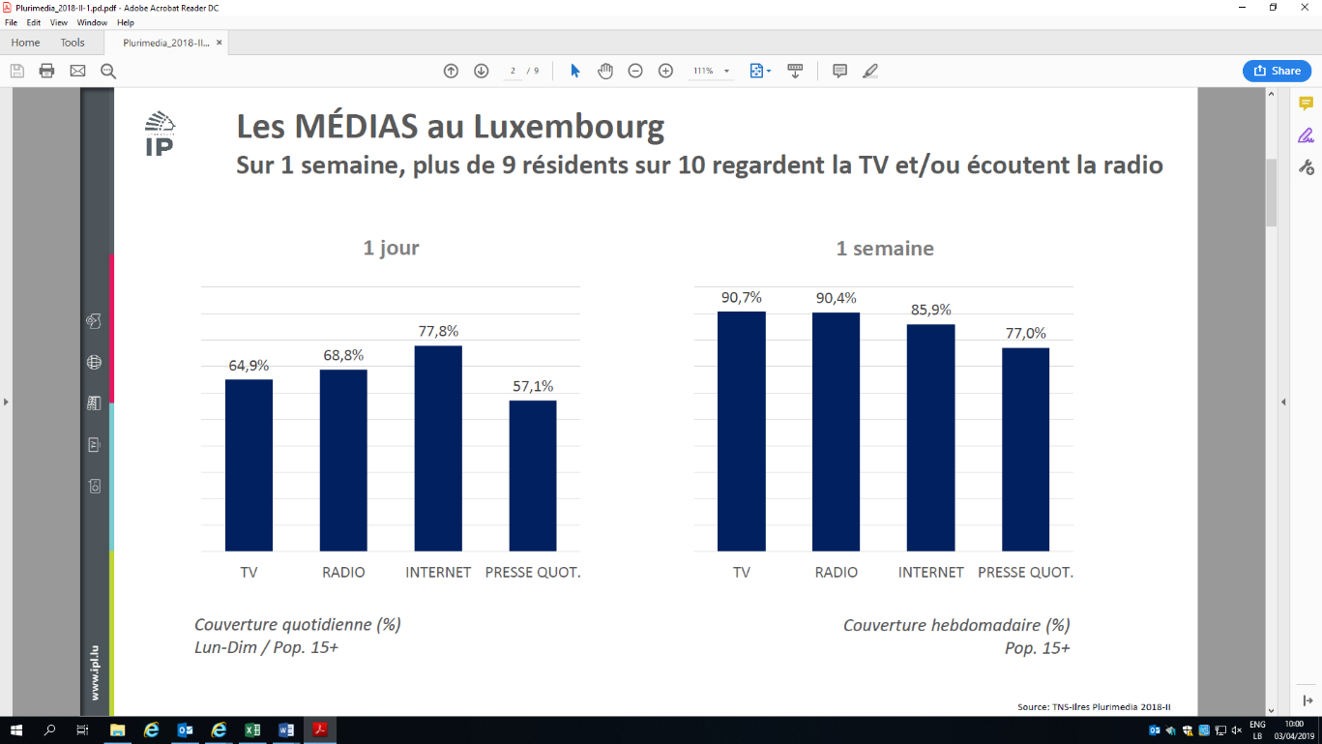

# Graph 6

**Ranking of media outlets in Luxembourg**

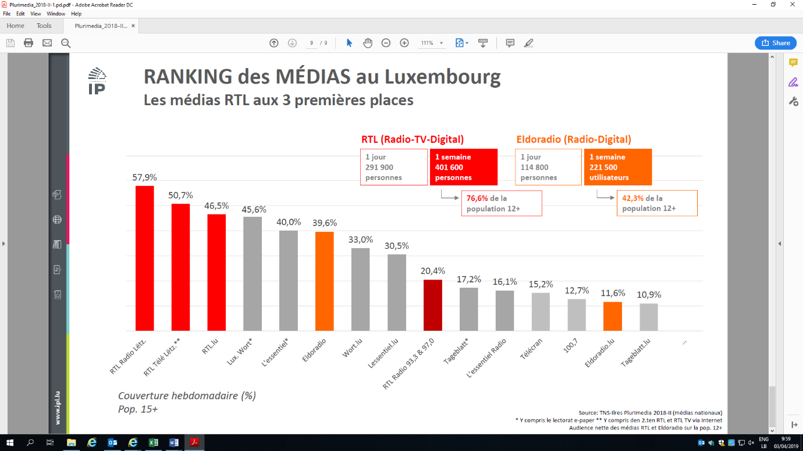

(b) Civil society

105. Pursuant to article 7 of the Act of 9 May 2012 amending the amended Act of 6 January 1996 on development cooperation, non-profit associations and foundations established under the amended Act of 21 April 1928 on non-profit associations and foundations, and whose social purpose includes development cooperation, are granted status as non-governmental development organizations. This status is granted by a minister on the basis of a request from the organization justifying its capabilities, competences and experience in the area of development cooperation and, more particularly, in implementing programmes and projects for the benefit of people living in developing countries. Status is granted for a period of one year and may be renewed. The Ministry of Foreign and European Affairs has approved about 100 non-governmental organizations.

5. Cultural life

106. Cultural life in Luxembourg is incredibly high-quality and diverse. It is multicultural and open to the world, features multilingualism in every area of activity, boasts a multitude of first-rate cultural facilities, and hosts a number of festivals and traditions. The result is a cultural landscape of astounding literary, artistic, architectural and musical diversity which pervades everyday life and which also reflects the rapid and continuing development of the Luxembourg cultural scene. Accordingly, cultural policy is based on a broad definition of the concept of culture and is focused on safeguarding the democratic values of the country’s multicultural society.

107. Situated at the heart of Europe and home to people of more than 170 nationalities, Luxembourg has established itself as a cultural crossroads. Respect, tolerance and openness are distinctive features of culture in Luxembourg, and its multicultural environment offers many opportunities for culture to flourish – and in several languages at that.

108. Given its history and geographical location, Luxembourg has been influenced since the Middle Ages by two major cultures – those of France and Germany. The indigenous cultural scene has nevertheless managed to preserve its special features and identity – a “personal touch” that weaves together past and present. Great importance is attached, for instance, to the Luxemburgish language and literature. However, performances such as plays are staged mainly in their original version, and films are consistently shown in their original version in cinemas.

109. Luxembourg culture gained considerable international recognition during the country’s preparations for 1995, when the City of Luxembourg – listed as a UNESCO World Heritage site since 1994 – was first designated European Capital of Culture. As the only city so far to have had that title bestowed on it twice, Luxembourg made the innovative move of involving the border regions of neighbouring countries when it was named “Luxembourg and Greater Region, European Capital of Culture 2007”. In order to ensure the continued cooperation of all concerned, the cultural authorities of the Grand Duchy of Luxembourg, Saarland, Rhineland-Palatinate, Lorraine and Wallonia (including the French- and German-speaking communities of Belgium) created the Espace Culturel Grande Région association in Luxembourg in 2008. The aim of the association is not only to promote the richness, diversity and originality of the cultural and artistic scene in the Greater Region – the first cross-border region to define and present itself as a common cultural space – but also to increase the mobility of those involved in staging cultural events and audiences, as well as to increase the number of events.

110. Luxembourg also attaches importance to regional cultural development: while the capital plays a prominent role in cultural life, regional cultural provision is equally comprehensive and enables people to participate both actively and passively. Despite its small size, Luxembourg has an impressive number of talented artists and modern cultural sites and facilities, and is home to many local and foreign organizers of cultural events.

111. Culture is an integral part of everyday life, and is enjoyed by consumers and participants alike. The Luxembourg cultural scene, like artistic and creative talent in general and talented young people in particular, enjoys strong public support and encouragement and certainly deserves wider recognition beyond the country’s borders. The international recognition gained by many Luxembourg artists abroad, as reflected in international cooperation projects and partnerships with renowned cultural institutions, highlights the country’s many and varied cultural activities.

II. General framework for the protection and promotion of human rights

A. Acceptance of international human rights norms

1. Status of treaty ratification by Luxembourg

| *Treaty* |  | *Date of signature* | *Date of ratification* |
| --- | --- | --- | --- |
|  |  |  |  |
| Convention against Torture and Other Cruel, Inhuman or Degrading Treatment or Punishment | CAT | 22 Feb. 1985 | 29 Sep. 1987 |
| Optional Protocol to the Convention against Torture and Other Cruel, Inhuman or Degrading Treatment or Punishment | CAT-OP | 13 Jan. 2005 | 19 May 2010 |
| International Covenant on Civil and Political Rights | CCPR | 26 Nov. 1974 | 18 Aug. 1983 |
| Second Optional Protocol to the International Covenant on Civil and Political Rights, aiming at the abolition of the death penalty | CCPR-OP2-DP | 13 Feb. 1990 | 12 Feb. 1992 |
| International Convention for the Protection of All Persons from Enforced Disappearance | CED | 6 Feb. 2007 |  |
| Convention on the Elimination of All Forms of Discrimination against Women | CEDAW | 17 July 1980 | 2 Feb. 1989 |
| International Convention on the Elimination of All Forms of Racial Discrimination | CERD | 12 Dec. 1967 | 1 May 1978 |
| International Covenant on Economic, Social and Cultural Rights | CESCR | 26 Nov. 1974 | 18 Aug. 1983 |
| International Convention on the Protection of the Rights of All Migrant Workers and Members of Their Families | CMW |  |  |
| Convention on the Rights of the Child | CRC | 21 Mar. 1990 | 7 Mar. 1994 |
| Optional Protocol to the Convention on the Rights of the Child on the involvement of children in armed conflict | CRC-OPAC | 8 Sep. 2000 | 4 Aug. 2004 |
| Optional Protocol to the Convention on the Rights of the Child on the sale of children, child prostitution and child pornography | CRC-OPSC | 8 Sep. 2000 | 2 Sep. 2011 |
| Convention on the Rights of Persons with Disabilities | CRPD | 30 Mar. 2007 | 26 Sep. 2011 |

2. Acceptance of individual complaints procedures by Luxembourg

| *Treaty* |  | *Acceptance of individual complaints procedures* | *Date of acceptance* |
| --- | --- | --- | --- |
|  |  |  |  |
| Individual complaints procedure under the Convention against Torture | CAT, art. 22 | Yes | 29 Sep. 1987 |
| Optional Protocol to the International Covenant on Civil and Political Rights | CCPR-OP1 | Yes | 18 Aug. 1983 |
| Individual complaints procedure under the International Convention for the Protection of All Persons from Enforced Disappearance | CED, art. 31 | - |  |
| Optional Protocol to the Convention on the Elimination of All Forms of Discrimination against Women | CEDAW-OP | Yes | 1 July 2003 |
| Individual complaints procedure under the International Convention on the Elimination of All Forms of Racial Discrimination | CERD, art. 14 | Yes | 22 July 1996 |
| Optional Protocol to the International Covenant on Economic, Social and Cultural Rights | CESCR-OP | Yes | 3 Feb. 2015 |
| Individual complaints procedure under the International Convention on the Protection of the Rights of All Migrant Workers and Members of Their Families | CMW, art. 77 | - |  |
| Optional Protocol to the Convention on the Rights of the Child on a communications procedure | CRC-OP-IC | Yes | 12 Feb. 2016 |
| Optional Protocol to the Convention on the Rights of Persons with Disabilities | CRPD-OP | Yes | 26 Sep. 2011 |

3. Acceptance of inquiry procedures by Luxembourg

| *Treaty* |  | *Acceptance of the inquiry procedure* | *Date of acceptance* |
| --- | --- | --- | --- |
|  |  |  |  |
| Inquiry procedure under the Convention against Torture | CAT, art. 20 | Yes | 29 Sep. 1987 |
| Inquiry procedure under the International Convention for the Protection of All Persons from Enforced Disappearance | CED, art. 33 | - |  |
| Inquiry procedure under the Optional Protocol to the Convention on the Elimination of All Forms of Discrimination against Women | CEDAW-OP, arts. 8–9 | Yes | 1 July 2003 |
| Inquiry procedure under the Optional Protocol to the International Covenant on Economic, Social and Cultural Rights | CESCR-OP, art. 11 | - |  |
| Inquiry procedure under the Optional Protocol to the Convention on the Rights of the Child on a communications procedure | CRC-OPIC, art. 13 | Yes | 12 Feb. 2016 |
| Inquiry procedure under the Optional Protocol to the Convention on the Rights of Persons with Disabilities | CRPD-OP, arts. 6–7 | Yes | 26 Sep. 2011 |

B. Legal framework for the protection of human rights

112. Any dispute that originates in a human rights violation listed in national legislation or in one of the international covenants or conventions to which Luxembourg is a party may be brought before the national courts. The subject of the dispute determines the competent court. The formal context guaranteeing respect for human rights and fundamental freedoms, that is, the working of the judicial system of Luxembourg, has already been discussed in the section on national courts and tribunals. We shall therefore not deal with it again here.

1. Main constitutional guarantees of human rights and fundamental freedoms

113. The Constitution of Luxembourg, which is a “rigid” written Constitution, guarantees the rights of citizens. The relatively large number of articles in the Constitution devoted to the rights and freedoms of citizens of Luxembourg highlights the importance attached, in the organization of the State, to the free development of individuals and their protection vis-à-vis those in authority. This is especially significant as in Luxembourg the Constitution prevails over any other national rule of law. In the event of conflict, therefore, the Constitution sets aside any incompatible national rule.

114. Specifically, the Constitution guarantees the following 15 public rights to all citizens and, in principle, to all aliens residing on the territory of the Grand Duchy:

* Equality before the law
* Individual freedom
* Inviolability of the domicile
* Inviolability of property
* Freedom of opinion
* Freedom of the press
* Inviolability of correspondence
* Right of petition
* Freedom of worship
* Freedom of assembly
* Freedom of association
* Right to public education
* Right to institute proceedings against public officials
* Right to employment and social security
* Freedom of trade and industry.

115. Furthermore, all citizens are entitled to forbid anyone access to their residence. No residence may be searched except in the cases established by law and in the forms prescribed by it. Freedom of opinion and freedom of the press are guaranteed, except for abuses such as encouragement to commit crimes or offences and attacks upon a person’s honour or the reputation of others.

116. The Constitution guarantees freedom of religion and worship, as well as the freedom to manifest one’s religious opinions. It also guarantees freedom of conscience by stating that no one may be compelled to take part in any way in the acts and ceremonies of a religion, or to observe its days of rest.

117. Primary education is compulsory and free of charge. The Constitution makes it obligatory for the State to set up free secondary education establishments and the requisite higher education programmes.

118. Finally, the Constitution does not merely protect paid work and trade union freedoms, but generally safeguards all occupations, trade, industry, independent professions and agricultural work. It also compels the legislature to organize social security, health protection and workers’ time off.

119. Since the Constitution may be revised only by a very strict procedure (dissolution and the convening of a new Chamber, vote by a two-thirds majority), the guarantees it confers in the field of human rights are sufficiently protected.

2. Scope of treaties, covenants and protocols

120. International instruments are self-executing and do not require implementing regulations, unless their terms expressly state the contrary. Consequently, they directly confer rights and obligations on the subjects of national sovereignty and may, without any other action, be implemented by the country’s administrative courts and courts of law. Disregard of them by a domestic court opens the way for an appeal.

121. With respect to the relationship between international law and national law, it is a generally established principle that international law has priority over national law; in other words, international treaties take precedence over laws and all other provisions of national law. However, prior to the conclusion of international treaties, every effort is made to ascertain whether their substance is in conformity with existing domestic law. If that is not the case, national legislation is adopted prior to ratification of the treaty. The provisions of the Constitution ensure that the internal implementation of treaties is equated with the implementation of laws. Implementation measures are based on the provisions of the treaty. The treaty prevails over national law, even a subsequent law, because the treaty derives from a higher source than the will of an internal body. Specifically, therefore, the covenants of concern to us form part of the positive law of Luxembourg with effect from the time of their ratification.

3. Judicial penalties

122. In Luxembourg, no one may be prosecuted save in the cases provided for by law and following the form prescribed by law. No one may be arrested or detained other than in cases provided for by law and following the form prescribed by it, and no one may be arrested, apart from in cases of flagrante delicto, other than on the basis of a reasoned court order, which must be served on the person concerned. Every person must be informed without delay of the legal remedies available to help them regain their freedom. The law determines in advance which court will be competent to hear civil or criminal cases, either by reason of the residence of the parties or by reason of the acts to be tried. No one may be reassigned against his or her will from the jurisdiction of the court designated by law. No penalty may be handed down or applied except under the law.

C. Framework within which human rights are promoted at the national level

1. National human rights institutions

(a) Office of the Ombudsman

123. The Office of the Ombudsman was set up on 1 May 2004 pursuant to the Ombudsman Act of 22 August 2003.

124. The Office of the Ombudsman is an independent body that does not receive instructions from any authority. It is not answerable to either the administrative authorities or the Government.

125. The Office was established as part of an administrative reform aimed at bringing the authorities closer to the people and improving relations between citizens and the authorities.

126. The Ombudsman is appointed for a non-renewable eight-year term by a simple majority of the Chamber of Deputies. He or she must be a Luxembourg national, hold a university degree and be proficient in the country’s three languages.

127. The Office of the Ombudsman receives complaints from natural and legal persons, on matters affecting them, in relation to the functioning of the State and communal authorities.

128. It balances the different viewpoints, questions the authorities concerned, consults the necessary documents and meets with the officials responsible in the situation in question. If appropriate, the Office may transmit its recommendations to the authorities concerned with a view to reaching an amicable solution to the dispute.

129. This free service is aimed at strengthening citizens’ confidence in democracy and institutions. Citizens may submit their claims directly to the Office or indirectly, through a member of the Chamber of Deputies. The Ombudsman is regarded as the representative of citizens.

130. The Office of the Ombudsman is also designated as the national preventive mechanism in accordance with article 3 of the Optional Protocol to the Convention against Torture and Other Cruel, Inhuman or Degrading Treatment or Punishment. In this capacity, it is responsible for the external monitoring and assessment of places where persons are deprived of their liberty on the national territory.

(b) Ombudscomité fir d’Rechter vum Kand

131. A Luxembourg committee on the rights of the child known as the Ombudscomité fir d’Rechter vum Kand was established by the Act of 25 July 2002. The Ombudscomité is an independent and neutral committee responsible for implementing and promoting the Convention on the Rights of the Child, which was ratified by Luxembourg in 1993.

132. The duties of the Ombudscomité are to:

* Examine the mechanisms established to protect and promote the rights of children, with a view to recommending adjustments, where appropriate, to the competent authorities
* Issue opinions on laws and regulations, including in draft form, concerning the rights of the child
* Investigate the situation of children and ensure the implementation of the Convention on the Rights of the Child
* Submit to the Government and the Chamber of Deputies an annual report on the situation of children’s rights and on its own activities
* Promote the development of children’s freedom of expression and their active participation in matters that concern them
* Examine situations in which the rights of children are not respected and make recommendations to remedy such situations
* Receive information and complaints concerning violations of children’s rights and, in accordance with procedures which it shall determine, hear any child who requests a hearing
* Issue, on the basis of information or complaints or in connection with particular cases that it has investigated, recommendations or advice designed to better protect the rights and interests of children

133. The Ombudscomité is composed of six members appointed by the Grand Duke; gender parity is observed in the selection of the chair and vice-chair. They serve a five-year term, which may be renewed once. The members of the Ombudscomité are appointed on the basis of their expertise in the area of children’s rights.

134. The members of the Ombudscomité are completely neutral and independent in the discharge of their duties.

135. In the exercise of their duties and within the limits set by laws and regulations, Ombudscomité members have free access to the facilities of all public and private organizations that offer residential or non-residential care for children, or that examine, assist, guide, train or work with them. They are entitled to request any information or document, except for those subject to medical confidentiality or any other form of professional confidentiality. However, they may not intervene in judicial proceedings.

(c) Centre for Equal Treatment

136. The Centre for Equal Treatment was set up under the Act of 28 November 2006. It operates independently with the aim of promoting, analysing and monitoring equal treatment for all persons without discrimination on grounds of race, ethnic origin, sex, religion or belief, disability or age.

137. In fulfilling its mandate, the Centre performs a number of functions, including:

* Publishing reports, issuing opinions and recommendations and undertaking studies on all matters related to discrimination
* Producing and providing any information and documentation relating to its mandate
* Providing assistance to persons who consider themselves to be victims of discrimination by offering advice and guidance designed to inform them of their individual rights, legislation, jurisprudence and available remedies

138. The Centre is composed of a collegiate body of five members, including the chair. The chair and the other members each serve a five-year term. They are appointed by the Head of State at the recommendation of the Chamber of Deputies on the basis of their expertise in the promotion of equal treatment. The Centre submits a comprehensive annual report on its activities to the Government and the Chamber of Deputies.

(d) Advisory Commission on Human Rights

139. The Act of 21 November 2008 on the establishment of an Advisory Commission on Human Rights in the Grand Duchy of Luxembourg conferred legal status on the Commission, which has the same formal rank as the Office of the Ombudsman, the Ombudscomité fir d’Rechter vum Kand and the Centre for Equal Treatment.

140. The duties of the Advisory Commission on Human Rights are set out in a new law, under which:

* The Government must seek the opinion of the Advisory Commission on all human rights projects.
* The Advisory Commission may, on its own initiative, examine any issues it deems appropriate.
* The Government must transmit the opinions of the Advisory Commission on draft legislation to the Chamber of Deputies and the Council of State; this gives the opinions the status of a parliamentary document. In its deliberations, the parliamentary committee examining a bill takes into account the proposals made by the Advisory Commission with regard to the bill.

2. Dissemination of human rights instruments

141. The Government regularly informs the public of the submission of periodic reports, mainly through press releases issued to all the media.

3. Raising human rights awareness among public officials and other professionals

142. Article 10 of the Civil Service Code on the duties of civil servants provides that civil servants “… must behave with dignity and civility both in their dealings with their superiors, colleagues and subordinates and in their dealings with the users of their services, whom they are to treat with understanding, thoughtfulness and without any discrimination”. Before taking office, civil servants must also take an oath stating that they will perform their duties with integrity, precision and impartiality.

143. The Training Institute of National Education is continually striving to offer training to support teachers in their interaction with others, whether it is support for language learning or specific information on issues, such as traumas and challenges faced by certain categories of students who have recently arrived, among others. These courses are offered both as part of initial training and as continuous learning. In addition, the Office of Education for Foreign Children participates in specific events to raise the awareness of school staff in particular on the importance of intercultural communication.

144. The basic training of probationary police officers from the B1, C1 and C2 forces was modified in 2018. The “Police and Society” module is still part of the curriculum. It consists mainly of the study of the police’s interactions with citizens at the legal and regulatory level (human rights and individual freedoms) and also in terms of professional standards and intercultural sensitivity. The module currently includes the following courses:

* Human rights (10 hours)
* Constitution and public freedoms (18 hours)
* Constitutional principles, fundamental rights and civil liberties (12 hours)
* Rights and duties of public officials (14 hours)
* Professional standards for the police and efforts to combat extremism/fanaticism (14 hours)
* Victimology (12 hours)

145. The Act of 18 July 2018[[4]](#footnote-5) on the General Police Inspectorate provides in its article 10 (3) “that [the General Police Inspectorate] shall participate in the training of members of the police in professional standards and human rights”.

146. Non-governmental associations that are active in areas such as immigration and that work with different cultures (for instance, the Support Association for Migrant Workers and the Foreigners’ Action and Liaison Committee) regularly give lectures about their work and train police officers in intercultural sensitivity. These sessions may be organized as initial or continuous training.

4. Promotion of human rights awareness through educational programmes and Government-sponsored public information

147. In 2016, a new course, entitled “Life and Society”, was added to the school curriculum. Among its key objectives is the promotion of tolerance based on understanding. This understanding is meant to cover the plurality of lifestyles, cultures and religions and the values and beliefs, with a view to mitigating the effects that ignorance can have on radical or dogmatic positions regarding other cultures or groups of people. The Universal Declaration of Human Rights is an integral part of the “Life and Society” course.

5. Development cooperation and assistance

148. The government programme issued in December 2013 provides for robust, proactive action in the area of development cooperation, in particular by maintaining the rate of 1 per cent of gross national income devoted to official development assistance for the period 2014–2018.

149. For 2018, the budget allocated to official development assistance is €400.3 million, some 83 per cent of which is managed by the Ministry of Foreign and European Affairs. The development cooperation funds, through which some 56 per cent of official development assistance is channelled, finance bilateral and multilateral cooperation activities, initiatives led by non-governmental development organizations and the deployment of volunteers, associate experts, young experts, cooperation officers, trainees and fellows in the service of development cooperation. The ratio between bilateral and multilateral cooperation within official development assistance has been around 70/30 per cent for several years.

150. Luxembourg’s official development assistance consists solely of donations and is untied. However, public aid often serves as a catalyst for mobilizing other funds, including from the private sector.

151. In order to maximize the impact of its cooperation programme, Luxembourg continues to pursue a policy of targeted intervention in a limited number of key partner countries. Five of these countries are in sub-Saharan Africa (Burkina Faso, Cabo Verde, Mali, the Niger and Senegal); one is in Central America (Nicaragua); and one is in South-East Asia (Laos). Bilateral aid is channelled mainly to the least developed countries. Thus, in 2016, two former partner countries, which had graduated to the category of middle-income countries, ceased to benefit from multi-annual Indicative Cooperation Programmes. The cooperation programme of Luxembourg nevertheless maintains a presence in these countries – El Salvador and Viet Nam – in order to consolidate its activities and promote a transition towards other forms of cooperation.

152. In September 2018, the Government of Luxembourg approved the country’s new comprehensive strategy for cooperation, which incorporates a needs-based approach and is designed to address the new development cooperation context. The main objective is to contribute to the reduction and eventual eradication of extreme poverty by providing support for sustainable economic, social and environmental development.

153. To achieve this objective, Luxembourg continues to promote a multi-stakeholder approach to the implementation of the 2030 Agenda for Sustainable Development and the achievement of the related Sustainable Development Goals. Alongside gender equality and environmental sustainability, human rights are one of the three cross-cutting priorities.

154. In order to contribute effectively to the collective commitment to “leave no one behind” and to work towards the achievement of the Sustainable Development Goals, official development assistance will be focused on four thematic priorities: improving access to high-quality basic social services, enhancing the socioeconomic integration of women and young people, promoting inclusive and sustainable growth and strengthening inclusive governance.

155. The coalition agreement concluded in December 2018 is a continuation of the 2013 agreement. The commitment to continue to allocate one per cent of the gross national income to official development assistance is reaffirmed in the agreement.

D. Reporting process at the national level

156. In June 2015, the Government in council decided to establish an Interministerial Human Rights Committee with responsibility for the ongoing coordination of its work of monitoring the implementation of international human rights law in Luxembourg, including by submitting regular reports to the treaty bodies of the United Nations system. The Interministerial Committee holds working sessions every six to eight weeks, bringing together representatives of all ministries and administrative authorities concerned with human rights. Each session is followed by a consultation meeting with civil society and national human rights institutions. The Committee also monitors the implementation of the recommendations made under the universal periodic review of the Human Rights Council. The work of the Interministerial Committee is coordinated by the Ministry of Foreign and European Affairs, and its meetings are chaired by the Ambassador-at-Large for Human Rights.

III. Information on non-discrimination and equality

157. With a view to emphasizing the importance attached to the principle of equality and non-discrimination, many laws in Luxembourg contain specific provisions that reiterate the prohibition of all forms of discrimination.

158. In criminal matters, the main legal provision on combating discrimination is article 454 of the Criminal Code, which was introduced by the Act of 19 July 1997[[5]](#footnote-6) and which contains an exhaustive list of all forms of discrimination, including on the basis of origin, skin colour, sex or age.

159. In addition, the concept of “gender identity” was added to article 454 of the Criminal Code by the Act of 20 July 2018, approving the Council of Europe Convention on Preventing and Combating Violence against Women and Domestic Violence (Istanbul Convention).[[6]](#footnote-7)

160. Article 455 of the Criminal Code sets out the applicable penalties for the various forms of discrimination.

161. In addition to the Criminal Code, other national laws also deal with discrimination.

162. Firstly, the Act of 28 November 2006 on equal treatment, which transposes European Council Directive 2000/43/EC of 29 June 2000 into national law, defines and promotes the principle of equality by prohibiting any direct or indirect discrimination based on religion or belief, sex or sexual orientation.[[7]](#footnote-8)

163. Secondly, the Act of 16 December 2008 on the Reception and Integration of Foreign Nationals in the Grand Duchy of Luxembourg gives the Luxembourg Reception and Integration Agency legal powers to combat all forms of discrimination and provides for the establishment of a National Integration and Anti-Discrimination Action Plan.[[8]](#footnote-9) A range of anti-discrimination projects were launched under the first Action Plan, which was published in November 2010 and focused on four areas of action, namely reception, integration, action against discrimination and migration monitoring.[[9]](#footnote-10) In the new National Integration Action Plan adopted in July 2018, the fight against discrimination, the promotion of diversity and equal opportunities have been integrated into all the areas of action.[[10]](#footnote-11)

164. Since 2002, the Luxembourg Reception and Integration Agency has been operating a programme of information and awareness-raising activities to combat discrimination.

165. These activities are supported by the PROGRESS community programme and are designed to combat discrimination within the meaning of article 19 of the Treaty on the Functioning of the European Union, namely discrimination based on religion or belief, disability, age, sexual orientation or racial or ethnic origin.

166. Since its creation, the Reception and Integration Agency has represented the Grand Duchy of Luxembourg in the Governmental Expert Group on Non-Discrimination.

167. In order to encourage associations and public and private companies in Luxembourg to promote diversity, the Luxembourg Charter for Diversity was launched in 2012.

168. The Charter operates at the national level and is supported, by the Union of Luxembourg Enterprises and other employers’ associations, the American Chamber of Commerce Luxembourg and business networks, as well as by the European Commission, the Ministry of Family Affairs, Integration and the Greater Region, the Ministry of Equality between Women and Men and the Centre for Equal Treatment.

169. In order to monitor the Inspiring More Sustainability project launched under the Charter, the Government has set up a Luxembourg Charter for Diversity Committee composed of the following key partners: Deutsche Bank, the Luxembourg Reception and Integration Agency, PricewaterhouseCoopers, RBC Investor & Treasury Services and Sodexo.[[11]](#footnote-12) The Committee steers the project and collaborates with two working groups composed of representatives from 10 different entities, including public institutions and companies.

170. In order to promote diversity within companies and among the general public, since 2012, the Luxembourg Charter for Diversity Committee has organized a national Diversity Day. The event aims to bring together companies, public entities and associations to promote diversity.

171. In addition to its direct anti-discrimination efforts, the Government is implementing an equal opportunities policy through its integration programmes. In order to place the integration of applicants for international protection at the heart of its reception policy, the Government has developed the Supported Integration Programme. This Programme lays the groundwork for the integration of persons who are applying for or who have been granted international protection, beginning in the first weeks after they arrive in Luxembourg. The Programme is based on the principle that there are two prerequisites for well-planned integration: learning the country’s national and administrative language and understanding how everyday life works in Luxembourg. In order to promote the social and professional integration of all persons seeking international protection, it is imperative that all adults in that category are able to attend information and training sessions, irrespective of their age and level of education.

172. Lastly, staff from the Luxembourg Reception and Integration Agency have taken a large number of training courses on preventing all forms of discrimination, including courses on cultural, sexual and gender diversity, the Arab world and diversity management.

173. With regard to equality between women and men, in the legal sphere the 2006 constitutional amendments anchored equality between women and men in the Constitution. There have also been legal reforms concerning parity in lists for European and national elections (Act of 15 December 2016),[[12]](#footnote-13) domestic violence (2003,[[13]](#footnote-14) 2013[[14]](#footnote-15) and 2018[[15]](#footnote-16)) and violence against women in general (ratification of the Istanbul Convention in 2018,[[16]](#footnote-17) criminalizing all forms of violence against girls and women), and equal treatment in access to and supply of goods and services (2012).[[17]](#footnote-18) In addition, the Labour Code has been amended to guarantee equal pay, combat sexual harassment and encourage companies to promote equality between women and men in the workplace, including through participation in the positive actions programme.[[18]](#footnote-19)

174. Article 26 bis of the amended Act of 27 July 1991[[19]](#footnote-20) on electronic media provides that “audiovisual and sound media services shall not feature any incitement to hatred based on race, sex, opinion, religion or nationality”. Article 27 bis (1) (d) of the same Act stipulates that commercial communications must not feature “any discrimination based on sex, racial or ethnic origin, nationality, religion or belief, disability, age or sexual orientation”.

175. In 1991, Luxembourg introduced binding legislation to combat sexist discrimination in the media and advertising. Article 26 bis of the amended Act of 27 July 1991 on electronic media provides that “audiovisual and sound media services shall not feature any incitement to hatred based on race, sex, opinion, religion or nationality”. Article 27 bis of the same Act states that commercial communications may not offend human dignity or feature any discrimination based on sex, racial or ethnic origin, nationality, religion or belief, disability, age or sexual orientation.

176. In addition to the amended Act of 8 June 2004 on freedom of expression in the media, the Press Council has drawn up a code of conduct that applies to all actors in the Luxembourg press and to all media. Article 5 of the Act specifies that the press must avoid and must oppose any discrimination on grounds of sex, race, nationality, language, religion, ideology, ethnic origin, culture, class or belief, while ensuring respect for fundamental human rights. Thus, the press has undertaken to indicate a person’s racial, religious, national or ethnic origins only when this information is essential for understanding the facts or when there is a direct link with the information.

177. In 2013, Luxembourg created the Luxembourg Independent Media Authority, a public institution responsible for monitoring the proper application of current regulations in the area of audiovisual media. Listening to radio and television audiences is one of the priorities of the Luxembourg Independent Media Authority. Thus, any natural or legal person who considers himself or herself aggrieved by the content of a service may lodge a complaint with the Authority insofar as the content undermines the protection of minors or human dignity or contains pornographic elements. In the interest of transparency, the Authority publishes all decisions taken by the Board on its website.

1. \* The present document is being issued without formal editing. [↑](#footnote-ref-2)
2. The fertility rate measures the number of children a woman would have over the course of her lifetime if the fertility rates observed in the year under review at each age remained unchanged. [↑](#footnote-ref-3)
3. Calculated on the basis of the theoretical monthly average number of dropouts until the end of their schooling. This number has been extrapolated based on actual current dropout rates. [↑](#footnote-ref-4)
4. Act of 18 July 2018 on the Grand-Ducal Police: http://data.legilux.public.lu/eli/etat/leg/loi/2018/07/18/a621/jo. [↑](#footnote-ref-5)
5. Act of 19 July 1997: http://legilux.public.lu/eli/etat/leg/loi/1997/07/19/n1/jo. [↑](#footnote-ref-6)
6. Act of 20 July 2018: http://data.legilux.public.lu/eli/etat/leg/loi/2018/07/20/a631/jo. [↑](#footnote-ref-7)
7. Act of 28 November 2006: http://data.legilux.public.lu/eli/etat/leg/loi/2006/11/28/n1/jo. [↑](#footnote-ref-8)
8. Act of 16 December 2008: http://data.legilux.public.lu/eli/etat/leg/loi/2008/12/16/n5/jo. [↑](#footnote-ref-9)
9. http://www.olai.public.lu/fr/publications/programmes-planactions-campagnes/plan/07-olai\_plan\_daction\_fr.pdf. [↑](#footnote-ref-10)
10. http://www.olai.public.lu/fr/actualites/2018/07/pan/PAN-integration.pdf. [↑](#footnote-ref-11)
11. http://www.chartediversite.lu/. [↑](#footnote-ref-12)
12. Act of 15 December 2016: <http://data.legilux.public.lu/eli/etat/leg/loi/2016/12/15/n2/jo>. [↑](#footnote-ref-13)
13. Act of 8 September 2003 on domestic violence: [http://data.legilux.public.lu/eli/etat/leg/loi/2003/09/08/n1/jo.](http://data.legilux.public.lu/eli/etat/leg/loi/2003/09/08/n1/jo.%20)  [↑](#footnote-ref-14)
14. Act of 30 July 2013 amending the Act of 8 September 2003: <http://data.legilux.public.lu/eli/etat/leg/loi/2013/07/30/n1/jo>. [↑](#footnote-ref-15)
15. Act of 20 July 2018 approving the Council of Europe Convention on Preventing and Combating Violence against Women and Domestic Violence, signed in Istanbul on 11 May 2011: [http://data.legilux.public.lu/eli/etat/leg/loi/2018/07/20/a631/jo.](http://data.legilux.public.lu/eli/etat/leg/loi/2018/07/20/a631/jo.%20)  [↑](#footnote-ref-16)
16. Council of Europe Convention on Preventing and Combating Violence against Women and Domestic Violence <https://rm.coe.int/090000168008482e>. [↑](#footnote-ref-17)
17. While the Convention is focused on all forms of violence against women, it explicitly recognizes that domestic and other violence also affects male victims. The Convention therefore encourages States to apply its provisions to male victims as well. As its legislation is generally gender-neutral, Luxembourg applies the Convention to both sexes. [↑](#footnote-ref-18)
18. Positive actions programme: http://mega.public.lu/fr/travail/programme-actions-positives/index.html. [↑](#footnote-ref-19)
19. Act of 27 July 1991: http://data.legilux.public.lu/eli/etat/leg/loi/1991/07/27/n1/jo. [↑](#footnote-ref-20)