Committee on the Elimination of Discrimination   
against Women

Pre-session working group

Fortieth session

14 January-1 February 2008

Responses to the list of issues and questions with regard   
to the consideration of the fifth periodic report

Luxembourg*

* The present report is being issued without formal editing.

Committee on the Elimination of Discrimination against Women

Fifth periodic report of Luxembourg (CEDAW/C/LUX/5)

Responses to the Committee’s list of issues and questions

(CEDAW/C/LUX/Q/5)

Pre-session working group

Fortieth and forty-first sessions

16-20 July 2007

Preliminary comments

– Requests for additional information should be addressed to Ms. Maddy Mulheims, Government Counsellor First Class, Ministry of Equal Opportunity, Tel. +352 2478 58 10, maddy.mulheims@mega.etat.lu.

– In order to make this document more understandable and readable, tables containing statistical data supporting the presentation have been integrated into the text. The Committee’s questions have been retained in the text for the same reason.

General matters, Constitution, laws and reservations

1. *Please provide information on the process of preparing the report. Please indicate, in particular, whether consultations were held with non-governmental organizations and women’s groups and whether it was presented to Parliament or any designated high-level authority.*

As indicated in paragraphs 4 and 5 of the report, the Government, in its declaration of 4 August 2004, provided under the topic heading “Gender equality” that, in the preparation of the country’s fifth periodic report, hearings would be held with non-governmental organizations, the Commission on the Family, Equal Opportunity and Youth of the Chamber of Deputies, the National Council of Women of Luxembourg (CNFL) and the Committee on Female Employment (CTF) in order to raise awareness and involve all relevant stakeholders. The fifth periodic report would be supplemented by a National Plan of Action on Gender Equality that would set policy goals for gender equality in the areas of equal treatment, access to the labour market, representation of women in political life, support structures, domestic violence, social rights and education. Efforts to promote gender equality would not be confined to implementing special measures for women but would expressly mobilize to that end all general initiatives and policies, since equality policy concerns women and men alike.

Following its adoption by the Council of Government, the draft report prepared in cooperation with the ministries concerned was submitted to the Commission on the Family, Equal Opportunity and Youth of the Chamber of Deputies.

Thereafter, on 6 March 2006, the Ministry of Equal Opportunity and the Commission on the Family, Equal Opportunity and Youth of the Chamber of Deputies held a seminar on the fifth periodic report and the National Plan of Action on Gender Equality. The aim of the seminar, which drew 102 participants —   
82 women and 20 men — was to discuss the National Plan of Action on Gender Equality, to supplement it and to involve men and women stakeholders in its implementation.

In addition to non-governmental organizations, CNFL and CTF, invitations were extended to employers’ organizations, trade unions, the Association of Luxembourg Cities and Municipalities (Syvicol) and the ministerial advisory bodies that play an important role in ensuring the Plan’s implementation at all levels of society.

The seminar was organized into five thematic workshops dealing with the   
12 themes of the National Plan of Action. The workshop reports were discussed by the parliamentary commission. The discussions covered, inter alia, the Law on the naming of children, the incorporation of gender equality into article 11 of the Constitution, gender budgeting, the use of gender-neutral terms in civil service language relating to the names of occupations, titles and functions, succession to the throne of the House of Nassau, the implementation in Luxembourg of several European directives, municipal policies, education and training.

The seminar discussions enabled the Chamber of Deputies to gather the information necessary for a parliamentary debate on gender equality policy and for identifying action that it might take.

2*. In its previous concluding comments, the Committee expressed its concern about Luxembourg’s reservations to articles 7 and 16(1) (g) of the Convention (A/58/38 (Part 1), para. 300). After the adoption of the Law of 23 December 2005 on the naming of children, please provide information about a timetable for withdrawal of the reservation to article 16(1) (g) (para. 26). Please also indicate what efforts are taking place, including a timetable, to withdraw the reservation to article 7.*

At the 17 February 2006 meeting of the Council of Government, following adoption of the fifth periodic report on the implementation of the Convention, the Government decided to withdraw the reservations entered by Luxembourg to articles 7 and 16 of the Convention. The adoption of the Law of 23 December 2005 on the naming of children makes it possible to withdraw the reservation to article 16. Work is under way with a view to withdrawing the reservation to article 7. The Commission of Institutions and Constitutional Revision of the Chamber of Deputies will then, during the 2007-2008 parliamentary session, submit a proposed constitutional amendment to, inter alia, article 3 of the Constitution concerning transmission of the crown of the Grand Duchy.

The Grand Duke has instructed his services to prepare a revision of the family compact concerning the order of succession to the throne.

Notification of the withdrawal of the two reservations will take place as soon as possible.

3. *The report states that the revision of article 11 of the Constitution, which is intended to include gender equality in the text of the Constitution, has been under way since 1999 (para. 15). The report further states that the new text will be put before the Chamber of Deputies shortly. Please indicate the reasons for the long delay in passing the law and what obstacles, if any, the bill is now likely to face before the Chamber of Deputies.*

On 16 March 2006, the Chamber of Deputies adopted in first reading the new text for article 11 (2) of the Constitution, which reads as follows: “Women and men are equal in rights and duties. The State shall actively promote the elimination of such obstacles as may exist with respect to gender equality”. The text was adopted by Parliament in second reading on 21 June 2006.

4*. Please provide further information on the court cases mentioned in paragraph 6 of the report regarding articles 11 and 16 of the Convention. Please state when the decisions were made and provide details of the reasoning of the courts.*

There has been no new case-law on the matter since 2002.

5. *Please provide information on any training programmes on the Convention and the Optional Protocol that are taking place or have been undertaken for Government officials, the police, judges and prosecutors, and their impact. Please indicate whether such training is systematic and/or a mandatory requirement.*

The conference “The CEDAW Convention Today” (“L’Actualité de la Convention CEDAW”) to mark the twenty-fifth anniversary of the Convention and the Optional Protocol, which had been scheduled for 25 November 2004, was cancelled due to lack of interest. The Government’s commitment to implementing the Convention is a component of training on the mainstreaming of a gender dimension in the work of ministry officials and employees and members of gender competency groups.

The measures envisaged in the National Plan of Action on Gender Equality include the following training module under the responsibility of the Ministry of Justice (see chapter 2, Education and training, of the National Plan of Action on Gender Equality): “Proactive awareness-raising for personnel of the judiciary, police and correctional institutions.”

Temporary special measures

6*. The report provides little information on temporary special measures, covered under article 4, paragraph 1, of the Convention. Please provide updated information on whether temporary special measures, including the use of quotas or incentives, are in place to increase the number of women and girls in all sectors and the nature and impact of these measures in accordance with article 4, paragraph 1, of the Convention and the Committee’s General Recommendation 25.*

In addition to the special measure in the Grand Ducal Regulations of   
21 December 2004 authorizing priority recruitment of female candidates for prison guard positions below the NCO level (see paragraph 50), measures in favour of the underrepresented sex in the sphere of employment may be considered temporary special measures in keeping with the aim of article 4 of the Convention.

New measures to promote the employment of young people have been in effect since 2 July 2007. In particular, the old “stage d’insertion” (internship of integration into professional life) has been replaced by a new “contrat d’initiation à l’emploi” (CIE) or “job traineeship contract” concluded between the sponsor enterprise, the young person and the Employment Administration. Its purpose is to provide the young person with practical training during working hours to facilitate entry into the labour market. The job traineeship contract is reserved for sponsor enterprises that can offer the young person a real prospect of employment at the end of the contract. The sponsor enterprise receives from the Employment Fund (Fonds pour l’emploi) a monthly reimbursement of 50 per cent of the pay received by the young person, as well as the employer’s share of social security contributions. In the case of persons of the underrepresented sex in the sponsor’s industry or field, the reimbursement is set at 65 per cent.

Measures for implementing provisions regarding the underrepresented sex are also provided for by law (Labour Code, Book II, Chapter II). The sex deemed to be underrepresented in a given occupation or trade is that which accounts for   
40 per cent or less of the total number of workers engaging in that occupation or trade in the national territory.

An employer wishing to hire a person of the underrepresented sex may obtain partial reimbursement from the Employment Fund for that purpose. In order for these measures to apply, the employer is authorized to disseminate or publish job offers or advertisements giving priority to the underrepresented sex. Moreover, in order to ensure full wage equality between men and women, the employer may provide specific advantages to facilitate the pursuit of an occupational activity by workers of the underrepresented sex that he has hired or to eliminate or offset disadvantages in the pursuit of those workers’ careers.

Training for job seekers re-entering the labour market, with or without pay:   
a training programme for job seekers re-entering the labour market, comprising alternating periods of practical and theoretical training, may be proposed by the Employment Administration for job seekers aged 30 or over who registered with its job placement offices for at least three months. The firm pays an amount equivalent to 50 per cent of the minimum wage for unskilled workers to the Employment Fund. In the case of job seekers of the underrepresented sex, the amount paid by the firm is reduced to 35 per cent of the wage received by the trainees.

The Labour Code also provides for affirmative action, namely, measures to create specific advantages to facilitate the pursuit of an occupational activity by the underrepresented sex or to eliminate or offset disadvantages in the pursuit of a career.

The measures envisaged in this regard are:

1. Implementing a new organization of work;

2. Specific recruitment measures before and/or after hiring;

3. Special training activities;

4. Measures pertaining to changes of occupation;

5. Action pertaining to promotion;

6. Action designed to facilitate access by members of the underrepresented sex to positions of responsibility or decision-making positions;

7. Measures designed to achieve a better balance between family life and work.

The affirmative action must form part of a firm’s equality plan (except in the public sector) (see para. 196 to 200 of the fifth periodic report of Luxembourg).

Entitled “National Plan for Innovation and Full Employment”, the national reform plan adopted in 2005 is a strategy document guiding public policies for the years 2005 to 2008 in these areas. It forms part of an overall vision of sustainable development articulating environmental, social and economic elements in the tradition of the Luxembourg social model.

With respect to the section of the Luxembourg report on employment policies, such policies should go hand in hand with gender equality policies.

The envisaged reforms form part of the philosophy underlying the national reform plan 2005-2008, the main outcomes of which concern the following:

– Childcare facilities for schoolchildren outside of school hours (implementation of the “drop-in centre” (“maison relais”) approach);

– Continuing efforts to close the wage gap between men and women and affirmative action in private sector firms (the female employment rate is rising steadily);

– Framework agreement between employers’ organizations and trade unions on telecommuting;

– Gradual implementation of the lifelong-learning strategy (raising the level of basic training and skills of the adult population, responding to the labour market’s needs for skills and training, making the workplace a place of learning, creating or developing places of learning to encourage basic training, encouraging the social and vocational integration of disadvantaged and poorly qualified people);

– Provision of quality education and training (adapting education and training systems to new needs with regard to skills).

Moreover, actions funded by the European Social Fund are aimed at fostering a high level of employment and equality between men and women (Axis 4 — Equal opportunities for men and women).

The national reform plan measures described above contribute to increasing women’s participation in the labour market.

There are no other measures that respond to the goals of article 4 of the Convention.

Stereotypes and education

7. *In its previous concluding comments, the Committee was concerned about the persistence of stereotypical attitudes which threatened to impede women’s enjoyment of their rights (A/58/38 (Part 1), para. 308). The report gives a few examples of efforts on the part of the Government to eliminate such attitudes, but does not indicate whether a comprehensive strategy exists to combat stereotypes which targets both men and women. Please provide this information, and also elaborate on whether an assessment of the impact of existing measures has been undertaken and, if so, what lessons have been learned and how these have informed policy development.*

The requested information is set out in detail in paragraphs 79 and 80.

The various media campaigns form part of a comprehensive communication strategy and can be grouped by priority themes as follows:

2002-2003: Reconciling work and private life and the roles of women and men;

2003-2004: Equal pay for women and men;

2004-2005: Women in decision-making;

2006-2007: Changing mentalities and combating stereotypes.

The impact of the strategy was assessed by random sampling in 2006. The visibility of the campaigns and public opinions and attitudes on the themes covered were assessed through two rounds of telephone surveys with samples of 504 and 510 persons respectively. Of the respondents, 56 per cent said that they had seen the Ministry’s campaigns on television or at the cinema. Of these, 78 per cent expressed approval. The campaigns’ very simple slogans were well retained (25 per cent). The themes dealt with in the “top of mind” campaigns were equal pay and domestic violence towards women. It was noteworthy that 75 per cent of women respondents, but also 70 per cent of men, thought that there was a wage imbalance detrimental to women, reflecting a growing awareness of pay inequality between the sexes. The campaigns are regularly selected for national advertising awards, for which one of the selection criteria is clarity of the message, as well as artistic quality and originality. The impact of communications measures will be evaluated in the framework of the National Plan of Action on Gender Equality in 2008-2009.

8*. The report notes that the Ministry for the Advancement of Women has placed particular emphasis on sensitizing teachers and promoting a gender-differentiated approach to teaching (para. 74). Please provide details on the nature, scope and impact of these programmes.*

The requested information is set out in detail in paragraphs 75 to 78 of the fifth periodic report. The impact was reflected in the systematic mainstreaming of the gender dimension in the offerings (training and instruction) of the University of Luxembourg (see para. 78 of the fifth report).

9. *The report notes that girls and boys make different educational choices that are influenced by occupational stereotypes (para. 151). Please describe what measures and time-bound targets the Government has in place for increasing the number of female students in non-traditional fields, and progress made towards their achievement in the last five years.*

In addition to the measures described in paragraph 152 of Luxembourg’s fifth report, namely, “girls’ and boys’ days”, mention should also be made of the “Forsche forschende Frauen” (feisty women researchers scheme). In order to awaken girls’ interest in science and research, the Ministry of Culture, Higher Education and Research, in cooperation with the University of Luxembourg and the National Research Fund, has launched the “Forsche forschende Frauen” scheme which brings secondary-school girls into contact with women researchers through meetings and training periods in research laboratories.

The impact of measures to encourage girls to choose occupations in which women have not traditionally worked has not been analysed.

The research and training bill provides for a special measure to assist pregnant women researchers in receipt of a research and training scholarship; it would extend the maximum period for which the scholarship is awarded by the length of statutory maternity leave in Luxembourg, enabling them to receive their scholarship throughout their maternity leave.

In order to increase the number of women researchers and to reconcile raising a family with the pursuit of research by parents, the University of Luxembourg allows the latter to reduce the percentage of time they must spend on teaching duties from 40 per cent to 20 per cent, while continuing their research activities.

10. *The Committee on the Rights of the Child noted that a large number of foreign children (more than 40 per cent of the school population) are often disadvantaged by the educational programme and teaching methods in Luxembourg, including language problems (CRC/C/15/Add.250, para. 50). Please provide an analysis of the situation of immigrant and foreign girls, including girl children of asylum-seekers, in education, as well as the efforts made to ensure that immigrant children are integrated into the educational sector (para. 184) and the impact of such efforts.*

Children newly arrived in the Grand Duchy of Luxembourg and asylum-seekers’ children must attend school, like all other children and young people resident in the Grand Duchy, irrespective of their parents’ status.

Young people over the age of 16, regardless of their status, may continue their education by following training courses that do not require a work permit and that come within the exclusive responsibility of the Ministry of National Education.

Efforts made by the Ministry of National Education to provide reception facilities for children coming from a foreign country

Foreign Children’s School Service

• Reception: parents and pupils who have just arrived in Luxembourg, regardless of their country of origin (European Union member State or third country), are received and provided with information by the Cellule d’accueil scolaire pour élèves nouveaux arrivants (CASNA) (Educational reception unit for newly arrived pupils), which was set up in 2005 as a kind of dedicated one-stop referral point of the Ministry of National Education. These reception facilities are provided in Portuguese two days a week by a schoolteacher of Portuguese origin.

Number of beneficiaries: over the past two years, 400 families a year have been received by the unit.

• Intercultural mediation: intercultural mediators trained by the Ministry of National Education translate information and, if necessary, accompany new arrivals when they enrol in school.

Service for the equivalence of diplomas

A service for the recognition of diplomas operates within the National Ministry of Education and Vocational Training. It is responsible for:

• Acting as a first point of contact and informing the public about the recognition of diplomas;

• Carrying out the groundwork for the recognition of foreign diplomas, certificates and qualifications;

• Participating in the incorporation in Luxembourg law of the forthcoming European directive on the recognition of vocational qualifications;

• Establishing electronic and hard-copy documentation on recognition procedures;

• Setting up a database of foreign diplomas which makes it possible to detect fakes;

• Informing the public about Europass;

• Representing the Ministry in contacts with other administrative authorities and with the Commission of the European Communities in matters concerning the recognition of diplomas.

The service cooperates closely with the services responsible for primary and secondary education, vocational training and the schooling of foreign children.

Efforts made by the Ministry of National Education to integrate children coming from a foreign country

Integrated school

During its November 2000 debate to determine the direction of policy on integrated schools, the Chamber of Deputies clearly advocated a unified school system as a means of preserving social cohesion. Following the adoption of a 24‑point motion, the Ministry of National Education implemented a package of measures encompassing the integration in school of children speaking a foreign language, intercultural education and teacher training.

General measures

Legislative measures

The Act of 25 June 2005 on the organization of general and technical secondary schools explicitly makes incitement to racial hatred, xenophobia and religious intolerance an offence punishable by a disciplinary measure. The disciplinary council may either expel the pupil or refer him or her to the class council (article 42).

School textbooks

A multicultural perspective has been introduced into most textbooks, be they readers, history, geography, civics or moral and social education books. The goal is to prevent intolerance, racism and sexism and to make it possible for all pupils, whether Luxembourgers or foreigners, to identify with the contents.

The history and geography syllabuses in primary and secondary education do not have a national, but rather a European or world focus. The same is true of the current affairs textbooks used in technical secondary education (moreover, in order to take account of pupils’ linguistic background, textbooks are bilingual in German and French).

Teacher training

As part of teachers’ in-service training, courses are offered on human rights and the rights of the child. These courses suggest points of reference and overall values to be passed on to pupils. Teachers are given the practical skills to use a creative approach and games for familiarizing pupils with these issues.

Specific measures

Intercultural mediators

The provision of intercultural mediation in Luxembourg’s schools dates back to 1999, when it was introduced in response to the large influx of asylum-seekers, mainly from the Balkans (intercultural mediators speaking Albanian and Serbo-Croat). At first, it was regarded as a temporary measure, but the demand for intercultural mediation has grown steadily and it is being extended to other languages, namely Portuguese, Chinese and Russian.

In the 2006 annual report of the European Monitoring Centre on Racism and Xenophobia, this measure was cited as an example of good practice.

Primary education

Learning Luxembourgish is compulsory and is promoted at preschool level with a view to maintaining social cohesion.

In early education and preschool classes which have a large proportion of Portuguese children, a Portuguese-speaker may be called in regularly for a few hours a week to improve mother-tongue fluency (maternal language assistant).

In primary education, Portuguese parents may enrol their children in integrated mother-tongue classes. The purpose of these classes is to maintain and develop the children’s ability to speak their mother tongue and to foster a positive self-image.

For two hours a week during school hours, some subjects on the official curriculum (introduction to science, history and geography) are taught in Portuguese by Portuguese teachers.

Secondary education

• Classes in a particular language: in technical secondary education, it is possible to follow technical and vocational training in French in classes specially created for this purpose.

• “Allet” classes (German as a foreign language) in lower secondary education (seventh to fifth forms).[1]* These classes take pupils who have reached the level of the sixth year of primary schooling, have a very good command of French and mathematics, but display some weaknesses in German. The “Allet” classes offer coaching in German. They are available in the Lycée de Garçons Luxembourg (Luxembourg Boys Secondary School), Lycée classique de Diekirch (Diekirch Classical Secondary School), Lycée Hubert Clément (Hubert Clément Secondary School) in Esch-sur-Alzette, Lycée classique d’Echternach (Echternach Classical Secondary School) and Lycée technique de Bonnevoie (Bonnevoie Technical Secondary School). The percentage of foreign pupils in the seventh form, which had remained constant at about 16 per cent since 1991, rose to 21 per cent this year.

Pupils generally achieve good results, depending on their motivation. There are no significant differences between the marks of boys and girls. A total of 190 pupils were enrolled in these classes in the 2007-2008 school year.

On 21 July 2006, the Chamber of Deputies passed an act authorizing the Government to arrange international classes preparing pupils for the International Baccalaureate. These classes have been introduced in two secondary schools: the Lycée technique du Centre (Central Technical Secondary School) and the Athénée du Luxembourg (Luxembourg Secondary School).

Foreign Children’s School Service

• Services of intercultural mediators provided free for teachers, parents and pupils;

• Special information meetings for foreign parents;

• Contacts with foreign embassies and associations;

• Vocational training taught in French;

• Translation of textbooks (from German into French) and official information documents (into Portuguese, Serbo-Croat, etc).

Moreover, social and occupational integration is closely related to success at school. Many children and young people of foreign origin are from modest sociocultural backgrounds. These children’s performance at school is below average in all countries. A working group on non-discrimination at school has just been set up. The purpose of its studies is to propose measures to prevent both foreign and Luxembourger pupils from failing at and dropping out of school.

Information for persons newly arrived in the Grand Duchy of Luxembourg

Means of information used:

• Information brochures on reception measures (translated into the main target languages), special classes, intercultural mediators, integrated mother-tongue classes;

• Press and radio;

• Ministry Internet site;

• Information meetings for parents;

• Information documents for local authorities;

• Intercultural mediators;

• Occasional lectures as part of teacher training at university.

Means of circulating information:

• On request (telephone calls);

• By the Internet;

• On the premises of the Ministry of National Education — CASNA to be more precise;

• At local authorities’ offices.

Evaluation of projects implemented

Since January 2005, the Ministry has been assessing State secondary schools at regular intervals (Protocole d’action Qualité Scolaire, PAQS).

The Statistics and Analyses Service was created in 2006. Among other things, it conducts surveys of school failure and dropout rates.

The Foreign Children’s School Service follows up requests made to CASNA and applications for intercultural mediation. In addition, it monitors the progress of pupils in the reception classes of secondary schools, inter alia by making visits to such classes and holding brainstorming meetings for the teachers involved.

The figures

An analysis of the statistics shows that there is no discrimination between boys and girls and that the proportion of foreign girls in the various types of education is only slightly different from that of boys. Furthermore, in classical secondary education where the level of instruction is most demanding, the proportion of foreign girls is higher than the proportion of foreign boys.

Early and preschool education, primary and special education — 2006/07 school year (provisional figures)

|  | *F* | | | *M* | | | *Total* | | | | |
| --- | --- | --- | --- | --- | --- | --- | --- | --- | --- | --- | --- |
| *Level* | *Lux.* | *For.* | *Total* | *Lux.* | *For.* | *Total* | *Lux.* | *For.* | *Total* | *F* | *M* |
|  |  |  |  |  |  |  |  |  |  |  |  |
| Early | 57.5% | 42.5% | 100 % | 54.2% | 45.8% | 100 % | 55.8% | 44.2% | 100 % | 47.3% | 52.7% |
| Preschool | 55.7% | 44.3% | 100 % | 54.5% | 45.5% | 100 % | 55.1% | 44.9% | 100 % | 48.8% | 51.2% |
| Primary | 58.4% | 41.6% | 100 % | 58.8% | 41.2% | 100 % | 58.6% | 41.4% | 100 % | 48.9% | 51.1% |
| Special | 22.4% | 77.6% | 100 % | 34.7% | 65.3% | 100 % | 29.6% | 70.4% | 100 % | 41.9% | 58.1% |
| **Grand total** | **57.6%** | **42.4%** | **100 %** | **57.4%** | **42.6%** | **100 %** | **57.5%** | **42.5%** | **100 %** | **48.7%** | **51.3%** |

Post-primary — 2006/07 school year (figures at beginning of school year)

|  |  | *F* | | |  | *M* | | |  | *Total* | | |  |  |  |
| --- | --- | --- | --- | --- | --- | --- | --- | --- | --- | --- | --- | --- | --- | --- | --- |
|  |  | *Lux.* | *For.* | *Total* |  | *Lux.* | *For.* | *Total* |  | *Lux.* | *For.* | *Total* |  | *F* | *M* |
|  |  |  |  |  |  |  |  |  |  |  |  |  |  |  |  |
| Classical secondary education | Lower classical sec. | 78.8% | 21.2% | 100% |  | 81.8% | 18.2% | 100% |  | 80.2% | 19.8% | 100% |  | 54.1% | 45.9% |
| Upper classical sec. | 82.6% | 17.4% | 100% |  | 84.5% | 15.5% | 100% |  | 83.4% | 16.6% | 100% |  | 56.3% | 43.7% |
| Technical secondary education | Lower sec. | 56.3% | 43.7% | 100% |  | 58.5% | 41.5% | 100% |  | 57.4% | 42.6% | 100% |  | 48.3% | 51.7% |
| Lower prep | 39.4% | 60.6% | 100% |  | 38.8% | 61.2% | 100% |  | 39.1% | 60.9% | 100% |  | 40.2% | 59.8% |
| Upper stream for technicians | 60.9% | 39.1% | 100% |  | 65.6% | 34.4% | 100% |  | 63.7% | 36.3% | 100% |  | 41.9% | 58.1% |
| Upper technical stream | 68.6% | 31.4% | 100% |  | 68.8% | 31.2% | 100% |  | 68.7% | 31.3% | 100% |  | 59.6% | 40.4% |
| Upper vocat. stream | 56.1% | 43.9% | 100% |  | 60.4% | 39.6% | 100% |  | 58.7% | 41.3% | 100% |  | 39.2% | 60.8% |
| **Classical secondary total** | | **80.8%** | **19.2%** | **100%** |  | **83.1%** | **16.9%** | **100%** |  | **81.8%** | **18.2%** | **100%** |  | **55.2%** | **44.8%** |
| **Tech. secondary total** | | **58.6%** | **41.4%** | **100%** |  | **59.4%** | **40.6%** | **100%** |  | **59.0%** | **41.0%** | **100%** |  | **47.2%** | **52.8%** |
| **Grand total** | | **66.6%** | **33.4%** | **100%** |  | **66.4%** | **33.6%** | **100%** |  | **66.5%** | **33.5%** | **100%** |  | **49.8%** | **50.2%** |

N.B. Asylum-seekers are deemed to be persons of foreign nationality and received as such.

Early education — 3-4 year-olds; preschool education — compulsory, 4-6 year-olds; primary education — compulsory,   
6-12 year-olds; special education — for children with learning difficulties, 6-12 year-olds.

The extended availability of childcare also promotes the integration of foreign children. The availability of childcare also benefits immigrant children.

In 2005, a new approach was taken to help achieve a better balance between work and family life, namely, drop-in centres “maisons relais” where children are cared for outside school hours. These centres provide various services to Luxembourger and foreign children, such as homework assistance, supervision and vacation activities. The purpose of these activities is to promote integration through learning or improvement of the Luxembourg language in an out-of-school setting.

In post-primary education, a continuous school day was introduced as a pilot project at the start of the 2005-2006 school year. The number of reception and supervision facilities at the preschool and primary levels is increasing. Early education (3-4 years-olds) will become standard throughout the country as of 2009; municipalities will be required to offer such education and parents will be free to choose whether or not to enrol their children.

In addition to providing daycare for children, a growing number of municipalities now offer “school meals” (any service in which school-age children are received, supervised and served food during the main mealtime) and “homework assistance” (any non-school, non-residential service in which primary school pupils are received and supervised outside school hours in order to offer them recreational activities and homework assistance).

Violence against women

11. *With the exception of domestic violence, the report does not provide any information on violence against women, including sexual violence. Please provide updated data on the prevalence of, and measures taken to prevent and combat, all forms of violence against women, in accordance with the Committee’s General Recommendation 19. This should include information on the support services that are available to women who are victims of violence and the number of prosecutions and the sentences imposed against perpetrators. Please also indicate whether a population-based survey on violence against women has been conducted, and any results of such a survey.*

The Act of 26 May 2000, which has now become Chapter V. Sexual harassment of Section IV. Equal treatment of women and men of Book II of the Labour Code, protects all female employees, interns, apprentices, pupils and students from sexual harassment in the workplace. In 2006, police statistics indicate any cases of sexual harassment in the workplace.

According to police statistics, 760 women and girls and 598 men and boys were recorded as victims of all forms of violence. These statistics include murder, manslaughter, voluntary assault and battery resulting in inability to work, voluntary assault and battery not resulting in inability to work, involuntary assault and battery, hostage-taking, kidnapping, abduction, rape and offences committed under the law on domestic violence.

Of all these recorded offences whose victims were female, 49 per cent involved domestic violence and 6 per cent involved rape.

Domestic violence accounted for 12 per cent of all offences against persons recorded by the police. In domestic violence cases, 87 per cent of victims were female and 83 per cent of attackers were male. In 2006, 35 judgements with sentences were handed down under the law on domestic violence (maximum sentence: three years of prison and a fine of €1,000).

In order to respond effectively to all these forms of violence, the national police have been given additional staff to combat this type of crime.

In case of need, women who are victims of physical, psychological or sexual violence can stay in women’s shelters and can consult many specialized counselling services throughout the country. These services are fully funded by the State, on the basis of agreements concluded between the State and the organizations that manage them.

No population-based survey on violence against women has been conducted.

Trafficking and exploitation of prostitution

12*. The Committee, in its previous concluding comments, recommended the adoption of comprehensive policies to combat trafficking in women and girls (A/58/38 (Part 1), para. 313). Please provide details on the steps the Government has taken to respond to this recommendation and, in particular, provide information about statistical data of women trafficked into Luxembourg, of traffickers prosecuted and punished and information about the support services and protection available to trafficked women, including permits to stay in the country.*

The National Plan of Action on Gender Equality provides for the following measures to combat the trafficking of women for purposes of sexual exploitation and to raise awareness among the clients of prostitution about the risks involved:

– Quantitative and qualitative assessment of public attitudes, and men’s attitudes in particular, towards purchasing sexual services with or without use of a condom;

– Mapping prostitution sites;

– Inventory of client demand;

– Creation of a support network for victims of trafficking for purposes of sexual exploitation;

– Awareness-raising and training for workers responsible for providing support to women victims of trafficking;

– Awareness-raising among clients about the phenomenon of trafficking of women for the purposes of sexual exploitation and the risks of transmission of sexually transmitted diseases;

– Development of a special information tool in several languages for persons engaged in prostitution.

Mapping of prostitution in Luxembourg

On 14 June 2007, the Ministry of Equal Opportunity presented the results of the mapping of prostitution in Luxembourg. Luxembourg’s red light districts were observed and male and female prostitutes and pimps were interviewed. The interviews included questions about prostitutes’ backgrounds, their prostitution activities, their knowledge about health care and prevention, their social contacts and social support and their outlook for the future. Although there were found to be different types of prostitutes (“occasional” and “conventional” prostitutes, drug addicts and new migrants), the main reason given for engaging in prostitution was financial gain.

Study on prostitution

On instructions from the Ministry of Equal Opportunity, an opinion research company carried out a survey on prostitution in Luxembourg in February 2007, in which 1,010 persons aged at least 18 and living in Luxembourg were surveyed. The results showed that 12 per cent of men said that they had paid for sexual services, compared with 0 per cent of women.

Measures to combat trafficking of women

As part of the work of incorporating into Luxembourg law the provisions of the Council of Europe Convention on Action against Trafficking in Human Beings, the Palermo Protocol to prevent, suppress and punish trafficking in persons and the European Commission Framework Decision on combating trafficking in human beings, the Ministry of Equal Opportunity has set up a working group whose main task is to establish a network for the effective care of victims of human trafficking. The bill on combating trafficking in human beings will be submitted to Parliament in late 2007. The bill on free movement of persons and immigration, to be submitted in late October 2007, contains specific provisions on residence permits for victims of trafficking who are nationals of third countries.

In 2006, a special investigation unit with the title “Trafficking in human beings for purposes of sexual exploitation” was created within the national police. Women victims of trafficking for purposes of sexual exploitation are cared for in women’s shelters and walk-in services by non-governmental organizations.

Judgements handed down under articles 379 and 379 bis of Chapter VI of the Penal Code on prostitution, exploitation and the trafficking of human beings

Between January 2006 and August 2007, 10 cases were tried before the Luxembourg courts under articles 379 and 379 bis of the Penal Code. In six cases, the offenders were male and in eight cases they were female. All the victims were female.

13. *Please provide details about the impact of the Government’s decision to no longer issue visas or permits to persons from non-European Union countries to work as cabaret artists, as part of its efforts to combat human trafficking (para. 90).*

Since the 1 May 2004 decision to no longer issue visas or work permits to persons from non-European Union countries to work as cabaret artists, cabaret owners can be seen to have reorganized and adapted their ways of operating.

The entry of new countries into the European Union has made it possible for women, notably from Lithuania, Poland, Romania, Bulgaria and the Czech Republic, to be recruited as cabaret performers for short periods of time. Cabaret owners sign bogus contracts and treat the women as independent workers, making it very difficult for the police to carry out investigations and provide accurate figures, since the women in question are entitled to travel and move around with a valid passport (cf. Schengen agreements). Most of the women do not register themselves properly when they enter Luxembourg territory. As a consequence, the authorities are unable to keep track of their numbers or monitor their stay.

Nevertheless, the police and the Inspectorate of Labour and Mines have begun issuing summonses to cabaret owners because the women (independent workers) are not registered with social security. The fines imposed by the courts are not preventing cabaret owners from continuing to exploit women. However, a multidisciplinary working group established by the Ministry of Justice is looking at ways for the State to tackle the situation. The bills being drafted on trafficking in human beings and assistance measures and the aliens’ police law will make it possible to combat the exploitation of women more effectively.

Political participation

14*. The representation of women remains low in Government, Parliament,* *municipal councils and other public bodies despite the Committee’s previous recommendation that the State party develop further measures to increase women’s role in decision-making in all spheres (A/58/38 (Part 1), para. 311). What measures are being undertaken to realize women’s full and equal participation in such bodies, including the use of temporary special measures in accordance with article 4, paragraph 1, of the Convention and the Committee’s General Recommendations 23 and 25?*

The measures described under article 7, paragraphs 97 to 113 of the fifth periodic report respond to the Committee’s recommendations in paragraph 311 of document A/58/38.

The National Plan of Action on Gender Equality provides for the following measures:

– Promotion of women’s participation in political and economic decision-making

• Funding of training for female political candidates and elected members;

• Research on women’s participation in political and economic decision-making;

• Incentives to private firms, through the affirmative action programme, to ensure that women and men are represented equally in decision-making positions in all spheres and at all levels;

• Information and awareness-raising activities, studies and actions in private-sector firms.

– Promotion of a municipal gender equality policy

• Implementation of the circular sent by the Ministry of the Interior and Territorial Planning, the Ministry of Equal Opportunity and the Association of Luxembourg Cities and Municipalities (Syvicol) in July 2005 to municipal administrations informing them of the policy on gender equality (see para. 113 of the fifth periodic report of Luxembourg).

– “Gender equality in local development” project

• The Ministry of Equal Opportunity has begun a gender in municipal politics project in partnership with Slovenia and Denmark. The project involves developing training tools and measures to promote women’s participation in local political decision-making. Its progress is described in paragraphs 110 to 112 of the fifth periodic report.

Employment

15. *The Committee, in its previous concluding comments, was concerned about ongoing discrepancies in salaries and wages between women and men for work of equal value and recommended the adoption of policies to eradicate the pay discrimination against women (A/58/38 (Part 1), paras. 314 and 315). Please provide information on the impact of the measures described in the report designed to eradicate the wage gap between women and men, including the effect of the Law of 30 June 2004.*

In response to the recommendations in paragraphs 314 and 315 of document A/58/38, two studies were carried out:

Study 1

Are women discriminated against in the labour market? Study carried out by the Central Statistics and Economic Studies Service (STATEC) and presented on 24 April 2007 at the conference “Gender equality in employment: reality or myth?”

Study 2

“Gender equality in collective agreements.” Legal analysis carried out by Viviane Ecker, Doctor of Laws and expert in gender equality at the Commission of the European Communities, in order to:

– Determine the reasons for wage discrimination with a view to eradicating it by making stakeholders aware of the problem;

– Analyse the impact of collective agreements on equality of treatment and pay for women and men with a view to improving their effectiveness in achieving equal treatment and pay.

The second study showed that collective agreements have very little impact on ensuring equal pay for women and men. It was sent to employers’ organizations, trade unions, professional associations and wage commissions for their advice and opinions and the responses are expected by mid-October 2007. To eliminate discrimination for which there is no objective explanation, the Government has decided to apply, for an open-ended trial period, the principle of an obligation to take measures that may subsequently be replaced by an obligation to achieve results.

On 24 April 2007, the Ministry of Equal Opportunity, in cooperation with the Ministry of the Middle Classes, Tourism and Housing, the Ministry of the Economy and Foreign Trade, the Ministry of Labour and Employment and the Central Statistics and Economic Studies Service, organized a conference entitled “Gender equality in employment: reality or myth?” The purpose of the conference was to inform employers’ organizations, trade unions and businesses about the ongoing wage gap between women and men and to make participants take responsibility for the issue. Some 200 people took part in the conference.

16*. The report provides limited information about trends, since the last report, in women’s share in various occupations, and levels, of the labour market. Please provide such an overview and also disaggregate all the information by ethnicity, where appropriate, and age groups of women.*

Statistical data are disaggregated by nationality, since categorization by ethnic group is not relevant. The data from the activity report of the Employment Administration (ADEM) for the year 2006 show that, on average, salaried employment for residents is growing more quickly for women (+3.3 per cent over the period) than for men (+1.7 per cent). For non-residents, the gender gap is smaller (+6.9 per cent for women and +6.3 per cent for men).

It should be noted that women account for 41.3 per cent of the resident labour force in Luxembourg.

Changes in the employment rate for persons aged 25 to 54, by nationality and sex, 1983-2006

Men Women Men Women

Luxembourg nationals Foreign nationals

Nationals

Foreign nationals

Women

Men

Women

Men

*Percentages*

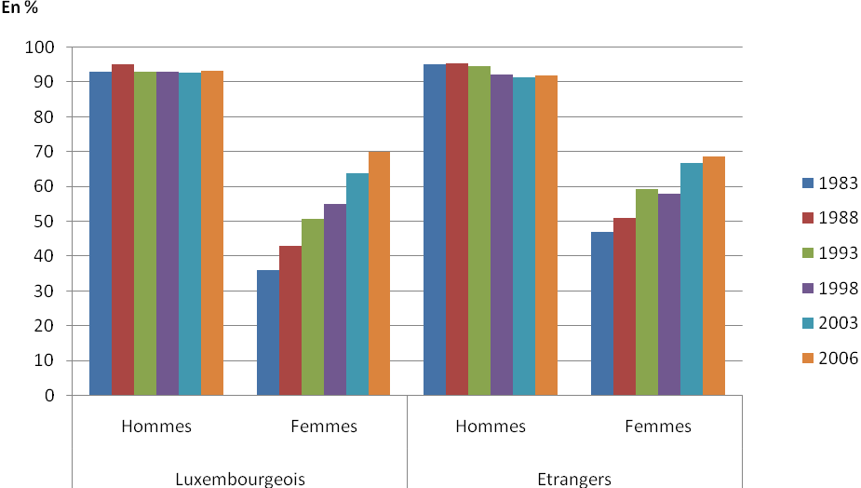

| *Year* | *Luxembourg nationals* | |  | *Foreign nationals* | |  | *Total* | |
| --- | --- | --- | --- | --- | --- | --- | --- | --- |
| *Men* | *Women* | *Men* | | *Women* | *Men* | | *Women* |
|  |  |  |  | |  |  | |  |
| 1983 | 93.0 | 36.0 | 95.1 | | 47.0 | 93.7 | | 39.2 |
| 1984 | 93.6 | 37.6 | 94.9 | | 47.7 | 95.5 | | 43.9 |
| 1985 | 93.4 | 38.7 | 93.8 | | 48.1 | 94.1 | | 44.2 |
| 1986 | 94.4 | 41.1 | 95.5 | | 49.8 | 96.0 | | 47.2 |
| 1987 | 94.5 | 42.9 | 96.1 | | 54.0 | 94.9 | | 46.4 |
| 1988 | 95.0 | 43.0 | 95.4 | | 50.9 | 95.1 | | 45.5 |
| 1989 | 93.6 | 43.8 | 94.8 | | 53.8 | 94.0 | | 47.0 |
| 1992 | 93.8 | 49.8 | 93.7 | | 60.0 | 93.8 | | 53.3 |
| 1993 | 92.9 | 50.7 | 94.7 | | 59.3 | 93.5 | | 53.7 |
| 1994 | 92.5 | 49.9 | 92.6 | | 60.5 | 92.5 | | 53.8 |
| 1995 | 91.9 | 50.0 | 92.6 | | 59.0 | 92.2 | | 53.4 |
| 1996 | 92.0 | 51.8 | 92.2 | | 56.4 | 92.1 | | 53.6 |
| 1997 | 92.0 | 53.2 | 91.4 | | 60.8 | 91.8 | | 56.2 |
| 1998 | 93.0 | 54.9 | 92.2 | | 57.9 | 92.7 | | 56.1 |
| 1999 | 92.9 | 58.0 | 92.7 | | 63.6 | 92.8 | | 60.3 |
| 2000 | 94.1 | 59.5 | 90.4 | | 64.5 | 92.6 | | 61.6 |
| 2003 | 92.6 | 63.9 | 91.3 | | 66.9 | 92.0 | | 65.3 |
| 2006 | 93.3 | 70.0 | 92.0 | | 68.6 | 92.7 | | 69.4 |

*Source*: Labour Force Survey — Central Statistics and Economic Studies Service (STATEC).

Field: Residents.

Changes in the employment rate for persons aged 15 to 19, by nationality and sex,   
 1983-2006



*Percentages*

| *Year* | *Luxembourg nationals* | |  | *Foign nationalsre* | |  | *Total* | |
| --- | --- | --- | --- | --- | --- | --- | --- | --- |
| *Men* | *Women* | *Men* | | *Women* | *Men* | | *Women* |
|  |  |  |  | |  |  | |  |
| 1983 | 38.2 | 36.1 | 43.4 | | 46.9 | 39.7 | | 39.1 |
| 1984 | 35.6 | 31.2 | 43.8 | | 39.1 | 37.8 | | 33.3 |
| 1985 | 32.3 | 31.6 | 36.0 | | 39.1 | 33.6 | | 34.3 |
| 1986 | 31.0 | 30.7 | 32.4 | | 32.4 | 31.5 | | 31.3 |

Women

Men

Men

Women

Foreign

nationals

Luxembourg

nationals

| *Year* | *Luxembourg nationals* | |  | *Foreign nationals* | |  | *Total* | |
| --- | --- | --- | --- | --- | --- | --- | --- | --- |
| *Men* | *Women* | *Men* | | *Women* | *Men* | | *Women* |
|  |  |  |  | |  |  | |  |
| 1983 | 38.2 | 36.1 | 43.4 | | 46.9 | 39.7 | | 39.1 |
| 1984 | 35.6 | 31.2 | 43.8 | | 39.1 | 37.8 | | 33.3 |
| 1985 | 32.3 | 31.6 | 36.0 | | 39.1 | 33.6 | | 34.3 |
| 1986 | 31.0 | 30.7 | 32.4 | | 32.4 | 31.5 | | 31.3 |
| 1987 | 28.0 | 24.7 | 38.3 | | 35.8 | 31.0 | | 28.0 |
| 1988 | 20.4 | 22.7 | 35.5 | | 30.9 | 25.0 | | 25.2 |
| 1989 | 24.1 | 20.4 | 33.9 | | 24.7 | 27.2 | | 21.7 |
| 1992 | 19.3 | 21.0 | 28.8 | | 24.2 | 22.9 | | 22.2 |
| 1993 | 8.8 | 8.5 | 22.2 | | 21.3 | 14.3 | | 13.4 |
| 1994 | 13.8 | 14.1 | 18.7 | | 21.1 | 15.6 | | 16.7 |
| 1995 | 11.2 | 11.7 | 20.4 | | 16.7 | 14.9 | | 13.7 |
| 1996 | 9.0 | 7.7 | 20.0 | | 15.9 | 13.3 | | 10.9 |
| 1997 | 7.4 | 3.5 | 13.7 | | 10.7 | 9.8 | | 6.4 |
| 1998 | 10.1 | 5.0 | 9.4 | | 10.0 | 9.8 | | 7.0 |
| 1999 | 10.8 | 6.2 | 14.6 | | 12.0 | 12.3 | | 8.6 |
| 2000 | 8.7 | 7.4 | 12.0 | | 7.7 | 9.9 | | 7.5 |
| 2003 | 7.5 | 6.3 | 11.1 | | 5.6 | 8.9 | | 6.1 |
| 2006 | 7.4 | 3.4 | 7.3 | | 5.1 | 7.4 | | 4.0 |

*Source*: Labour Force Survey — STATEC.

Field: Residents.

Economically active rate for persons aged 15 to 64, by nationality and sex, 2006

Non-European  
Union Countries

Italy

Other European  
Union Countries

Men

Women

Belgium

France

Luxembourg

Portugal

*Percentages*

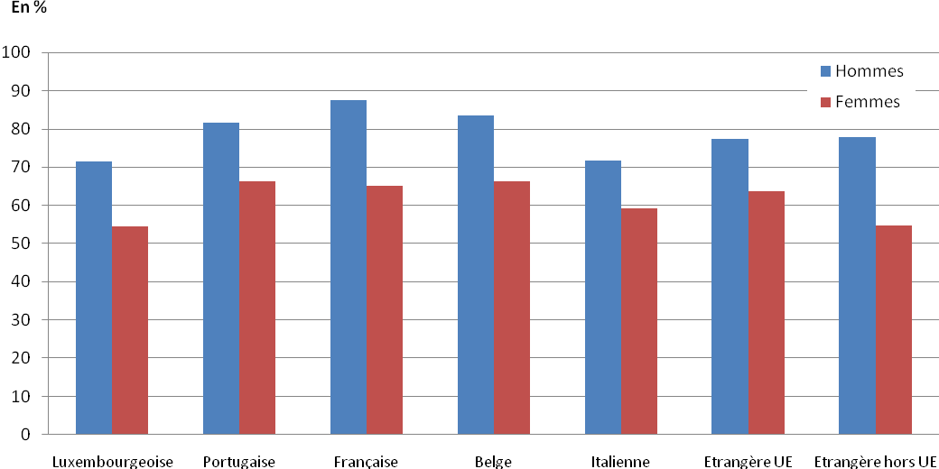

| *Nationality* | *Men* | *Women* | *Total* |
| --- | --- | --- | --- |
|  |  |  |  |
| Luxembourg | 71.4 | 54.4 | 62.8 |
| Portugal | 81.5 | 66.2 | 74.4 |
| France | 87.5 | 65.2 | 76.6 |
| Belgium | 83.4 | 66.2 | 75.0 |
| Italy | 71.7 | 59.1 | 65.8 |
| Other European Union countries | 77.4 | 63.7 | 69.9 |
| Non-European Union countries | 77.8 | 54.8 | 64.4 |
| **Total** | **75.3** | **58.2** | **66.7** |

*Source*: Labour Force Survey — STATEC.

Field: Residents.

Distribution of wage earners, by place of residence and sex, 1988, 2003 and 2006

| *Residence* | *Numbers* | | |  | *Percentages across rows* | | |  | *Percentages in columns* | | |
| --- | --- | --- | --- | --- | --- | --- | --- | --- | --- | --- | --- |
| *Men* | *Women* | *Total* | *Men* | | *Women* | *Total* | *Men* | | *Women* | *Total* |
|  |  |  |  |  | |  |  |  | |  |  |
| **1988** |  |  |  |  | |  |  |  | |  |  |
| Residents | 83 692 | 45 837 | 129 529 | 64.6 | | 35.4 | 100.0 | 82.5 | | 87.1 | 84.1 |
| Including: |  |  |  |  | |  |  |  | |  |  |
| – Luxembourg nationals | 59 725 | 31 139 | 90 864 | 65.7 | | 34.3 | 100.0 | 58.9 | | 59.1 | 59.0 |
| – Foreign nationals | 23 967 | 14 698 | 38 665 | 62.0 | | 38.0 | 100.0 | 23.6 | | 27.9 | 25.1 |
| – Cross-border workers | 17 754 | 6 813 | 24 567 | 72.3 | | 27.7 | 100.0 | 17.5 | | 12.9 | 15.9 |
| **Total** | **101 446** | **52 650** | **154 096** | **65.8** | | **34.2** | **100.0** | **100.0** | | **100.0** | **100.0** |
| **2003** |  |  |  |  | |  |  |  | |  |  |
| Residents | 99 589 | 68 176 | 167 765 | 59.4 | | 40.6 | 100.0 | 58.2 | | 66.5 | 61.4 |
| Including: |  |  |  |  | |  |  |  | |  |  |
| – Luxembourg nationals | 55 644 | 37 538 | 93 182 | 59.7 | | 40.3 | 100.0 | 32.5 | | 36.6 | 34.1 |
| – Foreign nationals | 43 945 | 30 638 | 74 583 | 58.9 | | 41.1 | 100.0 | 25.7 | | 29.9 | 27.3 |
| – Cross-border workers | 71 388 | 34 274 | 105 662 | 67.6 | | 32.4 | 100.0 | 41.8 | | 33.5 | 38.6 |
| **Total** | **170 977** | **102 450** | **273 427** | **62.5** | | **37.5** | **100.0** | **100.0** | | **100.0** | **100.0** |
| **2006** |  |  |  |  | |  |  |  | |  |  |
| Residents | 102 475 | 73 459 | 175 934 | 58.2 | | 41.8 | 100.0 | 55.1 | | 64.8 | 58.7 |
| Including: |  |  |  |  | |  |  |  | |  |  |
| – Luxembourg nationals | 55 083 | 39 817 | 94 900 | 58.0 | | 42.0 | 100.0 | 29.6 | | 35.1 | 31.7 |
| – Foreign nationals | 47 392 | 33 642 | 81 034 | 58.5 | | 41.5 | 100.0 | 25.5 | | 29.7 | 27.1 |
| – Cross-border workers | 83 656 | 39 912 | 123 568 | 67.7 | | 32.3 | 100.0 | 44.9 | | 35.2 | 41.3 |
| **Total** | **186 131** | **113 371** | **299 502** | **62.1** | | **37.9** | **100.0** | **100.0** | | **100.0** | **100.0** |

*Source*: General Social Security Inspectorate [Inspection Générale de la Sécurité Sociale — IGSS].

Field: Residents and cross-border workers.

Distribution of women wage-earners, by economic activity and place of residence, 2006

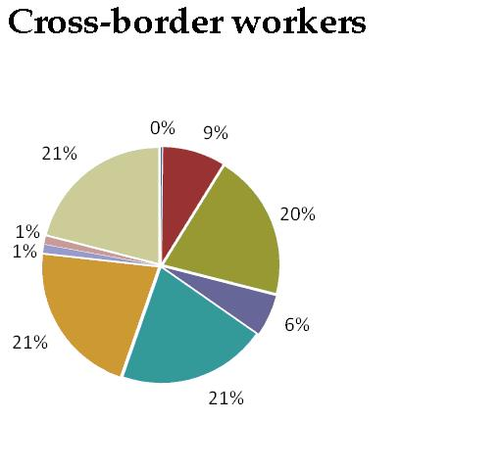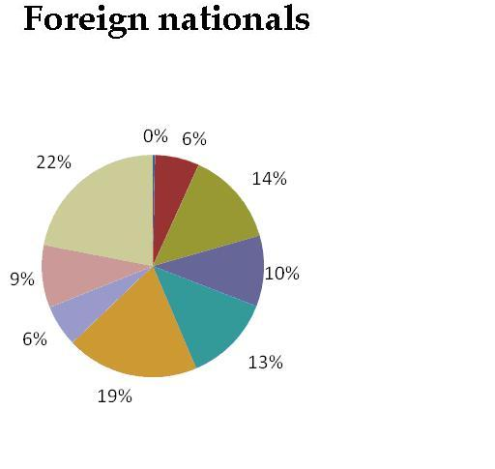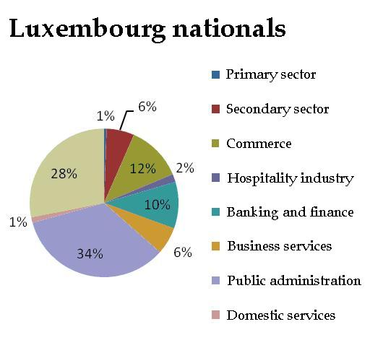

|  | *Numbers* | | | |  | *Percentages across rows* | | | |  | *Percentages in columns* | | | | | |
| --- | --- | --- | --- | --- | --- | --- | --- | --- | --- | --- | --- | --- | --- | --- | --- | --- |
| *Sector of economic activity* | *Luxembourg nationals* | *Foreign nationals* | *Cross-border workers* | *Total* |  | *Luxembourg nationals* | *Foreign nationals* | *Cross-border workers* | *Total* |  | *Luxembourg nationals* | *Foreign nationals* | | *Cross-border workers* | *Total* | |
|  |  |  |  |  |  |  |  |  |  |  |  |  | |  |  | |
| Agriculture, hunting, forestry | 189 | 93 | 59 | 341 |  | 55.4 | 27.3 | 17.3 | 100.0 |  | 0.5 | 0.3 | 0.1 | | | 0.3 |
| Fisheries, aquaculture | 0 | 0 | 0 | 0 |  | 0 | 0 | 0 | 0 |  | 0.0 | 0.0 | 0.0 | | | 0.0 |
| Extractive industries | 19 | 7 | 9 | 35 |  | 54.3 | 20.0 | 25.7 | 100.0 |  | 0.0 | 0.0 | 0.0 | | | 0.0 |
| Manufacturing | 1 546 | 1 594 | 2 573 | 5 713 |  | 27.1 | 27.9 | 45.0 | 100.0 |  | 3.9 | 4.7 | 6.4 | | | 5.0 |
| Electricity, gas and water production and distribution | 127 | 18 | 9 | 154 |  | 82.5 | 11.7 | 5.8 | 100.0 |  | 0.3 | 0.1 | 0.0 | | | 0.1 |
| Construction | 736 | 565 | 868 | 2 169 |  | 33.9 | 26.0 | 40.0 | 100.0 |  | 1.8 | 1.7 | 2.2 | | | 1.9 |
| Car and appliance sales and repair | 4 832 | 4 644 | 8 051 | 17 527 |  | 27.6 | 26.5 | 45.9 | 100.0 |  | 12.1 | 13.8 | 20.2 | | | 15.5 |
| Hospitality industry | 683 | 3 461 | 2 281 | 6 425 |  | 10.6 | 53.9 | 35.5 | 100.0 |  | 1.7 | 10.3 | 5.7 | | | 5.7 |
| Transport and communications | 1 810 | 1 156 | 1 389 | 4 355 |  | 41.6 | 26.5 | 31.9 | 100.0 |  | 4.5 | 3.4 | 3.5 | | | 3.8 |
| Banking and finance | 4 039 | 4 291 | 8 235 | 16 565 |  | 24.4 | 25.9 | 49.7 | 100.0 |  | 10.1 | 12.8 | 20.6 | | | 14.6 |
| Real estate, leasing and business services | 2 368 | 6 481 | 8 553 | 17 402 |  | 13.6 | 37.2 | 49.1 | 100.0 |  | 5.9 | 19.3 | 21.4 | | | 15.3 |
| Public administration | 13 608 | 2 040 | 461 | 16 109 |  | 84.5 | 12.7 | 2.9 | 100.0 |  | 34.2 | 6.1 | 1.2 | | | 14.2 |
| Education | 448 | 354 | 239 | 1 041 |  | 43.0 | 34.0 | 23.0 | 100.0 |  | 1.1 | 1.1 | 0.6 | | | 0.9 |
| Health and social services | 7 221 | 3 840 | 5 050 | 16 111 |  | 44.8 | 23.8 | 31.3 | 100.0 |  | 18.1 | 11.4 | 12.7 | | | 14.2 |
| Community and personal services | 1 532 | 1 518 | 1 328 | 4 378 |  | 35.0 | 34.7 | 30.3 | 100.0 |  | 3.8 | 4.5 | 3.3 | | | 3.9 |
| Domestic services | 473 | 3 063 | 433 | 3 969 |  | 11.9 | 77.2 | 10.9 | 100.0 |  | 1.2 | 9.1 | 1.1 | | | 3.5 |
| Activities beyond Luxembourg’s borders | 42 | 268 | 113 | 423 |  | 9.9 | 63.4 | 26.7 | 100.0 |  | 0.1 | 0.8 | 0.3 | | | 0.4 |
| Other activities | 144 | 249 | 261 | 654 |  | 22.0 | 38.1 | 39.9 | 100.0 |  | 0.4 | 0.7 | 0.7 | | | 0.6 |
| **Totals** | **39 817** | **33 642** | **39 912** | **113 371** |  | **35.1** | **29.7** | **35.2** | **100.0** |  | **100.0** | **100.0** | **100.0** | | | **100.0** |

*Source*: IGSS.  
Field: Residents and cross-border workers.

17. *The report describes the Law of 19 May 2003 which introduced measures to promote the reconciliation of family and working life (para. 18). However, the record on parental leave shows that the number of mothers taking leave is consistently higher than that of fathers (para. 87). What concrete measures, in addition to the legislative changes discussed in the report, does the Government intend to take to encourage better sharing of work and family responsibilities between men and women?*

The Government does not envisage any additional measures that would encourage better sharing of family and work responsibilities between women and men. However, the Ministry of Family Affairs and Social Integration is working to promote the harmonization of family and working life by encouraging:

1. The establishment of drop-in centres (“*maisons relais*”) for children;

2. The establishment of nurseries and day-care centres for children;

3. The provision of childcare in private homes.

1. Establishment of drop-in centres (“*maisons relais*”)[2] for children

The concept of “maisons relais” for children involves quantitative (an increase in their number), geographical (distribution according to need throughout Luxembourg) and qualitative (an increase in the services that they provide) elements.

According to a 2003 Centre for Population, Poverty and Socioeconomic Policy Studies (CEPS)[3] study, in 2003 approximately 26 per cent of all children in need of care of the kind used by households where both parents work avail themselves of the care system provided by these childcare facilities.

In 2005, although the Grand Duchy of Luxembourg had places for 8,000 children in out-of-school centres, the Government[4] estimated that 30,000 places would be needed by 2013. A geographical needs assessment arrived at an estimate of 30 per cent in rural areas and 50 per cent in urban areas (an average of 40 per cent). These estimates took into account the number of children residing in the Grand Duchy of Luxembourg and the past experience of existing childcare facilities.

As of August 2007, the Grand Duchy of Luxembourg had 92 *maisons relais* offering a total of 10,449 places.

2. Establishment of day nurseries[5] and day-care centres[6] for children

As of 31 December 2006, the early childhood care system comprised 163 day nurseries and day-care centres with a total of 5,208 places and no waiting list.

3. Provision of childcare in private homes

Childcare provision in private homes comprises all activities involving the provision of daytime and/or nighttime care and accommodation for groups of more than three and less than eight minor children.

In 2006, Luxembourg had a total of 73 parental aides in 31 municipalities.

18. *The statistics in the report indicate that women have higher educational achievements than men and exceed men in general enrolment at tertiary level. What strategies has the Government put in place or considered to ensure that young women seek and retain jobs commensurate with their academic achievements?*

Since 2005, as part of the affirmative action measures introduced by the private sector, the Ministry of Equal Opportunity has been funding a “cross mentoring” project involving companies working in various sectors.

The project is geared towards women graduates occupying managerial posts within companies. In a “mentoring” relationship, one person, the “mentor”, provides another, the “mentee”, with career development support and expertise. This privileged interaction is separate from the normal working relationship between the two individuals concerned. In the case of “cross mentoring”, the “mentor” and the “mentee” are not employed by the same company. Thus, the exchange of experiences can bridge any gaps arising from the existence of differing corporate cultures. “Cross mentoring” can take place between companies in different sectors or even between individuals working in the public and private sectors. An assessment of the project has shown that, for “mentees”, one of the most important issues is career development, along with conflict management and ways of reconciling their professional and private lives. In companies that have participated in the project, women showing significant potential receive ongoing career development support.

Health

19. *The report states that sex education is no longer considered as the exclusive preserve of specialized professionals (para. 277). It does not, however, state what specific measures have been taken to increase women’s access to reproductive and sexual health services and family planning in order to avoid unwanted pregnancies and women’s recourse to illegal abortion. Please provide this information.*

In addition to the information provided in paragraphs 271 to 281 of the fifth periodic report, the following should be noted:

• Condoms are provided free of charge and are distributed in educational establishments through vending machines. Non-governmental organizations and family planning clinics also distribute them;

• A guide to young people’s emotional and sexual health is currently being prepared in cooperation with the Family Planning Centre, the Ministry of Education and the Ministry of the Family;

• Cooperation with non-governmental organizations working on the ground has been stepped up in order to ensure that sex education is provided from an early age.

In recent years, public and political awareness of problems relating to the voluntary termination of pregnancy has increased.

20. *The report notes that there has been a significant increase in mortality rates from lung cancer among women (paras. 243 and 245). The report further states that lung cancer deaths among women have increased by more than 47 per cent since 1980 and that it is feared that these rates will grow further (para. 261). Also, the report indicates that at 18 years of age, the proportion of girls who smoke regularly is significantly higher than the proportion of boys (para. 264). Please indicate what the Government is doing to target women and girls in its anti-smoking campaigns and to address the increasing incidence of lung cancer among women.*

The Tobacco Control Act of 11 August 2006 is designed to protect people against the harmful effects of passive smoking and to encourage them to give up smoking. Among other things, it prohibits smoking in public places, particularly hospitals and schools, the sale of tobacco products to minors under the age of 16 and any advertising or sponsorship that promotes tobacco and related products.

The number of smokers in Luxembourg has decreased since 2005

|  | *1987* | *1993* | *1998* | *2001* | *2002* | *2003* | *2004* | *2005* | *2006* |
| --- | --- | --- | --- | --- | --- | --- | --- | --- | --- |
|  |  |  |  |  |  |  |  |  |  |
| Smokers | 33% | 29% | 32% | 30% | 30% | 33% | 31% | 27% | 25% |

*Source*: TNS — Polling and Survey Institute (ILRES) — Luxembourg Cancer Foundation survey on smoking in Luxembourg.

In 2006, 25 per cent of the population of Luxembourg (aged 15 and over) smoked. Among young people aged 15 to 17, 11 per cent of boys and 26 per cent of girls smoke, while 26 per cent of men and 34 per cent of women aged 18 to 24 are smokers.

The Ministry of Health, in cooperation with experts and partners on the ground, is currently drawing up a national anti-smoking plan. Intended to prevent and reduce smoking and smoking-related diseases and deaths, the plan’s objectives include concerted action to prevent smoking among young people by promoting a less acceptable view of tobacco, projecting a more objective image of smokers and focusing on long-term behavioural change.

Results of annual surveys conducted by TNS-ILRES-Luxembourg   
Cancer Foundation

Representative sample of the resident population aged 15 and over (in-person interviews)

**Smokers aged 15 to 17**

**32**

**36**

**29**

**24**

**19**

**18**

**0**

**10**

**20**

**30**

**40**

**50**

**2001**

**2002**

**2003**

**2004**

**2005**

**2006**

**15-17**



TNS-ILRES/FLCC Survey 2006

**Girls and boys aged 15 to 17**

**30**

**35**

**28**

**28**

**22**

**11**

**26**

**16**

**20**

**33**

**39**

**28**

**0**

**10**

**20**

**30**

**40**

**50**

2001

2002

2003

2004

2005

2006

Male

Female

All



TNS-ILRES/FLCC Survey 2006

**Smokers aged 18 to 24**

**46**

**47**

**52**

**47**

**41**

**35**

**0**

**10**

**20**

**30**

**40**

**50**

**2001**

**2002**

**2003**

**2004**

**2005**

**2006**

**18-24**



TNS-ILRES/FLCC Survey 2006

**Men and Women aged 18 to 24**

**54**

**52**

**53**

**48**

**36**

**34**

**33**

**40**

**39**

**41**

**47**

**0**

**10**

**20**

**30**

**40**

**50**

2001

2002

2003

2004

2005

2006

Male

Female

All



TNS-ILRES/FLCC Survey 2006

Women in vulnerable situations

21. *Please describe the situation of foreign women, and in particular women from outside the European Union, in Luxembourg. This should include a discussion of measures in place to eliminate discrimination and achieve equality for foreign women and girls in areas such as education, health, employment and participation in public life. Please also indicate the impact of such measures, as well as any temporary special measures.*

On 25 September 2005, the Government Aliens Commission asked the SeSoPI Centre to conduct, in partnership with the Institute for Social Training, an external evaluation of the INLUX pilot project “Live better in Luxembourg”, which was introduced by the Ministry of the Family as part of a series of measures to facilitate and strengthen the integration of foreigners into Luxembourg’s multicultural society. One of the project’s fundamental objectives is for participants to acquire basic proficiency in one of the country’s languages (Luxembourgish or French) so that they can communicate confidently with other residents. Most of the participants taking formal courses are married women who are nationals of non-European Union countries and come from the middle or upper social classes. By the end of the pilot project, participants had acquired basic proficiency in one of the two languages taught, allowing them to communicate confidently with other residents, and were committed to pursuing their education and training beyond the first stage of the project.

22*. The report provides little information about the situation of older women. Please give an overview of their situation, in particular their economic well-being. In this regard, indicate the impact of women’s limited number of years in paid employment due to family and childcare responsibilities in regard to pension rights, social security and health coverage, and measures in place to counteract any negative impact.*

On the whole, the *income level* of older persons is comparable to the disposable income of people in other age groups and the disposable income of older women is similar to that of men of the same age. There is a significant difference between the disposable income levels of women and men only among the very oldest individuals. This difference is attributable to the fact that, following a change in their marital status, most women are entitled to a survivor’s benefit (a derived right following the death of their spouse) which is worth less than the personal pension of the original beneficiary.

**Relationship between the equivalent income of older persons and persons in other age groups (resident population)**

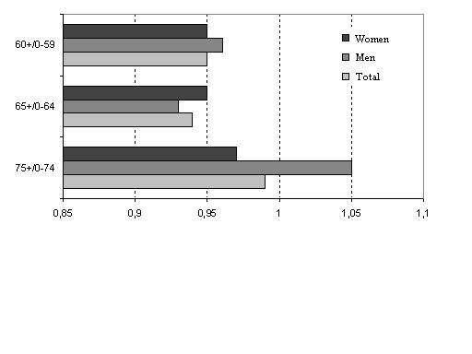

*Source:* Eurostat (2004).

Overall, the *risk of older persons being affected by poverty* is limited. However, women are at greater risk than men and the risk of women finding themselves in a precarious situation increases with age. This phenomenon is attributable to the fact that older women receive only a limited amount of income from personal pensions (as a result of career interruptions) and a reduced survivor’s benefit.[7]

Poverty risk (threshold of 60 per cent of equivalent median income) by age group



Women  
 Men  
 Total

*Source*: Eurostat (2004).

Estimates of *time actually worked* as a proportion of the maximum potential time worked by age group show that women of retirement age have spent considerably more time not working than they have working. Thus, we have two scenarios: most women of working age are not economically active and are therefore unlikely to be entitled to a personal pension, and most women who are entitled to a personal pension have had incomplete careers, meaning that their pension benefits will be limited. Both scenarios mean that the disposable income of older women comes mainly from the personal pension of their spouse or, as the case may be, from a survivor’s benefit and/or social assistance.

**Estimated time actually worked as a proportion of the maximum potential time worked by age group in 2000 (women)**

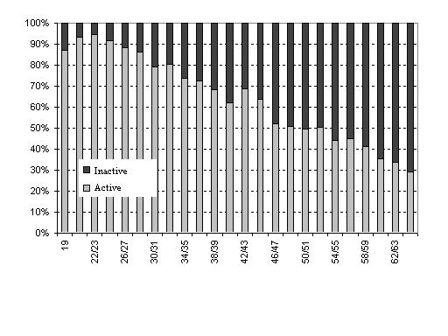

*Source*: B. Lejealle, 2003.

Over the generations, *stopping work* in order to raise children has become much more common than stopping work after marriage. Members of the oldest generation tended to stop work after marriage in anticipation of having children. Until the late 1980s, women who stopped working once they married received a cash reimbursement of their pension contributions, which meant that they forfeited their entitlement to a personal pension.

**Reasons for career interruptions before the ages of 25, 30 and 35 for women aged between 26 and 34, 35 and 44, 45 and 54 and 55 and 64 in 2000 (as a percentage of the total number of interruptions by age group)**

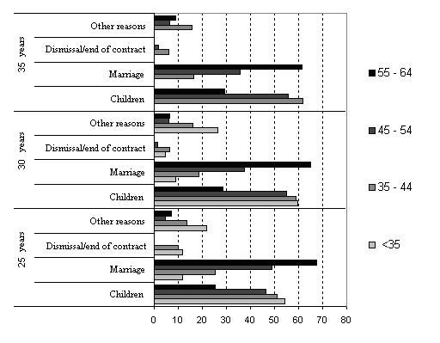

*Source*: B. Lejealle, 2003*.*

Special provisions allow women to retain their pension rights if they stop working in order to *raise children*. In certain circumstances, one parent may receive additional pension increments corresponding to at least two years of compulsory coverage. Supplementary coverage is also generated when periods during which one parent was raising one or more children under the age of six are taken into account.[8]

The treatment of periods spent raising children as qualifying periods enables a woman to take early retirement at age 60 if her compulsory and supplementary contribution periods total 40 years. For example, women entitled to an early pension at age 60 complete the qualifying period of 40 years by adding an average of eight years of supplementary contribution periods. These supplementary periods vary very little in the case of an old-age pension taken at age 65.

**Years of compulsory periods (compuls.) and supplementary periods (suppl.) by type of pension (age 57 = early pension at age 57; age 60 = early pension at   
age 60; old-age = old-age pension at age 65), by sex and by place of work (Lux. = Grand Duchy of Luxembourg; abr. = abroad) in 2002**

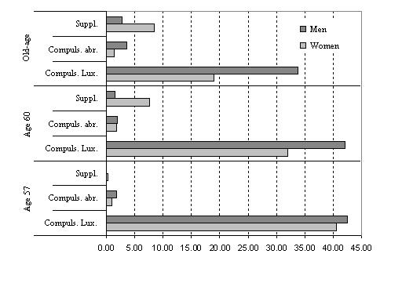

*Source*: IGSS.

Generally speaking, the disability pension plays an important role in pension entitlement and some 30 per cent of new retirees are recipients of a disability pension. This route seems to be extremely popular in the case of early retirement before age 60, for women as well as for men. Disability pensions aside, the retirement age for women is considerably higher than that for men. This phenomenon is particularly common among unskilled women (manual workers), because these women have to go on working to complete the qualifying period of 20 years required for receipt of at least the minimum legal pension.

**Retirement age in 2003, by sex, for recipients of disability and old-age (including early old-age) pensions**

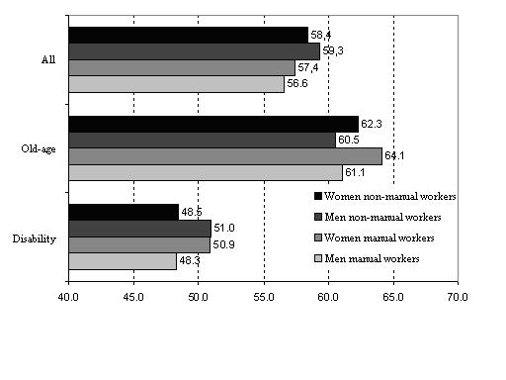

*Source*: IGSS*.*

In the Grand Duchy of Luxembourg, no annual old-age pension or survivor’s benefit may be lower than 90 per cent of a reference amount when the insured person has completed at least a qualifying period of 40 years of compulsory insurance periods and/or supplementary periods. If the amount of the pension falls below the amount of the *minimum pension*, the recipient is paid a pension supplement to make up the difference between the amount of the minimum pension and the amount of his or her personal pension. If the insured person has not completed the 40-year qualifying period but can prove that he or she has at least 20 years of contribution periods, the minimum pension is reduced by one fortieth for each missing year.

In the case of the disability pension and the old-age pension at age 65, most recipients of the minimum-pension supplement are women. Periods of reduced activity with low wages, combined with supplementary periods, provide entitlement to the minimum pension even though the contributions made are insufficient to generate adequate levels of personal pension.

**Percentage of people receiving minimum-pension supplements, by type of personal pension awarded (age 57 = early pension at age 57; age 60 = early pension at age 60; disability = disability pension; old-age = old-age pension at age 65) and by residence, in 2004 (as a percentage of all personal pensions)**

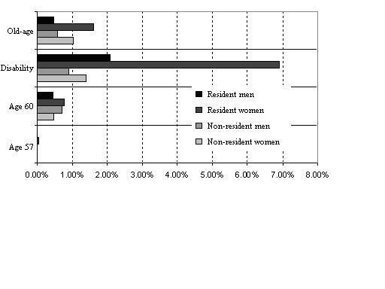

*Source*: IGSS.

However, when for one reason or another the amount of a household’s income falls below the level of the *minimum guaranteed income*, the household receives a supplement to make up the difference between the minimum guaranteed income and its disposable income. A supplementary allowance is thus available to households consisting of persons of retirement age whose financial resources are limited.

Payment for *health care* in Luxembourg is based on a system of compulsory insurance derived from the Bismarckian system. It covers all persons in regular employment, salaried or otherwise, or in receipt of alternative income (sickness, maternity or unemployment benefits, disability or old-age pension or survivor’s benefit, guaranteed minimum income, etc.) or granted asylum-seeker status. By derogation from the principle of personal insurance, the law accords “derived rights” to members of an insured person’s family (spouse, children) or to his/her partner if these persons do not have their own entitlements. Sickness and maternity insurance covers the cost of the following benefits: outpatient medical or other care, laboratory analyses and tests, hospital care, pharmaceutical products, rehabilitation and spa cures, health aids and prostheses and health-service transport.

Ease of access to health care is enhanced by: 1. free choice of a doctor and direct access to specialist doctors and hospital polyclinics; 2. a sufficient number of doctors and other health-care professionals; 3. an estimated 91.8-per-cent average reimbursement rate based on sickness and maternity insurance charges for 2004; 4. reimbursement facilities or prepayment for some expensive services for insured persons experiencing financial difficulties.

The purpose of long-term care insurance is to cover at least part of the costs arising from health care and the *need for assistance from a third party* to perform the essential acts of everyday life. The payment of such costs by the community is justified both by the widespread nature and the uniformity of the risk, which can affect anyone at any age, and by the magnitude of the costs, which can hardly be borne by one person alone or even by his or her family without compromising their material survival. Long-term care insurance thus creates an unconditional entitlement to benefits, i.e. one that doesn’t require means-testing of the dependent person.

In 2006, a total of 1,526 women received a minimum-guaranteed-income supplement in addition to their personal pensions.

In August 2007, 497 women out of a total of 666 beneficiaries (74.62 per cent) received the supplementary benefit created by the Act of 30 April 2004 authorizing the National Solidarity Fund to pay part of the cost of the services provided for the care of persons admitted to an integrated centre for older persons, a care centre or any other medical/social institution providing day and night care.

Special measures

Baby years

Under certain conditions, one or both parents may receive additional pension increments corresponding to two years’ of insurance calculated on the basis of the last salary subject to contributions before the insurable event. This period is extended to four years from the third child or if the child is disabled.

Periods spent raising children

Measuring “child-raising periods” involves factoring in periods during which one of the parents was raising in Luxembourg one or more children aged under six.

Such periods are used only to complete the qualifying period for the early retirement pension (at 60) or the minimum pension or for receiving lump-sum pension increments, which vary only according to the length of the contributory period.

The “child-raising” lump sum

A “child-raising” lump sum is payable from age 60 to parents who are unable to factor into their pension periods spent raising their children.

Like the “baby years”, this lump sum can be awarded to only one of the parents, meaning that the majority of recipients are women.

Parental leave

Parental leave may be granted under certain circumstances to any person who is raising one or more children aged under five in his or her home.

In order to qualify for full-time parental leave, the parent must devote himself or herself full-time to raising one or more children and must not engage in any employment for the duration of the leave. In the case of part-time leave, the employment may not exceed half the normal monthly working hours applicable to the workplace by law or under a collective agreement.

Child-raising allowance

The child-raising allowance may be awarded, at least until the child reaches the age of two, to persons residing in Luxembourg and raising one or more children in their home.

Recipients must devote themselves principally to the raising of children in the family home and must not engage in any employment or be in receipt of any alternative income. Mothers may claim half the allowance, regardless of any income they may earn from one or more part-time jobs, provided that their total effective working week does not exceed half its normal duration.

Provisions to promote the expansion of childcare facilities

The government programme provides that as part of efforts to achieve a better balance between work and family life, its partners shall make significant efforts to expand childcare facilities (nurseries, day-care centres).

In order to ensure better childcare and to enable parents who so wish or who have no other choice to combine working with family life, the Government is encouraging municipalities to set up facilities throughout the country for preschool and primary schoolchildren.

The introduction of the continuous school day in post-primary education, on a pilot basis, was scheduled for the start of the 2005-2006 school year. The number of facilities for preschool and primary schoolchildren is increasing. Preschool education will be available throughout the country from 2009, on the understanding that municipalities will have an obligation to provide such education, and parents will be free to choose whether or not to enrol their children.

An increasing number of municipalities already offer, in addition to day-care centres for children, “school meals” (any service in which school-age children are received, supervised and served food during the main meal time) and “homework assistance” (any non-school, non-residential service in which primary school pupils are received and supervised outside school hours in order to offer them recreational activities and homework assistance).

Part-time working in the civil service

Part-time working may be authorized on a 25-, 50- or 75-per-cent basis, provided that it does not disrupt the proper functioning of the service.

Although, in principle, part-time working must be arranged according to a daily schedule, the head of the service may nevertheless agree with the employee, in the interest of the service, on a different distribution of working hours over part of the week, month or even year. This arrangement is also available for employees taking leave in the form of part-time working.

Reinstatement of civil servants who interrupted their career to raise their children

This measure, which is a transitional one, applies to civil servants who, under the old legislation on leave of absence, were forced to resign in order to devote themselves to raising their children. Such persons now have the option of reinstatement, as supernumerary staff outside the manning table, in the functions which they were performing before they resigned, with their career status at the time of their resignation restored.

Seniority credit in the civil service

Civil servants who are on leave without pay or on leave in the form of part-time working qualify for seniority credit. The following limits apply to employees who devote themselves to raising children aged under 15 years:

• A maximum of 10 years for employees taking leave without pay;

• Full credit for employees taking leave in the form of part-time working.

23. *Please provide information and data about the situation of disabled women and girls, including the financial, medical and other support provided to ensure the protection of their rights.*

1. Residential care for disabled women and girls

*Residential services*

In 2006, of the 719 residential spaces established for disabled persons, 347 were occupied by females and 350 by males. The budgetary resources used in the 2006 financial year to meet the staffing and operating costs of accommodating the female occupants of these places was in the order of 9.7 million euros.

*Self-defence and sex-education classes*

The Day Centre of the HMC League has introduced a self-defence class for disabled women in cooperation with Info-Handicap and a sex education course in cooperation with the Family Planning Centre. Other organizations such as APEMH provide one-on-one counselling to women on sexuality and sexual abuse and offer places on self-defence courses open to the general public.

2. Income for seriously disabled persons[9]

Any person aged between 18 and 65 years who is authorized to reside in the territory of the Grand Duchy and to be domiciled and actually reside therein and who has a diminished capacity to work of at least 30 per cent as the result of a physical, mental, sensory or psychological disorder and/or of psycho-social difficulties aggravating such disorder and whose state of health is such that any attempt to work is counter-indicated or whose skills are so limited that it is impossible to adapt a job in the ordinary world of work to his or her needs may claim the income for seriously disabled persons.[10]

In 2006, 309 women received the income for seriously disabled persons.

3. United Nations Convention on the Rights of Persons with Disabilities

On 30 March 2007, the Grand Duchy of Luxembourg signed the United Nations Convention on the Rights of Persons with Disabilities, which introduced such general principles as non-discrimination, equality of opportunity, and gender equality.

Optional Protocol

24*. Please provide information about the steps taken to make widely known the Optional Protocol, which Luxembourg ratified in 2003.*

See information under paragraph 5.

1. * *Translator’s note*. The Luxembourg school system is like the French school system insofar as the lowest form in a secondary school is the seventh form and the two top forms are the first form. Thus the seventh to the fifth forms correspond to the first to third forms in an English school.
2. A “maison relais” provides temporary, non-residential, social and educational activities for children under 18.
3. See article by Blandine Lejealle: “Sur le mode de garde des jeunes enfants: entre souhait et réalité” (Childcare options: between the ideal and the reality), based on the PSELL-3/2003 study by the Panel Socio-Economique Liewen zu Lëtzebuerg (Life in Luxembourg Socioeconomic Panel — PSELL), a 2003 survey of a representative sample of Luxembourg’s resident population. The PSELL-3 study, based on data gathered in 2003, was conducted as part of the European Union Statistics on Income and Living Conditions (EU-SILC) statistics programme, which gathers information on the incomes and living conditions of individuals and households in the different European Union member countries.
4. 2006 Government declaration on the nation’s economic, social and financial situation.
5. A day nursery is defined as any non-residential service that provides care and education in licensed facilities to children who are under four years of age or are not yet enrolled in school.
6. A day-care centre is defined as any non-residential service that provides care and education in licensed facilities to children enrolled in early, preschool or primary education, outside school hours or during school holidays.
7. The surviving spouse’s benefit consists of three quarters of the proportional payments increments (including regular and one-off increments), all the lump-sum increments (including one-off increments) and the full amount of the end-of-year payment to which the insured person was or would have been entitled. Provisions setting an aggregate limit on benefits are applicable if the survivors’ total income exceeds a certain threshold.
8. There are two distinct types of period: 1. compulsory periods, during which contributions are made in the beneficiary’s name; 2. supplementary periods, which are used only to complete the qualifying period for the early retirement pension (at 60), the minimum pension or for receiving lump-sum pension increments.
9. For a full definition of the conditions for the award of the income for seriously disabled persons, see article 1 of the Disabled Persons Act of 12 September 2003 cited below.
10. The income for seriously disabled persons was introduced by the Disabled Persons Act of   
    12 September 2003 (*Mémorial A,* No. 144 of 29 September 2003, p. 2,937).